Preface



This book introduces basic education on subsea well development for students, fresh offshore engineers and universities’ staffs. The book consists of six chapters as follows: The first chapter discusses overview of subsea well. In the second chapter, drilling subsea well, subsea well specification, subsea well construction, subsea well completion and standard and code practiced used in subsea technology are explained in detailed with an example. The third chapter discusses subsea blowout preventer (BOP) and how to control BOP during drilling rig. The forth chapter comes up with subsea wellhead components and wellhead guide system, the fifth chapter discusses on subsea well test and completion using senTHREE-7 as an example and wellhead fatigue analysis is discussed in the last chapter using Subsea Pro -Simulation & Installation- Software.

Many pictures and illustrations are enclosed in this book to assist the readers’ understanding. It should be noted that some pictures and contents are borrowed from other companies’ websites and brochures which are quoted and listed in the references. This book mainly is designed for basic education on subsea engineering purposes only not for traded.

2017 (Third Edition)
Book No: 2003201702

Published by | 

Authors

Jaswar KOTO, Dr.Eng, C.Eng, C.Mar.Eng
Professor on Offshore Engineering
President of Ocean & Aerospace Research Institute, Indonesia
President of International Society of Ocean, Mechanical & Aerospace
-scientists & engineers- (ISOMAse)
Contract at Mechanical Engineering, Universiti Teknologi Malaysia.
Email: jaswar.koto@gmail.com, jaswar@isomase.org

Acknowledgements

Alhamdulillahhirobbilalamin, first and foremost, all praises and syukur are only to Allah (S.W.T) to give us strength and ability to complete this book.

We would like to take this opportunity to express our highest appreciation to our colleagues and friends in the Ocean and Aerospace Research Institute, Indonesia, Universiti Teknologi Malaysia (UTM) and Institut Teknologi Sepuluh Nopember (ITS), Indonesia to provide proper guidance, full support, encouragement, invaluable ideas, comment, recommendation, critics, suggestions and advice that to assist us for the successful completion of this book.

To our families that always pray for our successful, all this things cannot pay for all what they all have done. Our special thanks also to our postgraduate students.

Above this all, our highest praises, thanks and syukur to Almighty Allah Subhanahu Wa’Talla, the most gracious the most merciful, who gave us the knowledge, courage and patience to accomplish this project. May the peace and blessings of Allah be upon Prophet Muhammad Sallallahu Alaihi Wasallam.

The authors are grateful to all friends, institutions and parties for supporting this book.

List of Figures

Figures and Description | Pages
Figure.1-1: Subsea wellhead suppliers | 12
Figure.2-1: Examples of offshore rigs | 14
Figure.2-2: Examples of drilling rigs | 15
Figure.2-3: Sequences of well drilling using drilling riser operated from MODU | 17
Figure.2-4: An example of deep water drilling rigs | 18
Figure.2-5: BOP installed on Jack-up during drilling in shallow water | 19
Figure.2-6: BOP on top wellhead at seabed during drilling in deep water | 21
Figure.2-7: Semi-Submersible and drill ship drilling rig | 22
Figure.2-8: Running the temporary guide base | 24
Figure.2-9: Running the drill-bit to drill the 36-in hole | 25
Figure.2-10: Running the 30-in casing and PGB | 26
Figure.2-11: Installing the diverter | 28
Figure.2-12: Running the surface casing and High Pressure Well Head Housing | 30
Figure.3-1: Ram and Annular BOP on top of wellhead | 34
Figure.3-2: Typical layout of a BOP | 36
Figure.3-3: Typical types of a BOP | 37
Figure.3-4: Part description ram-type BOP | 38
Figure.3-5: Typical types of Ram’s BOP | 39
Figure.3-6: Typical pipe ram BOP | 39
Figure.3-7: Typical blind rams BOP | 40
Figure.3-8: Typical shear rams BOP | 40
Figure.3-9: Typical blind-shear rams BOP | 41
Figure.3-10: Typical variable-bore rams BOP | 41
Figure.3-11: Two typical types of Annulus’ BOP | 42
Figure.3-12: Diagram of the wedge-faced BOP | 43
Figure.3-13: Diagram of spherical BOP | 44
Figure.3.14: Typical Rotational BOP | 45
Figure.3-15: Typical Diverters BOP | 46
Figure.3-16: Typical subsea BOP used in North Sea Operation | 47
Figure.3-17: Common typical well control system | 48
Figure.4-1: Wellhead casing design for North Sea Operation | 51
Figure.4-2: Subsea wellhead system | 53
Figure.4-3: An example of a subsea wellhead | 56
Figure.4-4: An example of casing head | 57
Figure.4-5: An example of casing hanger | 57
Figure.4-6: Intermediate Casing Hanger Profile | 58
Figure.4-7: An example of tubing head | 59
Figure.4-8: An example of tubing hanger | 60
Figure.4-9: Schematic of wellhead housing | 61
Figure.4-10: Intermediate Casing Hanger Profile | 62
Figure.4-11: SS-15 Subsea Wellhead System running tool family | 63
Figure.4-12: SS-Series Conductor Wellhead Running Tool | 64
Figure.4-13: SS-Series Subsea Wellhead Running Tool | 65
Figure.4-14: Casing Hanger Running Tool | 65
Figure.4-15: BOP Isolation Test Tool | 67
Figure.4-16: Nominal bore protector, 133/8-in. wear bushing, and 95/8-in. wear bushing | 68
Figure.4-17: Typical Low-Pressure Wellhead Housings | 68
Figure.4-18: SS type of High-Pressure Wellhead Housings | 69
Figure.4-19: Typical casing design for Central North Sea | 72
Figure.4-20: Typical lithology at Central North Sea | 72
Figure.4-21: An example of drilling guide base | 73
Figure.4-22: An example typical Permanent Guide Base | 74
Figure.4-23: An example of permanent Guide Base | 75
Figure.4-24: Schematic of permanent guide base | 76
Figure.5-1: Well Completion methods | 77
Figure 5-2: Open-hole well completion technique | 78
Figure.5-3: Screen well completion technique | 79
Figure.5-4: Casing or liner well completion technique | 80
Figure.5-5: An example well testing | 81
Figure.5-6: Subsea well suspension | 82
Figure.5-7: BOP stack temporary removed from well | 83
Figure.5-8: Tree and BOP installations | 84
Figure.5-9: Well Completion | 86
Figure.5-10: Installation and intervention | 87
Figure.5.11: Isolation and Production Preparation | 89
Figure.6-1: Flowchart of wellhead fatigue analysis process | 92
Figure.6-2: Static wellhead loading analysis | 95
Figure.6-3: Wellhead Load Conditions | 99
Figure.6-4: Force diagram acting on subsea wellhead | 100
Figure.A-1: Subsea Pro –Simulation and Installation | 104
Figure.A-2: Wellhead analysis using Subsea Pro –Simulation and Installation | 104

List of Tables

Tables and Description | Pages
Table.2-1: Standard Code Practiced for Subsea Production System | 16
Table 6-1: Buckling Sensitivity Example: SLEM Multistring System Values | 97
Table.A-1: Pressure unit conversion | 105
Table.A-2: SI to US unit conversion | 105

Table of Contents

Preface 1
Authors 2
Acknowledgements 3
Table of Contents 4
List of Figures 7
List of Tables 10
Subsea Well 11
1.1. Introduction 11
Subsea Well Drilling 13
2.1. Introduction 13
2.2. Types of Drilling Rigs 13
2.3. Standard Code Practiced 15
2.3. Subsea Well Construction Operations 16
2.3.1. Deep Water Well Construction 17
2.4. Subsea Well Drilling Specification 18
2.4.1. Shallow Water 19
2.4.2. Deep Water 20
2.5. North Sea’s Well Drilling 23
2.5.1. Positioning the Rig 23
2.5.2. Running the Drilling Guide Base 23
2.5.3. Drilling the 36" Hole 24
2.5.4. Running & Cementing the 30-in Casing 25
2.5.5. Installation of the Diverter 28
2.5.6. Drilling the 26-in Hole 29
2.5.7. Running & Cementing the 18⅝-in Casing 29
2.5.8. Installing the BOP 30
2.5.9. Drilling the 17½-in Hole 30
2.5.10. Running & Cementing the 13⅜-in Casing 30
2.5.11. Drilling the 12¼-in Hole 31
2.5.12. Preparing the Well for Completion 31
Blowout Preventer 33
3.1 BOP Work Drilling Rigs 33
3.2. BOP Stack Principle 35
3.3. BOP Activation 37
3.2.1. Ram BOP 37
3.2.2. Annular BOP 42
3.2.3. Rotational BOP 44
3.2.4. Diverters BOP 45
3.5. BOP in North Sea Operation 46
3.5. Control Methods 48
3.5.1. Shallow Water 48
3.5.2. Deep Water 49
Subsea Wellhead 50
4.1. Wellhead Casing Design 50
4.2. Wellhead Function Requirements 52
4.3. Wellhead Operation Requirements 53
4.4. Subsea Wellhead Components 55
4.4.1. Casing Head 56
4.4.2. Casing Hanger 57
4.4.3. Intermediate Casing Hanger 58
4.4.4. Production Casing Hanger 59
4.4.3. Tubing Head 59
4.4.3. Tubing Hanger 59
4.4.4. Wellhead Housing 60
4.4.5. Lockdown Bushing 61
4.4.6. Metal-to-Metal Annulus Seal Assembly 62
4.4.7. Elastomeric Annulus Seal Assembly 62
4.4.8. Running and Test Tools 62
4.4.9. Bore Protectors and Wear Bushings 67
4.4.10. Low-Pressure Wellhead Housing 68
4.4.11. High-Pressure Wellhead Housing 69
4.5. Casing Design: North Sea Operation 70
4.6. Wellhead Guide Base System 73
4.6.1. Temporary Guide Base 73
4.6.2. Permanent Guide Base 74
Subsea Well Completion 77
5.1. Subsea Well Completion Preparation 77
5.1.1. Open-Hole Well Completion 78
5.1.2. Screen Completion 78
5.1.3. Casing or Liner Completion 79
5.1. Subsea Test Tree 80
5.3. Subsea Well Testing 80
5.3. Tubing String & Tubing Hanger Installation 81
5.4. Subsea Well Production Test 82
5.5. Cleaning up the Well 90
5.6. Suspending Subsea Well 90
Subsea Well Fatigue Analysis 91
6.1. Introduction 91
6.2. Simple Linear Elastic Model 92
6.3. Static Wellhead Loading 97
6.4. Thermal Induced Loading 98
6.5. Wellhead Reliability Analysis 98
References 102
Appendixes 104
Autobiographies 106

Chapter.1

1.0 Subsea Well

1.1. Introduction
In the early 20th century, subsea well drilling began when shallow water fixed platforms were used to access offshore reservoirs. Subsea well drilling and production did not really develop to be widely viable until after 1947. The subsea well production, particularly in the US Gulf of Mexico, has resulted in the discovery and delivery of a significant contribution to the total US energy production, with about 35% of crude oil production in the US coming from subsea well developments.
In the subsea well construction, subsea wellhead, blowout preventer (BOP) and tree are one of the most vital pieces of equipment. The subsea wellhead system performs the same general functions as an onshore surface wellhead. The subsea wellhead supports and seals casing strings and also supports the BOP stack during drilling and the subsea tree after completion.
The completion subsea well design includes the tubing size, completion components and equipment, and subsea tree configuration. Components of subsea completion equipment include the subsea wellheads and the subsea tubing hanger, and subsea tree systems. In the following section only subsea wellhead including well drilling will be discussed.
Currently, there are five main suppliers of subsea wellhead systems as shown in Figure.1-1.

Figure.1-1: Subsea wellhead suppliers.

This book mainly consists six chapters to be discussed as follows: subsea well, subsea well drilling, blowout preventer, subsea wellhead components, well test and completion and wellhead fatigue analysis.

Chapter.2

2.0 Subsea Well Drilling

2.1. Introduction
Subsea well drilling has considerably higher costs than for land-based drilling, depending on water depth and well complexity, which requires a larger volume of hydrocarbon reservoirs that can be economically justified. Despite an increase in complexity, improvements in drilling technology have allowed more complex well patterns to be drilled to a greater depth such that additional hydrocarbon resources can be developed at a greater distance from the drilling or production structure, allowing more energy to be produced with less environmental impact. Some of these improved capabilities include complex directional and horizontal drilling, ultra-High-Temperature-High-Pressure (HTHP) drilling for high-temperature high-pressure environments and extreme extended-reach drilling.
Surface pressure control, while drilling the oil well, is provided by a BOP. A well blowout could occur when the pressure is not contained during drilling operations by the column of drilling fluid, casings, wellhead and BOP. Once the subsea well has been drilled, it is completed to provide an interface with the reservoir rock and a tubular conduit for the well fluids. The surface pressure control is provided by a subsea tree, which is installed on top of the subsea wellhead. The tree consists of isolation valves and chokes equipment to control the flow of well fluids during production.

2.2. Types of Drilling Rigs
As drilling extended further offshore into deeper water, subsea drilling rigs have become larger and more complex with workers who are more highly skilled. International oil companies do not normally own fleets of drilling rigs; instead they contract or lease them from a drilling contractor The drilling contractor provides the drilling rig and people to supervise, operate and maintain the equipment
There are two basic categories of subsea drilling rigs, as shown in Figure.2-1 which is bottom-supported drilling rigs such as jack-ups and floating drilling rigs include submersible, semi-submersible units and drill ships.
Firstly, the platforms can be moved from place to place, allowing for drilling in multiple locations. The second is those rigs that are temporarily or permanently placed on a fixed-location platform.
Platform rigs are complete drilling rigs that are assembled on a production platform and may be temporary or permanent installations. Some production platforms are built with a drilling rig that is used for the initial development and completion then may be “cold stacked” for a period of time until it is again needed to drill or work-over a well.
Mobile Offshore Drilling Unit (MODU) are drilling rigs that are used exclusively to drill offshore and that float either while drilling or when being moved from location to another.
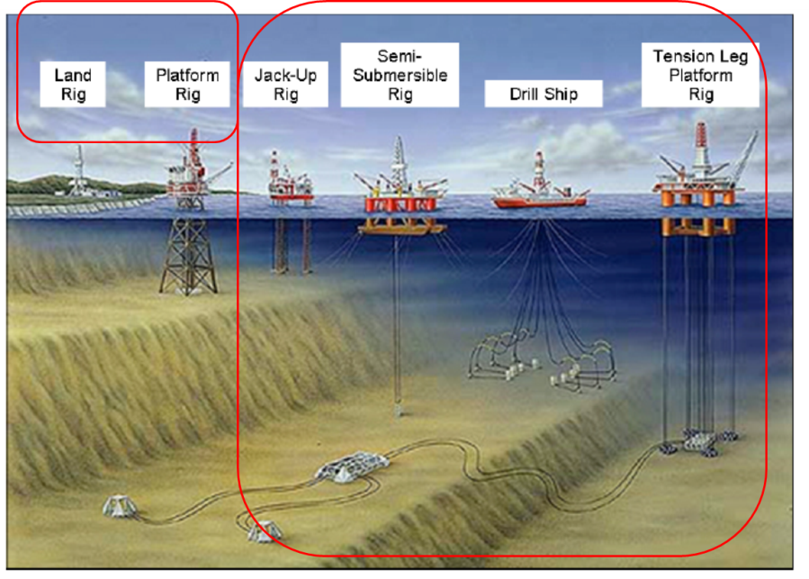
Figure.2-1: Examples of offshore rigs.

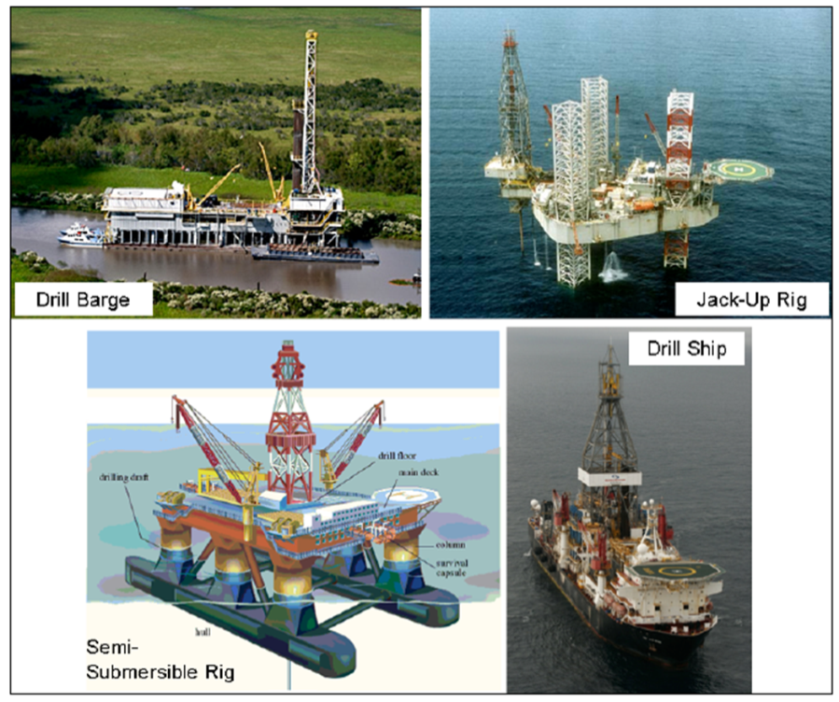
Figure.2-2: Examples of drilling rigs.

2.3. Standard Code Practiced
A subsea tree is basically a stack of valves installed on a subsea wellhead to provide a controllable interface between the well and production facilities. A subsea tree contains various valves used for testing, servicing, regulating, choking the stream of produced oil, gas, and liquids coming up from the well below. The various types of subsea tree are used for either production or water/gas injection. Configurations of subsea tree can be different according to the demands of the various projects and field developments.
In subsea production system such as subsea wellhead, tree, subsea pipeline and riser are normally designed according to the standards and codes practiced as shown Figure.2.2. The wellheads are usually designed according to API 17D (ISO13628-4) and API 6A (ISO10423). The wellhead system suspends the casing and serves as a barrier for well fluids against the environment.

Table.2-1: Standard Code Practiced for Subsea Production System.

2.3. Subsea Well Construction Operations
As drilling progresses, successively smaller and stronger casings are installed if they extend back to surface or liners, rather than casings, if the liner extends back to the previous casing. For drilling from permanent installations and for drilling from a jack-up rig, a conductor pipe is installed and secured to the seabed for circulation of the drilling fluid to remove cuttings. For those applications of the BOP are installed just below the drilling rig. The brief sequences of drilling operation involves as shown in Figure.2-3:
- Drilling a large diameter hole first and
- Running a large diameter conductor casing in open hole and cement casing in place,
- Drilling progressively smaller hole sizes as down-hole pressures increase.

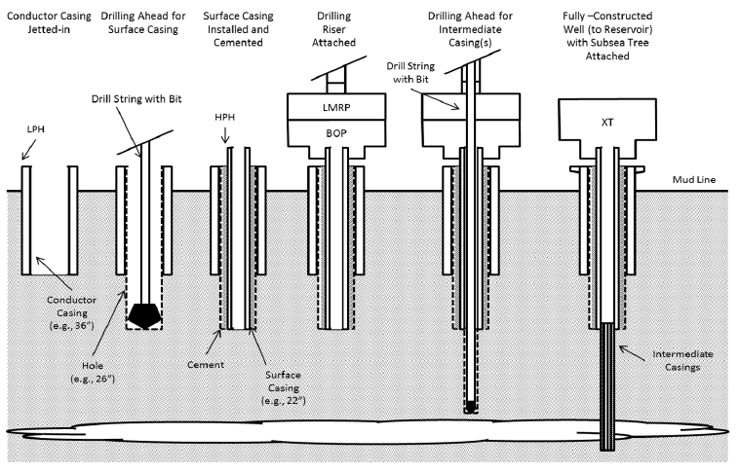
Figure.2-3: Sequences of well drilling using drilling riser operated from MODU [DNV]

2.3.1. Deep Water Well Construction
For deep water operations after drilling the first casing interval, a drilling riser is attached to the wellhead and used to circulate drilling fluid to remove cuttings. The BOPs and riser are installed at the seafloor onto a wellhead system. The wellhead system is run while attached to the first string of casing run inside a large diameter conductor pipe that accommodates the jetting or drilling action.
The first string of casing is usually conducted as “riser-less drilling”, namely, with no riser connection and therefore with fluid and cuttings exhausted to the seafloor. For each drilled interval, the drill bit is rotated either from a surface-located mechanical motor or by a down-hole mud motor.
The hole is drilled into subsurface formations as high-pressure drilling fluid (mud) is pumped down the inside of the drill string to circulate downward and lift the drilling cuttings upward through the casing annulus. Once the drilling fluid and cuttings reach the drilling rig, the cuttings are removed by vibrating shale shakers and the drilling fluid is processed and chemically treated to sustain continuous recirculation. Efficient processing and proper treatment are important because they limit the quantity of drilling fluid required and the volume of waste generated.
Each depth interval of the well is evaluated and designed in the planning stages and re-evaluated for modification during the wellbore construction process. The length of each interval, the drilling fluid density, the drilling assembly, the casing to be run, the type and quantity of cement to be used, the type of drilling fluid used and many other processes are decided based on the anticipated subsurface pressures, equipment limitations, actual wellbore conditions
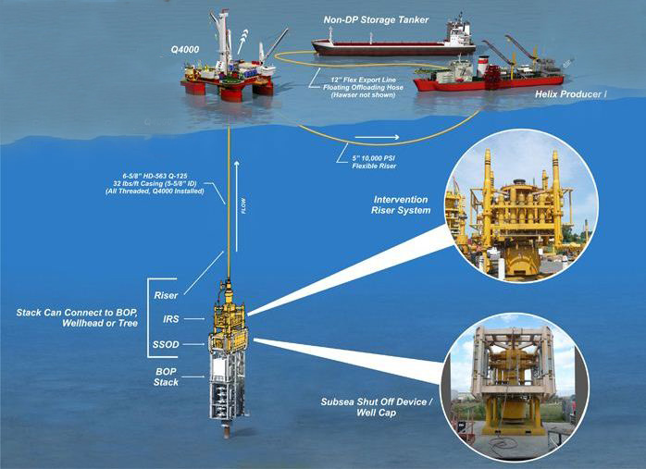
Wellhead
Figure.2-4: An example of deep water drilling rigs [Subsea World News].

2.4. Subsea Well Drilling Specification
The operations and equipment used for subsea well drilling from an offshore production platform are almost identical to those used for a land well. In the subsea well drilling, the conductor is driven into the seabed and then the hole-sections are drilled through the wellhead and BOP equipment, which is similar to that used on land locations. In shallow water, the wellhead and BOP are located on the lower deck of the platform. When the well has been drilled and completed the tree which is also similar to that used on land locations, is mounted on top of the wellhead.
The type of wellhead and BOP equipment used when drilling a subsea well from a mobile drilling rig will be quite different from that used on a platform based operation. The equipment used in this case will depend on whether the operation is being conducted from a floating drilling vessel such as Drill-ship or Semi-Submersible, or from a stable Jack-up drilling vessel. The vessel used will in turn depend largely on whether the well is an exploration or development well, and the water depth in which it is being drilled

2.4.1. Shallow Water
In shallow water, if the water depth is below 135m approximately, the drilling platform is in contact with and fixed to the sea bed. This means that the BOP can be installed at the surface similar as for onshore wells on top of the wellhead system at the level of the platform as shown in Figure.2-5.

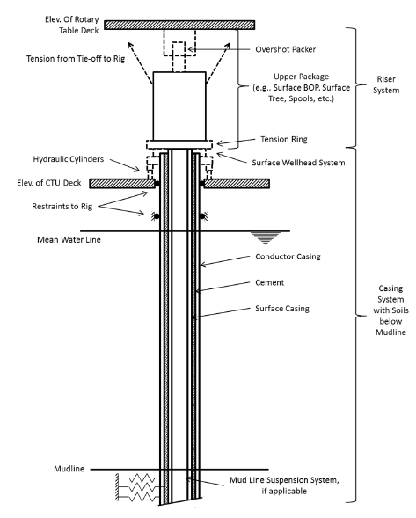  Example of riser for drilling/production operations from a jack-up | 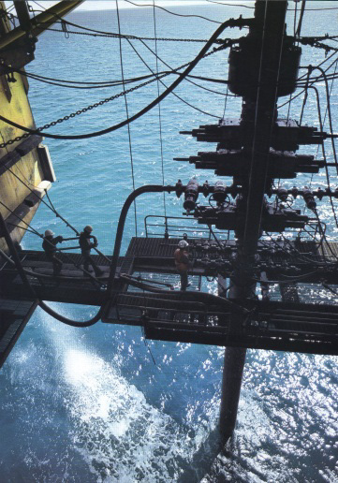  Riser  BOP
Figure.2-5: BOP installed on Jack-up during drilling in shallow water [DNV].

2.4.1.1. Well Drilling from Jack-Up
When drilling from a Jack-up, the drilling operations are very similar to platform-based and land-based operations, with a conductor being driven into the seabed, and conventional wellhead and surface BOP stack equipment being used as shown in Figure.2-5. However, since the Jack-up will have to move off location when the drilling operation is complete the casing strings must be physically supported at the seabed and it must be possible to remotely disconnect the casing strings between the seabed and surface when the operation is complete. The only alternative to this seabed support is to leave a ‘free-standing’ conductor on location, but in most areas this is not a feasible alternative. Seabed support for such wells is provided by a Mud-Line Suspension (MLS) system. The MLS system is a series of full bore housings and hangers run with the casing strings which will be discussed fully later in this section.
When drilling with an MLS system the casing strings are temporarily extended back from the mud-line to surface and the conventional wellhead, then the BOP stack is put on top of these extension strings which are just beneath the rig-floor. The MLS system only provides physical support for the casing strings. All annulus sealing and monitoring functions are provided by the wellhead at surface.
When the well has been drilled it is possible to convert the MLS system into a subsea wellhead, such that the well can be completed subsea, although this is not a typical application of MLS technology. These systems are generally used on development drilling operations, where a platform is to be used for production purposes. The operation is conducted as follows: a Jack-up drilling unit and MLS system is used to drill the wells; the wells are suspended, and the tieback strings removed; the rig is moved away from the location. When the platform is complete it is installed over the location, and the wells are re-entered and re-connected, with extension strings, to the lower deck of the platform. A conventional wellhead and Xmas tree system are installed on top of the extension or tie-back strings. This is known as a ‘pre-drilling’ operation.

2.4.2. Deep Water
In deeper water, the drilling rig should be installed on a floating device such as semi-submersible or drill ship as shown in Figure.2-6. In a storm, because of the bigger waves and the heavier swell, the floating rig should be disconnected from the well. Located at the sea bed, above the subsea wellhead system, the BOP will stay connected to the well ensuring the well’s safety and security.
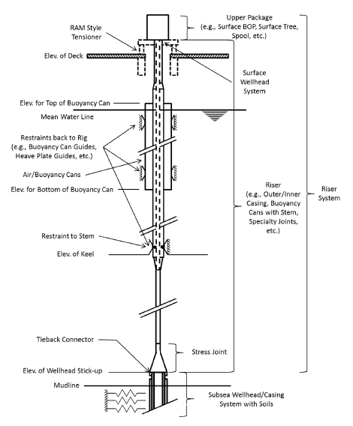  Example of riser for drilling/production operations from a Spar | 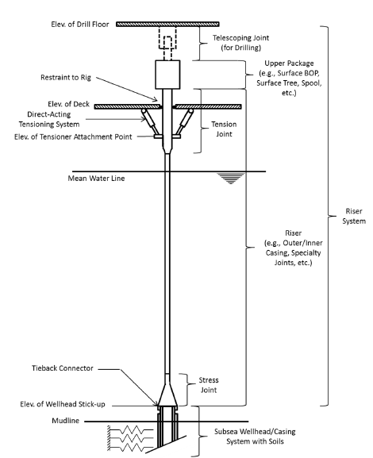  Example of riser for drilling/production operations from a TLP

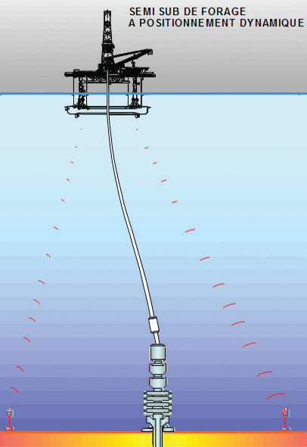
Riser
Connection
Flexible joint
BOP
Wellhead
Conductor Pipe
Acoustic beacon

Figure.2-6: BOP on top wellhead at seabed during drilling in deep water.

2.4.1.1. Well Drilling from Drill-ship or Semi-Submersible
When drilling from a floating vessel such as Drill-ship or Semi-Submersible as shown in Figure.2-7, there is always the possibility that, at some point during the drilling operation, the vessel will have to disconnect from the well or even move off location due to bad weather. The wellhead and all other BOP equipment are therefore situated on the seabed, with the drilling fluids being circulated back to the drilling vessel via a marine riser. The BOP stack on the seabed is the primary well control device in the event of a kick. A hydraulic latch between the marine riser and the BOP stack ensures that it is possible to close in the well, disconnect the marine riser from the top of the BOP stack and move the rig off location safely at any stage during the drilling operation. When the well has been drilled it is either suspended, for later completion, or it may be completed immediately, and a subsea tree installed on the wellhead. It is assumed that the well is to be completed immediately after the drilling operations are complete.
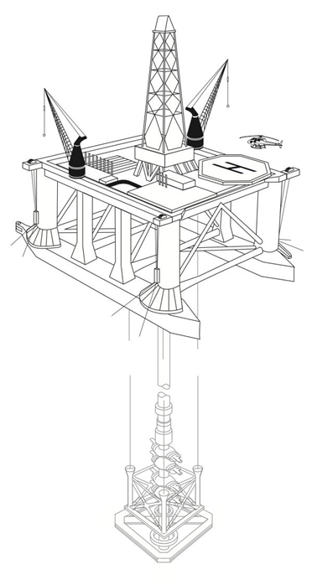 | 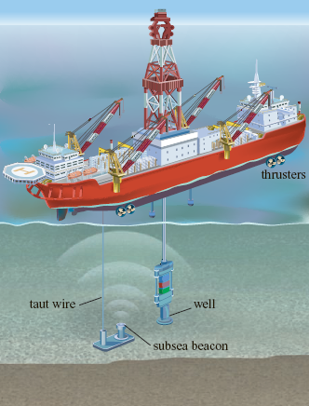
Figure.2-7: Semi-Submersible and drill ship drilling rig.

2.5. North Sea’s Well Drilling
This section takes a case study on subsea well drilling in North Sea Operation. The outline the operations and equipment used when drilling and completing a well from a floating vessel using a subsea wellhead system are described. A description of the operations involved in drilling from a Jack-up, using an MLS system. In this study, the casing scheme used as the basis for discussion in this section will be: 30-in, 18⅝-in, 13⅜-in, 9⅝-in and 7-in. It is worth noting that all manufacturers use the same basic principles, although there are certain differences in the design and operation of some components.

2.5.1. Positioning the Rig
The drilling location is generally indicated by a survey vessel, using a marker buoy, prior to the arrival of the drilling vessel. The rig is towed onto the location, and anchor-handling tugs are used to drop the anchors in a prescribed pattern. The anchors are tensioned to ensure that they are securely set into the seabed, then slacked off and adjusted to obtain the final position and heading of the rig.
This whole operation may take a few hours or a few days, depending on weather conditions. The drilling rig may be held in position over the well by using anchors, or by using dynamic positioning techniques. If anchors are used, great care must be taken to ensure that the anchors do not damage seabed pipelines.
The condition of the seabed directly beneath the rig will generally have been checked by a seabed survey before the rig arrives on location, but a final check is generally made with a Remotely Operated Vehicle (ROV) prior to running the equipment.

2.5.2. Running the Drilling Guide Base
The first stage in the drilling operation is to establish an anchor point on the seabed for the 4 guidelines (¾-in or ⅞-in diameter wire) which are used to guide drilling tools and casing from the rig to the seabed as shown in Figure.2-8. The drilling guide base is discussed in the section.4.3. The guidelines are attached to a Drilling or Temporary Guide Base (D/TGB), which is the first piece of equipment to be lowered to the seabed. The guidelines are attached to the base at a 6ft radius from the center, and are kept in tension.
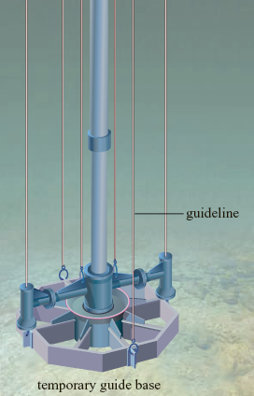 | 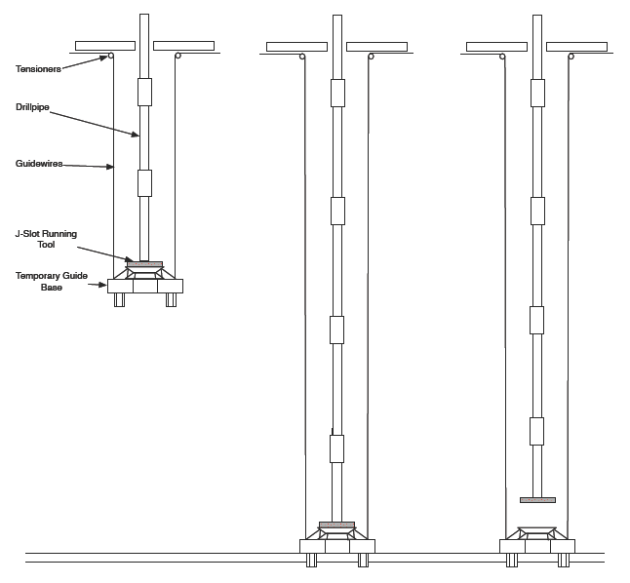

Figure.2-8: Running the temporary guide base.

The TGB is initially positioned in the ‘moon-pool’ of the rig. Then a special running tool, run on drill-pipe, is latched into the base. The running tool has 4 pins which engage J-slots on an internal profile. Sacks of barite, cement or similar, are loaded onto the base to increase its weight to some 25000-lbs – 30000-lbs and it is lowered to the seabed on drill-pipe. When the TGB has landed on the seabed the running tool is unlatched by rotating the drill-pipe by ⅛ of a turn to the right. The running tool and drill-pipe can then be retrieved. A level indicator (bull’s eye) on the TGB indicates whether or not the structure is lying in a horizontal position on the seabed. If the TGB is level the tension on each guideline is then adjusted to about 2000 lbs.

2.5.3. Drilling the 36" Hole
A 36-in hole is then drilled to a typical depth of 100-ft – 200-ft below the seabed. The bit is guided down through the TGB by means of a Utility Guide Frame (UGF) fixed around the drill-pipe just above the bit, and attached to the guide wires as shown in Figure.2-9. Once the bit has been guided through the TGB, and the first 30-ft of hole has been drilled, the UGF is pulled back to surface.
The 36-in hole may be drilled using an 18½-in bit and 36-in hole-opener or a pilot hole may be drilled and opened out to 36-in diameter on a second run. The hole is normally drilled with sea water, with the drilled cuttings simply settling onto the seabed without riser or BOP is installed at this stage. Having drilled to the required depth the hole is displaced to mud to prevent debris from settling onto the bottom of the hole when running the 30" casing.
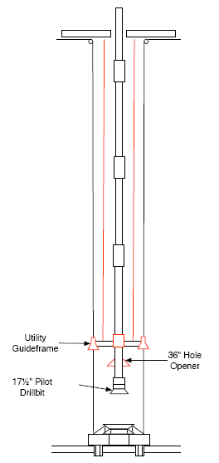 | 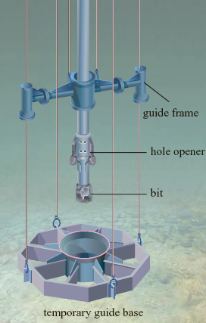

Figure.2-9: Running the drill-bit to drill the 36-in hole.

2.5.4. Running & Cementing the 30-in Casing
The 30-in casing and Casing Head Housing (CHH), is run to the seabed with the Permanent Guide Base (PGB) as shown in Figure.2-10. The PGB provides precise alignment for the BOP stack, and subsequently Xmas tree, over the Wellhead. The four guideposts are 12-ft high, and spaced at a 6-ft radius around the center of the base. A machined profile on the inside of the central slot provides support for the 30-in Wellhead housing, and allows it to be locked in place. The PGB rests on the TGB.
The PGB is positioned in the moon-pool of the rig, and the guidelines are inserted into the guide posts. The 30-in casing is run from the rig floor through the PGB. The top joint of casing, with the 30-in Casing Head Housing welded to it, is lowered through the rotary table, landed on the PGB, and locked in place. The 30-in Casing Head Housing supports the weight of the 30-in casing, locks the 30-in casing into the PGB, and provides an internal profile onto which the 18¾-in high pressure wellhead housing will land.
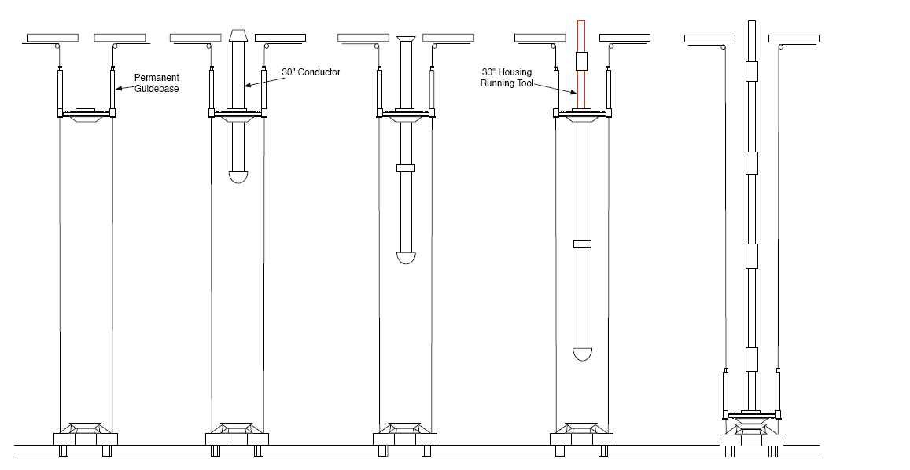
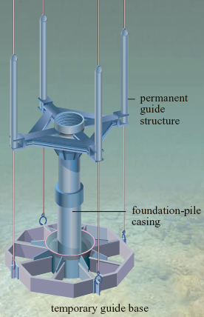

Figure.2-10: Running the 30-in casing and PGB.

Drill-pipe for cementing the casing is run down inside the casing and the wellhead, and made up to the underside of the 30-in running tool. The 30-in running tool is made up to the 30-in casing housing. The running tools can be cam or rotation operated. They have drill-pipe thread preparations on their upper and lower end. The upper connection is to allow the tool to be run on drill-pipe, and the lower is for suspending a cement stinger inside the casing. An O-ring on the outside of the running tool seals against a polished surface on the inside of the CHH preventing circulation up the annulus between the cement stinger and 30-in casing.
The 30-in running tool is then locked into the 30-in casing and the casing string, and PGB can be picked up as a single unit and run down until the PGB ‘lands’ on the TGB. The ‘gimbal’ on the underside of the PGB rests on the funnel of the TGB to give vertical alignment (checked with an ROV viewing a bull’s-eye indicator on the PGB). The casing is cemented by circulating cement down the drill pipe and out through the casing shoe until cement returns are observed, on a TV camera, to be coming up between the TGB and the PGB, and spilling onto the seabed. The volume of cement used is generally 100% in excess of the gauge hole annular volume. The cement is then displaced to just above the shoe, the running tool released from the 30-in housing, and the tool and drill pipe retrieved. The 30-in casing is a major load bearing element in the wellhead system and it is essential that the 30-in casing is cemented all the way up to the seabed. If cement is not observed at the seabed a ‘top-up’ cementation, via a stinger through the PGB, will generally be performed.
Although many companies do use them as standard it is not always necessary to use a TGB. Indeed in soft conditions the TGB may sink into the seabed, or settle unevenly. It is possible to drill the 36-in hole, and run the 30-in casing, without the use of a TGB. In this case the guidelines are attached to the guideposts of the PGB. Before cementing the 30-in casing however, it is important to check that the slope of the PGB is less than 1 (otherwise the BOP stack may not latch properly).
In the case of a very soft seabed the 30-in casing can be ‘jetted’ into position. A jetting bit with a stabilizer on drill pipe is run down inside the 30-in casing and suspended from the casing running tool. The jetting bit should be spaced out such that it lies about 2-ft from the open-ended shoe joint. The 30-in housing is locked onto the PGB and the running tool made up as before. The whole assembly is then lowered to the seabed. Sea water is pumped through the jetting assembly to wash away the formation (holes in the running tool allow the water to escape from the drill-pipe/casing annulus and spill onto the seabed). The casing is lowered slowly, as jetting continues, until the PGB is a few feet from the mud-line. The jetting is stopped, the running tool released, and the drill-pipe is retrieved.

2.5.5. Installation of the Diverter
The 26-in hole will generally be drilled with seawater to 1000-2000 ft. In most cases this hole section is drilled without circulation back to the rig and in this case the drilled cuttings are again deposited on the seabed. If however, the drill bit encounters an unexpected gas pocket (shallow gas) there will be no blowout protection in place. For exploration wells therefore, a riser and diverter system is normally installed prior to commencing the 26-in hole. The riser and diverter system is comprised of 4 basic pieces of equipment as shown in Figure.2-11:
- A hydraulic latch to provide a sealed interface between the 30-in casing housing and the riser.
- A flexible joint to allow some deflection of the riser (about 10°).
- A marine riser to provide a conduit for returns to the rig.
- A flow diverter to safely vent oﬀ any gas that may be encountered.
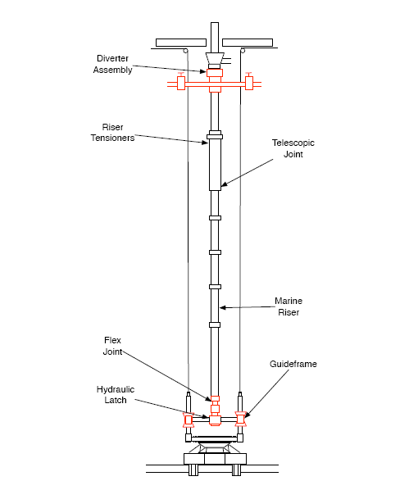
Figure.2-11: Installing the diverter.

2.5.6. Drilling the 26-in Hole
Due to I.D. restrictions of the hydraulic latch and riser, a 26-in bit cannot be run through a diverter system. The 26-in hole is therefore drilled by first drilling a small diameter (12¼-in) pilot hole, logging the open formations, removing the diverter assembly, then opening out to 26-in diameter. The logging operation is performed to ensure that there are no open hydrocarbon bearing sands in the pilot hole section, prior to removal of the diverter assembly. Alternatively the 26-in hole is drilled by drilling a small diameter (12¼-in) pilot hole, logging and then running an under-reamer down through the diverter assembly to open the hole out to 26-in. The diverter assembling has to be removed before running the 18⅝-in casing.

2.5.7. Running & Cementing the 18⅝-in Casing
Having drilled the 26-in hole the diverter, riser and hydraulic latch are recovered and laid down. The required length of 18⅝-in casing string is made up. A 18¾-in high pressure wellhead housing (with a wear bushing installed) is made up onto the top of the casing. The 18¾-in Wellhead housing is the high pressure housing onto which the BOP and subsequently tree will latch and seal. Typically 13⅜-in, 9⅝-in and 7-in casing hangers will be landed and seal inside this high pressure housing.
As before, a drill pipe cementing stringer, attached to the underside of the running tool, is run down inside the casing. The running tool is then made up (with left drill-pipe hand rotation) into the 18¾-in housing as shown in Figure.2-12. The entire assembling is lowered on drill pipe until the 18¾-in housing lands and locks in place in the 30-in housing on the seabed. The casing annulus is circulated and cemented. The running tool is rotated a few turns to the right for release, and the drill pipe and tool are recovered.
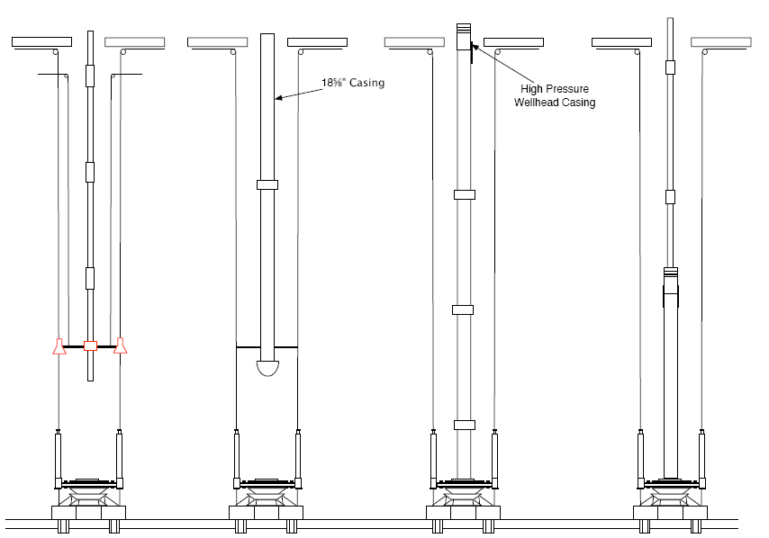
Figure.2-12: Running the surface casing and High Pressure Well Head Housing (HPWHH).

2.5.8. Installing the BOP
Since the 17½-in hole section will be drilled to considerable depth, a subsea BOP stack and marine riser will generally be required at this stage in the operation. The most common subsea BOP stack configuration used in North Sea operations is the 18¾-in 10,000 psi single stack system shown in the Figure.3.16.

2.5.9. Drilling the 17½-in Hole
The 17½-in bit and Bottom Hole Assembly (BHA) are run and the 17½-in hole-section is drilled and taking mud returns to surface. The BHA is a component of a drilling rig which is the lowest part of the drill string, extending from the bit to the drill pipe. The BHA can consist of drill collars, subs such as stabilizers, reamers, shocks, hole-openers, and the bit sub and bit. When the casing point has been reached the hole is circulated clean, and the drilling assembly recovered in preparation for running the 13⅜-in casing.

2.5.10. Running & Cementing the 13⅜-in Casing
The wear bushing sitting inside the 18¾-in housing is removed. The 13⅜-in casing is run into the hole through the BOP stack and riser assembly. The 13⅜-in casing hanger is run together with a seal assembly (or pack-off) which is used to seal off the 18⅝-in x 13⅜-in annulus after the cement job is complete. The entire assembly is run in hole on a casing hanger running tool and casing or drill-pipe. The system is designed such that the casing can be run, landed, cemented and the seal assembly energized, all in one trip.
Having landed the casing hanger in the 18¾-in housing the cement is pumped and displaced down the running string. The running string may be either casing joints, extending back to the rig, or drill pipe. In the case of drill-pipe a special cement plug retainer is connected to the underside of the casing hanger running tool, and the cement operation is conducted in a similar fashion to a liner cementation. At the end of the cement job the running string is rotated to the right. This releases the running tool, while simultaneously energizing the pack-off assembly on the outside of the hanger. When the pack-off is set it can be pressure tested, and then the running tool can be picked up and pulled back to surface. Since the casing is an integral part of the BOP system it is vital that the annulus between successive casings is properly sealed off. It is good practice to flush the wellhead area prior to pulling the running string back to the surface. A wear bushing is installed above the 13⅜-in hanger to protect the sealing surfaces during the next drilling phase.

2.5.11. Drilling the 12¼-in Hole
The 12¼-in bit and BHA are made up and run to just above the cement inside the 13⅜-in casing. Prior to drilling out of the shoe the casing is pressure tested. To ensure that it is safe to drill ahead, a leak-off test is performed immediately after drilling out of the casing shoe. The next section of hole (12¼-in) is drilled to the required depth, cleaned out, and the 9⅝-in casing is run and cemented. Exactly the same procedures are used for the 9⅝-in casing, as for the 13⅜-in casing string. If necessary, well drilling can be continued to deeper by drilling an 8½-in hole and running and cementing 7-in casing. The 3 hanger system (13⅜-in, 9⅝-in, 7-in) is the most common, but in certain parts of the world 4 hanger systems (16-in, 13⅜-in, 9⅝-in, 7-in) are necessary.

2.5.12. Preparing the Well for Completion
The well is now ready for completion, and as stated in the introduction it is assumed that the well is to be completed immediately after the drilling operations are complete. At this stage, there are a number of alternative ways in which the operation may proceed. These routes are dependent on the way in which the well is to be perforated and cleaned up.
The well may be perforated with casing guns prior to the running of the tubing, it may be perforated with tubing conveyed perforating guns run on the tubing, or it may be perforated with through tubing perforators after the well has been completed. The advantages and disadvantages of each of these scenarios are discussed widely in textbooks relating to completion operations, and will not be discussed here. It will be assumed that the casing is to be perforated with tubing guns, after the completion has been installed.
The production casing must be cleaned up, and the drilling fluid displaced to brine, after the drilling operation is complete, and before any production tubing is run in the hole. A casing scraper is run on drill-pipe, to the bottom of the production string, and a series of viscous pills, followed by brine, are circulated until the drilling fluid has been completely displaced to clean brine.

Chapter.3

3.0 Blowout Preventer

3.1 BOP Work Drilling Rigs
During drilling, the pipe is required to be closed, however it cannot use a valve since most of the time the drill string is inside the well. During normal operations the fluid is pumped through the drill pipe. The fluid returns from the annulus between the drill pipe and the casing along with the drilled cuttings. The hydrocarbon influx firstly will displace the column of mud inside the well. They will choose the easiest path to come up. The hydrocarbon influx will naturally come up through the larger cross section of the annulus than through the small nozzles of the drill bit. Thus, a blowout preventer (BOP) is required to close around the drill pipe and isolate the annulus.
The BOP is a large and specialized valve usually installed redundantly in stacks which is used to seal, to control and to monitor oil and gas wells. The BOP is installed during drilling which is located between the wellhead system and the drill floor as shown in Figure.3-1. The annular always sits on top of the BOP stack, but the ram is bottom of the BOP stack.

Drill Pipes

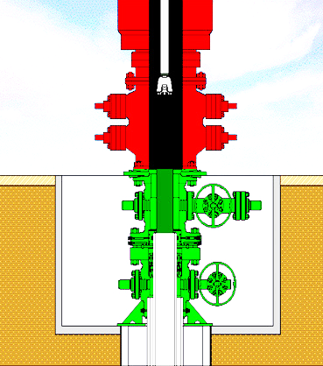
Ram
Annulus
BOP
Wellhead
Well at surface

Figure.3-1: Ram and Annular BOP on top of wellhead [onshore].

The BOP is used to seal, control and monitor the well in case of blowout. The BOP is developed to cope with extreme erratic pressures and uncontrolled flow or formation kick emanating from a subsea well reservoir during drilling. Early warning signs of a subsea well kick are as follows:
- Sudden change in drilling rate;
- Change in surface fluid rate;
- Change in pump pressure;
- Reduction in drill pipe weight;
- Surface mud cut by gas, oil or water;
- Connection gases, high background gas units, and high bottoms up gas units in the mud logging unit
In conjunction with other equipment and techniques, the BOP is used to close the well in and to allow the crew to control a kick before it becomes a blowout. The BOP should be designed to:
- Close the top of the hole.
- Control the release of fluids.
- Permit pumping into the hole.
- Allow movement of the inner string of pipe
These requirements mean that as follows:
- There must be enough casing in the well to provide an anchor for the wellhead equipment,
- There must be provision for equipment to close the hole with or without pipe in well,
- The equipment must provide for the attachment of lines for bleeding off pressure
- It must allow pumping into the working string or annulus
The recommended component codes for designation of BOP stack arrangements are as follows:
- Rotating head ($G$),
- Annular type BOP ($A$),
- Single ram type BOP with one set of rams, either blank or for pipe as operators prefers ($R$),
- Double ram type BOP with two sets of rams, positioned in accordance with operator’s choice ($R_{d}$),
- Triple ram type BOP with three sets of rams, positioned in accordance with operator’s choice ($R_{t}$),
- Drilling spool with side outlet connection for choke and kill line ($S$) and 1000 psi rated working pressure ($K$).

3.2. BOP Stack Principle
A BOP stack installation could consist of both annular BOP working as preventer on the top of the stack and ram BOP on the bottom of the stack as backup as shown in Figure.3-2. Working preventer is always positioned far from the source of danger, to be in position to change it if fails.
In order to control a blowout the BOP stack is fitted with hydraulic lines which is kill line valve and a choke line valve. The choke line valve is used to redirect the mud from the well bore to the choke manifold during a kick and to evacuate the lighter fluid from the well. The kill line valve is used to direct drilling fluid to the BOP during a kick and to pump a heavier drilling fluid in the well.
The service pressure of the BOP is chosen to support the maximum pressure encountered during drilling operations. The pressure range is usually from 5000 psi to 15000 psi (345 bar to 1035 bar approximately).

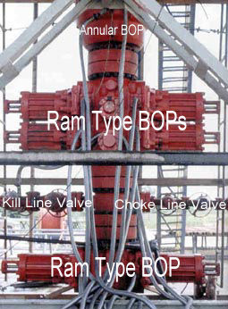
Figure.3-2: Typical layout of a BOP.

Any assembly of blowout prevention equipment can be rated by the lowest pressure item in the hookup; whether it is casing, casing head, preventers or other fittings primarily exposed to well pressure.
The bursting pressure of the casing will often be the determining factor for rating the working pressure of the assembly. API Bulletin D 13 gives the pressure ratings for blowout preventer equipment, as shown in Table.3-1.

Table.3-1: Catalogue of pressure ratings for BOP [API]
API Class | Working pressure 10⁵ Pa (psi) | Service Condition
2 M | 138 (2000) | light duty
3 M | 207 (3000) | low pressure
5 M | 345 (5000) | Medium pressure
10 M | 689 (10000) | high pressure
15 M | 1034 (15000) | Extreme pressure

3.3. BOP Activation
The BOP allows the subsea well to be controlled at any time. It is usually installed redundantly in BOP stacks. The BOP comes in four basic types in drilling rig as shown in Figure.3-3. The rams and annular BOP are often used together in drilling rig BOP stacks, typically with at least one annular BOP capping a stack of several ram BOP.

Figure.3-3: Typical types of a BOP.

3.2.1. Ram BOP
A ram BOP is similar in operation to a gate valve, but uses a pair of opposing steel plungers, rams as shown in Figure.3-4. The rams extend toward the center of the wellbore to restrict flow or retract open in order to permit flow. The rams can close the well with the drill-pipe inside the well. In an emergency shear, the rams can be used to cut the pipe inside the well if necessary.
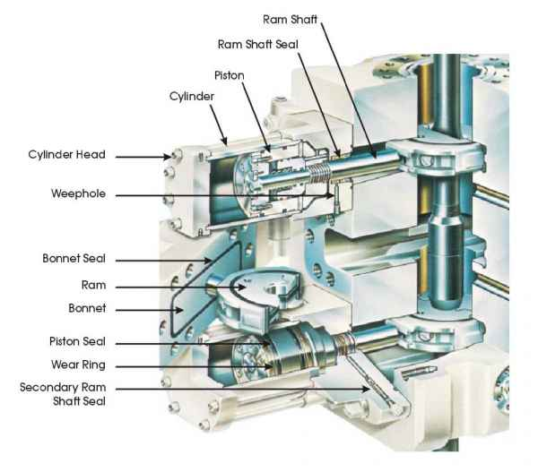
Figure.3-4: Part description ram-type BOP.

The inner and top faces of the rams are fitted with packers (elastomeric seals) that press against each other, against the wellbore, and around tubing running through the wellbore. Typically, the rams are categorized into three types as shown in Figure.3-5. All the Rams are hydraulically activated. During drilling operations the closure of the well with the BOP can be manually or automatically activated.

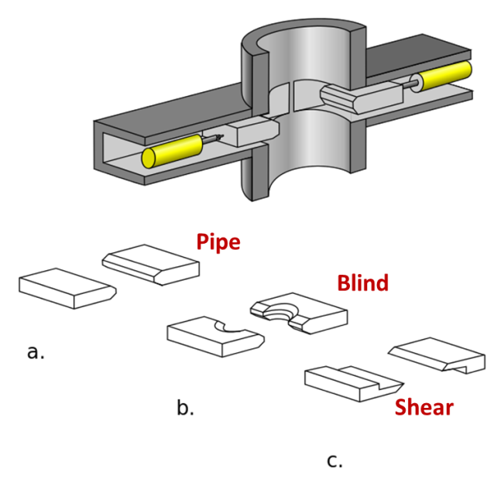
Figure.3-5: Typical types of Ram’s BOP.

3.2.1.1. Pipe Rams
Pipe rams close around a drill pipe, restricting flow in the annulus between the outside of the drill pipe and the wellbore but the pipe rams do not obstruct flow within the drill pipe. Variable-bore pipe rams can accommodate tubing in a wider range of outside diameters than standard pipe rams, but typically with some loss of pressure capacity and longevity. Pipe rams are provided with semicircular openings which match the diameter of the pipe sizes for which they are designed as shown in Figure.3-6.
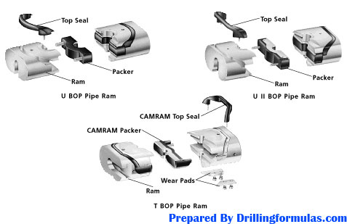
Figure.3-6: Typical pipe ram BOP.

It is absolutely vital that the pipe rams in a preventer fit the drill pipe or tubing in the use, and all concerned must be certain in this regard at all times.
If more than one size of drill pipe is in the hole, most operators require a second ram preventer in the stack.

3.2.1.2. Blind Rams
Blind rams is also known as sealing rams which have no openings for tubing as shown in Figure.3-7. The blinds rams can close off the well when the well does not contain a drill string or other tubing, and seal it. Blind rams can also be used as drill pipe cutters. The use of blind rams for such purposes is acceptable only when there is the treat of open blowout, and nothing else can be done
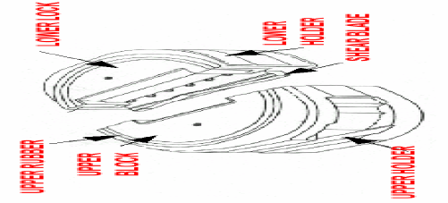
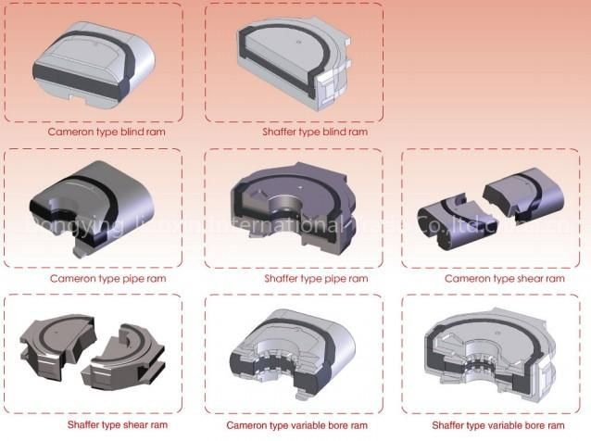
Figure.3-7: Typical blind rams BOP.

3.2.1.3. Shear Rams
Shear rams cut through the drill string or casing with hardened steel shears as shown in Figure.3-8.
Figure.3-8: Typical shear rams BOP.

3.2.1.4. Blind Shear Rams
Blind shear rams is also known as shear seal rams or sealing shear rams which are intended to seal a wellbore, even when the bore is occupied by a drill string, by cutting through the drill string as the rams close off the well. The upper portion of the severed drill string is freed from the ram, while the lower portion may be crimped and the “fish tail” captured to hang the drill string off the BOP. Figure 3-9 shows an example of blind shear ram.

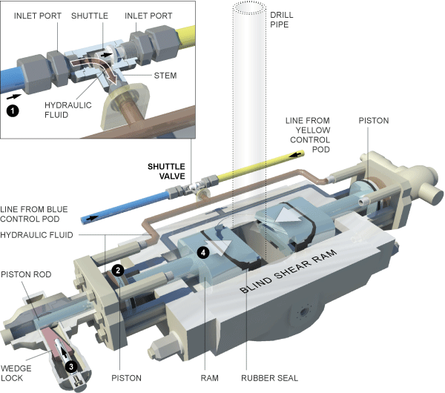
Figure.3-9: Typical blind-shear rams BOP.

3.2.1.5. Variable Bore Rams
Figure 3-10 shows an example of variable bore rams.
Figure.3-10: Typical variable-bore rams BOP.

3.2.2. Annular BOP
An annular BOP can close around the drill string and casing. The annular Bop can be categorized into two types: wedge-faced and spherical as shown in Figure.3-11. The annular BOP closes around any pipe diameter and can even close the well fully without any pipe being in the hole. Drill pipe including the larger-diameter tool joints can be stripped through an annular preventer by careful control of the hydraulic closing pressure.
The annular BOP is also effective at maintaining a seal around the drill pipe even as it rotates during drilling. Regulations typically require that an annular preventer be able to completely close a wellbore, but the annular BOP is generally not as effective as ram preventers in maintaining a seal on an open hole.

Figure.3-11: Two typical types of Annulus’ BOP.

3.2.2.1. Wedge-Faced BOP
The original type of annular blowout preventer uses a “wedge-faced or conical-faced” piston as shown in Figure.3-12. As the piston rises, vertical movement of the packing unit is restricted by the head and the sloped face of the piston squeezes the packing unit inward, toward the center of the wellbore as shown in Figure.3-12 (b). Diagram of the annular BOP is in open and fully closed configurations. The flexible annulus in blue is forced into the drill pipe cavity by the hydraulic pistons.
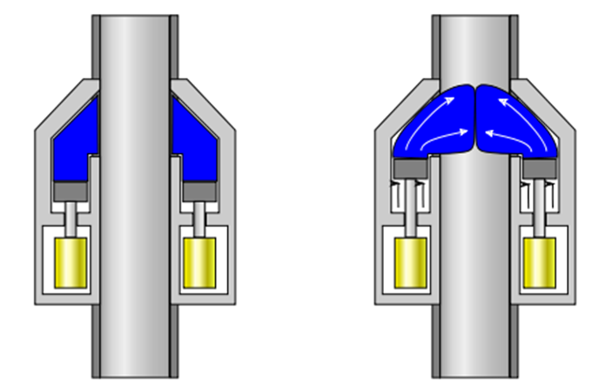
Drill
Pipes
Drill
Pipes
Flexible
Annulus
Piston
(b)
(a)
Figure.3-12: Diagram of the wedge-faced BOP.

3.2.2.2. Spherical BOP
A spherical BOP consists of five major parts as follows: the upper housing, the lower housing, the sealing element, an adapter ring and a piston. The spherical BOP can close the well at different devices such as the drill string as shown in Figure.3-13. The packing element is subject to wear and tear whereas the rest is pretty though and handles up to 5000 psi.
The spherical BOP model in smaller sizes or with lower working pressure has bolted covers. Those in larger sizes or with higher working pressures have wedge covers. In bolted cover models, the upper housing fastens to the lower housing with studs and nuts. Wedge cover models fasten with locking segments and a locking ring.

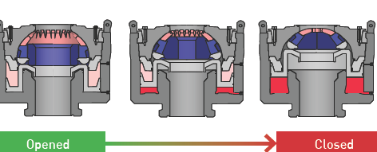
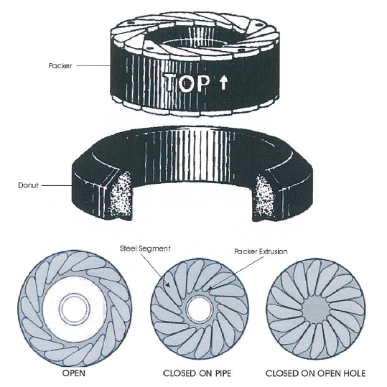
Figure.3-13: Diagram of spherical BOP.

3.2.3. Rotational BOP
Rotational BOP is always positioned at the top of the stack above annular preventer. It is used when differential pressure at the wellhead does not exceed 34,5x105 Pa (500 PSI), and in such situation it must enable manipulation (withdrawing and embedding) and rotation of drill stem through the closed working (sealing) element.
Rotational part of the rotational BOP is mounted on the drill pipe by use of unique prong, and is posted on the working floor. When it is required, the rotational head is connected to the housing, mounted on the top of annular preventer. Rotational sleeve is rotated by the rotation of the Kelly as shown in Figure.3-14, and it is at the same time rotating the working rubber element on the cylindrical bearing.
The rotational BOP is used under several conditions as follows:
- Drilling in layers that are suspected to cause possible kick off.
- When drilling on the balance or under balanced (drilling the rocks of great permeability or porosity; to avoid pollution with mud).
- When using indirect circulation.
- When the drilling is done using air or gas.
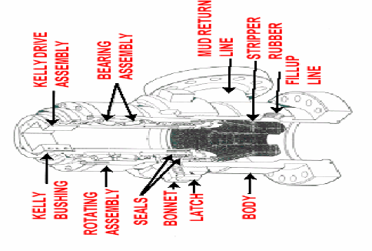
Figure.3.14: Typical Rotational BOP.

3.2.4. Diverters BOP
Diverters as the name says are used to, direct eventual invaded higher pressure fluid from the well, to the cleaning and reservoir system and not to danger the workers on the working platform of the derrick as shown in Figure.3-15. That is accomplished by closing the working sealing element of the diverter and opening diverter pipe lines whose diameter is from 101,6 mm (4-in) to 304,8 mm (12-in).
There are usually two relief lines, and one that is opened must be always in the direction that provide that gas or dangerous fluid will be carried away of the rig floor.
The line is opened at the same moment the working sealing element is closed. It is important because failing to do so it is possible to fracture shallow rocks and the gas or high pressure fluid can rupture to the surface near or far from the rig uncontrolled. That is especially dangerous offshore when using the platform that is standing on the see-bottom on the legs, because the material can be washed over below one leg, and the platform can turn over.
Diverters are mainly used in offshore drilling. Onshore they are rare in use: mainly in drilling for the conductor when the well is to be with total depth over 6000 m. That is because there is no other preventer that will enable the passage of the bit of 660.4 mm (26-in) diameter, that is used to drill the hole for casing with diameter of 508 mm (20-in).
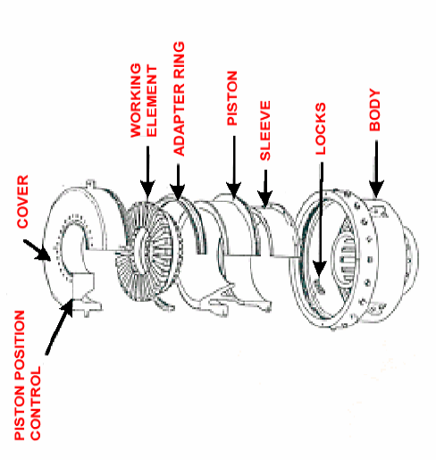
Figure.3-15: Typical Diverters BOP.

3.5. BOP in North Sea Operation
The most common subsea BOP stack configuration used in North Sea operations is the 18¾-in 10,000 psi single stack system as shown in the Figure.3-16. The BOP stack is comprised of the following components:
- A hydraulic connector which latches onto and seals on the 18¾-in wellhead housing.
- A set of four rams and an annular preventer.
- A ‘Lower Marine Riser Package’ (LMRP) comprising of a hydraulic connector which latches onto the top of the BOP stack (allowing the LMRP to be disconnected from the BOP stack and retrieved on the riser if the rig has to move oﬀ location for any reason), a second annular preventer, and a flexible joint which allows up to 10° of deflection of the marine riser.
- A marine riser equipped with integral choke and kill lines.
- A telescopic joint at surface to accommodate the heave of the rig whilst the marine riser is maintained in constant tension with a heave compensation device.
The BOP stack, LMRP, riser and choke and kill lines are run in one operation. Once the BOP stack is landed and latched onto the 18¾-in housing the required tension is set on the marine riser tensioners and the flow line is hooked up. The BOP stack is then pressure tested.
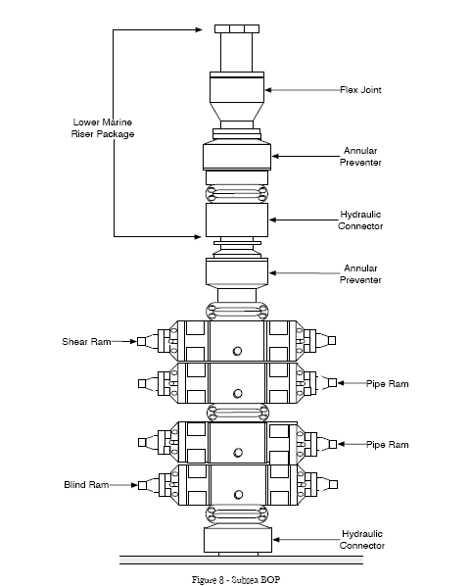
Figure.3-16: Typical subsea BOP used in North Sea Operation.

3.5. Control Methods
Typical well control system which consists of BOP, electric driller panel, choke control panel, mud pump, an accumulator or pump lift and etc. as shown in Figure.3-17. Location of BOP and wellhead differs for shallow water and deep water.

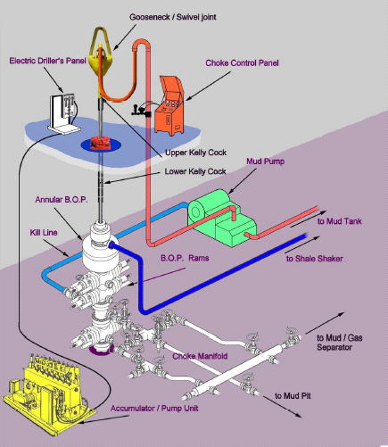
Figure.3-17: Common typical well control system.

3.5.1. Shallow Water
When wells are drilled on land or in very shallow water where the wellhead is above the water line which is called surface wellheads. BOPs are activated by hydraulic pressure from a remote accumulator. Several control stations will be mounted around the rig. They also can be closed manually by turning large wheel-like handles.

3.5.2. Deep Water
In deeper offshore operations with the wellhead just above the mud-line on the sea floor as called as subsea wellheads. There are four primary ways by which a BOP can be controlled. The possible means are:
- Electrical Control Signal: The information is sent from the surface through a control cable.
- Acoustical Control Signal: The information is sent from the surface based on a modulated/encoded pulse of sound transmitted by an underwater transducer.
- ROV Intervention: A Remotely Operated Vehicle (ROV) mechanically controls valves and provides hydraulic pressure to the stack via “hot stab” panels.
- Dead-man Switch or Auto Shear: This is fail-safe activation of selected BOPs during an emergency, and if the control, power and hydraulic lines have been severed.

Chapter.4

4.0 Subsea Wellhead

4.1. Wellhead Casing Design
For subsea wellhead system design, it is imperative to consider casing growth, which will affect the wellhead load intensively. Generally, the casing will connect with a tubing hunger with a screw thread on the top and be fixed with cement. It is a comparatively simple structure. The most important parameters for casing design are wall thickness and length. Based on guaranteeing the intensity and reliability, there is a growing need to consider conservative materials and resources with the increase in operating costs and withstand the cyclic swing of oil prices. Subsea oil development is not significant to survival when oil prices are very low.
There are many typical casing design examples. Figures.4-1 is a typical wellhead casing schemes used in North Sea. As the oil explorations move into deep-water drilling of high-pressure and high-temperature wells, it has become more and more popular and necessary to increase the scope of the optimization by encompassing more design parameters into the analysis. Consequently, numerous variables can be taken into account within the design spectrum. However, usually it is imperative to integrate all of the subsea components in the analysis of the casing design, which we will elaborate on in wellhead reliability analysis section.
Normally, a lot of different design parameters are proposed under the same conditions. To counter this problem, a dimensionless parameter called the Wellhead Growth Index has been developed, which greatly aids the ability to determine the severity of the design and a means of describing the severity of wellhead growth, without sacrificing any rigor. WHI encapsulates the annuli fluid expansion and wellhead growth and it provides a simple practical way to view the casing movement and fluid expansion in the annuli during the course of drilling and also during the production phase of the well. It is defined as the ratio of the annulus fluid expansion of the casing to the actual volume of the exposed segment above the top of the cement [G.R. Samuel].

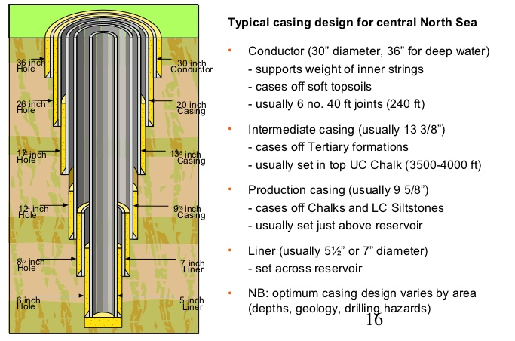
Figure 4-1: Wellhead casing design for North Sea Operation.

The annulus fluid expansion includes the unconstrained volume change and the annulus volume change due to annulus pressures. Wellhead growth gives an estimate of the circumferential and axial strain on the casings. With the circumferential and lateral strain, the total volume of the expansion of all casing string for all casing segments is given by:

$∆v=\sum_{j=1}^{m}{\sum_{i=1}^{n}{{\left[\frac{π}{4}\left(2 d ∆d l+d^{2} ∆l\right)+v_{a}\right]}_{i,j}}}$ (4-1)

The total area of the annulus cross section for each casing string is given by

$a={\left.\sum{\sum{\frac{π}{4}} D^{2}}\right|}_{i,j}$ (4-2)

Where; $d$ is casing diameter (in), $D$ is annulus gap between the casings (in), $l$ is segment length of the exposed casing (ft), $n$ is number of exposed casing sections, $m$ is number of casings, $v$ is annulus volume (ft³), $v_{2}$ is volumetric change due to annulus pressures, $∆d$ is change in the casing diameter (in), $∆l$ is wellhead growth (in) $∆v$ is change in the annulus volume (ft³) and WHI is Wellhead Growth Index.
Using Equations (4-1) and (4-2) with approximations, the wellhead growth index for multiple casing string is given by

$WHI=\frac{\sum_{j=1}^{m}{\sum_{i=1}^{n}{{\left[\frac{π}{4}\left(2 d ∆d l+d^{2} ∆l\right)+v_{a}\right]}_{i,j}}}}{{\left.\sum{\sum{\frac{π}{4}} D^{2}}\right|}_{i,j}}$ (4-3)

The Wellhead Growth Index (WHI) gives a quantitative predictive capability for interpreting the calculation results. The higher the value of WHI, the higher the severity of the casing design involved. Calculation of WHI at different stages of the casing design will aid in comparing the relative rigorousness of the overall casing design.

4.2. Wellhead Function Requirements
The main function of the subsea wellhead system is to serve as a structural and pressure-containing anchoring point on the seabed for the drilling and completion systems and for the casing strings in the well. The wellhead system incorporates internal profiles for support of the casing strings and isolation of the annulus. In addition, the system incorporates facilities for guidance, mechanical support, and connection of the systems used to drill and complete the well. Figure.4-2 illustrates the main building blocks of a subsea wellhead system.
The subsea wellhead system should provide orientation of the wellhead and tree system with respect to the tree-to-manifold connection. It should be interface with and support the tree system and BOP. It also accepts all loads imposed on the subsea wellhead system from drilling, completion, and production operations, inclusive of thermal expansion. Particular attention should be given to the horizontal tree concept where the BOP is latched on top of the tree. The subsea wellhead system should ensure alignment, concentricity, and verticality of the low-pressure conductor housing and high-pressure wellhead housing. It should be of field proven design, as far as possible, and designed to be installed with a minimum sensitivity to water depth and sea conditions.
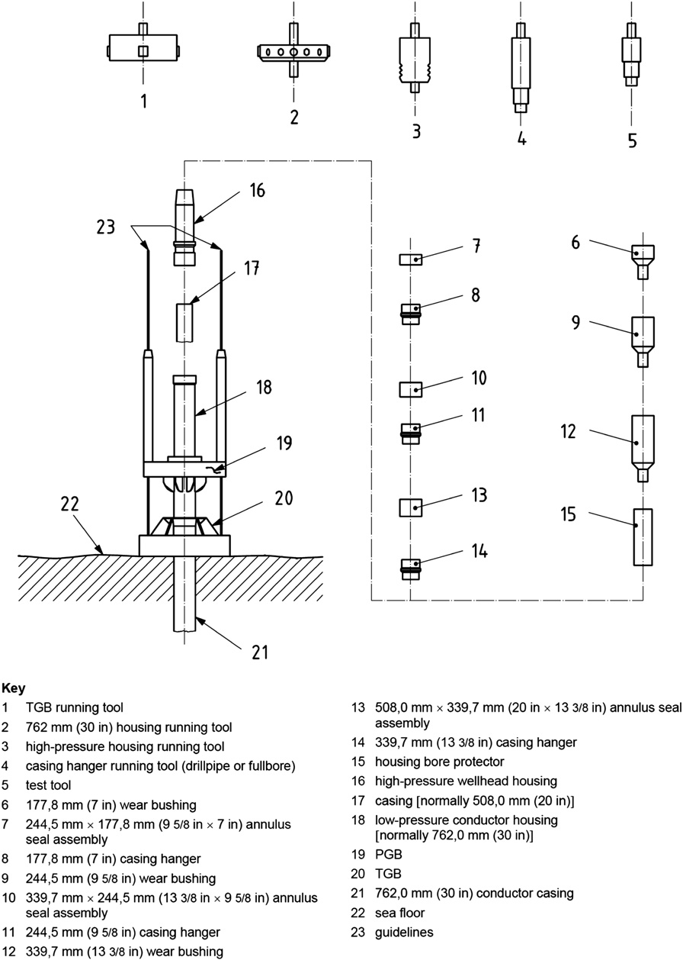
Figure.4-2: Subsea wellhead system [API Technical Report 17TR13].

4.3. Wellhead Operation Requirements
In the operation requirement, the subsea wellhead system should provide the ability to install the following equipment in the same trip: the Production Guide Base (PGB), the 36-in. conductor and the low-pressure conductor housing. The assembly should be designed to be preinstalled in the moon-pool prior to being run subsea. The subsea wellhead allows for jetting operations for the casing pressure and for the drill and cement as a contingency case. It should include provision for efficient discharge of the drill cuttings/cement returns associated with the drilling operations. The subsea wellhead should provide a bore protector and wear bushings to protect the internal bores of the wellhead system components during drilling, completion, and retrieval operations.
The wellhead system should be ensured that all seals and locking arrangements can be tested in situ and also be ensured that the complete pack-off or seal assembly can be retrieved and replaced in the event of a failed test. The wellhead system should be ensured that all permanent seals are protected during the running phase and remotely energized after landing.
Other operation requirements are as follows:
- Be designed such that the running string with wellhead tools and components will not snag or be restricted when running in or being pulled out of the hole.
- Provide tooling that allows for seal surfaces to be cleaned after cement operation and prior to setting seal assemblies without pulling the running string; that is, the tool should allow cleaning of seal surfaces by circulation prior to pack offsetting.
- Be designed to allow for landing of the casing hanger and installation of the seal assembly and removal of the same (in case of failure) in a single trip. Multipurpose tools should as far as possible be used to avoid pulling of the running string for tool change-outs.
- Allow for large enough flow-by areas, and particle size, at the casing hanger and casing hanger running tool level (to be compared with the clearance between ID of the previous casing and the OD of the collars of the attached casing).
- Be designed to allow for testing of the BOP without having to pull the wear bushing.
- Provide guidance for equipment entering the well during drilling, completion, and subsequent operations.
- Allow for safe and efficient retrieval of all installed equipment during permanent abandonment of the well.
- Be designed to allow access for both work class and inspection ROVs. ROV grab bars should be included wherever an ROV operation is defined to provide stabilized working conditions for the ROV.

4.4. Subsea Wellhead Components
A subsea wellhead is the component at the surface of an oil or gas well that provides the structural and pressure-containing interface for the drilling and production equipment. The primary purpose of a subsea wellhead is to provide the suspension point and pressure seals for the casing strings that run from the bottom of the hole-sections to the surface pressure control equipment.
A standard subsea wellhead system will typically consist of the following: wellhead housing, conductor housing, casing hungers, casing head, annulus seals, Temporary Guide Base (TGB) and Production Guide Base (PGB), low-pressure housing, high-pressure wellhead housing, bore protectors and wear bushings and Running and test tools as shown in Figure.4-3.
The high-pressure wellhead housing is the primary pressure-containing body for a subsea well, which supports and seals the casing hangers, and also transfers external loads to the conductor housing and pipe, which are eventually transferred to the ground.
Subsea wellheads are typically welded onto the first string of casing, which has been cemented in place during drilling operations, to form an integral structure of the well. In exploration wells that are later abandoned, the wellhead may be recovered for refurbishment and re-use. In Offshore well, if a wellhead is located on the production platform it is called a surface wellhead, and if located beneath the water then it is referred to as a subsea wellhead.

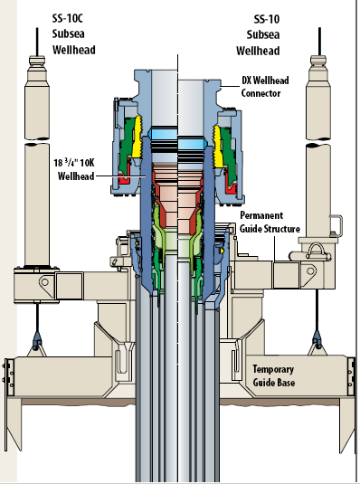 | 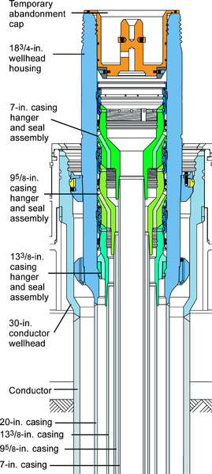
Figure.4-3: An example of a subsea wellhead [Drill Quip]

4.4.1. Casing Head
The lowest part of a wellhead is almost always connected to the surface casing string which provides a means of suspending and packing off the next casing string. A casing head is attached to surface casing or to another casing head to provide a hanging point for the next string of casing. If there is one casing head, it is welded or screwed to the surface casing which is depending on diameter, and the production casing is hung from it. If more than one casing string is used inside the surface casing, then more than one casing head may be needed. An intermediate casing head may be added with each new casing string until the production casing has been hung. Figure.4-4 shows an example of casing head.
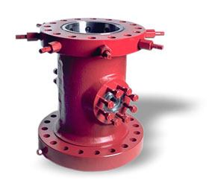 | 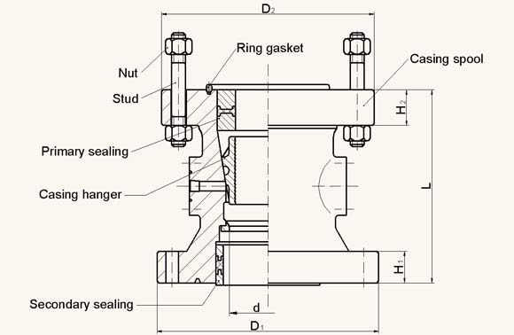
Figure.4-4: An example of casing head [FMC].

4.4.2. Casing Hanger
The top of a casing head has a cone-shaped bowl that holds the casing hanger. Figure.4-5 shows an example of casing hanger. A casing hanger is a set of slips that grips and supports a casing string. Metal and rubber packing rings fit over the slips to complete the casing hanger assembly and provide an annular seal. Threaded or flanged outlets on the side of the casing head allow access to the sealed annulus for pressure gauges that warn of casing leaks.
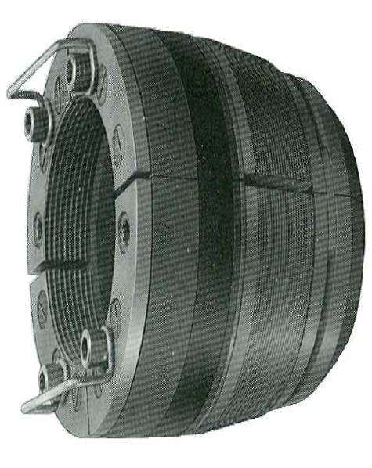 | 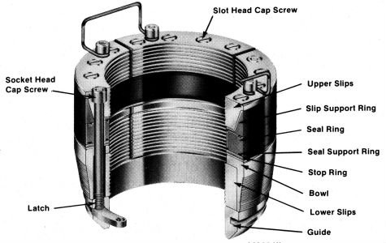
Figure.4-5: An example of casing hanger.

Three types of end and outlet flanges are controlled by API Spec. 6A. (10-4)
- There are 6B and 6BX flanges that can be used as integral, blind or weld neck flanges.
- Type 6B may also be used as threaded flanges.
- Some type of 6BX blind flanges may also be used as test flanges.
The third type – segmented flanges are used on dual completion wells and are integral with the equipment.

4.4.3. Intermediate Casing Hanger
The intermediate casing hanger for the system lands in the first hanger position in the lower portion of the wellhead. Figure.4-6 illustrates the profile for an intermediate casing hanger. The casing hanger can nominally be for either a 16-in or 13-5/8-in. casing. The casing hanger features an expanding load ring that lands into the wellhead seat segments to suspend the casing and BOP pressure end loads.

Figure.4-6: Intermediate Casing Hanger Profile [Y.Bai]

The analysis is performed on existing field-proven hangers of similar designs to compare stress levels. Reliability data also will be collected from similar equipment and lessons learned should be incorporated into the design. Further reliability work is performed during FMECAs (Failure Mode effect and Criticality Analysis). Finally, through testing, the hanger is positively proof tested to the design loads, pressures, and combined loads in the exact sequence in which they would be applied in the field, without experiencing any permanent deformation.

4.4.4. Production Casing Hanger
The production casing hanger for the system lands in the second hanger position. The casing hanger can nominally be either for a 113/4-in or 103/4-in casing. The casing hanger features an expanding load ring that lands into the second set of wellhead seat segments to support the casing and BOP pressure end loads. Using the approach above, detailed stress analysis and classical calculations should be performed in fashion similar to the analysis performed for the intermediate hanger.

4.4.3. Tubing Head
A tubing head is an equipment attached to the casing spool used to hang the tubing (smallest casing string) and seal the annulus between the tubing and casing. Figure.4-7 shows an example of tubing head. The top spool on a wellhead assembly contains the highest pressure in the wellhead, and contains a load shoulder to hang the tubing hanger and tubing string. When the well is completed, the tree is installed on top of the head with a tubing head adapter. Providing a means to support and test the BOPs while completing the well, the tubing head is a necessary component when drilling and completing a well.
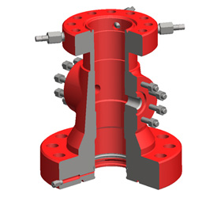
Figure.4-7: An example of tubing head [FMC].

4.4.3. Tubing Hanger
A tubing hanger is mechanism used to hang the tubing from within the tubing head by means of a thread. These load-bearing devices are installed in the top bowl of the tubing head and are run through the BOP also doubling as a means to access and manipulate additional smaller tubing lines that are utilized down-hole and extended to the surface on the outside of the tubing string(s). Figure.4-8 shows an example of tubing hanger.
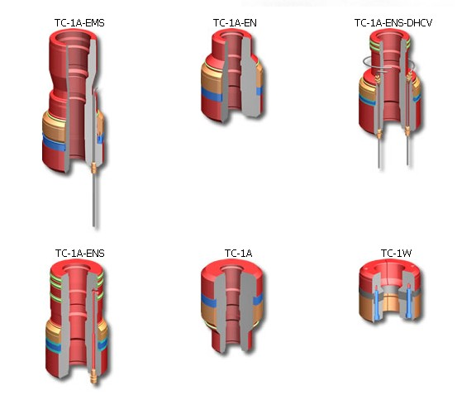
Figure.4-8: An example of tubing hanger [FMC].

4.4.4. Wellhead Housing
The wellhead housing is the primary housing supporting both the intermediate and production casing strings. In API 17D [2], very detailed profiles are introduced. Figure.4-9 is a schematic of typical wellhead housing. Two kinds of subsea analyses are necessary to consider in the wellhead housing design procedure: load stress analysis and thermal analysis. The hanger landing shoulder will sustain loads from the tubing hanger. Normally, a Finite Element Analysis (FEA) and riser fatigue analysis will be performed to verify the design capacities.
In addition, thermal analysis is performed to determine the temperature profiles through the system so that temperature derating can be accounted for as appropriate. A prototype wellhead should be tested to the test pressure as well as loaded with simulated casing loads and BOP test pressure with hangers in place simulating the real production environment in total without experiencing any permanent deformation.

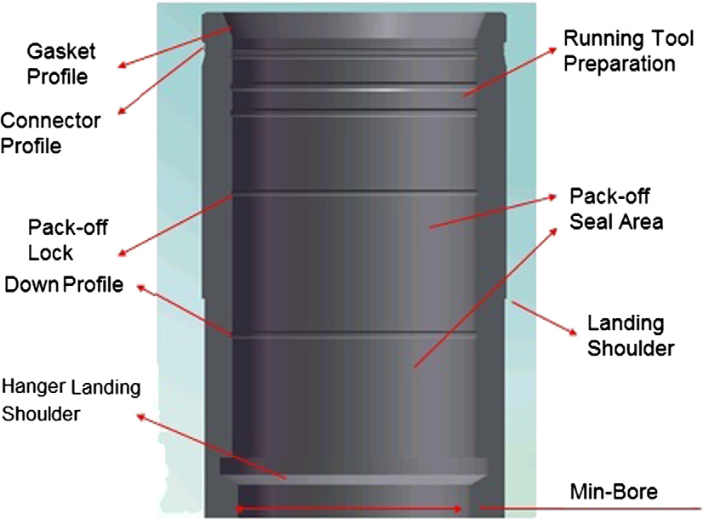
Figure.4-9: Schematic of wellhead housing [Y.Bai]

4.4.5. Lockdown Bushing
A lockdown mechanism is recommended to prevent movement of the casing hangers due to thermal expansion or annulus pressure when the well is put on production. The lockdown bushing is used to permanently hold the production casing hanger in place so that the annulus seal assembly locked to the hanger does not move and get damaged during start-up or shut-down operations. This system’s lockdown bushing has a rated lockdown capacity of 3.2 million pounds. It is installed using a related tool using full-open water operations.
The design approach for this piece of equipment is handled as same as other components of wellhead. Design calculations and finite element analysis are performed in conjunction with the gathering of reliability lessons learned and FMECA to confirm the integrity of the design up-front. Tests should be performed to confirm that the lockdown bushing and tool can definitely function as designed, and load testing is performed to confirm the load capacity.

4.4.6. Metal-to-Metal Annulus Seal Assembly
The metal-to-metal annulus seal assembly is used to seal off the casing string annulus pressure from the bore pressure to isolate geological formations from one another. The typical profile is showed in Figure 4-10.
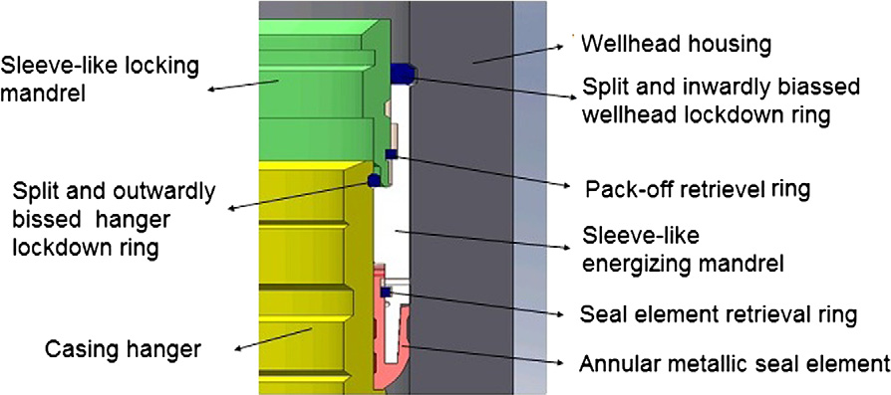
Figure.4-10: Intermediate Casing Hanger Profile [Y.Bai]

The metal-to-metal assembles usually needs practice testing to confirm that it could withstand the high pressure and temperature.

4.4.7. Elastomeric Annulus Seal Assembly
The elastomer seal assembly is used in an emergency when the primary metal seal fails to function should the bore of the wellhead or casing hanger have a deep scratch. The elastomer seal assembly seals in a different vertical location in the wellhead, which should seal away from the damaged area.

4.4.8. Running and Test Tools
The standard subsea wellhead system will include typical running, retrieving, testing, and reinstallation tools. These tools include: conductor wellhead running tool, high-pressure wellhead running tool, casing-hanger seal-assembly running tool, multipurpose tool and accessories, BOP isolation test tool and Seal-assembly running tool as shown in Figure.4-11.
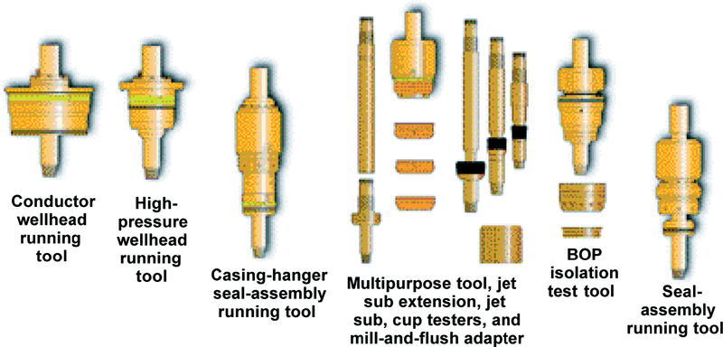
Figure.4-11: SS-15 Subsea Wellhead System running tool family [SPE].

4.4.8.1. Conductor Wellhead Running Tool
Figure.4-12 shows an example conductor wellhead running tool (SS-Series) which features a cam-actuated locking mechanism and low friction bearing surfaces that minimizes torque while the tool is being released from the conductor wellhead. The conductor wellhead running tool runs the conductor casing and conductor wellhead and guide base. The conductor wellhead running tool can be used for jetting in the conductor or cementing the conductor into a predrilled hole. The tool runs wellhead housing and guide base in one trip and has removable plugs proves large flow-by area for returns while jetting or turbo frilling.
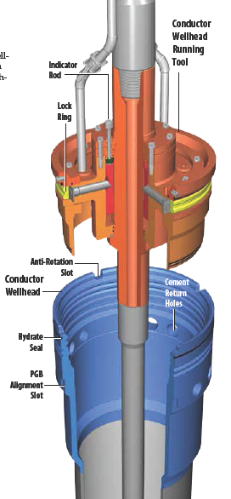
Figure.4-12: SS-Series Conductor Wellhead Running Tool [Drill-Quip].

4.4.8.2. Subsea Wellhead Running Tool
The high-pressure wellhead running tool operates just like the conductor wellhead running tool, but it runs the high-pressure wellhead and 20-in casing as shown in Figure.4-13. It is a cam-actuated tool that minimizes any high torque that may be encountered during operations
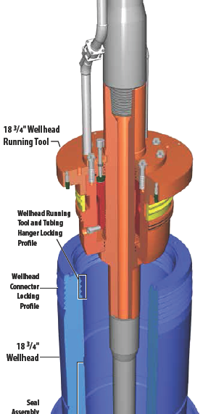

Figure.4-13: SS-Series Subsea Wellhead Running Tool [Drill-Quip].

4.4.8.3. Casing Hanger Running Tools
The intermediate and production casing hanger running tools run the casing hangers and set the annulus. These tools normally are designed using the same technology, lessons learned, and in many cases the same parts as the standard 15-ksi running tool, as shown in Figure 4-14.

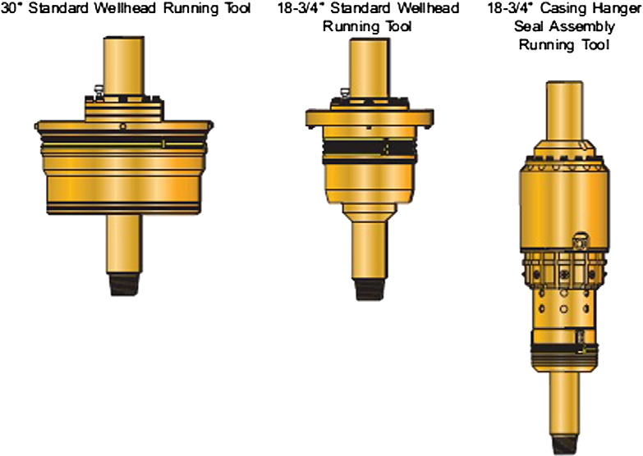
Figure.4-14: Casing Hanger Running Tool (Drill-Quip)

4.4.8.4. Multipurpose Tool and Accessories
The multipurpose tool runs and retrieves the nominal bore protector and all wear bushings. A jet sub and/or jet sub extension can be attached to the multipurpose tool so that wellhead washout can occur during the retrieval process. The multipurpose tool also retrieves the seal assembly, and becomes a mill-and-flush tool by attaching the mill-and-flush adapter.

4.4.8.5. BOP Isolation Test Tool
The BOP test is done periodically offshore within 14-day period basis or prior to changing operations such as from drilling to completion and from drilling different hole sizes or pressure formations. The test run is according to the operator procedures and the service company based on operator requirement and the corresponding government regulations. The BOP test tool is designed with an approach that is similar that for other components and tools in this system. It is used to test the BOP in terms of future formation pressure that the operator is currently drilling into, and is also used to run and retrieve wear bushings, as shown in Figure.4-15.

Figure.4-15: BOP Isolation Test Tool (Drill-Quip)

The isolation test tool is used to test the pack-off per MMS (Mineral Management Service) requirements while simultaneously isolating the BOP stack/riser. The tool operates with a simple straight-in/straight-out approach. Once set in position with the weight down, drill string pressure is applied up to a target test pressure of 20-kpsi.

4.4.8.6. Seal-Assembly Running Tool
The seal-assembly running tool is used in the event that a second seal assembly needs to be run. The seal-assembly running tool is a weight-set tool, and, like the casing-hanger seal-assembly running tool, it allows testing of the BOP stack and recovers the seal assembly if it cannot be installed (because of debris in the sealing area of the annulus).

4.4.9. Bore Protectors and Wear Bushings
Once the high-pressure wellhead housing and the BOP stack are installed, all drilling operations will take place through the wellhead housing. The risk of mechanical damage during drilling operations is relatively high, and the critical landing and sealing areas in the wellhead system need to be protected with a removable bore protector and wear bushings, as shown in Figure.4-16. These wellhead components are run on a multipurpose tool.

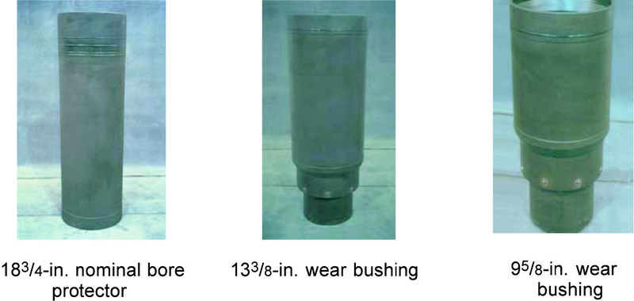
Figure.4-16: Nominal bore protector, 133/8-in. wear bushing, and 95/8-in. wear bushing (SPE)

4.4.10. Low-Pressure Wellhead Housing
The Low-Pressure Wellhead Housing (LPWH) is typically 30-in and 36-in provides a location point for the drilling guide base as shown in Figure.4-17. The low-pressures wellhead housing also provides an interface for the 18¾-in high-pressure housing. It is important for this first string to be jetted or cemented in place correctly, because this string is the foundation for the rest of the well.

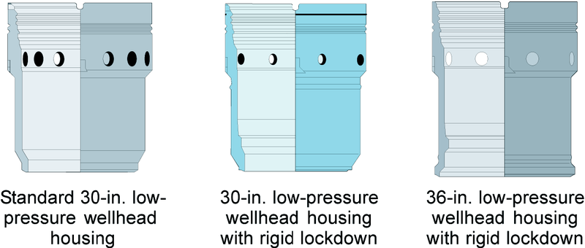
Figure.4-17: Typical Low-Pressure Wellhead Housings (SPE)

4.4.11. High-Pressure Wellhead Housing
The subsea High-Pressure Wellhead Housing (HPWH) typically 18¾-in is effectively a unitized wellhead with no annulus access. It provides an interface between the subsea BOP stack and the subsea well. The subsea wellhead is the male member to a large-bore connection, as shown in Figure.4-18. The female counterpart is the wellhead connector on the bottom of the BOP stack that will be made up in a remote subsea, ocean-floor environment. The 18¾-in wellhead will house and support each casing string by way of a mandrel-type casing hanger. The ID of the 18¾-in. wellhead provides a metal-to-metal sealing surface for the seal assembly, when it is energized around the casing hanger. The wellhead provides a primary landing shoulder in the bottom ID area to support the combined casing loads, and will typically accommodate two or three casing hangers and a tubing hanger. The minimum ID of the wellhead is designed to let a 17½-in. drilling bit pass through.
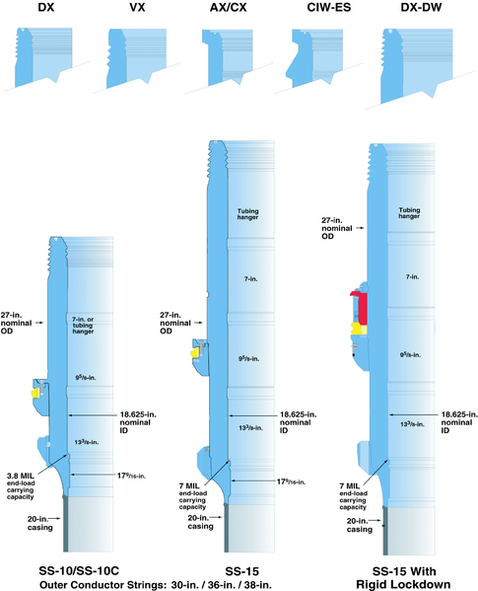
Figure.4-18: SS type of High-Pressure Wellhead Housings (SPE)

4.5. Casing Design: North Sea Operation
North Sea operators are facing well architecture challenges. These challenges will have a significant impact on the future integrity of their wells and future production rates. Well integrity challenges affect the structural, tubing and casing design of the well. The optimum casing design varies by area such as depths, geology, drilling hazards.
Current typical casing design and lithology for central North Sea is shown in Figure.4-19 and Figure.4-20, respectively, which consists as follows:
- Conductor (30-in diameter, 36-in for deep water)
  - supports weight of inner strings
  - cases off soft top soils
  - usually 6 no. 40-ft joints (240-ft)
- Intermediate casing (usually 13 3/8-in)
  - cases off Tertiary formations
  - usually set in top UC Chalk (3500-ft – 4000-ft)
- Production casing (usually 9 5/8-in)
  - cases off Chalks and LC Siltstones
  - usually set just above reservoir
- Liner (usually 5½-in or 7-in diameter)
  - set across reservoir

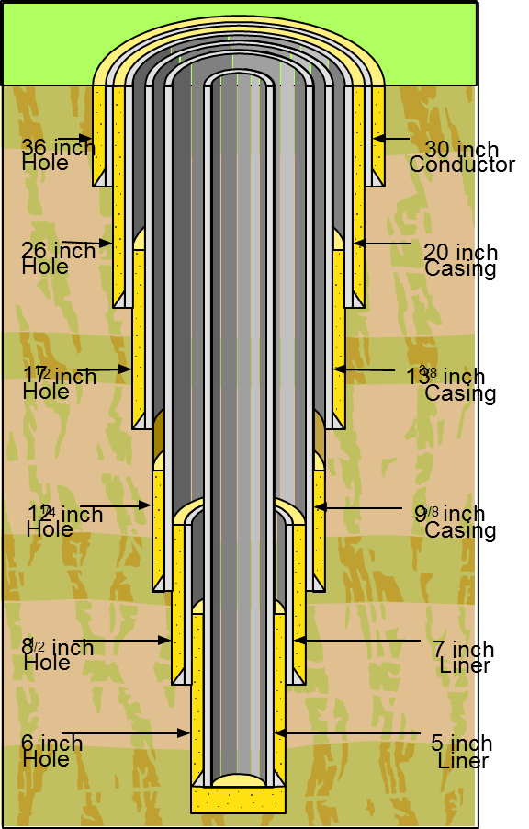
Figure.4-19: Typical casing design for Central North Sea [Adrian Adams].
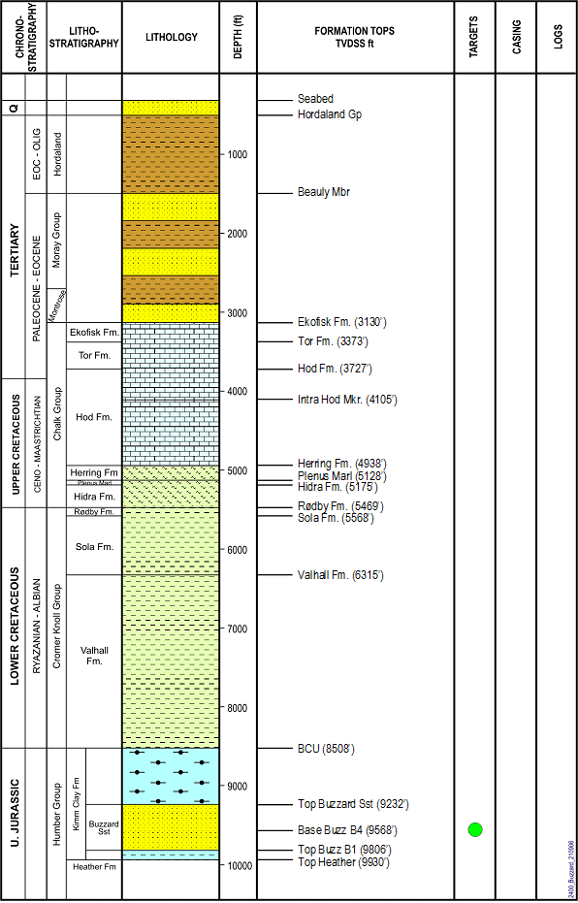
Figure.4-20: Typical lithology at Central North Sea [Adrian Adams].

4.6. Wellhead Guide Base System
The drilling guide bases provide a means for guiding and aligning the BOP onto the wellhead. The drilling guide bases are categorized into temporary and permanent guide bases as shown in Figure.4-21(a). In wellhead system installation, guide wires from the rig are attached to the guideposts of the base, and the wires are run subsea with the base to provide guidance from the rig down to the wellhead system as shown in as shown in Figure.4-21(b). Each guide base can incorporate customer-specified features, such as remote-retrievable capabilities and special flow-by features.

Subsea wellhead system (a) | Installation stage (b)
Figure.4-21: An example of drilling guide base [DNV-GL].

4.6.1. Temporary Guide Base
At the early stage of subsea well drilling operations, the Temporary Guide Base (TGB) is usually the first optional piece of equipment being deployed as shown in Figure.4.19. The TGB is also known as a Drilling Guide Base, with a central opening for drilling of the first section of the well and facilities for attachment of guidelines. The TGB serves as an anchor for the guidelines and as a foundation for the Permanent Guide Base (PGB) and providing a controlled reference point for wellhead elevation. It should be noted that on single satellite wells the TGB may be omitted if there are no requirements for accurately controlled elevation of the wellhead. On multiple well templates, the TGB forms an integral part of the template.
The TGB has four lifting eyes which are attached to the drilling ship or platform by means of wire lines. The lifting eyes basically can act like a casing string centralizer. The TGB also has a dead load compartment and a funnel gimbal receiver on top of it to accommodate the next stage of equipment the Retrievable Guide Base (RGB) or Re-Runnable Guide Base (RRGB). There are some cases that this piece of equipment is not able to be used, it will depend on the conditions of the seabed; and a high deviation of the casing string makes almost impossible to use it. At the time of the cementing stage of the conductor, there is a piece called a Running Tool attached to a Cementing Head that accommodates on top of the Casing Housing.
The Casing Housing is basically a low pressure containment piece that supports the next piece of the completion which is the Wellhead and all the casing and tubing hanger inside.

4.6.2. Permanent Guide Base
The Permanent Guide Base (PGB) is a simple conductor supported and moon-pool installable guide base used for guiding of subsea trees and BOP and associated drilling equipment during drilling operations with moored floating rigs as shown in Figure.4-22(a). The PGB can also provide a landing porch for tie-in systems. The PGB commonly consists of alignment pin, conductor landing shoulder, cement return holes and gimbal as shown in Figure.4-22(b).
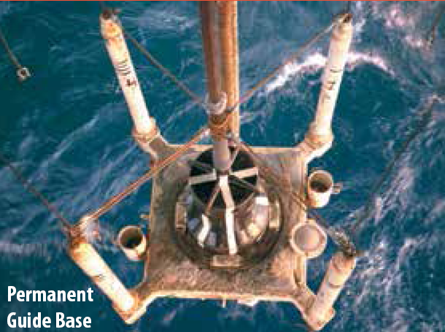  Installation PGB (a) | 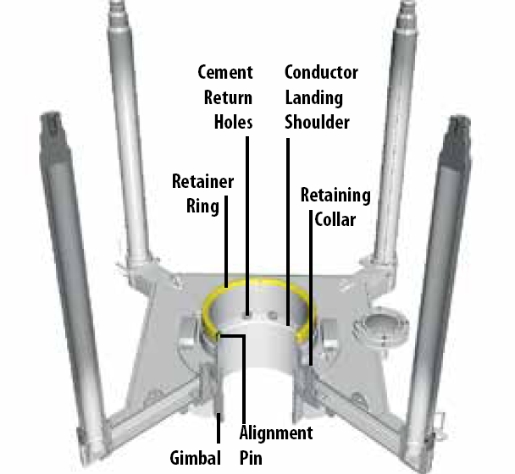  Typical an example of PGB (b)
Figure.4-22: An example typical Permanent Guide Base [Drill Quip].

The PGB can be categorized into several types: non-retrievable or expandable, diver-assisted, remote-retrievable or ROV-compatible as shown in Figure.4-23.

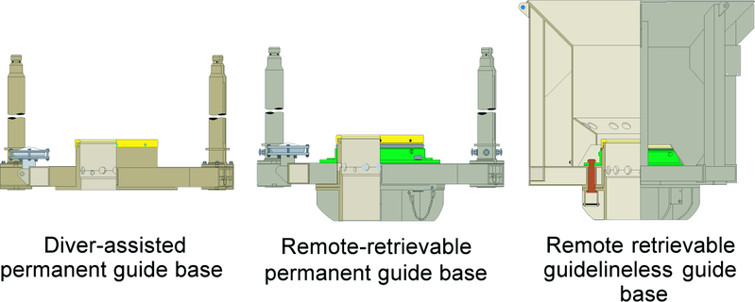
Figure.4-23: An example of permanent Guide Base [Drill Quip].

The PGB should provide a second well slot adjacent to an existing wellhead. Figure.4-24 shows typical schematics of the PGB. This means that a base structure can be landed and it can be locked to the existing well conductor housing by using the guide base locking profile. It should satisfy the same functional and design requirements as the PGB defined above, with the following additions or modifications:
- The PGB includes a second well slot with the same functionality as a TMGB.
- The PGB includes a two-well manifold with piping arrangement, ROV-operable isolation valves, hubs for vertical tree connection, and horizontal inboard tie-in facilities for production lines and service umbilical, as well as an electrical connection system between the inboard hub and the trees.
- The PGB will not be installed with the conductor pipe.

Figure.4-24: Schematic of permanent guide base [DNV-GL].

Chapter.5

5.0 Subsea Well Completion

5.1. Subsea Well Completion Preparation
After completion subsea well drilling, the subsea well temporarily is suspended prior to the start of subsea completion. In production system, subsea completion well is the process of making a subsea well ready for production. This principally involves preparing the bottom of the hole to the required specifications and running in the production tubing. They are associated down-hole tools as well as perforating and stimulating as required. There are three alternative approaches commonly and widely used in the industry, as illustrated in Figure 5-1:

Figure.5-1: Well Completion methods

The completion design includes the tubing size, completion components and equipment, and subsea tree configuration. Components of subsea completion equipment include the subsea wellheads and the subsea tubing hanger/tree systems.

5.1.1. Open-Hole Well Completion
Open-hole completion is the most basic type in which the bottom hole well completion would be to leave the entire drilled reservoir section open after drilling, as shown in Figure.5-2. The open-hole completion is sometimes referred to as “barefoot” completion which is widely applied. As the open-hole completion does not required equipment to be installed there are savings in both costs and time.
This method involves simply setting the casing in place and cementing it above the producing formation. Then continue drilling an additional hole beyond the casing and through the productive formation. Because this hole is not cased, the reservoir zone is exposed to the wellbore.
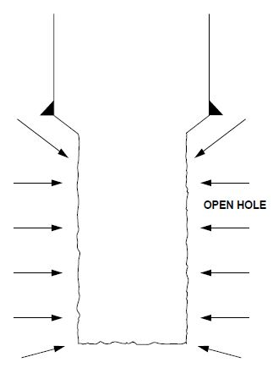
Figure 5-2: Open-hole well completion technique [PS]

5.1.2. Screen Completion
In this technique, once the drilling through completed reservoir section has been completed, a wire-wrapped screen or steel pipe which has slots or alternative sand control screen is installed as shown Figure.5-3.
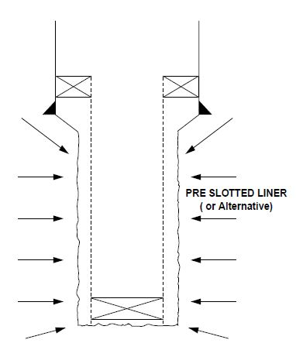
Figure.5-3: Screen well completion technique [PS]

5.1.3. Casing or Liner Completion
The last method is to install either a casing string which extends back to surface or a liner which extends back into the shoe of the previous casing string, which would then be cemented in place by the displacement of a cement slurry into the annular space between the outside wall of the casing and the borehole wall as shown Figure.5-4. Then the casings are perforated with tiny holes along the wall facing the formations. Thus, the production can flow into the well hole.
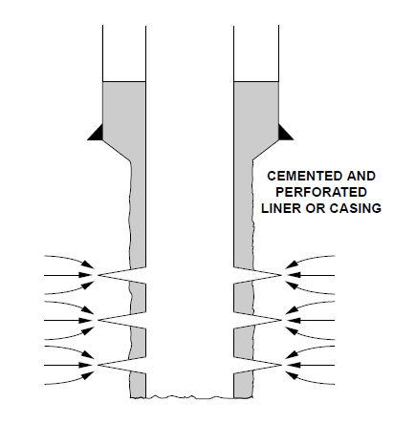
Figure.5-4: Casing or liner well completion technique [PS]

5.1. Subsea Test Tree
This section discusses a case study on subsea well completion using SenTREE Subsea Test Tree (SSTT) and horizontal tree. The SenTREE Subsea Test Tree (SSTT) systems integrate with the BOP and any well test, completion or tree system. Three types of senTHREE are available currently as follows:
- SenTREE-3 Subsea Test Tree is 3-in, 15,000-psi SSTT for exploration and appraisal operations.
- SenTREE-7 Subsea Test Tree is 7 3/8-in, 10,000-psi SSTT for completion, flow testing, intervention, and other subsea well operations
- SenTREE-HP Subsea Test Tree 6 3/8-in, 15,000-psi completion SSTT for well intervention, stimulation, and abandonment.

5.3. Subsea Well Testing
In the exploration stage of a well, a subsea well is test to evaluate the production and flow capabilities of the well after discovering a potential zone. In order to test a subsea well, a Drill Stem Test (DST) string is run through BOP. The DST string typically consists of perforating guns, gauges, gauge-carrier with surface readout capabilities, retrievable packer and test-valve tool. This is connected by tubing up to seabed, then to a retrievable well-control test tree set in the BOP to ensure that disconnection, if required, is done in controlled way. Reservoir fluids flow past the DST gauges at the reservoir level where pressure and temperature are detected, then flow through the tubing and test tree, and finally to the surface. An example of the controlled disconnection tool is SenTREE 3 & 7 as shown in Figure.5-5.
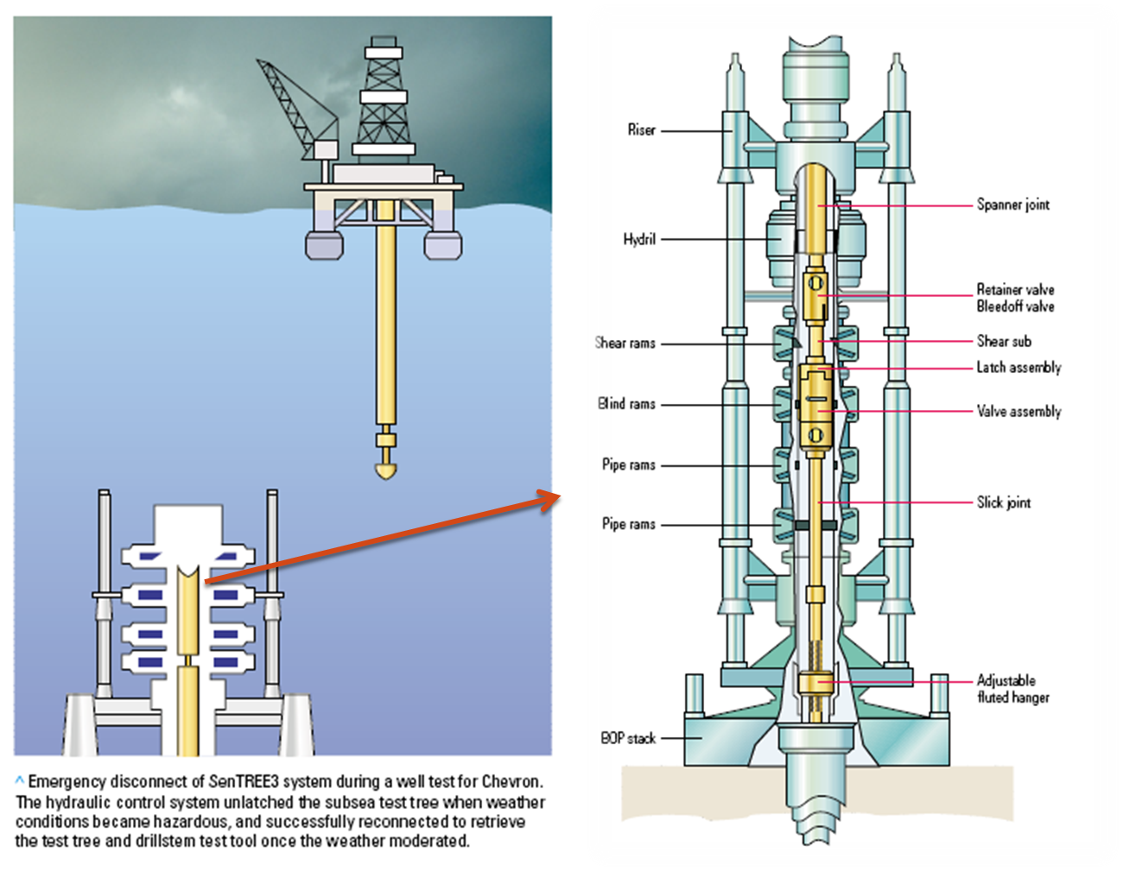
Figure.5-5: An example well testing [Alan Christie.el.al]

5.3. Tubing String & Tubing Hanger Installation
The tubing string is made up and run in hole. The tubing hanger is attached to the top of the string. The entire assembly is run through the drilling riser and BOP either on a completion riser or drill-pipe and landed in the wellhead. If an oriented tubing hanger is used, the tubing hanger is oriented with respect to the guideposts, landed, locked in place and the production packer is set. The pressure integrity of the tubing string, tubing hanger to wellhead seals and the production packer are then tested. The operation of the subsurface safety valve is also tested.
Wire-line plugs are set in the tailpipe of the packer, and generally also the tubing hanger and the completion riser are unlatched from the tubing hanger and retrieved. There are now sufficient barriers to flow to allow the BOP and drilling riser system to be removed safely.

5.4. Subsea Well Production Test
As the tubing hanger is installed in the tree, subsea completions are performed during tree installation. Procedures installation of a horizontal tree typically has several steps.

5.4.1. Well Suspension
After completing well drilling, the suspension packer is installed. Then, the suspend flow from the well with kill fluid to shut off flow retrieve the riser and BOP is conducted as shown in Figure 5-6.
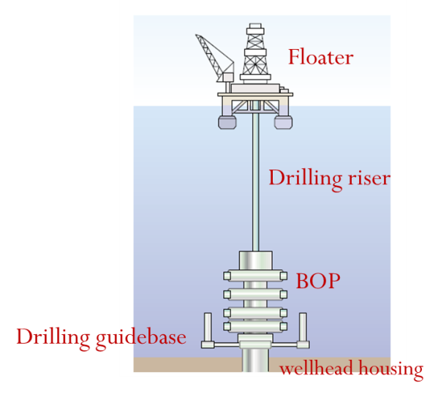
Complete drilling and install the suspension packer
Figure.5-6: Subsea well suspension

5.4.2. BOP Stack Removal
In this stage, the BOP stack is unlatched from the wellhead and the stack and riser system is retrieved as shown in Figure 5-7.
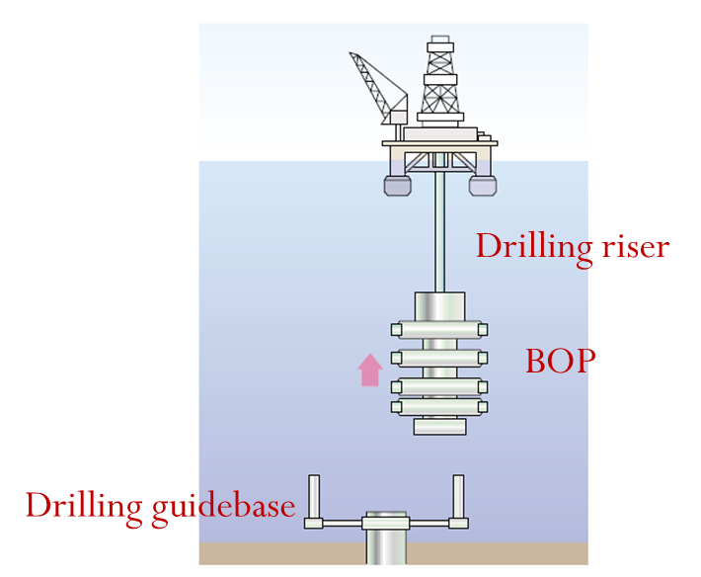
Retrieve the drilling risers and BOP stack, move rig off
Figure.5-7: BOP stack temporary removed from well

5.4.3. Tree and BOP Installation
The drilling guide base is retrieved with ROV assistance and then run the production flow-base and latch onto wellhead housing as shown in Figure.5-8. The tree is landed on the production flow base, lock the connector, test seal function valves with an ROV and release Tree Running Tool (TRT)., BOP stack is run onto horizontal tree, lock connector, run BOP test tool and test, function-test tree. When the tree has been landed, the wellhead connector is energized and all of the major functions are tested. The tree to wellhead seals and riser system are then tested for pressure integrity.
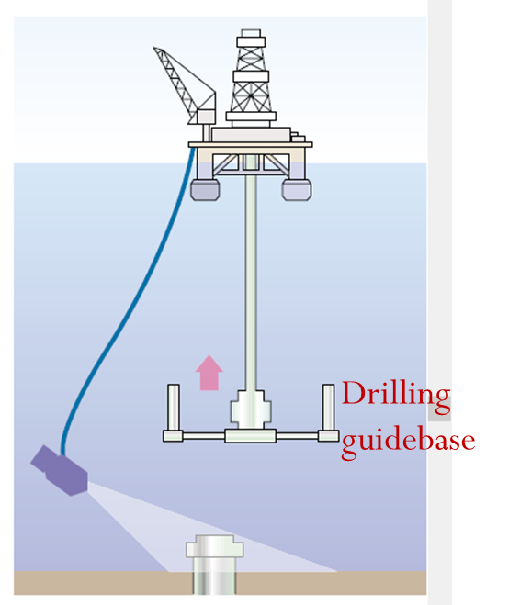  Retrieve drilling guide base with ROV assistance | 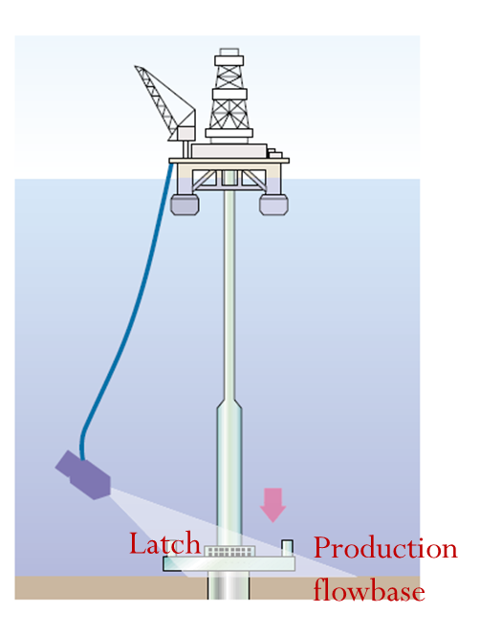  Run the production flow-base and latch onto wellhead housing

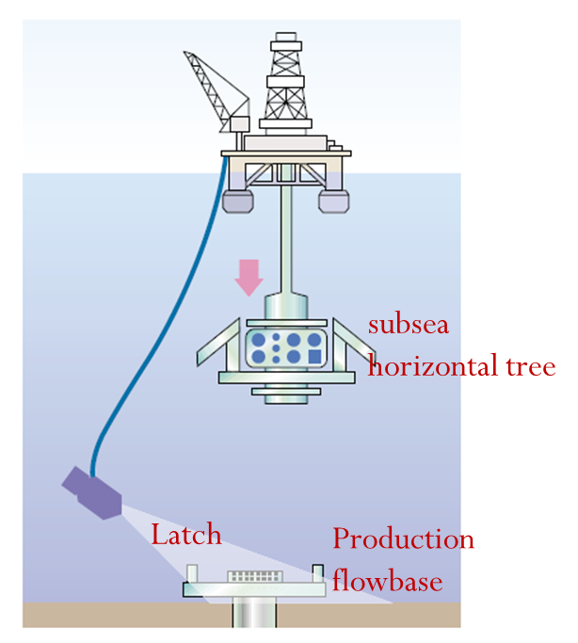  Run subsea horizontal tree | 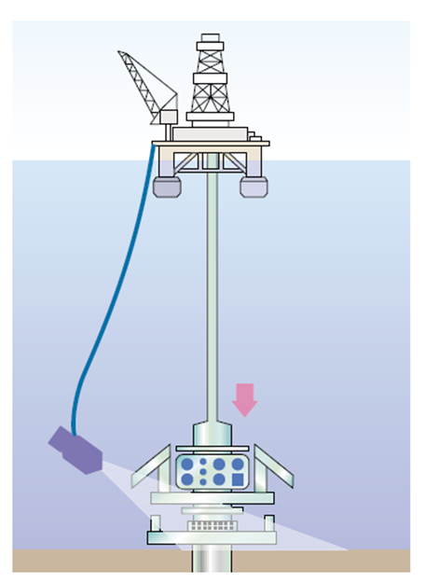  Land the tree, lock the connector, test seal function valves with an ROV, release Tree Running Tool (TRT)

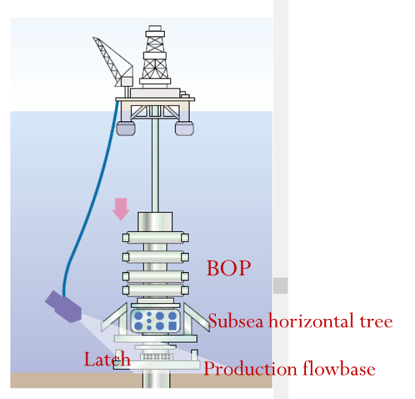
Run BOP stack onto horizontal tree, lock connector, run BOP test tool and test, function-test tree.
Figure.5-8: Tree and BOP installations

5.4.4. Well Completion
In the well completion, the well changes to completion fluid, condition of the well prior to running completion, run the completion with production equipment and the subsea completion and test tool using senTREE-7.
The SenTREE-7 is set and make-up using the following procedures: suspension packer is retrieved, removes wear bushing from tree, make up SenTREE7 system, rack back as shown in Figure.5-9. Run completion string is run, make up Tubing-Hanger Tool (THRT) and SenTREE-7 system on tubing hanger, Run landing string with umbilical, Make up surface control head to landing string. Land hanger in production tree and test seals. Rig up wire-line and retrieve straddle sleeve. Run seat protectors. Circulate tubing to potable water for drawdown. Set wire-line plug, test string and set packer.

Run BOP stack onto horizontal tree, lock connector, run BOP test tool and test, function-test tree | 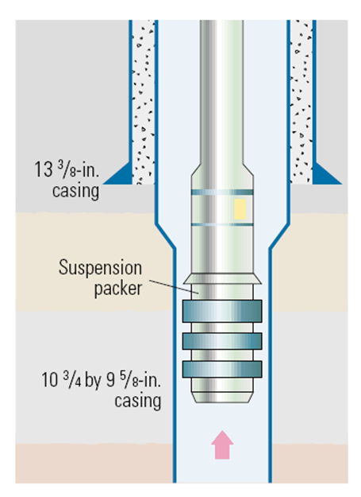  Retrieve suspension packer, remove wear bushing from tree, make up SenTREE7 system, rack back

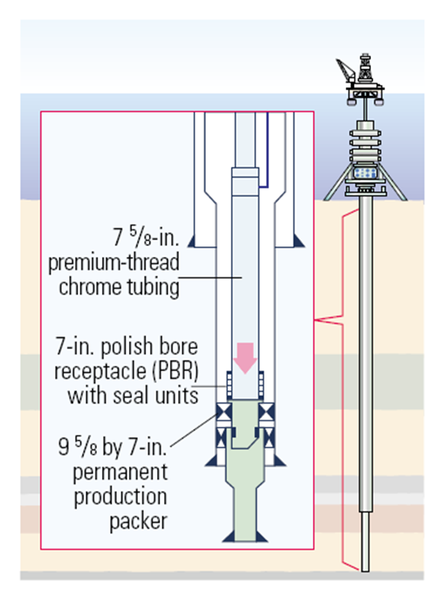
Run completion string, make up Tubing-Hanger Tool (THRT) and SenTREE-7 system on tubing hanger, Run landing string with umbilical, Make up surface control head to landing string
Figure.5-9: Well Completion

5.4.5. Installation and Intervention
In this stage, rams are closed, land off and test hanger, set and test packer underbalance the well, perforate, clean up flow and pull out the landing string as shown in Figure.5-10.

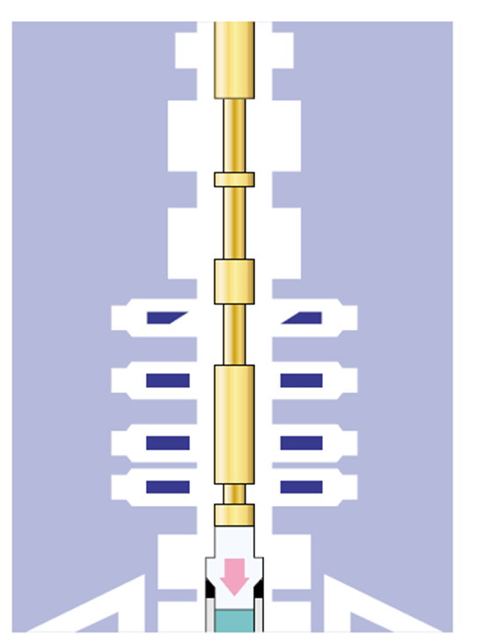
Land hanger in production tree and test seals. Rig up wire-line and retrieve straddle sleeve. Run seat protectors. Circulate tubing to potable water for drawdown. Set wire-line plug, test

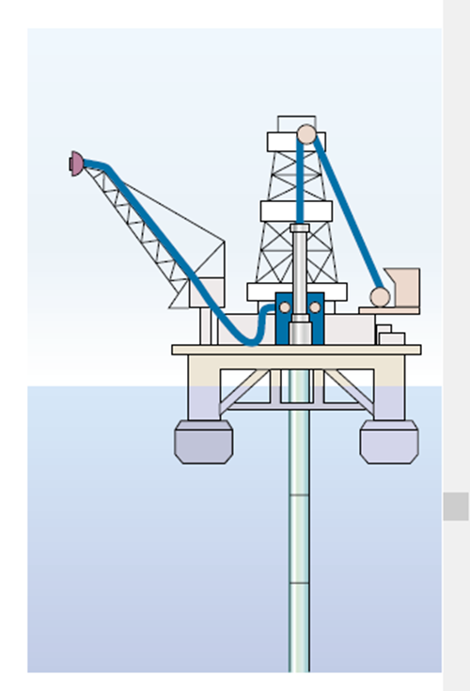  Rig up production test package. Rig up electric wire-line and lubricator | 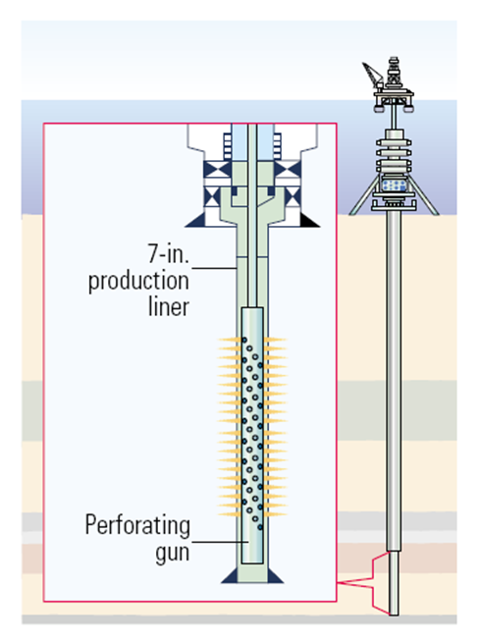  Run guns, correlate and perforate well
Figure.5-10: Installation and intervention

5.4.6. Isolation and Production Preparation
Run and set hanger plug, open rams, unlatch tubing-hanger running tool (THRT), pull THRT out of hole with landing string. Run internal tree cap, run and set internal tree cap plug, unlatch THRT from internal tree cap, recover landing string, recover BOP and riser as shown in Figure.5-11.
Production test is carried out, Rig up production test package. Rig up electric wire-line and lubricator. Run guns, correlate and perforate well, acid stimulation and multi-rate test. Unlatch THRT and retrieve landing string and SenTREE-7 tool, Rig down production test package and flow-heat. Finally, run internal tree cap, run and set internal tree cap plug, ROV closes tree valves, unlatch THRT from internal tree cap, retrieve THRT and landing string, retrieve BOP stack, retrieve guide wires, and install debris cap, deploy legs, recover BOP and riser

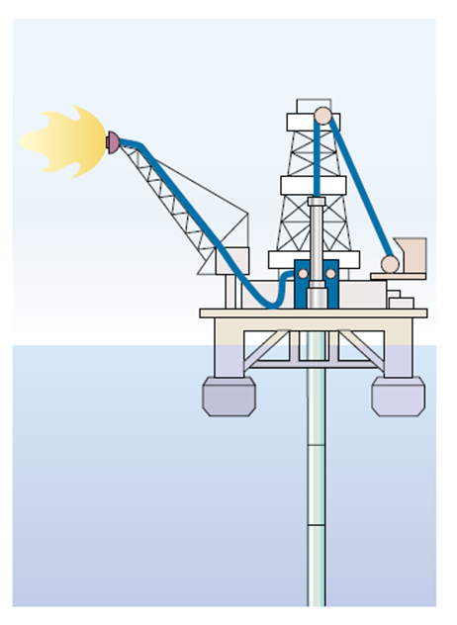  Carry out production test, acid stimulation and multi-rate test | 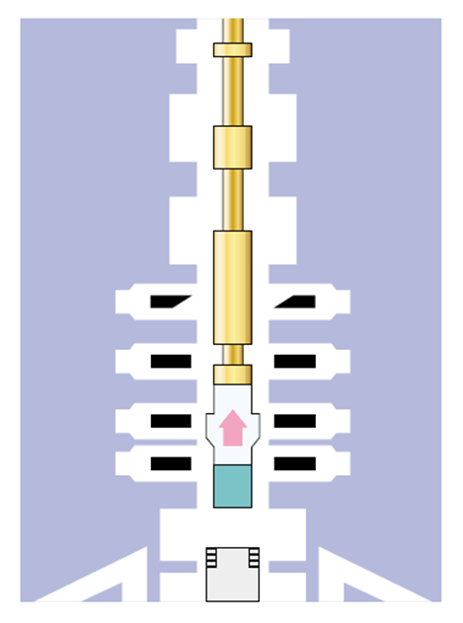  Unlatch THRT and retrieve landing string and SenTREE-7 tool. Rig down production test package and flow-heat

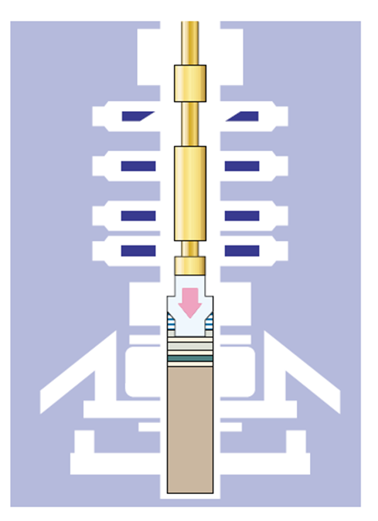  Run internal tree cap | 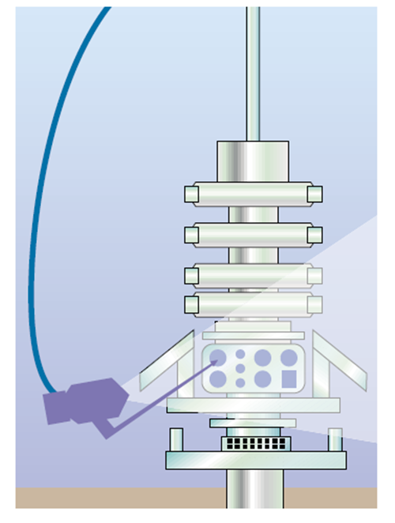  ROV closes tree valves. Retrieve THRT and landing string

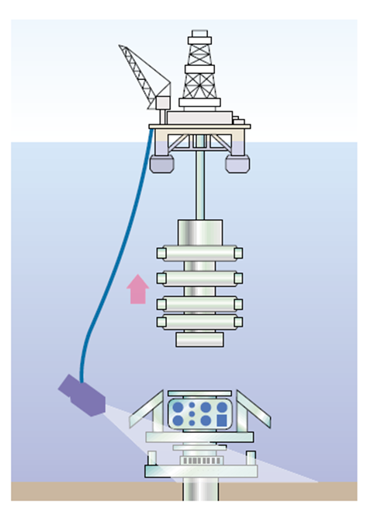Retrieve BOP stack, retrieve guide wires | 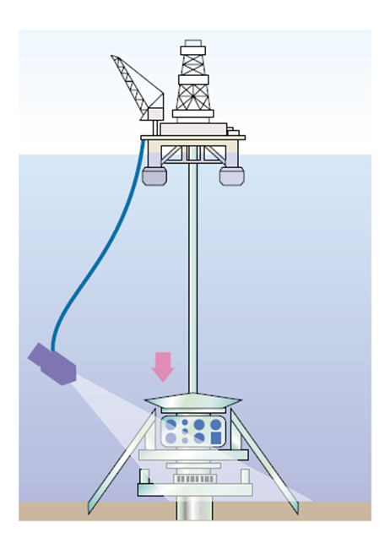Install debris cap, deploy legs

Figure.5.11: Isolation and Production Preparation.

5.5. Cleaning up the Well
The wire-line plugs are retrieved from the tubing string. The perforating guns are run and the production casing is perforated. Flow from the well is then initiated and the well is cleaned up and tested. The flow can be initiated in a number of ways. The tubing can be run partially filled, coiled tubing can be used to circulate light fluid or Nitrogen, or a circulating device in the tubing string can be opened and the tubing circulated to lightweight fluid prior to perforating.

5.6. Suspending Subsea Well
When the well is cleaned up the master valves on the tree are closed, and the riser system is displaced to seawater. The riser is then disconnected from the top of the tree and the riser retrieved. A tree cap is then run and latched onto the top of the tree. The well is now ready for connection of the pipelines, control umbilical, and production as shown in Figurre.5.12.
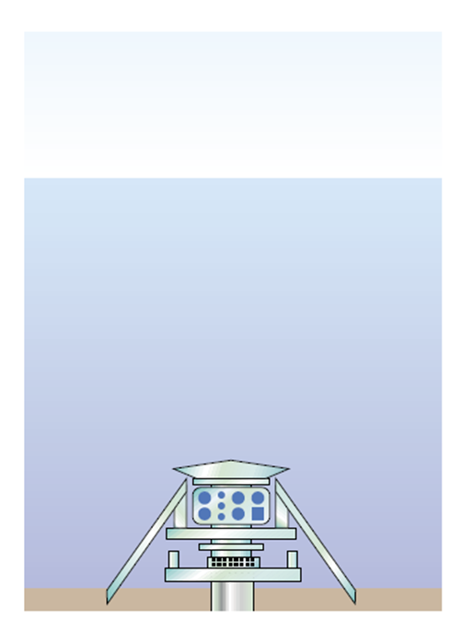  Suspend well | 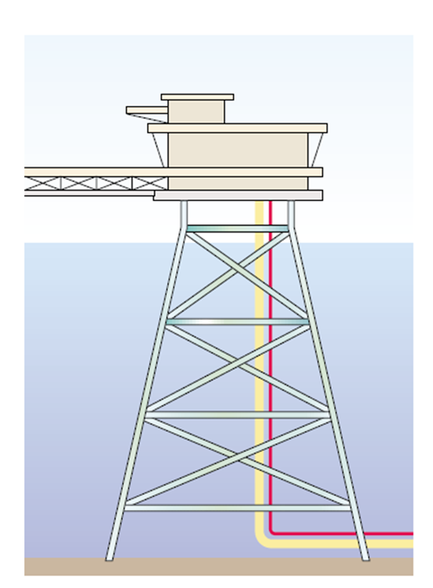  Tie-in pipeline for production
Figure.5.12: A typical suspending subsea well.

Chapter.6

6.0 Subsea Well Fatigue Analysis

6.1. Introduction
Wellhead fatigue analysis is purposed to predict the fatigue damage in wellhead system components for the life of the well. Environmental conditions, operational data, system descriptions, and material properties are appropriately applied to engineering analysis system to predict local and global responses, which are then combined with material properties and damage models as shown in Figure.6-1. The Wellhead fatigue analysis process consists of computing cyclic loads experienced in the wellhead/casing system, relating cyclic loads to cyclic stresses for each location of interest and using a damage model to calculate fatigue life at each location of interest.
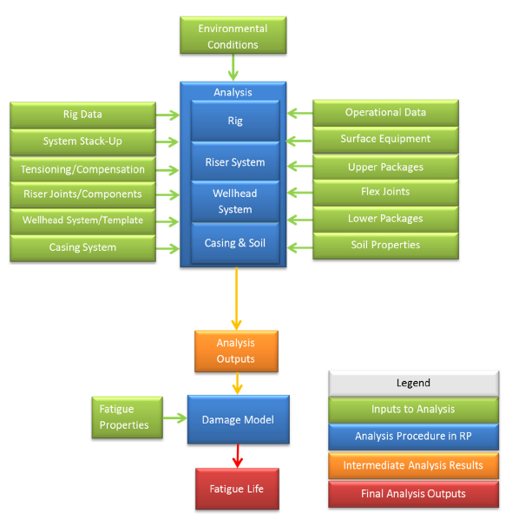
Figure.6-1: Flowchart of wellhead fatigue analysis process [DNV].

In this section, wellhead analysis approach based on a Simple Linear Elastic Model (SLEM) of multistring wellbore systems is described. This approach can be used to facilitate understanding and analysis of various complex wellhead load events in terms of a simple linear model. Although the simple linear model is limited because nonlinear effects due to buckling are not considered, wellhead loads and displacement behave as a linear system to a good first-order approximation in many realistic situations. Loads on conductor and surface casings are considered in particular, since many surface/rig events tend to impact these strings more directly. Also, they must bear the primary load burden due to their greater relative stiffness and tendency to displace linearly.

6.2. Simple Linear Elastic Model
Fatigue calculations should combine the effects of all relevant environments, operations, and system configurations to determine the total damage. The calculation of the resultant stress or damage due to the combination of various loading events is essential to properly estimating the fatigue damage.
In this section, wellhead analysis approach based on a Simple Linear Elastic Model (SLEM) of multistring wellbore systems is described. This SLEM approach is a facilitation to give better understanding and analysis of various complex wellhead load events in terms of a simple linear model. The SLEM for multistring wellhead displacements and loads for a free-standing wellhead system is presented. Use of the SLEM in a systematic analysis of wellhead load events is also discussed.
Based on Oil country tubular goods (OCTG) casing or tubing string typically operates within the material’s linearly elastic region. The relation of axial stress strain is governed by Hooke’s law and the string material elastic modulus ($E$). Since the tubular string functions as a prismatic bar, Hooke’s law can be expressed as follows:

$δ=\frac{PL}{EA}$ (6-1)

where; $δ$ is the resultant displacement of the tubular string, $P$ is an applied axial load on the tubular string, $L$ is free length of tubular string and $A$ is cross-sectional area.
This may be expressed in terms of a stiffness or spring constant ($k$) as is familiar for linear elastic springs:

$P=k∙δ$ (6-2)

where; tubular string stiffness ($k$) is given by:

$k=\frac{EA}{L}$ (6-3)

For an offshore platform or jack-up well with a free-standing wellhead structure, the wellhead is free to move vertically, and all casing and tubing strings landed in the wellhead are subject to uniform wellhead displacement. The system is statically indeterminate and must be analyzed as a composite system. For a wellbore with $n$-strings linked at the wellhead without including down-hole liners or outer casings not in contact with the wellhead, the composite system stiffness $k_{sys}$ is the sum of the stiffness from each string as shown in Equation.6-4:

$k_{sys}=\frac{E_{1}∙A_{1}}{L_{1}}+\frac{E_{2}∙A_{2}}{L_{2}}+…+\frac{E_{n}∙A_{n}}{L_{n}}=\sum_{i=1}^{n}{k_{n}}$ (6-4)

It should be noted that for a casing or tubing string $i= q$ composed of w sections with changes in geometry or material, the composite stiffness of that particular string is given by the following equation:

$\frac{1}{k_{q}}=\frac{1}{k_{q,1}}+\frac{1}{k_{q,2}}+…+\frac{1}{k_{q,w}}=\sum_{z=1}^{w}{\frac{1}{k_{q,z}}}$ (6-5)

Each string landed into the wellhead contributes an axial load ($P_{i}$). In order to satisfy mechanical equilibrium, the sum of all axial loads at the wellhead must be zero. If there is $m$ static wellhead loads ($W_{j}$) due to weight of the wellhead, BOPs, trees and also upward forces applied by rig tension systems which are applied to the system as shown in Figure.6-2. The equation of equilibrium now requires that the sum of all string axial loads balance the net static load:

$\sum_{i=1}^{n}{P_{i}}=\sum_{j=1}^{m}{W_{j}}$ (6-6)

Using Figure.6-2, when any load ($W$) is applied to the wellhead system, the wellhead and all strings landed in the wellhead will have a uniform displacement ($δ_{sys}$). The displacement can be determined by the system stiffness, ($k_{sys}$) and the applied load, ($W)$ as follows:

$δ_{sys}=\frac{W}{k_{sys}}$ (6-7)
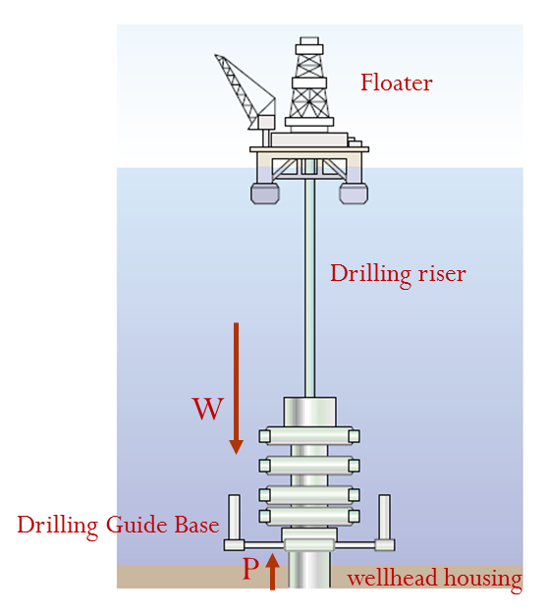
Figure.6-2: Static wellhead loading analysis.

Based on this uniform displacement, the applied load ($W$) is thus distributed onto each string in proportion to its relative individual stiffness. As a result, the axial load of each string is changed by an incremental load ($∆P_{i}$):

$∆P_{i}=k_{i}∙δ_{sys}$ (6-8)

In order to model the change in wellhead displacement and actual wellhead loads for each string throughout the life of the well, the preceding equations and conditions must be applied to each step of the well construction process as well as subsequent states during production operations. The global datum point for wellhead displacement is the flange height of the outer casing string in its initial free-standing state. The methodology is simplified by utilizing the initial and subsequent load states for each string considered in isolation from the overall wellbore system. An axial load result can be calculated using a single-string model based on a fixed nominal wellhead condition. Each single-string load can then be added to the multistring wellhead system and the appropriate redistribution of axial loads can be determined based on the discussion and equations above. The initial axial load $P_{i,o}$ contributed by each string added to the system corresponds to the hook load when it is landed in the wellhead. This is calculated from cumulative buoyed weight based on its nominal length, tubular weight, mud and slurry densities, and wellbore deviation. In addition, the landed weight of each string may include over-pull or slack-off.
For any new load state S such as a well life production operation, each string undergoes a change in axial load ($∆P_{i,s}$), When changing in operation conditions such as temperature or pressures.
For example, after commencement of production, the wellbore heats up and any given casing will tend to expand axially due to a net increase in temperature relative to the initial state. Similarly, during a cold injection or stimulation operation, each string will tend to go into increased tension due a thermal contraction. The resultant change in axial load and the associated unconstrained axial displacement for each string considered in isolation may be calculated using a standard single-string force or displacement model.
As each new string is added to the system, the wellhead undergoes a uniform displacement as discussed above and the new string landed weight will be distributed among the outer strings. If the cement has set before the new string is landed, the new string will also “slump” somewhat to bear a portion of its own weight. Likewise, for any changes in the string state during operation, the subsequent changes in axial load are redistributed across the multistring system based on relative stiffness.
A procedural method based on the foregoing discussion of simple linear elasticity, the SLEM can be summarized as follows:
- For operational load step ($S$), identify the strings $i = 1 to n$ already installed or to be landed in the current step and calculate the current composite system stiffness:

$k_{s}=\sum_{i-1}^{n}{k_{n}}$ (6-9)

- For each string ( $i = 1 to n$), determine the load change ($∆P$) relative to ($P_{i,o}$) based on single-string analysis; for a string to be landed in the current step ($S$), define $∆P_{i,s}=P_{i,o}$.
- Identify static wellhead loads $j = 1$ to m to be applied in the current load step ($S$): $W_{1,s}$, $W_{2,s}$, ..., $W_{m,s}$.
- Calculate the current incremental wellhead system displacement ($δ_{s}$) as follows:

$δ_{s}={\left[\sum_{i=1}^{n}{∆P_{i,s}}+\sum_{j=1}^{m}{W_{j,s}}\right]}/{k_{s}}$ (6-10)

- For each string, calculate the final redistributed multistring axial load based on the current load step:

$P_{i,s}=P_{i,s-1}+{∆P}_{i,s}-δ_{s}∙k_{i}$ (6-11)

6.3. Static Wellhead Loading
In the first sensitivity study, incremental wellhead displacements were calculated for a range of arbitrary static wellhead loads using both SLEM in Equation.6-9 and also state-of-the-art stress simulation software with advanced numerical modeling of multistring system behavior. There is nearly exact agreement between the SLEM solution and the numerical model, which does account for any nonlinear effects such as buckling. This indicates that the multistring system reacts in an essentially linear fashion to static wellhead loads. This result holds even for loads on the order of the axial rating of the outer casing.
This is consistent with the general observations noted above, in that the majority of the load is distributed onto the outer casing, which is either unbuckled or for which buckling strain is negligible relative to elastic strain.
Table 6-1 shows examples calculation of the system stiffness values using Subsea Pro Simulation and Installation- as shown in Figure.A-1 & A-2. In this example, the outer surface casing accounts for 92.1% of the composite system stiffness.

Table 6-1: Buckling Sensitivity Example: SLEM Multistring System Values
String. No | Section | A  (m²⁾ | E  (kN/m²) | L  (m) | $$k$$  (kN/m) | $$k/{k_{sys}}$$  (%) | $$k_{sys}$$  (kN/m)
1 | 1 | 0.96628 | 2.068E+08 | 152.40 | 1.311E+06 | 92.1% | 1.424E+06
2 | 1 | 0.52750 | 2.068E+08 | 1524.00 | 7.159E+04 | 5.0%
3 | 1 | 0.80097 | 2.068E+08 | 304.80 | 5.436E+05 | 2.0%
 | 2 | 0.39488 | 2.068E+08 | 2743.20 | 2.977E+04
4 | 1 | 0.21461 | 2.068E+08 | 3505.20 | 1.266E+04 | 0.9%

6.4. Thermal Induced Loading
A second sensitivity study was carried out to investigate the effects of thermal induced loads. Heating of the wellbore tends to induce buckling of the inner casings and tubing. This is because the outer casing will tend to restrain upward well growth driven primarily by the compressive force of the inner strings; as a consequence it will tend to go into tension. Production and injection operations were defined appropriately to focus on thermal effects as opposed to production pressures.
The initial operating state is steady-state production followed by a long duration of shutdown at roughly constant SITHP. After the wellbore returns to geostatic temperatures, kill operations are undertaken that cool the wellbore even more and also reduce wellhead pressure to a minimal value. The kill is then continued as a long-term, low-rate mud injection.
If the conductor is added to the system by assuming the wellhead to be fixed to the outer flange, then the overall system becomes stiffer. The increase in system stiffness results in a greatly reduced range of movement and a tighter clustering of the different model results.

6.5. Wellhead Reliability Analysis
Palmer and King (2008) define fatigue as the phenomenon leading to fracture under repeated or fluctuating stresses. Nazir and Khan (2007) agreed that fatigue failure occurs when the damage to the structure accumulates to a critical level (allowable fatigue strength); this is due to fluctuations at small and moderate excursions which are not large enough to cause first-excursion failure. The study of the factors and hotspots areas of fatigue is important so that the failure probability can be minimized.
Tanasa el at. (2015) said that fatigue damage of a wellhead system is contributed by vessel motions and riser motion. She also includes that the three typical hotspots of fatigue for deepwater wellhead. The first hotspots of fatigue are on the welds of the conductor and wellhead housings. This is because the welded parts are welded by human and it might have manufacturing faults. Second is the connector on the conductor and wellhead housing. The last hotspots are on the base material transitions.
Exploring oil into deeper water requires drilling the high pressure and high temperature wells (Bai, 2010). It is necessary to increase the scope of the optimization by encompassing more design parameters into the analysis. Consequently, numerous variables can be taken into account within the design spectrum but it is imperative to integrate all of the subsea components in the analysis of the casing design.
Drilling a well in deep water, the wellhead will bear the intricate forces from the environment and the drilling operation, which will affect the integral reliability of the wellhead system. Normally an FEA model is built to analyze the wellhead system reliability in terms of taking all factors into consideration, including loading from the marine environment and the drift of a drilling vessel or platform, and nonlinear response between casing string and soil stratum. Figure.6-3 illustrates the scheme of a wellhead system subjected to different loads.
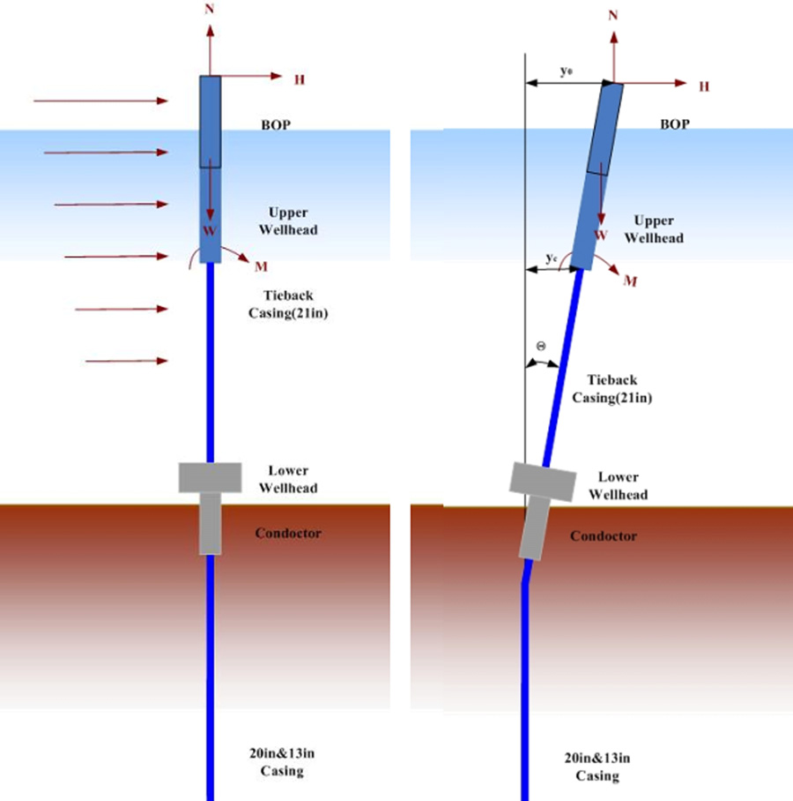
Figure.6-3: Wellhead Load Conditions [Y.Bai]

Figure.6-4 shows the force diagram for a wellhead during the drilling operation, where $F_{x}$ is the sum of the external force on the riser in the $x$ direction, $F_{y}$ is the sum of the external force on the riser in the y direction, $W$ is the weight of the BOP and wellhead and ($F_{d}$) is the direct wave force on the BOP and wellhead upper seabed.

Figure.6-4: Force diagram acting on subsea wellhead [Y.Bai].

The casing string’s displacement equation can be explained as follows:

$\frac{d^{2}}{d^{2}x}\left[EI(x)\frac{d^{2}γ}{d^{2}x}\right]+\frac{d}{dx}\left[N(x)\frac{dγ}{dx}\right]+Dc\left(x\right)p\left(x,γ\right)=q(x)$ (6-12)

where; $EI(x)$ is bending stiffness of combination of casing string, cement ring, etc., kNm2; $q(x)$ is unit external force ($kN/m$); $Dc\left(x\right)$ is external diagram of casing string, m; $N(x)$ is axial force ($kN$); $p\left(x,γ\right)$ is unit (area) horizontal soil force ($kN/m^{2}$) which is determined by Equations.6-13 and Equation.6-14.

$\left\{\begin{aligned}P_{u}=3C_{u}+γX=\frac{εC_{u}X}{D_{c}}, X<X_{r} \\ P_{u}=9C_{u}, X≥X_{r} \\ X_{r}=\frac{6C_{u}D_{c}}{γD_{c}+εC_{u}}\end{aligned}\right.$ (6-13)

$\left\{\begin{aligned}\frac{P}{P_{u}}=0.5 {\left(\frac{y}{y_{50}}\right)}^{\frac{1}{3}}, \frac{y}{y_{50}}<8 \\ \frac{P}{P_{u}}=1.0, \frac{y}{y_{50}}≥8\end{aligned}\right.$ (6-14)

Where; $P_{u}$ is critical soil force; $x$ is distance under the seabed; $y$ is horizontal displacement of casing string; $C_{u}$ is un-drained shear strength of soil; $ε$ is a coefficient 0.25 to 0.5 ; $γ$ is submerged weight of soil.
After obtaining the displacement of the casing string, the bending moment can also be obtained and used to judge the stability of the wellhead.

Chapter.7

7.0 Roncador Subsea Well System

7.1. Roncador Field
Campos Basin is located offshore Rio de Janeiro State, on the Southeast region of Brazil. It covers are 100 km² ranging from 20 m to 3400 m water depth. After 11 years discovering 2 giant fields in Campos Basin, Albacora in 1984 and Marlim in 1985 in water depth 200 m to 2000 m, In 1996 Petrobras discovered of Roncador Field in water depth ranging from 1,500 m to 1,900 m. Roncador Field was a giant field located in the northern area of Campos Basin.

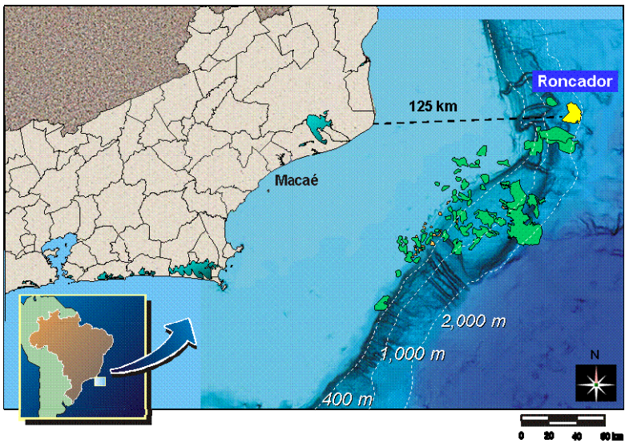
Figure 7.1: Maps of Campos Basin and Roncador Field

The Roncador Field has been leading the technological challenges of Petrobras in ultra-deep water since it is discovery. It has the world's first drill pipe riser, subsea tree and Early Production Riser (EPR) rated 2,000m. The first well in Roncador is RJS-436A connected to the FPSO Seillean from 1999 to 2001 using EPR at water depth 1,853m with GLL TLD 2000 subsea tree. This field has 3 billion barrels of proven recoverable oil reserves. Due to its large reservoir size, the field was divided into four modules, Module 1 has oil well 28-31 API, Module 2 oil wells 18 API, Module 3 has oil well 22 API and Module 4 has oil well 18 API. Module 1 has two phases, Phase 1 and Phase 1A. There are total 94 wells in Roncador Field, which is 60 wells are production well and 34 wells are water injection wells. Two types of subsea technologies were used; vertical and horizontal. Both tree technologies are guidelineless with vertical flowline connection with individual vertical modules. Several offshore floating structures have been chosen to operate in Roncador Field for production activity such as floating production storage and offloading vessels and semi-submersibles.

7.2. Roncador Field Project Development
Petrobras developed Roncador field in four modules because of its large size and different oil gravity in each area. Module 1 has several phases. Figure 7.2 shows the project development modules in Roncador Field.

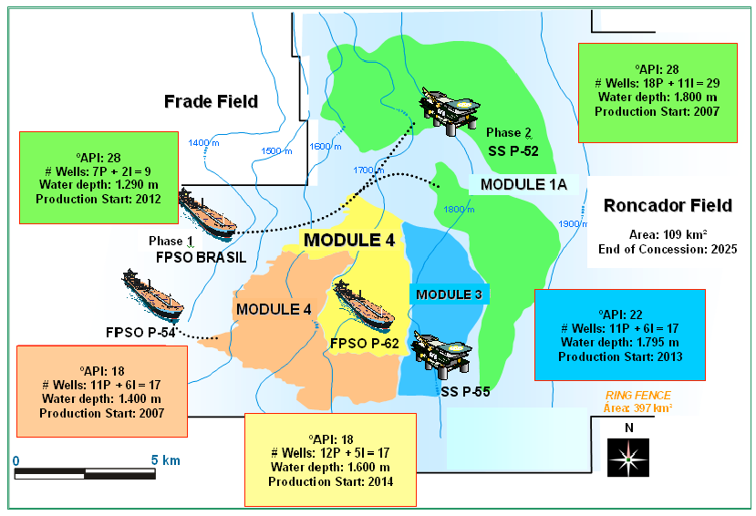
Figure 7.2: Project Development Modules in Roncador Field

The Early Production Phase started producing in 1999 from the first well, RJS-436. This well located at water depth 1,853 m and connected to FPSO Seillean. This phase was set to produce early in order to create revenue for the project to cover the huge costs for development the whole field. During this phase, the production was 20,000 bbld.
Phase one of Module 1 consisted of several wells connected to semi-submersible production facility P-36. It is start producing in 2000 and later in March 15, 2001, this semi-submersible has sunk due to explosions due to human error. During that time, P-36 is considered the biggest submersible which produced 84,000 bbld of oil and 1.3MMscmd of processing gas. After the P-36 incident, Petrobras has started with Module 1A: Phase One. They want the field to producing as soon as possible. FPSO Brasil has been installed on water depth 1,290 m and eight production wells have been connected to the vessel. On 2002, the field has started production again.
In Module 1A Phase Two, new build semi-submersible P-52 has been fabricated and installed in 2007. This platform is connected to 18 subsea production wells and 11 water injection wells. The submersible produce 20,000 bbld peaking to 180,000 in second part of 2008. The peak gas produced from this phase was 3.2MMscmd. For this project, we will focus on Module 1A only. A module 2 development consists of 17 long horizontal wells which 11 of them are production wells and 6 are water injection wells. FPSO P-54 has been assigned for production in this module and started operation in 2007. This phase has helped to boost the overall production from the field to 460,000 bbld. A module-3 development consists of 11 add-on production wells and 7 water injection wells. For this module, semi-submersible P-55 has been assigned for production. The production capacity for this platform is 180,000 bbld and gas compression capacity is 6 MMscmd. The platform started its production in 2013. Module 4 development consists of 19 wells, which is 12 wells are production well and another 7 wells are water injection well. An FPSO P-62 has been assigned for this module. This FPSO is a cloned to the P-54 FPSO. The production capacity is 180,000 bbld and gas compression capacity is 6 MMscmd. This platform started its production in 2014.

7.3. Floating Structures in Roncador Field
In Module 1A, there two types of floating structures used for production, floating storage production and offloading (FPSO) and semi-submersible.

7.3.1. Brazil FPSO
After the P-36 sunk due to explosion, Petrobras chartered a production unit called FPSO Brazil from Single Buoy Mooring (SBM) for 5 and half years. This FPSO were temporarily substitutes for P-36 and has been assigned in water depth 1,300 m. FPSO Brazil was a conversion of crude tanker to FPSO. The conversion has been done in Keppel Shipyard. Her former name was Esso Saba until 1987, then changed to Esso Freeport until 1993 and later changed to Moscliff until 2002. It was built in 1978 by AG Weser in Bremen, Germany. The hull dimension for this FPSO is 348 m length, 52 m breadth and 25.61 m depth. The max operating draft is 20. 91 m. Her deadweight is 244,000 tonnes. Her storage capacity is 1,708,000 bbls with the maximum output 90,000 bbls oil per day. Her water injection capacity is 50,000 bbls per day and gas lift and export capacity is 3MMscmd. There are 22 risers and 10 swivel stacks attached to this FPSO. This FPSO start operating in December 2002.

Table 7.1: Details of FPSO Brazil as below (SBMOffshore, 2015);
Description | Units
IMO Number | 7360849
Name of the ship | FPSO Brazil
Type of ship | Floating Storage/Production
MMSI | 308418000
Gross tonnage: | 120,545 tons
DWT | 244,000 tons
Year of Build | 1974
Builder | AG Weser – Bremen, Germany
Flag | Bahamas
Home Port | Nassau
Class Society | ABS
Manager and Owner | SBM System – Marly, Switzerland
Former Name | Moscliff (until 2002)
 | Esso Freeport (until 1993)
 | Esso Saba (until 1987)
Number of riser | 8 x 6" production
 | 2 x 6” & 1 x 8” gas injection
 | 1 x 12” gas export
 | 3 x 6” water injection
 | 8 x umbilicals
Swivel stack | 2 x 14” production
 | 2 x 6” gas lift / export
 | 1 x 10” water injection
 | 1 x 10” fire water
 | 1 x 8” test
 | 2 x utility / hydraulic
 | 1 x LV electric
Storage capacity | 1,708,000 bbls
Max. throughput | 90,000 bbls oil per day
Gas lift + Export | 3 MMscmd
Water injection | 50,000 bbls

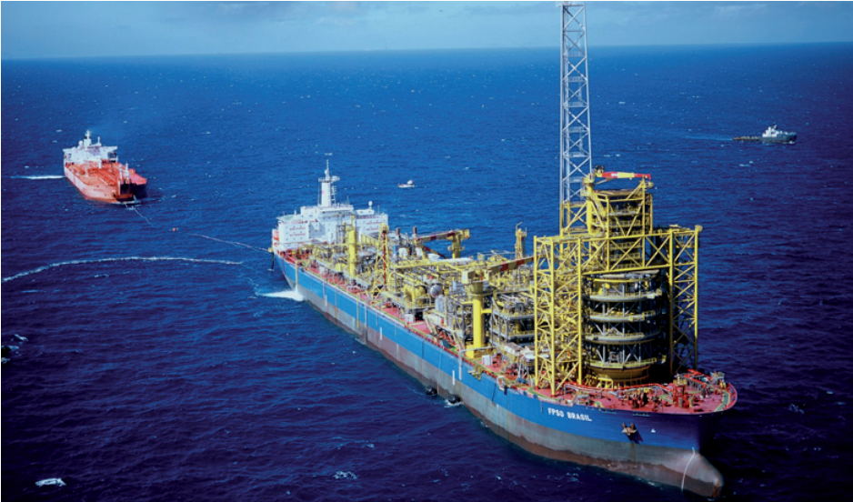
Figure 7.3: FPSO Brasil (

7.3.2. P-52 Submersible
Petrobras has built a new semi-submersible for Module 1A Phase Two. This semi-submersible has been designed by Aker Solution for hull and Technip for topside. Petrobras has appointed FELS Setal and Keppel FELS for hull and topside fabrication. The dimension for this semi-submersible is 361 m length, 295 m breadth and 210 depths. The deadweight is 45,832 tonnes while the topside weight is 25,000 tonnes. Operating draft is 89 m. The displacement is 89,000 tonnes. This semi-submersible has oil production capacity 180,000 bbld and water injection capacity 300,000 bbld.

Table 7.2: Details of P-52
Description | Units
IMO Number | 8768725
Name of the ship | Petrobras 52 (P-52)
Type of ship | Semi-submersibles
MMSI | 538002729
Gross tonnage: | 60,924 tons
DWT | 45,382 tons
Year of Build | 2007
Builder | Keppel FELS Ltd. - Singapore
Flag | Marshall Islands
Home Port | Majuro
Class Society | DNV
Manager and Owner | Petrobras
Number of riser | 24 Flexible riser
 | 46 SCR
hull design | Aker solution
hull fabrication | FELS Setal
topside design | Technip
topside fabrication | Keppel FELS
Hull Fabrication yard | Keppel FELS (BrassFELS)
Max. throughput | 180,000 bbls oil per day
Gas lift + Export | 3.2 MMscmd
Water injection | 300,000 bbls
Anchoring System | Taunt Leg
No of mooring lines | 16 lines

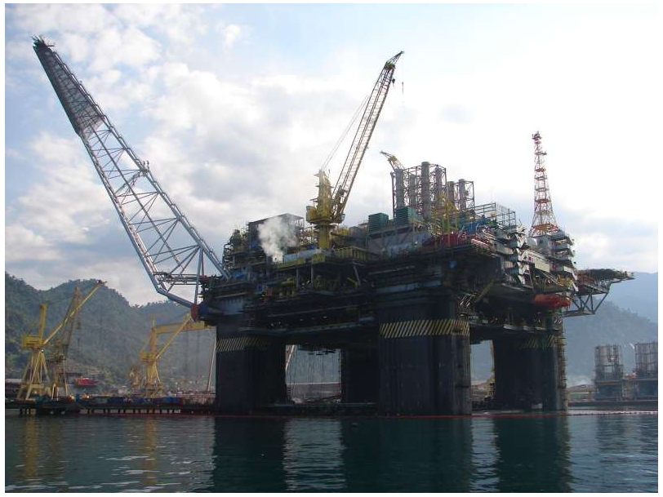
Figure 7.4: Petrobras 52 (P-52)

7.4. Drilling System
In this part, we will discuss on the drilling activities and geology as well as reservoir at Roncador field Module 1. This Module 1 has been worked on from 2002 to 2007 which are capable to handle 180,000 barrels of oil per day. The Roncador field consists of turbidite sandstone reservoirs and the field can be divided into two main blocks, which are separated by expressive fault with different oil/water contact as shown in Figure 1.
Figure 7.5: West-East structural geological section. (Bordieri, E., 2008)

The turbidite sandstone reservoirs are defined as a thick succession of gravel/sand-rich tubular reservoir confined to intra-slope troughs defined by subsidence along districts faults soling out on underlying evaporates. These reservoirs have high porosity up until 24% to 30% and permeability around 400 to 5000mD. These reservoirs required massive water injection systems in all development modules to maintain reservoir pressures near the original pressure because they do not have great aquifers in contact with the oil zones.
In this field, the horizontal and vertical deviated development have been drilled, which the horizontal applied in the thin subzones or low permeability subzones in order to increase the productivity and infectivity. These horizontal wells have been equipped with the gravel pack and the vertical with the selective frac-pack interval. Around 80 wells have been drilled in the Roncador field and all production system has been fully implemented. The horizontal well drilling was used in Roncador field, which can have improved the recovery, higher Productivity Index (PI) and less wells to drain the same reservoir areas. Based on the x, the total time spent in drilling was 62 days, which include the second horizontal section. The problems arise were BOP, running the 13 3/8 csg. and the second horizontal section. If the problems not happened, the time incurred for drilling can be reduced.
The extensive drilling and well completion activities on going with the three dynamic positioning (DP) operated drilling rig working in parallel not only during pre-survey activities but also during the pipeline installation activities. During the drilling activities, the drilling rigs had deployed transponder arrays to set as reference systems and give safe frequencies to prevent conflict with the drilling rigs transponders. The Roncador field development includes 18 subsea production wells and 11 subsea water injection wells tied back to the semisub through 45 risers 23 umbilicals. It also has three subsea manifolds.

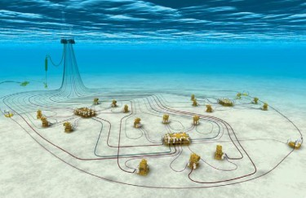
P-52
Oil: 180.000 bpd
Water depth: 1800 m
MSGL-RO-02 6 production wells
Subsea System: 29 Wells
-18 Production Wells
-11 Water Injection Wells
-1 Oil Export Pipeline
-1 Gas Export Pipeline
-3 Subsea Manifolds:
- Gas-lift Injection
- Chemical Products inj.
- Well control
MSGL-RO-01 6 production wells
MSGL-RO-03
3 production wells + 3 injection wells
Figure 7.6: Roncador Subsea system (Subsea World News)

7.5. Wellhead and Subsea Tree
Wellhead system is functioning as structural and pressure-containing anchoring point on the seabed for the drilling and completion systems and for the casing strings in the well. The primary function of subsea tree is to control the oil and gas flow out of the well. Besides that, tree has also been used to control the injection of gas or water into non-producing well in order to enhance production rates of oil from other wells. Tubing hanger can either located in wellhead or tree is used to suspend the production tubing or casing.
Most of the wells in Roncador Field Module 1A are vertical or deviated multiple-completion or cluster wells due to the stratified high-net sandstones. However, some of them are horizontal wells also. These wells are equipped with 16" x 10,000 psi wellheads and on the production wells used 5" tubing hanger in order to achieve the expected oil production that is 10,000 bbld.
Figure 7.7 shows Module 1A standard well design. Slender well technology has been introduced in Roncador field and this helped to decrease the drilling time to 35/40 days.
Well design for Roncador Field is as follows;
- The 30” conductor pipe is jetted down 1,910 m with low pressure housing.
- The 26” hole is drilled to 2,237 m and 20” casing string is run and cemented with 16 ¾” x 10,000 psi wellhead housing.
- Then, 16” hole is drilled to 2,598 m and the 13 3/8” casing is run and cemented.
- The 12 ¼” hole is drilled until reached TD and 9 5/8” casing is run.
- For well completion, the wells are perforated with 7” wireline conveyed guns and frac-packed for sand control.
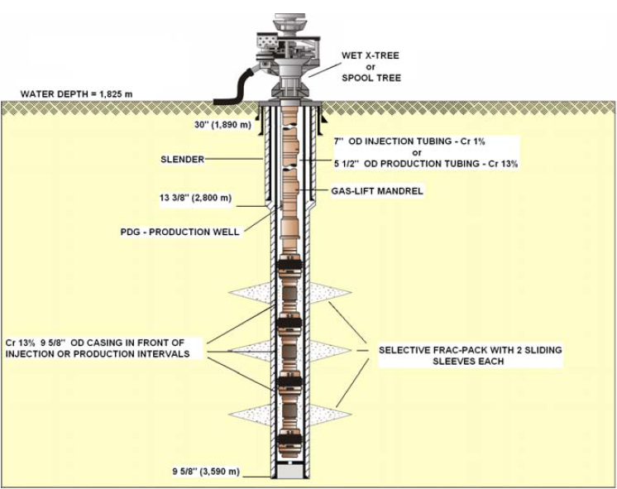
Figure 7.7: Standard Well for Module 1A

In Roncador Field, Module 1A, there are two types of subsea trees technologies have been installed which is compatible with a 6 5/8-inch wellbore; vertical subsea trees and horizontal subsea trees. For vertical subsea trees, total 7 trees have been installed in this field with three different model which two trees are GLL-2000 and GLL-VII tree, three trees are GLL-VI-2000. Only three horizontal subsea trees have been installed in this field.
Figure 7.8 shows vertical guidelines tree used in Roncador. The main characteristic of vertical GLL tree as listed below;
- 4” x 2” x 5,000 psi subsea tree.
- one master valve in the production bore.
- all tree valves are hydraulic direct operated from the production facility.
- chemical injection ports downstream and upstream the production wing valve.
- temperature and pressure transducer in the tree block.
- two independent 3/8” lines to operate the DHSV.
- high pressure tree cap, thus eliminating the use of blank plugs in the tree manifold
- dual check valve in the 2 inches’ annulus bore, which is automatically closed when the tubing hanger running tool or subsea tree is removed, eliminating the use of blank plugs.
- ROV intervention panel in the tree cap allows redirecting different control lines to collectively operate a group of valves, through the use of three way valves.

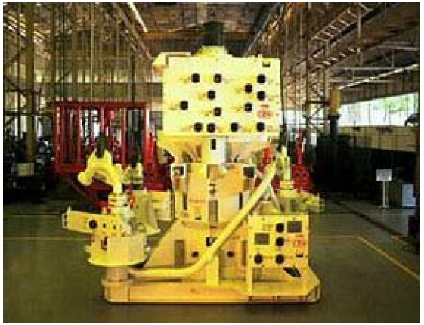
Figure 7.8: Guidelineless Vertical subsea tree with vertical flowline connection with individual Vertical Connection Modules

Figure 7.9 shows the horizontal guidelineless subsea tree installed in this field. The main characteristics of the horizontal trees used are the same than the vertical subsea tree and the main differences are listed as follows;
- 5” x 2” x 5000 psi
- metal x metal seals in the TH
- blank plugs with metal x metal seals
- external tree cap, allowing light workovers to be performed with the tree cap installed
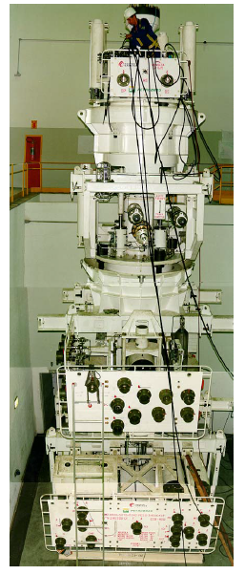
Figure 7.9: Horizontal Tree vertical flowline connection with individual Vertical Connection Modules

For ultra-deepwater wells, horizontal subsea tree technology is selected due to these reasons;
- High flow rate: ultra-deep-water fields are planned to have high flow rate wells. The Horizontal trees will allow production strings with larger diameter (> 5 ½ in).
- Light workover: Horizontal Xmas trees allow some workover operations in the well without running BOP stack, saving rig time.
- Speed up well intervention: Horizontal Xmas trees allow replacement of production string without retrieving the Xmas tree.

Chapter.8

8.0 Perdido Subsea Well System

8.1. Perdido Field
The Perdido Development is located in the Perdido Basin and Foldbelt in the Alaminos Canyon Protraction Area which is jointly developed by Shell, BP, and CVX. This area is located in the western Gulf of Mexico, 200 miles south of Freeport and only eight miles north of the Mexico maritime border. The Perdido has three fields which are the Great White, Silvertip, and Tobago fields. All the fields are developed with subsea wells tied back to the host, which is a SPAR with full offshore processing capabilities and pipelines for export. The Perdido production hub has the capacity to handle 100,000 barrels of oil and 200 million cubic feet of gas daily.

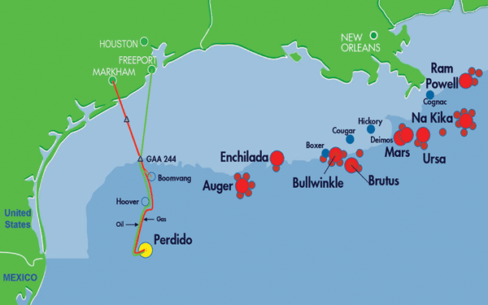
Figure 8.1: Perdido field Location (http://www.ogj.com).

8.1.1. Challenges and Issues
Significant challenges associated with development of these fields include:
- Extreme water depth:
Water depth at the three fields ranges from 2400 ~ 3000 meter. This extreme depth represents significant installation, operation, maintenance and flow assurance challenges.
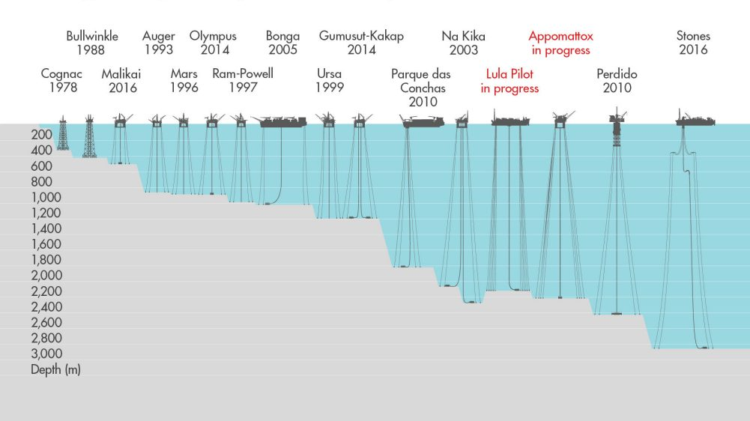
Figure 7.2: Perdido Deepwater (http://www.shell.com).

- Problematic seafloor terrain:
In addition to the Perdido Canyon, faults, and significant chemosynthetic communities, the rugged seafloor terrain in this area includes geologic features such as fluid expulsion, seafloor erosion, and steep slopes. These seafloor features make the subsea equipment layout and choice of host location extremely challenging.
- Distinct fluid properties:
The reservoirs of these three fields consist of three different oil-bearing formations, Oligocene (Frio), Upper Wilcox (WM-12), and Lower Wilcox (WM-50) with fluid properties ranging from 17 to 40 API and gas/oil ratios from 350 ~ 2,600 scf/bbl.
- Low-Temperature And Low-Pressure Reservoirs:
The reservoirs exhibit characteristics of low temperature and low-pressure, as a result, a novel subsea boosting technology was required to ensure the deliverability of the reservoirs.
- Market condition:
The project was sanctioned when the industry experienced an active market condition, which made on-time delivery of equipment and an accurate cost estimate of the project extreme difficult.

8.1.2. Overcomes of Challenges
In order to overcome those challenges, the Perdido Development is using cutting-edge technologies that include Wet-Tree Direct Vertical Access (DVA) wells and a unique subsea boosting system for artificial lift. The development system also incorporates a high-pressure single-bore top-tensioned riser with surface BOP, for drilling/completion of the subsea wells. Unique features of the subsea system are as follows:
- All wells are subsea (wet trees operated by umbilicals) and consist of 22 local DVA wells and 12 offset wells. An offset well is an existing wellbore that may be used as a guide for planning a well.
- A compact 6-slot SPAR equipped with a platform rig will drill and complete the DVA wells and process production from all wells, as compared to the conventional dry tree DVA technology requiring 22 slots, and thus a larger host.
- The DVA wells will be drilled, completed, and intervened through a single high-pressure drilling/completion riser with the host rig through a surface BOP system, using only one of the six well bay slots.
- Production from both the offset and DVA subsea wells is commingled through dual-header manifolds. All production then flows from manifolds into five separation and boosting systems where gas flows naturally to the topside facility and liquids are pumped using powerful electrical submersible pumps.

8.2. Drilling
The offshore drilling rigs used for Perdido project was the Tulsa, a H&PS Rig 205 rig from Helmerich & Payne, Inc. (H&P). The rig’s drilling module is supported by a custom skid base that spans the spar’s 65-ft (19.8 m) capping beams and is designed to be assembled by the spar’s two pedestal cranes. Rig 205 also has been upgraded in a number of other areas, Freeny said. These include draw works disc brakes, a 49-1⁄2-in. rotary table with PS-21 slips, a “Cyclone” Iron Roughneck, and a 16-3⁄4-in. x 5,000-psi BOP with setback dolly positioning. The drilling operation of Perdido Spar drilling rig were using the riser system as it is for the deep water operation.

8.2.1. Drilling Procedures
After all the position of the spar and connections (mooring) between the surface and the seafloor are secured, it is now the time to start the drilling process of the offshore wells.
- To start an offshore well drilling, firstly the drill pipe is installed.
- Next step, the conductor which is a thick wall large diameter hollow tube is installed. Then, the conductor pipe and guide are run down into the sea to be embedded in the seafloor. After the conductor pipe penetrates the seafloor, the drill pipe is released and pulled back to the spar.
- A jet bit connected to the bottom of the drill pipe is run down to the sea floor. The bit is run down to the bottom of the hole through the conductor pipe. With aid from the bit, it jets away the sediment with high-pressure seawater. When the conductor has penetrated about the suitable depth, the jet bed is retrieved and a large drill bit is introduced using the same method. The drill bit rotates and drill the sediments and rocks below the sea bed. The cutting were just washed to the top of the well by seawater pumped through the bit.
- A second run of smaller diameter conductor is now lowered into the hole equipped with a guide shoe at bottom of the conductor that stops the conductor scraping on the wellbore.
- Float collar are installed above the shoe and a cementing tool is connected to the top of the conductor. The seawater were pushed out by a plug driven by high pressure cement filling the conductor. On reaching the float collar this plug is ruptured and cement flows out of the bottom of the conductor and up the annular space between the wellbore and the conductor.

Figure 3: Cement filling the space between conductor and wellbore.

- Drilling continues with a smaller diameter bit penetrating the cement plugs and float collar into fresh rock. After a suitable depth has been drilled, the drill string is removed then steel tubing known as casing is lowered into the hole and cemented in place. The casing has an attached wellhead.
- A blowout preventer, BOP is then lowered and locked onto the wellhead. The BOP is connected to the sea surface by a riser, a large diameter tubing which allows drilling fluids to be returned to the surface.
- After the riser is attached, the usage of sea water is replaced by special fluid known as drilling mud that is pumped down the string and exits through the small holes in the bit. The mud cools the bit and clears the cutting from the hole to the spar at the surface to be examined to characterize the rock types that are being penetrated.
- A set of decreasing diameter bits and casing are used to penetrate the well deeper into the rock. Every casing was sealed by cement. Density of drilling mud is controlled by adding dense minerals when needed to produce a dense mud which exert sufficient pressure in the well to counteract pressure from outer fluids encountered in the rock. This combination of the dense mud column contains improperly cemented casing aims to control pressures in the well.

Figure 4: The cutting brought to spar by mud to be examined

- The potential oil and/or gas reservoir are detected from the drilling cuttings for traces of gas or oil. To gather more information about the reservoir, the drill bit is replaced with a diamond studded coring bit at the bottom of core barrel to cut a section of the reservoir rock and return it to surface for detailed analysis.

Figure 5: A sample of reservoir taken to be analyse

- When sufficient data has been gathered from the reservoir, a decision is made on whether to complete the well for production, suspend efforts with the option to return to the well at a later date for more information or to plug and abandon the well.
- If the well has seem to have production potential, the reservoir is lined with casing. The casing is then perforated to allow reservoir fluids to enter the well and travel up the completed production string to surface into the storage.
Figure 6: Perforated casing accumulate the reservoir fluids

8.2.2. The Challenges

8.2.2.1. Development Challenges
The early development drilling for Perdido Spar is challenging for many reasons. One of it was the rugged sea floor makes it harder to install subsea equipment and pipelines, and the extreme water depth makes drilling more difficult. Other than that, the reservoirs there have a wide range of permeability and low pressure. The wells show significant different of quality of oil and gas at different areas.

8.2.2.2. Deepwater Drilling Challenges
Successful deep water drilling is achieved if the total well depth in the desired holes size is reached safely and the designed casings are placed across the desired depth intervals.

- Deepwater Geohazards
Geohazards are some potential source of problems such as steep unstable slopes, irregular topography, over-pressured sands at relatively shallow depths, active faults, landslides, gas hydrates, sea floor erosion, ground conditions raging from weak under consolidated soils to rock and locally corrosive soils that could require special design of the conductor.

In the Gulf of Mexico, streams of warm water that flow beneath the ocean surface and that travel from the Caribbean Sea into the Gulf and back out again called Loop Current could cause havoc with the drilling rig and making the riser experienced fatigue from vortex-induced vibration.

D
C
B
A
Figure 7: The Gulf of Mexico Loop Current

The Loop Current in the Gulf of Mexico may form a short loop (A) or may become elongated into the gulf (B). When the loop is long, it often pinches off a spinning body of water called an eddy (C). These eddies drift west throughout most of the gulf areas over many weeks (D) and eventually lose energy in the western Gulf. The cycle of loop and eddy currents repeats itself several times a year.

- Shallow Hazards of the Deep
Operators begin the process of deep water drilling by picking drilling targets and locations. Other than man-made obstacles such as cables, pipelines, wellheads and even unexploded ordnance, some areas of the seafloor contained natural hazards to drilling such as active fluid escape pockmarks, mud volcanoes and active fault scarps that can create unstable substrate, making anchoring rigs and spudding wells impossible. In deep-water, unstable slopes, slumping and sliding are also considered as the challenges for drilling operations.
Just below the seafloor, threats to drilling come from shallow water and gas flows, gas-bearing channels and active faults, etc. Presence of shallow water or gas pockets could pose a risk of blowouts or seafloor collapsing during and after drilling operations.
Figure 8: Formation of shallow water flow hazards in deep water.
As sediments are deposited, rates of fluid escape may or may not keep pace with the rate of compaction. If the fluids are unable to escape at a rate that allows equilibrium with hydrostatic pressure, the sands become over-pressured. Drilling into an over-pressured sand allows the trapped water to be released, often suddenly.

- Borehole Instability
A number of mechanical instability problems such as caving in the well and total bore hole collapse always been associated with the characteristics of the deep water sediments. Borehole Instability affects both, vertical and directional wells, depending on the stress regime underground. Except for some situation such as drilling in salt dome area, the directional wells are more likely to experienced high collapse pressure gradients due to well inclination. To overcome this, higher density of mud are used in order to keep the bore hole walls from collapsing.
In consequence, well trajectory in deep and ultra-deep water wells must be carefully designed to minimize borehole instability. Unfortunately, some of the procedures usually used by directional drillers are quite limited in deep water situations. For instance, the common approach of lifting the kick off point (KOP) to reduce well inclination is not always possible in deep water due to the characteristics of the shallow weaker sediments.

- Drilling Mud
Environmental friendly, easy to handle, good chemical inhibition, versatile composition and good transporting capability are some of the main characteristics a drilling fluid must have to overcome the following challenges:
- Keep chemically reactive, fragile and unstable formations in place,
- Allow high rates of penetration,
- Deliver calliper under the desired tolerance,
- Be economically feasible.
The current drilling program of Perdido drilling requires both water- and oil-based mud to be used in its drilling operations.

8.3. Field Layout System
The Perdido Development consists of three different fields which is Great White, Tobago and Silvertip (red break line). The development of the field has four major subsea clusters (blue line) as illustrated in Figure 7.3. The field layout is based on a subsea wet-tree Direct Vertical Access (DVA) concept with additional subsea tiebacks from offset wells. The concept provides for rig access to a maximum number of subsea wells while minimizing the size of the host platform. The following is a description of the unique characteristics of the four clusters.

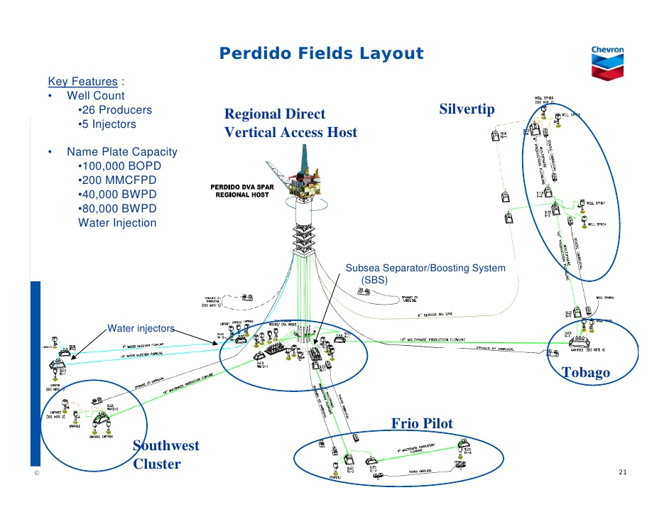
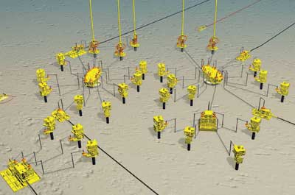
Figure.7-3: Perdido Subsea System [Smith].

8.2.1 DVA Cluster:
The DVA Cluster was configured for the development of the majority of the Great White anchor reservoir. This cluster is directly beneath the host facility and its arrangement can accommodate up to twenty-two subsea wells. These wells are to be drilled, completed and intervened by the Spar rig (H&P 205) through a high-pressure drilling/completion riser and a surface BOP system. In order to accommodate DVA to the wells and the subsea boosting equipment in this cluster, all equipment was placed within a 175 ft radius circle.
All DVA production is commingled and collected at two dual-header manifolds. The manifold is also designed for the tie-in of flowlines from the offset well clusters. The production then flows from each manifold into two separation and boosting systems (SBSs) at the base of top-tensioned risers where gas flows naturally to the topside facility, while liquids are pumped using high horsepower electrical submersible pumps

8.2.2. Southwest Cluster
The Southwest Cluster is approximately three miles southwest of the DVA Cluster. This cluster consists of three production wells and two water injection wells. Fluid from the production wells is commingled and flows to the north manifold at the DVA Cluster through a single 10-inch flowline with Glass Sphere (or Syntactic) Poly-Urethane (GSPU) insulation. The choice of a single flowline eliminated the need for a manifold at the SW Cluster. Instead, a flowline termination sled with four hubs was used to allow the initial tie-in of the production wells and one future tie-in of a daisy chain flowline or an additional well.
This cluster is also configured to accommodate a couple of water injection wells. Water for the injection wells is provided through a 10-inch water injection line with steel catenary riser from the host. Similar in layout to the production wells, a flowline sled is used for distributing water to the SW injection wells while a daisy-chained water injection line to the DVA Cluster supplies the three water injection wells at the DVA Cluster.

8.2.3. Oligocene Cluster (Frio Pilot)
The Oligocene Cluster consists of two wells that are being used to test a shallow reservoir (2000 feet below the mudline) in the Great White field. The two wells are located about two miles south of the DVA Cluster and daisy-chained with single 8-inch flowline insulated with GSPU. The production is then commingled and flows to the south manifold at the DVA Cluster.

8.2.4. Regional Cluster (Silvertip and Tobago)
The regional cluster consists of subsea tiebacks from both Tobago and Silvertip fields. Tobago is approximately seven miles east of the DVA Cluster, and Silvertip is about two miles north of Tobago. This cluster is configured to support maximum of six wells. In phase I, there will be a total of three wells, four from Silvertip and two from Tobago. The two fields are daisy-chained with a single 10-inch GSPU-insulated flowline, and their production is commingled and flows to a dedicated subsea boosting system at the DVA Cluster. In order to mitigate the possibility of hydrate formation during an unplanned shutdown, there is a 6-inch un-insulated oil service line from the host to Silvertip to establish a flow loop for dead oil circulation when necessary.

8.3. Subsea Facilities

8.3.1. Surface BOP and Completion of Subsea Wells
All of Perdido’s wells are being drilled either from the spar itself, or from moored or dynamically-positioned floaters with single or dual derrick systems. That difference in drilling systems led to some variety in the way the subsea trees were installed. The idea of using wet-tree wells with direct vertical access from the spar helped minimize the size of the host platform. All of the drilling, completion and subsequent maintenance of the spar’s 22 wells can be completed using the onboard rig. The rig is held in a fixed position over a well by adjusting the mooring lines on the spar. Tension on the mooring lines can be adjusted to reposition the rig over a different slot. This system is significantly less expensive than using a 5th generation floating rig to complete and service the wells.
Perdido’s onboard capability includes a custom wellhead, riser and blowout preventer (BOP) system. The surface BOP is a custom made 16-3⁄4-inch unit with a rating of 5,000 psi. It is connected to a top-tensioned, high pressure drilling and completion riser (DCR), which was also designed specifically for the Perdido project.
The second key novel technology was using surface BOP to drill and complete a cluster of 22 subsea wells. The wet-tree DVA concept was adopted for the Perdido Development in order to minimize the size of the host, while maximizing the number of subsea wells with direct vertical access (DVA) from the Spar. For the DVA subsea wells, drilling, completion, and workovers are performed with a rig located on the Spar. The rig stays in a fixed position over the dedicated drilling/completion slot, and the host is moved by the active mooring system around the well pattern to provide vertical access to all the wells in the working area. Significant cost saving are achieved using this arrangement, compared to using a 5th generation floater to drill and complete the wells in this water depth.

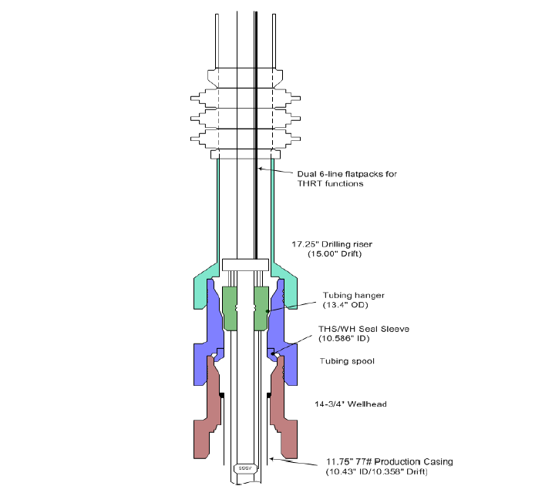
Figure.7-5: Schematic for installing subsea tubing hanger with a surface BOP.

A custom wellhead, riser, and BOP system was developed for this project. The surface BOP (blow out preventer) is a 16-3/4- inch 5,000 psi rated stack. It is connected to a top-tensioned, high-pressure drilling and completion riser (DCR). The DCR was specially designed for this project. It has a 17.25-inch OD and a 15-inch drift, and it is rated for 5000 psi internal pressure at surface with 10.1 ppg fluid in the riser. Unlike surface BOP operations from floaters, no subsea isolation device (SID) will be installed on the bottom of the riser because the Spar rig is considered to be a permanently moored structure and because the DCR is designed to stay connected during hurricane abandonment.
Well operations are in general very similar to dry-tree DVA wells for most drilling and completion activities (drilling, running casing, wellbore cleanout, perforating, gravel packing).
The most significant challenge for the completion of subsea wells with a surface BOP is running and landing the subsea tubing hanger without a subsea isolation devise. The three main issues that needed to be addressed for this operation were (1) double terminations of the umbilical lines if a surface spanner joint is used, (2) the need to be able to pressure up the annulus for testing, and (3) the size/weight of a conventional IWOCS umbilical for this water depth. The Perdido solution is a hybrid configuration in which the IWOCS umbilical is replaced by two six-line flat packs for hydraulic functions and a single TEC line for the electrical connection. The lines are run with the landing string just like control lines are run with the production tubing. As a result, no surface spanner joint is required.

8.3.2. UWD-10 Slimbore
FMC Technologies' UWD-10 Slimbore Systems allow the use of reduced-diameter riser systems for drilling and production applications are suitable for H2S service and are available in 16-3/4", 14-3/4" and 13-5/8" nominal-bore diameters. Each system has a rigidizing mechanism to provide enhanced fatigue resistance.
The UWD-10 Wellhead System is designed for a complete range of drilling and production scenarios in shallow or deep water with subsea or surface BOPs. This makes it possible for early-generation drilling vessels to drill in deeper water, and floating production facilities can increase the quantity of production risers tied back to the host platform.
Based on the industry-leading UWD-15 running tools design, the Slimbore continues the tradition of providing multi-function running and test tools. The tools provide the option of running and retrieving components either individually or in combination.
Advantages of a Slimbore Wellhead System
- Designed to be used with Surface BOPs
- Allows for lighter drilling packages on TLP and Spars
- Designed with smaller and lighter casing programs
- Reduces mud costs due to smaller drilling risers
- Can be used in shallow and deepwater applications

13 5/8” Wellhead Housing and Running Tools
13 5/8” Slimbore Wellhead Housing
  - 4.0 million ft-lb bending capacity (18 ¾ H4)
  - Rigidizing Mechanism provides 1.5 million pounds of preload
  - 2.85 million lb. Internal load shoulder rating
  - Capacity for up two casing hangers, or one hanger and tubing hanger
  - 10,000 psi plus 1.0 million pounds casing for 1st hanger and 650,000 pounds casing/tubing 13 5/8” Wellhead Housing Running Tool
  - 1.0 MM Rated Casing Capacity • Runs and Retrieves Nominal Bore Protector
  - Performs BOP tests up to 10,000 psi Rigid Lock Setting Tool
  - “Bolts-on” to the Wellhead Housing Running Tool
  - Preloads the Rigid Lock using ROV or Drill Pipe Pressure

13 5/8” Spring Loaded Tool & Wear Bushing
  - 10,000 psi Rated Working Pressure
  - Run/Retrieve all Wear Bushings and pressure test BOP stack on the same trip
  - Can perform BOP tests in all wellhead positions
  - Retrieve 13 5/8” Annulus Seal Assemblies
  - Spring loaded mandrel provides 4.63 in2 of flowby area
  - 5,000 lbs of drill string weight required to compress spring and close flowby
  - No drill pipe rotation required to function tool

13 5/8” EVDT Tubing Hanger (shown in wellhead)
  - 10,000 psi Working Pressure
  - Available for 5” – 7” tubing
  - Features a 1-1/2” annulus gate valve
  - Can accommodate up to 11 down hole lines

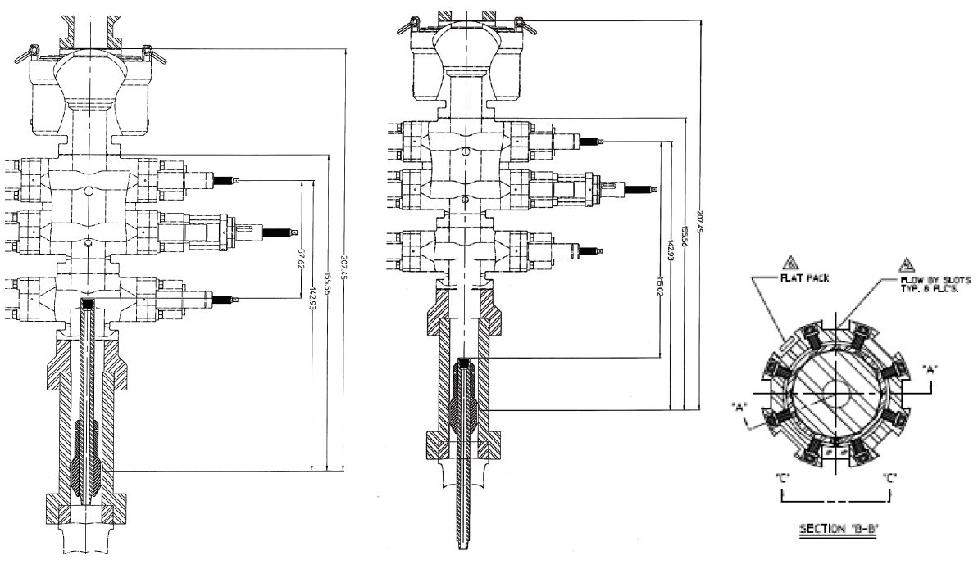

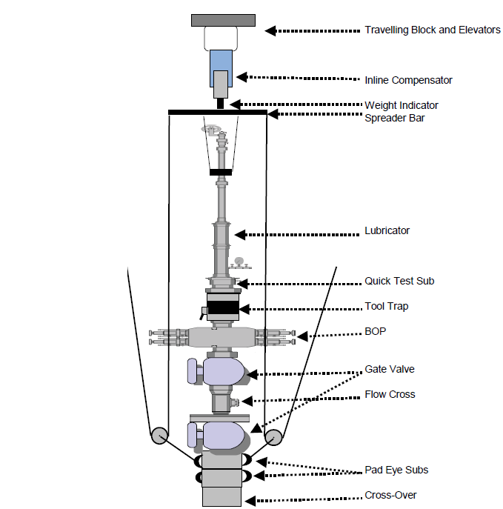

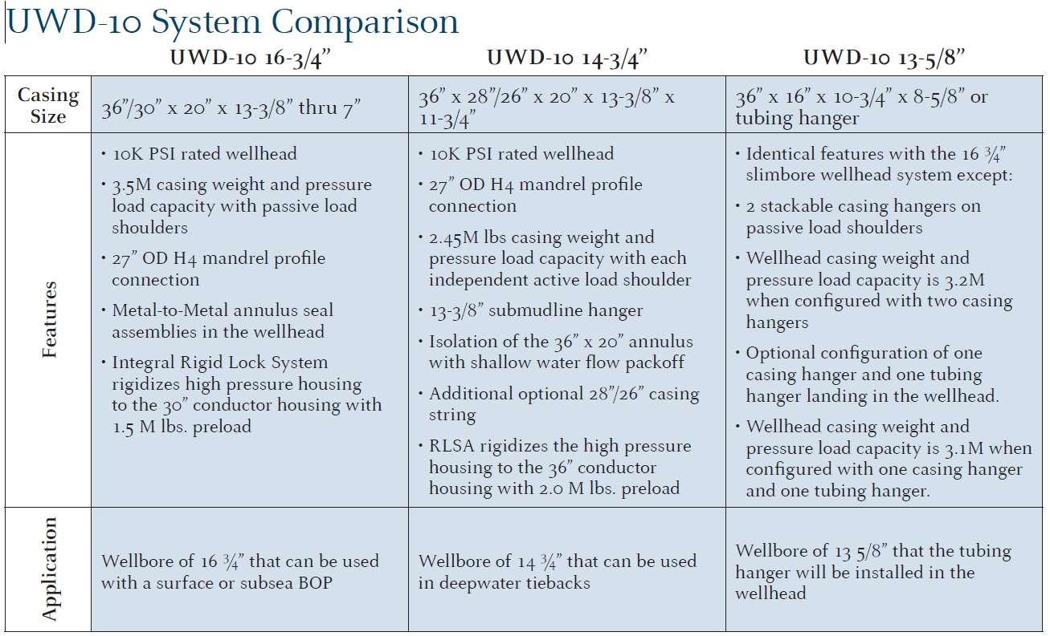

8.3.1. Chemical Injection
In addition to the subsea injection of LDHI and paraffin inhibitor mentioned above, methanol injection is included at each subsea tree for displacement of trees/jumpers and bull-heading at shutdown. Provision for downhole scale inhibitor is included for select wells, to mitigate scaling risks due to waterflood, as well as to prevent scaling on the ESP motor surface, which could lead to motor overheating. Subsea defoamer injection has been provided into each Caisson, to aid in the subsea separation.

8.3.2. Subsea Boosting System
Since the reservoirs of Great White, Tobago, and Silvertip all have similar characteristics of low temperature, low pressure, and are in ultra deepwater, production simulation indicated that artificial lift was required to ensure reasonable production rates. Therefore, the need for artificial lift in order to economically develop these prospects was recognized early in the feasibility assessment phase of the project.
Several subsea artificial lift systems, such as riser base gas-lift, multiphase pumps, two-phase separation with single-phase pumps, and wellbore pumps were identified as potential lift methods for the above three prospects. A thorough feasibility assessment of the artificial lift systems was conducted, and the technology gaps for implementing each of them were identified.
A formal system selection process was then implemented. It was determined that a subsea caisson separator and electric submersible pump (ESP) was the preferred system. This system will achieve two-phase separation with single-phase pumping. It was also decided that a rigorous technology maturation plan from design, equipment qualification, and a fullscale flow loop test would be carried out to demonstrate the robustness of the system before the project was sanctioned.

8.3.2.1. Concept Description
The Perdido Subsea Boosting System (SBS) employs a Vertical Gas-Liquid Cylindrical Cyclonic (GLCC) separator that achieves two-phase separation as shown in Figure 7.4. The separator consists of an inlet assembly based on the GLCC concept, for passive gas-liquid separation, and a 35-inch, 350-foot long caisson inserted into the seabed for liquid retention.
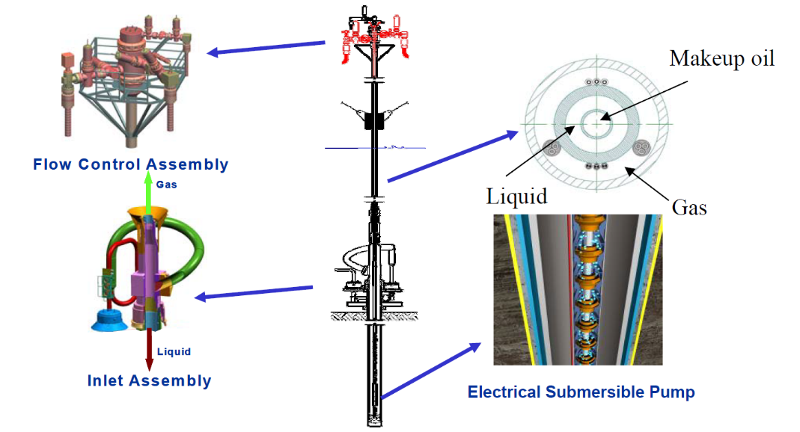
Figure.7-4: Perdido Subsea Boosting System [Nova].

A 1,600 hp ESP is deployed inside the caisson. The inlet assembly is connected to the host through a 14-inch Top Tensioned Riser that contains three separate flows. After the production is separated, the liquid drops down to the bottom of the caisson and the gas flows upward through the outer annulus of the riser naturally. The liquid is then pumped by the ESP though a 7-5/8 inch tube inside the riser. In order to extend pump life, a 2-7/8 inch tube inside the 7-5/8 inch production tube enables oil to be recycled down from the topside into the caisson to ensure there is sufficient liquid flow to cool the pump motor during low flow rate scenarios, such as well ramp-up. The primary concept behind the GLCC is to separate as much free gas as possible to enhance ESP power efficiency. However, the ESP is still capable of handling a moderate amount of gas with the liquid. Therefore, the separator is not required to perform complete gas-liquid separation. The system is also quite efficient in terms of power consumption since the ESP is primarily used to boost only liquid. Furthermore, this system can accommodate significant variations in fluid characteristics, such as GOR and water cut, over the life of the reservoir. This robustness of design accommodates significant sub-surface uncertainties.

8.3.2.2. Equipment Packages
The major equipment packages for the SBS include foundation, 35-inch caisson, inlet assembly, top-tensioned caisson riser, electric submersible pump (ESP) with outflow assembly, and flow control assembly. Descriptions of these packages are provided below and are illustrated in Figure 7.4.

Foundation and 35-inch Caisson
The foundation consists of two conductors, which serve to anchor the seabed equipment and accommodate loads imparted by the caisson riser. In addition, the conductors provide a sub-mudline receptacle for the caisson. The caisson is a 345-footfully welded fabrication with no threads or seals. The primary function of the caisson is to provide surge volume for the separated production liquids such that the system will ride through variations in flow caused by flowline slugging. During steady-state operations, liquid will be maintained at a level to keep the ESP inlet flooded. The caisson diameter and overall volume are important design parameters to transform wild variations in liquid inflow into gradual level changes, which allow for smoother ESP operation.

Inlet Assembly
The primary function of the Inlet Assembly (IA) is to receive multi-phase production from the field and separate it into two streams, liquid and gas. Secondarily, the IA serves to mechanically connect the top-tension riser to the foundation embedded into the sea floor. The IA receives production via a rigid jumper from either the north or south manifold, or the Regional Flowline mini-manifold.
The upper end of the IA attaches to the caisson riser with a subsea 18-¾ inch hydraulic connector. Separated gas rises up through the top of the IA directly into the inner bore of the caisson riser. The lower end of the IA attaches to the caisson with a 42-inch diameter hydraulic connector. Liquids separated in the IA drop into the caisson along the wall.

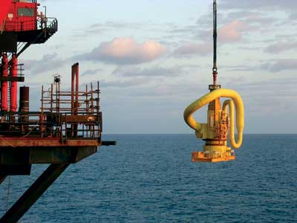
Figure.7-4: Installing an inlet assembly [OGJ]

Chapter.9

9.0 NC3 Subsea Well System

9.1. NC3 Field
PETRONAS Carigali Sdn. Bhd. has developed the NC3 gas field located in SK316 Block, approximately 200km North of Bintulu, Sarawak. The water depth in NC3 field is around 104m-107m. NC3 will be made the hub for the SK316 development. It comprises a Central Processing Platform (CPP) and a bridge-linked Wellhead Platform (WHP). The processed gas will be evacuated to shore via the existing trunkline through E11R-C or dedicated newly-to-be-installed trunkline to shore. In March 2010, successful drilling of the NC3 wildcat well and a subsequent appraisal well brought significant discovery for Petronas in Block SK316 with early estimation of 2.6 trillion standard cubic feet (tscf) of net gas in place.

Figure 9.1: Location of NC3

9.1.1 Selection Platform in Shallow Water
The jack up is the rig type of choice in NC3 development because of its stable work platform and inexpensive mobilization costs. The structure of jack up rig has to cope with environmental loading, including wind and wave action combined with sometimes strong tidal flows. The main design consideration for jack up structures is in material selection. Figure 9.2 shows an example of material selection of jack up rig by Abeele and Voorde (2011) and Figure 9.3 shows NC3 jack up rig (Offshore Energy Today, 2017).
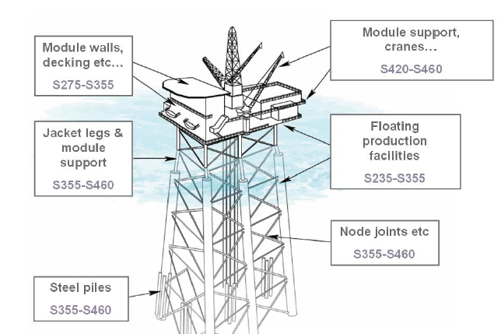
Figure 9.2: Material Selection for Jacket Structure [Abeele and Voorde, 2011]

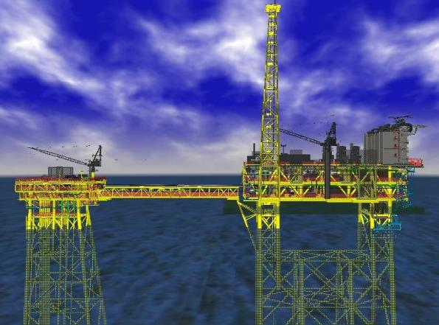
Figure 9.3: NC3 jack up rig [Offshore Energy Today, 2017]

9.1.2 Design Life
The platform facilities inclusive of piping, mechanical, electrical, instrument system, flowlines and interfield pipeline shall be designed for 25 years and design life for structural and Trunkline shall be designed for 30 years.

9.1.3 NC3 Coordinates
The coordinates for installation of wellhead platform, 2 unit gas platform and pipeline from NC3 DP-A to E11R-C as below:

Table 9.1: Wellhead platform (NTM 73/2015)
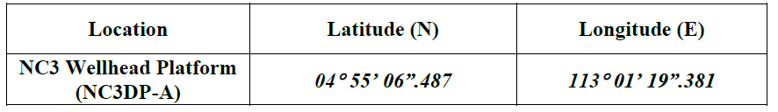

Table 9.2: Gas Platforms (NTM 35/2015)

Table 8.3: Pipeline from NC3 DP-A to E11R-C (NTM 36/2015)

9.2 Design Guideline

9.2.1. Codes and Standards
The latest PETRONAS Technical Standards (PTS) and international codes/standards will be utilized for the design of all parts of the NC3 development. Where such standards are not applicable, accepted industry practice will be used.

Table 2.1.1: Codes and Standards
No of PTS | Technical Standard
PTS 30.10.73.10 | Cathodic Protection, January 2012
PTS 30.10.73.31 | Design, Operation & Maintenance of Cathodic Protection System for Onshore Buried Pipelines, October 2011
PTS 30.10.73.34 | Design of Cathodic Protection System for Offshore Pipelines
PTS 30.48.00.31 | Protective Coatings and Linings, September 2012
PTS 31.37.00.11 | Instrument air supply, February 20122
PTS 31.38.01.11 | Piping – General Requirements, November 2009
PTS 31.38.01.29 | Pipe Supports, September 2012
PTS 31.40.00.20 | Pipeline and Riser Engineering, September 2012
PTS 31.40.10.17 | Pipeline/Trawlgear Interaction, February 2010
PTS 31.40.20.38 | Line Pipe Specification (Amendments/Supplements to API 5L 44th edition/ISO3183:2007), October 2011
PTS 31.40.30.31 | External Polyethylene & Polypropylene Coating for Line Pipe, January 2010
PTS 31.40.30.32 | External Fusion-Bonded Epoxy Powder Coating for Line Pipe, September 2012
PTS 31.40.30.33 | Bituminous Enamel Coating of Steel of Line Pipe, October 2011
PTS 31.40.30.36 | Elastomer Coatings and Model Sheatings for Offshore Riser Protection, October 2012
PTS 31.40.40.38 | Hydrostatic Pressure Testing of New Pipelines, February 2008
PTS 37.05.10.11 | Diesel Oil Systems in Oil and Gas Production Facilities, December 2009
Other References
API 1102 | Steel Pipeline Crossing Railroads and Highways, December 2007
API Specification 5L | 44th edition/ISO3183:2007, January 2012
ASM E B31.8 | Gas Transmission and Distribution Piping System, January 2010
DN V 1981 | Rules for Submarine Pipeline Systems, April 1981
DN V RP E305 | On-Bottom Stability Design of Submarine Pipelines, October 1988
DN V RP F103 | Cathodic Protection of Submarine Pipelines by Galvanic Anodes, October 2010
DN V RP F107 | Risk Assessment of Pipeline Protection, October 2010
DN V RP F109 | On-Bottom Stability Design of Submarine Pipelines, October 2010
DN V RP F110 | Global Buckling of Submarine Pipelines – Structural Design due to High Temperature/ High Pressure, October 2007
ISO 15589-2 | Petroleum and Natural Gas Industries  Cathodic Protection of Pipeline Transportation Systems Part 2: Offshore Pipelines
OT C 6335 | Design of Submarine Pipeline against Upheaval Buckling

9.2.2. Regulatory Approval
The NC3 will be developed, operated and maintained in accordance with Malaysian Government Regulations and Laws. Application shall be made under Section 21 (1) and 22 (2) EEZ Act, 1984 for New Offshore Facilities (EEZA) to the following government departments:
- Secretarial MDTCA;
- Attorney General Chambers;
- Ministry of Energy, Communications and Multimedia (MECM);
- Ministry of Transport;
- Sarawak Marine Department;
- Hydrography Department; and
- Department of Environment (DOE).

9.2.3. Standardization Policy
The design shall aim at maximizing standardization and utilization of identical or similar equipment on different parts of this development and as those of the existing facilities.

9.3. Design Parameters

9.3.1. Reservoir Characteristic
The reservoir fluid data and properties for NC3 wells are shown in Tables 3.1.1 Figure 3.1.1 and Figure 3.1.2 respectively.

Table 3.1 .1: NC3 Wells Pressures and Temperatures
Description | NC3
Maximum Close In Tubing Head Pressure (CITHP) (barg) | 324.2
Maximum Flowing Tubing Head Pressure (FTHP) (barg) | 241.7
Flowing Tubing Head Temperature (FTHT) (°C) | Refer to Figure 3.1.1 below
Maximum Reservoir Pressure (barg) | 446

Reservoir Compositions
The NC3 feed compositions are derived from HYSYS characterized fluid data .The reservoir fluid compositions are tabulated in Table 3.2.1.

Table 3.2.1: NC3 Reservoir Fluid Compositions
Component | NC3 Fluid (MoIe %)
Nitrogen | 0.791
CO2 | 19.604
Methane | 75.164
Ethane | 2.695
Propane | 0.817
i-Butane | 0.206
n-Butane | 0.171
i-Pentane | 0.085
n-Pentane | 0.047
n-Hexane | 0.066
Mcyclopentan | 0.022
Benzene | 0.051
Cyclohexane | 0.017
m-c-C6* | 0.017
Toluene | 0.070
E-Benzene | 0.003
m-Xylene | 0.029
o-Xylene | 0.009
NC3-C7* | 0.037
NC3-C8* | 0.023
NC3-C9* | 0.011
NC3-C10* | 0.016
NC3-C11* | 0.009
NC3-C12* | 0.008
NC3-C13* | 0.008
NC3-C14* | 0.005
NC3-C15* | 0.006
NC3-C16* | 0.003
NC3-C17* | 0.002
NC3-C18* | 0.002
NC3-C19* | 0.001
NC3-C20* | 0.001
NC3-C21* | 0.001
NC3-C22* | 0.001
NC3-C23* | 0.001
NC3-C24* | 0.000
NC3-C25* | 0.000
NC3-C26* | 0.000
NC3-C27* | 0.000
NC3-C28* | 0.000
NC3-C29* | 0.000
NC3-C30* | 0.000
NC3-C31* | 0.000
NC3-C32* | 0.000
NC3-C33* | 0.000
NC3-C34* | 0.000
NC3-C35+* | 0.000

NC3 Wells Production Forecast
NC3 wells production forecast from Year 2015 to Year 2049 is plotted in the Figure 3.4.1. The field production profile comprises of gas, condensate and water flow rates are indicated at stock tank conditions. The following Table 3.4.1 summarizes the revised production profile on an annualized basis from NC3. All flow rates indicated are at stock tank condition.
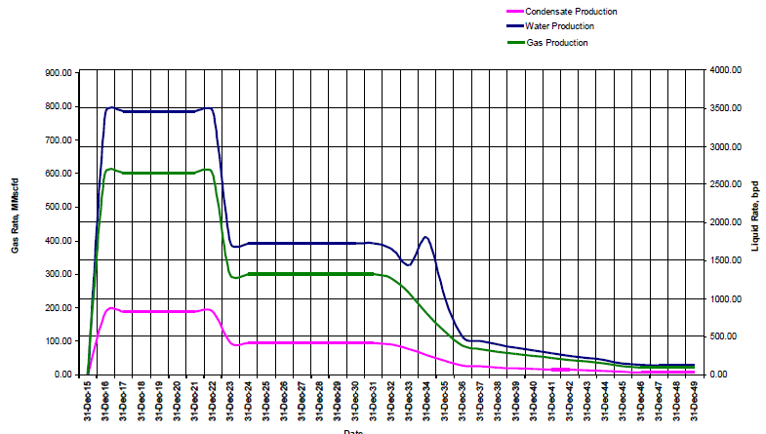
Figure 3.4.1: NC3 Field Production Profile from Year 2015 to Year 2049

Table 3.4.1: NC3 Production Profile
Year | Gas Flowrate (MMSCFD) | Condensate (BOPD) | Water (BWPD) | FTHP (barg) | FTHT (°C) | Reservoir Pressure (barg)
31-Dec-15 | 0.00 | 0.00 | 0.00 | 0.00 | 137.78 | 450.70
31-Dec-16 | 600.00 | 822.00 | 3450.00 | 240.23 | 134.44 | 404.44
31-Dec-17 | 600.00 | 822.00 | 3450.00 | 198.70 | 134.44 | 370.91
31-Dec-18 | 600.00 | 822.00 | 3450.00 | 159.23 | 134.44 | 339.98
31-Dec-19 | 600.00 | 822.00 | 3450.00 | 120.50 | 134.44 | 310.94
31-Dec-20 | 600.00 | 822.00 | 3450.00 | 149.31 | 128.89 | 283.92
31-Dec-21 | 600.00 | 822.00 | 3450.00 | 115.11 | 128.89 | 257.47
31-Dec-22 | 600.00 | 822.00 | 3450.00 | 61.20 | 128.89 | 231.67
31-Dec-23 | 300.00 | 411.00 | 1725.00 | 167.10 | 116.94 | 224.36
31-Dec-24 | 300.00 | 411.00 | 1725.00 | 156.70 | 116.94 | 213.90
31-Dec-25 | 300.00 | 411.00 | 1725.00 | 145.89 | 116.94 | 203.05
31-Dec-26 | 300.00 | 411.00 | 1725.00 | 134.64 | 116.94 | 191.78
31-Dec-27 | 300.00 | 411.00 | 1725.00 | 123.02 | 116.94 | 180.26
31-Dec-28 | 300.00 | 411.00 | 1725.00 | 108.32 | 116.94 | 168.25
31-Dec-29 | 300.00 | 411.00 | 1725.00 | 91.11 | 116.94 | 155.71
31-Dec-30 | 300.00 | 411.00 | 1725.00 | 73.25 | 116.94 | 142.78
31-Dec-31 | 300.00 | 411.00 | 1725.00 | 54.36 | 116.94 | 129.17
31-Dec-32 | 287.35 | 393.66 | 1652.25 | 40.00 | 116.94 | 114.77
31-Dec-33 | 243.61 | 333.74 | 1438.00 | 40.00 | 102.22 | 101.82
31-Dec-34 | 183.64 | 251.58 | 1791.13 | 40.00 | 87.64 | 91.37
31-Dec-35 | 128.59 | 176.16 | 1016.29 | 40.00 | 84.44 | 85.12
31-Dec-36 | 85.78 | 117.52 | 493.25 | 40.00 | 77.22 | 80.51
31-Dec-37 | 76.28 | 104.50 | 438.62 | 40.00 | 77.22 | 77.44
31-Dec-38 | 68.01 | 93.18 | 391.08 | 40.00 | 77.22 | 74.90
31-Dec-39 | 60.63 | 83.06 | 348.62 | 40.00 | 77.22 | 72.84
31-Dec-40 | 53.99 | 73.97 | 310.47 | 40.00 | 77.22 | 71.19
31-Dec-41 | 48.09 | 65.89 | 276.54 | 40.00 | 66.11 | 69.97
31-Dec-42 | 42.79 | 58.62 | 246.03 | 40.00 | 66.11 | 68.99
31-Dec-43 | 37.89 | 51.91 | 217.87 | 40.00 | 66.11 | 68.07
31-Dec-44 | 32.01 | 43.86 | 184.06 | 40.00 | 66.11 | 67.34
31-Dec-45 | 24.27 | 33.25 | 139.57 | 40.00 | 64.72 | 67.19
31-Dec-46 | 21.19 | 29.04 | 121.87 | 40.00 | 64.72 | 67.51
31-Dec-47 | 20.56 | 28.17 | 118.23 | 40.00 | 64.72 | 67.90
31-Dec-48 | 20.44 | 28.00 | 117.53 | 40.00 | 64.72 | 68.26
31-Dec-49 | 20.14 | 27.59 | 115.80 | 40.00 | 64.72 | 68.57

Table 1: Contaminant Level in NC3 Well Properties
Field | Carbon Dioxide CO₂, Mole % | Hydrogen Sulfide H₂S, PPM | Mercury Hg, 𝜇g/Sm³ | Chloride Cl, mg/L
NC3 | 17-20 | 77-140 | 300-500 | 2000-3000

9.4. Design Consideration

9.4.1. Zero Flaring
NC3 field facilities will be develop based on zero flaring philosophy under normal operation except for purging and assist gas.

Contaminant Level
Topsides facilities will be designed to suit the levels of contaminants expected from the well properties of NC3 fluid.
The system at NC3 and NC8 field are sour as defined by NACE MR 0175. Contaminant removal unit will not be installed on the WHP and CPP facilities to reduce the contaminant level to the acceptable limit, except for Mercury. Mercury Removal Unit will be provided in the future at each of gas and condensate system.
Materials of equipment and piping especially analytical instruments including construction shall take into consideration mercury presence in the production line

9.4.2. Reliability & Availability

System to be designed for 98% reliability and 96% availability covering both planned and unplanned event.

9.4.3. Existing E11R-C Facilities
E11R-C is a riser platform which is located approximately 80 km South West of NC3. Since this facility is located close to NC3 field, the concept development has considered the possibility of using the existing export facilities form E11R-C to MLNG.
Trunkline No.6 has been potentially identified as the available pipeline to be utilised for sending the dehydrated gas and condensate recovered from the NC3 and NC8 production wells. The following are system design/operating condition for TL6 identified for potential tie-in should this option to utilise the pipeline is selected for further development.
Table 2: Trunkline no. 6 Design & Operating Condition
Description | Trunkline No. 6
Design Pressure (Barg) | 118.6
Maximum Allowance Operating Pressure (Barg) | 115
Design Temperature Upper/Lower (ºC) | 65/-29
Pipeline Size | DN 800
Pipeline Length | 119 km
Pipeline Design Capacity (MMscfd) | 550

9.4.4. Field Development Scheme
As per selected configuration, NC3 will be developed as a CPP with a living Quarter (LQ) module and it is bridge linked to a separate NC3 WHP. A compression Platform (CM) will be installed and bridge linked to NC3 CPP in future. The topside facilities shall be designed for 900 class rating.
Dehydrated gas and condensate shall be sent to E11R-C via a new 80 km 32” pipeline from NC3 to E11R-C where it will tie in to the existing 32” Trunkline no. 6 from E11R-C to the shore.

In the later years, a remote unmanned NC8 will be developed and tied in to boost the declining NC3 production and pressure. A 20” Corrosion Resistance Alloy subsea pipeline will be installed to transfer FWS from NC8 to NC3 WHP. Production form NC8 and NC3 will be commingled and processed at NC3 CPP before dehydrated gas and condensate are exported to shore via E11R-C.
Existing Trunkline no. 6 will be used for exporting gas and condensate from SK316 fields until some period of time, meanwhile a new 32” carbon steel pipeline Trunkline no. 7 will be installed in future parallel to trunkline Trunkline no. 6 from E11R-C to shore. Process upsets at NC3 is likely to enhance corrosion of Trunkline no. 6 due to handling of very corrosive gas with high CO₂ % from SK316 fields. Should Trunkline no. 6 be estimated as unfit for export in future, the new Trunkline no. 7 will be installed for balance production life of SK316.
Figure xx: Overall SK316 Complex Facilities Scheme

9.4.5. Facilities Description

9.4.5.1 NC3 Wellhead Platform, WHP
NC3 will be developed as a wellhead platform bridge linked to a manned NC3 Central Processing Platform (CPP).

- Design Conditions
    - The production wells for NC3 are estimated to have maximum CITHP of 324 Barg. NC3 wellhead shall be rated for API 10000. The design of NC3 WHP and downstream facilities will be rated for 900 class rating with the spec break after choke valve.
- FWS Flow Lines
    - The flow line size will be sized for NC3 production wells based on erosional velocity criteria for peak production. Each flow line will be provided with a choke valve for pressure let down to exports pressure. All floweriness at the downstream of choke valve will be commingled in the Production Manifold. Wet gas flow meter will be used to measure the flow rate of the flow line. It will be installed at each flow line and located at the downstream of the choke valve.
- Production Manifold
    - The individual flow lines from the producing wellheads will commingle in the Production Manifold and FWS will be sent to the export facilities for onward transmission to the CPP.

9.4.5.2 NC3 Central Processing Platform, CPP
The well fluids from the NC3 well head platforms shall be routed to NC3 CPP for processing.

9.4.5.3 Modification on Existing E11R-C Facilities
Modifications at E11RC includes tie in of NC3 export gas and condensate to existing Trunk line no.6.
The following major tie-ins are foreseen at E11R-C:
- Tie-in of received NC3 gas & condensate production to existing Trunk line no.6
The modification work at E11RC will also include removal of existing connections to the Trunk line no. 6 which will be used for NC3 production. The remaining corrosion allowance in 2015 was calculated to be 1.74 mm by considering the critical thickness of 10.4 mm. Trunk line no. 6 have already lost wall thickness of 3.1 mm from original thickness of 16.8 mm after being operated for 8 years. With calculated corrosion rate about 0.39 mm per year, the remaining life beyond 2015 was calculated to be 4.5 years with CO₂ content 3 moles %, no H₂S and no Chloride. The current contamination for NC3 is with 17 - 20% CO₂, 77 – 140 ppm H₂S and Chloride content 2000- 3000 mg per L. These conditions are far more aggressive than the conditions used for calculating the remaining life of Trunk line no. 6.
It appears that the present conditions were not taken into cognisance in the Requalification of trnk line no 6 report. Process upsets in NC3 processing may result in water carryover with un-dehydrated gas and possible water drop out in the pipeline. This will enhance corrosion rates of the Trunk line no. 6. To overcome this scenario a new 32” trunk line is proposed in future between E11R-C to shore (Trunk line no. 7). This new trunk line shall be installed under a scenario when unforeseen corrosion of Trunk line no. 6 makes the trunk line is not usable for export of gas and condensate in future.

9.4.5.4 Wellhead
Wellhead is a general term used to describe the pressure-containing component at the surface of an oil well that provides the interface for drilling, completion, and testing of all subsea operation phases. It can be located on the offshore platform or onshore, in which case it is called a surface wellhead; it can also be settled down on the mudline, in which case it is called a subsea wellhead or mudline wellhead.
NC3 deck is designed to provide support for six (6) conductor slots. The deck shall be supported at six (6) leg nodes. The platform is configured to accommodate 1 current 32” diameter riser to E11R-C platform, 1 future 20” diameter riser from NC8WHP, 1 future 32” diameter riser and 1 future 30” diameter riser.

Subsea Structures & Production System Engineering (this one overview)

9.4.5.5 Tree System
For the dry tree system, trees are located on or close to the platform. Dry tree platforms have a central well bay for the surface trees, providing direct access to the wells for workover and recovery. The size of the central well bay on dry tree platforms is dictated by well count and spacing. Topside equipment has to be arranged around the well bay. The surface trees are designed for full reservoir shut-down pressures. A large production manifold is required on deck, and a skiddable rig is required for individual well interventions.
Diagram xx: Dry tree system for NC3

Dry tree system production systems are the main alternative to the subsea well cluster architecture. Their surface well architectures provide direct access to the wells. Deepwater surface well architectures in the form of a wellhead platform (WHP) associated with either an FPSO or an FPU are starting to emerge in other parts of the world (West Africa, Southeast Asia). Existing (or actually planned) WHP hubs are currently all based on a TLP concept with either full drilling capacities or with tender assistance (mini-TLP).

9.4.5.6 Production Manifold
NC3 is using production manifold. The individual flowlines from the producing wellheads will commingle in the production manifold and FWS will be sent to the export facilities for onward transmission to the CPP.

Diagram xx: Typical process flow on fixed structure platform

9.4.5.7 Pipelines
Subsea pipelines are used for a number of purposes in the development of subsea hydrocarbon resources, as shown in Diagram xx . A flowline system can be a single-pipe pipeline system, a pipe-in-pipe system, or a bundled system. Normally, the term subsea flowlines is used to describe the subsea pipelines carrying oil and gas products from the wellhead to the riser foot; the riser is connected to the processing facilities (e.g., a platform or a FPSO). The subsea pipelines from the processing facilities to shore are called export pipelines. The subsea pipelines include:
  - Export (transportation) pipelines
  - Flowlines to transfer product between platforms, subsea manifolds, and
satellite wells
  - Flowlines to transfer product from a platform to export lines;
  - Water injection or chemical injection flowlines;
  - Pipeline bundles.

Diagram xx: Application of subsea pipelines

9.4.6 Subsea Surveying & Installation in Shallow Water

9.4.6.1 Subsea Survey

The subsea survey is described as a technique that uses science to accu- rately determine the terrestrial or 3D space position of points and the distances and angles between them in the seabed area for subsea field development.
Geophysical and geotechnical surveys are conducted to evaluate seabed and subsurface conditions in order to identify potential geological constraints for a particular project. Subsea survey may be done with following aids:
- Survey Pattern for Selected Subsea Field and Each Pipeline Route
- Geotechnical Study
- Survey Vessel
- Survey Aids
- Gyrocompass
- Navigation Computer and Software

9.4.6.2 Subsea Survey Equipment Requirements
For the main survey vessel, survey equipment is used to meet this specification. Vessels must follow high safety standards and comply with all national and international regulations, and marine support will be compatible for survey and coring operations. All survey systems are able to operate simultaneously with minimal interference as follows:
- Multibeam Echo Sounder (MBES)
- Side-Scan Sonar

9.4.6.3 Subsea Metrology and Positioning
Metrology is defined by the International Bureau of Weights and Measures (IBWM) as “the science of measurement, embracing both experimental and theoretical determinations at any level of uncertainty in any field of science and technology”. This section describes the subsea positioning systems, which are integrated with the main survey computer in order to provide accurate and reliable absolute positioning of the surface and subsurface equipment.
Transducers
A transducer is a device for transforming one type of wave, motion, signal, excitation, or oscillation into another.
Calibration
Calibration is the process of comparing a measuring instrument with a measurement standard to establish the relationship between the values indicated by the instrument and those of the standard.
Water Column Parameter
A water column is a conceptual column of water from surface to bottom sediments. The application of the correct speed of sound through seawater is critical to the accuracy of the acoustic positioning.

9.4.6.4 Subsea Soil Investigation
Subsea soil investigations are performed by geotechnical engineers or engineering geologists to obtain information on the physical properties of soil and rock around the subsea field development for use in the design of subsea foundations for the proposed subsea structures. A soil investigation normally includes surface exploration and subsurface exploration of the field development. Sometimes, geophysical methods are used to obtain data about the field development. Subsurface exploration usually involves soil sampling and laboratory tests of the soil samples retrieved. Surface exploration can include geological mapping, geophysical methods, and photogrammetry, or it can be as simple as a professional diver diving around to observe the physical conditions at the site.
To obtain information about the soil conditions below the surface, some form of subsurface exploration is required. Methods of observing the soils below the surface, obtaining samples, and determining physical properties of the soils and rocks include test pits, trenching (particularly for locating faults and slide planes), boring, and in situ tests.

9.4.6.5 Subsea Foundation
A foundation is a structure that transfers loads to the earth. Foundations are generally broken into two categories: shallow foundations and deep foundations. A subsea production structure may be supported by piles, by mudmats with skirt or directly by the seabed. It could also be supported by a combination of these three structures.
NC3 is using Pile or Skirt-Supported Structures. The foundation piles of a pile-supported structure should be designed for compression, tension, lateral loads, and also shear stress as applicable. The structure is properly connected to the pile/skirt This can be accomplished with a mechanical device or by grouting the annulus between the pile and sleeve.

9.4.7 Installation
Most subsea structures are built onshore and transported to the offshore installation site. The process of moving subsea hardware to the installation site involves three operations: load-out, transportation, and installation operations. A typical subsea installation also includes three phases: lowering, landing, and locking.

9.4.7.1 Typical Installation Vessels
Installation of subsea structures may involve the following:
  - Transportation barges and tug boats
  - Drilling vessels including jack-up rigs, semi-submersibles, and drill ships
  - Pipe-laying and umbilical-laying vessels
  - Heavy lift vessels
  - Offshore support vessels

Transportation Barges and Tug Boats
Subsea structures are normally transported from onshore to the offshore installation site by transportation barge. Once at the offshore installation site, the subsea structure is transferred from the transportation barge to the drilling rig or construction vessels. Figure xx showing KPV Redang

9.4.7.2 General Arrangement Layout.
Selection of the proper transportation barge and the arrangement of the structures on the deck depend primarily on the following features:
  - Dimensions, weight, and center of gravity (CoG) height of the structure
  - Distance and transportation route
  - Schedule constraints
  - Cost
  - Ability to avoid bad weather
Transportation barges are normally towed by tug boats from one location to another. A typical tug boat is KPV Kapas shown in Figure xx

Figure xx: KPV Kapas

Drilling Vessels
Drilling vessels are mainly designed for drilling activities, but they are also used for the Subsea Production System (SPS) installation because of their installation capacities such as water range, lifting capacity, and positioning capacity

Figure xx: SKD Berani Semisubmersible Tender Assisted Drilling Rig

Pipe-Laying Vessels
Pipe-laying vessels can be categorised according to their pipe-laying methods based on site characteristics, such as water depth and weather. The three most common types are the S-lay, J-lay, and reel-lay types.
For NC3 project, S- lay type has been used to instal the pipeline in South China Sea. Sapura 3000 is the most commonly used S lay type vessel in Malaysian waters. The S-lay method has been used for many years to lay offshore pipelines. An S-lay vessel has a broad deck operating area. The pipe joint assembly line is deployed in the middle or at the side of the main deck, which includes pipe conveyors units, welding, NDT inspection and coating stations etc. The stern of the vessel is constructed into a sloping slideway with a stinger, which is used to modify and control the configuration (stress/stress distributions along the pipeline) of the pipeline in an “S” shape down to the seabed.

Figure xx: Sapura 3000
Figure xx: S lay

9.4.8 Installation Analysis
Installation analysis is a type of calculation for the validation of lifting capacity, strength capacity for lifting objects and vessel structures, etc. Installation analysis can be divided into two categories based on different phases of installation engineering: (1) preliminary installation analysis of the front-end engineering design (FEED) for determining the installation method, installation vessels and equipment, as well as the relevant installation duration and cost estimations, and (2) detailed installation analysis of the engineering design with the goal of developing and installation procedure and relevant installation drawings. The preliminary installation analysis is just used for some critical installation activities such as SPS splash zone lowering and pipeline installation at maximum water depth to prove the feasibility/ capability of the vessel and equipment, whereas the detailed installation analysis is designed to provide a step-by-step analysis of the SPS installation. The subsea installation can be categorised into three types of installation events: (1) subsea equipment deployment installation, (2) pipeline/riser installation, and (3) umbilical installation. The minimum required data for an installation analysis normally include:
  - Environment and geotechnical data
  - Vessel motion characteristics
  - Subsea production system data
  - Rigging system data

9.4.8.1 Pipeline/Riser Installation Analysis
NC3 installation methods for pipelines/risers S-laying method, in which the pipe is laid from a near horizontal position on a lay barge using a combination of horizontal tension and a stinger (bend limiting support)
A subsea riser or pipeline is exposed to different loads during installation from a laying vessel depending on the installation methods. The loads include hydrostatic pressure, axial tension, and bending. The normal failure modes may be local buckling and buckling propagation due to external pressure and bending moments for pipeline/riser installation.
The installation analysis includes two parts: static analysis and dynamic analysis. The stress or strain criteria used for the installation calculation are different based on the project. In most cases, the strain criteria are used for the analysis. However, in some projects, stress criteria are also used. For example, the stress criteria are 72% SMYS and 96% SMYS for pipeline sag-bend area and pipeline overbend area (as shown in Figure xx), respectively, according to DNV OS F101 2007. The stress analysis during the pipeline installation procedure should be carried out in detail to check the stress criteria.

Figure xx: S-lay pipeline installation analysis

The analysis provides the maximum allowable sea states and maximum expected tension loads and stress/strain distribution during installation procedure. The pipeline/riser installation analysis is normally carried out by using OFFPIPE or Orcaflex software.

9.5.0 Instrumentation and Control

5.1 Field Instrumentation

The field instrumentation in general shall meet the requirement for environmental, service conditions and area classification of the installed locations.
Process control instrumentation and process safety instrumentation shall be segregated and functionally independent from each other.
All wetted parts in contact with the process fluid, in general, shall be 316 SS/316L SS. Special materials shall be used based on the piping specifications. Instruments in contact with the process fluid shall be NACE certified to MR0175/lSO15156, unless otherwise specified.
Shutdown valves shall be provided with field manual reset type solenoid valves, unless otherwise indicated in the P&lDs. Blowdown valves shall be provided with manual reset type and dual coil solenoid valves, unless otherwise specified. All blowdown valves shall be provided with air accumulator (air accumulator with automatic transfer mechanism shall switch over to the backup air supply upon detection of low instrument air) generally be sized for three valves operations to prevent valve operation during utility supply failure, i.e. upon detection of low instrument air pressure.
Actuator shall be diaphragm with spring return single acting. Partial Stroke Test (PST) may be considered to use for ESD valves that are unable to meet the required test frequencies based on the IPF Studies. The use of external independent PLCs and use of pneumatic switches shall not be used for PST.
Analysis time shall be kept as short as possible, and in all control application including alarm and protective systems, the permissible analysis time shall be agreed to by the COMPANY. In case performance criteria specified cannot be met using an in situ type analyzer, sample handling system shall be considered.

5.2 Control and Safety Systems

The control and safety systems shall be self-contained, capable of stand-alone operation. These systems shall adopt modular design utilizing the latest proven technology with redundant configuration capabilities for high reliability and availability.
The following systems shall be provided on the facilities:
- Process Monitoring & Control System (PMCS)
- Safety Instrumented System (SIS)
- Fire & Gas System (FGS), FGS shall be standalone for each location.
- High Integrity Pressure Protection System (HIPPS).
- Information Management System (IMS).
- Asset Management System (AMS) and Alarm and Event Management System (A&EMS).
- Well Testing facilities.
- Wellhead Control System facilities.
- Gas and Condensate Metering.
- Pipeline Leak Detection System (PLDS).
- Telecommunication Systems
The control and safety systems shall be designed to accomplish the following objectives:
- The protection of personnel.
- Environment protection.
- Safeguarding of the assets.
- Control of the plant.
- Safe start-up and shutdown of all platform and equipment.
- Automatic protective action where deviation of plant variables could result in a hazard to personnel, environment or equipment.
- Provision of sufficient information to allow the plant to be operated safely and effectively.

5.3 Process Monitoring and Control System (PMCS)

The PMCS shall have ability to perform computations and control functions independently.
PMCS shall have following requirements as minimum:
- PMCS will have the ability to perform independently of other locations.
- PMCS shall have dual redundant processor, power supply and communication link to have high reliability and availability.
- 20% installed spares and 20% spare space shall be provided in the PMCS panels.

5.4 Safety Instrumented System (SIS)

The SIS shall be required for the process safety and protective functions.
SIS shall have the following requirements as minimum:
- SIS shall be independent of the monitoring and control system.
- SIS will initiate platform shutdown and blowdown of the facilities, termed as Emergency Shutdown (ESD-0), Emergency Shutdown and Venting (ESD-1), Process Shutdown (PSD) and isolation of a distinct part of the process termed as USD (Unit Shutdown) depending upon the upset condition.
- Provide maintenance and startup override.
- Manual remote shutdowns and blowdown initiations shall be possible from manned locations based on hazardous events observed at remote wellhead platforms.
- Hardwired console design shall cover the locations.

5.5 Fire and Gas System (FGS)

The FGS is required for early detection and warning of fire and gas and prevention/minimization escalation of a fire or explosion event will be required. Fire and gas functions shall be designed non fail safe (contacts closed to alarm and outputs energized to control) and shall have monitored input and output loops.
FGS shall have the following requirements as minimum:
- FGS shall be independent of SIS in each location.
- FGS shall be fault tolerant, fail safe, with redundant power supply and communication to have high reliability and availability.
- FGS system shall generate an audible and visual alarm.
The following type of fire and gas detectors shall be considered as applicable:
- Smoke Detectors (optical type).
- IR Point Type Combustible Gas Detectors.
- IR Open Path Type Combustible Gas Detectors.
- Point Type Hydrogen Sulphide (H2S) Gas Detectors.
- Fusible Plug Loop.
- Hydrogen gas detector for battery room.
- Flame Detector.
- Heat Detector

5.6 Well Testing

Wet Gas Meter with individual flowline concept shall be adopted for well test metering and reservoir management. Well test metering shall be based on automatic operation and continuous online measurement, capable of unmanned functioning and due to platform distance, where operator could monitor well testing remotely from manned location. Required calculations shall be performed by flow computers located on the respective platform and shall be redundant serial linked to respective PMCS for data transfer.

5.7 Wellhead Control System

Wellhead platforms Christmas tree valves will comprise of Surface Controlled Sub-Surface Safety Valve (SCSSV), Surface Safety Valve (SSV), WV (Wing Valve). All these valves will utilize hydraulic operated actuators.
The wellhead control system will consist of reservoir, hydraulic pumps and well control modules. The control medium shall be instrument air. Each well control module will be designed for the required valve sequencing for well startup (locally and remotely) and shutdown scenarios and valve sequence override for wellhead black start and SCSSV equalization operations.
Wellhead Control Panel (WHCP) shall be fail-safe design so that loss of hydraulic supply shall result in the release of actuating medium pressure and sequential closure of SSVs, SCSSVs, and WVs. The panel shall also ensure that the SSV and SCSSV on each wellhead string are opened and closed in the correct sequence to avoid damage to the SCSSV. The well control module logic for sequencing and shutdown shall be implemented in SIS with electronic flowline initiators.

5.8 Emergency Shutdown & Blowdown

The ESD system shall be designed as fails safe. In the event of loss of any of the control to the system, all shutdown valves (SDV) shall fail closed and all blowdown valves (BDV) fail open. An automatic shutdown system will be an integral part
The following shutdown levels are required:
- ESD-0 is activated only by abandon platform push button by OIM before abandon from the facility.
- ESD-1 is activated automatically by confirmed fire or confirmed gas. ESD-1 is also activated manually by ESD push button.
- PSD is activated by process fault or inevitable loss of utility, which is essential for production/process or activated by PSD push button.
- USD is activated by trip of an individual process or utility equipment or manual initiation by equipment start/stop push button to shutdown of individual equipment or a selected group of equipment without total loss of production.
The Perdido Development is located in the Perdido Basin and Foldbelt in the Alaminos

9.6 Definitions and Abbreviations

9.6.1 Definitions
The following terms used in this document have the meaning defined below:
PETRONAS CARIGALI SDN. BHD | : | PCSB
TECHNIP GEOPRODUCTION (M) SDN. BHD. | : | TPGM

9.6.2 Abbreviations
3LPE | : | 3-Layer Polyethylene
3LPP | : | 3-Layer Polypropylene
A&EMS | : | Alarm and Event Management System
AC | : | Alternating Current
AE | : | Double Layer Asphalt Enamel
AGRU | : | Acid Gas Removal Unit
AISC | : | American Institute of Steel Construction
ALARP | : | As Low As Reasonably Practicable
AM | : | Amplitude Modulation
AMS | : | Asset Management System
ANSI | : | American National Standards Institute
API | : | American Petroleum Institute
ASME | : | American Society of Mechanical Engineers
ASTM | : | American Society for Testing and Materials
AWS | : | American Welding Society
BDV | : | Blowdown Valve
BOCC | : | Bintulu Operations Coordination Centre
BOPD | : | Barrel Oil per Day
BP | : | Boiling Point
BPD | : | Barrel Per Day
BS | : | British Standards
BWPD | : | Barrel Water per Day
CBMS | : | Condition Based Monitoring System
CCIR | : | Consultative Committee on International Radio
CCITT | : | Consultative Committee on International Telegraphy and Telephony
CCR | : | Central Control Room
CCTV | : | Closed Circuit Television
CDBM | : | Corrosion Design Basis Memorandum
CITHP | : | Closed In Tubing Heat Pressure
CPP | : | Central Processing Platform
CRA | : | Corrosion Resistance Alloy
dB | : | Decibel
dBA | : | Decibels, weighted sound pressure level
DBM | : | Design Basis Memorandum
DC | : | Direct Current
DNV | : | Det Norske Veritas
DOE | : | Department of Energy
DOSH | : | Department of Occupational Safety & Health
DSF | : | Deck Support Frame
E11R-C | : | E11 Riser Platform C
EEZA | : | Exclusive Economic Zone Act
EIA | : | Electronics Industries Association
EOS | : | Equation of State
EPCIC | : | Engineering, Procurement, Construction, Installation & Commissioning
EQA | : | Environmental Quality Act
ESD | : | Emergency Shutdown
Ex’d’ | : | Flameproof
Ex’e’ | : | Increased Safety
F&G | : | Fire and Gas Detection
FBE | : | Fusion Bonded Epoxy
FEED | : | Front End Engineering Design
FGS | : | Fire and Gas System
FM | : | Frequency Modulation
FO | : | Fiber Optic
FTHP | : | Flowing Tubing Head Pressure
FTHT | : | Flowing Tubing Head Temperature
FWS | : | Full Well Stream
GMDSS | : | Global Maritime Distress and Safety System
GMS | : | Gas Metering Station
GPA | : | General Platform Alarm
GTG | : | Gas Turbine Generator
GWR | : | Guide Wave Radar
HART | : | Highway Addressable Remote Transducer
HAT | : | Highest Astronomical Tide
HF | : | High Frequency
HH | : | High High
HIPPS | : | High Integrity Pressure Protection System
HLO | : | Helicopter Landing Officer
HMI | : | Human Machine Interface
HSE | : | Health, Safety and Environment
HVAC | : | Heating, Ventilation and Air Conditioning
ICAO | : | International Civil Aviation Organization
IEC | : | International Electro-technical Commission
IMCS | : | Intelligent Motor Control System
IMO | : | International Maritime Organization
IMS | : | Information Management System
INMARSAT | : | International Maritime Satellite
IP | : | Ingress Protection
IPF | : | Instrument Protective Function
IR | : | Individual Risk
IS | : | Intrinsically Safe
ISO | : | International Standards Organization
ITU | : | International Telecommunication Union
ITU-R | : | International Telecommunication Union – Radio-communication, (formally CCIR)
ITU-T | : | International Telecommunication Union – Telecommunication Standardization, (formally CCITT)
JB | : | Junction Box
KHz | : | kilohertz
LAN | : | Local Area Network
LAT | : | Lowest Astronomical Tide
LER | : | Local Equipment Room
LL | : | Low Low
LNG | : | Liquified Natural Gas
LQ | : | Living Quarters
LV | : | Low Voltage
MAC | : | Manual Alarm Callpoint
MCC | : | Motor Control Center
MDTCA | : | Ministry of Domestic Trade and Customer Affairs
MESC | : | Materials and Equipment Standards and Codes
MHz | : | Megahertz
MLNG | : | Malaysia LNG Sdn Bhd
MMI | : | Man Machine Interface
MMSCFD | : | Million Metric Standard Cubic Feet per Day
MSL | : | Mean Sea Level
MV | : | Medium Voltage
MW | : | Molecular Weight
NACE | : | National Association of Corrosion Engineers
NDB | : | Non Directional Beacon
NFPA | : | National Fire Protection Association
NVR | : | Network Video Recorder
OSHA | : | Occupational Safety And Health Act
OTN | : | Open Transport Node-Proprietary Standards
P&ID | : | Piping and Instrumentation Diagram
PABX | : | Private Automatic Branch Exchange
WHCP | : | Wellhead Control Panel
WHP | : | Wellhead Platform
WRC | : | Welding Research Council

References

- A.S. Halal, R.F. Mitchell, 1994, Casing Design for Trapped Annulus Pressure Buildup, Drilling and Completion Journal, June, 107.
- Abdul Khair, J., Jaswar, Koto, Affis Effendi, Ahmad Fitriadhy, 2015, Buckling Criteria for Subsea Pipeline, Jurnal Teknologi, Vol.74:5.
- Adrian Adams, Well design and construction, Nexen Petroleum UK.
- Aker Solution, Subsea Structures, http://akersolutions.com/
- Alan Christie, Ashley Kishino, et.al, Subsea Solution, Oilfield Review, 2000.
- American Petroleum Institute, 1992, Specification for Subsea Wellhead and Tree Equipment, first ed., API Specification 17D.
- American Petroleum Institute, 2004, Petroleum and Natural Gas Industries d Drilling and Production Equipment d Wellhead and Tree Equipment, nineteenth ed., API, 6A.
- American Petroleum Institute, 2008, Specification for Pipeline Valves, API, 6D.
- American Petroleum Institute, 2015, General Overview of Subsea Production Systems, API Technical Report 17TR13.
- American Petroleum Institute, Recommended Practice for Design and Operation of subsea production systems.
- American Society of Mechanical Engineers, 2008, Process Piping, ASME, B31.3.
- American Welding Society, 2008, Structural Welding Code – Sheet Steel, AWS, D1.3.
- An Introduction to Well Engineering, King Petroleum Services, http://www.kingpetroleum.co.uk/training/wellEngHandout/wellEngTrainingHandout.php
- Bordieri, E., Barbosa V. C., Dias, R. (2008). An overview of the Roncador Field
- Bordieri, E., Barbosa V. C., Dias, R. (2008). An Overview of the Roncador Field Development, a Case in Petrobras Deep Water Production, Offshore Technology Conference, 5-8 May, Houston, Texas, USA.
- DNV Recommend Practice, 2005, Cathodic Protection Design, DNV, RP B401.
- DNV Recommended Practice, 2015, Wellhead fatigue analysis DNVGL-RP-0142.
- Drill Quip, SS Series Subsea Wellhead Systems, http://www.dril-quip.com/
- FMC, Enhanced Vertical Deepwater Tree (EVDT), Subsea System.
- G.R. Samuel, G. Adolfo, 1999, Optimization of Multistring Casing Design with Wellhead Growth, Landmark Drilling & Well Services, SPE Paper 56762.
- H. Matlock, L.C. Reese, 1960, Generalized Solutions for Laterally Loaded Piles, Journal of the Soil Mechanics and Foundations Division, ASCE, Vol. 86, No SM5, pp. 63–91.
- International Standards Organization, 2007, Design and Operation of Subsea Production System - Subsea Wellhead and Tree Equipment, ISO, 13628–4.
- J. Koto (2016). INTRODUCTION TO DRILLING & PRODUCTION RISERS, Ocean & Aerospace Research Institute, Indonesia, lecture notes distributed in Department of Mechanical Engineering, Naval Architecture and Offshore Engineering at the Universiti Teknologi Malaysia, Johor on January 2016.
- J. Koto, 2016, Introduction to Subsea Wellhead, Edition.1, Ocean & Aerospace Research Institute, Indonesia.
- Jaswar, M. H. Hashim, Abd Khair Junaidi and Efi Afrizal, 2013, Effect of Axial in Offshore Piperline Design, The 12th Asian International Conference on Fluid Machinery, 25-September-2013, pages.1-7, Yogyakarta, Indonesia.
- Jaswar, M. K. R. A. Razak1and Efi Afrizal, 2013, Vortex-Induced Vibration of Riser Caused by External Load, The 12th Asian International Conference on Fluid Machinery, 25-September-2013, pages.1-10, Yogyakarta, Indonesia.
- Matanović Davorin, Well control equipment, Faculty of Mining, Geology and Petroleum Engineering, University of Zagreb in Croatia
- National Association of Corrosion Engineers, 2002, Petroleum and Natural Gas Industries Material for Use in H2S-Containing Environments in Oil and Gas Production, NACE MR0175.
- Offshore Deep water drilling process.
- Offshore Technology Conference (2010). Perdido Development: World’s First Ultra-deep Water Drilling & Production Facility, OTC20887, Offshore Technology Conference.
- Offshore Technology Conference (2014). Drilling Evolution of the Ultra Deepwater Drilling Campaign in Mexico, Perdido Fold Belt, OTC-25030-MS, Offshore Technology Conference.
- Petroleum Support (PS), Well Completion Method, http://petroleumsupport.com/
- R. Cummings, C. Garcia, A. Hawthorn, R. Holicek, J.R. Dribus & L. Haslin (2015). Beyond Deep -The Challenges of Ultra-deep Water, Schlumberger.
- SBMOffshore. (2015). FPSO Brasil. Retrieved May 1st, 2016.
- Shell (2012). Deepwater, Shell International Exploration and Production B.V., Netherlands.
- Shell (2012). Perdido: World’s DEEPEST OFFSHORE drilling and production platform, Shell, VP, PennWell Custom Publishing, U.S.A.
- Smith.B, 2007, Deep Water Gulf of Mexico, Deep Water Exploration & Projects Chevron North America Exploration and Production.
- Society of Petroleum Engineers, Subsea Wellhead, http://petrowiki.org/
- Subsea Well/Pipeline Development, 2010 Nova Award Nomination 16.
- Subsea World News, Brazil: Petrobras Finds Oil Seep in Roncador Field.
- Subsea World News, https://subseaworldnews.com/2011/12/23/usa-bsee-completes-unannounced-spill-drill-to-test-subsea-containment-response/
- The Graduate School for Energy and Transportation Professions, What is a Blowout Preventer (BOP) stack? IFP School, France.
- United States Department of Labor, Drilling -Blowout Preventers-, https://www.dol.gov/
- William. C. Lyons, 2010, Working Guide to Drilling Equipment and Operations, Elsevier.
- Y. Bai, Q. Bai, Subsea Pipelines and Risers, Elsevier, Oxford, 2005.
- Y.Bai, Q.Bai, Subsea Engineering Handbook, 2010, Elsevier.

Appendixes

A.1 Subsea Pro -Simulation and Installation-
Subsea Pro –Simulation and Installation is a tool for analysing design and installation of the subsea production system. This software was developed by Ocean and Aerospace Research Institute, Indonesia.

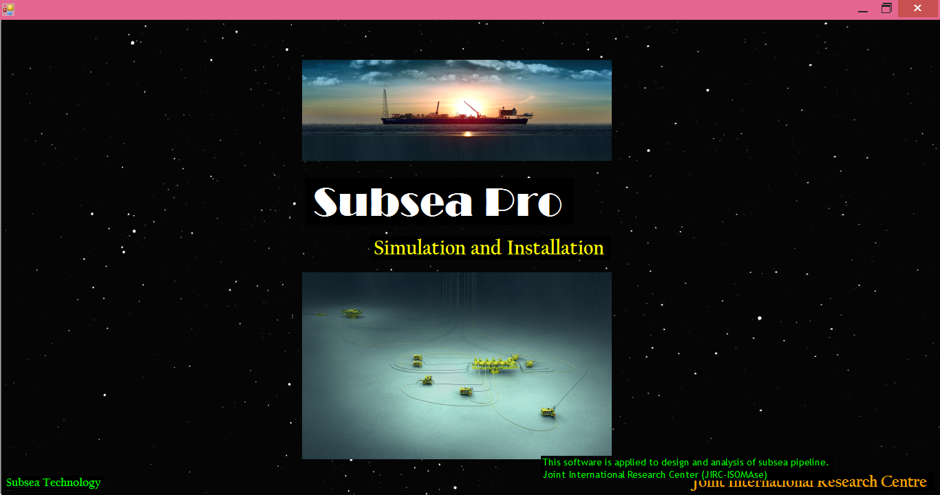
Figure.A-1: Subsea Pro –Simulation and Installation.
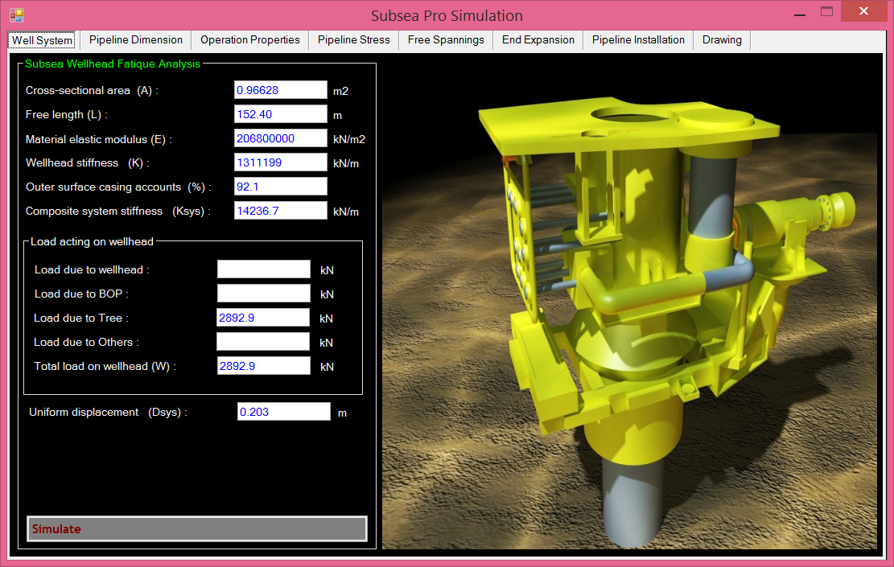
Figure.A-2: Wellhead analysis using Subsea Pro –Simulation and Installation.
A.2 Unit Conversion
Table.A-1: Pressure unit conversion
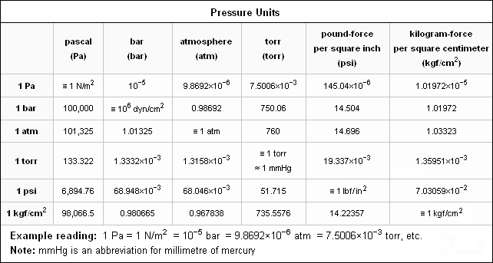

Table.A-2: SI to US unit conversion
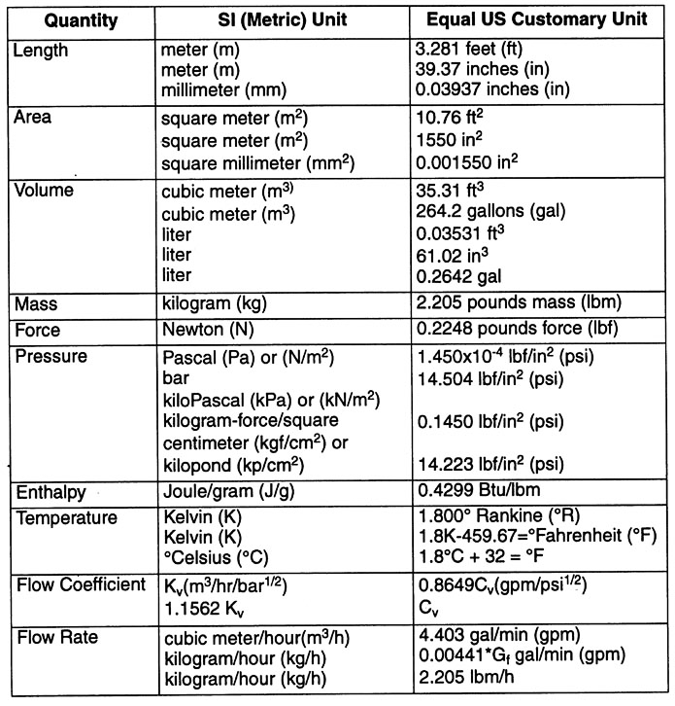

Autobiographies

 | Jaswar Koto was born on October, 1970. He is a descendant of the Prophet Rasullullah S.A.W through Husein R.A. He is a President of Ocean and Aerospace Research Institute, Indonesia. Professor on offshore engineering and also President of International Society of Ocean, Mechanical & Aerospace for scientist and engineers.
He has been invited as a Visiting Professor more than 16 times, received several international awards and supervised PhD, Master and Bachelor Students.
He received his bachelor degree in 1994 from Institut Teknologi Sepuluh Nopember (ITS), Indonesia, Curtin University in 1996 and Notre Dame University in 1999. In 2003 he has completed PhD with receiving award in engineering form Aerospace and Marine Engineering, Osaka Prefecture University, Japan.
He has started his researches since 1994 on structure analysis of fluid flow in subsea pipelines, subsea pipeline corrosion due to Carbon Monoxide, design and hydrodynamic analysis of AUV in Australia. Then, he joined Research and Development Institute, Sumitomo Heavy Industries -Marine Engineering-, Japan. In 2005, he joined ExxonMobil projects. Since 2010, he has a contract with Department of Aeronautical, Automotive, and Ocean Engineering, Faculty of Mechanical Engineering. He is also appointed as head of High Performance Computing, CICT, Universiti Teknologi Malaysia.

