Preface



This book consists of nine chapters which introduce subsea manifold system and its application in oil and gas exploration fields such as Kuito, Gemini, Albacora, Marlim, Namorado, Roncador, Shell Mensa, BP Thunder Horse, Total Otter, Shell Alliance, Shell Bijupira and etc. The book explores overview subsea production system in chapter 1, subsea manifold in chapter 2, template in chapter 3, cluster manifold in chapter 4, manifold’s components in chapter 5, design and analysis manifold in chapter 6, piling and foundation in chapter 7, installation of manifold in chapter 8 and manifolds around the world I chapter 9.

Many pictures and illustrations are enclosed in this book to assist the readers’ understanding. It should be noted that some pictures and contents are borrowed from other companies’ websites and brochures which are quoted and listed in the references. This book mainly is designed for basic education of subsea engineering purposes only not for traded.

2017 (Third Edition)

Acknowledgements

Alhamdulillahhirobbilalamin, first and foremost, all praises and syukur are only to Allah (SWT) to give us strength and ability to complete this book.

We would like to take this opportunity to express our highest appreciation to our colleagues and friends in the Ocean and Aerospace Research Institute, Indonesia, Universiti Teknologi Malaysia (UTM) and Institut Teknologi Sepuluh Nopember (ITS), Indonesia to provide proper guidance, full support, encouragement, invaluable ideas, comment, recommendation, critics, suggestions and advice that to assist us for the successful completion of this book.

To our families that always pray for our successful, all this things cannot pay for all what they all have done. Our special thanks also to our postgraduate students.

Above this all, our highest praises, thanks and syukur to Almighty Allah Subhanahu Wa’Talla, the most gracious the most merciful, who gave us the knowledge, courage and patience to accomplish this project. May the peace and blessings of Allah be upon Prophet Muhammad Sallallahu Alaihi Wasallam.

The authors are grateful to all friends, institutions and parties for supporting this book.

Table of Contents

Preface 1
Acknowledgements 2
Table of Contents 3
List of Figures 7
List of Tables 11
1.0 Subsea Production System 12
1.1. General 12
1.2. Quad 204 Subsea System 13
2.0 Subsea Manifold 15
2.1. General 15
2.2. Subsea Manifold 16
2.3. Function of Subsea Manifold 18
2.4. Template and Manifold 20
3.0 Template 22
3.1. General 22
3.2. Template Manifold Design 24
3.3. Suction piles 26
3.3.1. Single Suction Piles 26
3.3.2. Mini Suction Piles 27
3.4. Manifold Template 28
3.5. Tie-Back Template 29
3.6. Riser-Support Template 31
4.0 Cluster Manifold 33
4.1. General 33
4.2. Cluster Manifold Design 34
4.3. Cluster Manifold in Gemini Project 35
5.0 Components of Manifold 36
5.1. General 36
5.2. Manifold Header 39
5.3. Manifold Piping 39
5.4. Manifold Valves 41
5.4.1. Valve Types 42
5.4.2. Size and Pressure 45
5.5. Manifold Chokes 46
5.6. Control System 47
5.7. Framework structure 48
5.8. Foundation 48
5.9. Tie-ins to wells and flowlines 49
5.10. Insulation 49
5.11. Subsea Modules 49
6.0 Design of Manifold 50
6.1. General 50
6.1. Code and Standard 51
6.2. Frame Structures Design 51
6.2.1. Structural Design 51
6.2.2. Structural Analysis 52
6.2. Manifold Piping Design 55
6.3. Pigging Loop 59
6.4. Padeyes 60
6.5. Control Systems 61
6.6. Cathodic Protection 62
6.7. Materials Selection 63
6.7.1. HP/HT Manifolds 63
6.7.2. Material Evaluation 63
6.7.3. Metallic Materials 65
6.8. Hydrate Prevention and Remediation 65
7.0 Piling and Foundation 69
7.1. General 69
7.2. Design Methodology 73
7.2.1. Codes and Standards 74
7.3. Design Loads 74
7.3.1. Permanent Loads 74
7.3.2. Live and Dynamic Loads 74
7.3.3. Environmental Loads 75
7.3.4. Accidental Loads 75
7.4. Geotechnical Design Parameters 75
7.4.1. Index Properties 75
7.4.2. In Situ Stresses 76
7.4.3. Undrained Shear Strength 77
7.4.4. Drained Characteristics 79
7.4.5. Consolidation Characteristics 79
7.4.6. Thixotropy 79
7.5. Suction Pile Sizing Geotechnical Design 79
7.5.1. Pile Axial, Lateral, and Torsional Capacities 79
7.5.2. Stability Analyses 80
7.5.3. Penetration Analysis 81
7.5.4. Installation Impact Response 82
7.6. Suction Structural Design 83
7.6.1. Allowable Stresses 84
7.6.2. Buckling Checks 85
7.6.3. Transportation Analysis 86
8.0 Installation of Subsea Manifold 88
8.1. Seafastening 88
8.2. Installation Capability 89
8.2.1. Lifting System 90
8.2.2. Splash Zone Lifting 91
8.2.3. Motion Compensation 93
8.2.4. Deepwater Installation Challenges 95
8.3. Installation Equipment 96
8.3.1. Crane Barge 97
8.3.2. DP Rig and Drilling Riser 98
8.4. Installation Methods 100
8.4.1. Added Mass Theory 101
8.4.2. Pendulum Theory 102
8.4.3. Conventional Installation Methods 103
8.4.4. Sheave Installation Method 105
8.4.5. Innovative Installation Methods 106
8.6. Installation Analysis 114
8.6.1. Barge Lift 116
8.6.2. Splash Zone 118
8.6.3. Transferring to A&R Wire 121
8.6.4. Lowering in Deep Water 122
8.6.5. Landing on the Seabed 123
8.7. Examples Manifold Installation 124
8.7.1. Installation of Manifold of Total Otter 124
8.7.2. Installation of Manifold of Shell Alliance 125
8.7.3. Installation of Manifold of BP Thunder Horse 126
8.7.4. Installation of Manifold of Shell Bijupira 127
8.7.5. Installation of Manifold of Shell Mensa 128
8.7.6. Installation of Manifold of Roncador 129
9.0 Manifolds around the Worlds 131
9.1. General 131
9.2. Trends in Subsea Manifold Design 131
9.2.1. First Stage 131
9.2.2. Second Stage 132
9.2.3. Third Stage 133
9.3. Kuito Field Phase 1A 133
9.4. Gemini Subsea Field 135
9.5. Albacora, 1996-1997 137
9.6. Marlim, 1998 139
9.7. Namorado, 2001 139
9.8. Roncador Field 140
9.9. Statoil Lufeng 142
9.10. ExxonMobil Zafiro 143
9.11. Anadarko Genghis Khan 145
9.12. PetroCanada Terra Nova 146
9.13. Perdido 147
References 149
Appendixes 154
Autobiographies 155

List of Figures

 | Figures and Description | Pages
Figure.1-1 | Classification of subsea production system | 13
Figure.1-2 | Subsea production system of Quad 204 | 15
Figure.2-1 | Subsea manifold applied in oil & gas production system | 17
Figure.2-2 | Categories of subsea manifolds | 18
Figure.2-3 | Subsea template supporting wellheads and protective structure | 19
Figure.2-4 | Template and Manifold | 21
Figure.3-1 | An example template manifold | 24
Figure.3-2 | An example of template and manifold | 25
Figure.3-3 | Mudmat | 26
Figure.3-4 | Skirt of Template | 26
Figure.3-5 | Suction Pile | 27
Figure.3-6 | Single Suction Piles | 28
Figure.3-7 | Suction Piles of Manifold | 29
Figure.3-8 | Multiwell/Manifold Template | 30
Figure.3-9 | Well Spacer/Support Template | 31
Figure.3-10 | Manifold Template with Production Riser | 32
Figure.4-1 | Schematic of Typical Manifold | 34
Figure.4-2 | Cluster manifold | 35
Figure.4-3 | Cluster Manifold in Gemini Field Arrangement in Gemini Field | 36
Figure.5-1 | An example of a manifold | 38
Figure.5-2 | P52 Manifold | 39
Figure.5-3 | Manifold Piping | 41
Figure.5-4 | Pigging Diverter Valve | 41
Figure.5-5 | Manifold piping and instrumentation diagram/drawing | 42
Figure.5-6 | Magnum Subsea Gate Valve with Fail-Safe Actuator | 43
Figure.5-7 | WOM Subsea Gate Valve with ROV Bucket | 44
Figure.5-8 | Typical Two-Way Subsea Ball Valve | 45
Figure.5-9 | Check Valve | 46
Figure.5-10 | Hydraulic-actuated variable Chokes | 47
Figure.5-11 | Subsea Control Modules | 48
Figure.5-12 | Hydraulic Actuated Gate Valves | 48
Figure.5-13 | Manifold Flowmeter | 49
Figure.5-14 | Manifold Sensor | 49
Figure.5-15 | P52 Manifold: SCM | 49
Figure.6-1 | Front and Plan Views for a Typical Tie-In Manifold | 50
Figure.6-2 | ISO View of a Manifold Structure Frame | 51
Figure.6-3 | Production Manifold and Interfaces | 52
Figure.6-4 | Manifold Piping System | 53
Figure.6-5 | Von Mises Stress Distribution of Piping System in the Operating Condition | 54
Figure.6-6 | 8.625-in. _ 8.625-in. _ 6.625-in. Header Reducing Tee | 54
Figure.6-7 | Stress Distribution in Middle Section of Tee | 55
Figure.6-8 | Manifold Pigging Loop | 57
Figure.6-9 | Insulation Design Based on 3D Thermal FEA | 63
Figure.6-10 | Temperature Distribution of the Metal Surface of Valves in a Manifold | 64
Figure.7-1 | Foundation design | 65
Figure.7-2 | Aspect Ratios of Piles | 66
Figure.7-3 | Suction Pile and Its Installation Mechanism | 67
Figure.7-4 | Suction Pile Used in Subsea Structure | 68
Figure.7-5 | Example of Gamma Density Log Compared to Lab Tests | 72
Figure.7-6 | Example of In Situ and Laboratory Undrained Shear Strength Profiles | 74
Figure.7-7 | Suction Pile Installation Sequence | 79
Figure.7-8 | An example of maximum and von misses stresses calculated using Subsea Pro Simulation | 81
Figure.8-1 | Forces on Seafastening | 85
Figure.8-2 | Lifting off from Deck and Maneuvering Object Clear of Transportation Vessel | 87
Figure.8-3 | Splash Zone Lifting | 88
Figure.8-4 | Installation of Subsea Structure with HCLS | 90
Figure.8-5 | Difference in Load Control and Positioning, Shallow Water vs. Deepwater | 92
Figure.8-6 | Manifold Installation from a Crane Barge | 93
Figure.8-7 | Installation of Temple Using THIALF in the Ormen Lange Field | 94
Figure.8-8 | Manifold Installation Using Drilling Riser | 95
Figure.8-9 | Installation method of manifold | 96
Figure.8-10 | Simple gravity pendulum
Figure.8-11.a | Installation using AHTS | 97
Figure.8-11.b | Installation using Crane Barge | 97
Figure.8-11.c | Installation of Jubarte PLEM (292 TE). | 98
Figure.8-11.d | Installation using drilling riser | 98
Figure.8-12 | Sheave Installation method | 100
Figure.8-13 | Roncador Manifold-1 (1885m water depth) | 100
Figure.8-14 | Pendulous Installation Method for P52 Manifold Installation | 103
Figure.8-15 | Pendulous Installation Method for MSGL-RO-2 & 3 manifolds (1900 m water depth) | 104
Figure.8-16 | MSGL-RO-2 & 3 manifolds | 104
Figure.8-17 | Pencil Buoy Installation | 105
Figure.8-18 | Subsea Deployment System | 107
Figure.8-19 | Fiber Rope Deployment System, 125Te SWL | 108
Figure.8-20 | Manifold installation steps | 110
Figure.8-21 | Deep water Installation Issues | 110
Figure.8-22 | Structural analysis during installation | 111
Figure.8-23 | Load and Resistance Factor Design (LFRD) checking for axial load plus bending moment | 112
Figure.8-24 | Lifting condition: von Mises stress distribution (MPa) | 113
Figure.8-25 | Subsea manifold in splash zone | 114
Figure.8-26 | Development of Hydrodynamic Added Mass at Different Levels of Submergence, Splash Zone Lifting | 114
Figure.8-27 | Hydrodynamic Added Mass, Lifted Object Slightly Submerged | 115
Figure.8-28 | Initial lowering manifold | 117
Figure.8-29 | Lowering manifold in deep water | 118
Figure.8-30 | Landing of manifold in seabed | 118
Figure.8-31 | Installation of manifold of Total Otter | 119
Figure.8-32 | Installation of manifold of Shell Alliance | 120
Figure.8-33 | Installation of manifold of BP Thunder Horse | 121
Figure.8-34 | Installation of manifold of Shell Bijupira | 123
Figure.8-35 | Installation of manifold of Shell Mensa | 124
Figure.8-36 | Installation of manifold of Roncador | 125
Figure.9-1 | Typical Manifolds of the First Stage (a) and the Second Stage (b) | 127
Figure.9-2 | Field Arrangement of Kuito Field Phase 1A | 129
Figure.9-3 | PLEM Foundation Kuito 1B | 130
Figure.9-4 | Gemini Field Arrangement | 131
Figure.9-5 | Gemini System Integration Test (SIT) | 132
Figure.9-6 | Albacora Phase 1 in 1996, 2 Unit, 640m water depth | 133
Figure.9-7 | Albacora Phase 2 in 1997, 5 Unit, 400m water depth | 133
Figure.9-8 | 1998, Marlim 2 Unit, 820m Water Depth | 134
Figure.9-9 | 2001 Namorado, 1 Unit, 200m Water Depth | 135
Figure.9.10 | Roncador P-52 subsea layout | 136
Figure.9-11 | 2002, Roncador Phase-1, 1-Unit, 1,892m water depth | 137
Figure.9-12 | 2006, Roncador Phase-2, 2-Unit, 1,892m water depth | 137
Figure.9-13 | Statoil Lufeng | 138
Figure.9-14 | ExxonMobil Zafiro | 140
Figure.9-15 | Anadarko Genghis Khan | 141
Figure.9-16 | PetroCanada Terra Nova | 142

List of Tables

 | Tables and Description | Pages
Table 1-1 | Standard Temperature Ratings | 18
Table 1-2 | Material Class Rating | 18
Table.8-1 | SWOT Analysis, Pendulous Installation Method | 103
Table.8-2 | SWOT Analysis, Pencil Buoy Method | 106
Table.8-3 | SWOT Analysis of a Subsea Deployment System | 107
Table.8-4 | SWOT Analysis of a Fiber Rope Deployment System | 109
Table.9-1 | Summarize the subsea infrastructure that has been installed in Roncador field | 135

Chapter.1

1.0 Subsea Production System

1.1. General
In oil and gas production, subsea production systems are typical oil wells located on the seabed either shallow or deep water. Subsea production systems can range in complexity from a single satellite well with flowline linked to a fixed platform to several wells on a template producing and transferring via subsea processing facilities to a fixed or floating facility, or directly to an onshore installation.
The production system is classified into: subsea production control system, subsea structures and manifold system, subsea intervention system, subsea umbilical system and Subsea processing system as shown in Figure.1-1.

Figure.1-1: Classification of subsea production system.

1.2. Quad 204 Subsea System
Figure.1-2 shows the complex and highly technical Quad 204 project which consists of a new Floating Production System Offshore (FPSO) to replace the existing Schiehallion FPSO; an extension of the existing subsea system with 15 new or replacement flow lines and 21 new or replacement risers; and 14 new wells in addition to the 52 existing wells. This major project will access the remaining hydrocarbon reserves in the Schiehallion and Loyal fields, extending production through to 2035. The Quad 204 offshore redevelopment project is located some 130km west of Shetland, UK, under a £30m+ contract awarded by BP.
The Quad 204 will be fabricating 74 modules in carbon steel for the subsea system. These include 44 process fluid handling structures (including manifolds, flowline and riser terminations, and subsea isolation valve structures), and 30 control distribution structures (such as assemblies and umbilical terminations), amounting to a total of some 2,300 tonnes of fabrication.
The eight different manifolds range in size from 56 tonnes to 131 tonnes, the largest measuring some 10.8 by 10.8 by 9.2 metres. Three subsea isolation valve structures and 14 control distribution assemblies (measuring some 12.5 x 10 x 3.8 metres), weighing 58 tonnes and 65 tonnes each respectively, are also among the items to be produced, along with flowline and riser end termination assemblies and umbilical end terminations, weighing 10-12 tonnes each, and two 20 tonne dynamic umbilical termination assemblies.

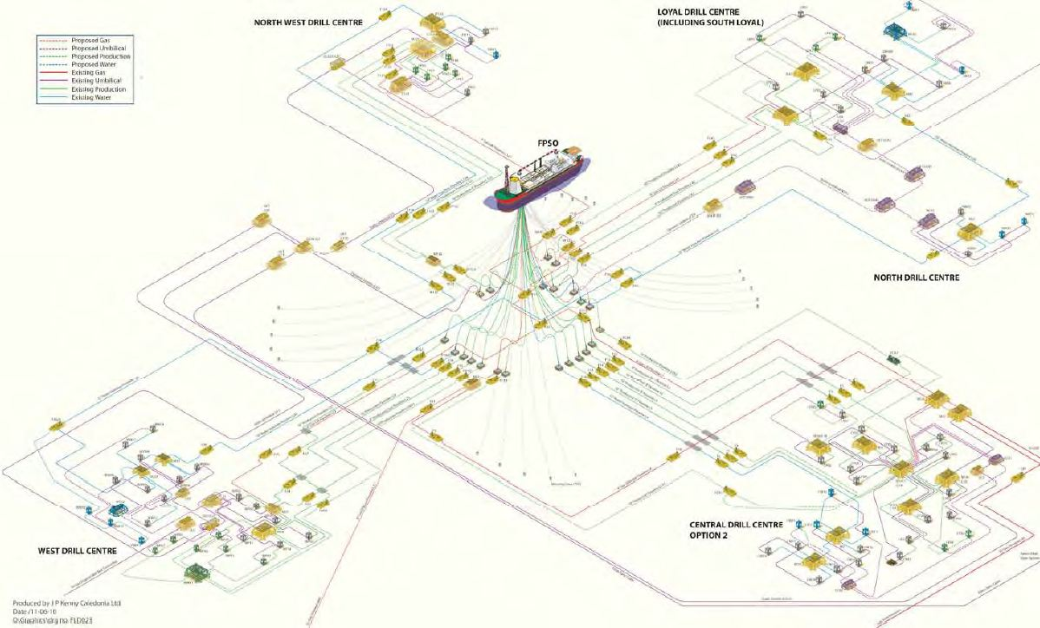
Flowline
Riser
Manifold
PLET
Well
Jumper

Figure.1-2: Subsea production system of Quad 204 [Subsea].
Chapter.2

2.0 Subsea Manifold

2.1. General
The subsea manifold is a system of headers, branched piping and valves used to gather produced fluids or to distribute injected fluids. The wells and pipelines are connected to the subsea manifold by jumpers. The subsea manifold should provide sufficient piping, valves and flow controls to safely gather produced fluids or distribute injected fluids such as gas, water or chemicals (ISO 13628-1).
A subsea manifold is structurally independent from the wells as shown as shown in Figure.2-1. The subsea manifold is functionally a subsea flow router that connects between subsea trees and flowlines. The subsea manifold is general used to optimize the subsea layout arrangement and also reduce the quantity of risers connected to the platform. In subsea production system, if connected to dual flowlines, the subsea manifold can typically accommodate pigging in which they have the capability of routing production from a particular tree to a particular flowline.. In Norwegian terms the manifold is often referred to as the “Template or Manifold”, since the manifold is an integral part of the template.
Subsea manifolds vary greatly in size and shape, though can be huge structures reaching heights of 30 metres. Although this equipment often has a protective structure surrounding it, there is still a serious risk of fishing gear becomming snagged on the protruding elements or within inner cavities.
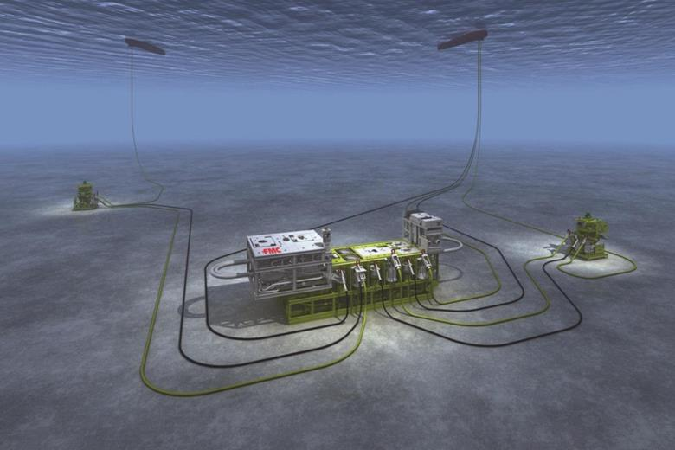
Platform
Jumper
Manifold
Pipeline
Riser
Well
Typical subsea structure system
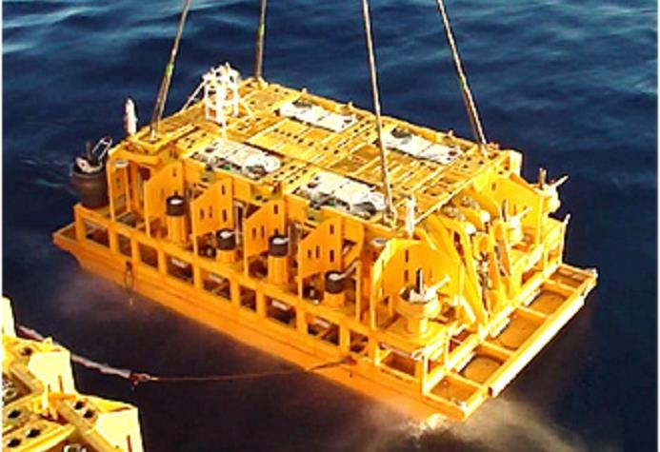
Subsea manifold installation
Figure.2-1: Subsea manifold applied in oil & gas production system [FMC]

2.2. Subsea Manifold
The subsea manifold is installed on the seabed within an array of wells to gather product or to inject water or gas into wells. There are several types of subsea manifolds, ranging from a simple Pipeline End Manifold (PLEM) and Pipeline End Termination (PLET) to large structures such as an entire subsea process system as follows: template manifold, cluster manifold and Pipeline End Manifold (PLEM) and Pipeline End Termination (PLET) as shown in Figure.2-2
Category of subsea manifold required is generally determined based on the field layout development. A PLEM is one of the most common manifolds in this range. The PLEM is directly connected to pipelines and its installation considerations are key factors in the design.

Figure.2-2: Categories of subsea manifolds.

A subsea template is a large steel structure which is used as a base for various subsea structures such as wells and subsea trees and manifolds detail will discussed in chapter 3. The Figure 2-3 shows a number of wellheads on a subsea template. The wellheads can be seen with their guidebases (4 x white rods) pertruding from each corner, which are used to locate other equipment, i.e. trees. The size of a template is dependant on the number of structures attached to it.
Many will have protective structures covering them, as does the template pictured right. This helps prevent damage from fishing activities and also improves fishing safety by reducing the likelihood of nets becoming snagged on the equipment will have protective structures covering them, as does the template pictured right. This helps prevent damage from fishing activities and also improves fishing safety by reducing the likelihood of nets becoming snagged on the equipment.
Most subsea templates / manifolds will be protected by a 500 metre safety zone centered on one position. However, other equipment may also be clustered within the same area, justifying the need to have a 500 metre safety zone

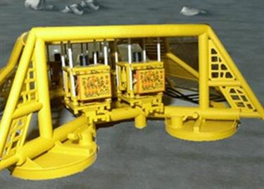
Figure.2-3: Subsea template supporting wellheads and protective structure [Fishsafe].

Cluster manifold is a stand-alone structure designed to direct fluids for multiple subsea trees placed around it which will be discusses in chapter 4. A cluster manifold is generally designed to direct fluids for only one or two subsea trees. The cluster manifold is a structure used to support a centrally located manifold for gathering of produced fluids and/or distribution of injected fluids
A Pipeline End Manifold (PLEM) generally connects directly to a subsea flow line without the use of a pipeline end termination (PLET).

2.3. Function of Subsea Manifold
Subsea manifolds have been used in the development of oil and gas fields to simplify the subsea system, minimize the use of subsea pipelines and risers, and optimize the fluid flow of production in the system. The manifold is an arrangement of piping and/or valves designed to combine, distribute, control, and often monitor fluid flow. The functions and purposes of subsea manifolds can be summarized as follows:

Subsea manifold systems are often configured for the following specific functions:

2.4. Template and Manifold
The subsea manifold system is mainly comprised of a manifold and a template foundation as shown in Figure.2-4. The manifold support structure is an interface between the manifold and the template foundation. It provides necessary facilities to guide, level, and orient the manifold relative to the template foundation. The connection between the manifold and the manifold supporting structure allows the manifold to retrieve and reinstall with sufficient accuracy so as to allow for the subsequent reuse of the production and well jumpers.

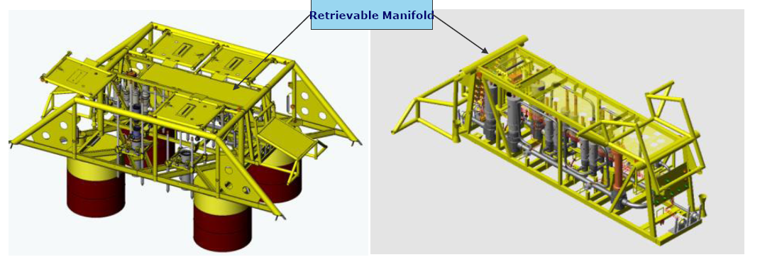
Figure.2-4: Template and Manifold [DNV-GL]

A manifold is a structural frame with piping, valves, control module, pigging loop, flow meters, etc. The foundation provides structural support for the manifold. It may be either a mudmat with skirt or a pile foundation, depending on seabed soil conditions and manifold size.

Chapter.3

3.0 Template

3.1. General
A template is a seabed-founded structure that consists of a structural framework and a foundation either driven/suction piles or gravity-based which is arranged so as to provide support for various subsea equipment such as
- subsea wellheads and trees,
- piping manifolds for production, injection, well testing, chemical distribution systems
- control system components such as subsea Control Module (SCMs), hydraulic piping, electrical cabling
- drilling and completion equipment
- pipeline pull-in and connection equipment
- production risers
A template manifold is a subsea structure on the seabed that provides guidance for drilling or other equipment as shown in in Figure.3-1. The template manifold is a drill-through structure designed to house multiple subsea Christmas trees on top of it and gather/route flow at the same time. It is required when subsea trees are grouped side-by-side. Trees are connected directly into the manifold via mandrels when installed.

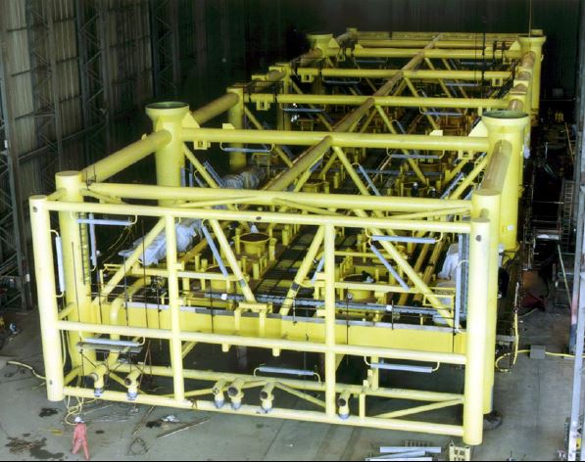
Figure.3-1: An example template manifold

The template manifold is as a guide, hang off and support to drilling and to the wellhead conductor. It is also the structural framework or base for the subsea trees and the manifold, risers, wellheads, drilling and completion equipment, and pipeline pull-in and connection equipment as shown in Figure.3-2. The structure should be designed to withstand any loads, such as from thermal expansion of the wellheads and the pipelines.

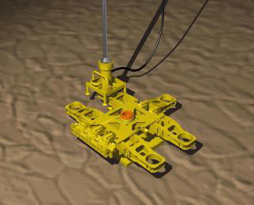 | 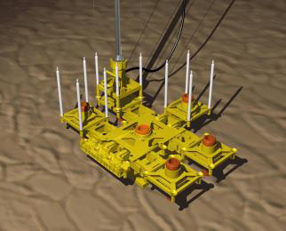
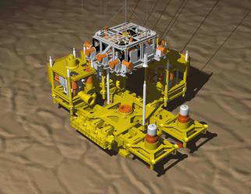 | 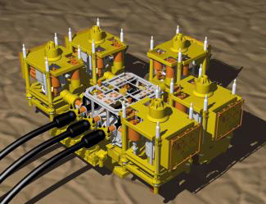
Figure.3-2: An example of template and manifold.

Template manifold must be fabricated and installed before the start of drilling, which gives less schedule flexibility. It does not allow the re-use of exploration wells because they are typically not grouped together. Statoil Norne in North Sea has template manifold.

3.2. Template Manifold Design
Production from the templates may flow to floating production systems, platforms, shore, or other remote facilities. The template is typically used to group several subsea wells at a single seabed location. Templates may be of a unitized or modular design. Typical templates are described next. Actual templates may combine features of more than one of these types.
The design of the template manifold will vary with location, installation methods, pipeline methods, protection requirements and drilling methods as shown in Table.3-1.

Table.3-1: Criteria of design of the template manifold
Factors to be considered in design | Description
Location | Local legislation
Installation methods | Moon-pool, drill-pipe, crane vessel, modular, barge or wet tow
Pipeline methods | Horizontal or vertical flow-line connection, pipeline forces
Protection requirements | Fishing gear protection, dropped objects
Drilling methods | Suction of drill cuttings, cement suction, drill cutting injection

Based on seabed condition, the template foundation of manifold was designed with: mudmats, washout sleeves, skirts and suction piles. A Mudmat is as a foundation and providing bearing capacity to avoid settlements as shown in Figure.3-3. Washout sleeves is to avoid shortfall and fracture in seabed during 36” drilling. Skirts to penetrate seafloor for resist lateral forces and to provide friction against heave during installation as shown in Figure.3.4.
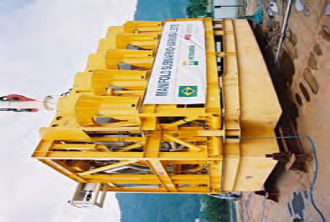
Mudmat
Figure.3-3: Mudmat [Paul Betteridge]

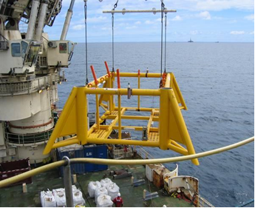
Figure.3-4: Skirt of Template [Paul Betteridge]

3.3. Suction piles
Suction piles or a large single suction pile to support vertical and horizontal loads on the manifold

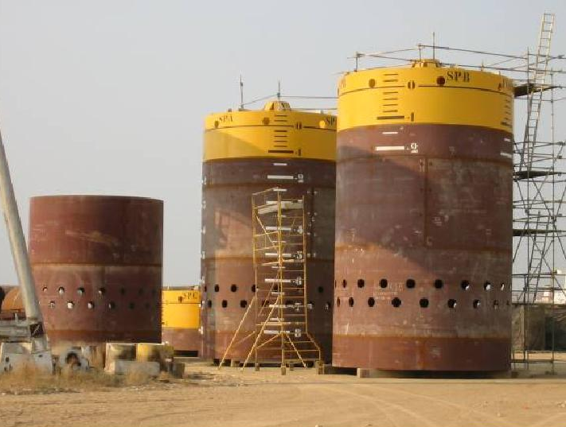  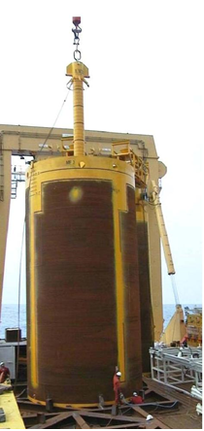  Suction Pile (Bonga) | 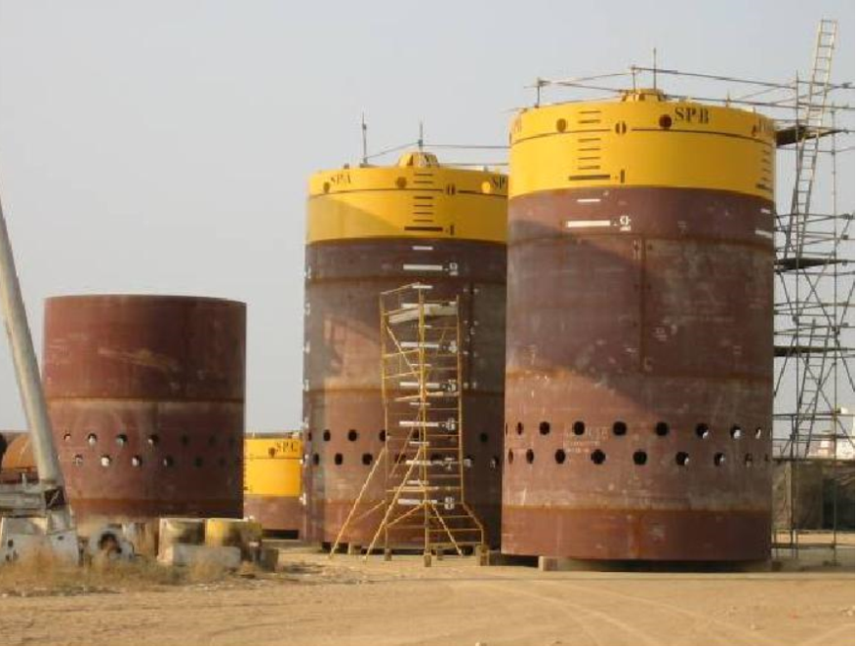  Suction Piles (Lobito)
Figure.3-5: Suction Pile [Paul Betteridge]

3.3.1. Single Suction Piles
There are several benefits of suction piles as follows:

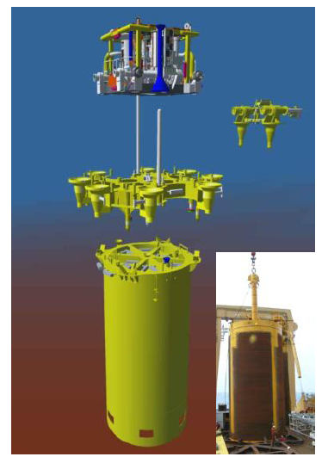
Figure.3-6: Single Suction Piles [DNV-GL]

3.3.2. Mini Suction Piles
Template foundations with skirts or mini-suction piles:
- Installed before main manifold so reduced weight
- Allow drilling taking place (normally one season prior to manifold installation)
- Each mini pile) can be sucked down individually to adjust elevation
- Supports weight of manifold or template and anchors it in place on the seabed
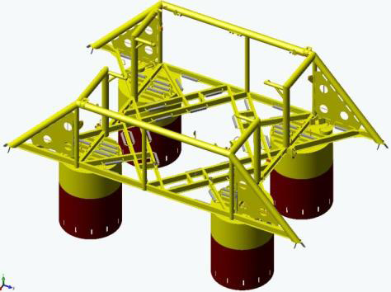
Figure.3-7: Suction Piles of Manifold [DNV-GL]

3.4. Manifold Template
A template with multiple wells that incorporates a manifold system is illustrated in Figure.3-8. A manifold template is one that is used to support a manifold for produced or injected fluids. Wells would not be drilled through such a template, but may be located near it or in the vicinity of the template.

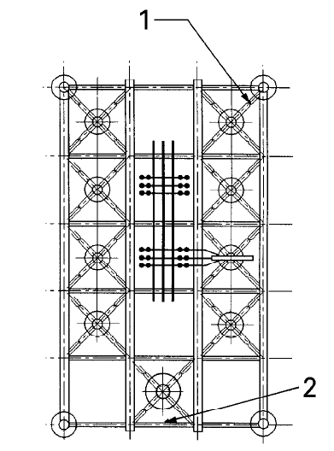
4
3
1. Guidepost (if required), 2. Production riser base
3. Tree, 4. Manifold header and valves
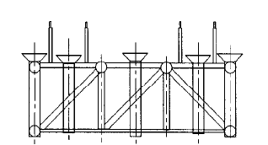

Figure.3-8: Multiwell/Manifold Template.

3.5. Tie-Back Template
Tie-back template or a well spacer or is a multiwell template used as a drilling guide to predrill wells at a single seabed location. The multiwell template that is used as a drilling guide to predrill wells prior to installing a surface facility is referred to as a well space/tie-back template. The wells are typically tied back to the surface facility during completion. The wells could also be completed subsea with individual risers back to the surface as shown in Figure 3-9. If wells are to be drilled through the template, it should provide a guide for drilling, landing capability for the first casing string, and sufficient space for landing a BOP stack. If subsea trees are to be installed on the template, it should provide proper mechanical guidance for positioning of the trees and sufficient room for all installation and intervention operations.
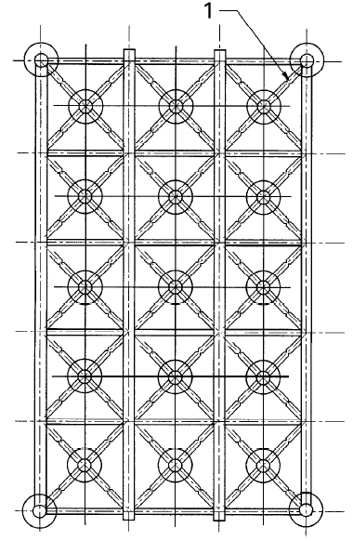
1. Typical tree guidepost receptacle (if required)
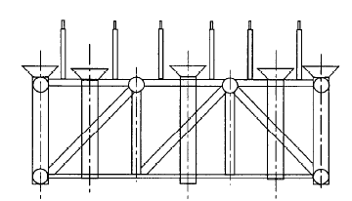
Figure.3-9: Well Spacer/Support Template.

3.6. Riser-Support Template
A riser-support template supports a marine production riser or loading terminal and serves to react to loads on the riser throughout its service life. This type of template may also include a pipeline connection capability. Figure.3-10 shows a combination template with wells, manifold, and production riser support.

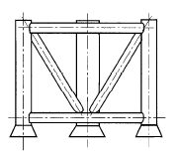  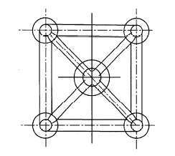 | 1. Typical tree guidepost receptacle (if required)
Figure.3-10: Manifold Template with Production Riser.

Templates designed to provide underwater wellhead support should incorporate a well bay and associated structure capable of withstanding drilling loads. The design should provide sufficient rigidity to maintain required spatial tolerances between components when under deflection.
Design loads may also include weight from surface casings due to inadequate cementing and drilling riser loads caused by vessel offsets.
The template should withstand pipeline installation forces, snag loads, and any loads induced by thermal expansion. If the template cannot be practically designed for pipeline snag loads, a protective breakaway device should be considered. The template should provide a sufficiently strong foundation to be able to transfer design loads into the seabed. The template should be capable of withstanding the applicable loads due to the use of maintenance equipment.
In seismically active regions, the effects of earthquakes on the template should be considered. The design should allow for thermal expansion loads of elements heated by the produced fluid stream. The possibility of accidental snagging of the structure by trawling equipment, anchors, or other foreign objects, and the resultant loading, should be considered. The structural shape and strength should be designed to accommodate the maximum snag load without damaging critical components.
If the template is to be recovered at the end of the project, a recovery method should be considered. During installation and retrieval of the template, the vertical center of buoyancy should be maintained well above the center of gravity. Placement of any sacrificial anodes should be considered, avoiding areas subjected to accumulation of drill cuttings.

Chapter.4

4.0 Cluster Manifold

4.1. General
A cluster manifold is a structure used to support a centrally located manifold for gathering of produced fluids and/or distribution of injected fluids as shown in Figure.4-1.
In this arrangement, individual satellite wells are clustered around the manifold and tied back (to the manifold) using either flexible or rigid pipe. This type of template also includes connection point(s) for tie-in of flowlines or production risers to/from the manifold to the host facility.

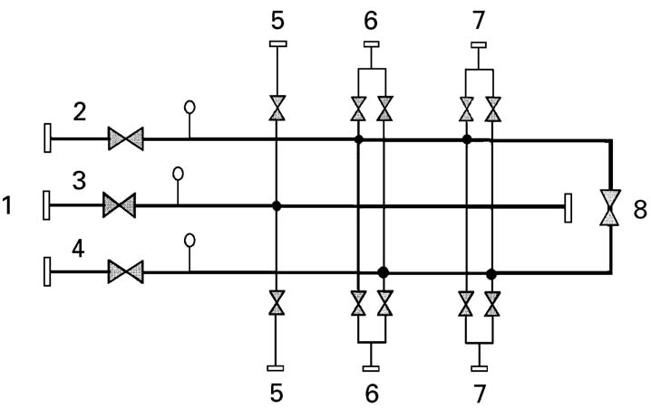
Key:
1.to flowline or riser system, 2.oil production line, 3.water injection line, 4.well test line,
5.to water injection line, 6.to oil production tree, 7.to oil production tree and 8.possible pigging valve
Figure.4-1: Schematic of Typical Manifold

The main umbilical can also be terminated at the cluster manifold so that chemical distribution piping, hydraulic piping and/or electrical cabling can be installed on the manifold. Individual umbilical jumpers can then be used to link each well back to the chemical/hydraulic/electrical systems on the cluster manifold. Alternatively, the main umbilical can be terminated at a separate subsea umbilical distribution unit, to which each of the wells is directly linked by an umbilical jumper, thus avoiding additional connections and complexity on the cluster manifold.
Cluster manifold structures, together with the associated manifold, are typically installed as a single-piece unit and are often small enough to be run through the moonpool of a suitable MODU, thus saving considerable cost versus the use of a heavy lift vessel. Typically, the manifold and various other functional components can be retrieved and reinstalled independently of the structure itself, for maintenance purposes.

4.2. Cluster Manifold Design
A cluster manifold is one that is installed as one unit or as modules assembled around a base structure, such as a well. Cluster manifold typically consist of manifold roof protection, manifold, pig loop module, drill out injection PGB, mudmat and center pile as shown in Figure 4-2 is a stand-alone structure designed to direct fluids for multiple subsea
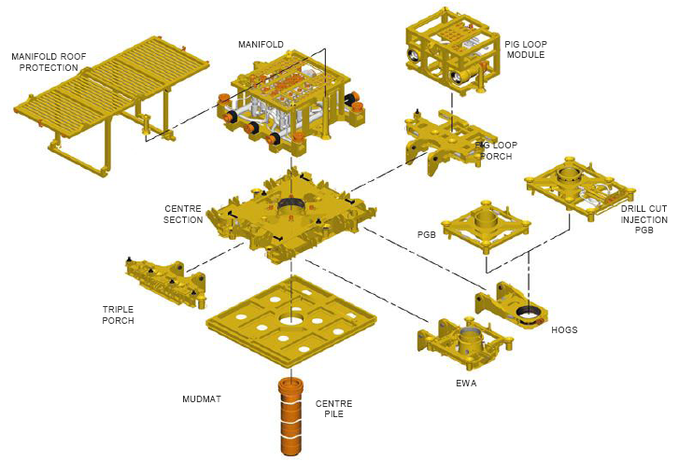
Figure.4-2: Cluster manifold [DNV-GL]

4.3. Cluster Manifold in Gemini Project
Cluster manifold is a stand-alone structure designed to direct fluids for multiple subsea trees placed around it as shown in Figure.4-3. It typically can accommodate 4-8 wells per manifold. Both the TOTAL and Shell's manifolds shown in the picture are cluster manifolds. When subsea Christmas trees are grouped closely in a central location (but not side by side), either a cluster manifold or a PLEM is required depending on the number of trees anticipated. A Daisy Chain field layout has the same manifold requirements.
- Provides flexibility to co-mingle or segregate any particular wells
- Can accommodate pigging capability
- Can include chemical injection
- Allow the re-use of exploration wells
- Has reduced risk of dropped objects and SimOps compared to template manifold.

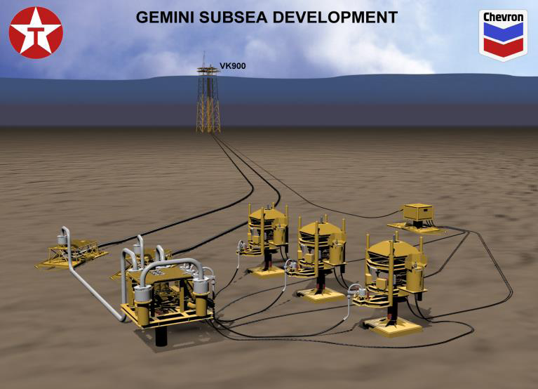
4-in-diameter flexible jumpers
Manifold
3 unit Trees
single 36-in suction pile
12-in-diameter rigid jumpers
12-in-diameter flowline
Figure.4-3: Cluster Manifold in Gemini Field Arrangement in Gemini Field [DNV-GL]

Chapter.5

5.0 Components of Manifold

5.1. General
A manifold system design typically fulfills the functions of gathering and/or distributing fluids, direct flow through headers, allow isolation of individual well slot from header, incorporate flow-line connections, and allow continuity of pigging. The manifold system is designed to be operated without maintenance during a project’s lifetime. Furthermore, components such as choke modules, subsea control modules, and multiphase meter modules are designed to be retrievable. In most project applications, all manifold piping connections are welded to minimize leak paths and increase reliability. Many manifolds feature a removable pigging loop to allow round trip pigging of the production flow-lines.
Figure.5-1 shows a typical example of manifold viewed from inside. A subsea manifold is typically composed of the following major components:

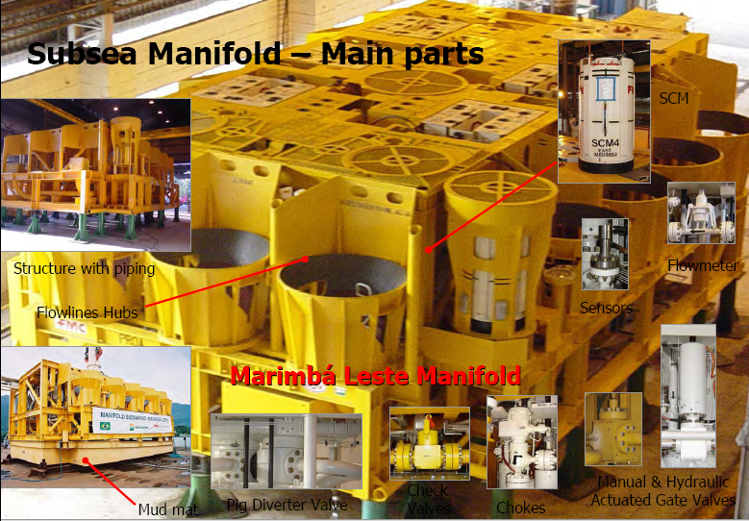
Figure.5-1: An example of a manifold [Mario L. P. G. Ribeiro].

P-52 Manifold  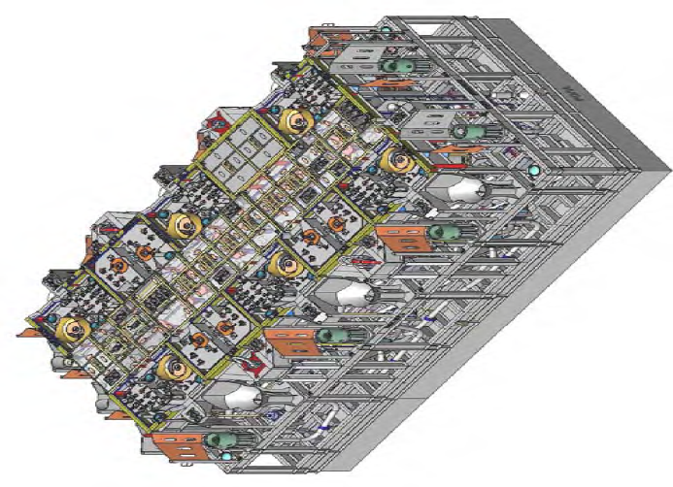  - Dimensions: 16.5m (L) x 8.5m (W) x 5.2m (H)  - Weight in air: 280 tons  - WD installation: 1900m  - CG: 3.15m | 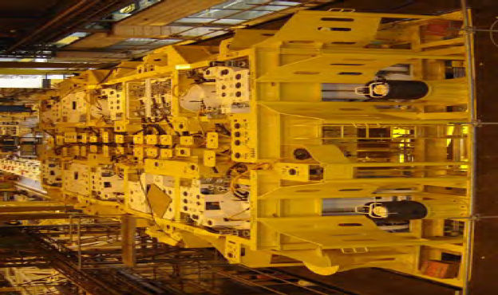
 | 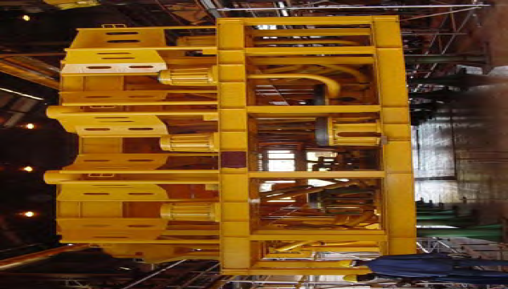
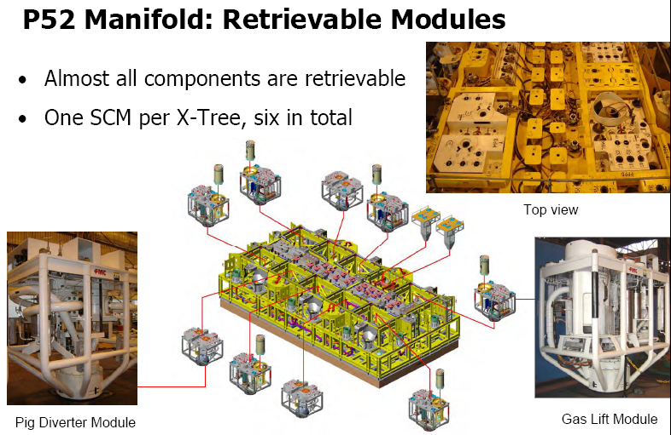
Figure.5-2: P52 Manifold [Mario L. P. G].

5.2. Manifold Header
Flow-lines or piping are connected to one or two headers in the manifold. Two production headers have the advantage of:
- Increased flexibility in export options
- Increased flexibility for future tie-ins
- Increased production availability
- Possibility for installing a pigging loop
- Possibility for hydrate plug removal from two sides

5.3. Manifold Piping
A wide range of pipework configurations is possible. Each header connects to an individual flowline. The pipework sizing is based on the tree piping size and the flowline diameters. The main circuit is designed to accommodate pigging operations. The material of construction needs to be compatible with production and injection fluids.
- Test headers can be incorporated to test individual or groups of trees
- Test headers can be a second or even third header isolated in the manifold. Insulation may be required for unscheduled or emergency shutdowns
Subsea manifold valves are mounted within the piping system to control the production and injection fluids. The manifold piping consists of main piping, remote actuated valves, pigging loop valve and ROV panel adopted as shown in Figure.5-3. Figure.5-4 shows pigging diverter valve.

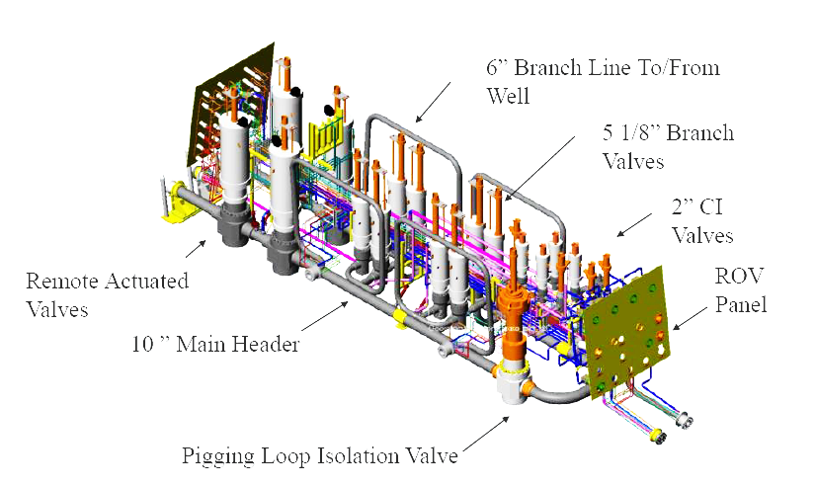
Figure.5-3: Manifold Piping

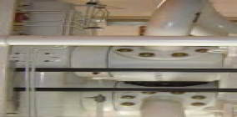
Figure.5-4: Pigging Diverter Valve

The overall weight of the manifold is dependent on the piping configuration. Normally only functional requirements are established by operators, so manufacturers are not given the arrangement to be adopted, which leaves the design team relatively free to design the piping system. The use of flanged components or welded ones is basically dependent on manufacturers’ criteria and must be considered in the analysis of a manifold’s designed lifetime.
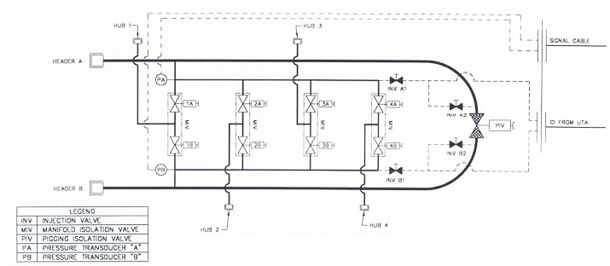
Figure.5-5: Manifold piping and instrumentation diagram/drawing (P&ID).

5.4. Manifold Valves
Valves on the subsea manifold are essential for directing and controlling the flows. The reliability of subsea manifolds is strongly dependent on subsea valves because the flow is directly through them. They can be either manual or hydraulically actuated. Sometimes chemical injection valves are placed on the manifold as well.
- Branch valves are generally slab type gate valves (similar to tree valves). Their sizes are based on the production/injection tree size.
- Flowline header valves are also gate type, but ball valves have been used previously. Their sizes are based on the flowline size.
- Materials are chosen for compatibility with production and injection fluids. Most of time, it is CRA-clad.
- Double barrier philosophy generally used against production fluids.
  - Two valves in series
  - One valve and one pressure cap
  - Primary seal is generally a metal-to-metal seal
In a diverless subsea manifold, these valves are hydraulically actuated, on/off types and are used to direct the flow to the manifold production header or to the manifold test header and they are also used in chemical injection lines. In the manifolds designed to allow the passing of pigs, valves are used to provide the connection between the main headers. Figure.5-6 illustrates a Magnum subsea gate valve with fail-safe actuator, which can be used in water depths up to 2500 m
.
Figure.5-6: Magnum Subsea Gate Valve with Fail-Safe Actuator [Gate Valves & Actuators]

One of the main design requirements of the subsea system is that all remotely controlled valves should be located within retrievable manifold frames or modules. The selection and location of the valves on the manifolds is of prime importance. Design specifications of valve type, size, pressure rating, and actuator function are required prior to detailing manifold layouts. Every type of valve has its strengths and weaknesses. For some applications, a ball valve provides a number of benefits over an API 6A gate valve that would potentially make it the best choice. Some of the features to consider are size, weight, height, speed of operation, seal wear, weldability, depth sensitivity, ROV intervention, fluid displacement during operation, and low-pressure sealing.

5.4.1. Valve Types
Gate valves or ball valves are two typical valves used in the manifolds. Gate valves have a long history of use in subsea blowout preventer (BOP) stacks, trees, and manifolds and are considered relatively reliable devices because both the valve and the valve actuators have been through extensive development with proven field use and design improvements. Figure.5-7 illustrates two types of subsea gate valves. Figure.5-6a shows a WOM (Worldwide Oilfield Machine, Inc.) subsea gate valve with actuator, compensator, and ROV bucket. The hydraulic actuator is designed with a fail-safe model and spring returns with the ROV. The mechanical ROV is for backup. Figure.5-6b shows a WOM subsea gate valve with only an ROV bucket. Both valves are designed, built, and tested based on API 6A [API] and 17D [API], which can be used up to a water depth of 13,000 ft (4000m).

Figure.5-7: WOM Subsea Gate Valve with ROV Bucket [Gate Valves & Actuators]

Ball valves also are proven items and their use in deeper water depths is increasing. In some deep-water applications, ball valves can provide operational and cost advantages over gate valves, and improvements in nonmetallic seals and coatings are raising the reliability of ball valves. Ball valves were initially used downstream by the gas industry in gas pipeline valves. At that time, pipeline gate valves were the standard valves used in liquid pipelines [API]. Even today, gate valves are frequently specified for liquid pipelines, and ball valves are specified for gas pipelines. When gas wells were completed in the Gulf of Mexico in the 1960s, ball valves were installed in pipelines both as isolation valves and as terminal valves to tie in lateral lines from future wells and platforms. In the late 1970s, ball valves were installed in the North Sea and encountered problems due to the more challenging conditions of the sea. Later, ball valves were installed in subsea projects as emergency shutdown (ESD) valves to prevent gas in a pipeline from flowing back to a platform in the event of a major leak.
Figure.5-8 shows a typical two-way subsea ball valve from Autoclave Engineers that is designed to facilitate operation by an ROV. The valve design incorporates additional O-ring seals, which prevent the ingress of seawater into the valve. Seawater would adversely affect the operation of the valve and also contaminate the process fluid. The valve can be used in water depths to 3800m with maximum internal pressures of 20 ksi.

Figure.5-8: Typical Two-Way Subsea Ball Valve [Autoclave Ball Value]

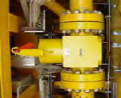
Figure.5-9: Check Valve

5.4.2. Size and Pressure
Manifold valves are usually required to carry the same pressure rating as Christmas tree valves in terms of the possible failure of the choke or valves on the tree. Normally, ball valves can more easily accommodate the size, whereas gate valves are more suited for the pressure. When people think of deep-water valve applications, API 6A gate valves typically come to mind because the first ventures into subsea at any depth have been exploration drilling. Typical BOP chokes and kill stack valves are 3 1/16-in. (0.078m), 10,000- or 15,000-psi API 6A gate valves. For the API 6A gate valves, size is a real challenge, while the increasing need for 10-ksi ball valves has been the biggest development effort for ball valves. Gate valves are preferred for all smaller sizes in which they are available, and ball valves are preferred for sizes 10 in and larger.
Size has revealed another anomaly in subsea manifolds for all valves. Specifications are calling for 5000- or 10,000-psi valves that meet API 6A or 17D requirements in pipeline sizes that do not exist in either specification. A 5 1/8-in. (0.13m) or 6 3/8-in. (0.16m) 6A valve size defines the bore, but pipe size is defined by the outside diameter. A manifold specification calling for 8-in. (0.20m), 10,000-psi valves will likely be met with a valve having a 6 3/8–in. (0.16m) bore. The pipe grade and wall thickness must be known to properly select the valves. Table 5-1 compares some typical API 6A sizes with a heavy-wall pipe.

Table.5-1: Comparison of Typical API 6A Size with Pipe Size [API]
Nominal Pipe Size | Standard Valve Bore* | Pipe ID**
2 in. | 1-13/16 in. or 2-1/16 in. | 1.689 in.
3 in. | 2-9/16 in. | 2.624 in.
4 in. | 4-1/16 in. | 3.438 in.
6 in. | 5-1/8 in. | 5.189 in.
8 in. | 7-1/16 in. | 6.813 in.
10 in. | 9 in. | 8.500 in.
12 in. | 11 in. | 10.126 in.
16 in. | 13-5/8 in. | 12.814 in.
Notes:
*Standard valve bore as per API 6A, 10K flanges.
**Pipe ID for the nominal pipe size and a standard pipe schedule of 160.

5.5. Manifold Chokes
The choke is used to control the flow of the well by adjusting the downstream pressure in a production manifold or upstream pressure in an injection manifold to allow commingled production/injection. Hydraulic-actuated variable chokes are used for diverless subsea manifolds. These chokes can be residents at the manifold or installed at retrievable modules.
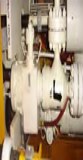
Figure.5-10: Hydraulic-actuated variable Chokes.

5.6. Control System
Control system for the manifolds is the same as the control system for the trees. Multiple options for the control system have been used in the manifold design
- No controls on the manifold. The manifold is controlled by tree subsea control modules (SCMs).
- SCMs on the manifold.
- Manifold with control system distribution units with flying leads going to trees
Subsea valves are normally actuated by means of a direct control system or electro hydraulic multiplexed system. The use of one type or another depends on the distance of the subsea manifold to the host platform and the number of functions to be controlled. A multiplexed control system provides a quick response to valve actuation and greatly reduces the number of umbilicals needed.
The control system has a significant impact on the acquisition cost of a subsea manifold, especially the multiplexed control system. The impact on maintenance costs is also considerable because an unexpected failure can lead to an interruption of the well’s production.
The SCM, as shown in Figure.5-11, contains electronics, instrumentation, and hydraulics for safe and efficient operation of subsea manifold valves and chokes. Other tree mounted equipment includes various sensors as shown in Figure.5-12, electrical and hydraulic connectors.

Figure.5-11: Subsea Control Modules (SCM) | 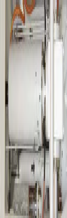  Figure.5-12: Hydraulic Actuated Gate Valves
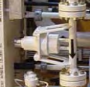  Figure.5-13: Manifold Flowmeter | 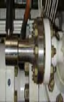  Figure.5-14: Manifold Sensor

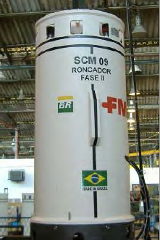 | 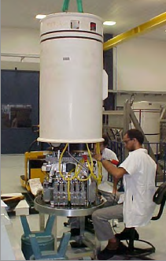 | 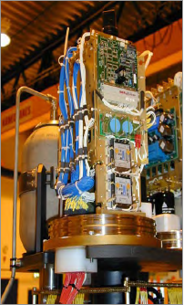
Figure.5-15: P52 Manifold: SCM

5.7. Framework structure
The framework is a welded structure to provide support for the pipework and valves and contain the foundation interface structure. The pipework is allowed to float inside the framework within limits and it is not rigidly attached to the frame. The frame can also be used for lifting and landing of the jumper tie-in tools

5.8. Foundation
- Mud mats – a simple foundation resting directly on the seabed, generally with a short skirt around the perimeter to resist lateral loads.
- Piles – long cylindrical structures embedded into the soil intended to hold a subsea structure above the seabed. Foundations may utilize one or more individual piles.
- Intermediate Structures – an intermediate structure can be used to interface a subsea manifold with a pile foundation to reduce weight of the manifold structure or to ease retrieval of the manifold. Intermediate structures can be either retrievable or permanent structures.

5.9. Tie-ins to wells and flowlines
The tie-in hubs placed on the outer edge of the manifold, which are used to tie-in jumpers that bring in fluid from the production wells and export fluid into the flowlines (production manifold). The tie-in sizing is based on the tree piping size and the flowline diameters. and the loads applied from the flowlines

5.10. Insulation
Generally gas manifolds are not insulated and oil manifolds are insulated. For oil production, insulation is necessary to allow adequate cool-down time to treat or remove trapped production water. Gas production is generally treated continuously with chemicals to prevent hydrates.

5.11. Subsea Modules
The main objective of the subsea module is to house components with a high failure probability in a place that permits the recovery of all components either by divers, ROVs, or a specific running tool, thus saving time during maintenance operations.
One important aspect to be considered in subsea manifold modularization is any increase in cost, weight, and equipment complexity. Modularization increases equipment availability, but it also increases the number of connections, which in turn increases the chances of leakage. Therefore, it is essential for a highly reliable seal component to be used in these modules and retrievable cartridges.

Chapter.6

6.0 Design of Manifold

6.1. General
The manifold should provide a sufficient amount of piping, valves, and flow controls to, in a safe manner, collect produced fluids or distribute injected fluids such as gas, water, or chemicals. The manifold should have sufficiently sized bores in piping and valves to allow pigging. If wells are to be completed on the template, the manifold should provide for the connection of the Christmas tree.
The manifold may provide for mounting and protection of equipment needed to control and monitor production/injection operations. The manifold may also include a distribution system for hydraulic or electrical supplies for the control system.
Where wells are incorporated into the template and manifold, the addition of spare well slots should be considered. If satellite wells are to be tied in, the template and manifold design should provide this capability considering pipeline and umbilical connections, pull-in loads, valving, and pigging capabilities. The initial design considerations should consider the types of accidental damage loads to which the system may be subjected.
A maintenance approach should be considered early in the design of a template/manifold system. Specifically, the following items should be considered:
- Maintenance method;
- Retrievable components;
- Access space for divers, ROVs, or other maintenance equipment;
- Height above seabed for visibility;
- System safety with components removed;
- Identification of failing components.
Manifold design and analyses should address the following issues:
- Steel frame structures and painting design;
- Pipework and valve design;
- Connection equipment and control equipment;
- CP design;
- Flow assurance and hydraulics.

6.1. Code and Standard
The following standards are a selection normally used for template/manifold design. The code requirements will vary with customer preference and local legislation
- ISO 13628-15 Subsea structures and manifolds (2011)
- ISO 13628-1 General requirements and recommendations
- Steel structure: Eurocode 3
- NORSOK U-001 (Dropped objects)
- ASME B 31.3 (Process piping)
- ASME B 31.8 (Gas transmission piping)
- DNV-OS-F101 (Submarine pipeline systems)
- BS8010 Part 3
- DNV standards for planning and Execution of Marine Operation

6.2. Frame Structures Design
The manifold should be designed with the ability to be installed together with the template and as a separate module. Cluster manifolds should be based on an integrated template and protection structure with a separately retrievable manifold.

6.2.1. Structural Design
Manifold modules belong to subsea structures. Therefore, their structural design follows relevant standards for subsea structures, such as ISO 13819-1 and ISO 13819-2. The design pressure for a steel manifold piping system or the nominal wall thickness for a given design pressure may be determined according to ASME B31.8, Chapter VIII, or DNV OS F-101. Formulas used for wall thickness design, flexibility analysis, and code stress checks may be determined from the same documents. For example, the formula from ASME B31.8 is:

$P=\frac{2St}{D}FET$ (6-1)

where; $P$ is design pressure, $D$ is nominal outside diameter of pipe; $S$ is specified minimum yield strength, $t$ is nominal wall thickness, $F$is design factor, $E$ is longitudinal join factor and $T$is temperature derating factor.

6.2.2. Structural Analysis
The manifold system may include valves, hubs, connectors for pipeline and tree interfaces, chokes for flow control, and Through-Flowline (TFL) diverters. It may also include control system equipment, such as a distribution system for hydraulic and electrical functions. Figure.6-1 shows the front and plan views for a typical tie-in manifold.

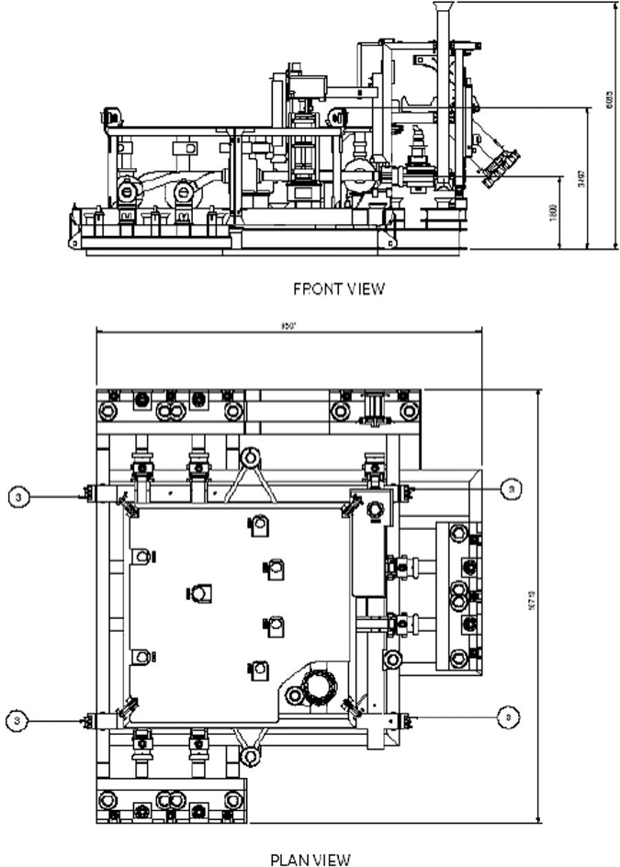
Figure.6-1: Front and Plan Views for a Typical Tie-In Manifold

Structural Frame
Figure.6-2 shows an ISO view of a production manifold structural frame. The manifold structural frames satisfy the following requirements:
- Be designed to the requirements of API RP2A [API].
- Be fabricated to requirements of AWS D1.1 [API].
- Provide support and protection for header piping and control tubing.
- Provide the means for guidance and alignment of the manifold onto the pile foundation.
- Consist of a primary structural frame and ancillary protective structures, support structures, alignment and guidance systems, and installation and handling facilities.
- Provide sufficient open space for installing the manifold piping and valves, and be strong enough to resist all anticipated loads and deflections.
- Be designed with the bottom of the frame suitable for supporting the static weight of the manifold on the ground/deck.
- Provide a four-point lift arrangement suitable for a four-legged flexible wire rope sling. The lift points shall be strong enough to support the weight of the manifold in its as-installed configuration. All lift points will be designed in accordance with API 17D [API].
- Contain all anodes necessary to cathodically protect the manifold system from external corrosion, including any anodes needed to protect the system from external drainage, such as half of the total area of attached jumpers and flying leads.
Figure.6-2: ISO View of a Manifold Structure Frame (Mario, 2006)

Interfaces
Figure.6-3 shows a typical production manifold with interfaces for UTA (Umbilical Termination Assembly), ROV (remotely operated vehicle), and others. The following interfaces in the design of the manifold are considered:
- Well/flowline jumper interface to manifold hub including spacing for and access to pipeline end connector running tools;
- Pressure cap installation and retrieval;
- ROV access for valve functioning/isolation;
- ROV access to flying lead junction plates;
- Operational interfaces associated with installation, lifting and handling (padeyes, slings, bridles, spreader bars, installation vessel, etc.);
- Pile foundation top.

Figure.6-3: Production Manifold and Interfaces.

6.2. Manifold Piping Design
The piping system, header, and branch piping should be designed based on DNV OS-F101/ASME31.8, Chapter VIII, and comprises the entire piping: straight pipes, bends, tees, and reducers on the header and branches. The following issues should be considered for the manifold piping stress analysis:
- Internal pressure;
- Hydrotesting;
- Thermal loads;
- Operating with jumper loads;
- Flowline jumper connection loads;
- Well jumper connection loads;
- Environmental loads;
- External corrosion;
- Internal corrosion/erosion;
- Piping supports to accommodate all anticipated loading, deflections, and vibrations.
Piping system should be designed to satisfy the requirements for internal pressure, thermal loads, hydrostatic collapse, and external operational loads, and fabricated to ASME Section IX requirements. Piping stress analysis should be performed using a finite element software package, such as CAESAR II, Ansys, or Abaqus, to confirm that the manifold piping system is fit for the intended purpose for its entire life span.
To conduct a detailed finite element analysis for a piping system such as that shown in Figure.6-4, beam elements are used to simulate the piping system. Figure.6-5 shows the analysis results of the maximum stress in the whole system under operational loads. The displacements of piping at valve positions also should be checked to ensure they are within the movement limits of the valve base.
Figure.6-4: Manifold Piping System
Figure.6-5: Von Mises Stress Distribution of Piping System in the Operating Condition

Pipe fittings in the manifold piping system should be in accordance with ASME B16.9 if practicable. If nonstandard fittings are used, the fitting should be checked in accordance with ASME B31.8, Appendix F, and ASME Boiler and Pressure Vessel Code, Section VIII, Division 2 [ASME]. Figure.6-6 shows an 8.625-in. (0.22m) _ 8.625-in. (0.22m) _ 6.625-in. (0.17m) header reducing tee used in a piping system. The linearized stresses at three sections of the tee are evaluated for the hydrotest conditions and operating cases under external and internal pressure loads as well as thermal expansion loads based on the methods of the ASME Boiler and Pressure Vessel Code, Section VIII, Division 2.

Figure.6-6: 8.625-in. _ 8.625-in. _ 6.625-in. Header Reducing Tee

Figure.6-7 shows the stress distribution in a tee section for evaluation. Based on the stress criteria in Mandatory Design Based on Stress Analysis of Section VII, Division 2. ASME “Design by Analysis” approach is based on the Tresca (shear stress) failure theory with a linear elastic material property. The design by analysis requires the most severe combination of loadings satisfy limits of stress intensities. In the code, the general membrane stress is an average primary stress across a solid section excluding geometry discontinuities. The local membrane stress is the average primary stress across a solid section including discontinuities. The bending stress is a component of primary stress proportional to the distance from the centroid of a solid section.

Figure.6-7: Stress Distribution in Middle Section of Tee

- The primary general membrane stress allowable:
$PL < k x Sm$, where $k = 1$, Sm is the allowable stress intensity – typically the lesser of 2/3 the yield stress (SY) or 1/3 the ultimate tensile stress (SUT).
- The primary local membrane stress allowable:
$PL < 1.5 x k x Sm$.
- The primary membrane stress plus bending stress allowable:
$PL + PB < 1.5 x k x Sm$
- The primary stress plus secondary stress allowable:
$PL + PB + Q < 3.0 x k x Sm$
For the hydrotest case, the stress criteria are as follows:
- The maximum primary membrane stress intensity is 0.9 SY.
- The allowable primary membrane plus bending stress:
$Pm + PB < 1.35SY$ for Pm < 0.67SY,
$Pm + PB < 2.15SY – 1.2Pm$ for 0.67 < Pm < 0.9SY.

Three sections are chosen for the stress evaluation and the positions of the sections are shown in Figure.6-7, where section A–A crosses the area of wall thickness discontinuity.

6.3. Pigging Loop
The manifold piping loop is designed to allow passage of pigs through the main headers to provide round-trip pigging of the flowlines from the production platform.
The pigging loop should satisfy the following requirements:
- Is subsea installable and retrievable without guidelines using a suitable spreader beam with rigging?
- Conforms to the same standards as the manifold header piping.
- Has a full-bore gate valve that will allow a pig to pass without hang-ups. This valve should be hydraulically operated.
- Provides facilities to inject chemicals/methanol through two parallel hydraulically operated gate valves with integral check valves mounted to either side of the full-bore gate valve.
- Is of the same material and size as the production manifold pipeline header piping.
- Is insulated to the same requirements as the production manifold pipeline header piping, with the exception of the pipeline end connectors.
- Is constructed with bends having a minimum radius of five times the nominal pipe diameter (5D).
- Mounts on the inlet hubs of the production manifold.
- Is not required to provide anodes for its own cathodic protection. Electrical continuity to the production manifold will be demonstrated.
- Is coated with three-part epoxy paint with the exception of stainless steel tubing, unless otherwise specified.
Pigging loop system design should consider the following:
- Piping size;
- Bend radius;
- Internal protrusions;
- Valve types;
- Pig launcher/receiver;
- Pig location determination.
Figure.6-8 shows a pigging loop designed for a production manifold. The loop has two 5D bends and an ROV panel for the connector.

Figure.6-8: Manifold Pigging Loop.

6.4. Padeyes
Padeyes should be designed in accordance with the industry practice using a design safety factor of typically 4 or greater based on minimum specified ultimate material strength at the maximum rated pickup angle during installation [API]. This factor of safety is to be applied to the design lift. The design lift includes the total weight to be lifted multiplied by the dynamic load factor (DAF ¼ 1.33), which can be found in the Lloyd’s Rules for Fixed Offshore Installations, Part 4, Chapter 3, or 1.3 in DNV Rules for Marine Operations, Part II, Chapter 5, Section 2.2.2; the weight inaccuracy factor (WF ¼ 1.1), which can be found in DNV Rules for Marine Operations, Part I, Chapter 3, Section 3.5; and the sling factor (SKL ¼ 1.3), which can be found in DNV Rules for Marine Operations, Part II, Chapter 5, Section 3.1. The out-of-plane force is considered by using 8 degrees as the transverse angle in the calculations.

Allowable values for weld material are the same as base material for full penetration and groove welds.

6.5. Control Systems
The production control system and its components should be designed according to ISO 13628-6 [ISO]. For polymer-based hoses, material selection should be based on a detailed evaluation of all fluids to be handled, but it should not be used for pure methanol service (with less than 5% water); see API Spec 17E [API].
The annulus bleed system is exposed to a mixture of fluids, such as production fluid, methanol, completion fluid, and pressure-compensating fluid.
A hose qualification program should be carried out, including testing of candidate materials in stressed conditions representative of actual working pressures, unless relevant documentation exists.
For umbilicals, the electric cable insulation material should also be qualified for all relevant fluids. The materials selected for the electrical termination should be of similar type, in order to ensure good bonding between different layers. The material selection for metals and polymers in electrical cables in the outer protection (distribution harness) and in connectors in distribution systems should have qualified compatibility with respect to dielectric fluid/pressure-compensation fluid and seawater.

6.6. Cathodic Protection
Cathodic Protection should be used for all submerged, metallic materials, except for materials that are immune to seawater corrosion. A surface coating should also be used for components with complex geometries and where its use will result in a cost-effective design.
Cathodic design should be carried out in accordance with DNV RP B401 [DNV-GL], Cathodic Protection Design, or ANSI/NACE RP 0176, Cathodic Protection of Steel Fixed Offshore Structures. The design should ensure reliable electrical continuity to each individual element for the defined design life, including continuity through the sealine termination.
Welded anode connections are recommended for subsea applications. Flanged and screwed connections should be avoided where possible. The electrical continuity to the cathodic protection system should be verified by actual measurements for all components and parts not having a welded connection to an anode.
Any components permanently exposed to ambient seawater and for which efficient cathodic protection cannot be ensured should be fabricated from seawater-resistant materials. Exceptions are components where corrosion can be tolerated, that is, where pressure containment or structural integrity will not be compromised.
Material selection should take into account the probability for, and consequences of, component failure.
The following materials are regarded as corrosion resistant when submerged in seawater at ambient temperature:
- Alloy 625 and other nickel alloys with equal or higher PRE value;
- Titanium alloys with suitable performance under cathodic protection (should be documented for the relevant operating conditions);
- GRP;
Stainless steels Type 6Mo and Type 25 Cr duplex are borderline cases and not considered as fully seawater resistant for temperatures above 15ºC. These materials should not be used for threaded connectors without cathodic protection.
The location and number of CP inspection points for intervention and risk of hydrogen-induced cracking should also be evaluated and determined. Hydrogen-Induced Stress Cracking (HISC) issues should be addresses for duplex stainless steel pipework exposed to cathodic protection. The duplex stainless steels are susceptible to HISC when exposed to elevated stresses in conjunction with cathodic protection potentials lower than typically –850 mV relative to the Ag/AgCl/ seawater reference electrode. DNV- RP- F112 should be incorporated into the piping design code when designing duplex stainless steel pipework.

6.7. Materials Selection

6.7.1. HP/HT Manifolds
Materials for high pressure (HP) or high temperature (HT) manifolds should meet these requirements:
- All piping pipe is made of duplex stainless steel alloy.
- All tees, crosses, elbows, and flanges are made of duplex stainless steel alloy.
- The production pipeline end connectors and hubs are made of materials based on their UNS designation (unified numbering system designation).
- The manifold frame is made from carbon steel.

6.7.2. Material Evaluation
For the materials used in subsea structures, manifolds, piping, and other components having importance for the safety and operability of the subsea production system, the following factors apply to the materials selection:

The materials to be used should normally fulfill the following requirements:

6.7.3. Metallic Materials
Corrosivity Evaluation in Hydrocarbon Systems
Evaluation of corrosivity should include at the least:
- CO2 content;
- H2S content;
- Oxygen content and content of other oxidizing agents;
- Operating temperature and pressure;
- Acidity, pH;
- Halogenide concentration/water chemistry;
- Velocity.
The evaluation of CO2 corrosion should be based on an agreed-on corrosion prediction model or previous experience from the same field.
Risk for “sour” conditions during the lifetime should be evaluated. Requirements for corrosion-resistant alloys in sour service should comply with ANSI/NACE MR 0175, Sulfide Stress Cracking Resistant Metallic Materials for Oil Field Equipment, with amendments given in this part of ISO 13628.

Corrosivity Evaluation in Water Injection Systems
Water injection systems are used for injection of deaerated seawater, raw untreated seawater, and produced water including aquifer water.
Corrosivity evaluations for deaerated injection seawater should be based on the maximum operating temperature appropriate for the given geographical area. For carbon steel submarine injection flow-lines used for low corrosive services, the minimum corrosion allowance should be 3 mm.
All components that may contact injection water should be resistant against well-treatment chemicals or well-stimulation chemicals if backflow situations can occur. For carbon steel piping, the maximum flow velocity should be evaluated considering the corrosivity and erosivity of the system.

6.8. Hydrate Prevention and Remediation
As subsea field development expands into deep-water environments, operators need to consider the potential risk of gas hydrate formation in well-bores, subsea pipelines, and subsea equipment during both drilling and production operations. Hydrates can also form in certain sections of subsea equipment exposed to stagnant fluids under normal or transient flow conditions. The hydrate management philosophy for subsea systems is as follows:
- No continuous inhibition of the subsea system is required in flowing conditions.
- No part of the fluid system is allowed to enter the hydrate formation domain during flowing and shutdown conditions.
- During start-up operations, the cold production fluid released by the well is inhibited at the wellhead until the production temperature reaches a temperature high enough to ensure sufficient cool-down time if another shutdown occurs.
Remediation of hydrate plugs in subsea equipment can be difficult or impossible. In shallow-water field developments, the pipeline and subsea equipment could potentially be depressurized to allow a hydrate plug to dissociate. In deep water, the hydrostatic head of liquids in the pipeline may be generally high enough to keep the hydrates stable. While the pipeline could be displaced, the tree piping, jumper piping, and manifold branch valves are typically not designed for pigging or circulation.
One of the challenges is to apply thermal insulation to subsea equipment in optimal locations to achieve the most benefits. To design thermal insulation for subsea equipment with complex geometries, thermal finite element analysis (FEA) is typically performed. Although a certain minimum thermal insulation thickness is required to achieve the required cool-down time, it is sometimes not practical to insulate all of the surfaces due to access, manufacturing assembly process, equipment testing requirement, contingency procedures for disassembly and repair, etc.
Figure.6-9 illustrates a subsea tree that was modeled using a 3D FEA method that was capable of modeling the complex geometry. The tree body, the valve blocks, the choke, and tree connectors have irregular exterior surfaces. Based on the 3D thermal analysis, the thermal insulation thickness can be optimized to avoid cold spots to meet the cool-down requirements.

Figure.6-9: Insulation Design Based on 3D Thermal FEA [D.Janoff]

Subsea gate valves have a complex internal geometry and flat exterior surfaces unlike the typically round cross section of upstream and down-stream piping. Areas that trap fluids inside the valve cavity are prone to hydrate blockage if the valve is not properly insulated. Furthermore, the valve actuators are not typically insulated to avoid overheating the actuator sealing elements and the hydraulic fluid. The actuator behaves like a large fin and dissipates a lot of heat unless the valve assembly is properly analyzed. Three-dimensional thermal FEA is useful for understanding the heat flow and, hence, designing the insulation around the valve body. Figure.6-10 shows the results of temperature distribution in a group of valves in a manifold.
Figure.6-10: Temperature Distribution of the Metal Surface of Valves in a Manifold [D. Janoff]

The insulation on any part of a manifold piping system is usually of sufficient thickness to meet the cool-down time required for hydrate management. This insulation coupled with high fluid temperatures may exceed the qualification temperature of the electronic components for instruments. Care should be taken to select the proper instruments and determine the insulation thickness around those electronic components. Either the electronics for the components should be prequalified at a higher temperature or sections of the insulation have to be cut away to provide the cooling for the electronics. The connecting jumpers between the tree and manifold, and between the manifold and flow-line, would appear to be reasonably straightforward to insulate, and do not suffer from the potential cold spots at the manifold due to valves.

Chapter.7

7.0 Piling and Foundation

7.1. General
The increasingly more robust and specialized anchoring systems with piles for drilling and production systems have found wide applications in the exploration and exploitation of hydrocarbons offshore from shallow water to deep-water. The anchoring systems were designed based on soil conditions and load considerations and can be categorized into three groups as shown in Figure.7.1:

Figure.7-1: Foundation design

Figure.7-2 shows a comparison of these three groups based on the foundation aspect ratios of L/D (length/ diameter). The foundation used in subsea equipment may be either a mudmat, a skirt, or a suction pile depending on the seabed soil conditions, while piles are usually used for anchoring the drilling and production unit. The mudmat configuration relies on the footprint of the structure to support the combined weight of the manifold system and attached components such as jumpers. A skirt that penetrates deeper into the seabed than the mudmat resists horizontal forces and some portion of the vertical load. The mudmat foundation is described in the chapter on PLETs.
Figure.7-2: Aspect Ratios of Piles

The change in the suction pile aspect ratio (characteristic shape of suction piles) was inevitable based on the soil conditions due to the requirement of a big driving force. Based on the required driving force, the suction pile aspect ratio may range between 2:1 for stiff clay and 7:1 for very soft clay. The full penetration in soil of a suction pile is critical.
Since the early 1980s, when the idea of suction installation was first introduced and applied, the suction pile has found wide applications in deep water development due to its lower fabrication costs and installation time compared to conventional foundation options. Suction anchors are generally used as the main foundation and anchoring system in deep water fields because of the following advantages:
- Fixed location on the seabed, which is important in subsea developments;
- Simple installation procedures with no need for proof load testing at the site;
- No special limitation on the water depth for application or installation: and
- The capacity of suction anchors can be defined more precisely than that of drag anchors.
Figure.7-3 shows a typical suction pile and its installation mechanism. A suction anchor is a cylindrical unit with an open bottom. It is equipped with a valve at the top. Suction piles are installed by applying differential pressure by the way of pumping out water from the interior of the pile. The differential pressure constitutes the driving force necessary to overcome the resistance due to the penetrated soil. In the first step of installation, the suction pile (anchor) penetrates to soil under its self-weight, with free evacuation of the water located inside the skirts. In the second step, an additional driving force is created by pumping out the water entrapped between the anchor top and the soil plug. After reaching the final penetration depth, the valve is generally closed in order to increase the pullout resistance. Installation by suction is less efficient in cohesion less soils than in clay soil. A suction pile works well in homogeneous soils, such as clean sand and particularly very soft to soft clay, which is commonly used in deep water applications.

Figure.7-3: Suction Pile and Its Installation Mechanism [H. Dendani]

Suction piles are widely used in subsea structures, such as subsea manifolds and well protection structures, and it has been also employed as an alternative solution for pipeline installation and for stopping pipeline walking under cyclic thermal loads, as shown in Figure.7-4. A piled foundation may use either a single pile or multiple piles.
Figure.7-4: Suction Pile Used in Subsea Structure

This section provides a general description of the design of suction piles and foundations, including:

7.2. Design Methodology
The API RP design codes ensure adequate foundation safety using the working stress design method. The partial coefficient method is used in DNV codes, by which the target safety level for the structure is reached by applying partial coefficients to the characteristic loads and soil parameters and taking into account the reliability of the design data.
Suction pile design includes preliminary pile sizing and final structure design. In the preliminary pile sizing, the pile aspect ratio (L/D) versus steel weight should be optimized prior to the final suction pile design. Suction pile sizing assumes that the pump-in suction pressure is acceptable for the available soil strength (i.e., soil plug stability check) and that the pump-out pressure is acceptable for the available soil strength.
The suction pile foundation design should account for the loads in the lift, transportation, installation, penetration, and in-place conditions:
- Seabed slope, installation tolerances, and effects from possible scouring;
- Soil bear capacity and bear stress should satisfy API RP 2A-WSD [API];
- Stability analysis of the manifold should include overturning, sliding, and shearing resistance;
- Suction loads due to repositioning or levelling;
- Invasion of soil into pile sleeves should be prevented;
- For foundation and skirt systems, arrangements should be made for air escape during splash zone transfer and water escape during seabed pene-tration. Lift stability and wash-out of soil should be taken into account;
- Structures with skirt foundation should be designed for self-penetration;
- Skirt-system facilities for suction and pumping should, where required, be included to allow for final penetration, leveling, and breaking out prior to removal. The suction and pump systems should be operated in accordance with the selected intervention strategy;
- Settlement of the structures for initial settlement and long-term defor-mation (during installation and lifetime) should be accounted for. Designers must ensure that the pump capacity will be sufficient to provide adequate flow at the required pressure in order to allow efficient operations. This must be verified by testing the pump in submerged condition.

7.2.1. Codes and Standards
The following is a list of codes and standards that can be used for the design of suction piles:
- API RP 2SK: Recommended Practice for Design and Analysis of Station keeping Systems for Floating Structures;
- API RP 2A-LRFD: Recommended Practice for Planning, Designing and Constructing Fixed Offshore Platforms;
- API RP 2A-WSD: Recommended Practice for Planning, Designing and Constructing Fixed Offshore Platforms;
- AISC Manual of Steel Construction LRFD;
- API Bulletin 2U: Stability Design for Cylindrical Plates;
- API Bulletin 2V: Design of Flat Plate Structures;
- DNV, Rules for Classification of Fixed Offshore Installations, 1995;
- DNV-RP-B401, Recommended Practiced Cathodic Protection Design;
- DNV-RP-E303, Geotechnical Design and Installation of Suction Anchors in Clay.

7.3. Design Loads

7.3.1. Permanent Loads
The permanent load will not vary in magnitude, position, and direction in the consideration period. It includes the dead load of the structure and any long-term static load applied to the subsea structure.

7.3.2. Live and Dynamic Loads
A live load is applied to the foundation during installation or the considered working period. It may vary in magnitude, position, and direction.

7.3.3. Environmental Loads
The influence of environmental factors such as current and wave action can result in significant hydrodynamic loads on installations, which are typically transferred as dynamic loads to the foundations.

7.3.4. Accidental Loads
An accidental load considers the load due to fishing gear snagging or impact of dropped objects.

7.4. Geotechnical Design Parameters
Reliable information concerning the soil layering and properties should be collected. The soil investigation program should include high-quality geophysical and geotechnical surveys. The geophysical survey allows geo-hazards to be detected and also provides for a regional geological overview. The geotechnical survey should allow for the collection of high-quality soil samples in as nearly an undisturbed state as feasible. In situ geotechnical tests (such as cone penetrometer tests, in situ shear vane tests) should be per-formed. The depth of the geotechnical borings should exceed the anchor’s penetration. The number of these borings should be defined as a function of the soil variability. One boring should be performed at each anchor location when lateral variability of the soil properties is expected.
The following main soil properties are needed for the design of suction anchors:
- Index properties;
- In situ stresses and stress history;
- Undrained shear strength;
- Drained characteristics;
- Consolidation characteristics;
- Interface strength and thixotropy.

7.4.1. Index Properties
The index properties (including water content, unit weight, plasticity index, grain size distribution, and organic content) are needed to characterize the soil. The unit weight, as deduced from laboratory tests, should be in agreement with the bulk density of the soil evaluated by core logging (gamma-ray absorption). Core logging before liner opening using nondestructive techniques is the best way to assess the quality of the samples as shown in Figure.7-5.
Figure.7-5: Example of Gamma Density Log Compared to Lab Tests [H. Dendani].

7.4.2. In Situ Stresses
The in situ effective stresses and stress history are mainly needed to establish the consolidation stresses for laboratory tests. The in situ stresses are evaluated from the following geotechnical parameters: unit weight, pore pressure, and coefficient of earth pressure at rest. The stress history is commonly expressed by an over consolidation ratio (OCR).

7.4.3. Undrained Shear Strength
The undrained shear strength is a key parameter for the design. The vari-ation of this parameter with the stress path should be assessed. Anisotropic triaxial compression (CAUc), triaxial extension (CAUe), and direct simple shear tests (DSS) are necessary to derive the undrained shear strength profiles. The in situ cone penetration tests (CPTs) generally provide the trend in the variation of the undrained shear strength with depth. The in situ shear vane allows in situ measurement of the undrained shear strength.
The undrained cyclic shear strength has to be evaluated to calculate the capacity under cyclic loads. The undrained cyclic shear strength should be obtained for various stress paths. The remolded shear strength is an important parameter because it is used to calculate the penetration resistance of the skirt walls. The remolded shear strength profile may be deduced from laboratory tests (fall-cone, laboratory vane tests) and in situ tests (mainly from in situ vane tests).
A typical example of undrained shear strength profiles obtained on a field is shown in Figure.7-6. The figure shows a satisfactory agreement between these different sets of data.
Figure.7-6: Example of In Situ and Laboratory Undrained Shear Strength Profiles [H. Dendani]

7.4.4. Drained Characteristics
The drained friction angle and its associated cohesion have to be evaluated when the suction anchor is required to support long-term loading.

7.4.5. Consolidation Characteristics
The consolidation characteristics include compressibility modulus, Poisson’s ratio, coefficient of permeability and the OCR. These characteristics are needed for anchor capacity calculations under long-term loads.

7.4.6. Thixotropy
Thixotropy is the increase in the undrained shear strength of remolded clay with time and without any consolidation effect.

7.5. Suction Pile Sizing Geotechnical Design

7.5.1. Pile Axial, Lateral, and Torsional Capacities
Suction anchors can be designed for different loading conditions:
- mooring applications for floating production units; in this case the suction anchor should resist to an inclined mooring load where the vertical component may be high when fiber ropes are used;
- anchoring for TLPs and other structures such as riser towers where the suction anchor should support uplift loading; and
- foundations for subsea structures where the anchor should resist to a compression load combined with horizontal load and moment.
For the suction pile foundations used to support the manifolds, the foundations should have sufficient capacities to withstand all loads from the manifold system, including compression, lateral, moment, and torsion under both subsea equipment installation and operating conditions. The safety factors are determined in the design basis. As an example, the following safety factors (FOS) were used in a GoM application:

Operating Conditions
FOS = 1.9 for the axial failure;
FOS = 1.9 for the lateral failure;
FOS = 1.5 for the torsional failure.

Installation Conditions
FOS = 1.5 for all type of failures.

The safety factor of 1.9 for the axial failure and lateral failure includes a load factor of 1.3 for dead loads and a resistance factor of 0.7 for soil axial capacity. The safety factor for the torsional failure is reduced to 1.5 due to the fact of the consequence of torsional failure is less severe than axial and lateral failures. However, the negative impact of torsional loading on the axial capacity and lateral capacity of the system’s foundation should be considered during the design stage. A safety factor against all type of installation loading is reduced to 1.5 due to the nature of their temporary, short period of presentation, which also agrees with API RP 2A.
Suction piles should be designed to provide adequate lateral and axial capacities. The tasks include:
- Foundation stability;
- Penetration resistance and the accompanying required suction for final penetration;
- Retrieval resistance and the accompanying required overpressure;
- Vertical settlements of the manifold;
- Maximum horizontal displacements;
- Maximum responses due to the impact when landing the suction pile anchor and the interface guide base at the seabed.

7.5.2. Stability Analyses
Stability calculations are performed for the following two separate conditions:
- Vertical load in combination with torsion moment, utilizing the skin friction and plugged end bearing of the suction pile anchor;
- Horizontal load in combination with an overturning moment, utilizing the shear strength of the soil surrounding the anchor.
The combined vertical and torsion resistances are solved by computing the allowable skin friction according to API and the maximum value applicable for suction-assisted penetration beyond the self-penetration depth.

7.5.3. Penetration Analysis
A penetration analysis involves the calculation of skirt penetration resistance, under pressure needed to achieve the target penetration depth, allowable under pressure by means under pressure giving either large soil heave inside the skirts or cavitations in the water, and soil heave inside the caisson. The penetration analysis is commonly performed using the general principles given in Andersen and Jostad. Such an analysis includes the following parameters:
- Penetration resistance;
- Self-weight penetration of the anchor;
- Required under pressure as a function of depth;
- Allowable under pressure as a function of depth;
- Soil heave as function of depth;
- Maximum penetration depth.
The penetration resistance $R_{TOT}$ is conventionally evaluated using the following expression:

$R_{TOT}=R_{side}+R_{tip}$ (7-1)

Where; $R_{side}$ is the resistance along the sides of the walls due to the side shear, and $R_{tip}$ is the bearing capacity at the skirt tip. The effect of inner stiffeners must be included in the penetration resistance, and the penetration resistance may be higher if there are sand layers or boulders in the clay.
The required under pressure needed to penetrate the skirts is calculated by the following expression:

$∆u={\left(R_{TOT}-W^{'}\right)}/{A_{in}}$ (7-2)
Where; $W^{'}$ is the submerged weight of the suction anchor during installation and $A_{in}$ is the inside suction anchor area. The allowable underpressure with respect to large soil heave within the cylinder due to bottom heave at the skirt tip level can be calculated by bearing capacity. In shallow water the allowable pressure should not exceed the cavitation pressure.
The required suction should be less than the allowable suction, which is the critical suction that may induce failure of the soil plug inside the suction anchor.
In the conventional approach, the resistance along the sides of the walls ($R_{side}$) is calculated considering that the external ($f_{ext}$) and the internal ($f_{int}$) frictions are governed by the same expression:

$f_{ext}=f_{int}=α∙{Su}_{DSS}$ (7-3)

Where; $α$ is an adhesion factor commonly taken as the inverse of the sensitivity value (the ratio between the intact and the remolded shear strengths), and ${Su}_{DSS}$ is an average DSS shear strength over the penetration depth.
Recent installation of suction anchors equipped with inside stiffeners in highly plastic clays showed that the conventional approach gives high penetration resistance compared to the measurements. It is believed that a mixture of remolded soil and water is trapped within the stiffener zone, leading to low internal strength during installation not taken into account by the conventional approach. Several analyses are required to establish a mechanism to address the bearing resistance of the internal stiffeners and the friction generated on the inner skirt wall:
- special laboratory tests to investigate the behavior of the soil between internal ring stiffeners,
- finite element analyses with large displacement formulations, and
- site specific calibration.

7.5.4. Installation Impact Response
The impact response analysis of lowering the suction pile to the seabed is to check the limiting heave motions of the pile close to the seabed. A range of crane lowering speeds should be used considering the available water evacuation areas, suction pile anchor geometry, and prevailing soil conditions. The check criteria are to avoid soil-bearing capacity failures and to avoid high hydrodynamic pressures within the suction pile anchor that could influence its structural design. Figure.7-7 illustrates the landing sequence of suction pile installation.
Figure.7-7: Suction Pile Installation Sequence [A.Couch]

7.6. Suction Structural Design
The suction pile should be designed to withstand the following loads:
- Maximum loads applied and equilibrated by the soil reactions;
- Maximum negative pressure (under pressure) required for pile embedment;
- Maximum internal pressure (overpressure) required for pile extraction;
- Maximum loads imposed on the pile during lifting, handling, launching, lowering, recovery, etc.
The maximum horizontal and vertical loads should be used for the global structural design of piles. A structural finite element model may be used for the global structural pile analysis to ensure that the pile wall structure and appurtenances have adequate strength in highly loaded areas. The structural components of the suction pile should be designed in accordance with the applicable provisions of API RP 2A, AISC, and API Bulletins 2U and 2V. In general, cylindrical shell elements should be designed in accordance with API RP 2A or API Bulletin 2U, flat plate elements in accordance with API Bulletin 2V, and all other structural elements in accordance with API RP 2A or AISC, as applicable.
In API RP 2A and AISC, allowable stress values are expressed, in most cases, as a fraction of the yield stress or buckling stress. In API Bulletin 2U, allowable stress values are expressed in terms of critical buckling stresses. In API Bulletin 2V, allowable stresses are classified in terms of limit states. Two basic limit states are considered in API Bulletin 2V: ultimate limit states and serviceability limit states. Ultimate limit states are associated with the failure of the structure, whereas serviceability limit states are associated with adequacy of the design to meet its functional requirements. For the purposes of suction pile design, only the ultimate limit state is considered in design.

7.6.1. Allowable Stresses
For structural elements designed in accordance with API RP 2A or AISC, the safety factors recommended in API RP 2A and AISC should be used for normal design conditions. For extreme design conditions, the allowable stresses may be increased by one-third.
For structural elements analyzed using finite element techniques, the von Mises (equivalent) stress should not exceed the maximum permissible stress as shown here:

$σ=η_{0} σ_{γ}$ (7-4)

Where; $η_{0}$ is the basic usage factor and $σ_{γ}$ is the material yield strength.
The basic usage factor $η_{0}$ is 0.8 for the maximum in-place loading condition and 0.6 for normal operating, transportation, lifting, lowering, and recovery conditions. Figure.7-8 shows an example of calculation in operating condition for grade X70. The permissible stresses are based on the fiber stresses for simple beam analyses, and the membrane or mid-thickness stresses for finite element analysis (FEA) using plate elements. For laterally loaded plates also exposed to in-plane (e.g., membrane) stresses, the surface Von Mises stress computed at the middle of the plate field which is midway between stiffeners and/or girders should not exceed the following:

$σ_{p}=\left(η_{0}+0.1\right) σ_{γ}$ (7-5)

The nominal elastic stress calculated in the middle of the plate field due to lateral pressure acting alone should not exceed the maximum permissible stress ($η_{0}σ_{γ}$).

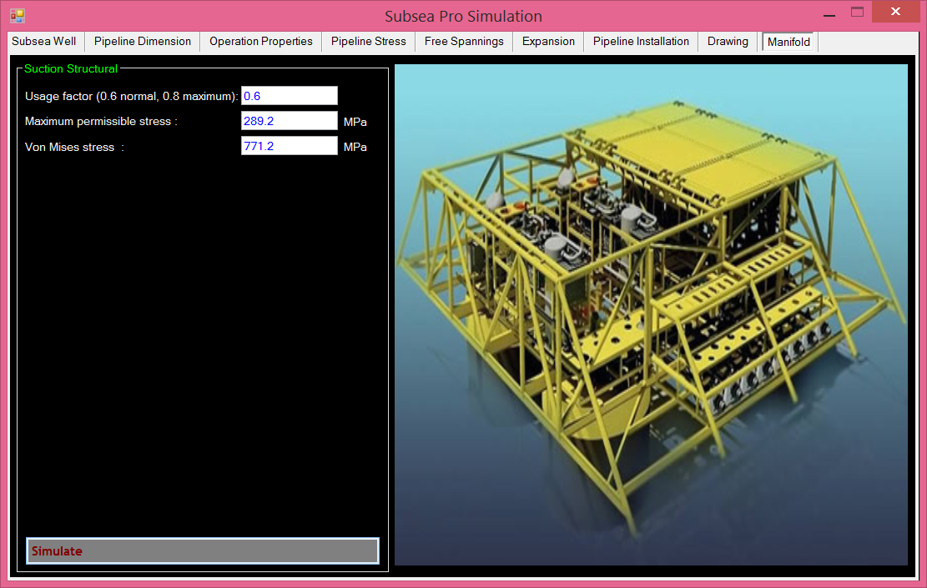
Figure.7-8: An example of maximum and von misses stresses calculated using Subsea Pro Simulation.

7.6.2. Buckling Checks
Hydrostatic buckling calculations should be performed in order to check the capacity of the shell wall of a pile during pile embedment for local shell buckling. Although the buckling of the shell wall is not a concern for operating conditions due to the soil supporting the structure, it is a potential concern during installation. When the pile is penetrating the soil and is subjected to differential embedment pressures, there is a potential for local buckling due to axial and hoop stress interactions.
The design minimum buckling collapse pressure of the pile should have an adequate safety margin to ensure the shell of pile is strong enough to resist the maximum possible suction pressure. In addition, an adequate safety margin between the design minimum buckling pressure and the required suction pressure for embedment of the pile should be applied.
A closed, unstiffened cylinder under hydrostatic pressure will buckle between end supports by forming a pattern of circumferential lobes. The lobes formed around the circumference, or the buckling mode, are a function of the unsupported shell length-to-diameter ratio L/D and cylinder D/t ratio. Buckling may be purely elastic or a combination of elastic deformation and elastoplastic deformation. In the case of suction piles, the D/t and L/D ratios are such that elastic buckling is the predominant mechanism.
Two analytical approaches are available for determining the buckling capacity:
- Design code-based buckling capacity analysis methods using an esti-mated unsupported length of shell;
- Finite element analysis of buckling behavior incorporating full soil/ structure interactions to explicitly model the degree of soil support to the shell of a suction pile.
A number of design codes provide analysis methods to determine the design buckling strength of a suction pile. The methodology detailed in API RP 2A for combined axial compression, hydrostatic pressure, and bending may be used to check the pile wall for local buckling during the embedment process. The semi-empirical technique used in API RP 2A is appropriate for pile diameter–to–wall thickness ratios of less than 300 (D/t < 300), the methodology must be adapted to account for multiple wall thickness cans between ring frames. This is accomplished by using a weighted average wall thickness in the calculations that is a function of effective buckling length. The effective buckling length will decrease as the pile penetrates the soil and the part of the pile sticking up above the mudline decreases. As the pile penetrates deeper into the soil, the soil will progressively support the pile wall and increase the buckling capacity by forcing the wall structure into a higher mode of buckling failure.

7.6.3. Transportation Analysis
A transportation analysis should be carried out for the following procedures:
- The pile structure is handled and transferred to the transportation barge.
- During transportation to the installation site, the piles in the trans-portation barge are normally supported at two locations with cradles. The cradles will take the roll forces, while pitch plates welded to the pile and the barge deck will take pitch forces.
- Before installation into the seabed, the pile structure is upended from a horizontal to a vertical position.
The loads considered in the transportation analysis should include the self-weight of the suction pile and inertial loads developed from a motion analysis. A dynamic load factor of 2.0 should be used in the design calculations according to API RP 2A-WSD. The calculations for padeye design can be carried out by hand, and the padeye support structures should be checked by an FEA method for the simulation of all pile structures. Lift analysis should be performed to check the structural integrity of the suction pile and lift attachments under installation and removal onto the transport barge and pile lowering and recovery.

Chapter.8

8.0 Installation of Subsea Manifold

8.1. Seafastening
In deep water fields the contribution of installation activities to project costs and schedule is higher than for shallower developments. The risks associated with installation are also higher. The metocean condition of deep water is a key factor for the installation of subsea structures. Relatively gentle conditions in offshore West Africa may not mean installation operations are easier than in the GOM because the persistent swell is likely to result in ideal conditions for vessel motion resonance. High currents in offshore Brazil are likely to be a dominating factor.
A subsea development may have more than 30 wells, which require an extensive installation program of manifolds, PLETs, jumpers, and suction pile foundations. Excluding the flowlines, which are small lift weight components having compact dimensions, we must still consider the large number of individual items that require a long installation program and the large number of heavier manifolds, which also present installation challenges.
The installation of a subsea system should satisfy the following issues:
- Be video -recorded during installation operations.
- Use installation tools with a fail-safe design.
- Allow flushing of hydraulic circuits subsequent to connection of interfaces.
- Where possible, not be dependent on unique installation vessels.
- Have position indicators on all interface connections.
- Be installable utilizing a minimum number of installation vessels.
- Require installation within a defined practical weather window that is consistent with the specific type of installation equipment and vessel to be used.
- Require a minimum number of special installation tools.
- Facilitate fully reversible sequential installation techniques/operations.
Seafastening is the principal of securing the structures to be transported and installed offshore to the vessel deck. The seafastening need to be able to withstand the forces introduced by the vessels motion during transit. The main forces acting on the seafastening are a result of vessel roll and pitch motion. The total force on seafastening due to either roll or pitch motion will be [Simen]:
The gravitational force caused by the roll/pitch angle + the force caused by the roll/pitch acceleration. Figure 8-1 shows an illustration of the forces introduced by vessel roll motion [Simen].
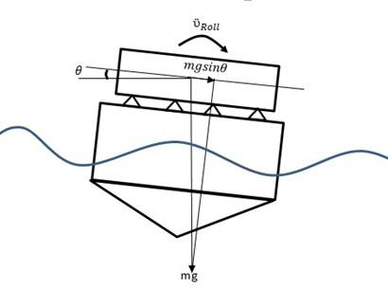
Figure.8-1: Forces on Seafastening [Simen]

Where; ${\ddot{ν}}_{roll}$ is roll acceleration (m/s²), $mg\sin{θ}$ is Gravitational force caused by the roll angle (N) and $θ$ is roll angle (deg).

8.2. Installation Capability
In the deep water installation, a number of challenges come up due to the increasing of water depths in the field development. These challenges potentially constrain the installation capacity for subsea structures in deep-water. The capabilities of the subsea installation system are mainly depending on the limitations of the following components of the system:
- Lifting and lowering system, which includes vessel, lift line, and over-boarding/lift line deployment system;
- Load control and positioning system, including motion compensation system, buoyancy hook/payload control/positioning, and communications. The lifting and lowering system directly related to the weight of the loads to be lowered to the deep seabed, the dynamic responses that can augment these loads, and the decrease in the capability of the lifting systems. The load control and positioning system related to placing the load in the desired location, at the correct compass heading, and at a stable attitude on the seabed. The effects of these issues are discussed in following sections.

8.2.1. Lifting System
Steel wire ropes with multifall lowering systems are very well understood and durable, but they are limited in their application to very deep water. As the water depth increases, the ratio of the weight of the cable to the weight of the payload increases quickly. At 3000 m the weight of a 0.13m wire rope is about the same as its 170-tonne payload. At a depth of about 6000 m, the Safe Working Load (SWL) of the steel wire rope is entirely used up by its self-weight, leaving zero payload capacity.
During lift off from deck and maneuvering the object clear of the transportation vessel, the following aspects should be considered according to DNV-RP-H103, section 9.1.1.2.
- Clearance between lifted object and crane boom.
- Clearance between the underside of the lifted object and grillage/seafastening structure on the vessel.
- Clearance between crane boom and any other object/structure.
- Bottom clearance between crane vessel and seabed for lifting operations at small water depths.
The different clearances are presented in Figure 8-2.
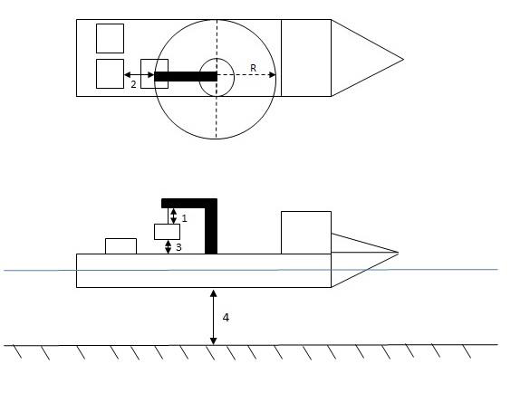
Figure.8-2: Lifting off from Deck and Maneuvering Object Clear of Transportation Vessel [Simen]

The potential for resonance, associated with the natural period of the payload on the line and with surface vessel excitation, can give rise to very large dynamic loads. It is also difficult to estimate the hydrodynamic added mass for a complex payload shape. Fiber rope is also used in deepwater hardware installations. Fiber options include aramids, polyester, and high-modulus polyethylene for offshore applications. The fiber ropes have several attractive properties such as lower self-weight, small allowable bend radii, lower axial stiffness, a large damping ability to absorb heave created by surface waves, and the ability to be repaired. Petrobas used a polyester rope to successfully install a manifold in deep water of 2000 m (6560ft). However, fiber rope has potential problems related to stretch, creep, and its relatively low melting point.

8.2.2. Splash Zone Lifting
Buoyancy units may have an important role to play in reducing the static lifting line tensions. However, buoyancy units for large subsea components to be installed in deep water are not easy to design in such a way that they are manageable and economic. The load control and stability problems of buoyancy are difficult to solve; in particular, the inertia and hydrodynamic loading of the system are increased, which contributes to undesirable dynamic effects.
The oscillating sea surface can cause loss of buoyancy and lead to snap loads in the lifting line, if the lowering speed and timing of the operation is not thoroughly planned. Figure 8-3 below presents two different stages of a splash zone lifting operation [Sarkar].
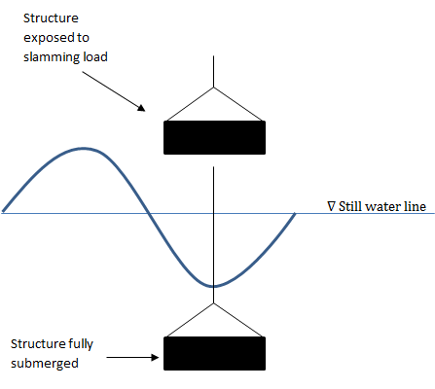
Figure.8-3: Splash Zone Lifting [Sarkar]

Very significant dynamic effects can result when lowering heavy weights on long lines. The excitation caused by the motions of the surface vessel can be amplified with large oscillations and high dynamic tensile loads in the lifting line. Motions in the heave direction may be only lightly damped, and the added mass of the load can be very significant. For example, a suction anchor consisting of a flooded cylinder with closed top will have an added mass that is many times its weight in air due to the water trapped inside and entrained around it. When combined with dynamic magnification caused by oscillations due to surface waves, the line tension of 460 tons is obtained for a suction anchor with a weight in air of 44 tons.
The shape of the item to be installed, which in turn determines the added mass, can therefore be crucial to this dynamic response and to the ability to install it. It can be shown that for lowering into deep water there will nearly always be a depth at which a resonant response will occur. It is important for this resonant region to be passed through relatively quickly and for it not to occur at full depth where careful control is required for placement of the payload on the seabed. Modeling methods, as shown in the next section, have been developed to predict the behavior of these dynamic responses so that design and planning of the lowering operations can attempt to minimize and avoid them.

8.2.3. Motion Compensation
For the installation of subsea structures in deep water, installation contractors encounter limitations when using equipment without heave compensation systems. Limitations include:
- Excessive dynamic amplification of the load during lowering, with the risk of overloading or even rupturing of the cable;
- Unstable situations during the landing of the subsea structure and its positioning on the seabed;
- ROV assistance operations with respect to the moving load.
Active and passive motion compensation systems are mainly used in subsea installations. Many cranes for subsea installation are equipped with an Active Heave Compensation (AHC) system to compensate for the vertical heave motion at the crane jib tip by means of a powerful computer system and a high-speed winch system. A Passive Heave Compensator (PHC), such as a crane master, is another kind of heave compensator that can alleviate the high hook loads. In essence, the crane master is a damped spring system set above the subsea structure using compacted gas over an oil accumulator acting as an isolator. Two types of PHC systems for subsea structure installation are introduced here because of their impressive heave compensation effects.

Heave-Compensated Landing System
The Heave-Compensated Landing System (HCLS) used by Delmar consists of the following equipment: a compensating buoy system, compensating belly chain, and pendant wire. Figure.8-4 shows an example of the HCLS installation of subsea structure with an anchor handling vessel (AHV) [J. Soliah]. The buoyancy system suspends the subsea structure, keeping the system close to a neutrally buoyant condition in the vertical direction. The subsea contracture is lowered to the seafloor in a controlled manner by paying out wire from the AHV, which transfers more chain and thus more weight to the buoyancy system. As more chain is added, the added weight overrides the buoyant forces, causing the subsea structure to slowly sink. The length and configuration of the chain are the compensating portion of the system. HCLS has a very good heave compensation effect, but it is difficult and complicated to get the subsea equipment overboard from the barge.
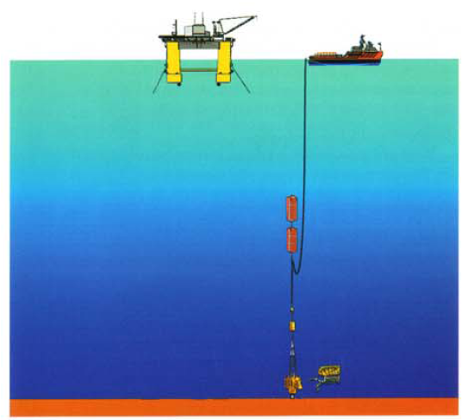
Floater
Ship
Subsea Structure
Pendant Wire
Compensating Belly Chain
Compensating Buoy System
Figure.8-4: Installation of Subsea Structure with HCLS [J.Soliah]

Polyester Rope
Polyester rope is one of the most popular ropes used as anchor and mooring lines in the mooring systems of the offshore industry. It is very close to nylon in strength but stretches very little. Polyester rope has highly elastic properties and a good damping effect. Typical mechanical properties for poly-ester rope can be found in the Orcaflex software database, which is based on a catalog published by Marlow Ropes Ltd.

8.2.4. Deepwater Installation Challenges
When performing installation of subsea structures in deepwater areas, new challenges arise as a result of the increased water depth. These challenges can generally be classified in the following respective areas [Rowe]:
- Lifting and lowering technology
- Load control and positioning
- Metocean effects and weather window requirements
The challenges related to lifting and lowering technology is the weight of the structures to be installed, which combined with the dynamic response, can exceed the capacity of the lifting system. Conventionally steel wire deployment systems are used for installation work, but the applicability of steel wire systems are reduced as the water depth is increased. This is related to the large self-weight of steel wire, which reduces the available payload capacity of the wire at increasing water depths. When lowering heavy structures on long lifting lines, there is also a significant risk of resonant motion between the oscillating surface vessel and the lifting system. This can introduce large dynamic forces and result in failure of the lifting line. [Rowe]
Challenges with load control and positioning will increase at greater water depths. Due to the long length of lifting line, relatively small currents can cause a very large offset between the installation vessel and the structure being landed on the seabed. Deepwater soil conditions also tend to be very soft, and bearing capacity failure of the seabed beneath the subsea structure may cause an unacceptable structure orientation. Also control of the deployment system hook will be more challenging. After releasing the subsea structure, the hook will become less controllable and could get entangled with the subsea structure. The difference in positioning of the subsea structure is presented in Figure 8.5 [Rowe]
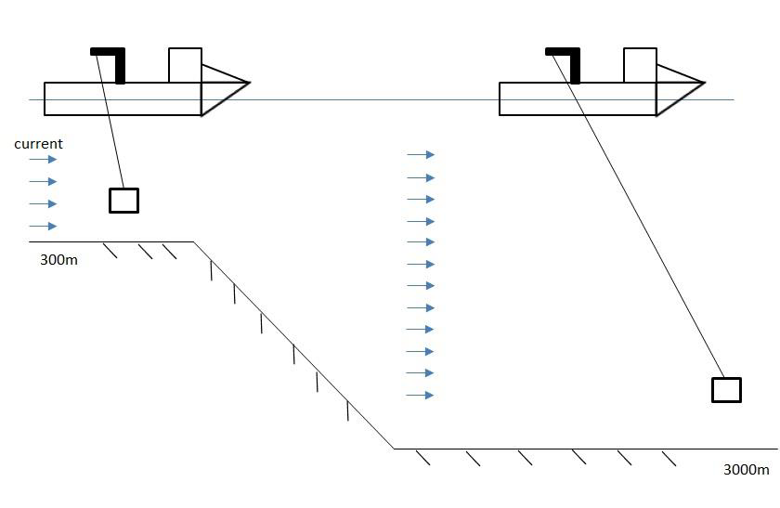
Figure.8-5: Difference in Load Control and Positioning, Shallow Water vs. Deepwater [Simen]

Challenges with metocean effects and weather window requirements are related to the increased time required to perform the installation, when the water depth is increased. Duration of the lowering operation and recovery of the deployment line will increase, and the time needed for positioning and control will increase. The required duration of weather windows, in order to perform the operation, will hence be larger than for a similar operation in more shallow water [Rowe]

8.3. Installation Equipment
The installation of a subsea structure/manifold requires careful planning and coordination with workboats, a crane barge or floating drilling vessel, and acoustic and electrical location equipment. The choice of installation vessel is based on vessel availability, existing mooring equipment, adequate crane capacity, and suitable deck space for transportation.

8.3.1. Crane Barge
Figure.8-6 illustrates a manifold installation from a crane barge. The foundation suction pile is 60.3 tons, while the manifold is 88.5 tons. The manifold is landed and locked to the suction pile. A ROV is used to monitor the direction and position of the manifold during the entire installation procedure.
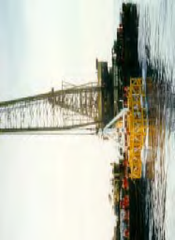
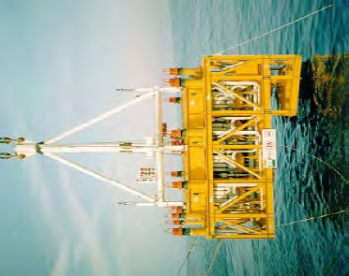

Figure.8-6: Manifold Installation from a Crane Barge.

In water depths up to 1000 m, manifolds are normally installed by cable from a crane barge or drilling riser directly, depending on the wire length and crane capacity. For water depths greater than 1000 m, for which the length of the crane cable is not long enough to land the subsea structure directly on the seabed, an A&R wire and winch may be used to land the structure, and the load is transferred from the crane to the A&R wire at a water depth of approximately 100 m.

5.2.1.1. THIALF in the Ormen Lange Field
Figure.8-7 shows the installation of a temple using THIALF in the Ormen Lange Field at a water depth of 820 m.

Figure.8-7: Installation of Temple Using THIALF in the Ormen Lange Field [T. Bernt]

8.3.2. DP Rig and Drilling Riser
Figure.8-8 shows a manifold installation from a DP rig using a drilling riser. Because the manifold size was bigger than the moon-pool size on the available rig, the manifold could not be lowered through the moon-pool directly, so a means to transport the manifold from the shipyard to the field was required. The rig was maneuvered so that it was placed over the transportation barge, allowing the riser connection and the lift operation. The manifold was then fixed by six stoppers and prior welded underneath the moon-pool to avoid movement during the transport and installation phases.
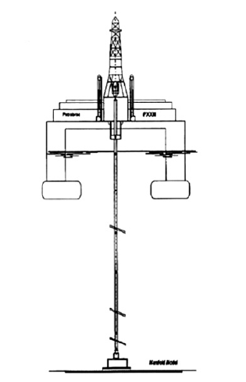 | 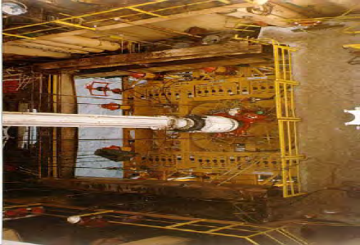  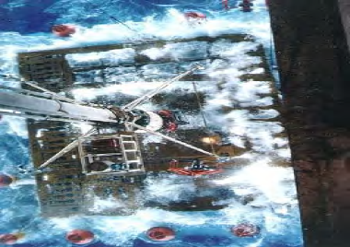
Figure.8-8: Manifold Installation Using Drilling Riser [M.T.R. Paula & Mario L. P]

The installation methods by crane barge and by DP rig using drilling risers in a water depth of 500 m were compared based on the analysis of Petrobras projects. Analyzing the results and considering the barge’s daily cost as around 80% of the rig’s daily cost, the following conclusions were made:
- Installation using a crane barge is not economically feasible in crowded areas where a lot of equipment and flowlines have already been installed at the seabed or in water depths where the mooring system demands special resources.
- Time spent waiting on the weather for an operational window and the mooring system deployment task represents around 35% of the total manifold installation cost when the installation is made by a crane barge. The installation of stoppers in the drilling rig, underneath the moon-pool, represents 30% of the total manifold installation cost.
- The total cost of the installation by drilling riser is 25% lower when
- Compared with the total cost of the installation by crane barge and there is a potential optimization that can be reached.
- The option of using a crane barge is still attractive because such a resource is promptly available and an installation by rig may impact the drilling schedule and completion of other activities.

8.4. Installation Methods
The installation method and equipment selected for the subsea structure should ensure safe and reliable operation in accordance with the selected intervention strategy. The subsea production system should fulfill the following requirements:
- Installation equipment for temporary and permanent should not cause obstructions and restrict intervention access.
- Disconnection of lifting slings and lifting beams/frames/arrangements used during installation should be according to the selected intervention strategy. A backup system may be provided.
- The installation system should not represent any hazard to the permanent works during installation, release, reconnection, and removal.
Lifting/installation arrangements should be designed to minimize the lifting height. There are several installation methods of manifolds

Figure.8-9: Installation method of manifold

8.4.1. Added Mass Theory
In fluid mechanics, added mass is the inertia added to a system because an accelerating or decelerating body must move some volume of surrounding fluid as it moves through it. In the case of unsteady motion of body underwater or unsteady flow around object, it should be considered the additional force resulting from the fluid acting on the structure when formulating the system equation of motion. This added effect is added mass. Most floating structures can be modeled, for small motions and linear behavior, by a system equation with the basic form similar to a typical mass-spring-dashpot system described by the following equation:

$m\ddot{x}+b\dot{x}+kx=f\left(t\right)$ (8.1)

Where; $m$ is the system mass, $b$ is the linear damping coefficient, $k$ is the spring coefficient which is force ($F$) needed to extend or compress a spring by some distance ($l$) is proportional to that distance ($k=F/l)$, $f\left(t\right)$ is the force acting on the mass, and $x$ is the displacement of the mass. The natural frequency $ω$of the system is simply

$ω=\frac{2π}{T}\sqrt{\frac{k}{m}}$ (8.2)

In a physical sense, this added mass is the weight added to a system due to the fact that an accelerating or decelerating body (unsteady motion: $dt ≠ 0$ ) must move some volume of surrounding fluid with it as it moves. The added mass force opposes the motion and can be factored into the system equation as follows:

$m\ddot{x}+b\dot{x}+kx=f\left(t\right)- m_{a}x ̈$ or $(m+m_{a})\ddot{x}+b\dot{x}+kx=f\left(t\right)$ (8.3)

where $m_{a}$ is the added mass.

From here we can treat this again as a simple spring-mass-dashpot system with a new mass $m' = m+m_{a}$ such that the natural frequency of the system is now

$ω'=\frac{2π}{T'}=\sqrt{\frac{k}{m+m_{a}}}$ (8.4)

8.4.2. Pendulum Theory
An ideal simple pendulum consists of a massive bob tied to one end of a perfectly inextensible, flexible and weightless string as shown in Figure.8-10. When a pendulum is displaced sideways from its resting, equilibrium position, it is subject to a restoring force due to gravity that will accelerate it back toward the equilibrium position.

Figure.8-10: Simple gravity pendulum

The radius of oscillation or equivalent length ($L$) of any physical pendulum can be shown to be

$L=\frac{I}{m'R}$ (8.5)

Where; $I$ is the moment of inertia of the pendulum about the pivot point, $m$ is the mass of the pendulum, and $R$ is the distance between the pivot point and the center of mass. Substituting this expression above, the period ($T$) of a compound pendulum is given by

$T=2π\sqrt{\frac{I}{m'R}}$ (8.6)

For example, a rigid uniform rod of length ($L$); pivoted about one end has moment of inertia ($I={ML^{2}}/3$). The center of mass is located at the center of the rod, so $R=L/2$ Substituting these values into the above equation gives

$T=2π\sqrt{\frac{2L}{3g}}$ (8.7)

For small acceleration can be written as

$T=2π\sqrt{\frac{L}{g}}$, $θ≪1$ (8.8)

8.4.3. Conventional Installation Methods

8.4.3.1. Work Wire
This work wire installation is w/o heave motion compensation which is divided into two systems as follows:
- Anchor Handling Tug Supply (AHTS)
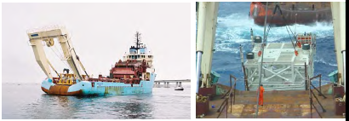
Figure.8-11.a: Installation using AHTS
- Crane Barge
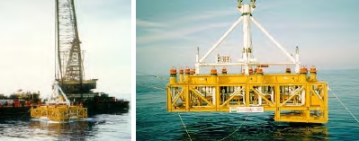
Figure.8-11.b: Installation using Crane Barge

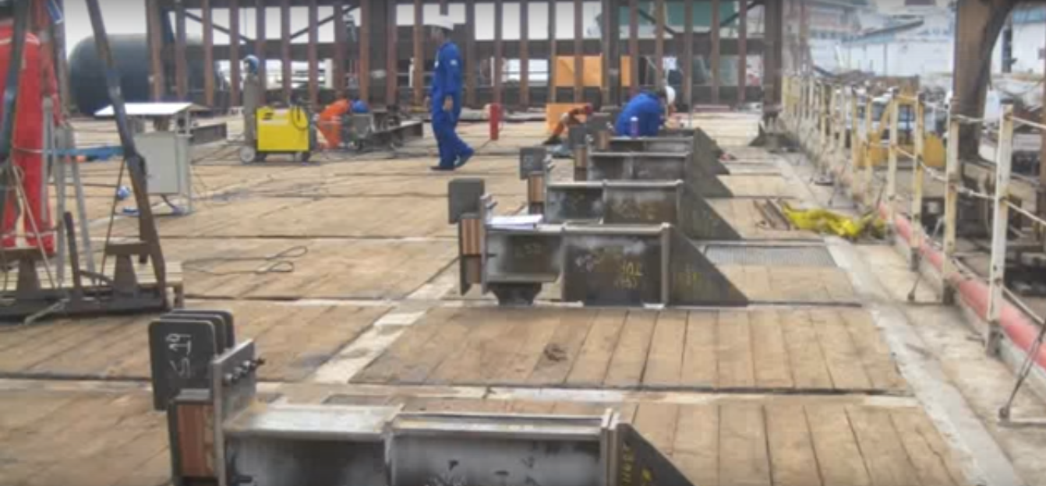  Seafastening mobilization | 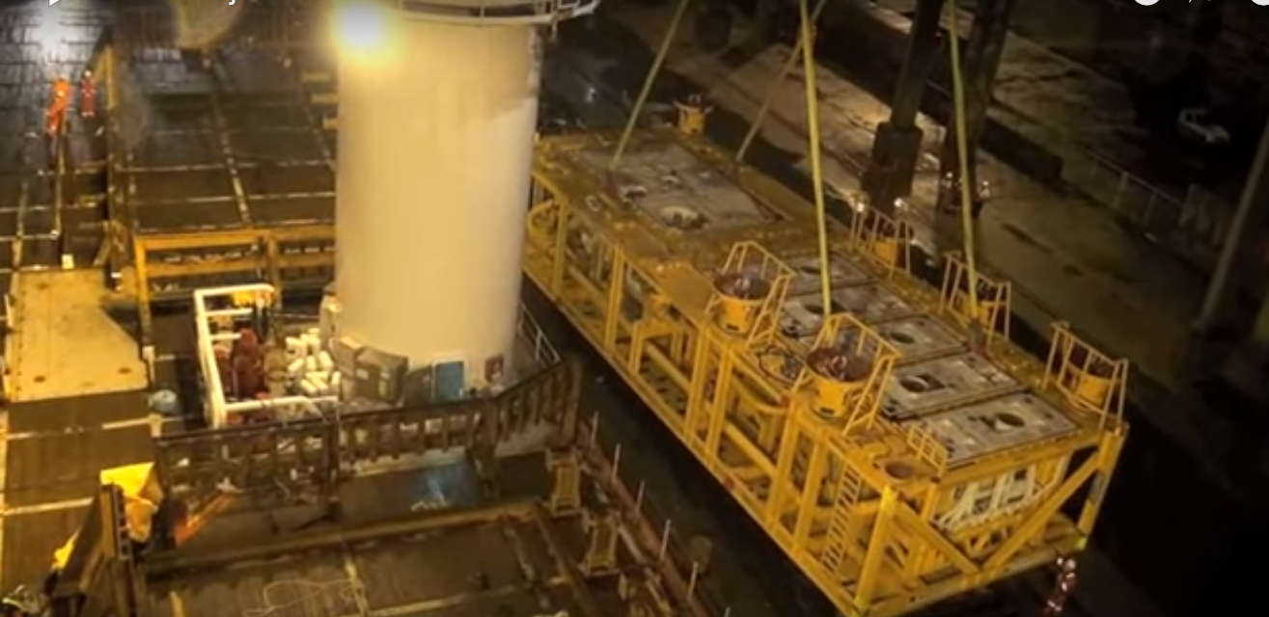  Load out to vessel
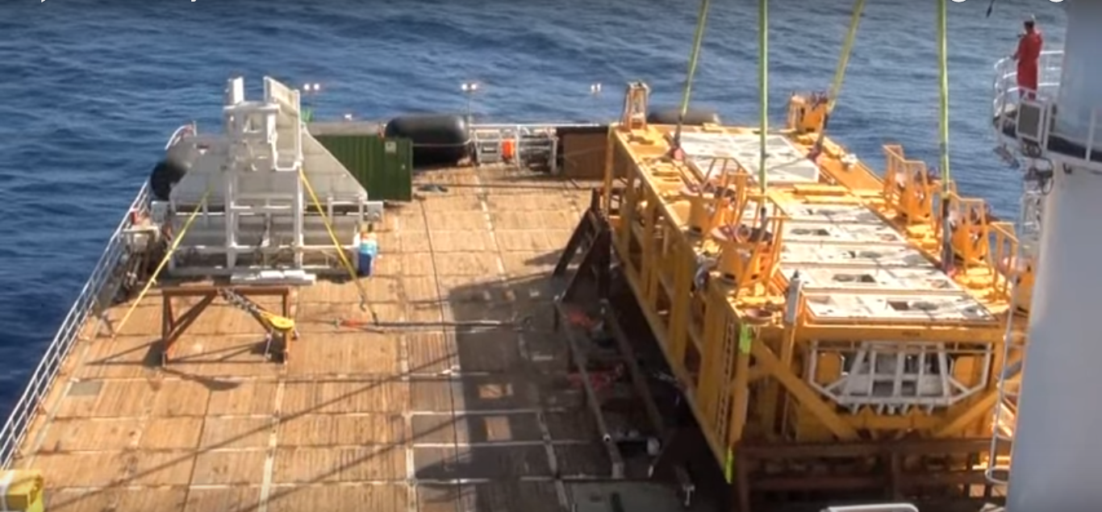  Overboarding at rig location | 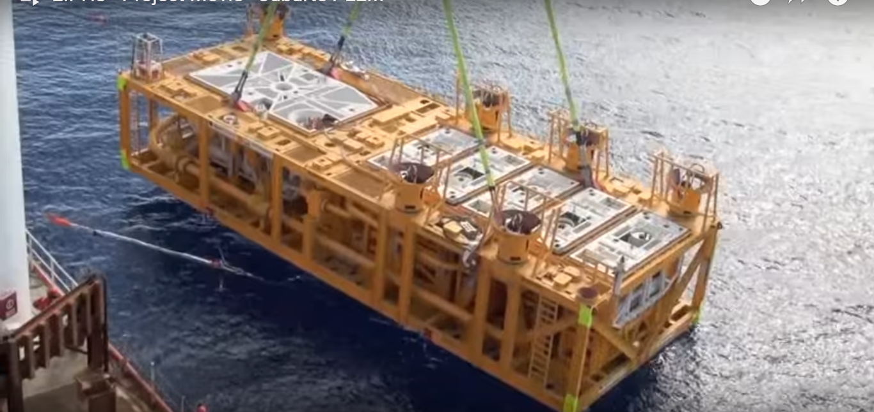  Enter splash zone
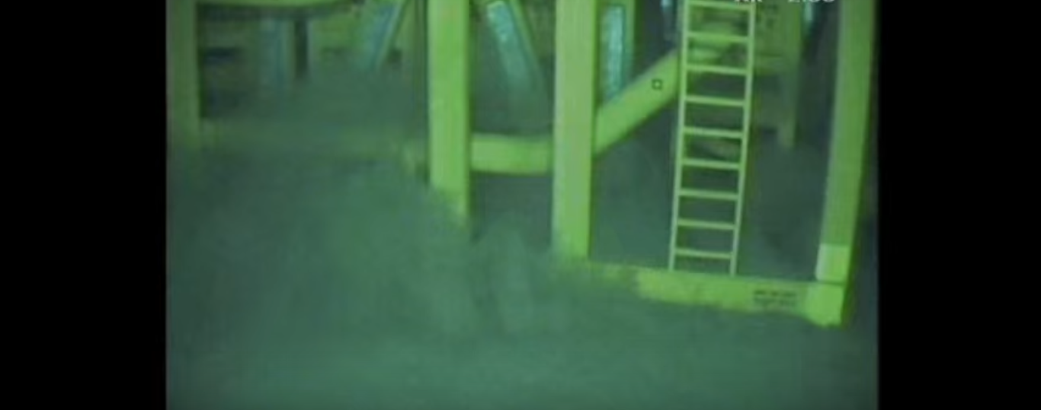 | 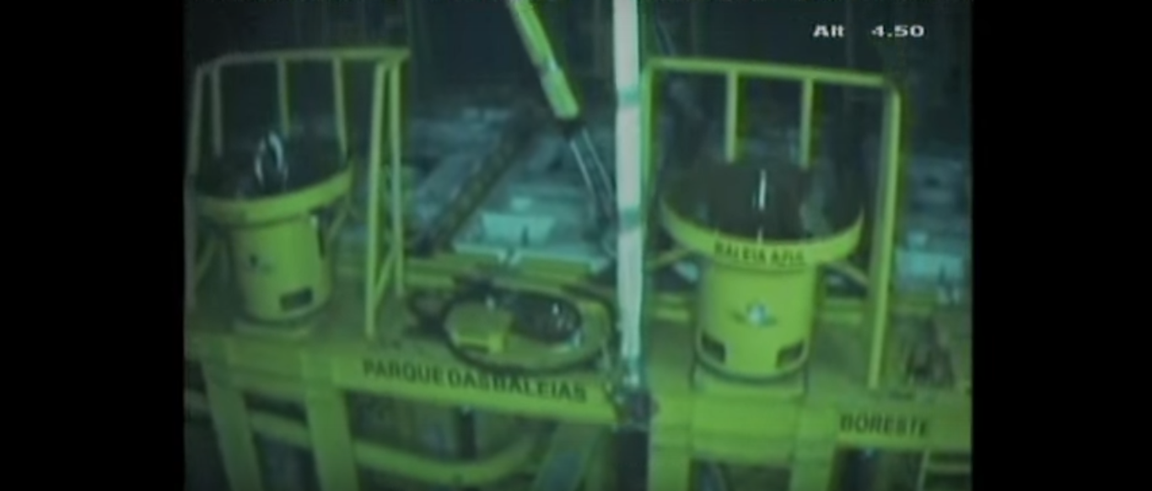
PLEM landing on seabed
Figure.8-11.c: Installation of Jubarte PLEM (292 TE).

8.4.3.2. Drilling Riser

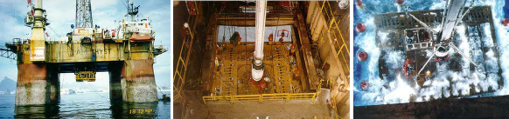
Figure.8-11.d: Installation using drilling riser

8.4.4. Sheave Installation Method
Figure.8-12 shows the procedure sheave installation method, in which an SS rig provided heave motion compensation while AHTS 1 lifted the manifold together with the SS rig and AHTS 2 oriented the manifold.
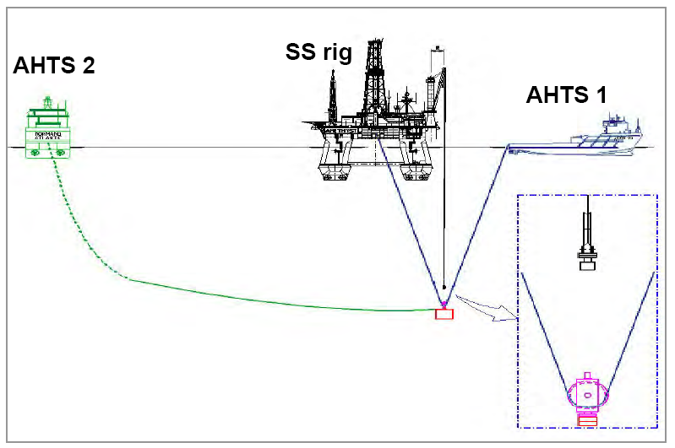
Figure.8-12: Sheave Installation method [Mario L. P].

8.4.4.1. Roncador Manifold-1 Sheave Installation
The Roncador manifold project located in the ultra-deep Campos Basin offshore from Brazil marks the first time a subsea manifold has been installed at a water depth exceeding 1600 m. The Roncador manifold was installed at water depth of 1885 m using steel cables and support vessels as shown in Figure.8.13.

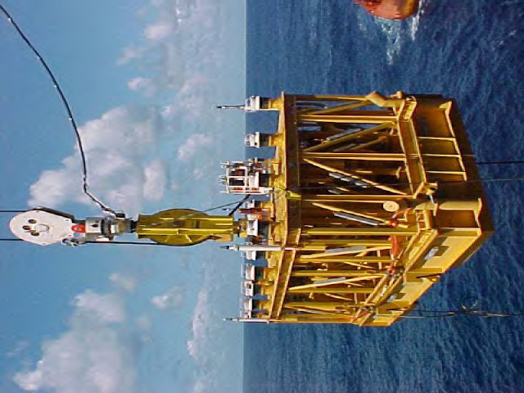 | 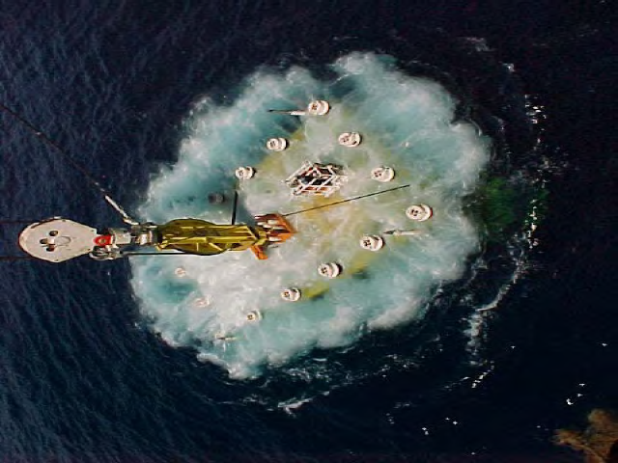
Figure.8-13: Roncador Manifold-1 (1885m water depth) [Mario L. P].

8.4.5. Innovative Installation Methods

8.4.5.1. Pendulous Installation Method
The pendulous installation method is a non-conventional method for installing subsea structures in deepwater areas. The method was developed by the company Petrobras in order to install a 280Te manifold in 1900m water depth. The main drivers for developing this method was the low availability and high cost of specialized deepwater construction vessels (DCV) and heavy lift vessels (HLV), which could have led to high cost and possible deviation from schedule. The usage of synthetic fiber rope deployment systems was also assessed, but there was no field proven or prototypes of a fiber rope deployment system in the market that could fulfill the project requirements [Wang]
The method can be performed with two standard offshore support vessels like e.g. diving support vessels, ROV support vessels or even DP class anchor handling thugs which are smaller vessels with a lower day rate and a higher availability than the DCV/HLV. One of the vessels have to be equipped with a conventional deck crane or A-frame, to allow for over boarding and splash zone lifting, while the other vessel has a fiber rope deployment winch.[ Wang]
The deployment line will be pre-rigged with lifting slings, and buoyancy elements will be fitted to the rope to reduce the required lifting capacity. The method is capable of installing structures up to 300Te at 3000m water depth. [Wang]
Figure.8-8 shows the pendulous procedure for installation of manifolds as follows:
- Manifold carried by transportation vessel
- Manifold was hang off
- Manifold overboarding from the vessel
- Pendulous motion of manifold

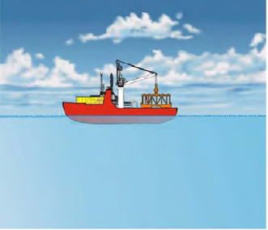  (a) | 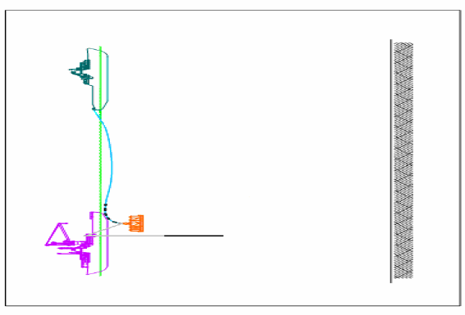  (b)
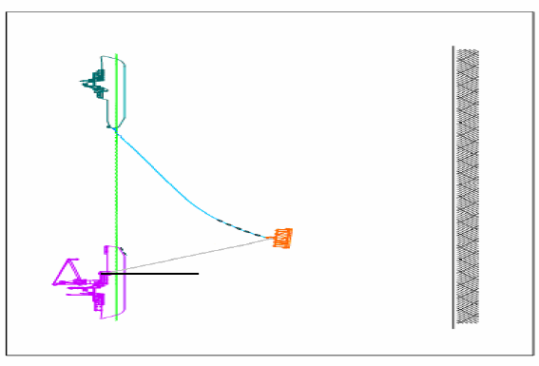  (c) | 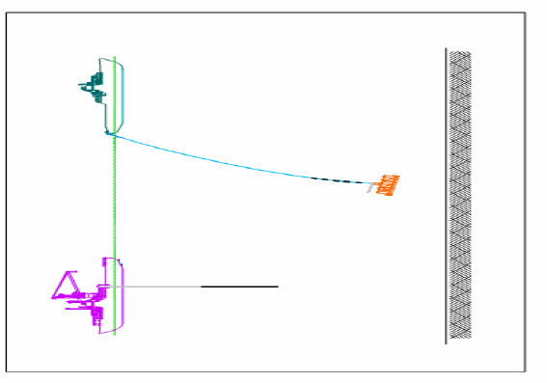  (d)
Figure.8-14: Pendulous Installation Method for P52 Manifold Installation [Mario L. P]

The pendulous installation method introduces a method to install heavy subsea structures at great water depths, without the requirement of using DCV or HLVs. The method also solves the problems related to resonant motion between the lifting system and the crane tip motion. The risk is considered to be higher for performing a pendulous installation compared to conventional vertical deployment. Even though the method avoids problems with resonance during deployment, two vessels need to be located close to each other, introducing the risk of ship collision and reducing the operable sea-states. A SWOT analysis of the pendulous installation method is presented in Table 2.2 below.

Table.8-1: SWOT Analysis, Pendulous Installation Method
Strength | Weakness
- System capacity  - Resonant motion during deepwater installation avoided. | - Require two installation vessels  - Complex installation sequence  - Long operational duration
Opportunity | Threat
Deepwater installation during seasons comprised with good weather | Risk of ship collision

P-52 Manifold Pendulous Installation
Figure.8-15 shows the pendulous procedure for MSGL-RO-2 & 3 (P52) manifold installation by a barge and an AHTS. The manifold as shown in Figure.8.10 has these dimensions:
- Dimensions: 16.5m (L) x 8.5m (W) x 5.2m (H)
- Weight in air: 280 tons
- Water depth installation: 1900m
- Center of Gravity : 3.15m
Buoyancy sets are used to decrease the load on the rope.

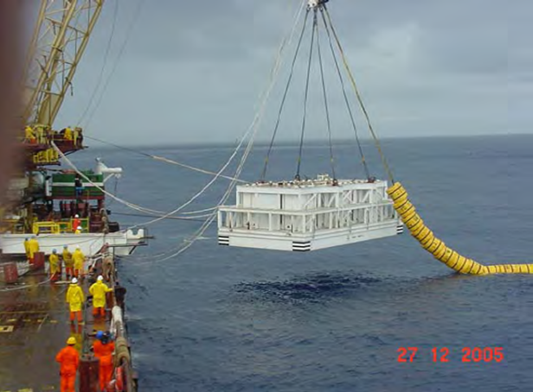 | 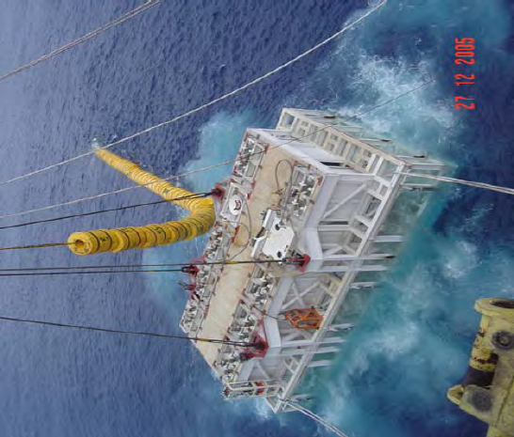
Figure.8-15: Pendulous Installation Method for MSGL-RO-2 & 3 manifolds (1900 m water depth) [Mario L. P].

Figure.8-16: MSGL-RO-2 & 3 manifolds [Mario L. P]

8.4.5.2. Pencil buoy method
The pencil buoy method is a subsurface transportation and installation method developed by the company Aker Marine Contractors. The pencil buoy method reduces the offshore installation sequence from a lifting and lowering operation to a pure lowering operation. This is done by wet towing the structure from an inshore load out site to the desired offshore location [Mork].
The pencil buoy method avoids offshore splash zone lifting and will reduce the weather criterion related to a subsea lifting operation. The method allows for installation of heavy structures with limited usage of large crane vessels, and can hence be a solution to vessel availability problems. The largest disadvantage of the pencil buoy method is that it is only capable of installing a single subsea structure per offshore trip, making the method inefficient for field developments at remote locations. The applicability of the pencil buoy method, for deepwater lifting operations, is also limited. The method depends on a conventional deployment winch, for lowering of subsea structures to the seabed, and will face the same problems related to payload capacity as a conventional deployment system. A SWOT analysis of the pencil buoy method is presented in Table 8.2 below.
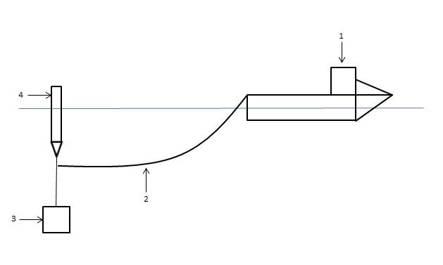
Figure.8-17: Pencil Buoy Installation.

Table.8-2: SWOT Analysis, Pencil Buoy Method
Strength | Weakness
- System capacity  - Applicable for harsh weather conditions. | - Inefficient  - Relies on deployment winch applicable for deepwater installation
Opportunity | Threat
Installation of large structures with small vessels | Breakage of tow line

8.4.5.3. Subsea Deployment System
The Subsea Deployment System (SDS) is an installation method developed by the company Subsea Deployment Systems Ltd. The method is based on the usage of a Submersible Deployment Vessel (SDV) to transport and install subsea equipment. The method allow for installation of subsea structures weighing from a hundred tons to several thousand tons, in water depths of 100-3000m, without the usage of a HLV. [Joensen]
The subsea deployment system, as the pencil buoy method, is based on wet towing subsea structures offshore. The method avoids offshore overboarding and splash zone lifting operations. I.e. The method has the same advantages related to reduction of weather criterions and limited usage of large crane vessels. The method utilizes a subsea deployment vessel, with designated buoyancy tanks, to control the submergence level of the subsea structure during tow. Because the subsea deployment vessel and the structure to be installed are slightly buoyant during the operation, the effective tension in the lifting line is greatly reduced. The landing on seabed operation is not affected by motion of the surface vessel, and weather criterions can be further reduced. The method is seen as highly applicable for deepwater deployment of subsea structures, with inefficiency being the largest disadvantage. A SWOT analysis of the subsea deployment system is presented in Table 8-3.
The SDS avoids offshore over boarding and splash zone lifting, by submerging the subsea structure at an inshore location before towing it offshore. This reduces the dynamic loading on the structure and vessel equipment (crane, wire, lifting slings), hence allowing for installation in rougher weather conditions than traditional methods. The subsea deployment system is presented in Figure 8-18. [Joensen]

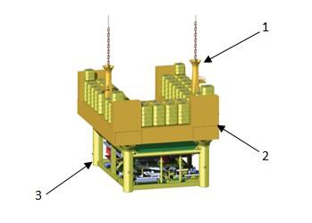
Subsea structure to be installed
Submersible deployment vessel
Cain Tower
Figure.8-18: Subsea Deployment System. [SDS]

Table.8-3: SWOT Analysis of a Subsea Deployment System
Strength | Weakness
- System Capacity  - Applicable for harsh weather conditions  - Ease of positioning and control. | - Inefficient  - Technology still under development
Opportunity | Threat
Can be used for deepwater installation with smaller vessels | No operational experience

8.4.5.4. Fiber Rope Deployment System
The fiber rope deployment system is a new deployment system, developed by the company ODIM. The fiber rope deployment system is similar to traditional vertical deployment, but utilizes fiber rope as deployment line for subsea lifting operations. The usage of traditional steel wire systems have become unpractical, and are struggling to meet the industries demand of installing heavy structures in water depths exceeding 2000m. The reason for this is the large self-weight of steel wire, which severely reduces the allowable payload capacity of the wire. Hence very large wires are needed to install subsea structures at great water depths. Larger wires require larger storage drums, higher winch power, and larger vessels. Fiber ropes have been seen as a solution to the self-weight problem related to steel wire, since fiber ropes are close to neutrally buoyant in water. However the mechanical behavior of fiber ropes is different from the behavior of steel wire, and traditional handling systems are not applicable to use in combination with fiber ropes. [Torben, 2008].
The largest fiber rope deployment system developed today has the capacity to install structures up to 125Te down to a water depth of 3000m, and has successfully solved the self-weight problems related to the conventional steel wire system. Fiber ropes also have the possibility of being repaired offshore by trained personnel. If a section of rope is worn, the rope section can be cut out, and a new piece of rope can be spliced in. The sheaves of the fiber rope deployment system are designed to handle splices. Figure 8-19 presents a 125Te SWL fiber rope deployment system. [Torben, 2010].
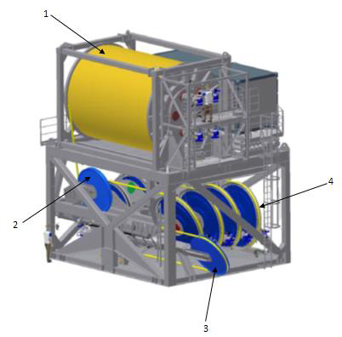
Cable traction control unit
Inboard damping device
Spooling device
Storage drum
Figure.8-19: Fiber Rope Deployment System, 125Te SWL [Torben, 2010]

The fiber rope deployment system is similar to conventional vertical deployment, but solves the problems related to self-weight of steel wire. The fiber rope is close to neutrally buoyant in water and will have approximately the same payload capacity at any water depth. The fiber rope deployment system also has a higher possible winch pay-out rate than a steel wire system. This results in a shorter duration of the lifting operation, and hence a shorter operational weather window is required. This gives the system an advantage for deepwater lifting operations. One of the disadvantages related to fiber ropes, are the shorter expected time to failure than conventional steel wire. However, offshore repair of fiber ropes is possible. The fiber rope deployment system relies on an installation vessel with a large deck crane for overboarding and splash zone lifting, and problems related to vessel availability is still a governing factor. A SWOT analysis of the fiber rope deployment system is presented in Table 8.4.

Table.8-4: SWOT Analysis of a Fiber Rope Deployment System
Strength | Weakness
- Neutrally buoyant lifting line  - Active heave compensated system  - Offshore repair of lifting line  - Deployment rate. | - Dependent on large installation vessel  - Maintenance challenges
Opportunity | Threat
Can be used on smaller installation vessel, rigged with A-frame, for deepwater installation | Behavior of rope splices

8.6. Installation Analysis
Subsea manifold design should be subjected to a thorough analysis to ensure that the structure can handle the installation, leveling, and lowering forces with proper safety factors. The normal practice is to perform the installation analysis during the final phases of the project in order to establish limiting weather criteria for the marine operations. However, if a preliminary dynamic analysis is conducted earlier, during the conceptual or design phase, a preliminary assessment of the main factors of dynamic loading may allow integration of structural design criteria and operational requirements. Lifting analysis can help to quantify dynamic forces and thus identify the critical stages of the operation. In cases where the hydrodynamic forces will determine the sea state limitation, an analysis can potentially enable an expansion of the operational weather window and optimization of the project schedule. Figure.8-20 illustrates the technical issues related to deepwater installations. Orcaflex is typical software used for the dynamic simulation and analysis of various installation operations.
During installation, the lifted structure is exposed to dynamic loading due to the motion of the installation vessel and the direct action of waves. The installation procedure involved in the lifting operations normally includes following steps:

Figure.8-20: Manifold installation steps

Figure.8-21: Deep water Installation Issues [S.J. Rowe]

Manifold Structural Analysis using Finite Element Analysis (FEA) as shown in Figure 8.22 consists of three points as follows:
- Structure life analysis of a manifold includes as follows:
- Construction steps: manufacture, assembly, integration test
- Road and sea transportation
- Installation
- Operation
- Loads of a manifolds categorized by :
- Permanent loads
- Operational loads
- Environmental loads
- Dynamic Amplification Factor (DAF) should be 2.

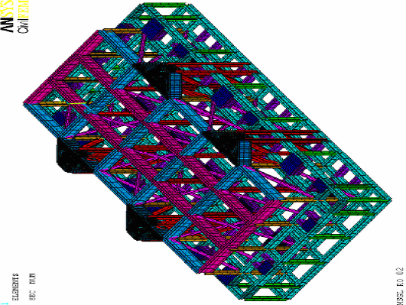
Figure.8-22: Structural analysis during installation [Mario]

8.6.1. Barge Lift
The main purpose of the analysis is to determine the minimum crane lifting speed required to avoid re-contact of the manifold with the barge deck while lifting and to analysis Load and Resistance Factor Design (LRFD) during installation. This minimum crane lifting speed could be obtained by using the criteria that the crane lifting velocity should be greater than the relative vertical velocity between the manifold base and the barge to avoid re-contact. The pendulum motion of a structure due to crane tip movement is one of the limiting criteria. Bumper frames and tugger lines can be used to control the motion of the structure. Figure.8.23 shows Manifold Structural Analysis of Global Model: AISC - LRFD checking. Figure.8.24 shows Manifold Structural Analysis of Local Model: von Mises checking.

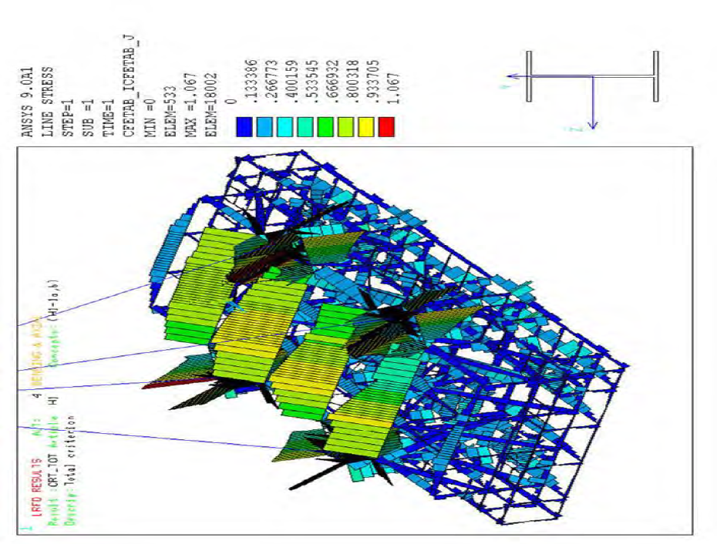 | 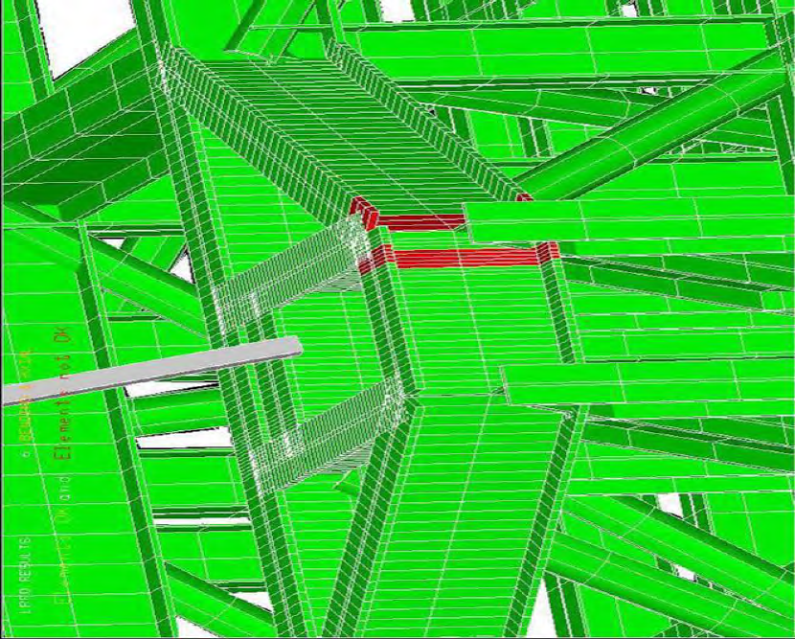
Figure.8-23: Load and Resistance Factor Design (LFRD) checking for axial load plus bending moment [Mario].

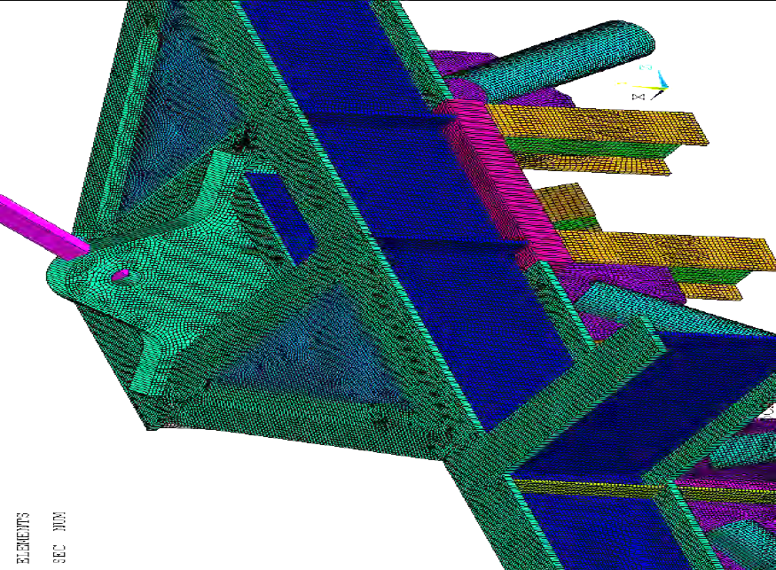
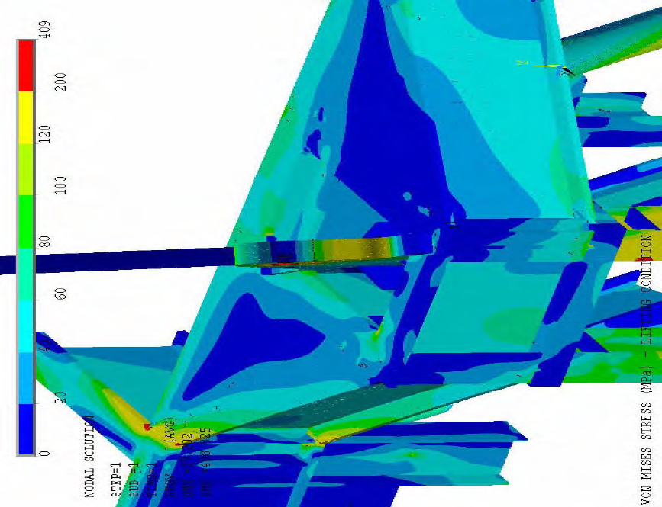
Figure.8-24: Lifting condition: von Mises stress distribution (MPa) [Mario].

8.6.2. Splash Zone
The motions of the installation vessel combined with the motion of surface waves will create a significant load on the subsea structure when it is lowered through the splash zone. It is important to determine the wave loads during the passage through the splash zone and the added mass and damping when the subsea structure is submerged to the seabed. However, the added mass and drag coefficients are immersion dependent.
The installed structure should be exposed to extreme direct wave loading in the analysis. The added mass associated with the installed structure at different submerged volumes may be estimated using the radiation/diffraction software Diodore, while the drag coefficients are estimated using CFD software. The slamming forces are estimated separately using the DNV code [Det Norske Veritas].
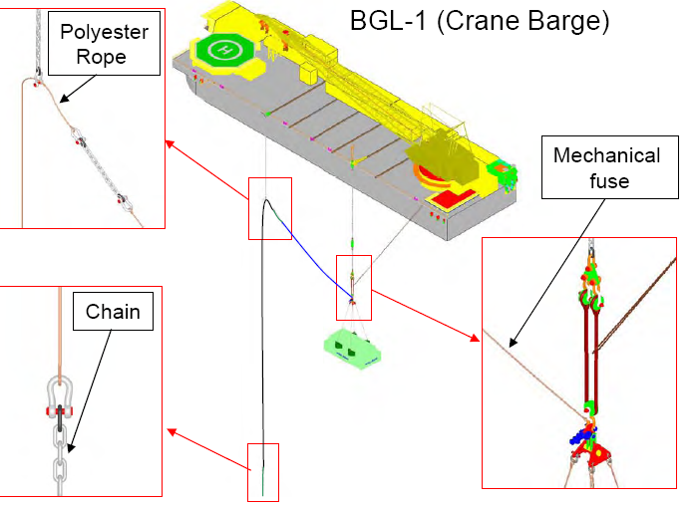
Figure.8-25: Subsea manifold in splash zone [Mario].

The hydrodynamic added mass will vary with different levels of submergence, as presented in Figures 8-26 and 8-27.
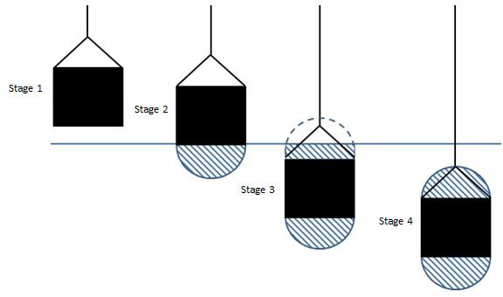
Figure.8-26: Development of Hydrodynamic Added Mass at Different Levels of Submergence, Splash Zone Lifting.
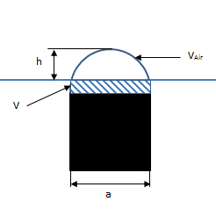
Figure.8-27: Hydrodynamic Added Mass, Lifted Object Slightly Submerged

- The hydrodynamic added mass for stage 1 and 2 is set equal to:
Half the hydrodynamic added mass of a fully submerged object, effect of object height is not accounted for. The hydrodynamic added mass ($A$) for stage 1 and 2 is found as:

$A_{1,2}=f∙ρ∙C∙\frac{π}{4}a^{2}b$ (8.9)

Where; $f$ is added mass reduction factor, $ρ$ is density of seawater, $C$is hydrodynamic added mass coefficient, $a$ is width of the lifted object and $b$ is depth of the lifted object.

- The hydrodynamic added mass for stage 3 is set equal to:
The added mass is half the hydrodynamic added mass of a fully submerged object + volume of water on top of the lifted object, up to the still water line. Effect of object height is accounted for. The volume of water on top of the lifted object is found as:

$V= V_{tot}- V_{air}$ (8.10)

Where; $V$ is Volume of water on top of the lifted object, $V_{tot}$ is Volume of half circle, $V_{air}$is Volume of half circle above still water line

$V_{tot}=\frac{π}{4}a^{2}b$ (8.11)

$V_{air}= \left[{\left(\frac{a}{2}\right)}^{2}∙\cos^{-1}\left(\frac{\frac{a}{2}-h}{\frac{a}{2}}\right)-\left(\frac{a}{2}-h\right)\sqrt{ah-h^{2}}\right]∙b$

Where; $h$ is height from still water line to the top of the half circle.

The hydrodynamic added mass for stage 3 can now be found as:

$A_{3}=\left[1+\sqrt{\frac{1-λ^{2}}{2\left(1+λ^{2}\right)}}\right]∙f∙\left(V∙ρ+\frac{ρ∙C∙\frac{π}{4}a^{2}b }{2}\right)$ (8.12)

$λ=\frac{\sqrt{A_{p}}}{h_{1}+\sqrt{A_{p}}}$

Where; $h_{1}$ is submerged height of lifted object and $A_{p}$ is projected area of lifted object normal to flow direction.
- The hydrodynamic added mass for stage 4 is found as:

$A_{4}=\left[1+\sqrt{\frac{1-λ^{2}}{2\left(1+λ^{2}\right)}}\right]∙f∙ρ∙C∙\frac{π}{4}a^{2}b$ (8.13)

8.6.3. Transferring to A&R Wire
After lowering through the splash zone, the installed structure is lowered further to a water depth of about 100 m to transfer the load from the crane to A&R wire if the crane wire is not long enough for the water depth. Once it reaches the transfer depth, the payout on the crane wire is stopped, the A&R winch wire is deployed and then connected with an ROV to the lowering yoke, and the load transfer is made from the crane main hook wire to the A&R winch.
The hydrodynamic coefficients of the installed structure are kept the same as those of the final phase of the splash zone analysis. The tensions on the yoke and the motions of the installed structure during the upending procedure are checked.

Figure.8-28: Initial lowering manifold [Mario].

8.6.4. Lowering in Deep Water
After transferring the structure load to the A&R winch, A&R wire is used to lower the structure to the seabed. To determine the peak vertical motions of the subsea structure during the lowering procedure, the resonance depth has to be calculated. In a regular wave analysis, the resonance occurs where the wave period corresponding to the maximum heave motions of the vessel in a particular wave period range matches the natural period of the subsea structure lowering system. The natural period of the lowering system depends on the length of the A&R wire, so at a certain length of A&R wire resonance occurs and the corresponding depth is identified as the resonance depth. For the calculation of the natural period of the lowering system, the reader is referred to Section 5.3.5.1 of DNV-RP-H103 [Det Norske Veritas]. The hydro-dynamic parameters of the structure are the same as for the last step. Dynamic loading is mainly due to crane tip motion.
Figure.8-29: Lowering manifold in deep water [Mario].

8.6.5. Landing on the Seabed
The hydrodynamic coefficients used in the landing analysis are same as those used in the lowering analysis. The maximum allowable touchdown velocity should be specified in the installation criteria. Installation may be performed in heave compensation mode to satisfy the criteria. The hydrodynamic parameters of the structure may be influenced by the seabed. Dynamic loading is mainly due to crane tip motion.

Figure.8-30: Landing of manifold in seabed [Mario].

,

8.7. Examples Manifold Installation

8.7.1. Installation of Manifold of Total Otter
Otter’s location makes it one of the northern-most fields in the North Sea. It is also one of the deepest subsea tiebacks in the U.K. North Sea. It is a good example of how technical innovation and ongoing commercial effectiveness within the industry can unlock the stranded reserves of the UKCS. Otter not only adds new reserves but also extends the life of its host, the Eider Field.
Otter is a development of six subsea wells which are tied back to the Shell Expro-operated Eider platform. It is located in the northern North Sea, 150 km northeast of Shetland in a water depth of 180 m. Hydrocarbons are exported from Otter via the Eider platform to North Cormorant. The oil is then sent to the Sullom Voe Oil Terminal in Shetland via the Brent system, and the gas is sent to the St. Fergus Gas Terminal via the FLAGS system

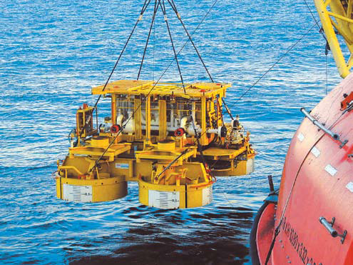
Figure.8-31: Installation of manifold of Total Otter [FMC]

8.7.2. Installation of Manifold of Shell Alliance
As part of its Gulf of Mexico subsea alliance with Shell, FMC Technologies has designed and installed a wide range of standard manifolds, well jumpers and sleds.
- Four standard manifolds installed for Macaroni, Angus, Europa and Crosby projects
- More than 30 standard well jumpers fabricated
- Two electro-hyraulic controlled gas life riser termination sleds for Nakika north flowline.

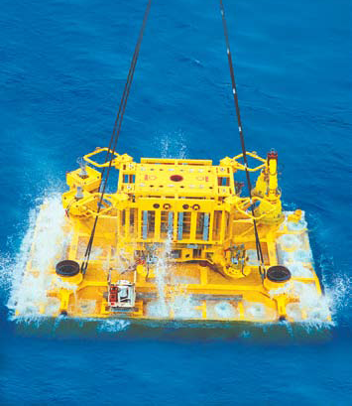
Figure.8-32: Installation of manifold of Shell Alliance [FMC]

8.7.3. Installation of Manifold of BP Thunder Horse
The BP Thunder Horse project, located in 1,920 meters of water in the Gulf of Mexico, represents the world’s first full-field HP/HT (15,000 psi/350° F) subsea development. Each of the four manifolds (2 - 10 slot and 2 - 4 slot) is supported by a single 20 foot (6 meter) diameter suction pile.
Other manifold features include ‘HH’ trim, full insulation, dedicated SCMs and removable pigging loops.
- 10-slot and 4-slot manifold configurations
- HP/HT (15,000 psi/350° F) design with ‘HH’ trim
- Suction pile foundation
- Vertical connection systems
- All header and well connections with mechanical connectors
- Dedicated SCM (Subsea Control Module) for manifold functions

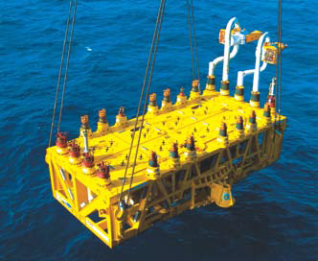
Figure.8-33: Installation of manifold of BP Thunder Horse [FMC]

8.7.4. Installation of Manifold of Shell Bijupira
The Bijupira and Salema Fields were discovered in 1990 and are located 250 km east of Rio de Janeiro. The blocks range in water depths from 480 to 880 m. The fields have combined estimated recoverable reserves of around 170 mmbo. The partnership between FMC Technologies and MODEC International supplied the FPSO vessel and turret, flowlines, riser system, controls, manifolds and tie-in systems.
The FPSO receives hydrocarbons from the subsea wells, gathered around two centers on the seabed some 5 km apart and can process up to 70,000 bopd. The Bijupira Salema development has a total of three production and two water-injection manifolds. The FPSO’s turret has space for fifteen risers, three umbilicals and two spare slots. The vessel
is secured to the seabed by nine mooring lines, giving the vessel the ability to weathervane. Artificial lift is required to raise the reservoir fluids to the surface for processing by the injection of high-pressure seawater.

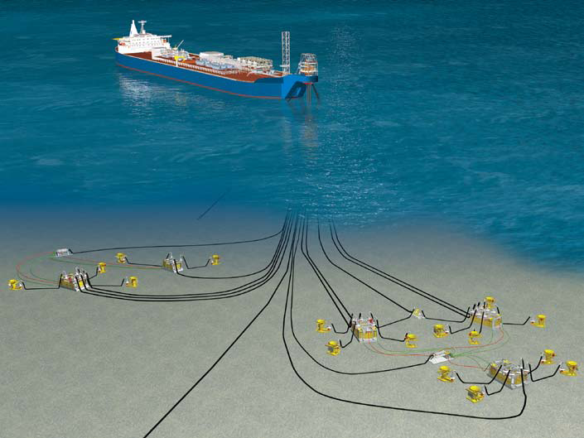
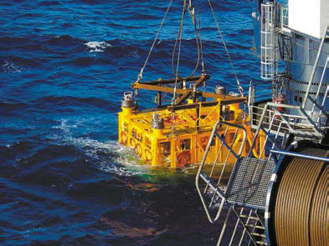
Figure.8-34: Installation of manifold of Shell Bijupira [FMC]

8.7.5. Installation of Manifold of Shell Mensa
The Shell Mensa project involved the development of the Mensa natural gas field located in the Gulf of Mexico 225 km southeast of New Orleans in water depths of 1,610 m. The initial development included three subsea electrohydraulic-controlled subsea trees individually connected via 6” flowlines to a subsea manifold located approximately 9 km away. An additional subsea tree was installed five years after the initial development. A single 12” pipeline transports the gas 102 km was tieback from the manifold to the West Delta 143 shallow-water production platform.
The gas is processed and commingled with other gas produced at the same facility and transported to shore by pipeline. Shell Mensa was installed in 1997 and early 1998 and has been in production since April 1998. A fourth Mensa well was installed in 2003. The new well’s flowline and umbilical were tied back to the spare hubs in the Mensa manifold. An 8” flowline was used between the fourth well and the manifold for increased flow rate.
- Four vertical 4”x2” 10,000 psi subsea trees
- Three (3) split trees
- One (1) standard Shell Alliance tree
- One 6” 10,000 psi subsea manifold with 12” production header

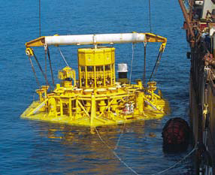
Figure.8-35: Installation of manifold of Shell Mensa [FMC]

8.7.6. Installation of Manifold of Roncador
The Roncador manifold project located in the ultradeep Campos Basin offshore Brazil marks the first time a subsea manifold has been installed at a water depth exceeding one mile. Installed using steel cables and support vessels, the Roncador manifold was designed to reduce costs by distributing gas from the production unit in a single gas line for injection into six wells at a water depth of 1,610 meters.
- Designed to operate in water depths to 2,000 meters
- Controls flow of gas lift from six wells
- Five pig diverters and retrievable pig detector
- Gas measuring equipment
- Three choke modules, one for every two wells

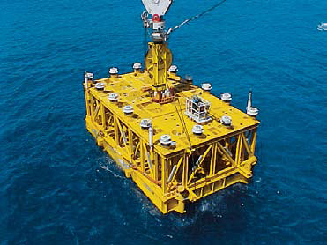
Figure.8-36: Installation of manifold of Roncador

Chapter.9

9.0 Manifolds around the Worlds

9.1. General
Subsea manifolds are an integral part of many subsea developments that provides effective gathering and distribution points for subsea systems. The manifolds are designed in various configurations, such as template or cluster manifolds with internal or external pigging loops, horizontal or vertical connectors. Two applications of manifolds in subsea production systems are described in the following sections along with their functions.

9.2. Trends in Subsea Manifold Design
Continuous innovations in subsea manifold design have been achieved in past two decades as the water depth of oil/gas field developments has increased. The diverless subsea manifolds present quite a few more challenges than the manifolds used in shallow water. Operating needs and costs are the main factors pushing these innovations. The development of subsea manifolds has gone through the following stages based on the applications of Petrobras’ subsea manifolds in deep water [M.T.R. Paula]:

9.2.1. First Stage
The manifolds of the first stage were designed to be operated in water depths up to 1000 m. The manifolds have an independent subsea support base with four lift points at the top of frame. A leveling system is designed to compensate up to 2⁰ degrees of inclination, and normally four retrievable chokes and valve modules are set, with each one for two different wells. The manifolds at this stage were designed to guarantee reliability and installation in any soil conditions, but the design resulted in a large, heavy manifold, which made installation difficult and expensive. Figure.9-1a shows a first-stage manifold being installed.

9.2.2. Second Stage
The next stage of manifold design was diverless manifolds being built that incorporated the experience acquired from the first-stage subsea manifolds. Figure.9-1b shows a typical manifold from the second stage. A comparison of the manifolds in the first and second stages is summarized in Table.9-1.
Figure.9-1: Typical Manifolds of the First Stage (a) and the Second Stage (b) [M.T.R. Paula]

Table.9-1: Comparison of Manifolds in the First Stage and the Second Stage [M.T.R. Paula]
Characteristics | First Stage | Second Stage
Dimensions (m) | 19(L) x 14(W) x 7(H) | 12(L) x 12(W) x 6(H)
Weight (tonne) | 400 | 160
Well slots | 8 | 8
Production capacity (m³/d) | 8000 | 8000
Price (relative value) | 100% | 70%
ROV operation | Docked on the structure | Landed on the top of the manifold
Control system | Electrohydraulic multiplexed | Electrohydraulic multiplexed
Retrievable modules | Control module and valves/chokes | Control module
Connection system | Vertical | Vertical
Subsea base | Independent | Fixed
Lift point | Four | One central
Leveling system | Yes | No

The weight of the manifolds in the second stage was reduced, but also the size. No subsea base installations were required because geomechanical analysis of the soil confirmed that no special foundation was necessary. The manifold structure itself has a mudmat with skirts around its base and is designed to compensate the seabed slope. No additional leveling system was required. Besides the reduction in size and weight, another reason for the decreased installation cost was the introduction of a central point, which enabled the manifold to be lifted and hung by drilling risers or wire during the offshore transport and deployment phases

9.2.3. Third Stage
The manifolds in the third stage incorporated a retrievable choke module and the provision of a cradle for one subsea multiphase flow meter (MFM) after installation. In the manifolds designed during this stage, the valves were set at the highest or lowest positions of the pipes to avoid contact with gas and water caused by oil segregation during the period during which any valve is closed. They also saw the development of a new procedure for removal of the water before any well enters into production.

9.3. Kuito Field Phase 1A
The manifold used in Kuito Field Phase 1A is a clustered manifold system with 12 production wells [C. Davison]. The production manifold is tied back with three flowlines to an FPSO. Each well is connected to the manifold with a 4-in. (10.2cm) flexible well jumper. The field arrangement of Kuito Field Phase 1A is illustrated in Figure.9-2.

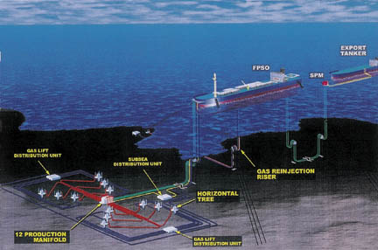
Figure.9-2: Field Arrangement of Kuito Field Phase 1A [C. Davison]

The production manifold has an 11-in production header designed for round-trip pigging and a 6-in test header for individual testing of each well. There is a hydraulically actuated ball valve in line with each header. The 11-in ball valve isolates the two production flowlines and allows pigging of the production lines. The 6-in ball valve isolates the test header from the production headers. Twenty-four 4 1/ 16-in hydraulically actuated gate valves allow each well to be connected to either the production or test header.
The manifold structure is permanently installed on a 30-in pile. Figure.9-3 shows a Pipeline End Manifold (PLEM) Foundation Kuito 1B. A guide mast, installed in the pile prior to installation of the manifold, provides guidance during installation of the manifold structure and reduces the vertical loads during landing.
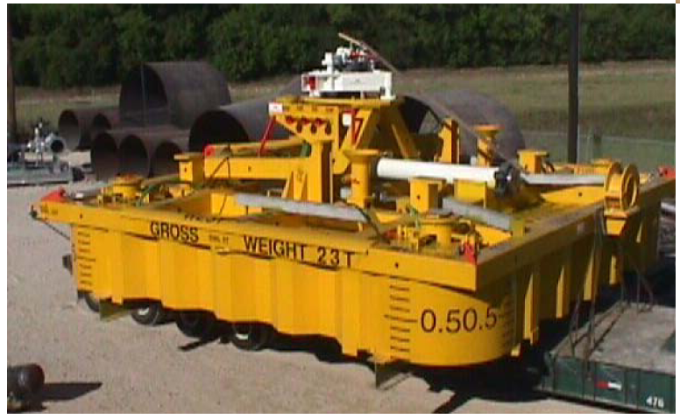
Figure.9-3: PLEM Foundation Kuito 1B [Mario L. P. G. Ribeiro].

9.4. Gemini Subsea Field
The Gemini Field is located in Mississippi Canyon Block 292 (MC 292), approximately 90 miles southeast of New Orleans in a water depth of 3400 ft. The field was discovered in 1995 with the drilling and subsequent testing of MC 292 Well No. 1. It is a subsea field development tied back to the Viosca Knoll (VK) 900 Platform located 27.5 miles northwest of MC 292 in 340 ft of water as shown in Figure.9-4. Chevron is operator of VK 900 with 75% working interest and Texaco holds the remaining 25%

4-in-diameter flexible jumpers
Manifold
3 unit Trees
single 36-in suction pile
12-in-diameter rigid jumpers
12-in-diameter flowline
Figure.9-4: Gemini Field Arrangement [DNV-GL]

From the figure, the subsea development system consists of three subsea wells connected to a 4-slot cluster manifold using 4-in-diameter flexible jumpers. Each well is located approximately 15.24-m from the manifold. The manifold has two headers connected together via a pigging loop. The manifold is supported on the seafloor using a single conductor. Two 12-in rigid jumpers connect the manifold to two 12-in flowlines that extend 44.3km to the platform. Figure.9-5 shows during integration test of the Gemini Subsea System.

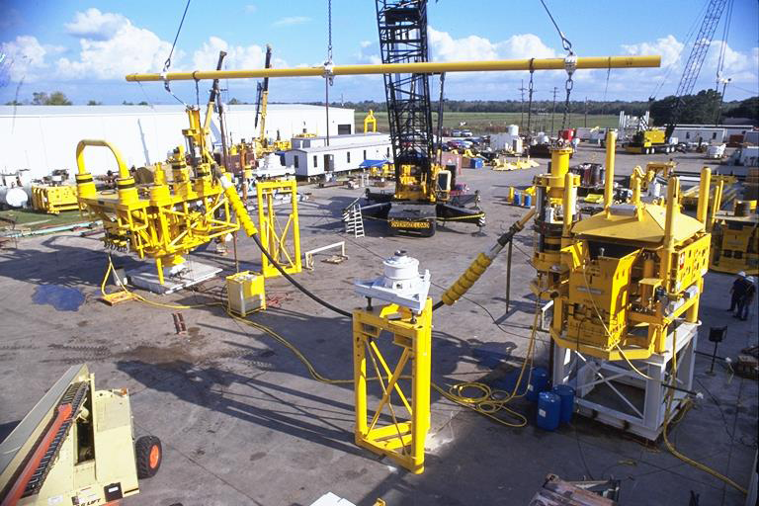
Figure.9-5: Gemini System Integration Test (SIT) [DNV]

The subsea manifold gathers the production from three wells and directs it to one of the two flow-lines to the platform. The manifold consists of dual 12-in headers and a removable pigging loop. One of the 12-in headers contains an ROV-operated isolation valve, whereas the other includes a remotely operated fail-safe closed valve that serves as the pigging isolation valve while the system is in normal production. The manifold has the ability to accept production from up to four subsea wells with four 4-in. nominal connection hubs. Each hub is piped to a dual valve block, which provides the ability to access either header. The valves are remotely operated through the control pod on the tree associated with the connection.
The manifold was designed to be a moon-pool deployed and retrieved using the Ocean Star semisubmersible drilling rig and it is supported on the seabed using a single 36-in suction pile.

9.5. Albacora, 1996-1997
Albacora is one of the last decade discovered deep water giant fields, located at Campos Basin, offshore Brazil. The Campos Basin was explored since 1968. The Campos Basin became the main petroleum province in Brazil. Ranging from shore to 3,400 m water depth, with a total area of 110,000 km² its total proved reserves, in water depth up to 1,000 m, reaches 2.78 X 10⁹ barrels of oil and 58.2 x 10⁹ std m³ of gas, 16 % of this being located in the Albacora field.
In 1984, with the wildcat well 1RJS297, drilled at 293 m water depth, the Albacora field was discovered. Further efforts led to the knowledge of the field's full extension, which is presently accepted as covering an area of nearly 235 Km 2. Since this first discovery and the following successes in Marlin field, the basin development strategies had been reviewed to attain those new challenges in deep waters.

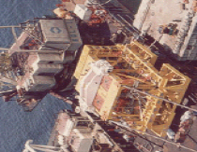

Figure.9-6: Albacora Phase 1 in 1996, 2 Unit, 640m water depth [Mario L. P. G. Ribeiro]

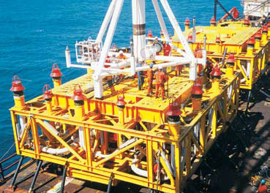

Figure.9-7: Albacora Phase 2 in 1997, 5 Unit, 400m water depth [FMC]

9.6. Marlim, 1998
Marlim field is located in the north-eastern part of Campos Basin, about 110km offshore Rio de Janeiro, in water depths ranging from 650m to 1,050m. It has some 102 production wells and 50 injection wells. Over 80km of rigid pipelines and 400km of flexible lines have been laid on the field.
The field produces around 390,000 bopd and 252,000 bpd of water, and around 705,000 bwpd are injected into the field. The refinery has reported an average production of 353,027 bpd for 2007.
Marlim was discovered by well 1-RJS-219-A in February 1985. The 75m column was predominantly unconsolidated sandstone, with a permeability as high as two darcies. The discovery also showed high-gravity oil (17-21 degree API). At the time of discovery, the Marlim reservoir had an oil-in-place volume of about 9 billion barrels and an expected 1.7 billion barrels of oil in total reserves.

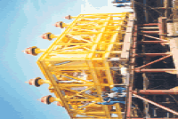

Figure.9-8: 1998, Marlim 2 Unit, 820m Water Depth [Mario L. P. G. Ribeiro]

9.7. Namorado, 2001
This field began production in February 1979. It is comprised of four (4) production wells from the Garoupa Field in 120 m (400 ft) water depth and four (4) wells from Namorado Field in 160 m (530 ft) water depth.
- No. Trees: 3
- Water Depth: 100 - 300 m
- Tree Type: Vertical
- Tree Pressure: 5,000 psi
- Tree Bore Size: 4”x2”
- Hydrocarbon: Oil and Gas
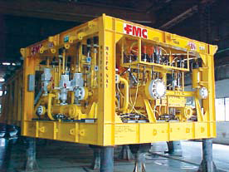 | 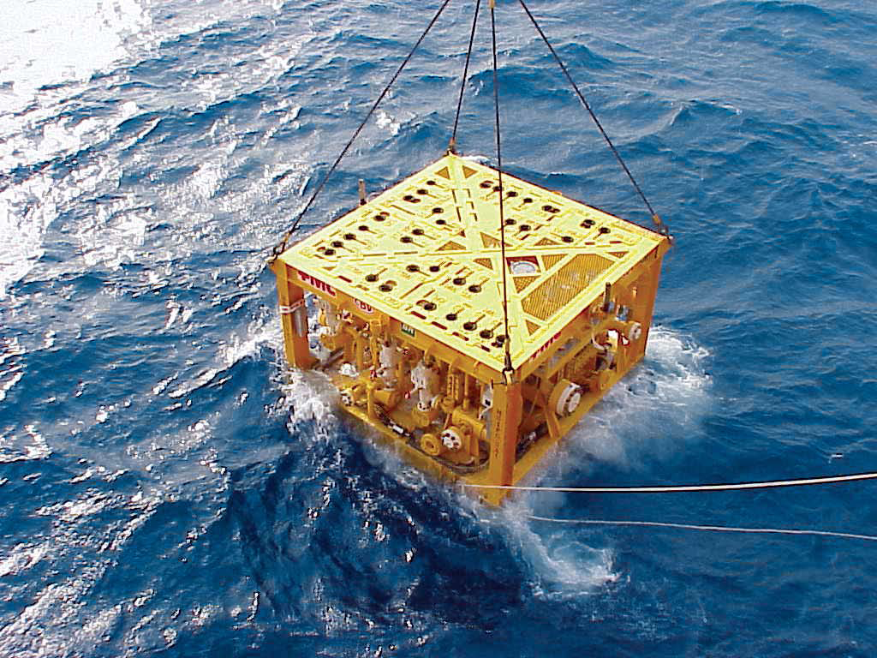
Figure.9-9: 2001 Namorado, 1 Unit, 200m Water Depth [FMC].

9.8. Roncador Field
The field was discovered in October 1996 and is located in P-36 block. The operator Petrobras had been preparing for a deep-water technical challenge such as Roncador under its PROCAP (Petrobras Technological Development Program on Deep Water Production Systems) and PROCAP-2000 initiatives. The field is considered to be a major breakthrough. It involves world’s first drill pipe riser, subsea tree and early production riser (EPR) rated for 2,000 metres. Roncador has 53 production wells, 29 injection wells and is anticipated to peak in 2014.

Table 9.1: Summarize the subsea infrastructure that has been installed in Roncador field [Bordieri E., 2008]
Module | Subsea Manifold | Gathering System
Module | Subsea Manifold | Flexible | Rigid | Umbilical
1A Phase 1 | 1 gas-lift manifold | 4in - 6in (205km) | 5.5in - 7in (33 km) | 115km
1A Phase 2 | 2 gas-lift manifolds | 4in - 7in  (295 km) | - | 168km
2 | 2 control manifolds | 2.5in - 6in (143 km) |  | 76km
3 | 2 gas-lift manifolds  & 2 water injection manifolds | 4in - 7in  (59 km) | 8in - 10in (61km) | 96km
4 | 2 gas-lift manifolds  & 2 water injection manifolds | 4in - 7in  (107 km) |  | 68km

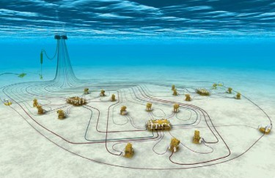
P-52
Oil: 180.000 bpd
Water depth: 1800 m
MSGL-RO-02 6 production wells
Subsea System: 29 Wells
-18 Production Wells
-11 Water Injection Wells
-1 Oil Export Pipeline
-1 Gas Export Pipeline
-3 Subsea Manifolds:
- Gas-lift Injection
- Chemical Products inj.
- Well control
MSGL-RO-01 6 production wells
MSGL-RO-03
3 production wells + 3 injection wells
Figure.9.10: Roncador P-52 subsea layout.

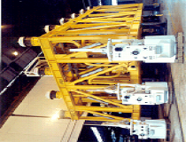

Figure.9-11: 2002, Roncador Phase-1, 1-Unit, 1,892m water depth [Mario L. P. G. Ribeiro]

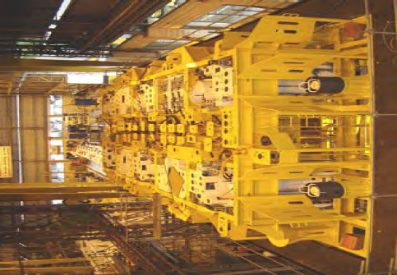

Figure.9-12: 2006, Roncador Phase-2, 2-Unit, 1,892m water depth [Mario L. P. G. Ribeiro]

9.9. Statoil Lufeng
The Lufeng subsea development consists of a HOST template with manifold and control distribution system which supports five horizontal 5”x2” 5,000 psi subsea trees producing oil to a round-trip piggable header. The HOST template was secured using a singular pile. The manifold is considered non-retrievable during the life of the field. The subsea trees are fitted with a mudline booster pump which is used to individually boost the production from each well to a resident FPSO. The FPSO provides the power source and controls the output of the mudline booster pumps and houses the electro-hydraulic control system for the subsea trees. Horizontal subsea trees are utilized to enable installation of largebore tubing (7” casing). The system is diverless, with ROVs performing any necessary intervention. Intervention tooling is launched from the FPSO using guideline and guidelineless techniques.

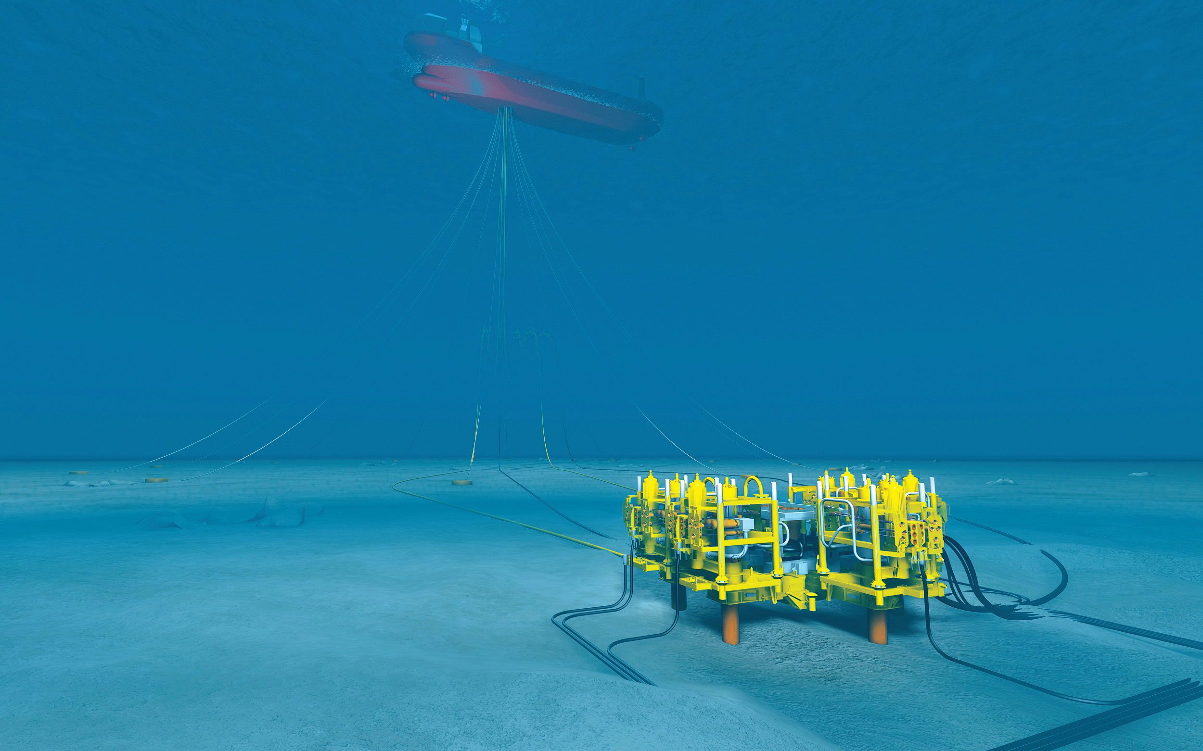
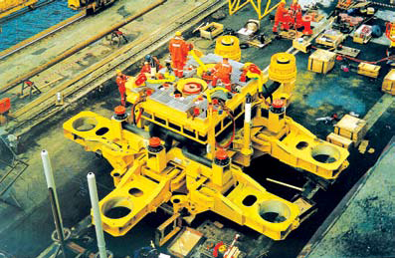
Figure.9-13: Statoil Lufeng [FMC, 2003]

9.10. ExxonMobil Zafiro
The Zafiro Field, located on Block B, is 65 km northwest of Equatorial Guinea in water depths of 425 to 850 m. The latest development, known as the Zafiro Southern Expansion Area, utilizes a turret moored FPSO as a host, which is expected to recover about 150 mmbo.
The subsea systems contract calls for the supply of nineteen (19) subsea trees (fourteen vertical 4”x2” 5,000 psi subsea trees, five horizontal (HOST) 5”x2” 5,000 psi subsea trees), a production six-slot water-injection manifold systems, a water-injection flowline end termination and associated “gooseneck” integral hydraulic connectors, KOS-100 topside and subsea production control system MCS; unique semicircular external turret-mounted HPU; VSE and EPU on the FPSO and related equipment and services. Equipment deliveries and installation activities were commenced in March 2002.

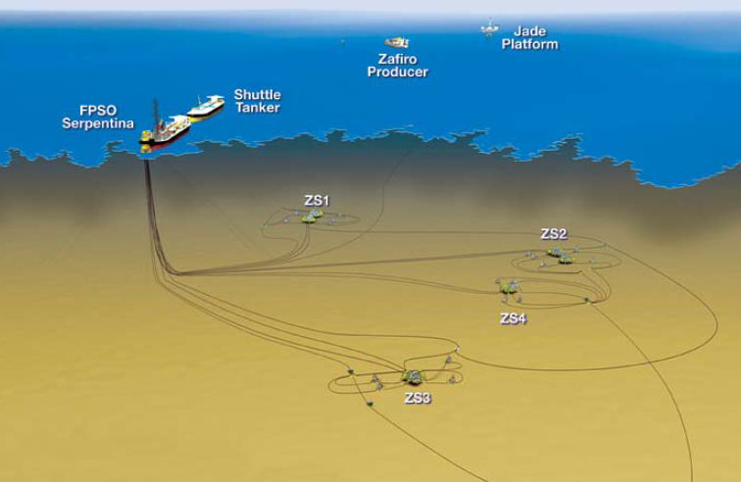
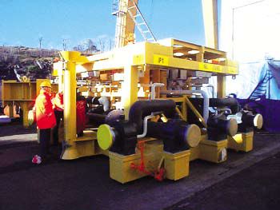
Figure.9-14: ExxonMobil Zafiro [FMC, 2002].

9.11. Anadarko Genghis Khan
The field was discovered in 2005 on GC 652 with well K1-1 drilled by Anadarko with semisub Noble's Paul Romano and completed by GlobalSantaFe's ultra-deepwater semisubmersible CR Luigs. In October 2007, BHP Billiton brought its Genghis Khan development into production. The field is located in the deepwater Gulf of Mexico, approximately 192km off the coast of Louisiana It lies in the western flank of the Shenzi structure, which is located on the adjacent blocks. The water depth is approximately 1,307m. Estimated gross hydrocarbon reserves have been put in the range from 65 to 170 million barrels of oil equivalent [Oil & Gas].

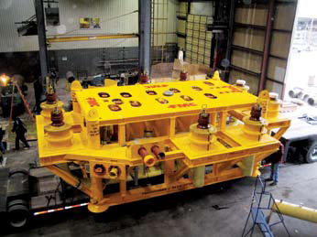
Figure.9-15: Anadarko Genghis Khan [FMC, 2006]

9.12. PetroCanada Terra Nova
The Terra Nova project is located in the Jeanne d’Arc Basin, 350 km east-southeast of St. John’s Newfoundland. It is comprised of three (3) geological blocks: Graben, East Flank and Far East. Phases I and II consist of twenty-four (24) wells drilled through seven (7) subsea templates and one spare subsea tree. The subsea wells are linked to a Floating Production Storage and Offloading (FPSO) facility. Subsea layout consists of production wells feeding into manifolds, which in turn are connected by flexible flowlines to a riser base, and then to the FPSO via a riser system
Ph I:
- Nineteen (19) horizontal 5”x2” 6,650 psi trees
- Seven (7) HOST® templates and manifolds
- Pig loop modules
- Subsea wellheads
Ph II: Six (6) horizontal 5”x2” 6,650 psi trees
Ph III: Two (2) horizontal 5”x2” 6,650 psi trees

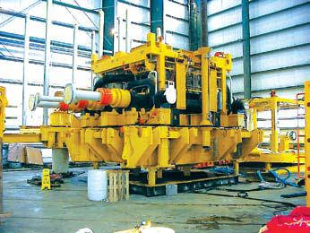
Figure.9-16: PetroCanada Terra Nova [FMC, 2006]

9.13. Perdido
For the Perdido development, two production manifolds were located under the host Spar structure. Each manifold has two main headers and each header is connected to one of the five artificial lift subsea boosting systems. Round trip pigging capability is not required. Capability for planned and potential future production dictates the need for connection points on the manifolds. This includes future DVA well tie-ins, as well as potential flowline sled connections. Both manifolds use an identical configuration, which includes 10 inlet hubs (eight 5-inch hubs and two 7-inch hubs), providing maximum flexibility for future production. In addition, the design allows production from any branch hub to be directed to either header for full operational flexibility.
The manifolds are located in the center of the DVA cluster, surrounded by twenty-two subsea wells, including water injectors along with production wells. Since all twenty-two wells were batch set before the manifolds were installed, there was concern about the potential for large mounds of drill cuttings and other debris. As a result, a suction pile was used to provide the foundation support, instead of the traditional mudmat in order to minimize the need of an extensive flat level area with minimum elevation tolerance.
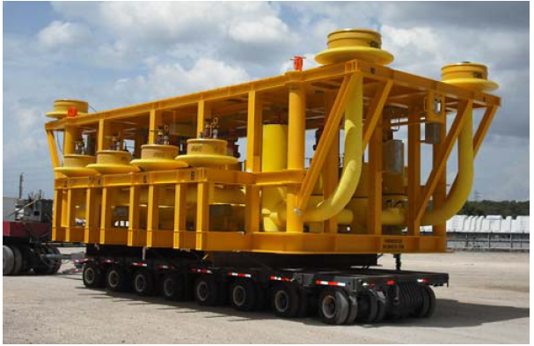
Figure.9-17: Perdido [FMC]

References

- A. Couch, et al., Independence Installation, OTC 18585, Offshore Technology Conference, Houston, Texas, 2007.
- A. Eltaher, Y. Rajapaksa, K.T. Chang, Industry Trends for Design of Anchoring Systems for Deepwater Offshore Structures, OTC 15265, Offshore Technology Conference, Houston, Texas, 2003.
- A.H. Techet, Added Mass, Hydrodynamics, MIT, USA
- American Petroleum Institute, Pipeline Valves, twenty-second ed., API Spec 6D, (2002).
- American Petroleum Institute, Recommended Practice for Design and Operation of Subsea Production Systems, API-RP- 17A (2002).
- American Petroleum Institute, Recommended Practice for Planning, Designing and Constructing Fixed Offshore Platforms-Working Stress Design, twenty first ed, API-RP-2A-WSD, 2002.
- American Petroleum Institute, Specification for Subsea Umbilicals, third ed., API Spec 17E, 2003.
- American Petroleum Institute, Specification for Subsea Wellhead and Christmas Tree Equipment, API Spec 17D, 1992.
- American Petroleum Institute, Specification for Wellhead and Christmas Tree Equipment, seventh ed., API Spec 6A, 2000.
- American Society of Mechanical Engineers, Boiler and Pressure Vessel Code, Section VIII, Div. 3, ASME (2007).
- American Society of Mechanical Engineers, Gas Transmission and Distribution Piping Systems, ASME B31.8, 2010.
- American Welding Society (AWS), Structural Welding Code – Steel, AWS D1.1, 2008 ed.
- Autoclave Ball Value, http://www.autoclave.com/products/ball_valves/index.html.
- B. Rose, Flowline Tie-in Systems, SUT Subsea Awareness Course, Houston, 2008.
- B.L. Bastes, The Albacora Field Subsea Development: A Case History, Offshore Technology Conference, 2-5 May,1994, Houston, Texas
- Bordieri, E., Barbosa V. C., Dias, R. (2008). An Overview of the Roncador Field Development, a Case in Petrobras Deep Water Production, Offshore Technology Conference, 5-8 May, Houston, Texas, USA.
- C. Davison, P. Dyberg, P. Menier, Fast-Track Development of Deepwater Kuito Field, Offshore Angola, OTC 11873, Offshore Technology Conference, Houston, Texas, 2000.
- D. Janoff, N. McKie, J. Davalath, Prediction of Cool Down Times and Designing of Insulation for Subsea Production Equipment, OTC 16507, Offshore Technology Conference, Texas, Houston, 2004.
- D.R. Mefford, Deep Water Subsea Ball Valves, Cameron, http://www.c-a-m.com/, (2010).
- Det Norske Veritas, Cathodic Protection Design, DNV RP-401, (1993).
- Det Norske Veritas, Modeling and Analysis of Marine Operations, DNV-RP-H103 (2009).
- Det Norske Veritas, Submarine Pipeline Systems, DNV-OS- F101 (2003).
- DNV-GL, Introduction to Subsea Production Systems, Templates and Manifolds, 2014.
- E. Coleman, G. Isenmann, Overview of the Gemini Subsea Development, OTC 11863, Offshore Technology Conference, Houston, Texas, 2000.
- Fishsafe, Subsea Templates & Manifolds.
- FMC, ExxonMobil (MEGI) Zafiro SEA, Southern Expansion Area (SEA), Equatorial Guinea Block B, 2002.
- FMC, Manifolds & Sleds, 2006
- FMC, PetroCanada Terra Nova, Canada Blocks Graben, East Flank, Far East, 2003.
- FMC, Shell Bijupira Salema, Brazil
- FMC, Shell Mensa, Gulf of Mexico Block MC 687
- FMC, StatoilHydro Lufeng, China Block 22/1, 2003.
- FMC, Total Otter, U.K. Block 210/15a
- Gate Valves & Actuators, http://www.magnum-ss.com/ss-gatevalve.html.
- H. Dendani, Suction Anchors: Some Critical Aspects for Their Design and Installation in Clayey Soils, OTC 15376, Offshore Technology Conference, Houston, Texas, 2003.
- International Organization for Standardization, Petroleum and Natural Gas Industries - Offshore structures - Part 1: General requirements, ISO 13819-1, first ed., (1995)
- International Organization for Standardization, Petroleum and Natural Gas Industries - Offshore structures - Part 2: Fixed steel structure (Interim standard), ISO 13819-2, first ed., (1995)
- International Organization for Standardization, Petroleum and Natural Gas Industries – Design and Operation of Subsea Production Systems – Part 6: Subsea Production Control Systems, ISO 13628-6, (2006).
- J. Mauricio, et al., Development of Subsea facilities in the Roncador Field (P-52), OTC 19274, Offshore Technology Conference, Houston, Texas, 2008.
- J. Soliah, M. Guinn, Subsea Equipment Installations Utilizing Anchor Handling Vessels, Deepwater Technology (October 2003) 25–27.
- J. Koto, 2016, Subsea Pipeline End Structure, Ocean & Aerospace Research Institute, Indonesia
- J. Koto and A.K. Junaidi, 2017, Subsea Pipeline Design & Analysis, Ocean & Aerospace Research Institute, Indonesia
- J.-L. Colliat, Anchors for Deepwater to Ultra-deepwater Moorings, OTC 14306, Offshore Technology Conference, Houston, Texas, 2002.
- Joensen Arnbjorn, Paul David, 2011, A Low Tech, Low Risk System for the Installation of Large Structures in Deep Water, Aberdeen, U.K, SPE Offshore Europe Oil and Gas Conference and Exhibition
- K.H. Andersen, H.P. Jostad, Foundation Design of Skirted Foundations and Anchors in Clay, OTC 10824, Offshore Technology Conference, Texas, Houston, 1999.
- Lloyd’s Register of Shipping, Rules and Regulations for the Classification of Fixed Offshore Installations, Lloyd’s Register (1990).
- M.T.R. Paula, E.L. Labanca, C.A.S. Paulo, Subsea Manifolds Design Based on Life Cycle Cost, OTC 12942, Offshore Technology Conference, Houston, Texas, 2001.
- Mario L. P. G. Ribeiro, Milton V. B. Segura and José A. N. Ferreira, Subsea Manifold Design for Pendulous Installation Method In Ultra Deep Water, OMAE, 2000.
- Mork Henrik, Lunde Johannes, 2007, A Cost-Effective and Safe Method for Transportation and Installation of Subsea Structures – The Pencil Buoy Method, Aberdeen, Scotland, U.K, SPE Offshore Europe.
- NACE International, Corrosion Control of Steel-Fixed Offshore Platforms Associated with Petroleum Production, NACE Standard RP 0176-03, Houston, 2003.
- Oil & Gas Journal (OGJ), The Subsea System, 2010.
- Oil & Gas, Genghis Khan Development, United States of America, offshore technology.com
- P. Sparrevik, Suction Pile Technology and Installation in Deep Waters, OTC 14241, Offshore Technology Conference, Houston, Texas, 2002.
- Paul Betteridge, Subsea Production Systems, Subsea Forum - Young Engineers Day, Paris, 13th June 2007
- R.G. Standing, B. Mackenzie, R.O. Snell, Enhancing the Technology for Deepwater Installation of Subsea Hardware, OTC 14180 (2002).
- Rowe Stephen J, Mackenzie Brian, Snell Richard, 2001, Deepwater Installation of Subsea Hardware, Huston, Texas, Proceedings of the 10th Offshore Symposium
- S.J. Rowe, B. Mackenzie, R. Snell, Deepwater Installation of Subsea Hardware, Proc. 10th Offshore Symposium, Houston, Texas, 2001.
- Sarkar Arunjyoti, Gudmestad Ove T, 2010, Splash Zone Lifting Analysis of Subsea Structures, Sanghai, China, 29th International Conference on Ocean, Offshore and Arctic Engineering
- SDS, A Step Change In Subsea Installation, Subsea Deployment Systems Ltd
- Simen Thorgersen, Comparison study of deepwater installation methods, Master’s Thesis, Faculty of Science and Technology, University of Stavanger, Norway, 2014.
- Subsea World News, UK: Babcock Nets Subsea Structures Contract for BP Quad 204 Project
- T. Bernt, E. Smedsrud, Ormen Lange Subsea Production System, OTC 18965, Offshore Technology Conference, Houston, Texas, 2007.
- Torben Sverre Rye, Ingeberg Per, 2010, Field Pilot of Deep Water Installation in Two-Fall Using Fibre Rope, Rio de Janeiro, Rio Oil & Gas Expo and Conference 2010 Proceedings
- Torben Sverre, Ingeberg Per, Bunes Øyvind, 2008, Fiber Rope Deployment System and Rope Management Process, Vancouver, BC, Canada, Proceedings of the Eighteenth (2008) International Offshore and Polar Engineering Conference
- Wang Alan M, Zhu Shaoua, Zhu Xiaohuan, Xu Jingkuo, He Min, Zhang Changzhi, 2013, Pendulous Installation Method and its Installation Analysis for a Deepwater Manifold in South China Sea, Anchorage, Alaska, USA, Proceedings of the Twenty-third (2013) International Offshore and Polar Engineering Pencil buoy method
- Wikipedia, Pendulum

Appendixes

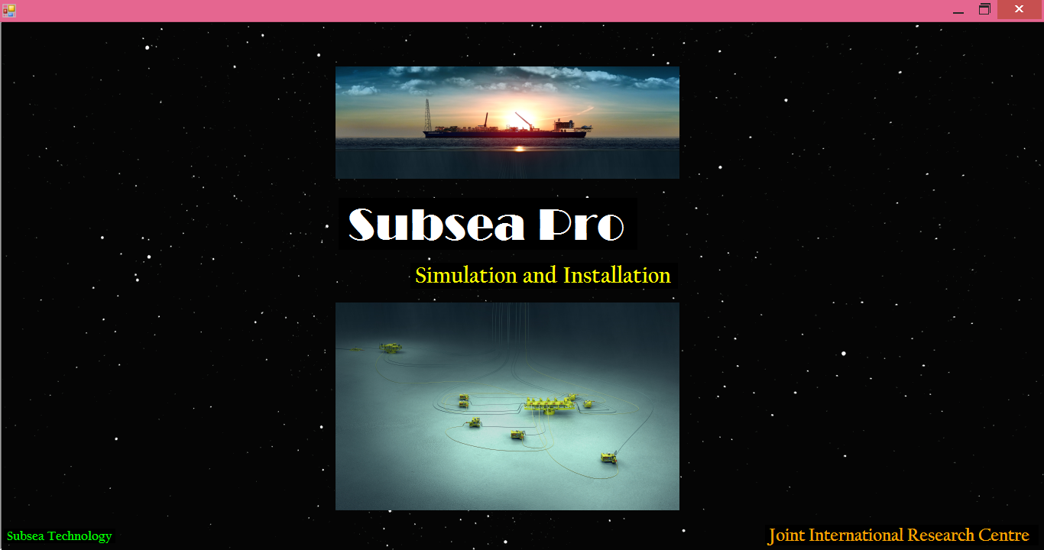
Figure.A-1: Subsea Pro -Simulation and Installation-.

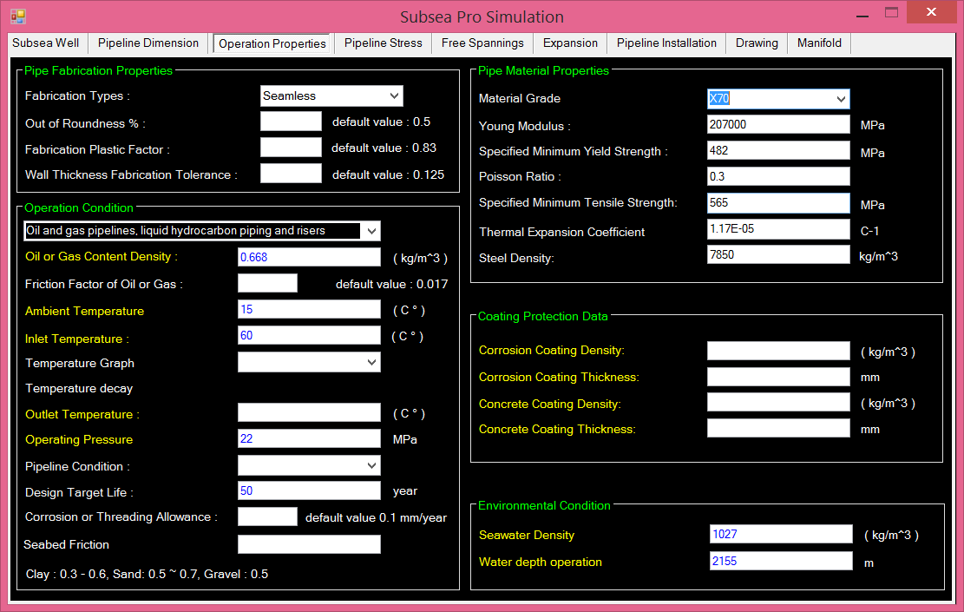
Figure.A-2: An example of material properties in Subsea Pro -Simulation and Installation-.

Autobiographies

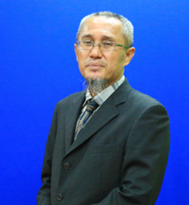 | Jaswar Koto was born on October, 1970. He is a descendant of the Prophet Rasullullah S.A.W through Husein R.A. He is a President of Ocean and Aerospace Research Institute, Indonesia. Professor on offshore engineering and also President of International Society of Ocean, Mechanical & Aerospace for scientist and engineers.
He has been invited as a Visiting Professor more than 16 times, received several international awards and supervised PhD, Master and Bachelor Students.
He received his bachelor degree in 1994 from Institut Teknologi Sepuluh Nopember (ITS), Indonesia, Curtin University in 1996 and Notre Dame University in 1999. In 2003 he has completed PhD with receiving award in engineering form Aerospace and Marine Engineering, Osaka Prefecture University, Japan.
He has started his researches since 1994 on structure analysis of fluid flow in subsea pipelines, subsea pipeline corrosion due to Carbon Monoxide, design and hydrodynamic analysis of AUV in Australia. Then, he joined Research and Development Institute, Sumitomo Heavy Industries -Marine Engineering-, Japan. In 2005, he joined ExxonMobil projects. Since 2010, he has a contract with Department of Aeronautical, Automotive, and Ocean Engineering, Faculty of Mechanical Engineering. He was appointed as head of High Performance Computing, CICT, Universiti Teknologi Malaysia.

