Preface



This book introduces strength and collision mechanics of ships and offshore structures which consists of eleventh chapters. In order, they are overview of ships and offshore structures, loads on the ships and offshore structures, matrix algebra method, introduction to finite element, finite element method, shear and stress of ships and offshore structures, ship and offshore structures strength analysis, buckling on ships and offshore structures, collision mechanic on ships and offshore structure, case studies on strength analysis of jacket structure due to ship collision and fracture of scantling support structure of gas processing module on FPSO.

In the book, many pictures and illustrations are enclosed in this note to assist the readers’ understanding. It should be noted that some pictures and contents are borrowed from other companies’ websbites, notes and brochures, without written permit. Even though the exact sources are quoted or listed in the references, please use this note for engineering education purposes only.

2018 (Second Edition)

Acknowledgements

First and foremost, all praises, thanks and syukur to Allah (S.W.T) to give us strength and ability to complete this book.

We would like to take this opportunity to express our highest appreciation to our colleagues in the Ocean and Aerospace Research Institute, Indonesia, Universiti Teknologi Malaysia and Institut Teknologi Sepuluh Nopember, Indonesia to provide proper guidance, encouragement, invaluable ideas, comment, recommendation, critics, suggestions and advice that to assist us for the successful completion of this book.

To our families that always pray for our successful, all this things cannot pay for all what they all have done. Our special thanks also to our postgraduate students.

Above this all, our highest praises, thanks and syukur to Almighty Allah Subhanahu Wa’Talla, the most gracious the most merciful, who gave us the knowledge, courage and patience to accomplish this project. May the peace and blessings of Allah be upon Prophet Muhammad Sallallahu Alaihi Wasallam.

The authors are grateful to all friends, institutions and parties for supporting this book.

List of Figures
Figures | Description | Page
Figure.1.1.a | Main parts of components of a ship | 14
Figure.1.1.b | Types of ships and offshore structures | 15
Figure.1.2.a | Examples of high-speed craft | 16
Figure.1.2.b | Components of Custom high speed picker boat | 16
Figure.1.3 | Examples of Offshore Oil Vessels | 17
Figure.1.4.a | Fishing Vessel | 18
Figure.1.4.b | Components of Catcher boat | 18
Figure.1.5 | Examples of harbour work crafts | 19
Figure.1.6.a | Examples of dry cargo ships | 20
Figure.1.6.b | Components of General Cargo Ship | 20
Figure.1.6.d | Components of Container ship | 21
Figure.1.7 | Liquid cargo ships | 22
Figure.1.8 | Examples of Passenger ships | 23
Figure.1.8.a | Cruise Ship | 24
Figure.1.8.b | Components of Car & Passenger Ferry | 25
Figure.1.8.c | Components of Catamaran | 26
Figure.1.9 | Recreational Boats | 27
Figure.1.10 | Icebreaker ship | 28
Figure.1.11 | Autonomous Underwater Vehicle (AUV) | 28
Figure.1.12.a | Examples of Warships | 30
Figure.1.12.b | Submarines | 30
Figure.1.13 | Typical hull of a ship | 32
Figure.1.14 | Typical interior hull of ship | 32
Figure.1.15 | External part of the hull of a ship | 33
Figure.1.16 | Typical weather decks of a ship | 34
Figure.1.17 | Construction of a Hull | 35
Figure.1.18 | Carrier Deck Schematic | 37
Figure.1.19 | Construction of stem part | 39
Figure.1.20 | Construction of mid-ship part | 40
Figure.1.22 | Construction of stern part | 42
Figure.1.23 | Construction of rudder part | 43
Figure.1.24 | Construction of rudder bearing | 44
Figure.1.26 | Construction of Shaft Line | 46
Figure.1.27 | Construction of Engine Room | 46
Figure.1.28 | Typical number of components of floating and fixed platforms | 48
Figure.1.29 | Several offshore structures | 49
Figure.1.30 | Typical Gravity based Offshore Structure | 50
Figure.1.31 | Typical of Jack-up | 51
Figure.1.32 | Different Compliant Structures through the years | 52
Figure.1.33 | Guyed tower | 53
Figure.1.34 | Tension Leg Platform | 54
Figure.1.35 | Articulated Tower | 55
Figure.1.36 | Floating Production System | 56
Figure.1.37 | The ongoing operations to an FPSO and the production process | 58
Figure.1.38 | Truss SPAR DTU in Kikeh, Malaysia | 58
Figure.1.39 | Three types of SPAR | 59
Figure.1.40 | Typical of Semi-submersible and TLP | 61
Figure.1.41 | Typical of Semi-submersible | 62
Figure.2.1 | Wind load at structure | 71
Figure.2.2 | Buoyancy loads of structures | 73
Figure.2.3 | Ice load on a structure | 75
Figure.2.4 | Block of Ship Structure | 78
Figure.2.5 | Front view of ship structure | 78
Figure.2.6 | Different types of framing systems of ships | 80
Figure.2.7 | Midship section for a double hull oil tanker | 81
Figure.2.8 | Midship section for a Navy destroyer | 81
Figure.2.9 | Rationally-based Structural Design | 82
Figure.2.10 | Levels of structural analysis | 83
Figure.2.11 | Failure Probabilities | 85
Figure.2.12 | Stress of structure | 87
Figure.2.13 | Wave-induced pressure variations on floating structure | 89
Figure.2.14 | Wave-induced buoyancy distribution | 90
Figure.2.15 | Hogging and sagging on a floating structure | 90
Figure.2.16 | Whipping stress due to slamming | 92
Figure.2.17 | Primary, Secondary and Tertiary Ship Structural Loads | 93
Figure.2.18 | An example of hull girder bending | 94
Figure.2.19 | Trapezoid Method | 96
Figure.2.20 | Biles’ Method | 97
Figure.2.21 | Weight curve for a typical small cargo ship | 98
Figure.2.22 | An example of a ledger-style spreadsheet for weight accounting and control | 99
Figure.2.23 | Wave height versus length of ships | 101
Figure.2.24 | Section area curve calculated using Bonjean method | 102
Figure 2.25 | Diagrams of strain and stress distribution along the cross-section at cracking and ultimate limit states | 105
Figure 2.26 | Diagrams. Stress profile for estimating the positive cracking moment of a T-shaped beam | 106
Figure 2.27 | Diagrams. Strain and stress profiles for estimating the positive nominal moment of a T-shaped beam | 107
Figure.4.1 | Structures analysis using Finite Element Method | 124
Figure.4.2 | An example of mesh | 125
Figure.4.3 | Stress analysis using FEM | 126
Figure.4.4 | Vibration analysis using FEM | 127
Figure.4.5 | Fatigue analysis using FEM | 128
Figure.4.6 | Heat Transfer analysis using FEM | 128
Figure.5.1 | Uniform prismatic bar | 134
Figure.5.2 | Simple bar element | 135
Figure.5.3 | Two axial elements | 138
Figure.5.4 | Simple two-dimensional truss element | 141
Figure.5.5 | Plane trusses element in local and global coordinates | 142
Figure.5.6 | Stress-strain law in isotropic linear elastic | 148
Figure.5.7 | Simple three-dimensional truss element | 149
Figure.5.8 | Frames in ship structures | 154
Figure.5.9 | Beam loading (a) and deformation of the natural axis (b). | 155
Figure.5.10 | Beam section and stress distribution | 155
Figure.5.11 | Finite Element discretization | 157
Figure.5.12 | Hermite shape function | 158
Figure.5.13 | 2-D Element | 165
Figure.6.1 | Bending and shear stress distributions | 169
Figure.6.2 | Shear stress in I beam | 170
Figure.6.3 | Shear force on box-shaped barge | 170
Figure.6.4 | Shear and stress at midship | 172
Figure.6.5 | Shear and stress of box-beam with constant plating thickness | 173
Figure.6.6.a | Example of shear flow calculation in internal longitudinal bulkheads | 179
Figure.6.6.b | Example of shear flow calculation in multi-cell section | 180
Figure.6.7 | Ship inclined to an angle θ | 183
Figure.7.1 | Maximum deflection of rectangular plates under uniform pressure | 201
Figure.7.2 | Maximum stresses in rectangular plates under uniform pressure | 202
Figure.7.3 | Transverse pressure for small and large deflections | 205
Figure.7.4 | Membrane effect for long simply-supported plates | 207
Figure.7.5 | Stress and strain regions | 208
Figure.7.6.a | Design curves for plates under uniform pressures | 208
Figure.7.6.b | Design curves for plates under uniform pressures | 209
Figure.7.6.c | Design curves for plates under uniform pressures | 210
Figure.7.6.d | Design curves for plates under uniform pressures | 211
Figure.7.6.e | Design curves for plates under uniform pressures | 213
Figure.9.1 | Ship to ship collision | 258
Figure.9.2 | Force deflection relation for stiff bow collision into a side shelf | 260
Figure.9.3 | Stages in the collapse mechanism for a side shell | 261
Figure.9.4 | Surge, Sway and Yaw Motion | 261
Figure.9.5 | Chart of Coefficients $a_{H}$ and ${x'}_{H}$ | 267
Figure.9.6 | Flowchart of Ship Manoeuvring Simulation (SMS) tool | 269
Figure.10.1 | ANSYS LS-DYNA Simulation Flowcharts | 279
Figure.10.2 | Manoeuvring Simulation Flowchart | 280
Figure.10.3 | GT-STRUDL Simulation Flowcharts | 281
Figure.10.4 | Geometry Elements Solid 164 | 283
Figure.10.5 | Material Properties of Jacket Leg | 283
Figure.10.6 | Material Properties of Supply Vessel | 284
Figure.10.7 | Constrains | 284
Figure.10.8 | Contact Parameter Definition | 285
Figure.10.9 | Initial Velocity of Contact Object | 286
Figure.10.10 | Boundary Condition of Jacket Leg | 289
Figure.10.11 | Maximum Dent (plane x-y) | 289
Figure.10.12 | Sideway Collision | 290
Figure.10.13 | Stern/Bow Collision | 291
Figure.10.14 | Manouvring Drift Collision | 291
Figure.10.15 | Maximum Dent ( plane x-y-z) | 292
Figure.10.16 | Graph of Deformation at Jacket Leg due to Extreme Sideway Collision at Mean Sea Level | 293
Figure.10.17 | Graph of Stresses at Jacket Leg due to Extreme Sideway Collision at Mean Sea Level | 293
Figure.10.18 | Graph of Deformation at Jacket Leg due to Extreme Stern/Bow Collision at Mean Sea Level | 294
Figure.10.19 | Graph of Stresses at Jacket Leg due to Extreme Stern/Bow Collision at Mean Sea Level | 294
Figure.10.20 | Graph of Deformation at Jacket Leg due to Extreme Manouvring Drift Collision at Mean Sea Level | 295
Figure.10.21 | Graph of Stresses at Jacket Leg due to Extreme Manouvring Drift Collision at Mean Sea Level | 295
Figure.10.22 | Graph of Deformation at Jacket Leg due to Extreme Sideway Collision at Low Water Level | 296
Figure.10.23 | Graph of Stresses at Jacket Leg due to Extreme Sideway Collision at Low Water Level | 296
Figure.10.24 | Graph of Deformation at Jacket Leg due to Extreme Stern/Bow Collision at Low Water Level | 297
Figure.10.25 | Graph of Stresses at Jacket Leg due to Extreme Stern/Bow Collision at Low Water Level | 297
Figure.10.26 | Graph of Deformation at Jacket Leg due to Extreme Manouvring Drift Collision at Low Water Level | 298
Figure.10.27 | Graph of Stresses at Jacket Leg due to Extreme Manouvring Drift Collision at Low Water Level | 298
Figure.10.28 | Graph of Deformation at Jacket Leg due to Extreme Sideway Collision at High Water Level | 299
Figure.10.29 | Graph of Stresses at Jacket Leg due to Extreme Sideway Collision at High Water Level | 299
Figure.10.30 | Graph of Deformation at Jacket Leg due to Extreme Stern/Bow Collision at High Water Level | 300
Figure.10.31 | Graph of Stresses at Jacket Leg due to Extreme Sideway Collision at High Water Level | 300
Figure.10.32 | Graph of Deformation at Jacket Leg due to Extreme Manouvring Drift Collision at High Water Level | 301
Figure.10.33 | Graph of Stresses at Jacket Leg due to Extreme Manouvring Drift Collision at High Water Level | 301
Figure.10.34 | Graph of Deformation at Jacket Leg due to Normal Sideway Collision at High Water Level | 302
Figure.10.35 | Graph of Stresses at Jacket Leg due to Normal Sideway Collision at High Water Level | 302
Figure.10.36 | Graph of Deformation at Jacket Leg due to Normal Stern/Bow Collision at High Water Level | 303
Figure.10.37 | Graph of Stresses at Jacket Leg due to Normal Stern/Bow Collision at High Water Level | 303
Figure.10.38 | Graph of Deformation at Jacket Leg due to Normal Manouvring Drift Collision at High Water Level | 304
Figure.10.39 | Graph of Stresses at Jacket Leg due to Normal Manouvring Drift Collision at High Water Level | 304
Figure.10.40 | Graph of Deformation at Jacket Leg due to Normal Sideway Collision at Low Water Level | 305
Figure.10.41 | Graph of Stresses at Jacket Leg due to Normal Sideway Collision at Low Water Level | 305
Figure.10.42 | Graph of Deformation at Jacket Leg due to Normal Stern/Bow Collision at Low Water Level | 306
Figure.10.43 | Graph of Stresses at Jacket Leg due to Normal Stren/Bow Collision at Low Water Level | 306
Figure.10.44 | Graph of Deformation at Jacket Leg due to Normal Manouvring Drift Collision at Low Water Level | 307
Figure.10.45 | Graph of Stresses at Jacket Leg due to Normal Manouvring Drift Collision at Low Water Level | 308
Figure.10.46 | Graph of Deformation at Jacket Leg due to Normal Sideway Collision at High Water Level | 309
Figure.10.47 | Graph of Stresses at Jacket Leg due to Normal Sideway Collision at High Water Level | 309
Figure.10.48 | Graph of Deformation at Jacket Leg due to Normal Stern/Bow Collision at High Water Level | 310
Figure.10.49 | Graph of Stresses at Jacket Leg due to Normal Stern/Bow Collision at High Water Level | 310
Figure.10.50 | Graph of Deformation at Jacket Leg due to Normal Manouvring Drift Collision at High Water Level | 311
Figure.10.51 | Graph of Stresses at Jacket Leg due to Normal Manouvring Drift Collision at High Water Level | 311
Figure.10.52 | Determined joint load | 312
Figure.10.53 | Deformed Shape of Jacket Leg due to Manouvring Drift Ship Collision at High Water Level | 322
Figure.10.54 | Deformed Structure due to Extreme Manouvring Drift Collision at High Water Level | 322
Figure.10.55 | Deformed Structure due to Extreme Manouvring Drift Collision at Low Water | 323
Figure.10.56 | Initial condition of Jacket Structure | 326
Figure.10.57 | The First Collision on High Water Level on Manouvring drift Collision | 327
Figure.10.58 | The Thirteenth Collision on High Water Level on Manouvring drift Collision | 327
Figure.10.59 | The Twentyfifth Collision on High Water Level on Manouvring drift Collision | 328
Figure.10.60 | The Thirtyseventh Collision on High Water Level on Manouvring drift Collision | 328
Figure.10.61 | Graph of displacement in Push Over Analysis of Manoeuvring Drift Collision at High Water Level | 329
Figure.10.62 | Graph of Reaction due to Push Over Analysis of Manoeuvring Drift Collision at High Water Level | 330
Figure.11.1 | SIF on the type of center crack in finite width strip | 335
Figure.11.2 | Location of support structure modules on the FPSO Belanak | 337
Figure.11.3 | Configuration of support structure | 339
Figure.11.4 | Load on the support structure | 339
Figure.11.5 | Local modeling of support structure in ANSYS | 340
Figure.11.6 | Stress distribution and hot spot stress | 341
Figure.11.7 | Initial crack | 341
Figure.11.8 | Stress distribution on initial crack | 342
Figure.11.9 | Chart 𝛥𝐽 to initial cracks | 344
Figure.11.10 | Crack propagation | 345
Figure.11.11 | Number of cycles to initial crack | 345
Figure.11.12 | Crack propagation circumferential direction | 346

List of Tables

Tables | Description | Page
Table.4.1 | Dimension of element | 129
Table.4.2 | Basic types of elements | 129
Table.10.2 | Collision Scenario | 285
Table.10.3 | Contact Stiffness of ANSYS Result at Normal Condition | 311
Table.10.4 | Contact Stiffness of ANSYS Result at Extreme Condition | 311
Table.10.5 | List Unity Check Jacket Leg of Sideway Collision on extreme velocity at High Water Level | 313
Table.10.6 | List Unity Check Jacket Leg of Sideway Collision on extreme velocity at Mean Sea Level | 314
Table.10.7 | List Unity Check Jacket Leg of Sideway Collision on extreme velocity at Low Water Level | 315
Table.10.8 | List Unity Check Jacket Leg of Stern/Bow Collision on extreme velocity at High Water Level | 316
Table.10.9 | List Unity Check Jacket Leg of Stern/Bow Collision on extreme velocity at Mean Sea Level | 317
Table.10.10 | List Unity Check Jacket Leg of Stern/Bow Collision on extreme velocity at Low Water Level | 318
Table.10.11 | List Unity Check Jacket Leg of ManoeuvringDrift Collision on extreme velocity at High Water Level | 319
Table.10.12 | List Unity Check Jacket Leg of Manoevring Drift Collision on extreme velocity at Mean Sea Level | 320
Table.10.13 | List Unity Check Jacket Leg of Manoevring Drift Collision on extreme velocity at Low Water Level | 321
Table.10.14 | Output Result Maximum Global Displacements of Jacket Platform due to Extreme Manoeuvring Drift Collision at Mean Sea Level | 323
Table.10.15 | Output Result Maximum Global Displacements of Jacket Platform due to Extreme Manoeuvring Drift Collision at High Water Level | 324
Table.10.16 | Output Result Maximum Global Displacements of Jacket Platform due to Extreme Manoeuvring Drift Collision at Low Water Level | 324
Table.10.17 | Error Percentage the Reaction of Jacket Structure | 330
Table.10.18 | Error Percentage the Displacement of Jacket Structure | 331
Table.11.1 | Maximum single amplitude accelerations | 338
Table.11.2 | Output stress at the initial crack | 342
Table.11.3 | Stress intensity factor of crack initiation | 343

Table of Contents

Preface 1
Acknowledgements 2
List of Figures 3
List of Tables 9
Table of Contents 10
1.0. Ships and Offshore Structures 14
1.1. Introduction 14
1.1.1. Types of ships and Offshore Structures 15
1.1.2. Ship Hull 31
1.1.3. Components of Ships 38
1.1.4. Construction of Hull 38
1.2. Offshore Structures 47
1.2.1. Fixed Offshore Structures 48
1.2.4. Compliant Structures 51
1.2.5 Floating Structures 55
1.2.6. Subsea System 61
1.3. Safety regulations for different types of ships and Offshore Structures 62
2.0. Load and Moment 64
2.1. Overview 64
2.2. Types of Loading 66
2.2.1. Gravity Loads 67
2.2.2. Environmental Loads 68
2.3. Ship and Offshore Structural Components 76
2.4. Ship and Offshore Structural Design Process 82
2.5. Structural “Failure” 83
2.7. Ship Structural Loads 88
2.8. Primary, Secondary and Tertiary Ship Structural Loads 92
2.9. Primary Structure: The Hull Girder Bending Concept 93
2.10. Weight Curves for Ships 95
2.11. Buoyancy Curves for Ships 99
2.12. Moment of Inertia and Section Modulus Calculation 103
2.12.1. Rectangular Cross-Section Behavior 104
2.12.2. T-Beam Section Behavior 105
2.13. Composite Beam Approach 110
3.0 Matrix Algebra Method for Engineering 113
3.1 Matrix Algebra 113
3.1.1 Addition and Subtraction 114
3.1.2 Scalar Multiplication 115
3.1.3 Matrix Multiplication 115
3.1.4 Transpose Matrix 116
3.1.5 Symmetric Matrix 117
3.1.6 Identity Matrix 117
3.1.7 Determinant of a Matrix 117
3.1.8 Singular Matrix 118
3.1.9 Matrix Inversion 118
3.1.10 Positive Define Matrix 119
3.1.11 Differentiation and Integration of a Matrix 120
4.0. Application of Finite Element in Ships and Offshore Structures 121
4.1 Introduction 121
4.2 What is Finite Element Analysis 122
4.3 How Does Finite Element Analysis Work? 122
4.4 FEA in Engineering Analysis 124
4.5 Types of Finite Elements 128
4.6 Spring Systems 130
4.6.1. One Spring Element 130
4.6.2. Two Spring Elements 131
4.7. Exercises 132
5.0 Introduction to Finite Element 133
5.1 Introduction 133
5.2 The Stiffness Matrix Method 133
5.3 The Stiffness Matrix: Bar Element 134
5.4. Exercises: 138
5.5 Trusses Element 139
5.5.1. 2-D (Plane) Trusses 139
5.5.2 Effect of Temperature 147
5.5.2 3-D Trusses 148
5.6 Beam Element 152
5.6.1. Potential Energy Approach 155
5.6.2. 1-D Beam 156
5.6.3. 2-D Beam 162
5.6.4. 3-D Beam 164
5.7. Stiffness Matrix Analysis – 7 Step Process (Summary): 165
6.0. Shear and Stress of Ship and Offshore Structures 166
6.1 Shear Stress in Small Open Beam Sections 166
6.2. Shear Stress and Shear Flow in Closed and Large Beam Sections 170
6.3. Multi-Cell Shear Flow 177
6.4. Asymmetric Bending: Asymmetric Loading and Asymmetric Sections 181
6.5. Shear Lag and “Effective Breadth” 185
6.5.1. Application of Shear Lag and Effective Breadth – Stiffener Design 189
6.6. Hull–Superstructure Interaction 192
7.0 Ship and Offshore Structures Strength Analysis 195
7.1 Tertiary Structure: Plate 195
7.1.1 Boundary Conditions and Plate Bending 195
7.1.2 Small Deflection Plate Theory 196
7.1.3. Large Deflection Plate Bending 202
7.1.4. Effect of Initial Deformation 204
7.1.5. Plates Loaded Beyond Their Elastic Limit (“Elastic-Plastic” Design) 206
7.1.6. Design for Permanent Set 207
7.2. Secondary Structure 215
7.2.1. Stiffened Panels in Bending 215
8.0 Buckling on Ships and Offshore Structures 217
8.1. Buckling Failure Modes 217
8.2. Buckling of Columns for Ideal Modes 217
8.3. Eccentricity Buckling of Columns 222
8.4. Buckling of Beam Columns 223
8.5. Elastic Plate Buckling Under Uniaxial Compression 229
8.6. Elastic Buckling of Plates Due to Biaxial Compression, Shear, and Bending. 234
8.6.1. Biaxial Compression 235
8.6.2. Pure Shear 235
8.6.3. Pure In-Plane Bending 238
8.7. Buckling of Plates Subject to Combined Loads (in-plane and lateral loads). 239
8.8. Ultimate Strength of Plates 242
8.9. Torsional Buckling of Stiffeners -Tripping- 244
8.10. Buckling of Stiffened Panels. 246
8.10.1. Buckling of a “Gross Panels” (“Grillage Buckling”): 250
8.10 Classification Societies. 252
8.11. Reliability Methods 253
9.0 Collision Mechanic on Ships and Offshore Structure 256
9.1 Collision Mechanic 256
9.1.1 External Collision Mechanics 256
9.1.2. Internal Collision Mechanics 259
9.1.3. Response of Steel Tubular Member Subjected to Collision Load 260
9.1.4. Accidental Impact Load 261
9.1.5. Manoeuvring 261
9.1.6. Finite Element Method 272
10.0 Strength Analysis of Jacket Structure due to Ship Collision 277
10.1 Input Variable 277
10.2. Simulation Flowchart 277
10.2.1 ANSYS LS-DYNA Simulation 277
10.2.2. Manoeuvring Simulation 279
10.2.3 GT-STRUDL Simulation 280
10.2.4 Simulation Description 281
10.3. Data Collection 285
10.4. Simulations Results 288
10.4.1. ANSYS LS-DYNA 288
10.4.2. Dynamics Analysis of Jacket Platform 292
10.4.3. Response Analysis of Jacket Structure 311
10.4.4. Push over Analysis for Collision Application 324
11.0 Fracture of Scantling Support Structure of Gas Processing Module on FPSO 331
11.1. Introduction 331
11.2. Fracture Mechanics 332
11.3. Stress Intensity Factor 333
11.4. Crack Propagation 334
11.4. Simulation and Discussion 335
11.4.1. Simulation Condition 335
11.4.2. Global Analysis 336
11.4.3. Local Analysis 339
11.4.4. Crack Propagation 341
References 346
Autobiographies 352

Chapter 1

1.0. Ships and Offshore Structures

1.1. Introduction
Ships and offshore floating structures are large buoyant watercrafts. Ships and offshore floating structures are generally distinguished from boats based on size, shape and cargo or passenger capacity. Ships and offshore floating structures are used on open and ice seas, lakes, rivers, and oceans for a variety of activities, such as the transport of people or goods, fishing, entertainment, public safety, drilling and exploration of oil and gas and warfare.
Ships and offshore floating structures are constructed using the principles of naval architecture that require same structural components and their classification is based on their function. Ship and offshore floating structures has huge structures with a number of components in it as shown in Figure.1.1. It consists of various parts that are bind together to make this huge structure resist a huge amount of forces that act upon it, during its life at the sea.

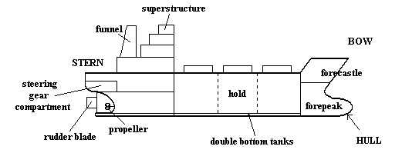
Figure.1.1.a: Main parts of components of a ship.

Figure.1.1.b: Types of ships and offshore structures.

1.1.1. Types of ships and Offshore Structures

1.1.1.1. High-Speed Craft
Multihulls including Wave Piercers, Small Water-plane Area Twin Hull (SWATH), Surface Effect Ships and Hovercraft, Hydrofoil, Wing In Ground Effect Craft (WIG).

Small Water-plane Area Twin Hull (SWATH) | Wing In Ground Effect Craft (WIG)
Hovercraft | 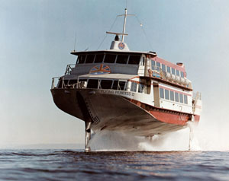  Hydrofoil
Figure.1.2.a: Examples of high-speed craft.

1.1.3.3. Components of Custom High Speed Picker Boat
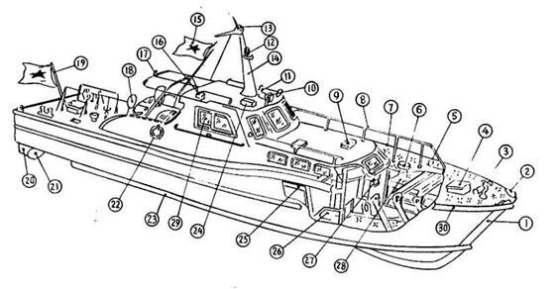 | 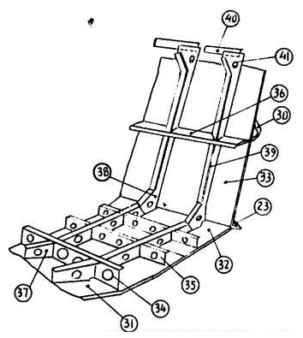

Figure.1.2.b: Components of Custom high speed picker boat

1. Stem, 2.Fair-lead, 3.Cross bitt, 4. Hatch, 5. Bollard, 6. Mushroom ventilator, 7. Cleat, 8. Hand rail, 9. Ventilator hatch, 10. Search light, 11.Whistle, 12. Mast head light, 13. Anchor light, 14. Mast, 15. Custom flag, 16 . Side light, 17. Stern light, 18. Cowl head ventilator, 19. Ensign staff, 20. Rudder, 21. Propeller, 22. Lifebouy, 23. Spray strip, 24. Siren, 25. Cabin, 26. Galley, 27. Toilet, 28. Bed room, 29. Steering room, 30. Fender, 31. Keel, 32. Bottom plating, 33. Side plating, 34. Center girder, 35. Side girder, 36. Side stringer, 37. Floor, 38. Side bracket, 39. Frame, 40. Beam, 41. Beam bracket.

1.1.1.2. Offshore Oil Vessels
Offshore Oil Vessels includes Platform Supply Vessel, Pipe Layers, Accommodation and Crane Barges, Semi-Submersible and Ship Drilling Rigs, Production Platforms, Floating Production Storage and Offloading.
Platform Supply Vessel | Pipe Layers
Semi-Submersible | Drill ship
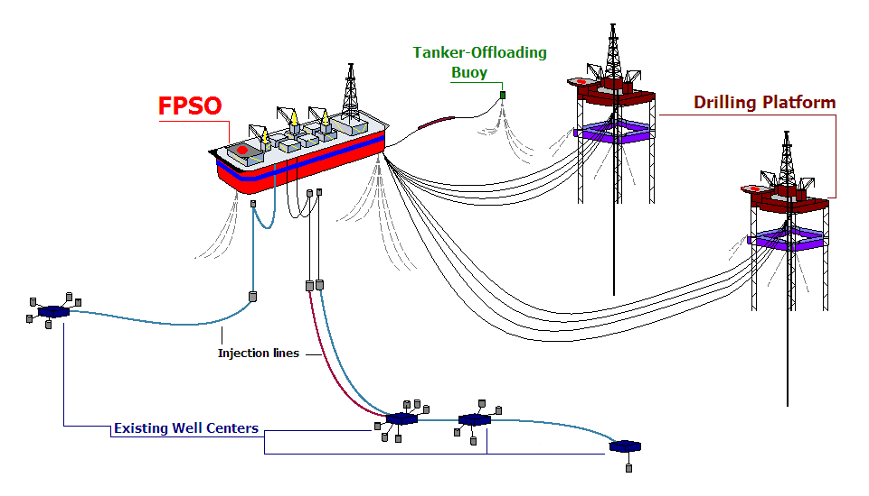
Figure.1.3: Examples of Offshore Oil Vessels.

1.1.1.3. Fishing Vessels
Fishing Vessels includes motorized fishing trawlers, trap setters, seiners, long liners, trollers & factory ships, traditional sailing and rowed fishing vessels and boats used for hand-line fishing.

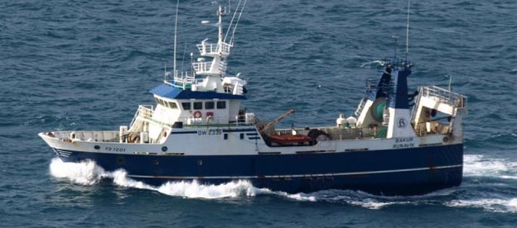
Figure.1.4.a: Fishing Vessel.

1.1.1.3.1. Components of Catcher boat

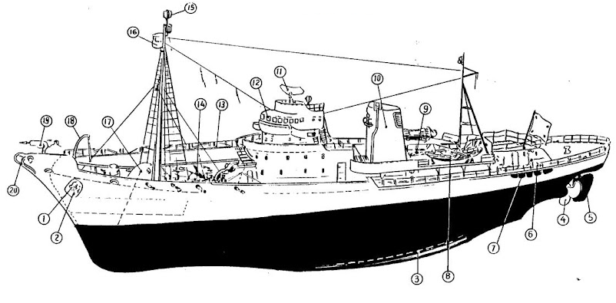

Figure.1.4.b: Components of Catcher boat

1. Anchor, 2. Anchor recess, 3. Bilge keel, 4. Propeller, 5. Rudder, 6. Bollard, 7. Rope fender, 8. Whale boat, 9. Skylight, 10 . Funnel, 11 . Radar scanner, 12. Wheel house, 13. Catwalk, 14. Whale winch, 15. Direction finder antenna, 16. Crow’s nest, 17. Companion, 18. Davit, 19. Whale gun, 20. Forward roller

1.1.1.4. Harbour Work Crafts
Harbour work crafts include cable layers, tugboats, dredgers, salvage vessels, tenders, pilot boats, floating dry docks, floating cranes and lightership.
Tugboat | Dredgers
Floating crane | 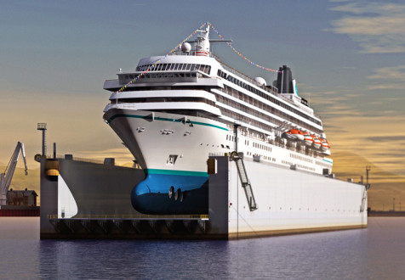  Floating dry dock
Figure.1.5: Examples of harbour work crafts.

1.1.1.5. Dry Cargo Ships
Dry cargo ships include bulk carriers, cargo liners, container vessels, barge carriers, ro-ro ships, refrigerated cargo ships, timber carriers, livestock & light vehicle carriers.
Bulk carrier | Container ship
Ro-Ro ship | Timber carrier
Figure.1.6.a: Examples of dry cargo ships.

1.1.1.5.1. Components of General Cargo Ship

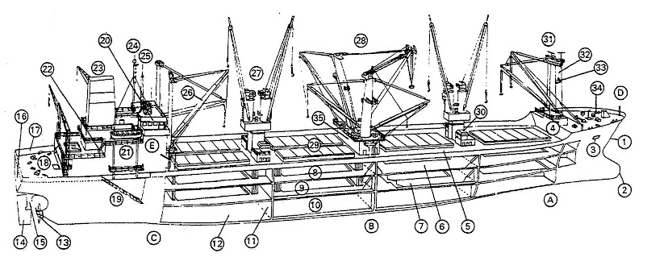

Figure.1.6.b: Components of General Cargo Ship

A bow, B midship body, C quarter, D forecastle, E bridge castle, 1 stem, bow, 2 bulb, 3 hawse pipe, 4 forecastle break, forecastle bulkhead, 5 main deck, 6 second deck, 7 third deck or lop deck, 8 upper ‘tween deck, 9 lower ‘tween deck, 10 lower hold, 11 transverse bulkhead, 12 tank top plating, 13 propeller, 14 rudder, 15 stern frame, 16 counter stern, 17 bulwark, 18 mooring gear, 19 accommodation ladder, 20 bridge, flying bridge, “monkey island”, 21 lifeboat, 22 ladder, 23 funnel, 24 signal mast, “Christmas tree”, 25 aerials, 26 cargo derricks, 27 cargo cranes, 28 heavy lift rig, 29 hatch covers, 30 ventilator, 31 mast top, mast platform, 32 samson post, king post, 33 navigation light, 34 hawse gear, 35 deck house

1.1.1.5.2. Components of Container ship

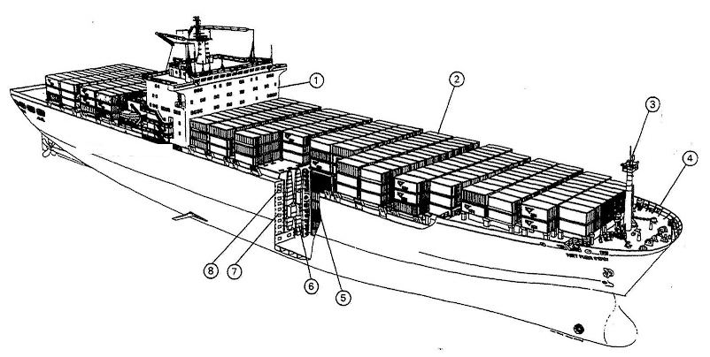
Figure.1.6.c: Components of Container ship

1. bridge castle front, 2. deck containers, 3. foremast and mast top, 4. forecastle, 5. insulated containers in holds, 6. container refrigeration ducts, 7. double hull, 8. passageway

1.1.1.6. Liquid Cargo Ships
Liquid Cargo Ships include oil tankers, double acting tanker (DAT), liquefied natural gas carriers and chemical carriers.
Double Acting Tanker (DAT | Very Large Crude Oil Carrier (VLCC)
Liquefied Natural Gas Carrier | Chemical carriers
Figure.1.7: Liquid cargo ships.

1.1.1.7. Passenger Vessels
Passenger Vessels includes cruise ships and Special Trade Passenger (STP) Ships, cross-channel ships, coastal and harbour ferries, luxury & cruising yachts, Sail Training and Multi-Masted Ships.

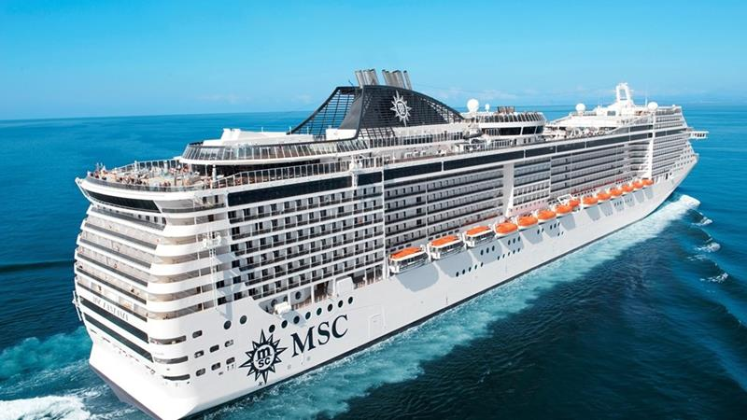  Cruise Ships | 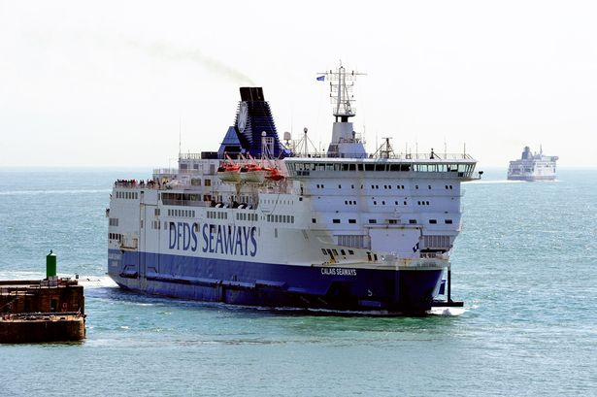  Cross-Channel Ship
Luxury & Cruising Yacht | Harbour Ferrie

Figure.1.8: Examples of Passenger ships.

1.1.1.7.1. Components of Cruise ship

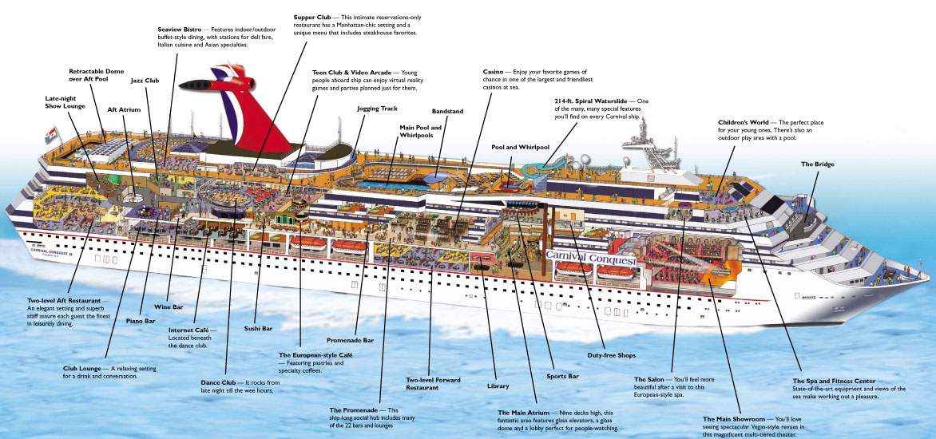

Figure.1.8.a: Cruise Ship.

1.1.1.7.2. Components of Car & Passenger Ferry

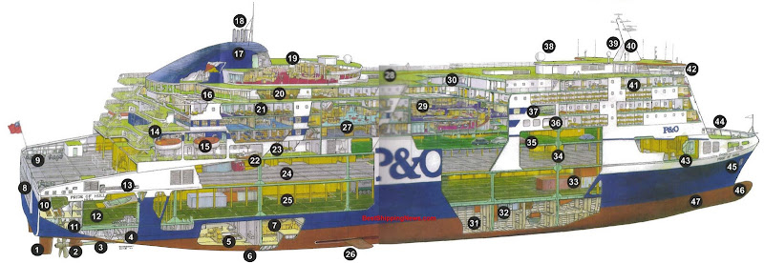
Figure.1.8.b: Components of Car & Passenger Ferry

1. Becker rudder, 2. Controllable pitch propeller, 3. Sterntube, 4. Ballast tank, 5. Aft engine room with gearbox, 6. Seawater inlet chest, 7. Forward engine room with 1 of the 4 main engines, 8. Stern ramp, 9. Mooring gear, 10. CO2 – battery space, 11. Harbour control room for loading officer, 12. Maindeck for trailers and double stacked containers, 13. Gangway, 14. Outside decks, 15. Lifeboat hanging in davits, 16. Deck 11, 17. Funnel, 18. Exhaust pipes, 19. Panorama lounge, 20. Officer and crew mess, 21. Passenger cabins, 22. Fast-rescue boat, 23. Driver accommodation, 24. Upper trailer deck, 25. Ramp to lower hold, 26. Stabilizer, retractable, 27. Shops and restaurants, 28. Helicopter deck, 29. Entertainment spaces and bars, 30. Fan room, 31. Heeling tank, 32. Void, 33. Ro-ro cargo
34. Web frame, 35. Car deck, 36. Marine evacuation system, 37. Cinema, 38. Satellite dome for internet, 39. Satellite dome for communication (Inmarsat), 40. Radar mast, 41. Officer cabins, 42. Wheelhouse, 43. Car deck fan room, 44. Forecastle, 45. Anchor, 46. Bulbous bow, 47. Bow thrusters

1.1.1.7.3. Components of Catamaran Passenger & Auto-Car Carrier

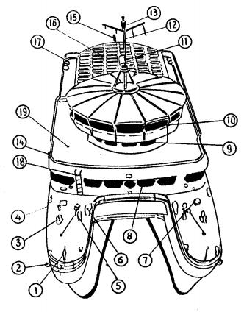
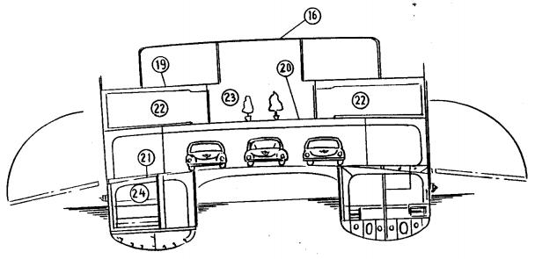
Figure.1.8.c: Components of Catamaran

1 . Jack staff, 2. Anchor, 3. Bollard, 4. Fair-lead, 5. Capstan, 6. Ventilator, 7. Hatch, 8. Steering room, 9. First class pass. Room, 10 . Panorama room, 11 . Radar scanner, 12. Mast, 13 . Mast lamp, 14 . Side lamp, 15 . Ensign staff, 16 . Permanent awning, 17 . Liferaft, 18. Vertical ladder, 19. Promenade deck, 20. Bridge deck, 21 . Upper deck, 22 . Second class pass .room, 23 . Garden, 24 . Crew’s space

1.1.1.8. Recreational Boats and Craft
Recreational boats and craft include rowed, masted and motorised crafts.
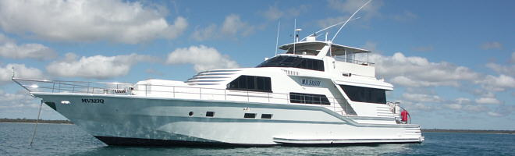
Recreational boat
Rowed
Figure.1.9: Recreational Boats.

1.1.1.9. Special-Purpose Vessels
Special-Purpose Vessels include Weather and Research Vessels, Deep Sea Survey Vessels, and Icebreakers.

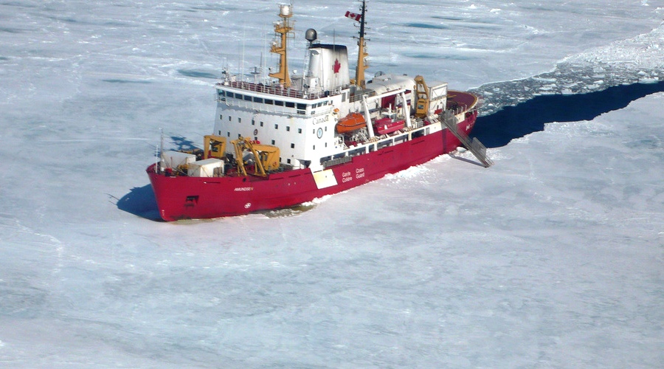
Figure.1.10: Icebreaker ship.

1.1.1.10. Submersibles
Submersibles include Industrial Exploration, Scientific Research, Autonomous Underwater Vehicle (AUV), Remote Operation Vehicle (ROV), Tourist and Hydrographic Survey.
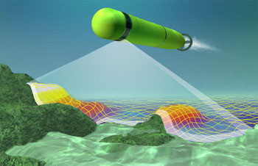
Figure.1.11: Autonomous Underwater Vehicle (AUV).

1.1.1.11. Warships
Warships include surface combatant: deep and shallow draft, submarines, aircraft carrier, frigate, destroyer, landing ship, amphibious
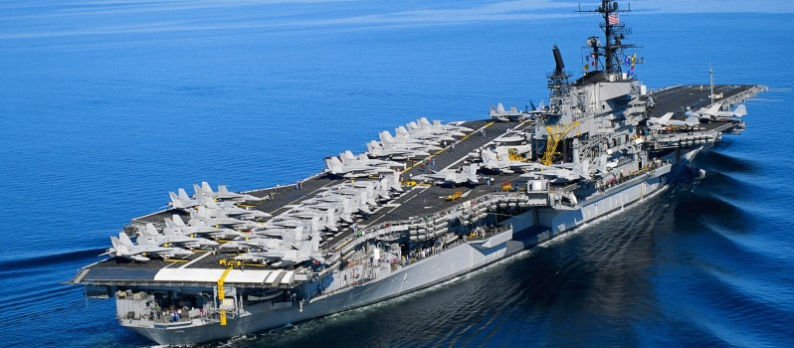  Aircraft Carrier | Submarine
Destroyer | Landing ship
Figure.1.12.a: Examples of Warships.

1.1.1.11.1. Components of Submarine

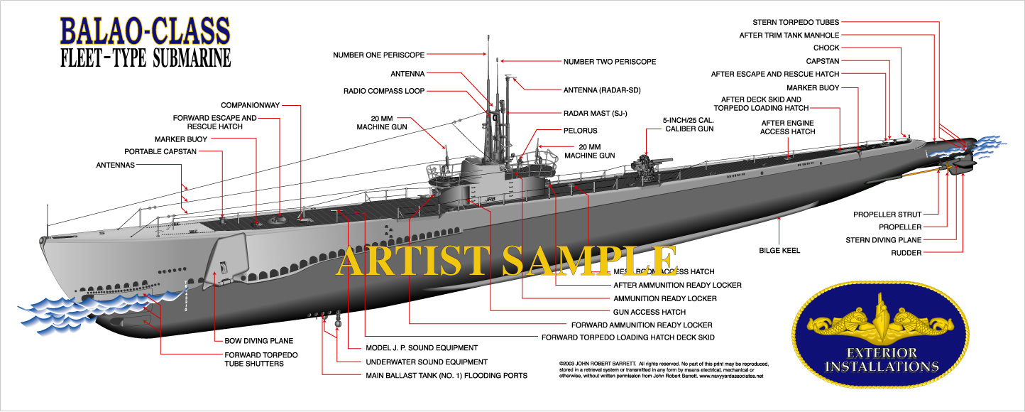
Figure.1.12.b: Submarines.

1.1.2. Ship Hull
The hull is the main body of the ship below the main outside deck. The hull consists of an outside covering (or skin) and an inside framework to which the skin is secured. The skin and framework are usually made of steel and secured by welding. However, there may still be some areas where rivets are used. The steel skin may also be called shell plating.

1.1.2.1. Hull Design
Figure 1.13 shows a typical ship hull design in which the front end of the ship is the bow. When you move toward the bow, you are going forward, when the vessel is moving forward, it is going ahead. When facing toward the bow, the front-right side is the starboard bow and the front-left side is the port bow. The central or middle area of a ship is amidships. The right center side is the starboard beam and the left center side is the port beam. The rear of a vessel is the stern. When you move in that direction you are going aft, when the ship moves in that direction it is going astern. When looking forward, the right-rear section is called the starboard quarter and the left-rear section is called the port quarter. The entire right side of a vessel from bow to stern is the starboard side and the left side is the port side. A line, or anything else, running parallel to the longitudinal axis or centerline of the vessel is said to be fore and aft and its counterpart, running from side to side, is athwartships. From the centerline of the ship toward either port or starboard side is outboard and from either side toward the centerline is inboard. However, there is a variation in the use of outboard and inboard when a ship is on berth (moored to a pier). The side against the pier is referred to as being inboard; the side away from the pier as outboard

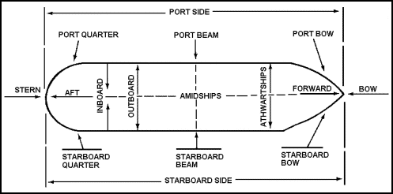
Figure.1.13: Typical hull of a ship.

1.1.2.2. Interior of Hull
The interior of the ship is divided by the bulkheads and decks into watertight compartments as shown in Figure.1.14. A vessel could be made virtually unsinkable if it were divided into enough small compartments. However, too many compartments would interfere with the arrangement of mechanical equipment and the operation of the ship. Engine rooms must be large enough to accommodate bulky machinery. Cargo spaces must be large enough to hold large equipment and containers.

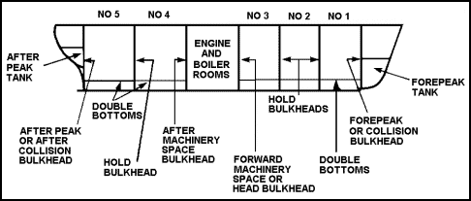
Figure.1.14: Typical interior hull of ship.

The engine room is a separate compartment containing the propulsion machinery of the vessel. Depending on the size and type of propulsion machinery, other vessel machinery may be located there (such as generators, pumping systems, evaporators, and condensers for making fresh water). The propulsion unit for Army vessels is a diesel engine. The "shaft" or rod that transmits power from the engine to the propeller leads from the aft end of the engine to the propeller.

1.1.2.3. External part of Hull
The waterline is the water-level line on the hull when afloat. The vertical distance from the waterline to the edge of the lowest outside deck is called the freeboard. The vertical distance from the waterline to the bottom of the keel is called the draft. The waterline, draft, and freeboard will change with the weight of the cargo and provisions carried by the ship. The draft of the ship is measured in feet and inches. Numbered scales are painted on the side of the ship at the bow and stern.

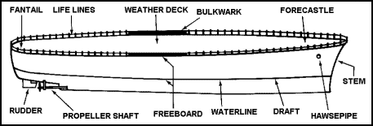
Figure.1.15: External part of the hull of a ship.

The relationship between the drafts at the bow and stern is the trim. When a ship is properly balanced fore and aft, she is in trim. When a ship is drawing more water forward than aft, she is down by the head. If the stern is too far down in the water, she is down by the stern. If the vessel is out of balance laterally or athwartship (leaning to one side), she has a list. She may be listing to starboard or listing to port. Both trim and list can be adjusted by shifting the weight of the cargo or transferring the ship's fuel and water from one tank to another in various parts of the hull.
The part of the bow structure above the waterline is the prow. The general area in the forward part of the ship is the forecastle. Along the edges of the weather deck from bow to stern are removable stanchions and light wire ropes, called life lines. Extensions of the shell plating above the deck are called bulwarks. The small drains on the deck are scuppers. The uppermost deck running from the bow to the stern is called the weather deck. The main deck area over the stern is called the fantail or poop deck. The flat part of the bottom of the ship is called the bilge. The curved section where the bottom meets the side is called the turn of the bilge.
Below the waterline are the propellers or screws which drive the ship through the water. The propellers are attached to and are turned by the propeller shafts. A ship with only one propeller is called a single-screw ship. Ships with two propellers are called twin-screw ships. On some ships (especially landing craft) there may be metal frames built around the propellers (called propeller guards) to protect them from damage. The rudder is used to steer the ship.

1.1.2.4. Deck of a Ship
The decks aboard ship are the same as the floors in a house. The main deck is the first continuous watertight deck that runs from the bow to the stern. In many instances, the weather deck and the main deck may be one and the same. Any partial deck above the main deck is named according to its location on the ship. At the bow it is called a forecastle deck, amidships it is an upper deck, and at the stern it is called the poop deck. The term weather deck includes all parts of the forecastle, main, upper, and poop decks exposed to the weather. Any structure built above the weather deck is called superstructure.

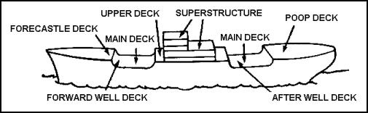
Figure.1.16: Typical weather decks of a ship.

The main centerline structural part of the hull is the keel, which runs from the stem at the bow to the sternpost at the stern. The keel is the backbone of the ship. To the keel are fastened the frames, which run athwartship. These are the ribs of the ship and gives shape and strength to the hull. Deck beams and bulkheads support the decks and gives added strength to resist the pressure of the water on the sides of the hull.

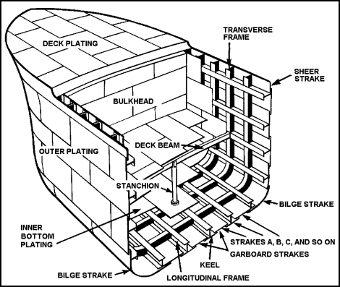
Figure.1.17: Construction of a Hull

The skin, or shell plating, provides water-tightness. The plates, the principal strength members of a ship, have various thicknesses. The heaviest plates are put on amidships. The others are put on so that they taper toward both ends of the ship (from the keel toward the bilge and from the bilge toward the upper row of plates). Using plates of various thicknesses reduces the weight of the metal used and gives the vessel additional strength at its broadest part. The plates, put on in rows from bow to stern, are called strakes. They are lettered consecutively, beginning at the keel and going upward.
The bottom row of strakes on either side of the keel, are called garboard strakes. The strakes at the turn of the hull, running in the bilge, are bilge strakes. The strakes running between the garboard and bilge strakes are called bottom strakes and the topmost strakes of the hull are sheer strakes. The upper edge of the sheer strake is the gunwale.

1.1.2.5 Compartmented and Numbered
Knowing how a ship is compartmented is crucial for navigating its vast interior. Each compartment of the ship is stamped with a series of alphanumeric numbers, known as "bull's-eyes," which give information on where you are, and what that compartment's function is. The information is given in the following order: deck number, frame number, relation to the centerline of the ship, and compartment usage. Each of these parts is separated by a hyphen.
Decks above the main deck are numbered 01, 02, 03, etc. and are referred to as levels. Below the main deck, there are the first, second, third decks, etc. (remember, on a carrier the hangar deck, the one below the flight deck, is the main deck.). Frame numbers tell you where you are in relation to the bow of the ship; the numbers increase as you go aft. The third number in the bull's-eye reflects compartmentation numbers in relation to the ship's centerline. EVEN numbers are to PORT, and ODD numbers are to STARBOARD. The numbers increase as you travel outboard. The last letter stamped on the compartmentation number indicates what the compartment is used for. Below are some typical codes:

Carrier Compartment Usage Codes
Codes | Explanation
A | Supply and storage
B | Guns
C | Ship control
E | Machinery
F | Fuel
M | Ammunition
L | Living quarters
T | Trunks and passages
V | Void
W | Water

Example Bull’s-eye: 3-75-4-M
Codes | Explanation
3 | Indicates the third deck (see Figure.5)
75 | Indicates the compartments forward boundary is on or immediately aft of ship’s frame 75.
4 | Indicates the fourth compartment outboard of the centerline to port (even numbers to port, odd to starboard).
M | Indicates the compartment is used for ammunition (see above).

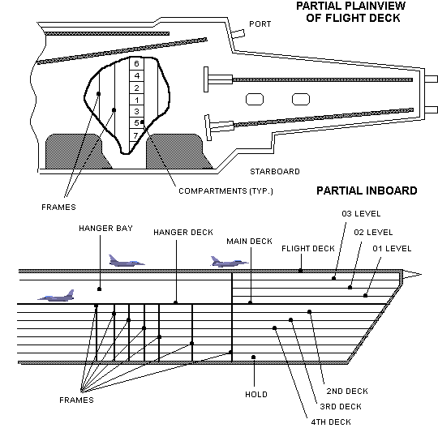
Figure.1.18: Carrier Deck Schematic

1.1.3. Components of Ships

1.1.4. Construction of Hull

1.1.4.1. Stem Part

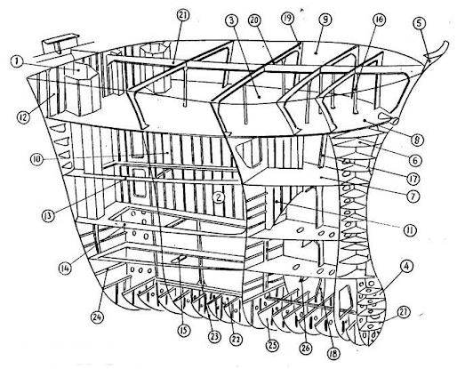
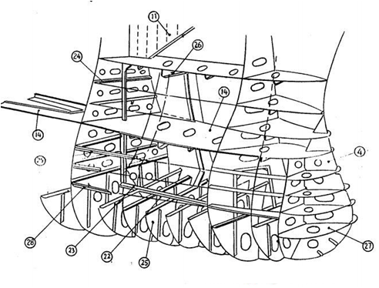
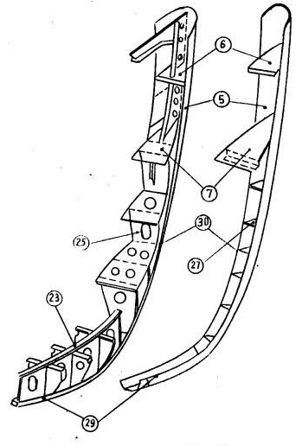

Figure.1.19: Construction of stem part

1.Chain locker, 2. Fore peak tank, 3. Boatwain’s store, 4. Bulbous bow, 5. Fashion plate, 6. Breast hook, 7. Second deck, 8. Upper deck, 9. Forecastle deck, 10. Center division, 11. Wash plate, 12. Collision bulkhead, 13. Side stringer, 14. Panting stringer plate, 15. Panting beam, 16. Pillar, 17. Frame, 18. Tank side bracket, 19. Beam bracket, 20. Beam, 21. Deck girder, 22. Center girder, 23. Rider plate, 24. Horizontal stiffener, 25. Deep floor, 26. Panting stringer under beam, 27. Rib, 28. Shell long, 29. Keel, 30 Plate stem

1.1.4.2. Mid-Ship Part

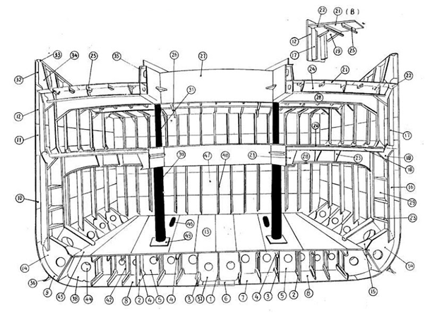
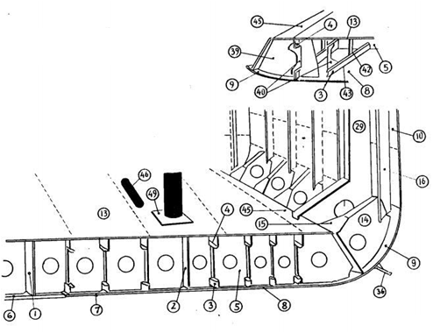
Figure.1.20: Construction of mid-ship part

1. Center girder, 2. Side girder, 3. Bottom longitudinal, 4 . Top longitudinal of double bottom, 5. Solid floor, 6. Keel, 7 . Astrake, 8. Bottom plating, 9. Bilge strake, 10. Side plating, 11. Top side strake, 12. Sheer strake, 13. Inner bottom plating, 14. Tank side bracket, 15. Gusset plate, 16. Hold frame, 17. Tween deck frame, 18. 2nd deck beam, 19. Beam bracket, 20. duck, 21. Upper deck, 22. Stringer plate, 23. Tripping bracket, 24. Deck transverse beam, 25. Deck longitudinal, 26. Deck girder, 27. Hatch coaming, 28. Strong beam, 29. Web frame, 30. Hold pillar, 31. Tween deck pillar, 32. Bulwark plate, 33. Hand rail, 34. Bulwark stay, 35. Horizontal stiffener, 36. Bilge keel, 37. Docking bracket, 38. Bracket to margin plate, 39. Water tight floor, 40. Bracket to water tight floor, 41. Vertical stiffener, 42. Strut, 43. Scallop or Serration, 44. Lightening hole, 45. Margin plate, 46. Manhole, 47. Water tight bulkhead, 48. Bulkhead stiffener, 49. Doubling

1.1.4.3. Stern Part

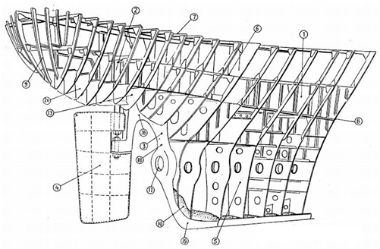

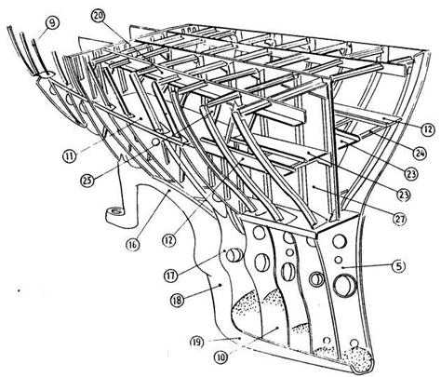

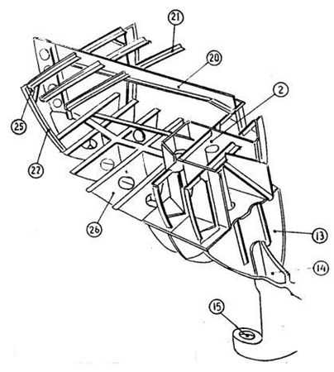
Figure.1.22: Construction of stern part

1 . After peak tank, 2 . Rudder stock trunk, 3. Stern frame, 4. Rudder, 5. Deep floor, 6. Tank top plate, 7. Upper deck, 8. After peak bulkhead or Stuffing box bulkhead, 9. Cant frame, 10. Cement, 11. Inner bottom plate, 12 . Panting stringer, 13. Transom floor, 14. Rib, 15. Gudgeon, 16. Crown, 17. Boss, 18. Propeller post, 19. Heel piece, 20. Deck girder, 21. Deck beam, 22. Frame, 23. Horizontal stiffener, 24. Panting beam, 25. Beam bracket, 26. Floor, 27. Wash plate

1.1.4.3.1. Rudder

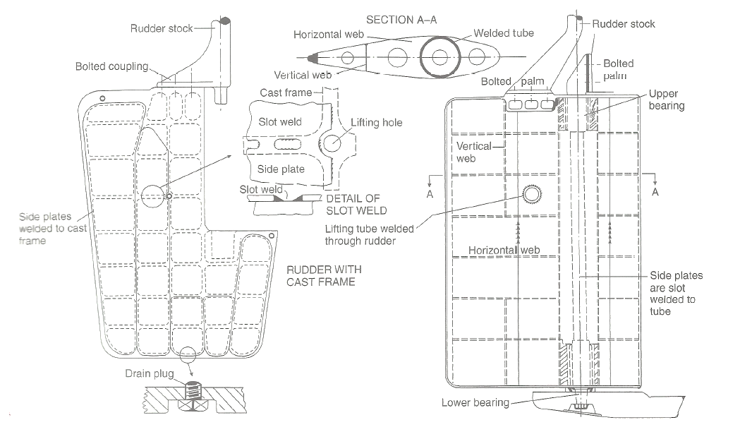
Figure.1.23: Construction of rudder part

1.1.4.3.2. Rudder Bearing
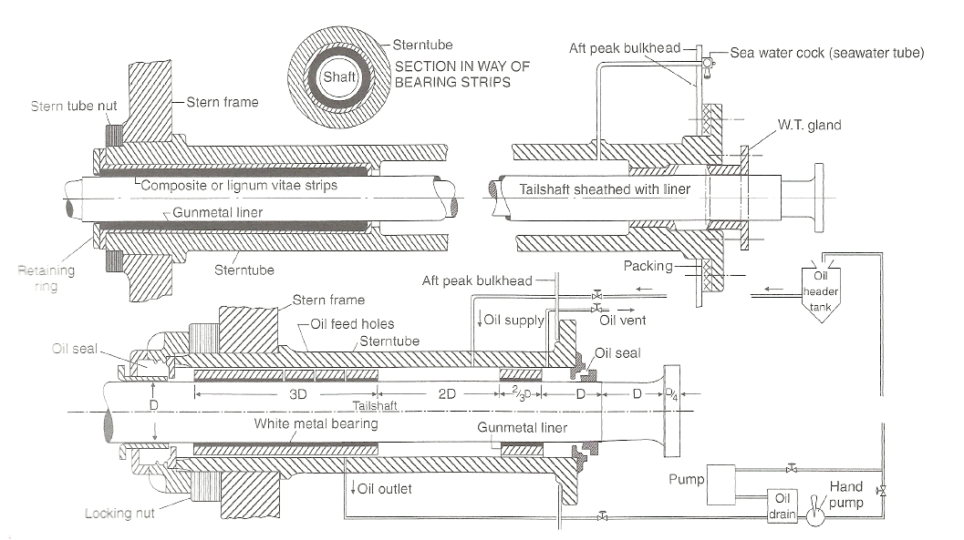
Figure.1.24: Construction of rudder bearing.

1.1.4.3.3. Transom Stern

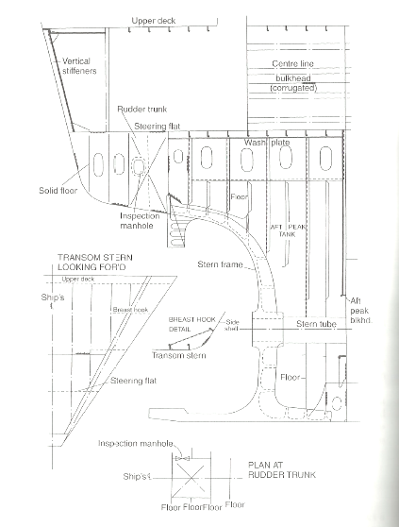

Figure.1.25: Construction of Transom Stern.

1.1.4.3.4. Shaft Line

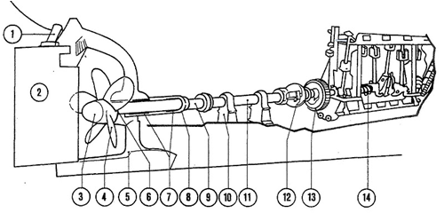

Figure.1.26: Construction of Shaft Line.

1.rudder stock, 2.rudder, 3.propeller bonnet, 4.propeller, 5.stern frame,
6.stern tube sealing, 7.stern tube bearings, 8.stern tube, 9.propeller shaft, tail shaft, 10.plummer Mock, pillow block, shaft block, 11.intermediate shaft, 12.thrust shafts
13.flywheel, 14.crankshaft, shaft alley, shaft tunnel

1.1.4.4. Engine Room

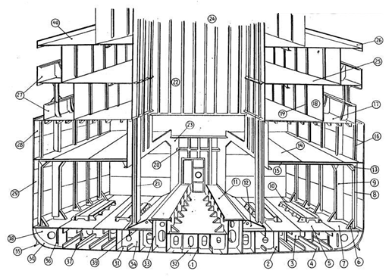
Figure.1.27: Construction of Engine Room.

1 . Center girder, 2. Side girder, 3. $olid floor, 4. Bottom long, 5. Tank top plating, 6. Tank top bracket, 7. Horizontal margin plate, 8. Frame, 9. Web frame, 10. Auxiliary engine bed, 11. Main engine bed, 12. Engine bed bracket, 13. Beam bracket, 14. Engine room platform, 15. Deck beam, 16. Twin deck frame, 17 . Upper deck, 18. Cabin wall, 19 . Wall side stiffener, 20. Horizontal stiffener, 21. Engine room pillar, 22 . Engine casing, 23. Engine room recess, 24. Engine opening, 25. Saloon deck, 26. Curtain plate, 27 . Bulwark plate, 28. Sheer strake, 29. Side plating, 30. Bilge strake, 31. Bottom plating, 32. Keel, 33. Engine girder, 34. Docking bracket, 35. Bilge keel, 36. Vertical stiffener, 37. Strut, 38. Bracket to margin plate
39. Half depth girder, 40. Boat deck

1.2. Offshore Structures
The offshore structures built in the ocean to explore oil and gas are located in depths from very shallow water to the deep ocean. Depending on the water depth and environmental conditions, the structural arrangement and need for new ideas required. Based on geometry and behaviour, the offshore structures for oil and gas development has been divided into following categories.
An offshore platform deals with topside facilities as well as the underlying drilling facilities. The topside facilities lying above the sea level involves an optimization between space as well as weight yet involves all the necessities for the oil extraction purposes. The ambient components of any offshore platform involves derricks, drilling rigs, oil storage facilities and tanks, injection compressors, gas compressors , gas turbine generators, HVAC, Piping, Instrumentation, Basic machinery like primary and auxiliary power generators, cooling system, pressure regulation etc. Also worth mentioning are control wheelhouses for operating personnel, suitable accommodation and helipads. Cranes and lifting system for loading and unloading operations are also there.
In the undersea extraction systems, some of the terms worth mentioning are drill collars, drill bits, wellheads, conduits, risers, BOPs, etc. Though not complicating stuff about the details and description of each of these, drill bits and collars involve drilling into the sea bed to create the oil well for extraction. On the other hand, wellheads provide structural and pressure containing interface at the opening to any oil or gas well for drilling and production.
Risers are components synonymous with any drilling platform inherently. This is basically a conduit that provides an extension from wellhead subsea to the drilling system above. They are basically of two types: marine drilling risers for floating platforms or tie-back drilling risers for fixed platforms. Risers have the catalytic role of conducting the crude oil or gas from the wellhead to the drilling rig by the virtue of a piston like mechanism which in turn is sent to the above rig for processing. The design of the riser depends on the filed layout, vessel interface, fluid properties and environmental conditions. Risers may be flexible or rigid. Also they remain stable and in tension due to self-weight. They may have profiles to reduce excess load and non-viscous fluid flow.

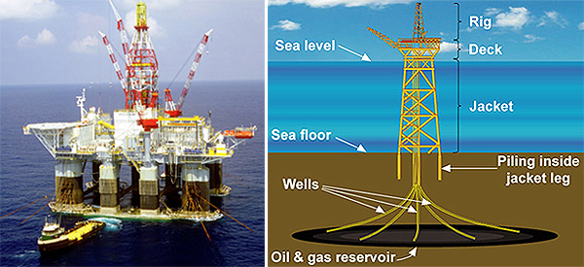
Figure.1.28: Typical number of components of floating and fixed platforms.

1.2.1. Fixed Offshore Structures
The fixed offshore structures shall exhibit a low natural period and deflection again environmental loads. Several types of offshore structures are as follows: Steel Fixed Structures, Concrete Gravity Offshore Stuctures and Jack-Up.

1.2.1.1. Steel Fixed Structures
The steel template type structure consists of a tall vertical section made of tubular steel members supported by piles driven into the sea be with a deck placed on top, providing space for crew quarters, a drilling rig, and production facilities. The fixed platform is economically feasible for installation in water depths up to 500m. These template type structures will be fixed to seabed by means of tubular piles either driven through legs of the jacket (main piles) or through skirt sleeves attached to the bottom of the jacket. The principle behind the fixed platform design is to minimize the natural period of the structure below 4 seconds to avoid resonant behaviour with the waves (period in the order of 4 to 25 seconds. The structural and foundation configuration shall be selected to achieve this concept.

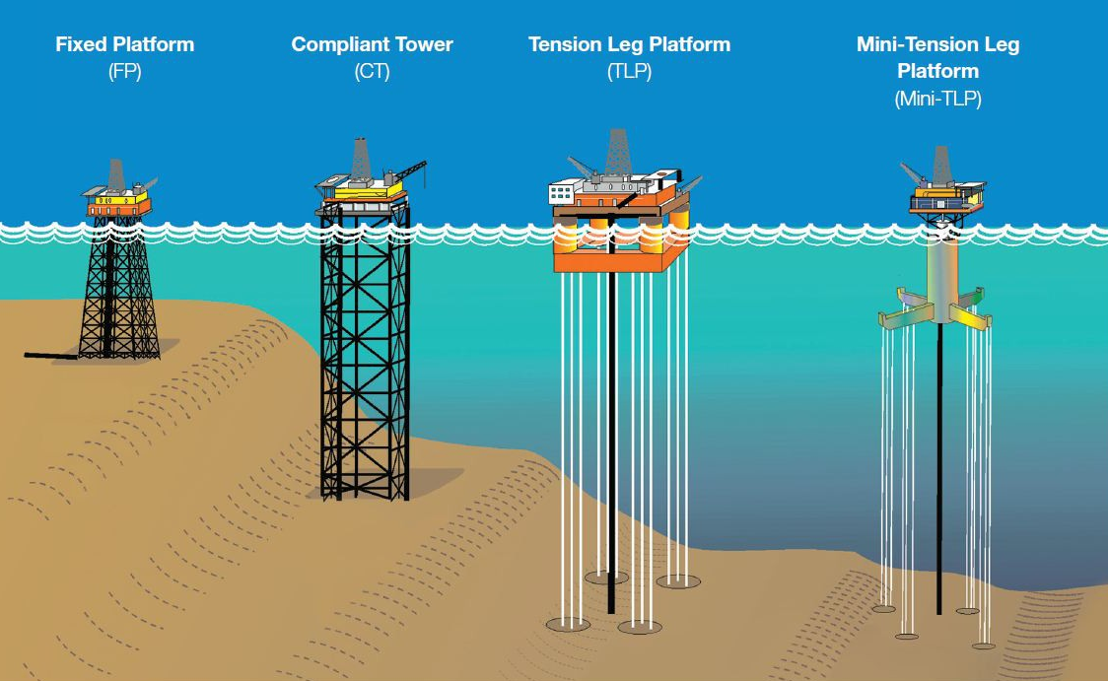
Figure.1.29: Several offshore structures.

1.2.1.2 Concrete Gravity Platforms
Concrete gravity platforms are mostly used in the areas where feasibility of pile installation is remote. These platforms are very common in areas with strong seabed geological conditions either with rock outcrop or sandy formation. Some part of North Sea oil fields and Australian coast, these kinds of platforms are located. The concrete gravity platform by its name derives its horizontal stability against environmental forces by means of its weight. These structures are basically concrete shells assembled in circular array with stem columns projecting to above water to support the deck and facilities. Concrete gravity platforms have been constructed in water depths as much as 350m.
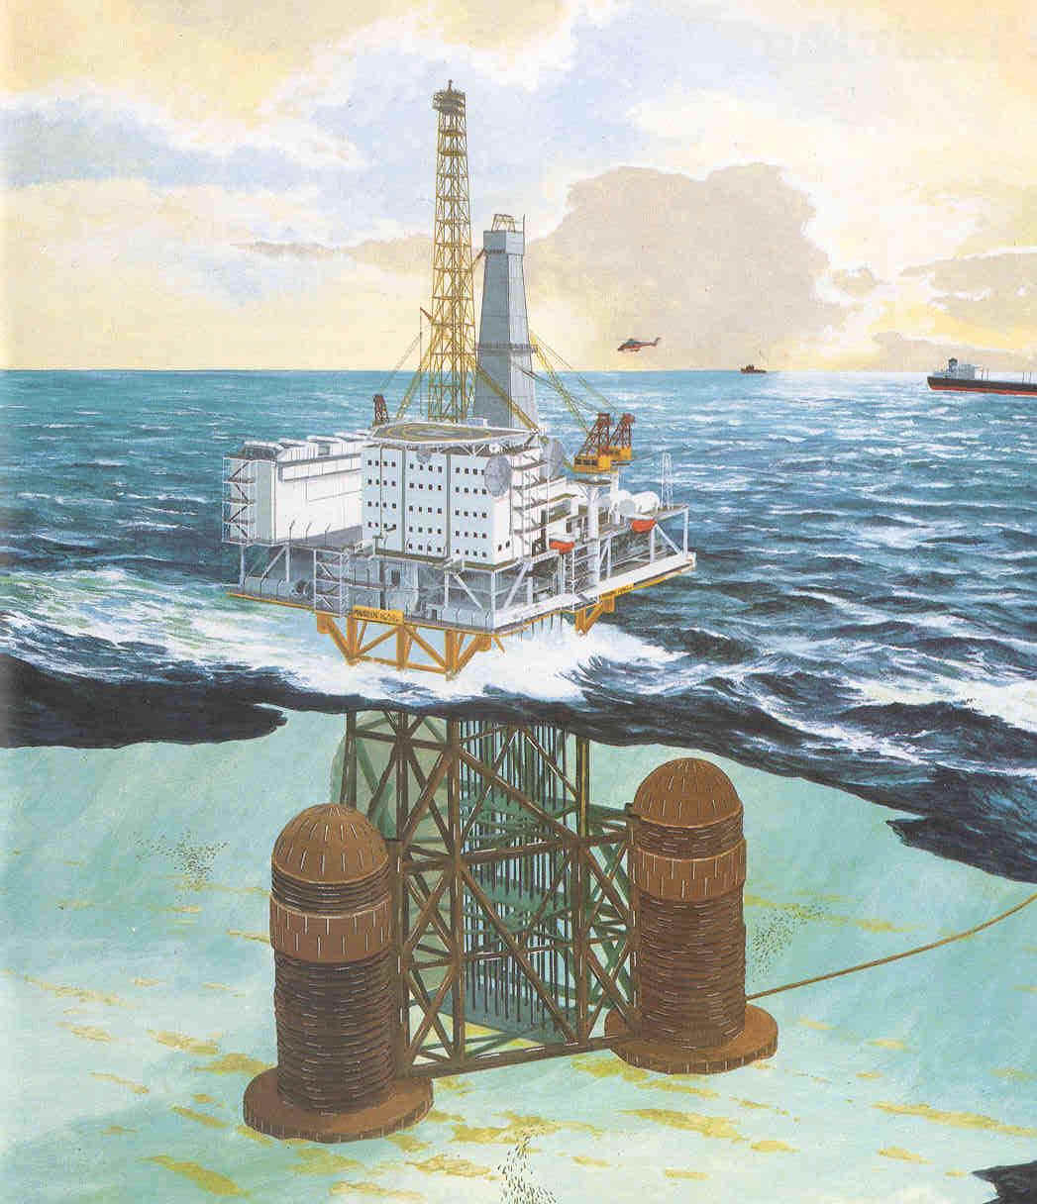
Figure.1.30: Typical Gravity based Offshore Structure [Courtesy].

1.2.1.2 Jack-Up
Jack-Up drilling rigs are a type of self-elevating, mobile platform capable of raising the hull part which is obviously buoyant above the sea level and penetrating its steel legs into the sea-bed for support for deep sea drilling operations. The name "jack-up" is derived from versatile nature of the legs or jacks which can be suitably jacked above or below the hull accordingly when not in operation and when in operation.
Figure.1.31: Typical of Jack-up.

1.2.4. Compliant Structures
In addition to the developing technologies for exploration and production of oil and natural gas, new concepts in deep-water systems and facilities have emerged to make ultra-deep-water projects a reality. With wells being drilled in water depths of 3000m, the traditional fixed offshore platform is being replaced by state-of-the-art deep-water production facilities. Compliant Towers, Tension Leg Platforms, Spars, Subsea Systems, Floating Production Systems, and Floating Production, Storage and Offloading Systems are now being used in water depths exceeding 500m. All of these systems are proven technology, and in use in offshore production worldwide.

1.2.4.1. Compliant Tower
Compliant Tower (CT) consists of a narrow, flexible tower and a piled foundation that can support a conventional deck for drilling and production operations. Unlike the fixed platform, the compliant tower withstands large lateral forces by sustaining significant lateral deflections, and is usually used in water depths between 300m and 600m.
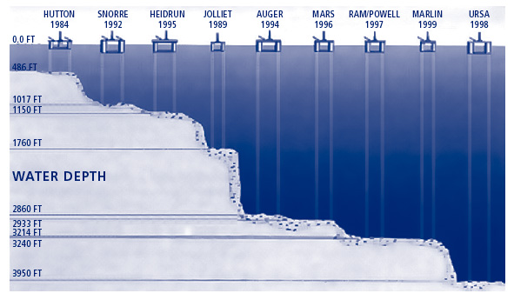
Figure.1.32: Different Compliant Structures through the years [Courtesy]

1.2.4.2. Guyed Tower
Guyed tower is an extension of complaint tower with guy wires tied to the seabed by means of anchors or piles. This guy ropes minimizes the lateral displacement of the platform topsides. This further changes the dynamic characteristics of the system.

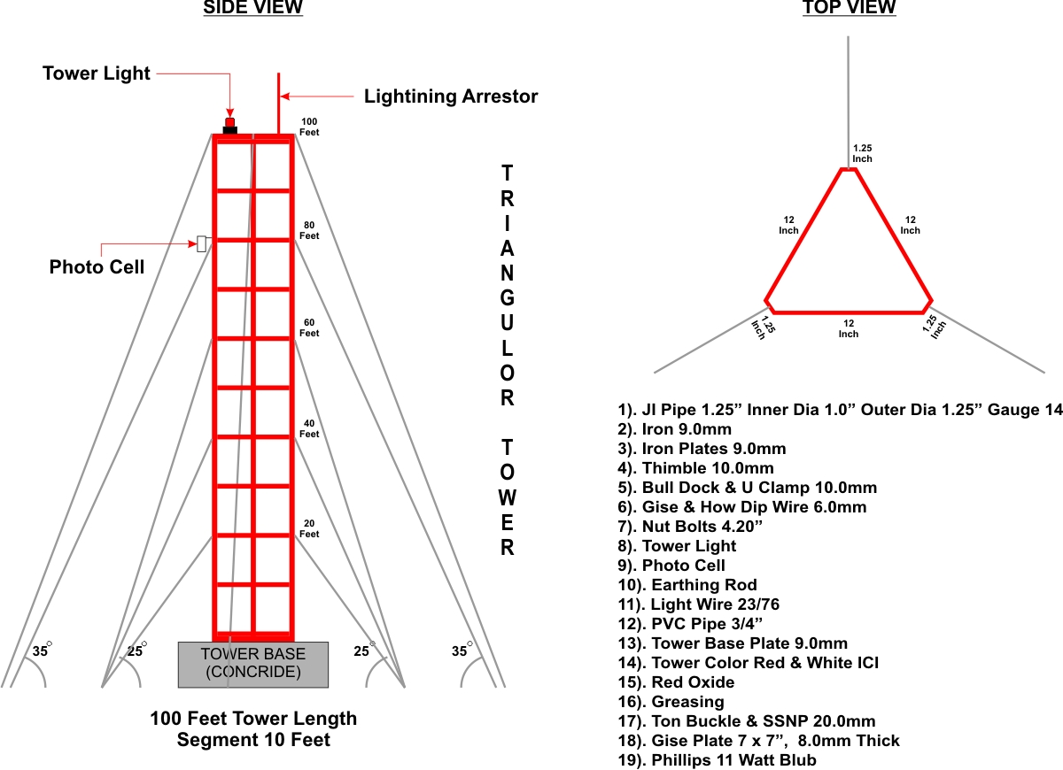 Figure.1.33: Guyed tower

1.2.4.3. Tension Leg Platforms
A Tension-leg platform is a vertically moored floating structure normally used for the offshore production of oil or gas, and is particularly suited for water depths around 1000m to 1200 meters (about 4000 ft). The platform is permanently moored by means of tethers or tendons grouped at each of the structure’s corners. A group of tethers is called a tension leg. A feature of the design of the tethers is that they have relatively high axial stiffness (low elasticity), such that virtually all vertical motion of the platform is eliminated. This allows the platform to have the production wellheads on deck (connected directly to the subsea wells by rigid risers), instead of on the seafloor. This makes for a cheaper well completion and gives better control over the production from the oil or gas reservoir. Tension Leg Platform (TLP) consists of a floating structure held in place by vertical, tensioned tendons connected to the sea floor by pile-secured templates. Tensioned tendons provide for the use of a TLP in a broad water depth range with limited vertical motion. The larger TLP’s have been successfully deployed in water depths approaching 1250m. Mini-Tension Leg Platform (Mini-TLP) is a floating mini-tension leg platform of relatively low cost developed for production of smaller deep-water reserves which would be uneconomic to produce using more conventional deep-water production systems. It can also be used as a utility, satellite, or early production platform for larger deep-water discoveries. The world’s first Mini-TLP was installed in the Gulf of Mexico in 1998. SPAR Platform (SPAR) consists of a large diameter single vertical cylinder supporting a deck. It has a typical fixed platform topside (surface deck with drilling and production equipment), three types of risers (production, drilling, and export), and a hull which is moored using a taut catenary system of six to twenty lines anchored into the seafloor. SPAR’s are presently used in water depths up to 1000m, although existing technology can extend its use to water depths as great as 2500m.

$Tension =Buoyancy - Weight$ (1.1)

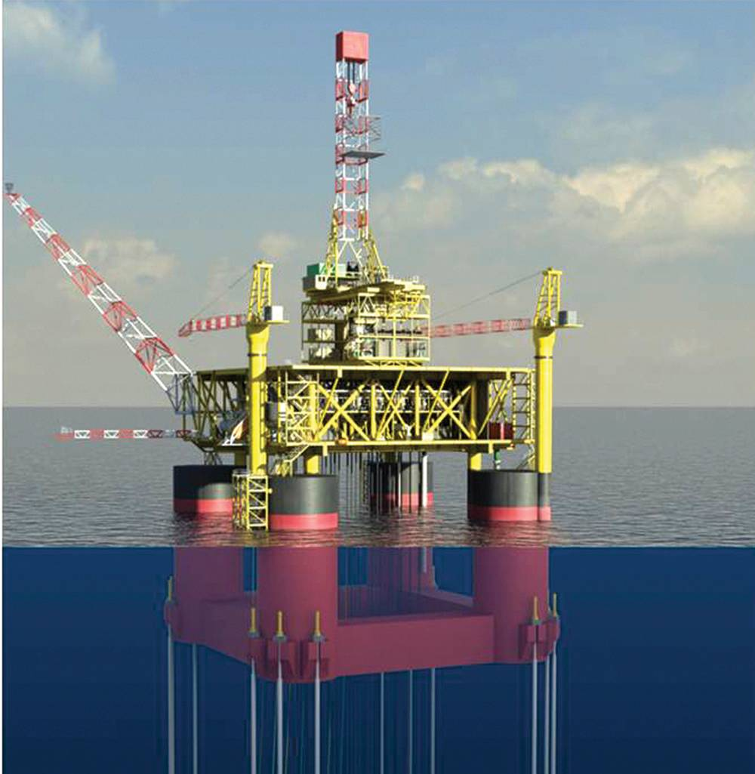 | 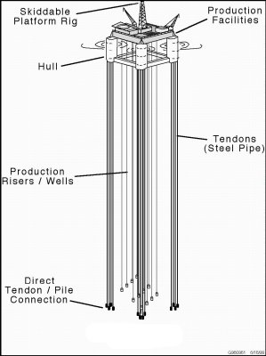
Figure.1.34: Tension Leg Platform

1.2.4.4. Articulated Tower
Articulated tower is an extension of tension leg platform. The tension cables are replaced by one single buoyant shell with sufficient buoyancy and required restoring moment against lateral loads. The main part of the configuration is the universal joint which connects the shell with the foundation system. The foundation system usually consists of gravity based concrete block or sometimes with driven piles. The articulated tower concept is well suited for intermediate water depths ranging from 150m to 500m.
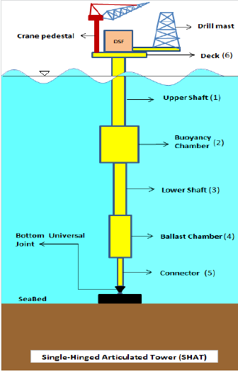
Figure.1.35: Articulated Tower

1.2.5 Floating Structures

1.2.5.1 Floating Production System
Floating Production System (FPS) consists of a semi-submersible unit which is equipped with drilling and production equipment. It is anchored in place with wire rope and chain, or can be dynamically positioned using rotating thrusters. Production from subsea wells is transported to the surface deck through production risers designed to accommodate platform motion. The FPS can be used in a range of water depths from 600m to 2500m feet.
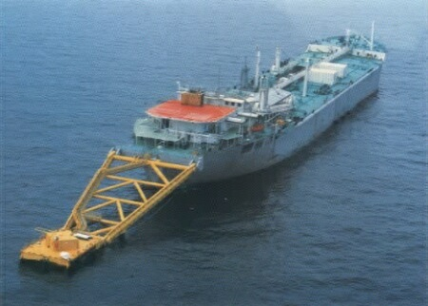
Figure.1.36: Floating Production System

1.2.5.2 Floating Production, Storage and offloading System
Floating Production, Storage and Offloading System (FPSO) consists of a large tanker type vessel moored to the seafloor. An FPSO is designed to process and stow production from nearby subsea wells and to periodically offload the stored oil to a smaller shuttle tanker. The shuttle tanker then transports the oil to an onshore facility for further processing. An FPSO may be suited for marginally economic fields located in remote deep-water areas where a pipeline infrastructure does not exist. Currently, there are no FPSO’s approved for use in the Gulf of Mexico. However, there are over 70 of these systems being used elsewhere in the world.
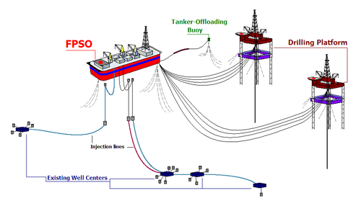
Figure.1.37: The ongoing operations to an FPSO and the production process.

1.2.5.2 SPAR
A spar is a type of floating oil platform typically used in very deep waters, and is named for logs used as buoys in shipping that are moored in place vertically. Spar production platforms have been developed as an alternative to conventional platforms. The deep draft design of spars makes them less affected by wind, wave and currents and allows for both dry tree and subsea production. Spars are most prevalent in the US Gulf of Mexico; however, there are also spars located offshore Malaysia and Norway.

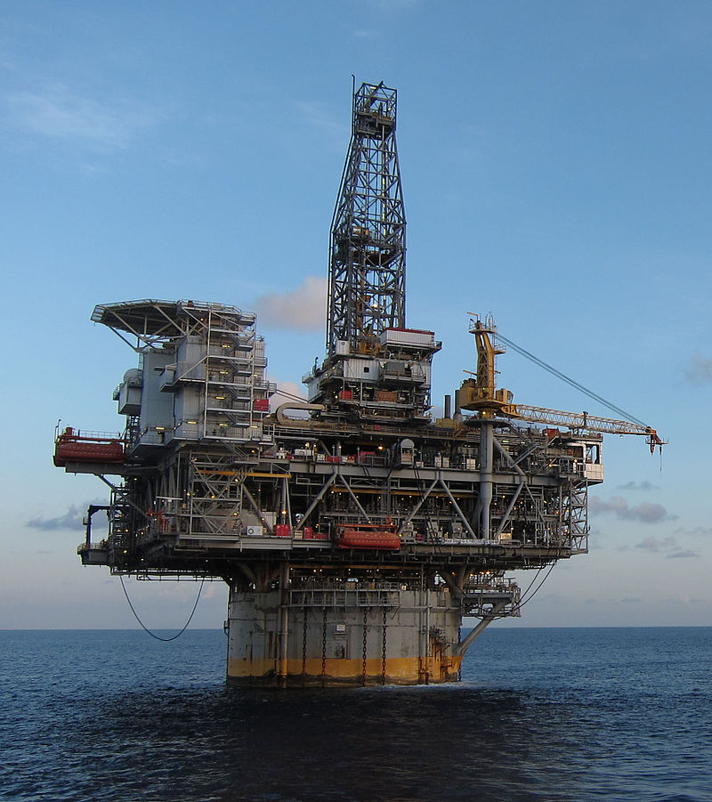
Figure.1.38: Truss SPAR DTU in Kikeh, Malaysia.

A spar platform consists of a large-diameter, single vertical cylinder supporting a deck. The cylinder is weighted at the bottom by a chamber filled with a material that is more dense than water to lower the center of gravity of the platform and provide stability. Additionally, the spar hull is encircled by helical strakes to mitigate the effects of vortex-induced motion. Spars are permanently anchored to the seabed by way of a spread mooring system composed of either a chain-wire-chain or chain-polyester-chain configuration.
There are three primary types of spars; the classic spar, truss spar, and cell spar. The classic spar consists of the cylindrical hull noted above, with heavy ballast tanks located at the bottom of the cylinder.

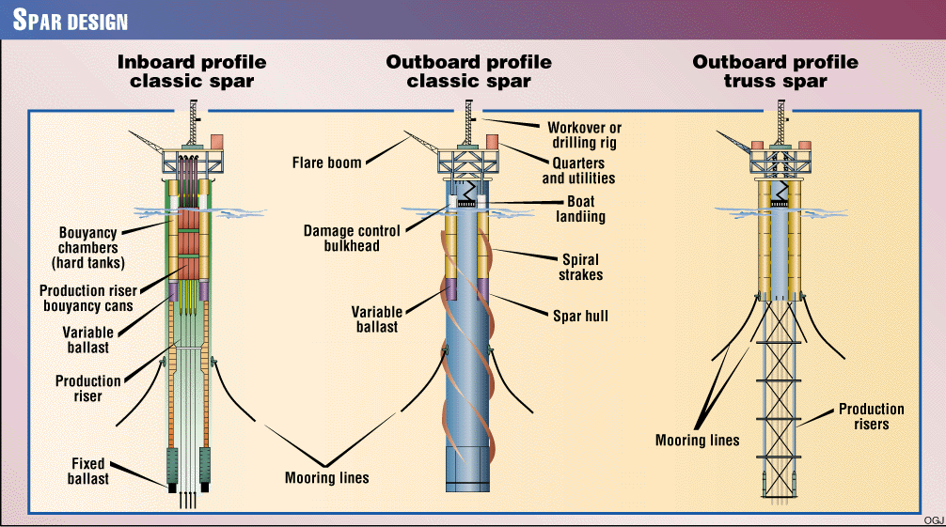
Figure.1.39: Three types of SPAR.

A truss spar has a shorter cylindrical "hard tank" than a classic spar and has a truss structure connected to the bottom of the hard tank. This truss structure consists of four large orthogonal "leg" members with X-braces between each of the legs and heave plates at intermediate depths to provide damping. At the bottom of the truss structure, there is a relatively small keel, or soft tank, that houses the heavy ballasting material. Soft tanks are typically rectangular in shape but have also been round to accommodate specific construction concerns. The majority of spars are of this type.
A third type of spar, the cell spar, has a large central cylinder surrounded by smaller cylinders of alternating lengths. At the bottom of the longer cylinders is the soft tank housing the heavy ballasting material, similar to a truss spar. The cell spar design was only ever used for one platform, the Red Hawk spar, which was decommissioned in 2014 under the Bureau of Safety and Environmental Enforcement's "Rigs-to-Reefs" program. At the time of its decommissioning it was the deepest floating platform to ever be decommissioned

1.2.5.3 Semi-Submersible
They are floating installations which rest on four or six pillar-like legs called columns with an equal weight distribution on each. These columns or legs are in turn attached to large basements called pontoons floating on the water surface. These pontoons may be ballasted or de-ballasted accordingly on and off operations. Often these pontoons delve deeper under the water surface and maintain the buoyancy and position of the floating system. There is always a greater draft. Thereafter the operational deck is kept well aloof from the wave disturbance or the rough seas. However due to Small Water-plane Area the structure is sensitive to load variations and must be trimmed accordingly. They by the virtue of their equivalent weight distribution and a high draft, it has a greater stability than normal ships. The number of legs, pontoon design, the situation of the risers and drill equipment are decided at pre-design stage. They are generally instrumental in Ultra-deep waters where the fixed structures pose a problem. Their position is maintained generally by a catenary mooring system or sometimes in modern structures by Dynamic: Positioning System. These structures are gigantic and may be towed from one location to another by the virtue of a kind of ships called Heavy Lift ships.
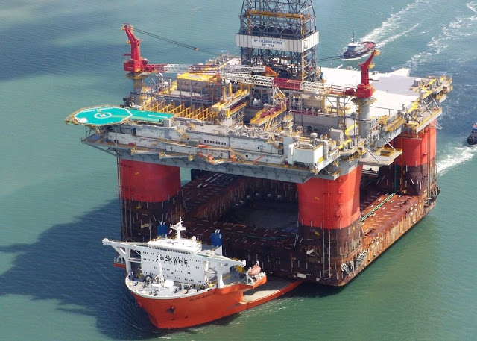
Figure.1.40: Typical of TLP and Semi-submersible.

1.2.6. Subsea System
Subsea System (SS) ranges from single subsea wells producing to a nearby platform, FPS, or TLP to multiple wells producing through a manifold and pipeline system to a distant production facility. These systems are presently used in water depths greater than 1500m.

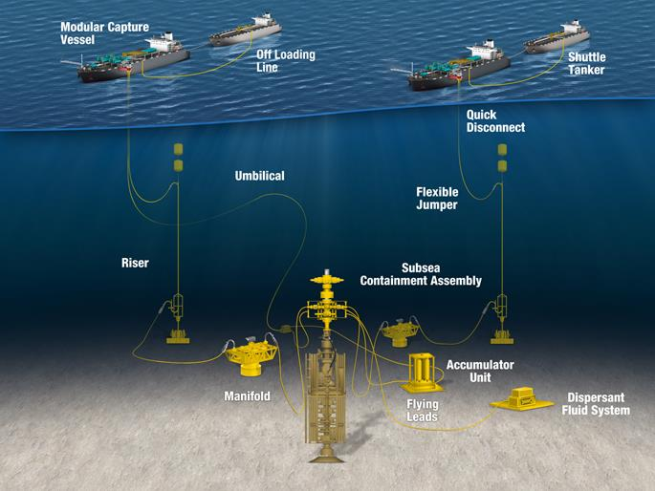
Figure.1.41: Typical of Semi-submersible.

1.3. Safety regulations for different types of ships and Offshore Structures
While there are no universally applicable definitions of ship types, specific descriptions and names are used within IMO treaties and conventions. The following is a non-exhaustive list ship types defined in various IMO instruments:
- A passenger ship is a ship which carries more than twelve passengers. (SOLAS I/2)
- A fishing vessel is a vessel used for catching fish, whales, seals, walrus or other living resources of the sea. (SOLAS I/2)
- Fishing vessel means any vessel used commercially for catching fish, whales, seals, walrus or other living resources of the sea. (SFV 1993 article 2)
- A nuclear ship is a ship provided with a nuclear power plant. (SOLAS I/2)
- Bulk carrier means a ship which is constructed generally with single deck, top-side tanks and hopper side tanks in cargo spaces, and is intended primarily to carry dry cargo in bulk, and includes such types as ore carriers and combination carriers. (SOLAS IX/1.6)
- Bulk carrier means a ship which is intended primarily to carry dry cargo in bulk, including such types as ore carriers and combination carriers. (SOLAS XII/1.1)
- Oil tanker means a ship constructed or adapted primarily to carry oil in bulk in its cargo spaces and includes combination carriers, any "NLS tanker" as defined in Annex II of the present Convention and any gas carrier as defined in regulation 3.20 of chapter II-1 of SOLAS 74 (as amended), when carrying a cargo or part cargo of oil in bulk. (MARPOL Annex I reg. 1.5)
- General cargo ship: A ship with a multi-deck or single-deck hull designed primarily for the carriage of general cargo. (MEPC.1/Circ.681 Annex)
- High-speed craft is a craft capable of a maximum speed, in metres per second (m/s), equal to or exceeding 3.7 times the one-sixth power of the volume of displacement corresponding to the design waterline (m³), excluding craft the hull of which is supported completely clear above the water surface in non-displacement mode by aerodynamic forces generated by ground effect. (SOLAS X/1.2, HSC Code 2000 para 1.4.30)
- Mobile offshore drilling unit (MODU) means a vessel capable of engaging in drilling operations for the exploration for or exploitation of resources beneath the sea-bed such as liquid or gaseous hydrocarbons, sulphur or salt. (SOLAS IX/1, MODU Code 2009 para 1.3.40)
- Special purpose ship (SPS) means a mechanically self-propelled ship which by reason of its function carries on board more than 12 special personnel. (SPS Code para 1.3.12) m

Chapter 2

2.0. Load and Moment

2.1. Overview
The successful ship structure designer learns to efficiently balance the multitude of variables inherent in such an open ended design project. For instance, thousands of different materials could be used in the vessel’s construction. Each would lead to a unique solution, some of which would be better than others. One goal of the book is to give an introduction to marine materials so that readers came to this course with an idea of materials trade-offs. This section will concentrate on types of loading, metals as building materials as they are the most plentiful, and easiest to analyze. Vessels are also built of wood, concrete and composites, and students interested in designing ships with these materials are encouraged to consider a number of senior electives, including Marine Fabrication Methods, Composite Materials, and Independent Research Courses.
Loads on ships are relatively uncertain and in many cases are very difficult to predict. Given that, it is not surprising that probabilistic methods of load prediction are becoming more popular in naval architecture! The sizes of structural components are limited due to deck clearances, piping, wiring and the general arrangements. In addition to the loads, plating thickness is often driven by weight, economic and fabrication issues. It is literally impossible to say that the perfect ship is an optimization reality.
The ship structure design process is fairly well developed. Starting with a blank piece of calculation paper, the structural designer begins by estimating the loads. They then select appropriate analysis techniques. They then determine the necessary structural characteristics of the components, such as plating thickness, the moment of inertia and the yield strength. The basic structural arrangement is then developed, and the components are analyzed for acceptable factors of safety. As the optimum is rarely (never) found the first time, the design engineer then iterates by adjusting the numbers of stiffeners, the plating thicknesses and/or possibly the materials until an acceptable or “optimal” design is reached. The final step is to develop the structural drawings, starting with the Midships Construction Drawing. The complete structural design of a large ship may take tens of thousands of man-hours, while a simple small craft may be done in only a few hours.
This book covers enough material that if the student successfully learns it, they will be able to perform a complete preliminary structural design of a medium-sized commercial or military vessel made of metal. The course coverage is also sufficient for the student to complete nearly the entire structural design of a vessel up to 79 feet.
One challenge for anyone learning naval architecture is the terminology. Some of the terms make sense in common modern language, but many defy common logic as their origins are centuries old and span many languages. A “ceiling” for example, is not overhead as in common language, but rather is the inside skin of the vessel’s topsides. A “floor” on a ship is not something you usually walk on (which is a deck, tank top, or sole), but is a frame supporting the hull bottom and possibly the lowest deck.
The basic ship structural components are commonly divided into two general types: plating and stiffeners. Stiffeners include frames, longitudinal, stringers, deck beams, deck girders, bulkhead stiffeners, and stanchions. Plating includes bulkhead plating, bottom plating, side shell plating, and deck plating, to name only a few. Ship structures are most commonly made of combinations of plating and stiffeners. Analytically we often treat stiffeners as beams or 1-D objects, which mean that their length is much greater than their width or height (a pencil is an example). We often treat plating as 2-D objects, with two dimensions (length and width) much greater than the thickness (a piece of paper is an example). A third class of structures is “solids”, which are 3-D objects with their length, width and thickness all of similar dimension. For manufacturing and weight reasons, solids are rarely used in typical vessels and will not be covered in this course.
Ship structures are also characterized by which loads they are intended to resist.
- Primary structure resists the global bending of the vessel due to vessel hogging and sagging conditions. Primary structure is evaluated by treating the ship as a very large box beam subjected to bending by the waves.
- Tertiary structure resists the local hydrostatic pressures and/or point loads. A common example is side plating with seawater pressure on one side.
- Secondary structure either resists large areas of hydrostatic loads or transfers the tertiary loads to primary structure. A secondary structure may be the combined plating and stiffener structure of the hull bottom or side.
Note that a single piece of structure may resist multiple loads. Hull bottom plating for example, is a part of primary, secondary and tertiary structure.
In this book we will work our way through the important topics by starting with primary structure, then going to tertiary structure, and finishing with secondary structure. This means that we will start with beams (and stiffeners), then do plating, and finally combine the two into panels. We will use three methods of design analysis: traditional theoretical methods built on a “Mechanics of Materials” approach (often referred to as “first principles”), classification society rules (often referred to as “rules-based”), and finite element analysis or “FEA” (often referred to as a “computer-based numerical approximation method”).
It is important that the student keeps up with the material as it is cumulative and rapidly presented. The student should also plan on taking a proactive approach to the design projects as they require significant time!
Down the road, the material in this book will help the student with the Fundamentals of Engineering exam, the Professional Engineers licensure exam, and graduate school. Currently there is a shortage of naval architects and ship structural engineers. This shortage is forecast to continue for the foreseeable future.
Much of the material covered in this course, and summarized in these notes, is taken from experience of the instructors as well as the very few references on ship structural design and analysis. One of the primary references is Ship Structural Design: A Rationally-Based, Computer-Aided, Optimization Approach (by Owen Hughes, published by SNAME, referred to as “Hughes” throughout the course notes). Another important reference is Principles of Naval Architecture (published by SNAME, referred to as “PNA” throughout the course notes). Other useful references are: Ship Design and Construction (by Thomas Lamb, published by SNAME), The Elements of Boat Strength (by Dave Gerr, published by McGraw-Hill), and Ultimate Limit State Design of Steel-Plated Structures (by Jeom Paik and Anil Thayamballi, published by Wiley).

2.2. Types of Loading
Loads acting on ships and offshore structures are from gravity, environment and seismic. The gravity loads are arising from dead weight of structure and facilities either permanent or temporary. Seismic loads are arising from gravity loads which are a derived type. The environmental loads play a major role governing the design of offshore structures. Before starting the design of any structure, prediction of environmental loads accurately is important.

2.2.1. Gravity Loads

2.2.1.1. Structural Dead Loads
Dead loads include the all the fixed items in the platform deck, jacket, bridge and flare structures. It includes all primary steel structural members, secondary structural items such as boat landing, padeyes, stiffeners, handrails, deck plating, small access platforms etc.
The primary structural steel members will be calculated based on the structural information in the model automatically when a computer program is used to analyse the structure. But the weight of secondary structural steel items shall be calculated applied to the structural model at appropriate locations.

2.2.1.2. Facility Dead Loads
The structure built either for drilling or wellhead type platform or for process type platform supports various equipment and facilities and cargo. These are fixed type items and not structural components. They do not have any stiffness to offer in the global integrity of the structure and shall not be modelled. The weight of such items shall be calculated and applied at the appropriate locations according the plan of the structure. These items include
- Mechanical equipment
- Electrical equipment
- Piping connecting each equipment
- Electrical Cable trays
- Instrumentation items
- Engines

2.2.1.3. Cargo and Fluid Loads
The cargo and fluid loads are weight of cargo, fluid on the platform during operation such as fuel, fresh water and ballast water. This may include all the fluid in the equipment and piping. The weight of these items shall be calculated accurately and applied to the correct locations.

2.2.1.4. Live Loads
Live loads are defined as movable loads and will be temporary in nature. Live loads will only be applied on areas designated for the purpose of storage either temporary or long term. Further, the areas designed for laydown during boat transfer of materials from boat shall also be considered as live loads.
Other live loads include open areas such as walkways, access platforms, galley areas in the living quarters, helicopter loads in the helipad, etc. These loads shall be applied in accordance with the requirement from the operator of the platform. This load varies in nature from owner to owner but a general guideline on the magnitude of the loads is given below.

2.2.1.5. Drilling Loads
Drilling loads are due to drill rigs placed on top of the platform for drilling purposes. These are large equipment assembled together and placed on top. Normally, drilling rigs are as heavy as 500 Tonnes to 1000 Tonnes. These will deliver reaction forces on the deck and the stiffness of the drilling rigs are not considered in the structural analysis. Hence the weight of the structure shall be applied as load on the structure. Further, during drilling, additional loads will be developed due to drill string and pulling operations. These loads also shall be considered in the analysis.

2.2.2. Environmental Loads

2.2.2.1. Wind Loads
The wind speed at 10m above LAT (Lowest Astronomical Tide) is normally provided ($V_{o}$). This wind speed shall be extrapolated to the height above for the calculation of wind speed. The extrapolation shall be calculated as below.

$V ={ V}_{o}{\left(\frac{y}{10}\right)}^{1/8}$ (2.1)

Where; $y$ is the elevation of point in consideration in m above LAT and V is the velocity at that point. Wind loads shall be calculated as per API RP2A guidelines.
Sustained wind speeds (10min mean) shall be used to compute global platform wind loads and gust wind (3 second) shall be used to compute the wind loads to design individual members. The wind pressure can be calculated as

$f_{w}=\frac{ρg}{2}V^{2}$ (2.2)

where $F$ is the wind pressure per unit area, $ρ$ is the density of air (0.01255 $kN/m^{3}$), $g$ is the gravitational acceleration (9.81 m/sec2) and $V$ is the wind speed in $m/sec$.

Equation 1.2 an be simplified by substituting the values and can be expressed as

$f_{w}=0.62{ V}^{2}$ $kN/m^{2}$ (2.3)

The total wind load on the platform can be calculated using the wind blockage area and the pressure calculated as above. The shape coefficient ($C_{s}$) shall be selected as per AP RP2A guidelines. But for the calculation of global wind load (for jacket and deck global analysis) shape coefficient can be 1.0.
The total force on the platform can be calculated as

$F_{x} = f_{w}{ A}_{x} C_{s}$ (2.4)

$F_{y} = f_{w}{ A}_{y} C_{s}$ (2.5)

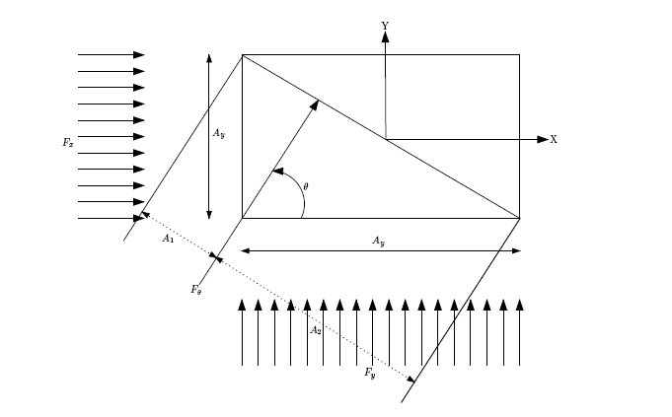
Figure.2.1: Wind load at structure.

The exposed areas (${ A}_{x}$ and${ A}_{y}$) shall be calculated as length x height or width x height depending on the axis system followed.
Wind load on oblique directions can be calculated using following relationship.

$F_{θ}=F_{x}\cos\left(θ\right)+F_{y}\sin\left(θ\right)$ (2.6)

In practical design, it is often only $F_{x}$ and $F_{y}$ will be calculated and applied in the structural analysis as basic loads and the wind load effect due to non-orthogonal directions are simulated using factors in terms of $F_{x}$ and $F_{y}$ in the load combinations. The factors can be calculated as
The projected areas can be calculated as $A_{1}= A_{x} cos(µ)$ and $A_{2} = A_{y} sin(µ)$

$F_{θ}=f_{w} \left(A_{1}+A_{2}\right)$ (2.7)

$F_{θ}=f_{w} \left(A_{x} cos(µ)+A_{y} sin(µ)\right)$ (2.8)

$F_{θx}=f_{w} \left(A_{x} cos(µ)+A_{y} sin(µ)\right)\cos\left(θ\right)$ (2.9)

$F_{θy}=f_{w} \left(A_{x} cos(µ)+A_{y} sin(µ)\right)\sin\left(θ\right)$ (2.10)

Where; $F_{θx}$ and $F_{θy}$ are the components of Fµ in x and y directions respectively.

2.2.2.2. Wave Loads
In the planning process offshore structure (offshore structure), the determination of the structure of work ability is influenced by the work load on the structure. Designer must determine the accuracy of the load to be applied in the planning of offshore structure in advance.
According to Indiyono (2003) wave load is the biggest load caused by environmental load on offshore structure. FPSO exposed to wave load will accelerate in every movement. Scantling support facility structure gas system processing module located on the FPSO is also accelerated due to the movement of the FPSO. In accordance with Newton's second law, the existing structures on the vessel will experience a force due to vessel movement resulting in acceleration. For translational motion, inertia force is obtained in Equation.2.11.

$F=m∙a$ (2.11)

Where; $m$ is mass and $a$ is acceleration
According to Bhattacharayya (1978), there are four moments of rotational motion is important that inertial moment, damping moment, restoring moment, and exciting moments. Moment of inertia equation is:

$I=mr^{2}$ (2.12)

Where; $m$ is mass of the ship (kg), $r$ is radius of gyration (m).
Whereas for the moment force, the equation is:
$Moment=Iα$ (2.13)
Where; $α$ is acceleration rotary ($rad/s^{2}$) and $I$ is inertial moment ($kg.m^{2}$)
Response on offshore structures (either fixed or floating structure) due to regular waves in each frequency can be determined by using spectra method. Response Amplitude Operator (RAO) or often referred to as the Transfer Function is a function of the response caused by the waves in the frequency range of offshore structures.
RAO is a tool for transferring force to the wave movement dynamic response of structures. According to Chakrabarti (2005), RAO equation can be searched with the following equation.

$RAO(ω)=\frac{X_{p}(ω)}{η(ω)}$ (2.14)

Where; $X_{p}(ω)$ is amplitude of the structure and $η(ω)$ is amplitude of the wave.
Response spectrum is multiplication between wave spectrum with RAO square. Equation from the response spectrum is (Chakrabarti, 1987) as follows:

$S_{R}(ω)={[RAO(ω)]}^{2} s(ω)$ (2.15)

where $S_{R}(ω)$ is response spectrum ($m^{2}-sec$), $s(ω)$ is wave spectral ($m^{2}-sec$), 𝑅𝐴𝑂 is Response amplitude operator, 𝜔 angular frequency ($rad/sec$).

2.2.2.3. Current Loads
Oceans currents induce drag loading on offshore structures. These currents together with the action of waves generate dynamic loads. Ocean currents are classified into few types based on their nature versus tidal current, wind driven current and current generated due to ocean circulation. Wind driven currents are small in nature and it varies linearly with depth where as tidal currents vary nonlinearly with depth. Similarly, the currents generated due to ocean circulation will vary nonlinear with depth and can be as much as 5 m /sec.
The current variation with depth is shown in Figures and can be expressed as below.

$V_{T}=V_{oT}{\left(\frac{y}{h}\right)}^{1/7}$ (2.16)

Where; $V_{T}$ is the tidal current at any height from sea bed, $V_{oT}$is the tidal current at the surface, $y$ is the distance measure in m from seabed, $h$is the water depth.

$V_{w}=V_{ow}\left(\frac{y}{h}\right)$ (2.17)

Where; $V_{w}$ is the wind driven current at any height from sea bed, $V_{ow}$ is the wind driven current at the surface.

2.2.2.4. Buoyancy Loads
The offshore structural members mostly made buoyant by air tight sealing of the welds to avoid water entry. This is purposely planned so that the overall structure will have adequate buoyancy during installation. Typical example is the jacket structure. This kind of structure requires at least a reserve buoyancy of 10% to 15%. The reserve buoyancy is defined as buoyancy in excess of its weight. To obtain this buoyancy, structural tubular members are carefully selected such that their buoyancy / weight ratio is greater than 1.0.
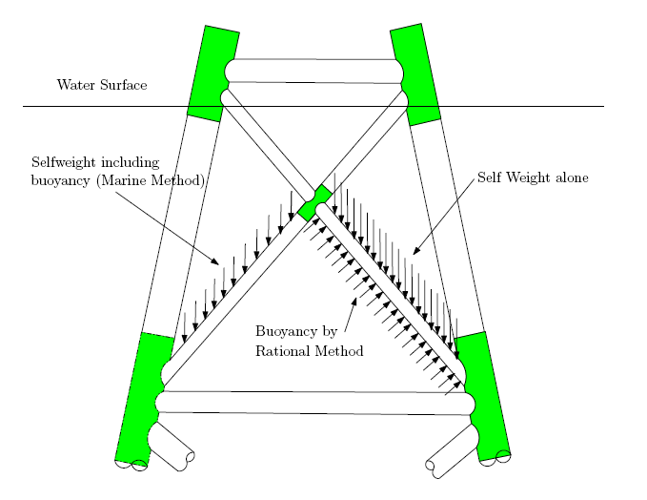
Figure.2.2: Buoyancy loads of structures

This means that the member will °oat in water. On other hand, if the member is part of a structure supported at its two ends and forced to be submerged by weight of other members, this member will experience a upward force equal to the displaced volume of water. This is called buoyancy force. The buoyancy force can be calculated by two methods.
- Marine Method
- Rational Method
The marine method assumes that the member in consideration considered to have rigid body motion. This means that the weight of the member is calculated using submerged density of steel and applied to the member vertically down as an uniformly distributed load. This buoyant weight WB of the member per unit length can be calculated as

$W_{B}=\frac{1}{4}π\left(D^{2}-{\left(D-t\right)}^{2}\right)\left(ρ_{s}-1.025\right)$ (2.18)

Where; $ρ_{s}$ is the density of steel.
Unlike gravity which is a true body force acting on every particle of a body, buoyancy is the resultant of fluid pressure acting on the surface of the body. These pressures can only act normal to the surface.
The rational method takes in to account this pressure distribution on the structure, results in a system of loads consisting of distributed loads along the members and concentrated loads at the joints. The loads on the members are perpendicular to the member axis and in the vertical plane containing the member. The magnitude of this distributed member load can be expressed as

$B_{B}=\frac{1}{4}πD^{2}ρ_{w}\cos\left(α\right)$ (2.19)

Where; $α$ is the angle between the member and its projection on a horizontal plane.
The joint loads consist of forces acting in the directions of all of the members meeting at the joint. These joint forces act in a direction that would compress the corresponding members if they acted directly on them, and have magnitude of:

$P_{B}=ρ_{w}∙A∙ h$ (2.20)

Where; $A$ is "displaced" area i.e. the material area for flooded members, the enclosed area for non-flooded members $h$ is water depth at the end of the member being considered.

2.2.2.5. Ice Loads
For structures located in polar regions and cold countries, ice loading shall be considered in the design. In this regions, the ice sheets of varying thicknesses can move from one location to other due to tide and under water current. These ice sheets when come closer and hit the offshore structures, large impact force is experienced by the structure.

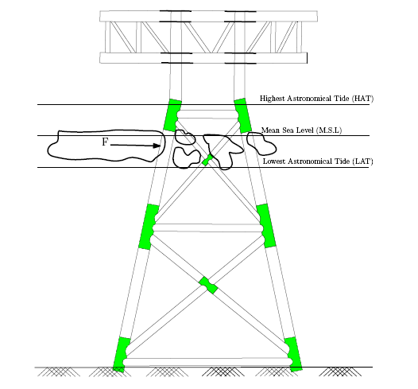
Figure 2.3: Ice load on a structure.

This kind of force cannot be calculated by means of analytical tools. However, based on
experimental studies, an empirical equation is available and can be used to estimate the force $F_{ice}$.

$F_{ice}=C_{ice}∙f_{ice}∙A$ (2.21)

Where; $f_{ice}$ is Crushing strength of ice vary between 1.5 MPa to 3.5 MPa, $C_{ice}$ is Ice force coefficient vary between 0.3 to 0.7 and $A$ is Area struck by ice (Diameter of member x ice sheet thickness).

2.2.2.6. Mud Loads
Platforms located in the vicinity of the river mouth (shallow water platforms) may experience
the mud flow loads. The river flow brings sediment transport and nearby mud towards the platform and may slide through the location.
Sometimes over a long period of time sediment settlement at the location of the platform may have sloping surface and mud slides can also generate mud loads. These loads ($F_{mud}$) can be calculated using the following equation:

$F_{mud}=C_{mud}∙τ∙D$ (2.22)

Where; $C_{mud}$ is Force Coefficient vary from 7 to 9, $τ$ is Shear strength of soil 5 KPa to 10 kPa and $D$ is Diameter of pile or or member).

2.3. Ship and Offshore Structural Components
A ship is constructed primarily as a network of welded together cross-stiffened plates, sometimes referred to as a “grillage” (in the “old days” – prior to the 1940s – all steel ships were of riveted construction). The plates are stiffened by welded girders or “stiffeners”, such as I-beams, T-beams, angles, etc. Nomenclature for ship structural components is somewhat standardized, although also somewhat confusing to the newcomer. The below figures illustrate nomenclature of some of the important ship structural components. The first illustration shows a perspective view. The second illustration shows section views, with the port side showing structural components which run longitudinally, and the starboard side showing structural components which run transversely.
Traditionally, the term “keel” (or Center Vertical Keel or CVK) refers to the longitudinal center plane girder which runs along the bottom of the ship (often loosely described functionally as the ship’s “backbone”). The term “plating” refers to thin structure, including the outer “shell” plating (side and bottom plating), deck and inner bottom plating, and bulkhead plating. The ship’s side and bottom shell plating is typically arranged in longitudinal rows referred to as “strakes”. Strakes may be designated either by letters or by specific noun names. The ‘A’ strake (also known as the Garboard Strake) is the strake adjacent to the keel. Strakes may be designated by successive letters outboard of the ‘A’ strake as shown in Figures.2.1-2.2. The strake located at the turn of the bilge is referred to as the Bilge Strake. The upper-most strake (located at the deck edge) is referred to as the Sheer Strake. As you will learn in this course, the shear strake experiences high stresses, so it is often constructed from higher strength materials or of thicker plating.
The ship’s plating is stiffened by welded girders or “stiffeners”, which vary in name depending on their location and orientation (in the “old days” everything was riveted instead of welded). Longitudinal is stiffeners which run longitudinally (fore-aft) along the bottom of the ship, and stiffen the bottom plating. Stringers run longitudinally along the sides of the ship (nominally above the bilge strake) and stiffen the side shell plating. Deck girders run longitudinally and stiffen the various deck plating. Frames run transversely from the CVK to the main deck, and stiffen the outer plating (bottom plating and side shell plating). Floors are the (usually) larger portion of the frames which run from the CVK to the bilge strake. In addition to stiffening the bottom plating, the floors also function as foundations for the inner bottom plating and also as tank boundaries and machinery foundations. Deck beams run transversely and stiffen the various decks plating (note that deck beams run transversely but deck girders run longitudinally – so deck beams are fundamentally perpendicular to deck girders).

Figure.2.4: Block of Ship Structure

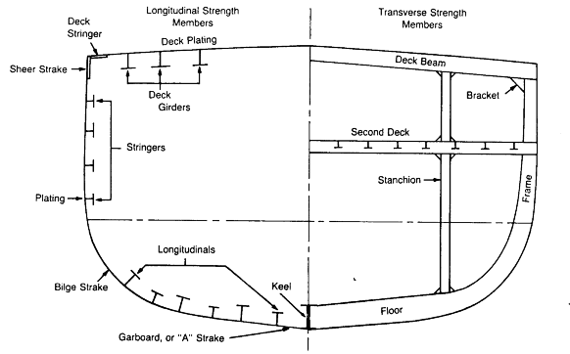
Figure.2.5: Front view of ship structure

The sizes and spacing of longitudinal and transverse stiffeners vary in different types and sizes of vessels for a number of reasons. Some vessels have larger, closely-spaced frames with widely spaced longitudinal. This type of framing system is referred to as “transverse framing”. Transverse framing systems are usually designed for ships whose primary structural loads are hydrostatic or impact-type loads, and are often found on shorter ships (such as workboats) and submarines. Some vessels have closely spaced longitudinal and more widely-spaced frames. This type of framing system is referred to as “longitudinal framing”. Longitudinal framing systems are often chosen for ships whose primary loads are due to longitudinal bending (flexure). Most larger ocean-going ships actually have what is referred to as “combination framing” systems, which are better for dealing with combined loads (including hydrostatic, longitudinal bending, torsion, racking, etc.). Most Navy surface ships are of this type.
In addition to having different types of framing systems, some ships are constructed with “single hull” or “single bottom construction” (Figure.2.3). This type of construction is often found on smaller ships. Most large modern ships are of “double bottom” construction (see illustration). Double bottom construction has advantages of being stronger, providing volume in which liquids can be stored without taking up valuable cargo space, and providing some damage resistance in the bottom. Double bottom construction has disadvantages of being more expensive to construct with higher maintenance costs, and it also moves the neutral axis downward (increasing bending stresses in the main deck). Also note that many oil tankers are constructed as “double hull”, in which the entire bottom and side shell are enclosed with an inner skin – this having a perceived advantage of being less susceptible to oil spills, although this has been shown to be not necessarily the case.

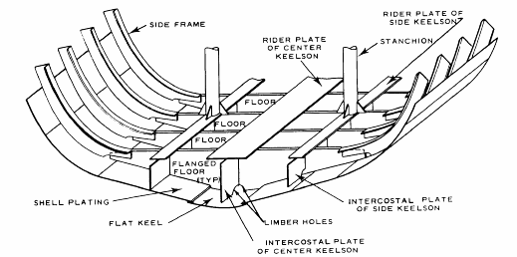
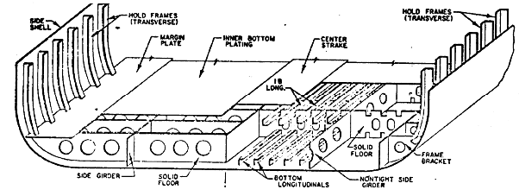
Figure.2.6: Different types of framing systems of ships.

Structural drawings provide details of structural arrangements, materials, construction methods, etc. Of the many structural drawings, the Midships Construction Drawing provides a section view (the midships section), providing the details of the structure amidships (sometimes structural details for other sections located fore and aft of midships are also indicated on this drawing). Shown in Figures 2.7 - 2-8 below are several example Midships Construction Drawings. The Figures 2.7 shows a midships section including a “deep frame” and other “scantlings” (structural dimensions) for a double hull oil tanker, and the Figures 2.8 shows a midships section for a Navy destroyer (DD-963 class).

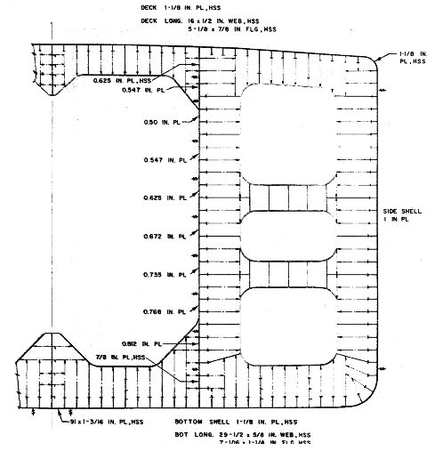
Figure.2.7: Midship section for a double hull oil tanker

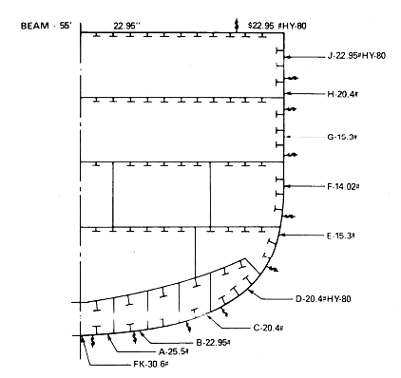
Figure.2.8: Midship section for a Navy destroyer

2.4. Ship and Offshore Structural Design Process
Designing a ship’s structure follows the same basic process as designing any structure. It is an iterative process, with many compromises (trade-offs). The basic steps include:
- Determining environmental and/or operating conditions
- Selecting geometry
- Determining loads (forces)
- Estimating boundary conditions
- Selecting analytical methods
- Selecting materials
- Analyzing
- Optimizing (minimizing cost, weight and others)
- Documenting (specifications and drawings)
An example of a flowchart method for ship structural analysis is (from Hughes):

Figure.2.9: Rationally-based Structural Design.

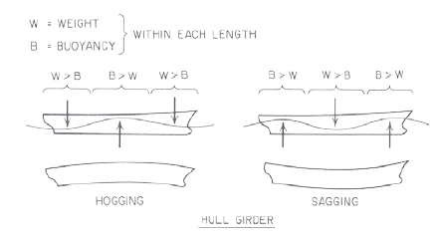
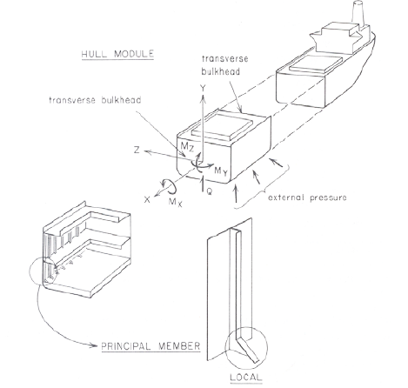
Figure.2.10: Levels of structural analysis.

2.5. Structural “Failure”
Most operators or owners would consider that something has “failed” when it can no longer perform the function for which it was intended. In the world of structural design, two criteria are generally used for considering “failure”, as each has different approaches to its analysis. The two criteria can be illustrated through a simple example – a crane boom. It is easy to visualize that the boom can fail by “breaking”. It could be that the stress level within the steel of the boom exceeds the ultimate strength of the steel and the boom fractures. The solution might be to specify a stronger material. Some polymers such as synthetic rubber are “stronger” than many steels. Does it make sense to build a crane boom out of rubber? Probably not – as the deflection would be too large. A structure that deforms beyond an acceptable or allowable limit also “fails” and would be just as useless (and possibly just as dangerous) as one that breaks. The point is that an engineer has to consider whether a particular design is “strength-driven” or “stiffness-driven”. The first (“strength-driven”) requires analysis that uses stresses and strengths of the materials. The second (“stiffness-driven”) requires an analysis that predominantly uses stiffness parameters such as the modulus of elasticity, and the “slenderness” of the structural members.
The history of naval architecture includes periods when both criteria were used. Wood is neither very stiff nor very strong, and designers using wood need to carefully consider both. Fiberglass tends to be strong (although brittle) but not very stiff. Steel is stiff, and some grades are very strong. Carbon fiber laminates are strong and stiff, but expensive. Until the last few years, ship structural design has focused on strength-driven design, as almost all construction was steel. As more and more composites (fiberglass and carbon fiber laminates) have found applications on modern marine vessels, the issues of stiffness-driven design have returned. One example was the recent problems on a 240’ fiberglass motor vessel. As the vessel deflected more than usual for a vessel of that size, the design codes (rules) did not consider the effect on other structure. As a result, a problem arose where the hull and structure deflected more than the steel propeller shaft could! This resulted in unforeseen stresses in the propeller shaft, and it bent.
As most catastrophic ship structural failures are caused by the failure of strength-driven designs, this course concentrates in this area. Whether a structure will fail is typically determined (in the “Working Stress Design Method”) by calculating a Factor of Safety. In design, regulations (and common sense) indicate that the minimum factor of safety should be greater than one. Most marine design codes in practice today have a minimum acceptable factor of safety of at least two for most failure modes, and at least three for buckling failure modes. The American Bureau of Shipping (ABS), which provides rules for designing and building vessels in the United States, has factors of safety ranging from 1.5 to 8, depending on the application’s criticality and the load uncertainty. At the low end, a mainsail batten on a racing yacht may have a factor of safety very near one. If the batten breaks, the sail shape is compromised, but serious damage is unlikely. A batten’s low weight and stiffness are important to performance however so the batten is carefully engineered to just meet the expected worse load conditions. On the high end, failure of mission-critical (or life-critical) structural components on a naval combatant may require a higher factor of safety.
For consistency, in this class we will use a required factor of safety for “material yield” of 2 and a required factor of safety for “buckling” of 3 as constituting an adequate design.

$FOS=\frac{Capacity}{Load}=\frac{Strength}{Stress}$ (2.23)

A visual way to look at Factor of Safety in a real world, probabilistic method, is by comparing the probabilistic distributions of the stress and the strength of a given structural component. The loads are uncertain in most cases, so a “one hundred year event” might cause a very high stress. Similarly, a particularly weak batch of steel may give very low strengths. If the high load occurs when a low strength occurs, failure will occur. In the figure below, the difference between the two means ($μ$) is the safety margin, which is a function of the factor of safety. The shaded area represents where failure will occur.

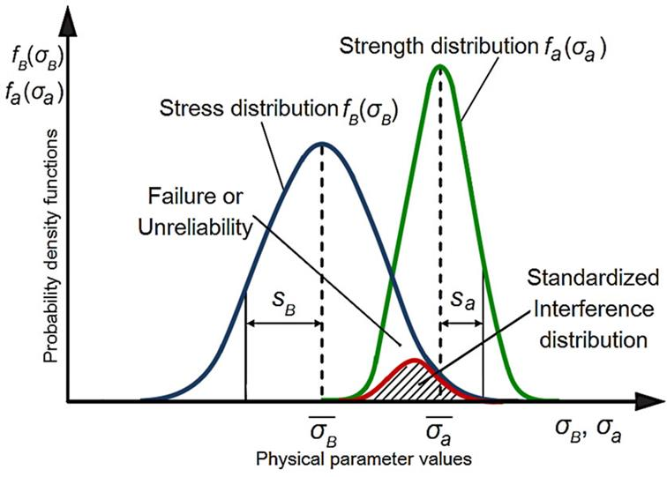
Figure.2.11: Failure Probabilities [Al Sayed]

Strength may be a material property such as ultimate tensile strength ($σ_{ult}$) or tensile yield strength ($σ_{Y}$), or it may be a buckling strength (for example column buckling capacity). Stress within a structural component depends primarily on loading and geometry. You have considered various types of stresses. Here we consider that, for strength-driven designs in the marine environment, there are 7 basic failure modes:

In the failure assessment, it was common to assume that only one load was applied to a structure at a time. In naval architects, a common example is a beam in bending. The beam will have stresses caused by the bending, but will also have shear stresses. The most commonly used method to address this is to combine these stresses into an equivalent “Von Mises Stress” which is using the Distortion-Energy Theory. This Von Mises Stress gives an equivalent stress that can be compared to the tensile or compressive strengths of the material to determine a minimum factor of safety. Since most ship structures are usually built-up from thin plating (2-D plane stress), we use a 2-D version of the Von Mises Stress:

$σ_{vm}=\sqrt{σ_{x}^{2}+σ_{y}^{2}-σ_{x}σ_{y}+3τ_{xy}^{2}}$ (2-D “plane stress) (2.24)

Figure.2.12: Stress of structure

Another common problem with ship design is that the structure often has holes or cutouts in it to reduce weight, or allow pass-through of cargo, liquids, pipes, cables or personnel. These discontinuities cause stress concentrations. The stress concentration is addressed by a factor multiplied by the (nominal) uniform field stress. Two approaches are used: an empirical method based on tests of various configurations, and a “fracture mechanics” (theoretical) approach.
Another issue with ships is that anyone who has walked down a passageway of a ship in a storm knows that their “weight” (as defined by weight = mass x gravity) which is not constant. Each time the ship rises on a wave the person’s weight “increases”, which increases the load on the deck plating. A common way to deal with this in structural analysis is to use a “static-equivalent” calculation method by modifying the basic dynamics equation and replacing the acceleration term with the standard gravitational acceleration multiplied by a factor:

$F=m∙a →F=m∙g∙DAF$ (2.25)

where “DAF” is the Dynamic Amplification Factor. Another name for the DAF is “g-force”. Due to ship motions, most ship dynamic analyses use DAFs between 1 and 3. ISO Regulations currently in development limit the vertical acceleration forces in proposed vessels to those sustainable by humans..

2.7. Ship Structural Loads
Usually the most difficult part of ship structural design to get right is to correctly estimate the loads! In some cases it is not too hard. For example, the foundation for the propeller shaft thrust bearing should never exceed the thrust produced by the propeller, so estimating its load is relatively easy. On the other hand, estimating the maximum wave height that will break on the deck of a ship rounding Cape Horn (and the resulting forces on the ship) is very difficult. Luckily for naval architects, for mid to large size vessels, there is much historical data which can be (and is) used to produce reasonable estimates of future extreme loads. If it sounds like statistics and probability are used, you are right! The most accurate method for determining the majority of ship loads is probabilistic load prediction. While more accurate than the traditional, empirical deterministic methods, it is also more time consuming. In this course we will use the traditional deterministic methods, and accept a somewhat lower level of accuracy, in order to cover the key analytical methods.
It is important for the naval architect to carefully think through what the possible loads or “load cases” are. During one of the America’s Cup design projects, the designers identified 28 potential “extreme” load cases for the analysis of the deck structure, including waves breaking over it, submergence due to capsizing, impact from the spinnaker pole, and maximum crew “live” loads. As it turned out, the first failures occurred before the vessel even went to sea, due to a load case they didn’t analyze – and hadn’t even imagined! During the commissioning ceremony, a lady walked on the deck wearing high heels, with very narrow heels. Each place she stepped, her heels punched a hole through the thin carbon fiber laminate! The (easy) solution was simply placing a thick carpet down on the deck while in port, and banning high heels while underway.
There are a number of ways of classifying loads (forces) on ships. One method is classifying the loads based upon the timeframe of the load as compared to the dynamics of the ship structure and structural components. Static loads are loads which are not considered to change over relatively short periods of time – or those loads which change with periods far greater than the structures’ natural frequencies of vibration or flexure. “Stillwater loads” include external hydrostatic pressures (without considering waves), internal tank pressures, and all onboard weights. Onboard weights include fixed or “lightship” weight items (including the ship’s structure, machinery and piping systems, deck gear, outfitting and furnishings, and fixed portions of weapons systems, etc.), and variable weight items (including cargo, fuel, water, holding and waste, provisions and stores, crew and effects, etc.). Variable weight is sometimes called “deadweight”. The Figure.2.13 below illustrates static loads including hydrostatic pressure loads and various lightship and variable weight loads on structures.
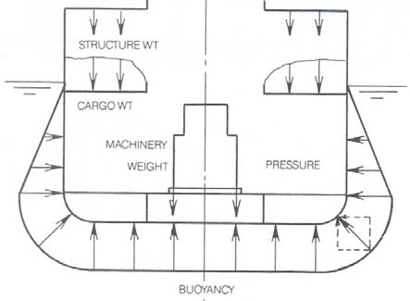
Figure.2.13: Wave-induced pressure variations on floating structure.

Slowly-varying loads include wave-induced loads, and are characterized as having a period slightly longer than the natural flexural periods of the ships primary structure. Waves cause variable hydrostatic and dynamic pressures on the hull, due to both the wave motion and the ship motion. The distribution of the pressures on the hull can be considered longitudinally (causing longitudinal bending of the ship – like a bending beam), transversely (causing transverse distortion of the hull – called “racking”) and obliquely (causing combinations of bending, racking and torsion or twisting of the hull). The figure below illustrates wave-induced pressure variations – including longitudinal and transverse effects. Wave pressures vary slowly (typically on the order of 5-15 seconds for large open ocean waves), and therefore wave induced loads are sometimes referred to and treated as “quasi-static”.
The longitudinal distribution of buoyancy applied to a ship by a passing wave (or a ship passing through a wave) creates a bending moment on the ship, which varies along the length of the ship. This is a wave-induced buoyancy distribution. The two extreme cases are given specific names. A “hogging” condition is when the crest of the wave is amidships and trough at bow and stern as illustrated in Figures.2.14 - 2.15. This causes flexure of the hull which puts the main/upper decks in tension and keel and bottom plating in compression. A “sagging” condition is the reverse –with trough amidships, but crest at bow and stern. This puts the main/upper deck in compression and keel and bottom plating in tension. The net bending stress distribution, however, requires knowledge and accounting of the still-water loading as well (including hydrostatic buoyancy distribution and weight distribution). This will be discussed in greater detail subsequently.

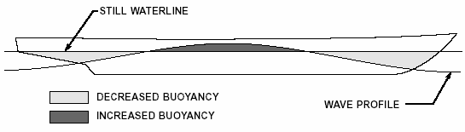
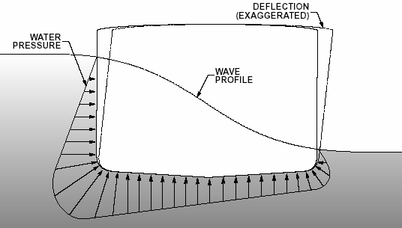
Maximum
Figure.2.14: Wave-induced buoyancy distribution
Buoyancy
Buoyancy
Buoyancy
Weight
Weight
Weight
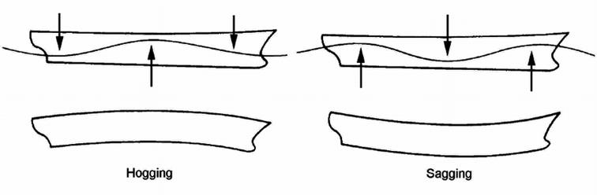
Figure.2.15: Hogging and sagging on a floating structure.

In addition to waved-induced buoyancy distributions, there are a number of other “slowly-varying” loads which might be important (and must be considered) when designing a ship’s structure. These include: wave slap on sides and foredecks, sloshing of liquids in tanks, shipping water (“green water” on decks), localized inertial loads (such as masts), and launching and berthing loads.
The third basic category of loads is “rapidly-varying loads”, whose timescales are on the order of the natural periods of vibration or flexure of the ships structure and components (on the order of a second or less). These are basically the true dynamic loads on the ship structures. These types of loads include slamming loads, which occur because of the ships motions in waves, and result in localized buckling and shell plating damage, as well as overall flexure of the ship’s hull (known as whipping). The effects of slamming are illustrated in the below figures. Another important dynamic load is called springing, which is a flexural resonance of the ships hull girder due to rapid wave encounters as the ship “drives” through the waves. Mechanical vibrations within the ships structure can also be caused by propeller and machinery rotations (although these effects are usually localized in the vicinity of machinery). Other important dynamic loads include combat loads (particularly important and often critical design loads for naval ships) including underwater explosions, air blasts, and even nuclear weapons.
In designing for these various loads, there are a number of methods used for analysis of stresses and deflections. Analyses can be static or dynamic, probabilistic or deterministic, and even linear or nonlinear. For most basic ship structural design, naval architects utilize “quasi-static”, deterministic, linear analyses. Slowly-varying wave-induced loads are considered at a “snapshot in time” for each “load case” (e.g. hogging wave, sagging wave, etc.). For localized structural components, sometimes dynamic effects are considered using a dynamic amplification factor (DAF). Probabilistic nature of loads and strength capacities are addressed using the Factor of Safety (FOS). By requiring FOS to be above a minimum level (requiring stress levels remain well within the linear-elastic range of the material stress-strain behavior) allows analysis to be treated primarily in a linear manner.

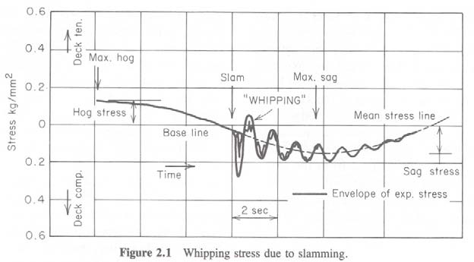
Figure.2.16: Whipping stress due to slamming

2.8. Primary, Secondary and Tertiary Ship Structural Loads
The previous section should have pointed out one very important concept. Something a naval architect quickly learns is that any piece of ship structure is likely to see more than one load at the same time. Consider the bottom plating for example. When the vessel is “sagging”, the bottom plating goes into tension. At the same time, the plating between two stiffeners is bending upward due to hydrostatic pressure. That means that the inside the face of the plating has tensile stresses from both the hydrostatic pressure and from the global hull bending. The outer face has tensile stresses from the vessel sagging, but also compressive stresses from the plate bending. How much they cancel each other depends on the plate thickness, frame spacing, and longitudinal spacing. A few seconds later however the vessel goes into “hogging” and the outer face has the two tensile stresses while the inner face has a mix of tensile and compressive! In addition to global and tertiary loading going on at the time, an underwater explosion, collision with flotsam or other loads might be happening.

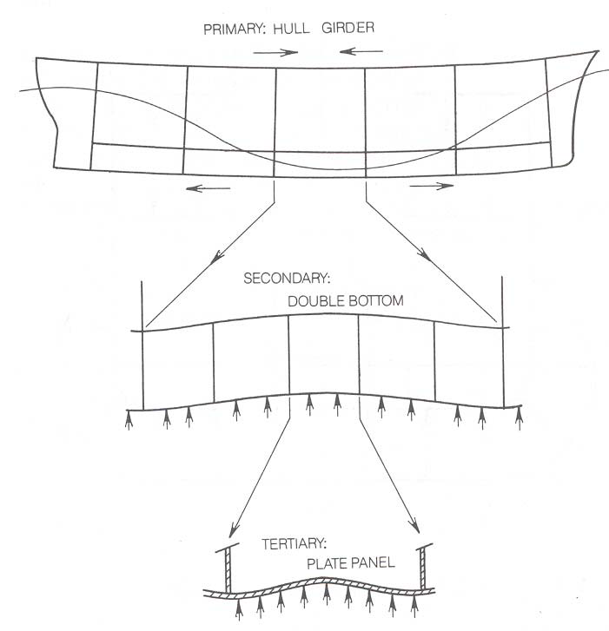
Figure.2.17: Primary, Secondary and Tertiary Ship Structural Loads

2.9. Primary Structure: The Hull Girder Bending Concept
As discussed in the previous section, a wave crest amidships will cause a vessel to hog. Acting as a beam (or, since it runs longitudinally, we actually call it a girder), the deck of the vessel will be in tension and the hull bottom in compression. We can use the Euler beam bending equation to determine the stress in the hull bottom plating and deck plating. While the equation to find the maximum stress is simple ($M∙{Y_{max}}/I$), determining the values of the bending moment ($M$), distance from the neutral axis to the outer fiber ($Y_{max}$) and the moment of inertia ($I$) are not! While it seems like a very simple calculation for such a large structure, it is a critical calculation, and one that occasionally goes wrong.

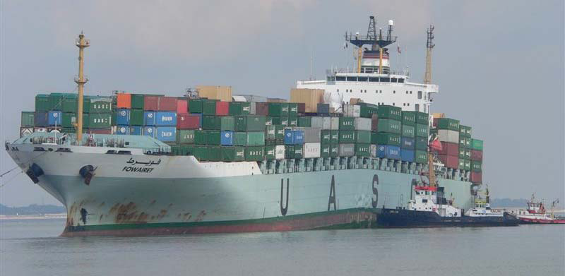

Figure.2.18: An example of hull girder bending

In statics and strength of materials we used boundary conditions that included fixed, simply-supported, roller, pinned, and others. One that might not have been covered was the “elastic foundation”. You can think of this as providing continuous support of a varying amount. A mattress is one example. Carrying that example further is a water bed. For ships, water is an elastic foundation. What this means is that we have to apply the basic concepts to calculate the moment as “force times distance”. If we integrate a load curve then we get a shear curve, and integrating the shear curve gives the bending moment curve. For ships, the load curve is a summation of the weight curve and the buoyancy curve. We get the weights from a weight and moment sheet and the buoyancy curve is also called the “Curve of Sectional Areas” or “Section Area Curve”, which is developed from the hull lines (usually the body plan if done manually).
To start this process we initially assume the vessel is in static equilibrium, which gives us the assumptions that the sum of the forces is zero and the sum of the moments is zero. This means that none of the ship’s six degrees of freedom (DOF) (3 translations: surge, sway, heave and 3 rotations: pitch, yaw, roll) is out of balance, and the vessel will not accelerate in any DOF. For ships the basic case is when the weight is equal to the buoyancy and the LCG is at the same station as the LCB. The process to find the bending moments by hand is:
- Draw a horizontal line on a piece of engineering paper that will represent the vessel’s length (x-axis). Mark on it the stations, ranging from 10 on the left to 0 on the right. Include any overhangs. Sketch in the vessel profile and cargo loading as appropriate.
- Draw another horizontal line below the first. Draw a weight curve on the line by adding up the weights at each station. More will be shown on this later. The weight curve will use the units LT/ft (or lb/ft if a small vessel). Weights will be recorded below the line (as they are downward or negative).
- Draw another horizontal line below the weight curve and draw the buoyancy curve based on the body plan. The units will also be LT/ft. Note that forward of station 0 and aft of station 10 the values should be zero. Buoyancy is recorded above the line (as it is upward or positive).
- Draw another horizontal line below the buoyancy curve and draw the load curve. At each station add the weight and buoyancy values to get the load curve. The units should still be LT/ft.
- Starting at the left side, integrate the load curve to get the shear curve. Note that if there is no stern overhang, the shear at Station 10 should be zero. The units should now be LT (or lb).
- Starting at the left side, integrate the shear curve to get the bending moment curve. Again, unless there is stern overhang, the moment at station 10 should be zero. The new units will be LT-ft (or ft-lb).

2.10. Weight Curves for Ships
For real ships, generation of a weight curve is not as simple as illustrated in the previous example. There are several methods that may be employed (and are often employed) to generate a weight curve for a real ship. All methods utilize an accounting tool such as a spreadsheet (table) to account for the various weight items. Specific information required for each item include weight, longitudinal position of the center of gravity (lcg), and longitudinal extents (including forward and aft bounds/locations of the distributed weight). For completeness, transverse and vertical c.g. are often included in the table, even though these are not required for the weight curve calculation. Some weight items extend only over a small ship length, so they are treated as distinct weight items (point loads). Examples of distinct weight items include the ship’s anchor, winches, masts, propellers, rudders, and even transverse bulkheads. Other weight items extend over portions of the ship’s length, and therefore their distributions are important – these are distributed weight items.
Examples of distributed weight items include the ship’s hull plating and stiffeners, superstructure, cargo weights (containers, bulk cargo, cargo oil, etc.), machinery (turbines, boilers, reactors, etc.), piping and ventilation systems, to name only a few.
For distributed weight items, the weights may be uniformly distributed (in which case the LCG is located in the center of the distributed length), or they may be non-uniformly distributed (in which case the LCG is not in the center). Non-uniform weight distributions are usually modeled using a simple trapezoid, which are described by the items total weight (the total area of the trapezoid), LCG (located at the centroid of the trapezoid), forward boundary and after boundary. The heights of each end of the trapezoid are related to the total weight, total length, and center of gravity position. This is known as the “Trapezoid Method”, and is illustrated in the figure 2.19. Note that there is a mathematical calculation that can be made (in the spreadsheet) for calculating the heights of the ends of the trapezoid given the weight, length, and LCG.

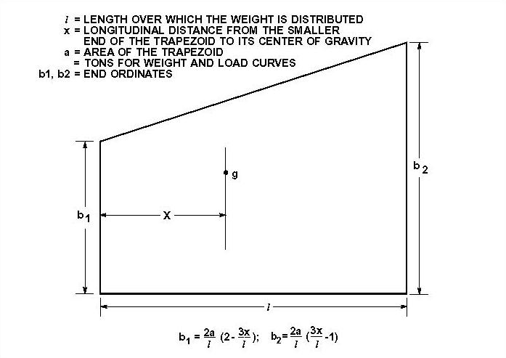
Figure.2.19: Trapezoid Method

Some distributed weight items extend over the entire length of the vessel (or nearly so), such as some piping systems, ventilation systems, and certainly the ship’s hull plating. For these types of distributed weights an approximation known as “Biles’ Method” is sometimes used to distribute these weights. This method assumes that the weight decreases near the bow and stern, and that there is an area of parallel middle body. This type of weight is therefore represented by two trapezoids (the ends) and a rectangle (parallel middle body). Like the trapezoidal method, Biles’ Method provides mathematical calculations of the heights of the sides (and middle) of the distribution. This is illustrated in the figure 2.20, for estimating the hull weight distribution of a simple vessel.

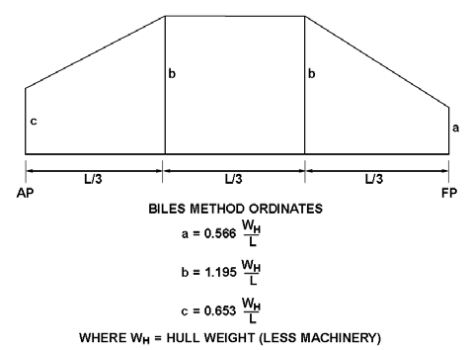

Figure.2.20: Biles’ Method.

The hull weight distribution for a more complex hull form, such as a destroyer, is only very grossly estimated using Biles’ Method. A better representation for such hulls is made by estimating the distribution for a large number of sections, using the Trapezoidal Method for each section (for a particular frame spacing, for example). Another method employed in practice for the hull weight distribution is made by scaling the section area curve.
With all of the weight items accounted for (lightship and variable loads), the total weight distribution (curve) can be plotted. The figure 2.21 illustrates a weight curve for a typical small cargo ship.

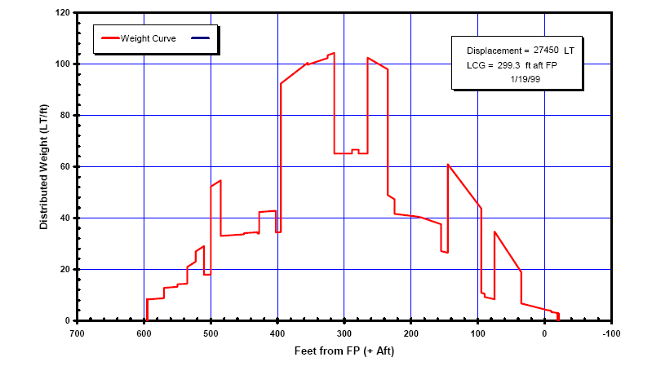
Figure.2.21: Weight curve for a typical small cargo ship.

To develop an accurate weight curve we need to consider all the “major” weight items. On an aircraft carrier this can be approximately 30,000 pieces! What is a “major weight item” is up to the naval architect to determine. On a weight critical vessel such as a racing yacht, a common rule of thumb is that everything that weighs more than 2 kg is considered as a major weight item!
Figure 2.22 is an example of a ledger-style spreadsheet for weight accounting and control. In modern shipbuilding each item is often weighed before installation. The first table lists the major weight items in a certain “weight group” (in this case the “machinery group”). The second table lists the total for each weight group, plus certain additional items including “margin” and “ballast”.
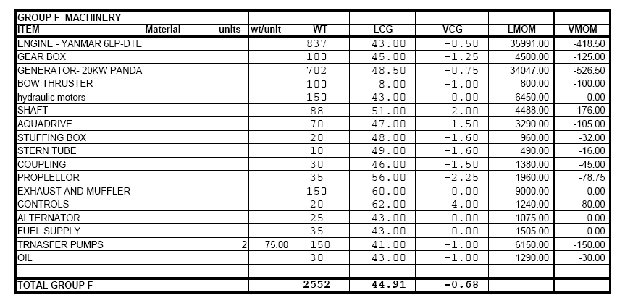
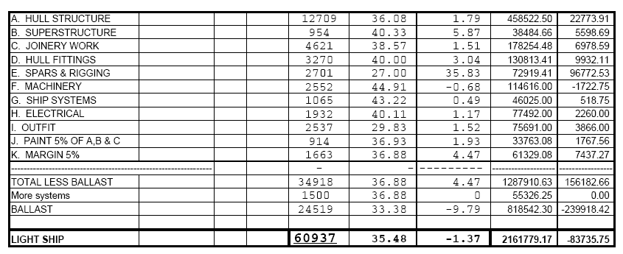
Figure.2.22: An example of a ledger-style spreadsheet for weight accounting and control.

2.11. Buoyancy Curves for Ships
The goal of the hull girder analysis is to develop an acceptable “Factor of Safety” (FOS) for the hull structure. In the section 2.11, methods for generating a weight curve has been discussed. This means, development of the buoyancy curve is necessary to be done. Using the buoyancy curve, then the load, shear force and bending moment curves are founded. Lastly, we will need to calculate the hull’s section modulus and apply Euler’s beam theory to find the stresses.
The previous sections showed the general approach, and for simple hull forms it is easy to extend the weight spreadsheet to calculate the bending moments. More common today the buoyancy curve is a byproduct of the hull lines development using a hydrostatics or CAD software program. For this course, we will use the HydroMax module of MaxSurf to generate a buoyancy curve.
Recall from the section on loads that the longitudinal distribution of buoyancy applied to a ship by a passing wave (or a ship passing through a wave) creates a wave-induced bending moment on the ship, which varies along the length of the ship. Note that this is in addition to the still water hydrostatic bending moment! Recall also the two extreme cases – hogging and sagging condition. We will therefore consider these as likely “worst-case” conditions and analyze them.
The approach is to consider that the ship is “statically balanced” on a wave of a given wave height and wave length. The design hogging and sagging wave profile is selected based upon classification society or design authority rules. The wave length used is usually the length between perpendiculars (LBP). The wave height used depends upon the type and size of ship, and is generally given by the classification or rules authorities. For this course, we will use a design value specified for naval combatants (U.S. Navy):

$H_{w}=1.1\sqrt{L_{BP}}$ (2.26)

Where; $H_{w}$ is the design wave height and $L_{BP}$ is the ship’s length between perpendiculars.
The profile or form of the wave is usually chosen as “troichodal”. A troichodal wave form has steeper crest and flatter trough than a sinusoidal wave form, and is normally used because it gives a better representation of an actual open ocean wave as shown in figure 2.23. Occasionally, for shallow water, a conidial wave is used, as it has even steeper crests. We will use the troichodal wave form for this course.
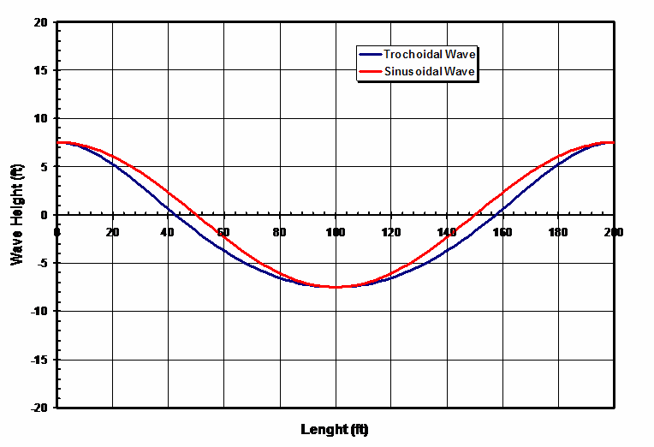
Figure.2.23: Wave height versus length of ships

In the simulation, Hydromax software can be used to generate still water and wave-induced buoyancy distributions and also load, shear and moment curves, by integrating hull offsets. In the “old days” (before PC computers - which most of your professors are old enough to remember), all of the integration had to be done “by hand” using hand calculators (or, in the really old days, by slide rules). One tool which came in handy for this was the “Bonjean Curves”, which provided section areas as a function of waterline (drafts) at each station location. The Bonjean Curves could be used to calculate a modified section area curve, which incorporated the still water plus wave induced buoyancy distribution. The figure 2.24 illustrates this. It’s unlikely that you would ever have to do this, but who knows

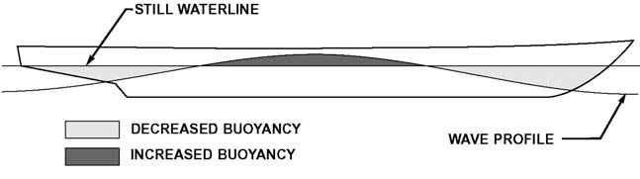
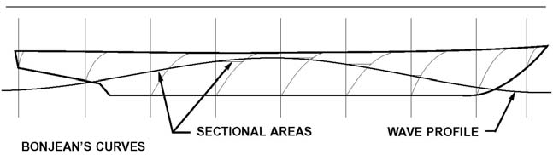
Figure.2.24: Section area curve calculated using Bonjean method.

For initial concept design studies, naval architects often use approximate equations to estimate the wave-induced bending moments. A quick review of the literature (Principles of Naval Architecture (PNA), etc.) will turn up dozens of approximate methods, some more accurate than others. In almost all cases, the methods are semi-empirical (meaning that they are based on fundamental theories, but are adjusted based on test results and comparisons with actual ships). They also tend to be conservative, meaning that they will usually give results (bending moments, stresses) higher than actual. This is to avoid the potential situation where a ship is under-designed due to its falling outside the typical values appropriate to the equations (the empirical parts).
In many cases the approximate equations are only applicable to a particular ship type, such as bulkers, tankers, containerships or destroyers. Understandably, the more specific the equation, the more likely it will be accurate within its limits. In Principle of Naval Architecture (Volume I, page 213), a very general added bending moment in waves equation used by ABS is given (bending moment added to the maximum still water bending moment). It has the form:

$M_{w}=C_{2}L^{2}BHK_{b}$ (2.27)

Alternatively, Hughes presents an approximation that is often used in Europe (by DNV): For the vessel from Station 1 (of 10) to $C_{B}L/4$ forward of midships, the added bending moment in waves (bending moment added to the still water bending moment):

$M_{w-sagging}=125 L^{2}B\left(C_{B}+0.2\right)h_{w}$ (N. m)

$M_{w-hogging}=165 L^{2}BC_{B}h_{w}$ (N. m) (2.28)

For $L < 350$ meters, $h_{w}$ is the smallest of: $D$ or $13-{\left(\frac{250-L}{105}\right)}^{3}$ or $13-{\left(\frac{L-250}{105}\right)}^{3}$

For $L > 350$ meters, $h_{w}=\frac{227}{\sqrt{L}}$
Note that all parameters must be given in consistent metric units ($L, B, h_{w}$ in meters, $M_{w}$ in N.m)
Forward of Station 1 the bending moment tapers to zero at Station 0 and aft of $C_{B}L/4$ forward of midships it also tapers to zero at Station 10. This gives a bending moment diagram that is trapezoidal.
It is considered “good practice” when calculating the bending moment using the buoyancy and weight curves method to compare the results to the approximate equations shown above! If there is a large discrepancy a red flag goes up and more digging is necessary.

2.12. Moment of Inertia and Section Modulus Calculation
The previous sections were devoted to finding the maximum shear force and bending moment. The goal was to generate the information necessary to determine the maximum stress in the hull girder due to longitudinal bending. With the maximum moment determined, the next step is to calculate for the critical hull structural sections the section modulus (combines the 2nd moment of area and distance from the neutral axis to the hull bottom and deck).
The moment of inertia (2nd Moment of Area) of a rectangular area about its own horizontal mid-plane (i.e. its own horizontal centroidal axis with respect to distance from an axis ($r$), is given by:

$I_{o}=\int{r^{2} dm}$ (2.29)

The good news for naval architects is that nearly all ship structures are made up of rectangular pieces which are primarily plates. In order to combine a number of rectangular components together, such as in an I-beam, we use the parallel axis theorem. Recall that the moment of inertia of a composite area about a baseline axis is given by:

$I_{BL}=\sum{I_{o}}+\sum{A_{i}∙y_{i}^{2}}$ (2.30)

Where; $A_{i}$ is the cross sectional area of each part which is i-th part and $y_{i}$ is the vertical distance from the centroid of that part to the baseline axis.
The height of the overall centroidal axis which we will henceforth loosely refer to as the “Neutral Axis” above a baseline axis is found from:

$y_{NA}=\frac{\sum{A_{i}∙y_{i}^{2}}}{\sum{A_{i}}}$ (2.31)

Note that in order to find the moment of inertia about the neutral axis, we must apply the parallel axis theorem again:

$I_{NA}=I_{BL}-A∙y_{NA}^{2}$ (2.32)

Note that the total area A is given by $\sum{A_{i}}$
The Section Modulus (SM) combines the moment of inertia and the maximum distance from the neutral axis (i.e. the distance to the outermost material of the beam section).

${SM}_{top}=\frac{I_{NA}}{y_{top}}$ , ${SM}_{bottom}=\frac{I_{NA}}{y_{tbottom}}$ (2.33)

The minimum section modulus is useful, as the maximum bending stress is found by dividing the maximum bending moment by the minimum section modulus.

2.12.1. Rectangular Cross-Section Behavior
The cracking moment of the section can be estimated using the cross-section properties. The strain and stress distribution along the cross-section is shown in figure 2.25.
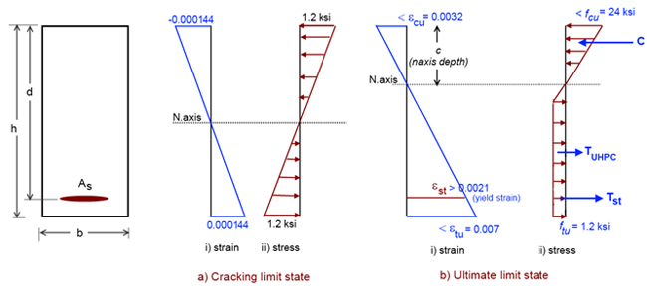
Figure 2.25: Diagrams of strain and stress distribution along the cross-section at cracking and ultimate limit states.

2.12.2. T-Beam Section Behavior
The cracking moment of the T-beam section can be estimated similar to that as the rectangular section. The stress profile along the T-beam cross-section at cracking is shown in figure 2.25. Due to the unsymmetrical cross-section, the values of the positive cracking moment (web in tension) and negative cracking moment (flange in tension) differ significantly from each other. The cracking moment ($M_{cr})$ values for the T-beam can be obtained using the equation shown in the figure.2.27.
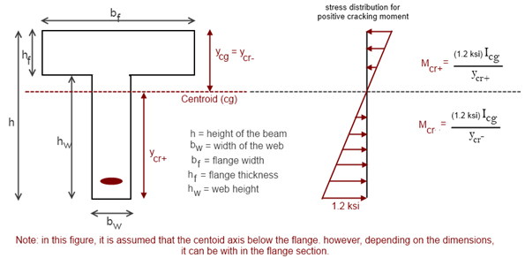
Figure 2.26: Diagrams. Stress profile for estimating the positive cracking moment of a T-shaped beam.

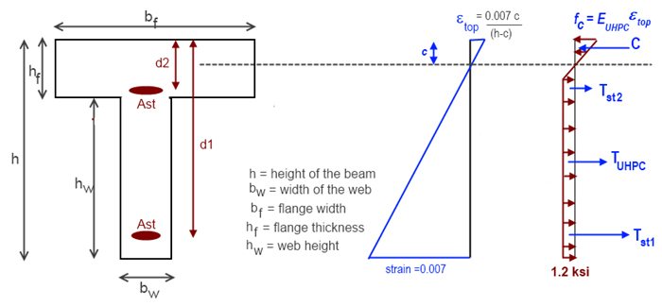
Figure 2.27: Diagrams. Strain and stress profiles for estimating the positive nominal moment of a T-shaped beam.

What becomes apparent after designing a few beams is that for efficiency (minimizing weight) the beam would have the same factor of safety at the top and bottom. If the beam is made of a uniform material, that would mean the top and bottom should have the same section modulus, which means the neutral axis is in the middle. If the materials are different, you would put the higher strength material where the lower section modulus is.
When a T-beam, L-beam (“angle”), or flat bar is welded to the hull or deck plating, the question becomes “how much of the plating can I count as a flange” (i.e. what is “bp” in the spreadsheet)? The question is a good one because of a number of factors, including the philosophical question of: “which would you want to fail first, the hull shell or the flange?”
There are some rules of thumb used by the Classification Societies, as well as theoretical approaches that we will cover as part of the effective breadth and effective width concepts.
Calculating the moment of inertia and the section modulus for a complete ship’s hull is almost identical to that of a simple beam as in the above spreadsheet – except that it includes many more pieces, and we may want to include the possibility of having curved and inclined plates! This is also a great use for a spreadsheet. When these calculations were done by hand, a common approximation was to ignore all the Io contributions of the horizontal plates as they were very small.
These days they are usually included as the spreadsheet calculates them automatically, but you may see both methods used as the difference is very small, except for large stiffeners such as a CVK. Another common practice is to calculate the moment of inertia of just the starboard half of the ship’s cross-section, and then multiply it by two to get the full moment of inertia.
The basic process for calculating the Section Modulus for both “deck” (main deck) and “keel” (bottom plating) for a ship
is as follows:
- Calculate the area of each component ($A_{i}$)
- Calculate the height of each component area (centroid) above the baseline ($y_{i}$)
- Calculate the 1st moment of each component area about the baseline ($A_{i}y_{i}$)
- Calculate the moment of inertia (2nd moment of area) of each component about the baseline ($A_{i}∙y_{i}^{2}$)
- Calculate the moment of inertia of each component about its own horizontal centroidal axis (I0)
Note for vertical or horizontal plates (with breadth b, height h): $I_{o}= bh^{3}/12$
- Calculate the height of the NA above the baseline ($y_{NA}=\frac{\sum{A_{i}∙y_{i}^{2}}}{\sum{A_{i}}}$)
- Calculate the moment of inertia of the total section about the baseline ($I_{BL}=\sum{A_{i}∙y_{i}^{2}}+I_{o}$2 + ΣI0)
- Calculate the moment of inertia of the total section about the NA ($I_{NA}=I_{BL}-A∙y_{NA}^{2}$)
- Calculate the section modulus for deck and keel

Exercise 2.12 (T-Beam)
Figure below shows a simple built of T-beam Stiffener & Plate used for a ship. It is assumed the following is the data for each component, $b_{f}=6.08 in$, $t_{f}=0.455 in$, $b_{w}=5.470 in$, $t_{w}=0.32 in$, $b_{p}=24 in$, $t_{p}=0.5 in$. Determine the moment of inertia and minimum section modulus.
Solution

Example 2.12 (Box-Shaped Barge):
Figure below shows a simple box-shaped barge. It is assumed the following is the data for each component, deck: $b_{d}=6.0 ft$, $t_{d}=1 in$, side: $b_{s}=1 in$, $h_{s}=20 ft$, bottom: $b_{p}=12.5 ft$, $t_{p}=1 in$ in, $M_{max}=34800 ft.LT$. Determine total Moment of inertia of section about NA and the maximum bending stress and FOS.
Deck
Bottom
Side
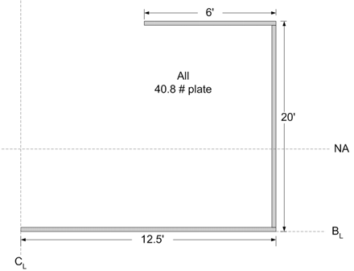

Height of NA above BL: $y_{NA}=\frac{\sum{A_{i}∙y_{i}^{2}}}{\sum{A_{i}}}=\frac{45843}{460}=99.74in ≈100 in ≈8.3 ft$
Total Moment of inertia of section about NA:
$I_{BL}=\sum{A_{i}∙y_{i}^{2}}+I_{o}$
$I_{NA}=I_{BL}-A∙y_{NA}^{2}$
$I_{NA}=1123457.5+7557175-460∙{\left(99.74\right)}^{2}=4104802 {in}^{4}$, this for only ½ the section, so the full, $I_{NA}=2*4104802=8209603.01 {in}^{4}$
The maximum bending stress and FOS is as follows:
$y_{max}=y_{deck}=240-99.74=140.263 in$ ${SM}_{deck}=\frac{I_{NA}}{y_{deck}}=\frac{8209603.01 }{140.263}=58530 {in}^{3}$
$M_{max}=34800 ft.LT$
$σ_{deck}=\frac{M_{max}}{{SM}_{deck}}=\frac{34800}{58530} ∙\left(12\frac{in}{ft}\right)∙\left(2240\frac{lb}{LT}\right)=15982\frac{lb}{{in}^{2}}$
$FOS=\frac{σ_{Y}}{σ_{deck}}=\frac{36 ksi}{15.98 ksi}=2.25$

Not all structure can be considered “structurally effective” for longitudinal bending. It makes sense that only continuous longitudinal structure is counted, and it must be rigidly connected. Hatch covers and stanchions, for example, are not counted as contributing to global (longitudinal) hull strength. A general “rule-of-thumb” is that structural components must be continuous for at least 40% of the LBP to be counted. Additionally, there are “shadow zones” near hatch openings and discontinuities, so that even longitudinally-continuous members might not be counted in these locations. See PNA for more information on “shadow zones”.
For an inclined plate (width w, thickness t, angle to horizontal θ), the local horizontal moment of inertia is given by (this is incorporated into the spreadsheet):

$I_{o}=\frac{wt\left(w^{2}\sin^{2}{θ}+t^{2}\cos^{2}{θ}\right)}{12}$ (2.34)

For curved plate (radius r, area a) approximately thickness times arc length)), the horizontal local moment of inertia is given by (also incorporated into the spreadsheet):

$I_{o}=\left(\frac{1}{2}-\frac{4}{π^{2}}\right)ar^{2}$ , $h=\frac{\left(π-2\right)}{π}r$ (2.35)

2.13. Composite Beam Approach
At this point we have calculated the bending moment and the section modulus of beams and hull girders. That gives us the bending stresses due to waves and hull weight distributions. We used Euler’s beam equation as the numerical model for the “simple beam” analysis. The problem is that Euler’s equation is somewhat limited as it assumes that all the material in the moment of inertia calculation has the same stiffness (Modulus of Elasticity). It is easy to see the issue if we replaced the steel main deck with one made of neoprene. It would be just as watertight, but it sure would not carry the same amount of load!
There is a relatively simple way to take into account different materials in a bending beam. It is not as accurate as using a higher-order method available in finite element analysis, but it works well enough for preliminary design if the factors of safety are adequate. In a nutshell the method “replaces” one of the materials with an amount of the other material that
would give it an equivalent axial stiffness (EA). In other words, you create a flange of the base material that is the same thickness but may be wider or narrower than the actual flange. The method is called the “composite beam” method by naval architects, or the “equivalent area” method by civil engineers.
The method works especially well for simple composite beams such as steel reinforced concrete (civil engineers use this all the time in buildings and bridges), but is adapted and used also to some extent for simple analyses of thin walled beams such as ships. It is also quite often used in “composite construction”. In the 19th century, wood frames capped with a bronze or steel strap and metal frames with wood planking, were frequently used in ship construction. It means fiberglass frames capped with carbon fiber, or similar “composite” configurations.
The most common use in ships is for decks or superstructures of different materials (e.g. an aluminum superstructure with a steel hull). For the method to be most accurate it ideally must be a full-width superstructure, uniform over its length, and rigidly connected. The method is also applied to other structures such as stiffened panels.
The basic steps of the composite beam approach are:
- Define the transformation factor: $T_{i}=\frac{E_{i}}{E_{base}}$, (for example: material $i$= aluminum, base material = steel)
- Transform the breadth of all structural components of material $i$ by multiplying the current breadths by the transformation factor $T_{i}$ (this can be done in a table). Note: The net height of the transformed section must remain the same (we transform only the breadth of the components).
- Using the transformed breadth for components of material i, calculate the section properties for the transformed section:
  - Neutral axis of the transformed section ($NA_{tr}$)
  - Moment of inertia of the transformed section ($I_{tr}$)
  - Section modulus for the extreme fibers of each material (using $NA_{tr}$ and $I_{tr}$)
- Calculate the stresses within each material:
    - Within the base material, $σ_{base}=\frac{M_{y}}{I_{tr}}$ , ($y$ is distance from $NA_{tr}$)
    - Within material $i$ use $σ_{i}=T_{i}\frac{M_{y}}{I_{tr}}$
Note that because of this transformation, a material located closer to the neutral axis might have a lower factor of safety!
The figures on the next page illustrate this transformation.
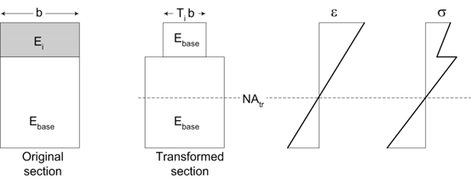
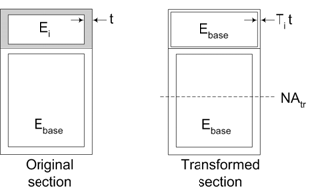

Example 2.13:
Figure below shows a steel-capped wood beam. Determine the minimum FOS for a mahogany & 316L (annealed) SS composite beam w/ a moment of 40,000 ft-lb.
Use $E_{wood}=1.5$5 msi and $E_{steel}=30$ msi
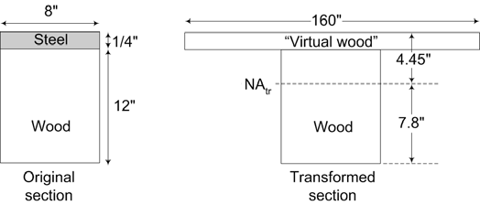
Solution
Chapter 3

3.0 Matrix Algebra Method for Engineering

3.1 Matrix Algebra
The linear system of algebraic equation is written as

$\begin{matrix}a_{11}x_{1}+a_{12}x_{2}+ …+a_{1n}x_{n}=b_{1} \\ a_{21}x_{1}+a_{22}x_{2}+ …+a_{2n}x_{n}=b_{1} \\ … \\ a_{m1}x_{1}+a_{m2}x_{2}+ …+a_{mn}x_{n}=b_{m}\end{matrix}$ (3.1)

Where; $x_{1,…,n}$are the unknowns. Equation.3.1 can be expressed in matrix form as

$Ax=b$ (3.2)

Where; A is a matrix is a rectangular array of numbers arranged in rows (m) and columns (n). The array of numbers below is an example of a matrix.

$A=\left[\begin{matrix}a_{11} & a_{12} & … & a_{1n} \\ a_{21} & a_{22} & … & a_{2n} \\ … & … & … & … \\ a_{m1} & a_{m2} & … & a_{mn}\end{matrix}\right] x=\left\{\begin{matrix}x_{1} \\ x_{2} \\ … \\ x_{m}\end{matrix}\right\} b=\left\{\begin{matrix}b_{1} \\ b_{2} \\ … \\ b_{m}\end{matrix}\right\}$ (3.3)
The number of rows and columns that a matrix has is called its dimension or its order. By convention, rows are listed first; and columns, second.
Matrix Notation
Statisticians use symbols to identify matrix elements and matrices.
- Matrix elements. Consider the matrix below, in which matrix elements are represented entirely by symbols
.$\left[\begin{matrix}a_{11} & a_{12} & … & a_{1n} \\ a_{21} & a_{22} & … & a_{2n} \\ … & … & … & … \\ a_{m1} & a_{m2} & … & a_{mn}\end{matrix}\right]$
- By convention, first subscript refers to the row number; and the second subscript, to the column number. Thus, the first element in the first row is represented by A₁₁. The second element in the first row is represented by A₁₂. And so on, until we reach the fourth element in the second row, which is represented by A_{nm}.
- Matrices. There are several ways to represent a matrix symbolically. The simplest is to use a boldface letter, such as A, B, or C. Thus, A might represent a n x m matrix, as illustrated below.
$$\left[\begin{matrix}a_{11} & a_{12} & … & a_{1m} \\ a_{21} & a_{22} & … & a_{2m} \\ … & … & … & … \\ a_{n1} & a_{n2} & … & a_{nm}\end{matrix}\right]$$
Another approach for representing matrix A is:
A = [ A_{nm} ] where n = 1, 2, …, and m = 1, 2, ….
This notation indicates that A is a matrix with 2 rows and 4 columns. The actual elements of the array are not displayed; they are represented by the symbol A_{nm}.
Matrix Equality
To understand matrix algebra, we need to understand matrix equality. Two matrices are equal if all three of the following conditions are met:
- Each matrix has the same number of rows.
- Each matrix has the same number of columns.
- Corresponding elements within each matrix are equal.

3.1.1 Addition and Subtraction
Consider two matrices A and B, both of dimension (m x n), the addition and subtraction are defined by
$C=A+B$, with $c_{mn}=a_{mn}+b_{mn}$ and $C=A+B$, with $c_{mn}=a_{mn}-b_{mn}$ (3.4)
Example of addition matrices

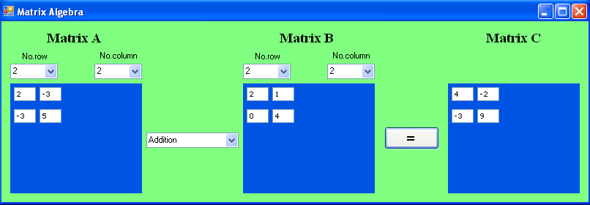
Example of subtraction matrices
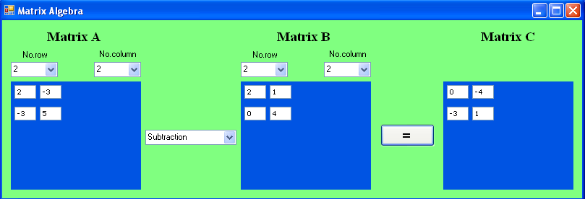

3.1.2 Scalar Multiplication
The multiplication of a matrix A by a scalar $λ$ is defined as
$λA= \left[λa_{mn}\right]$ (3.5)

3.1.3 Matrix Multiplication
The product of an (m x n) matrix A and an (n x l) matrix B results in (m x l) matrix C which is written as
$C=AB$, with $c_{ij}=\sum_{n=1}^{m}{a_{ik}x b_{kj}}$ (3.6)
Where i = 1, 2, …, m; j = 1, 2, …, l.
Note that, in general, $AB≠BA$, but $\left(AB\right)C=A(BC)$.
Example of multiplication matrices
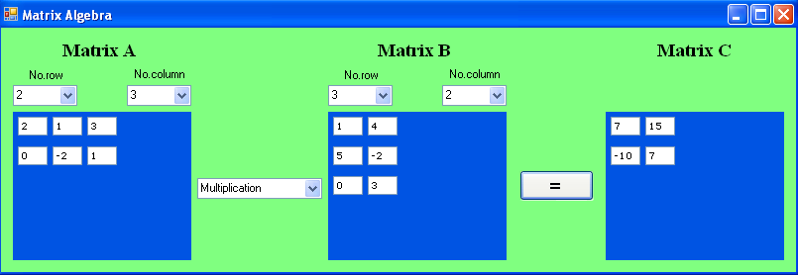

3.1.4 Transpose Matrix
The transpose of one matrix is another matrix that is obtained by using rows from the first matrix as columns in the second matrix. If $A=\left[a_{ij}\right]$, then the transpose of A is
$A^{T}=\left[a_{ji}\right]$ (3.7)
Notice that ${(AB)}^{T}=B^{T} A^{T}$
For example, it is easy to see that the transpose of matrix A is A'. Row 1 of matrix A becomes column 1 of A'; row 2 of A becomes column 2 of A'; and row 3 of A becomes column 3 of A'.
$A=\left[\begin{matrix}a_{11} & a_{12} \\ a_{21} & a_{22} \\ a_{31} & a_{32}\end{matrix}\right]$ $A^{T}=\left[\begin{matrix}a_{11} & a_{21} & a_{31} \\ a_{12} & a_{22} & a_{32}\end{matrix}\right]$
Note that the order of a matrix is reversed after it has been transposed. Matrix A is a 3 x 2 matrix, but matrix A' is a 2 x 3 matrix.
With respect to notation, this web site uses a prime to indicate a transpose. Thus, the transpose of matrix B would be written as B'.
Example of transpose matrix
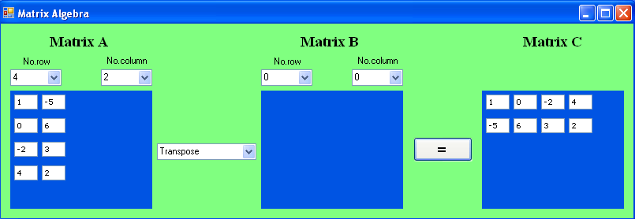

3.1.5 Symmetric Matrix
A square (n x n) matrix A is called symmetric, if

$A= A^{T}$ or $a_{ij}= a_{ji}$ (3.8)

3.1.6 Identity Matrix
The identity matrix is a diagonal matrix with 1’s along the principal diagonal. For example,

$I=\left[\begin{matrix}1 & 0 & 0 \\ 0 & 1 & 0 \\ 0 & 0 & 1\end{matrix}\right]$, that $AI= A$, $Ix = x$ (3.9)

3.1.7 Determinant of a Matrix
The determinant of square matrix $A$ is a scalar number denoted by det $A$ or $\left|A\right|$. For 2 x 2 and 3 x 3 matrices, their determination are given by

$$A= \left[\begin{matrix}a_{11} & a_{12} \\ a_{21} & a_{22}\end{matrix}\right]$$ | $$\det{A}=a_{11}a_{22}-a_{21}a_{12}$$
$$A=\left[\begin{matrix}a_{11} & a_{12} & a_{13} \\ a_{21} & a_{22} & a_{23} \\ a_{31} & a_{32} & a_{33}\end{matrix}\right]$$ | $$\det{A}=a_{11}a_{22}a_{33}+a_{12}a_{23}a_{31}+ a_{21}a_{32}a_{13}-a_{13}a_{22}a_{31}-a_{12}a_{21}a_{33}-a_{23}a_{32}a_{11}$$

Example.4.1:
$A=\left[\begin{matrix}a_{11} & a_{12} & a_{13} & a_{14} \\ a_{21} & a_{22} & a_{23} & a_{24} \\ a_{31} & a_{32} & a_{33} & a_{34} \\ a_{41} & a_{42} & a_{43} & a_{44}\end{matrix}\right]$, | Find determinant A
Solution

Det A = $a_{11}a_{22}a_{33}a_{44}$ + $a_{11}a_{23}a_{34}a_{42}$ + $a_{11}a_{24}a_{32}a_{43}$
+ $a_{12}a_{21}a_{34}a_{43}$ + $a_{12}a_{23}a_{31}a_{44}$ + $a_{12}a_{24}a_{33}a_{41}$
+ $a_{13}a_{21}a_{32}a_{44}$ + $a_{13}a_{22}a_{34}a_{41}$ + $a_{13}a_{24}a_{31}a_{42}$
+ $a_{14}a_{21}a_{33}a_{42}$ + $a_{14}a_{22}a_{31}a_{43}$ + $a_{14}a_{23}a_{32}a_{41}$
- $a_{11}a_{22}a_{34}a_{43}$ - $a_{11}a_{23}a_{32}a_{44}$ - $a_{11}a_{24}a_{33}a_{42}$
- $a_{12}a_{21}a_{33}a_{44}$ - $a_{12}a_{23}a_{34}a_{41}$ - $a_{12}a_{24}a_{31}a_{43}$
- $a_{13}a_{21}a_{34}a_{42}$ - $a_{13}a_{22}a_{31}a_{44}$ - $a_{13}a_{24}a_{32}a_{41}$
- $a_{14}a_{21}a_{32}a_{43}$ - $a_{14}a_{22}a_{33}a_{41}$ - $a_{14}a_{23}a_{31}a_{42}$

3.1.8 Singular Matrix
A square matrix A is singular if det A = 0, which indicates problems in the system (non-unique solutions, degeneracy, etc.)

3.1.9 Matrix Inversion
For a square and non-singular matrix A (det A $≠$ 0), its inverse $A^{-1}$ is constructed in such a way that

$AA^{-1}= A^{-1} A=I$ (3.10)

The cofactor matrix (C) of matrix A is defined by

$C_{ij}= {\left(-1\right)}^{i+j} M_{ij}$

Where $M_{ij}$ is the determinant of the smaller matrix obtained by eliminating the i^{th} row and j^{th} column of A.

Thus, the inverse of A can be determined by

$A^{-1}=\frac{1}{\det{A }} C^{T}$ (3.11)

We can show that ${\left(AB\right)}^{-1}=B^{-1} A^{-1}$.

Example.1:
$${\left[\begin{matrix}a & b \\ c & d\end{matrix}\right]}^{-1}=\frac{1}{\left(ad-bc \right)}\left[\begin{matrix}d & -b \\ -c & a\end{matrix}\right]$$

Checking,
$${\left[\begin{matrix}a & b \\ c & d\end{matrix}\right]}^{-1} \left[\begin{matrix}a & b \\ c & d\end{matrix}\right]= =\frac{1}{\left(ad-bc \right)}\left[\begin{matrix}d & -b \\ -c & a\end{matrix}\right] \left[\begin{matrix}a & b \\ c & d\end{matrix}\right]= \left[\begin{matrix}1 & 0 \\ 0 & 1\end{matrix}\right]$$

Example.2:
$${\left[\begin{matrix}1 & -1 & 0 \\ -1 & 2 & -1 \\ 0 & -1 & 2\end{matrix}\right]}^{-1}=\frac{1}{\left(4-2-1 \right)}{\left[\begin{matrix}3 & 2 & 1 \\ 2 & 2 & 1 \\ 1 & 1 & 1\end{matrix}\right]}^{T}=\left[\begin{matrix}3 & 2 & 1 \\ 2 & 2 & 1 \\ 1 & 1 & 1\end{matrix}\right]$$

Checking
$$\left[\begin{matrix}1 & -1 & 0 \\ -1 & 2 & -1 \\ 0 & -1 & 2\end{matrix}\right]\left[\begin{matrix}3 & 2 & 1 \\ 2 & 2 & 1 \\ 1 & 1 & 1\end{matrix}\right]= \left[\begin{matrix}1 & 0 & 0 \\ 0 & 1 & 0 \\ 0 & 0 & 1\end{matrix}\right]$$

If det $A = 0$, (i.e is singular), then $A^{-1}$ does bot exist. The solution of the linear system of the equation 4.1 can be expressed as

$X = A^{-1} b$ (3.12)

Thus, the main task in solving a linear system of equation is to found the inverse of the coefficient matrix.

3.1.10 Positive Define Matrix
A square (n x n) matrix A is said to be positive define, if for all non-zero vector x of dimension n

$X^{T}Ax >0$ (3.13)

Note that positive matrices are non singular.

3.1.11 Differentiation and Integration of a Matrix
Let

$A\left(t\right)=\left[a_{ij}(t)\right]$

then the differentiation is defined by

$\frac{d}{dt}A\left(t\right)= \left[\frac{da_{ij}(t)}{dt}\right]$ (3.14)

and the integration by

$\int{A\left(t\right)}=\left[\int{a_{ij}(t)}dt\right]$ (3.15)

Chapter 4

4.0. Application of Finite Element in Ships and Offshore Structures

4.1 Introduction
The Finite Element Analysis method (also called FEM for “Finite Element Method”), goes back to ancient mathematicians. Archimedes used the basic technique with a 96-side polygon to approximate the value of π to 30 decimal places (recall that the circumference of a circle = 2πr). The FEA was first developed in 1943 by R. Courant, who utilized the Ritz method of numerical analysis and minimization of variations calculus to obtain approximate solutions to vibration systems. Shortly thereafter, a paper published in 1956 by M. J. Turner, R. W. Clough, H. C. Martin, and L. J. Topp established a broader definition of numerical analysis. The paper centered on the "stiffness and deflection of complex structures".
By the early 70's, FEA was limited to expensive mainframe computers generally owned by the aeronautics, automotive, defense, and nuclear industries. Since the rapid decline in the cost of computers and the phenomenal increase in computing power, FEA has been developed to an incredible precision. Present day supercomputers are now able to produce accurate results for all kinds of parameters.
The single biggest development in ship structural design and analysis over the last decade has been the introduction and acceptance of FEA. This tool has significantly changed the way we design ships and its use will continue to grow. It offers both faster and more accurate solution to complex structural problems. For the structural design engineer, it is necessary to know both the basic theory that it uses (so you know its limitations) and how the particular computer code functions. FEA is not “reality”, and Finite Element Analysis computer programs are not always correct, so sometimes it can provide some incredibly bad results (although it is usually human “operator” error which produces the incredibly bad results with Finite Element Analysis computer programs).

4.2 What is Finite Element Analysis
The Finite Element Analysis is used in structural design to solve complex structural problems. Applications include linear, nonlinear (due to nonlinearities in material, geometry (contact, etc.), boundary conditions, etc.), dynamic (ballistic, impact, transient, harmonics/vibration), heat transfer, and fluid dynamics.
The FEA consists of a computer model of a material or design that is stressed and analyzed for specific results. It is used in new product design, and existing product refinement. A company is able to verify a proposed design will be able to perform to the client's specifications prior to manufacturing or construction. Modifying an existing product or structure is utilized to qualify the product or structure for a new service condition. In case of structural failure, FEA may be used to help determine the design modifications to meet the new condition.
There are generally two types of analysis that are used in industry: 2-D modeling, and 3-D modeling. While 2-D modeling conserves simplicity and allows the analysis to be run on a relatively normal computer, it tends to yield less accurate results. 3-D modeling, however, produces more accurate results while sacrificing the ability to run on all but the fastest computers effectively. Within each of these modeling schemes, the programmer can insert numerous algorithms (functions) which may make the system behave linearly or non-linearly. Linear systems are far less complex and generally do not take into account plastic deformation. Non-linear systems do account for plastic deformation, and many also are capable of testing a material all the way to fracture.

4.3 How Does Finite Element Analysis Work?
In Finite Element Analysis, a structure is firstly divided into a large number of discrete sub-structures called “elements”. Each element is “connected” to adjacent elements at points called “nodes”, where the “loads” (forces and moments) are applied, and “displacements” (translations and rotations) are determined. For the total structure, including the many elements which make it up, the laws of solid mechanics are applied (within each element and between elements): equilibrium of forces and moments (statics and dynamics), compatibility of displacements (translations and rotations), laws of material behavior (stress-strain or “Hooke’s” laws), to name only a few.

Figure.4.1: Structures analysis using Finite Element Method.

These nodes make a grid called a mesh. This mesh is programmed to contain the material and structural properties which define how the structure will react to certain loading conditions. Nodes are assigned at a certain density throughout the material depending on the anticipated stress levels of a particular area. Regions which will receive large amounts of stress usually have a higher node density than those which experience little or no stress. Points of interest may consist of: fracture point of previously tested material, fillets, corners, complex detail, and high stress areas. The mesh acts like a spider web in that from each node, there extends a mesh element to each of the adjacent nodes. This web of vectors is what carries the material properties to the object, creating many elements.

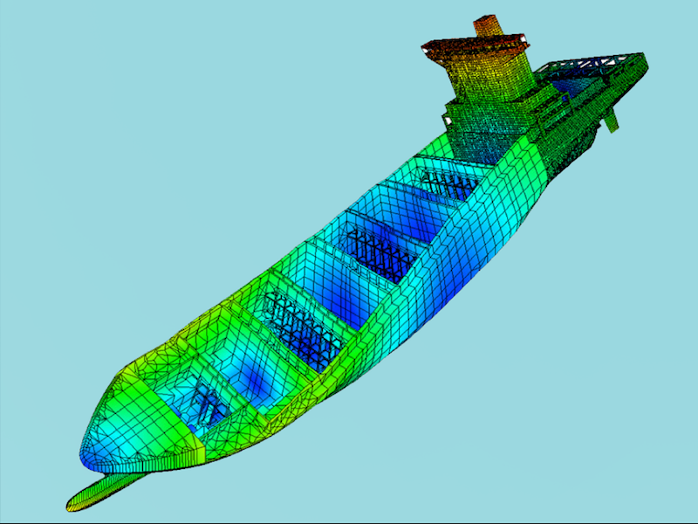

Figure.4.2: An example of mesh.

4.4 FEA in Engineering Analysis
Brief Story of Finite Element
- 1943: courant (Variational methods),
- 1956: Turner, Clough, Martin and Topp (Stiffness)
- 1960: Clough (Finite Element “Plane Problem”,
- 1970s: Application on mainframe computer,
- 1980s: microscumputer pre and postprocessors,
- 1990s: analysis of large structural system

Finite Element is widely used in engineering such as:
- Mechanical, ship and offshore, aerospace, automotive and civil engineering
- Structural analysis static/dynamic, linear and nonlinear
- Thermal and fluid flows
- Fatigue and vibration
- Electromagnetics
- Geomechanics
- Biomechanics

Structural analysis consists of linear and non-linear models. Linear models use simple parameters and assume that the material is not plastically deformed. Non-linear models consist of stressing the material past its elastic capabilities. The stresses in the material then vary with the amount of deformation as in Figure 6.3.
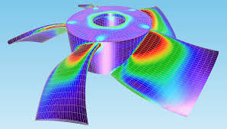 | 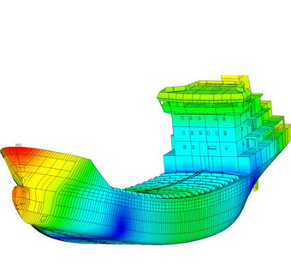
Figure.4.3: Stress analysis using FEM
Vibrational analysis is used to test a material against random vibrations, shock, and impact. Each of these incidences may act on the natural vibrational frequency of the material which, in turn, may cause resonance and subsequent failure.
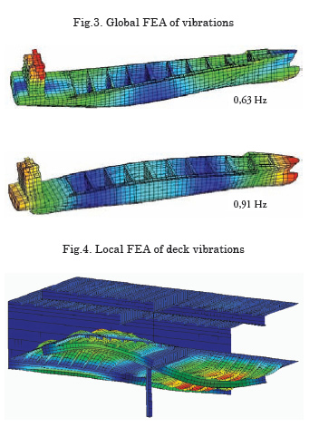 | 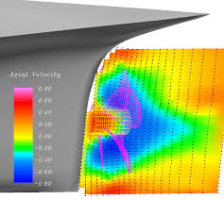
Figure.4.4: Vibration analysis using FEM
Fatigue analysis helps designers to predict the life of a material or structure by showing the effects of cyclic loading on the specimen. Such analysis can show the areas where crack propagation is most likely to occur. Failure due to fatigue may also show the damage tolerance of the material (Figure 6.5).
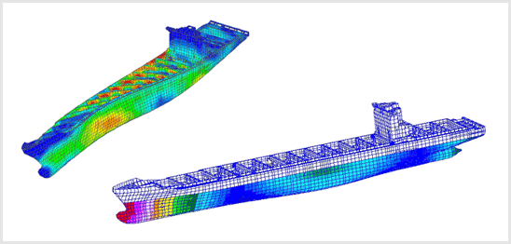
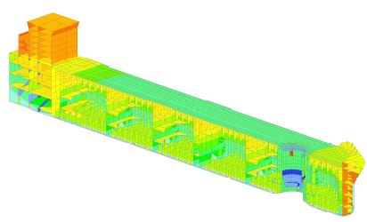
Figure.4.5: Fatigue analysis using FEM.
Heat Transfer analysis models the conductivity or thermal fluid dynamics of the material or structure (Figure 6.6). This may consist of a steady-state or transient transfer. Steady-state transfer refers to constant thermo properties in the material that yield linear heat diffusion.
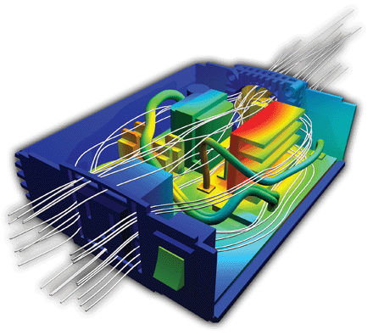 | 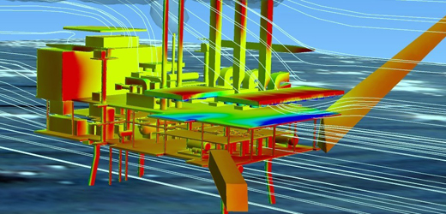
Figure.4.6: Heat Transfer analysis using FEM.

Results of Finite Element Analysis
FEA has become a solution to the task of predicting failure due to unknown stresses by showing problem areas in a material and allowing designers to see all of the theoretical stresses within. This method of product design and testing is far superior to the manufacturing costs which would accrue if each sample was actually built and tested.

4.5 Types of Finite Elements
The mechanical behavior of each element is modeled using equations from solid mechanics. The basic types of elements include truss, beam, shell and solid as shown in Table.5.1 - 5.2.

Table.4.1: Dimension of elements
1-D (Line) Element | spring, truss, beam, pipe etc.
2-D (Plane) Element | Membrane, plate, shell, etc
3-D (Solid) Element | 3-D fields,- temperature, displacement, stress, flow velocity  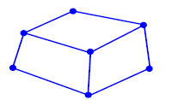

Table.4.2: Basic types of elements
Truss elements  2-node elements which allow only translation at the nodes (1-3 Degree Of Freedom (FOD) per node). Used for bars and rods.  Note that a “truss” element has “pinned” ends, and therefore can carry no end moments. The bar element has 2 nodes (one at each end, and 2 total DOF (1 translation at each node). | Beam Elements  2-node elements which allow translation and rotation at each node (2-6 DOF per node).
Shell Elements  3-node (triangular shell) or 4-node (quad shell) elements. Used for “thin” plates (flat or curved). | Solid Elements  4-node (tetrahedral) or 8-node (brick) elements. Used for “thick” plates or solid parts.

Once the structure is modeled using these discrete elements, then the elements must be interconnected at the nodes (compatibility), then the loads (or displacements) must be applied (at the nodes), then the displacements and stresses can be determined at the nodes using methods of matrix math (known as “Linear Algebra” or “Matrix Algebra”).

Note --------------------------------------------------------------------------------------------------------
It should be realized that Finite Element Analysis is a numerical approximation of a complex structure. It is not “reality”. It is made by breaking the structure up into small (discrete) parts whose mechanical behavior can be better modeled and predicted than the entire structure as a whole.
The model and results can usually be made more accurate by making the element sizes smaller, but it is still only as good as the simplified mechanics equations used (solid or “continuum” mechanics). Why a model with really small elements (called “fine mesh”) is not always more accurate is a function of how stress is calculated.
A simple example is that of tensile stress P/A. As the area (A) gets smaller, the stress goes up. If the force (P) cannot be easily resolved at the nodes, then the Finite Element Analysis code will over-predict the stresses at certain nodes. You will see examples of this in class.

4.6 Spring Systems

4.6.1. One Spring Element

Structural elements (truss, beam, shell, solid) are modeled as spring-like objects. Consider a simple 1-D truss element (a “bar”) attached at one end with a force applied at the other to act as a spring as shown in the figure below. The nodal force ($f_{i,j}$) is equal to the nodal displacement of the end point ($u_{i,j}$) multiplied by a spring constant (we call “stiffness” $k$).

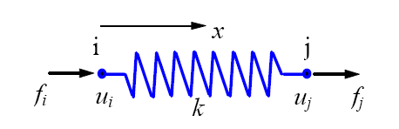  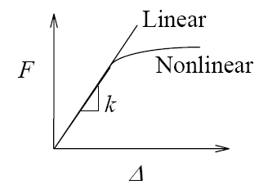 | Spring force –displacement relationship is written as:  $F = k ∆$ where; $∆ =u_{j}-u_{i}$  $k=\frac{F}{∆}$, (> 0) is the force needed to produce a unit strecth.  Consider linear proble, the uqilibrium of forces for the spring at node i and j respectively can be expressed as :  $f_{i}= -k\left(u_{j} – u_{i}\right)=ku_{i}-ku_{j}$  $$f_{j}= k\left(u_{j} – u_{i}\right)=-ku_{i}+ku_{j}$$  In matrix form can be written as:  $\left[\begin{matrix}k & -k \\ -k & k\end{matrix}\right] \left\{\begin{matrix}u_{i} \\ u_{j}\end{matrix}\right\} = \left\{\begin{matrix}f_{i} \\ f_{j}\end{matrix}\right\}$ or  $f= k u$  where, k is stiffness matrix, u is displacement vector, and f force vector

4.6.2. Two Spring Elements

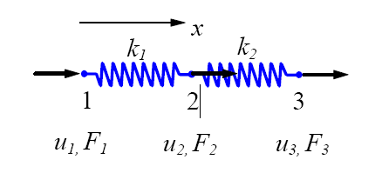
For element 1,  $$\left[\begin{matrix}k_{1} & {-k}_{1} \\ {-k}_{1} & k_{1}\end{matrix}\right] \left\{\begin{matrix}u_{1} \\ u_{2}\end{matrix}\right\} = \left\{\begin{matrix}f_{1}^{1} \\ f_{2}^{1}\end{matrix}\right\}$$ | For element 2  $$\left[\begin{matrix}k_{2} & {-k}_{2} \\ {-k}_{2} & k_{2}\end{matrix}\right] \left\{\begin{matrix}u_{2} \\ u_{3}\end{matrix}\right\} = \left\{\begin{matrix}f_{1}^{2} \\ f_{2}^{2}\end{matrix}\right\}$$
Where $f_{i}^{m}$ is the internal force acting on local node i of element m (i = 1,2).

Consider the equilibrium of forces at as follows:

node 1  $$F_{1}=f_{1}^{1}$$ | node 2  $$F_{2}= f_{2}^{1}+ f_{1}^{1}$$ | node 3  $$F_{3}=f_{2}^{2}$$

That is
$$F_{1}=k_{1}u_{1}-k_{1}u_{2}$$ | $$F_{2}={-k}_{1}u_{1}+\left(k_{1}+k_{2}\right)u_{2}-k_{2}u_{3}$$ | $$F_{3}={-k}_{2}u_{2}+k_{2}u_{3}$$
In matrix form
$$\left[\begin{matrix}k_{1} & {-k}_{1} & 0 \\ {-k}_{1} & k_{1}+k_{2} & {-k}_{2} \\ 0 & {-k}_{2} & k_{2}\end{matrix}\right] \left\{\begin{matrix}u_{1} \\ u_{2} \\ u_{3}\end{matrix}\right\} = \left\{\begin{matrix}F_{1} \\ F_{2} \\ F_{3}\end{matrix}\right\}= \left\{\begin{matrix}f_{1}^{1} \\ f_{2}^{1}+ f_{1}^{1} \\ f_{2}^{2}\end{matrix}\right\}$$

Boundary and local conditions:
Assuming $u_{1}=0$ and $F_{2}=F_{3}=P$, we have

$$\left[\begin{matrix}k_{1} & {-k}_{1} & 0 \\ {-k}_{1} & k_{1}+k_{2} & {-k}_{2} \\ 0 & {-k}_{2} & k_{2}\end{matrix}\right] \left\{\begin{matrix}0 \\ u_{2} \\ u_{3}\end{matrix}\right\} = \left\{\begin{matrix}F_{1} \\ P \\ P\end{matrix}\right\}$$

Which reduces to

$\left[\begin{matrix}k_{1}+k_{2} & {-k}_{2} \\ {-k}_{2} & k_{2}\end{matrix}\right] \left\{\begin{matrix}u_{2} \\ u_{3}\end{matrix}\right\} = \left\{\begin{matrix}P \\ P\end{matrix}\right\}$ and $F_{1}=k_{1}u_{2}$, unknowns $\left\{\begin{matrix}u_{2} \\ u_{3}\end{matrix}\right\}$.

Solving the equations, we obtain the displacements

$\left\{\begin{matrix}u_{2} \\ u_{3}\end{matrix}\right\}=\left\{\begin{matrix}P/{k_{1}} \\ {2P}/{k_{1}}+P/{k_{2}}\end{matrix}\right\}$ and the reaction force $F_{1}=-2P$.

4.7. Exercises
Three Spring Elements  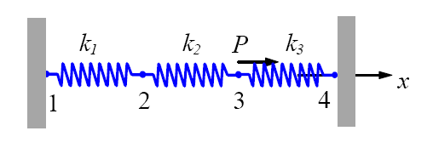 | Determine the matrix form of the spring elements

Chapter 5

5.0 Introduction to Finite Element

5.1 Introduction
Most structural analysis problem can be treated as linear static problem, based on the following assumptions
- Small deformations (Loading pattern is not changed due to the deformed shape)
- Elastic materials (no plasticity or failures)
- Static loads (the load is applied to the structure in a slow or steady fashion)
Linear analysis can provide most of the information about the behavior of a structure and can be good approximation for many analyses. It is also the bases of nonlinear analysis in most of the cases.

5.2 The Stiffness Matrix Method
Consider a uniform prismatic bar as shown below

.
$$k_{x}$$
$$f_{x}$$
$$u_{x}$$
$$u_{x}=0$$

Figure.5.1: Uniform prismatic bar.

If $L$ is length, $A$ is cross-sectional area, $E$ is elastic modulus, $u=u(x)$ is displacement, $ε=ε(x)$ is strain and $σ=σ(x)$ is stress, then strain-displacement relation is $ε=\frac{du}{dx}$ and stress-strain relation can be written as $σ=Eε$. For the 1-D bar element (similar to the spring) can be written as

$f_{x}= k_{x} u_{x}$ (5.1)

where $f_{x}$ is applied force ((N)) in x-direction, $k_{x}$ is stiffness of element (N/m) in x-direction and $u_{x}$ is displacement (m) in x-direction. The “stiffness” for a 1-D truss element (bar) can be derived as

$k =\frac{force}{displacement}= \frac{F}{\frac{F ∙ L}{A ∙ E}}= \frac{A ∙E}{L}$ (1-D bar element) (5.2)

To give a better understanding of some of the fundamental mathematics (without delving too deeply into the theory of matrix algebra), we will discuss several simple applications of FEA which illustrate the general process. This simplified version of FEA is often called the “Stiffness Matrix Method”.
For each node in a structure, we have 6 possible displacements – in 6 possible degrees of freedom (DOF): 3 (linear) translations ($u_{x}, u_{y}, u_{z}$) and 3 (angular) rotations ($r_{x}, r_{y}, r_{z}$). Displacements may be specified at certain nodes (such as boundary conditions (BCs) or calculated. For each node, we also have 6 possible forces: 3 linear forces ($f_{x}, f_{y}, f_{z}$) and 3 moments ($m_{x}, m_{y}, m_{z}$). The stiffness matrix for each element depends upon geometries and material properties.

5.3 The Stiffness Matrix: Bar Element
Let’s take a simple 1-D bar element (a 1-D version of the “truss” element) (axial displacement only along the x-axis).

Figure.5.2: Simple bar element

From static equilibrium, the element stiffness matrix can be written as:

Applying a force ($f_{x1}$) at node 1,  $$f_{x1}= k\left(u_{x1}-u_{x2}\right) = ku_{x1}-ku_{x2}$$ | Apply a force ($f_{x2}$) at node 2,  $$f_{x2}= k\left(u_{x2}-u_{x1}\right)= ku_{x2}-ku_{x1}$$
The simultaneous equations in “matrix form” can be written as:

$\left[\begin{matrix}k_{1} & {-k}_{1} \\ {-k}_{1} & k_{1}\end{matrix}\right] \left\{\begin{matrix}u_{x1} \\ u_{x2}\end{matrix}\right\} = \left\{\begin{matrix}f_{x1} \\ f_{x2}\end{matrix}\right\}$ (5.3)

From above equation, the “element stiffness matrix” is a “square matrix” and is of size DOF x DOF (2 x 2), the element displacement array is 1 x DOF (1 x 2) and is therefore a vector, and the force array is also 1 x DOF (1 x 2) and is also a vector.
As discussed early, the axial stiffness of a bar is $k= \frac{AE}{L}$, Then, the element stiffness matrix can be re-written as:

$\left[k^{e}\right]=\left[\begin{matrix}k_{11} & k_{12} \\ k_{21} & k_{22}\end{matrix}\right]= \left[\begin{matrix}\frac{AE}{L} & -\frac{AE}{L} \\ -\frac{AE}{L} & \frac{AE}{L}\end{matrix}\right]=\frac{AE}{L}\left[\begin{matrix}1 & -1 \\ -1 & 1\end{matrix}\right]$ (5.4)

Recall that we desire the displacements, which we can get by “inverting” the stiffness matrix: $\left\{u\right\}= {\left[k\right]}^{-1} \left\{f\right\}$. From “matrix algebra”, for a 2 x 2 matrix,

$\left[A\right]=\left[\begin{matrix}a & b \\ c & d\end{matrix}\right]={\left[A\right]}^{-1}\frac{\left[\begin{matrix}d & -b \\ -c & a\end{matrix}\right]}{ad-bc}$ ,

Then the element stiffness can be

${\left[k^{e}\right]}^{-1}=\left(\frac{AE}{L}\right)\frac{\left[\begin{matrix}1 & 1 \\ 1 & 1\end{matrix}\right]}{\left(1\right)\left(1\right)- (-1)(-1)}$ (5.5)

This inverted matrix is singular. In other word the inversion gives a 0 on the bottom, or infinite values. Thus the displacements are unbounded (infinite), which means our structure would have “Rigid Body Motion” (RBM). This means that we need to prescribe some type of constraints on our displacements (we call these constraints “boundary conditions”). For our bar element, in order to avoid RBM, we need at least 1 of the 2 nodes to be constrained. Then this effectively “reduces” the stiffness matrix to one that is not singular.
Let’s fix node 2 ($u_{x2}=0$). Then, the applied ($f_{x1}$) and reaction ($f_{x2}$) forces can be written as

$f_{x1}= k_{11}u_{x1}$, and $f_{x2}= k_{21}u_{x1}$

Thus we can solve for our unknown displacement at node 1, and also our unknown reaction force at node 2. Once we have displacements at nodes 1 and 2, we can find the average axial strain in the bar element:

$ε=\frac{u_{x1}-u_{x2}}{L}$

The average axial stress in the bar element (using Hooke’s Law):

$σ=εE$ (5.6)

This is the solution to a FEA problem. For many elements (combining together to make the structure), we create arrays (vectors and matrices), which are denoted with capital letters F, K and U.

$\left\{f\right\}= \left[k^{e}\right] \left\{u\right\} →\left\{F\right\}= \left[K\right] \left\{U\right\}$ (5.7)

Where; F is vector array of nodal forces “Force Vector”, K is matrix element stiffness “Stiffness Matrix” and U is vector array of nodal displacements “Displacement Vector”. This can be solved mathematically using a matrix inversion method (this is analogous to simple division for the 1-D case):

$\left\{F\right\}=\left[K\right]\left\{U\right\} → \left\{U\right\}= {\left[K\right]}^{-1}\left\{F\right\}$ (5.8)

Once the displacements {U} are known, then the strains and stresses can be determined:

- $ε= \frac{∆u}{L} \left(strain for the 1-D bar, more complicated for 2-D and 3-D\right)$
- $σ= E∙ε \left(stress for the 1-D bar, more complicated for 2-D and 3-D\right)$

As shown above, the Finite Element Analysis solution for the displacement array $\{U\}$ is found by multiplying the inverse of the stiffness matrix $[K]$ and the force array $\{F\}$. While the fundamental idea is somewhat straight forward, the mathematics to implement this (especially calculating the inverse of the stiffness matrix) is not, and requires a detailed understanding of matrix algebra (linear algebra).
Let’s take two axial elements,

Figure.5.3: Two axial elements.

For the 2-element axial bar, the forces at the nodes can be related:
$$F_{A}=f_{a1}$$ | $$F_{B}=f_{a2}+f_{b1}$$ | $$F_{C}=f_{b2}$$

The displacements of the nodes can also be related:
$$U_{A}=u_{a1}$$ | $$U_{B}=u_{a2}=u_{b1}$$ | $$U_{C}=u_{b2}$$

Combining these relations with the basic results for the single element bar from the previous pages, we have:
$$F_{A}=k_{a}U_{A}-k_{a}U_{B}$$  $$F_{B}=-k_{a}U_{A}+k_{a}U_{B}+k_{b}U_{B}-k_{b}U_{C}$$  $$F_{C}={-k}_{b}U_{B}-k_{b}U_{C}$$ | where  $k_{a}=\frac{A_{a}E_{a}}{L_{a}}$, $k_{b}=\frac{A_{b}E_{b}}{L_{b}}$

This can be written in “matrix form” as:

$\left\{\begin{matrix}F_{A} \\ F_{B} \\ F_{C}\end{matrix}\right\}=\left[\begin{matrix}k_{a} & -k_{a} & 0 \\ -k_{a} & k_{a}+k_{b} & {-k}_{b} \\ 0 & -k_{b} & k_{b}\end{matrix}\right] \left\{\begin{matrix}U_{A} \\ U_{B} \\ U_{C}\end{matrix}\right\}$

Note that the stiffness matrix $[K]$ can actually be “assembled” from the element stiffness matrices $[k^{e}]$ along the diagonal.
Consider for the 2-element bar a constraint (boundary condition) at node A so that $U_{A}=0$, with applied forces $F_{A}$ and $F_{B}$. This 3 x 3 matrix problem can be solved by “partitioning” matrix [K] (and then inverting partitioned sub-matrix). We partition around known displacements (BCs) as illustrated below.

$\left\{\begin{matrix}F_{A} \\ F_{B} \\ F_{C}\end{matrix}\right\}=\left[\begin{matrix}k_{a} & -k_{a} & 0 \\ -k_{a} & k_{a}+k_{b} & {-k}_{b} \\ 0 & -k_{b} & k_{b}\end{matrix}\right] \left\{\begin{matrix}0 \\ U_{B} \\ U_{C}\end{matrix}\right\}$

Partitioning around the known UA gives the following relations, which can be used to solve for the unknown displacements (UB and UC) and unknown support reaction at the constraint (FA):

For the lower partition:

$$\left\{\begin{matrix}F_{B} \\ F_{C}\end{matrix}\right\}=\left[\begin{matrix}-k_{a} & k_{a}+k_{b} & {-k}_{b} \\ 0 & -k_{b} & k_{b}\end{matrix}\right] \left\{\begin{matrix}U_{B} \\ U_{C}\end{matrix}\right\}+\left[\begin{matrix}{-k}_{b} \\ 0\end{matrix}\right]\left\{U_{A}=0\right\}$$

plus for the upper partition:

$F_{A}=k_{a}\left\{U_{A}=0\right\}+\left[\begin{matrix}-k_{a} & 0\end{matrix}\right] \left\{\begin{matrix}U_{B} \\ U_{C}\end{matrix}\right\}$

Finally, solving for strain and stress:

$ε_{a}=\frac{U_{B}-U_{A}}{L_{a}}$, $ε_{b}=\frac{U_{C}-U_{B}}{L_{b}}$, $σ_{a}=ε_{a}E_{a}$, $σ_{b}=ε_{b}E_{b}$

5.4. Exercises:
Exersice.1 Propulsion Shaft Analysis Using the Stiffness Matrix Method
You need to analyze the propeller drive train, shown schematically below. The goal is to figure out how far the propeller will move forward under load, thereby giving you a minimum spacing between the propeller and strut

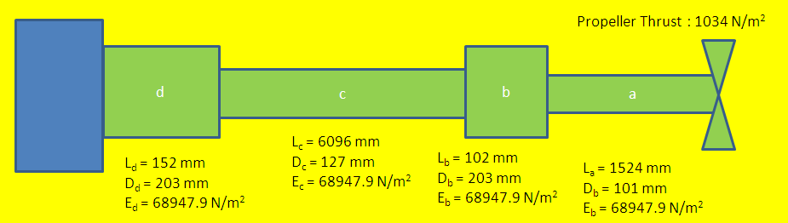

Determine displacement, strain and stress.

Exersice.2

Determine displacement, strain and stress.

5.5 Trusses Element

5.5.1. 2-D (Plane) Trusses
The main difference between 1-D structure and the trusses is the truss element has various orientations which are explained in local and global coordinates. The local coordinate run along the element, but the global element is fixed and does not depend on the element’s orientation.

Figure.5.4: Simple two-dimensional truss element.

The element matrix equation can be written in a similar manner to the bar element, except adding the additional DOF at each node. Also note that the y-displacements do not produce a force directly to the truss element (since it is pin-ended).

at x-direction  $f_{x1}=k u_{1}-ku_{2}$  $f_{x2}=-k u_{1}+ku_{2}$ | at y-direction  $f_{y1}=0$  $f_{y2}=0$

The matrix equation can be written as

$\left\{f\right\}=\left[k^{e}\right]\left\{u\right\}→ \left\{\begin{matrix}f_{x1} \\ f_{y1} \\ f_{x2} \\ f_{y2}\end{matrix}\right\}=\frac{AE}{L}\left[\begin{matrix}1 & 0 & -1 & 0 \\ 0 & 0 & 0 & 0 \\ -1 & 0 & 1 & 0 \\ 0 & 0 & 0 & 0\end{matrix}\right]\left\{\begin{matrix}u_{1} \\ v_{1} \\ u_{2} \\ v_{2}\end{matrix}\right\}$ (5.9)

The “global” structure stiffness matrix can be built as before (by “assembly” using the element stiffness matrices).
Consider a truss element oriented at an angle $Φ$ from the horizontal as shown in the figure below. The members of a trusses structure are oriented at angles to one another forming triangular sub-structures which provide the rigidity to the truss. Therefore, in order to combine different truss elements, each with different element coordinates (x and y), a transformation must be used. The way this is done is to establish a set of global coordinates (X and Y), into which the local element coordinates (x and y) are transformed. In order to understand, simple trigonometry is used for this transformation.
Element and structure coordinate frames | Transformation from global into local coordinates.

Figure.5.5: Plane trusses element in local and global coordinates.

Consider node.1, forces applied in the global X-Y coordinate frame can be transformed into the element x-y frame as follows. This is a standard vector coordinate transformation:

x-direction  $f_{x1}=F_{x1}\cos{ϕ}+F_{y1}\sin{ϕ}$  $f_{y1}=F_{x1}\sin{ϕ}+F_{y1}\cos{ϕ}$ | y-direction  $f_{x2}=F_{x2}\cos{ϕ}+F_{y2}\sin{ϕ}$  $f_{y2}=-F_{x2}\sin{ϕ}+F_{y2}\cos{ϕ}$

Thus, the forces in the global coordinate frame {F} can be transformed to forces in the local or element coordinate frame {f} with a matrix multiplication:

$\left\{\begin{matrix}f_{x1} \\ f_{y1} \\ f_{x2} \\ f_{y2}\end{matrix}\right\}=\left[\begin{matrix}\cos{ϕ} & \sin{ϕ} & 0 & 0 \\ \sin{ϕ} & \cos{ϕ} & 0 & 0 \\ 0 & 0 & \cos{ϕ} & \sin{ϕ} \\ 0 & 0 & -\sin{ϕ} & \cos{ϕ}\end{matrix}\right]\left\{\begin{matrix}F_{X1} \\ F_{Y1} \\ F_{X2} \\ F_{Y2}\end{matrix}\right\}$ (5.10)

The matrix is called the “transformation matrix”, and is denoted [T], thus

$\left\{f\right\}=\left[T\right]\left\{F\right\}, ……where T=\left[\begin{matrix}\cos{ϕ} & \sin{ϕ} & 0 & 0 \\ \sin{ϕ} & \cos{ϕ} & 0 & 0 \\ 0 & 0 & \cos{ϕ} & \sin{ϕ} \\ 0 & 0 & -\sin{ϕ} & \cos{ϕ}\end{matrix}\right] "TM (2-D)"$ (7.5.3)

Just as the force vector can be transformed using the transformation matrix, the displacement vector be transformed using the (same) transformation matrix! Thus:

$\underset{force}{\underbrace{\left\{f\right\}=\left[T\right]\left\{F\right\}}} and \underset{displacement}{\underbrace{\left\{u\right\}=\left[T\right]\left\{U\right\}}}$ (5.11)

Using a little “matrix algebra”:

$\underset{Eq.7.5.1}{\underbrace{\left\{f\right\}=\left[k^{e}\right]\left\{u\right\}}}→ \underset{Eq.7.5.4}{\underbrace{\left[T\right]\left\{F\right\}}}=\left[k^{e}\right]\underset{Eq.7.5.4}{\underbrace{\left[T\right]\left\{U\right\}}}$ (5.12)

Because of its unique structure, ${\left[T\right]}^{-1}={\left[T\right]}^{T} (inverse=transpose)$. This is a very useful property for the transformation matrix. The global matrix can be written as

$\left\{F\right\}= {\left[T\right]}^{-1}\left[k^{e}\right]\left[T\right]\left\{U\right\}={\left[T\right]}^{T}\left[k^{e}\right]\left[T\right]\left\{U\right\}$

$\left\{F\right\}= \underset{\left[K^{e}\right]}{\underbrace{{\left[T\right]}^{T}\left[k^{e}\right]\left[T\right]}}\left\{U\right\}= \left\{K^{e}\right\}\left\{U\right\}$ (5.13)

Note that we have defined a “global element stiffness matrix”: $\left[K^{e}\right]={\left[T\right]}^{T}\left[k^{e}\right]\left[T\right]$

In terms of the global coordinate system (X, Y), the global element stiffness matrix for a truss element is:

$$\left[K^{e}\right]=\frac{AE}{L}\left[\begin{matrix}\cos{ϕ} & \sin{ϕ} & 0 & 0 \\ \sin{ϕ} & \cos{ϕ} & 0 & 0 \\ 0 & 0 & \cos{ϕ} & -sin{ϕ} \\ 0 & 0 & \sin{ϕ} & \cos{ϕ}\end{matrix}\right] \left[\begin{matrix}1 & 0 & -1 & 0 \\ 0 & 0 & 0 & 0 \\ -1 & 0 & 1 & 0 \\ 0 & 0 & 0 & 0\end{matrix}\right] \left[\begin{matrix}\cos{ϕ} & \sin{ϕ} & 0 & 0 \\ \sin{ϕ} & \cos{ϕ} & 0 & 0 \\ 0 & 0 & \cos{ϕ} & \sin{ϕ} \\ 0 & 0 & -\sin{ϕ} & \cos{ϕ}\end{matrix}\right]$$

Solution

$$\left[\begin{matrix}\cos{ϕ} & \sin{ϕ} & 0 & 0 \\ \sin{ϕ} & \cos{ϕ} & 0 & 0 \\ 0 & 0 & \cos{ϕ} & -sin{ϕ} \\ 0 & 0 & \sin{ϕ} & \cos{ϕ}\end{matrix}\right] \left[\begin{matrix}1 & 0 & -1 & 0 \\ 0 & 0 & 0 & 0 \\ -1 & 0 & 1 & 0 \\ 0 & 0 & 0 & 0\end{matrix}\right]= \left[\begin{matrix}\cos{ϕ} & 0 & -cos{ϕ} & 0 \\ \sin{ϕ} & 0 & -\sin{ϕ} & 0 \\ -cos{ϕ} & 0 & \cos{ϕ} & 0 \\ -\sin{ϕ} & 0 & \sin{ϕ} & 0\end{matrix}\right]$$

$$\left[\begin{matrix}\cos{ϕ} & 0 & -cos{ϕ} & 0 \\ \sin{ϕ} & 0 & -\sin{ϕ} & 0 \\ -cos{ϕ} & 0 & \cos{ϕ} & 0 \\ -\sin{ϕ} & 0 & \sin{ϕ} & 0\end{matrix}\right] \left[\begin{matrix}\cos{ϕ} & \sin{ϕ} & 0 & 0 \\ \sin{ϕ} & \cos{ϕ} & 0 & 0 \\ 0 & 0 & \cos{ϕ} & \sin{ϕ} \\ 0 & 0 & -\sin{ϕ} & \cos{ϕ}\end{matrix}\right]=\left[\begin{matrix}\cos^{2}{ϕ} & \sin{ϕ}\cos{ϕ} & -\cos^{2}{ϕ} & -\sin{ϕ}\cos{ϕ} \\ \sin{ϕ}\cos{ϕ} & \sin^{2}{ϕ} & -\sin{ϕ}\cos{ϕ} & -\sin^{2}{ϕ} \\ -\cos^{2}{ϕ} & -\sin{ϕ}\cos{ϕ} & \cos^{2}{ϕ} & \sin{ϕ}\cos{ϕ} \\ -\sin{ϕ}\cos{ϕ} & -\sin^{2}{ϕ} & \sin{ϕ}\cos{ϕ} & \sin^{2}{ϕ}\end{matrix}\right]$$

Thus, the global element stiffness matrix can be written as:

$\left[K^{e}\right]=\frac{AE}{L}\left[\begin{matrix}\cos^{2}{ϕ} & \sin{ϕ}\cos{ϕ} & -\cos^{2}{ϕ} & -\sin{ϕ}\cos{ϕ} \\ \sin{ϕ}\cos{ϕ} & \sin^{2}{ϕ} & -\sin{ϕ}\cos{ϕ} & -\sin^{2}{ϕ} \\ -\cos^{2}{ϕ} & -\sin{ϕ}\cos{ϕ} & \cos^{2}{ϕ} & \sin{ϕ}\cos{ϕ} \\ -\sin{ϕ}\cos{ϕ} & -\sin^{2}{ϕ} & \sin{ϕ}\cos{ϕ} & \sin^{2}{ϕ}\end{matrix}\right]$

$\left[K^{e}\right]=\frac{AE}{L}\left[\begin{matrix}c^{2} & sc & -c^{2} & -sc \\ sc & s^{2} & -sc & -s^{2} \\ -c^{2} & -sc & c^{2} & sc \\ -sc & s^{2} & sc & s^{2}\end{matrix}\right] where:c= \cos{ϕ}, s= \sin{ϕ}$ (5.14)

Use this “global element stiffness matrix” [$K^{e}$] to assemble your global structure stiffness matrix [$K$].

Example 5.5.1:
Consider a simple truss frame structure (pinned joints).

Note the numbering of the nodes and that each node has 2 DOFs (total 6 DOF). Assume for this example that the truss is supported (pinned) at A and C (so that U1 = 0, V2 = 0, U3 = 0, V4 = 0) and that a force is applied at B (so that F3 and F4 are known). Assume also that all truss elements have same E (elastic modulus) and same A (cross-sectional area).

It’s useful to make a “Transformation Table”:

Element | $$ϕ (deg)$$ | $$\cos{ϕ}$$ | $$\sin{ϕ}$$ | $$\cos^{2}{ϕ}$$ | $$\sin^{2}{ϕ}$$ | $$\sin{ϕ}\cos{ϕ}$$
a | 0 | 1 | 0 | 1 | 0 | 0
b | 90 | 0 | 1 | 0 | 1 | 0
c | 135 | -0.707 | 0.707 | 0.5 | 0.5 | -0.5

Assemble the global element stiffness matrices (1 for each element). Note the annotation for global DOFs (1-6).

Call above equation as follows:

$$\left[K^{e}\right]=\frac{AE}{L}\left[\begin{matrix}\cos^{2}{ϕ} & \sin{ϕ}\cos{ϕ} & -\cos^{2}{ϕ} & -\sin{ϕ}\cos{ϕ} \\ \sin{ϕ}\cos{ϕ} & \sin^{2}{ϕ} & -\sin{ϕ}\cos{ϕ} & -\sin^{2}{ϕ} \\ -\cos^{2}{ϕ} & -\sin{ϕ}\cos{ϕ} & \cos^{2}{ϕ} & \sin{ϕ}\cos{ϕ} \\ -\sin{ϕ}\cos{ϕ} & -\sin^{2}{ϕ} & \sin{ϕ}\cos{ϕ} & \sin^{2}{ϕ}\end{matrix}\right]$$

$$\left[K^{a}\right]=\frac{AE}{L_{a}}\left[\begin{matrix}1 & 0 & -1 & 0 \\ 0 & 0 & 0 & 0 \\ -1 & 0 & 1 & 0 \\ 0 & 0 & 0 & 0\end{matrix}\right]$$ | $$\left[K^{b}\right]=\frac{AE}{L_{b}}\left[\begin{matrix}0 & 0 & -1 & 0 \\ 0 & 1 & 0 & -1 \\ 0 & 0 & 0 & 0 \\ 0 & -1 & 0 & 1\end{matrix}\right]$$ | $$\left[K^{c}\right]=\frac{AE}{L_{c}}\left[\begin{matrix}0.5 & -0.5 & -0.5 & 0.5 \\ -0.5 & 0.5 & 0.5 & -0.5 \\ -0.5 & 0.5 & 0.5 & -0.5 \\ 0.5 & -0.5 & -0.5 & 0.5\end{matrix}\right]$$

Note for this problem: $L_{a}=L_{b}$ and $L_{c}=\sqrt{2L_{a}}= \sqrt{2L_{b}}$ thus:

Assemble the global structure stiffness matrix based on each global element stiffness matrix (note that we simply add along the diagonal): Assemble the global structure stiffness matrix based on each global element stiffness matrix (note that we simply add along the diagonal):

$\left[K^{c}\right]=\frac{AE}{L_{a}}\left[\begin{matrix}0.35 & -0.35 & -0.35 & 0.35 \\ -0.35 & 0.35 & 0.35 & -0.35 \\ -0.35 & 0.35 & 0.35 & -0.35 \\ 0.35 & -0.35 & -0.35 & 0.35\end{matrix}\right]$

Assemble the global structure stiffness matrix based on each global element stiffness matrix (note that we simply add along the diagonal):

$\left[K\right]=\frac{AE}{L}\left[\begin{matrix}1+0 & 0+0 & -1 & 0 & 0 & 0 \\ 0+0 & 0+1 & 0 & 0 & 0 & -1 \\ -1 & 0 & 1+0.35 & 0-0.35 & -0.35 & 0.35 \\ 0 & 0 & 0-0.35 & 0.35 & 0.35 & -0.35 \\ 0 & 0 & -0.35 & 0.35 & 0+0.35 & 0-0.35 \\ 0 & -1 & 0.35 & -0.35 & 0-0.35 & 1+0.35\end{matrix}\right]$

$\left[K\right]=\frac{AE}{L}\left[\begin{matrix}1 & 0 & -1 & 0 & 0 & 0 \\ 0 & 1 & 0 & 0 & 0 & -1 \\ -1 & 0 & 1.35 & -0.35 & -0.35 & 0.35 \\ 0 & 0 & -0.35 & 0.35 & 0.35 & -0.35 \\ 0 & 0 & -0.35 & 0.35 & 0.35 & 0-0.35 \\ 0 & -1 & 0.35 & -0.35 & -0.35 & 1.35\end{matrix}\right]$

Assemble the stiffness matrix equations, and apply the BCs:

$\left\{\begin{matrix}F_{1} \\ F_{2} \\ F_{3} \\ F_{4} \\ F_{5} \\ F_{6}\end{matrix}\right\}=\frac{AE}{L}\left[\begin{matrix}1 & 0 & -1 & 0 & 0 & 0 \\ 0 & 1 & 0 & 0 & 0 & -1 \\ -1 & 0 & 1.35 & -0.35 & -0.35 & 0.35 \\ 0 & 0 & -0.35 & 0.35 & 0.35 & -0.35 \\ 0 & 0 & -0.35 & 0.35 & 0.35 & 0-0.35 \\ 0 & -1 & 0.35 & -0.35 & -0.35 & 1.35\end{matrix}\right]\left\{\begin{matrix}U_{1}=0 \\ V_{2}=0 \\ U_{3} \\ V_{4} \\ U_{5}=0 \\ V_{6}=0\end{matrix}\right\}$

Partition around known BC’s:

$\left\{\begin{matrix}F_{1} \\ F_{2} \\ F_{3} \\ F_{4} \\ F_{5} \\ F_{6}\end{matrix}\right\}=\frac{AE}{L}\left[\begin{matrix}1 & 0 & -1 & 0 & 0 & 0 \\ 0 & 1 & 0 & 0 & 0 & -1 \\ -1 & 0 & 1.35 & -0.35 & -0.35 & 0.35 \\ 0 & 0 & -0.35 & 0.35 & 0.35 & -0.35 \\ 0 & 0 & -0.35 & 0.35 & 0.35 & 0-0.35 \\ 0 & -1 & 0.35 & -0.35 & -0.35 & 1.35\end{matrix}\right]\left\{\begin{matrix}U_{1}=0 \\ V_{2}=0 \\ U_{3} \\ V_{4} \\ U_{5}=0 \\ V_{6}=0\end{matrix}\right\}$

$\left\{\begin{matrix}F_{3} \\ F_{4}\end{matrix}\right\}=\frac{AE}{L}\left[\begin{matrix}1.35 & -0.35 \\ -0.35 & 0.35\end{matrix}\right]\left\{\begin{matrix}U_{3} \\ V_{4}\end{matrix}\right\}$

Invert and solve for the displacements $U_{3}$ and $V_{4}$:

$\left\{\begin{matrix}U_{3} \\ V_{4}\end{matrix}\right\}=\frac{L}{AE}{\left[\begin{matrix}1.35 & -0.35 \\ -0.35 & 0.35\end{matrix}\right]}^{-1}\left\{\begin{matrix}F_{3} \\ F_{4}\end{matrix}\right\}= \frac{L}{AE}\left[\begin{matrix}1 & 1 \\ 1 & 3.85\end{matrix}\right] \left\{\begin{matrix}F_{3} \\ F_{4}\end{matrix}\right\}$

Solve for the reactions at nodes A and C:

$\left\{\begin{matrix}F_{1} \\ F_{2} \\ F_{5} \\ F_{6}\end{matrix}\right\}=\frac{AE}{L}\left[\begin{matrix}-1 & 0 \\ 0 & 0 \\ -0.35 & 0.35 \\ 0.35 & -0.35\end{matrix}\right]\left\{\begin{matrix}U_{3} \\ V_{4}\end{matrix}\right\}=\frac{AE}{L}\left[\begin{matrix}-1 & 0 \\ 0 & 0 \\ -0.35 & 0.35 \\ 0.35 & -0.35\end{matrix}\right]\frac{L}{AE}{\left[\begin{matrix}1.35 & -0.35 \\ -0.35 & 0.35\end{matrix}\right]}^{-1}\left\{\begin{matrix}F_{3} \\ F_{4}\end{matrix}\right\}$

$\left\{\begin{matrix}F_{1} \\ F_{2} \\ F_{5} \\ F_{6}\end{matrix}\right\}=\left[\begin{matrix}-1 & 1 \\ 0 & 0 \\ 0 & 1 \\ 0 & -1\end{matrix}\right]\left\{\begin{matrix}F_{3} \\ F_{4}\end{matrix}\right\}=\left[\begin{matrix}F_{4}-F_{3} \\ 0 \\ F_{4} \\ -F_{4}\end{matrix}\right]$

Element strain, stress:
Use the transformation matrix to obtain displacements in element coordinate frames:$\left\{u\right\}=\left[T\right]\left\{U\right\}$.

Example for a truss element “a” with nodes “A” and “B” oriented at an angle $ϕ$ to global X-axis:
$ε_{a}=\frac{U_{B}-U_{A}}{L_{a}}=\frac{\left(U_{B}-U_{A}\right)\cos{ϕ}+\left(V_{B}-V_{A}\right)\sin{ϕ}}{L_{a}}$

5.5.2 Effect of Temperature
It is assumed the stressed induced by the temperature change is an isotropic linearly elastic, as shown in the Figure below.

$$ϵ_{0}$$
$$σ=E\left({ϵ-ϵ}_{0}\right)$$

Figure.5.6: Stress-strain law in isotropic linear elastic.

The initial strain ($ϵ_{0}$) can be expressed as

$ϵ=α ∆T$

where; $α$ is the coefficient of thermal expansion and $∆T$ is the average change in temperature in the element.

The stress-strain equation is written as

$σ=\frac{E}{l}\left[\begin{matrix}-l & -m & l & m\end{matrix}\right]u-Eα ∆T$

5.5.2 3-D Trusses
Consider the figure below, the 3-D truss element can be written as a straightforward generalization of the 2-D truss element.

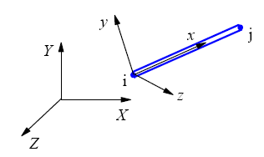
Figure.5.7: Simple three-dimensional truss element.

Local | Global
$$x, y, z$$  $${U'}_{i},{v'}_{i},{w'}_{i}$$  1-DOF at node | $$X,Y, Z$$  $$U_{i},v_{i},w_{i}$$  3-DOF at node

The global element stiffness matrix can be written as:

$\left[K^{e}\right]=\frac{AE}{L}\left[\begin{matrix}{\cos\left(x,X\right)}^{2} & \cos\left(x,Y\right)\cos\left(x,X\right) & \cos\left(x,Y\right)\cos\left(x,Z\right) & -{\cos\left(x,X\right)}^{2} & -\cos\left(x,Y\right)\cos\left(x,X\right) & -\cos\left(x,Y\right)\cos\left(x,Z\right) \\ \cos\left(x,Y\right)\cos\left(x,X\right) & {\cos\left(x,Y\right)}^{2} & \cos\left(x,X\right)\cos\left(x,Z\right) & -\cos\left(x,Y\right)\cos\left(x,X\right) & -{\cos\left(x,Y\right)}^{2} & -\cos\left(x,Y\right)\cos\left(x,Z\right) \\ \cos\left(x,X\right)\cos\left(x,Z\right) & \cos\left(x,Y\right)\cos\left(x,Z\right) & {\cos\left(x,Z\right)}^{2} & -\cos\left(x,X\right)\cos\left(x,Z\right) & -\cos\left(x,Y\right)\cos\left(x,Z\right) & -{t\cos\left(x,Z\right)}^{2} \\ -{\cos\left(x,X\right)}^{2} & -\cos\left(x,Y\right)\cos\left(x,X\right) & -\cos\left(x,X\right)\cos\left(x,Z\right) & {\cos\left(x,X\right)}^{2} & s\cos\left(x,X\right) & \cos\left(x,X\right)\cos\left(x,Z\right) \\ -\cos\left(x,Y\right)\cos\left(x,X\right) & {\cos\left(x,Y\right)\cos\left(x,Y\right)}^{2} & -\cos\left(x,Y\right)\cos\left(x,Z\right) & \cos\left(x,Y\right)\cos\left(x,X\right) & {s\cos\left(x,Y\right)}^{2} & \cos\left(x,Y\right)\cos\left(x,Z\right) \\ -\cos\left(x,X\right)\cos\left(x,Z\right) & -\cos\left(x,Y\right)\cos\left(x,Z\right) & -{\cos\left(x,Z\right)\cos\left(x,Z\right)}^{2} & \cos\left(x,X\right)\cos\left(x,Z\right) & \cos\left(x,Y\right)\cos\left(x,Z\right) & {\cos\left(x,Z\right)}^{2}\end{matrix}\right]$

$\left[K^{e}\right]=\frac{AE}{L}\left[\begin{matrix}c^{2} & sc & st & -c^{2} & -sc & -st \\ sc & s^{2} & ct & -sc & -s^{2} & -st \\ ct & st & t^{2} & -ct & -st & -t^{2} \\ -c^{2} & -sc & -ct & c^{2} & sc & ct \\ -sc & s^{2} & -st & sc & s^{2} & st \\ -ct & -st & -t^{2} & ct & st & t^{2}\end{matrix}\right]$ (5.15)

where c, s, t are direction cosine of the local x-axis with respect to the global x, y and z axes, respectively ($c= \cos\left(x,X\right), s= \cos\left(x,Y\right), t=\cos\left(x,Z\right)$).

The formula for calculating c, s and t area

$c=\frac{x_{2}-x_{1}}{l_{e}}, s=\frac{y_{2}-y_{1}}{l_{e}} and t=\frac{z_{2}-z_{1}}{l_{e}}$

$l_e= \sqrt{{\left(x_{2}-x_{1}\right)}^{2}+{\left(y_{2}-y_{1}\right)}^{2}+{\left(z_{2}-z_{1}\right)}^{2}}$

Exercise.5.5.1
Consider a simple truss frame structure as shown Figure next side. It is given that E = 2.0 x 10⁵ N/mm², L is 762 mm. Complete the following  - The stiffness matrix for each element  - Solve the global displacement  - Stress each element  - Reaction force.  Boundary condition  $E=E_{1-2}$,${A=A}_{1-2}$, and $L_{1}=L_{2}= L$, then  $k_{1}^{e} = \frac{E_{1}A_{1}}{L_{1}}= \frac{EA}{L}$and $k_{2}^{e} = \frac{E_{2}A}{L_{2}}= \frac{EA}{L}$ | 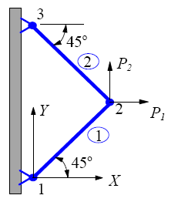

Exercise.5.5.2
Consider a simple truss frame structure as shown Figure next side. It is given that E = 2.0 x 10⁵ N/mm², L is 889 mm. Complete the following  - The stiffness matrix for each element  - Solve the global displacement  - Stress each element  - Reaction force.  If$E=E_{1-3}$,$A=A_{1-2}$, $A_{3}=A\sqrt{2}$, $L= L_{1-2}$, and $L_{3}= L\sqrt{2}$, then  $k_{1}^{e} = \frac{EA}{L}$, $k_{2}^{e} = \frac{EA}{L}$ and $k_{3}^{e} = \frac{EA_{3}}{L_{3}}= \frac{EA\sqrt{2}}{L\sqrt{2}}=\frac{EA}{L}$ | 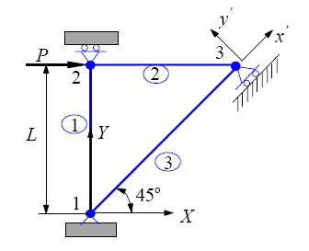

Exercise.5.5.3
Consider the four simple truss frame structure as shown Figure below. It is given that E = 2.0 x 10⁵ N/mm², L₁ and L₂ are 762 mm and 889 mm, respectively, Area (A) is 645 mm² and F₁ and F₂ are 88 kN and 111 kN, respectively. Complete the following
- The stiffness matrix for each element
- Find the global stiffness matrix
- Solve the global displacement
- Stress each element
- Reaction force.

$$Stiffness Element.1 \& 4= EA\left[\frac{L_{2}L_{3}L_{1-4}}{L_{1}L_{2}L_{3}L_{4}}\right]=EA\left[\frac{15}{600}\right]$$ | $$Stiffness Element.2= EA\left[\frac{L_{1}L_{3}L_{4}}{L_{1}L_{2}L_{3}L_{4}}\right]=EA\left[\frac{20}{600}\right]$$ | $$Stiffness Element.3= EA\left[\frac{L_{1}L_{2}L_{4}}{L_{1}L_{2}L_{3}L_{4}}\right]=EA\left[\frac{12}{600}\right]$$

Exercise.5.5.4
Consider two simple bar-truss frame structures as shown Figure below. Determine displacement of node 1 and the stress in the element 1-3.

5.6 Beam Element
Beams are slender members used for supporting transverse loading. Long horizontal members used in buildings, bridges, and shaft. Complex structures with rigidly connected members are called frames and it may be found in ship, offshore, aeroplane and automotive structures.

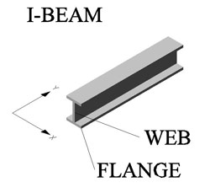

Figure.5.8: Frames in ship structures

Figure below shows the cross section and bending stress distribution. For small deflection, the normal stress ($σ$) can be written as
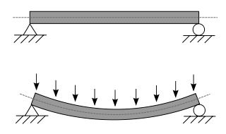
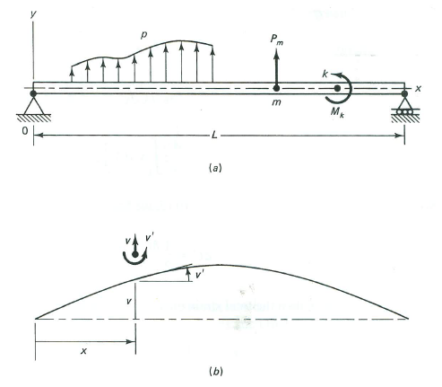
Figure.5.9: Beam loading (a) and deformation of the natural axis (b).

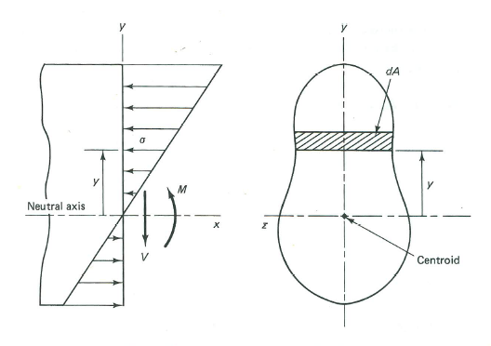
Figure.5.10: Beam section and stress distribution.

$σ=-\frac{M}{I}y$ (7.6.1)

$ϵ=\frac{σ}{E}$ (7.6.2)

$\frac{d^{2}v}{dx^{2}}=\frac{M}{EI}$ (7.6.3)

Where; $ϵ$ is the normal strain, M is the bending moment at the section, $v$ is the deflection of the centroidal axis at x, and I is the moment of inertia of the section about the natural axis.

5.6.1. Potential Energy Approach
Strain energy in an element of length $dx$ is

$dU= \frac{1}{2} \int{σ ϵ dA dx}$

$dU= \frac{1}{2} \left(\frac{M^{2}}{EI^{2}}\int{y^{2} dA }\right)dx=\frac{1}{2}\frac{M^{2}}{EI}dx$ (5.16)

Using Equation.5.15, the total energy in the beam can be written as

$U= \frac{1}{2} \int_{0}^{L}{EI}{\left(\frac{d^{2}v}{dx^{2}}\right)}^{2}dx$ (5.17)

The potential energy of the beam is then given by

$Π= \frac{1}{2} \int_{0}^{L}{EI}{\left(\frac{d^{2}v}{dx^{2}}\right)}^{2}dx-\int_{0}^{L}{pvdx-\sum_{m}{p_{m}v_{m}}}-\sum_{m}{M_{k}{v'}_{k}}$ (5.18)

Where; $p$ is the distributed load per unit length, $p_{m}$ is the point load at point m, $M_{k}$ is the moment of couple applied at point k, $v_{m}$ is the deflection at point m and ${v'}_{k}$ is the slope at point k.

5.6.2. 1-D Beam
The beam is Beam is divided in to elements…each node has two degrees of freedom as shown in the figure below. Degrees of freedom of node-j are Q2j-1 and Q2j. Q2j-1 is transverse displacement and Q2j is slope or rotation. The vector for global element can be written as

$Q={\left[Q_{1},Q_{2},…,Q_{10}\right]}^{T}$ (5.19)

For single element, the local degrees are written as

$q={\left[q_{1},q_{2},q_{3},q_{4}\right]}^{T}$ (5.20)

Figure.5.11: Finite Element discretization.

The local-global correspondence can be written as

$q={\left[v_{1},{v'}_{1},v_{2},{v'}_{2}\right]}^{T}$ (5.21)

The shape function for interpolation v on an element are defined in term of $ξ$ on -1 to 1, as shown

Figure.5.12: Hermite shape function.

Each of the Hermite shape functions is of cubic order represented by

$H_{i}=a_{i}+b_{i}ξ+ c_{i}ξ^{2}+d_{i}ξ^{3} where i=1,2,3,4$ (5.22)

The condition given in the following table

 | $$H_{1}$$ | $${H'}_{1}$$ | $$H_{2}$$ | $${H'}_{2}$$ | $$H_{3}$$ | $${H'}_{3}$$ | $$H_{4}$$ | $${H'}_{4}$$
$ξ$= -1 | 1 | 0 | 0 | 1 | 0 | 0 | 0 | 0
$ξ$ = 1 | 0 | 0 | 0 | 0 | 1 | 0 | 0 | 1

The coefficient a, b, c and d can be obtained by impossing these conditions. Thus

$$H_{1}=\frac{1}{2}\left(2-3ξ+ξ^{3}\right)$$ | $$H_{2}=\frac{1}{4}\left(1-ξ-ξ^{2}+ξ^{3}\right)$$
$$H_{3}=\frac{1}{4}\left(2+3ξ-ξ^{3}\right)$$ | $$H_{4}=\frac{1}{4}\left(-1-ξ+ξ^{2}+ξ^{3}\right)$$

The Hermite shape function can be used to write $v$ in the form

$v\left(ξ\right)=H_{1}v_{1}+H_{2}{\left(\frac{dv}{dξ}\right)}_{1}+H_{3}v_{2}+H_{4}{\left(\frac{dv}{dξ}\right)}_{2}$ (5.23)

The coordinates transform by the relationship

$x=\frac{x_{1}+x_{2}}{2}+\frac{x_{2}-x_{1}}{2}ξ$

Since $l_{e}=x_{2}-x_{1}$ is the length of the element, then

$dx=\frac{l_{e}}{2}dξ$ (5.24)

The chain rule ${dv}/{dξ}=\left({dv}/{dx}\right) \left({dx}/{dξ}\right)$ , then

$\frac{dv}{dξ}=\frac{l_{e}}{2}\frac{dv}{dx}$ and $dx=\frac{l_{e}}{2}dξ$ (5.25)

Noting that $\frac{dv}{dx}$ evaluated at nodes 1 and 2 is $q_{2}$ and $q_{4}$, respectively, we have

$v\left(ξ\right)=H_{1}q_{1}+\frac{l_{e}}{2}H_{2}q_{2}+H_{3}q_{3}+\frac{l_{e}}{2}H_{4}q_{4}$ (5.26)

Which may be denoted as

$v=Hq$ (5.27)

Where $H=\left[H_{1},\frac{l_{e}}{2}H_{2},H_{3},\frac{l_{e}}{2}H_{4}\right]$

Let’s we call the potential energy, the element strain energy is given by

$U_{e}= \frac{1}{2} \int_{0}^{L}{EI}{\left(\frac{d^{2}v}{dx^{2}}\right)}^{2}dx$ (5.28)
From Eq. 7.7.7,

$\frac{dv}{dx}=\frac{2}{l_{e}}\frac{dv}{dξ}, and \frac{d^{2}v}{dx^{2}}=\frac{4}{{l^{2}}_{e}}\frac{d^{2}v}{dξ^{2}}$

Then substituting Eq.5.27, we obtain

${\left(\frac{d^{2}v}{dx^{2}}\right)}^{2}=q^{T}\frac{16}{{l^{4}}_{e}}{\left(\frac{d^{2}H}{dξ^{2}}\right)}^{T}\left(\frac{d^{2}H}{dξ^{2}}\right)q$ (5.29)

$\left(\frac{d^{2}H}{dξ^{2}}\right)=\left[\frac{3}{2}ξ, \frac{3ξ-1}{2}\frac{l_{e}}{2}, -\frac{3}{2}ξ,\frac{3ξ+1}{2}\frac{l_{e}}{2}\right]$ (5.30)

By using Eq.5.25 and 5.28, then we obtain

$U_{e}= \frac{1}{2} \int_{0}^{L}{EI{\left(\frac{d^{2}v}{dx^{2}}\right)}^{2}\frac{l_{e}}{2}dξ }$ (5.31)
By subtituting Eq.5.29 and Eq.5.30, Eq.5.31 can be written as

$U_{e}= \frac{1}{2} \frac{l_{e}}{2}\int_{0}^{L}{EI}{\left(q^{T}\frac{16}{{l^{4}}_{e}}{\left(\frac{d^{2}H}{dξ^{2}}\right)}^{T}\left(\frac{d^{2}H}{dξ^{2}}\right)q \right)}^{2}dξ$

$U_{e}= \frac{4EI}{{l^{3}}_{e}}\int_{0}^{L}{{\left(q^{T}{\left[\frac{3}{2}ξ, \frac{3ξ-1}{2}\frac{l_{e}}{2}, -\frac{3}{2}ξ,\frac{3ξ+1}{2}\frac{l_{e}}{2}\right]}^{T}\left[\frac{3}{2}ξ, \frac{3ξ-1}{2}\frac{l_{e}}{2}, -\frac{3}{2}ξ,\frac{3ξ+1}{2}\frac{l_{e}}{2}\right]q \right)}^{2}dξ}$

$U_{e}= q^{T}\frac{8EI}{{l^{3}}_{e}}\int_{-1}^{1}{\left[\begin{matrix}\frac{9}{4}ξ^{2} & \frac{3}{8}ξ\left(-1+3ξ\right)l_{e} & -\frac{9}{4}ξ^{2} & \frac{3}{8}ξ\left(1+3ξ\right)l_{e} \\ \frac{3}{8}ξ\left(-1+3ξ\right)l_{e} & {\left(\frac{-1+3ξ}{4}\right)}^{2}{l_{e}}^{2} & -\frac{3}{8}ξ\left(-1+3ξ\right)l_{e} & \frac{-1+9ξ^{2}}{16}{l_{e}}^{2} \\ -\frac{9}{4}ξ^{2} & -\frac{3}{8}ξ\left(-1+3ξ\right)l_{e} & \frac{9}{4}ξ^{2} & -\frac{3}{8}ξ\left(1+3ξ\right)l_{e} \\ \frac{3}{8}ξ\left(1+3ξ\right)l_{e} & \frac{-1+9ξ^{2}}{16}{l_{e}}^{2} & -\frac{3}{8}ξ\left(1+3ξ\right)l_{e} & {\left(\frac{1+3ξ}{4}\right)}^{2}{l_{e}}^{2}\end{matrix}\right]}dξq$

(5.32)

$U_{e}= \frac{1}{2}q^{T}k^{e}q$ (5.33)

where
$k^{e}=\frac{EI}{{l^{3}}_{e}}\left[\begin{matrix}12 & 6l_{e} & -12 & 6l_{e} \\ 6l_{e} & 4{l^{2}}_{e} & -6l_{e} & 2{l^{2}}_{e} \\ -12 & -6l_{e} & 12 & -6l_{e} \\ 6l_{e} & 2{l^{2}}_{e} & -6l_{e} & 4{l^{2}}_{e}\end{matrix}\right]$

The j-th column of K represents the forces applied to the bar to maintain a deformed shape with unit displacement at node j and zero displacement at other node.

We assume load $p$ is uniformly distributed in the element:

$\int_{l_{e}}{pvdx}=\left(\frac{pl_{e}}{2}\int_{-1}^{1}{Hdξ}\right)q$ (5.34)

Substitute Eq.5.22 and Eq.5.27 and integrating, we obtain

$\int_{l_{e}}{pvdx}=f^{eT}q$ (5.35)

where $f^{eT}=\left[\begin{matrix}\frac{pl_{e}}{2} & \frac{p{l^{2}}_{e}}{12} & \frac{pl_{e}}{2} & -\frac{p{l^{2}}_{e}}{12}\end{matrix}\right]$

Using the bending moment and shear force equations

$M=EI\frac{d^{2}v}{dx^{2}}$, $V=\frac{dM}{dx}$ and $v=Hq$

We get the element bending moment and shear force

$M=\frac{EI}{{l^{2}}_{e}}\left[6ξq_{1}+\left(3ξ-1\right)l_{e}q_{2}-6ξq_{3}+(3ξ+1)l_{e}q_{4}\right]$
$V=\frac{6EI}{{l^{3}}_{e}}\left(2q_{1}+l_{e}q_{2}-2q_{3}+l_{e}q_{4}\right)$ (5.36)

$\left\{\begin{matrix}R_{1} \\ R_{2} \\ R_{3} \\ R_{4}\end{matrix}\right\}=\frac{EI}{{l^{3}}_{e}}\left[\begin{matrix}12 & 6l_{e} & -12 & 6l_{e} \\ 6l_{e} & 4{l^{2}}_{e} & -6l_{e} & 2{l^{2}}_{e} \\ -12 & -6l_{e} & 12 & -6l_{e} \\ 6l_{e} & 2{l^{2}}_{e} & -6l_{e} & 4{l^{2}}_{e}\end{matrix}\right]\left\{\begin{matrix}q_{1} \\ q_{2} \\ q_{3} \\ q_{4}\end{matrix}\right\}+\left\{\begin{matrix}\frac{-pl_{e}}{2} \\ \frac{-p{l^{2}}_{e}}{12} \\ \frac{-pl_{e}}{2} \\ \frac{p{l^{2}}_{e}}{12}\end{matrix}\right\}$ or $R=k^{e}q+f$ (5.37)
Exercise 5.7
Simple beam as shown below has E = 200 GPa, I = 4 x 10⁻⁶ mm⁴ given uniform load at element 2, please find vertical deflection at midpoint?

1
2
3
2 m
2 m
p= 12 kN/m
Solution

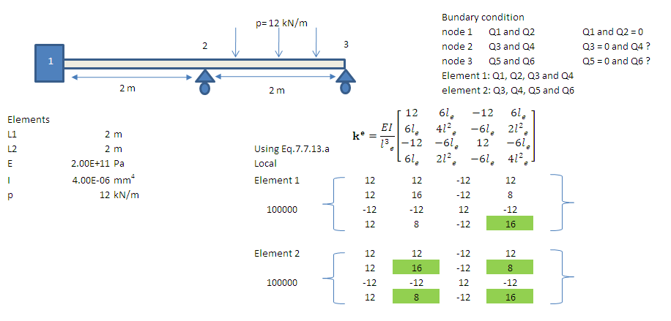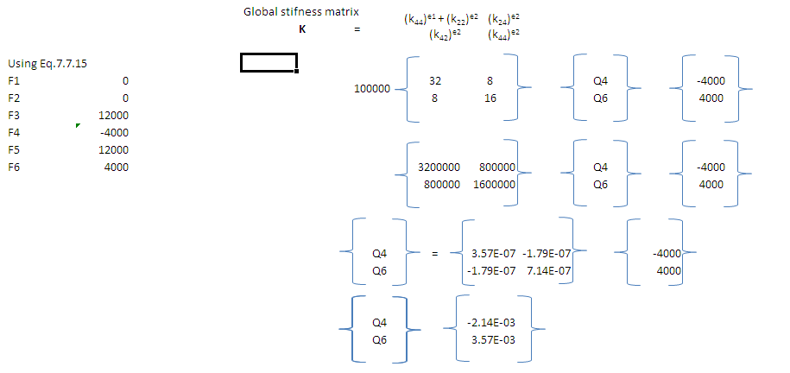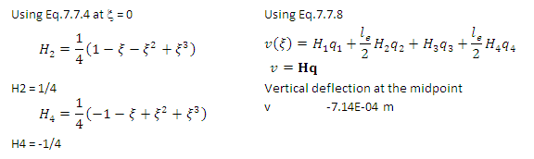

5.6.3. 2-D Beam
For 2-D element, the local degrees are written as

$q={\left[q_{1},q_{2},q_{3},q_{4},q_{5},q_{6}\right]}^{T}$ (5.38)

The local-global correspondence can be written as

$q'={\left[{q'}_{1},{q'}_{2},{q'}_{3},{q'}_{4},{q'}_{5},{q'}_{6}\right]}^{T}$ (5.39)

The local-global transformation

$q'=Lq$ (5.40)

where;

$L=\left[\begin{matrix}l & m & 0 & 0 & 0 & 0 \\ -m & l & 0 & 0 & 0 & 0 \\ 0 & 0 & 1 & 0 & 0 & 0 \\ 0 & 0 & 0 & l & m & 0 \\ 0 & 0 & 0 & -m & l & 0 \\ 0 & 0 & 0 & 0 & 0 & 1\end{matrix}\right]$

${k'}^{e}=\left[\begin{matrix}\frac{EA}{l_{e}} & 0 & 0 & \frac{EA}{l_{e}} & 0 & 0 \\ 0 & \frac{12EI}{{l^{3}}_{e}} & \frac{6EI}{{l^{2}}_{e}} & 0 & \frac{-12EI}{{l^{3}}_{e}} & \frac{6EI}{{l^{2}}_{e}} \\ 0 & \frac{6EI}{{l^{2}}_{e}} & \frac{4EA}{l_{e}} & 0 & \frac{-6EI}{{l^{2}}_{e}} & \frac{2EA}{l_{e}} \\ \frac{-EA}{l_{e}} & 0 & 0 & \frac{EA}{l_{e}} & 0 & 0 \\ 0 & \frac{-12EI}{{l^{3}}_{e}} & \frac{-6EI}{{l^{2}}_{e}} & 0 & \frac{12EI}{{l^{3}}_{e}} & \frac{-6EI}{{l^{2}}_{e}} \\ 0 & \frac{6EI}{{l^{2}}_{e}} & \frac{2EA}{l_{e}} & 0 & \frac{-6EI}{{l^{2}}_{e}} & \frac{4EA}{l_{e}}\end{matrix}\right]$

Call Eq.5.38.a and Eq.5.38, then we obtain

$U_{e}= \frac{1}{2}{q'}^{T}{k'}^{e}q^{'}= \frac{1}{2}q^{T}L^{T}{k'}^{e}Lq= \frac{1}{2}q^{T}k^{e}q$ (5.41)

where; $k^{e}=L^{T}{k'}^{e}L$
If there is distributed load ($p$)on the a member, we have

${q'}^{T}f^{'}=q^{T}L^{T}f'$ (5.42)

where $f^{'}=\left[\begin{matrix}0 & \frac{pl_{e}}{2} & \frac{p{l^{2}}_{e}}{12} & 0 & \frac{pl_{e}}{2} & -\frac{p{l^{2}}_{e}}{12}\end{matrix}\right]$

The point loads and couples are simply added to the global load vector. On gathering stifness and loads, we get the system of equations

$F=KQ$ (5.43)

5.6.4. 3-D Beam
For 2-D element, the local degrees are written as
Figure.5.13: 2-D Element.

Recall that a “truss” is a pin-joined member that has 2 DOF (translation) at each node, but is not able to transmit moments. A “beam”, on the other hand, can transmit moments (i.e. it can bend). A frame structure with “welded” (i.e. rigid) joints, would then be considered to be made up of “beam elements”, which are able to “stretch” (or compress), as well as “bend”. So, a rigid-jointed frame structure could have 3 DOF at each node – axial displacement (u), transverse displacement (v), and angular rotation ($θ$). This is illustrated in the below figure.

What do the element displacement and force vectors look like?

$6 total DOF… \left\{u\right\}= \left\{\begin{matrix}u_{1} \\ v_{1} \\ Θ_{1} \\ u_{2} \\ v_{2} \\ Θ_{2}\end{matrix}\right\}$, and $6 forces and moments … \left\{f\right\}= \left\{\begin{matrix}F_{x1} \\ F_{y1} \\ M_{1} \\ F_{x2} \\ F_{y2} \\ M_{2}\end{matrix}\right\}$

It is 6 x 6 matrix. It is made up of elements for axial stiffness ($AE/L$) and bending stiffness$\left(EI/L^{3}\right)$

The bending stiffness terms are developed using matrix analysis (see Hughes)

$\left[k^{e}\right]=\left[\begin{matrix}α & 0 & 0 & -α & 0 & 0 \\ 0 & 12β & 6βL & 0 & -12β & 6βL \\ 0 & 6βL & 4βL^{2} & 0 & -6βL & 2βL^{2} \\ -α & 0 & 0 & α & 0 & 0 \\ 0 & -12β & -6βL & 0 & 12β & -6βL \\ 0 & 6βL & 2βL^{2} & 0 & -6βL & 4βL^{2}\end{matrix}\right] where; α=\frac{AE}{L} and β=\frac{EI}{L^{3}}$

The rest is the same as before such as transformation, assembly, partitioning, inversion, etc.

5.7. Stiffness Matrix Analysis – 7 Step Process (Summary):
The following provides a summary of the process for solution of a problem using the stiffness matrix method:
- Define structural model
  - Free body diagram
  - Geometry → Transformation Matrix
  - Material properties
- Calculate each global element stiffness matrix [Ke]
- Assemble the global structure stiffness matrix [K]
- Apply BCs to {F} and/or {U}, then partition
- Solve for the global displacements and reactions
  - Global displacements in non-BC DOFs (nodes)
  - Reaction forces at BCs (nodes)
- Transform the element coordinate system, solve for element nodal displacements
- Solve for element strains, stresses and factors of safety

Chapter 6

6.0. Shear and Stress of Ship and Offshore Structures

6.1 Shear Stress in Small Open Beam Sections
This section look at hull girder loading and gone through the process of calculating the weight and buoyancy curves. This calculation gives us the load curve, then the shear force curve, and finally the bending moment curve. The shear force curve also helps us to find the shear stress in the hull. In earlier courses you solved shear stress problems, mostly due to “direct shear” and torsion, but you did not spend a lot of time looking at more global shear stress issues. The reason was that in long (“slender”) beam-like components, the shear stresses are often small and are overshadowed by bending stresses. Because ship hull girders cannot be considered long “slender” members, and because of unusual geometry and loading, we cannot just ignore (or overly simplify) shear stresses for ship structures.
In the “Box-Shaped Barge Global Hull Girder Bending” in-class exercise we did earlier, we noted that the shear force was zero at Stations 0, 5 and 10. Shear force at the ends was zero because the vessel had no overhanging bow or stern, so no weight was unsupported. The midships had zero shear force because the loading was symmetric. While it makes for a nice quick example, unfortunately “in the real world” these conditions rarely occur. The good news is that the shear force is often a small part of the combined stress. The bad news is that sometimes it is very difficult to calculate.
The challenge for the naval architect is to design to the minimum allowable factor of safety, without “over-designing” (which makes the ship “over-weight”). It would be nice to say that the bending stress gives the highest stress, and it is located at the location farthest from the ship’s neutral axis, and where the bending moment is the highest. While global bending stresses are often high, it is the combined stress we have to worry about, and that comes from adding the bending stress from the global bending to the shear stress from the global bending, and then additional stresses due to local bending due to hydrostatic pressure or cargo loads.
Shear stresses can be due to “direct shear” such as in a bolt in direct shear, torsional loading such as in propeller shafts, or when a structural member is bending such as beams - and ships. The torsion equation for shear stress as a function of the radial location for a circular shaft is the very familiar:

$τ\left(r\right)=\frac{T∙r}{J}$ (6.1)

Where; $T$ is the internal torque, $r$ is the radial distance, and $J$ is the polar moment of inertia of the shaft cross-section.
The equation for shear stress due to bending (as a function of the distance from the neutral axis) is the familiar:

$τ\left(y\right)=\frac{V∙Q(y)}{I∙t(y)}$ (6.2)

Where; $V$ is the internal shear force, $y$ is the distance from the neutral axis, $I$ is the moment of inertia (2nd moment of area) of the beam cross-section, $Q$ is the 1st moment of area of the area above y, and t is the thickness of the cross-section at y.
Recall that, for a rectangular cross section, the shear stress distribution is parabolic, with maximum at the middle (neutral axis), and minimum of zero at the top and bottom. This is of course, different than the bending stress (normal stress) distribution, which is linear from zero at the neutral axis to maximum at the top and bottom. This comparison is illustrated in the Figure.6.1.

Bending Stress Distribution | Shear Stress Distribution
Figure.6.1: Bending and shear stress distributions.

Recall also that the maximum shear stress ($τ_{max}$) occurring at the neutral axis ($y = 0$) for the rectangular cross section is:

$τ_{max}=1.5 \frac{V}{A_{s}}$ (rectangular cross-section) (6.3)

Which; is precisely 1.5 times the average shear stress $τ_{average}=V/{A_{s}}$ .
A common approximation often used in structural design manuals for small open sections, such as channels (C-beams), I-beams, angles (L-beams), etc., is to only count a vertical shear area (As), and then use the simple shear equation $τ=V/{A_{s}}$ to estimate the maximum shear stress as shown in Figure 6.2. This obviously has some accuracy issues, but due to shear lag (which we will study later), and relatively low shear loads in many civil engineering structures, it has a reasonable track record. As an example, for a I-beam with web thickness $τ_{web}$ and overall height h, then $A_{s}=τ_{web}h$,

Figure.6.2: Shear stress in I-beam.

Example 6.1:
Figure below shows an open “L” (angle) beam with a shear load of 10,000 lb and a tensile load of 15,000 lb. Determine the FOS if it is HY-80 and compare with HY-100.
Solution
 | HY-80 steel | HY-100 steel | HY-130 steel
Tensile yield strength | 80k psi  (550 MPa) | 100k psi  (690 MPa) | 130 k psi  (900 MPa)
Hardness (Rockwell) | C-21 | C-25 | C-30
Elastic Properties
Elastic modulus (GPa) | 207
Poisson's Ratio | .30
Shear modulus (GPa) | 79
Bulk modulus (GPa) | 172
Thermal Properties
Density (kg/m³) | 7746 | 7748 | 7885
Conductivity (W/mK) | 34 | 34 | 27
Specific heat (J/kgK) | 502 | 502 | 489
Diffusivity (m²/s) | .000009 | .000009 | .000007
Coefficient of expansion (vol.)  (K⁻¹) | .000011 | .000014 | .000013
Melting point (K) | 1793 | 1793 | 1793

Projected Area $A_{s}=a∙b=3 in x 0.25 in = 0.75 {in}^{2}$
The maximum shear stress, $τ_{max}=\frac{V}{A_{s}}=\frac{10000 lb}{ 0.75 {in}^{2} }=13300 psi$
Factor of Safety, ${FOS}_{shear}=\frac{τ_{Y}}{τ_{max}}=\frac{0.58σ_{Y}}{τ_{max}}=\frac{0.58\left(80,000 lb/{in}^{2}\right)}{13300 lb/{in}^{2}}=3.49$
The “L” also has a tensile load, so we need to use the equivalent stress:
$σ=\frac{P}{A}=\frac{15000 lb}{0.25in (3in+0.75in)}=16000psi$
$σ_{vm}=\sqrt{σ_{x}^{2}{+σ}_{y}^{2}-{2σ}_{x}σ_{y}+3τ^{2}}=\sqrt{{\left(16000\right)}^{2}+0-0+3{\left(13300\right)}^{2}}=28050psi$
${FOS}_{vm}=\frac{80000 psi}{28050 psi}=2.85$

6.2. Shear Stress and Shear Flow in Closed and Large Beam Sections
The simple shear stress equations shown above work fine for small, open structural sections, such as those often used in civil engineering construction (such as bridges and buildings). However, ship sections are neither small nor open, so a more detailed analysis is needed. Large sections, and those like box beams that are closed (an aircraft wing spar is another example) experience a characteristic called shear flow. This concept, while somewhat challenging, is almost unique to naval architecture and ignoring it has caused a number of very expensive ship structural failures. The most recent example was the 123’ Coast Guard Cutters of 2005!
Let we will start with a review of how we found the shear force. Recall the box-shaped barge example.

Figure.6.3: Shear force on box-shaped barge.

So how is shear force transmitted through the ship section and into shear stress? Like a solid rectangular beam section, it is not constant across the section! But, a ship structure is in fact a complex thin-walled structure so it is a little more complicated than a solid beam section.
Consider a general thin-walled symmetric which is about a centerline plane of box beam, subjected to a vertical shear force $V$. As we saw above, when developing the shear force and bending moment curves, $V(x)$ varies along the length of the ship and causes a corresponding variation in the bending moment $M(x)$

Figure.6.4: Shear and stress at midship.

For a small cross-section of the ship having a length $dx$ (as the x-axis is the principal axis in the ship), the variation in $V$ and $M$ at the fore and aft ends of $dx$ cause an inequality in bending stress across the element ($σ_{A}$ and $σ_{B}$ in the figure.3.4). Here is where it gets interesting. If we isolate a portion of the differential segment by making two cuts, one cut at the centerline ($C_{L}$) and the other at an arc length “s” running counterclockwise along the bottom plating and then topside from $C_{L}$ (see the figure), the imbalance of longitudinal stress within the bottom portion of the beam must be balanced by a shear force across the cut sections. Because of symmetry, there is no shear stress at the $C_{L}$, so all shear stress must be at the other cut (at arc length s).
Longitudinal equilibrium (in the x-direction) requires

$τ\left(s\right)∙t\left(s\right)∙dx=\int_{0}^{s}{σ_{B}\left(s\right)∙t\left(s\right)∙ds}-\int_{0}^{s}{σ_{A}\left(s\right)∙t\left(s\right)∙ds}$ (6.4)

Substituting our bending stress equation ($σ = My/I$) on both faces (A and B) gives

$τ\left(s\right)∙t\left(s\right)∙dx=\frac{M_{B}-M_{A}}{I}\int_{0}^{s}{y\left(s\right)∙t\left(s\right)∙ds}=\frac{dM}{I}\int_{0}^{s}{y\left(s\right)∙t\left(s\right)∙ds}$ (6.5)

Substituting $dM = Vdx$ (from simple beam theory) gives

$τ\left(s\right)∙t\left(s\right)=\frac{V}{I}\int_{0}^{s}{y\left(s\right)∙t\left(s\right)∙ds}$ (6.6)

Thus the shear stress is a function of “s” (the arc length from the “open” end), and is:

$τ\left(s\right)=\frac{V∙Q(s)}{I∙t(s)}$ $Q\left(s\right)=\int_{0}^{s}{y\left(s\right)∙t\left(s\right)∙ds}$ (6.7)

Note the similarity to the basic shear stress equation for small open sections:

$τ\left(y\right)=\frac{V∙Q(y)}{I∙t(y)}$ (6.8)

Since naval architects try to avoid changing the plating thickness too often (as the tapers add cost), if the thickness is constant, then

$τ\left(s\right)=\frac{V∙\int_{0}^{s}{y\left(s\right)∙ds}}{I}$ $(t=constant)$ (6.9)

Note that we have defined the integral $Q(s)$as the 1st moment about the NA of the cumulative section area starting from the “open” (shear stress-free) end of the section. Note that the integral $Q(s)$ is maximum at the NA (and 0 at all “open” ends of the section – including the CL plane!), and thus shear stress is maximum at the neutral axis NA, just like it would be for a solid section.
Note also that $V$ and $I$ are for the entire section (i.e. $V(x)$ and $I(x)$), while $Q$ (and maybe t) is a function of the arc length s from the “open” end (i.e. $Q(s)$ and t(s)).
The product $τ∙t$ (shear stress x thickness = lb/in2 x in = lb/in) is appropriately named the shear flow (in analogy to pipe flow) and is often denoted by symbol

$q\left(s\right)=τ\left(s\right)∙t\left(s\right)=\frac{V}{I}Q(s)$ (6.10)

Note that the ratio $\frac{V}{I}$ is a constant at each cross-section (x). Thus, this ratio simply scales the integral $Q(s)$ to get the shear flow $q\left(s\right)$.

As a specific case, consider a box-beam with constant plating thickness $t$ as shown in Figure.6.5:

Figure.6.5: Shear and stress of box-beam with constant plating thickness.

For horizontal portions, $y$ is constant, and therefore $Q$ (and therefore $q$ and $τ$) increases linearly with arc length $s$ which is the horizontal distance from CL, “g” is the distance from the NA to the deck.

In the deck:
$Q\left(s_{1}\right)=\int_{0}^{t}{y∙t∙ds_{1}}=gts_{1}$

$τ\left(s_{1}\right)=\frac{Vgts_{1}}{tI}=\frac{Vg}{I}s_{1}$ (linear in s) similar for bottom (6.11)

In the side shell
In the side shell since; $y\left(s\right)=g-s_{2}$
$Q\left(s_{2}\right)=Q_{A}+\int_{0}^{s_{2}}{y∙t∙ds_{2}}=Q_{A}+t∙g\int_{0}^{s_{2}}{ds}-t\int_{0}^{s_{2}}{s_{2}}ds=\left(g∙s_{2}-\frac{1}{2}S_{2}^{2}\right)t$
$τ\left(s_{2}\right)=τ_{A}+\frac{Q}{I}\left(g∙s_{2}-\frac{1}{2}S_{2}^{2}\right)$ (parabolic in s) max at NA (6.12)

Example 6.2:
Figure below shows a simple box-shaped barge. It is assumed the following is the data for each component, deck: $b_{d}=6.0 ft$, $t_{d}=1 in$, side: $b_{s}=1 in$, $h_{s}=20 ft$, bottom: $b_{p}=12.5 ft$, $t_{p}=1 in$ in, $M_{max}=34800 ft.LT$, $V=V_{max}=464 LT=1,039,360 lb$ Determine shear stress at deck edge, bilge chine and NA.
Deck
Bottom
Side

Solution
$y_{NA}=100 in=8.3 ft$ , $I=8,233,720 {in}^{4}$, $V=V_{max}=464 LT=1,039,360 lb$

$τ\left(deck edge\right)=\frac{(1,039,360)∙(240-100)}{8,233,720} 72=1,272$ psi

$τ\left(bilge chine\right)=\frac{(1,039,360)∙(100)}{8,233,720} 150=1,893$ psi,

$τ\left(NA\right)=1,272+ \frac{(1,039,360)}{8,233,720} \left[140∙140-\frac{1}{2}{\left(140\right)}^{2}\right]=2,509$ psi

**Note that if the plating thickness $t$varies around the cross-section, then this variation must be included in the integration of $Q(s)$ (i.e. we must use the full equation for $τ(s)$).

6.3. Multi-Cell Shear Flow
For more complex ship structural cross-sections where there are multiple decks or longitudinal bulkheads, and where thickness t varies around the cross-section, a numerical technique is explained in PNA and Hughes.
This technique capitalizes on the conservation of shear flow $q(s)$ around the open and closed sections of the cross-section. Several examples from Hughes as shown in Figure.6.6:
- Internal longitudinal bulkheads (Figure.6.6.a)
- Multiple open decks, with large bilge radius (Figure.6.6.b)
Note that the maximum shear stress is at the neutral axis (NA), but the shear stress at the deck edge is not negligible! Note conservation of shear flow at corners and “branch points” (shear flows add or subtract).
Figure.6.6.a: Example of shear flow calculation in internal longitudinal bulkheads.

Figure.6.6.b: Example of shear flow calculation in multi-cell section.

Apart from some barges and canoes, it is rare to find a completely open,” single-cell” hull! In reality, hulls are divided into multiple “cells” by decks, longitudinal bulkheads and tank tops. How we calculate shear flow in these cases is an extension of how we calculate it in the single cell case, with one twist. First though, let’s think about a two cell hull divided by a “tween” deck (Figure.6.6.b). By definition, on centerline or where the deck terminates at the inboard end, the shear stress is zero. The shear flow then increases linearly outboard. It reaches a peak corresponding to the equations:

$τ\left(s\right)=\frac{V∙Q(s)}{I∙t(s)}$ (6.13)

Where

$Q\left(s\right)=\int_{0}^{s}{y(s)∙t(s)∙ds}$

Now, from the equations above, what is the equation of shear stress of a deck located on the neutral axis? Well, since y is the distance from the neutral axis to the deck, and in this case is zero, the shear flow and also the shear stress is zero on that deck! This makes sense when we realize that shear flow is a response to load carried in bending, and material located at the neutral axis has no bending stress and is therefore not carrying any bending load.
If the deck is located anywhere but the neutral axis, it is going to carry some bending load, and therefore will have some shear flow. As that flow grows as the distance from the deck or centerline increases, the deck is carrying more load. When the deck intersects the topsides (shell plating), that load must be transferred into the topsides. At this intersection the shear flow from the decks above is added in, creating a jump in shear flow at each intersection, as illustrated in the figure above.
A bigger challenge is the case where longitudinal bulkheads such as those used in wing tank structures are used. The figure above (right figure) shows the general situation. Using the pipe flow analogy and starting at the centerline on the bottom, we know that shear flow builds linearly until it reaches the intersection of the bottom with the longitudinal bulkhead. The question is: how much goes through the bulkhead and how much goes through the shell plating (topsides)? The challenge is that this is a structurally statically indeterminate problem, and we must use a statically determinate approach to get an answer. The solution is to temporarily impose “imaginary cuts” in the structure that will stop the shear flow and create a determinate solution. When this happens it is clear that the “cuts” will distort due to the uneven loading (try bending a rolled piece of paper with a gap in the top). If we then “close the gaps”, and find the force required to restore equilibrium, we will get the shear flow “jump” across the “cut”.
It should be clear that some type of numerical technique should be used to do this calculation. For this course it is sufficient for the student to understand just the basic concept of how we solve longitudinal multi-cell shear flow problems, but should be able to calculate shear stress anywhere in a single cell or multi-decked vessel (such as illustrated in the left figure above).

6.4. Asymmetric Bending: Asymmetric Loading and Asymmetric Sections
So far we have only checked the stresses and Factors of Safety (FOS) in the ship when it is upright. In this condition, we have essentially only considered vertical bending of symmetric sections.
However, ships do roll in a seaway, and/or may have a permanent list due to off-center flooding damage (such as battle damage or collision), or due to off-center loading (such as improper cargo loading or grounding). Most of the time, a vessel is “weakest” when it is upright, but not always! Because of this we need to know how to calculate for a rotated hull (or rotated load). Asymmetric loading also occurs due to quartering seas. The process for evaluating asymmetric loading or asymmetric sections is relatively straight forward as it is based on combining force components.
Most modern naval architecture software incorporates asymmetric loading (and in some cases asymmetric sections due to structural damage), so it is unlikely that you will need to do these calculations “by hand”. However, it is necessary that you understand the basic process (and implications) for dealing with such situations.
Consider a ship inclined to an angle $θ$ as shown in the Figure.6.7, with a y-z coordinate frame as shown (y axis is the centerline and z axis is the upright neutral axis of the cross-section). The vertical bending moment has components $M_{y}$ and $M_{z}$ about the CL and NA respectively, given by:

$M_{y}=M\sin{θ}$ $M_{z}=M\cos{θ}$ (6.14)

Where; $M$ is the vertical bending moment (due to weight and buoyancy distributions). Defining moments of inertia $I_{NA}$ as about the upright NA and $I_{CL}$ as about the CL (note symmetry), we can write the bending stress at a point ($y,z$) by superposition:

$σ\left(y,z\right)=\frac{M\sin{θ}∙z}{I_{CL}}+\frac{M\cos{θ}∙y}{I_{NA}}$ (6.15)

The maximum values of bending stress will occur at the upper and lower corners, where both y and z are maximum (the deck edge at the top and bilge strake at the bottom).

$σ_{max}=\frac{M\sin{θ}∙z_{max}}{I_{CL}}+\frac{M\cos{θ}∙y_{max}}{I_{NA}}$ (6.16)
$σ_{max}=\frac{M\sin{θ}∙z_{max}}{{SM}_{CL-deckedge}}+\frac{M\cos{θ}∙y_{max}}{{SM}_{NA-deckedge}}$ (6.17)

Figure.6.7: Ship inclined to an angle θ.

The maximum stress will occur at an angle of inclination θ when

$\frac{dσ_{max}}{dθ}=0 →\frac{M\sin{θ}∙z_{max}}{{SM}_{CL-deckedge}}+\frac{M\cos{θ}∙y_{max}}{{SM}_{NA-deckedge}}=0$ (6.18)

$\tan{θ}=\frac{{SM}_{NA-deckedge}}{{SM}_{CL-deckedge}} →θ\left(σ_{max}\right)=\tan^{-1}\left(\frac{{SM}_{NA-deckedge}}{{SM}_{CL-deckedge}}\right)$ (6.19)

For typical large ocean-going ships, $θ\left(σ_{max}\right)$ are approximately 30 degrees (± 10 degrees).

The bending stress is zero at the neutral axis of the inclined condition. From (6.15):

$\frac{M\sin{θ}∙z}{I_{CL}}+\frac{M\cos{θ}∙y}{I_{NA}}=0 → y=-\left[\frac{I_{NA}}{I_{CL}}\tan{θ}\right]z$ (6.20)

This in an equation for a line (in y and z) defining the neutral axis of the inclined condition. Thus we can find the angle of the neutral axis of the inclined condition with respect to the original upright neutral axis:

$\tan{ψ}=\frac{y}{z}=-\left[\frac{I_{NA}}{I_{CL}}\tan{θ}\right] → ψ\tan^{-1}\left[\frac{I_{NA}}{I_{CL}}\tan{θ}\right]$ (6.21)

Example 6.4:
Figure below shows a simple box-shaped barge. It is assumed the following is the data for each component, deck: $b_{d}=6.0 ft$, $t_{d}=1 in$, side: $b_{s}=1 in$, $h_{s}=20 ft$, bottom: $b_{p}=12.5 ft$, $t_{p}=1 in$ in, $M_{max}=34800 ft.LT$, $V=V_{max}=464 LT=1,039,360 lb$. Determine the maximum bending stress and FOS.
Deck
Bottom
Side
Solution
Assume: $I_{NA}= 8,223,720 {in}^{4} (full section)$, ${SM}_{NA-deckedge}=58,741 {in}^{3}$, $M = 34,800 ft-LT$

Now: $I_{CL}= 4,893,672 {in}^{4} (full section)$, ${SM}_{CL-deckedge}=\frac{I_{CL}}{Z_{max}}=\frac{14,893,672 {in}^{4}}{150 in}=99,291{ in}^{3}$

At what angle of inclination does maximum bending stress occur?

$θ\left(σ_{max}\right)=\tan^{-1}\left(\frac{{SM}_{NA}}{{SM}_{CL}}\right)=\tan^{-1}\left(\frac{58,741}{99,291}\right)={30.6}^{0}$

The maximum bending stress at the deck edge?

$σ_{max}=\left(34,800 ft-LT\right)\left(\frac{2240 lb}{LT}\right)\left(12\frac{in}{ft}\right)\left[\frac{\cos\left({30.6}^{0}\right)}{58,741 {in}^{3}}+\frac{\sin\left({30.6}^{0}\right)}{99,291{ in}^{3}}\right]=18,502 psi$

${FOS}_{Asym}=\frac{σ_{Y}}{σ_{max}}=\frac{36 ksi}{18.5 ksi}≈1.9$

Compare to Factors of Safety at symmetries (FOS = 2.25) for vertical-only bending from exercise 6.2. In this case the stress went up when heeled.
What factors, such as B/D ratio, might influence this trend?
We can think of this as bounding our maximum bending stress as the ship is heeled, or as the ship rolls in the seaway.

6.5. Shear Lag and “Effective Breadth”
Simple beam theory assumes that “plane section remain plane”, and therefore that bending stress is directly proportional to distance from the NA (linear distribution), and thus in any web & flange type beam (I-beam, Box beam, etc.) the stress should be constant across the flange. However, the strain in a bending beam comes primarily from the curvature of the web, and only reaches the flanges through shear which is transmitted across the web-flange connection. The elongated (or shortened) web “pulls” the flange along, through shear forces, setting up shear distortion (and stresses) in the flange. The shear distortion of the flange is such that the portion of the flange away from the web undergoes less distortion (and therefore less stress). The bending stress in the flange away from the web is said to “lag behind”, and therefore the term shear lag has been used to describe this effect.

Figure.6.8: Distribution of stress on ship.

The exact distribution of bending stress across the flange can be calculated through theory, but it is too complex for basic design work (and certainly for this introductory course). For typical ship hulls, it has been found to be only a few percent different. However, for non-slender or shallow beams, with wide flanges and/or short webs (such as ship’s double bottoms and tank tops), it can be significant. Because it really only becomes important for “non-slender” beams, shear lag effects are typically not considered for “slender” beams used in civil engineering construction (buildings and bridges), but it is important to consider shear lag effects in ship structural design. The problem with shear lag is that using the simple Euler beam equation would predict stresses less than the maximum stresses occurring at the junction of the web and flange (as shown above).
One solution to this problem was proposed by Commodore Henry Shade (USNA Class of 1923) 1. Shade proposed defining an “effective breadth” of the flange plating which, when used in calculating the moment of inertia (and section modulus) of the beam section, would give the correct maximum stress at the junction of the web and flange using simple beam theory ($σ = M_{y}/I$). The concept is illustrated in the below figures. Shade’s effective breadth is normally denoted with be (but in some literature with the Greek letter λ).

Figure.6.9: Distribution of stress on ship.

In other words, since simple beam theory (Euler’s equation) calculates the average stress, and it is the maximum stress that will yield first, the concept of effective breadth is used to help us calculate the actual maximum stress in the part, specifically at the web-flange junction. The way we do this is to calculate the moment of inertia (and section modulus) based on the effective breadth rather than the actual breadth of the flange. Since bending stress $σ = M_{y}/I$, by making I smaller, the stress goes up.
Schade, in his original papers (published in the SNAME Transactions in 1951 and 1953), produced dozens of graphs showing effective breadth factors for a wide variety of structural shapes (including I-beams, T-beams, Box-beams, multiple-web girders/panels, etc.) and a variety of loading conditions (including uniformly distributed loads, non-uniform loads, and point loads).
For basic ship structural design (and for this course), we are concerned especially with shear lag and effective breadth in the design of stiffened plating (panels), specifically the selection/design of stiffener scantlings (dimensions) necessary to support hydrostatic and other distributed loadings. Thus, we are concerned primarily with uniform loading (hydrostatic pressure at depth) and with single and multi-web girders. These special cases from the many dozens of Shade Curves is plotted in the below figure. Note that one curve is for a single web girder flange (like an I-beam or T-beam), and the other for multiple-web girder flanges (like stiffened plating panels).
The Shade Curve is used by first calculating the ratio L0/B (note the effect of the beam end conditions), then extracting the ratio be/B using the curve for the correct type of girder flange (single or multi-web), then finally calculating the effective breadth be by multiplying by the flange width or stiffener spacing B.
Figure.6.10: Distribution of stress on ship.

By studying the above Shade Curves, you should notice that for longer (or “slender”) beams (as L0/B → 10), there is very little shear lag effect (be/B → 1.0). Conversely, for shorter (or “non-slender”) beams (especially for L0/B < 3), shear lag effect is important. This is why civil engineers are not normally concerned with shear lag effects, as most civil engineering structures are built using longer (or “slender”) structural beams, but naval architects are concerned with shear lag effects. You might notice that a multiple-web girder is essentially stronger than an equivalent single web girder for the same breadth (B) (note that be/B is greater than 1 for larger L0/B for the multiple-web girder, and is always greater than the value for the single web girder). This is essentially because of the Poisson effect, which we will revisit later when we study plate bending.
A simplifying design rule used by ABS and other classification societies, is to use an effective breadth that is either the stiffener spacing (B) or 1/3 of the length between frames or supports (L), whichever is less:

$b_{e}=B$ or $b_{e}=\frac{L}{3}$ (whichever is less) (ABS rules)

6.5.1. Application of Shear Lag and Effective Breadth – Stiffener Design
An important application of shear lag and effective breadth in naval architecture is in the design of plate stiffeners, such as longitudinal, stringers, etc. For this application, we consider each stiffener (between frames), with an effective breadth of attached plating, to act as a bending beam, with a uniformly distributed load (hydrostatic pressure on the plating) (we will include additional stresses due to global hull girder bending later). This is illustrated in the figure below. In design practice, the beam end conditions (at the frames) are taken as simply-supported, since this gives a “worst-case” load (with maximum bending moment at the center of the beam span).
Figure.6.11: Distribution of stress on ship.

Example 6.5
Consider longitudinal supporting bottom plating on a ship (assume A-36 steel) as shown figure below. What are the maximum bending stress and the minimum FOS (vs. material yield)?
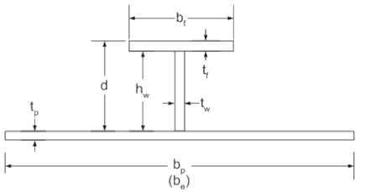 | 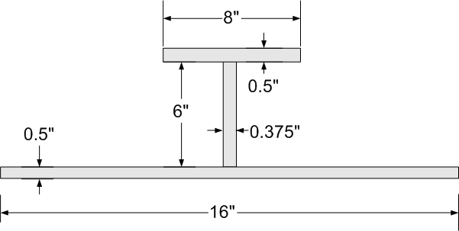

Solution
Consider only hydrostatic pressure and ignore global hull girder bending stress. The following information is provided:
- $H$ (hydrostatic head) 32 ft
- $L$ (frame spacing) 4 ft
- $B$ (stiffener spacing) 3 ft
- $t_{p}$ (plate thickness) 0.5 in
- $t_{f}$ (flange thickness) 0.5 in
- $t_{w}$ (web thickness) 3/8 in 0.375 in
- $h_{w}$ (web height) 6.0 in
- $b_{f}$ (flange breadth) 8.0 in
For a simply-supported beam with a uniform load:
$M_{max}=\frac{wL^{2}}{8}$
Where; w is the uniform load (force/length).
In this case $w$ is due to the hydrostatic pressure on the plate:
$w=\left(density\right) \left(depth\right) \left(stiffner spacing\right) \left(ρgH\right)\left(B\right)$
$w=\left(64 \frac{lb}{{ft}^{3}}\right)\left(32 ft\right)\left(3 ft\right)=6144\frac{{lb}_{f}}{ft}$

Since the stiffener spacing $B = 3 ft$, and the ends are simply-supported ($L_{0} = L = 4 ft$), then $L_{0}/B = 4/3 = 1.33$.
As an illustration of using the Shade curve (uniform load, multi-web girder), we have $b_{e}/B ≈ 0.5$, so the effective breadth of attached plating is $b_{e} ≈ 1.5 ft$.
Or, using the ABS Rules, $b_{e} = L/3 = 1.33 ft$ (which less than $B = 3 ft$).
Note that we can use the full breadth of the flange since $b_{f} < B$ and $b_{f} < L/3$
Thus, we have the below effective beam section (stiffener with effective breadth of attached plating).
Using a section modulus calculation (spreadsheet) for these scantlings gives:

${SM}_{min}={SM}_{top}=27.625 {in}^{3}$

Maximum bending stress and minimum FOS:

$M_{max}=\frac{wL^{2}}{8}=\frac{\left(6144 {lb}/{ft}\right){\left(4 ft\right)}^{2}}{8}=12,288 ft lb$

$σ_{max}=\frac{M_{max}}{{SM}_{min}}=\frac{12,288 ft lb }{27.625 {in}^{3}}\left(12\frac{in}{ft}\right)=5,338 \frac{lb}{{in}^{2}}=5.34 ksi$

$FOS=\frac{σ_{Y}}{σ_{max}}=\frac{36 ksi}{5.34 ksi}=6.7$ > 2

Additional notes about maximum bending moments and deflections for beams:
In the previous example, we used a maximum bending moment at the center of the beam ($M_{max}=\frac{wL^{2}}{8}$). This is used in many ship structural design applications, since it is the “worst-case” moment for a uniformly-loaded beam (note that hydrostatic pressure provides a uniform load on a horizontally-oriented beam/stiffener). This maximum moment can be derived for a simply-supported uniformly loaded beam using the Principle of Static Equilibrium. Maximum bending moment (and also maximum shear force and maximum deflection) can likewise be determined in a similar manner for any combination of end condition and load type. Rather than do this “from scratch” for each possible case, it is often useful to make use of design manuals, which usually contain listings of maximum bending moments ($M_{max}$), shear forces ($V_{max}$), and deflections ($y_{max}$) for a wide range of such conditions. Some cases used often in ship structural design (and which we will use in this course) are shown below.

6.6. Hull–Superstructure Interaction
Up to now we have considered the hull to be a single, continuous beam that we can analyze using Euler and Schade methods, plus shear flow. A good question is, “how does the superstructure interact structurally with the rest of the hull?”
Like most naval architecture answers, this one starts with, “it depends!” Follow-on questions might include: “How long and wide is the deckhouse?”, “How is it structurally connected to the deck?” and “What material is it made of?”. The basic approach is to determine whether the deckhouse is structurally “stiff enough” to influence the bending characteristics of the hull. Similarly, an equally important question is “does the hull’s deflection influence the deckhouse?”
Here are some thought provoking questions about hull/superstructure interactions. Imagine a hull subject to a hogging moment. Does that put the deck in tension or compression? Hopefully you immediately answer, tension! The deck is getting longer due to the hogging. Think of a short deckhouse (about 20% of the vessel’s length) that is just sitting on the deck at midships and is not attached. The deck will just expand and contract underneath the deckhouse and no loads(apart from friction and gravity) will transmit to the deckhouse, except that the deckhouse is being pushed up in the middle by the deck and is unsupported at the forward and aft ends as the deck has dropped due to hogging deflection! That is a similar case to the hull only getting hydrostatic support in the middle! In other words, the deckhouse would hog as well as the hull! In this case, while the deck is in tension, the bottom of the deckhouse will be in compression!
Now imagine that while the vessel is hogged, the rectangular deckhouse is bolted to the deck at only the four corners. How do you get the four corners to cinch down to the deck? You screw the bolts down tight, which puts a large tensile stress on the bolts. When the vessel hogs, the two forward bolts will also move forward while the two aft bolts will move aft. That will put the bottom of the deckhouse in tension. At the same time, the forward and aft bolts move down relative to the middle. That push up in the middle may cause the deckhouse to bend, which increases the deckhouse hog. On the other hand, since the bottom of the deckhouse now moves with the deck, the bottom of the deckhouse is now in tension!
What is the goal? Well, structures last longer and can be built lighter if they don’t carry loads, so naval architects will often use methods that have some boundary condition fixity so that the deckhouse is neither in tension nor compression. Since not attaching it would give a compressive load, and making it rigidly attached would give a tensile load, the solution is to use a compliant joint. The most common is an expansion joint as shown in the below figure. Where the joints go is important, and from the discussion above it should be clear that the highest loads will be at the forward and aft ends of the deckhouse. These are common stress “hot spots” on ships, with cracking seen on many ships, including the DDG963, CG47, PC and others.
This is a good time to remind the student of the old engineering proverb, “the load goes to the stiffest structure”. It is often hard to determine how the superstructure will react unless its relative stiffness compared to the hull is known. This is therefore a very good application for finite element analysis, which will be our next topic.

Figure.6.12: Distribution of stress on ship.

Chapter 7

7.0 Ship and Offshore Structures Strength Analysis

7.1 Tertiary Structure: Plate
The focus in this course so far has been to analyze beam structures, where we defined a beam as a structure that has one dimension (x-axis) larger than the other two (y and z axes). This allowed us to ignore Poisson’s effects, which is the main difference between plates and beams. Plates are structures that have two dimensions that are similar in magnitude and one (thickness) that is much less. Many of the same theories used for beams can be modified slightly to apply to plate structures. The other big difference between beams and plates is that for plates we always have to consider loads in more than one direction.
In the section, plate analysis is used to design plating for the hull, decks and bulkheads. The analysis is under condition as while point loads are possible, most plate loading is due to hydrostatic pressure in external or internal pressures. On the bottom plating the pressure will be uniform, but on the topsides and side shell plating, it will be linearly varying.

7.1.1 Boundary Conditions and Plate Bending
Plates have many of the characteristics that beams have. Initial deflection is proportional to load, giving a linear response that is relatively easy to calculate. Larger deflections have a nonlinear elastic component called membrane stresses that increase apparent strength and stiffness. Plastic deformation follows. Plates can also fail in buckling. As with beams, the boundary conditions strongly influence the failure loads.
A typical plate on a ship is one of the hull bottom plating. It is bounded on its four sides by longitudinal and frames. These stiffeners are much stiffer than the plate, and carry the load from the plate to the bulkheads and/or web frames. As far as the plates are concerned, the stiffeners are rigid structures. As a rigid structure they can be modeled using the standard boundary conditions. Most commonly these are simply-supported, pinned or fixed. The former allows translations in plane but not out-of-plane and allows rotations about the axis (like a hinge on a roller). The second allows no translations but does allow translations (like a fixed hinge). The third allows neither translation nor rotation.
One concept to understand in plate bending is how much stress is generated in the different directions of a plate. Stress, by definition, is a function of strain (radius of curvature for bending). Plate analysis is mostly about bending loads, causing an uneven distribution of strain. Take for example a plate that is 4 feet long (in the x-direction) and 2 feet wide (in the y-direction) that has a point load in the middle that is normal to the plate (in the z-direction). The plate deflects such that the location of the point load has the most deformation. Looking at the stresses along the x-axis and the y-axis, it is interesting to note that the y-axis stresses will be larger. Why? Since the maximum deflection is the same along both x and y axes, but the x dimension is larger, it figures that along the y-axis the radius of curvature is tighter, giving a larger strain and a higher stress. This in general is true; the stress will be higher in the shorter plate dimension.
Typically we refer to a plate having thickness denoted by t, a length or span (longer dimension) denoted a, and a short width or breadth (shorter dimension) denoted b. d a

7.1.2 Small Deflection Plate Theory
We might think of a plate bending like a row of beams, with the beams glued or welded together at their adjacent boundaries. Recall that Hooke’s law for 1-D (like a beam) is:
$σ=E∙ε$ (7.1)

Recall also for a beam that:

$σ_{x}=\frac{M_{y}}{I}$ (7.2)

Combining:

$ε_{x}=\frac{M_{y}}{EI}$ (7.3)

We see that EI is a “bending stiffness” for a beam. The main assumptions for beam bending were that plane sections remained plane, and that no transverse strain or stress existed, so no transverse bending.
For a 2-dimensional plate bending we must limit the deflection to small values (less than ¾ of the plating thickness t). Unlike a beam, for a plate this is necessary because membrane stresses develop for larger deflections (due to the Poisson effect). Additional assumptions for this “small deflection plate bending” are:
- No strain or stress exists through thickness
- There is bending strain (or stress) on the top and bottom, but the strain (or stress) at the neutral axis is zero.
- Plane sections remain plane
- Material is isotropic
- Material behavior remains in the linear elastic range
Consider a very thin beam of width b (perhaps made with a very narrow plate) vs. a very wide plate of width b and length a, unsupported along its sides, but both with simply-supported end conditions, and both loaded with a point load at the center. The beam bends downward in a curve as you would imagine. However, due to the Poisson effects, the deformed plate looks like a Pringle! For the beam, the “bending stiffness” EI can be calculated as:

$EI_{beam}=E{\frac{bt}{12}}^{3}$ (7.4)

However, for the wide plate, the equivalent “bending stiffness” is

$EI_{plate}=E\frac{bt^{3}}{12\left(1-υ^{2}\right)}$ (7.5)

A parameter which gives the “bending stiffness” per unit width b is denoted D is known as the “flexural rigidity” of the plate, which using the above gives:

$D= \frac{EI_{plate}}{b}=E\frac{bt^{3}}{12\left(1-υ^{2}\right)}$ (7.6)

For different materials, υ ranges from 0.01 -0.45 (although some composite laminates can be 0.15 to 0.8). A typical value is 0.3. So, which is stiffer, the beam or the plate? Since υ is greater than 0, then the plate is thicker than the beam. Thus, a wide plate is stiffer than a row of beams (having the same total width b. Why? Because of the Poisson effect.
For a plate of width b and length a, the governing equation for bending deflection can be derived in a similar (just more complex) approach to the differential equation for beam bending – using static equilibrium of a differential element of plating (see Hughes). The governing equation is the 4th order partial differential equation known as the Biharmonic Equation:

$∇^{4}w= \frac{p}{D}$ (7.7)

Where; w is the lateral (out of plane) deflection of the plate, p is the lateral pressure (load) on the plate, and D is the “flexural rigidity” of the plate (as defined above).
In rectangular x-y Cartesian coordinates, the Biharmonic Equation is:

$\frac{∂^{4}w}{∂x^{4}}+2\frac{∂^{4}w}{∂x^{2}∂y^{2}}+\frac{∂^{4}w}{∂y^{4}}=\frac{p}{D}$ (7.8)

Note that in FEA, simply-supported boundary conditions cannot be applied on all edges, or you get rigid-body motion! At least one node must be constrained in all translations (typically 1 edge pinned).
Solutions to the Biharmonic Equation with a uniformly distributed load p (uniform pressure) for different boundary conditions have been solved using some advanced mathematics (by some very smart people). The two most important we will use. These are for simply-supported and clamped (fixed) boundary conditions.

The solution for simply-supported edges (all 4 edges simply-supported) was given by Navier, who applied a uniform load p as a Fourier Series (a summation of sinusoids of different frequencies). The maximum deflection (which occurs at the center of the plate is:

$w_{max⁡(ss)}=k_{1}\frac{5pb^{4}}{384D}$ (7.9)

Where; $k_{1}$ is a parameter which depends upon the “aspect ratio” of the plate (a/b), where a = long side and b = short side.

The solution for the clamped boundary condition (all 4 edges clamped) was given by Levy:

$w_{max⁡(clamped)}=k_{2}\frac{5pb^{4}}{384D}$ (7.10)

Where; $k_{2}$ is a parameter which depends upon the aspect ratio a/b.

For both simply-supported and clamped boundary conditions, the maximum stress can be written:

$σ_{max}=k∙p∙{\left(\frac{b}{t}\right)}^{2}$ (7.11)

Where; $k$ is a parameter which depends upon the aspect ratio a/b AND the boundary conditions.

For all of the above, use the figures below and on the next page. Note however that the locations of the maximum stress components for simply-supported and clamped BCs are not the same! Note also the directions of the maximum stress components for each BC. For the simply-supported BC, the maximum stress components occur simultaneously at the center of the plate, thus VonMises must be used to determine equivalent stress and FOS.
Small deflection plate bending is a conservative method for predicting maximum bending stress and deflection in a plate that works in most ship design cases, particularly stress values well below yield. The common approach is that the design engineer starts by assuming that the deflection is going to be small and uses this theory. If the predicted deflection is greater than ¾ t, then they make the panel smaller (by reducing stiffener spacing), make the plate thicker, or go to large deflection theory
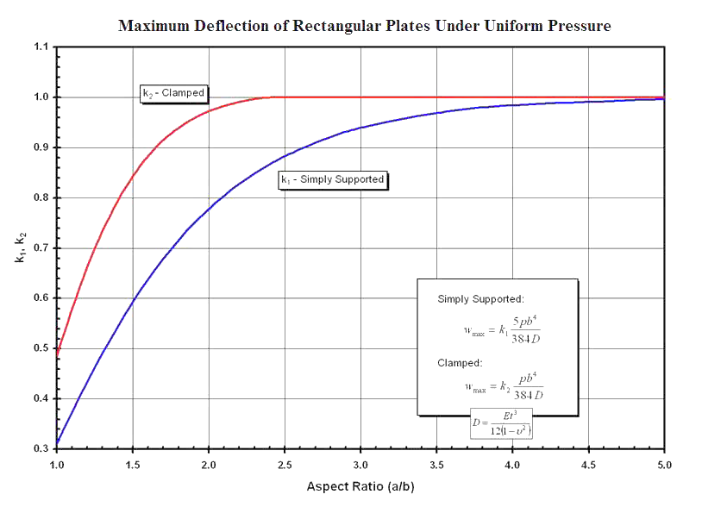

Figure.7.1: Maximum deflection of rectangular plates under uniform pressure

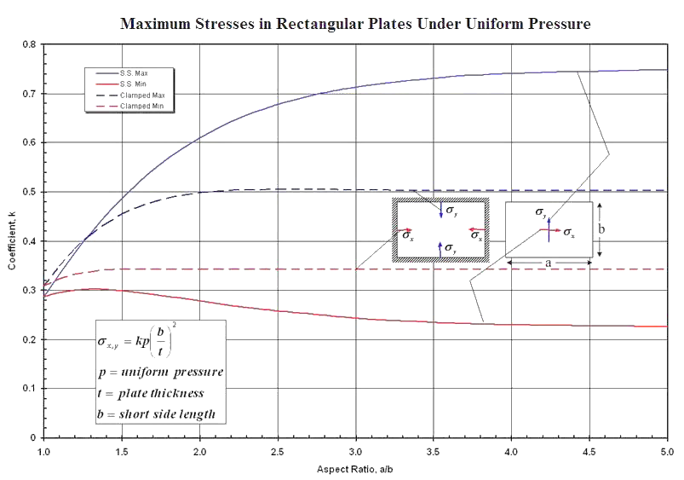
Figure.7.2: Maximum stresses in rectangular plates under uniform pressure

Exercise 7.1.2
1. Stiffened Plate Salvage Patch Design
Work in teams of two and consider the following ship structural design problem. You are the DCA on a DDG-51 class destroyer. While on patrol in a war zone, your ship strikes a floating mine, which blows a hole in a bow compartment, causing the compartment to flood. It is desired to apply an external patch over the hole so that the compartment can be dewatered using salvage pumps. The hole in the plating has been trimmed by divers to an opening which is nearly rectangular, of dimensions 6 ft wide by 3 ft high. It is expected that the patch would have to withstand a hydrostatic pressure of 30 feet of seawater. One candidate patch built by HT3 Smuckatelli is made of ½” A36 steel plate with three MT 2x6.5 (T-stiffeners) as shown in the figure below. The patch is to be installed by securing it with J-bolts around the edges (therefore, assume simply-supported edges). Calculate the maximum stress in the plating and the stiffeners, and the minimum FOS vs. material yield. For the MT 2 x 6.5 T-stiffeners, you can use the following approximate dimensions: d = 2.0”, $t_{w}$ = 0.25”, $b_{f}$ = 3.94”, $t_{f}$ = 0.37”.

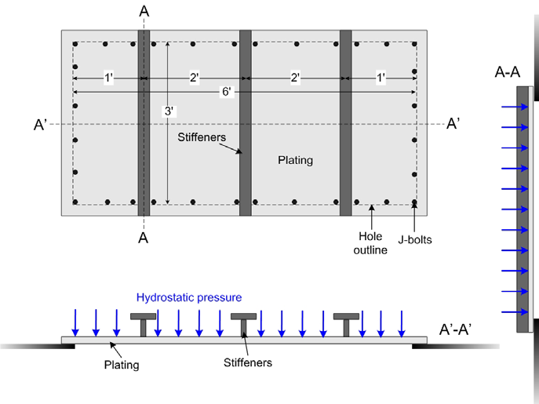

7.1.3. Large Deflection Plate Bending
Small-deflection plate bending theory works well if the deflection is less than about ¾ of the plate thickness. This generally occurs when the material is relatively “stiff”, with relatively small spans, when moderate factors of safety are used (greater than 2), and when the boundary conditions are “mostly fixed” (no translations at the ends - pinned or better). This is generally OK for more than 90% of ship structural design.
If the deflection of the plate exceeds about ¾ of the thickness, then the edges of the plate try to “pull-in”. If the edges are constrained (pinned, fixed, welded, etc.), then there is resistance to this “pull-in”, and we get “membrane” or “in-plane” effects, which create tensile forces throughout the plate. Simple every-day examples of membrane effects include sailboat sails, guitar strings, and balloons.
An interesting result of this membrane effect is that it increases the effective stiffness of the structure to bending. Structures with in-plane tensile forces which increase effective stiffness are called “membrane structures”. For these types of structures, because deflections can be “large” (greater than ¾ the thickness), we must resort to a “large deflection plate bending method”, which is a non-linear method.
Generally, large deflection methods account for non-linear stiffness (i.e. the structure gets “stiffer” as the deflection increases). This occurs because of the edge pull-in effects, as well as an increase in stiffness with the larger curvatures. The result is an increase in the apparent strength of the structure (i.e. the structure “appears” stronger because strains are lower due to the higher effective stiffness).
The equations for plates subject to large deflections and membrane effects are more complex than for small deflection bending. The basic equations are discussed in detail in Hughes.
A simplified result was developed for large aspect ratio plates (a/b greater than about 2), without initial deflection, with edges pinned (fixed from translation but not rotation). This is referred to by many Naval Architects as “Muckle’s Equation”:

$p= \frac{Eπ^{5}}{8b^{4}}\left(\frac{t}{4}w^{3}+\frac{2t^{3}}{12\left(1-υ^{2}\right)}w\right)$ (7.12)

Note that there is a linear term plus a nonlinear term in w. A comparison of this large-deflection result (bending plus membrane effect) and the small deflection result (bending only) is given in the figure below. Note that for larger deflections, the plate is able to carry more loading due to pressure for a given displacement w. This illustrates the apparent strength increase due to the membrane effect.
Note also that for small deflections which is less than about ¾ of the plating thickness, the two are very close, thus the reason small deflection theory works well for small deflections less than $¾ t$.

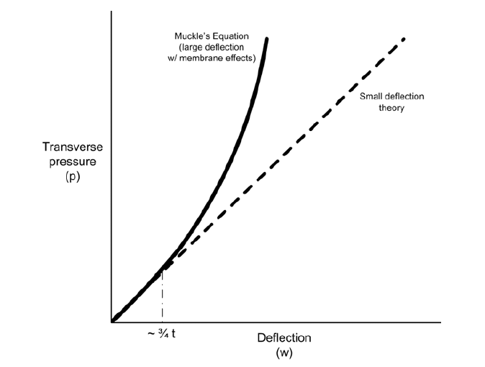
Figure.7.3: Transverse pressure for small and large deflections.

7.1.4. Effect of Initial Deformation
We have seen that the apparent stiffness (and apparent strength) of a plate in bending increases with deflection. The more curvature and deflection a plate has, the more membrane effect, the “stiffer” the plate is!
With this apparent strengthening of the plate, the question might arise as to whether it makes sense to “pre-deflect” a plate. The figure below (from Hughes) addresses this question by comparing the stress-pressure relation for large aspect ratio (a/b greater than about 2) simply-supported plates. The upper curves are for zero initial deflection (i.e. not “predeflected”). As the lateral load (pressure) increases, the bending stresses with membrane effects included are less than with small-deflection theory, because there is less deflection and therefore less bending! The lower curves are for “predeflected” plate (with initial deflection equal to ½t). The mean magnitude of stress is significantly reduced for given lateral load (pressure) due to the immediate impact of membrane effects limiting further deflection (and stress).

In “real life” stiffened plating on ships has some amount of inward “dishing”, or pre-deflection, due to shrinkage of the weld metal (which pulls the plating inward) or “permanent set” (which will be discussed subsequently). This gives some ships the “hungry horse look”. Interestingly, while undesirable from an aesthetics and hydrodynamics stand point, the inward dishing or pre-deflection is actually beneficial from the stand point of strength vs. lateral loads (pressure) and inplane tension. However, while beneficial vs. lateral loads and in-plane tension, the pre-deflection may lead to premature buckling for plates subject to compressive loads. For this reason, it is general practice in naval architecture to try to limit pre-deflection in shell plating to avoid buckling. That said, pre-deflection is used frequently in transverse bulkheads and platform deck plating.
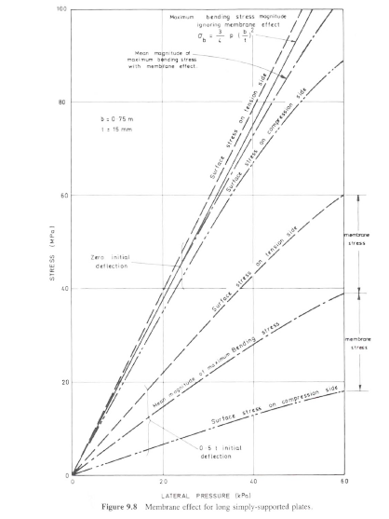

Figure.7.4: Membrane effect for long simply-supported plates.

7.1.5. Plates Loaded Beyond Their Elastic Limit (“Elastic-Plastic” Design)
While greater than 90% of ship structural design is done limiting material behavior within the linear elastic range, there are a number of situations for which it might be acceptable (and beneficial) to design for the “strain-hardening” region of the material (this is limited to ductile materials of course – steel and aluminum are examples). This type of design analysis is referred to as “elastic-plastic” design analysis. As a review from your Strength of Materials class, the figure below illustrates “strain-hardening” of a low-carbon steel when loaded beyond its elastic region.
So why would we design to this material region? The answer is that if we are confident of the maximum loads and fatigue life we can allow for some strain-hardening of the material (which will increase our yield strength). With a higher yield strength and a fixed factor of safety that we must meet, we can use thinner plate. That will save us weight and building cost!
Note however that elastic-plastic design is a “one-time” design. In naval architecture, we may use this to account for an initial permanent set in the plate (which we will discuss subsequently) or to account for a reduced fatigue life (damage accumulation).
Figure.7.5: Stress and strain regions

7.1.6. Design for Permanent Set
The most widely used application of elastic-plastic design for naval architects is to design for a “permanent set”. This essentially allows a ship to have slightly “dished” plating (for shell plating this is commonly referred to as a “hungry horse” look, as the ship’s frames stand out like ribs). For hydrodynamic drag and/or aesthetic reasons however, maximum allowable permanent set ($w_{p}$) is normally limited in a ship’s specification, usually as some fraction of frame spacing or longitudinal stiffener spacing. Typically, specified limits are $s/50 → s/250$, where “s” is the shortest dimension of the stiffener or frame spacing (i.e. the plate dimension “b”).
The theory of elastic-plastic plate bending is very complex, and not amenable to analytic analysis. In ship design, we often design for a maximum allowable permanent set ($w_{p}$) using either FEA or empirical equations and design curves. One suitable method using empirical equations and design curves is given in Hughes. The design curves are given on the following page (Hughes figures 7.6.a - 7.6e). To use these curves we define several dimensionless parameters:

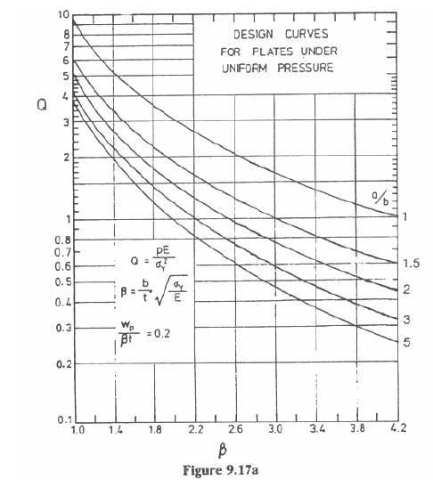
Figure.7.6.a: Design curves for plates under uniform pressures.

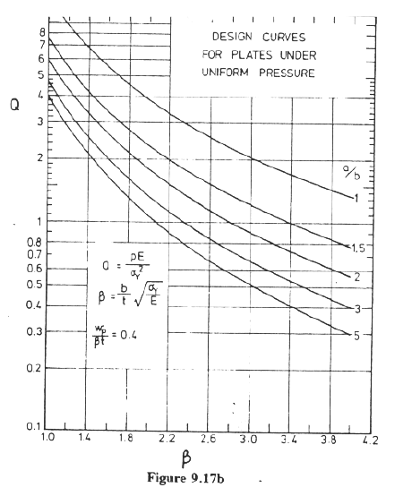
Figure.7.6.b: Design curves for plates under uniform pressures.

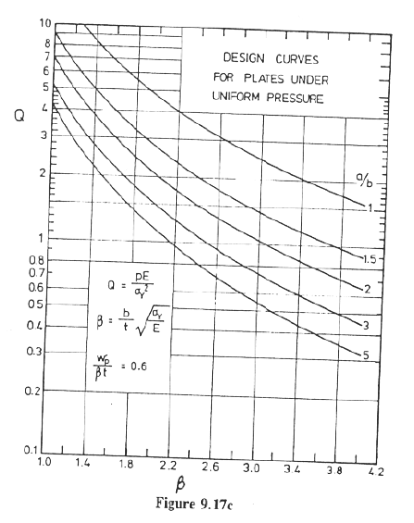
Figure.7.6.c: Design curves for plates under uniform pressures.

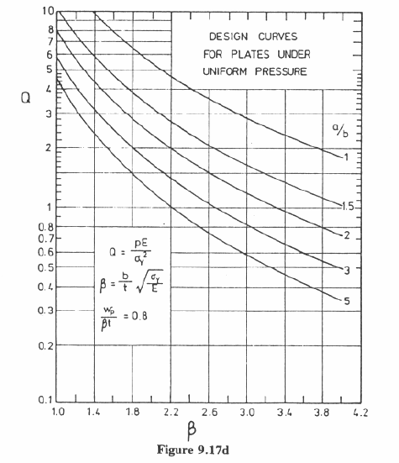
Figure.7.6.d: Design curves for plates under uniform pressures.

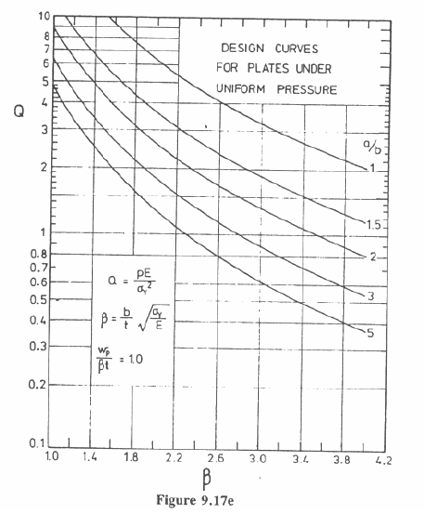
Figure.7.6.e: Design curves for plates under uniform pressures.

Dimensionless plate slenderness parameter

$β=\frac{b}{t}\sqrt{\frac{σ_{Y}}{E}}$ (7.13)

Where; $b$ is frame spacing, $t$ is plate thickness, $σ_{Y}$ is yield strength and $E$ is material elastic modulus. Note: “slender” plates$β > 2.4$ and “sturdy” plates $β < 2.4$
Dimensionless plate load parameter

$Q=\frac{pE}{{σ_{Y}}^{2}}$ (7.14)

Note $p$ is the lateral pressure load
Dimensionless plate permanents set parameter

$\frac{w_{p}}{βt}$ (7.15)

Note $w_{p}$ is the lateral plate permanent set

Are ship plates typically considered “slender” or “sturdy”?
Use typical values for A36 steel ($E=29 msi$ and $yield \left(Y\right)is 34 ksi$ and $b/t$ ranges from 30-100) to get an idea.

To use the permanent set design curves:
- Specify proposed plate dimensions based on frame spacing and longitudinal stiffener spacing ($a, b$), along with material elastic modulus ($E$) and yield strength ($σ_{Y}$). Determine the required hydrostatic pressure ($p$). Determine the maximum allowable permanent set, based on minimum plate dimension ($w_{p}$).
- Calculate the plate aspect ratio ($a/b$), dimensionless plate load parameter ($Q$), and dimensionless plate permanent set parameter ($\frac{w_{p}}{βt}$).
- For the calculated plate permanent set parameter ($\frac{w_{p}}{βt}$), select the appropriate set of design curve figure (figures 7.6.a-e). Use the closest value of $\frac{w_{p}}{βt}$.
- For the appropriate figure, enter the curves on the vertical axis with the calculation of $Q$. For the curve with the closest plate aspect ratio ($a/b$), read down to find the required value of $β$.
- Using the required value of $β$, calculate the minimum required plating thickness ($t$). For design, we usually specify the plating thickness as the next larger standard plate thickness.

Example 7.1.6:
Consider ship bottom plating of a ship with frame spacing ($b$) 25 inches, longitudinal spacing ($a$) 120 inches, material A36 steel ($σ_{Y}=36 ksi$, $E = 30 msi$), along with a design head ($H$) 45 Feet of Sea Water (FSW) and a design specification $w_{p}< s/50$ , $g=64\frac{lb}{{ft}^{3}}$. It is assumed uniform pressure, determine the acceptable thickness.

Solution
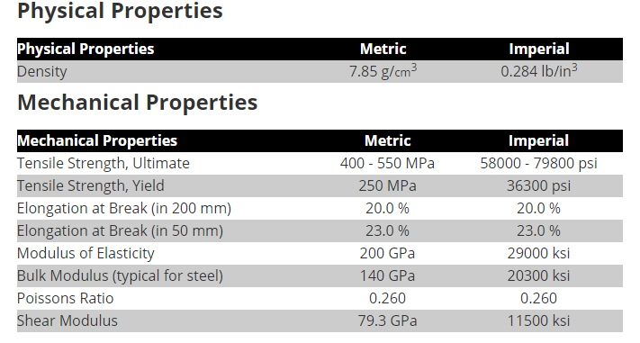
A36 has a density of 7,800 kg/m3 (0.28 lb/cu in). Young's modulus for A36 steel is 200 GPa (29,000,000 psi). A36 steel has a Poisson's ratio of 0.26, and a shear modulus of 75 GPa (10,900,000 psi).

$w_{p}=\frac{b}{50}=\frac{25 in}{50}=0.5 in$

$\frac{a}{b}=\frac{120 in}{25 in }=4.8$

$Q=\frac{pE}{{σ_{Y}}^{2}}=\frac{\left(ρgH\right)E}{{σ_{Y}}^{2}}=\frac{\left(\left(64\frac{lb}{{ft}^{3}}\right)\left(45ft\right)\left(30,000,00\frac{lb}{{in}^{3}}\right)\right)}{{\left(36,000\frac{lb}{{in}^{2}}\right)}^{2}}\left(\frac{1{ft}^{2}}{144{in}^{2}}\right)=0.46$

$\frac{w_{p}}{βt}=\frac{w_{p}}{b\sqrt{\frac{σ_{Y}}{E}}}=\frac{0.5 in}{25in\sqrt{\frac{36,000psi}{30,000,000psi}}}=0.58$

With $Q = 0.46$ and $a/b = 4.8 ≈ 5.0$,

$β=3.4=\frac{b}{t}\sqrt{\frac{σ_{Y}}{E}}=\frac{25in}{t}\sqrt{\frac{36,000psi}{30,000,000psi}} →t=0.254in$

7.2. Secondary Structure
When we started this course we mentioned that ship structures can be categorized by how they are loaded. Primary structure was related to the ship globally bending due to cargo and waves. Tertiary structure was the plating bending due to predominantly hydrostatic pressure loads. The third type of structure is called secondary structure and includes stiffened panels.

7.2.1. Stiffened Panels in Bending
A stiffened panel includes the plates and the stiffeners connected to the plates. As we saw early on, the stiffeners could be longitudinal, stringers, frames, girders, floors, etc. A stiffened panel is usually considered bounded by a very stiff structure such as a deep web, bulkhead, or vertical plating such as the topsides or superstructure. Depending on how stiff the CVK is, it might also be considered a stiffened panel boundary.
One of the lessons we learned when we studied plates was that plates bend relatively easily, and to avoid large deflections we need to either make the plate fairly thick or have small plate dimensions. The basic trade-off is that the design approach of thin plate with many stiffeners is lighter but not as puncture tolerant as a thick plate with fewer stiffeners. Depending on labor and the availability of automated welding machines, either approach might be less expensive to manufacture.
One extreme example of a light weight ship structure is Sairy Gamp, a 9.5 foot, 10 pound canoe built in 1883 for the noted outdoorsman George Washington Sears for long-distance travel. The canoe is owned by the Smithsonian Institution. In the picture below, notice the extremely close frames. The challenge in building a boat like this (she is a Rushton canoe) is that the frames were steamed to bend, yet many would break. The limit is how small the builder could make the frames. What makes this boat interesting from a ship structures point of view is that similarly sized boats on the market today range from 16 to 50 pounds!1.
We can analyze stiffened panels using a number of different approaches. The most common are: FEA, grillage theory, orthotropic plate theory, and beam-on-elastic foundation method. Section 3.8 of PNA goes into some detail on each method. Today, FEA is commonly used, and looking at the last three, the most common is the beam-on-elastic foundation method, which is often used by civil engineers.
Orthotropic plate theory blends the stiffeners with the plate to get effective $E$ and $I$ values for an equivalent plate. $E$ does not have to be equal in the longitudinal and transverse directions. Commodore Schade developed a number of charts to assist with this method and it can be applied relatively quickly. For this reason it is still used by naval architects. It gives a good idea of the predicted deflections and plating stress, but does not work as well for the stiffeners. It is however a method with wide applications in composite materials structures.
The grillage method breaks down the stiffeners and plating into individual beams with point loads at the intersections. As each beam can be represented by a simple equation similar to those used in the stiffness matrix method, a series of equations for deflection at each intersection can be created that must be in equilibrium. These simultaneous equations can then be solved. If this sounds like a good application of computers, it is!
We will use the FEA method in this class, along with a first-principles approach. In practice, either FEA or the Classification Society Rules are used. The typical approach used by ABS for example, starts with finding the plate thickness using a modified first-principles approach (an empirically-modified small deflection plate bending method), then calculating the section modulus of the stiffener (with an effective breadth of attached plating) needed to support the bending moment.

Chapter 8

8.0 Buckling on Ships and Offshore Structures

8.1. Buckling Failure Modes
Buckling is the collapse of a structure due to instability. A rope for instance has virtually no buckling resistance, while a steel rod has some. Buckling can be either elastic, where it returns to its original shape after it is buckled, or inelastic, where it does not. Both elastic buckling and inelastic buckling are usually considered “stiffness driven failures”, but elastic buckling is not usually catastrophic to a ship. Normally we design ship structures for no buckling, elastic or inelastic, but as designers we need to decide appropriate factors of safety for different components. For example, would it be worse to have elastic buckling of plating or stiffeners? How about inelastic buckling of either?

8.2. Buckling of Columns for Ideal Modes
First, we define the maximum load that the column can sustain without collapse as the “ultimate load” ($P_{ult}$), and the maximum stress, as the average stress at the buckling load, as the “ultimate stress” or “ultimate strength” of the column ($σ_{ult}$). As you should recall, the “critical buckling load” ($P_{cr}$) is the maximum compressive load the column can sustain without buckling. For an “ideal” column, you should recall that the critical buckling load (called the “Euler critical buckling load” ($P_{E}$)) is

$P_{cr}=\frac{π^{2}EI}{L_{e}^{2}}=P_{E}$ (8.1)

Where; $L_{e}$ is the effective length of the column, which depends on the type of end supports (end conditions). This can also be written as $L_{e}=kL$, where $k$ is an “effective length factor”. Recall that $k = 1$ if both ends are pinned, $k = 0.5$ if both ends are fixed, and $k = 2$ if one end is fixed and the other free. Thus $L_{e}=kL$ , $k = 1$ (pinned - pinned), $k=0.5$ (fixed - fixed), $k=2$ (fixed - free).

Special note: For welded ship stanchions and stiffeners treated as columns, we usually use an intermediate value

$k=\sqrt{2}=0.707$ (welded ship stanchions or stiffeners) (8.2)

The “critical buckling stress” ($σ_{cr}$) is the average stress at the critical buckling load. You should recall that the critical buckling stress (called the “Euler critical buckling stress”) is

$σ_{cr}=\frac{P_{cr}}{A}=\frac{π^{2}EI}{AL_{e}^{2}}=σ_{E}$ (8.3)

For “practical” critical buckling stress, we often use radius of gyration defined by $I=ρ^{2}A$ or $ρ=\sqrt{\frac{I}{A}}$,

Then the critical buckling stress is written:

$σ_{cr}=\frac{π^{2}E}{{\left(\frac{L_{e}}{ρ}\right)}^{2}}$ (8.4)

Where; $\frac{L_{e}}{ρ}$ is the “slenderness ratio” of the column.
It is useful to plot the “ultimate strength curve” for a column. Here we plot the ultimate strength (stress) vs. the slenderness ratio (see the figure on the next page). Note that we have plotted the critical buckling stress ($σ_{cr}$) as well as a horizontal line for the yield strength. Not that the ultimate strength of the column (for a given slenderness ratio) will be the lesser of $σ_{cr}$ or $σ_{Y}$. Thus, we say that for “short” columns ($\frac{L_{e}}{ρ}$ small $σ_{Y}<σ_{cr}$), the column will fail due to compressive yield (i.e. $σ_{ult}≈σ_{Y}$). Conversely, for “long” or “slender” columns ($\frac{L_{e}}{ρ}$ large, $σ_{Y}>σ_{cr}$), the column will fail due to elastic buckling (i.e. $σ_{ult}≈σ_{cr}$).
In an ideal world, you might think that we should design our columns so that $σ_{Y}=σ_{cr}$. This would lead to an “optimal” design (minimum weight). However, since elastic buckling of a column is catastrophic compared to compressive yielding, we generally desire to ensure that buckling occurs after yielding. Thus, we use a factor of safety for buckling of 3.0 (vs. 2.0 for yielding).
As can be seen in the Figure.8.1, very short columns (also called “compression blocks”) fail by yielding, which very long columns fail by elastic buckling. In the intermediate range (between “short columns” and “slender columns”) lies a range of values of slenderness ratio for which real columns fail at a stress below both yield and critical buckling stress for the ideal column. Columns in this range of slenderness ratio are called “intermediate columns”, and tend to fail due to inelastic stability – meaning that there is a partial yielding of the material, usually due to small irregularities or “eccentricities” in the geometry of the column. This will be discussed in greater detail subsequently.
Figure 8.1: Buckling stress analysis.

Example 8.2:
Figure below shows a simple column deck support (stanchion) made using a wide flange I-beam W6 made of HTS ($σ_{y}=47 ksi$), with a compressive load $P = 100,000 lb$, and a length $L = 12 ft$, as shown in table below. Assume that the load P is applied as an “ideal” compressive load (no eccentricities), and that there are no “shear lag” effects (i.e. $kL/b$ large so that $be/b ≈ 1$). Determine FOS yield and buckling.
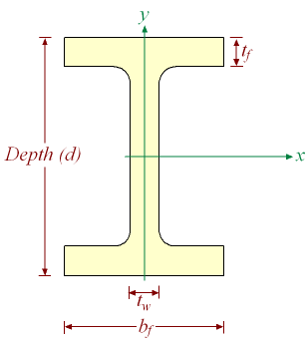

Solution
From Wide Flange Properties Table below,

The modulus material, $E=30,000,000 \frac{lb}{{in}^{2}}$,

The effective length of the column, $L_{e}=(0.707)(144 in)$,

W6 has radius of gyration ($ρ=1.52 in$) (lesser of $ρ_{1-1}=2.70 in$ and $ρ_{2-2}=1.52 in$).

Let used Equation of critical buckling stress (Eq.8.4), $σ_{cr}=\frac{π^{2}E}{{\left(\frac{L_{e}}{ρ}\right)}^{2}}$

$σ_{cr}=\frac{π^{2}30,000,000 }{{\left(\frac{(0.707)(144 )}{1.52}\right)}^{2}}=66.0 ksi$ note here $σ_{cr}>σ_{y}$

Compressive stress $σ=\frac{P}{A}=\frac{100,000 lb}{7.34 {in}^{2}}=13.6 ksi$

${FOS}_{buckling}=\frac{σ_{cr}}{σ}=\frac{66.0 ksi }{13.6 ksi}=4.8$ note > 3.0

${FOS}_{yeild}=\frac{σ_{Y}}{σ}=\frac{47.0 ksi }{13.6 ksi}=3.4$ note > 2.0

8.3. Eccentricity Buckling of Columns
Eccentricities can be caused by the following:
- Initial deflection of the column (due to residual stresses due to welding, imperfect manufacture, or permanent set from previous load application)
- Load eccentricity (line of action of compressive load is off-set from the centroidal axis of the column
- Lateral loads (transverse bending and deformation – this creates what we call a “beam-column”)
Figure.8.2: Eccentricity buckling of column analysis.

The effect of the eccentricity is to produce a combined compression and bending on the column. The effect of this is essentially to “magnify” the effect of the compressive load. The maximum compressive stress, which occurs locally on the “inside” compression flange of the column can be written:

$σ_{max}=\frac{P}{A}+\frac{M_{y}}{I}=\frac{P}{A}+\frac{P∆∅}{{SM}_{comp}}$ (8.5)

Where; $∆=e+δ_{0}$ (is load eccentricity + initial deflection, i.e. the “total” eccentricity), ${SM}_{comp}$is section modulus (to the compression side), $∅$ is the “Eccentricity Magnification Factor”,

$∅≈\underset{Initial deflection eccentricity}{\underbrace{\sec\left(\frac{π}{2}\sqrt{\frac{P}{P_{E}}}\right)}}≈\underset{Load eccentricity}{\underbrace{\frac{P_{E}}{P_{E}-P}}}$

It is assumed that the column with eccentricity will collapse when the maximum compressive stress reaches the yield stress (i.e. when $σ_{max}=σ_{Y}$). Note that this is considered inelastic (plastic) buckling.
Note also that the effect of eccentricity (initial deflection or load eccentricity) is essentially to “pre-buckle” the column. However, you see that the Euler buckling load comes in as the “eccentricity magnification factor”, the effect of which is to magnify the bending moment created by the eccentricity. This is an important point, since the column will actually deflect more (than the initial deflection) due to the magnification effect.

Example 8.3:
Using exercise 8.2, but assume 3” eccentricity on ${SM}_{min}$ side ($P = 100,000 lb$), $σ_{E}= 66,000psi$, area ($A=7.34 {in}^{2})$. Determine FOS yeild and bucking.

Solution:
Euler critical buckling load is $P_{E}=σ_{E}A=\left(66,000psi\right)\left(7.34 {in}^{2}\right)=484,440 lb$

$∅≈\frac{P_{E}}{P_{E}-P}=\left[\frac{484,440lb}{484,440lb-100,000lb}\right]=1.26$

$σ_{max}=\frac{100,000lb}{7.3{in}^{2}}+\frac{\left(100,000lb\right)\left(3in\right)\left(1.26\right)}{5.61{in}^{3}}=13.6ksi+67.4ksi=81.0ksi$

${FOS}_{Yeild}=\frac{σ_{Y}}{σ_{max}}=\frac{47.0ksi}{81.0ksi}=0.58$ (note < 2.0)

${FOS}_{backling}=\frac{σ_{cr}}{σ}=\frac{66.0ksi}{13.60ksi}=4.8$

8.4. Buckling of Beam Columns
A beam-column is a column that is loaded by an axial compressive load ($P$), plus a lateral load w. The lateral load induces a bending moment as a beam, which is additive to the bending moment induced by the axial compressive load with its eccentricities.
The maximum bending moment is the sum of the bending moment due to the lateral load ($M_{w}$) plus the bending moment due to the axial compressive load with its eccentricity (eccentricity of load and/or initial deflection). The total eccentricity now includes the axial compressive load eccentricity ($e$), an initial eccentricity ($δ_{0}$), plus an additional eccentricity due to the bending induced by the lateral load ($δ_{w}$):

$M_{max}=M_{w}+Φ∙P∙∆=M_{w}+Φ∙P\left(e+δ_{0}+δ_{w}\right)$ (8.6)

To find the maximum stress in the beam-column, we apply the column bending equation, including this additional bending moment. However, in this case, to find the maximum stress we must calculate the stress on both the top and bottom flanges of the beam-column:

$σ_{top}=-\frac{P}{A}±\frac{M_{max}}{{SM}_{top}}$ , $σ_{bottom}=-\frac{P}{A}±\frac{M_{max}}{{SM}_{bottom}}$ (8.7)

The ± indicates that the bending portion of the stress is dependent upon the side of the beam-column on which the lateral load ($w$) acts.
The simplest beam-column is one which has pinned ends on both ends, and is subject to a uniform lateral load ($w$) (lb/ft). In this case

$M_{w}=\frac{wl^{2}}{8}$ and $δ_{w}=\frac{5wl^{4}}{384EI}$ (8.8)

Figure.8.3: Buckling of Beam Columns.

Note that a spreadsheet is a nice tool for evaluating beam-columns. This will be illustrated on the example on the following page.
It is assumed that, like the column with eccentricity (initial or load), the beam-column will collapse when the maximum compressive stress reaches the yield stress (i.e. when $σ_{max}=σ_{Y}$). Note that this is considered inelastic (plastic) buckling.
One very important application of beam-columns in ship structural design is a ship stiffener (such as a bottom longitudinal or stringer), including an “effective width” of attached plating. When subject to a hydrostatic pressure load (lateral load) in addition to a compressive hull girder compressive load (i.e. ship in a hogging condition), the longitudinal along with an “effective width” of attached plating acts as a beam-column see Figure.8.4. Note the similarity of this to the simple bending approach taken for the stiffener design previously. The “effective width” of attached plating ($b_{e}$) is either the stiffener spacing $B$ or $1.9 t_{p}\sqrt{\frac{E}{σ_{Y}}}$ (whichever is less).
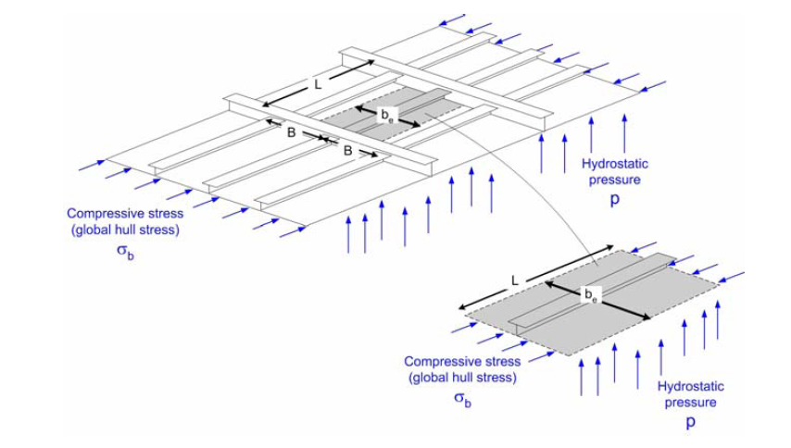
Figure 8.4: Hydrostatic pressure load in addition to a compressive hull girder compressive load.

The latter is approximately equal to $60·t_{p}$ for mild steel ($E ≈ 30$ msi, $σ_{Y} ≈30$ ksi), so this value used to be specified by ABS in their rules for steel ships. Note also the term “effective width” is used (not “effective breadth” which was due to shear lag). This will be explained more fully subsequently when we discuss buckling of plates.
For the beam-column made up of the stiffener and attached plating, we include only the “effective width” of attached plating ($b_{e}$) in the calculation of A, I, and SM (both flange and plate sides). This is illustrated in the following example.

Example 8.4:
Consider a beam-column made up of ship longitudinal and attached plating, subject to a hydrostatic head of 20 Feet of Sea Water (FSW) and simultaneously to a compressive stress (from global hull girder bending) of 15,000 psi. Assume the material is A36 steel, frame spacing (b) is 72 inches, longitudinal spacing is ($b_{e}$) 24 inches, stiffener has a depth 4 inches and flange width 4 inches, and all plate thickness is ½ inch (plating, web and flange).
Determine the factors of safety at buckling and yield of this beam-column.

Solution
First, we must find the area properties of the stiffener with its attached effective width of plating:

$1.9t_{p}=\sqrt{\frac{E}{σ_{Y}}}=1.9\left(0.5in\right)\sqrt{\frac{29,000,00 psi}{36,300 psi}}=26.85 in$

$b_{e}=24 in$ (the stiffener spacing is 24 inches, which is less than 26.85 inches)
Using our section modulus spread sheet, we find the following effective area properties:

A = 15.75 in², I = 32.68 in⁴, ${SM}_{flange}=9.28 {in}^{3}$, ${SM}_{plate}=33.34 {in}^{3}$

he elastic buckling stress (Euler buckling stress):

$σ_{cr}=σ_{E}=\frac{π^{2}EI}{AL_{e}^{2}}=\frac{π^{2}\left(29,000,00 psi\right)\left(32.68 {in}^{4}\right)}{\left(15.75 {in}^{2}\right){\left(0.707∙72 in\right)}^{2}}=229.100 psi$

Calculate the compressive load ($P$)

$P=σ_{b}A=\left(15,000 psi\right)\left(15.7 {in}^{2}\right)= 236,250 lb$

The Euler buckling load ($P_{E}$) is

$P_{E}=σ_{E}A=\left(229,199 psi\right)\left(15.7 {in}^{2}\right)=3,809.884 lb$

The eccentricity magnification factor ($∅$):

$∅=≈\frac{P_{E}}{P_{E}-P}=\left(\frac{3,809.884 lb}{3,809.884 lb- 236,250 lb}\right)=1.07$

Calculate the maximum stress on the compression side of the beam-column:

$w=ρgHB=\left(64 \frac{lb}{{ft}^{3}}\right)\left(20 ft\right)\left(2ft\right)\left(\frac{1ft}{12in}\right)=213.33 \frac{{lb}_{f}}{in}$

$M_{w}=\frac{wL^{2}}{8}=\frac{\left(213.33 \frac{{lb}_{f}}{in}\right){\left(72 in\right)}^{2}}{8}=138.240 in lb$

$δ_{w}=\frac{5wL^{4}}{384EI}=\frac{5\left(213.33 \frac{{lb}_{f}}{in}\right){\left(72 in\right)}^{4}}{384\left(29,000,00 psi\right)\left(32.68 {in}^{4}\right)}=0.08 in$

$M_{max}=M_{w}+∅∙P∙∆=M_{w}+∅∙P∙\left(e+δ_{0}+δ_{w}\right)$

$M_{max}= 138.240 in lb+\left(1.07\right)\left(236,250lb\right)\left(0+0+0.08in\right)=158,400 inlb$

$σ_{plate}=-\frac{P}{A}-\frac{M_{max}}{{SM}_{plate}}=-\frac{236,250 lb}{15.7 {in}^{2}}-\frac{158,400 inlb }{33.34 {in}^{3}}=-15.0 ksi-4.8 ksi=-19.8 ksi (tension)$

$σ_{flange}=-\frac{P}{A}-\frac{M_{max}}{{SM}_{flange}}=-\frac{236,250 lb}{15.7 {in}^{2}}+\frac{158,400 inlb }{9.28 {in}^{3}}=-15.0 ksi +17.1 ksi=2.8 ksi (tension)$

Calculate the safety factor (FOS):

${FOS}_{Yield}=\frac{σ_{Y}}{σ_{max}}=\frac{36.3 ksi}{19.8 ksi}=1.83$ (note < 2.0)

${FOS}_{buckling}=\frac{σ_{cr}}{σ}=\frac{229 ksi}{15.0 ksi}=15.3$ (note > 2.0)

As a design tool, it is very useful to set up a spreadsheet to do this beam-column calculation. Below is a screen capture of such a spreadsheet. By careful inspection of this spreadsheet, you should realize that the same spreadsheet could be used for design of a ship stiffener for compression and/or bending. Specifically, it can be used for simple bending (due to hydrostatic pressure alone) by setting the compressive stress to zero, and using the “effective breadth” of attached plating (from the Shade curve) in lieu of the “effective width”. Note that the cell which calculates the “effective width” of attached plating uses an “IF” statement to find the correct value (see the top of the previous page, and use the “Help” menu in Excel). Note also that this spreadsheet can be used for the case when the stiffeners are on the non-pressure side of the plating (normal hull stiffeners), or for the case when the stiffeners are on the pressure side of the plating.
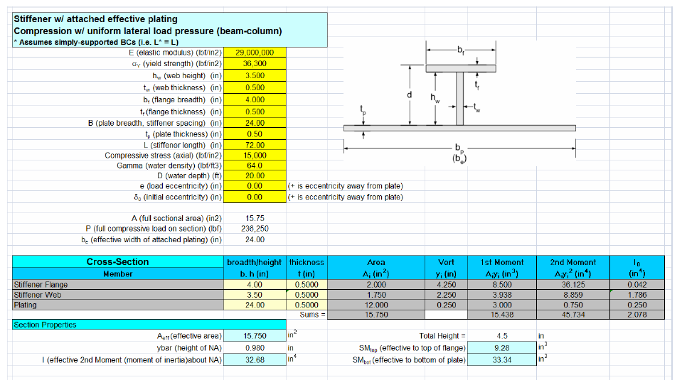
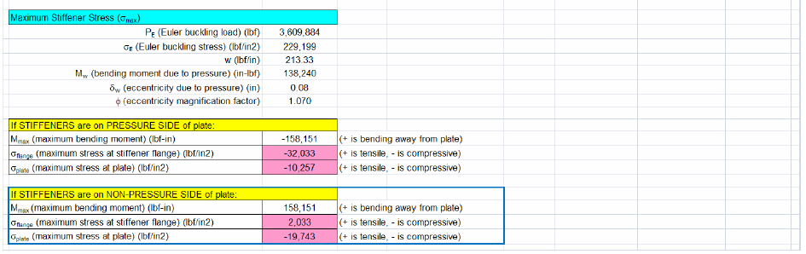

8.5. Elastic Plate Buckling Under Uniaxial Compression
Unlike columns, plates rarely fail in compressive yield - rather they usually buckle. Consider a plate loaded in compression, simply-supported at the loaded ends, but free on the unloaded edges (see the figure below). Note that the edge dimensions are defined such that “b” is the dimension of the loaded edge, and “a” is the unloaded edge. Note also that since here we are considering a very “wide” plate, we have here that b>>a.
If we consider this to be a “very wide column”, then the critical buckling stress would be the Euler buckling stress

$σ_{cr}=\frac{π^{2}EI}{AL_{e}^{2}}=\frac{π^{2}E}{{\left[{L_{e}}/ρ\right]}^{2}}$ (8.9)

However, for a wide plate, we have a Poisson effect (similar to the Poisson effect for plate bending), and the critical buckling stress for the wide plate is

$σ_{cr}=\frac{π^{2}D}{a^{2}t}=\frac{π^{2}E}{12\left(1-v^{2}\right)}{\left[t/a\right]}^{2}$ (8.10)

Recall that $D$ is the flexural rigidity of the plate

$D=\frac{EI_{effective}}{b}=\frac{Et^{3}}{12\left(1-v^{2}\right)}$ (8.11)

Note that the ratio ($a/t$) for the plate plays the same role as the “slenderness ratio” ($L/ρ$) for the column, and therefore buckling of a plate is geometry-driven. If the plate is also subject to bending (such as an eccentricity) this is simply a plate bending case, so $σ_{Y}$ controls the strength (like an eccentric column)!
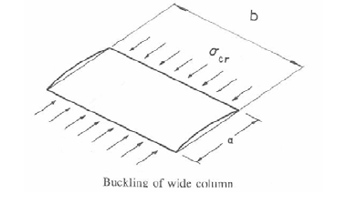

Figure.8.5: Elastic plate buckling of column under Uniaxial Compression

Similar to the lateral plate bending case, there are closed-form solutions, which depend upon boundary conditions (edge conditions) and characteristics of the applied loads. For “regular” plates with aspect ratio ($a/b$), the solution can be written in a very convenient form known as “Bryan’s Equation”

$σ_{cr}=k\frac{π^{2}D}{b^{2}t}=k\frac{π^{2}E}{12\left(1-v^{2}\right)}{\left[t/b\right]}^{2}$ (8.12)

where $k$ is a coefficient which depends on the aspect ratio (similar to the coefficients for bending). Specifically, for plates which are simply-supported (as shown in the below figure) then

$k={\left(\frac{mb}{a}+\frac{a}{mb}\right)}^{2}$ (8.13)

where “m” is the number of “buckling ½ waves” in the x-direction (direction of load), m = 1, 2, 3, etc., and the minimum value of $k$ will give the lowest buckling capacity. For $a ≥ b$, there will be 1 wave in the y-direction (this gives the minimum buckling energy and therefore minimum σcr). The coefficient “$k$” can be plotted vs. aspect ratio ($a/b$) for simply-supported BCs as shown in the below figure
Figure.8.6: Elastic Plate Buckling shape of a long plate

Note that the buckling stress is lowest when the number of “buckling ½ waves” is equal to the aspect ratio (i.e$. m = a/b$ and $n = 1$). This is the preferred buckling shape! Basically, the plate will try to “buckle in squares” (i.e. with an aspect ratio of one). You can theoretically increase the buckling stress by using a/b ≈ 1.5, 2.5, 3.5, etc. However, if the plate is “pre-deflected” or forced to some alternate shape, it may seek that alternate mode shape.
The above assumes that the plate is supported on all four edges. While this is a good assumption for watertight plates such as the hull and deck, it does not consider possible buckling of, for instance, a T-stiffener that has a stanchion landed on it.
In cases where the loaded edge is unsupported the minimum $k$ value can be as low as 0.4. An alternate form of Bryan’s equation that is often used for design is written as

$σ_{cr}=KE{\left(\frac{t}{b}\right)}^{2}$ (8.14)

Here, as you can see by comparing with the original form, the coefficient $K$ includes the Poisson ratio. So it is important to realize that this form assumes a value for Poisson ratio $v= 0.3$ (which is not always valid, but works with steel)! The value of the coefficient “$K$” can be plotted for different edge conditions (BCs) as shown in the below figure. Note that the lowest buckling stress for the simply-supported edge conditions (all edges) is about 3.62, so this value is often used as the “lower bounds” on elastic buckling design of plates.
Figure.8.7: Buckling stress coefficients “K” in the design formula for flat plates under uni-axial compression

Exercise 8.5:
A simply-supported plate is under uni-axial compression with the axial compressive stress $σ_{a}= 15,000 psi$ (note the subscript “a” is for “axial”). The plate thickness is 0.75 in and its dimensions are $a = 72$ in and $b = 36$ in. Find the Factor of Safety (FOS) at buckling.

Solution
Let use Eq.8.14
$σ_{cr}=KE{\left(\frac{t}{b}\right)}^{2}$

$σ_{cr}=3.62\left(30,000,00 \frac{lb}{{in}^{2}}\right){\left(\frac{0.75 in}{36 in}\right)}^{2}=47.0 ksi$

${FOS}_{buckling}=\frac{σ_{cr}}{σ_{a}}=\frac{47.0 ksi }{15.0 ksi }=3.1$

8.6. Elastic Buckling of Plates Due to Biaxial Compression, Shear, and Bending.
Unfortunately for the ship structural designer, much of the time there are multiple loads along both edges of a plate. These can be caused by the longitudinal hogging and sagging loads, the transverse hydrostatic-induced loads, and the lateral loads caused by the direct application of hydrostatic pressure on one side of the plate. With all of these loads, it is no surprise that we may have a reduced buckling capacity! In particular, an in-plane compressive load on a plate that is restricted from lateral expansion by an adjoining plate will also have a transverse stress develop due to Poisson’s effects (as illustrated in the figure below).
Figure.8.8: An example of tripping

For many relatively simple load situations the designer can use approximate closed form solutions. For more complex problems, finite element analysis is used. In both cases the solution is very dependent on the loads and boundary conditions assumed. In that regard, FEA has a distinct advantage as it is relatively easy to vary the loads and boundary conditions.

8.6.1. Biaxial Compression
The general equation for the bi-axial compression situation (illustrated in the figure above) is the same as for uni-axial compression, but it gets a bit more complex as the buckling can be induced from either the “a” or “b” direction. This means that the ratio of each direction’s stress compared to that direction’ buckling stress, and the combination of the two directions, are both important. Additionally, the aspect ratio still plays a significant part. For instance, if the applied stress parallel to the x-axis, σax, is at 95% of the critical buckling stress in that direction, (σax)cr then it is easy to visualize that it would not take much applied compressive stress in the y-direction, σay , to get the plate to buckle. Although we will not cover this phenomenon in any greater detail in this class, the student is referred to Hughes for a more detailed explanation, including methods for predicting using “hand calculations”. Of course, it is most suitable to analyze these problems using FEA.
Note that if edge loads are not uniform, such as due to shear flow, then we also have shear to think about!

8.6.2. Pure Shear
In ship structures, the plating is commonly subjected to large shear loads. This occurs mostly in the side shell plating of the ship, which usually carries the greatest amount of shear stress, but can also occur in the deck plating due to shear flow.
For pure shear, characteristic buckling occurs at 450 to the x-y axis (see the figure below). However, the precise wave length and buckled shape due to pure shear will depend upon the aspect ratio (a/b) and the boundary conditions. You can experiment with this phenomenon by applying shear forces to a piece of paper with your hands. Notice the diagonal “wrinkling” of the paper?
Figure.8.9: Characteristc shear buckling pattern

The general equation for predicting the critical buckling stress due to shear is almost identical to “Bryan’s Equation” discussed for the uni-axial case. The “design” form of this equation is:

$τ_{cr}=K_{s}E{\left(\frac{t}{b}\right)}^{2}$ (8.15)

where $K_{s}$ is a coefficient which depends on the aspect ratio of the plate and the boundary conditions. The figure below (taken from Hughes) provides Ks. Note that this figure plots Ks as a function of the inverse aspect ratio ($b/a$) instead of the aspect ratio ($a/b$)! Also note that, as was the case for the “design form” of Bryan’s equation, this assumes a Poisson ratio $v=0.3$ (OK for steel or aluminum).

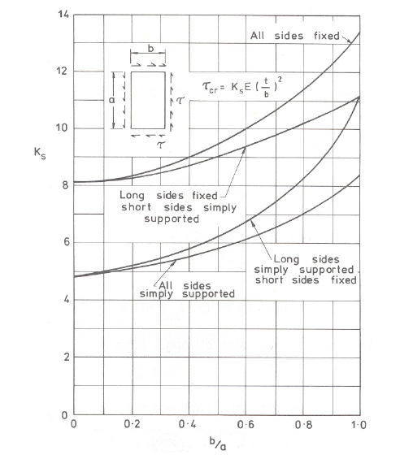
Figure.8.10: Values of $K_{s}$versus $b/a$.

As was the case for uni-axial compression, we desire a factor of safety of at least 3 vs. shear buckling:

${FOS}_{τ-buckling}=\frac{τ_{cr}}{τ}≥3.0$ (8.16)

Exercise 8.6:
Using exercise 8.5, but say it is subject to a pure shear stress $τ = 15 ksi$. What is the FOS at shear buckling?

Solution

$\frac{b}{a}=\frac{36 in}{72 in}=0.5$

From above figure, assuming simply-support BCs: $K_{s}=5.7$
$τ_{cr}=5.7 \left(30,000,00 \frac{lb}{{in}^{2}}\right){\left(\frac{0.75 in}{36 in}\right)}^{2}=74.2 ksi$

${FOS}_{buckling}=\frac{τ_{cr}}{τ_{a}}=\frac{74.20 ksi }{15.0 ksi }=4.9$ (OK)

8.6.3. Pure In-Plane Bending
The web of an I-beam (or the side-plate of a box-girder!) sees applied stress that varies across the “plate” of the web (i.e. tension is maximum on one edge and max compression on the other). This variation in compressive stress across the web can lead to buckling of the web. The part of the web seeing the compressive stress buckles in an alternating ½ wave pattern (see the figure below).
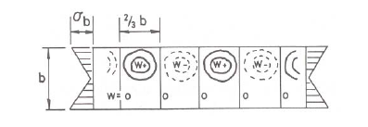
Figure.8.11: Compressive stress buckles in an alternating ½ wave pattern.

This can be illustrated using a piece of paper. Lay the paper on a table and apply a “in-plane bending load” to the paper using your hands. Notice the alternating ½ wave pattern on the compression side of the paper.
Although we will not cover this phenomenon in any greater detail in this class, the student is referred to Hughes for a more detailed explanation, including methods for predicting using “hand calculations”. Of course, it is most suitable to analyze these problems using FEA.

8.7. Buckling of Plates Subject to Combined Loads (in-plane and lateral loads).
Many plates are subject to combined in-plane loads (tension or compression) and lateral loads (hydrostatic pressure). For example, bottom plating (between frames and longitudinal) are subject to tensile and compressive stresses from global hull girder bending plus hydrostatic pressure. Plating at other locations may also see these combined loads (deck plating, bulkheads with tanks, etc.).
Our approach to designing these plates depends upon the types of loads. For in-plane tension plus lateral pressure, if deflections are small (we can use small-deflection theory), then we can simply use superposition of the stresses calculated separately, and σVM. However, if deflections are large (membrane effects), then the best solution is to use a nonlinear FEA method.
For in-plane compression plus lateral pressure, we cannot simply use superposition of the stresses, since the in-plane compression will have the effect of magnifying the lateral deflection (similar to the beam-column). The details of this approach are provided in Hughes, with only the basic result provided here. The outcome is determined by the ratio of inplane
compressive load to lateral pressure. There are two general possibilities:
- If the compressive load is low enough that buckling would not normally occur on its own (without the hydrostatic pressure), then the in-plane compression acts as a magnifier of the lateral deflection due to the pressure (similar to the beam-column). If this is the case, we might consider two additional possibilities:
- If the in-plane compressive stress is “relatively small”, then it acts only as a multiplier for the out of plane bending due to the lateral pressure. In this case, we can use figures 12.18 and 12.19 from Hughes (see next page).
  - We first use figure 12.18 to check the maximum deflection (note that σe is the Euler buckling stress for the plate (which can be found using Bryan’s Equation).
  - Next, we use figure 12.19 to calculate the maximum bending stresses at the center of the plate in the x and y directions (these bending stresses include the magnification effect).
  - Next we add the in-plane compressive stress to the bending stress in the x or y direction as appropriate.
  - Finally, we find the equivalent vonMises stress at the center of the plate, and determine the factor of safety vs. material yield.
- If the in-plane compressive stress is “relatively large”, then it is likely that the plate would buckle or collapse with the addition of the lateral pressure load. In this case, it may buckle in a different “mode shape” than the normal lowest energy mode due to the deflection caused by the lateral pressure. For example, for a/b = 2 it would buckle in a single ½ wave (bowl) shape vice two ½ waves as it would otherwise. Another possibility is that it might “snap through” to its normal lowest energy mode in spite of the existence of the lateral pressure. This “snap through” can be very violent (and loud). Another condition which can cause “snap through” is when a “predeflected” shape is opposite to the lateral pressure – then “snap through” may also occur (examples of this are bilge radius plate or submarine hull plating).
Figure.8.12: Deflection in a different “mode shape”.

- If the compressive stress is high enough that buckling would likely occur on it own (without the lateral pressure), then it will buckle with lateral pressure!
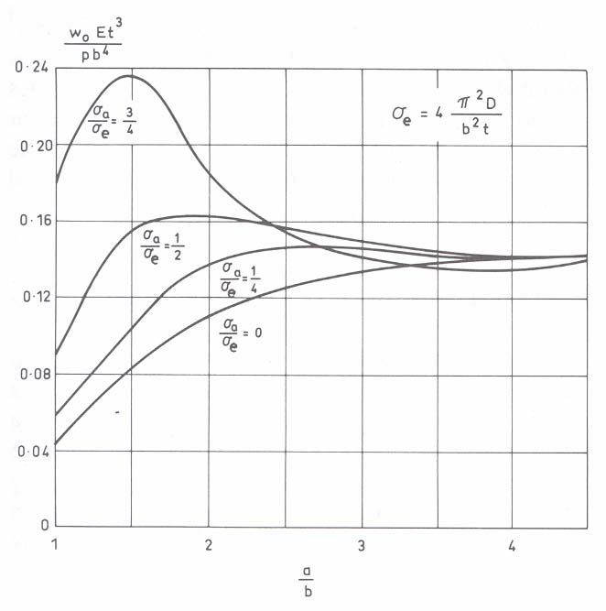
Figure.8.13: Maximum deflection due to unaxial compression and lateral pressures; simply support plate.

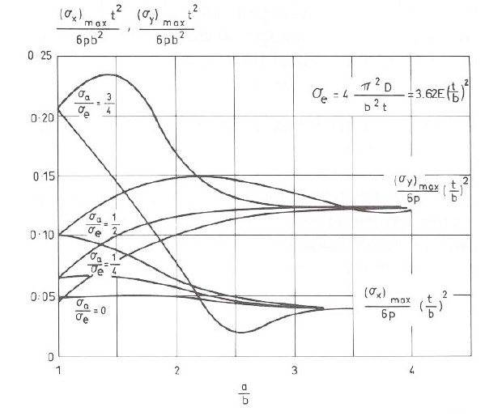
Figure.8.14: Maximum bending stress due to unaxial compression and lateral pressures; simply support plate.

Exercise 8.7:
Consider a ship’s bottom plating subjected to a hydrostatic pressure head of 30 feet of sea water (FSW) and simultaneously to a compressive stress (from global hull girder bending) of 12,000 psi. Assume the material is A36 steel, frame spacing is 48 inches, longitudinal spacing is 24 inches, and that the plating thickness is ½ inch. Determine the factors of safety vs. material yield of this plate.

8.8. Ultimate Strength of Plates
As discussed previously, the collapse of columns occurs either by elastic buckling if the column is slender (Euler or “ideal” column buckling) or by the commencement of yielding which so seriously decreases the column bending stiffness that collapse by inelastic buckling follows almost immediately. In the case of plating, the mechanism of collapse is more complex. Specifically, collapse of plating depends upon type of loading, boundary conditions, aspect ratio, initial distortion, and even residual stresses.
For “slender” plates subject to an increasing compressive uni-axial stress (without lateral load), the plate goes through a number of phases prior to ultimate failure or collapse. At low levels of stress, the plate remains flat, as the stress remains below the elastic buckling stress and below the yield stress. The first noticeable response when the stress reaches the elastic buckling stress is that the plate buckles, and as a result the center portion of the plating partially “escapes” from the axial shortening being applied by the compressive stress. As a result the center buckled portion of the plate “sheds” some of the load, which is transferred to the edges of the plate. In this post-buckled state, the outer edges of the plate are carrying higher stress (higher than the mean stress σa) and the center portion carries a lower stress. This is illustrated in the figure below. As the compressive stress continues to increase, eventually the stress on the outer edges of the plate reaches the material yield stress, and the edges yield (plastic deformation). Eventually, as the center portion of the plate also yields, and the plate collapses.
The extent to which a plate will buckle and collapse depends upon several factors, including load (magnitude, type, etc.), plate geometry (late aspect ratio a/b, thickness, initial distortions), boundary conditions, and manufacturing variances (welds, voids, etc.). Because of this highly variable nature, evaluation of collapse of plate structures is usually investigated using finite element analysis (FEA).
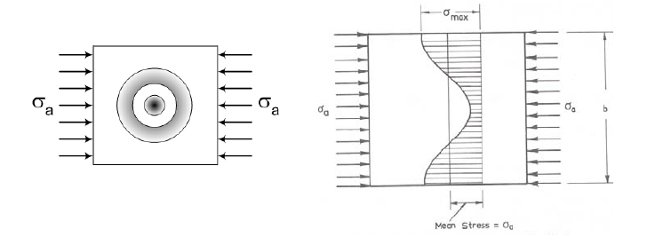
Figure.8.15: Ultimate strength of plates.

8.9. Torsional Buckling of Stiffeners -Tripping-
A stiffener may buckle by twisting or rotating about its line of attachment to the plating as shown in Figure.8 This is referred to as tripping. This is not the same as the column or beam-column type of buckling we have discussed previously for stiffeners, and it is not the same as local compressive buckling of the web or buckling of the flange. Tripping of several stiffeners in a uniaxially-loaded panel is illustrated in the below figure. Note that the plate may also rotate to some extent to accommodate the stiffener rotation – this is not plate buckling, but rather part of the stiffener tripping phenomenon. Tripping could be elastic or plastic, but usually plastic and catastrophic.

Figure.8.16: An example of Torsional Buckling of Stiffeners

The key to minimizing the possibility of this torsional buckling mode is to maximize the torsional stiffness (GJ) of stiffener. Note that G (shear modulus or modulus of rigidity) is already high for steel. Therefore, the best way to minimize tripping is by maximizing J (polar moment of inertia) of stiffener.
A slightly simplified solution for stiffener tripping is presented in Hughes. The result is that for stiffener tripping due to a uni-axial compression:

$σ_{cr-tripin}=\frac{1}{I_{sp}}\left[π^{2}E{\left(\frac{h}{A_{x}}\right)}^{2}I_{sz}\right]$ (8.17)

Where; $h$ is distance (height) from plate to shear center of stiffener, $A_{x}$ is stiffener area (flange + web), $I_{sp}$ is polar moment of inertia of stiffener about center of rotation ($I_{x}$ + $I_{y}$) , $I_{sz}$ is moment of inertia of stiffener about axis through centroid of stiffener and parallel to web ($I_{y1}$)
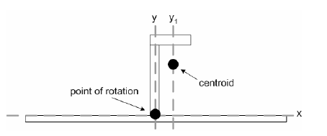
Figure.8.17: An example of Torsional Buckling of Stiffeners

Taking a look at this solution, you should be able to see that the design goal to prevent tripping is that we desire a stiffener to be short (small $I_{sp}$) and wide (large $I_{sz}$). The below figure illustrates the idea. What are problems with “Best” stiffeners on the right? When are they used?

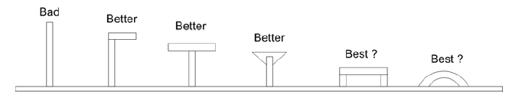
Figure.8.18: An example of tripping

Note that the desire for stiffener to be short (small $I_{sp}$) is counter to the desire to maximize vertical moment of inertia ($I_{x}$) which we desire for vertical bending stiffness (the main purpose of the stiffener). Therefore, designing a stiffener to resist tripping is partially a trade-off or compromise with the stiffener’s main function to resist vertical bending. One solution to this is to install “tripping brackets” at several spots along the length of the stiffener to resist tripping.
A simplified solution for stiffener tripping applies to open thin-walled stiffener sections (T’s, L’s, and flat bars). In this case h ≈ d (web height), $b_{f}$is flange width, $A_{f}$ is flange area, $A_{w}$is web area, and we can simplify

$I_{sp}=d^{2}\left(A_{f}+\frac{A_{w}}{3}\right)$ and $I_{sz}=b_{f}^{2}\frac{A_{f}\left(\frac{A_{x}}{3}-\frac{A_{f}}{4}\right)}{A_{x}}≅\frac{b_{f}^{2}A_{f}}{12}$ (8.18)

This results in a simplified equation for critical stress for stiffener tripping for open thin-walled stiffener sections:

$σ_{cr-tripin}=\frac{π^{2}E}{12+4\frac{A_{w}}{A_{f}}}{\left(\frac{b_{f}}{a}\right)}^{2}$ (8.19)

A few additional notes: Increasing flange width too much may lead to (local) flange buckling. However, flange buckling can be prevented by maintaining an adequate width-to-thickness ratio – a good guideline is: ${b_{f}}/{t_{f}}≤14$ (for mild steel), ${b_{f}}/{t_{f}}≤10$ (for Alum, HTS, HYs). For steel, all standard sections are “compact sections” and have adequate width-to thickness ratios. This is not true for aluminum, however, and this should be checked carefully. Actually for designing stiffeners with aluminum, you should refer to the “Aluminum Design Manual” (The Aluminum Association) for complete design guidelines.

8.10. Buckling of Stiffened Panels.
We have discussed buckling of columns, which we have applied to the design/analysis of stanchions between decks, as well as stiffeners with effective width of attached plating, including stiffeners under combined axial compression due to global hull girder bending and lateral hydrostatic pressure (beam-columns). We have also discussed buckling of plating (between stiffeners), which we have applied to design of ship’s bottom, side and deck plating, including plating under combined axial compression due to global hull girder bending and lateral hydrostatic pressure.
Panels are defined here as plating plus attached stiffeners, which extend between major supports. Here the term “major supports” refers to very stiff longitudinal or transverse structure such as bulkheads, web or ring frames, hull chines, etc.
A panel can buckle in a number of ways:
- Elastic buckling of plating between stiffeners. This is also known as “dimpling”. This is least likely to be a problem (except for fatigue considerations). In PNA, this is referred to as “mode 1 buckling”.
- Elastic and inelastic buckling of stiffeners between frames (with effective width of attached plating). This may not be catastrophic unless an entire row of stiffeners (between frames) buckles together inelastically, in which case it may lead to collapse of the entire panel between frames. In PNA, this is referred to as “mode 2 buckling”.
- Elastic or inelastic torsional buckling of stiffeners between frames (“tripping”). This is almost always catastrophic and can rapidly lead to total panel collapse. In PNA, this is referred to as “mode 3 buckling”.
- Elastic or inelastic buckling of an entire panel made up of several frame bays. This is also known as “global buckling”, “gross panel buckling”, or “overall grillage buckling”. In PNA, this is referred to as “mode 4 buckling”.
The figures below (from PNA Volume 1) provide photographs illustrating modes 2, 3, 4 (shown in a ship panel test machine).
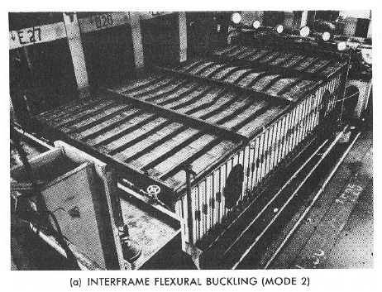

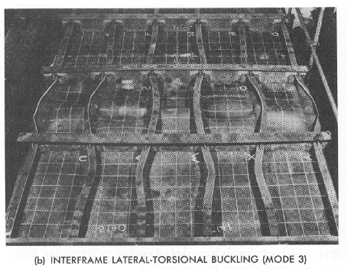
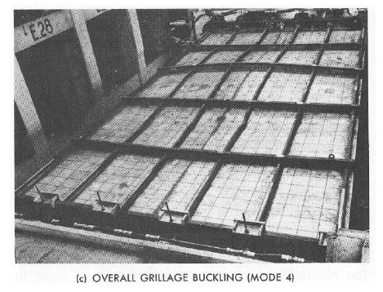
Figure.8.19: An example of Torsional Buckling of Stiffeners

As a matter for design priority, which of these “buckling modes” would we want to fail first? The answer is of course “…it depends!” Elastic plate buckling (mode 1 or “dimpling”) is generally not catastrophic, as the stiffeners are designed to carry the load if the plating buckles, so it is preferred for elastic plate buckling to occur first. Elastic buckling of stiffeners between frames with effective width of attached plating (mode 2) is more noticeable but relatively easy to fix (by adding additional stiffeners or in the field with stanchions or wood supports) but may become catastrophic if allowed to progress. Stiffener tripping, which generally can rapidly become inelastic (plastic), almost always progresses leading to total panel collapse, so this should be last. Thus, we employ a design goal (recommendation):

$σ_{cr-stiffener}≥1.1∙\overset{FOC>3}{\overbrace{σ_{cr-plate}}}$ and $σ_{cr-tripping}≥1.1∙σ_{r-stiffener}$ (8.20)

Our general recommended method is as follows:
- Calculate critical buckling stress for plate $σ_{cr-plate}$
- Calculate critical buckling stress for stiffener (with effective width of plating) $σ_{cr-stiffener}$
- Calculate critical buckling stress for stiffener tripping $σ_{cr-tripping}$
- Make sure $σ_{cr-stiffener}≥1.1∙\overset{FOC>3}{\overbrace{σ_{cr-plate}}}$ and $σ_{cr-tripping}≥1.1∙σ_{r-stiffener}$

8.10.1. Buckling of a “Gross Panels” (“Grillage Buckling”):
Larger panels require additional cross-stiffening. These are often referred to as “grillage panels” or “gross panels”. This cross-stiffening includes intermediate transverse stiffeners (frames or deck beams) in addition to the longitudinal stiffeners (longitudinals, stringers, or deck girders).
Figure.8.20: An example of Torsional Buckling of Stiffeners

For lateral loads on these “gross panels”, the stiffeners usually carry more of the load. Usually if the stiffeners are OK for bending, then they are usually OK for buckling. In-plane loads are more challenging. The plate carries most of the in-plane load (stress), and may dimple (plate buckling).
Stiffeners in line with the primary in-plane compressive loads (longitudinals and deck girders) offer the greatest resistance to buckling! Transverse stiffeners (frames and deck beams) primarily provide intermediate support for the longitudinal, stringers and deck girders – to prevent out-of-plane deflections and rotations and reduce tripping. Thus the frames and deck beams must be stiff relative to longitudinal, stringers and deck girders. Thus, to avoid overall “gross panel” buckling, the intermediate transverse members (frames and deck beams) should be stiffer than the longitudinal, stringers and deck girders that they support!
Minimum transverse rigidity/stiffness to prevent “grillage” buckling (uniaxial compression): Hughes provides a relation for the ratio of transverse to longitudinal stiffness necessary to prevent “gross panel” buckling. This is a semi-empirical, and compares rigidity of transverse stiffeners to rigidity of longitudinal stiffeners:

$\frac{γ_{y}}{γ_{x}}=\frac{B^{4}}{π^{2}C{ a}^{4}} \left(1+\frac{1}{P}\right)$ (8.21)

Where; $γ_{y}$ is stiffness ratio of transverse stiffener, including effective width of plating, which is $γ_{y}=\frac{EI_{y}}{Da}$, $γ_{x}$ is stiffness ratio of longitudinal stiffener, including effective width of plating, which is $γ_{x}=\frac{EI_{x}}{Db}$, B is width of entire cross-stiffened panel, L is length of entire cross-stiffened panel, a is spacing of transverse stiffeners (frames or deck beams), b is spacing of longitudinal stiffeners (longitudinals or deck girders), $C=0.25+2/{N^{3}}$, N is number of “sub-panels” longitudinally ($N$ = L/a), P is number of longitudinal stiffeners ($P=\frac{B}{b}.$ (Note: for the example on the previous page, N = 3 and P = 5)

As long as $\frac{γ_{y}}{γ_{x}}>1$ then the compressive strength of the cross-stiffened panel is determined mainly by the compressive strength of the longitudinally-stiffened “sub-panels” (i.e. between transverse stiffeners). If $\frac{γ_{y}}{γ_{x}}>1$, then it is sufficient to consider only buckling of the longitudinally-stiffened “sub-panels” (between frames or deck beams).
Note: In designs where there is a longitudinal bulkhead supporting the main deck and bottom panels, then the cross stiffened panel width B should be taken as the distance between the longitudinal bulkhead and the deck edge or side-shell (chine), or the distance between longitudinal bulkheads.

8.10 Classification Societies.
The major focus of this course has been to learn the analytical methods that provide tools for us to design ship structures. We call this approach using “first principles.” The assumption has been that we have not had any outside regulatory influences on our designs. That assumption does not apply to many of our designs however, as the Code of Federal Regulations (CFR) has some structural requirements. The Coast Guard is tasked with administering the maritime sections of the CFR and for some vessels the naval architect must have the plans reviewed by the Coast Guard.
In the civil construction side of engineering, the most widely known structural code is the Universal Building Code (UBC). This multi-volume manual includes “cook-book” style equations combined with tables and graphs to allow a contractor or civil engineer to quickly determine the required scantlings. When applying for a building permit the owner must submit the plans for review by the local government, which will check that the plans meet local codes. As the UBC cannot be tailored for all locations, it has sections that can be scaled to different locations and the local laws will often cite different UBC sections. The UBC is not managed by a government agency, rather it is updated by the International Conference of Building Officials (ICBO).
The maritime equivalent of the ICBO is the classification societies. These are non-profit organizations that establish guidelines for building vessels. The societies are based in the larger maritime nations (generally one per country) and have common guidelines established by the International Association of Classification Societies (IACS). Most American companies build and “classify” their ships with the American Bureau of Shipping (ABS). Internationally, other big classification societies are Det Norske Veritas (DNV), Germanischer Lloyd, and Lloyd’s (to name only a few).
The genesis of the classification societies was a request from the insurance companies that ships should conform to minimum standards. As vessel types vary tremendously, there is no “Universal Shipbuilding Code”. Instead, ABS has about 50 different rules and guides, ranging from steel ships to water carriers to offshore racing yachts. Many of the codes can be downloaded free of charge from the ABS website (www.eagle.org).
Some of the ABS Rules are:
- Steel Vessel Rules
- Steel Barges - Ocean Service Barges of any Length
- Steel Vessels Under 90 m - Crewboats, Tugs
- High Speed Naval Craft- Patrol Boats HSVs
- Steel Vessels for Service on Rivers, ICW - River Barges, Towboats
- Bulk Carriers for Service on the Great Lakes - Freshwater Operations
- Reinforced Plastic Vessels - F. R. P. Vessels
- Aluminum Vessels - Aluminum Commercial Vessels 100’ - 500’
- Naval Vessel Rules
- MODU - Mobile Offshore Drilling Units
Some of the (less-comprehensive) Guides are:
- Motor Pleasure Yachts - Steel, Aluminum, or FRP
- High Speed Craft, - Commercial/Government Service Planing vessels
- Fishing Vessels - Steel Fishing Vessels Under 90 m (200’)
- Offshore Racing Yachts - Steel, Aluminum, or FRP Sailing Vessels
- Fire Fighting Vessels - Steel Fireboats
- Crew Accommodations Guide
- Oil Recovery Vessels - Oil Spill Cleanup Vessels
- Floating Production Storage and Offloading Vessels - (FPSO)
- Small Waterplane Area Twin Hulled Vessels - (SWATH)
The Rules and Guides include sections on intact and damaged stability, structures, firefighting, etc. When you design your vessels in the capstone courses you will have to meet the ABS codes if they apply to your vessel!

8.11. Reliability Methods
Probably the largest error in the analysis we have done in this class is our assumptions of the loads. We have assumed that our design will face a maximum load, but we have never clearly described where that load value came from. We have also mostly ignored fatigue effects! The methods we have used could easily be called “the traditional method” of ship structural design. The maximum loads came from historical correlation. If we found that a particular design method routinely developed problems, we would increase the maximum load values until the failures reached an acceptable value.
This has worked because ships have evolved slowly and we have used conservative minimum factors of safety! Using this approach on new vessel types, such as the X-Craft, has produced some dramatic failures! In the past, when faced with a new type, a smart naval architect simply increased the factor of safety.
A better approach started development in the 80’s. It is called the reliability method and uses probability and statistics to better predict what the maximum loads might be. It is based on characterizing the loads in terms of statistical and probabilistic distributions and then determining what an “acceptable probability of failure” is. What is an acceptable level can be determined from historical examples and current litigation! If a new construction material is considered for example, then the new probability of failure can be calculated, and if it is not acceptable, then the structural members could be increased. Below is a copy of one of the first figures from these notes and it illustrates that we have gone full circle from an overview, through deterministic methods, and now back to reliability.
Reliability methods can yield excellent results that traditional methods would never indicate. For example, when the first carbon/epoxy America’s Cup yachts were built, they used traditional ABS methods and factors of safety (3-4 for composites). A detailed study of the aerospace-grade composites used in Dennis Conner’s syndicate indicated that as the materials had such a low variation in properties compared to that assumed by ABS (which was based on typical fiberglass boat laminates), by using reliability methods the factors of safety could be reduced to 1.25-2. That meant the next boat’s structure could be as much as 70% lighter!

Chapter 9

9.0 Collision Mechanic on Ships and Offshore Structure

9.1 Collision Mechanic
The analysis of collision mechanics is generally based upon the solution of the differential equation of dynamic equilibrium. The collision force is a function of relative indentation of the ship and platform. Thus, an incremental solution procedure is required.
The problem is greatly simplified if the collision duration is considerably smaller than the natural period of the governing motion. This assumption is often valid for relevant rigid body motions of floating and articulated platforms. In this case, the solution can be based upon a quasi-static solution using the principles of conservation of momentum and conservation of energy.
This way, the determination of impact kinematics and energy transfer during collisions can be decoupled from the analysis of strain energy dissipation in colliding objects. A static solution applies for collisions lasting significantly longer than the natural period of vibration for leg impacts may be such that significant dynamic effects are involved. This has been investigated to a very small extend. Normally, a static analysis is considered appropriate, but possible dynamic magnification should also be evacuated.
The process involved in collision is complicated. The analysis of a ship-ship collision is usually separated into two classes. These are External Collision Mechanics and Internal Collision Mechanics.

9.1.1 External Collision Mechanics
External collision mechanics is concerned with the rigid body motion of the two ships involved in the collision. The two ships are hence referred to as the struck and striking ships. Thus, external collision mechanics deals with the kinetic energy of the struck and striking ships, including an allowance for the added masses of water.
Collisions are conveniently in term of energy. This involves the transformation of kinetic energy into elastic and plastic strain energy and equivalently to elastic and plastic strain deformation. Collisions are by their very nature dynamic events and can be described by the general differential equations of motion. However if the impact duration is long compared to the natural period of vibration, the collision event can be described quasi-statically by using the conservation of momentum principle (although this is not applicable to all possible collision involving FPSOs).

Figure.9.1: Ship to ship collision, (Source: HSE Collision, 2000)

According to HSE-Collision, 2000 resistance of Ship-shaped structures to side impact, the conservation of momentum yields:

$\left(M_{B}+M_{A}+δ_{m}\right) U=M_{A}∙V_{A}+M_{B}∙V_{B}$ (9.1)

With; $M_{B}$ is the displacement mass including added mass of the striking vessel, $M_{A}$ is the displacement mass including added mass of the struck vessel, $V_{B}$ is the velocity of the striking vessel, $V_{A}$, is the velocity of the struck vessel, $U$ is the velocity after collision, $δ_{m}$ is the added mass coefficient.
At the end of the impact, the translational kinetics energy is:

$E_{K}=\frac{1}{2}\left(M_{B}+M_{A}+δ_{m}\right) U^{2}$ (9.2)

When the two vessels move as one body after collision i.e. the coefficient of restitution is zero. The direction of collision normal to the struck ship centre-line is importance, in this direction $V_{A}= 0$ and the velocity component of the striking ship is $V_{B}\sin{θ}$, where θ is the angle of encounter. Equation.9.2 can be rewritten as

$U=\frac{M_{B}∙V_{B}\sin{θ}}{M_{B}+M_{A}+δ_{m}}$ (9.3)

For the component of $U$ in the direction of collision which is normal to that of the struck ship. Therefore the lost kinetics energy is written as

$E_{i}=\frac{1}{2}M_{B} {\left(V_{B}\sin{θ}\right)}^{2}-\frac{1}{2}(M_{B} +( M_{A} + δ_{m}))\frac{M_{B}^{2}∙ {\left(V_{B} ∙\sin{θ}\right)}^{2}}{{\left[M_{B}+ \left(M_{A}∙ δ_{m}\right)\right]}^{2}}$ (9.4)

Where; $i$ denotes internal energy, since the lost kinetic energy is conserved in this form.
If $M_{A}>> M_{B}$ and that the striking ship is almost totally stopped by the platform, thus the second part of the equation is negligible yielding:

$E_{i}=\frac{1}{2}M_{B} {(V_{B}sinθ)}^{2}$ (9.5)

The above assumes that the centre of masses for the struck and striking vessel have coincident line of actions producing no rotation. However for an FPSO, the colliding object could also be such that the masses have a similar order of magnitude; thus Equation.9.3 would be applicable.
The case of a relatively stiff bow colliding with an FPSO is shown graphically in Figure 9.2
Figure.9.2: Force deflection relation for stiff bow collision into a side shelf (Source: HSE Collision, 2000).

9.1.2. Internal Collision Mechanics
Internal collision mechanics is concerned with the response of the struck and the striking vessel to collision. This specially means the relationship between force and deformation of the two vessels.
When a ship’s bow has collided with the side of vessel, there is global and local response to impact. In side-ship collision, the deformation can be quite large and as a result the structural members in the struck ship can experience failure modes such as yielding in bending crushing and rupture. The damage process can be different depending on the collision situation, as depicted in Figure.9.3.
The global response involves the bending of the struck vessel longitudinally, with the struck side experiencing compressive stresses. These stresses are small compared to the stresses induced in the local impact zone. In this area the lateral components of the collision force produces bending and shear action in the stiffened side shell. This has two phases: first elastic and then plastic. Beyond this point the side shell and supporting stiffeners momentarily unload and act effectively as a mechanism, deforming laterally towards the axis of the ship, until sufficient geometry is achieved to resist the load axially. Thus the side shell resists the load as a tensile membrane up to the point of rupture.

Figure.9.3: Stages in the collapse mechanism for a side shell (HSE Collision, 2000)

9.1.3. Response of Steel Tubular Member Subjected to Collision Load
Steel tubular members, used in fixed braced offshore structures, have proved to have excellent energy absorption capabilities. Calculation and experience have shown that in most moderate accidental impact cases, the collision energy is absorbed and the striking vessel is stopped by the hit bracing member. Thus, usually the damages to the installation are limited to a single member, and sufficient installation strength to sustain the functional and environmental loads in the damaged condition is easily achieved.
Collision damage of installation members may take the form of local indentation, overall bending or combination of both, depending on the member geometry, end condition, type of impact, etc. The commonest members of offshore platform are of a circular tubular section with typical geometries in the ranges, $40 < D/t < 60$ and $10 < L/D < 30$; under lateral impact they are susceptible to localized denting and ovalization as well as overall bending. Such deformation reduces their resistance to axial and bending loads, and their effects need to be incorporated in load-carrying capacity analyses (Kenny, 1988).

9.1.4. Accidental Impact Load
In cases where the stiffness of the impacted part of the Installation is very large in comparison to that of the impacting part of the vessel, as for example in collisions involving concrete Installations or fully grouted elements, the impact energy absorbed locally by the Installation may be very low and it is important to examine damage caused by the impact force (OTR, 2001).

In such cases, the impact force, F, may be taken as:

$F=P_{o} or V \sqrt{c a m}$, whichever is the less (9.6)

Where; $P_{o}$is the minimum crushing strength (or punching shear as appropriate) of the impacting part of the vessel and the impacted part of the Installation (MN), c is stiffness of the impacting part of the vessel (MN/m), V is impact speed (m/s), m is vessel displacement (kg), $a$ is vessel added mass coefficient: 1.4 for sideways collision and 1.1 for bow or stern collision.

9.1.5. Manoeuvring
The manoeuvring motion of a ship can be represented as a rigid body with directions in surge, sway, and yaw. The mathematical model for manoeuvring motion of ships can be described by the following equations of motion using the coordinate system as shown in Figure.9.4.
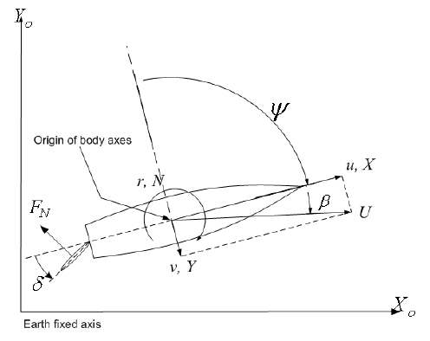
Figure.9.4: Surge, Sway and Yaw Motion (Jaswar et al.2011)

The non-dimensional force for surging, sway and moment for yaw can be expressed as:
$$X^{'}=\left(m^{'}+m_{x}^{'}\right)\left(\frac{L}{U}\right)\left(\frac{\dot{U}}{U}cosβ-\dot{β}sinβ\right)+\left(m^{'}+m_{y}^{'}\right)r^{'}sinβ$$
$$Y^{'}=\left(m^{'}+m_{y}^{'}\right)\left(\frac{L}{U}\right)\left(\frac{\dot{U}}{U}sinβ-\dot{β}cosβ\right)+\left(m^{'}+m_{x}^{'}\right)r^{'}cosβ$$
$N^{'}=\left(I_{zz}^{'}+i_{zz}^{'}\right){\left(\frac{L}{U}\right)}^{2}\left(\frac{\dot{U}}{L}r'-\frac{U}{L}\dot{r'}cosβ\right)$ (9.7)

The non-dimensional quantities are defined as

$$m^{'},m_{x}^{'},m_{y}^{'}=\frac{m,m_{x},m_{y}}{0.5ρL^{2}d}$$
$${ I}_{zz}^{'},i_{zz}^{'} =\frac{I_{zz},i_{zz}}{0.5ρL^{4}d}$$
$$X^{'},Y^{'} =\frac{X,Y}{0.5ρ{LU}^{2}d}$$
$$N^{'} =\frac{N}{0.5ρ{L^{2}U}^{2}d}$$
$r^{'} =\frac{r}{U}L$ (9.8)
Where; L is ship length, d is Depth, m is ship mass, m_{x} and m_{y} are added mass of ship, m’, m’x, m’y are dimensionless mass of ship, and added mass in x- and y-directions, I_{zz} and i_{zz} are Moment and added moment of inertia of ship, U is ship speed, $β$ is drift angle, r is angular velocity, r′ is dimensionless turning rate, $ρ$ is density of fluid, X and Y are external surge and sway force acting on ship, N is yaw moment acting on ship, X’ and Y’ are dimensionless surge and sway force acting on a ship and N’ is dimensionless yaw moment acting on a ship.
The aforementioned external forces are expressed as:

$$X=X_{H}+X_{P}+X_{R}$$
$$Y=Y_{H}+Y_{P}+{ Y}_{R}$$
$N=N_{H}+N_{P}+N_{R}$ (9.9)

Where; subscript H indicates hull, subscript P indicates propeller and the subscript R indicates the rudder.

9.1.5.1. Forces and Moments Acting on Hull
In Kijima mathematical model, the forces and moments acting on Hull (X’_{H}, Y’_{H}, and N’_{H}) can be expressed as:

$${X'}_{H}={X'}_{βr}r'sinβ+{X'}_{uu}\cos^{2}β$$
$${Y'}_{H}={Y^{'}}_{β}β+{Y^{'}}_{r}r^{'}+{Y^{'}}_{ββ}β\left|β\right|+{Y^{'}}_{rr}r^{'}\left|r^{'}\right|+\left({Y^{'}}_{ββr}β+{Y^{'}}_{βrr}r^{'}\right)βr^{'}$$
${N'}_{H}={N^{'}}_{β}β+{N^{'}}_{r}r^{'}+{N^{'}}_{ββ}β\left|β\right|+{N^{'}}_{rr}r^{'}\left|r^{'}\right|+\left({N^{'}}_{ββr}β+{N^{'}}_{βrr}r^{'}\right)βr^{'}$ (9.10)

Where; ${Y^{'}}_{β}, {Y^{'}}_{r} , {Y^{'}}_{ββ} ,{Y^{'}}_{rr} ,{Y^{'}}_{ββr} , {Y^{'}}_{βrr} ,{{ N}^{'}}_{β} ,{{ N}^{'}}_{r} ,{{ N}^{'}}_{ββ} ,{{ N}^{'}}_{rr} ,{{ N}^{'}}_{ββr} and {N^{'}}_{βrr}$ are the coefficients of hydrodynamic derivative.
The hydrodynamic derivative coefficients are defined as follow:
$${ Y^{'}}_{β}=0.5πk+1.9257\left(\frac{C_{b}B}{L}\right)σ_{a}$$
$${Y^{'}}_{r}-\left(m^{'}+m_{x}^{'}\right)=0.25πk+0.052e_{a}^{'}-0.457$$
$${{ Y}^{'}}_{ββ}=-1.199C_{b}σ_{a}+1.05$$
$${Y^{'}}_{rr}=0.225\left(\frac{dC_{b}}{B}\right).e_{a}^{'}-0.12$$
$${Y^{'}}_{ββr}=10.443{\left(\frac{d\left(1-C_{b}\right)}{B}.e_{a}^{'}\right)}^{2}-9.374\left(\frac{d\left(1-C_{b}\right)}{B}.e_{a}^{'}\right)+1.227$$
$${Y^{'}}_{βrr}=7.1256\left(\frac{d\left(1-C_{b}\right)}{B}\right)$$
$${N^{'}}_{β}=k\left(15.0668{\left(\frac{d\left(1-C_{b}\right)}{B}.e_{a}^{'}K_{form}\right)}^{2}-23.819\left(\frac{d\left(1-C_{b}\right)}{B}.e_{a}^{'}K_{form}\right)+1.802\right)$$
$${N^{'}}_{r}=-0.54k+k^{2}-0.0477e_{a}^{'}K_{form}+0.0368$$
$${N^{'}}_{ββ}=43.857{\left(\frac{d\left(1-C_{b}\right)}{B}.e_{a}^{'}K_{form}\right)}^{2}-3.671\left(\frac{d\left(1-C_{b}\right)}{B}.e_{a}^{'}K_{form}\right)+0.086$$
$${N^{'}}_{rr}=0.15K_{form}-0.068$$
$${N^{'}}_{βrr}=-0.4086C_{b}+0.27$$
${N^{'}}_{ββr}=-0.826(d(1-C_{b})/B)e_{a}^{'}-0.026$ (9.11)

Where; k=2d/L, e_{a} and $e_{a}^{'}$ express fullness of aft run, $σ_{a}$ is the aft sections fullness, K_{form} is the form factor. These parameters can be determined using equation (9.12).
$e_{a}=\frac{L}{B}\left(1-C_{pa}\right)$
$e_{a}^{'}=e_{a}/\sqrt{\frac{1}{4}+\frac{1}{\frac{B}{d^{2}}}}$
$$σ_{a}=\frac{1-C_{wa}}{1-C_{pa}}$$
$K_{form}=(\frac{1}{e_{a}^{'}}+\frac{1.5}{\frac{L}{B}}-0.33)(0.95σ_{a}+0.40)$ (9.12)

9.1.5.2. Forces and Moments Induced by Propeller
The expression used to determine the propeller forces and moment are shown below. For conventional propulsion system, $Y_{P}^{'}$ and $N_{P}^{'}$ are equal to zero.
$${X'}_{P}=\frac{\left(1-t_{p}\right)n^{2}D_{p}^{4}K_{T}cosδ }{0.5LdU^{2}}$$
$$Y_{P}^{'} =0$$
$$N_{P}^{'} =0$$
(4.14)
Where:
$$K_{T}=C_{1}+C_{2}J_{p}+C_{3}J_{p}^{2}$$
$$J_{p}=\frac{\left(1-W_{p}\right)Ucos\left(β\right)}{nD_{p}}$$
(9.14)
Where; $t_{p}$ is thrust deduction coefficient, n is propeller revolution, $D_{p}$ is propeller diameter, C_{1,} C_{2,} and C₃ are constants for propeller open characteristics and $W_{p}$ is effective wake fraction coefficient.

9.1.5.3. Forces and Moments Induced by Rudder
The force induced by rudder in the surge direction affected by additional drag while rudder induced sway force and yaw moment are affected by hull force factor. The forces and moment induced by rudder are defined as follows.

$${X'}_{R}=-\left(1-t_{R}\right)F_{N}^{'}sinδ$$
$${Y'}_{R}=-\left(1+a_{H}\right)F_{N}^{'}cosδ$$
${N'}_{R}=-\left({x'}_{R}+a_{H}{x'}_{H}\right)F_{N}^{'}cosδ$ (9.15)

Where; 𝛿 is rudder angle, $t_{R}$ is Additional drag coefficient, $a_{H}$ is interactive force coefficients among hull, ${x'}_{H}$is represents non-dimensional distance between center of gravity of the ship and center of additional lateral force, ${x'}_{R}$ is represents non-dimensional longitudinal distance between center, of gravity of the ship and center of lateral force and $F_{N}^{'}$is rudder normal force
Additional drag coefficient, $t_{R}$ is determined using equation (9.16).

$1-t_{R} = 0.28C_{B} + 0.55$ (9.16)

While $a_{H}$ and ${x'}_{H}$ can be obtained from the chart shown in Figure.9.5
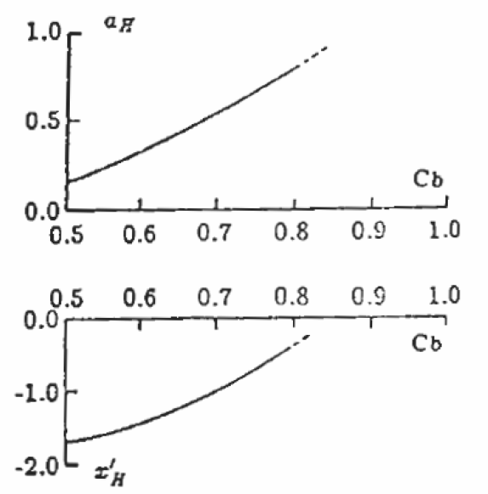
Figure.9.5: Chart of Coefficients $a_{H}$ and ${x'}_{H}$ , (Source: Yoshimura et al.1996)

Meanwhile, the rudder normal force can be determined using equation.9.17.

$F_{N}^{'}=\left(\frac{A_{R}}{Ld}\right)C_{N}U_{R}^{2}sin\left(α_{R}\right)$ (9.17)

Where; $A_{R}$ is rudder area, $C_{N}$ is gradient of the lift coefficient of rudder, $U_{R}$ is Effective rudder inflow speed and $α_{R}$ is effective rudder inflow angle
The values of $C_{N}$ and $U_{R}$ are calculated using equation.9.18.

$$C_{N}=\frac{6.13ᴧ}{ᴧ+2.25}$$

$U_{R}=\frac{V_{rh}^{2}+V_{rh}V_{rp}+CV_{rp}^{2}}{U^{2}}$ (9.18)

Where; $ᴧ$ is rudder aspect ratio, $V_{rh}$is effective flow due to interaction between hull and propeller, $V_{rp}$ is effective flow due to interaction between propeller and rudder and $C$ is rudder coefficient

9.1.5.4. Ship Manoeuvring System Process
The ship turning circle trial is made to starboard using maximum rudder angle at 35º without changing engine control setting from the initial speed. The rudder angle is executed on the steady approach at zero yaw-rate. The most essential information to be obtained from this manoeuvre is tactical diameter, speed, yaw rate and drift angle. Process flow of the ship manoeuvring simulation is shown in Figure.9.6. Input data which is kept in the excel “Main”, “ CP Curve”, “Manoeuvre”, “Exp-Propeller” and “Rudder” sheets are browsed, opened and read using Open-File Dialog before displayed on Microsoft Office toolbox in VB as shown in Figure 4.7. The “Main” sheet contents data such as length, beam, draft and displacement of hull, engine, and shaft consists of force and moment hydrodynamic derivatives coefficients. Default values for the hydrodynamics coefficient are zero. Open test data of propeller such as thrust and torque coefficient are located in the “Exp-Propeller” excel sheet. Rudder profile is kept in the “Rudder” sheet.

Input Data Read From Excel Sheets
Reading
Form Factor
Hull Fullness
Ship Resistance
Added Mass & Moment
Propulsion Parameter
Hydrodynamics Derivatives
Hydrodynamics Force and Moments: Hull, Propeller & Rudder
Hydrodynamics Force and Moments: Hull, Propeller & Rudder
Stored
Manoeuvring Motion in VB-2008

Simulation Result Stored to Excel Sheet
Figure.9.6: Flowchart of Ship Manoeuvring Simulation (SMS) tool

Using those input data, firstly, propulsion parameters such as K-form, ship resistance such as friction and wave, wake fraction and thrust deduction are estimated using numerical mathematical method. Using propeller characteristics and those propulsion parameters are then used to predict propeller thrust. On the other side of flowchart, hydrodynamics parameters, force and moments acting on hull fullness factors, added mass and moment and hydrodynamics derivatives are calculated using ship parameters such as length, breadth, draft, etc. combination the propulsion and hydrodynamics parameters, forces and moment acting on total interaction between hull, propeller, and rudder, respectively. Finally, ship trajectory, speed, rate of turning, drift of angle, and moving direction are estimated.

9.1.5.5. Mathematical Model Modification
The mathematical model proposed by Kijima used to simulates a ship with rudder. Hence, the mathematical model needs to be modified to simulate the use of a pod propulsor rather than a rudder. Unlike the conventional propulsor, pod propulsor not only produce thrust force to propel the ship but also act as a controlling device to give direction to the ship. In general, a pod propulsor consisted of two main parts which are pod body and strut. This can be illustrated by Figure.9.7.

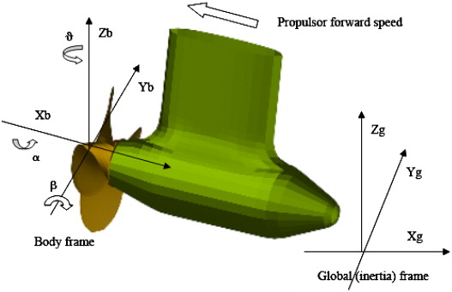
Figure.9.7: Pod Body and Strut (Pengfei Liu, et. al. 2009)

In this study, the forces and moments induced by rudder are replaced by the forces and moments induced by pod propulsor. Meantime, modifications do not take into account changes in the hull forces and moments (X_{H}, Y_{H}, and N_{H}). The proposed equations for external forces and moments are expressed as:

$$X=X_{H}+X_{P}+X_{POD}$$
$$Y=Y_{H}+Y_{P}+Y_{POD}$$
$N=N_{H}+N_{P}+N_{POD}$ (9.19)

Where; subscript H indicates hull, subscript P indicates propeller and subscript POD indicates pod propulsion.

The forces and moments induced by pod propulsion can be determined using equation.9.20.

$$X_{POD}=X_{Strut}+X_{Body}$$
$$Y_{POD}=Y_{Strut}+Y_{Body}$$
$N_{POD}=N_{Strut}+N_{Body}$ (9.20)

Where; $X_{Strut}$, $Y_{Strut}$ and $N_{Strut}$ are forces and moments induced by strut and $X_{Body}$, $Y_{Body}$ and $N_{Body}$ are forces and moments induced by pod body.

9.1.5.6. Forces and Moments Induced by Propeller (Modified)
Pod propulsion is different from the conventional propulsion system as it can be steered over 360°. Hence, the thrust produced by the propeller not only acting in the surge direction but also in sway and yaw direction. In this situation, equation.9.20 is no longer suitable to express the forces and moments induced by pod propeller. Modification has been made and the new proposed equations are shown below:

$${X'}_{P}=\frac{\left(1-t_{pod}\right)n^{2}D_{p}^{4}K_{T}cosδ_{p} }{0.5LdU^{2}}$$
$${Y'}_{P}=\frac{\left(1-t_{pod}\right)n^{2}D_{p}^{4}K_{T}sinδ_{p}}{ 0.5LdU^{2}}$$
${N'}_{P}=\frac{-{x'}_{pod}\left(1-t_{pod}\right)n^{2}D_{p}^{4}K_{T}sinδ_{p}}{0.5LdU^{2}}$ (9.21)

Where; $t_{pod}$ is thrust deduction due to pod suction, n is propeller revolution, $D_{p}$ is Propeller diameter, $K_{T}$ is Thrust coefficient, $δ_{p}$ is Pod angle and ${x'}_{pod}$ is represents non-dimensional longitudinal distance between centre of gravity of the ship and centre of pod propulsion

9.1.5.7. Forces and Moments Induced by Strut
A pod propulsion not only produce thrust force but also lift force (normal force). The strut of the pod unit intends to act like a conventional rudder as the controlling device. The forces and moments induced by the strut are almost same with the conventional rudder but there are some changes in the equations parameters. The new proposed equations are expressed as:

$${X'}_{strut}=-\left(1-t_{R}\right)F_{s}'sin\left(δ_{p}\right)$$
$${Y'}_{strut}=-\left(1+a_{Hpod}\right)F_{s}'cos\left(δ_{p}\right)$$
${N'}_{strut}=-\left({x^{'}}_{pod}+a_{Hpod}{x^{'}}_{Hpod}\right)F_{s}'cos\left(δ_{p}\right)$ (9.22)

Where; $δ_{p}$ is Pod angle, $t_{R}$ is Additional drag coefficient, $a_{Hpod}$is Interactive force coefficients among hull and pod, ${x^{'}}_{Hpod}$ is Represents non-dimensional distance between centre of gravity of the ship and point of action of the normal force, ${x^{'}}_{pod}$is Represents non-dimensional longitudinal distance between centre of gravity of the ship and centre of pod unit and $F_{s}'$ is Strut normal force.

Strut normal force can be calculated using equation.9.23.

$F_{S}^{'}=\left(\frac{A_{S}}{Ld}\right)C_{Ns}U_{p}^{2}sin\left(α_{pod}\right)$ (9.23)

Where; $A_{S}$ is Strut area, $C_{Ns}$ is Gradient of the lift coefficient of strut, $U_{p}$ is Effective pod inflow speed and $α_{pod}$ is Effective pod inflow angle
Gradient of the lift coefficient of strut and effective pod inflow speed are calculated using equation.9.24.

$C_{Ns}=\frac{6.13ᴧ_{s}}{ᴧ_{s}+2.25}$
$U_{p}=\frac{V_{hp}^{2}+V_{hp}V_{ps}+C_{S}V_{ps}^{2}}{U^{2}}$ (9.24)

Where; $ᴧ_{s}$ is Strut aspect ratio, $V_{hp}$is Effective flow due to interaction between hull and pod propeller, $V_{ps}$ is Effective flow due to interaction between pod propeller and strut and $C_{S}$ is Strut coefficient
In pod propulsion system, V_{hp} is taken as the advance velocity, V_{A}. Since the pod is steerable, the inflow velocity is almost not influenced by the ship hull. Hence, reduction in effective flow is relatively small. This can be illustrated by Figure 4.9.
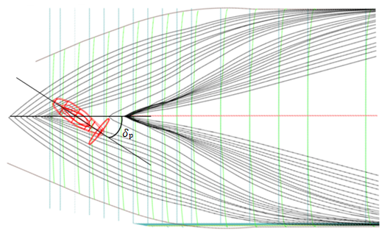
Figure.9.8: Pod Unit and Hull Stern (Top View).

9.1.5.8. Forces and Moments Induced by Pod Body
Besides the strut effects, there are also effects on pod body due to the side force generated by pod propeller. Equations.9.26 are proposed to determine the forces and moments induced by the pod body.

$${X'}_{Body}=\frac{-\left(1-t_{pod}\right)n^{2}D_{p}^{4}K_{T}\sin{α_{pod}}sinδ_{p} }{0.5LdU^{2}}$$
$${Y'}_{Body}=\frac{-\left(1+a_{Hpod}\right)n^{2}D_{p}^{4}K_{T}\sin{α_{pod}}cosδ_{p} }{0.5LdU^{2}}$$
${N'}_{Body}=\frac{-\left({x^{'}}_{R}+a_{Hpod}{x^{'}}_{Hpod}\right)n^{2}D_{p}^{4}K_{T}\sin{α_{pod}}cosδ_{p}}{0.5LdU^{2}}$ (9.26)

9.1.6. Finite Element Method
The finite element method (FEM) is a numerical technique for finding approximate solutions to partial differential equations (PDE) and their systems, as well as integral equations. In simple terms, FEM is a method for dividing up a very complicated problem into small elements that can be solved in relation to each other. Its practical application is often known as finite element analysis (FEA).
FEM is a special case of the more general Galerkin method with polynomial approximation functions. The solution approach is based on eliminating the spatial derivatives from the PDE. This approximates the PDE with a system of algebraic equations for steady state problems, a system of ordinary differential equations for transient problems.
These equation systems are linear if the underlying PDE is linear, and vice versa. Algebraic equation systems are solved using numerical linear algebra methods. Ordinary differential equations that arise in transient problems are then numerically integrated using standard techniques such as Euler's method or the Runge-Kutta method.
In solving partial differential equations, the primary challenge is to create an equation that approximates the equation to be studied, but is numerically stable, meaning that errors in the input and intermediate calculations do not accumulate and cause the resulting output to be meaningless. There are many ways of doing this, all with advantages and disadvantages. The finite element method is a good choice for solving partial differential equations over complicated domains (like cars and oil pipelines), when the domain changes (as during a solid state reaction with a moving boundary), when the desired precision varies over the entire domain, or when the solution lacks smoothness. For instance, in a frontal crash simulation it is possible to increase prediction accuracy in "important" areas like the front of the car and reduce it in its rear (thus reducing cost of the simulation). Another example would be in Numerical weather prediction, where it is more important to have accurate predictions over developing highly nonlinear phenomena (such as tropical cyclones in the atmosphere, or eddies in the ocean) rather than relatively calm areas.
Finite element method includes modelling the structure with small elements that are connected is called a finite element. A function used to tip displacement elements. Each element is connected directly or indirectly with an interface that can be a node and / or a line of demarcation and / or surface barrier. By knowing the stress / strain the material that forms the structure, it can be determined that the node behaviour is a function of the nature of the other elements in the structure. The combination of the equations that describe the behaviour of each node is in the form of a series of algebraic equations are expressed in matrix notation.

Stages in the formulation of the finite element method in solving the problems of the structure are a little detail will be described below. This stage aims to demonstrate the general procedure to be followed in the finite element formulation of a problem (Logan, 1993).

Step 1 Discredited and Select Element Types.
Step 1 involves dividing the body into an equivalent system of finite element with associated nodes and choosing the most appropriate element type. The total number of elements used and their variation in size and type within a given body are primarily matters of engineering judgement.

Step 2 Select a Displacement Function
Step 2 involves choosing a displacement function within element. The function is defined for each element using the parameter values ​​at the vertices of the elements. Usually used polynomial linear, quadratic, or cubic function is as simple as the finite element formulation. Geometric series can also be used.

Step 3 Define the Strain/ Displacement and Stress/Strain Relationships
Strain/displacement and stress/strain relationships are necessary for deriving the equation for each finite element. In the case of one-dimensional deformation, say, in the x direction, we have strain ε_{x} related to displacement u by
(9.27)
Where; ε_{x} is small strains and u is displacement
In addition, the stresses must be related to the strain through the stress/strain law-generally called the constitutive law. The ability to define the material behavior accurately is most important in obtaining acceptable results. The simplest of stress/strain laws, Hooke’s law, often uses in stresses analysis, is given by

(9.28)

With; is stress in the x direction and E is modulus of elasticity

Step 4 Derive the Element Stiffness Matrix and Equation
Initially, the development of element stiffness matrices and element equation was based on the concept of stiffness influence coefficient, which presupposes a background in structural analysis. There are (3) three methods that usually used in Element Stiffness Matrix such as: Direct Equilibrium Method, Work or Energy Methods, and Methods of Weighted Residuals.

Step 5 Assemble the Element Equation to Obtain the Global or Total Equations and Introduce Boundary Conditions
Element equations obtained in step IV can be combined using the method of superposition to obtain global equations entire structure. In the direct stiffness method entails the meaning of the concept of continuity or compatibility requires that the structure remains rigid conditions and there is no crack / tear anywhere in the structure.
At this stage it can be seen that the global rigidity matrix is a singular matrix since its determinant is equal to zero. To avoid the singularity problem, it must determine the boundary conditions (also known as constraints or pedestal) so that the structure remains in place and does not move as a rigid body.

The final assembled or global equation written in matrix form is

$\{F\} = [K]\{d\}$ (9.29)

Where {F} is the vector of global nodal forces, [K] is the structure global or total stiffness matrix, and {d} is now the vector of known or unknown structure nodal degrees of freedom or generalized displacements.

Step 6 Solve for the Unknown Degrees of Freedom (or Generalized Displacement)
Equation.9.29, modified to account for the boundary conditions, is a set of simultaneous algebraic equations that can be written in expanded matrix form as:

(9.30)

Where; n is the structure total number of unknown nodal degrees of freedom. These equations can be solved for the d’s by using an elimination method (such as Gauss-Seidel’s Method).

Step 7 Solve for the Element Strains and Stress
The second important scale for structural analysis problem is strain and stress. These quantities can be obtained as expressed directly as function displacement.

Step 8 Interpret the Result
The end goal is to interpret and analyze the results to be used in the design process. Determining the location of the structure where the largest deformation and stress are usually very important in making decisions in their design.

Chapter 10

10.0 Strength Analysis of Jacket Structure due to Ship Collision

10.1 Input Variable
This chapter puts emphasis on the results obtained from the data analysis and simulation. The results consist to analyze the initial and collision effect, time, and the push-over method for ultimate strength of structure and simulation using ANSYS, GT-STRUDL and visual basic. Discussions of the results are also included in this chapter. The variables used in the simulation are shown as Table.10.1 to predict the conditions, tides, collision types, and loads of the structure. The research variables are shown as Table.10.1:
Table.10.1: Input Variables
No. | Item | Description
1 | Conditions | Normal, Extremes
2 | Tides | Low Water Level (LWL), Mean Sea Level (MSL), High Water Level (HWL)
3 | Collision types | Stern and Bow Collisions  Sideway Collisions  Manoeuvring Effect Collisions  (Heading Angles: 10º, 15º)
4 | Loads | Self-weight, Environmental Loading, Impact Loading

10.2. Simulation Flowchart

10.2.1 ANSYS LS-DYNA Simulation

Figure.10.1: ANSYS LS-DYNA Simulation Flowcharts

10.2.2. Manoeuvring Simulation
Figure.10.2: Manoeuvring Simulation Flowchart

10.2.3 GT-STRUDL Simulation

Figure.10.3: GT-STRUDL Simulation Flowcharts

10.2.4 Simulation Description

The description of simulation as below:
- Collecting data of supply vessel, data of jacket, record accident of supply vessel, environmental data.
- Geometry Modelling Jacket Leg and supply vessel by ANSYS LS-DYNA Software.
Modelling steps will be explain on Figure.10.2
- Geometry Modelling of jacket leg and supply vessel.
Geometry modelling jacket leg and supply vessel based on the data CONOCO BELANAK and velocity variation based on investigation data. Element Solid 164 for jacket leg (Figure.10.4). Solid 164 is element 8 nodes that has degree of freedom in every nodes for translation velocity, acceleration in x, y, z.
- Material Properties
A material property for jacket leg is plastic kinematics (Figure.10.5) and assumption for vessel is rigid body with material property is plastic kinematic hardening on Figure.10.6.
- Meshing model.
Meshing is dividing model by elements. There are 3 type of meshing process: Mesh Line, Mesh Area, Mesh Volume.
- Boundary Condition
Length of jacket leg is 10.14 meters, assumption fixed support on jacket leg. Six degree of freedom constrains for this model. (Figure.10.7)
- Contact object and target
Modelling Collision in ANSYS LS-DYNA must be defining to contact object or target. Vessel as contact object and jacket leg as target object (Figure.10.8). There are 2 methods in contact process, rigid to flexible and flexible to flexible. In this model, chosen rigid to flexible. Vessel as rigid, then jacket leg as flexible. Rigid to flexible
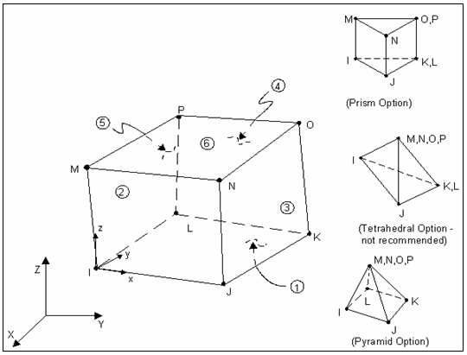Figure Figure.10.4: Geometry Elements Solid 164

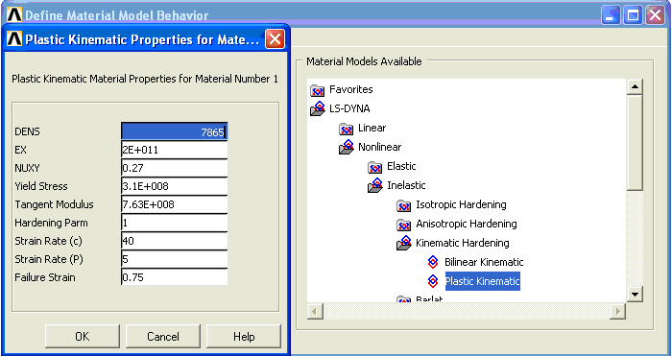
Figure.10.5: Material Properties of Jacket Leg

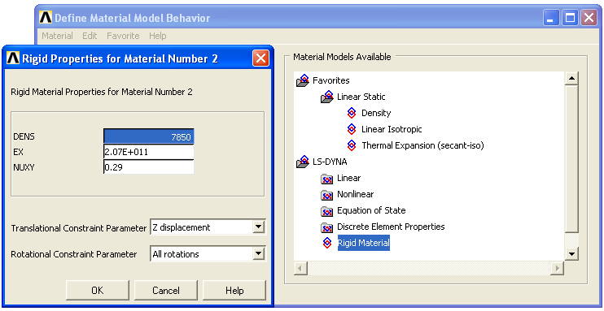
Figure.10.6: Material Properties of Supply Vessel

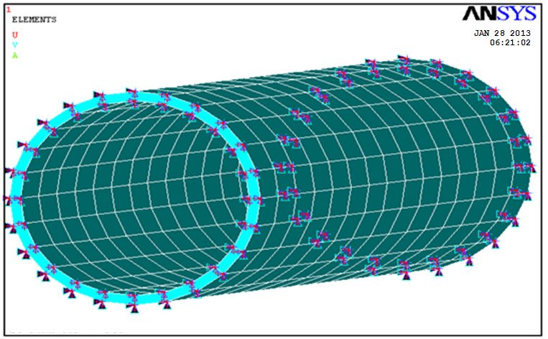
Figure.10.7: Constrains

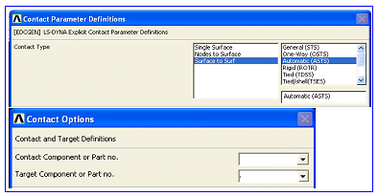
Figure.10.8: Contact Parameter Definition

- Input velocity contact object and loading.
Input velocity contact object based on Table 5.1, Figure 5.9 to show input velocity contact object.
- Running model to get the deformation subjected to Impact Loading.
- Loading variation based on tides, type of collision, and supply vessel velocity.

Table.10.2: Collision Scenario
Collision Scenario | MSL |  | LWL |  | HWL
Collision Scenario | Normal | Extreme | Normal | Extreme | Normal | Extreme
Collision Scenario | Velocity | Velocity | Velocity | Velocity | Velocity | Velocity
Collision Scenario | (m/s) | (m/s) | (m/s) | (m/s) | (m/s) | (m/s)
Sideway Collision | 0.28 | 0.54 | 0.28 | 0.54 | 0.28 | 0.54
Stern/Bow Collision | 0.39 | 0.73 | 0.39 | 0.73 | 0.39 | 0.73
Manoeuvring Collision | 0.74 | 1.29 | 0.74 | 1.29 | 0.74 | 1.29

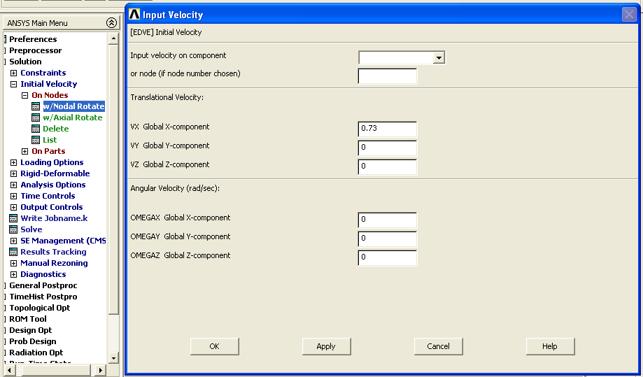
Figure 5.9: Input Initial Velocity of Contact Object

- The output of software ANSYS LS-DYNA 9.0 version used to input GT-STRUDL 27 version. Step of modelling would be explained in Figure.10.3.
- Result running is to acquire the strength of the Jacket structure.
- Next step is dynamic analysis, as shown as below:
- Dynamic load data
It used to show Transient Loading. Data shown as graphic by command STORE TIME HISTORY to entry time history and click result to know the result of the model.
- Dynamic analysis result show joint displacement, velocity, force, and moment of dynamic analysis as time function.

10.3. Data Collection
1. Tides data:
Height Water Level | = 1.309 meter
Mean Sea Level | = 1.29 meter
Low Water Level | = 0.91 meter

2. Jacket Criteria
Platform’s Name | = CONOCO BELANAK
Platform’s Type | = Wellhead Platform
Leg | = 4 Legs
Deck | = 2 Decks
Deck Dimension | = 45’ x 80 ’
Water Depth | = 294’- ”
Platform Orientation | = 141º47’6”
Diameter of Jacket Leg | = Ø65’
Length of vertical brace of Jacket Leg | = 10.14 meters

3. Wave Component
Average Wave Length | = 100 feets
Wave Height Significant | = 7.3 feets
Wave Height Average of One of Tenth Highest | = 9.3 feets
Average Wave Period | = 5.4 seconds
Significant Range Period | = 3.0 -11.1 seconds
Water Depth | = 294’- ”

4. Wind
Wind Description | = Fresh breeze
Wind Range | = 17-21 knots
Wind Velocity | = 20 knots

5. Current
Surface current speed | = 0.3 m/s
Seabed current speed | = 1.9 m/s
6. Material Properties of Jacket Leg

Density | = 7865 | kg/m3
Young's modulus | = 2.07E0+11 | Pa
Poison's ratio | = 0.27 | no unit
Yield stress | = 3.10E+08 | Pa
Tangent modulus | = 7.63E+08 | Pa
Hardening parm | = 1 | no unit
Strain rate ( c ) | = 40 | no unit
Strain rate ( P ) | = 5 | no unit
Failure strain | = 0.75 | no unit

7. Material Properties of Vessel
Density | = 7580 | kg/m3
Young's modulus | = 2.07E0+11 | Pa
Poison's ratio | = 0.27 | no unit

10.4. Simulations Results

10.4.1. ANSYS LS-DYNA
Figure.10.10: Boundary Condition of Jacket Leg

The boundary condition must be defined
Set the Boundary condition of the jacket leg (Figure.10.10) is the one step before running the programme which is constrained movement in x, y, z axis (Figure.10.11).

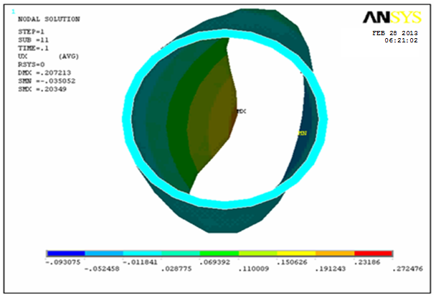

Figure.10.11: Maximum Dent (plane x-y)

10.4.1.1. Local dent of jacket leg
There are 3(three) types of collision in this study, such as: sideway collision (see Figure.10.12), stern/bow collision (see Figure.10. 13) and manoeuvring drift collision (see Figure.10.14). To study the global structural response due to collision, the local dent of the tubular member under impact load must be discussed first so that the transmission of the impact load can be established. The shape and area of the local dent depends on the collision modes (see Figure.10.15). Because of the complexity of the impact problem, it is difficult to find a simple analytical model to establish the relation between the local denting of the tubular member and the impact load.

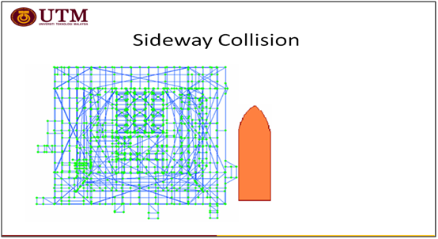
Figure.10.12: Sideway Collision
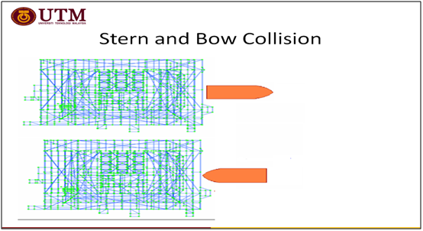
Figure.10.13: Stern/Bow Collision

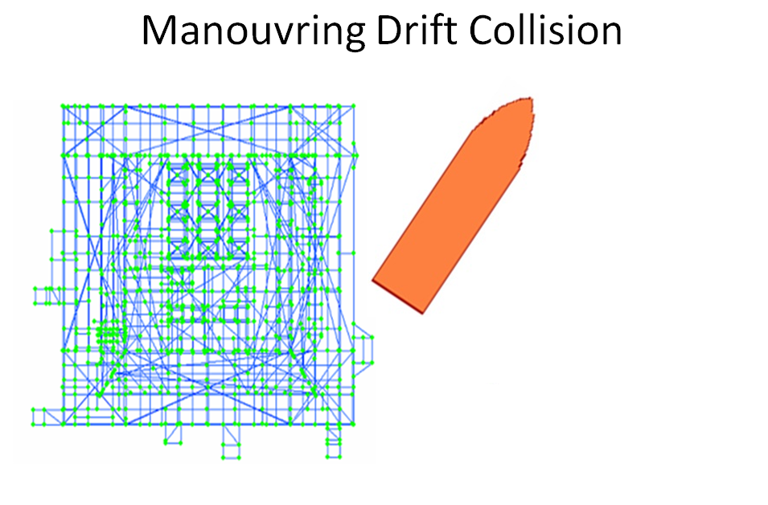
Figure.10.14: Manouvring Drift Collision

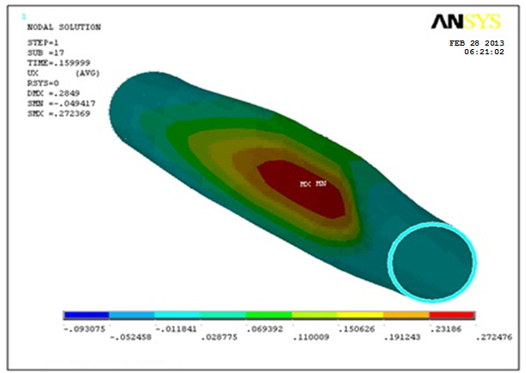
Figure.10.15: Maximum Dent (plane x-y-z)

10.4.1.2. Impact Load Identification
Geometry numerical simulation analysis is carried out to identify the impact load characteristics according to the indentation of impacted member. In this study, non-linear linear finite element analysis is performed to calculate the deformation of jacket leg for various possible load conditions, so that the relationship between deformation and loading parameters can be established. From there, the actual load parameters can be determined according to the measured deformation information.

10.4.2. Dynamics Analysis of Jacket Platform

10.4.2.1. Extreme Condition at Mean Sea Level

Figure.10.16: Graph of Deformation at Jacket Leg due to Extreme Sideway Collision at Mean Sea Level.

2.27E+08
Figure.10.17: Graph of Stresses at Jacket Leg due to Extreme Sideway Collision at Mean Sea Level.

According to Figure.10.16 and Figure.10.17 shown that maximum deformation 0.2352 meters at 0.16 seconds and maximum stresses at jacket leg 2.27E+08 pascals at 0.17 seconds.

0.2724
Figure.10.18: Graph of Deformation at Jacket Leg due to Extreme Stern/Bow Collision at Mean Sea Level.

Figure.10.19: Graph of Stresses at Jacket Leg due to Extreme Stern/Bow Collision at Mean Sea Level.

According to Figure.10.18 and Figure.10.19 shown that maximum deformation 0.2724 meters at 0.16 seconds and maximum stresses at jacket leg 2.93E+08 pascals at 0.17 seconds.

0.3524
Figure.10.20: Graph of Deformation at Jacket Leg due to Extreme Manouvring Drift Collision at Mean Sea Level.

Figure.10.21: Graph of Stresses at Jacket Leg due to Extreme Manouvring Drift Collision at Mean Sea Level.

According to Figure.10.20 and Figure.10.21 shown that maximum deformation 0.3524 meters at 0.17 seconds and maximum stresses at jacket leg 3.06E+08 pascals at 0.17 seconds.

10.4.2.2 Extreme Condition at Low Water Level

Figure.10.22: Graph of Deformation at Jacket Leg due to Extreme Sideway Collision at Low Water Level.

Figure.10.23: Graph of Stresses at Jacket Leg due to Extreme Sideway Collision at Low Water Level.

According to Figure.10.22 and Figure.10.23 shown that maximum deformation 0.2352 meters at 0.18 seconds and maximum stresses at jacket leg 2.10E+08 pascals at 0.18 seconds.

Figure.10.24: Graph of Deformation at Jacket Leg due to Extreme Stern/Bow Collision at Low Water Level.

Figure.10.25: Graph of Stresses at Jacket Leg due to Extreme Stern/Bow Collision at Low Water Level.

According to Figure.10.24 and Figure.10.25 shown that maximum deformation 0.2840 meters at 0.17 seconds and maximum stresses at jacket leg 2.94E+08 pascals at 0.17 seconds.

0.3524
Figure.10.26: Graph of Deformation at Jacket Leg due to Extreme Manouvring Drift Collision at Low Water Level.

Figure.10.27: Graph of Stresses at Jacket Leg due to Extreme Manouvring Drift Collision at Low Water Level.

According to Figure.10.26 and Figure.10.27 shown that maximum deformation 0.3524 meters at 0.17 seconds and maximum stresses at jacket leg 3.06E+08 pascals at 0.17 seconds.

10.4.2.3 Extreme Condition at High Water Level

Figure.10.28: Graph of Deformation at Jacket Leg due to Extreme Sideway Collision at High Water Level.

Figure.10.29: Graph of Stresses at Jacket Leg due to Extreme Sideway Collision at High Water Level.

According to Figure.10.28 and Figure.10.29 shown that maximum deformation 0.2352 meters at 0.17 seconds and maximum stresses at jacket leg 2.22E+08 pascals at 0.17 seconds.

Figure.10.30: Graph of Deformation at Jacket Leg due to Extreme Stern/Bow Collision at High Water Level.

Figure.10.31: Graph of Stresses at Jacket Leg due to Extreme Sideway Collision at High Water Level.

According to Figure.10.30 and Figure.10.31 shown that maximum deformation 0.2572 meters at 0.17 seconds and maximum stresses at jacket leg 2.94E+08 pascals at 0.17 seconds.

Figure.10.32: Graph of Deformation at Jacket Leg due to Extreme Manouvring Drift Collision at High Water Level.

Figure.10.33: Graph of Stresses at Jacket Leg due to Extreme Manouvring Drift Collision at High Water Level.

According to Figure.10.32 and Figure.10.33 shown that maximum deformation 0.3524 meters at 0.17 seconds and maximum stresses at jacket leg 3.06E+08 pascals at 0.17 seconds.

10.4.2.4 Normal Condition at Mean Sea Level

Figure.10.34: Graph of Deformation at Jacket Leg due to Normal Sideway Collision at High Water Level.

Figure.10.35: Graph of Stresses at Jacket Leg due to Normal Sideway Collision at High Water Level.

According to Figure.10.35 and Figure.10.36 show that maximum deformation 0.2027 meters at 0.17 seconds and maximum stresses at jacket leg 1.85E+08 pascals at 0.17 seconds.

Figure.10.36: Graph of Deformation at Jacket Leg due to Normal Stern/Bow Collision at High Water Level.

Figure.10.37: Graph of Stresses at Jacket Leg due to Normal Stern/Bow Collision at High Water Level.

According to Figure.10.36 and Figure.10.37 shown that maximum deformation 0.2246 meters at 0.18 seconds and maximum stresses at jacket leg 1.96E+08 pascals at 0.18 seconds.

Figure.10.38: Graph of Deformation at Jacket Leg due to Normal Manouvring Drift Collision at High Water Level.

Figure.10.39: Graph of Stresses at Jacket Leg due to Normal Manouvring Drift Collision at High Water Level.

According to Figure.10.38 and Figure.10.39 shown that maximum deformation 0.2246 meters at 0.17 seconds and maximum stresses at jacket leg 2.963E+08 pascals at 0.17 seconds.

10.4.2.5 Normal Condition at Low Water Level

Figure.10.40: Graph of Deformation at Jacket Leg due to Normal Sideway Collision at Low Water Level.

Figure.10.41: Graph of Stresses at Jacket Leg due to Normal Sideway Collision at Low Water Level.

According to Figure.10.40 and Figure.10.41 shown that maximum deformation 0.2027 meters at 0.17 seconds and maximum stresses at jacket leg 1.43E+08 pascals at 0.17 seconds.

Figure.10.42: Graph of Deformation at Jacket Leg due to Normal Stern/Bow Collision at Low Water Level.

1.2E+08
Figure.10.43: Graph of Stresses at Jacket Leg due to Normal Stren/Bow Collision at Low Water Level.

According to Figure.10.42 and Figure.10.43 shown that maximum deformation 0.2246 meters at 0.16 seconds and maximum stresses at jacket leg 1.2E+08 pascals at 0.16 seconds.

Figure.10.44: Graph of Deformation at Jacket Leg due to Normal Manouvring Drift Collision at Low Water Level.

Figure.10.45: Graph of Stresses at Jacket Leg due to Normal Manouvring Drift Collision at Low Water Level.

According to Figure.10.44 and Figure.10.45 shown that maximum deformation 0.2740 meters at 0.16 seconds and maximum stresses at jacket leg 2.93E+08 pascals at 0.16 seconds.

10.4.2.6 Normal Condition at High Water Level

Figure.10.46: Graph of Deformation at Jacket Leg due to Normal Sideway Collision at High Water Level.

Figure.10.47: Graph of Stresses at Jacket Leg due to Normal Sideway Collision at High Water Level.

According to Figure.10.46 and Figure.10.47 shown that maximum deformation 0.2140 meters at 0.16 seconds and maximum stresses at jacket leg 1.4E+08 pascals at 0.16 seconds.

Figure.10.48: Graph of Deformation at Jacket Leg due to Normal Stern/Bow Collision at High Water Level.

Figure.10.49: Graph of Stresses at Jacket Leg due to Normal Stern/Bow Collision at High Water Level.

According to Figure.10.48 and Figure.10.49 shown that maximum deformation 0.2246meters at 0.16 seconds and maximum stresses at jacket leg 1.30E+08 pascals at 0.16 seconds.

Figure.10.50: Graph of Deformation at Jacket Leg due to Normal Manouvring Drift Collision at High Water Level.

Figure.10.51: Graph of Stresses at Jacket Leg due to Normal Manouvring Drift Collision at High Water Level.

According to Figure.10.48 and Figure.10.49 shown that maximum deformation 0.2740 meters at 0.16 seconds and maximum stresses at jacket leg 2.963E+08 pascals at 0.16 seconds.
Table.10.3 and Table.10.4 show that manouvring drift collision is the biggest dent, stress impact, and stiffness to the jacket structure.

Table.10.3: Contact Stiffness of ANSYS Result at Normal Condition.
Type of | Mass of | Velocity of | Energy | Dent | Stress | Stiffness
Collision | vessel | vessel | kinetics | Depth | Impact | Stiffness
 | kg | m/s | J | m | N/m² | N/m
Sideway | 2500000 | 0.28 | 1345932.00 | 0.2027 | 1.85E+08 | 9.13E+08
Stern/Bow | 2500000 | 0.39 | 2051638.88 | 0.2246 | 1.96E+08 | 8.73E+08
Manouvring  Drift | 2500000 | 0.74 | 9400923.00 | 0.2740 | 2.96E+08 | 1.08E+09

Table.10.4: Contact Stiffness of ANSYS Result at Extreme Condition.
Type of | Mass of | Velocity of | Energy | Dent | Stress | Stiffness
Collision | vessel | vessel | kinetics | Depth | Impact | Stiffness
 | kg | m/s | J | m | N/m² | N/m
Sideway | 2500000 | 0.54 | 52018.35 | 0.2352 | 2.27E+08 | 9.65E+08
Stern/Bow | 2500000 | 0.73 | 74692.92 | 0.2724 | 2.93E+08 | 1.08E+08
Manouvring  Drift | 2500000 | 1.29 | 28568436.75 | 0.3224 | 3.06E+08 | 9.49E+09

10.4.3. Response Analysis of Jacket Structure

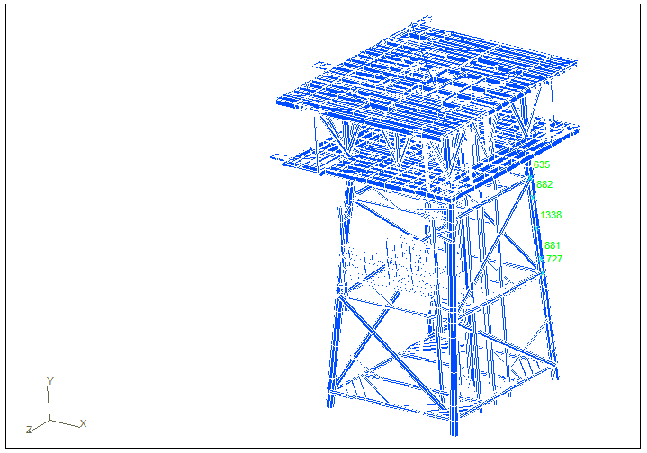
Figure.10.52: Determined joint load

Firstly for static analysis to acquired punching shear and unity check for every joint. The maximum result of unity check is 1.3428 and 99830 total elements of jacket structure. Based on Figure.10.52, modeling geometry of wellhead jacket structure, total horizontal load is varying for every tidal condition and assumed as join load such as: joint 882 (as horizontal load when low water level), joint 1338 (as horizontal load when mean sea level) and joint 881 (as horizontal load when low water level). Based on this result of unity check (see Table.10.3 until Table.10.11), the allowable stresses on storm condition is increased 30% from the initial condition. List Unity Check Jacket Leg on extreme and normal condition as shown as below:

Tabel.10.5: List Unity Check Jacket Leg of Sideway Collision on extreme velocity at High Water Level.

CHORD | BRACE | JOINT | UNITY CHECK | REMARKS
JL-10 | E15-1 | 635 | 0.4515 | SAFE
JL-10 | E15-2 | 635 | 0.5874 | SAFE
JL-10 | E15-3 | 635 | 0.4517 | SAFE
JL-10 | 1767 | 635 | 0.2730 | SAFE
JL-10 | E15-3 | 635 | 0.2933 | SAFE
JL-11 | 1767 | 635 | 0.5070 | SAFE
JL-12 | E50-2 | 809 | 0.1348 | SAFE
JL-12 | 1472 | 809 | 0.7717 | SAFE
JL-12 | E50-104 | 809 | 0.6427 | SAFE
JL-12 | E50-2 | 809 | 0.3007 | SAFE
JL-12 | 1472 | 809 | 0.3198 | SAFE
JL-12 | E50-104 | 809 | 0.2997 | SAFE
JL-13 | E50-2 | 809 | 0.8509 | SAFE
JL-13 | 1472 | 809 | 0.7717 | SAFE
JL-13 | E50-2 | 809 | 0.3007 | SAFE
JL-13 | 1472 | 809 | 0.3198 | SAFE
JL-15 | 1741 | 1042 | 0.4239 | SAFE
JL-16 | E17-2 | 728 | 0.8500 | SAFE
JL-16 | E17-9 | 728 | 0.5050 | SAFE
JL-16 | 1478 | 728 | 0.5477 | SAFE
JL-16 | 1766 | 728 | 0.8258 | SAFE
882 | 1473 | 882 | 1.3300 | SAFE

Tabel.10.6: List Unity Check Jacket Leg of Sideway Collision on extreme velocity at Mean Sea Level.

CHORD | BRACE | JOINT | UNITY CHECK | REMARKS
JL-10 | E15-1 | 635 | 0.4515 | SAFE
JL-10 | E15-2 | 635 | 0.5874 | SAFE
JL-10 | E15-3 | 635 | 0.4517 | SAFE
JL-10 | 1767 | 635 | 0.2730 | SAFE
JL-10 | E15-3 | 635 | 0.2933 | SAFE
JL-11 | 1767 | 635 | 0.5070 | SAFE
JL-12 | E50-2 | 809 | 0.1348 | SAFE
JL-12 | 1472 | 809 | 0.7717 | SAFE
JL-12 | E50-104 | 809 | 0.6427 | SAFE
JL-12 | E50-2 | 809 | 0.3007 | SAFE
JL-12 | 1472 | 809 | 0.3198 | SAFE
JL-12 | E50-104 | 809 | 0.2997 | SAFE
JL-13 | E50-2 | 809 | 0.8509 | SAFE
JL-13 | 1472 | 809 | 0.7717 | SAFE
JL-13 | E50-2 | 809 | 0.3007 | SAFE
JL-13 | 1472 | 809 | 0.3198 | SAFE
JL-15 | 1741 | 1042 | 0.4239 | SAFE
JL-16 | E17-2 | 728 | 0.8500 | SAFE
JL-16 | E17-9 | 728 | 0.5050 | SAFE
JL-16 | 1478 | 728 | 0.5477 | SAFE
JL-16 | 1766 | 728 | 0.8258 | SAFE
1338 | 1473 | 1338 | 1.2760 | SAFE

Tabel.10.7: List Unity Check Jacket Leg of Sideway Collision on extreme velocity at Low Water Level.

CHORD | BRACE | JOINT | UNITY CHECK | REMARKS
JL-10 | E15-1 | 635 | 0.4365 | SAFE
JL-10 | E15-2 | 635 | 0.5724 | SAFE
JL-10 | E15-3 | 635 | 0.4367 | SAFE
JL-10 | 1767 | 635 | 0.2580 | SAFE
JL-10 | E15-3 | 635 | 0.2783 | SAFE
JL-11 | 1767 | 635 | 0.4920 | SAFE
JL-12 | E50-2 | 809 | 0.1198 | SAFE
JL-12 | 1472 | 809 | 0.7567 | SAFE
JL-12 | E50-104 | 809 | 0.6277 | SAFE
JL-12 | E50-2 | 809 | 0.2857 | SAFE
JL-12 | 1472 | 809 | 0.3048 | SAFE
JL-12 | E50-104 | 809 | 0.2847 | SAFE
JL-13 | E50-2 | 809 | 0.8359 | SAFE
JL-13 | 1472 | 809 | 0.7567 | SAFE
JL-13 | E50-2 | 809 | 0.2857 | SAFE
JL-13 | 1472 | 809 | 0.3048 | SAFE
JL-15 | 1741 | 1042 | 0.4089 | SAFE
JL-16 | E17-2 | 728 | 0.8350 | SAFE
JL-16 | E17-9 | 728 | 0.4900 | SAFE
JL-16 | 1478 | 728 | 0.5327 | SAFE
JL-16 | 1766 | 728 | 0.8108 | SAFE
881 | 1473 | 881 | 1.1260 | SAFE

Tabel.10.8 : List Unity Check Jacket Leg of Stern/Bow Collision on extreme velocity at High Water Level.

CHORD | BRACE | JOINT | UNITY CHECK | REMARKS
JL-10 | E15-1 | 635 | 0.4515 | SAFE
JL-10 | E15-2 | 635 | 0.5874 | SAFE
JL-10 | E15-3 | 635 | 0.4517 | SAFE
JL-10 | 1767 | 635 | 0.2730 | SAFE
JL-10 | E15-3 | 635 | 0.2933 | SAFE
JL-11 | 1767 | 635 | 0.5070 | SAFE
JL-12 | E50-2 | 809 | 0.1348 | SAFE
JL-12 | 1472 | 809 | 0.7717 | SAFE
JL-12 | E50-104 | 809 | 0.6427 | SAFE
JL-12 | E50-2 | 809 | 0.3007 | SAFE
JL-12 | 1472 | 809 | 0.3198 | SAFE
JL-12 | E50-104 | 809 | 0.2997 | SAFE
JL-13 | E50-2 | 809 | 0.8509 | SAFE
JL-13 | 1472 | 809 | 0.7717 | SAFE
JL-13 | E50-2 | 809 | 0.3007 | SAFE
JL-13 | 1472 | 809 | 0.3198 | SAFE
JL-15 | 1741 | 1042 | 0.4239 | SAFE
JL-16 | E17-2 | 728 | 0.8500 | SAFE
JL-16 | E17-9 | 728 | 0.5050 | SAFE
JL-16 | 1478 | 728 | 0.5477 | SAFE
JL-16 | 1766 | 728 | 0.8258 | SAFE
882 | 1473 | 882 | 1.3428 | SAFE

Tabel.10.9: List Unity Check Jacket Leg of Stern/Bow Collision on extreme velocity at Mean Sea Level.

CHORD | BRACE | JOINT | UNITY CHECK | REMARKS
JL-10 | E15-1 | 635 | 0.4515 | SAFE
JL-10 | E15-2 | 635 | 0.5874 | SAFE
JL-10 | E15-3 | 635 | 0.4517 | SAFE
JL-10 | 1767 | 635 | 0.2730 | SAFE
JL-10 | E15-3 | 635 | 0.2933 | SAFE
JL-11 | 1767 | 635 | 0.5070 | SAFE
JL-12 | E50-2 | 809 | 0.1348 | SAFE
JL-12 | 1472 | 809 | 0.7717 | SAFE
JL-12 | E50-104 | 809 | 0.6427 | SAFE
JL-12 | E50-2 | 809 | 0.3007 | SAFE
JL-12 | 1472 | 809 | 0.3198 | SAFE
JL-12 | E50-104 | 809 | 0.2997 | SAFE
JL-13 | E50-2 | 809 | 0.8509 | SAFE
JL-13 | 1472 | 809 | 0.7717 | SAFE
JL-13 | E50-2 | 809 | 0.3007 | SAFE
JL-13 | 1472 | 809 | 0.3198 | SAFE
JL-15 | 1741 | 1042 | 0.4239 | SAFE
JL-16 | E17-2 | 728 | 0.8500 | SAFE
JL-16 | E17-9 | 728 | 0.5050 | SAFE
JL-16 | 1478 | 728 | 0.5477 | SAFE
JL-16 | 1766 | 728 | 0.8258 | SAFE
1338 | 1473 | 1338 | 1.2870 | SAFE

Tabel.10.10: List Unity Check Jacket Leg of Stern/Bow Collision on extreme velocity at Low Water Level.

CHORD | BRACE | JOINT | UNITY CHECK | REMARKS
JL-10 | E15-1 | 635 | 0.4365 | SAFE
JL-10 | E15-2 | 635 | 0.5724 | SAFE
JL-10 | E15-3 | 635 | 0.4367 | SAFE
JL-10 | 1767 | 635 | 0.2580 | SAFE
JL-10 | E15-3 | 635 | 0.2783 | SAFE
JL-11 | 1767 | 635 | 0.4920 | SAFE
JL-12 | E50-2 | 809 | 0.1198 | SAFE
JL-12 | 1472 | 809 | 0.7567 | SAFE
JL-12 | E50-104 | 809 | 0.6277 | SAFE
JL-12 | E50-2 | 809 | 0.2857 | SAFE
JL-12 | 1472 | 809 | 0.3048 | SAFE
JL-12 | E50-104 | 809 | 0.2847 | SAFE
JL-13 | E50-2 | 809 | 0.8359 | SAFE
JL-13 | 1472 | 809 | 0.7567 | SAFE
JL-13 | E50-2 | 809 | 0.2857 | SAFE
JL-13 | 1472 | 809 | 0.3048 | SAFE
JL-15 | 1741 | 1042 | 0.4089 | SAFE
JL-16 | E17-2 | 728 | 0.8350 | SAFE
JL-16 | E17-9 | 728 | 0.4900 | SAFE
JL-16 | 1478 | 728 | 0.5327 | SAFE
JL-16 | 1766 | 728 | 0.8108 | SAFE
881 | 1473 | 881 | 1.1890 | SAFE

Tabel.10.11: List Unity Check Jacket Leg of Manouvring Drift Collision on extreme velocity at High Water Level.

CHORD | BRACE | JOINT | UNITY CHECK | REMARKS
JL-10 | E15-1 | 635 | 0.4515 | SAFE
JL-10 | E15-2 | 635 | 0.5874 | SAFE
JL-10 | E15-3 | 635 | 0.4517 | SAFE
JL-10 | 1767 | 635 | 0.2730 | SAFE
JL-10 | E15-3 | 635 | 0.2933 | SAFE
JL-11 | 1767 | 635 | 0.5070 | SAFE
JL-12 | E50-2 | 809 | 0.1348 | SAFE
JL-12 | 1472 | 809 | 0.7717 | SAFE
JL-12 | E50-104 | 809 | 0.6427 | SAFE
JL-12 | E50-2 | 809 | 0.3007 | SAFE
JL-12 | 1472 | 809 | 0.3198 | SAFE
JL-12 | E50-104 | 809 | 0.2997 | SAFE
JL-13 | E50-2 | 809 | 0.8509 | SAFE
JL-13 | 1472 | 809 | 0.7717 | SAFE
JL-13 | E50-2 | 809 | 0.3007 | SAFE
JL-13 | 1472 | 809 | 0.3198 | SAFE
JL-15 | 1741 | 1042 | 0.4239 | SAFE
JL-16 | E17-2 | 728 | 0.8500 | SAFE
JL-16 | E17-9 | 728 | 0.5050 | SAFE
JL-16 | 1478 | 728 | 0.5477 | SAFE
JL-16 | 1766 | 728 | 0.8258 | SAFE
882 | 1473 | 882 | 1.3380 | SAFE

Tabel.10.12: List Unity Check Jacket Leg of Manouvring Drift Collision on extreme velocity at Mean Sea Level.

CHORD | BRACE | JOINT | UNITY CHECK | REMARKS
JL-10 | E15-1 | 635 | 0.4515 | SAFE
JL-10 | E15-2 | 635 | 0.5874 | SAFE
JL-10 | E15-3 | 635 | 0.4517 | SAFE
JL-10 | 1767 | 635 | 0.2730 | SAFE
JL-10 | E15-3 | 635 | 0.2933 | SAFE
JL-11 | 1767 | 635 | 0.5070 | SAFE
JL-12 | E50-2 | 809 | 0.1348 | SAFE
JL-12 | 1472 | 809 | 0.7717 | SAFE
JL-12 | E50-104 | 809 | 0.6427 | SAFE
JL-12 | E50-2 | 809 | 0.3007 | SAFE
JL-12 | 1472 | 809 | 0.3198 | SAFE
JL-12 | E50-104 | 809 | 0.2997 | SAFE
JL-13 | E50-2 | 809 | 0.8509 | SAFE
JL-13 | 1472 | 809 | 0.7717 | SAFE
JL-13 | E50-2 | 809 | 0.3007 | SAFE
JL-13 | 1472 | 809 | 0.3198 | SAFE
JL-15 | 1741 | 1042 | 0.4239 | SAFE
JL-16 | E17-2 | 728 | 0.8500 | SAFE
JL-16 | E17-9 | 728 | 0.5050 | SAFE
JL-16 | 1478 | 728 | 0.5477 | SAFE
JL-16 | 1766 | 728 | 0.8258 | SAFE
1338 | 1473 | 1338 | 1.2460 | SAFE

Tabel.10.13: List Unity Check Jacket Leg of Manouvring Drift Collision on extreme velocity at Low Water Level

CHORD | BRACE | JOINT | UNITY CHECK | REMARKS
JL-10 | E15-1 | 635 | 0.4365 | SAFE
JL-10 | E15-2 | 635 | 0.5724 | SAFE
JL-10 | E15-3 | 635 | 0.4367 | SAFE
JL-10 | 1767 | 635 | 0.2580 | SAFE
JL-10 | E15-3 | 635 | 0.2783 | SAFE
JL-11 | 1767 | 635 | 0.4920 | SAFE
JL-12 | E50-2 | 809 | 0.1198 | SAFE
JL-12 | 1472 | 809 | 0.7567 | SAFE
JL-12 | E50-104 | 809 | 0.6277 | SAFE
JL-12 | E50-2 | 809 | 0.2857 | SAFE
JL-12 | 1472 | 809 | 0.3048 | SAFE
JL-12 | E50-104 | 809 | 0.2847 | SAFE
JL-13 | E50-2 | 809 | 0.8359 | SAFE
JL-13 | 1472 | 809 | 0.7567 | SAFE
JL-13 | E50-2 | 809 | 0.2857 | SAFE
JL-13 | 1472 | 809 | 0.3048 | SAFE
JL-15 | 1741 | 1042 | 0.4089 | SAFE
JL-16 | E17-2 | 728 | 0.8350 | SAFE
JL-16 | E17-9 | 728 | 0.4900 | SAFE
JL-16 | 1478 | 728 | 0.5327 | SAFE
JL-16 | 1766 | 728 | 0.8108 | SAFE
881 | 1473 | 881 | 1.0860 | SAFE

According to Table.10.5 until Table.10.13, the maximum unity check is 1.3380 of Extreme Manoeuvring Drift Collision at high water lever. Based on API RP 2A WSD, 30% increasing load and the condition of the jacket is safety.
Deformed shape due to extreme manoeuvring drift collision at high water level shown in Figure.10.38 and deformed structure shown in Figure.10.39 (Deformed Structure due to Extreme Manouvring Drift Collision at High Water Level) and Figure.10.40 (Deformed Structure due to Extreme Manouvring Drift Collision at Low Water Level).
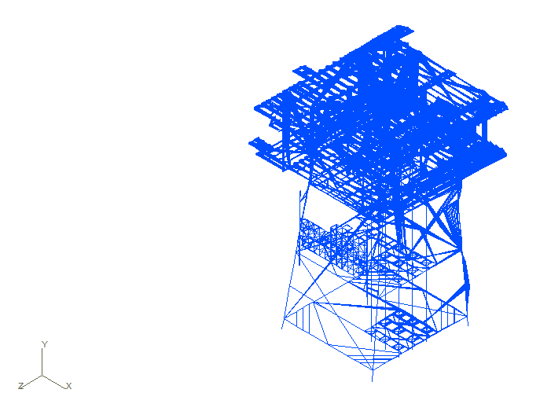
Figure.10.53: Deformed Shape of Jacket Leg due to Manouvring Drift Ship Collision at High
Water Level.

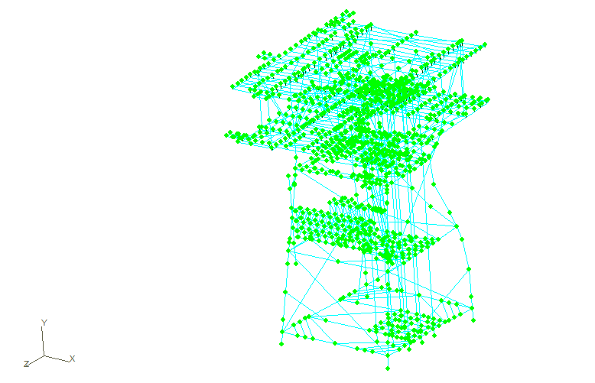
Figure.10.54: Deformed Structure due to Extreme Manouvring Drift Collision at High Water
Level.

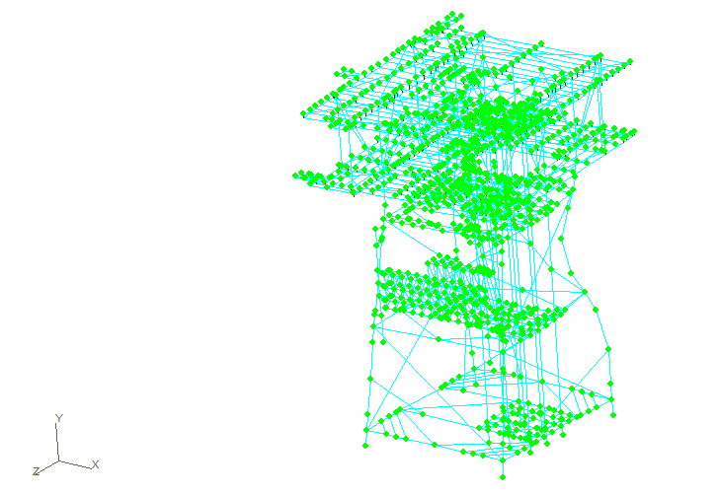
Figure.10.55: Deformed Structure due to Extreme Manouvring Drift Collision at Low Water
Level.

Table.10.14: Output Result Maximum Global Displacements of Jacket Platform due to
Extreme Manouvring Drift Collision at Mean Sea Level.
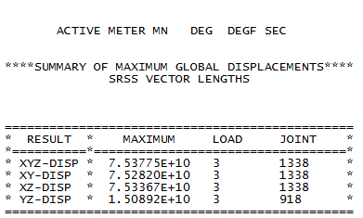

Table.10.15: Output Result Maximum Global Displacements of Jacket Platform due to
Extreme Manouvring Drift Collision at High Water Level.
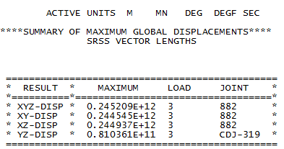

Table.10.16: Output Result Maximum Global Displacements of Jacket Platform due to Extreme Manouvring Drift Collision at Low Water Level.
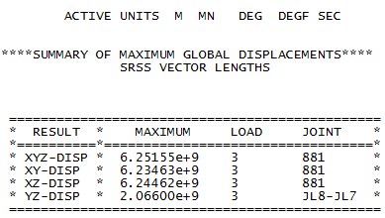

Table.1.14, Table.10.15, and Table.10.16 are representing the maximum global displacement of Manoeuvring Drift Collision at high water level is 0.2452E+12 meters.

10.4.4. Push over Analysis for Collision Application
Post impact analysis can be classified in to following three categories.
- Post Impact Strength Analysis.
- Post Impact Redundancy Analysis
Post impact strength analysis is carried out to check the structure against 1 year environmental loads with all gravity loads. This is to ensure the structure is able to function as normal for some period of time so that any repair needs to be carried out due to the impact. However, at this stage, the structure need not be designed for 100 year storm loads. Obviously, the structure is checked for stresses against allowable stresses as per API RP 2A.
Push Over analysis is carried out to check the global integrity in terms of collapse behaviour. The analysis will be performed using the full non-linear structural model. The analyses will be conducted by first applying the dead loads and the buoyancy loads, and then incrementally increasing a concentrated force at the point of impact until either instability in the model is achieved or the resisting strain energy of the structure greatly exceeds the specified impact energy.
Energies associated with the two non-linear springs (representing the energy absorptions due to local deformation of the vessel and jacket), the elements used to model the impacted member, and the remainder of the structure will be computed at each incremental step of the analysis which will effectively produce a history of the energy distribution as a function of the impact force.
The energy response from the structure will be used in an energy balance relationship to proportion the levels of energy dissipated by the substructure and the vessel. The impact load will be determined at which the sum of the strain energies of the structure and vessel equals the kinetic energy of the supply ship. Rebound (unloading) analysis will be carried out as this impact load is removed; this will give the final displaced shape of the structure which could be used as the initial point for the post-impact pushover analysis, if required.
The ultimate axial and bending moment capacity of the jacket tubular joints will be checked to see that they have sufficient capacity to carry the maximum brace loads from the abnormal environmental condition and the accidental ship impact conditions.
The structure model must recognize loss of strength and stiffness past ultimate. The analysis tracks the performance of the structure as the level of force is increased until it reaches the extreme load specified. As the load is incrementally increased, structural elements such as members, joints, or piles are checked for inelastic behavior in order to ensure members, such as horizontals members.
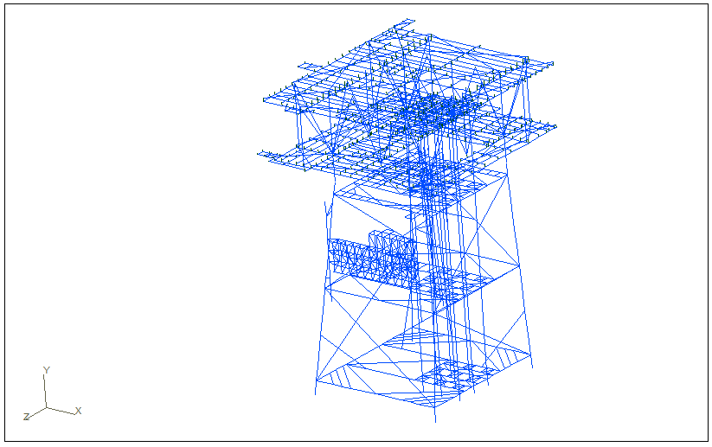
Figure.10.56: Initial condition of Jacket Structure

The deformation step of jacket structure due to manoeuvring drift collision is shown in Figure.10.41 (Initial condition of Jacket Structure), Figure.10.42 (The First Collision on High Water Level on Manouvring drift Collision), Figure.10.43 (The Thirteenth Collision on High Water Level on Manouvring drift Collision), Figure.10.44 (The Twenty-fifth Collision on High Water Level on Manouvring drift Collision), Figure.10.45 (The Thirty-seventh Collision on High Water Level on Manouvring drift Collision). The structure collapse due to increasing collision load on the jacket leg.

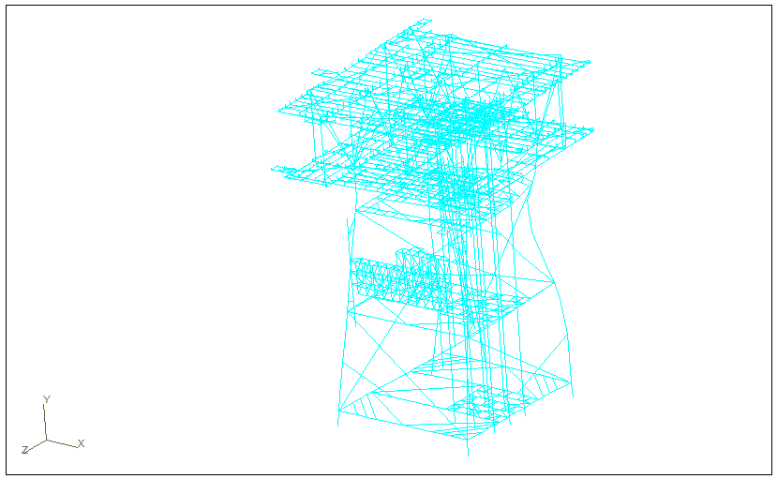
Figure.10.57: The First Collision on High Water Level on Manouvring drift Collision.

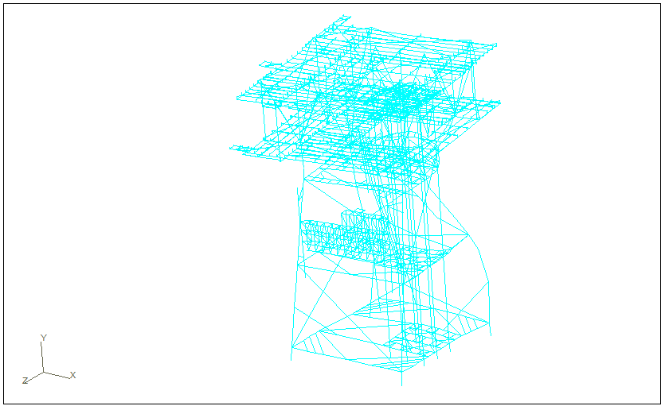
Figure.10.58: The Thirteenth Collision on High Water Level on Manouvring drift Collision.

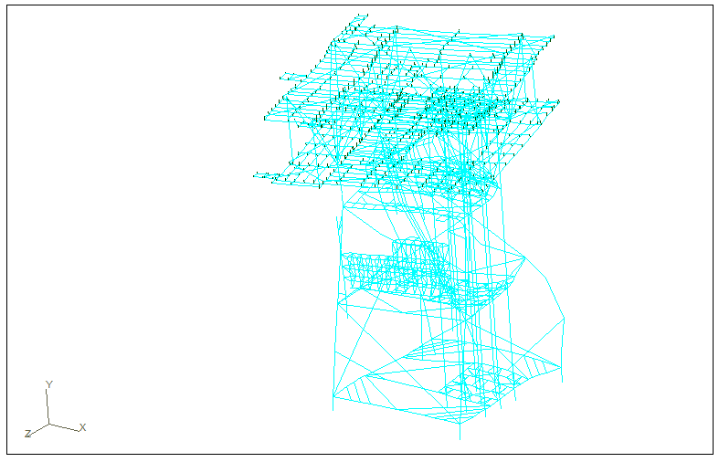
Figure.10.59: The Twenty-fifth Collision on High Water Level on Manouvring drift Collision.
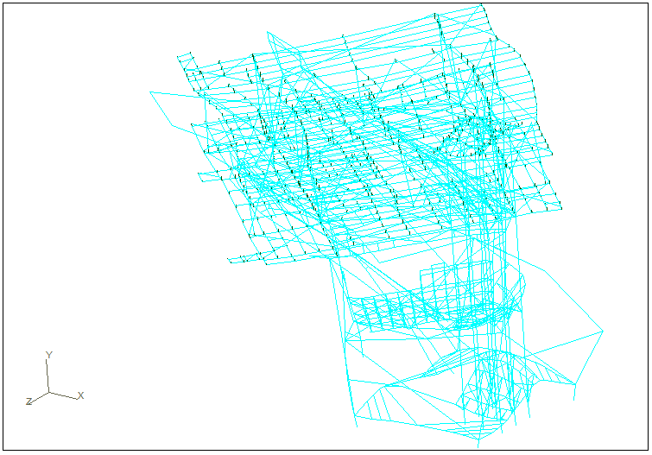
Figure.10.60: The Thirty-seventh Collision on High Water Level on Manouvring drift Collision.

Figure.10.61: Graph of displacement in Push Over Analysis of Manoeuvring Drift Collision at High Water Level

Figure.10.61 shown that correlation of displacement and number of collision due to pushover analysis can follow by equation y = 1.14E+11x³ + 2.29E+12x² - 8.06E+13x + 1.63E+14. That equation can predict safety condition of jacket structure after collision attacked.

Figure.10.62: Graph of Reaction due to Push over Analysis of Manoeuvring Drift Collision at High Water Level.

Figure.10.62 shown that correlation of reaction and number of collision due to pushover analysis can follow by equation y = 6E+11e^{0.1593x} . That equation can predict safety condition of jacket structure after collision attacked.

Table.10.17: Error Percentage the Reaction of Jacket Structure
NUMBER OF COLLISION | REACTION COMPARISON |  | ERROR
NUMBER OF COLLISION | GT-STRUDL (MN) | EQUATION  (MN) | %
1 | 5.3321E+10 | 7.0361E+11 | 0.1686
13 | 9.0429E+13 | 4.7592E+12 | 0.2001
25 | 8.6841E+14 | 3.2191E+13 | 0.3302
37 | 6.4276E+15 | 2.1773E+14 | 0.2164
50 | 1.6076E+16 | 1.7271E+15 | 0.0191

Table.10.18: Error Percentage the Displacement of Jacket Structure
NUMBER OF COLLISION | DISPLACEMENT COMPARISON |  | ERROR
NUMBER OF COLLISION | GT-STRUDL  (MN) | EQUATION  (MN) | %
1 | 5.3321E+10 | 8.4804E+13 | 0.9994
13 | 9.0429E+13 | -2.4733E+14 | 1.3656
25 | 8.6841E+14 | 1.3605E+15 | 0.3617
37 | 6.4276E+15 | 6.0903E+15 | 0.0525
50 | 1.6076E+16 | 1.6108E+16 | 0.0020

According to Table.10.17 and Table.10.18, the highest error percentage for displacement and reaction of jacket structure due Push over analysis is 0.3302 % and 1.3656 %.

Chapter 11

11.0 Fracture of Scantling Support Structure of Gas Processing Module on FPSO

11.1. Introduction
Study on fracture cause of failure in the ship structure has occurred since the early 1900s. S.T. Rolfe (1975) analyze comprehensively about the criteria of hardness (toughness) to the hull that can be used for steels with varying levels of strength. In fact the stress concentration always occurred in the construction of complex structures by welding, such as ships. Local high voltage resulted in a discontinuity or defect will occur in the hull (Rolfe, 1975).
Analysis of crack initiation and crack propagation in ship structures have been conducted since 1998 (Andersen, 1998). Ayyub and Souza (2000) analyzed the fatigue life of ship structures based on reliability. Analysis of ship structures experienced an increase. At the beginning of the study focused on the behavior of crack initiation to failure, until in the present analysis of ship structures lead to structural reliability and risk in the event of failure of the structure.
Application of fracture studies with fracture mechanics of elastic plastic approach would be more appropriate to use to analyze the behavior of embedded cracks and deformation properties of the material has a larger plastic after accruing continuous loading of a material such as Ductile. As we know that the materials Ductile material is often used as the compiler of bed material of the building structure. Based on previous research done on the tubular structure (Aulia, 2005) crack propagation behavior has adapted to the analysis results presented by Broek (1987) analysis based on elastic plastic mechanics fracture. This method is suitable applied in the analysis fracture in offshore structure.
During its development, including three-dimensional crack straight through-crack, surface crack, corner crack and embedded crack studies have been carried out. The fact reveals that the embedded crack is more common in brittle and ductile materials having a catastrophic impact of hazards. Even though recent research using the theory of elastic plastic crack embedded resolution states that using these parameters, namely J, Q, and Tz is able to explain well the crack front with increasing radius and strain hardening exponent (Zhao, 2009). The same thing is also disclosed in an earlier study, that the approaches J, the relative can be used in a variety of purposes relating to fracture, taking into account the concept of stress-strain on the material (Dowling, 1987).
According to Barsom (1987), cracks have been investigated in several classes of tankers. Even though according to research by Wang (2009) of some material and the formulation of crack propagation, propagation behavior will be more clearly observed by including a load factor of the ratio of the work.
Kurniawan (2010) conducted the reliability analysis scantling support module to fatigue loads, the results of fatigue life of 116.3 years, or 3.88 times the lifespan of its operations. Ardhiansyah in 2010 also conducted the reliability analysis scantling support module against extreme loads, the combination of the three extreme loads obtained maximum stress 96 MPa and the obtained results of the structure remains safe to operate

11.2. Fracture Mechanics
Fracture mechanism initiated by the presence of cracks (crack) on the surface of the connection. This mechanism is the local conditions of stress and strain around the crack is influenced by global parameters such as loading, material properties, and geometry. Repeated loading (cyclical) will cause the crack to grow and lead to failure of the connection that eventually resulted in the failure of structure overall.
Methods of Linear Elastic Fracture Mechanic (LEFM) is a method that shows the relationship between stress field and its distribution around the crack tip with the size, shape, orientation of cracks, and material properties due to external load imposed on the material. Methods of Linear Elastic Fracture Mechanic (LEFM) can be used for very small plastic region, where the voltage is lower than the voltage of the license (σ <0.8 σys) (Broek, 1987).
As linear elastic methods is inappropriate used in large structures using low-or moderate-strength steel for large plastic zone around the crack, thus causing the elastic-plastic behavior. It is developing methods elastic plastic fracture mechanics (EPFM) to show the characteristics of plastic material behavior.
J-integral is a contour in the region around the crack tip. The main concept is the energy balance between the stored strain energy and effort to work by external forces to explain the energy available for crack growth. J-integral is equivalent to force the growth of small cracks in the contours near the crack tip that considered.
Stress and strain field measurements on average are going on around the crack tip in elastic-plastic behavior, symbolized with 𝐽. A relationship J with K can be viewed at the following equation.

$J=\frac{K_{I}^{2}}{E'}$ (11.1)

Where; $E'$ is 𝐸 for plane stress and $E' = E / (1 - v2)$ for plain strain. 𝐸 is modulus Young and v is the Poisson ratio.

11.3. Stress Intensity Factor
Stress intensity factor is a parameter that contains the concept of energy balance principle and the distribution around the crack tip. If the stress intensity factor (K) reaches the threshold stress intensity factor (K threshold), then the cracks began to spread, and failure of occurs when the price structure (K) has reached a critical material (KIC) that called fracture toughness.
In this study used the type of Center Crack in Finite Width Strip, can be seen from Figure 1. From the Figure.11.1, it know that the direction of crack propagation towards thickness or depth and the direction of circumferential that happening
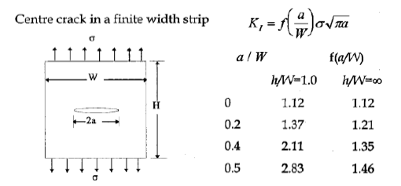
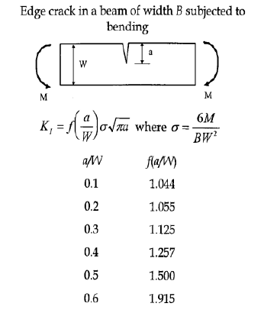
Figure.11.1: SIF on the type of center crack in finite width strip (Wang, 1996).

11.4. Crack Propagation
At fracture mechanics, the addition of crack size ($Δα$) during one cycle of loading (load cycle) is related to the stress intensity factor range $ΔK$ for the loading cycle. This relationship is expressed in the Paris and Erdogan formulation as follows (Almar-Naess, A. Ed, 1985):

$Δα=C{(ΔK)}^{m}$ (11.2)

The addition of cracks in one cycle is usually very small compared to the size of the cracks. So that Equation 7 can be written as follows (Anderson, 1998):

$\frac{dα}{dN}=C{(ΔK)}^{m}$ (11.3)

The existence of the mean stress causes the necessity of adding a correction factor to the Paris equation as modifications made Foreman, for EPFM method must be corrected with plastic so that the elastic parameters of Equation 8 becomes (Barsom, 1987):

$\frac{dα}{dN}=\frac{C{(ΔJ)}^{m}}{1-R}$ (11.4)

Where

$ΔJ=\frac{{ΔK}^{2}}{E}$

To get the number of cycles when there is a failure, then do the integration of Paris equation (Bai, 2003):

$N_{f}=\int_{a_{0}}^{a_{cr}}{\frac{dα\left(1-R\right)}{C{(ΔJ)}^{m}}}$ (11.5)

$N_{f}=\frac{a_{cr}-a_{0}\left(1-R\right)}{C{(\frac{{ΔK}^{2}}{E})}^{m}}$ (11.6)

11.4. Simulation and Discussion

11.4.1. Simulation Condition
A study of literature and data collection from books, textbook, journal, and discussion report which is similar to this study is included. In addition, the search was also conducted on the data FPSO Belanak include environmental data, ship structure and data scantling support structure. Figure.11.2 shows the distribution modules and location of the support structure which is investigated in this research.
Modeling FPSO was designed using Maxsurf to obtain the coordinates of the structure of the FPSO. Then convert the modeling conducted in Maxsurf to MOSES to get RAO. Performed loading of FPSO Belanak structures are used to find the reaction force of the global FPSO structures due to wave loads acting on the FPSO Belanak.
Validate the results of calculations with the data prior to this research. After getting the inertia force on the center of gravity module and the 8 legs support structure, performed stress analysis calculations (stress analysis) by modeling locally scantling support structure with ANSYS.11 to review the stress distribution on the support structure scantling.
Modeling of initial crack is assuming dimensions in accordance with DNV OS F201 code. Location of crack initiation is at the location of the hotspot stress that has been obtained from running the model with the structure of the actual load. After modeling the crack is done, the next step is to enter the maximum and minimum loading of the previous global analysis.In a two-component gel, it is easy to modify the molecular structure of either of the two components.

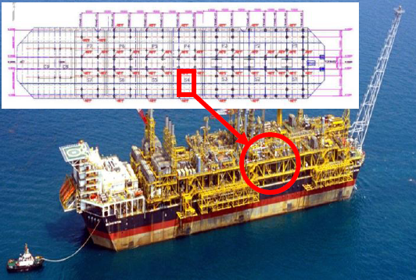

Figure.11.2: Location of support structure modules on the FPSO Belanak (McDermott, 2010)

11.4.2. Global Analysis
Results of simulation covers global analysis, local analysis, and crack propagation. Wave load calculation was performed to obtain single amplitude accelerations, wave drift force, and the Response Amplitude Operator (RAO) motion of the FPSO to the five-way wave heading which are the direction of 0, 45, 90, 135 and 180 degress in surge motion, heave, sway, roll , pitch and yaw. The calculation is done on the condition of the Light Draft Vessel with draft 16.2m, with MOSES 6.0 software and wave conditions was 100 annual wave conditions.
The results of calculation of the maximum single-amplitude accelerations relative to the MOSES 6.0 with relative points are used there is 9 points that is reviewed, the module and support structure as much as 8. Here is an output of maximum single amplitude accelerations compared with data owned by Conoco Phillips as found in Table.11.1.

Table.11.1: Maximum single amplitude accelerations
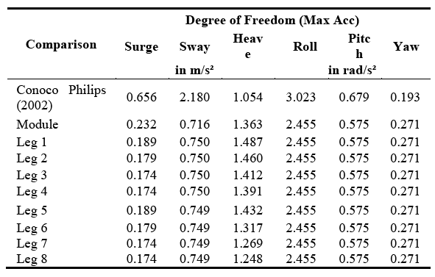

FPSO affected by wave loads will accelerate in every movement. Module facility located on the FPSO is also accelerated due to the FPSO motion, then according to Newton's law of accelerating objects that have a force. FPSO experience translational and rotational motion due to wave loads. For translational motion, inertia force is obtained by Equation.2.11. For the rotational motion, inertia force obtained with Equations.2.12 - 2.13.
Gas processing module FPSO Belanak has 8 support structures with configuration as shown in Figure 3. Distance of the support structure closest to the center line FPSO is 5 m. While the size of the gas processing module itself is 22 x 30 m. Support Structure located on frame 30 and 33 of the FPSO. Therefore, the load response on each leg was calculated to determine its structure support that receives the most critical load.
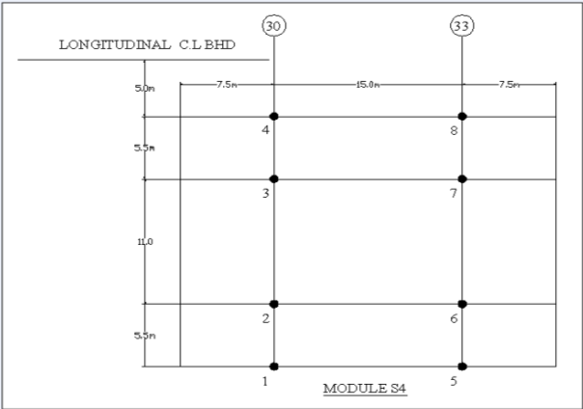
Figure.11.3: Configuration of support structure

With the distance mass points between the COG FPSO with mass points of each support structure different from each other. Between leg leg 1 through 8 will have a different reaction in receiving the load of motion FPSO itself. From the calculation results can be seen that the structure of support that receives the greatest load is on the leg 5 as shown in Figure.11.4.

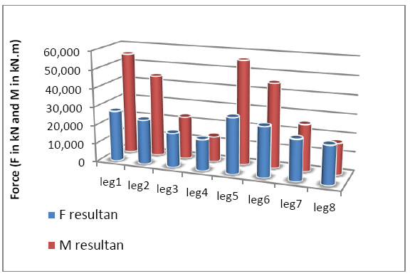
Figure.11.4: Load on the support structure.

11.4.3. Local Analysis
In local analysis, the area taken is a connection part between ship hull with scantling support module. Local analysis phase performed using ANSYS.11 software with a focus on the scantling support structure of gas processing module. In the simulation, the scantling area is locked from movement in all directions, but the support structure is free movement in 6 degree of freedom (6-DOF) show on the Figure.11.5.
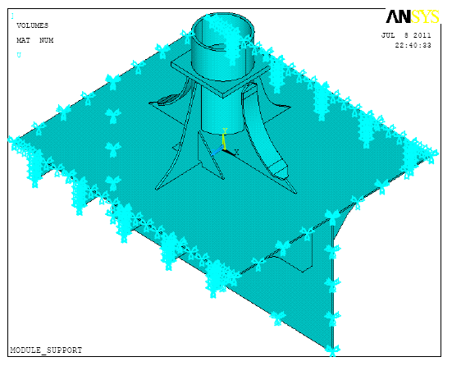
Figure.11.5: Local modeling of support structure in ANSYS 11.

Figure.11.6 is a local model of scantling support structure that has been given a load, obtained from global analysis. The figure shows stress distribution around the connection between hull and scantling support module with stress of 6:47 MPa which is the largest stress value (hotspot stress) on the structure.
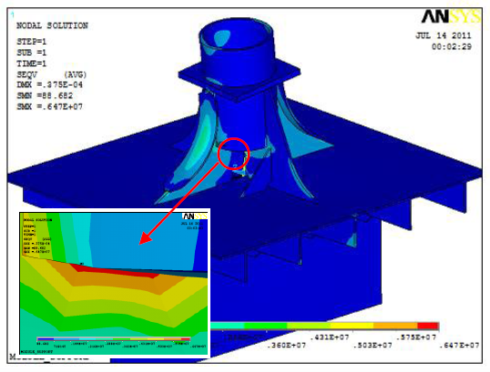
Figure.11.6: Stress distribution and hot spot stress.

Given initial crack in this research are assuming dimensions in accordance with DNV OS F201 code. Location of crack initiation is at the location of the hotspot stress that has been obtained from running the model with structure of the actual load as shown in Figure.11.7.
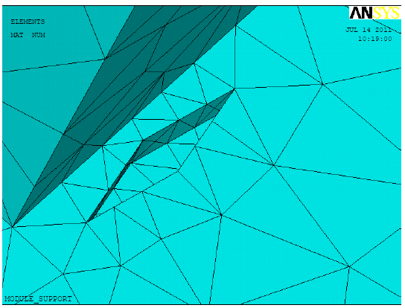
Figure.11.7: Initial crack
After modeling the crack is done, the next step is to enter the maximum and minimum loading of the previous global analysis. In the simulation, the scantling area is locked from movement in all directions, but the support structure is free movement in 6 degree of freedom (6-DOF). Here are loading and the results of running ANSYS for the loading in the initial crack can be seen in Figure.11.8. From the results obtained for the highest stress 25.1 MPa.

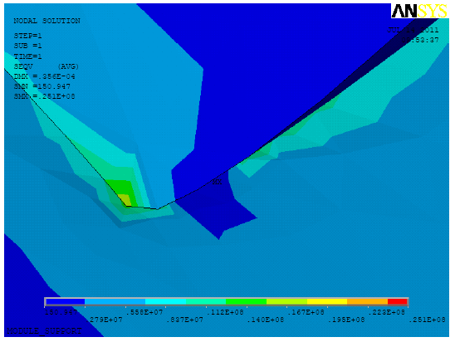
Figure.11.8: Stress distribution on initial crack.

11.4.4. Crack Propagation
From the results obtained from the local analysis, obtained the maximum stress is at the tip of crack, according to the theory of embedded elliptical crack, which is when $β = π / 2$ and stress obtained by the Table11.2.

Table.11.2: Output stress at the initial crack.
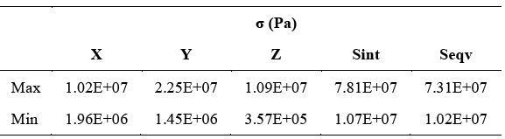

Due to the Stress Intensity Factor Equation to be used only need to insert a stress perpendicular to crack propagation both the direction of thickness and the direction of circumferential, only the stress to the global Y axis ANSYS are used.
Stress Intensity factor is calculated in the 2 position that is the position of crack depth (thickness) and towards the circumference of the object (circumferential crack). Stress Intensity factor circumferential direction calculated by the equation center crack in finite width strips on the equation at Figure.11.1. Stress Intensity Factor direction of thickness is also calculated by the equation at Figure.11.1. Stress Intensity Factor obtained in the direction of thickness (Kt) and direction of circumferential (Ks) in Table.11.3.

Table.11.3: Stress intensity factor of crack initiation
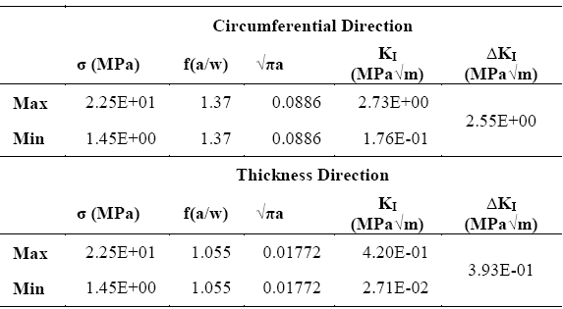

From Stress Intensity Factor calculations for the thickness direction of (Kt) and direction of circumferential (Ks), then look for the Stress Intensity Factor Range (ΔKI). ΔKI value has a value greater than the value ΔKth 0:11 MPa √ m, indicating the occurrence of crack propagation in the plate.
In this study, for calculations crack propagation performed on the direction of the thickness of the plate with a variation of the initial crack 0.0001 up to 0015. To calculate the rate of crack propagation, there should be a conversion value of the stress intensity factor into the value of J. The analytical value of J obtained by the concept of stress and strain field measurements of the average is going on around the crack tip using Equation 6. Figure.11.9 shows the variation of the difference in the value of ΔJ for various initial cracks. As shown in the graph, that ΔJ increases with increasing of the initial crack.
Crack propagation is the number of cycles with a given initial crack up to a certain size to happen next or crack propagation. Crack propagation is influenced by the magnitude of ΔJ. The larger ΔJ, the faster the propagation occurs.

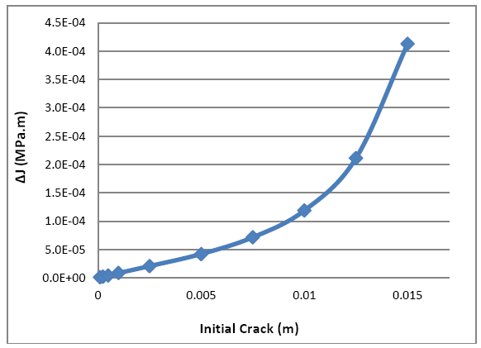
Figure.11.9: Chart 𝛥𝐽 to initial cracks.

The curves of crack propagation on crack initiation, can be seen in Figure.11.10. The curve below shows that the larger the initial crack, the greater the crack propagation. Crack propagation is affected by ΔJ and ΔJ is influenced by the crack initiation. In this case the final propagation distance is assumed at 0.7 T, where T is the plate thickness. When the larger the value of crack propagation, the stress cycles (N) required to reach the critical crack will be larger as shown in Figure.11.11.
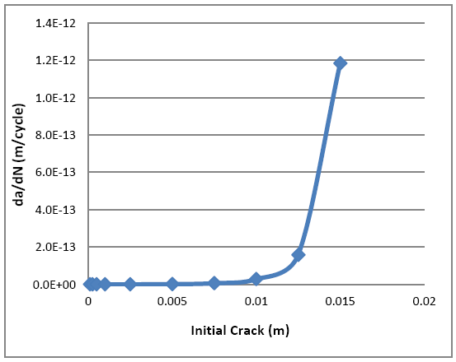
Figure.11.10: Crack propagation.

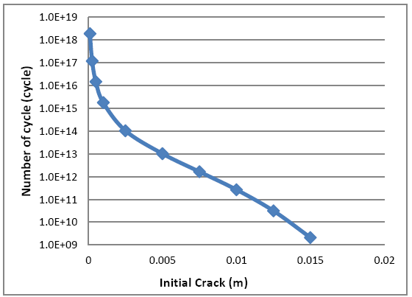
Figure.11.11: Number of cycles to initial crack

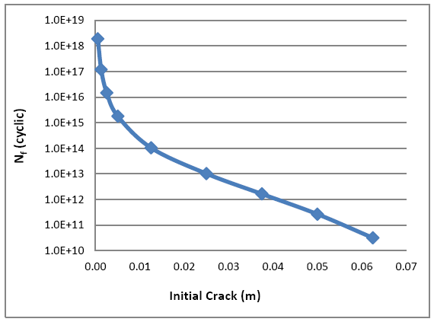
Figure.11.12: Crack propagation circumferential direction

References

- El-Sayed S. Aziz, Constantin Chassapis, 2011, Probabilistic Simulation Approach to Evaluate the Tooth-Root Strength of Spur Gears with FEM-Based Verification, Scientific Research Engineering, Vol.3, No.12, pp.1137-1148
- Agustin Dwi Sumiwi, Dynamics Responses Of Fixed Jacket Structure Subjected To Collision From Supply Vessel, Master Thesis, Mechanical Engineering, Universiti Teknologi Malaysia.
- Agustin Dwi Sumiwi, Efi Afrizal, Abd Khair Junaidi, 2014, Jacket Structure’s Responses due to Ship Collision, Journal of Ocean, Mechanical and Aerospace -Science and Engineering-, Vol.12, pp.21-26, October-2014.
- Agustin Dwi Sumiwi, Efi Afrizal, Jaswar, Handayanu, 2013, Offshore Structure Response due to Ship Collision on Jacket Legs, Jurnal Teknologi, Vol.66:2, January-2014.
- Agustin Dwi Sumiwi, Handayanu, Jaswar and Efi, 2012, Response of Jacket Structure Due To Ship Collision, Proceeding of the 6th Asia-Pacific Workshop on Marine Hydrodynamics, 3-September 2012, Johor, Malaysia.
- Almar-Naess, A.Ed. 1985. Fatigue Handbook: Offshore Steel Structure. Norway: Tapir Publisher.
- Al-Obaid, Y. F. 1994. Automated Analysis of Topside Platform Hatch Covers Subject To Drill Collar Impact. PAAET. Kuwait.
- Alonso, Paulo Sergio Rodrigues. (2012). The Shipbuilding & Offshore Market in Brazil - Opportunities for Suppliers. Aberdeen, Newcastle and London: Petrobus.
- Andersen, M. R. 1998. Fatigue Crack Initiation and Growth in Ship Structure. Thesis Department of Naval Architecht and Offshore Engineering. Denmark: Technical University of Denmark.
- Ardhiansyah, Fahmy. 2010. Analisis Keandalan Scantling Support Structure System Gas Processing Module FPSO Belanak Terhadap Beban Ekstrem. Tugas Akhir Jurusan Teknik Kelautan. ITS. Surabaya.
- Aulia, S. 2005. Analisa Umur Kelelahan Turbular Joint Tipe T dengan Retak Eliptis pada Chord Menggunakan Metode Elastic Plastic Fracture Mechanics. Tugas Akhir: Jurusan Teknik Kelautan.
- Barltrop, N., Okan, B. 2000. FPSO Bow Damage in Steep Waves. Rogue waves 2000 workshop. Brest.
- Barsom, John M. & Rolfe,.Stanley T. 1987. Fracture and Fatigue Control in Structures. Application of Fracture Mechanics. New Jersey.
- Battacharyya, R. 1978. Dynamic of Marine Vehicles. John Wiley and Sons Inc. New York.
- Brady, T. K., Utilization of Dependency Structure Matrix Analysis to Assess Implementation of NASA’s Complex Technical Projects, M.S. Thesis, Massachusetts Institute of Technology, 2002.
- Broek, David. 1987. Elementary Engineering Fracture Mechanics. Netherlands: Martinus Nijhoff Publishers.
- Broek, David. 1988. The Practical Use of Fracture Mechanics. Netherlands: Kluwer Academic Publishers.
- Browning, T. R., Applying the Design Structure Matrix System Decomposition and Integration Problems: A Review and New Directions, IEEE Transactions on Engineering Management, Vol.48, No. 3, August 2001.
- Browning, T. R., Use of Dependency Structure Matrices for Product Development Cycle Time Reduction, Proceedings of the Fifth ISPE International Conference on Concurrent Engineering Research and Application, Tokyo, Japan, July 15-17, 1998.
- Bunce, J. W. 1977. Analysis of The Interaction Between The Module Structures and The Deck of an Offshore Oil Production Platform. Pergamon Ltd., Great Britain.
- Cameron, J. et al. 1997. Ultimate Strength Analysis of Inland Tank Barges. USCG Marine Safety Center.
- Carrascosa, M., Eppinger, S. D., Whitney, D. E., Using the Design Structure Matrix to Estimate Product Development Time, Proceedings of DETC 1998, 1998 ASME Design Engineering Technical Conferences, Atlanta, Georgia, September 13-16, 1998.
- Chakrabarti, S. K. 2005. Handbook of Offshore Engineering Volume I. Offshore Structure Analysis Inc. Planfield. Illinois. USA.
- Chen, C.H., Ling, S. F., Chen, W., Project Scheduling for Collaborative Product Development using DSM, International Journal of Project Management 21 (2003) 291-299
- Chengxi shipyard Co., L. (2015). "Main Business." Retrieved 26 October, 2015, from http://chengxi.cssc.net.cn/cms_chengxi_en/compay_mod_file/news_detail.php?id=144&cart=7.
- Cho, S. H., An Integrated Method for Managing Complex Engineering Projects Using the Design Structure Matrix and Advanced Simulation, M.S. Thesis, Massachusetts Institute of Technology, 2001
- Cosco 2012. Sustainability utilization of energies and resources.
- Courtesy: www.atp.nist.gov/
- Courtesy: www.paroscientific.com/
- DnV Recommended Practice C205. 2007. Environmental Loads and Environmental Condition. Norway.
- DnV Recommended Practice OS-F201. 2001. Dynamics Risers. Norway.
- Dowling, N. E. 1987. J-Integral Estimates for Crack in Infinites Bodies. Engineering Fracture Mechanic Journal. 26(3): 333–348.
- Efendy, Moh Hafidz, EPC Management, presentation slide, presented Introduction to EPCI Class, Mechanical Engineering Faculty, Universiti Teknologi Malaysia, 21st Dec 2014.
- Efendy, Moh Hafidz, Overview of Project Planning and Scheduling in Oil and Gas Industry, presentation slide, presented in Offshore Oil and Gas Training Class, 8th March 2015.
- Efi Afrizal, Jaswar, Mufti, Agustin, Adi, and Agoes, 2012, Fracture Analysis at FPSOStruc ture Using J-Integral Contour with Finite Element Method (FEM), Proceeding of the 8th Marine Technology, October 2012, Terengganu, Malaysia
- F. M. Mufti, Efi Afrizal, E. B. Djatmiko, Murdjito, Jaswar, 2014, Fracture of Scantling Support Structure of Gas Processing Module on FPSO, Jurnal Teknologi, Vol.66:2, pp.53–59.
- Fineman,Milijana, Improved Risk Analysis for Large Project : Bayesian Network Approaach, thesis for Doctor of Philosophy, Queen Mary University of London, 2010.
- Germanischer Lloyd SE, Rules for Classification and Construction Ship Technology “Special Craft”, March 2012.
- Gourdet, G., (2008), Connection Hull-Topsides : Principle, Design and Returns of Experience. Bureau Veritas.
- Gray, C.F., Larson, E.W., Project Management The Managerial Process, Mc Graw Hill, Singapore, 2000.
- Guangzhou Wenchong Shipyard (CSSC) (2015). "Guangzhou Wenchong Shipyard (CSSC)." Retrieved 26 October, 2015, from http://www.guangzhou.ship2yard.com/map.php?id_shipyard=8739&google=map
- Guangzhou Wenchong Shipyard Co., L. (2015). "Guangzhou Wenchong Shipyard Co. Ld ". Retrieved 26 October, 2015, from http://gws.cssc.net.cn/cms_gzwccc_en/compay_mod_file/mode_3.php?cart=1.
- Gunawan, Indra and Ahsan, Kamrul, Project Scheduling Improvement Using Design Structure Matrix. International Journal of Project Organization and Management , 2 (4). pp. 2010.
- Hapsari, I., Model Development ton Integration Dependency Structure Matrix, Time Information and Resource Allocation Project Schedule, thesis Institute Sepuluh November, 2006.
- Hermanto, Budi, Schedule Risk Analysis in Offshore Development Project, Msc. Thesis, Universiti Teknologi Malaysia, 2010.
- Hwang, J. K., Bang, G. J., (2009), Detailed Design and Construction of the Hull of FPSO. Nineteenth International Offshore and Polar Engineering Conference, Osaka, Japan.
- Indiyono, P. 2003. Hidrodinamika Bangunan Lepas Pantai. Surabaya: Penerbit SIC.
- Intsok. (2012). Intsok Market Report - Who Is Who In The Brazilian Offshore Contractor And Engineering Industry FPSO Drilling SURF. Rio De Janeiro: Norwegian Oil and Gas Partners.
- Kurniawan, Andri. 2010. Analisa Keandalan Scantling Support Structure System Gas Processing Module FPSO Belanak Terhadap Beban Kelelahan. Tugas Akhir Jurusan Teknik Kelautan. ITS. Surabaya.
- Maheswari, J. U., Varghese, K., Project Scheduling using Dependency Structure Matrix, International Journal of Project Management 23 (2005) 223-230
- MarEX. (2014). Brasa Shipyard Completes Brazilian FPSO. Retrieved October 23, 2015, from http://www.maritime-executive.com/pressrelease/Brasa-Shipyard-Completes-Brazilian-FPSO--2014-09-15
- MarineLink. (2013). Brasa: FPSO Modules a Specialty. Retrieved October 23, 2015
- Marusiak J. April 2012. Shipping industry raises bar on sustainability.
- McDermott, J. 2010. Belanak FPSO Topsides Construction and Integration. OCEANO 2010 Seminar, 22th February 2010, ITS Surabaya, Indonesia.
- N. Bogdanos Marine Bureau (2015). "CHENGXI SHIPYARD GUANGZHOU (SOUTH CHINA)." Retrieved 26 October, 2015, from http://www.bogdanos-marine.gr/portfolio/chengxi-shipyard-guangzhou-south-china/.
- Nguyen, T. D. 2009. Scantling Optimazition Ropax Ship. University of Liege.
- O’Brein, D. P et al. 1993. Recent Developments in Offshore Rig/Platform Evacuation. Memorial University of Newfoundland. Canada.
- P.H. Miller, J.W. Stettler, Ship Structures, Lecturer Notes, Naval Architecture Program United States Naval Academy, Annapolis, Maryland.
- Palmer, A. C. 1997. Breakup of Firewall Between The B and C Modules of Piper Alpha Platform-I. Analysis by Hand Calculation. University of Cambridge. UK.
- Perez, Nestor.2004. Elementary Engineering Fracture Mechanics. Boston: Kluwer Academic Publishers.
- Pramono, D., Mudah Menguasai Microsoft Project 98, Elex Media Komputindo, 2002
- R A Shenoi, Ship Production Technology, Lecturer Note, The University of Southampton
- Rolfe, S. T. 1975. Fracture Mechanics, Fracture Criteria and Fracture Control for Welded Steel Ship Hulls. Prosiding Ship Structure Symposium.
- Saptana, Ignatius Y, Restructure Engineering Iteration on Local Control Room (LCR) Construction EPC Project with Design Structure Method (DSM), Msc. Thesis Indonesia University, 2013.
- SBM Offshore. (2014). BRASA Yard Documentation. from http://www.estaleiro-brasa.com.br/
- SBM Offshore. (2015a). Our Shipyard - BRASA. Retrieved October 23, 2015, from http://www.sbmoffshore.com/what-we-do/yards/brasa/
- SBM Offshore. (2015b). Sustainable Development in Brazil (pp. 7): SBM Offshore.
- SBM Offshore. April 2015. SBM Offshore Sustainability Strategy.
- Shetty, N. K. et al. 1998. Fire Safety Assessment and Optimal Design of Passive Fire Protection for Offshore Structures. Elsevier Science Limited. Northern Ireland.
- SORJ. (2015). Two SBM FPSOs to arrive in Brazil before summer. Ship And Offshore Repair Journal - The Official Journal of the International Association of Shiprepair Agents, 13(1).
- Terpstra, T., MacMillan, A. A., (2001 May), FPSO Design and Conversion: A Designer's Approach . Paper presented at the 2001 Offshore Technology Conference, Houston, Texas.
- UKOOA. 2002. Buckling and Ultinmate Strength Assessment for Offshore Structures. Glasgow.
- Wang, C.H. 1996. Introduction to Fracture Mechanics. DSTO Aeronautical and Maritime Research Laboratory, Melbourne
- Wasco Engineering Indonesia, Project Execution Plan D1 E-House Module, Doc. No. 21010-ABB-70000-PM-PL-0001, Wasco group, Indonesia, 2011.
- Windergen, K V. 1994. Course and Strength of Accidental Explosions on Offshore Installations. Christian Michelsen Research. Norway.
- Yassine, A. A., Whitney, D. E., Lavine, J., Zambito, T., Do-It-Right-First-Time (DRFT) Approach to Design Structure Matrix (DSM) Restructuring, Proceedings of DETC 2000, ASME 2000 International Design Engineering Technical Conferences, Baltimore, Maryland, September 10-13, 2000.
- Yassine, A. A., Whitney, D. E., Zambito, T., Assesment of Rework Probabilities for Simulating Product Development Process Using the Design Structure Matrix (DSM), Proceedings of DETC 2001, ASME 2001 International Design Engineering Technical Conferences, Computers and Information in Engineering Conference, Pittsburgh, Pennsylvania, September 9-12, 2001.
- Yassine, A., Braha, D., Complex Concurrent Engineering and the Design Structure Matrix Method, Concurrent Engineering: Research and Applications, Volume 11, Number 3, September 2003, Sage Publications.
- Yijun Liu, Introduction to Finite Element Method, Mechanical Engineering, Cincinnami University.
- Zhao, J. 2009. Three Parameter Approach for Elastic-Plastic Stress Field of an Embedded Elliptical Crack. Engineering Fracture Mechanic Journal. 76: 2429–2444.
- Zoepffel & Schneider GmbH (2015). "Chengxi Shipyard Guangzhou | Guangzhou | China." Retrieved 26 October, 2015, from http://www.zoepffel-schneider.com/shipyard/5.

Autobiographies

 | Jaswar Koto was born on October, 1970. He is a descendant of the Prophet Rasullullah S.A.W through Husein R.A. He is a president of Ocean and Aerospace Research Institute, Indonesia and Professor on offshore engineering. He is also president of International Society of Ocean, Mechanical & Aerospace for scientist and engineers.
He has been invited as a Visiting Professor more than 16 times, received several international awards and supervised PhD, Master and Bachelor Students. He received his bachelor degree in 1994 from Institut Teknologi Sepuluh Nopember (ITS), Indonesia, further studies in Curtin University of Technology in marine and Notre Dame University in business and in 2003 he has completed his PhD and also received “Excellence Academic Award” for doctor degree in engineering form Aerospace and Marine Engineering, Osaka Prefecture University, Japan.
He has started his researches since 1994 on structure analysis of fluid flow in subsea pipelines, subsea pipeline corrosion due to Carbon Monoxide, design and hydrodynamic analysis of AUV in Australia. Then, he joined Research and Development Institute, Sumitomo Heavy Industries -Marine Engineering-, Japan. In 2005, he joined ExxonMobil LNG Engineering Plan for Middle East projects. Since 2010, he has contract with Department of Aeronautical, Automotive, and Ocean Engineering, Faculty of Mechanical Engineering. He is also appointed as head of High Performance Computing, CICT, Universiti Teknologi Malaysia.

Agustin Dwi Sumiwi was born on August, 1985. She is a lecturer on Offshore Engineering, Ranaco Education and Training Institute, Ranaco Group of Company, Kemaman, Terengganu, Malaysia. She received his bachelor degree from Institut Teknologi Sepuluh Nopember (ITS),
She received master in Marine Technology, Mechanical Engineering, Universiti Teknologi Malaysia. She has more than 8 years teaching experience. She has involved in several offshore projects.

 | Handayanu was born on July, 1963. He is a lecturer on Offshore Engineering, Institut Teknologi Sepuluh Nopember (ITS), Surabaya, Indonesia. He received his bachelor degree from Institut Teknologi Sepuluh Nopember (ITS), Indonesia
He received master from University of Strathclyde, UK. In 2002, he has completed his PhD from Memorial University of Newfoundland, Canada. He has more than 23 years teaching experience. His specialist is on fatigue and fracture mechanic and FEM. He has published many papers and also has involved in many offshore projects.

 | Mufti Fathonah Muvariz is a Lecturer in Department of Mechanical Engineering at Politeknik Negeri Batam, Indonesia, where he teaches in Engineering Mechanic, Strength of Material, and Mathematics. He received his Bachelor’s Degree in Ocean Engineering from Institut Teknologi Sepuluh Nopember (ITS), Indonesia.
He received Master of Engineering in Marine Technology, Department of Mechanical Engineering, Universiti Teknologi Malaysia (UTM). His specialist is in Ship and Offshore Hydrodynamic, Fatigue and Fracture Mechanic, and CFD.

