Preface



This book introduces offshore risers for drilling and production which is divided into eight chapters. The first chapter discusses overview of riser used in offshore engineering. In the second chapter, offshore platforms such as fixed and floating structure are explained in detailed. The third chapter discusses on drilling risers including drilling equipment, design criteria and analysis and the fourth chapter discusses on production riser such as steel catenary, top tension riser, flexible and hybrid risers including riser design. The fifth chapter discusses on challenges of risers in the ultra-deep water. The chapter sixth comes up with design practiced of risers, chapter seventh discusses on global analysis of risers, the eighth chapter discusses on vortex induced vibration of risers and chapter nine and ten discusses on installation of risers and application of finite element on riser analysis.

Many pictures and illustrations are enclosed in this book to assist the readers’ understandings. It should be noted that some pictures and contents are borrowed from other companies’ websites and brochures which are quoted and listed in the references. This book mainly is designed for basic education on offshore risers engineering purposes only.

2017 (Third Edition)

Acknowledgements

First and foremost, praises, thanks and syukur to Allah (S.W.T) to give the authors strength and ability to complete this book.

The authors would like to take this opportunity to express our highest appreciation to our colleagues in the Ocean and Aerospace Research Institute, Indonesia and Universiti Teknologi Malaysia to provide proper guidance, encouragement, invaluable ideas, comment, recommendation, critics, suggestions and advice that to assist the author for the successful completion of this book.

To author’s families that always pray for our successful, all this things cannot pay for all what they all have done. Our special thanks also to the postgraduate students.

The author is grateful to all colleagues, friends, institutions and parties for supporting this book.

List of Tables

Table No. | Title | Page.No
Table 3.1 | Criteria for Drilling Riser Operability Limits | 29
Table 4.1 | Types of Top Tensioned Risers | 65
Table 6.1 | Classification of safety classes | 100
Table 6.2 | Limit States design of Risers | 103
Table 6.3 | Load effect factors | 104
Table 6.4 | Types of Riser Design & Analysis Methods | 107
Table 7.1 | Fabrication Factor [DNV 2010] | 106
Table 8.1 | Flow regimes | 124
Table 8.2 | Grid quality measurement | 130
Table 8.3 | Values of $C_{d}$ from experimental data and CFD simulation | 131
Table 8.4 | The values of $C_{l}$ from experimental data and CFD simulation | 131

List of Figures

Figure No | Title | Page.No
Figure 1.1 | Riser selection factors. | 9
Figure 1.2 | Functionally types of risers | 10
Figure.2.1 | Typical jacket structure | 15
Figure 2.2 | GB 260 complaint structure | 16
Figure 2.3 | Jack-up structure | 16
Figure 2.4 | An example of semi-submersible | 17
Figure 2.5 | An example of Rounded-shape FPSO | 18
Figure.2.6 | An example of SPAR | 19
Figure.2.7 | An example of Truss SPAR | 21
Figure.2.7 | An example of Cell SPAR | 22
Figure 2.8 | An example of TLP | 23
Figure 3.1 | Drilling Semisubmersibles | 24
Figure 3.2 | Typical drilling riser system | 25
Figure 3.3 | Key Components in a Drilling Riser System | 27
Figure 3.4 | Riser Connector | 28
Figure 3.5 | Motion-Compensating Equipment | 29
Figure 3.6 | Complete Riser Joint | 30
Figure 3.7 | Principal Parameters Involved in C/WO Riser Design and Analysis | 37
Figure 3.8 | Typical Finite Element Analysis Model for C/WO Risers | 39
Figure 4.1 | Various types of production subsea riser systems | 50
Figure 4.2 | Schematic of attached and pull tube risers design | 52
Figure 4.3 | Steel Catenary Riser (SCR) Diagram | 53
Figure 4.4 | Steel Catenary Riser Configurations | 56
Figure 4.5 | Riser Hang-Off Location | 58
Figure 4.6 | PIP Riser Pipe | 60
Figure 4.7 | Flex joint Steel Catenery Riser (SCR) | 61
Figure 4.8 | Tapered Stress Joint | 62
Figure 4.9 | An example of ball joint | 63
Figure 4.10 | An example of bend stiffeners | 63
Figure 4.11 | An example bending restrictor | 62
Figure 4.12 | Schematic of Weight Distributed SCRs | 63
Figure 4.13 | General Schematic of SCR supported by sub-surface buoy | 66
Figure 4.14 | COBRA Riser Arrangement | 67
Figure 4.15 | Top Tensioned Risers Used on Spar and TLP | 68
Figure 4.16 | Typical TTR System Configurations | 69
Figure 4.17 | TLP Tensioned Riser System | 71
Figure 4.18 | Spar Tensioned Riser System | 72
Figure 4.19 | Typical Buoyancy Modules | 73
Figure 4.20 | Flexible Riser Diagram | 74
Figure 4.21 | Flexible riser configurations | 74
Figure 4.22 | Typical Cross Section of Flexible Pipe | 76
Figure 4.23 | Typical Cross Section of an Unbonded Flexible Pipe | 77
Figure 4.24 | Typical End Fitting System | 80
Figure 4.25 | System Failure Mechanisms | 81
Figure 4.26 | Comparison of Steel and Flexible Pipe Failure Statistics | 81
Figure 4.27 | Bundled Hybrid Riser Diagram | 85
Figure 4.28 | Hybrid Riser Towers at the Girassol Field | 86
Figure 4.29 | Gooseneck Assembly | 88
Figure 4.30 | Lifting of a Flexible Jumper from a Barge | 89
Figure 4.31 | Single Hybrid Riser Tower (SHRT) general arrangement | 90
Figure 4.32 | Girassol Hybrid Riser Tower, HRT | 91
Figure 4.33 | Grouped SLOR with 6 risers arrangement | 92
Figure 4.34 | Guide Frame in Grouped SLOR | 93
Figure 4.35 | Metocean Data for Some Geographical Regions | 94
Figure 4.36 | An example wall thickness of rigid pipe in Medgas field | 96
Figure 5.1 | Global Offshore Production by water depth
Figure 5.2 | Challenges of ultra-deep water riser system | 99
Figure 5.3 | Deep water riser system in ultra-deep water | 99
Figure 6.1 | Load on risers system | 100
Figure 6.2 | Riser Design Cycle | 106
Figure 6.3 | Riser analysis methods flow | 107
Figure 7.1 | Wave Profiles | 110
Figure 7.2 | Definition of Spectral Density | 111
Figure 7.3 | Effective Weight and Tension | 115
Figure 7.4 | Basic definitions for two-slope SN-curves | 119
Figure 7.5 | Bent Riser under inline environmental load | 121
Figure 8.1 | Cylinder subjected to incident flow | 125
Figure 8.2 | 2D flow with boundary layer thickness, separation illustrated | 126
Figure 8.3 | Flow regimes and corresponding wake at increasing $R_{e}$ | 127
Figure 8.4 | Surface pressure from vortex shedding | 128
Figure 8.5 | Rectangular shaped solution domain | 130
Figure 8.6 | Structured grid | 131
Figure 8.7 | Unstructured grid | 131
Figure 8.8 | Graph of $C_{d}$ versus $R_{e}$ range 40 to 1500 | 135
Figure 8.9 | Graph of $C_{l}$ versus $R_{e}$ range 40 to 1500 | 136
Figure 8.10 | Contours of velocity magnitude (Re = 40, 200, 1000, and 1500) | 137
Figure 8.11 | Contours of Turbulent Viscosity (Re = 200, 1000, and 1500) | 138
Figure 8.12 | Helical strakes on chimney stacks to suppress VIV | 140
Figure 8.13 | Various devices for VIV suppression | 140
Figure 8.14 | Helical strakes | 141
Figure 8.15 | Helical strakes controlling the vortex shedding | 142
Figure 8.16 | Helical strakes parameters illustrated | 142
Figure 8.17 | Typical helical strake configuration with three starts | 143
Figure 8.18 | Regular cylinder with no ribbons attached | 144
Figure 8.19 | Cylinder with ribbons attached to trailing edge | 144
Figure 9.1 | Component of floating stability | 171
Figure 9.2 | Pressure around the hull | 172
Figure 9.3 | Center of buoyancy shift to starboard | 173
Figure 9.4 | CB shifts up due to increasing load | 174
Figure 9.5 | CB shifts when weight is removed/added/shifted | 175
Figure 9.6 | Simple of picture shown effect of Discharging Mass | 175
Figure 9.7 | Center of gravity shifts up when weight is shifted up | 177
Figure 9.8 | Center of gravity shifts up when weight is added | 178
Figure 9.9 | Center of gravity shifts to starboard when weight is shifted to starboard | 179
Figure 9.10 | Center of gravity shifts to starboard when weight is added at starboard | 180
Figure 9.11 | Effect of suspended weights on stability of a ship | 181
Figure 9.12 | Metacentric point of a ship | 182
Figure 9.13 | Illustration of the stability of bottom-heavy (left) and top-heavy (right) ships with respect to the positions of their center of buoyancy (CB) and gravity (CG) | 183
Figure 9.14 | Typical types of offshore riser installation | 184
Figure 9.15 | Typical Pipe Configuration during S-Lay and J-Lay of offshore riser installations | 185
Figure 9.16 | Typical pipe configurations during reel-system offshore riser installations | 186
Figure 10.1 | Application of lumped mass model of riser | 187
Figure 10.2 | Simplification of finite element method on riser | 188
Figure 10.3 | Lumped mass–spring configuration at j-th node | 190

Table of Contents

Preface 1
Acknowledgements 2
List of Tables 3
List of Figures 4
Table of Contents 8
1.0. Introduction to Riser 12
1.1. Overview 12
1.2. Types of Risers 13
1.3. Material of Risers 14
1.3.1 Metallic Pipe 15
1.3.2 Flexible Pipe 15
2.0. Offshore Platforms 16
2.1. General 16
2.2. Fixed Platforms 16
2.2.1. Steel Jacket Structure 16
2.2.2. Compliant Towers Structure 17
2.2.3. Jack-Up Structure 18
2.3. Floating Platforms 19
2.3.1. Semi-Submersible 19
2.3.2. FPSO 19
2.3.3. SPARS 20
2.3.4. Tension-Leg Platform 23
3.0. Drilling Riser 25
3.1. Introduction 25
3.1. Floating Drilling Equipment 26
3.1.1. Types of Drilling Risers 26
3.1.2. Components of Drilling Risers 28
3.1.3. Risers Connectors 29
3.1.2. Diverter and Motion-Compensating Equipment 31
3.1.4. Choke and Kill Lines and Drill String 32
3.2. Key Components of Subsea Production Systems 33
3.2.1. Subsea Wellhead Systems 33
3.2.2. BOP 34
3.2.3. Tree and Tubing Hanger System 35
3.3. Riser Design Criteria 35
3.3.1. Operability Limits 35
3.3.2. Component Capacities 36
3.4. Drilling Riser Analysis Model 37
3.4.1. Drilling Riser Stack-Up Model 37
3.4.2. Vessel Motion Data 38
3.4.3. Environmental Conditions 38
3.4.4. Cyclic p-y Curves for Soil 39
3.5. Drilling Riser Analysis Methodology 39
3.5.1. Running and Retrieve Analysis 41
3.5.2. Operability Analysis 42
3.5.3. Weak Point Analysis 43
3.5.4. Drift-Off Analysis 44
3.5.5. Vortex Induced Vibration 46
3.5.6. Wave Fatigue Analysis 47
3.5.7. Hang-Off Analysis 47
3.5.8. Dual Operation Interference Analysis 48
3.5.9. Contact Wear Analysis 49
3.5.10. Recoil Analysis 51
4.0. Production Riser 52
4.1. Introduction 52
4.2. Attached and Pull Tube Risers (PTRs) 53
4.3. Steel Catenary Risers (SCRs) 54
4.3.1. Steel Catenary Riser Design Analysis 57
4.3.2. Strength and Fatigue Analysis 57
4.3.3. Construction, Installation, and Hook-Up Considerations 58
4.3.4. Pipe-in-Pipe (PIP) System 60
4.3.5. End Line Riser Components 62
4.3.6. Weight Distributed SCR 66
4.3.7. Buoyancy Supported Riser (BSR) 67
4.3.8. Catenary Offset Buoyant Riser Assembly (COBRA) 67
4.4. Top Tensioned Riser (TTR) Systems 70
4.3.1. Top Tensioned Riser Configurations 71
4.3.2. Top Tensioned Riser Components 72
4.3.3. Design Phase Analysis 74
4.5. Flexible Risers 75
4.5.1. Flexible Riser Configuration 75
4.5.2. Flexible Pipe Cross Section 78
4.5.3. Flexible Riser Design Analysis 81
4.5.3. End Fitting and Annulus Venting Design 82
4.5.4. Integrity Management 83
4.6. Hybrid Risers 86
4.6.1. General Description 86
4.6.2. Sizing of Hybrid Risers 90
4.6.3. Sizing of Flexible Jumpers 91
4.6.4. Preliminary Analysis 91
4.6.5. Strength Analysis 92
4.6.6. Fatigue Analysis 92
4.6.7. Riser Hydrostatic Pressure Test 92
4.6.8. Free Standing Hybrid Riser (FSHR) 93
4.6.9. Hybrid Riser Tower (HRT) 95
4.6.10. Single Line Offset Riser (SLOR) 97
4.7. Riser Design 99
4.7.1. Diameter and Wall Thickness 99
4.7.2. Materials Selection 101
5.0. Ultra-Deep Water Riser Challenges 103
5.1. Global Offshore Production 103
3.5. Diameter Selection 104
5.2. Wall Thickness 104
5.2. Riser Weight 105
5.4. Dynamic Response 106
5.5. Platform Motion 106
5.6. Installation 106
5.2. Review on Deep Water Riser System 107
6.0. Design Practiced Methods of Risers 109
6.1. General 109
6.2. Design Principles 109
6.3. Design Loads 110
6.3.1 Functional Loads 110
6.3.2. Environmental Loads 111
6.3.3. Accidental Loads 112
6.3.4. Pressure Loads 113
6.4 Limit States Design 113
6.5 Riser Design Cycle 115
7.0. Global Analysis of Risers 118
7.1. Collapse 118
7.2. Ocean Waves 119
7.3. Ocean Current 122
7.4. Response Amplitude Operator (RAO) 123
7.5. Hydrodynamic Load Effect 123
7.6. Soil-Riser Interaction 125
7.7. Global Analysis 125
7.7.1. Static Analysis 125
7.7.2. Natural Frequency Analysis 128
7.7.3. Dynamic Analysis 129
7.7.4 Coupled-Uncoupled Analysis 129
7.8. Time Domain Fatigue Analysis 130
7.9. Analysis Method of a Vertical Tensioned Riser 133
7.10. Static Catenary Concept 135
8.0. Vortex-Induced Vibration of Risers 139
8.1. Theoretical Background 139
8.1.1. Fundamental Aspects of VIV 139
8.1.2. Analysis Method of Vortex-Induced Vibration 150
8.1.3. Reynolds-Averaged Navier-Stokes (RANS) 150
8.2. Vortex-Induced Vibration Using CFD 150
8.2.1. Computational Fluid Dynamic (CFD) 150
8.3. Vortex-Induced Vibration Analysis 155
8.3.1. Result of Grid Quality Evaluation 155
8.3.2. Validation of CFD Simulations 155
8.3.3. 2-D VIV Simulation 157
8.4.1. Fatigue of offshore structure due to VIV 160
8.4. Vortex-Induced Vibration Prevention 161
8.4.1. Vortex-Induced Vibration Suppression Devices 162
8.4.2. Changes to riser structural properties 168
9.0. Offshore Risers Installation 171
9.1. Ship Stability 171
9.1.1. Centre of Buoyancy (CB) 171
9.1.2. Centre of Gravity (CG) 173
9.1.3. Centre of Metacentric (CM) 181
9.2. Intact Stability 181
9.3. Installation of Riser 182
9.3.1. Laying by Lay Vessel 183
9.3.2. Laying by Reel Ship 184
10.0. Application of Finite Element on Risers 186
10.1. Displacement 186
10.2. Oscillation Frequency 189
10.3. Motion of Riser 190
10.4. Added Mass of Cylinder 191
10.5. Example using FEMorRis Software 193
References 197
Exercises 203
Autobiographies 208

Chapter 1

1.0. Introduction to Riser

1.1. Overview

A riser is a rigid or flexible pipe that connects an offshore floating production structure, a drilling rig to a subsea system either for production purposes such as production, injection and export and for drilling, completion and work-over purposes. Risers are considered to be the most critical product in an offshore pipeline development taking into an account the dynamic loads and sour service conditions they need to withstand. There several factors are needed to be considered for design and selection risers as shown in Figure.1-1. Rather, factors such as these should be weighed throughout the selection process to ensure the most beneficial style of riser is selected and developed. Ultimately, each design will have a list of factors similar to these that is specific to the requirements of the system and must be satisfied to ensure riser selection may be made safely and confidently.
Moreover, API (2009) defines the general riser functions as below:
- To conveys fluids between the wells and the floating production system.
- To import, export, or circulate fluids between the floating production system and remote equipment or pipeline systems.
- As guide drilling or work-over tools and tubular to and into the wells.
- To support auxiliary lines.
- To serve as, or be incorporated in a mooring element

Figure 1.1: Riser selection factors.

1.2. Types of Risers

Functionally, offshore risers can be classified into two which is drilling and production risers as show in Figure.1.2. The drilling risers can be classified into completion and work-over risers. The production risers can be classified into steel catenary risers, top tensioned riser systems, flexible risers and hybrid risers.

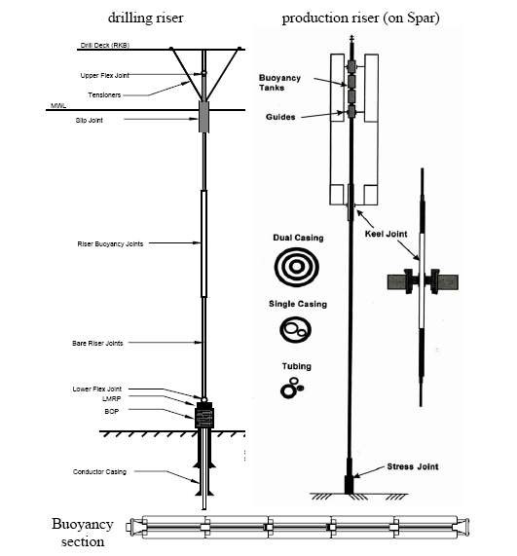
Figure 1.2: Functionally types of risers.

1.3. Material of Risers

Selection of materials for riser systems are based on several factors such as internal and external temperatures (maximum and minimum), internal fluid properties and external pressure, external environment, loads from environment such as wave, current and floater and incidental loads, service life, operations periods (temporary and permanent), period inspection and replacement possibilities and possible failure modes during the intended use. The selection of materials shall ensure compatibility of all components in the riser system.
According to material selection, risers can be divided into:
- Rigid riser
- Flexible riser
Steel pipes have traditionally been applied for conventional water depths. Titanium and composite pipes are suggested for deep water applications in order to keep the top tension requirement at an acceptable level. Steel risers with buoyancy modules attached can alternatively be applied for deep water. The required system flexibility for conventional water depths is normally obtained by arranging flexible pipes. In deep-water, it is however also possible to arrange metallic pipes in compliant riser configuration

1.3.1 Metallic Pipe
Traditionally low carbon steel has been the principle material for most risers systems. Typical material grades are X60, X65 or X70. Other materials like Aluminum, Titanium alloys are also used for deep water applications. For severe conditions like ultra deepwater, high temperature (HT), high pressure (HP) applications, Titanium has been considered for the riser application. Titanium may offer several benefits relative to steel for some of these configurations. This is due to a low modulus of elasticity (half that of steel) implying a higher degree of flexibility. Furthermore, the yield stress is typically higher than for steel and the specific weight is much lower (about half the steel weight).

1.3.2 Flexible Pipe
A flexible pipe is a pipe with low bending stiffness and high axial tensile stiffness, which is achieved by a composite pipe wall construction. The risers are composed of helical armoring layers d polymer sealing layers. Basically, there are two types of flexible pipes as follows:
- Un-bonded pipe
An un-bonded pipe typically consists of a stainless-steel internal carcass for collapse resistance, an extruded-polymer fluid barrier, a carbon-steel interlocked circumferential layer for internal pressure loads (pressure armor), helically wound carbon-steel tensile-armor layers for axial strength, and an extruded watertight external sheath.
- Bonded pipe
Bonded pipe typically consists of several layers of elastomer either wrapped or extruded individually and then bonded together through the use of adhesives or by applying heat and/or pressure to fuse the layers into single construction.

Chapter 2

2.0. Offshore Platforms

2.1. General
An oil platform, offshore platform oil rig is a large structure with facilities to drill wells, to extract and process oil and natural gas, or to temporarily store product until it can be brought to shore for refining and marketing. In many cases, the platform contains facilities to house the workforce as well.

2.2. Fixed Platforms
Fixed platforms are constructed by concrete or steel legs which anchored directly onto the seabed to support a deck for drilling rigs, production facilities and crew quarters. There are various types of fixed structures commonly used in oil rigs such as jacket platform, jack-up platform and compliant tower.

2.2.1. Steel Jacket Structure
A steel jacket structure is the most common kind of offshore structure used in shallow water. The leg jacket is fabricated from steel welded pipes and is pinned to the seabed with steel piles, which are driven through piles guides on the outer members of the jacket as shown figure.2.1.
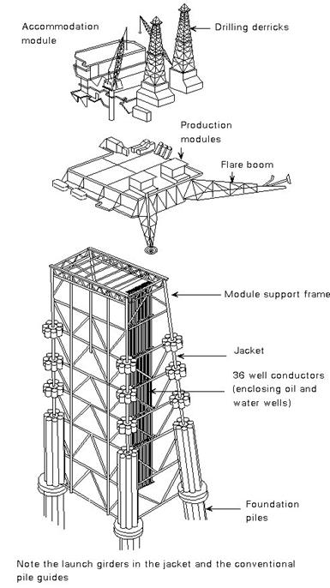
Figure 2.1: Typical jacket structure

2.2.2. Compliant Towers Structure
A compliant tower is a fixed rig structure which is normally used for the offshore drilling and production of oil or gas as shown in Figure.2-2. These platforms consist of slender, flexible towers and a pile foundation to support deck for drilling and production oil or gas. The compliant towers are usually designed to sustain significant lateral deflections and forces, and are typically used in shallow water.
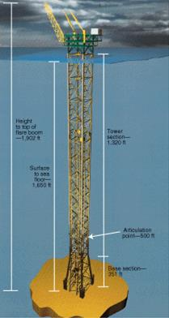
Figure 2.2: GB 260 complaint structure (Guntis Moritis)

2.2.3. Jack-Up Structure
A jack-up rig or a self-elevating unit is a type of mobile platform that consists of a buoyant hull fitted with a number of movable legs, capable of raising its hull over the surface of the sea as shown in Figure.2-3. Jack-up platforms are used as exploratory drilling platforms and offshore and wind farm service platforms. Jack-up platforms have been the most popular and numerous of various mobile types in existence. The total number of jack-up 'Drilling' rigs in operation numbers about 540 at the end of 2013.
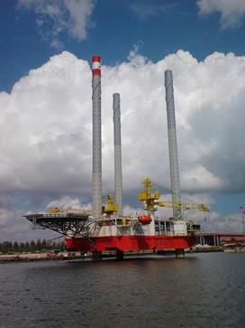
Figure 2.3: Jack-up structure.

2.3. Floating Platforms

A floating structure has enabled drilling and production oil and gas in the deep water and ultra-deep water such as in the Gulf of Mexico and elsewhere in the world. The floating structure is the highest possibility to select for a temporary or short presence at a location for drilling well or to install other offshore facilities. There are many forms of floating structures have been developed over the years such as ship-shape form, rounded-shape form, semi-submersible or spar platforms.

2.3.1. Semi-Submersible
A semi-submersible platform has columns and pontoons shapes of sufficient buoyancy to cause the structure to float with weight sufficient to keep the structure upright as shown in Figue.2-4. The semi-submersible platform is generally anchored by combinations of chain, chain-wire, wire or polyester rope during drilling or production operations. The semi-submersible platform can also be kept in place by the use of dynamic positioning (DP). The semi-submersible can be used up to 3000 meters.

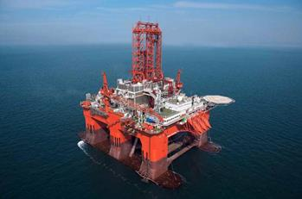 | 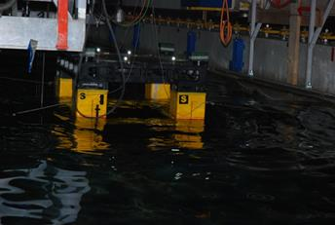  A semi-submersible under testing at Marine Technology Centre, Universiti Teknologi Malaysia
Figure 2.4: An example of semi-submersible.

2.3.2. FPSO
A floating production, storage and offloading (FPSO) is a floating vessel used for production and processing of hydrocarbons on deck and storage the oil. FPSO can be converted from oil or LNG tanker. A floating structure used only to store oil is referred to as a floating storage and offloading vessel (FSO). The FPSO can be classified into two types as follows
- Ship-shaped FPSO
- Round-Shaped FPSO as shown in Figure.2-5

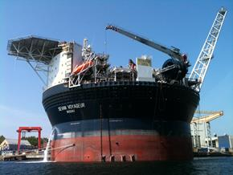 | 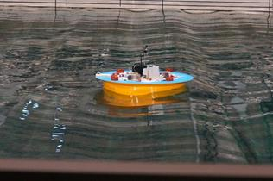  FPSO under testing at National Research Institute of Fisheries Engineering (NRIFE), Japan
Figure 2.5: An example of Rounded-shape FPSO.

2.3.3. SPARS
A spar is a type of floating oil platform typically used in very deep waters, and is named for logs used as buoys in shipping that are moored in place vertically. Spar production platforms have been developed as an alternative to conventional platforms. The deep draft design of spars makes them less affected by wind, wave and currents and allows for both dry tree and subsea production. Spars are most prevalent in the US Gulf of Mexico; however, there are also spars located offshore Malaysia and Norway.
A spar platform consists of a large-diameter, single vertical cylinder supporting a deck. The cylinder is weighted at the bottom by a chamber filled with a material that is denser than water to lower the center of gravity of the platform and provide stability. Additionally, the spar hull is encircled by helical strakes to mitigate the effects of vortex-induced motion. Spars are permanently anchored to the seabed by way of a spread mooring system composed of either a chain-wire-chain or chain-polyester-chain configuration. There are three primary types of spars; the classic spar, truss spar, and cell spar.

2.3.3.1 Classic SPAR
The classic spar consists of the cylindrical hull noted above, with heavy ballast tanks located at the bottom of the cylinder as shown in Figure.2-6.
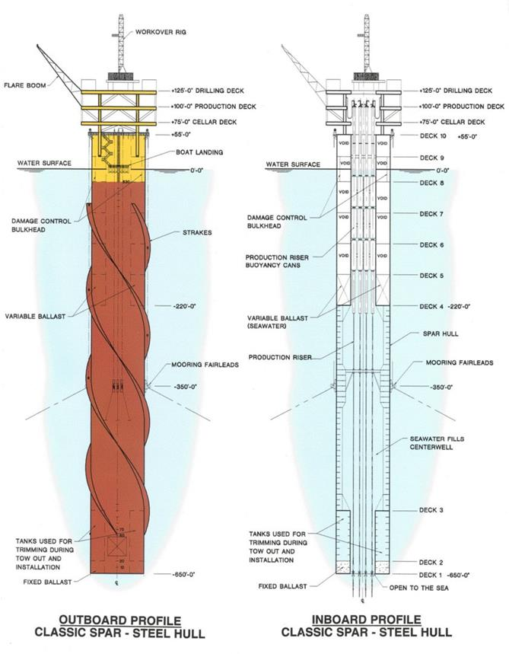
Figure.2.6: An example of SPAR.

2.3.3.2 Truss SPAR
A truss spar has a shorter cylindrical "hard tank" than a classic spar and has a truss structure connected to the bottom of the hard tank as shown in Figure.2-7. This truss structure consists of four large orthogonal "leg" members with X-braces between each of the legs and heave plates at intermediate depths to provide damping. At the bottom of the truss structure, there is a relatively small keel, or soft tank, that houses the heavy ballasting material. Soft tanks are typically rectangular in shape but have also been round to accommodate specific construction concerns. The majority of spars are of this type.
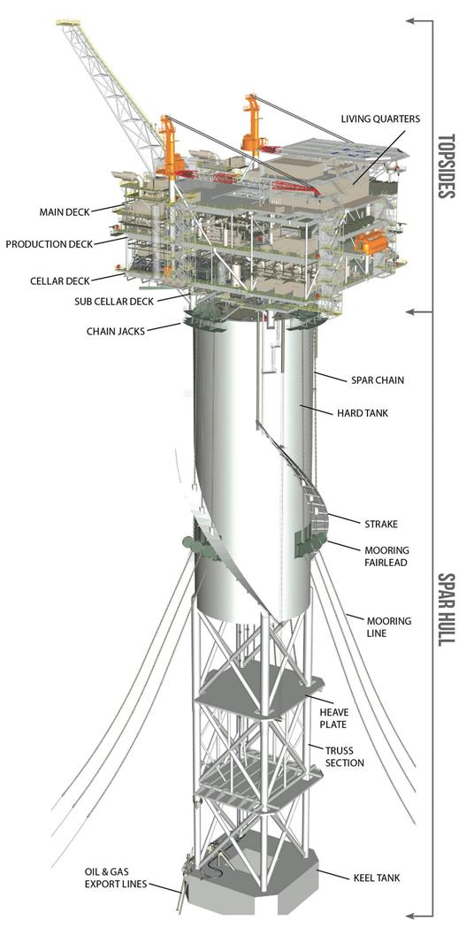
Figure.2.7: An example of Truss SPAR [William].

2.3.3.3 Cell SPAR
The cell SPAR has a large central cylinder surrounded by smaller cylinders of alternating lengths as shown in Figure.2-8. At the bottom of the longer cylinders is the soft tank housing the heavy ballasting material, which is similar to the truss SPAR. The cell spar design was only ever used for one platform, the Red Hawk spar, which was decommissioned in 2014 under the Bureau of Safety and Environmental Enforcement's "Rigs-to-Reefs" program.

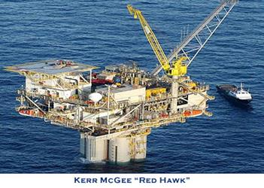 | 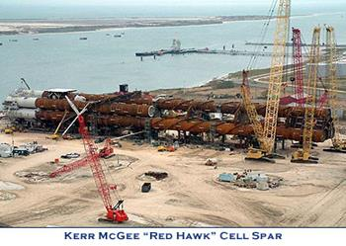
Figure.2.7: An example of Cell SPAR.

2.3.4. Tension-Leg Platform
A tension-leg platform (TLP) or extended tension leg platform (ETLP) is a vertically moored floating structure normally used for the offshore production of oil or gas, and is particularly suited for water depths greater than 300 metres and less than 1500 metres. The TLP has also been proposed for wind turbines.
TLPs have been in use since the early 1980s. The first tension leg platform was built for Conoco's Hutton field in the North Sea in the early 1980s. The hull was built in the dry dock at Highland Fabricator's Nigg yard in the north of Scotland, with the deck section built nearby at McDermott's yard at Ardersier. The two parts were mated in the Moray Firth in 1984.
The platform is permanently moored by means of tethers or tendons grouped at each of the structure's corners as shown in Figure.2-8. A group of tethers is called a tension leg. A feature of the design of the tethers is that they have relatively high axial stiffness (low elasticity), such that virtually all vertical motion of the platform is eliminated. This allows the platform to have the production wellheads on deck (connected directly to the subsea wells by rigid risers), instead of on the seafloor. This allows a simpler well completion and gives better control over the production from the oil or gas reservoir, and easier access for down-hole intervention operations.
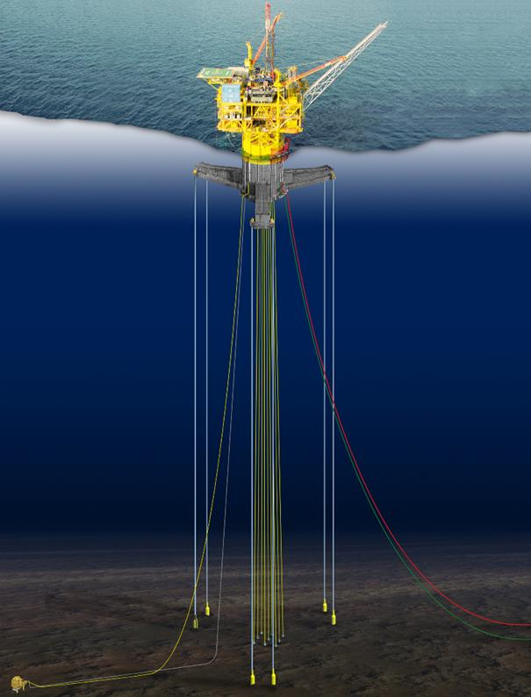
Figure 2.8: An example of TLP.

Chapter 3

3.0. Drilling Riser

3.1. Introduction
Integrity of drilling risers for oil and gas exploration is a critical issue due to increasing the water depth. The design and analysis of drilling risers are particularly important for dual operation and Dynamically Positioned (DP) semisubmersible or platform rigs. A series of dynamic analysis are required to be carried out for the purposes of integrity quality assurance. The objective of the dynamic analysis is to determine vessel excursion limits and limits for running/retrieval and deployment. In recent years, qualification tests are also required to demonstrate fitness for purpose as follows:
- Welded joints,
- Offshore riser coupling and
- Sealing systems.
Floating drilling risers are used on drilling semisubmersibles and drilling ships. Figure 3-1 shows an example drilling semisubmersible which consists of as follows:
- Riser,
- Intervention Riser System (IRS)
The IRS is able to be used to address the emergency intervention needs based on standard tooling and procedures and also loss of production. The IRS can be safely serviced according to all required through-tubing subsea well operations under multi-disciplinary operations being conducted in a single mobilization. The IRS enables access to both conventional and horizontal subsea trees in depths down to 3000 m.
- Subsea Shut Off Device (SSOD)
- BOP.
For risers installed in the Gulf of Mexico as an example, Vortex Induced Vibrations (VIV) is a critical issue. Some oil companies encourage use of monitoring systems to measure real-time vessel motions and riser fatigue damage. The monitoring results may also be used to verify the VIV analysis tools that are being applied in the design and analysis.

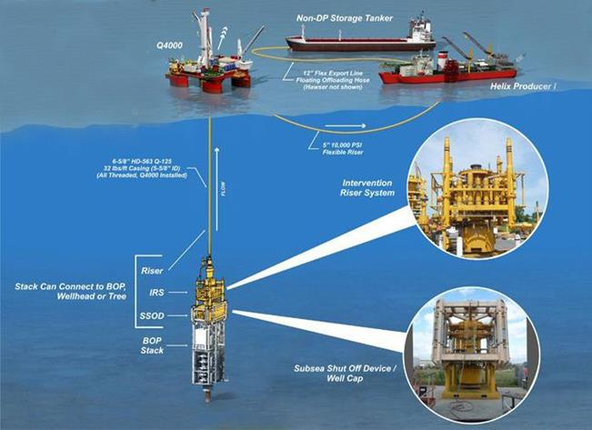
Figure 3.1: Drilling Semisubmersibles (Subsea World News).

3.1. Floating Drilling Equipment

3.1.1. Types of Drilling Risers
During installation and intervention in and on well, there are two different types of risers are used as follows:
- Completion and
- Work-Over Risers.
Completion and Work-Over Risers is an essential tool in the development of most subsea production systems. Riser arrangements and methods of implementation can vary considerably from one application to the next, with each role presenting specific design requirements.
Figure 3.2 is a typical figure for a Completion Work-Over Risers (CWOR). The CWOR can be a common system with items added or removed to suit the task being performed. Either type of risers provides communication between the wellbore and the surface equipment. Both resist external loads and pressure loads and accommodate wireline tools for necessary operations. The Telescopic Joint (TJ) compensates for rig heave. It is a riser joint consisting of an inner and outer barrel with a sealing element. The Upper Marine Riser Package (UMRP) is a new integrated riser tensioning system that uses the slip joint as the support structure for the riser tensioning cylinders. The UMRP is the unitized upper portion of the riser string, including the riser tensioners.

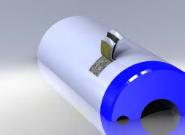
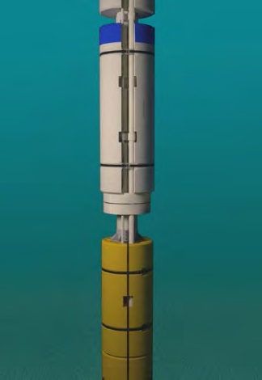
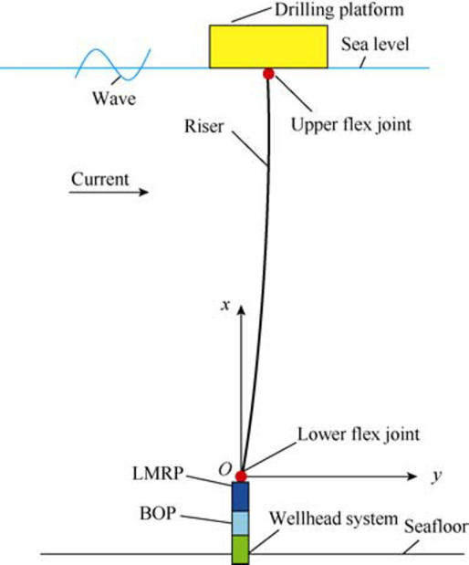
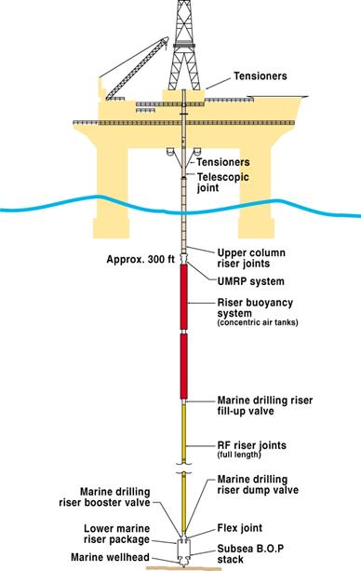
Skin system
Figure 3.2: Typical drilling riser system

2.2.1.1. Completion Riser
A completion riser is a riser that is designed to be run through the drilling marine riser and subsea BOP stack, and is used for the installation and recovery of the down-hole tubing and tubing hanger in a subsea well. Since the completion riser is run inside a drilling marine riser, it is not exposed to environmental forces such as wind, waves and current.
A completion riser typically consists of the following: Tubing Hanger (TH) running tool; TH orientation device (unless this is included in the design of the TH itself, as can be done for example if a subsea Horizontal Tree (HT) is used, or if a TH spool is used with a Vertical Tree (VT); a means of sealing off against the riser inside the BOP stack for pressure-testing and well control; a subsea test tree for well control during an emergency disconnect; retainer valve(s) to retain the fluid contents of the riser during an emergency disconnect; intermediate riser joints; lubricator valve(s) to isolate the riser during loading/unloading of long wire-line tool strings; a surface tree for pressure control of the wellbore and to provide a connection point for a surface wire-line lubricator system; a means of tensioning the riser, so that it does not buckle under its own weight.

2.2.1.2. Work-Over Riser
A work-over riser is a riser that provides a conduit from the upper connection on the subsea tree to the surface, and which allows the passage of wire-line tools into the wellbore. A work-over riser is not run inside a drilling marine riser and therefore it shall be able to withstand the applied environmental forces, i.e. wind, waves and currents. A work-over riser is typically used during installation/recovery of a subsea VT, and during wellbore re-entries which require full-bore access but do not include retrieval of the tubing.
A work-over riser typically consists of the following: the tree running tool; a wire-line coiled-tubing BOP, capable of gripping, cutting and sealing coiled tubing and wire; an emergency-disconnect package capable of high-angle release; retainer valve(s) to retain the fluid contents of the riser during an emergency disconnect; a stress joint to absorb the higher riser bending stresses at the point of fixation to the Lower Workover Riser Package (LWRP); intermediate riser joints; lubricator valve(s) to isolate the riser during loading/unloading of long wire-line tool-strings; a surface tree for pressure control of the wellbore and to provide a connection point for a surface wire-line lubricator system; a means of tensioning the riser, so that it does not buckle under its own weight.

3.1.2. Components of Drilling Risers
Figure.3-3 shows key components in a typical drilling riser system which is spider, guide base, wellhead, tree, BOP, tension joint and etc.

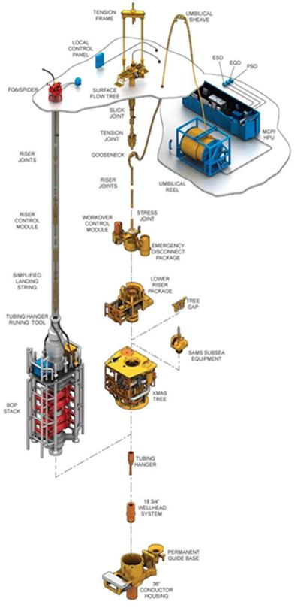 | 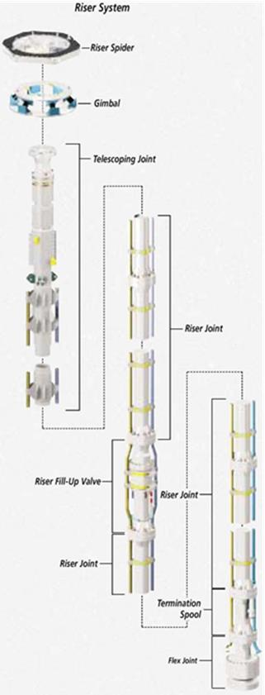
Figure 3.3: Key Components in a Drilling Riser System (FMC, Courtesy of World Oil)

3.1.3. Risers Connectors
Riser connectors are one of the most important riser components. As drilling depths have increased, riser connectors have evolved to address issues concerning high internal and external pressures, increasing applied bending moment and tension loads, and extreme operating conditions such as sweet and sour services. For connector design, the material selection and fabrication of bolts are critical issues.
Figure.3-4 shows bolt-based riser connectors which consists of as follows:
- The spider is a device with retractable jaws or dogs used to hold and support the riser on the uppermost connector support shoulder during running of the riser. The spider usually sits in the rotary table on the drill floor.
- The gimbal is installed between the spider and the rotary table. It is used to reduce shock and to evenly distribute loads caused by a rig’s roll/pitch motions, on the spider as well as the riser sections.
- A slick joint, also known as a telescope joint, consists of two concentric pipes that telescope together. It is a special riser joint designed to prevent damage to the riser and control umbilicals where they pass through the rotary table. Furthermore, it protects the riser from damage due to rig heave.
- Riser joints are the main members that make up the riser. The joints consist of a tubular midsection with riser connectors in the ends. Riser joints are typically provided in 9.14 to 15.24-m lengths. For the sake of operating efficiency, riser joints may be 75 ft in length. Shorter joints, called pup joints, may also be provided to ensure proper space-out while running the subsea tree, tubing hanger, or during work-over operations.
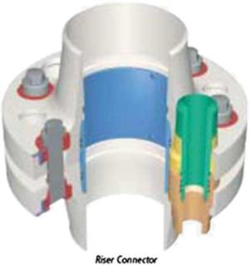
Figure 3.4: Riser Connector (Courtesy of World Oil)

Depending on configuration and design, a drilling riser system also consists of the following components:
- The BOP adapter joint is a specialized CWO riser joint used when the CWO riser is deployed inside a drilling riser and subsea BOP to install and retrieve a subsea tubing hanger.
- The lower work-over riser package (LWRP) is the lowermost equipment package in the riser string when configured for subsea tree installation/ work-over. It includes any equipment between the riser stress joint and the subsea tree. The LWRP permits well control and ensures a safe operating status while performing coiled tubing/wire-line and well servicing operations.
- An emergency disconnect package (EDP) is an equipment package that typically forms part of the LWRP and provides a disconnection point between the riser and subsea equipment. The EDP is used when the riser must be disconnected from the well. It is typically used in case of a rig drift-off or other emergency that could move the rig from the well location.
- The stress joint is the lowermost riser joint in the riser string when the riser is configured for work-over. The joint is a specialized riser joint designed with a tapered cross section, in order to control curvature and reduce local bending stresses.
- The tension joint is a special riser joint, which provides means for tensioning the CWO riser with the floating vessel’s tensioning system when in open-sea workover mode. The tension joint is often integrated in the lower slick joint.
- The surface tree adapter joint is a crossover joint from the standard riser joint connector to the connection at the bottom of the surface tree.
- The surface tree provides flow control of the production and/or annulus bores during both tubing hanger installation and subsea tree installation/work-over operations.

3.1.2. Diverter and Motion-Compensating Equipment
A diverter is similar to a low-pressure BOP. When either gas or other fluids from shallow gas zones enter the hole under pressure, the diverter is closed around the drill pipe or kelly and the flow is diverted away from the rig.
All floating drilling units have motion-compensating equipment as shown in Figure.3-5, installed to compensate for the heave of the rig. Compensators function as the flexible link between the force of the ocean and the rig. The equipment consists of the drill string compensator, riser tensioners, and guideline and pod-line tensioners. The drilling string compensator, located between the traveling block and swivel and kelly, permits the driller to maintain constant weight on the bit as the rig heaves. Riser tensioners are connected to the outer barrel of the slip joint with wire ropes. These tensioners support the riser, and the mud within it, with a constant tension as the rig heaves. The guideline and pod-line maintain constant tension on guideline wire ropes, and wire ropes that support the BOP control pod-lines as the rig heaves.

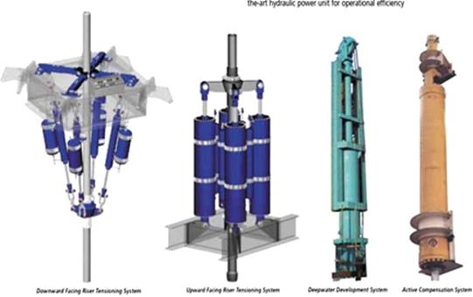
Figure 3.5: Motion-Compensating Equipment (Courtesy of World Oil).

3.1.4. Choke and Kill Lines and Drill String
Choke and kill lines are attached to the outside of the main riser pipe as shown in Figure.3-6. They are used to control high-pressure events. Both lines are usually rated for 15 ksi. High pressure is circulated out of the wellbore through the choke and killed lines by pumping heavier mud into the hole. Once the pressure is normal, the BOP is opened and drilling resumes. If the pressure cannot be controlled with the heavier mud, cement is pumped down the kill line and the well is killed.
The drill string permits the circulation of drilling fluid or liquid mud. Some functions of this mud are to:
- Cool the bit and lubricate the drill string
- Keep the hole free of cuttings by forced circulation to the top.
- Prevent wall cave-ins or intrusions of the formations through which it passes.
- Provide a hydrostatic head to contain pressures that may be present.

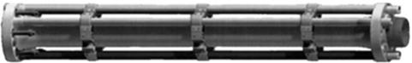
Figure 3.6: Complete Riser Joint (Courtesy of Offshore Magazine, [T. Clausen])

3.2. Key Components of Subsea Production Systems

3.2.1. Subsea Wellhead Systems
The foundation of any subsea well is the subsea wellhead which is discussed in Subsea Well Development -Introduction- [J.Koto]. The function of the subsea wellhead system is to support and seal the casing string in addition to supporting a BOP stack during drilling and also the subsea tree under normal operation.
Installation of equipment to the seabed is generally done by one of two methods as follows:
- Tensioned Guidelines
The first method is using Tensioned Guidelines attached to guide sleeves on the subsea structure orienting and guiding equipment into position.
- Dynamic Positioning
The second method is with a guideline-less method that uses a Dynamic Positioning Reference System to move the surface vessel until the equipment is positioned over the landing point, after which the equipment is lowered into place. Regardless of the guidance system, the procedure in which the wellhead system is installed is as follows:
- The first component installed is the temporary guide base. The temporary guide base serves as a reference point for the installation of subsequent well components compensating for any irregularities of the seabed. For guideline systems the temporary guide base also acts as the anchor point for guidelines.
- The conductor housing is essentially the top of the casing conductor. The casing conductor and housing are installed through the temporary guide base, either by piling or drilling, and provides an installation point for the permanent guide base and a landing area for the wellhead housing.
- The permanent guide base, which is installed on the conductor housing, establishes structural support and final alignment for the wellhead system. The permanent guide base provides guidance and support for running the BOP stack or the subsea tree.
- The wellhead housing (or high-pressure housing), which is installed into the conductor housing, provides pressure integrity for the well, supports subsequent casing hangers, and serves as an attachment point for either the BOP stack or subsea tree by using a wellhead connector.
- To carry each casing string, a casing hanger is installed on top of each string and the casing hangers are supported in the wellhead housing, which thus supports the loads deriving from the casing. To seal the inside annuli, an annulus seal assembly is mounted between each casing hanger and the well housing.

3.2.2. BOP
The marine riser is used as a conduit to return the drilling fluids and cuttings back to the rig and to guide the drill and casing strings and other tools into the hole. J.Koto in Subsea Well Development -Introduction- has provided a detail description on floating drilling.
The well is begun by setting the first casing string known as the conductor or structural casing da large-diameter, heavy-walled piped to a depth that is dependent on soil conditions and strength/fatigue design requirements. Its primary functions are to:
- Prevent the soft soil near the surface from caving in;
- Conduct the drilling fluid to the surface when drilling ahead;
- Support the BOP stack and subsequent casing strings;
- Support the Christmas tree after the well is completed.
The depth and size of each drilling string is determined by the geologist and drilling engineer before drilling begins. When drilling from a semi-submersible or drill ship, the wellhead and BOP must be located on the seabed.
The BOP stack is used to contain abnormal pressures in the wellbore while drilling the well. The primary function of the BOP stack is to preserve the fluid column or to confine well fluids or gas to the borehole until an effective fluid column can be restored.
At the lower end of the riser is the lower flex-joint. After the hole has been drilled to its final depth, electric logs are run to determine the probable producing zones. Once it has been determined that sufficient quantities of oil and gas exist, the production tubing is then run to the zone determined to contain that oil or gas. Only after this takes place is the well “completed” by removing the BOP stack and installing the fittings used to control the flow of oil and gas from the wellhead to the processing facility.

3.2.3. Tree and Tubing Hanger System
A tubing string is installed in and supported by a tubing hanger to complete the well for production. The tubing hanger system carries the tubing and seals of the annulus between casing and tubing.
A subsea tree is installed on the wellhead to regulate flow through the tubing and annulus. The subsea tree is an arrangement of remotely operated valves, which controls the flow direction, amount, and interruption.

3.3. Riser Design Criteria

3.3.1. Operability Limits
Table 3-1 presents the typical criteria used for determination of the operability limits for the drilling riser, defined mainly based on API 16Q. In general, a DNV F2 curve is used for the weld joints and a DNV B curve for the riser connectors (coupling). Two Stress Concentration Factors (SCFs) are used in fatigue analysis, one is 1.2 for the girth welds, and the other is roughly 2.0 for riser connectors, depending on the type of risers. In recent years, fatigue qualification testing has been performed to determine the actual S-N curve data. An Engineering Criticality Assessment (ECA) analysis is conducted to derive defect acceptance criteria for inspection.

Table 3.1: Criteria for Drilling Riser Operability Limits
Design Parameter | Definition | Drilling Conditions | Nondrilling Conditions
Low flex joint angle | Mean | 1_ | n/a
 | Max | 4_ | 90% of capacity (9_)
Upper flex joint angle | Mean | 2_ | n/a
 | Max | 4- | 90% of capacity (9_)
Von Mises stress | Max | 67% of s_{y} | 80% of s_{y}
Casing bending moment | Max | 80% of s_{y} | 80% of s_{y}

For the drilling riser, the safety factor on fatigue life is 3 because the drilling joints can be inspected. The fatigue calculations are to account for all relevant load effects, including wave, VIV, and installation-induced fatigue. In some parts, such as the first joints nearest the lower flex joint (LFJ), the fatigue life could be less, in which case the fatigue life will determine the inspection interval.

3.3.2. Component Capacities
In drilling, there are various component capacities needed to be defined such as:
- Riser Buoyancy
- Wellhead connector;
- LMRP connector;
- LFJ;
- Riser coupling and main pipe;
- Peripheral lines;
- Telescopic joint;
- Tensioner/ring;
- Active heave draw works;
- Hard hang-off joint;
- Soft hang-off joint;
- Spider-gimbal;
- Riser running tool.

3.3.2.1. Riser Buoyancy
Riser Buoyancy provides partial flotation for marine riser systems which allows the rig to deploy, operate and recover the marine riser to the depth capability of the drilling vessel [Matrix]. Riser analysis determines the total compensation or buoyancy required for the string over the water depth of the rig. The analysis takes into account tensioner capacity, sea state, mud weights, and Low Marine Riser Package (LMRP) and riser weights.
The riser buoyancy is manufactured from a combination of liquid epoxy resin binders and hollow glass microspheres, the encapsulant is vacuum processed to form a liquid monolithic syntactic. When cured the liquid forms a rigid polymer structure. Hollow Glass Microspheres (HGMS) appear as free flowing white powder to the naked eye. They are made from Borosilicate glass and range in density from 100 $kg/m^{3}$ to over 1000 $kg/m^{3}$.
The outer skin of the buoyancy module is manufactured from an integrally moulded fibreglass/aramid composite which produces a lightweight, tough, rigid outer layer that is abrasion and impact resistant. The outer skin consists of a double layer of FRP and a backing layer of aramid mesh. Extra reinforcement to high impact and strain areas is applied if required. The skin system can be painted with a variety of surface treatments including epoxy resin or polyurethane.

3.3.2.1. Riser Buoyancy
Riser Buoyancy provides partial flotation for marine riser systems which allows the rig

3.4. Drilling Riser Analysis Model

3.4.1. Drilling Riser Stack-Up Model
A schematic of a typical drilling riser stack-up was shown earlier in Figure.3-2. The weight in air and seawater for the telescopic joint, flex-joints, LMRP and BOP are needed to be defined for riser analysis.
The submerged weight and dimensions (length, width, height) for the production trees, manifolds, and jumpers are required for the dual activity interference analysis. The properties of the auxiliary rig drill pipe and wire rope will also be used in the interference analysis.
The recommended tensioner forces used in the analysis are calculated based on the mud weight. In the analysis, the drilling mud densities are typically assumed to be 8.0, 12.0, 16.0 ppg, etc. The maximum allowable bending moment in the casing may be determined assuming the allowable stress is 80% of yield strength.
The hydrodynamic coefficients to be used in the analysis include the normal drag coefficient and the associated drag diameters for the bare and buoyancy joints. The tangential drag coefficient may be taken from API RP 2RD. For the LMRP and the BOP, the vertical and horizontal drag areas and coefficients may be provided by suppliers.
The red alarm is typically 60 sec before disconnect point, and the yellow alarm is roughly 90 sec before the red alarm.

3.4.2. Vessel Motion Data
The required vessel motion data include the following:
- The principal dimensions of the vessel;
- The mass and inertia properties at maximum operation draft;
- Reference point locations for RAOs (Response Amplitude Operator);
- The survival draft RAOs for various wave directions;
- The maximum operating draft RAOs for various wave directions;
- The transit draft RAOs for various wave directions.

In addition, wave drift force quadratic transfer functions for surge, sway, and yaw are required to conduct irregular wave force calculations in a drift-off analysis. Wind and current drag coefficients for the vessel are also required.

3.4.3. Environmental Conditions
Generally angles denote the direction “from which” the element is coming, and they are specified as clockwise from true north.
Tidal variations will have a negligible effect on the loads acting on deep-water risers and may be negligible in the design.
Environmental conditions include:
- Omnidirectional hurricane criteria for the 10-year significant wave height and associated parameters;
- Omnidirectional winter storm criteria for 10- and 1-year return periods;
- The condensed wave scatter diagram for the full population of waves (operational, winter storm, and hurricane);
- Loop/eddy normalized profiles;
- The 10- and 1-year loop/eddy current profiles along with the associated wind and wave parameters;
- The bottom current percent exceedance and the normalized bottom current profile;
- The combined loop/eddy and bottom current normalized current profile as a fraction of the maximum;
- The combined loop/eddy and bottom current profiles for a 10-year eddy þ 1-year bottom, and 1-year eddy þ 1-year bottom;
- A 100-year submerged current probability of exceedance and profile duration.

Background current is the current that exists in the upper portion of the water column when there is no eddy present. Mean values of the soil undrained shear strength data, submerged unit weight profile, and 350 profiles are used along the soil column to calculate the equivalent stiffness of the soil springs, for analysis of the connected riser.

3.4.4. Cyclic p-y Curves for Soil
The methodology for deriving a p-y curve for soft clay for cyclic loading was developed by Matlock. A family of p-y curves will be required to model the conductor casing/soil interaction at various depths below the mud-line.

3.5. Drilling Riser Analysis Methodology
Some key terms for drilling riser design and analysis are shown in Figure.3-7. From a structural analysis point of view, a drilling riser is a vertical cable, under the action of currents. The upper boundary condition for the drilling riser cable is rig motions that are influenced by rig design, wave and wind loads. One of the key technical challenges for deep-water drilling riser design is fatigue of VIV due to surface loop currents and bottom currents.
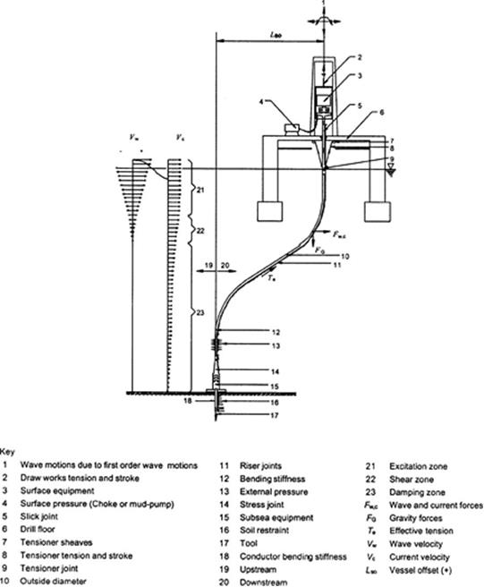
Figure 3.7: Principal Parameters Involved in C/WO Riser Design and Analysis (ISO 13628-7)

Figure.3-8 shows a typical finite element analysis model for C/WO risers. It illustrates the process of running riser and landing, the riser being connected or disconnected or in hang-off mode.
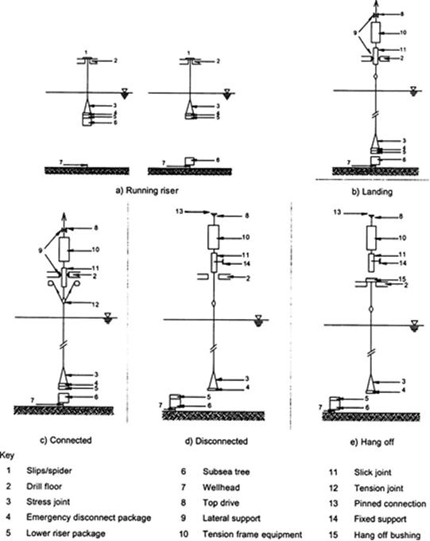
Figure 3.8: Typical Finite Element Analysis Model for C/WO Risers [API]

3.5.1. Running and Retrieve Analysis
The goal of running/retrieval analysis is to identify the limiting current environment that permits this operation. During this operation, the riser could be supported by the hook at 75 ft above the RKB (Rotary Kelly Bushing, a datum for measuring depth in an oil well), or it could be hanging in the spider. The critical configuration is the hook support because of its greater potential for contact between the joint and the diverter housing. The BOP is on the riser for deployment, and may not be on the riser if the riser is disconnected at the LMRP, in which case only the LMRP is on the riser.
The hook is considered to be a pinned support with only vertical and horizontal displacement restraints. The riser may rotate about the hook under current loading. The limiting criterion is contact between a riser joint and the diverter housing.
Static analysis is used to evaluate the effects of the current drag force. Wave dynamic action on the riser’s lateral motions is not considered.

3.5.2. Operability Analysis
The objective of the operability analysis is to define the operability envelope, for various mud weights and top tensions, per the recommendations of API RP 16Q. The operability envelope for the limiting criteria is computed using both static and dynamic wave analysis. The static analysis involves offsetting the rig upstream and downstream under the action of the current profile to find the limiting up and down offsets at which one limiting criterion is reached. Two current combinations are typically considered: background þ bottom and eddy þ bottom. Typically three mud weights are modeled with their respective top tensions.
The procedure for the dynamic analysis is the same as that for the static analysis except that wave loading is added, and the analysis is carried in the time domain, using regular waves based on $H_{max}$, and for at least five wave periods. The dynamic analysis predicts the maximum LFJ and upper flex-joint (UFJ) angles, which should be checked against their limiting values.
The limiting conditions for the flex-joint angles are typically as follows:
- Connected drilling for dynamic analysis:
- Upper flex-joint mean angle < 2 degrees; 4 degrees maximum;
- Lower flex-joint mean angle < 1 degree; 4 degrees maximum.
- Connected non-drilling:
- Upper flex-joint max angle < 9 degrees;
- Lower flex-joint max angle < 9 degree.
Note that the allowed limit for the upper and lower flex-joint angles is 1 degree for static analysis of connected drilling risers.
Other limitations on the dynamic riser response are as follows:
- Riser von Mises stresses < 0.67 yield stress for extreme conditions;
- Riser connector strength;
- Tensioner and TJ stroke limit.
Limitations may also arise from loading on the wellhead and conductor system:
- LMRP connector capability;
- BOP flanges or clamps;
- Wellhead connector capacity;
- Conductor bending moment (0.8 yield stress).
For drilling, usually it is the mean angles of the LFJ (1 degree) and the UFJ (2 degrees) that determine the envelope. For non-drilling conditions, usually it is the maximum dynamic bending moment in the casing that controls the envelope.

3.5.3. Weak Point Analysis
Weak point analysis forms a part of the design process of a drilling riser system. The objective of a weak point analysis is to design and identify the breaking point of the system under extreme vessel drift-off conditions should the LMRP fail to disconnect. The riser system should be designed so that the weak point will be above the BOP.
The basic assumption here is that all equipment in the load path is properly designed per the manufacturers’ specifications. The areas of potential weakness in a drilling riser system are typically:
- Overloading of the drilling riser;
- Overloading of connectors or flanges;
- Stroke-out of the tensioner;
- Exceedance of top and bottom flex-joint limits;
- Overloading of the wellhead.
Evaluation criteria for weak point analysis are derived for each potential weak point of the drilling riser system. The weak point criteria determine failure of the system. The evaluation criterion for stroke-out of the tensioners is typically the tensile strength (rupture) of the tensioner lines for each line. The maximum capacity of a padeye will be based on the load that causes yield in each padeye.
The failure load capacity for a flex-joint typically corresponds to the maximum bending moment and tension combination that the flex-joint can withstand. This typically relates to additional loading following angular lock-out.
The failure load capacity for standard riser joints and conductor joints is typically taken as the maximum combined tension and bending stress that the joint can withstand before exceeding the yield stress of the riser material.
To eliminate uncertainty, a full time-domain weak point computer analysis may be conducted, as follows:
- Perform dynamic regular wave analyses for a selected combination of wind, waves, and currents and establish the dynamic amplification of the loads generated at potential weak points, especially at the wellhead connector and at the LMRP connector.
- Sensitivity analyses are typically performed to determine the effect on the weak point of varying the critical parameters such as mud weight and soil properties.
- Vessel offsets should range from the drilling vessel in the mean position to extreme vessel offsets downstream, as determined by a coupled mooring analysis.
- Following the offset analysis of the drilling riser system, the results will be processed to extract the forces and moments generated by the offset position. These are then compared with the corresponding evaluation criteria at potential weak points along the drilling riser system.
If the weak point is below the BOP, failure would have severe consequences in terms of well integrity, riser integrity, or cost. Then further analysis should be conducted to relocate the weak point to a position with less onerous consequences in the event of failure. One option that might be considered in this context is to redesign the capacity of the hydraulic connectors or bolted flanges/bindings in the drilling riser system such that the weak point occurs at one of those locations.
In a mild environment, slow drift-off generates low static and dynamic moments on the wellhead because of the mild current and the low wave height. In a fast drift-off environment, the lower riser straightens out quickly before wave action magnifies the wellhead connector static moment when the tensioner strokes out. The suggested critical environment would be a combination of high current to generate a high static moment at the wellhead connector, high waves to cause high dynamic moments, and slow wind to generate slow drift.

3.5.4. Drift-Off Analysis
Drift-off analysis is a part of the design process for a drilling riser system on a DP rig. The objective of a drift-off analysis is to determine when to initiate disconnect procedures under extreme environmental conditions or drift-off/drive-off conditions. The analysis is performed for the drilling and the non-drilling operating modes. In each mode, the analysis will identify the maximum downstream location of the vessel under various wind and current speeds and wave height/period.
The first task in a drift-off analysis is to determine the evaluation criteria by which the disconnect point will be identified. These criteria are based on the rated capacities of the equipment in the load path:
- Conductor casing, based on 80% of yield;
- Stroke-out of the tensioner/telescopic joint;
- Top and bottom flex joints limits;
- Overloading of the wellhead connector;
- Overloading of the LMRP connector;
- Stress in the riser joint (0.67 of yield).
Coupled system analysis is used where the soil and casing, wellhead and BOP stack, riser, tensioner, and the vessel are all included in one model. Combinations of environmental actions (wind, current, and waves) are applied to the system, and the dynamic time-domain response is then computed. In this coupled vessel approach, the vessel drift-off (or vessel offset) is an output of the analysis. This approach, which accounts for soil/ casing/riser/vessel interactions, is more accurate than the uncoupled approach where the vessel offset is computed separately and then applied to the vessel drift curve to the riser model in a second analysis.
Following the static and dynamic analyses of the drilling riser system, the disconnect point of the system is identified as follows:
- The vessel offset, for the specified environmental load conditions, that generates a stress or load equal to the disconnect criteria of the compo-nent is the allowable disconnect offset for that particular component.
- The allowable disconnect offset should be determined for each of the key components along the drilling riser system.
- Then the point of disconnect (POD) corresponds to the smallest allowable disconnect offset for all critical components along the drilling riser system.
- Once the vessel offset at which the riser must be disconnected has been determined, the offset at which the disconnect procedure must be initiated (red limit) will typically be based on 60 sec. This is the EDS time.
- For non-drilling, the disconnect initiation offset is adjusted by 50 ft before the EDS time. This is the modified red limit for non-drilling.
- For drilling, the disconnect initiation offset is typically 90 sec before EDS.

3.5.5. Vortex Induced Vibration
Vortex-induced vibration (VIV) becomes one of the problems that concern everyone in marine industry as the marine riser system is designed to oil and gases from sea bed. The riser systems may have potential in experiencing a highly level of fatigue damage in a relatively period of time due to exposure of the riser to harsh current environments because of vortex-induced vibration. Vortex-induced vibration is a phenomenon where objects such as cylinder interact with moving fluid through it. When an object is immersed in moving water, it will experience a phenomenon where the sea currents caused the object to be excited by forces that caused by vortex shedding
Vortex-induced vibration is widely known in the oil and gas industry for several decades. The vortex-induced vibration is known as self-exciting, self-regulating, self-limiting highly phenomenon that received extensive attention in this oil and gas industry due to the flow-structure-interaction problem. This phenomenon commonly are excited by vortex shedding due to external load that is sea currents as the riser is experiencing sea currents in deep-water. This vortex-induced vibration also influenced by a large number of parameters including mass ratio, structure stiffness, damping, surface roughness and the most important parameters for this vortex-induced vibration are Reynolds number, Strouhal number, and reduced velocity. The body literature related to this vortex-induced vibration is massive.
There are several objectives of performing Vortex Induced Vibration (VIV) analysis of the drilling risers as follows:
- To predict VIV fatigue damage.
- To identify fatigue critical components.
- To determine the required tensions and the allowable current velocity.

In a VIV analysis of the drilling riser, the vessel is assumed to be in its mean position. The analysis includes these tasks:
- To generate mode shapes and mode curvatures for input to VIV analysis using a finite element modal analysis program.
- To model the riser using Shear7 based on the tension distribution deter-mined from initial static analyses.
- To analyze the VIV response of the riser for each current profile using Shear7, Orcaplex.
- To evaluate the damage due to each current profile.
- To plot the results in terms of VIV fatigue damage along the length of riser for each current profile.

3.5.6. Wave Fatigue Analysis
A time-domain approach is adopted for motion-induced fatigue assessment of the drilling riser. No mean vessel offsets or low-frequency motions are considered for motion fatigue analysis of the drilling riser.
The procedure for performing a fatigue analysis is as follows:
- Perform an initial mean static analysis.
- Apply relevant fatigue currents statically as a restart analysis.
- Perform dynamic time-domain analyses for the full set of load cases, applying the relevant wave data for each analysis.
- Post-process the results from the time-domain analyses to estimate fatigue damage of the drilling riser at the critical locations.

3.5.7. Hang-Off Analysis
Two hang-off configurations are assumed as follows: a hard hang-off in which the Telescopic Joint (TJ) is collapsed and locked, thereby forcing the top of the riser to move up and down with the vessel; and a soft hang-off in which the riser is supported by the riser tensioners with all air pressure vessels (APVs) open and a crown-mounted compensator (CMC), providing a soft vertical spring connection to the vessel.
Time-domain analysis is conducted using random wave analysis and a simulation time of at least 3 hr. The hard hang-off cases are the 1-year winter storm (WS), 10-year WS, and 10-year hurricane. The soft hang-off cases are the 10-year WS and the 10-year hurricane. The goal of the time-domain dynamic analysis is to investigate the feasibility of each mode.
In a hang-off configuration model, the riser is disconnected from the BOP, and only the LMRP is on the riser. For the hard hang-off method, only the displacements are fixed. The rotations are determined by the stiffness of the gimbal-spider. The trip saver is at the main deck.
For the soft hang-off method, the riser weight is shared equally by the tensioner and the draw works. The draw works have zero stiffness. The tensioner stiffness may be estimated based on the weight of the riser sup-ported by the tensioners and the riser stroking from wave action.
The evaluation criteria for soft and hard hang-off analyses are as follows:
- For soft hang-off, use the stroking limit for the tensioner and slip joint;
- Minimum top tension to remain positive to avoid uplift on the spider;
- Maximum top tension: rating of substructure and the hang-off tool;
- Riser stress limited to 0.67 Fy;
- Gimbal angle to prevent stroke-out;
- Maximum riser angle between gimbal and keel to avoid clashing with the vessel.

3.5.8. Dual Operation Interference Analysis
Dual operation interference analysis evaluates the different scenarios proposed for having the drilling riser in place and connected on the main rig while performing deployment activities on the auxiliary rig. The goal of this analysis is to identify limiting currents and offsets where these activities can take place without causing any clashing between the drilling riser, the suspended equipment on the auxiliary rig, or the winch. The distance between the main riser and the auxiliary rig and between the main rig and winch is an important design parameter. Note that clashing of the main riser with the moon-pool, vessel hull, or bracing will need to be assessed separately prior to finalizing the stack-up model.
A static offset will be applied according to supplied information on the dual operation activity and subsequently another static offset of the vessel due to current loading. Finally, the current loading will be added and then the system will be evaluated for minimum distance between the drilling riser, the dual operation equipment, and the vessel.
A drag amplification factor will be applied to the completion riser (off of the auxiliary rig) to account for VIV drag. No drag amplification will be added to the drilling riser (off of the main rig) to conservatively estimate its downstream offset due to the current. The auxiliary rig equipment will be considered deployed at 10, 30, 60, and 90% of water depth and upstream, whereas the main drilling riser will always be considered to be downstream and connected.

3.5.9. Contact Wear Analysis
The contact between the drill string and the bore of the subsea equipment may result in wearing of both surfaces due to the rotation and running/ pulling of the drill string. The softer bore of the subsea equipment will experience more wear than the drill string and, therefore, it is the subject of this section. The wear volume estimation is based on the work of Archard and others. The expression for wear is given by:

$V_{wt}=\left(K/H\right)∙N∙S$ (3-2)

Where; $V_{wt}$is total wear volume from both surfaces (in³), $K$ is material constant, $H$ is material hardness in BHN, $N$ is contact force normal to the surfaces (lbf), $S$ is sliding distance (in).
This result is based on several hundred experiments that included a wide range of material combinations. The experimental result demonstrates that the wear rate, $V_{w}/S$, is independent of the contact area and the rate of rotation or sliding speed, as long as the surface conditions do not change. Such a change can be caused by an appreciable rise in surface temperature. The H value for 80-ksi material is 197 BHN. For the flex-joint wear ring and wear sleeve, H is 176 BHN.
The normal force, N, is obtained from the contact analysis of the drill string for the load cases.
The sliding distance, S, is related to the string RPM as follows:

$S= π d \left(RPM\right) t$ (3-3)

Where; $d$ is the diameter of the drill pipe/tool joint and $t$ is the time in minutes.
Substitution of Equation (2-1) into Equation (2-2) and solving for t as a function of $V_{w}$ gives:

$t=\left(H/K\right)∙\left({V_{w}}/N\right)∙ \left(π dRPM\right)$ (3-4)

The drilling fluid provides lubrication with reduction in wear by comparison to the dry contact conditions. Therefore, the results of this study, which are based on unlubricated wear, will be conservative. The wear volume, Vw, can be further related to the wear thickness, tw, by the wear geometry as discussed in the next section.
Because the goal is to find the wear thickness, the wear geometry should be considered. The wear area is the crescent bounded by the bore and the OD of the tool joint or the drill pipe. The following are the possible contact cases:
- Tool joint contact with casing;
- Tool joint contact with BOP-LMRP;
- Tool joint contact with riser joint;
- Tool joint contact with flex-joint;
- Drill pipe contact with riser joint;
- Drill pipe contact with flex-joint.
For each tension, and each position of the tool joint, the flex-joint angle is increased between 0 and 4 degrees at increments of 0.1 degree. The reaction forces at each increment are reported. As long as the drill string tension is maintained at a given angle that is greater than zero, the wear process will continue under the reaction forces. Because of the large scale of the problem, these reaction forces remain unchanged for wear thicknesses of up to 1 in. So the question becomes this: How much time does it take to wear out a certain thickness?
The first step in calculating wear is to estimate the drill string tension near the mud-line since the contact reaction forces depend on this tension. To simplify the wear calculations, a conservative approach is implemented where the reaction forces for each contact location are normalized with respect to the drill string tension for the five positions of the tool joint.
A typical wear calculation procedure could be as follows:
- Determine as input the following:
- Angle of drilling;
- Material Brinell hardness;
- Tension range;
- RPM.
- Calculate the normal force from the reaction envelopes from the tension.
- Obtain the sliding distance, S, from the $t_{w}-V_{w}$ values.
- Obtain the time, t, in minutes for each $t_{w}$.

3.5.10. Recoil Analysis
The objectives of conducting a recoil analysis are to determine recoil system settings and vessel position requirements, which ensure that during disconnect the following are achieved:
- The LMRP connector does not snag.
- The LMRP risers clear the BOP.
- The riser rises in a controlled manner.
Recoil analysis is not required for every specific application if the vessel has an automatic recoil system. The criteria to be considered at each stage of recoil are as follows:
- Disconnect: The angle of the LMRP as it leaves the BOP should not exceed the allowable departure angle of the connector. This may limit the possibility of reducing tension prior to disconnect.
- Clearance: The LMRP should rise quickly enough to avoid clashing with the BOP as the vessel heaves downward.
- Speed: The riser should not rise so fast that the slip joint reaches maximum stroke at high speed.
Requirements for modeling the riser during recoil are the same as those needed for hang-off. In addition, it must be possible to account for the nonlinear and velocity-dependent characteristics of the tensioner system. A time-domain riser analysis program can be used alone or in conjunction with spreadsheet calculations from which tensioner characteristics are derived. The analysis sequence is as follows:
- Conduct analysis of the connect riser.
- Release the base of the LMRP, to reflect unlatching, and analyze the subsequent response for a short period of time.
- Change tensioner response characteristics to simulate valve opening or closure and analyze subsequent riser response for a number of wave cycles.
The analysis is repeated to determine the necessary time delay between operations. The upstroke of the riser must be monitored to detect whether top-out occurs and at what speed. If the riser is to be allowed to stroke on the slip-joint during hang-off, vertical oscillation of the riser following disconnect must also be monitored to ensure that clashing with the BOP does not occur.

Chapter 4

4.0. Production Riser

4.1. Introduction
A production riser system consists of conductor pipes connected to floaters on the surface and the wellheads at the seabed. Also, it is the primary device of the floating production system to convey fluids to and from the vessel. It is one of the most complex aspects of a deep-water production system.
Figure 3-1 illustrates various types of production subsea riser systems used in deep-water field developments. There are currently a number of configurations of production riser that have been utilized in subsea oil and gas exploration such as Attached and Pull Tube Risers, Steel Catenary Risers (SCRs), Top Tensioned Risers (TTRs), Flexible Risers and Hybrid risers.

Figure 4.1: Various types of production subsea riser systems.

Flexible risers are one of the common types of production risers. They may be deployed in a variety of configurations, depending on the water depth and environment. Flexible pipes have traditionally been limited by diameter and water depth; however, many deep-water projects in the Gulf of Mexico and Brazil are now employing SCRs for both export and import risers.
The choice between a flexible riser and an SCR is not clear cut. The purchase cost of flexible risers for a given diameter is higher per unit length, but they are often less expensive to install and are more tolerant to dynamic loads. Also, where flow assurance is an issue, the flexible risers can be designed with better insulation properties than a single steel riser.
Flexible risers and import SCRs are associated with wet trees. Top tensioned risers are almost exclusively associated with dry trees and hence do not usually compete with flexible risers and SCRs except at a very high level: the choice between wet and dry trees.

4.2. Attached and Pull Tube Risers (PTRs)
The attached and pull tube risers may be considered as the more simple approaches to riser design when comparing to some of the modern technological advances in the industry. Utilized on fixed platforms, compliant towers, and concrete gravity structures, these two designs are statically mounted to the supporting platform substructure and are limited to water depths (approximately 3,000 feet maximum) where these towers can be deployed. Both rely on ROV installation campaigns with the attached riser being installed in sections starting at seabed while the pull tube design may be pre-installed or retrofitted to the tower after its installation.
The methods for both designs and overall function are conceptually simple. The attached riser utilizes clamps, typically with polymer liners, to fix the riser pipe to the tower. The pull tube differs in that, although it is mounted statically to the tower, it serves as a conduit for a smaller diameter flow-line to pass through. The flow-line is typically pulled through the riser via a high capacity winch connected to the messenger wire of the flow-line. Both riser designs are presented schematically in Figure.4-2 while highlights for each are presented below.
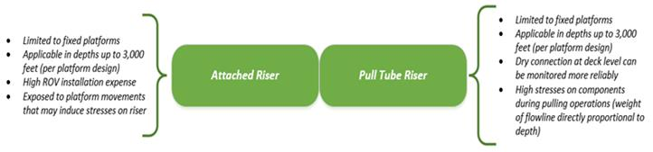
Figure 4.2: Schematic of attached and pull tube risers design.

Although the towers utilized in both designs are considered to be very stable, a 2% water depth translation is typically observed at the topsides in severe weather conditions which can place large fatigue loads on risers. This must be carefully considered during the design process to ensure the stress levels due to cyclic fatigue on the riser material is kept within acceptable limits.

4.3. Steel Catenary Risers (SCRs)
The steel catenary riser (SCRs) is generally connected to a floating platform with a flexible joint, steel or Titanium stress joint to absorb the potentially large angular movement of the platform (Quintin, 2007). The bottom end of the riser pipe rests on the seabed as a beam on elastic foundation. SCR has Simple design and easy to construct (Tellier, 2009). SCR has some advantages in terms of manufacturing cost, as example SCR can be suspended in longer lengths, removing the need for mid depth buoys. At the seabed, the need of riser base, stress joint or flex joint have been eliminated. This reduces the complexity of riser system and cost savings (Dikdogmus, 2012)
SCRs were initially used as export lines on fixed platforms. SCRs clearly have similarities with free-hanging flexible risers, being horizontal at the lower end and generally within about 20⁰ of the vertical at the top end. In this arrangement, the riser forms an extension of the flow-line that is hung from the platform in a simple catenary. Relative rotational movement between riser and platform can use a flex-joint, stress joint, and pull tube to offset the movement. Figure.4-3 illustrates an SCR system used in deep water.
The Auger platform is the first floating production facility to implement an SCR (870 m, Gulf of Mexico, 1993), whereby two 12-in. lines were used for oil and gas export. Since then, they have been progressively used in more severe application. SCRs were used in the late 1990s, again for exporting aboard the P-18 submersible offshore in Brazil. Recently, they have been used in large numbers as production risers associated with the Bonga FPSO.
The SCR is a cost-effective alternative for oil and gas export and for water injection lines on deep-water fields, where the large-diameter flexible risers present technical and economic limitations. An SCR is a free-hanging riser with no intermediate buoys or floating devices.
The SCR is self-compensated for the heave movement; that is, the riser is lifted off or lowered onto the seabed. The SCR riser still needs a ball joint to allow rotation of the risers to be induced by waves, currents, and vessel motion at the upper end connection.
The SCR is sensitive to waves and current due to the normally low level of effective tension on the riser. The fatigue damage induced by vortex-induced vibrations (VIVs) can be fatal to the riser. Use of VIV suppression devices such as helical stakes and fairing can help reduce the vibrations to a reasonable level which will be discussed on the section 8.4 on Vortex-Induced Vibration Prevention

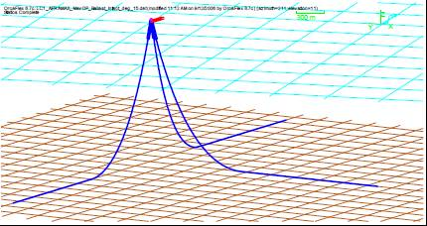
Steel Catenary Riser (Herve Quintin at all, 2007
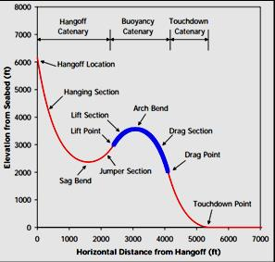
Lazy Wave SCR configuration (2H Offshore, 2014)
Figure 4.3: Steel Catenary Riser (SCR) Diagram.

SCRs as shown in Figure.4-4 are a preferred solution for deep-water wet tree production, water or gas injection, and oil or gas export. At the end of 2008, the total number of installed deep-water SCRs was more than 100 worldwide, with the majority installed in the Gulf of Mexico (GoM). Meanwhile, about 30 SCRs are used in the detailed engineering design phase. In addition, the SCR concept has been selected for most of the tie-back projects.

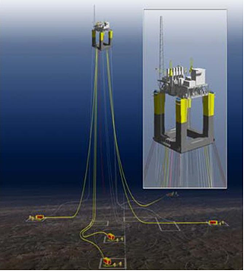
Figure 4.4: Steel Catenary Riser Configurations (DNV 2014)

The design, welding, and installation challenges associated with SCRs in ultra-deep-water floating production are primarily related to the higher hang-off tensions caused by the integration of their weight over the water depth, in combination with additional challenges from high-pressure (HP), high-temperature (HT) and sour service.

4.3.1. Steel Catenary Riser Design Analysis
In the pre-FEED phase, an initial design is carried out to define the following:
- Riser host layout (for interface with other disciplines);
- Riser hang-off system (flex-joint, stress joint, pull-tube, etc.);
- Riser hang-off location, spacing, and azimuth angle (hull layout, subsea layout, total risers and interference consideration);
- Riser hang-off angle for each riser;
- Riser location elevation at hull (hull type, installation, and fatigue consideration);
- Global static configuration.
The static behavior of catenary riser is mainly governed by the top pre-tensioned applied during installation. If the tension is low, large curvature at touchdown point region, meanwhile if pre-tension is high, riser will submitted high stress (Martis et al, 1999). Furthermore, Fatigue design of a SCR at touchdown point is challenging due to soil interaction (Feng et al, 2012).
A static configuration may be determined based on catenary theory accounting for hang-off angle, water depth, and riser unit weight. The SCR design should meet basic functional requirements such as SCR internal (and/or external) diameters, submerged tension on host vessel, design pressure/temperature, and fluid contents.
Due considerations should be given to future tie-back porches to accommodate the variations for a hang-off system, riser diameter, azimuth angles, and the required extreme response and fatigue characteristics.

4.3.2. Strength and Fatigue Analysis
The Long suspended length of riser will significantly increase vessel payload. Large dynamic motions of vessel due to wave yield potential buckling issues at touch down point (Nurwanto, 2012). Riser is o be highly dynamic and fatigue sensitive in harsh environment, where extreme and lengthen environmental condition (Hatton, 1998). As the SCR is directly connected to the vessel, the riser is subjected to the heave response of the vessel. This can cause compression in the touch down zone, which in turn results in high stresses (Tellier, 2009).
Apart from that, in order to reduce fatigue damaged and excessive bending moment that occur in simple SCR, researcher has come out with the weight distributed SCR which has various configuration, one of the configuration is Lazy Wave SCR. By clamping or install the buoyancy module along the SCR close to TDP (Figure 2.3.2), it will reduce the heave motion transmitted by facility, resulting the reduction of stress and fatigue damage both at the TDP and the Top End. This configuration requires mostly the same subsea installations as the free hanging, but because of the buoyancy elements it is more expensive (Buberg, 2014).
In preparation of FEED documentation, a preliminary strength and fatigue analysis is carried out to confirm the following items:
- Extreme response that meets the stress criteria per API 2RD [6] and extreme rotation for flex-joints;
- VIV fatigue life and the required length of strakes (or fairing);
- Wave fatigue life;
- Interference between risers and with floater hull.
In the detailed design phase, installation analyses and special analyses, such as Vortex Induced Motion (VIM)-Induced Fatigue Analysis, Semi-Submersible heave Vortex Induced Vibration (VIV)-Fatigue Analysis, and coupled system analysis, are conducted.

4.3.3. Construction, Installation, and Hook-Up Considerations
The effects of construction and installation operations may impose a permanent deformation and residual loads/torques on the riser system while consuming a proportion of the fatigue life. In-service requirements determine weld quality, acceptable levels of mismatch between pipe ends, and out-of-roundness, whereas Non-Destructive Testing (NDT) requirements are determined from fatigue life and fracture analysis assessments.

4.3.3.1. Construction Considerations
Risers are to be constructed in accordance with related guides that are consistent with specifications such as ABS Guide for Building and Classing Subsea Pipeline Systems and Riser. The pipe-laying methods and other construction techniques are acceptable provided the riser meets all of the criteria defined in these guides. Guides and specifications are to be prepared to describe alignment of the riser, its design water depth and trenching depth, and other parameters, such as:
- Water depth during normal pipe-laying operations and contingency situations;
- Pipe tension;
- Pipe departure angle;
- Retrieval;
- Termination activities.

4.3.3.2. Installation Considerations
The actual SCR installation philosophy may not be decided at the start of a project. Therefore, the pipeline specifications may have to be drafted with contingencies that consider all installation methods such as S-lay, J-lay, and reel lay. In the case of a J-lay, the boring internal diameter is likely to be changed. Therefore, 1 mm must be added to the pipe wall thickness to allow for the change.
For smaller diameter SCRs, installation with the reel-lay procedure may be possible. Substantial engineering effort should qualify the SCRs for reeling:
- Full-scale bending trials and testing of centralizers to maintain a constant annulus for a pipe-in-pipe situation;
- Full-scale fatigue testing of the reeling riser welds. It is important to accurately calculate the bending strain in the welds during the reeling operation, to assess crack propagation;
- Careful monitoring of the allowable bending strain.

4.3.3.3. Hook-Up Consideration
The term hook-up is another expression for the hang-off system of a riser. The hang-off system shown in Figure.4-5 is a system that connects SCRs to the offshore platform via flex-joints or stress joints. To consider a hook-up system, certain parameters have to be determined such as the hang-off location, hang-off spacing, hang-off angle, azimuth angle, and the location of elevation at the hull structure.

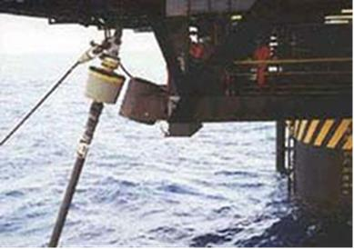
Figure 4.5: Riser Hang-Off Location

4.3.4. Pipe-in-Pipe (PIP) System
Pipe-in-Pipe thermal insulation is required for some production risers to avoid problems with hydrate, wax, or paraffin accumulation. However, PIP thermal insulation technology can often be used to satisfy the insulation requirements of lower. The use of external insulation, in some cases, might impair the riser’s dynamic performance by increasing drag and reducing weight in water. U-values, while maintaining an acceptable global dynamic response with the penalty of a heavier and perhaps more costly structure.

4.3.4.1. Structural Details
The inner and outer pipes of a PIP system, as shown in Figure 4.6, may be connected via bulkheads at regular intervals. Bulkheads limit relative expansion and can separate the annulus into individual compartments, if required. Use of bulkheads can be a good solution for pipelines, but for dynamic SCRs, one must consider the effects of high stress concentrations, local fatigue damage, and a local increase in heat loss. Alternatively, regular spacers (centralizers) can be used, which allow the inner and outer pipes to slide relative to each other while maintaining concentricity.
The items listed below are common effects for single-PIP SCRs:
- Residual curvature, which may change along the SCR during installation;
- Residual stresses due to large curvature history;
- Residual axial forces between the two pipes;
- Connection between the inner and outer pipes, including length and play of centralizers;
- Boundary conditions and initial conditions at riser terminations;
- Fatigue life consumed during installation;
- Preloading of inner and outer pipes;
- Axial forces and relative motions during operation, due to thermal expansion and internal pressure;
- Poisson’s ratio effect on axial strains;
- Local stresses in inner and outer pipes due to centralizer contact, including chattering effects;
- Frictional effects between inner and outer pipes;
- Thermal stresses and thermal cycling effects;
- Buckling checks (including helical buckling) due to thermal and general dynamic loading;
- Soil forces on outer pipe;
- Internal and external pressures having different effects on stress in inner and outer pipes;
- Effect of packing material in reversal of lay direction on a reel should be assessed and cross-section distortion minimized; the pipe yields as it is reeled and it is very soft at the reel contact point;
- Effects of PIP centralizers on pipe geometry during reeling;
- Wear of centralizers;
- Validity of VIV calculations (e.g., with regard to damping);
- Possible effect of any electrical heating on corrosion rates;
- Effect of damage (e.g., due to dropped objects striking outer pipe) on thermal and structural performance.

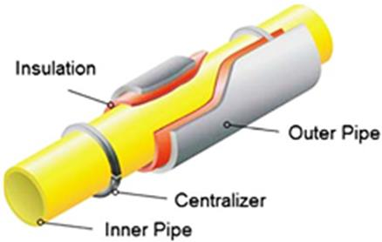
Figure 4.6: PIP Riser Pipe

4.3.5. End Line Riser Components
The components of a riser system must be strong enough to withstand high tension and bending moments, and have enough flexibility to resist fatigue, yet be as light as practicable to minimize tensioning and floatation requirements.

4.3.5.1. Flex Joints
A flex joint allows the riser system to rotate with minimum bending moment. The flex joint normally exhibits strong nonlinear behaviour at a small rotation angle and hence should ideally model as a nonlinear rotation spring or a short beam with nonlinear rotational stiffness. The flex joint is provided at the top region of SCR/SLWR riser end termination at vessel in order to minimize bending moment. The flex joint which consists of alternating layers of metal and elastomeric materials allows angular deflections at top connection of riser [API, 1998]. For case of deep water, the flex joint design considers the effect of high top tension and tension ranges for fatigue design.
A correct understanding of the flex joint stiffness is important in determining maximum stresses and fatigue in the flex joint region. The flex joint stiffness for the large rotations that typically occur in severe storms is much less than that for the small amplitudes that occur in fatigue analysis. Temperature variations can also result in significant changes in flex joint stiffness. In addition, it should be verified that the flex joint can withstand any residual torque that may be in the riser following installation or released gradually from the seabed section of the line. Steps may be taken to relieve torque prior to attachment.
Illustration of a flex joint and its application on SCR is shown in Figure.4-7. The bellows protect the elastomeric flex element from the explosive decompression caused by large internal pressure fluctuations in a gas-saturated environment. The cavity between the body/flex element and the bellows is sealed and filled with a water/propylene glycol-based corrosion inhibiting fluid..

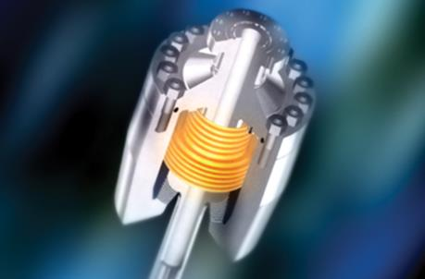 | 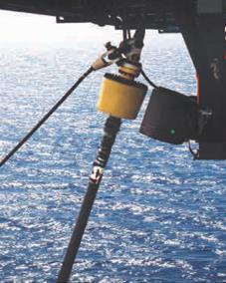
Figure 4.7: Flex joint Steel Catenary Riser (SCR) [Offshore Flex joint Technology].

4.3.5.2. Tapered Stress Joints
A tapered stress joint is used to provide a transition member between rigidly fixed or stiffer sections of the production riser and less stiff sections of the production riser. The tapered stress joint is used to reduce local bending stresses and to provide flexibility at the riser end. The tapered stress joints may be used in place of flex joints, but they usually impart larger bending loads to the vessel. The tapered stress joint is simple, inspectable, solid metal structures, and particularly able to cope with high pressures and temperatures. Figure .4-8 shows a stress joint, which may be made of either steel or titanium. The latter material has the advantage of good resistance to attack from sour and acidic well flows and, of course, gas permeation. Titanium gives lower vessel loads than steel and typically has better fatigue performance than steel.

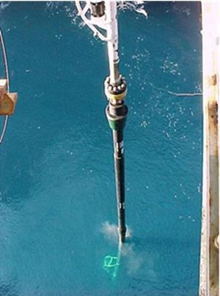 | 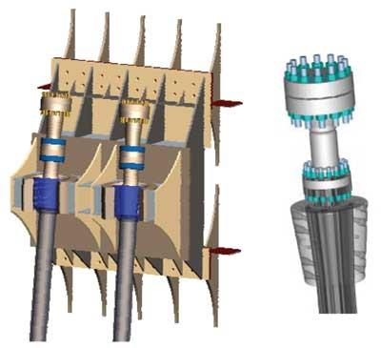
Figure 4.8: Tapered Stress Joint

4.3.5.3. Ball Joints
Ball joints consist of a ball and matching socket housing that join two pipe segments which maintains the fluid flow through the ball joint by a sliding seal between the ball and socket as shown in Figure.4-9. Shear and tension loads can be transferred across the joint with a minimal bending moment.
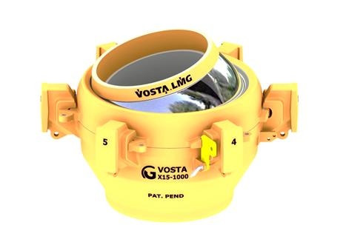
Figure 4.9: an example of ball joint

4.3.5.4. Bend Stiffeners
Bend stiffeners are used to increase and distribute the pipe bending stiffness in localized areas when subjected to anticipate bending moments that would otherwise be unacceptable, the increased stiffness reduces curvature and hence strain in the pipe layers. A typical application of bend stiffeners is at the top of dynamic risers, where they provide a continuous transition between the flexible pipe, with its inherent low bending stiffness, and the metal end fitting, which is very stiff. Bend stiffeners are often made of a polymeric molded material surrounding the pipe and attached to the end fitting, see Figure.4.10.

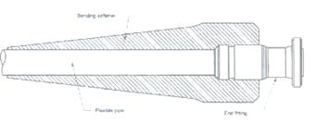 | 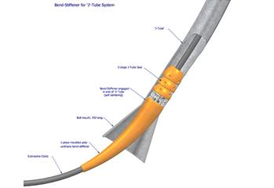

Figure 4.10: An example of bend stiffeners

4.3.5.5. Bending Restrictor
Bend restrictors are used to support a flexible pipe over free spans where there is the possibility of damaging the pipe structure because of over bending. Typical applications are at wellhead connectors, J-tube exits and rigid pipe crossovers as show in Figure.4-11. The bend restrictor normally consists of interlocking half rings that fasten together around the pipe so that they do not affect the pipe until a specified bend radius is reached, at which stage they lock.

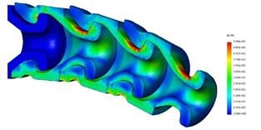 | 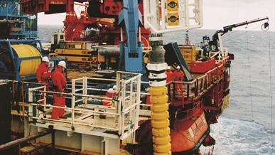
Figure 4.11: An example bending restrictor

4.3.6. Weight Distributed SCR
As Touch Down Point (TDP) region has critical buckling issues due to large heave and surge motions and fatigue problems, distribution weight is required as an alternative solution for SCR which is called Weight Distributed SCR. The WDSCR concept distributes varying weight along closer TDP of riser and with lightest possible as shown in Figure.4-12. The concept can be achieved by using well qualified ballast elements that are attached at certain sections of SCR. This WD concept enhances the applicability of SCRs to harsher environment by reducing the stresses around TDP, and hence also enhancing the fatigue performance.
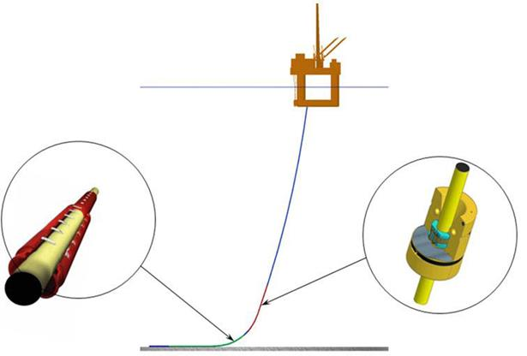
Figure 4.12: Schematic of Weight Distributed SCRs (Karunakaran, 2010)

4.3.7. Buoyancy Supported Riser (BSR)
By definition, the Buoyancy Supported Riser (BSR) is a system composed of a submersible buoy, anchored at the sea bottom by a certain number of tethers. As an intermediate floating element, the buoy connects the U-shape flexible jumpers to the SCR in which laying towards the seabed in catenary shape. General schematic of the system is shown in Figure.4.13.
The subsurface buoy concept was initially developed in 1996 by Deepstar JIP, in coordination with Texaco. During that time, the buoy was using H shape structure. In 1998, Petrobras had performed several studies and developed new rectangular ring buoy as the best solution to solve the H shape buoy problems. In 2002, the concept was finalized in 1800 m water depth, sustaining 19 risers [Franciss].
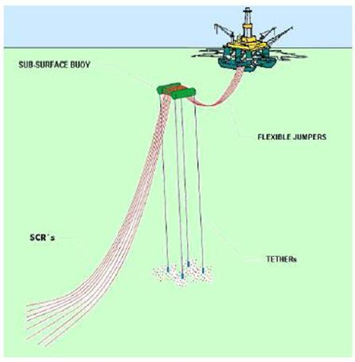
Figure 4.13: General Schematic of SCR supported by sub-surface buoy [Franciss]

4.3.8. Catenary Offset Buoyant Riser Assembly (COBRA)
COBRA riser is a new development of an offshore production riser system in 2012 for deep water in harsh environment for Northern North Sea condition. COBRA consists of a catenary riser section with a long, slender buoyancy module on top of bottom catenary section, which is tethered down to the seabed via two mooring lines. The top of catenary riser section is connected to the floater by a flexible jumper. This flexible jumper can absorb the floater motions, which give improvement both strength and fatigue performance on the overall system. The sub-surface buoy is positioned at particular water depth in order to reduce the surface wave and current effect, and anchored to a single suction pile on the seabed. Typical COBRA riser arrangement is shown in the Figure.4-14.
The concept of COBRA Riser was inspired by the simplicity and economical feature of steel catenary riser and motion handling capability of hybrid riser tower. This feature make COBRA riser able to handle deep and ultra-deep water applications in harsh environment. The COBRA riser has better dynamic performance compared to SCR which not suitable for large motion, and because of the dynamic response is reduce hence it will eliminate fatigue challenges at TDP (Holm, 2013).

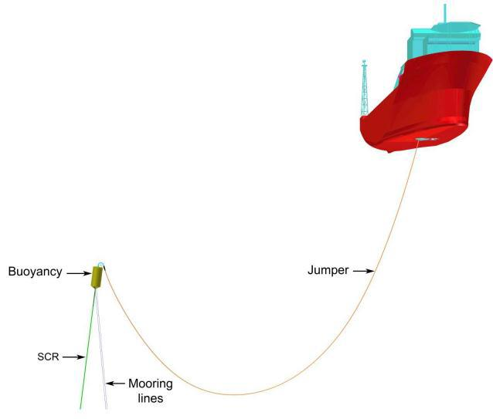
COBRA Riser Configuration (Karunakaran et al, 2013)
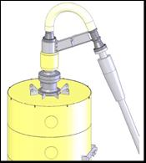  Flexible Jumper connected by Gooseneck joint (Tellier & Theti, 2009) | 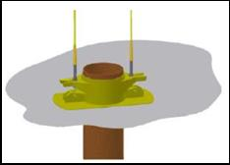  Suction Anchor Mooring Lines (Karunakaran & Baarholm, 2013)

Figure 4.14: COBRA Riser Arrangement [Karunakaran]

Furthermore, this concept is innovatively from Hybrid riser concept as it combine steel pipe and flexible pipe together in one system. The top configuration of COBRA riser is similar to Hybrid riser tower but the lower part has been replaced with simpler catenary section. Clearly, this concept avoid complicated and expensive bottom assembly of Hybrid Riser Tower. The long and slender buoyancy module is position minimally 200 meter below mean water level to reduce surface wave and current effect on catenary riser section (Karunakaran, 2013). This configuration will avoid the large movement at top of riser thus minimizing the fatigue and buckling effect.
The main components of COBRA are flexible Jumper, gooseneck assembly, sub-surface buoy, buoy the mooring lines, foundation assembly (suction anchor for mooring lines) and Steel Catenary Riser
Sub surface buoy reduce surface wave and current effect of catenary section. Submerged weight of mooring line close to neutral, minimized the accidental moment to the taper joint in case of rupture tendon. However, when riser is subjected to oscillatory motion, there is complex interaction between riser movement and seabed at TDP, penetrating the soil, thus increasing soil resistance (Karunakaran, 2013).
For the foundation Assembly according to D. Karunakaran, suction anchor is proposed for mooring lines foundation assembly. The two mooring lines are connected at the bottom of the buoy at the both sides of the SCR connection points in order to maintain the buoyancy can in the intended positions. Furthermore, an equal distance between the two lines shall be maintained on both connection points; at the anchor point and the buoy point (Masturi, 2014).

4.4. Top Tensioned Riser (TTR) Systems
TTRs are long circular cylinders used to link the seabed to a floating platform. These risers are subject to steady currents with varying intensities and oscillatory wave flows. The risers are provided with tensioners at the top to maintain the angles at the top and bottom under the environmental loading. The tension requirements for production risers are generally lower than those for drilling risers. The risers often appear in a group arranged in a rectangular or circular array.
TTRs rely on a top tensioner in excess of their apparent weight for stability. TTRs are commonly used on a Tension Leg Platform (TLP) [R. Burke] or spar dry tree production platform (spar), as shown in Figure.4-15.

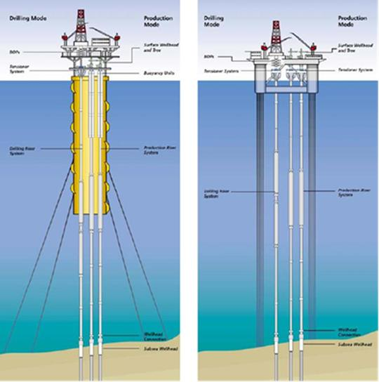
Figure 4.15: Top Tensioned Risers Used on Spar and TLP [World Oil]

At the surface, the riser is supported from the platform by hydro-pneumatic tensioners, which allow the riser to move axially or stroke, relative to the platform. TTRs were designed for shallow-water use, but as the water depths grew, so did the need for new designs.
TTRs are used as conduits between dynamic floating production units (FPUs) and subsea systems on the seafloor, for dry tree production facilities such as spars and TLPs.
TTRs are individual risers that rely on a top tension in excess of their apparent weight for stability. TTRs are commonly used on TLPs and spar dry tree production platforms. TTRs are generally designed to give direct access to the well, with the wellhead on the platform. This type of riser has to be capable of resisting the tubing pressure in case of a tubing leak or failure. The four types of TTRs are drilling risers, completion or work-over risers, production/injection risers, and export risers. Table.4-1 shows the types of TTRs and their reference specifications.

Table 4.1: Types of Top Tensioned Risers
Types of Top  Tensioned Riser | Applications | Specifications
Drilling | - MODU drilling risers  - Surface wellhead platform drilling riser | API RP16Q  API RP 2RD
Completion  Work-over (CWO) | - MODU completion workover risers (CWOR)  - Surface wellhead platform completion workover risers (CWOR) | API RP 17G  API RP 2RD
Production/  injection | - Surface wellhead platform production risers  - Subsea tie-backs | API RP 2RD  API RP 1111
Export | - Surface wellhead export risers | API RP 2RD  API RP 1111  ASME B31.4  ASME B31.8  30 CFR  49 CFR

4.3.1. Top Tensioned Riser Configurations
Figure.4-16 presents a typical TTR system configuration. TTRs consist of long, flexible circular cylinders used to link the seabed where the wellheads are located to a floating platform. TTRs are provided with tension at the top to maintain the angles at the top and bottom under environmental loading conditions. TTRs often appear in a group arranged in a rectangular or circular array.

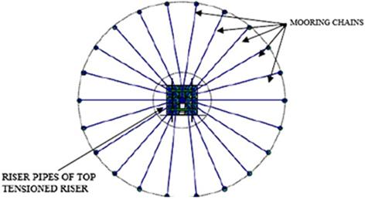

Figure 4.16: Typical TTR System Configurations

The following major design considerations are important when designing a TTR to prevent failure:
- Allowable floater motions;
- Allowable stroke of tensioning system;
- Maximum riser top tension;
- Size of stress joints and flex joints;
- Keel joints;
- Increasing length of riser joints;
- Design criteria for the safety philosophy of liquid barriers, valve, and seals;
- Current, interface with array, and VIV;
- Impact between buoyancy cans and hull guides.

4.3.2. Top Tensioned Riser Components

4.3.2.1. Riser System
Figure.4-17 presents a typical TTR setup for use with a TLP. The TTR configuration depends on the riser function and the number of barriers selected (single or dual). In general, the riser configuration comprises the following components:
- The main body is made up of rigid segments known as joints. These joints may be made of steel, titanium, aluminium, or composites, although steel is predominantly used.
- Successive joints are linked by connectors such as threaded, flanged, dogged, clip type, box, and pin connectors.
- The riser is supported by a tensioning system, such as traditional hydraulic tensioners, air cans, RAM tensioners, tensioner decks, and counterweights.

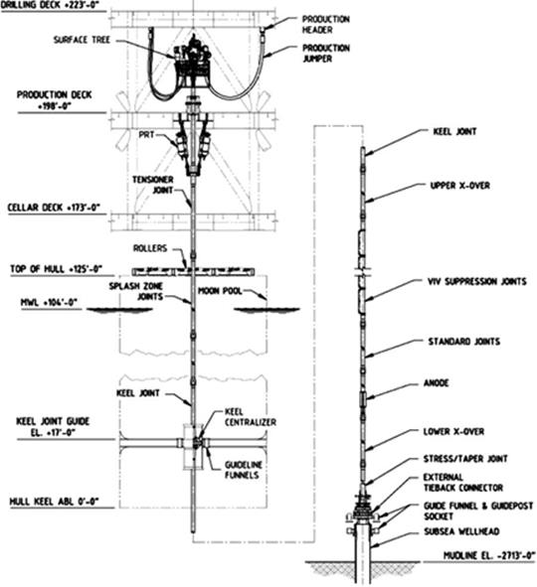
Figure 4.17: TLP Tensioned Riser System [R. Jordan]

3.3.2.2. Buoyancy System
For water depths exceeding 600 meter, buoyancy systems are required to provide lift, which reduces the top tension requirements, prevents excessive stresses in the riser, and reduces the hook load during deployment/retrieval of the BOP. Both synthetic foam and air-can buoyancy systems have been used for deep-water riser systems, either individually or in combination. Figure.4-18 presents a buoyancy-based TTR for use with a spar.
Buoyancy cans decouple the vertical riser movement from the vessel, and can be built by the fabrication yard. However, either a heavy lift vessel or a specially designed rig is required for offshore installation. It has large relative vertical motion in storm conditions and may generate lateral loads between the buoyancy cans and the spar center wall.

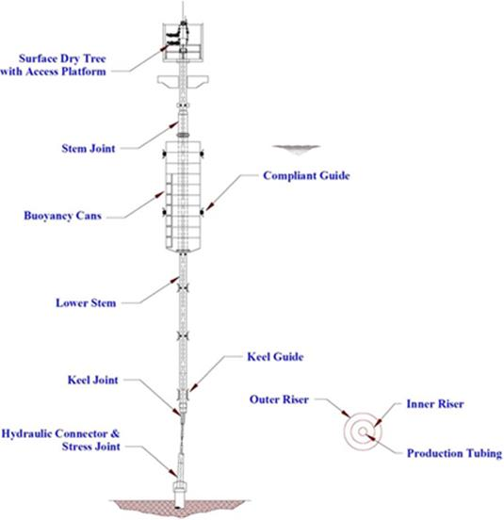
Figure 4.18: Spar Tensioned Riser System [Yu, T]

4.3.3. Design Phase Analysis
Before designing the TTR, several analyses need to be conducted to ensure that the riser design is up to specifications. To design a TTR system, these analyses must be performed:
  - Top tension factor analysis;
  - Pipe sizing analysis;
  - Tensioning system sizing analysis;
  - Stroke analysis;
  - Riser VIV fatigue analysis;
  - Interference analysis;
  - Strength analysis;
  - Fatigue analysis.

4.5. Flexible Risers

4.5.1. Flexible Riser Configuration
Flexible risers trace their origins to pioneering work carried out in the late 1970s. Initially flexible pipes were used in relatively benign weather environments such as offshore Brazil, the Far East, and the Mediterranean. Since then, however, flexible pipe technology has advanced rapidly and today flexible pipes are used in various fields in the North Sea and are also gaining popularity in the Gulf of Mexico. Flexible pipe applications include water depths down to 2400 meter, high pressures up to 10,000 psi, and high temperatures above 150⁰F, as well as the ability to withstand large vessel motions in adverse weather conditions.
The main characteristic of a flexible pipe is its low relative bending to axial stiffness due to having buoyancy modules as shown in Figure.4-19. This characteristic is achieved through the use of a number of layers of different materials in the pipe wall fabrication. These layers are able to slip past each other when under the influence of external and internal loads; hence, this characteristic gives a flexible pipe its property of low bending stiffness. The flexible pipe composite structure combines steel armor layers with high stiffness to provide strength and polymer sealing layers with low stiffness to provide fluid integrity. This construction gives flexible pipes a number of advantages over other types of pipelines and risers such as steel catenary risers. These advantages include prefabrication, storage in long lengths on reels, reduced transport and installation costs, and suitability for use with compliant structures.
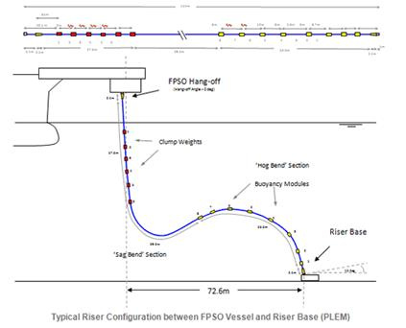 | 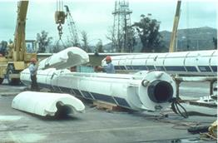
Figure 4.19: Typical Buoyancy Modules [SBS]

Flexible risers have been a successful solution for deep-water and shallow-water riser and flowline systems worldwide. Flexible risers are the result of an extraordinary development program that was based on flexible pipes. Flexible pipes were found to be ideally suited for offshore applications in the form of production and export risers, as well as flow-lines, as shown in Figure.4-20.

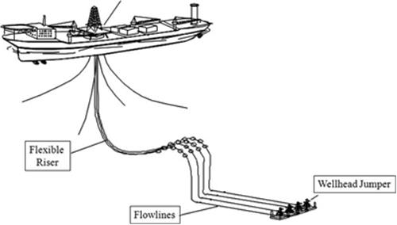
Figure 4.20: Flexible Riser Diagram.

Flexible risers can be installed in a number of different configurations. Riser configuration design shall be performed according to the production requirement and site-specific environmental conditions. Configuration design drivers include factors such as water depth, host vessel access/hang-off location, field layout such as number and type of risers and mooring layout, and in particular environmental data and the host vessel motion characteristics. Configuration of flexible risers is shown in the Figure.4-21.
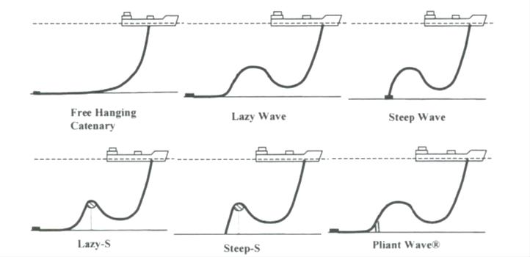
Figure 4.21: Flexible riser configurations [Halil Dikdogmus].

4.5.1.1. Free Hanging Catenary
The free hanging catenary riser is widely used in deep water. This configuration does not need heave compensation equipment, when the riser is moved up and down together with the floater, the riser is simply lifted off or lowered down on the seabed. In deeper water the top tension is large due to the long riser length supported, to reduce the size of the top tensioner buoyancy modules could be clamped to the top end of the riser. The surface motion is directly transferred to the Touch Down Point (TDP), this means that the failure mode could be over-bend or compression at the TDP. The most severe motion is heave from the first order vessel motion.

4.5.1.2. Lazy Wave and Steep Wave
For these configurations, buoyancy and weight are added along some length of the riser to
decouple the vessel motions from the touchdown point of the riser. Lazy waves are preferred to steep waves because they require minimal subsea infrastructure. However, while lazy waves are prone to configuration alterations if pipe content density changes during the riser’s lifetime, steep wave risers are able to maintain their configuration even if the riser content density changes.

4.5.1.3. Lazy S and Steep S
In these configurations, there is a subsea buoy which is either a fixed buoy (fixed to a structure at the seabed) or a buoyant buoy. The addition of the buoy removes the problem
associated with the touchdown point. The subsea buoy absorbs the tension variation induced by the floater, and the touchdown point eventually experiences only little or no tension variations. In case of large vessel motions, a lazy-S might still result in compression problems at the riser touchdown, leaving the steep-S as a possible alternative. Due to the complex installation procedure of ‘S’ configurations, they are considered only if catenary and wave configurations are not suitable for a particular field. A lazy-S configuration requires a mid-water arch, tether and tether base, while a steep-S requires a buoy and subsea bend stiffener.

4.5.1.4. Pliant Wave
This configuration is almost like the steep wave configuration where a subsea anchor controls the touchdown point i.e. the tension in the riser is transferred to the anchor and not to the touchdown point. This configuration is able to accommodate a wide range of bore content densities and vessel motions without causing any significant change in configuration and inducing high stress in the pipe structure. However, due to complex subsea installation that is required, it would be required only if a simple catenary, lazy wave or steep wave is not viable.

4.5.2. Flexible Pipe Cross Section
Flexible risers are multiple-layer composite pipes with relative bending stiffness, to provide performance that is more compliant. The flexible pipe structure shown in Figure.4-22 is composed of several layers (e.g., carcass) made of stainless steel to resist external pressure. The internal sheath acts as a kind of internal fluid containment barrier, the pressure armor is made of carbon steel to resist hoop pressure, the tensile armor is made of carbon steel to resist tensile loading, and the external sheath is a kind of external fluid barrier. In such applications, the flexible pipe section may be used along the entire riser length or limited to short dynamic sections such as jumpers.

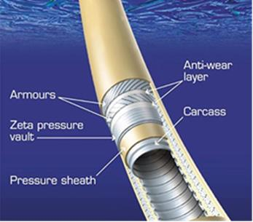
Figure 4.22: Typical Cross Section of Flexible Pipe (Bai, 2010)

Two types of flexible pipes are in use: bonded and unbonded flexible pipes. In bonded pipes, different layers of fabric, elastomer, and steel are bonded together through a vulcanization process. Bonded pipes are only used in short sections such as jumpers. However, unbonded flexible pipes can be manufactured for dynamic applications in lengths of several hundred meters. Unless otherwise stated, the rest of this chapter deals with unbonded flexible pipes.
Figure.4-23 shows a typical cross section of an unbonded flexible pipe. This figure clearly identifies the five main components of the flexible pipe cross section. The space between the internal polymer sheath and the external polymer sheath is known as the pipe annulus. The five main components of the flexible pipe wall are discussed in the following sections.
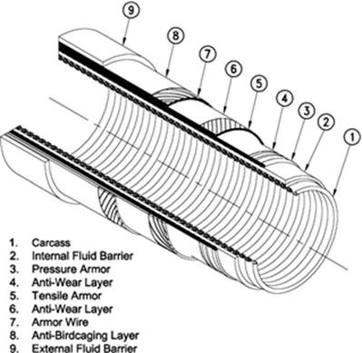
Figure 4.23: Typical Cross Section of an Unbonded Flexible Pipe

4.5.2.1. Carcass
The carcass forms the innermost layer of the flexible pipe cross section. It is commonly made of a stainless steel flat strip that is formed into an inter-locking profile. The main function of the carcass is to prevent pipe collapse due to hydrostatic pressure or build-up of gases in the annulus.

4.5.2.2. Internal Polymer Sheath
The internal polymer sheath provides a barrier to maintain the bore fluid integrity. Exposure concentrations and fluid temperature are key design drivers for the internal sheath. Common materials used for the internal sheath include Polyamide-11 (commercially known as Rilsan), high-density polyethylene (HDPE), cross-linked polyethylene (XLPE), and PVDF.

4.5.2.3. Pressure Armor
The role of the pressure armor is to withstand the hoop stress in the pipe wall that is caused by the inner bore fluid pressure. The pressure armor is wound around the internal polymer sheath and is made of interlocking wires.

4.5.2.4. Tensile Armor
The tensile armor layers are always cross-wound in pairs. As their name implies, these armor layers are used to resist the tensile load on the flexible pipe. The tensile armor layers are used to support the weight of all of the pipe layers and to transfer the load through the end fitting to the vessel structure. High tension in a deep-water riser may require the use of four tensile armor layers, rather than just two.

4.5.2.5. External Polymer Sheath
The external polymer sheath can be made of the same materials as the internal polymer sheath. The main function of the external sheath is as a barrier against seawater. It also provides a level of protection for the armor wires against clashing with other objects during installation.

4.5.2.6. Other Layers and Configurations
Besides the five main layers of a flexible pipe just discussed, there are other minor layers, which make up the pipe cross section. These layers include antifriction tapes wound around the armor layers. These tapes reduce friction and wear of the wire layers when they rub past each other as the pipe flexes due to external loads. Antiwear tapes can also be used to ensure that the armor layers maintain their wound shape. These tapes also prevent the wires from twisting out of their preset configuration, a phenomenon called birdcaging that is a result of hydrostatic pressure causing axial compression in the pipe.
In some flexible pipe applications, the requirement for the use of high-tensile wires for the tensile armor layers arises because of high-tensile loads, and yet the presence of a “sour” environment means that these wires would suffer an unacceptable rate of HIC/SSC. A solution to this situation is to fabricate a pipe cross section with two distinct annuli rather than one.

4.5.3. Flexible Riser Design Analysis

4.5.3.1. Design Basis Analysis Document
The design document should include the following, as minimum require-ments:
- Host layout and subsea layout;
- Wind, wave, and current data, as well as any vessel motion that is applicable to riser analysis;
- Applicable design codes and company specifications;
- Applicable design criteria;
- Porch and I-tube design data;
- Load case matrices for static strength, fatigue, and interference analyses;
- Applicable analysis methodology.
Several types of analyses have to be carried out when conducting the design analysis for a flexible riser, including these:
- Finite element modeling and static analysis;
- Global dynamic analysis;
- Interference analysis;
- Cross-sectional model analysis;
- Extreme and fatigue analysis.

4.5.3. End Fitting and Annulus Venting Design

4.5.3.1. End Fitting Design and Top Stiffener (Bellmouth)
The end fitting design is a critical component of the global flexible pipe design process. The main functions of the end fitting are to transfer the load sustained by the flexible pipe armor layers onto the vessel structure, and to complement the sealing of the polymer fluid barrier layers. Figure4-24 illustrates a typical end fitting system.
The most severe location for fatigue damage in the risers is usually at the top hang-off region. The riser is protected from over-bending in this area by either a bend stiffener or a bellmouth. Detailed local analyses for the curvature or bellmouth are carried out using a 2D finite element model.
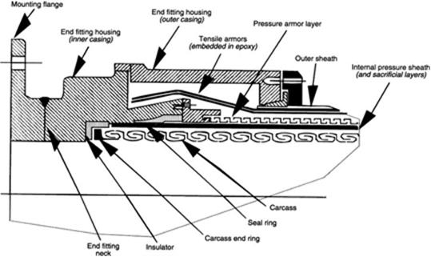
Figure 4.24: Typical End Fitting System.

3.4.3.2. Annulus Venting System
To prevent the build-up of gases in the annulus due to diffusion, a venting system is incorporated into the pipe structure to enable the annulus gases to be vented to the atmosphere. Three vent valves are incorporated into both end fitting arrangements of a pipe. The vent valves are directly connected to the annulus and are designed to operate at a preset pressure of about 30 to 45 psi. The vent valves in the end fitting arrangement located subsea are sealed to prevent any ingress of seawater into the annulus.

4.5.4. Integrity Management
This section deals mainly with risk assessment and integrity management of flexible pipes. A recognized methodology for formulating an integrity management plan involves carrying out a risk assessment and determining the risks inherent to the use of flexible pipe. Once risks have been deter-mined, specific integrity management measures can be identified to mitigate these risks.

4.4.4.1. Failure Statistics
It is important to determine actual failure mode statistics from operational statistics in order to overcome the failure or damage efficiently.
Figure.4-25 illustrates damage and failure mechanisms. From a total of 106 flexible pipe failure/damage incidents reported by UKCS operators (not including flooded annuli), it was found that 20% of flexible pipes have experienced some form of damage or failure. Figure.4-26 shows a comparison between rigid steel pipe and flexible pipe statistics.

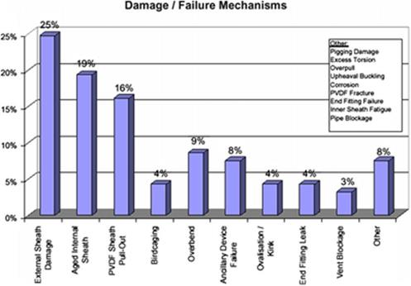
Figure 4.25: System Failure Mechanisms [Y.Bai]

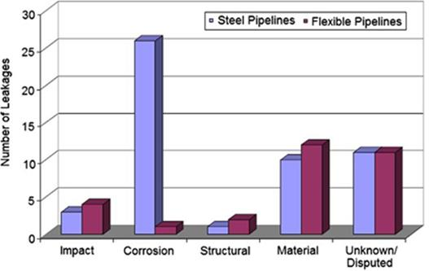
Figure 4.26: Comparison of Steel and Flexible Pipe Failure Statistics [Y.Bai]

3.4.4.2. Risk Management Methodology
Risk is often quantified as an integer that is the product of two other values, which are known as a probability of failure and a consequence rating. A risk management should take all possible failure modes into consideration, through an analysis of failure drivers (such as temperature, pressure, product fluid composition, service loads, and pipe blockage or flow restriction) and general failure modes (such as fatigue, corrosion, erosion, accidental damage, and ancillary equipment).

26.4.4.3. Failure Drivers
Five failure drivers contribute to the failure of a flexible riser system. The identified five failure drivers are:
- Temperature;
- Pressure;
- Product fluid composition;
- Service loads;
- Ancillary components.

26.4.4.4. Failure Modes
Failure modes for flexible riser systems include the following:
- Fatigue;
- Corrosion;
- Erosion;
- Pipe blockage or flow restriction;
- Accidental damage.

26.4.4.5. Integrity Management Strategy
The integrity management system establishes and maintains a database for design data and field operation data, including:
- Design basis and main design findings;
- Manufacturing data relevant for reassessment of risers;
- Operating temperature and pressure with focus on temperature fluctuations;
- Fluid compositions, injected chemicals, and sand production;
- Riser annulus monitoring and polymer coupon test results;
- Sea-state conditions, vessel motions, and riser response.

26.4.4.6. Inspection Measures
Inspection measures include:
- General visual inspection (GVI)/close visual inspection (CVI);
- Cathodic protection survey.

26.4.4.7. Inspection and Monitoring Systems
A typical inspection and monitoring system includes:
- Polymer monitoring: online, offline, topside, and subsea;
- Annulus monitoring: vent gas rate, annulus integrity;
- Riser dynamics: tension, angle, and curvature;
- Steel armor: inspection method, magnetic or radiograph;
- Use of existing sensors and pressure and temperature sensors.

26.4.4.8. Testing and Analysis Measures
Testing and analysis measures include:
- Coupon sampling and analysis;
- Vacuum testing of riser annulus;
- Radiography.

4.6. Hybrid Risers

4.6.1. General Description
The concept of a hybrid riser was developed based on the TTRs. Its principal feature is that it accommodates relative motion between a floating structure and a rigid metal riser, by connecting them with flexible jumpers. Figure.4-27 illustrates a bundled hybrid riser.
The main section of the bundled hybrid riser consists of a central structural tubular section, around which synthetic foam buoyancy modules are attached. Peripheral production and export lines run through the buoyancy modules and are free to move axially in order to accommodate thermal and pressure-induced extension. The central structural member is connected to the riser base by way of a hydraulic connector and stress joint. The peripheral lines are attached to hard piping on the base, which provides a connection to the subsea flow-lines, and terminates in goosenecks some 30 to 50 m below the water surface. Flexible piping is attached between the goosenecks and porches on the pontoons of the semisubmersible production vessel, providing the flow path to the vessel while accommodating relative movements between the rigid riser section and the platform.

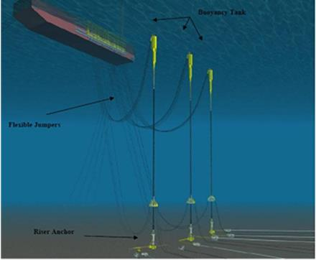
Figure 4.27: Bundled Hybrid Riser Diagram

Hybrid risers (HRs) consist of a vertical bundle of steel pipes supported by external buoyancy. Flexible jumpers connecting the top of the riser and the vessel are used to accommodate relative motion between the vessel and riser bundle.
The first use of hybrid risers was a deep-water production riser installed in 1988 in the Green Canyon Block 29 (GC29) by Cameron (Fisher and Berner, 1988). The system was reused in 1995 for deployment in Garden Banks 388 (GB388) in the Gulf of Mexico by Enserch Exploration Inc. and Cooper Cameron Co. This first-generation hybrid riser was installed through the moon-pool of a drilling vessel.
In recent years, HRs have become popular for use offshore of West Africa, for example, for the development of Total’s Girassol field, as shown in Figure.4-28. This second-generation hybrid riser was bundled, and it was fabricated at an onshore site with installation by tow-out and upending.
In this subsection, we present the current hybrid riser concept including the following main components:
- Riser base foundation;
- Riser base spools;
- Top and bottom transition fogging;
- Riser cross section;
- Buoyancy tank;
- Flexible jumper between the top of the riser and the hang-off point in the FPS.

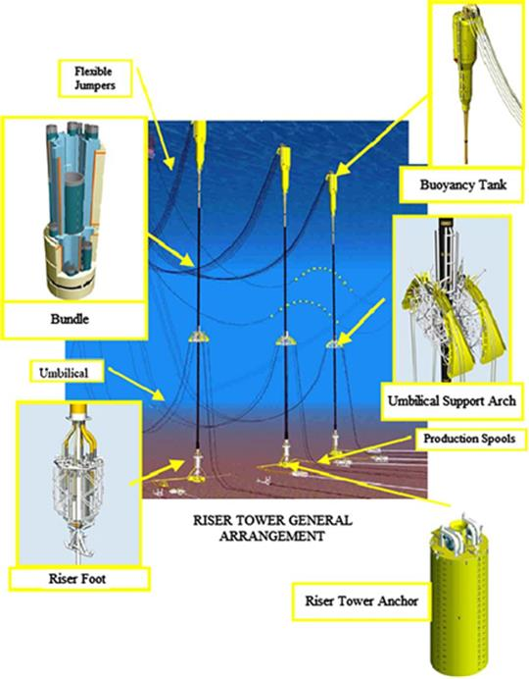
Figure 4.28: Hybrid Riser Towers at the Girassol Field.

4.6.1.1. Riser Foundation
The foundation structure for the HR consists of a steel suction anchor (and/ or a gravity base) that will support the HR installation aids (such as pulling winches) and the flex element (a roto-latch connector is proposed).
Two riser base foundation approaches are possible:
- Pinned riser base: This type of riser base allows free riser rotation.
- Fixed riser base: This type of riser base resists riser rotation.

4.6.1.2. Riser Base Spools
The riser base spool is designed to allow for relative displacements between the HR base and the flowline that may be caused by the thermal expansion of the flowline or/and angular movements (due to environmental loading) at the HR base.
For the common use of a pinned riser base, the receptacle for the flex element is inclined to optimize the design of the bundle connection to its base.
At the bottom of the hybrid riser, a forged Y-shaped tee allows:
- Vertical sections to be connected to the flex element;
- Lateral branch to be ended by a CVC to the rigid jumper spool.

4.6.1.3. Top and Bottom Transition Forging
Transition forging on the bottom of the riser connects the standard riser to the flow-line spool. A short thickened-wall section of pipe (adapter joint), typically 3 m long, provides a transition between the standard riser pipe and the large stiffness of the riser top assembly. A flanged connection mates with the flow spool that connects the flexible jumper and the standard riser.

4.6.1.4. Riser Cross Section
The two most important factors for describing the riser cross section are the wall thickness of the riser pipe and corrosion coatings and anodes.

4.6.1.5. Buoyancy Tank
A steel structured buoyancy tank is designed based on the following functional requirements:
- To thrust the HR dead weight.
- To provide sufficient pulling tension for the dynamic equilibrium of the HR.
- To limit maximum angular deflection of the HR with regards to its static position.
The riser is tensioned by means of an air or nitrogen-filled buoyancy tank. The tank contains a number of individual compartments separated by bulkheads. The bulkheads contain stiffeners arranged on the underside of each bulkhead plate to provide additional reinforcement. The buoyancy tank is designed to be pressure balanced with the external pressure of the water; this allows the thickness of the buoyancy tank skin to be limited to a minimal wall thickness.

4.6.1.6. Flexible Jumpers and Hook Up to Vessel
Flexible jumpers connecting the top of the riser and the vessel are used to accommodate relative motion between the vessel and riser bundle. Flexible pipe jumpers are used to connect goosenecks, located immediately below the air can and the vessel. Bend stiffeners, as shown in Figure.4-29, are used at the gooseneck and vessel termination points in order to restrict the bend radius of the jumper. The jumper’s properties are very much dependent on the riser service, pigging requirements, and insulation requirements.

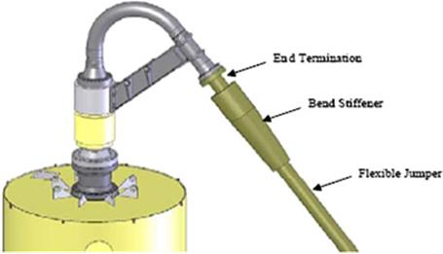
Figure 4.29: Gooseneck Assembly

4.6.2. Sizing of Hybrid Risers
The key design issues for the arrangement/sizing of the hybrid riser include:
- Overall arrangement: footprints at bases, hang-off locations/spacing;
- General arrangement:
- Riser thickness determination;
- Riser top: jumper with the characteristics and geometry of end fittings, geometry for the buoyancy tank;
- Riser base: forging and foundation;
- Sizing of buoyancy tank and suction anchor;
- Sizing of rigid jumper spool (at hybrid riser base) connected to the gas export pipeline via collet connectors.
The riser system is sized so that:
- Tethering tension is equivalent to what can be obtained from available equipment.
- Distributed buoyancy is equivalent to what is needed for neutral buoyancy in production mode.
- The upper air can provides enough buoyancy to give nominal overpull at the riser base.
- Flexible jumper hoses have sufficient length to accommodate relative vertical movement between the riser and platform at maximum drift-off position.

4.6.3. Sizing of Flexible Jumpers
Flowline jumpers are used to connect the riser base with the flowline base. The flowline jumpers are conventional subsea technology requiring five diameter bends for pigging. Figure.4-30 shows a flexible jumper being lifted from a barge during installation.

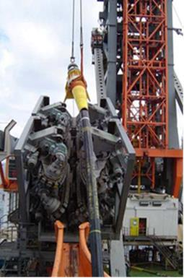
Figure 4.30: Lifting of a Flexible Jumper from a Barge

4.6.4. Preliminary Analysis
The key objective of the preliminary analysis is to get an indication of the requirements for:
- Buoyancy and tension distribution along the riser;
- VIV suppression devices.
Preliminary analysis is performed in two steps:
- Static analysis to determine response to currents and vessel displacement conditions;
- Time-domain regular wave analysis to determine response to time-varying loading.

4.6.5. Strength Analysis
The strength analysis should be conducted to optimize the following items for a range of possible loading conditions:
- Distributed buoyancy requirements;
- Top tension;
- Tethering tension (if any);
- Foundation loading.
The loading conditions include:
- Extreme waves;
- Extreme currents;
- Extreme vessel drift;
- Winds and currents from opposing directions.

4.6.6. Fatigue Analysis
Like any other riser analysis, a fatigue analysis for a hybrid riser should include vessel drift motions, first-order wave action, and VIV and installation-induced fatigue. VIV analysis of hybrid risers may consider current profiles of varying levels, up to and including 100-year return currents. The total VIV fatigue damage can then be calculated using the damage from each profile and the associated percentage occurrence.

4.6.7. Riser Hydrostatic Pressure Test
A pressure test must be carried out before any riser commences operation. The filling, cleaning, gauging, batching, logging, dewatering, and hydro-static pressure testing operations of the riser system should be performed in accordance with the requirements of DNV OS F101 and other relevant codes.
The sequence of pressure testing operations for a riser system is as follows:
- Filling;
- Cleaning and gauging;
- Hydro testing, including temperature stabilization, pressurization, air contents check, and hydrostatic test/holding period;
- Post-testing, including depressurization and documentation;
- Rectification activities (if required), including leak location during test, dewatering for rectification, and rectification of defects;
- Final/repeat hydrotesting;
- Testing, certificates, and witnessed signature.

4.6.8. Free Standing Hybrid Riser (FSHR)
The first concept of free standing hybrid riser was come from the drilling technology that was assembled the riser bundle with adequate buoyancy from a drilling rig. The riser tower foot and spools were connected to subsea base manifold and flexible jumpers at the top were connected to the rig. This concept was first installed in 1988 by Placid on the Green Canyon field block 29, where was then upgraded and reinstalled in the deeper Garden Bank field by Enserch in 1994. During that time, this concept was proved to be cost effective and well adapted to operate in the Gulf of Mexico (Alliot and Legras, 2005).
A flexible jumper connects the FPU and the riser through the gooseneck, and it decouples the vertical part of riser from the vessel motions (Nurwando, 2012). The key benefit of the free standing hybrid riser is that the steel riser vertical section is offset from the vessel using flexible jumpers, thereby decoupling the riser from vessel dynamic motions. Another reason operators are drawn to the FSHR arrangement is the option to pre-install the riser which provides flexibility in terms of overall project schedule. (Tellier and Thethi, 2009).
Recent field that has been used this concept is Roncador P-52 Oil Export System, located at 1800 m water depth. It combines a single rigid steel pipe with flexible pipe. It consists of a single near vertical pipe that connected to a foundation system at seabed. The riser is tensioned by means of a buoyancy can. This buoyancy can is connected to the top of the riser through a segment of chain, and it is located below the sea level. In this case, it is located beyond the influence of wave and high current. A gooseneck assembly is also located at top of the riser. A flexible jumper connects the FPU and the riser through the gooseneck, and it decouples the vertical part of riser from the vessel motions.
According to Marques et al. (2008), this concept has a reduced dynamic response, as a result of significant motion decoupling between the riser tower and the vessel motion. The vessel interface loads are small when compared with flexible pipe or SCRs configurations. In addition, there are possible cost savings on this concept with regards to the consideration that the riser can be installed prior to the installation of the Floating Production Unit (FPU).

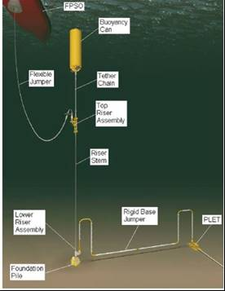
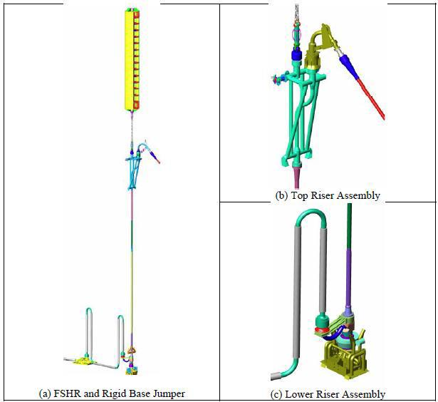
Figure 4.31: Single Hybrid Riser Tower (SHRT) general arrangement [Marques]

4.6.9. Hybrid Riser Tower (HRT)
Hybrid Riser Tower consist of a standing riser tower that composed of riser bundle, the riser bundle is attached to an articulated base with a flexible joint that anchored to the seabed by a suction caisson. The core of the bundle is connected to the buoyancy tank by a taper stress joint. The buoyancy tank supports the riser bundle and jumpers. The flexible jumpers are connected with gooseneck connections at the top of buoyancy tank. The core of the bundle consists of a steel pipe that is surrounded by synthetic foam buoyancy modules are attached. Steel risers are located on the outer perimeter of the foam buoyancy (Blevins, 2006). The bottom part of tower is fixed to the riser base foundation via a flexible joint.
Hybrid Riser Tower promotes various advantages for offshore subsea system such as a large diameter risers can be accommodated, the field layout is simplified and flexible hence can allows for future expansion, demanding flow assurance requirements can be met, riser loads on the Floating Production Unit are reduced by buoyancy tank and in place riser fatigue is low (Francois et al, 2006). Hybrid Riser Towers are one of the deep water riser types that offer benefits in terms of flow assurance, thermal performance, and also robust field layout. However, Hybrid Riser Tower need special bottom assemblies with heavy foundation and complicated spools (Karunakaran, 2013). This concept has an expensive bottom assembly, foundation, and complicated bottom connections (Nurwando, 2012), hence it is not suitable to use for project development with current oil and gas price.
BP’s Greater Plutonio field is one example of the field that has been used hybrid riser tower (HRT) concept. According to Louvety et al. (2009), the Greater Plutonio HRT is believed to be the largest installed in the world today, where it conveys all production and injection fluids from five operated fields on site. Another field that has been used this concept is Girassol field in Angola, West Africa. Compared to Greater Plutonio HRT, Girassol field is transporting the oil production through three towers.
The following figure shows the HRT arrangement taken from Girassol field.

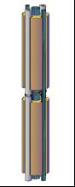
Riser Bundle configuration (Legras, 2011)
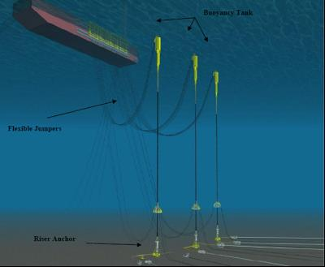 | 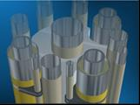
Figure 4.32: Girassol Hybrid Riser Tower, HRT (Legras, 2011, Acergy, 2006)

4.6.10. Single Line Offset Riser (SLOR)
concept, which Single Line Offset Riser (SLOR) that developed by 2H has similar concept with SHRT, offers an attractive solution due to its excellent fatigue performance and ability for pre-installation. However, recent field developments that require larger riser numbers and the need for tiebacks to existing development pose some problems to this concept. Firstly, the field layout challenge is mainly as a result of its large deflections due to the current loading. This requires each SLOR arrangement to have a large spatial clearance with the adjacent SLOR, mooring line, or umbilical. Secondly, when it comes to the maximum number of SLORs and jumpers connection that can be accommodated, this limitation on the field layout space might give insufficient facility for the initial and future project requirements (Dale et al., 2007). In order to meet the riser requirements on large offshore development, 2H Offshore and Subsea 7 have developed the new hybrid riser concept, called Grouped SLOR. This concept is a variant of SLOR and COR design which incorporates a guide frame connecting between 2 or more risers (typically 4-6), constraining them to move separately. This concept facilitates a large number of lines in close proximity but capable in maintaining the distance between adjacent lines, hence removes the clashing issues. This makes the installation, inspection, and maintenance, including removal and reinstallation procedure easier. Typical of Grouped SLOR arrangement is shown in Figure.4.33.

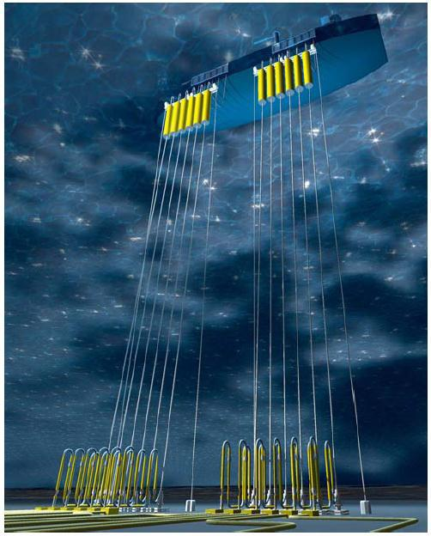
Figure 4.33: Grouped SLOR with 6 risers arrangement (Karunakaran et al., 2007)

According to Karunakaran et al. (2007), the main modification of each individual SLOR in the Grouped SLOR concept is located at the elongated large diameter upper stem between the top of the aircan and the gooseneck connector. This element is used to guide the riser at the guide frame elevation. The aircans are typically 5-6 m in diameter, and the length depends on the water depth and required overpull. The gooseneck is designed to be removed and attached after the SLOR and guide frame have been installed, in which allows the flexible jumper to pass over the top of the guide frame.
In addition to the upper stem configuration, the guide frame is the component that differentiates the Grouped SLOR from the standalone SLOR design. Fabricated from steel tubulars in a truss arrangement, this guide frame is easy to install. Due to its light weight, it can be installed using a standard vessel. The frame connection to seabed is using spiral strand steel tethers. The tethers are then restrained to the mudline by using suction piles. Buoyancy tanks arrangement is welded to this guide frame in order to maintain the pulling tension at the base of each tether at all times. A typical guide frame that used in the Grouped SLOR arrangement is shown in Figure.4-34.

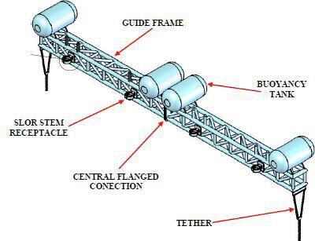
Figure 4.34: Guide Frame in Grouped SLOR (Karunakaran et al., 2007)

4.7. Riser Design

4.7.1. Diameter and Wall Thickness
In the preliminary stage, the diameter and wall thickness of the riser and pipe must be determined to minimize the cost of the pipes. Factors that influence riser diameter and wall thickness sizing include:
- Operating philosophy: transportation strategy, pigging, corrosion, inspection;
- Well characteristics: pressure, temperature, flow rate, heat loss, slugging, well fluids and associated chemistry;
- Structural limitations: burst, collapse, buckling, postbuckling;
- Installation issues: tensioning capacity of available vessels;
- Construction issues: manufacturability, tolerances, weld procedures, inspection;
- Vessel offsets and motions: The host vessel’s motions are defined by the global performance analysis accounting for wave, wind, and current loads using either time-domain analysis or frequency-domain analysis. The motion data are expressed as time traces of vessel motions or RAOs defined at the center of gravity (CoG) for the floater for predefined loading conditions. The motions at the riser hang-off location will be transferred from the CoG via rigid body assumptions. The riser system is considered to be a cable under current loads with a boundary condition that is defined as the motions at the hang-off location. Vessel RAOs are used throughout the whole design process and it is important for them to be well defined. The following definitions should always be provided with RAOs:
- What the motion phase angle is relative to, whether it is a lag or a lead;
- Vessel coordinate system;
- Location of point for which RAOs are given;
- Units;
- Direction of wave propagation relative to vessel.
- Metocean conditions: the location of a riser may dictate critical design conditions due to current, waves, etc. Figure.4-35 shows different metocean data for some geographical regions. The following metocean data are used in riser analyses:
- Water depth;
- Waves;
- Currents;
- Tide and surge variations;
- Marine growth.

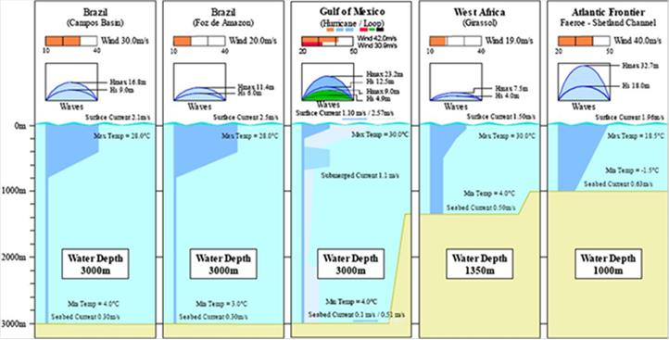
Figure 4.35: Metocean Data for Some Geographical Regions

- Deep-water environments: Four parameters must be analyzed for the design phase:
- Static and hydrodynamic loads;
- Soil interaction;
- Extreme storm situations

4.7.2. Materials Selection
Materials for riser systems shall be selected with due consideration of the internal fluid, external environment, loads, temperatures (maximum and minimum), service life, weld defect acceptance criteria, temporary/permanent operations, inspection/replacement possibilities, sweet/sour service requirements and possible failure modes during the intended use. The selection of materials shall ensure compatibility of all components in the riser system. According to material selection, risers can be divided into: Rigid (metallic) riser and flexible riser

4.7.2.1 Metallic Pipe
Steel pipes have traditionally been applied for conventional water depths. Traditionally low carbon steel has been the principle material for most risers systems. Typical material grades are X60, X65 or X70. Other materials like Aluminum, Titanium alloys are also used for deep water applications.
For severe conditions like ultra deepwater, high temperature, high pressure applications, Titanium has been considered for the riser application. Titanium may offer several benefits relative to steel for some of these configurations. This is due to a low modulus of elasticity (half that of steel) implying a higher degree of flexibility. Furthermore, the yield stress is typically higher than for steel and the specific weight is much lower (about half the steel weight).

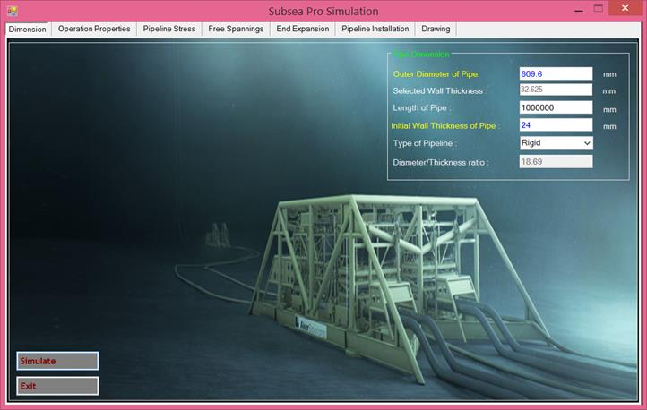
Figure 4.36: An example wall thickness of rigid pipe in Medgas field.

4.7.2.2 Flexible Pipe
A flexible pipe is a pipe with low bending stiffness and high axial tensile stiffness, which is achieved by a composite pipe wall construction. Basically, there are two types of flexible pipes, unbonded and bonded, composed of helical armoring layers and polymer sealing layers.
An unbonded pipe typically consists of a stainless-steel internal carcass for collapse resistance, an extruded-polymer fluid barrier, a carbon-steel interlocked circumferential layer for internal pressure loads (pressure armor), helically wound carbon-steel tensile-armor layers for axial strength, and an extruded watertight external sheath. The structure of a non-bonded flexible pipe is illustrated in Figure 2.6. And a bonded pipe typically consists of several layers of elastomer either wrapped or extruded individually and then bonded together through the use of adhesives or by applying heat and/or pressure to fuse the layers into single construction. Figure 2.7 shows an example of typical bonded pipe.

Chapter 5

5.0. Ultra-Deep Water Riser Challenges

5.1. Global Offshore Production

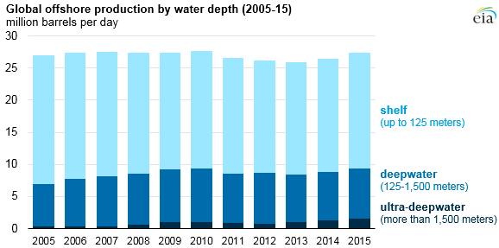
Figure 5.1: Global Offshore Production by water depth (EIA).

As the industry moved into ultra-deep water environment, the challenges that come with trend are still evolving and require further development. When it comes to riser, some of the challenges are presented in Figure 5.2.

Figure 5.1: Challenges of ultra-deep water riser system.

3.5. Diameter Selection
The process for selecting a diameter involves a detailed hydraulic analysis, especially for multiphase flows. However, there exist some empirical formulas that produce reasonable accuracy. For example Equation 5.1 can be used for sizing single phase gas lines.

$Q=\frac{500 D_{I}^{3}\sqrt{P_{1}^{2}-P_{2}^{2}}}{\sqrt{L_{m}}}$ (5.1)

Where: $D_{I}$ is inner diameter, $P_{1}$is psia at start point, $P_{2}$is psia at end point and $L_{m}$is length.

5.2. Wall Thickness
Statically, the external hydrostatic pressure acting on around the will increase proportionally with increasing the water depth. The external hydrostatic force can be written as

$F_{H}=ρgh$ (5.2)

Where: $ρ$ is sea water density ($kg/m^{3}$), $g$ is gravity acceleration ($m/s^{2}$) and $h$ is water depth.

In deep and ultra-deep water, the high external hydrostatic pressure on the riser will increase the probability of collapse failure. As the key driver of the wall thickness design, collapse resistance in deep and ultra-deep water condition normally required minimum thicker riser section. Eventually, this will increase the cost development of the field.
In order to calculate the required wall thickness for an offshore pipeline, five different failure modes must be assessed:
- Internal pressure containment (burst) during operation and hydro-test.
- Collapse due to external pressure.
- Local buckling due to bending and external pressure.
- Buckle propagation and its arrest.
- End expansion
The tolerance on wall thickness depends on the material specifications. For example, an ASTM A106 carbon steel pipe may be furnished 12.5% below the specified nominal wall thickness. Therefore, the minimum wall thickness $tmin$ calculated by the code design equation needs to be increased by the corrosion allowance C and the fabrication tolerance f (for example with a fabrication tolerance of 12.5% on the wall thickness, $f$ = 0.125. With these corrections, the commercial size to be procured can be obtained as:

$t = ( tmin + C )(1 + f )$ (5.3)

Where; $t$ is wall thickness, $tmin$ is minimum wall required by Practiced Code, $C$ is corrosion or threading allowance, and $f$ is the wall thickness fabrication tolerance.

5.2. Riser Weight
In ultra-deep water, the suspended length of riser is significantly long. This will increase the top-tension force. During service life, heavy riser weight will increase vessel payload. According to Howells and Hatton (1997), vessel payload may be 10 to 30% larger in nominal conditions and 50 to 100% larger in extreme storm conditions. In simple way, the weight of riser can be obtained as

$W=g∙ρ_{st}∙L∙A_{s}=g∙ρ_{st}∙L∙\frac{π\left(D_{o}^{2}-D_{i}^{2}\right)}{4}= g∙ρ_{st}∙L∙π∙\left(R_{o}^{2}-R_{i}^{2}\right)$ (5.4)

Where: $ρ_{st}$ is steel density ($kg/m^{3}$), $g$ is gravity acceleration ($m/s^{2}$) and $L$ is length of riser, $R_{o/i}$ is outer and inner radius of riser, respectively.

5.4. Dynamic Response
Design of risers in harsh environment has been a great challenge. For ultra-deep water field, steel catenary risers (SCR) have been an attractive riser option. However, the application presents design challenges due to large motions of the vessel from waves. In addition, large vessel offsets from wind, current and slow-drift wave motions are also sum up the challenges. Due to large dynamic heave and surge motions, there are buckling issues at touch-down point (TDP), and also fatigue problems due to vessel motions and soil-riser interaction (Karunakaran et al., 2005). Another challenge in ultra-deep water application comes from large currents speed. For large currents speed, vortex induced vibration (VIV) is an important issue. VIV in ultra-deep water risers gives significant fatigue damage. Normally, strakes along the critical area of riser are needed. In other hand, this will also increase drag forces.

5.5. Platform Motion
Riser arrangements to floating production system are mostly dependent on vessel drift offsets. For a tension leg platform (TLP) or spars with relatively small offsets, simple catenary risers may be adopted. However, as the water depth increase, the offsets increase
accordingly and this impacted on more severe dynamic motions. Alternative riser arrangements such hybrid risers or wave catenaries configurations may be needed.

5.6. Installation
In ultra-deep water conditions, a limitation on riser installation comes from tensioner capacity of the installations vessel. Moreover, in such extreme weather, the limitation might also come from the load capacity of abandonment and recovery winch. In case of reeling method, the deformations introduced by this method may reduce collapse resistance and require greater wall thicknesses at increased water depth. Again, by using higher wall thickness will ultimately increase the overall weight of the riser. Installation schedule is also taking important aspect. Greater water depth requires longer riser length, and hence it cost on longer installation schedule. The concept of uncoupled riser may save the installation time as the riser can be installed prior to the existence of the floater, in particular when more than a single riser is planned to be installed.

5.2. Review on Deep Water Riser System
In the riser system, particularly on the floating production system, the motions of the floater will have significant effect on the riser long-life performance. In vice versa, the riser presence will also give static and dynamic effect on the floater response. The floater, risers, and also the mooring system create a global system with complex response to environmental loading.
All of this interaction effects is called coupling effects. Types of risers that are influenced by this effect are normally called as coupled riser system. According to Chakrabati (2005), for some systems, the coupling effects may magnify the extreme hull/floater responses.
Recent year’s riser system development has been technically-proven for de-coupling the floater platform motions. These riser systems type are mainly developed for hybrid riser system. Among of these are single-line offset riser (SLOR), grouped single-line offset riser (Grouped SLOR), and recent new variant from the original concept of catenary bundle riser for single riser, which is called catenary offset buoyant riser assembly (COBRA).

Figure 5.2: Deep water riser system in ultra-deep water.

Chapter 6

6.0. Design Practiced Methods of Risers

6.1. General
Currently, there are generally two design practiced methods of riser used as a fundamental basis in structural criteria design. The first design practiced method is referred to as Working Stress Design (WSD), in which adopted a single safety factor for each limit state to account the influence of uncertainty. In riser design, WSD method is provided in API-RP-2RD.
Another method is referred to as Load and Resistance Factor Design (LRFD) where partial safety factor is accounted for each load effect and resistance. In riser design, LRFD method is provided in DNV-OS-F201. The LRFD method allows for a more flexible and optimal design with uniform safety level than the WSD method. This chapter focuses on the LRFD method and mainly based on DNV-OS-F201.

6.2. Design Principles
The basic design principles of riser is rooted to the safety philosophy, where all activities which involve with regards to the design are safe and conducted with due regard to public safety and protection of the environment. All phase from conceptual development until the abandonment shall establish the safety objective, e.g. covered the principle on reducing of any hazardous impact to as low as reasonably practicable.

Table 6.1: Classification of safety classes.
Safety Class | Definition
Low | Level of failure implies low risk of human injury and minor environmental and economic consequences.
Normal | Level of failure implies risk of human injury, significant environmental pollution or very high economic or political consequences.
High | For operating conditions, level of failure implies high risk of human injury, significant environmental pollution or very high economic or political consequences

6.3. Design Loads
According to DNV (2010) Section 3, the loads and deformations are defined into four groups as follows:

Figure 6.1: Load on risers system.

6.3.1 Functional Loads
- Weight and buoyancy of riser,
- tubing, coatings, marine growth, anodes, buoyancy
- modules, contents and attachments
- Weight of internal fluid
- Applied tension for top-tension risers
- Installation induced residual loads or pre-stressing
- Pre-load of connectors
- Applied displacements and guidance loads, including active
- positioning of support floater
- Thermal loads
- Soil pressure on buried risers
- Differential settlements
- Loads from drilling operations
- Construction loads and loads caused by tools

6.3.2. Environmental Loads
Environmental loads are defined as loads imposed directly or indirectly by environmental effects from as follows:

6.3.2.1. Waves
Wind driven surface waves are a major source of dynamic environmental forces on the risers. Such waves are irregular in shape, can vary in length and height, and can approach the riser from one or more directions simultaneously. Wave conditions may be described either by a deterministic design wave or by stochastic methods applying wave spectra. The selection of appropriate wave theories depends on the actual application and links to assumptions used for adjacent structures e.g. floater motion transfer function. Normally, linear wave theory combined with Wheeler Stretching should be considered in addition to disturbed kinematics if relevant.

6.3.2.2. Current
Current is a major contributor to both the static and dynamic loading on risers. However the relative importance of current loading increases with increasing water depth. The current velocity and direction profile is in general composed of wind driven and tide driven components. In some cases, the velocity and direction profile may also include contribution from:
- Oceanic scale circulation patterns
- Loop/eddy currents
- Currents caused by storm surge
- Internal waves
The vector sum of all current components at specified elevations from the seafloor to the
water surface describes the current velocity and direction profile for the given location. The current velocity and direction normally do not change rapidly with time and may be treated as time invariant for each sea state. These profiles may be established using a velocity profile formulation based on site specific data or recognized empirical relationships.

6.3.2.3. Floater motions
Floater motions are induced by wind, waves, and current, i.e.:
- Mean offset including steady wave drift, wind and current forces
- Wave frequency motions
- Low frequency motions,
Forced floater motions are defined as displacements imposed on the riser due to motions of the surface floater. These forced displacements may be introduced at several elevations on the riser depending on type of floater (e.g Semi, TLP, Spar, Ship). These displacements will increase the bending stress in the riser, which may be critical in some cases.

6.3.3. Accidental Loads
These are loads to which the riser may be subjected in case of abnormal operations, incorrect operation or technical failure. They typically result from unplanned occurrences. These include:
- Partial loss of station keeping capability
- Small dropped objects
- Tensioner failure
- Fires and explosions
- Flow-induced impact between risers
- Vessel impact

6.3.4. Pressure Loads
- External hydrostatic pressure
- Internal fluid pressure:
  - hydrostatic,
  - static and dynamic contributions,
  - Water levels

The verification is related to the following operational limitations:
- Maximum Working Pressure: 1034 bar (15000 psi)
- Minimum Design Temperature: -29 ºC (-20 ºF)
- Maximum Design Temperature: 107 ºC (225 ºF)
- Maximum “As-built” Weight: 6.8 T (150000 lb).
- Service : Standard/ Sour/ H2S

6.4 Limit States Design
DNV (2010) provides four categories for the limit states group, i.e. SLS, ULS, ALS, and FLS. The general descriptions of these categories are:

Table 6.2: Limit States design of Risers
Limit States Design | Definition
Serviceability Limit State (SLS) | The riser must be able to remain fit during the service period and operate properly. The serviceability limit states behavior associated with  - the limitations of deflections,  - displacements, and  - rotation or ovalisation of the riser pipe
Ultimate Limit State (ULS) | The riser must remain intact and avoid rupture, but not necessary be able to operate, and corresponds to the maximum resistance to peak design loads with 10-2 annual exceedence probability  Typical limit states for the riser system on this category are:  - Bursting  - Hoop buckling (collapse)  - Propagating buckling  - Gross plastic deformation and local buckling  - Gross plastic deformation, local buckling and hoop buckling  - Unstable fracture and gross plastic deformation  - Liquid tightness  - Global buckling
Accidental Limit State (ALS) | The riser must remain intact and avoid rupture, but not necessary be able to operate, and corresponds to infrequent accidental loads. The loads may be categorized into:  - Fires and explosions  - Impact/collisions  - Hook and snag loads  - Failure of support system, e.g. loss of buoyancy, loss of mooring line, etc.  - Failures due internal overpressure, e.g. failure of well tubing or packers, well kill, etc.  - Earthquake, tsunamis, iceberg.
Fatigue Limit State (FLS) | The riser must be able to remain fit to function during its service life due to accumulated excessive fatigue crack growth or damage under cyclic loading. The fatigue assessment methods may be categorized into:  - Methods based on S-N curves  - Methods based on fatigue crack propagation

Table 6.3: Load effect factors
Limit State | F-load effect  $$γ_{F}$$ | E-load effect  $$γ_{E}$$ | A-load effect  $$γ_{A}$$
ULS | 1.1*¹ | 1.3*² | N.A
FLS | 1.0 | 1.0 | N.A
SLS & ALS | 1.0 | 1.0 | 1.0
Notes:
*1. If the functional load effect reduces the combined load effects, $γ_{F}$ shall be taken as 1/1.1.
*2. If the environmental load effect reduces the combined load effects, $γ_{E}$ shall be taken as 1/1.3.

6.5 Riser Design Cycle
Design cycle of risers is started by choosing geometry, environmental load and hydrodynamic coefficients as shown in Figure 6.2. Using the pretension and static equilibrium, vortex shedding versus modal frequencies are analysed before Vortex Induced Vibration (VIV). Static and dynamic as well as fatigue are analysed to be accepted based selected society rules.

Figure 6.2: Riser Design Cycle.

Static analysis based on steady loads
- Deflections
- Top and bottom angles
- Mode shapes
- Stresses
Dynamic analysis based on inline and transverse unsteady loads
- Vortex induced vibration
- Fatigue analysis

Table 6.4: Types of Riser Design & Analysis Methods.
Sources | Type | Limitations
Empirical analysis | Commercial or in-house  Most popular design tool | Choice of coefficients
Numerical analysis | Mostly academic  Coupled FE/CFD  Numerical Simulation | Flow solver limitations  Low Reynolds number  Needs further development
Commercial software | Adopted from other  applications | Computational time  Convergence & validity
Laboratory testing | Water channel  Wave tanks  Towing tank | Small scale  Modeling  Measurements
In-situ testing | Field measurements  Large facilities, e.g., fjords  Full Scale | Cost  Practicality  Confidentiality

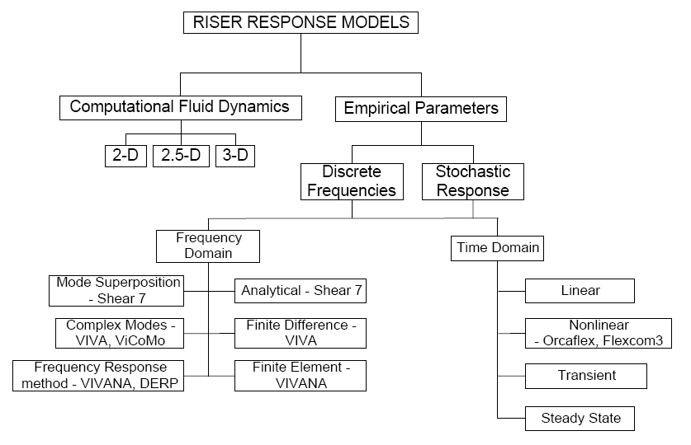
Figure 6.3: Riser analysis methods flow.

It should be noted: 2-D models are simpler and allow higher Reynolds number flow. Quasi 2-D models use 2-D strips and couple them for structural analysis. The 3-D models are more complex and are limited to lower Reynolds Number.

Chapter 7

7.0. Global Analysis of Risers

7.1. Collapse
In addition to internal pressure, pipe members also experienced the external pressure.
According to DNV (2010), this pressure shall be designed to the following condition:

$\left(p_{e}-p_{min}\right)≤\frac{p_{c}\left(t_{1}\right)}{γ_{sc}∙γ_{m}}$ (7.1)

Where; $p_{min}$ is a minimum internal pressure, $p_{c}\left(t_{1}\right)$ is the resistance for external pressure (hoop buckling) which is given by

$\left(p_{c}\left(t\right)-p_{el}\left(t\right)\right)∙\left(p_{c}^{2}\left(t\right)-p_{p}^{2}\left(t\right)\right)=p_{c}\left(t\right)∙p_{el}\left(t\right)∙p_{p}\left(t\right)∙f_{0}∙\frac{D}{t}$ (7.2)

$p_{el}\left(t\right)$ is the elastic collapse pressure (instability) of a pipe, given by

$p_{el}\left(t\right)=\frac{2∙E∙{\left(\frac{t}{D}\right)}^{3}}{1-ϑ^{2}}$ (7.3)

$p_{p}\left(t\right)$ is the plastic collapse pressure which is given by

$p_{p}\left(t\right)=2\frac{t}{D}∙f_{y}∙α_{fab}$ (7.4)

$α_{fab}$ is fabrication factor

Table 7.1: Fabrication Factor [DNV 2010]
Fabrication factor ($α_{fab}$)
Tensile strength or seamless pipe | Compressive strength for welded pipe
 | UOE/ | UO/TRB
1.00 | 0.85 | 0.925

$f_{0}$ = initial ovality, given by

$f_{0}=\frac{D_{max}-D_{min}}{D}$ (7.5)

7.2. Ocean Waves
A sea wave is a series of rolling bodies of water moving in the direction of their roll. Their energy is transmitted down through the water depth in elliptical orbits the eccentricity of which flattens with decreased water depth as shown in Figure 7.1. Ocean waves are produced as a result of an infusion of energy, either as a result of atmospheric winds and significant water body displacement.
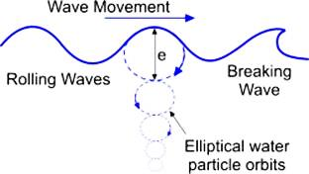  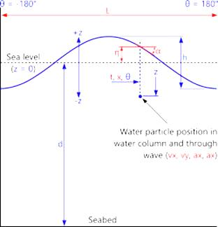 | 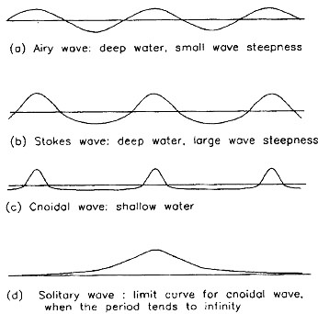
Figure 7.1: Ocean Wave Profile

The basic understanding of wave is important in order to design and analyse riser, whether during installation or operation. In general, two basic approaches are captured in order to consider the wave as environmental design load.
- Single Wave Method
One can be considered as the single wave method in which the design wave is presented by a wave period and a wave height. The single wave method is normally used in order to analyse the maximum (extreme) wave height that might occur during certain period of time. It is quite simple and easy to determine the responses due to this method. A regular (linear and non-linear) wave is commonly used for this method.
- Wave Spectrum Method.
The wave spectrum method is used to represent the actual sea-state condition at the site under consideration. A suitable wave spectrum model is normally chosen to represent an appropriate density distribution of the sea waves at the particular site. There are available several theoretical spectrum models such as Pierson-Moskowitz Spectrum, Bretschneider Spectrum, JONSWAP Spectrum, beside the measured design wave spectrum at the site.
The term of regular wave refers to a unidirectional train of waves with constant amplitude ($A$) and frequency ($f$). The result becomes the wave with typically of constant length. Linear wave is defined as the regular wave with small steepness, where wave steepness is the ratio of wave amplitude and wave length. It is also can be easily pictured as a sinusoidal function wave.
Non-linear wave is described as a regular wave with greater steepness. It has more peaked at the crest and flatter in the troughs. In addition, the valid description of the profile requires non-linear solutions of the relevant equations. Some example of the linear and non-linear waves is shown in Figure 7.1.
The linear and non-linear wave relates mostly to model and analyze the extreme wave condition. Even though that this regular wave, either linear or non-linear, is not really represent the actual sea environment, but they have significant importance as the basis for generating the wave spectrum method analysis. The linear wave can be combined by linear superposition to compose realistic models of actual sea condition in terms of energy spectra. The energy spectra curve, which is a function of spectral density $S(ω)$ and frequency ($f$), can be translated into a time history of complete wave motion including the subsurface kinematics by linear superposition of the components with random phase differences. This concept can be extended to directional spectra where the energy density is then a function of $S(ω,θ)$ of frequency and directions.
This definition of the power spectral density can be generalized to discrete time variables (${}_{}x_{n}$). As above we can consider a finite window of ($1≤1≤n≤N$) with the signal sampled at discrete times ($x_{n}=x(n∆t)$) for a total measurement period $(T=n∆t$)$T=$. Then a single estimate of the PSD can be obtained through summation rather than integration:
In the real ocean sea environment, waves are commonly referred as irregular waves. These waves are composed of random waves with different wave heights ($H$) and wave periods ($T$). It will be good to be modeled in terms of energy spectrum. The spectrum gives the distribution of wave energy among different wave frequencies or wave lengths on the sea surface.
The variance of the water surface elevation ($σ_{ζ}^{2}$) can be expressed as

$σ_{ζ}^{2}=\sum_{n=1}^{N}{\frac{1}{2}}ζ_{a_{n}}^{2}$ (7.6)

Thus, the wave amplitude ($ζ_{a_{n}}$) can be expressed by a wave spectrum ($S_{ζ}\left(ω_{n}\right)$ )

$S_{ζ}\left(ω_{n}\right)∙∆ω=\sum_{ω_{n}}^{ω_{n}+∆ω}{\frac{1}{2}}ζ_{a_{n}}^{2}\left(ω\right)$ (7.7)

Where; $∆ω$ is a constant difference between two successive frequencies.
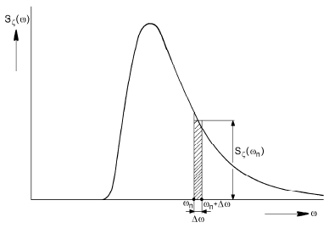
Figure 7.2: Definition of Spectral Density (Journée and Massie, 2001)

Considering, $∆ω→0$, the above equation becomes

$S_{ζ}\left(ω_{n}\right)∙dω=\frac{1}{2} ζ_{a_{n}}^{2}$ (7.8)

Where; it defines as the wave energy spectrum

7.3. Ocean Current
The ocean current is mainly introduced by the wind, water temperature, salt content, and density, the gravity of the moon, variation of atmospheric pressure and tidal effects. The ocean current travels clockwise in the northern hemisphere, but traveling counter-clockwise in the southern hemisphere. The ocean current at deeper sea depends on water pressure, density, temperature and salt content (salinity).
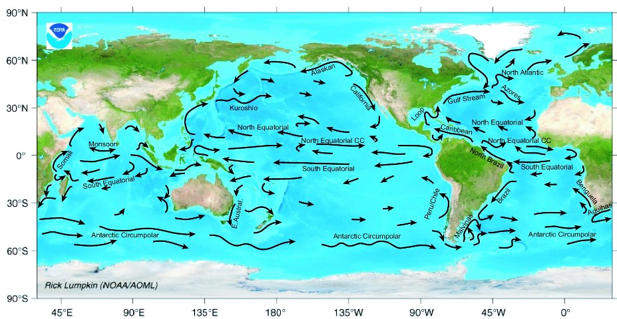

Density
Application of Physical principle on sea water that is denser will sink to the sea bead of ocean, then less dense of sea water has to move out of the way. In other word, the less dense sea water rises to surface. This circulation process creates a circular pattern known as Convection Current (CC).

Temperature
In the ocean, when sea water temperatures are high, the atoms in matter become "excited" from the energy and start to expand. Molecules, which are made up of atoms, also expand in this way. This expansion results in lowered density. Therefore, warmer sea water expands just like any other matter, and following the principle of density, it rises to the top of the ocean. The cooler sea water, which is denser than the warm water, sinks to the bottom and takes up the space left by the rising warm sea water. The result is Convection Current (CC).

Salinity, Density, and Temperature
In the ocean, when the sea water molecules of the ocean become heated, they expand. Extra space is created by this expansion into which salt and other molecules (e.g., calcium) can fit. Since warmer water thus can hold more salt and other molecules than cold water; it can have a higher salinity. To relate this to ocean currents, the higher the salinity of ocean water, the denser it becomes. When the salinity is high enough, the water will sink, starting Convection Current. This means that cold water can sit on top of warm water if the warm water has a high enough salinity, and that the natural flow of a current actually can be reversed based on the related density, salinity and temperature of the ocean water.

7.4. Response Amplitude Operator (RAO)
Response Amplitude Operator (RAO) is a dimensionless parameter to generate the response spectrum from the energy spectrum. It is also often called as a transfer function. For a floater which encountered by irregular wave, the vessel response spectrum of motion for each degree of freedom (e.g. heave, roll, etc.) can be found by using the transfer function for each individual motion and the wave energy spectrum.
Heave response spectrum can be found by using the transfer function of the motion and the wave energy spectrum by:

$S_{Z}\left(ω\right)={\left|\frac{z_{a}}{ζ_{a}}\left(ω\right)\right|}^{2}∙S_{ζ}\left(ω\right)$ (7.9)

Where; $z_{a}(ω)$ = heave amplitude, $ζ_{a}(ω)$ = wave amplitude and $S_{ζ}(ω)$= wave energy spectrum.

7.5. Hydrodynamic Load Effect
The hydrodynamic load effect on riser can be expressed by the Morison equation in terms of relative fluid-structure velocities and accelerations. The component includes hydrodynamic load in normal pipe and tangential pipe directions. For circular cross-section, the Morison equation can be expressed as (DNV, 2010):

$f_{n}=\frac{1}{2}ρC_{D}^{n}D_{h}\left|v_{n}-\dot{r_{n}}\right|\left(v_{n}-\dot{r_{n}}\right)+ρ\frac{πD_{b}^{2}}{4}C_{M}^{n}\dot{v_{n}}-ρ\frac{πD_{b}^{2}}{4}\left(C_{M}^{n}-1\right)\ddot{r_{n}}$
$f_{t}=\frac{1}{2}ρC_{D}^{t}D_{h}\left|v_{t}-\dot{r_{t}}\right|\left(v_{t}-\dot{r_{t}}\right)+ρ\frac{πD_{b}^{2}}{4}C_{M}^{t}\dot{v_{t}}-ρ\frac{πD_{b}^{2}}{4}\left(C_{M}^{t}-1\right)\ddot{r_{t}}$ (7.10)

Where;
$f_{n,t}$ is force per unit length in normal and tangential directions, respectively
$ρ$ is water density
$D_{b}$ is buoyancy diameter (i.e. equivalent diameter for description of resulting buoyancy on a general riser cross section)
$D_{h}$ is hydrodynamic diameter
$v_{n}$ , ${\dot{v}}_{n}$ is fluid velocity and acceleration in normal direction
${\dot{r}}_{n}$ , ${\ddot{r}}_{n}$ is structural velocity and acceleration in normal direction
$C_{D}^{n}$, $C_{M}^{n}$ is drag and inertia coefficients in normal direction
$v_{t}$ , ${\dot{v}}_{t}$ is fluid velocity and acceleration in tangential direction
${\dot{r}}_{t}$ , ${\ddot{r}}_{t}$ is structural velocity and acceleration in tangential direction
$C_{D}^{t}$, $C_{M}^{t}$ is drag and inertia coefficients in tangential direction
The above drag and inertia coefficients are dependent on several parameters, i.e.:
- Body shape;
- Reynolds number (Re = UD/ν), where U is the free stream velocity, D is the diameter of object considered, and ν is the kinematic viscosity;
- Keulegan Carpenter number KC = UMT/D, where UM is the free stream velocity amplitude of the oscillatory flow, and T is the period of oscillation;
- Roughness ratio k/D, where k is the characteristic dimension of the roughness on the body;
- Reduced velocity U/fnD, where fn is the natural frequency of the riser
- Relative current number Uc/UM, where Uc is the current velocity
Considering the above mentioned parameters, it is obvious that the hydrodynamic loading according to the Morison formulation is a major source to nonlinearities in the response characteristic of slender structures, as also implied by DNV (2010).

7.6. Soil-Riser Interaction
Soil condition at the seabed plays important role in riser design, especially in fatigue damage. At Touch Down Point (TDP) region of the riser, out-of-plane motions will occur as a consequence of oscillatory forces caused by transverse wave acting on the free hanging part of the riser. Depending on the stiffness and friction of the seafloor, out-of-plane bending stresses will be more or less concentrated in this TDP region when the riser is subjected to oscillatory motion. The pipe-soil interaction is commonly modelled by use of friction coefficient (sliding resistance) and linear springs (elastic soil stiffness) (Bai, 2005).

7.7. Global Analysis
In riser analysis, the purpose of performing the global analysis is to capture the overall responses from the rises system. These responses come from static and dynamic structural behaviour in such particular environmental loading condition. From DNV (2010), the global response quantities can be grouped into four main categories, i.e.:
- Cross-sectional forces, e.g. effective tension, bending moments, torsional moment
- Global riser deflections, e.g. curvature, elongation, angular orientation
- Global riser position, e.g. co-ordinates, translations, distance to other structures, position of Touch-Down Point (TDP) on seafloor, etc.
- Support forces at termination on rigid structures
A Finite Element Approach (FEA) is normally considered for global riser system analysis. It is strongly required to understand the basic modelling parameter in order to generate accurate result, e.g. regular or irregular loading due to waves and floater motions, current modelling, hydrodynamic parameter, special components modelling (buoyancy module, hinges, etc.), seafloor contact formulations, etc.

7.7.1. Static Analysis
The first step in global riser analysis is a static analysis. This step is required in order to develop further analysis, such as eigenvalue and dynamic analyses. The purpose of the static analysis is to establish the static equilibrium configuration due to static loading for given locations of riser terminations to rigid structures (e.g. terminations to floater and seafloor).
The classic catenary equations are applied to compute the coordinates and force components at 2nd element end in the local element system as shown figure below.
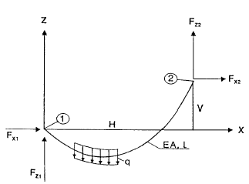

Based on figure above, the forces can be written as
$$F_{x2}=-F_{x1}$$
$$F_{z2}=-F_{z1}+ql$$
$$H=-F_{z1}\left[\frac{1}{EA}+\frac{1}{q}\ln\left(\frac{F_{z2}+T_{2}}{T_{1}-F_{z1}}\right)\right]$$
Where: $T_{1}=\sqrt{F_{x1}^{2}+F_{z1}^{2}}$; $T_{2}=\sqrt{F_{x2}^{2}+F_{z2}^{2}}$

$$V=\frac{1}{2EAq}\left(T_{2}^{2}-T_{1}^{2}\right)+\frac{1}{q}\left(T_{2}-T_{1}\right)$$
$$l_{d}=l+\frac{1}{2EAq}\left[F_{z2}T_{2}+F_{z1}T_{1}+F_{x1}^{2}\ln\left(\frac{F_{z2}+T_{2}}{T_{1}-F_{z1}}\right)\right]$$

Static riser analyses are normally performed using a nonlinear FE approach based on loading conditions. There are four basic static loading components according to DNV (2010). These loading components are explained below:

7.7.1.1. Volume forces
Static profile equilibrium on volume forces basis can be derived by simplified the calculations based on the effective tension and effective weight (Barltrop, 1998). The following figure shows the equilibrium state from a segment of curved pipe under the combined effects of tension, hydrostatic, and internal fluid pressure, where the expression can be equated to equilibrium by the considering equal and opposite pressure over the end faces of the segment.
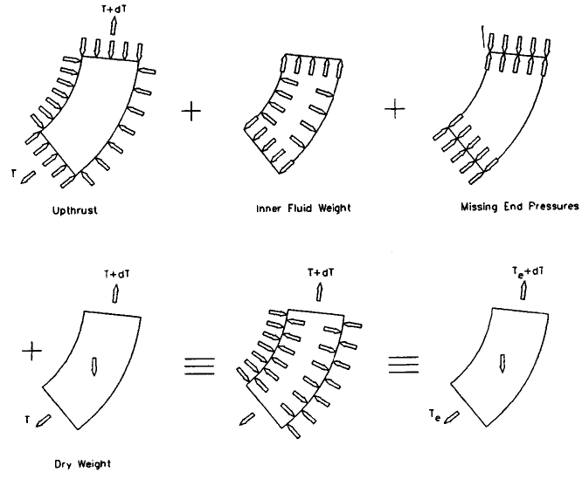
Figure 7.3: Effective Weight and Tension (Barltrop, 1998)

The derivation formula for the effective weight and tension based on above figure are
as follow:

$W_{ef}=γ_{s}A_{s}+γ_{i}A_{i}-γ_{e}A_{e}$ (7.11)

$T_{ef}=T_{i}+P_{e}A_{e}+P_{i}A_{i}-ρ_{i}U_{i}^{2}A_{i}$ (7.12)

Where;
$γ_{s,i,e}$ is weight density for structural (s), internal (i) and external (e), respectively
$A_{s,i,e}$ is area for structural (s), internal (i) and external (e), respectively
$P_{i,e}$ is pressure for internal (i) and external (e), respectively
$P_{i}$ is tension for internal
$ρ_{i}$ is mass density for internal
$U_{i}$ is flow velocity for internal

7.7.1.2. Specified forces
During installation or operating condition, specified tension forces are normally applied on top of the riser section, in order to keep the riser under particular tension state, and to avoid compression force which might lead to buckling. This additional force should also be accounted for the static equilibrium condition

7.7.1.3. Prescribed displacements
The prescribed displacements are used in order to simulate the static equilibrium condition from a stress-free condition (e.g. as laid condition) into a specified position. Some example on this case is a pull-in analysis during riser installation, where a riser that has been laid on the seabed is going to be connected to the wellhead.

7.7.1.4. Displacement dependent forces (current loading)
Some example of displacement dependent forces is current load. In order to determine the final static equilibrium conditions, it is important to see the relative magnitude effect of current load in comparison to the effective weight of the riser. The steady current will induce the drag forces on the riser, and on the sub-surface buoyancy (if any). The result will show whether or not the current has a significant effect on the static configuration.

7.7.2. Natural Frequency Analysis
To avoid the so called ‘resonance effect’ due to dynamic response of the structure, it is important to check the modes and correspondent frequencies of the riser system. The purpose of eigenvalue analysis is to calculate the Natural Frequencies ($f_{n}$) of the structure and the corresponding stress due to associated mode shapes. This analysis is normally performed as the first step prior to the dynamic analysis.
In case for Vortex Induced Vibration (VIV), eigenvalues analysis of the structure is very important. On each natural frequency on each mode shapes of the structure that close to the vortex shedding frequency, the structure might be excited and start to vibrate. The vibration amplitudes create cyclic loads that lead to fatigue damage on the structure.

7.7.3. Dynamic Analysis
The floater motions, station-keeping system such as mooring system and the risers creates a complex dynamic response to the environmental loading from wind, waves and current. Nonlinearities arise with respect to geometric stiffness, hydrodynamic loads, materials and riser components contact interfacing with other components. Common methods to analyse these nonlinearities are frequency domain analysis and time domain analysis.

7.7.3.1. Frequency Domain Analysis
According to DNV (2010), this method is based on linearization of stiffness, damping, inertia, and external forces at static equilibrium position (i.e. structural and load linearization). For irregular analysis, a stochastic linearization for combined wave/current loading is required.
The structural response will be represented by a spectrum, which means that the statistical properties of the response are known, and the response process (time history) will always be Gaussian. Consequently, non-symmetric response i.e. due to non-symmetric wave loading close to mean water level, cannot be correctly described (Larsen, 1987).

7.7.3.2. Nonlinear Time Domain Analysis
DNV (2010) describes this method as a step by step numerical integration of the incremental dynamic equilibrium equations based on Newton-Raphson method. A good representation of the riser system’s characteristics non-Gaussian response will be resulted as the consequence of the nonlinear approach on all nonlinear effects.
According to Larsen (1987), wave loads can be better described in this method compared to the frequency domain method. However, this statement is valid only for such effect, e.g. the unsymmetrical effect when current and waves are combined, variation of wet surface (load area) of the riser due to varying sea surface elevation in waves, the fact that a specific riser cross section will move and hence not stay in a position where wave induced velocities and accelerations can be calculated independently of riser displacements, non-linear wave theories.

7.7.4 Coupled-Uncoupled Analysis
Floater, risers, and station keeping system (mooring lines) are resulting in a complex dynamic system respond when they interact with the environmental loads. Moreover, current loading and damping influences due to slender structures attaced to the floater (i.e. riser, tethers, and mooring lines) may significantly influence the LF floater motions, in particular in deep water condition. As the consequence, it is important to determine the coupling effects when deriving the floater motion response as well as the riser response.
According to DNV (2010), the combined irregular wave frequency (WF) and low frequency (LF) environmental loading should be considered in riser analysis if riser dynamics is significantly influenced by low frequency excitation. This can be achieved by consistently representing the fully coupled analysis where the floater force model is introduced in a detailed Finite Element (FE) model of the complete slender structure system including all mooring lines and risers. However, DNV (2010) implies that this method requires substantial computational efforts and therefore should be considered as a tool for final verification purposes.
In order to capture the coupling effect with such a computational efficiency, the floater motion and slender structure analyses are then carried out separately. This is called uncoupled analysis. The first step is always a floater motion analysis, which is then applied as loading in terms of forced boundary displacements in subsequent slender structure analysis (i.e. individual riser or mooring line analysis).
The WF floater motions are considered as dynamic excitation using floater RAO transfer function, while LF floater motions are accounted for by an additional representative floater offset. The slender structure is consequently assumed to respond quasi-statically to LF floater motions.

7.8. Time Domain Fatigue Analysis
According to DNV (2010), the fatigue analysis should be based on S-N data, determined by fatigue testing of the considered welded detail, and the linear damage hypothesis. The stress range may be found by deterministic or spectral analysis. The determination of stress history shall consider the dynamic effects. This stress history can be defined as expected number of cycles at each stress range level during the predicted life span, and the practical application of this is to establish a long term stress range history that is on the safe side.
The basic fatigue capacity is given in terms of S-N curves, where $S$ is the constant given stress range, and $N$ is the number of stress cycle to failure. The expression of this S-N curve is given as

$\log\left(N\right)=\log\left(a\right)-m\log\left(S\right)$ (7.13)

Where; $a$ and $m$ are empirical constant established by experiments.
The stress range to be applied in fatigue damage calculation is given as:

$S=S_{0}∙SCF∙{\left(\frac{t_{3}}{t_{ref}}\right)}^{k}$ (7.14)

Where; $S_{0}$ is nominal stress range, $SCF$ is Stress Concentration Factor and ${\left(\frac{t_{3}}{t_{ref}}\right)}^{k}$ is Thickness correction factor, where this factor applies for pipes with a wall thickness $t_{3}$ greater than a reference wall thickness, $t_{ref}=25 mm$.
Bilinear (two-slope) S-N curves in log-log scale are also frequently applied for representation of the experimental fatigue data:

$\left\{\begin{aligned}a_{1}S^{-m_{1}} for S> S_{sw} \\ a_{2}S^{-m_{2}} for S≤ S_{sw} \end{aligned}\right.$ (7.15)

Where; $S_{sw}$ is the stress at intersection of the two SN curves given by:

$S_{sw}={10}^{\left(\frac{\log\left(a\right)-\log\left(N_{SW}\right)}{m_{1}}\right)}$ (7.16)

and $N_{SW}$ is the number of cycles which change in slope appears. The typical Log (NSW) is 6-7. The following figure shows the basic definitions for two-slope SN-curves.
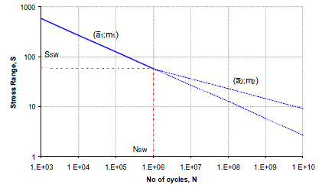
Figure 7.4: Basic definitions for two-slope SN-curves (DNV-OS-F201, 2010)

The accumulation of fatigue damage from stress cycles is adopting the Miner-Palmgren rule as below:

$D=\sum_{i}{\frac{n\left(S_{i}\right)}{N\left(S_{i}\right)}}$ (7.17)

Where; $n\left(S_{i}\right)$ is the number of stress cycles with range $S_{i}$ and $N\left(S_{i}\right)$ is the number of stress cycles to failure.
There are three different contributions to fatigue damage that should be assessed, i.e. the wave-induced, the low-frequency, and the vortex-induced-vibration (VIV) stress cycles. The procedures for calculating fatigue damage contributions for wave and low-frequency fatigue damage are (DNV, 2010):
- Divide the wave environment scatter diagrams into a number of representative blocks
- Select a single sea-state to represent all the sea-states within the block. This representative sea-state has the highest occurrence within the block.
- Calculate the fatigue damage within each simulation using rain-flow counting procedure and weight that with the probability of each block
- Sum-up the fatigue damage over all the blocks and obtain the fatigue damage for that direction
- Repeat the same procedure for other directions and sum-up the total fatigue damage by applying directional probabilities
- The predicted fatigue life is the reciprocal of this cumulative damage rate.

7.9. Analysis Method of a Vertical Tensioned Riser
Bent Riser under inline environmental load is as shown in the Figure 7.5. Then, basic equation of motion can be derived.

The flexural rigidity force is written as

$F_{f}=\frac{d^{2}}{dy^{2}}\left(EI(y)\frac{d^{2}x}{dy^{2}}\right)$ (7.18)

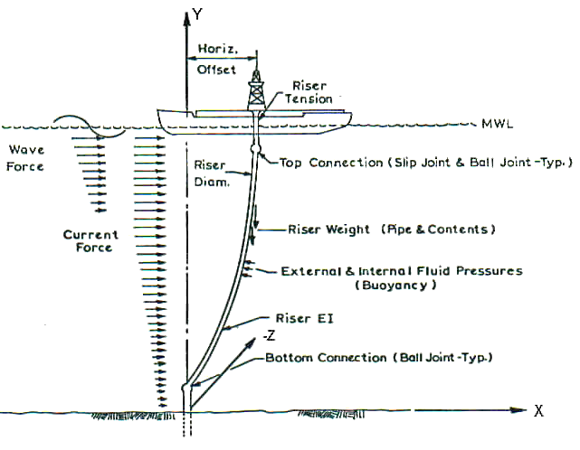
Figure 7.5: Bent Riser under inline environmental load

The axial tension force is written as

$F_{t}=-\frac{d}{dy}\left[F_{A}\left(y\right)\frac{dx}{dy}\right]$ (7.19)

Inertial resistance of riser is written as

$F_{I}=m\left(y\right)\ddot{x}$ (7.20)

Damping force of riser is written as

$F_{D}= c\left(y\right)\dot{x}$ (7.21)

For inline static analysis, the right hand side is the current force ($F_{CD}$).

$F_{CD}\left(y\right)=\frac{1}{2}ρC_{D}\left(y\right)D\left(y\right)U^{2}\left(y\right)=F_{t}(y)+F_{t}(y)+F_{I}(y)+F_{D}(y)$ (7.22)

$\frac{1}{2}ρC_{D}\left(y\right)D\left(y\right)U^{2}\left(y\right)=\frac{d^{2}}{dy^{2}}\left(EI(y)\frac{d^{2}x}{dy^{2}}\right)-\frac{d}{dy}\left[F_{A}\left(y\right)\frac{dx}{dy}\right]+m\left(y\right)\ddot{x}+c\left(y\right)\dot{x}$ (7.23

For transverse static analysis, the right hand side is the transverse (lift) force ($F_{CL}$).

$F_{CL}(y)=\frac{1}{2}ρC_{L}\left(y\right)D\left(y\right)U^{2}\left(y\right)=\frac{d^{2}}{dy^{2}}\left(EI(y)\frac{d^{2}z}{dy^{2}}\right)-\frac{d}{dy}\left[F_{A}\left(y\right)\frac{dz}{dy}\right]+m\left(y\right)\ddot{z}+c\left(y\right)\dot{z}$
(7.24)

The internal or external fluid pressure can be derived as

$F_{P}(y)=\frac{d}{dy}\left[\left\{A_{o}\left(y\right)p_{o}\left(y\right)-A_{i}\left(y\right)p_{i}\left(y\right)\right\}\frac{dx}{dy}\right]$ (7.25)

The external horizontal force is written as

$F_{E}(x,y,t)=f_{xs}(x,y,t)$ (7.26)

The effective tension (from bent tube, $F_{e} (y)$) is written as
$F_{e} \left(y\right)=\underset{Actual wall tension}{\underbrace{F_{A}\left(y\right)}}+\overset{\begin{aligned}Horizontal Load due to external and \\ internal fluid pressur\end{aligned}}{\overbrace{F_{P}(y)}}$ (7.27)

Where; $x$ is direction of current, y is vertical direction, z is transverse direction, m = total mass per unit length of riser section, $c$ is damping coefficient of riser section, $ρ$ is mass density of water, $F_{e} \left(y\right)$ is effective tension due to axial tension and pressure force, $D(y)$ is riser diameter versus y, $U(y)$ is current velocity versus y, $C_{D}\left(y\right)$ is drag coefficient for the riser, and $C_{L}\left(y\right)$maximum lift coefficient for the riser
If a dynamic analysis is required in current the right hand side is replaced by a time history of current force. For dynamic analysis due to the wave force, the right hand side takes on the form of the Morison equation force:

$F\left(y,t\right)=\frac{π}{4}ρC_{M}\left(y\right)D^{2}\left(y\right)\dot{u}\left(y,t\right)+\frac{1}{2}ρC_{D}\left(y\right)D\left(y\right)\left|u\left(y,t\right)\right|u\left(y,t\right)$ (7.28)

7.10. Static Catenary Concept
In physics and geometry, catenary is a curve formed by a chain, flexible pipe or cable that depends on the assumption of weight is only supported at the end. Mathematically, the catenary curve is the graph of the hyperbolic cosine function. Figure.7.6 shows single line element of the catenary line.
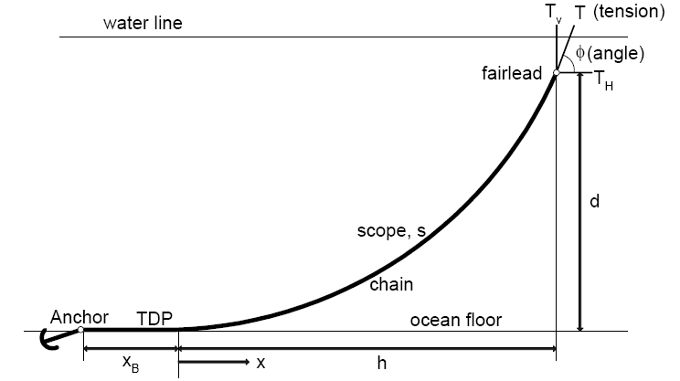
Riser
Figure.7.6: Single catenary line concept.

Based Figure 7.6, there is seventh independent variables are:
- $w$ is weight of line per unit length≈ 0.87x (weight in air) for steel
- $T$ is pretension at fairlead
- $φ$ is fairlead angle
- $h$ is horizontal component of catenary length
- $d$ is vertical component of catenary length
- $s$ is length of catenary called scope
- $x_{B}$ is component of line on bottom

There is two following two items which depends on $T$ and :
- $T_{H}$ is horizontal component of tension at fairlead
- $T_{V}$ is vertical component of tension at fairlead

Consider the following free-body diagram as shown figure below
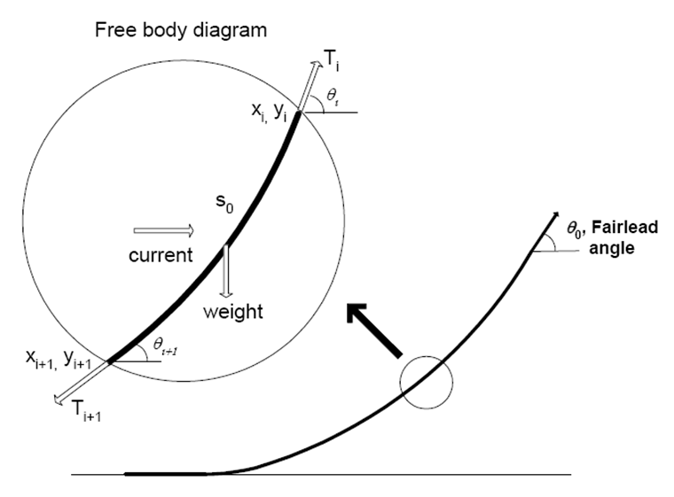
For a static analysis in the absence of any external force, the two equilibrium equations for horizontal can be written as
$T_{i}\cos{θ_{i}}-T_{i+1}\cos{θ_{i+1}}=0$ (7.29)
and vertical as
$T_{i}\sin{θ_{i}}-T_{i+1}\sin{θ_{i+1}}+w_{i}=0$ (7.30)
which may be solved for tension and angles of subsequent elements as follows:

$T_{i+1}={\left[{\left(T_{i}\cos{θ_{i}}\right)}^{2}-{\left(T_{i}\sin{θ_{i}}-w_{i}\right)}^{2}\right]}^{1/2}$ (7.31)

and

$\tan{θ_{i+1}}=\frac{T_{i}\sin{θ_{i}}-w_{i}}{T_{i}\cos{θ_{i}}}=\frac{T_{Vi}-w_{i}}{T_{Hi}}$ (7.32)

Then, knowing the coordinates of the upper end of the element ($x_{i}$,$y_{i}$), the corresponding coordinates for the lower end becomes

$x_{i+1}=x_{i}-\frac{l_{i}}{2}\left[\cos{θ_{i}}+\cos{θ_{i+1}}\right]$ (7.33)

$y_{i+1}=y_{i}-\frac{l_{i}}{2}\left[\sin{θ_{i}}+\sin{θ_{i+1}}\right]$ (7.34)

This calculation continues with the subsequent element until $y_{i+1}$ just exceeds - $d$, where the $d$ is the supplied depth of the line. For a catenary line with portions on the bottom, the solution can be obtained in closed form using catenary equations.
Basic catenary equation can be written as:

$y=y_{0}\cosh\left(x/{y_{0}}\right)$ (7.35)

Where; $y_{0}$is elevation at x = 0,
From the figure above, the suspended line length $s(x)$ as;

$s(x)= \left(\frac{T_{H}}{w}\right)\sinh\left(\frac{wx}{T_{H}}\right)$ (7.36)
and then, the vertical line dimension along catenary $d(x)$

$d(x)=\left(\frac{T_{H}}{w}\right) \left[\cos\left(\frac{wx}{T_{H}}\right)-1\right]$ (7.37)
It assume that total lengths, use $x = h$ in above equations, the top tension of the line as:
$T= \frac{w \left(s^{2}+ d^{2}\right)}{2d}$ (7.38)
The horizontal tension as
$T_{H}= \frac{w \left(s^{2}- d^{2}\right)}{2d}$ (7.39)
It can be reduced to be
$d=\frac{T-T_{H}}{w}$ (7.40)

The horizontal component of tension is constant along the line and is given by:
$T_{H}=T\cos{ϕ_{w}}$ (7.41)

The vertical component of line tension at the top becomes:
$T_{v}=T\sin{ϕ_{w}}=ws$ (7.42)

The horizontal span of the suspended portion of line
$h=\left(\frac{T_{H}}{w}\right)\log{\frac{T_{A}-T_{VA}}{T_{H}}}$ (7.43)

Chapter 8

8.0. Vortex-Induced Vibration of Risers

8.1. Theoretical Background

8.1.1. Fundamental Aspects of VIV
The Vortex Induced Vibration (VIV) is known as self-exciting, self-regulating, self-limiting highly phenomenon. As the fluid flow interacts with the object, energy dissipates at boundary layer because of viscous drag; separation takes place as the flow lacks sufficient kinetic energy.
This VIV phenomenon is generally highly favored by the shedding of vortex due to external loads caused by sea currents when the riser is being disturbed by sea currents in deep waters. This Vortex-Induced Vibration also influenced by a large number of parameters including mass ratio, structure stiffness, damping, surface roughness and the most important parameters for this vortex-induced vibration are Reynolds number, Strouhal Number ($S_{t}$), and reduced velocity.
The Vortex Induced Vibration can be observed in many engineering objects, such as offshore structures, production risers, bridges, aircraft control surfaces, thermo wells, engines, heat exchangers etc. The VIV received extensive attention in this oil and gas industry due to the flow-structure-interaction problem. The Vortex-Induced Vibration is widely known in the oil and gas industry for several decades.
Vortex-Induced-Vibration (VIV) of the riser joints occurs while drilling in areas with strong ocean currents. This phenomenon is what happens when a strong flow of water past a pipe creates vortices (turbulence) behind the pipe. These vortices then induce vibrations in the pipe, which have a severe impact on the fatigue life of the riser joints, and also cause other damage to the riser system. Vortex Induced Vibrations can cause severe oscillations of circular structures subjected to incident flow. This may again lead to fatigue damage and ultimately result in total collapse of the structure.

8.1.1.1. Reynolds Number ($R_{n}$)
There is two parameters namely the Reynolds number ($R_{n}$) and Strouhal Number ($S_{t}$) which is used to describe the flow around a fixed cylinder. The Reynolds number can be defined for several different situations where a fluid is in relative motion to a surface. In other word, the Reynolds number gives the ratio between inertial forces and friction forces in the fluid (Myrhaug, 2005) and is defined as

$R_{n}=\frac{ρUx}{μ}=\frac{Ux}{v}$ (8-1)

Where; $ρ$ is fluid density (${kg}/{m^{3})}$, $U$ is flow velocity ($m/s$), $x$ is characteristic length in meter, $x=D$ for a cylinder, $μ$ is dynamic viscosity of fluid ($kg/m·s$), and $v$ is kinematic viscosity of fluid (${m^{2}}/s$) which can be written as $v=μ/ρ$.
It is convenient to divide the different Reynolds number domains into separate flow regimes. Table 4-1 gives separate flow regimes and corresponding Reynolds number proposed by O.M. Faltinsen (Faltinsen, 1990).

Table 8.1: Flow regimes
Regimes | Reynolds Number
Subcritical flow regime | $$R_{e}<2 x {10}^{5}$$
Critical flow regime | $$2 x {10}^{5}< R_{e}<5 x {10}^{5}$$
Supercritical flow regime | $$5 x {10}^{5}< R_{e}<3 x {10}^{6}$$
Transcritical flow regime | $$R_{e}>3 x {10}^{6}$$

8.1.1.2. Response Frequency
For structures in air, the vibrations occur at the structures response frequency. For structures in water however, the picture is somewhat different as added mass plays a significant role in dictating the response frequency. This is easily illustrated by the experiment where a simple cylinder is attached to a spring with stiffness k and subjected to a uniform incident flow $U$ (Larsen, 2011), see Figure 8.5.

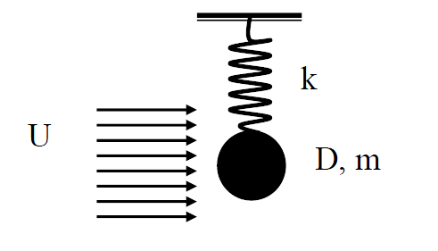
Figure 8.5: An experiment of cylinder in uniform flow.

The corresponding equation of oscillation for evaluating the response frequency of the system is given by Equation 4.3:

$\left(m+m_{a}\right)\ddot{y}(t)+ky(t)=0$ (8.2)

Where; $m$ is mass of cylinder ($kg$), $m_{a}$ is added mass ($kg$), $k=\frac{AE}{L}$ is spring stiffness ($N/m$), where $A$ is the cross-sectional area, $E$ is the (tensile) elastic modulus, $L$ is the length of the element. The $y(t)$ is displacement of cylinder can be written as

$y\left(t\right)=A_{y}\sin\left(ω_{s}t\right)$

Where; $A_{y}$ is amplitude of excitation
Differentiation of the displacement with respect to time velocity ($\dot{y}$) and acceleration ($\ddot{y}$) can be written as

$\dot{y}=ω_{s}A_{y}\cos\left(ω_{s}t\right)$ and $\ddot{y}=-{ω_{s}}^{2}A_{y}\sin\left(ω_{s}t\right)$. (8.3)

Inserted Eq. 8.3 into Eq.8.2 then this gives the still water response frequency of the cylinder:

$-\left(m+m_{a}\right){ω_{s}}^{2}A_{y}\sin\left(ω_{s}t\right)+kA_{y}\sin\left(ω_{s}t\right)=0$

$ω_{s}=2πf_{s}=\sqrt{\frac{k}{\left(m+m_{a}\right)}}$

$f_{s}=\frac{1}{2π}\sqrt{\frac{k}{\left(m+m_{a}\right)}}$ (8.4)

8.1.1.3. Strouhal Number ($S_{t}$)
The Strouhal Number ($S_{t}$) is proportional to the shedding frequency of the fluid, and given as:

$S_{t}=\frac{f_{s}∙L}{U}$ (8-5)

Where; $f_{s}$ is the frequency of vortex shedding, $L$ is the characteristic length (for example hydraulic diameter, or chord length) and $U$ is the flow velocity.
Avoiding resonance on riser would be an efficient way of avoiding the VIV phenomenon. This means that the reduced velocity ($U_{r}$) is kept lower than 1 (Blevins, 1994). Reduced velocity ($U_{r}$) can be expressed as

$U_{r}=\frac{U }{f_{n}L }<1$ (8.6)

Where; $f_{n}$ is the natural frequency which can be expressed as:

$f_{n}=\frac{1}{2π}\sqrt{\frac{k}{ m+m_{a}}}$ (8.7)

Where; $m$ is mass of cylinder, $m_{a}$ is added mass, $k$ is riser stiffness. Increasing the stiffness of the structure will increase the natural frequency of the structure, thus reducing the reduced velocity.
The mass ratio can be expressed as

$m^{+}=\frac{m}{ ρπL\frac{D^{2}}{4} }$ (8.8)

The riser stiffness can be written as

$k=EI$ (8.9)

Where; $E$ is Modulus of Elasticity, $I$ is the second moment of area, about an axis in the plane of the cross section through the centroid.

$I=π{\left(D_{o}^{4}-D_{i}^{4}\right)}/{64}$
$D_{o}$ is outer diameter of pipe and $D_{i}$ is inner diameter of pipe

8.1.1.4. Flow around a Cylinder
Figure 3.1 shows a simple test set-up where a cylinder with diameter D is subjected to incident flow U.

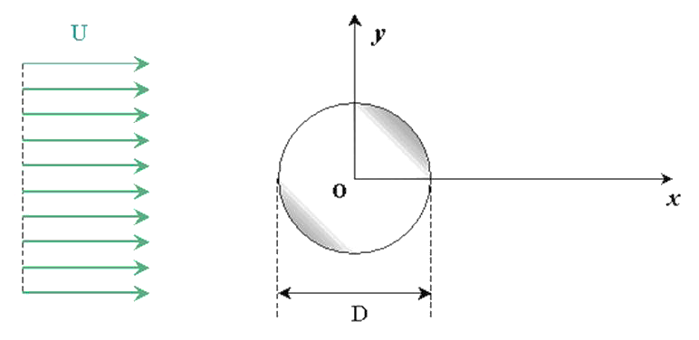
Figure 8.1: Cylinder subjected to incident flow

As the fluid approaches the leading edge of the cylinder, the pressure in the fluid will rise from the fluid pressure in the free flow to the stagnation pressure at the stagnation point on the cylinder. The high pressure near the leading edge of the cylinder will force the flow around the leading edge as the boundary layer on the cylinder develops. The high pressure is however not strong enough drive the flow about the back of the cylinder at sufficiently high Reynolds number. Consequently, the flow separates near the widest section of the cylinder and shed vortices downstream of the cylinder, creating a so-called vortex street. Flow separation starts if there exist a point S on a body surface where $\frac{du}{dx}=0$ and there is backflow aft of this separation point, see Figure 8.2.
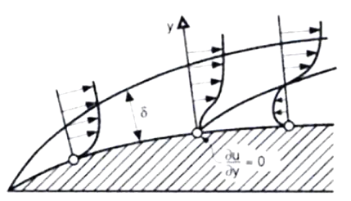
Separation
(a): 2-D flow with boundary layer thickness
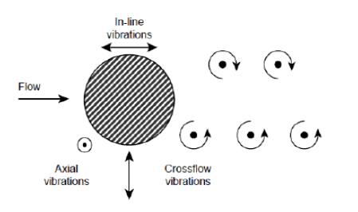
(b): Vibration in VIV

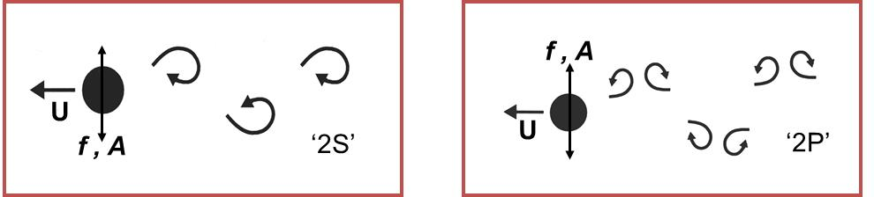
Shedding patterns in the wake of oscillating cylinders are distinct and exist for a certain range of heave frequencies and amplitudes. The different modes have a great impact on structural loading.
(c): Wake pattern behind cylinder.
Figure 8.2: Nature of flow around cylinder cause VIV.

Depending on the $R_{e}$, the shedding process and downstream vortex street will vary. The separate stages of the process for increasing $R_{e}$ are illustrated in Figure.8.3. From Figure 8.3 we see that flow separation occurs early, already at$5< R_{e}<40$, and a symmetric pair of vortices are formed. For further increasing Reynolds number, $40< R_{e}<150$, the wake becomes unstable, and laminar periodic staggered vortices of opposite signs are created. While the boundary layer on the cylinder remains laminar, the vortices become turbulent in the $150< R_{e}<300$ range. For a further increase in flow velocity, the subcritical flow regime $300< R_{e}<1.5 x {10}^{5}$ is reached. The flow separates close to 80 degrees aft of cylinder leading edge and the vortex shedding is now strong and periodic, creating cyclic forces in both IL and CF direction. Moving into the transitional flow range of$1.5 x {10}^{5}< R_{e}<3.6 x {10}^{6}$ , the boundary layer on the cylinder becomes turbulent which effectively delays the separation point to roughly 140 degrees aft of the leading edge. As a consequence the drag force on the cylinder is reduced. The same flow regime is characterised by a disorganized wake caused by bubbles and three-dimensional effects (Blevins 1994). Entering the supercritical flow regime, regular vortex shedding is established with both a turbulent boundary layer and a turbulent vortex street
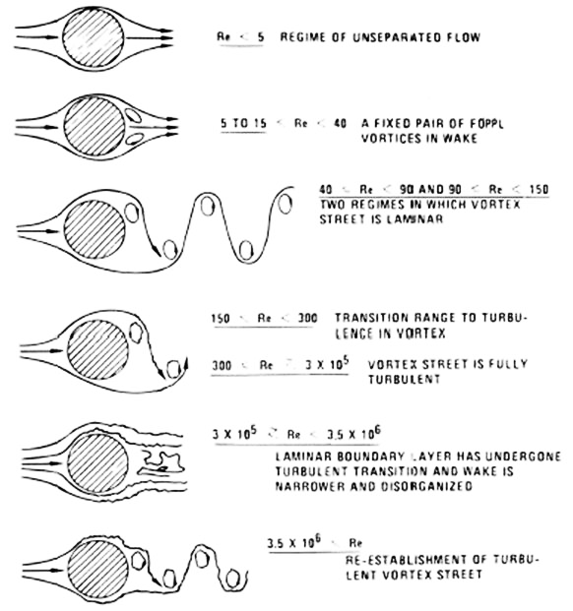
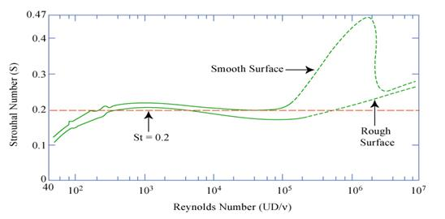
Figure 8.3: Flow regimes and corresponding wake at increasing Reynolds Number ( $R_{e}$).

8.1.1.5. Drag Force on a Fixed Circular Cylinder
The static drag force on a fixed cylinder is primarily caused by flow separation on the top and bottom side of a cylinder. This will induce a pressure difference between the leading and trailing edge, which integrated over the surface, gives a drag force. Friction forces acting tangentially to the cylinder surface will also add to the total drag force, but compared to the pressure force caused by flow separation, the viscous part is small.
The part of the drag force caused by a pressure difference from the leading and trailing is primarily a function the wake width. The width of the wake will again be a function of fluid separation; more specifically where on the cylinder surface separation occurs. For laminar boundary layer flow, fluid separation will start at approximately measured from the leading edge. For an increased flow velocity and moving through the supercritical and trans-critical flow regime, the boundary layer becomes fully turbulent. This induces later separation, and flow separation occurs at angels roughly equal to. The result is a narrower wake and reduced drag force. There are other ways of forcing the boundary layer to become turbulent than simply increasing flow velocity. Increased surface roughness will give a turbulent boundary layer earlier than a smooth surface, and may therefore decrease drag. The most famous example is the dimples on a golf ball.
The drag force may be expressed in a similar fashion as the excitation force given

$F_{D}=\frac{1}{2}C_{d}ρDU^{2}dl$ (8.10)

Where; $ρ$ is fluid density, $U$ is fluid velocity, $C_{d}$ is drag coefficient, $D$ is cylinder diameter and $dl$ is span-wise increment.
As can be seen from Equation 8.3, the total drag force is a function of both the drag coefficient ($C_{d}$) and the cylinder diameter ($D$). Below is a drag coefficient plot for a circular cylinder subjected to incident flow of varying flow velocity. The plot shows how a rough cylinder will experience a turbulent boundary layer earlier than the smooth cylinder, and therefore shows the associated drop in drag from a narrower wake, earlier. The increased cylinder diameter from suppression devices like strakes will clearly create a larger drag force on the riser section which means a larger static deflection. However, as will be discussed next, the benefits from strakes will not only reduce the fatigue damage from dynamic response, it will also reduce the VIV drag amplification, and thus the static response
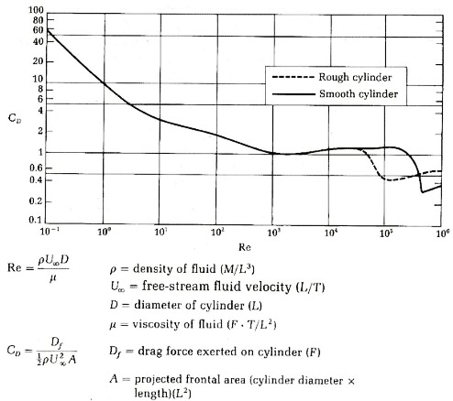
Figure 8.4: Drag coefficient for circular cylinder, smooth and rough surface (Schlichting & Gertsen, 2000).

8.1.1.6. Drag Amplification Caused by VIV
As mentioned above, vortex induced vibrations will increase the hydrodynamic diameter of the riser. This means that the effective diameter the incident flow “sees” is increased, resulting in a larger projected area and thus larger drag force. For long riser sections, this drag increase may result in a dramatic increase in static response.
Drag coefficient for risers in VIV conditions are found empirically, and several drag coefficient proposals have been introduced by scholars such as Blevins, Vandiver and Skop et al. respectively (Blevins, 1994).
In 1994, Blevin has proposed a method as written:

$\frac{C_{d}\left(\frac{A}{D}\right)}{C_{d}(A=0)}=1+2.1∙\left(\frac{A}{D}\right)$ (8.11)

Where; $C_{d}(A=0)$ is drag coefficient at zero amplitude, i.e. for the fixed cylinder as given in Figure 8.4, $A$ is VIV amplitude and $D$ is cylinder diameter.
Another method was proposed by Vandiver & Li, 2005:

$\frac{C_{d}\left(\frac{A}{D}\right)}{C_{d}(A=0)}=1+1.043∙{\left(\frac{2∙A_{rms}}{D}\right)}^{0.65}$ (8.12)

Where; $A_{rms}$ is Root Mean Square, square root of the time average of the square of the amplitude.
Vandiver & Skop et al has proposed another method,

$\frac{C_{d}\left(\frac{A}{D}\right)}{C_{d}(A=0)}=1+1.16∙{\left(\frac{2∙A_{rms}}{D}∙\frac{f_{n}}{f_{s}}-1\right)}^{0.65}$ (8.13)

Where; $f_{n}$ is natural frequency and $f_{s}$ is vortex shedding frequency.

8.1.1.7. Nature of Flow around Cylinders Induce VIV
Zdravkovich (1988) stated that “the different number of degrees of freedom of cylinders employed in various experiments showed such a wide variety of responses in wind and water tunnels that the governing mechanisms appeared obscure and incomprehensible.
The alternatively shed vortices induce pressure forces on the cylinder. As each shed vortex will induce a drag force in IL direction, while the sign of the induced pressure in CF direction will be opposite for each shed vortex, IL response will occur at twice the frequency of CF response. Figure 8.4 gives a section of a complete shedding cycle, where the shed vortices and corresponding surface pressures (Blevins, 1994). Long flexible cylinders can move in two directions and tend to trace a figure-8 motion. The motion is dictated by the tension in the cable and the speed of towing.

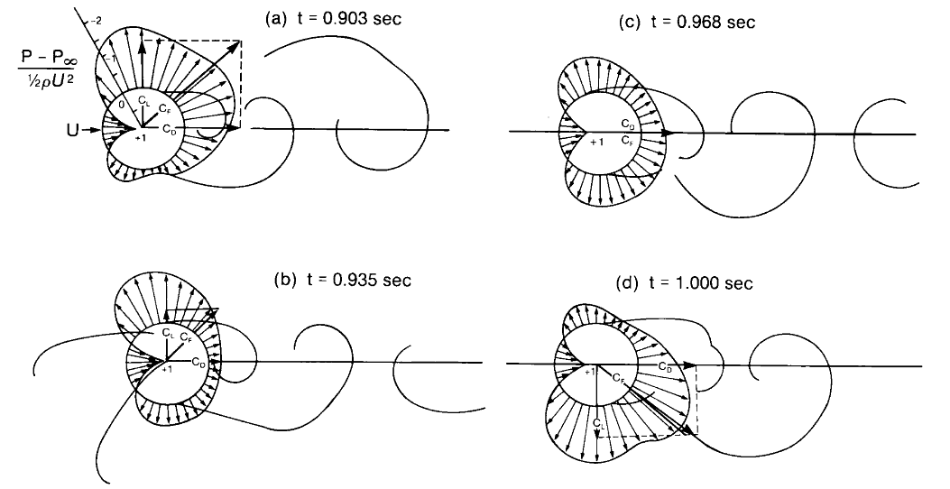
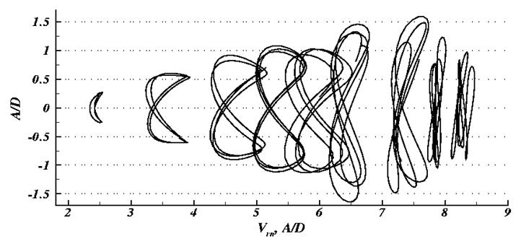
Figure 8.4: Surface pressure from vortex shedding (Blevins, 1994).

Integrated over the cylinder surface, the induced pressures will give excitation forces in IL and CF direction. As mentioned earlier, CFD programs are today capable of evaluating simple 2D-cases as illustrated above. Pressure distributions in the fluid are calculated directly and excitation forces thus found. For larger 3D-models however, empirical models are needed to analyse VIV problems. A critical aspect to evaluating VIV empirically is to be able to calculate correct response frequencies for every excited mode. Influence from added mass, and its influence on response frequency, has proved to be a difficult part of the VIV analysis.

8.1.2. Analysis Method of Vortex-Induced Vibration
Vortex-induced vibration is widely known in the world of oil and due to its effect on riser used to extract oil and gas from sea floor that caused by external load. In the previous literatures, the problems related to vortex-induced vibration are studied and investigated. As the result, many researchers have been done to solve this problem. There were several methods of analysis conducted previously to predict, simulate, and solve this vortex-induced vibration since this problem is concerned in oil and gas industry. The methods used to investigate this problem are including empirical method and computational method.

8.1.3. Reynolds-Averaged Navier-Stokes (RANS)
Reynolds-Averaged Navier Stokes (RANS) is an approach used in the numerical method for the analysis of vortex-induced vibration. Reynold-Averaged Navier-Stokes are derived from time-averaging the Navier-Stokes equations. The idea behind these equations is the Reynolds decomposition which referred to the separation of the flow variable. There are numerous studies of vortex-induced vibration using this Reynolds-Averaged Navier-Stokes for the simulation by numerical method.

$ρg_{x}-\frac{dp}{dx}+\frac{dτ_{xx}}{dx}+\frac{dτ_{yx}}{dy}+\frac{dτ_{zx}}{dz}=ρ\left(\frac{du}{dt}+u\frac{du}{dx}+v\frac{du}{dy}+w\frac{du}{dz}\right)$ (8.14)

8.2. Vortex-Induced Vibration Using CFD

8.2.1. Computational Fluid Dynamic (CFD)
In general, CFD simulation is divided into three main stages, which are pre-processor, simulator or solver, and post-processor. The processing stage is the stage where the geometry of the problem is defined as the solution domain and the fluid volume is divided into discrete cells or mesh. The physical modeling, parameter chemical phenomena, fluid properties and boundary conditions are necessary to be defined. The second stage, which is the solver stage where the fluid flow problem is solved using numerical methods which applied in the engineering software called ANSYS Fluent. The numerical methods are either finite different method (FDM), finite element method (FEM), or finite volume method (FVM).The last stage is the post-processor. The post-processor is performed for the analysis and visualization of the resulting solution. Many CFD packages are equipped with versatile data visualization tools, for instance domain geometry and grid display, vector plots, 2D and 3D surface plot, particle tracking and soon.

8.2.1.1. Pre-Processing Stage
Pre-processing stage is a stage where the flow fluid problem is defined by giving the input in order to get the best solution of the problem. There are many factors that affect the CFD solution accuracy and some of the factors are in this pre-processing stage. The pre-processing stages are divided into several stages which are:
- Define the solution domain
- Generation of mesh
- Parameters for physical modelling
- Properties of fluid
- Boundary conditions

Solution Domain
The solution domain can be defined as the abstract environment where the solution is calculated. The shape of the solution domain can be in any shape like circular and rectangular. For this study, the solution domain is in 2D which is illustrated as in Figure 8.5.

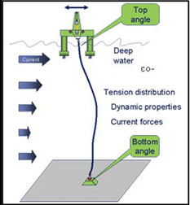
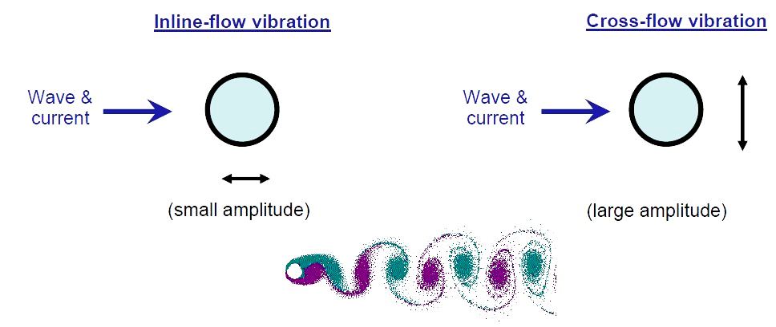
Figure 8.5: Rectangular shaped solution domain

Meshing
Meshing can be defined as the discrete locations at which the variables are to be calculated and to be solved. The grid divides the solution domain into a finite number of sub domains, for instance elements, control volumes etc. Meshing can be generated after the solution domain is defined. The term of mesh generation and grid generation is often interchangeably.
There are two types of grids by Ferziger and Peric used in this study which are structured grid and unstructured grid as shown in figure.4 and figure.5 respectively. A structured grid is a regular grid consists of groups of grid lines with the property that members of a single group do not cross each other and cross each member of the other groups only once. This is the simplest grid structure since it has only four neighbors for 2D and six neighbors for 3D. Even though it simplifies programming and the algebraic equation system matrix has a regular structure, it can be used only for geometrically simple solution domains.
Unstructured grid is a type of grid can be used for very complex geometries. It can be used for any discretization method, but they are best for finite element and volume methods. Even though it is very flexible, there is the irregularity of the data structure. Moreover, the solver for the algebraic equation systems is usually slower than for structured grids.

Figure 8.6: Structured grid

Figure 8.7: Unstructured grid

Boundary Condition
There are several boundary conditions for the discretized equations. Some of them are inlet, outlet, wall, prescribed pressure, symmetry and periodicity.
- Inlet Boundary Condition: The inlet boundary condition permits flow to enter the solution domain. It can be a velocity inlet, pressure inlet or mass flow inlet.
- Outlet Boundary Condition: The outlet boundary condition permits flow to exit the solution domain. It also can be a velocity inlet, pressure inlet or mass flow inlet.
- Wall Boundary Condition: The wall boundary condition is the most common condition regarding in confined fluid flow problems, such as flow inside the pipe. The wall boundary condition can be defined for laminar and turbulent flow equations.
- Prescribed Pressure Boundary Condition: The prescribed pressure condition is used in condition of external flows around objects, free surface flows, or internal flows with multiple outlets.
- Symmetry Boundary Condition: This condition can be classified at a symmetry boundary condition, when there is no flow across the boundary.

8.2.1.2. Simulation or Solving Setup Stage
In this stage, the numerical techniques are used to solve the fluid flow problems where all of CFD simulations used this technique. This technique or method is commonly called the discretization method. The meaning of the discretization method is that the differential equations are approximated by an algebraic equation system for the variables at some set of discrete location in space and time. There are three main techniques of discretization method, the finite difference method, the finite element method and the finite volume method. Even though these methods have different approaches, each type of method yields the same solution if the grid is very fine.
The Finite Difference Method (FDM) is one of the easiest methods to use, particularly for simple geometries. It can be applied to any grid type, whether structured or unstructured grids. FDM is very simple and effective on structured grid. It is easy to obtain higher-order schemes on regular grid. On the other hand, it needs special care to enforce the conservation condition. Moreover, for more complex geometry, this method is not appropriate. The advantage of FEM is its ability to deal with arbitrary geometries. The domain is broken into unstructured discrete volumes or finite elements. They are usually triangles or quadrilaterals (for 2D) and tetrahedral or hexahedra (for 3D). However, by using unstructured grids, the matrices of the linearized equations are not as well ordered as for structured grids. In conclusion, it is more difficult to find efficient solution methods.
FEM is widely used in structural analysis of solids, but is also applicable to fluids. To ensure a conservative solution, FEM formulations require special care. The FEM equations are multiplied by a weight function before integrated over the entire solution domain. Even though the FEM is much more stable than finite volume method (FVM), it requires more memory than FVM. FVM is a common approach used in CFD codes. Any type of grid can be accommodated by this method. Indeed, it is suitable for complex geometries. This method divides the solution domain into a finite number of contiguous control volumes (CV), and the conservation equations are applied to each CV.

8.3. Vortex-Induced Vibration Analysis

8.3.1. Result of Grid Quality Evaluation
At this stage, a grid for the further step of simulation shall be selected based on two criteria which are element quality and orthogonal quality. Both of the quality criteria are obtained from ANSYS ICEM. A tabulation of grid quality for structured grid and unstructured grid is given in Table 8.2. The table indicates the values of different grid quality for each type of grid.

Table 8.2: Grid quality measurement
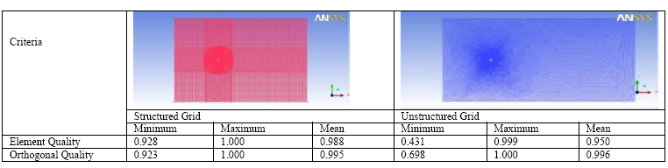

Based on the Table 8.1, it can be concluded that the best grid quality is the structured grid. The Table 1 shows that structured grid have better quality of element quality and orthogonal quality in term of minimum, maximum, and mean values. Therefore, the structured grid shall be used for further simulations.

8.3.2. Validation of CFD Simulations
The validation of the simulation is conducted by comparison between the simulation results with previous study. The comparison are made at $R_{e}$ = 40 and 200.

A) Steady Laminar Case at Re = 40
The simulation is set at $R_{e}$ = 40 and a steady laminar flow condition. The number of iteration for this simulation is 2000 with reporting interval is 1 and profile update interval is 1. The solution is converged at 339 iterations and yield $C_{d}$ equal to 1.632.
Table 8.3 shows the value of $C_{d}$ from the results of CFD simulation and the experiment results from previous study. The comparison of Cd values between the CFD simulation results and experiment results from previous study indicates that the value obtained from the CFD simulation is in good agreement to other measurements. The value of $C_{d}$ from CFD simulation from this study is within the range of the experiment values from the previous study. Therefore, the structured grid used for the CFD simulation shall be used for the simulations of vortex-induced vibration of 2D rigid riser at $R_{e}$ = 200, 1000, and 1500.

Table 8.3: Values of $C_{d}$ from experimental data and CFD simulation
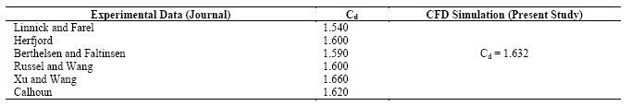

B) Transient (Unsteady) Case at R_{e} = 200
In this case, the rigid riser is exposed to the turbulent flow with Reynolds number of 200. The comparison is made with the experiment results as shown in Table 8.4. The Spalart-Allmaras turbulent model is selected for the turbulent model in modelling the transient flow case. 30 time steps/max iterations were chosen in one shedding cycle for Strouhal number of 0.2 (average estimation for flow past cylinder). The vortex shedding frequency for this case is 0.2 Hz and the time step is equal to 0.2 seconds with number of time steps of 1080. The simulations yield the value of $C_{d}$ =1.310 and $C_{l}$ = 0.602.

Table 8.4: The values of $C_{l}$ from experimental data and CFD simulation
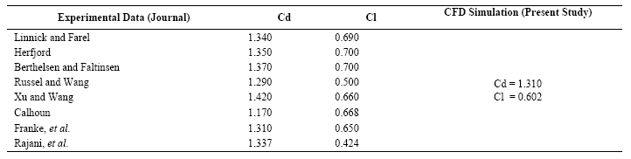

8.3.3. 2-D VIV Simulation
2D vortex-induced vibration at $R_{e}$ = 1000 and 1500 simulation will be discussed in the next section. The graphs of lift and drag coefficient is plotted against Reynolds number.

8.3.3.1. In-Line Vibration
Figure 8.8 shows the coefficient of drag against Reynolds number. The graph is plotted based on the values of coefficient of drag for each Reynolds number 40, 200, 1000, and 1500. The coefficient of drag is almost similar for each Reynolds number of 200, 1000, and 1500. The value of drag coefficient at Reynolds number 40 is higher compared to the value of drag coefficient at Reynolds number 200, 1000, and 1500. The Reynolds number of 40 is in the range of laminar flow where the vortex shedding will formed in a pair (two-attached re-circulating vortices) for the range of 40 < $R_{e}$ < 200. The Reynolds number 200 is in the range of turbulent flow, where the wake region behind the rigid riser experience the transition from laminar to turbulent in range 200 < $R_{e}$ < 300. The flow behind the rigid riser experiences complete turbulent for the Reynolds number 1000 and 1500 as the flow regime at range 300 < $R_{e}$ < 3.5x105 is complete turbulent flow.

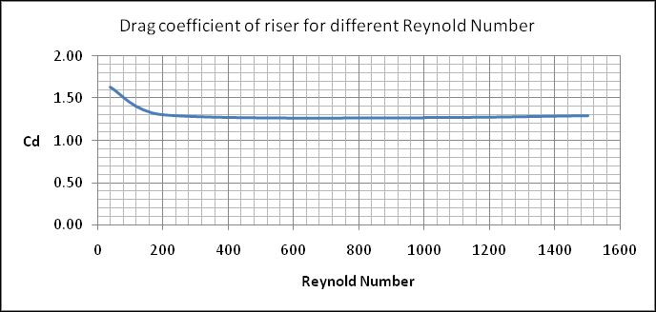
Figure 8.8: Graph of $C_{d}$ versus $R_{e}$ range 40 to 1500

For a laminar case ($R_{e}$ = 40), the drag coefficient is larger than the drag coefficient of turbulent flow ($R_{e}$ = 200, 1000, and 1500). This indicates that the drag force for laminar flow is larger than turbulent flow for Reynolds number 40 to 1500. Therefore, the in-line vibration of rigid riser for $R_{e}$ = 40 is higher than in-line vibration at $R_{e}$ = 200, 1000, and 1500.

8.3.3.2. Cross-Flow Vibration
Figure 8.9 shows the graph of lift coefficient against Reynolds number. The graph is plotted with the Reynolds number of 40, 200, 1000, and 1500. The graph indicates that for a Reynolds number range 40 to 1500, the value of lift coefficient increases. As mentioned in the above session, the Reynolds number of 40 is within the range of a laminar flow where the wake of laminar flow where the vortex shedding will form in a pair (two-attached re-circulating vortices). The Reynolds number 200 is in the range of turbulent flow, where the wake region behind the rigid riser experience the transition from laminar to turbulent in range 200 < $R_{e}$ < 300. The flow behind the rigid riser experiences complete turbulent for the Reynolds number 1000 and 1500 as the flow regime at range 300 < $R_{e}$ < 3.5x105 is complete turbulent flow.

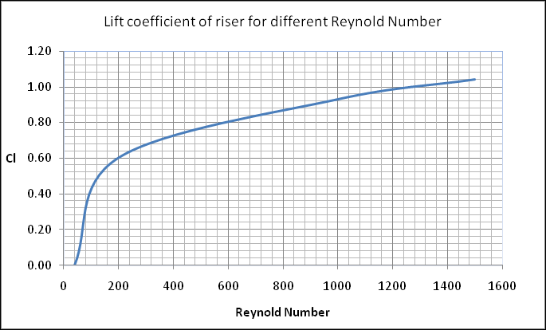
Figure 8.9: Graph of $C_{l}$ versus $R_{e}$ range 40 to 1500.

The simulation result of vortex-induced vibration of 2D rigid riser at $R_{e}$ = 40 yield the lift coefficient which almost zero that is 0.0018. This indicates that the cross-flow vibration at $R_{e}$ = 40 is very small as the vortex shedding in the flow regime behind the rigid riser body is symmetrical. Therefore, the pressure different is smaller as shown in Figure 8.10 and Figure 8.11. The value of lift coefficient increases significantly from $R_{e}$ = 40 to $R_{e}$ = 200 indicates that the cross-flow become significantly larger from the transition of laminar flow to turbulent flow. Therefore, the cross-flow vibration changes significantly during the transition of laminar flow to turbulent flow. The coefficient of lift increase (almost linear) from $R_{e}$ = 200 to $R_{e}$ = 1500.

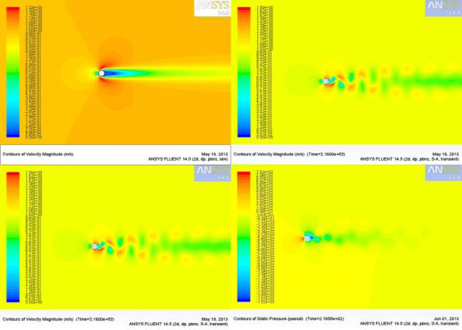
Figure 8.10: Contours of velocity magnitude ($R_{e}$ = 40, 200, 1000, and 1500)

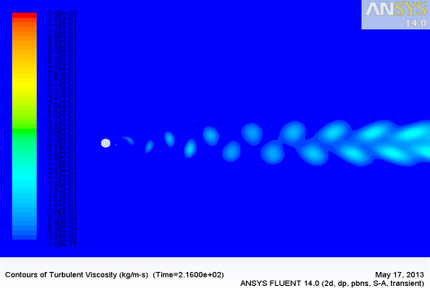
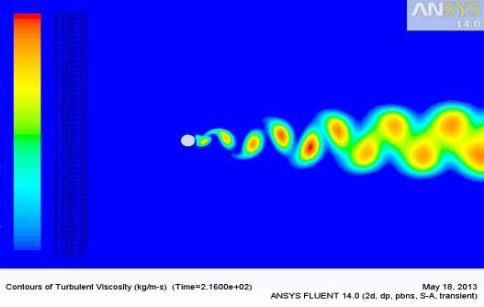
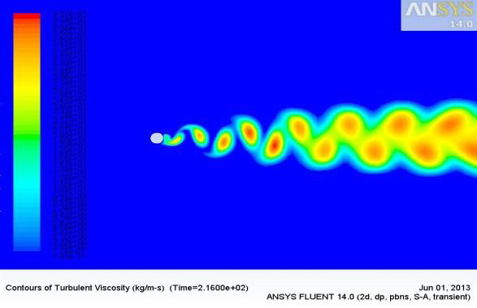
Figure 8.11: Contours of Turbulent Viscosity ($R_{e}$ = 200, 1000, and 1500).

8.4.1. Fatigue of offshore structure due to VIV
Long flexible cylinders (e.g., risers, tendons and mooring lines) exposed to the marine environment encounter ocean currents leading to vortex-induced vibration (VIV). These oscillations, often driven at high frequencies over extended periods of time, may result in structural failure of the member due to fatigue damage accumulation.
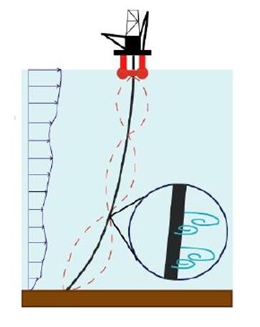
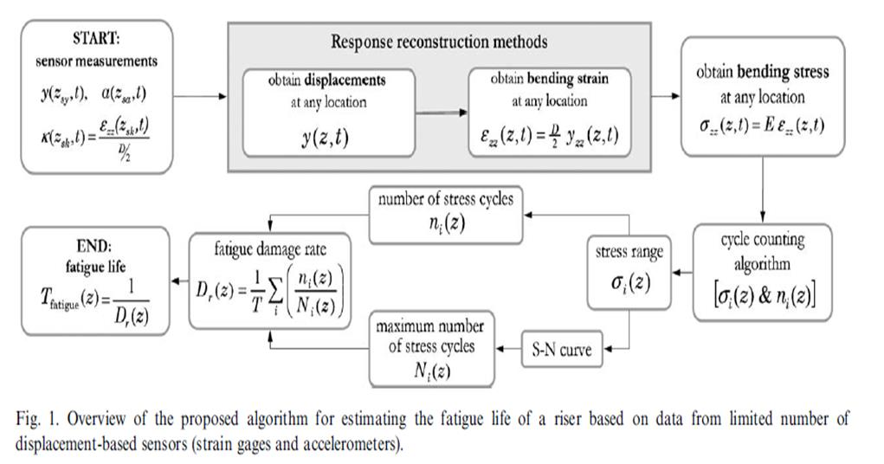
Monitoring VIV fatigue damage on marine risers (MIT proposed Method)

8.4. Vortex-Induced Vibration Prevention
There are several methods to prevent VIV such as using suppression devices and changes the structural properties.

8.4.1. Vortex-Induced Vibration Suppression Devices
Applying suppression devices to prevent VIV was first done on land based structures, i.e. structures subjected to wind, see Figure 8.12. The specific use of strakes to suppress VIV in wind has been used since the early 1960s (Allen, et al., 2008). For marine structures, efforts for developing VIV suppression devices in water started later, around the late 1970s.
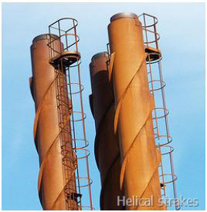
Figure 8.12: Helical strakes on chimney stacks to suppress VIV

Initially a variety of different VIV suppression devices were studied and many different devices have been proposed over the last three decades. Skaugset investigated the use of radial water jets in a helical pattern along the riser span (Lie & Larsen). The jets disrupted the vortex shedding process, thus reducing the CF and IL forces on the riser. Several proposals have been made for VIV suppression devices. Figure 8.13 illustrates some of the contributions to suppression devices (Blevins, 1994):
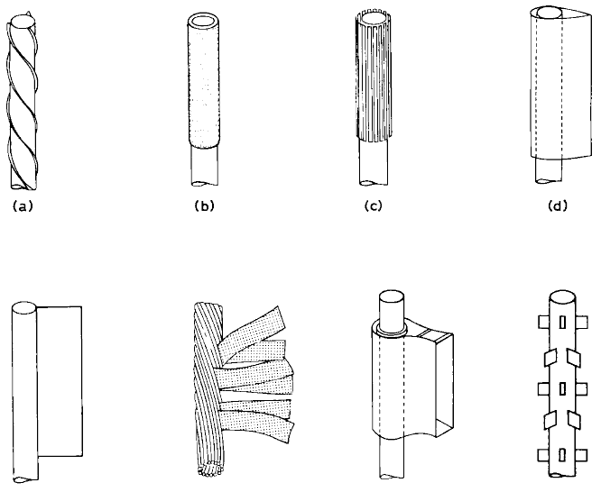

Helical strakes
Perforated shroud
Axial slats
Streamlined fairings
Splitter
Ribbon or hair cable

Figure 8.13: Various devices for VIV suppression

8.4.1.1. Helical Strakes
In the offshore industry however, active use of strakes to suppress VIV was not applied until the late 1970s. Helical strakes are used to “control” the vortex shedding process, that is, disrupt the span wise correlation of vortex shedding on the cylinder. This is perhaps the most common way of suppressing VIV is used in a range of different applications. Critical parameters for strake efficiency are height of strake, number of strake and pitch of strake.
Helical strakes are used to “control” the vortex shedding process, that is, disrupt the span wise correlation of vortex shedding on the cylinder. Figure 8.14 shows a simple sketch of how helical strakes disrupt the vortex shedding process. The riser to the left is bare. Under ideal conditions where influence from riser response has no effect on the shedding process, the vortex shedding will show strong correlation along the riser axis. Consequently, the time varying pressures as illustrated in Figure 8.14 will act on a significant area of the riser, resulting in CF and IL forces.
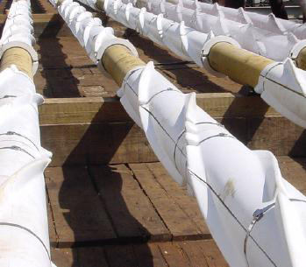 | 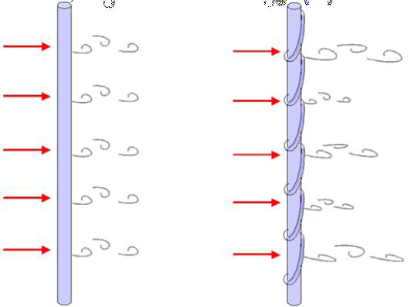
(a)
(b)
Figure 8.14: (a) Helical strakes, (b). Drag coefficient for circular cylinder, smooth and rough surface (Schlichting & Gertsen, 2000).

On the riser to the right, the sharp edges on the strakes force the flow to separate at the strake instead of on the cylinder surface (Lamb, 1991). This means that even though vortices indeed are shed, the geometry of the strakes disrupt the axial correlation of the vortices. This is seen in Figure 8.14 as the strength and location of the shed vortices are varying in the span wise direction. Thus, the global lift-and drag forces are reduced.

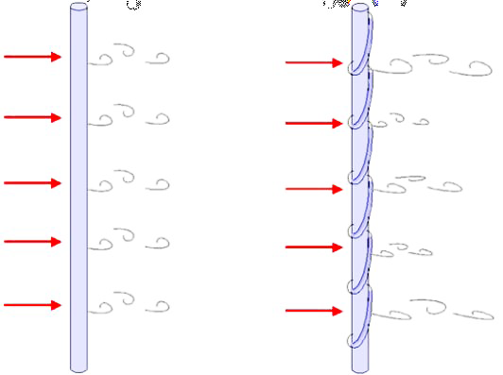
Figure 8.15: Helical strakes controlling the vortex shedding.

Several different strake geometries have been tested to find the most efficient configuration. From tests in wind tunnels a geometry with three starts, pitch of 5D and fin height equal to 0.1D was found to be most efficient for VIV suppression in wind. See Figure 8.16 for strake geometry description.

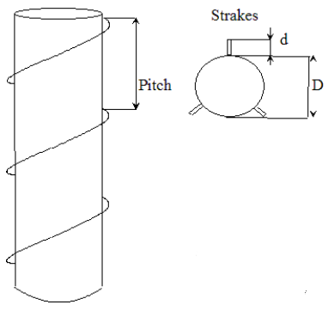
Figure 8.16: Helical strakes parameters illustrated (DNV, 2010)

In water a configuration of triple-start strakes, strake height d=0.25D and pitch equal to 17.5D was found to be more efficient than the previous models from wind tunnel tests. Most helical strakes used for VIV suppression in the offshore industry today have this configuration, or similar strake height with slightly different pitch, usually in the 15-20D range (Allen, et al., 2008).

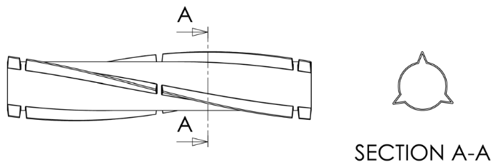
Figure 8.17: Typical helical strake configuration with three starts (Allen, et al., 2008)

8.4.1.2. Perforated Shroud
A perforated shroud may be fitted outside the cylinder section to suppress VIV. Blevins (Blevins, 1994) states the following parameters for maximum suppression efficiency:
- Shroud outside diameter: 1.25D
- Per cent open area: 30-40%
- Hole geometry: 0.125D

8.4.1.3. Axial Slats
- Slat shroud outside diameter: 1.29D
- Slat width: 0.09D
- Per cent open area: 40%
- Number of slats around circumference: 25-30

8.4.1.4. Streamlined Fairings
Along with helical strakes, streamlining of riser sections is today regarded as an efficient way of suppressing VIV. Fairings has been used on a numerous of deep water Gulf of Mexico risers with success (Allen, et al., 2008). Critical parameters are chord length and thickness of fairing.

8.4.1.5. Splitter
The splitter length is 4-5 times the riser diameter to be effective.

8.4.1.6. Ribbon or hair cable
Ribbons or hair cables may be used to prevent organized vortex formation in the wake of the cylinder section, and thus preventing VIV. Figure 8.18 shows incident flow on a bare cylinder. The wake clearly shows organized shed vortices. Figure 8.19 shows the same cylinder in the same flow, but fitted with ribbons. Shed vortices in the wake are significantly reduced.

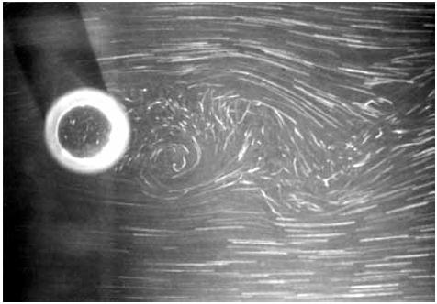
Figure 8.18: Regular cylinder with no ribbons attached

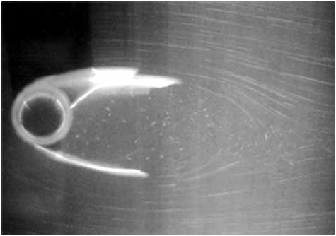
Figure 8.19: Cylinder with ribbons attached to trailing edge

This type of suppression device has many advantages over other devices like helical strakes. The advantages include ease of fabrication, simple design, easy handling and low maintenance (Kumar, et al., 2007). Blevins (Blevins, 1994) gives the following parameters:
- Ribbon width: 1-2D
- Ribbon length: 6-10D
- Ribbon thickness: 0.05D

8.4.1.7. Guide vane
The guide vanes work in a similar way as the streamlined fairing, namely by reducing flow separation around the cylinder. Design of a typical guide vane includes:
- Plate length of roughly 1D
- Lateral separation between the trailing edges of 0.9D.

8.4.1.8. Spoiler plates
Spoiler plates have proved to disrupt the vortex formation and shedding, and thus reducing vortex induced oscillations. Experiments have found a reduced excitation of up to 70% by use of spoilers (Kumar, et al., 2007). A trade-off however, is increased drag. Suggested spoiler geometry and configuration:
- Plate size: squares, D/3 on each side
- Number of plates: 4 in a circumferential ring
- Distance between plates: 2/3 D axial distance

8.4.2. Changes to riser structural properties
As mentioned earlier, VIV are oscillations at resonance. Thus, avoiding resonance would be an efficient way of avoiding the phenomenon. This means that the reduced velocity is kept lower than 1 (Blevins, 1994).

$U_{R}=\frac{U}{Df_{n}}<1$ (8.10)

Increasing the stiffness of the structure will increase the Eigen frequency of the structure, thus reducing the reduced velocity. For longer riser sections, however, this will in practice not be possible as higher mode Eigen frequencies will be excited.
Oscillations at resonance can be significantly decreased if the reduced damping of the structure is sufficiently high. Assuming a harmonic time varying lift force acting on the riser section

$F_{L}=\frac{1}{2}C_{L}ρDU^{2}∙\sin\left(ω_{s}t\right)$ (8.11)

Equation of motion thus becomes

$m\ddot{y}+2mζω_{0}\dot{y}+ky=\frac{1}{2}C_{L}ρDU^{2}∙\sin\left(ω_{s}t\right)$ (8.12)

Where; $y$ is CF displacement, $m$ is mass per unit length, added mass included, $ζ$ is structural damping factor, $k$ is spring stiffness and $ω_{0}$is Eigen frequency.
Assuming the steady-state solution is given as

$y\left(t\right)= A_{y}\sin\left(ω_{s}t+φ\right)$ (8.13)

$\frac{d^{2}(y)}{dt^{2}}=\ddot{y}=-{ω_{s}}^{2}A_{y}\sin\left(ω_{s}t+φ\right)$

$\frac{d(y)}{dt}=\dot{y}=ω_{s}A_{y}\cos\left(ω_{s}t+φ\right)$

Inserting Equation 8.13 into Equation 8.12 and differentiating gives the solution

$$m\left(-{ω_{s}}^{2}A_{y}\sin\left(ω_{s}t+φ\right)\right)+2mζω_{0}\left(ω_{s}A_{y}\cos\left(ω_{s}t+φ\right)\right)+k\left(A_{y}\sin\left(ω_{s}t+φ\right)\right)=\frac{1}{2}C_{L}ρDU^{2}∙\sin\left(ω_{s}t\right)$$

$yk\sqrt{{\left[1-{\left(\frac{ω_{s}}{ω_{0}}\right)}^{2}\right]}^{2}+{\left(\frac{2ςω_{s}}{ω_{0}}\right)}^{2}}=\frac{1}{2}C_{L}ρDU^{2}∙\sin\left(ω_{s}t\right)$ (8.14)

The largest amplitudes occur when the shedding frequency ($ω_{s}=2πf_{s}$) approaches the Eigen frequency of the cylinder, $ω_{s}=ω_{0}$, the equation 8.14 can be written as:

$yk\left(\frac{2ςω_{s}}{ω_{0}}\right)=\frac{1}{2}C_{L}ρDU^{2}∙\sin\left(ω_{s}t\right)$ (8.15)

Inserting Equation 8.13 into Equation 8.15 gives resonant amplitude

$\left(A_{y}\sin\left(ω_{s}t+φ\right)\right)k\left(\frac{2ςω_{s}}{ω_{0}}\right)=\frac{1}{2}C_{L}ρDU^{2}∙\sin\left(ω_{s}t\right)$

${\left.\frac{A_{y}}{D}\right|}_{ω_{s}=ω_{0}}=\frac{C_{L}ρU^{2}}{4kς}=\frac{C_{L}}{4πS^{2}δ_{r}}$ (8.16)

The right hand side of Equation 8.16 applies the Strouhal number relationship and the natural frequency relationship given in Equation 8.8 in Equation 8.16 denotes the reduced damping, given as

$δ_{r}=\frac{2m\left(2πζ\right)}{ρD^{2}}$ (8.17)

Blevins (Blevins, 1994) has found that a reduced damping ($δ_{r}$) larger than 64 reduces peak resonate amplitudes to less than $0.01∙D$. However, for most marine structures the reduced damping is smaller than one (Larsen, 2011).
As can be seen from the above discussion, avoiding VIV through modifying the marine structure and its properties has proved to be difficult. Therefore VIV suppression devices have been used to increase the hydrodynamic damping and disrupt the vortex shedding process to reduce VIV oscillations.

Chapter 9

9.0. Offshore Risers Installation

9.1. Ship Stability
Ship stability is an area of naval architecture and ship design that deals with how a ship behaves at sea, both in still water and in waves, whether intact or damaged. Stability calculations of a ship focus on the center of gravity (CG), center of buoyancy (CB), and metacenter of vessels and on how these interact as shown in Figure 9.1.

M

G

$$Waterline$$

B

K

Figure 9.1: Component of floating stability.

From the figure, $M$ is metacentric, $G$ is center of gravity, $B$ is center of buoyancy and K is the keel. The keel is the base line reference point from which all other reference point measurements are compared.

9.1.1. Centre of Buoyancy (CB)
Centre of buoyancy ($CB$) can be defined as the geometrical centre of the underwater volume and the point through which the total force of buoyancy may be considered to act vertically upwards with a force equal to the weight of the water displaced by the body. The geometric centre of the ship is underwater hull body. It is the point at which all the forces of buoyancy may be considered to act in a vertically upward direction.

M

G
$$Waterline$$

B

K

Pressure

Figure 9.2: Pressure around the hull.

The Centre of Buoyancy ($CB$) will move which depends the shape of the submerged portion of the hull body changes. The CB will shift to starboard when the ship rolls to starboard “$B_{1}$”, otherwise, the CB will shift to port when the ship rolls to port “$B_{1}$”.
K
B

$$Waterline$$

$$B_{1}$$

Figure 9.3: Center of buoyancy shift to starboard.

During loading condition, draft of a ship increase due to weight of a ship increase, then the CB will shift up “$B_{1}$”. Otherwise, when the ship’s hull is lightened during unloading, the drafts decrease as the ship sits shallower in the water, then the CB will shift down”$B_{1}$” in which the CB shifts in the same direction as the ship’s waterline.
$$Waterline$$

$$B_{1}$$

B

K

Figure 9.4: CB shifts up due to increasing load.

9.1.2. Centre of Gravity (CG)
Centre of Gravity (CG) is the centre of mass of the ship where all the forces of gravity working on the ship can be considered to act "G". The position of CG is dependent upon the distribution of weights within the ship. As the distribution of weights is altered, the position of “$G$” will react as follows: “G” moves towards a weight addition, “G” moves away from a weight removal, “G” moves in the same direction as a weight shift.

Removed
M

G

Added
$$Waterline$$

B

K

Figure 9.5: CB shifts when weight is removed/added/shifted.

9.1.2.1. Effect of Discharging Mass
In order to know the effect of removing mass on centre of gravity, let consider a rectangular plank as shown picture below. The effects of adding or removing weights would be as shown:
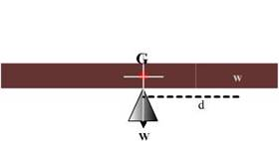 | 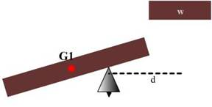
Figure 9.6: Simple of picture shown effect of Discharging Mass [JOANE].

If we cut the length of plank of mass ‘$w$’ kg whose CG is ‘$d$’ meters away from CG of the plank. Note that a resultant moment of ‘$w x d’$ kg m has been created in an anti-clockwise direction about ‘G’. The CG of the new plank shifts from ‘G’ to ‘G1’.
The new mass ($W-w$) kg now creates a tilting moment of $(W-w) x GG1$ about G.
Since both are referring to the same moment,

$(W-w) x GG1 = w x d$ (9.1)

$GG1 = (w x d)/(W-w)$ (9.2)

When a weight is removed from a body, the CG shifts directly away from the CG of the mass removed, and the distance it moves is given by:

$GG1 = (w x d)/Final mass$ (9.3)
Where, $GG1$ is the shift of CG, $w$ is the mass removed, $d$ is the distance between the CG of the mass removed and the CG of the body.

9.1.2.2. Effect of adding or loading mass
Equating the tilting moments created due to the added weight, which must again be equal:
$(W + w) x GG1 = w x d$
$GG1 = (w x d)/(W + w)$
$GG1 = (w x d)/ (Final mass)$ (9.4)

9.1.2.3. Application to ships
Discharging Weights:
$GG1 = (w x d) / (Final displacement)$ (9.5)

Loading Weights
$GG1 = (w x d) / (Final displacement)$ (9.6)

Shifting Weights
$GG2 = (w x d) / (Displacement)$ (9.7)

A. Vertical Weight Shifts
Shifting weight vertically, no matter where on board it is, will always cause the ship’s centre of gravity to move in the same direction as the weight shift.
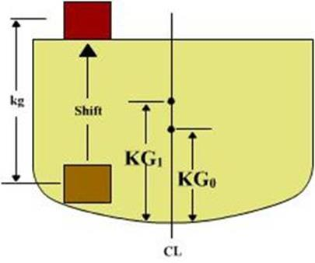
$$G_{o}$$
$$G_{1}$$

Figure 9.7: Center of gravity shifts up when weight is shifted up.

In order to calculate the height of the ship’s centre of gravity after a vertical weight shift, the following equation is used:
${KG}_{1} = ((Δ_{o} x {KG}_{0}) +/- (w x kg)) / Δ_{F}$ (9.8)

Where: ${KG}_{0}$ is the original height of the ship’s center of gravity (M), $Δ_{o}$ is the ship’s displacement prior to shifting weight (MT), $w$ is the amount of weight shifted (MT), $kg$ is he vertical distance the weight was shifted (M), $Δ_{F}$ is the ship’s displacement after shifting the weight (MT), ($+$) When the weight is shifted up use ($+$) and ($-$) When the weight is shifted down use ($-$).
B. Vertical Weight Additions or Removals
When weight is added or removed to/from a ship, the vertical shift in the center of gravity is found using the same equation.
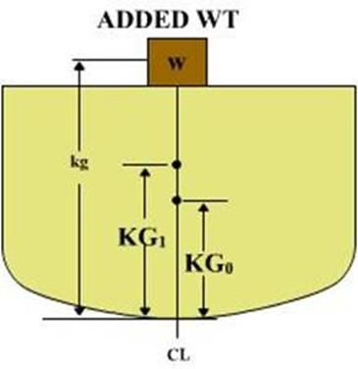
$$G_{o}$$
$$G_{1}$$

Figure 9.8: Center of gravity shifts up when weight is added.

${KG}_{1} = ((Δ_{o} x {KG}_{0}) +/- (w x kg)) / Δ_{F}$ (9.9)
Where: ${KG}_{0}$ is the original height of the ship’s center of gravity (M), $Δ_{o}$ is ship’s displacement prior to adding/removing weight (MT), $w$ is the amount of weight added or removed (MT), $kg$ is the height of the center of gravity of the added/removed weight above the keel (M), $Δ_{F}$ is the ship’s displacement after adding/removing the weight, ($+$) When the weight is added use ($+$) and ($-$) When the weight is removed use ($-$)

Example Problem
A ship with displacement ( $Δ_{o}$) is 3500 MT and ${KG}_{0}$ is 6 M. If a cargo with 30 MT crate is added 10 M above the keel, calculate the new height of the ship’s center of gravity (${KG}_{1}$)?
${KG}_{1} = ((Δ_{o} x {KG}_{0}) +/- (w x kg)) / Δ_{F}$
${KG}_{1} = ((3500 x 6) + (30 x 10)) / 3530$
${KG}_{1} = 6.034$ M

C. Horizontal Weight Shifts
Shifting weight horizontally, no matter where on board it is, will always cause the ship’s centre of gravity to move in the same direction as the weight shift. Noted: A weight shift causing the ship’s centre of gravity to move off centre line will always reduce the stability of the ship.

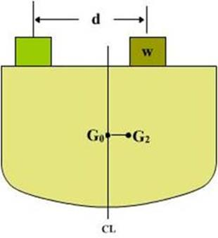
Figure 9.9: Center of gravity shifts to starboard when weight is shifted to starboard.

To calculate the horizontal movement of the ship’s centre of gravity, the following equation is used:
${GG}_{2} = (w x d) / Δ_{F}$ (9.10)
Where: $w$ is the amount of weight shifted (MT), $d$ is the horizontal distance the weight is shifted (M), $Δ_{F}$ is the ship’s displacement after the weight is shifted (MT).

Example Problem
A ship with displacement ( $Δ_{o}$) is 3200 MT. If a cargo of 50 MT weight is shifted 10 M to starboard, then calculate the change in the centre of gravity (${GG}_{2}$)?
${GG}_{2} = (w x d) / Δ_{F}$
${GG}_{2} = (50 x 10) / 32000$
${GG}_{2} = 0.01562$ M

D. Horizontal Weight Additions or Removals
When an off-centre weight is added or removed to/from a ship, the ship’s centre of gravity will move off centreline, the ship will develop a list.

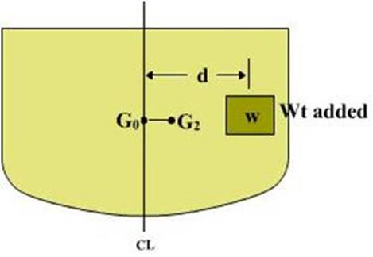
Figure 9.10: Center of gravity shifts to starboard when weight is added at starboard.

To calculate the horizontal movement of the ship’s centre of gravity after adding/removing an off-centre weight, the same equation is used:

${GG}_{2} = (w x d) / Δ_{F}$ (9.11)

Where: $w$ is the amount of weight added/removed (MT), $d$ is the distance from the centre of gravity of the weight to the ship’s centreline (M), $Δ_{F}$ is the ship’s displacement after the weight is shifted (MT).

Example Problem
A ship with displacement ( $Δ_{o}$) is 4800 MT. If 50 MT of cargo is loaded onto the Tween deck, 10 M from centreline, then calculate the change in the centre of gravity (${GG}_{2}$)?
${GG}_{2} = (w x d) / Δ_{F}$
${GG}_{2} = (50 x 10) / 48000$
${GG}_{2} = 0.0104$ M

H. Effect of Suspended Weights
The Centre of Gravity ($CG)$ of floating body is the point through which the force of gravity may be considered to act vertically downwards. For a suspended weight, whether the vessel is upright or inclined, the point through which the force gravity may be considered to act vertically downwards is $g_{1}$, the POINT OF SUSPENSION.
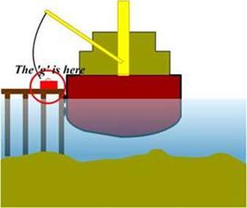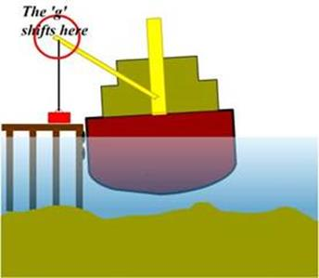
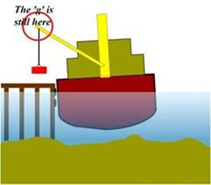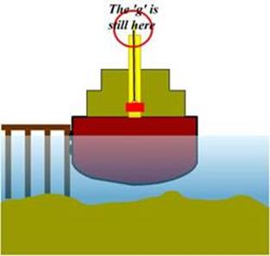
Figure 9.11: Effect of suspended weights on stability of a ship [JOANE].

In the conclusions it would like to say that:
- The CG of a body will move directly TOWARDS the CG of any weight ADDED.
- The CG of a body will move directly AWAY from the CG of any weight DISCHARGED.
- The CG of a body will move PARALLEL to the shift of the CG of any weight MOVED within the body.

9.1.3. Centre of Metacentric (CM)
As the ship is inclined through small angles of heel, the lines of buoyant force intersect at a point called the metacentric ($M$). As the ship is inclined, the centre of buoyancy moves in an arc as it continues to seek the geometric centre of the underwater hull body. This arc describes the metacentric radius.
As the ship continues to heel in excess of 7-10 degrees, the metacentre will move as shown in Figure 9.11. The position of the metacentre is a function of the position of the centre of buoyancy, thus a function of the displacement of the ship. The position of “M” moves as follows:
- As the Centre of Buoyancy moves up, the Metacentre moves down.
- As the Centre of Buoyancy moves down, the Metacentre moves up.

$$M$$
K
B

$$Waterline$$

$$B_{1}$$

Figure 9.12: Metacentric point of a ship.

9.2. Intact Stability
Intact stability calculations are relatively straightforward and involve taking all the centers of mass of objects on the vessel which are then calculated to identify the center of gravity of the vessel, and the center of buoyancy of the hull. Cargo arrangements and loadings, crane operations, and the design sea states are usually taken into account.

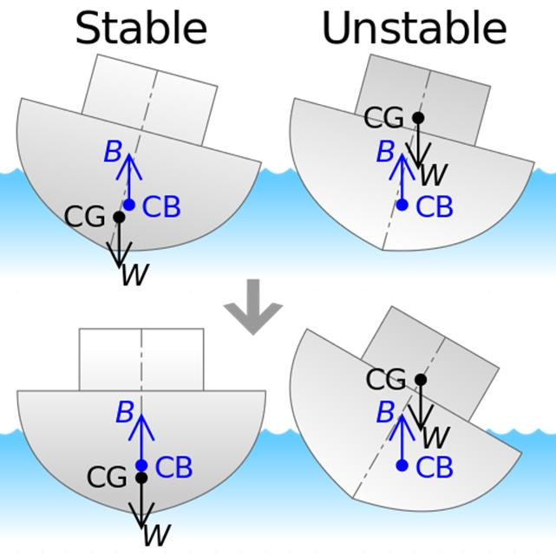
Stable
Unstable
Figure.9.13: Illustration of the stability of bottom-heavy (left) and top-heavy (right) ships with respect to the positions of their center of buoyancy (CB) and gravity (CG) [JOANE].

9.3. Installation of Riser
Various methods are used to install offshore risers. The method of installation determines the type of analyses that must be performed.

Figure 9.14: Typical types of offshore riser installation

9.3.1. Laying by Lay Vessel
Pipe laying method includes the S-lay and J-lay by a lay vessel involves joining pipe joints on the lay vessel, where welding, inspection, and field joint coating take place at a number of different workstations. Figure.9.2 illustrates the S-lay and J-Lay method. Pipe laying method progresses with the lay vessel moving forward on its anchors. The pipe is placed on the seabed in a controlled S-bend shape. The curvature in the upper section, or the over bending, is controlled by a supporting structure, called a stinger that is fitted with rollers to minimize damage to the pipe. The curvature in the lower portion is controlled by application of tension on the vessel using special machines.

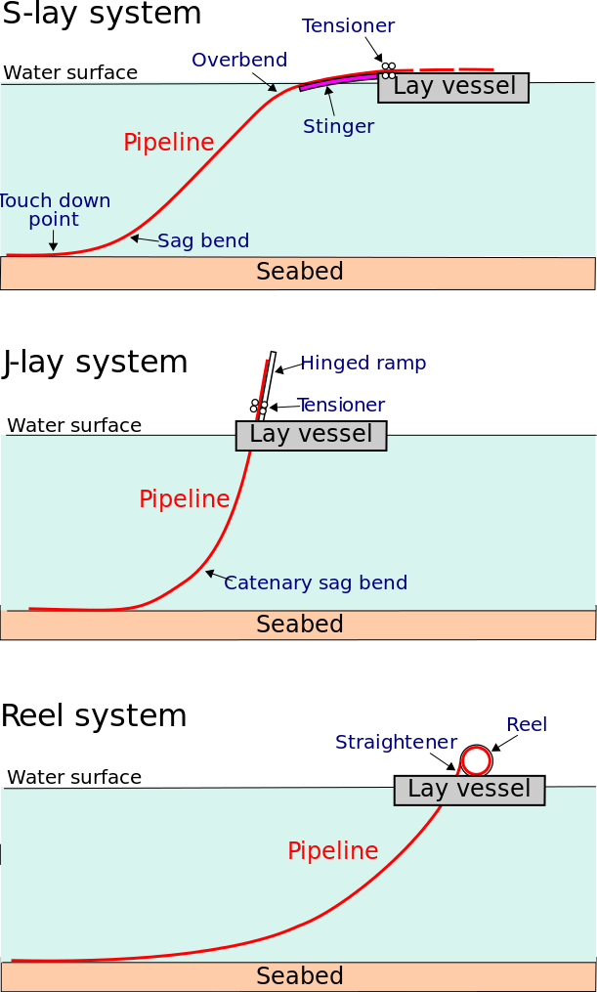
Figure 9.15: Typical Pipe Configuration during S-Lay and J-Lay of offshore riser installations

The pipeline designer must analyse the pipe-lay configuration to establish that the correct tension capacity and barge geometry have been used and that the pipe will not be damaged or overstressed during the laying process.
An appropriate analysis can be performed by a range of methods, from a simple catenary analysis that provides approximate solutions, to a precise analysis that uses finite element analysis. The main objective of the analysis is to identify stress levels in two main areas. The first is on the stinger where the pipe can undergo high bending, especially at the last support. Because the curvature can now be controlled, the pipeline codes generally allow a small safety factor. The second high-stress area is in the sag bend where the pipe is subject to bending under its own weight. The curvature at the sag bend varies with the pipeline’s lay tension and, consequently, is less controllable than the over-bend area.
In all cases the barge geometry and tension are optimized to produce stress levels in the pipe wall that stay within specified limits.

9.3.2. Laying by Reel Ship
The pipe reeling method has been applied widely in the North Sea and Gulf of Mexico for pipeline sizes up to 18 in. The pipeline is made up onshore and is reeled onto a large drum on a purpose-built vessel as shown in Figure.4-6. During the reeling process the pipe undergoes plastic deformation on the drum. During installation the pipe is unreeled and straightened using a special straightening ramp. The pipe is then placed on the seabed in a configuration similar to the J-lay configuration that is used by the laying barge, although in most cases a steeper ramp is used and over-bend curvature is eliminated. The analysis of the reeled pipe-laying method can be carried out using the same techniques as for a laying vessel. Special attention must be given to the compatibility of the reeling process with the pipeline steel grade since the welding process can cause unacceptable work hardening in higher grade steels. A major consideration in pipeline reeling is that the plastic deformation of the pipe must be kept within limits specified by the relevant codes, such as DNV-RP-F108. Existing reel ships reflect such code requirements.

Figure 9.16: Typical pipe configurations during reel-system offshore riser installations.

Chapter 10

10.0. Application of Finite Element on Risers

10.1. Displacement
By using basic theory of spring method, the riser is modeled as a line, which is divided into a series of line segments as shown in Figure 10.1. The line segments only model the axial and torsional properties of the line. The other properties such as mass, weight, buoyancy, etc. are all lumped to the nodes. A simple lumped mass model of the riser is shown in Figure 10.1. The riser is discrete into $N$ lumped mass nodes. Massless springs are used to connect nodes in consideration of the tangential elasticity of the line.

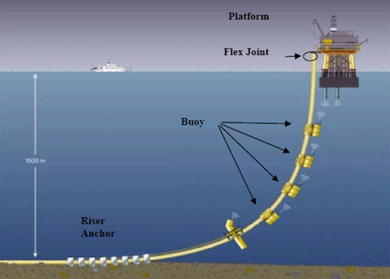
Figure 10.1: Application of lumped mass model of riser.

The force that spring experience will have to be same, otherwise the springs would buckle. Now by applying the famous hook's law, this means that
$F=k x$ (10.1)

Where; $F$ is external force, $k$ is stiffness of riser, $x$ is displacement.
The equations of forces for the j-th lumped mass node can be written in global coordinates. In order to solve the problem, one thing should be thought before creating the mathematical model which is about node-2. From figure below, node-2 is connected to both spring-1 and spring-2. Therefore, it would be experiencing forces from two springs and the force labeled as $F_{2}$ is the total force of the two component forces.

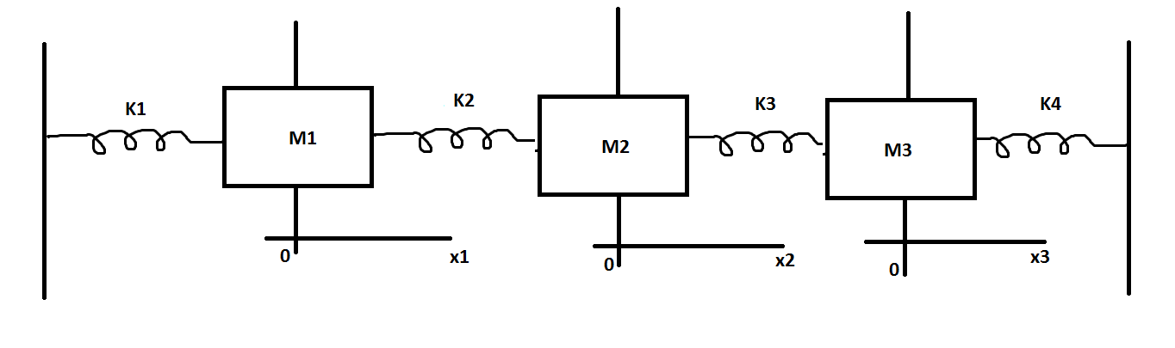
Equilibrium point for node 2
Equilibrium point for node 4
Equilibrium point for node 3
Displacement of node 4
Displacement of node 2
Displacement of node 3
$$F_{5}$$
$$x_{5}$$
$$x_{1}$$
$$x_{2}$$
$$x_{3}$$
$$x_{4}$$
$$F_{4}$$
$$F_{3}$$
$$F_{2}$$
$$F_{1}$$
Figure 10.2: simplification of finite element method on riser.

As shown in the Figure 10.2, since node-2 is influenced by two elastic forces which is one from spring-1 and other from spring-2, therefore total force on node-2 ($F_{2}$) can be described as follows:

$$F_{2}=\underset{elastic force by spring-1 acting on Node-2}{\underbrace{f_{1}^{2}}}+\underset{elastic force by spring-2 acting on Node-2}{\underbrace{f_{2}^{2}}}$$
(10.2)

By applying Eq.10.1, We can draw out four equations as follows.

$\left\{\begin{aligned}F_{1} = k_{1}\left(x_{1}-x_{2}\right) \\ f_{1}^{2}= k_{1}\left({-x}_{1}+x_{2}\right), f_{2}^{2}= k_{2}\left(x_{2}-x_{3}\right) \\ f_{2}^{2}= k_{2}\left({-x}_{2}+x_{3}\right), f_{3}^{2}= k_{3}\left(x_{3}-x_{4}\right) \\ f_{3}^{2}= k_{3}\left({-x}_{3}+x_{4}\right), f_{4}^{2}= k_{4}\left(x_{4}-x_{5}\right) \\ F_{5} = k_{4}\left({-x}_{4}+x_{5}\right)\end{aligned}\right.$ (10.3)

Since the two equations (the second and third one is the force being applied to a single node (Node 2). We can combine the two equations n and as result we would finally have three equations as follows.

$\left\{\begin{aligned}F_{1} = k_{1}x_{1}-k_{1}x_{2} \\ F_{2} = -k_{1}x_{1}+\left(k_{1}+k_{2}\right)x_{2}-k_{2}x_{3} \\ F_{3} = -k_{2}x_{2}+\left(k_{2}+k_{3}\right)x_{3}-k_{3}x_{4} \\ F_{4} = -k_{3}x_{3}+\left(k_{3}+k_{4}\right)x_{4}-k_{4}x_{5} \\ F_{5} = -k_{4}x_{4}+k_{4}x_{5}\end{aligned}\right.$ (10.4)

Now we have a set of simultaneous equation comprised of 3 equations (10.2-10.4). As you already seen above, a simultaneous equation can easily be converted into a matrix equation as follows.

$\left[\begin{matrix}F_{1} \\ F_{2} \\ F_{3} \\ F_{4} \\ F_{5}\end{matrix}\right]=\left[\begin{matrix}k_{1} & -k_{1} & & & \\ -k_{1} & \left(k_{1}+k_{2}\right) & -k_{2} & & \\ & -k_{2} & \left(k_{2}+k_{3}\right) & -k_{3} & \\ & & -k_{3} & \left(k_{3}+k_{4}\right) & -k_{4} \\ & & & -k_{4} & k_{4}\end{matrix}\right]\left[\begin{matrix}x_{1} \\ x_{2} \\ x_{3} \\ x_{4} \\ x_{5}\end{matrix}\right]$ (10.5)

$$\left[\begin{matrix}F_{1} \\ F_{2} \\ F_{3} \\ F_{4} \\ F_{j-1} \\ F_{j}\end{matrix}\right]=\left[\begin{matrix}k_{1} & -k_{1} & & & & \\ -k_{1} & \left(k_{1}+k_{2}\right) & -k_{2} & & & \\ & -k_{2} & \left(k_{2}+k_{3}\right) & -k_{3} & & \\ & & -k_{3} & \left(k_{3}+k_{4}\right) & -k_{4} & \\ & & & -k_{j-2} & \left(k_{j-2}+k_{j-1}\right) & -k_{j-1} \\ & & & & -k_{j-1} & k_{j-1}\end{matrix}\right]\left[\begin{matrix}x_{1} \\ x_{2} \\ x_{3} \\ x_{4} \\ x_{j-1} \\ x_{j}\end{matrix}\right]$$
(10.6)

Figure 10.3 shows the lumped mass–spring configuration at the j-th node. The force on the j-th node contains line tensions $T$ and $T_{j-1}$, the angles between segment and x-axis $θ_{j}$ and $θ_{j-1}$, node gravity $δ_{j}$, drag forces $f_{dxj}$and $f_{dzj}$. The forces for j-th node can be written as
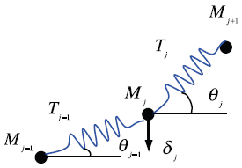
Figure 10.3: Lumped mass–spring configuration at j-th node
$\left[\begin{matrix}F_{xj} \\ F_{zj}\end{matrix}\right]=\left[\begin{matrix}T_{j}\cos{θ_{j}}-T_{j-1}\cos{θ_{j-1}}-f_{dxj} \\ T_{j}\sin{θ_{j}}-T_{j-1}\sin{θ_{j-1}}-f_{dzj}-δ_{j}\end{matrix}\right]$ (10.7)

Drag forces $f_{dxj}$ and $f_{dzj}$ may be derived from Morrison equations as follows

$\left[\begin{matrix}f_{dxj} \\ f_{dzj}\end{matrix}\right]=\left[\begin{matrix}-\frac{ρ}{2}D_{c}l\left(C_{dn}\sin{θ_{j}}\left|u_{nj}\right|u_{nj}-C_{dt}\cos{θ_{j}}\left|u_{tj}\right|u_{tj}\right) \\ \frac{ρ}{2}D_{c}l\left(C_{dn}\cos{θ_{j}}\left|u_{nj}\right|u_{nj}-C_{dt}\sin{θ_{j}}\left|u_{tj}\right|u_{tj}\right)\end{matrix}\right]$ (10.8)

$\left[\begin{matrix}u_{nj} \\ u_{tj}\end{matrix}\right]=\left[\begin{matrix}-\left({\dot{x}}_{j}-c_{j}\right)\sin{θ_{j}}+{\dot{z}}_{j}\cos{θ_{j}} \\ \left({\dot{x}}_{j}-c_{j}\right)\cos{θ_{j}}+{\dot{z}}_{j}\sin{θ_{j}}\end{matrix}\right]$ (10.9)

Where; $C_{dn}$ and $C_{dt}$ are the normal and tangential drag coefficients, respectively, and $c_{j}$ is the current speed. The influence of marine growth needs to be considered in the definition of drag coefficients. They are assumed to increase linearly with growth thickness, which depends on operational measures as well as structural behavior.

10.2. Oscillation Frequency
The $x(t)$ is displacement of cylinder can be written as

$x\left(t\right)=A_{x}\sin\left(ω_{s}t\right)$ (10.10)

Where; $A_{x}$ is the excitation amplitude of the cylinder.
Differentiation of the displacement ($x$) with respect to time, velocity ($\dot{x}$) and acceleration ($\ddot{x}$) can be written as

$\dot{x}=ω_{s}A_{x}\cos\left(ω_{s}t\right)$

$\ddot{x}=-{ω_{s}}^{2}A_{x}\sin\left(ω_{s}t\right)$. (10.11)

Let’s we call Eq.8.2 as written below

$\left(m+m_{a}\right)\ddot{x}(t)+kx(t)=0$

Inserted Eq.10.10 and Eq.10.11 into equation above, then this gives the still water response frequency of the cylinder:

$-\left(m+m_{a}\right){ω_{s}}^{2}A_{x}\sin\left(ω_{s}t\right)+kA_{x}\sin\left(ω_{s}t\right)=0$

$\left(m+m_{a}\right){ω_{s}}^{2}=k$

$ω_{s}=2πf_{s}=\sqrt{\frac{k}{\left(m+m_{a}\right)}}$

$f_{s}=\frac{1}{2π}\sqrt{\frac{k}{\left(m+m_{a}\right)}}$ (10.12)

10.3. Motion of Riser
The equations of motion for the j-th lumped mass node can be written in global coordinates as follows

$\left(m_{j}+m_{aj}\right){\ddot{x}}_{j}=F_{j}$ (10.13)

Where; $m_{j}$ is the mass matrix, $m_{aj}$ is the added mass matrix, $x_{j}$ is the displacement vector, and $F_{j}$ is the external force.
Using the Figure 10.7, Equation 10.13 can be rewritten as follows

$\left(m_{j}+A_{nj}\sin^{2}{θ_{j}}+A_{tj}\cos^{2}{θ_{j}}\right){\ddot{x}}_{j}+\left(A_{tj}-A_{nj}\right){\ddot{z}}_{j}\sin{θ_{j}}\cos{θ_{j}}=T_{j}\cos{θ_{j}}-T_{j-1}\cos{θ_{j-1}}-f_{dxj}$

$\left(m_{j}+A_{nj}\cos^{2}{θ_{j}}+A_{tj}\sin^{2}{θ_{j}}\right){\ddot{z}}_{j}+\left(A_{tj}-A_{nj}\right){\ddot{x}}_{j}\sin{θ_{j}}\cos{θ_{j}}=T_{j}\sin{θ_{j}}-T_{j-1}\sin{θ_{j-1}}-f_{dzj}-δ_{j}$
(10.14)
Where; $A_{nj}$ and $A_{tj}$ are the normal and tangential added mass, respectively; ${\ddot{x}}_{j}$ and ${\ddot{z}}_{j}$ are the acceleration of the j-th node at two directions.
In order to solve of the equations of motion in equation 10.8, the following initial and boundary conditions at the anchor position and displacement excitation at node-N should be introduced

$x_{0}\left(t\right)=x_{0}, { z}_{0}\left(t\right)=z_{0}$
$x_{N}\left(t\right)=x_{N}, y_{N}\left(t\right)=z_{N}$
$x_{i}\left(0\right)=x_{i}^{0}, y_{i}\left(0\right)=z_{i}^{0}$ (10.15)

10.4. Added Mass of Cylinder
When a body moves in a fluid, some amount of fluid must move around it. When the body accelerates, so too must the fluid. Thus, more force is required to accelerate the body in the fluid than in a vacuum. Since force equals mass times acceleration, we can think of the additional force in terms of an imaginary added mass of the object in the fluid.
One can derive the added mass of an object by considering the hydrodynamic force acting on it as it accelerates. Consider a sphere of radius ($R$) and length ($L$), accelerating at rate can be written as

$\dot{x}=\frac{∂x}{∂t}$ (10.16)

The hydrodynamic force in the x-direction can be founded by integrating the pressure over the area projected in the x- direction:

$F_{x}=\int{PdA_{x}}$ (10.17)

Where:
$dA_{x}=\cos{θ}dA$
$dA=Lds$
$ds=Rdθ$
$P=-ρ\left[\frac{∂ϕ}{∂t}+\frac{1}{2}{\left|∇ϕ\right|}^{2}\right]$ , by unsteady Bernoulli’s equation
$ϕ=U\frac{R^{2}}{r}\cos{θ}$ , for flow around a cylinder
${\left.\frac{∂ϕ}{∂t}\right|}_{r=R}=\dot{U}\frac{R^{2}}{r}\cos{θ}=\dot{U}R\cos{θ}$
${\left.\frac{1}{2}{\left|∇ϕ\right|}^{2}\right|}_{r-R}=\frac{1}{2}{\left|-U\frac{R^{2}}{r^{2}}\cos{θ},-U\frac{R^{2}}{r^{2}}\sin{θ}\right|}^{2}=\frac{1}{2}U^{2}$

So, the hydrodynamic force in the x-direction can be written as

$F_{x}=\int_{0}^{2π}{\left[-ρ\left[\frac{∂ϕ}{∂t}+\frac{1}{2}{\left|∇ϕ\right|}^{2}\right]\right]}\cos{θ}RLdθ$

$F_{x}=\int_{0}^{2π}{\left[-ρ\left[\dot{U}R\cos{θ}+\frac{1}{2}U^{2}\right]\right]}\cos{θ}RLdθ$

$F_{x}=-ρ∙RL∙\dot{U}R\underset{=π}{\underbrace{\int_{0}^{2π}{\cos^{2}{θ}dθ}}}-ρ∙RL∙\frac{1}{2}U^{2}\underset{=0}{\underbrace{\int_{0}^{2π}{\cos{θ}dθ}}}$

$F_{x}=-ρπR^{2}L\dot{U}$
(10.18)

Where; $a = \dot{U}$ is the acceleration of the body, and the negative sign indicates that the force is in the negative x-direction, opposing the acceleration. Thus, the body must exert this extra force, and the apparent added mass ($m_{a}$) is

$m_{a}=ρπR^{2}L$ (10.19)

10.5. Example using FEMorRis Software
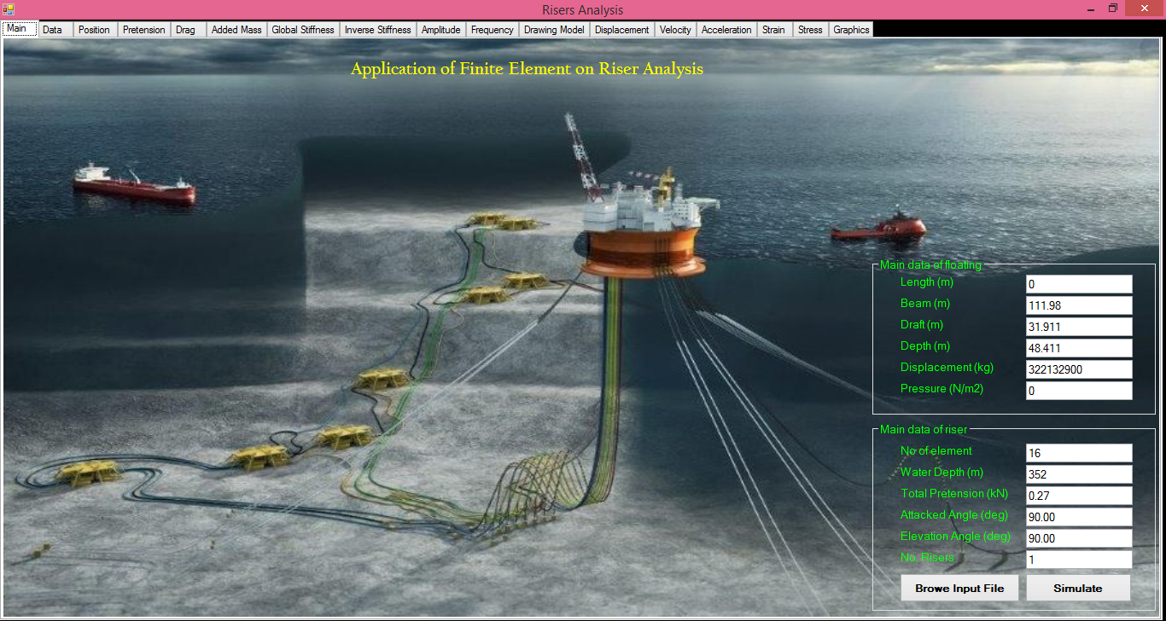

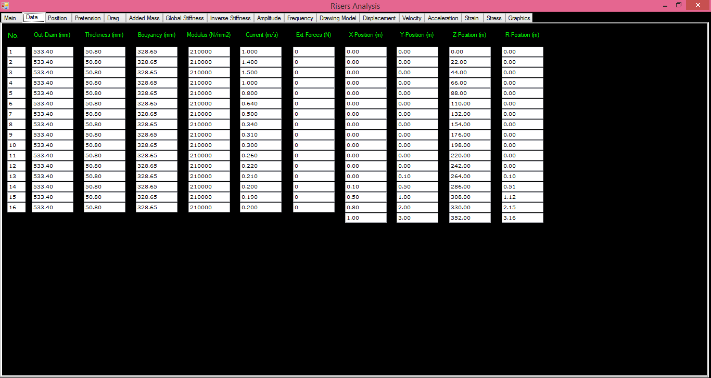
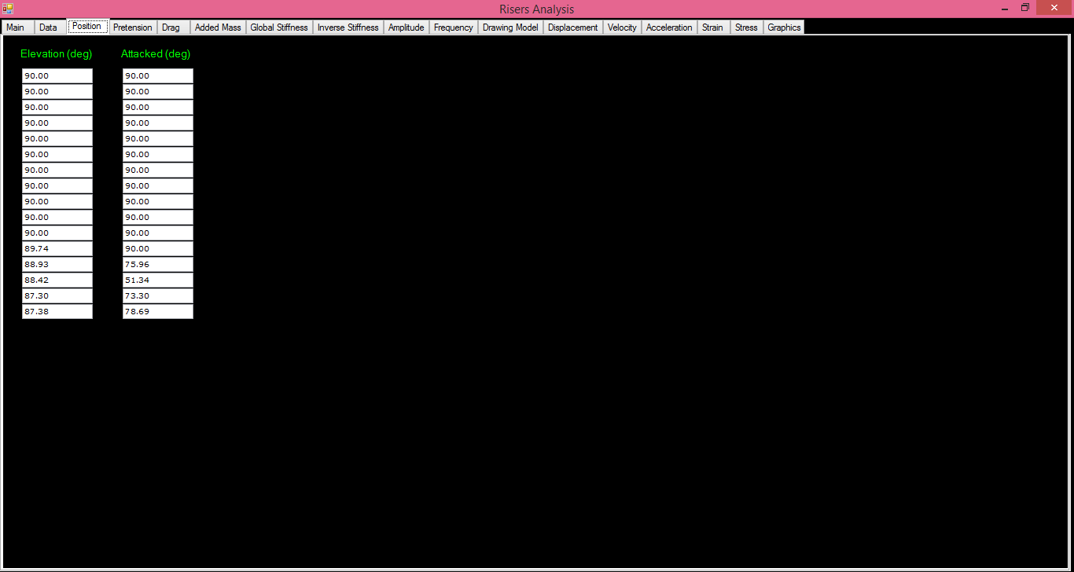
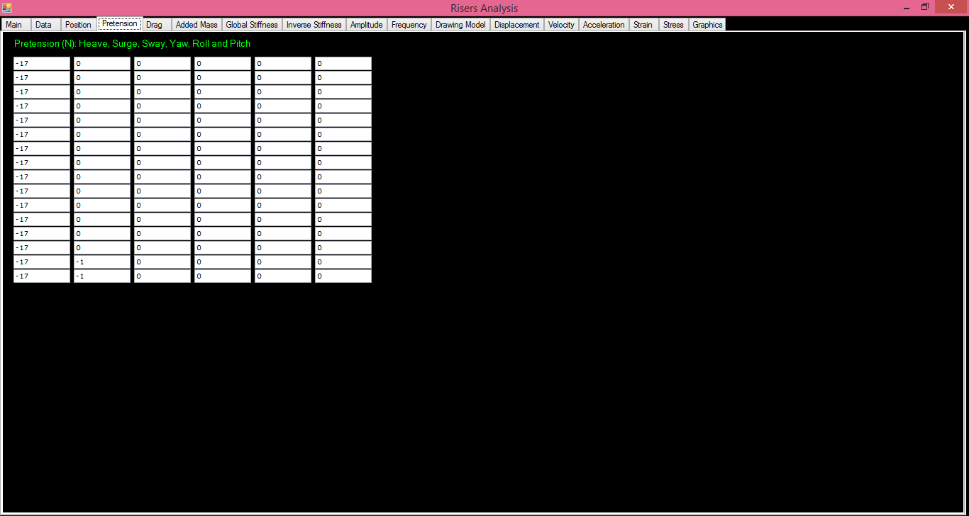
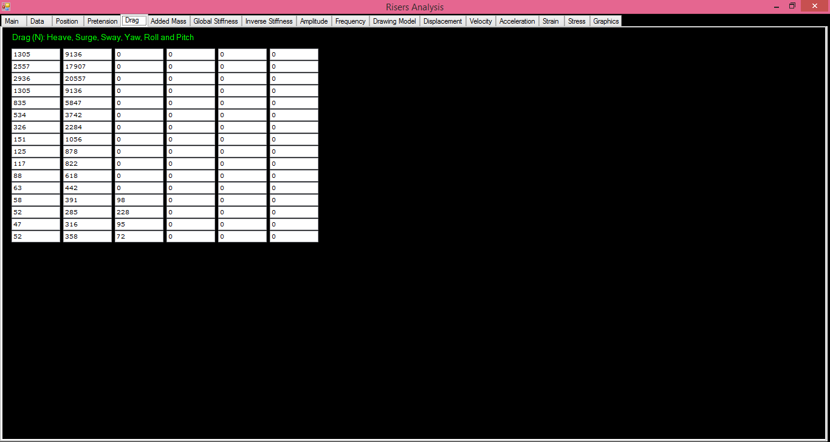

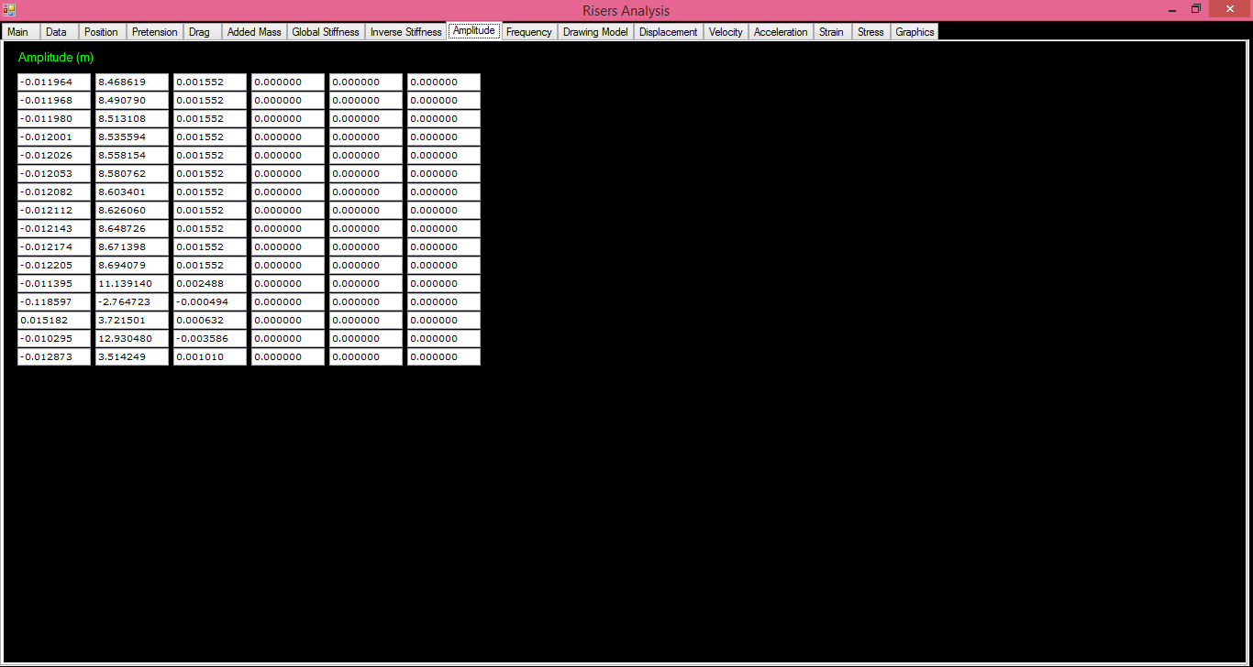
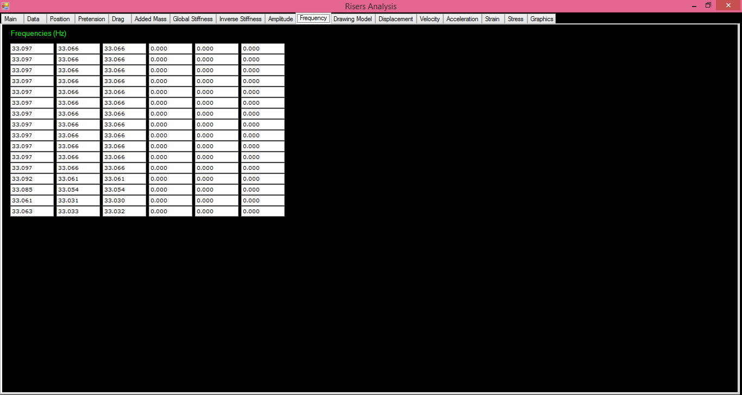
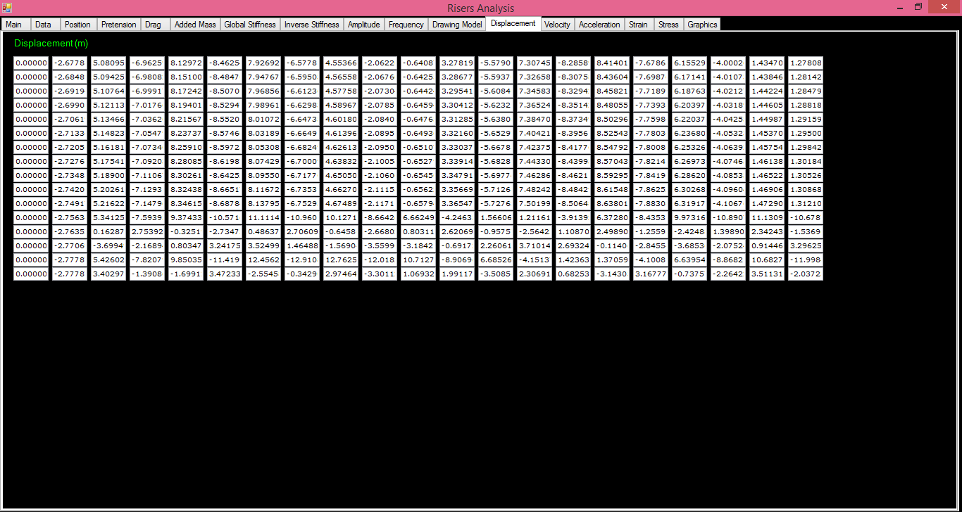

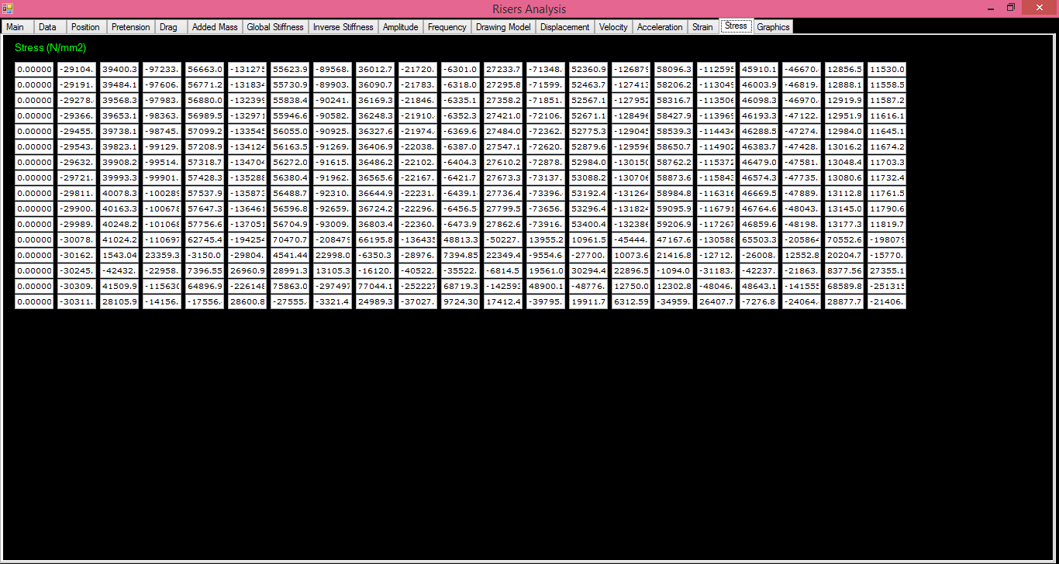

References

- Allen, D. W., Lee, L. & Henning, D. L., 2008. Fairings versus Helical Strakes for Suppression of Vortex-Induced Vibration: Technical Comparison. Houston, Offshore Technology Conference
- American Bureau of Shipping, 2001, Guide for Building and Classing: Subsea Pipeline Systems and Risers, ABS
- American Petroleum Institute, 1993, Recommended Practice for Design, Selection, Operation and Maintenance of Marine Drilling Riser Systems, API-RP- 16Q.
- American Petroleum Institute, 1998, Design of Risers for Floating Production Systems (FPSs) and Tension-Leg Platforms (TLPs), API RP 2RD.
- American Petroleum Institute, 1999, Specification for Unbounded Flexible Pipe, API Specification 17J.
- American Petroleum Institute, 2000, Specification for Line Pipe, API Specification 5L, fourth second ed.
- American Petroleum Institute, 2002, Recommended Practice for Flexible Pipe, API RP 17B.
- B. Seymour, H. Zhang, C. Wibner, 2003, Integrated Riser and Mooring Design for the P-43 and P-48 FPSOs, OTC 15140, Offshore Technology Conference, Houston, Texas.
- Blevins, R. D., 1994. Flow-Induced Vibration. s.l.:Krieger Publishing Company
- C.A Martis, R.M.C. Silva, A.B Costa (1999), “Parametric Analysis of Steel Catenary: Fatigue Behavior near the Touch Down Point”, International Offshore Conference, Brest, France.
- C.T. Gore, B.B. Mekha, 2002, Common Sense Requirements (CSRs) for Steel Catenary Risers (SCR), OTC 14153, Offshore Technology Conference, Houston, Texas.
- D.E. Thrall, R.L. Poklandnik, 1995, Garden Banks 388 Deep-water Production Riser Structural and Environmental Monitoring System, OTC 7751, Proc. of the 27th Offshore Technology Conference, Houston, Texas.
- Daniel Karunakaran (2013), “An Uncoupled Riser System for Ultra Deep-water and Harsh Environment”, Offshore Technology Conference, Paper 23986, Houston, Texas.
- DNV Course Notes, 2014. Course: Riser and Umbilicals-Technology Overview
- DNV, 2003, Offshore Riser Systems, Offshore Service Specification Det Norske Veritas DNV-OSS-302.
- DNV, 2010. DNV-RP-F204 Riser Fatigue, s.l.: Det Norske Veritas
- DNV-RP-C203, 2010. Fatigue Design of Offshore Steel Structures.
- E.A. Fisher, P. Holley, S. Brashier, 1995, Development and Deployment of a Freestanding Production Riser in the Gulf of Mexico, OTC 7770, Proc. 27th Offshore Technology Conference, Houston.
- E.H. Phifer, F. Kopp, R.C. Swanson, D.W. Allen, C.G. Langner, 1994, Design and Instal-lation of Auger Steel Catenary Risers, OTC 7620, Offshore Technology Conference, Houston, Texas.
- E.Tellier, Ricky Thethi (2009), “Evolution of Free Standing Riser” Proceeding of the ASME 2009, 28th International Conference on Ocean, Offshore and Arctic Engineering, Paper 79487, Honolulu, Hawaii, USA.
- EIA, 2016, Offshore oil production in deepwater and ultra-deepwater is increasing, Today in Energy, October, 2016, https://www.eia.gov/todayinenergy/detail.php?id=28552
- F. Kopp, B.D. Light, T.S. Preli, V.S. Rao, K.H. Stingl, 2004, Design and Installation of the Na Kika Export Pipelines, Flowlines and Risers, OTC 16703, Offshore Technology Conference, Houston, Texas.
- Faltinsen, O., 1990. Sea Loads on Ships and Offshore Structures. New York: Cambridge University Press.
- Feng Zi Li, Ying Min Law (2012), “ Fatigue Reliability Analysis of a Steel Catenary Riser at Touch-Down Point Incorporating Soil Model Uncertainties”, Applied Ocean Researc, 38(2012)100-110, Elsevier, Oxford.
- FMC Technologies, Completion Workover Riser System
- G. Chaudhury, J. Kennefick, 1999, Design, Testing, and Installation of Steel Catenary Risers, OTC 10980, Offshore Technology Conference, Houston, Texas.
- G. Wald, 2004, Hybrid Riser Systems, Deep-water Riser Engineering Course, Clarion Technical Conferences.
- Geir Magnus Knardahl, 2012, Vortex Induced Vibrations of Marine Risers, Norwegian University of Science and Technology
- Guntis Moritis, 1998, Tallest structure installed in Gulf, Oil & Gas Journal, http://www.ogj.com/articles/print/volume-96/issue-19/in-this-issue/production/tallest-structure-installed-in-gulf.html
- H. Matlock, 1975, Correlations for Design of Laterally Load Piles in Soft Clay, OTC, 2312, Offshore Technology Conference, Houston, Texas.
- H.M. Thompson, F.W. Grealish, R.D. Young, H.K. Wang, 2002, Typhoon Steel Catenary Risers: As-Built Design and Verification, OTC 14126, Offshore Technology Conference, Houston, Texas.
- Halil Dikdogmus, 2012, Riser Concepts for Deep Waters, Master Thesis, Norwegian University of Science and Technology.
- Herve Quintin, Jean-Luc Legras (2007), “Steel Catenary Riser Challenges and Solutions for Deep-Water Applications”, OTC, Paper 19118, Houston, Texas.
- International Standards Organization, 2005, Petroleum and Natural Gas Industries - Design and Operation of Subsea Production Systems - Part 7: Completion/Workover/Riser System, ISO 13628-7.
- J. Buitrago, M.S. Weir, 2002, Experimental Fatigue Evaluation of Deep-water Risers in Mild Sour Service, Deep Offshore Technology Conference, Louisiana, New Orleans.
- J. Remery, R. Gallard, B. Balague, 2004, Design and Qualification Testing of a Flexible Riser for 10,000 psi and 6300 ft WD for the Gulf of Mexico, Deep Oil Technology Conference, Louisiana, New Orleans.
- J.F. Archard, 1953, Contact and Rubbing of Flat Surfaces, Journal of Applied Physics, vol. 24 (No. 8) 981.
- J.K. Vandiver, 1998, Research Challenges in the Vortex-Induced Vibration Prediction of Marine Risers, Offshore Technology Conference, Houston, Texas.
- J.K. Vandiver, L Li, 1998, User Guide for SHEAR7, Version 2.1 & 2.2, for Vortex-Induced Vibration Response Prediction of Beams or Cables with Slowly Varying Tension In Sheared or Uniform Flow, Massachusetts Institute of Technology.
- J.M.J. Journée and W.W. Massie, 2001, Offshore Hydromechanics, Delft University of Technology
- J.MacGrail, F.Lim, 2H Offshore LTD (2004), “SLOR vs SCR for Deep-water Applications Technical Appraisal”. Isope, Toulon, France.
- Jaswar Koto and Abdul Khair Junaidi, 2014, Analysis of Vortex-Induced Vibration of Riser using Spalart-Almaras Model, Jurnal Teknologi, 69:7, 9–15.
- Jaswar, M. K. R. A. Razak and C.L.Siow, 2013, Vortex-Induced Vibration of Riser, the International Conference on Marine Safety and Environment, 12-November-2013, Johor Bahru, Malaysia.
- Jaswar, M. K. R. A. Razak1and Efi Afrizal, 2013, Vortex-Induced Vibration of Riser Caused by External Load, The 12th Asian International Conference on Fluid Machinery, 25-September-2013, pages.1-10, Yogyakarta, Indonesia
- JOANE, Ship Stability - Movement of the Centre of Gravity, Ship Inspection, http://www.shipinspection.eu/index.php
- K. Huang, X. Chen, C.T. Kwan, 2003, The Impact of Vortex-Induced Motions on Mooring System Design for Spar-Based Installations, OTC 15245, Offshore Tech-nology Conference, Houston, Texas.
- K. Vandiver, L. Lee, 2001, User Guide for Shear7 Version 4.1, Massachusetts Institute of Technology, Cambridge, March 25.
- L. Deserts, 2000, Hybrid Riser for Deep-water Offshore Africa, OTC 11875, Offshore Technology Conference, Houston, Texas.
- Lamb, W. S., 1991. Suppression of the Vortex Induced Vibration of Slender Cylidrical Structures, s.l.: Cranfield Institute of Technology, Department of Fluid Engineering and Instrumentation
- Lie, H. & Larsen, C. M., u.d. Vortex Induced Vibrations of Deepwater Risers and Pipelines-Review of Model Test Results, Trondheim: Norwegian marine Technology Research Institute, The Norwegian University of Science and Technology.
- M. Hogan, 2002, Flexjoints, ASME ETCE SCR Workshop, Houston, Texas, February.
- M. Wu, P. Jacob, J.F.S. Marcoux, V. Birch, 2006, The Dynamics of Flexible Jumpers Connecting A Turret Moored FPSO to A Hybrid Riser Tower, Proceedings of D.O.T XVlll Conference.
- Massachusetts Institute of Technology, 1995, SHEAR7 Program Theoretical Manual, Department of Ocean Engineering.
- Massachusetts Institute of Technology, 1996, User Guide for SHEAR7, Version 2.0, Department of Ocean Engineering.
- Matrix, Drilling Riser Buoyancy Systems, Document Reference No: E284 – Rev 1, 22/01/14
- Mohd Khirramadhan Bahar, Jaswar Koto, 2017, Hydrodynamic Analysis of COBRA Riser, The Fourth Conference, Ocean, Mechanical & Aerospace –scientists & engineers-, Universitas Andalas, Padang, Indonesia.
- Mohd Khirramadhan Bahari, Jaswar Koto, 2017, Hydrodynamic Of Catenary Offset Buoyancy Riser Assembly Riser, The Second Multidisciplinary Conference on Mechanical Engineering, McME 2017, Johor, Malaysia.
- Myrhaug, D., 2005. Oceanography TMR 4230, Current. Trondheim: Marine Technology Centre
- Offshore Flexjoint Technology, http://oilstates.com/wp-content/uploads/Offshore-FlexJoint-Technology.pdf
- P. Elman, R. Alvim, 2008, Development of a Failure Detection System for Flexible Risers, 18th International Offshore and Polar Engineering Conference.
- P.R. Geiger, C.V. Norton, 1995, Offshore Vessels, Their Unique and Applications for the Systems Designer, Marine Technology, vol. 32 (No. 1) 43–76.
- R. Burke, 2004, TTR Design and Analysis Methods, Deep-water Riser Engineering Course, Clarion Technical Conferences.
- R. Franciss, 2001, Vortex Induced Vibration Monitoring System in Steel Catenary Riser of P-18 Semi-Submersible Platform, OMAE2001/OFT-1164, Proceedings of OMAE’01.
- R. Jordan, J. Otten, D. Trent, P. Cao, 2004, Matterhorn TLP Dry-Tree Production Risers, OTC 16608, Offshore Technology Conference, Houston, Texas.
- S. Chakrabarti, 2005, Handbook of Offshore Engineering, Ocean Engineering Book Series, Elsevier, Oxford.
- SBS International LTD, http://www.sbsintl.com/index.html
- Stephen A Hatton, Neil Willis (1998), “Steel Catenary Risers for Deep-water Environments”, Offshore Technology Conference, Paper 8607, Houston, Texas.
- Subsea World News, https://subseaworldnews.com/tag/drill/
- T. Clausen, R. D’Souza, 2001, Dynamic Risers Key Component for Deep-water Drilling, Floating Production, Offshore Magazine, vol. 61, May.
- T. McCardle, 2008, Subsea Systems and Field Development Considerations, SUT Subsea Awareness Course.
- Tomy Nurwanto, 2012, COBRA Riser Concept for Ultra Deepwater Condition, Master Thesis.
- V. Alliot, J.L. Legras, D. Perinet, 2004, A Comparison between Steel Catenary Riser and Hybrid Riser Towers for Deep-water Field Developments, Deep Oil Technology Conference.
- Vandiver, J. K. & Li, L., 2005. Shear7 V4.4 Program Theoretical Manual, s.l.: Department of OceanEngineering, Massachusetts Institute of Technology.
- Vandiver, J. K., Swithenbank, S. & Jaiswal, V., 2006. The Effectiveness of Helical Strakes in the Suppression of High Mode Number VIV, Houston: Offshore Technology Conference
- William Furlow, 2016, Spar Innovations Society of Petroleum Engineers
- World Oil, 2003, Composite Catalog of Oilfield Equipment & Services, forty fifth ed., Gulf Publishing Company, Houston.
- Y. Bai, Q. Bai, 2005, Subsea Pipelines and Risers, Elsevier, Oxford.
- Y. Zhang, B. Chen, L. Qiu, T. Hill, M. 2003, Case, State of the Art Analytical Tools Improve Optimization of Unbonded Flexible Pipes for Deep-water Environments, OTC 15169, Offshore Technology Conference, Houston, Texas.
- Yong Bai, Qiang Bai, 2010, Subsea Engineering Handbook, Elsevier.
- Yu Du, WenhuaWu, Da Tang, Qianjin Yue, Feng Li, Ribin Xie, 2015, A novel underwater measurement method for mooring system using self-contained technique, Advances in Mechanical Engineering, Vol. 7(5) 1–12.
- Yu, T. Allen, M. Leung, 2004, an Alternative Dry Tree System for Deep-water Spar Applications, Deep Oil Technology Conference, New Orleans.

Exercises

Exercise.1
a) Explain response frequency of riser using the free oscillation theory
b) Find the spring constant ($k$) of the spring in N/m for given data: mass of 10 kg causes a vertical spring to stretch by 2.0 cm, Assume gravitational acceleration ($g$) is 9.81 ($m/s^{2}$).

$k=\frac{mg}{l}=\frac{10x9.81}{0.02}=4905$

c) If the added mass of riser is 0.1 of mass in air, determine the response frequency.

$f_{s}=\frac{1}{2π}\sqrt{\frac{k}{\left(m+m_{a}\right)}}=\frac{1}{2x3.14}\sqrt{\frac{4905}{10\left(1+0.1\right)}}=\frac{21.11}{6.28}=3.36$ hz

d) If the amplitude of excitation is 3 meter, determine the displacement of riser, velocity and acceleration at t = 1?

Example.2
Table.1 Riser dimension and environmental conditions of riser
Description | Values | Unit
Water depth ($h$) | 100 | $$m$$
Riser length ($L$) | 120 | $$m$$
Outside diameter ($D_{o}$) | 0.2500 | $$m$$
Inside diameter ($D_{i}$) | 0.2116 | $$m$$
Pretension | 200 | $kN$ (~1.5 times the riser weight)
Modulus of elasticity of riser pipe | 2.10x10⁸ | $$kN.m-2$$
Specific weight of the fluid outside ($ρ_{water}$) | 1025 | $$kg.m-3$$
Specific weight of the fluid inside ($ρ_{oil}$) | 800 | $$kg.m-3$$
Specific weight of the riser wall material ($ρ_{riser}$) | 7700 | $$kg.m-3$$
mass | m* = 2.7
Mass-damping parameters | mζ* = 0.054
Riser model elements | 80 below, 20 above still water
Riser ends | fixed but free to rotate
Uniform flow velocities | 0.16 - 0.93 | $$m/s$$
Kinematic viscosity of fluid ($v$) | 1.0 x 10² - 1.0 x 10⁴ | $${m^{2}}/s$$
Reynolds numbers $R_{n}=\frac{UD}{v}$ | 4.0 x 10⁴ ≤ R_{e} ≤ 2.3 x 10⁵

Table 1 shows dimension of a riser and environmental condition. Using the Catenary concept, analyse the following:
- Calculate external static pressure acting on riser ($F_{H}$) for given water depth.
$F_{H}=ρ∙g∙h=1025 x 9.81 x 100$

- Calculate weight of riser in empty ($W_{e}$) and operation ($W_{o}$) conditions
$W=g∙L∙(ρ_{st}∙π∙\left(R_{o}^{2}-R_{i}^{2}\right)-(ρ_{water}∙ π∙R_{i}^{2}))$
$W=9.81 x 120 x \left(7700 x 3.14 x \left({0.2500}^{2}- {0.2116}^{2}\right)-(1025x3.14x{0.2116}^{2})\right)$

- Calculate horizontal ($T_{H}$) and vertical ($T_{V}$) component of tension.
$T_{H}=T\cos{ϕ_{w}}=33.3 kN$
$T_{v}=T\sin{ϕ_{w}}=ws=197 kN$

- Calculate fairlead angle ($∅$)
$ϕ_{w}=\operatorname{acos}{\frac{T_{H}}{T}}=80 deg$

- Horizontal span of the suspended portion of line ($h$)

$h=\left(\frac{T_{H}}{w}\right)\log{\frac{T_{A}-T_{VA}}{T_{H}}}=50 m$

- Calculate Reynolds numbers ($R_{n}$) in the table below
Modes | U (m/s) | $$v$$ | $$R_{n}=\frac{UD}{v}$$
1st | 0.16 | $$0.92x{10}^{2}$$ | $$\frac{0.16 x 0.25}{0.92 x {10}^{2}}=4.35 x {10}^{4}$$
1st | 0.23 | $$0.92x{10}^{2}$$ | $$\frac{0.23 x 0.25}{0.92 x {10}^{2}}=6.25 x {10}^{4}$$
2nd | 0.38 | $$0.92x{10}^{4}$$ | $$\frac{0.38 x 0.25}{0.92 x {10}^{4}}=1.03 x {10}^{5}$$
3rd | 0.54 | $$0.92x{10}^{4}$$ | $$\frac{0.54 x 0.25}{0.92 x {10}^{4}}=1.47 x {10}^{5}$$
4th | 0.85 | $$0.92x{10}^{4}$$ | $$\frac{0.85 x 0.25}{0.92 x {10}^{4}}=2.31 x {10}^{5}$$

- Analyse the characteristic VIV modes.
Modes | $λ$ (m)
1st | $$2x120=240$$ | 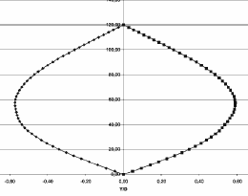
2nd | $$1x120=120$$ | 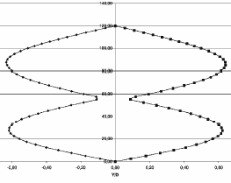
3rd | $$2/3x120=80$$ | 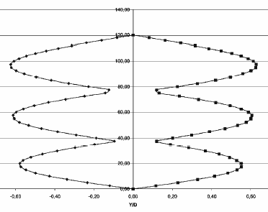
4th | $$2/4x120=60$$ | 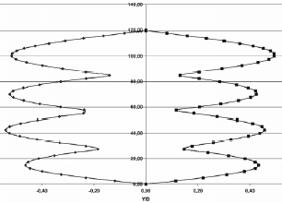

- Assume Strouhal number, $S_{T}=0.20$ for determining Vortex-Shedding Frequency ($f_{s}$).
Current Velocity  ($U (m/s))$ | Vibration Mode | Reduced Velocity ($V_{r}$) | Reduced Frequency ($1/{V_{r}}$) | $f_{s}=S_{t}U/D$ | Analyze
0.16 | 1st | 4.50 | 0.22 | =0.2*0.16/0.25=0.128 | $f_{s}<1/V_{r}$ (Non VIV)
0.23 | 1st | 6.75 | 0.15 | =0.2*0.23/0.25=0.184
0.31 | 2nd | 4.00 | 0.25 | =0.2*0.31/0.25=0.248
0.39 | 2nd | 5.00 | 0.20 | =0.2*0.39/0.25=0.312
0.40 | 2nd | 5.15 | 0.20 | =0.2*0.40/0.25=0.320 | $f_{s}>1/V_{r}$ (VIV)
0.47 | 2nd | 6.00 | 0.17
0.54 | 3rd | 4.00 | 0.25
0.62 | 3rd | 4.60 | 0.22
0.70 | 3rd | 5.15 | 0.19
0.78 | 3rd | 5.70 | 0.19
0.86 | 4th | 4.05 | 0.25
0.93 | 4th | 4.40 | 0.23

Exercise.1
Table.2 Riser dimension and environmental conditions of riser
Description | Values | Unit
Water depth ($h$) | 450 | $$m$$
Riser length ($L$) | 865 | $$m$$
Outside diameter ($D_{o}$) | 0.2500 | $$m$$
Inside diameter ($D_{i}$) | 0.2116 | $$m$$
Pretension | 1300 | $kN$ (~1.5 times the riser weight)
Modulus of elasticity of riser pipe | 2.10x10⁸ | $$kN.m-2$$
Specific weight of the fluid outside ($ρ_{water}$) | 1025 | $$kg.m-3$$
Specific weight of the fluid inside ($ρ_{oil}$) | 800 | $$kg.m-3$$
Specific weight of the riser wall material ($ρ_{riser}$) | 7700 | $$kg.m-3$$
mass | m* = 2.7
Mass-damping parameters | mζ* = 0.054
Riser model elements | 80 below, 20 above still water
Riser ends | fixed but free to rotate
Uniform flow velocities | 0.16 - 0.93 | $$m/s$$
Kinematic viscosity of fluid ($v$) | 1.0 x 10² - 1.0 x 10⁴ | $${m^{2}}/s$$
Reynolds numbers $R_{n}=\frac{UD}{v}$ | 4.0 x 10⁴ ≤ R_{e} ≤ 2.3 x 10⁵

Table 2 shows dimension of a riser and environmental condition. Using the Catenary concept, analyze the following:
- Calculate external static pressure acting on riser ($F_{H}$) for given water depth.
- Calculate weight of riser in empty ($W_{e}$) and operation ($W_{o}$) conditions
- Calculate horizontal ($T_{H}$) and vertical ($T_{V}$) component of tension.
- Calculate fairlead angle ($∅$)
- Horizontal span of the suspended portion of line ($h$)
- Compute the excursion based on the initial configuration
- Plot load versus excursion (line stiffness curve)

Exercise.2
Table.3: Riser dimension and environmental conditions and installation vessel specifications.
Description | Values | Unit
Risers
Water depth ($h$) | 100 | $$m$$
Riser length ($L$) | 120 | $$m$$
Outside diameter ($D_{o}$) | 0.2500 | $$m$$
Inside diameter ($D_{i}$) | 0.2116 | $$m$$
Modulus of elasticity of riser pipe | 2.10x10⁸ | $$kN.m-2$$
Specific weight of the fluid outside ($ρ_{water}$) | 1025 | $$kg.m-3$$
Specific weight of the fluid inside ($ρ_{oil}$) | 800 | $$kg.m-3$$
Specific weight of the riser wall material ($ρ_{riser}$) | 7700 | $$kg.m-3$$
Vessel description
Gross Tonnage | 33812 | Tonnes
Deadweight | 20178 | Tonnes
Length Overall x Breadth Extreme | 121.92 × 54.86 | m

Question
Table 3 shows installation vessel specification and dimension of a riser and environmental condition. Using data in the table, analyze the following:
- Calculate Trim angle of the vessel?
- Plot Trim angle versus length of riser during installation.

Autobiographies

 | Jaswar Koto was born on October, 1970. He is a descendant of the Prophet Rasullullah S.A.W through Husein R.A. He is currently a professor on offshore engineering and president at Ocean and Aerospace Research Institute, Indonesia. He is also president of International Society of Ocean, Mechanical & Aerospace for scientist and engineers
He has been invited as a visiting professor and guest lecturers for many thimes and has received several international awards. He actively supervises PhD, Master and Bachelor Students. He has published more than 150 papers, 13 books on ship and offshore engineering, has created 10 simulation software and he has invented 11 theories on Ice-Ship, Benefit-Cost-Risk, DSM, helicopter blade and hydrodynamic.
He received his bachelor degree in 1994 from Institut Teknologi Sepuluh Nopember (ITS), Indonesia, and then continued further studies in Curtin University of Technology and Notre Dame University. In 2003 he has completed his Ph.D with Academic Award “2.5 Years PhD” form Aerospace and Marine Engineering, Osaka Prefecture University, Japan.
Since 1994, he has started his researches on subsea pipeline structure analysis, corrosion on subsea pipeline due to Carbon Monoxide, hydrodynamic analysis of AUV in Perth, Australia. In 2003, he joined Research and Development Institute, Sumitomo Heavy Industries -Marine Engineering-, Japan. In 2005, he joined ExxonMobil for LNG EPC projects. He has a contract with Mechanical Engineering and High Performance Computing, CICT, Universiti Teknologi Malaysia.

Dr Adi Maimun obtained his B.Sc in Naval Architecture from the University of Strathclyde, Glasgow in 1983. He joined Universiti Teknologi Malaysia (UTM) as a tutor the same year. He later return to Strathclyde University for his Masters and Ph.D. in Marine Technology and obtained his degrees in 1985 and 1993 respectively
Dr Adi Maimun is currently serving as Professor of Naval Architecture at the Dept. of Aeronautics, Automotive and Ocean Engineering, Faculty of Mechanical Engineering. He was Head of Marine Laboratory (1986-1989), Head of Panel for Marine Technology (1999-2000), Head of Department for Marine Technology (2000-2007) and the Deputy Dean (Development) for the Faculty of Mechanical Engineering (2007-2011). Head of Marine Hydrodynamics Research Group, UTM (2010-present).
Dr Adi Maimun specializes mainly in the field of Marine Vehicles/Structures Dynamics using CFD, AIS, Time domain simulations and experimental work. He had taught, conducted research and consultancy work in the said field and had published over 70 papers in conferences and journals.
Dr. Adi Maimun is currently a Fellow Member of the Royal Institution of Naval Architects (UK) and a Chartered Engineer (UK). He had served as committee member for number years for the Malaysia Joint Branch (MJB) of Royal Institution of Naval Architects (RINA) and Institute of Marine Engineers Science and Technology (IMarEST). He is currently the Chairman (2015-2016) for RINA-IMarEST MJB (Southern Chapter). In the international field he had served in the International committee board for the conferences of MARTEC (since 2002), APHYDRO (since 2002) and OMAE (2008). Local organizing chairman for MARTEC 2004 and APHYDRO 2010. Malaysia Correspondent member for International Ship and Offshore Structures Congress (ISSC) (2015-2016).

