Preface



This book introduces subsea tree which is divided into five chapters. The first chapter discusses overview of subsea tree. In the second chapter, component of tree is discussed. Then, third chapter are explained the tree mounted control system, than continued with design and analysis in chapter fourth. Chapter five discusses installation and test and completion of tree is discussed. In the last chapter, Perdido field development was discussed.

In the book, many pictures and illustrations are enclosed to assist the readers’ understanding. It should be noted that many pictures and contents are borrowed from other companies’ websites, books and brochures. The exact sources are quoted and listed in the references. The book is for engineering education purposes only.

2017 (Second Edition)

Acknowledgements

Alhamdulillahhirobbilalamin, first and foremost, all praises and syukur are only to Allah (S.W.T) to give us strength and ability to complete this book.

We would like to take this opportunity to express our highest appreciation to our colleagues and friends in the Ocean and Aerospace Research Institute, Indonesia, Universiti Teknologi Malaysia (UTM) and Institut Teknologi Sepuluh Nopember (ITS), Indonesia to provide proper guidance, full support, encouragement, invaluable ideas, comment, recommendation, critics, suggestions and advice that to assist us for the successful completion of this book.

To our families that always pray for our successful, all this things cannot pay for all what they all have done. Our special thanks also to our postgraduate students.

Above this all, our highest praises, thanks and syukur to Almighty Allah Subhanahu Wa’Talla, the most gracious the most merciful, who gave us the knowledge, courage and patience to accomplish this project. May the peace and blessings of Allah be upon Prophet Muhammad Sallallahu Alaihi Wasallam.

The authors are grateful to all friends, institutions and parties for supporting this book.

List of Figures

Figures and Description | Pages
Figure.1.1: Basic component of tree | 9
Figure 1.2: Vertical Subsea Tree | 11
Figure 1.3: Schematic of Vertical Subsea Tree | 12
Figure 1.4: Horizontal Subsea Tre | 13
Figure 1.5: Schematic of Horizontal Subsea Tree | 14
Figure 1.6: Design Process of Subsea Tree | 15
Figure 1.7: Design Requirements | 16
Figure 1.8: Component Design Process | 17
Figure 2.1: Typical Components of a Vertical Subsea Tre | 21
Figure 2.2: Typical Components of an HST | 22
Figure 2.3: Differences between VSTs and HSTs | 23
Figure 2.4: Concentric and Multibore Tubing Hanger | 25
Figure 2.5: Horizontal Tubing Hanger Section View | 25
Figure 2.6: Typical Tubing Hanger Penetration Configurations | 26
Figure 2.7: Tubing Hanger Running Tool (THRT) | 27
Figure 2.8: Flowline Connector | 29
Figure 2.9: Hydraulic Tree Connector | 30
Figure 2.10: Configuration of Tree Valves | 31
Figure 2.11: Subsea Choke | 32
Figure 2.12: Trim Types | 33
Figure 2.13: Choke Schematic | 33
Figure 2.14: Pressure Drop in a Chok | 34
Figure 2.15: Tree Debris Cap | 35
Figure 2.16: ROV-Operated Tree Cap | 36
Figure 3.1: SCM Configuration | 39
Figure 3.2: PTT Located on a Subsea Tree | 40
Figure 3.3: Tree Running Tool | 41
Figure 4.1: Example of Chemical Injection Design for Subsea Tree | 43
Figure 4.2: Subsea tree thermal analysis using FEA | 46
Figure 5.1: Tree Installation by Drill Pipe (Left) and Rig Winch (Right) | 47
Figure 5.2: Installation Vessels | 48
Figure 5.3: Vertical Subsea Tree Installation by Drill Pipe | 49
Figure 5.4: Subsea Tree testing | 50
Figure 5.5: Horizontal Subsea Tree Installation Process | 56
Figure 6.1: Example of Enhanced Vertical Deepwater Tree | 63

List of Tables

Tables and Description | Pages
Table 1.1: Standard Temperature Ratings | 18
Table 1.2: Material Class Rating | 18
Table 1.3: Material Requirements | 19

Table of Contents

Preface 1
Acknowledgements 2
List of Figures 3
List of Tables 5
Table of Contents 6
1.0 Subsea Trees 8
1.1. Introduction 8
1.1. Function Requirements 8
1.2. Types of Trees 10
1.2.1. Vertical Subsea Tree 10
1.2.2. Horizontal Subsea Tree 11
1.2.3. Selection Criteria 13
1.3. Design Process 14
1.4. Service Conditions 18
2.0 Components of Subsea Trees 20
2.1. General 20
2.2. Tubing Hanger 24
2.3. Tree Piping 29
2.4. Flowline Connector 29
2.5. Tree Connectors 30
2.6. Tree Valves 31
2.6.1. Production Master Valves 31
2.6.2. Swab Valve 31
2.6.3. Annulus Master and Access Valves 32
2.6.4. Crossover Valve 32
2.7. Production Choke 33
2.7.1. Trims/Orifices Types 33
2.7.2. Choke Design Parameters 34
2.8. Tree Cap 35
2.9. Tree Frame 37
3.0 Tree Mounted Controls 39
3.1. Subsea Control Model (SCM) 39
3.2. Pressure and Temperature Transmitters 40
3.3. Tree Running Tools 41
4.0 Design and Analysis 43
4.1. Chemical Injection 43
4.2. Cathodic Protection 44
4.3. Insulation and Coating 45
4.4. Structural Loads 46
4.5. Thermal Analysis 46
5.0 Installation, Test and Completion 49
5.1. Trees Installation 49
5.2. Trees Testing 54
5.3. Trees Completion 55
6.0 Perdido Subsea Tree 61
6.1. Perdido Field 61
6.2. Enhanced Vertical Deepwater Tree 61
6.3. Tree Installation 63
References 65
Autobiographies 67

Chapter.1

1.0 Subsea Trees

1.1. Introduction
A subsea tree is an assembly of valves such as master, wing and swab valves, spools, and fittings as shown in Figure 1.1 used for an oil and gas wells. The subsea tree is installed on top of the wellhead. When the well and facilities are ready to produce and receive oil or gas, tree valves which is lower and master valves and wing valve are opened and the formation fluids are allowed to go through a flow line.

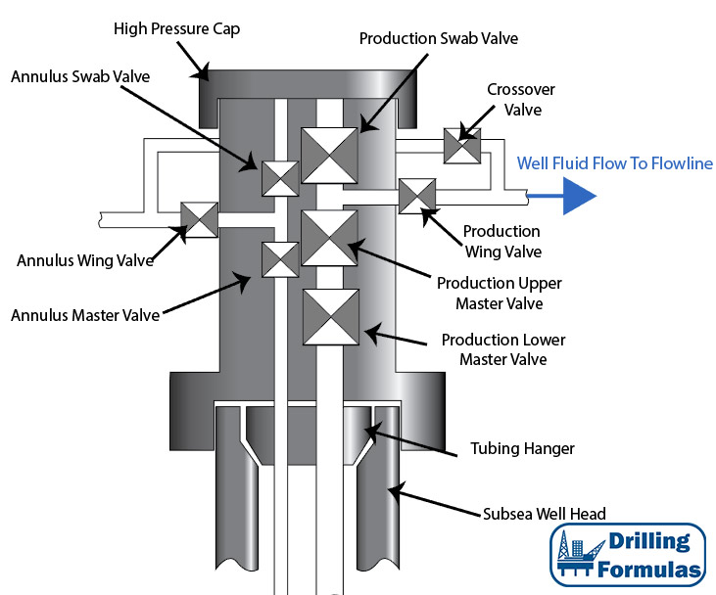

Figure.1.1: Basic component of tree [Drilling Formulas].

1.1. Function Requirements
The primary function of a subsea tree is to control the flow, usually oil or gas, out of the well. A subsea tree often provides numerous additional functions including:

Typical function requirements for subsea trees include:

1.2. Types of Trees

1.2.1. Vertical Subsea Tree
Vertical Subsea Trees (VSTs) are applied commonly and widely in subsea fields due to their flexibility of installation and operation. The well is completed before installing the tree. Figure 1.2 shows a vertical tree being lowered subsea.
Figure 1.3 illustrates the schematic of a typical vertical tree. The master valves are configured above the tubing hanger in the VST. The production and annulus bore pass vertically through the tree body of the tree. Master valves and swab valves are also stacked vertically. The tubing hanger lands in the wellhead, thus the subsea tree can be recovered without having to recover the down-hole completion.

Attached on wellhead
Figure 1.2: Vertical Subsea Tree [FMC]

Figure 1.3: Schematic of Vertical Subsea Tree [API RP 17A]

1.2.2. Horizontal Subsea Tree
Another type of subsea tree developed rapidly in recent years is the Horizontal Subsea Tree (HST). Figure 1.4 shows a horizontal tree made by FMC. The key feature of the HST is that the tubing hanger is installed in the tree body instead of the wellhead. This arrangement requires the tree to be installed onto the wellhead before completion of the well
Figure 1.5 shows the schematic of a horizontal tree. The valves are mounted on the lateral sides, allowing for simple well intervention and tubing recovery. This concept is especially beneficial for wells that need a high number of interventions. Swab valves are not used in the HST since they have electrical submersible pumps applications.
.

Figure.1.4: Horizontal Subsea Tree [FMC]

Figure.1.5: Schematic of Horizontal Subsea Tree [API RP 17A]

1.2.3. Selection Criteria
In the selection of a Horizontal Subsea Tree (HST) or a Vertical Subsea Tree (VST), the following issues should be considered:

1.3. Design Process
In the design process, the physical arrangement of valves, chokes, control modules, flow connections, maintenance interface and the support/protective structures of the tree are necessary. The designs of subsea trees vary in three ways as follows:

These parameters will affect the selection of the types of subsea tree, materials, and component arrangement.
A typical design process for a subsea tree is shown in Figure 1.6.
Parameters
Figure 1.6: Design Process of Subsea Tree

The design requirements include the requirements of function, performance, working capabilities, and the cost of the product, which is referred to as its economy. These are basic requirements when designing a product. Design requirements are shown in Figure 1.7. After the functions and requirements are clearly known by the designer, the tree type can be determined and the schematic diagram drawn. Draft structural drawings of the tree are usually done during this phase.

Figure.1.7: Design Requirements

Component design is almost the most important point in subsea tree design. Components of a typical subsea tree include:

The design should consider the components although some of them may be a system or subassembly. Calculations for, drawings, and reports for the components are completed in this phase. Subassembly and assembly design includes a report that shows the assembly procedures and the assembly drawings. Design procedures are shown in Figure 1.8.

Figure 1.8: Component Design Process

1.4. Service Conditions
Pressure ratings of subsea trees are standardized to 5000 psi (34.5 MPa), 10,000 psi (69.0 MPa), and 15,000 psi (103.5 Mpa). Recently 20,000-psi (138-Mpa) subsea trees have been applied successfully in subsea fields. Table 1.1 shows the standard temperature ratings per API Specification 6A. Subsea equipment should be designed and rated to operate throughout a temperature range of 35 to 250_F (Rating V) according to the API Specification 17D.

Table 1.1: Standard Temperature Ratings
 | Operating Range
Classification | Min (⁰C) | Max (⁰F) | Min (⁰C) | Max (⁰F)
K | -60 | 82 | -75 | 180
L | -46 | 82 | -50 | 180
P | -29 | 82 | -20 | 180
R | 20-24 | 20-24 | 20-24 | 20-24
S | -18 | 66 | 0 | 150
T | -18 | 82 | 0 | 180
U | -18 | 121 | 0 | 250
V | 2 | 121 | 35 | 250
Choosing materials classes is the responsibility of the user. All pressure-containing components should be treated as “bodies” for determining material requirements from Table 1.2. However, other wellbore pressure boundary penetration equipment, such as grease/bleeder fittings and lockdown screws, should be treated as “stems.” Metal seals should be treated as pressure-controlling parts.

Table 1.2: Material Class Rating
Retained Fluids | Relative Corrosivity of Retained Fluids | Partial Pressure of CO₂ (psia) (MPa) | Recommended Material Class
General | Non-corrosive | <7 (0.05) | AA
General | Slightly corrosive | 7-30 (0.05 – 0.21) | BB
General | Moderately to highly corrosive | >30 (0.21) | CC
Sour | Non-corrosive | <7 (0.05) | DD
Sour | Slightly corrosive | 7-30 (0.05 – 0.21) | EE
Sour | Moderately to highly corrosive | >30 (0.21) | FF
Sour | Very corrosive | >30 (0.21) | HH

Equipment should be designed to use materials based on the material class required, as shown in Table 1.3. If the mechanical properties can be met, stainless steels may be used in place of carbon and low-alloy steels, and corrosion-resistant alloys may be used in place of stainless steels.
Table 1.3: Material Requirements
Material Class | Service | Minimum Material Reuirement
Material Class | Service | Body, Onnet, End and Outlet Connections | Pressure controlling parts, stems, and Mandrel Hangers
AA | General | Carbon or low alloy steel | Carbon or low alloy steel
BB | General | Carbon or low alloy steel | Stainless steel
CC | General | Stainless steel | Stainless steel
DD | Sour | Carbon or low alloy steel | Carbon or low alloy steel
EE | Sour | Carbon or low alloy steel | Stainless steel
FF | Sour | Stainless steel | Stainless steel
HH | Sour | CRA | CRA

Chapter.2

2.0 Components of Subsea Trees

2.1. General
Components of a subsea tree vary according to the type of tree (Vertical Subsea Tree (VST) or Horizontal Subsea Tree (HST)) and specific design requirements of specific subsea fields. Static Weight of tree can be written as

$W_{tree}=\sum_{i=1}^{n}{W_{i}}$ (2.1)

Where $W_{i}$ is weight of component I, such as cap, valves and etc.

Components of a Vertical Subsea Tree (VST) from top to bottom are typically as illustrated in Figure.2.1

Figure.2.1: Typical Components of a Vertical Subsea Tree [Drill-Quip]

Components of a Horizontal Subsea Tree (HST) from top to bottom are typically illustrated in Figure.2.2:

Figure 2-2: Typical Components of an HST [Dril-Quip]

The main components that vary between VST and HST are as follows:

These differences are illustrated in Figure 2.3.

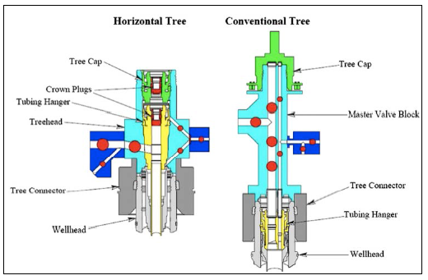
Figure 2.3: Differences between VSTs and HSTs [Vetco Gray]

2.2. Tubing Hanger
In a subsea well, production tubing is supported and sealed off inside the subsea wellhead housing. The tubing hanger and the running tool necessary to install it comprise a tubing hanger system. On wells with subsea well-heads, the subsea tubing hangers are run and landed through the marine riser and the subsea BOP stack with a full drilling fluid/completion fluid column in place. On wells that have been mudline suspended, the subsea tubing hangers are landed in a tubing head through a casing riser and a surface BOP stack.
The basic functions of a tubing hanger are as follows:

.
Three factors characterize the basic tubing hanger system for a subsea well:

Tubing Hanger Types
All tubing hanger systems can be summarized into two categories:

Concentric tubing hanger has a single central bore, threaded box down to make up to a single tubing string. The upper part of the tubing hanger body will have a central seal pocket to receive the mating male stab sub from the subsea production tree. The tubing hanger is lowered into position with a running tool that is connected mechanically or hydraulically to the tubing hanger body ID. The running string may be the drill pipe, tubing, or a custom-designed completion string with integral tubing strings and control lines. See the left side o Figure 2.4.
The multi-bore or orienting, tubing hanger incorporates the bore tubing hanger system. It also incorporates two or more pockets in the tubing hanger body for communications to multiple tubing strings and multiple stab receptacles, to maintain control over down-hole equipment. The multi-bore tubing hanger allows the operator to enter the annulus from directly over-head, through an annulus bore in the tree, to the tubing hanger and tubing/ equipment down-hole. This capability makes the tubing hanger orientation specific with respect to the tree. See the right side of Figure 2.4.

Figure.2.4: Concentric and Multi-bore Tubing Hangers [Dril-Quip]

In a horizontal tree system, the tubing hanger configuration is normally of the concentric type, with a production outlet beside (see Figure 2-5). The tubing hanger assembly consists of the hanger body, lockdown sleeve, locking dogs, gallery seals, pump down seal, electrical penetrator receptacle, bottom dry mate connector, and pup joint. There are four basic sizes of tubing hanger: 31/2, 4, 5, and 7 in. nominal.
Figure.2.5: Horizontal Tubing Hanger Section View

Penetration Configuration
Figure 2.6 shows a typical tubing hanger penetration configuration. The number of control ports through the tubing hanger depends on:
- How many SCSSV there are and whether they are balanced or unbalanced. A balanced SCSSV requires two control lines, whereas an unbalanced valve needs only one.
- Downhole pressure/temperature monitors (electric connector at the tubing hanger/tree extension sub interface). An electric cable extends below to the bottom of the tubing string where a sensing device is located.

Figure 2.6: Typical Tubing Hanger Penetration Configurations

For example, a typical configuration would include:
- Down-hole injection: 1 Hyd.
- SCSSV: 2 Hyd.
- Smart well hydraulics: 2 Hyd.
- Soft landing: 1 Hyd.
- Down-hole gauges: 1 or 2 Elec.

Tubing Hanger Running Tool
The tubing hanger running tool (THRT) is used to run the tubing hanger (TH) into the tree body. The THRT should have a balanced piston design with equivalent cross-sectional areas to prevent annulus pressure from acting to unlock the THRT from the TH and to ensure that the THRT remains locked even upon loss of hydraulic pressure during installation or work-over operations. The system design should be configured to prevent hydraulic locking of the seals during installation/retrieval of the THRT to/from the TH and slick joint. A THRT is illustrated in Figure 2.7.

Figure 2.7: Tubing Hanger Running Tool (THRT) [Dril-Quip].

2.3. Tree Piping
Tree piping is defined as all pipe, fittings, or pressure conduits, excluding valves and chokes, from the vertical bores of the tree to the flowline connections. The piping may be used for production, pigging, monitoring, injection, servicing, or testing of the subsea tree. Inboard tree piping is upstream of the first tree wing valves. Outboard tree piping is downstream of the first tree wing valve and upstream of the flowline connector.
Tree piping is normally designed in accordance with ASME B31.3. The guidelines in the API specifications are general and in many case open to interpretation. It is up to the manufacturer to apply the engineering judgment.

2.4. Flowline Connector
A flowline connector is used to connect subsea flowlines and umbilicals via a jumper to the subsea tree. In some cases, the flowline connector also provides the means for disconnecting and removing the tree without retrieving the subsea flowline or umbilical to the surface. Figure.2.8 shows a horizontal flowline connector system.
Flowline connectors generally come in three types: manual connec-tors operated by divers or ROVs, hydraulic connectors with integral hydraulics, or mechanical connectors with the hydraulic actuators con-tained in a separate running tool. The flowline connector system may utilize various installation methods, such as first-end or second-end connection methods. It may be either diverless or diver assisted and may utilize guidelines/guideposts to provide guidance and alignment of the equipment during installation.
The flowline connector support frame reacts to all loads imparted by the flowline and umbilical. Tree valves and tree piping are protected from flowline/umbilical loads, which could damage these components. Align-ment of critical mating components is provided and maintained during installation. Trees can be removed and replaced without damage to critical mating components. The flowline connector support frame is designed to allow landing a BOP stack on the wellhead housing after the flowline connector support frame is installed.
Figure 2.8: Flowline Connector [FMC]

2.5. Tree Connectors
Tree connectors are used to land and lock the subsea tree to a subsea wellhead. They provide mechanical and pressure connections as well as orientation between the tree assembly and the wellhead. Mechanical tree connectors are generally diver actuated using a series of screws to energize a locking mechanism. Connectors of this type are suitable for type S (simple) and DA (diver assist) trees run from jack-ups and not recommended for trees run from floaters.
Hydraulic tree connectors were originally designed as modified hydraulic drilling BOP connectors. However, current tree designs utilize a connector that is specifically designed for subsea applications. The connector offers additional features not normally present on the BOP H-4 style connector, such as a mechanical override for release and a backup mechanical lock. Hydraulic connectors are the most common type of tree connector. They are suitable for all types of tree. Figure 2.9 illustrates the H4 hydraulic connector from Vetco Gray.
Figure 2.9: Hydraulic Tree Connector [Vetco Gray]

2.6. Tree Valves
Subsea tree contains various valves used for testing, servicing, regulating, or choking the stream of produced oil, gas, and liquids coming up from the well below. Figure.2.10 shows a typical tree valve arrangement and configuration. The production flow coming from the well below passes through the Down-Hole Safety Valve (DHSV), which will shut down if it detects an accident, leak, or overpressure occurring.

2.6.1. Production Master Valves
Production Master Valves (PMVs) provide full opening during normal production. Usually these valves are high-quality gate valves. They must be capable of holding the full pressure of the well safely for all anticipated purposes, because they represent the second pressure barrier (the first is the DHSV). A production choke is used to control the flow rate and reduce the flow pressure.

2.6.2. Swab Valve
The Production Swab Valve (PSV) and Annulus Swab Valve (ASV) are open when interventions in the well are necessary. Subsea tree valves should be designed, fabricated, and tested in accordance with API 17D, API 6A, and API 6D. The valves can be both bolted on or built in.

2.6.3. Annulus Master and Access Valves
The Annulus Master Valve (AMV) and Annulus Access Valve (AAV) are used to equalize the pressure between the upper space and lower space of the tubing hanger during the normal production (i.e., when the DHSV is open).

2.6.4. Crossover Valve
Located in the crossover loop, a crossover valve (XOV) is an optional valve that, when opened, allows communication between the annulus and production tree paths, which are normally isolated. An XOV can be used to allow fluid passage for well kill operations or to overcome obstructions caused by hydrate formation.

Figure.2.10: Configuration of Tree Valves

2.7. Production Choke
A production choke is a flow control device that causes pressure drop or reduces the flow rate through an orifice. It is usually mounted downstream of the PWV in a subsea tree in order to regular the flow from the well to the manifold. It can also be mounted on the manifold. Figure 2.11 shows the subsea choke in a subsea tree.
The two most widely used choke types are positive chokes and adjust-able chokes. The adjustable choke can be locally adjusted by a diver or adjusted remotely from a surface control console. They normally have a rotary stepping hydraulic actuator, mounted on the choke body. This adjusts the size of orifice at the preferred value. Chokes have also been developed to be installed and retrieved by ROV tools without using a diver. In addition, the insert-retrievable choke leaves the housing in place, while the internals and the actuator are replaceable units.

Figure.2.11: Subsea Choke [Cameron and MasterFlo]

2.7.1. Trims/Orifices Types
Typical orifices used are of the disk type or needle/plug type. The disk type acts by rotating one disk and having one fixed. This will ensure the necessary choking effect. The needle/plug type regulates the flow by moving the insert and thereby providing a gap with the body. The movement is axial. Figure.2.12 shows all of the trim/orifice types per ISO 13628-4.
Figure 2.12: Trim Types

2.7.2. Choke Design Parameters
Several measurements must be known in order to select the proper choke for a subsea production system: how fast the flow is coming into the choke, the inlet pressure P1 of the flow, the pressure drop that occurs crossing the orifice, and the outlet or downstream pressure P2 of the flow, as shown in Figure 2.13.

Figure 2.13: Choke Schematic [Cameron]

Choke sizing is determined by Coefficient Value (CV), which takes into account all dimensions as well as other factors, including size and direction changes, that affect fluid flow in a choke. The CV equals number of gallons of per minute that will pass through a restriction (orifice) with a pressure drop of 1 psi at 60C. This CV calculation normally follows Instrument Society of America (ISA) guidelines.
Pressure is maintained through the tree piping as P1. When the flow crosses the orifice of the choke then the pressure drops. But soon the pressure will recover to a level (P2). The process is illustrated in the Figure 2.14.
The pressure drop is determined by the equation DP ¼ P1 – P2 (inlet pressure minus outlet pressure). The DP ratio, DPR, is considered the most important parameter for evaluating and ensuring the success of the subsea field development project. This ratio is determined as DPR ¼ DP/P1, which used to measure the capacity and recovery of the choke. The higher the value of DPR will be the higher the potential damage to the choke trim or body. Normally a special review of the trim is required if DPR is beyond 0.6.

Figure.2.14: Pressure Drop in a Choke [Cameron]

2.8. Tree Cap
Tree caps are designed to both prevent fluid from leaking from the wellbore into the environment and small dropped objects from getting into the mandrel. Designs are very different between HSTs and VSTs. Tree caps are usually designed to be recoverable for easy maintenance. The debris cap covers the top of the tree spool. It is installed, locked, unlocked, released, and recovered via ROV-assisted operations as shown in Figure 2.15.
Figure 2.15: Tree Debris Cap

An internal tree cap is designed to latch onto the spool body above the tubing hanger and seal off the area above the tubing hanger to the maximum rated working pressure. It is installed through the marine riser and latches full within the bore of the horizontal tree and should provide primary metal-to-metal and secondary elastomeric seals to isolate the internal tree from the environment. Figure 2.16 illustrates a configuration for an ROV-operated internal tree cap.
Figure 2.16: ROV-Operated Tree Cap [FMC]

2.9. Tree Frame
The tree frame is designed to protect critical components on the tree from objects falling from the surface. It also provides structural mounting for:

Guidance and orientation systems are designed for the tree frame in order to land the tree on the production guide base or a template. The tree frame is designed to protect the tree components during handling on the surface and subsea running and retrieving operations. Its strength and entire weight are calculated and checked to ensure these operations can be completed successfully. The subsea tree frame must be designed with no snag points or sharp edges that may cut or entangle the ROV tether or control umbilical.

Chapter.3

3.0 Tree Mounted Controls

3.1. Subsea Control Model (SCM)
The subsea control module is the interface between the control system and the tree. It is the main component of the tree-mounted control system. The SCM contains electronics, instrumentation, and hydraulics for safe and efficient operation of subsea tree valves, chokes, and downhole Valves. Other tree-mounted equipment includes various sensors and electrical and hydraulic connectors.
The SCM consists of a rectangular housing containing control valves, sensors, and electronic models. The lower base plate is integral with the tree frame, providing the interface with all of the hydraulic functions. The SCM is usually filled with a dielectric fluid that acts as a second barrier against ingress of seawater. Figure 3.1 shows a configuration for a typical SCM.
Figure 3.1: SCM Configuration

3.2. Pressure and Temperature Transmitters
Tree-mounted sensors include pressure and temperature sensors (or combined), which are placed in the annulus and production bore and upstream and downstream of the choke.
A pressure transmitter (PT) is normally used for a force-balanced technique, in which the current required by a coil resists the movement of the detecting diaphragm, giving a measure of applied pressure. The accuracy of $±$0.15% can be achieved. Usually a redundant PT is provided as it is flange mounted, which is impossible to replace if it fails.
A temperature transmitter (TT) is normally operated by measuring the output of the thermocouple, which is a simple device whose output is proportional to the difference in temperature between a hot and a cold junction. The hot junction is the one measuring itself and the cold one is at the head itself.
A pressure and temperature transmitter (PTT), as shown in Figure 3.2, is designed to combine the pressure and temperature element into one package. The temperature sensor is in a probe, which is designed to be flush mounted into the process pipe. This also helps reduce errors due to hydrate formation. The two devices are electrically independent.

Figure 3.2: PTT Located on a Subsea Tree [FMC]

3.3. Tree Running Tools
Running tools for subsea trees should be designed according to the tree configuration, depending on the project. The function of a hydraulic or mechanical subsea tree running tool (TRT) is to support the tree during installation and/or retrieval from the subsea wellhead. It may also be used to connect the completion riser to the tree during installation, testing, or work-over operations. Figure 3.3 shows a TRT being tested onshore.
Subsea tree running tools are normally hydraulically actuated if they cannot be weight or tension activated. Hydraulic tools can have hydraulic signals designed to satisfy the function. The theory is that no pressure loss will occur or leak will be detected if reaching the running tool function.

Figure 3.3: Tree Running Tool [Dril-Quip]

Chapter.4

4.0 Design and Analysis

4.1. Chemical Injection
Chemical injection and MeOH injection requirements should be deter-mined by flow assurance, in order to provide hydrate remediation. If the production tubing uses CRA material and HH trim material was used in the tree, then down-hole chemical injection may not be necessary. If tree chemical injection is necessary to prevent corrosion from the tree and downstream, then an injection point downstream of the production master valve should be provided. Chemical injection valves are small-sized hydraulic-actuated gate valves with a check.
Typical chemical injection points in subsea tree systems are as follows:
- One into production bore upstream of production wing valve;
- One into production bore downstream of production wing valve;
- One into production bore downstream of production choke;
- One into annulus bore downstream of annulus master valve.
Figure 4.1 shows an example of subsea tree chemical injection design.

Figure 4.1: Example of Chemical Injection Design for Subsea Tree

4.2. Cathodic Protection
Cathodic Protection (CP) is electrochemical protection that functions by making the metal surface of an electrochemical cell into a cathode that can decrease the corrosion potential to an acceptable level. The corrosion rate of the metal is also significantly reduced. Corrosion control of subsea tree systems should be achieved through the application of CP in conjunction with coatings.
Selection of the CP type is influenced by considerations of availability of electrical power, dependability of the overall system, and the total protective current required. Generally the galvanic anode system is more widely used in subsea tree systems.
The following design features are recommended when the CP is applied on subsea tree systems:
- All submerged metallic components are connected electrically to the base housing to ensure cathodic protection of the complete assembly. Items such as pressure caps that cannot be fully or easily connected electrically should be analyzed individually and have independent protection. The surface areas of all submerged components are calculated and input into the sacrificial anode calculations.
- All submerged components exposed to seawater, except for the stainless steel control tubing, junction plates, control couplers, etc., are coated with a subsea three-coat epoxy system.
- To achieve a cost-effective corrosion control program for each subsea structure, it may be beneficial to allow a certain amount of the structure to remain uncoated. The repair of minor coating damage may be eliminated if the cathodic protection system design accounts for the additional bare surface area. The bare or uncoated area should be protected by the inclusion of additional galvanic anodes.
Detailed design and calculation of current demand, selection of anodes, and anode mass and number are designed according to DNV RP B401.

4.3. Insulation and Coating
The trees and wellhead, as well as well jumpers, manifolds, flowline jumpers, and associated equipment, require corrosion coatings and thermal insulation to enable sufficient cool-down time in the event of a production stoppage.
The main objectives of thermal insulation are:
- Have sufficient time to confidently perform the preservation sequence at any operation condition.
- Avoid dramatic consequences of hydrate formation with associated production losses.
- Solve the shutdown problem and avoid the burden of the launching preservation sequence with associated production losses
The insulation system includes a layer of corrosion coating suitable for working temperature on the steel surface. This corrosion coating is applied in accordance with the manufacturer’s specifications. Areas that require insulation are specified in the engineering drawings. Areas that are not to be insulated because insulation will be detrimental to the function of the components are marked or adequately protected during installation process.

4.4. Structural Loads
The tree connector, tree body, tree guide frame, and tree piping must be designed to withstand internal and external structural loads imposed during installation and operation. The following are some tree and tree component load considerations:

Non-pressure-containing structural components should be designed in accordance with AWS D1.3.
The subsea tree framework is usually designed around standard API post centers (API RP 17A). This is typically, but is not always true, even if the tree is designed to be guideline-less. API defines the position of four guideposts evenly spaced around the well centerline at a 6-ft radius. This equates to 101.82 in. between the posts on any side of the square corners that they form.

4.5. Thermal Analysis
The cold point can be defined as a system component that can produce insulation discontinuities that cause thermal bridges. Prevention of cold spots is difficult to apply. Oil and gas industry experiences have highlighted difficulties in properly modeling the effect of cold spots. Their impact is often underestimated, which can have major impact on the thermal performance of subsea equipment. The thermal behavior of subsea trees in a subsea production system is important because of necessary for flow assurance and productivities.

A thermal leak is the result of heat transfer by three factors as follows:

Thermal analysis for subsea equipment is largely used to analyze the insulated components to illustrate that they meet the thermal insulation criteria conducted using Finite Element Analysis (FEA) approach. With the conventional FEA approach, the well stream inside the production bore is simplified as solid body; the heat convection between the subsea equipment and the surrounding seawater is approximated by singular constant or empirical correlation; and convection contribution of trapped fluids are either ignored or empirically estimated. In addition, thermal properties of materials involved are frequently treated as temperature-independent constants. All these simplifications introduce uncertainty to the results of thermal analysis.
Using the FEA, the components of subsea tree can be analyzed individually or together in a system model. Adjacent effects from neighboring components must be considered with care if two or more components are analyzed together. Figure 4.2 shows the thermal analysis using FEA.

Figure 4.2: Subsea tree thermal analysis using FEA

Chapter.5

5.0 Installation, Test and Completion

5.1. Trees Installation
Subsea trees can be installed either with a drill pipe or with the cable of a crane/winch, as shown in Figure 5.1. The typical size of a tree is 12 ft and typical weight is 20 to 50 tonne. This size allows trees to be installed through a moon-pool if the tree is already on the deck of a drilling vessel. Otherwise the tree will be transported by a transportation barge. The tree is lifted with the deck crane and lowered subsea. Because the cable of a crane is normally 200 to 300 m long, for deep water, the tree will be transferred to a rig winch, which has wire lengths of up to 1000 m. The installation vessel for a subsea tree can be a jack-up, semisubmersible, or drill ship, based on the water depth of the system, as illustrated in Figure 5.2.

Figure 5-1: Tree Installation by Drill Pipe (Left) and Rig Winch (Right)

In a VST configuration, the tubing hanger and down-hole tubing are run prior to installing the tree, whereas for an HST the tubing hanger is typically landed in the tree, and hence the tubing hanger and down-hole tubing can be retrieved and replaced without requiring removal of the tree.
By the same token, removal of an HST normally requires prior removal of the tubing hanger and completion string.

Water depth (m) | Platform | Mooring
< 120 | Jack-up, Tower | Spud Can or Mudmat
120 - 1200 | Semi-submersible, TLP and FPSO | Mooring (Anchors)
> 1200 | Semi-submersible, FPSO, TLP, SPAR | Mooring, Dynamically Positioned
> 600 | Drill ship | Dynamically Positioned
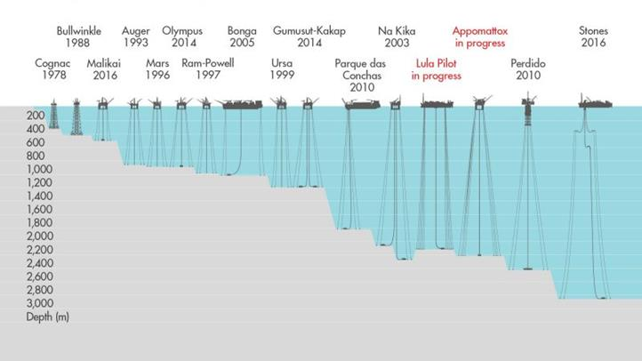
Figure 5.2: Installation Vessels [Shell]

VST systems are run on a dual-bore completion riser (or a monobore riser with bore selector located above the LRP and a means to circulate the annulus, usually via a flex hose from the surface). The TH of an HST is run on casing tubular joints, thereby saving the cost of a dual-bore completion riser; however, a complex landing string is required to run the TH. The landing string is equipped with isolation ball valves and a disconnect package made especially to suit the ram and annular BOP elevations of a particular BOP.
Guidance of trees onto the subsea wellhead is usually performed by guidelines that go from the surface to the PGB of wellhead. Guide wires are pushed into the guideposts of the tree and the tree is then lowered subsea. However, the guidelines are usually used in water depths of less than 500 m, because of the limit of wire length on the rig. For deeper water depths, a DP vessel, which uses thrusters to keep the vessel in location, may be needed to land and lock the tree onto the wellhead.
Typical procedures for installing a Vertical Tree via a drill pipe through a moon-pool are as follows as shown in Figure 5.3:

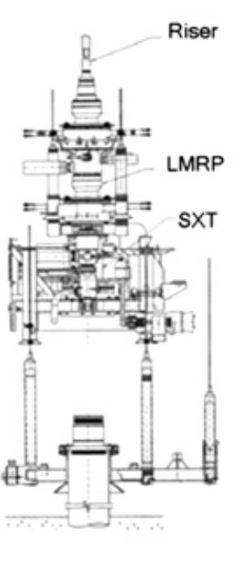  1 | 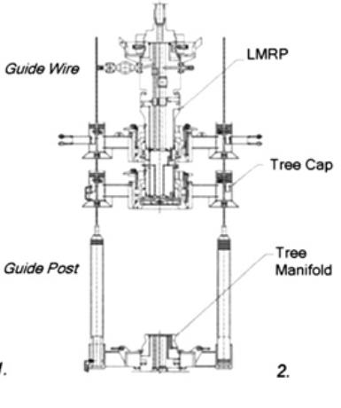  2
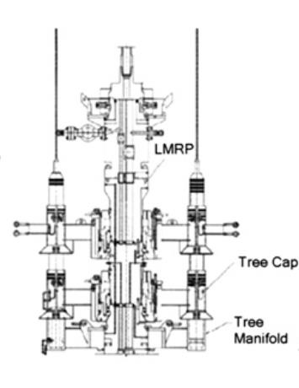  3 | 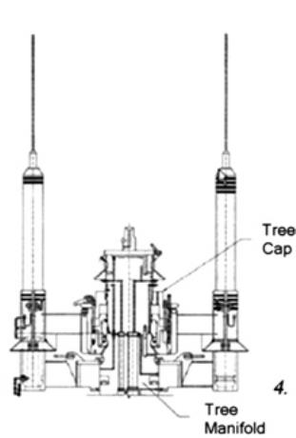  4

'Figure 5.3: Vertical Subsea Tree Installation by Drill Pipe.

5.2. Trees Testing
In the exploration stage of a well, after a potential pay zone is discovered, a well test is conducted to evaluate the production and flow capabilities of the well. In order to test a subsea well, a Drill Stem Test (DST) string is run through BOP. Typical DST string consists of perforating guns, gauges, gauge-carrier with surface readout capabilities, retrievable packer and test-valve tool. This is connected by tubing up to seabed, then to a retrievable well-control test tree set in the BOP to ensure that disconnection, if required, is done in controlled way. Reservoir fluids flow past the DST gauges at the reservoir level where pressure and temperature are detected, then flow through the tubing and test tree, and finally to the surface. An example of the controlled disconnection tool is SenTREE 3 & 7. The SenTREE 3 was equipped by Hydraulic Control System. SenTREE 7 was installed in 199, Shell in Serawak Typical procedures for installing a horizontal are given next.
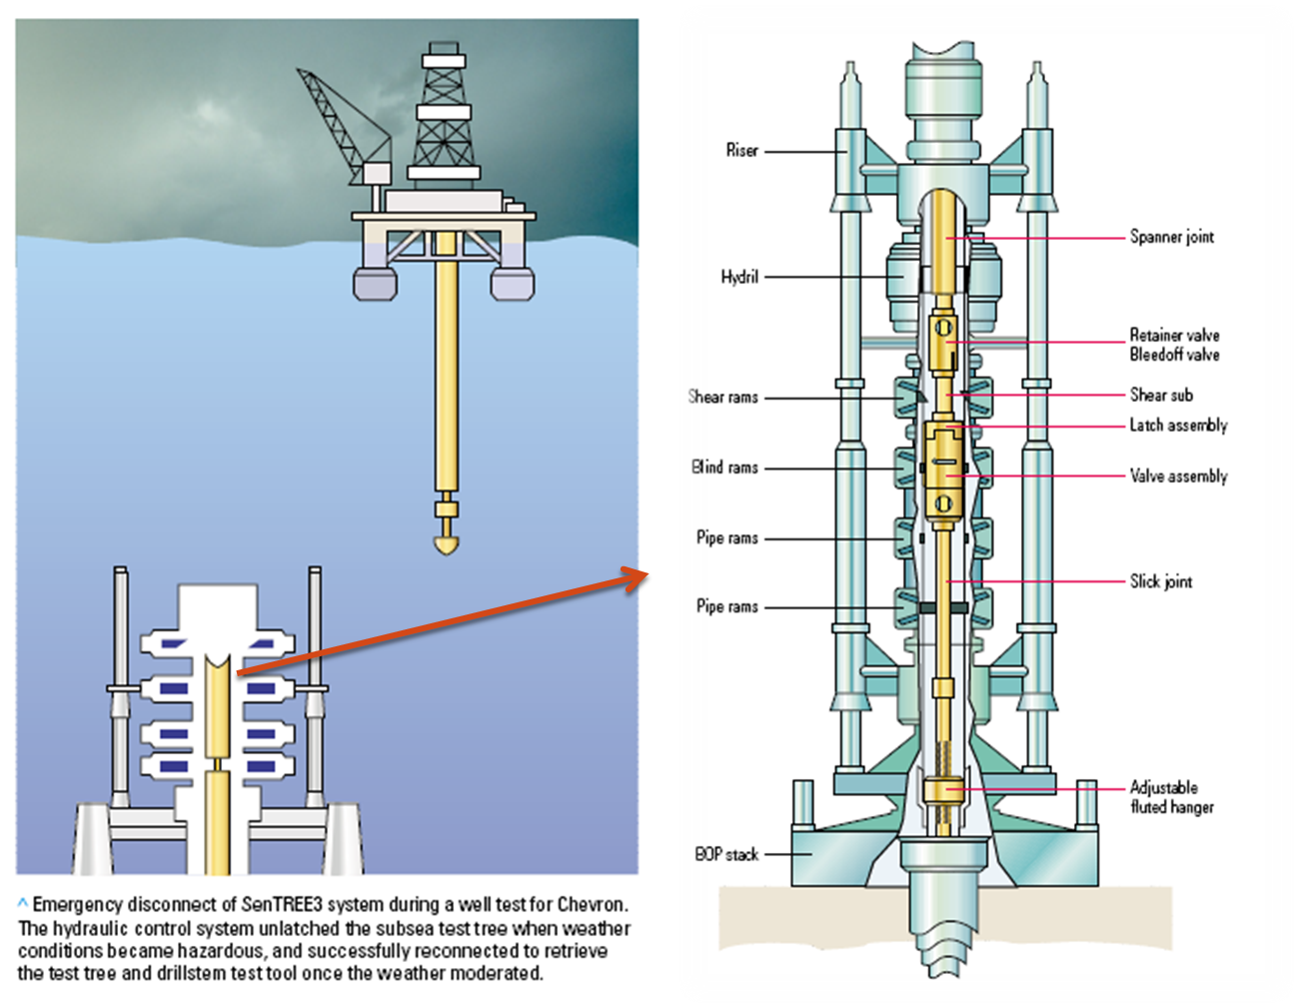
Figure 5.4: Subsea Tree testing [Schlumberger]

5.3. Trees Completion
Subsea Completion Sequences

As the tubing hanger is installed in the tree, subsea completions are performed during tree installation. Procedures installation of a horizontal tree typically is as shown in figure below:

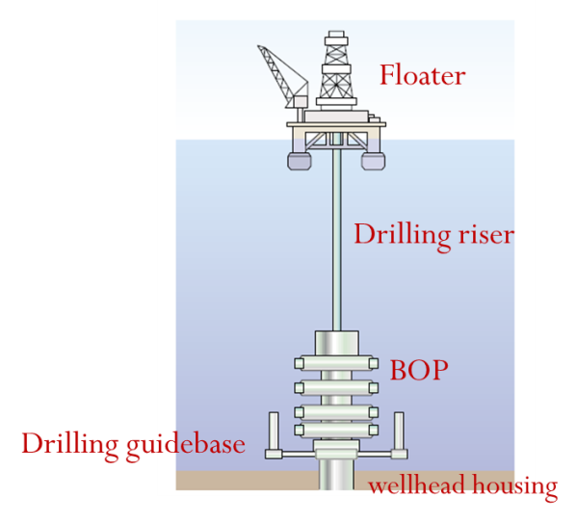  - Complete drilling and install the suspension packer | 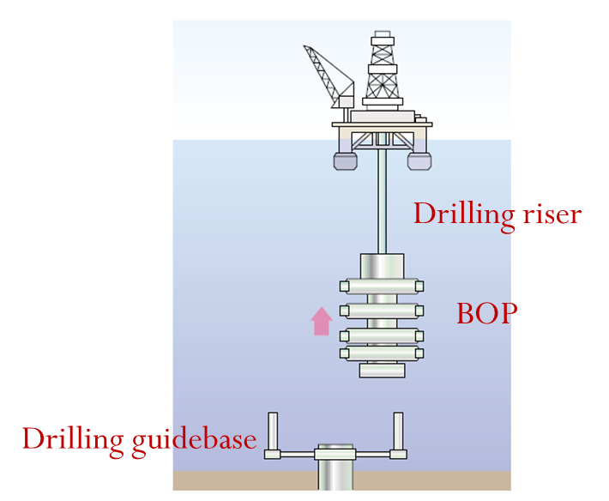  - Retrieve the drilling risers and BOP stack, move rig off

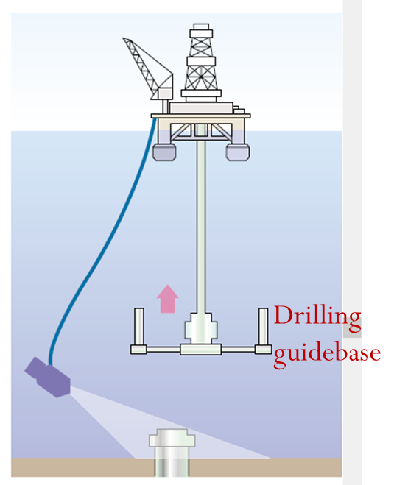  - Retrieve drilling guide base with ROV assistance | 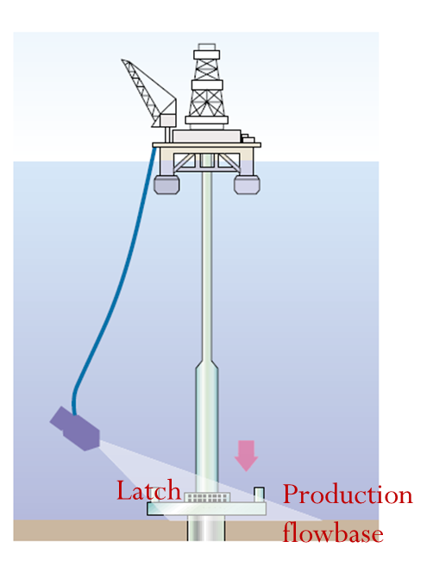  - Run the production flow-base and latch onto wellhead housing

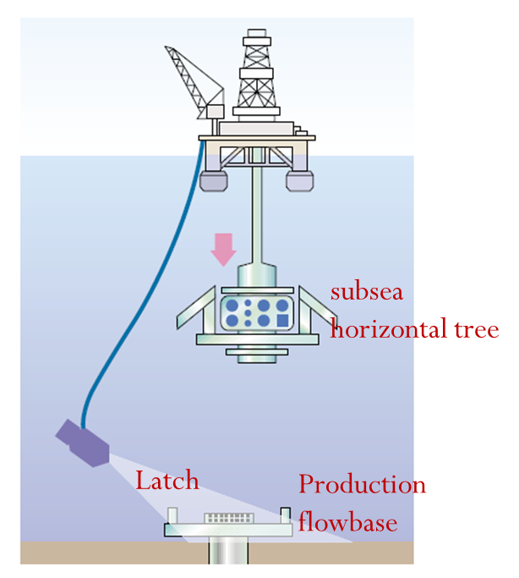  - Run subsea horizontal tree | 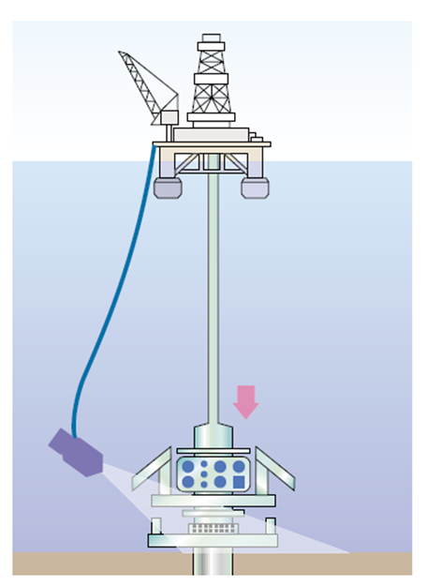  - Land the tree, lock the connector, test seal function valves with an ROV, release tree running tool (TRT)

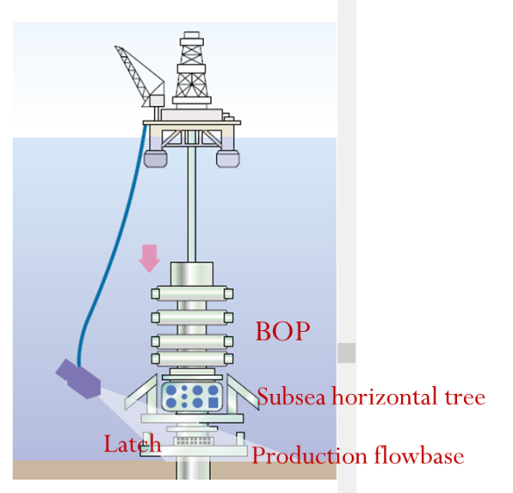  - Run BOP stack onto horizontal tree, lock connector, run BOP test tool and test, function-test tree | 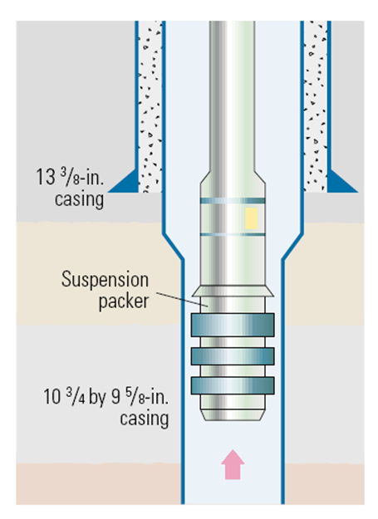  - Retrieve suspension packer, remove wear bushing from tree, make up sen TREE7 system, rack back

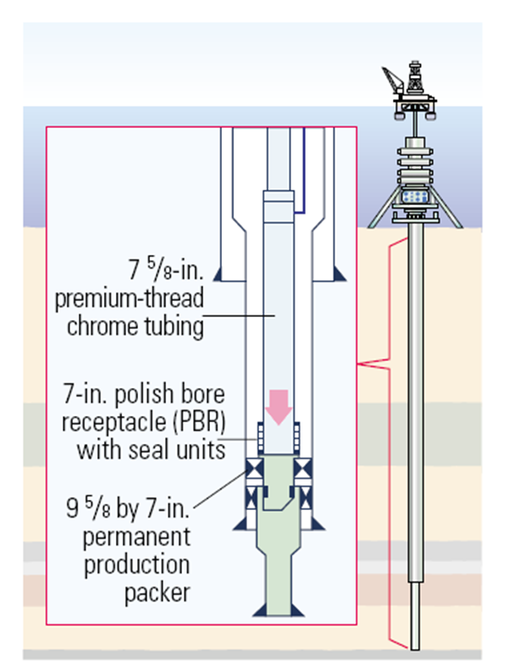  - Run completion string, make up tubing-hanger tool (THRT) and Sen TREE7 system on tubing hanger, Run landing string with umbilical, Make up surface control head to landing string | 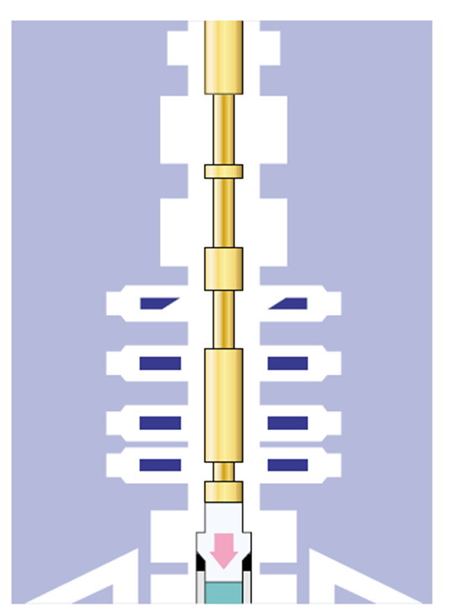  - Land hanger in production tree and test seals. Rig up wireline and retrieve straddle sleeve. Run seat protectors. Circulate tubing to potable water for drawdown. Set wireline plug, test string and set packer

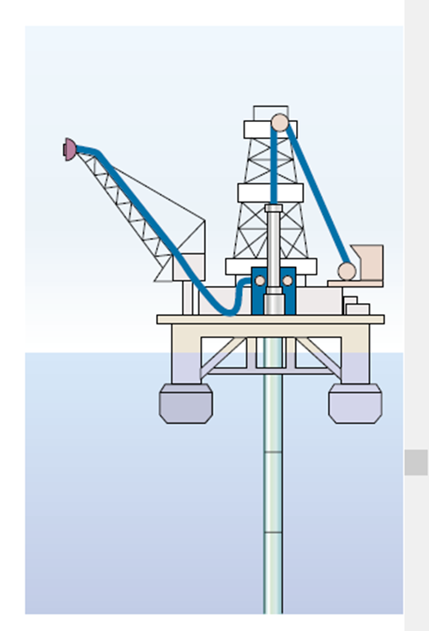  - Rig up production test package. Rig up electric wireline and lubricator | 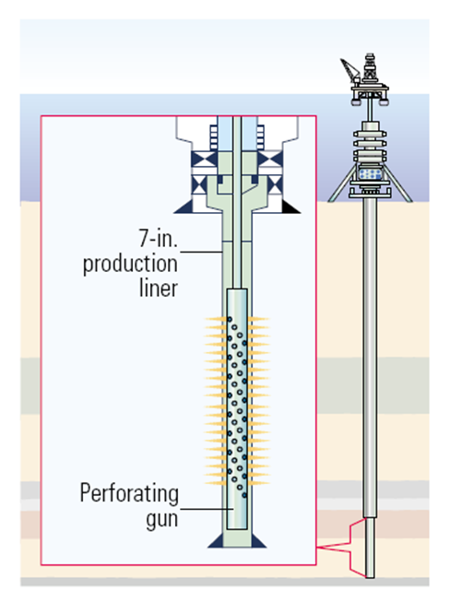  - Run guns, correlate and perforate well

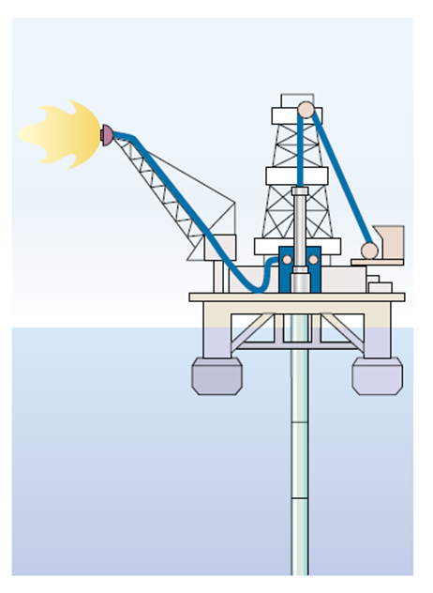  - Carry out production test, acid stimulation and multirate test | 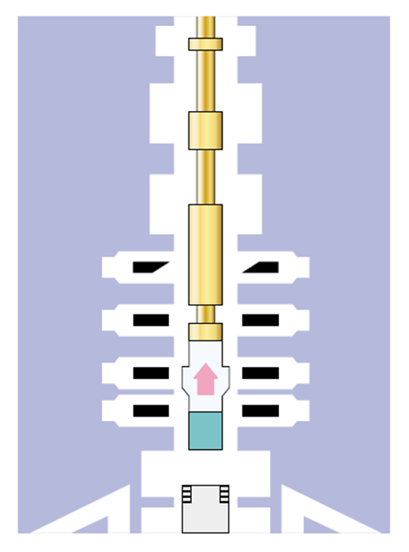  - Unlatch THRT and retrieve landing string and SenTREE7 tool. Rig down production test package and flowheat

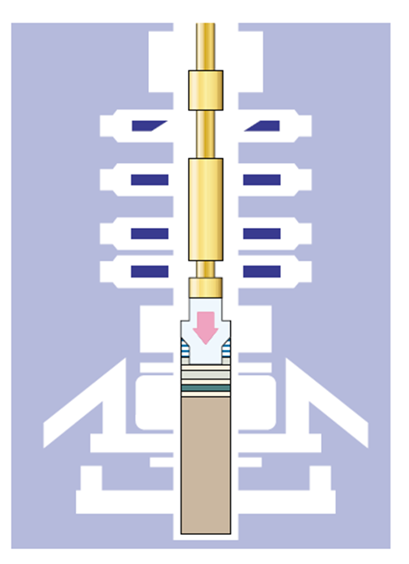  - Run internal tree cap | 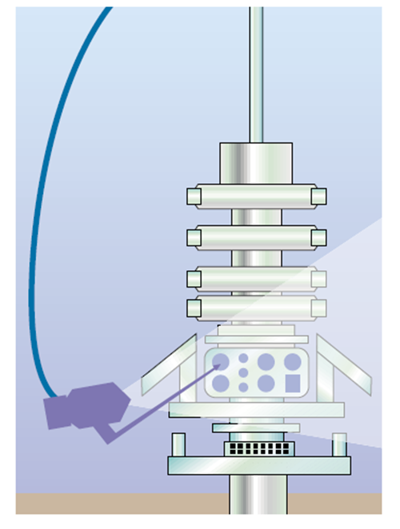  16. ROV closes tree valves. Retrieve THRT and landing string

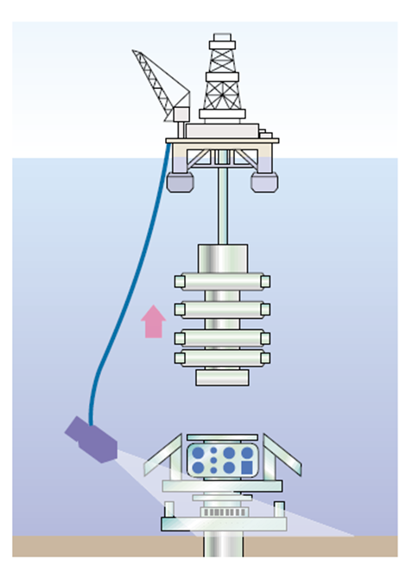  17. Retrieve BOP stack, retrieve guidewires | 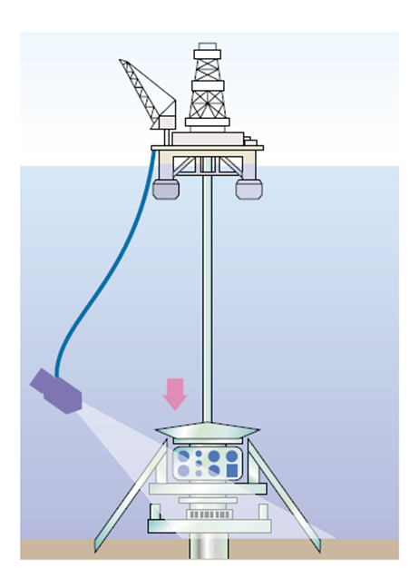  18. Install debris cap, deploy legs

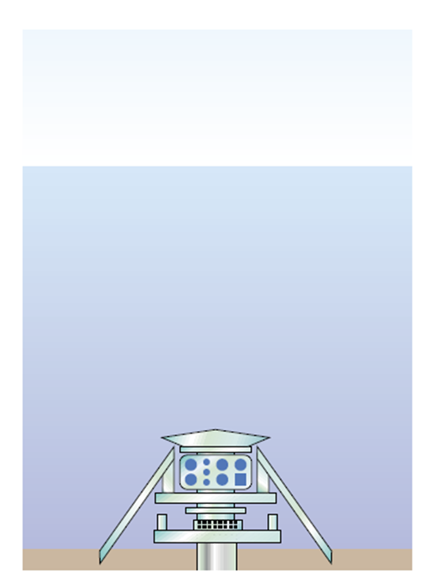  19. Suspend well | 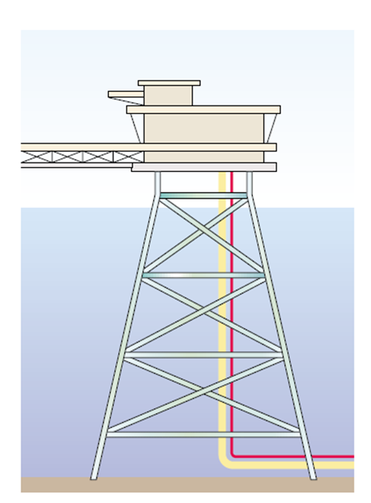  20. Tie-in pipeline for production

Figure 5.4: Horizontal subsea Tree Installation Process [Schlumberger]

Chapter.6

6.0 Perdido Subsea Tree

6.1. Perdido Field
With the water depth at Perdido approaching 3048 meter, Shell’s existing first generation standard tree system was not applicable, since it was rated for only 2286 meter of water depth. In addition, it was desired to incorporate technology advancements in seals, actuators, materials, and connectors, as well to have the ability to accommodate a wider range of deployment and intervention options. As a result, the project team developed an updated standard tree system called Enhanced Vertical Deepwater Tree (EVDT). Since its first installation in 2008, the EVDT has taken subsea production to greater depths at the Shell-operated Tobago field (Perdido project) in the Gulf of Mexico. Unique features of the EVDT system include:
  - Rated for 10,000 psi and 3048 meter of water depth
  - Retrievable flow module that contains both multi-phase flow meter and choke
  - Modular design that allows the tree system to be configured differently depending on the functional requirements of the field
  - Compact and light weight design that accommodates a wide range of deployment and intervention options

6.2. Enhanced Vertical Deepwater Tree
Vertical trees offer a variety of completion, intervention, and retrieval benefits due to their unique, vertical placement of valves in the bore and positioning of the hanger. FMC Technologies has pioneered the development of vertical subsea tree systems having installed more than 1,000 worldwide in conditions ranging from conventional to extreme.
The Enhanced Vertical Deepwater Tree (EVDT) is a mono-bore system that combines the critical safety and reliability features of vertical tree technology with the operational benefits of the horizontal tree providing the lowest lifecycle cost. With its patented design and modular structure, the EVDT maximizes the use of standard components and is manufactured globally within FMC Technologies’ major manufacturing centers. The tree is rated for up to 10,000 feet water depth and is capable of operating in temperatures up to 350 degrees Fahrenheit and 15,000 psi. It will soon be available for applications up to 400 degrees Fahrenheit and 20,000 psi. The EVDT is available in a unique slimbore configuration with 13 ⅝” OD tubing hanger allowing use of compact installation equipment, or as a full bore system with 18 ¾” hanger suitable for high volume completions.

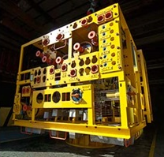
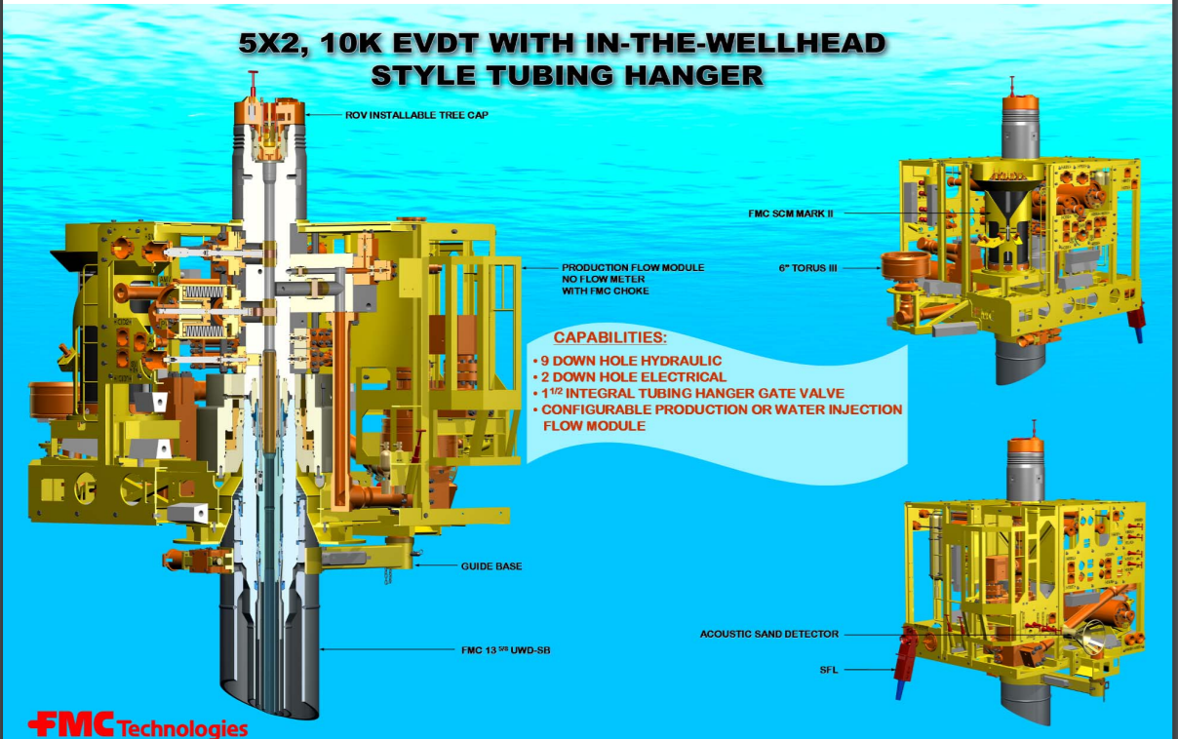
Figure 6.1: Example of Enhanced Vertical Deepwater Tree [FMC].

EVDT Advantages:
- Unique interface design offers operational flexibility for completion and workovers.
- The 18 ¾” H4 upper hub connection to the EVDT allows the BOP to connect on top of the tree eliminating the need for a special installation and intervention riser system.
- Common interface profile in the tubing hanger and tree top allows the tooling to be used interchangeably, significantly reducing the number of tools required during installation, intervention or removal.
- Slimbore configuration with 13 ⅝” OD and a compact, lightweight tree design enables installation from lower-cost rigs or via tree on wire methods from a vessel offering millions of dollars in operational savings.
- Ability to choose the preferred type of completion – installing the tubing hanger directly in the subsea wellhead or in the tubing head spool.
- Up to eleven downhole lines enable advanced functionality over the life of the field.
- Reconfigurable flow module packages critical components such as choke and flow meter into one module that is independently retrievable with a smaller rig reducing production downtime for maintenance from days to hours. Flow module also allows easy conversion from production to injection by replacing the choke as the field ages.
- Standardized tooling shared between 10,000 psi and 15,000 psi EVDT systems improves availability and significantly reduces hardware costs and lead time on projects.

6.3. Tree Installation
For the Perdido development, wells were planned to be drilled/completed by one of three methods:
- moored floaters with a dual derrick,
- dynamic positioned floaters with single derrick, and
- Spar rig.
As a result, several different tree installation methods were employed, including:
- Deployment with drill pipe from the rig
For a dual-derrick/dual activity rig, the trees systems were deployed with drill pipe using the second derrick. The tree deployment was mostly off the critical rig path, which provided substantial cost savings for tree deployment.
- Deployment with heave compensated lift system (HCLS)
For a floater with a single derrick, the trees systems were not installed with a rig, but deployed with an HCLS from an anchor-handling vessel.
- Deployment from a platform winch
Deploying trees on DVA wells under the Spar was more challenging than the methods mentioned above, since the Spar rig lacks a moon-pool and has significant constraints on weight and space. A purpose built traction winch with synthetic/fiber rope, mounted on a small cantilever deck attached to the upper deck of the Spar, was used for deployment of the trees systems from the Spar.

References

- A.S. Halal, R.F. Mitchell, Casing Design for Trapped Annulus Pressure Buildup, Drilling and Completion Journal (June 1994) 107.
- American Petroleum Institute, Petroleum and Natural Gas Industries d Drilling and Production Equipment d Wellhead and Christmas Tree Equipment, nineteenth ed., API, 6A, (2004).
- American Petroleum Institute, Recommended Practice for Design and Operation of Subsea Production Systems, API, 17A, (2002).
- American Petroleum Institute, Specification for Pipeline Valves, API, 6D, (2008).
- American Petroleum Institute, Specification for Subsea Wellhead and Christmas Tree Equipment, first ed., API Specification 17D, 1992.
- American Society of Mechanical Engineers, Process Piping, ASME, B31.3, (2008).
- American Welding Society, Structural Welding Code – Sheet Steel, AWS, D1.3, (2008).
- DNV Recommend Practice, Cathodic Protection Design, DNV, RP B401, (2005).
- Drilling Formulas, http://www.drillingformulas.com/
- FMC Technologies
- G.R. Samuel, G. Adolfo, Optimization of Multistring Casing Design with Wellhead Growth, Landmark Drilling & Well Services, SPE Paper 56762 (1999).
- H. Matlock, L.C. Reese, Generalized Solutions for Laterally Loaded Piles, Journal of the Soil Mechanics and Foundations Division, ASCE, Vol. 86, No SM5, pp. 63–91, (1960).
- International Standards Organization, Design and Operation of Subsea Production System - Subsea Wellhead and Tree Equipment, ISO, 13628–4, (2007).
- J. Koto, Subsea Connection & Jumper, Ocean & Aerospace Research Institute, Indonesia
- J. Koto, Subsea PLEM & PLET, Ocean & Aerospace Research Institute, Indonesia
- J. Koto, Subsea Production Life Cycle, Ocean & Aerospace Research Institute, Indonesia
- J. Koto, Subsea Production System Installation, Ocean & Aerospace Research Institute, Indonesia
- J. Koto, Subsea Production System, Ocean & Aerospace Research Institute, Indonesia
- J. Koto, Subsea Well Development, Ocean & Aerospace Research Institute, Indonesia
- J.Koto, Subsea Manifold and Its Application, Ocean & Aerospace Research Institute, Indonesia
- K.A. Aarnes, J. Lesgent, J.C. Hubert, Thermal Design of Dalia SPS Deepwater Christmas Tree - Verified by Use of Full - Scale Testing and Numerical Simulations, OTC 17090, Offshore Technology Conference, Houston, Texas, 2005.
- National Association of Corrosion Engineers, Petroleum and Natural Gas Industries Material for Use in H2S-Containing Environments in Oil and Gas Production, NACE MR0175 (2002).
- Oil & Gas Journal (OGJ), The Subsea System, 2010.
- Prakash Bahadur Thapa, Design of the Subsea Tree, Technical Report, Memorial University of Newfoundland, December 2016.
- Shell Global, http://www.shell.com/about-us/major-projects/appomattox.html
- Vetco Gray, https://www.geoilandgas.com
- Y.Bai, Q.Bai, Subsea Engineering Handbook, 2010, Elsevier.
- Yaojun Lu, Madhusuden Agrawal, Harold Brian Skeels, 2011, CFD Thermal Analysis of Subsea Equipment and Experimental Validation, Offshore Technology Conference, 2-5 May, Houston, Texas, USA.

Autobiographies

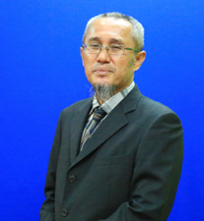 | Jaswar Koto was born on October, 1970. He is a descendant of the Prophet Rasullullah S.A.W through Husein R.A. He is a President of Ocean and Aerospace Research Institute, Indonesia. Professor on offshore engineering and also President of International Society of Ocean, Mechanical & Aerospace for scientist and engineers.
He has been invited as a Visiting Professor more than 16 times, received several international awards and supervised PhD, Master and Bachelor Students.
He received his bachelor degree in 1994 from Institut Teknologi Sepuluh Nopember (ITS), Indonesia, Curtin University in 1996 and Notre Dame University in 1999. In 2003 he has completed PhD with receiving award in engineering form Aerospace and Marine Engineering, Osaka Prefecture University, Japan.
He has started his researches since 1994 on structure analysis of fluid flow in subsea pipelines, subsea pipeline corrosion due to Carbon Monoxide, design and hydrodynamic analysis of AUV in Australia. Then, he joined Research and Development Institute, Sumitomo Heavy Industries -Marine Engineering-, Japan. In 2005, he joined ExxonMobil projects. Since 2010, he has a contract with Department of Aeronautical, Automotive, and Ocean Engineering, Faculty of Mechanical Engineering. He is also appointed as head of High Performance Computing, CICT, Universiti Teknologi Malaysia.

