Preface



This book introduces subsea pipeline design and analysis which consists of eleventh chapters. The first chapter discusses overview of subsea pipeline. In the second chapter, design requirement and analysis are discussed, the third chapter discusses on subsea pipeline design, chapter four discusses on subsea pipeline installation, other chapters orderly discuss on subsea pipeline protection, pipeline maintenance and case studies on Medgas project, Nosong-Bongawan, Kikeh, Gemusut Malaysia and Roncador, Brazil.

This book was designed for engineering education purposes only. Many pictures and illustrations are enclosed to assist the readers’ understanding. It should be noted that some pictures and contents are borrowed from companies’ websites and brochures, without written permit, even though the exact sources is listed in the references.

2017 (Third Edition)

Acknowledgements

Alhamdulillahhirobbilalamin, first and foremost, all praises and syukur are only to Allah (S.W.T) to give us strength and ability to complete this book.

We would like to take this opportunity to express our highest appreciation to our colleagues and friends in the Ocean and Aerospace Research Institute, Indonesia, Universiti Teknologi Malaysia (UTM) and Institut Teknologi Sepuluh Nopember (ITS), Indonesia to provide proper guidance, full support, encouragement, invaluable ideas, comment, recommendation, critics, suggestions and advice that to assist us for the successful completion of this book.

To our families that always pray for our successful, all this things cannot pay for all what they all have done. Our special thanks are also to our postgraduate students at Mechanical-Offshore Engineering, Universiti Teknologi Malaysia.

Above this all, our highest praises, thanks and syukur to Almighty Allah Subhanahu Wa’Talla, the most gracious the most merciful, who gave us the knowledge, courage and patience to accomplish this project. May the peace and blessings of Allah be upon Prophet Muhammad Sallallahu Alaihi Wasallam.

The authors are grateful to all friends, institutions and parties for supporting this book.

Table of Contents

Preface 1
Acknowledgements 2
Table of Contents 3
List of Figures 8
List of Tables 12
1.0 Field Development 14
1.1 Offshore Field Development 14
1.1.1 Subsea System Layout 15
1.1.2 Subsea Pipeline 16
1.1.3 Offshore Structures 17
1.1.4 Topside Processing System 19
12.1. Flow Assurance 20
12.1.1. Flow Assurance Challenges 21
12.1.2. Flow Assurance Concerns 22
12.2. Typical Flow Assurance Process 22
2.0 Design Requirements and Analysis 39
2.1. Introduction 39
2.2. Design Parameters 39
2.3. Optimum Design Process 40
2.4. Design Requirement Analysis 41
2.5. Process Design Analysis 42
3.0 Subsea Pipeline Design 44
3.1. Introduction 44
3.2. Standard Codes Practiced Design 44
3.3. Route Selection 45
3.3.1 Safest Route 46
3.3.2 Shortest Route 46
3.3.3 Easy Installation 46
3.3.4 Minimum Cost 47
3.3.5 Sustainability and Environmental friendly 47
3.6.6 Factors Considered in Route Selection 47
3.4. Pipeline Material Grade Selection 48
3.5. Pipeline Diameter Selection 48
3.6. Pipeline Wall Thickness Selection 50
3.6.1. Wall Thickness Allowance 50
3.6.2. Pipeline Expansion 51
3.6.3. Temperature Profile 54
3.6.4. Hoop Stress 55
3.6.5. Longitudinal Stress 57
3.6.6. Combined Stress 59
3.6.7. Thermal Strain 59
3.6.8. Pressure Strain 59
3.6.9. Combined Strain 60
3.7. Safety Margin of Pipeline Wall Thickness 60
3.7.1 Burst Pressure Design 60
3.7.2 External Pressure 63
3.7.3 Collapse Pressure Design 63
3.7.4 Euler Buckling Theory 65
3.7.5 Lateral Buckling Analysis 66
3.8. Free Span of Pipeline 68
3.9. Buckle Arrestors 77
4.0 Subsea Pipeline Installation 78
4.1. Introduction 78
4.2. Pull & Tow System 78
4.3. Laying by Lay Vessel 80
4.4. Laying by Reel Ship 81
5.0 Subsea Pipeline Flow Assurance 83
5.1. Flow Assurance 83
5.1.1. Flow Assurance Challenges 83
5.1.2. Flow Assurance Concerns 87
5.2. Typical Flow Assurance Process 87
5.2.1. Fluid Characterization and Property Assessments 87
5.2.2. Steady-State Hydraulic and Thermal Performance Analyses 90
5.2.3 Transient Flow Hydraulic and Thermal Performances Analyses 91
5.2.4. System Design and Operability 97
6.0 Subsea Pipeline Corrosion and Protection 104
6.1. Introduction 104
6.2. Pipeline Internal Corrosion 105
6.2.1. Sweet Corrosion: Carbon Dioxide ($CO2$) 106
6.2.2. Sour Corrosion: Hydrogen Sulfide (HS) 117
6.2.3. Internal Coatings 118
6.2.4. Internal Corrosion Inhibitors 119
6.3. Pipeline External Corrosion 120
6.3.1. Fundamentals of Cathodic Protection 120
6.3.2. External Coatings 122
6.4. Scales 133
6.4.1. Oil Field Scales 133
6.4.2. Operational Problems Due to Scales 136
6.4.3. Scale Management Options 137
6.4.4. Scale Inhibitors 137
6.4.5. Scale Control in Subsea Field 139
6.5. Subsea Pipeline Protection 140
6.5.1. Trenching and Burying 140
6.5.2. Rock-dumping 142
6.5.3. Mattress 142
6.5.4. Concrete Cover 142
7.0 Subsea Pipeline Maintenance 144
6.1. Preventive maintenance 144
6.2. Routine maintenance 144
6.3. Corrective Maintenance 144
6.4. Code Requirements DNV OS-F101 144
6.5. Inspection Strategy and Methods 145
6.5.1. Deep-water Pig Inspection 146
6.5.2. Deep-water ROV Inspection 147
6.5.3. AUV based Inspection 147
6.5.4. Risk Assessment 148
7.6. Pipeline Pigging 149
7.6.1. Pigging Technology 149
7.6.2. Type of Pigging 149
8.0 Medgaz Gas, Algeria-Spain 151
7.1. Medgaz Gas Transmission Project 151
7.1.1. Field Description 151
7.1.2. Design Parameters 152
7.1.3. Burst and Collapse Pressure Analysis 153
7.2. Safety Margin of Wall Thickness Analysis 154
7.2.1. Shallow Water 155
7.2.2. Deep Water 158
7.2.3. Ultra-deep Water 161
7.3. Finite Element Analysis 164
7.3.1. Geometry and Meshing 165
7.3.2. Load and Boundary Condition 165
7.3.3. Behavior of Pipeline without Coating 166
7.3.4. Behavior of Pipeline with Coating Thickness 45 mm 168
7.3.5 Behavior of Pipeline with Coating Thickness 80 mm 170
7.3.6 Model of Pipeline Buckling in ANSYS Workbench 172
7.3.7. Buckling Configuration of Hobbs Method 174
7.3.8. Non Linear Analysis of ANSYS 175
9.0 Nosong-Bongawan, Malaysia 179
8.1. Nosong-Bongawan Field 179
8.1.1. Field Description 179
8.1.2 Nosong Field Development 180
8.1.3 Standard and Specifications 181
8.2. Subsea Pipeline Analysis 189
8.2.1. Pipeline Design Parameter 189
8.2.2. Pipeline Material and Steel Properties 191
8.3. Subsea Strength Analysis 192
8.3.1. Pipeline Design Parameter 192
8.3.2. Buckling Analysis 193
10.0 Kikeh, Malaysia 195
9.1. Kikeh Field 195
9.1.1. Malaysian Offshore 195
9.1.2. Deep Water Challenges 197
9.1.3. Pipe Wall Thickness Design Criteria 197
9.1.4. Material Selection and Wall Thickness Design 198
9.1.5. Design Criteria 198
9.1.6. Design Limit States, Classes and Load Effect Factor 198
9.2. Kikeh Field Development 199
9.3. Subsea Pipeline Design and Analysis 202
9.3.1. Failure Mode and Wall Thickness Design Analysis 202
9.3.2. Material Grade Effect Analysis 203
9.3.3. Subsea Pipeline Stress Analysis 204
11.0 Gumusut-Kakap, Malaysia 209
10.1. Sedimentary Malaysia Basins 209
10.2. East Malaysia Oil and Gas Reservoir 212
10.3. Challenges of East Malaysian Deep Water 213
10.3.1 Complicated Seabed Relief 213
10.2. Long Thin Fields 214
10.3 Long Distance Tiebacks: 215
10.4. Gumusut-Kakap Field Development 215
10.4.1 Subsae Flowlines 215
10.4.2 Subsea Tree Systems 216
10.5. Flowlines of Gumusut-Kakap Field 218
10.5.1. Design Parameters 218
10.5.2. Safety Margin Theory 219
10.5.3. Results and Discussion 220
12.0 Roncador, Brazil 229
11.1. Introduction 229
11.2. Field Development 230
11.2.1 Roncador Subsea System 231
11. 3 Pipeline Design 233
11.3.1. Pipeline for Production 233
11.3.2. Pipeline for Gas Lift 235
11.4. Finite Element Analysis 236
11.4.1. Load and boundary conditions 236
11.4.2 Equivalent stress, strain and buckling for production pipeline 237
11.4.3. Equivalent stress, strain and buckling for gas pipeline 238
References 240
Appendixes 247
Autobiographies 254

List of Figures

Figures | Description | Pages
Figure 1.1 | Offshore Field Development components | 7
Figure 1.2 | Subsea production systems | 8
Figure.1-3 | Deep water developments [Offshore Magazine] | 11
Figure.1-4 | Development of deep-water floating systems, 1977 to 2009 | 12
Figure.1-5 | Application of FPSO -Petrobras Cascade and Chinook Project | 12
Figure.2-1 | Subsea pipeline design parameters | 14
Figure.2-2 | Subsea Pipeline Design Process | 15
Figure.2-3 | Subsea pipeline design analysis | 17
Figure.3-1 | Criteria to be considered in route selection | 20
Figure 3-2 | Sketch of Pipeline in Flat Seabed | 25
Figure 3-3 | Force Distribution | 25
Figure.3-4 | Distribution temperatures along the pipeline | 28
Figure.3-5 | Distribution of Internal Pressure | 29
Figure.3-6 | Pipeline Stresses | 31
Figure.3-7 | Pressure level relations (API-RP-1111, 1999) | 35
Figure.3-8 | Deflection of column | 39
Figure.3-9 | Pipeline Lateral Buckling Mode | 40
Figure.4-1 | Typical types of subsea pipeline installation | 44
Figure.4-2 | Pull and tow pipeline installations (surface) | 45
Figure.4-3 | Pull and tow pipeline installations (catenary) | 45
Figure.4-4 | Pull and tow pipeline installations (bottom) | 46
Figure.4-5 | Typical Pipe Configuration during S-Lay and J-Lay Pipeline Installations | 46
Figure.4-6 | Typical pipe configurations during reel-system pipeline installations | 47
Figure.5-1 | Subsea pipeline protection systems | 48
Figure.5-2 | Trenching protection of subsea pipeline [CTC Marine] | 49
Figure.5-3 | Rock-dumping protection of subsea pipeline | 50
Figure.5-4 | Mattresses protection of subsea pipeline | 49
Figure.5-5 | Concrete cover protection of subsea pipeline | 49
Figure.6-1 | Inspection Methods | 81
Figure.6-2 | Risk Based Inspection Concept | 83
Figure.6-3 | Pigging in Pipeline | 84
Figure.6-4 | Various type of pig | 85
Figure.7-1 | Route Map of Medgaz Pipeline (OTC20770) | 51
Figure.7-2 | Seabed profile along the route (OTC20770) | 52
Figure.7-3 | Burst and collapse pressures analysis | 54
Figure.7-4 | Subsea Pro Simulation and Installation software | 54
Figure.7-5.a | Safety Margin of Wall Thickness Analysis in the Shallow Water | 55
Figure.7-5.b | Wall thickness analysis in the shallow water | 56
Figure.7-5.c | Wall Thickness determination using Subsea Pro in the shallow water | 58
Figure.7-6.a | Safety margin of wall thickness analysis in the deep water | 59
Figure.7-6.b | Wall thickness analysis in the deep water | 60
Figure.7-6.c | Wall thickness determination using Subsea Pro in the deep water | 61
Figure.7-7.a | Safety margin of wall thickness analysis in the ultra-deep water | 62
Figure.7-7.b | Wall Thickness Analysis in Ultra-Deep Water | 63
Figure.7-7.c | Wall Thickness determination using Subsea Pro in the ultra-deep water | 64
Figure.7-8 | Pipeline Mesh | 65
Figure.7-9 | Pipeline Model | 66
Figure.7-10 | Equivalent Stress with different water depth | 67
Figure.7-11 | Equivalent Strain with different water depth | 68
Figure.7-12 | Equivalent Stress by using concrete coating thickness 45 mm | 69
Figure.7-13 | Equivalent Strain by using concrete coating thickness 45 mm | 70
Figure.7-14 | Equivalent Stress by using concrete coating thickness 80 mm | 71
Figure.7-15 | Equivalent Strain by using concrete coating thickness 80 mm | 72
Figure.7.16 | Pipeline Buckling In ANSYS Configuration | 73
Figure.7-17 | Buckling configuration | 74
Figure.7-18 | Buckle Length versus Concrete thickness | 74
Figure.7-19 | Slipping Length versus Coating Thickness | 75
Figure.7-20 | Imperfection Height of buckling versus Concrete Coating | 75
Figure.7-21 | Plastic Strain of Pipeline | 76
Figure.7-22 | Graph of Equivalent Stress due to Internal Pressure | 76
Figure.7-23 | Graph of Pipeline Deformation due to Internal Pressure | 77
Figure.7-24 | Plastic Strain of Collapse Pressure | 77
Figure.7-25 | Graph of Equivalent Stress due to External Pressure | 78
Figure.7-26 | Graph of Pipeline Deformation due to External Pressure | 78
Figure 8.1 | Wall thickness and stress analysis using Subsea Pro Simulation | 98
Figure 8.2 | Maximum Deformation (100m free span) | 98
Figure 8.3 | Maximum Deformation (50m free span) | 99
Figure 8.4 | Maximum Deformation (10m free span) | 99
Figure 9.1 | Malaysia Oilfield Offshore Concession Map | 110
Figure.9.2 | Location of Malaysia’s deep water project | 114
Figure.9.3 | Location of Malaysia’s on-development deep water project | 115
Figure.9.4 | Wall thickness design towards failure modes | 117
Figure.9.5 | Effect of material grade selection towards wall thickness design | 118
Figure.9.6 | Input data of UGP Pipeline program | 119
Figure.9.7 | Analysis using UGP Pipeline program | 119
Figure.9.8 | Kikeh Subsea Pipeline analysis using Subsea Pro Simulation | 122
Figure.10.1 | Seven sedimentary Malaysia basins | 125
Figure.10.2 | Geological features of NW Borneo offshore | 127
Figure.10.3 | Location of deep water projects in Malaysia | 128
Figure.10.4 | Rendered 3D image of Borneo Slope | 129
Figure.10.5 | Long Thin Fields of Malaysia deep water exploration | 129
Figure.10.6 | Long Distance Tiebacks of Malaysia deep water exploration | 130
Figure.10.7 | Gemusut-Kakap Subsea Oil export pipeline | 131
Figure.10.8 | Modular EVDT Tree installed at Gemusut-Kakap Subsea Field | 132
Figure.10.9 | Burst and collapse pressures analysis for Gemusut-Kakap | 134
Figure.10.10 | Minimum thickness of production flowlines for Gemusut-Kakap | 137
Figure.10.11 | Design parameters of production flowlines for Gemusut-Kakap | 137
Figure.10.12 | Pressure and Stress of production flowlines for Gemusut-Kakap | 138
Figure.10.13 | End expansion safety factor of production pipelines for Gemusut-Kakap | 138
Figure.10.14 | Drawing of production flowlines for Gemusut-Kakap | 139
Figure.10.15 | Minimum thickness of gas injection flowlines for Gemusut-Kakap | 139
Figure.10.16 | Design parameters of gas injection flowlines for Gemusut-Kakap | 140
Figure.10.17 | Pressure and Stress of gas injection flowlines for Gemusut-Kakap | 140
Figure.10.18 | End expansion safety factor of gas injection pipelines for Gemusut-Kakap | 141
Figure.10.19 | Drawing of gas injection for Gemusut-Kakap | 141
Figure.10.20 | Minimum thickness of water injection flowlines for Gemusut-Kakap | 142
Figure.10.21 | Design parameters of water injection flowlines for Gemusut-Kakap | 142
Figure.10.22 | Pressure and Stress of water injection flowlines for Gemusut-Kakap | 143
Figure.10.23 | End expansion safety factor of water injection pipelines for Gemusut-Kakap | 143
Figure.10.24 | Drawing of water injection flowlines for Gemusut-Kakap | 144
Figure.11.1 | Maps of Campos Basin and Roncador Field | 145
Figure.11.2 | Project Development Modules in Roncador Field | 146
Figure.11.3 | Roncador P-52 subsea layout | 148
Figure.11.4 | Equivalent stress for production pipeline | 153
Figure.11.5 | Equivalent strain for production pipeline | 153
Figure.11.6 | Production pipeline buckling In ANSYS configuration | 154
Figure.11.7 | Equivalent stress for gas pipeline | 154
Figure.11.8 | Equivalent strain for gas pipeline | 155
Figure.11.9 | Gas pipeline buckling In ANSYS configuration | 155
Figure.A.1 | Buckle Configuration | 168

List of Tables

Tables | Description | Pages
Table.1-1 | Number of Surface Structures Worldwide | 11
Table.3-1 | Design factor for pipelines and risers (ASME B31.4 and ASME B31.8) | 18
Table.3-2 | Load effect factor and load combination | 19
Table.3-3 | Safety class resistance factor, $γ_{SC}$ | 19
Table.3-4 | Tensile strength properties | 22
Table.3-5 | Crude oil sizing guidance | 23
Table.3-6 | Diameters for selected offshore projects | 23
Table.3-7 | Temperature de-rating factor, T, for steel pipe according to ASME B31.8 | 36
Table.3-7 | Lateral Buckling Constant | 36
Table.6-1 | Parameters design of Medgaz project | 52
Table.6-2 | External Pressure of Water Depth Level | 66
Table.6-3 | Pipeline deformation in ANSYS Workbench | 73
Table 8.1 | Pipeline Design and Operating Data | 95
Table 8.2 | Material Thermal Properties and Densities | 96
Table 8.3 | Steel Properties | 97
Table 8.4 | Actual and simulation result wall thicknesses | 97
Table.9.1 | Deep water projects in Malaysia’s seas | 111
Table.9.2 | General Details on Kikeh Gas Pipeline Design | 115
Table.9.3 | Result from UGP Pipeline program | 120
Table.9.4 | Corrosion allowance calculation | 120
Table.9.5 | Wall thickness comparison | 120
Table.10.1 | List oil and gas field developments in Malaysia’s seas | 126
Table.10.2 | Sizing of the flowlines according to type of wells | 131
Table.10.3 | Characteristic of subsea trees | 132
Table.10.4 | Design Parameters for flowlines | 133
Table.10.5 | Wall thickness and buckling of flowlines for Gemusut-Kakap | 135
Table 11.1 | Summarize the subsea infrastructure that has been installed in Roncador field | 148
Table 11.2 | Summarize the subsea transportation system that has been installed in Roncador field | 149
Table.11.3 | Rigid Production Pipeline Data | 150
Table.11.4 | Insulation and Coating Data for Production Pipeline | 150
Table.11.5 | Operating Data for Production Pipeline | 150
Table.11.6 | Environmental data for Production Pipeline | 150
Table 11.7 | Soil data for Production Pipeline | 151
Table.11.8 | Rigid gas pipeline data | 152
Table.11.9 | Insulation and coating data for gas pipeline | 152
Table.11.10 | Operating data for gas pipeline | 153
Table.11.11 | Environmental data for gas pipeline | 153
Table 11.12 | Soil data for gas pipeline | 153
Table C.1 | Wall thickness versus pressure | 164

Chapter.1

1.0 Field Development

1.1 Offshore Field Development
Offshore field development normally requires four elements as below and as shown in Figure 1.1. Each element (system) is briefly described in the following sub-sections.
- Subsea system
- Transport system: Flowline (FL), Pipeline (PL) and Riser
- Offshore structures: fixed or floating structures
- Topside processing system
If the wellhead is located on the seabed, it is called a wet tree. Wet trees are commonly used for subsea tiebacks using long flowlines to save cycle time (sanction to first production). If the wellhead is located on onshore or on deck of the structure, it is called a dry tree. Dry trees are useful for top tension risers (TTRs) or fixed platform risers and provide reliable well control system, low workover cost, and better maintenance.

Figure 1.1 Offshore Field Development Components [Alma]

1.1.1 Subsea System Layout
The subsea system can be broken into three parts as follows:
- Wellhead structure: (horizontal/vertical of X-tree) and manifold,
- Subsea Control System: Subsea Control Module (SCM), umbilical, Umbilical Termination Assembly (UTA), Flying Leads, Sensors, etc., and
- Connection System: Jumper and Pipeline Front/End Termination (PLFT/PLET).

Figure 1.2 Subsea production systems.

Wellhead (typically 28-in. diameter) is a topside structure of the drilling casing (typically 36-in. diameter) above the mud-line, which is used to mount a control panel with valves. The shape of the wellhead structure with valves looks like a pine tree so the wellhead is also called as “Christmas tree”. The manifold is placed to gather productions from multiple wellheads and send the productions using a smaller number of flow-lines.
The control system includes SCM, umbilical, UTA, flying leads, and sensors. SCM is a retrievable component used to control chokes, valves, and monitor pressure, temperature, position sensing devices, etc. that is mounted on the tree and/or manifold. UTA allows the use of flying leads to control equipment. Flying leads connect UTAs to subsea trees. Sensors include sand detectors, erosion detectors, pig detectors, etc.

1.1.2 Subsea Pipeline
Subsea pipelines are used for a number of purposes in the development of offshore hydrocarbon resources. These include e.g.:
- Export (transportation) pipelines;
- Pipeline bundles.
- Flowlines to transfer product from a platform to export lines;
- Water injection or chemical injection flowlines;
- Flowlines to transfer product between platforms, subsea manifolds and satellite wells;
Deep-water means water depths greater than 300 m by US MMS (Minerals Management Service) definition. Deep-water developments outrun the onshore and shallow water field developments. The reasons are:
- Limited onshore gas and oil sources (reservoirs)
- Relatively larger (~20 times (oil) and 8 times (gas)) offshore reservoirs than onshore
- More investment cost (>~20 times) but more returns
- Improved geology survey and E&P technologies
A total of 175,000 km or 4.4 times of the earth’s circumference of subsea pipelines have been installed by 2006. The deepest water depth that pipelines have been installed is 2,414 m in the Gulf of Mexico by Anadarko for the Independence Hub project in 2007. The record is broken by Petrobras Cascade flowlines which are installed in 2,689 m of water in GOM in 2009 [1].
The longest oil subsea tieback flowline length is 70 km from the Shell’s Penguin A-E and the longest gas subsea tieback flowline length is 120 km of Norsk Hydro’s Ormen Lange, by 2006 [2]. The deep-water flowlines are getting high pressures and high temperatures (HP/HT). Currently, subsea systems of 15,000 psi and 177ºC have been developed. By the year 2005, Statoil’s Kristin Field in Norway holds the HP/HT record of 13,212 psi and 167ºC, in 325 m of water.

1.1.3 Offshore Structures
The transported crude fluids are normally treated by topside processing facility above the water surface, before being sent to the onshore refinery facilities. If the water depth is relatively shallow, the surface structure can be fixed on the sea floor. If the water depth is relatively deep, the floating structures moored by tendons or chains are recommended as shown Figure 1.3.
Fixed platforms, steel jacket or concrete gravity platform, are installed in up to 1,353 ft water depth (Shell Bullwinkle in 1988). Four (4) compliant piled towers (CPTs) have been installed worldwide in water depths 1,000 ft to 1,754 ft by 2008 (one more CPT will
be installed in 366 m of water in offshore Angola, west Africa, in 2009). It is known that the material and fabrication costs for CPT are lower but the design cost is higher than conventional fixed jacket platform.
Tension leg platforms (TLPs) have been installed in water depths 482 ft to 4,674 ft (ConocoPhillips’ Magnolia in 2005).
Spar also called DDCV (deep draft caisson vessel), DDF (deep draft floater), or SCF (single column floater) is originally invented by Deep Oil Technology (later changed to Spar International, a consortium between Aker Maritime (later Technip) and J. Ray McDermott. Total 16 spars, including 15 in GOM, have been installed worldwide in water depths 1,950 ft to 5,610 ft (Dominion’s Devils Tower) by 2007. A new spar installed in late 2008 in 2,383 m of water in GOM for Shell’s Perdido project set up a new water depth record.
Semi-floating production systems (semi-FPSs) or semi-submersibles have been installed in water depths ranging from 262 ft to 7,920 ft (Anadarko’s Independence Hub in 2007). Floating production storage and offloading (FPSO) has advantages for moderate environment with no local markets for the product, no pipeline infra (remote) areas, and
short life fields. No FPSO has been installed in GOM by 2008, even though its concept for GOM environment application was approved by MMS in 2000. The first FPSO in GOM will be installed by Petrobras for Cascade and Chinook field development in 2,600
m of water in 2010. FPSOs have been installed in water depths between 66 ft to 4,796 ft (Chevron Agbami in 2008).
Floating structure types should be selected based on water depth, metocean data, topside equipment requirements, fabrication schedule, and workover frequencies. Figure 1.4 shows the floating systems development trend in 1977 - 2009.
Table 1.1 shows total number of deep-water surface structures installed worldwide by 2009. Subsea tieback means that the production lines are connected to the existing subsea or surface facilities, without building a new surface structure. The advantages of the subsea tiebacks are lower capital cost and shorter cycle time by 70% (sanction to first production) compared to implementing a new surface structure.

Table.1-1: Number of Surface Structures Worldwide [Offshore Magazine Poster] & [Jim McCaul]
Structure Types | No. of Structures | Water Depths (ft)
Fixed Platforms (WD>1,000’) | ~6,000 | 40 - 1,353
Compliant Towers | 4 | 1,000 – 1,754
TLPs | 22 | 482 - 4,674
Spars | 17 | 1,950 - 5,610
Semi-FPSs (Semi-submersibles) | 45 | 262 – 7,920
FPSOs | 159 | 66 – 4,796
Subsea Tiebacks | 3,622+ | 49 – 7,600

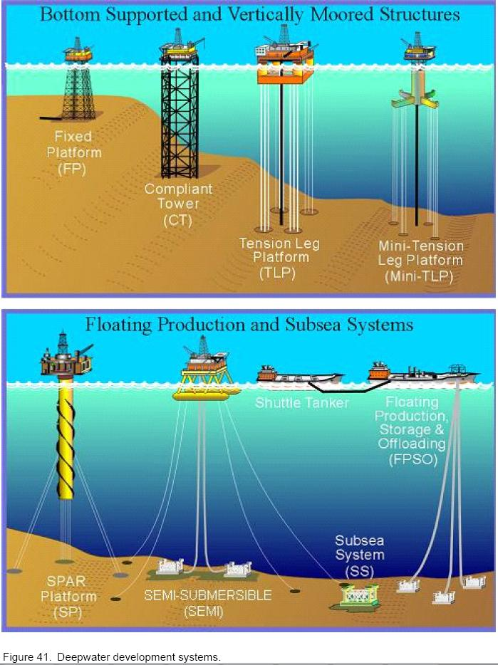
Figure.1-3: Deep water developments [Offshore Magazine]
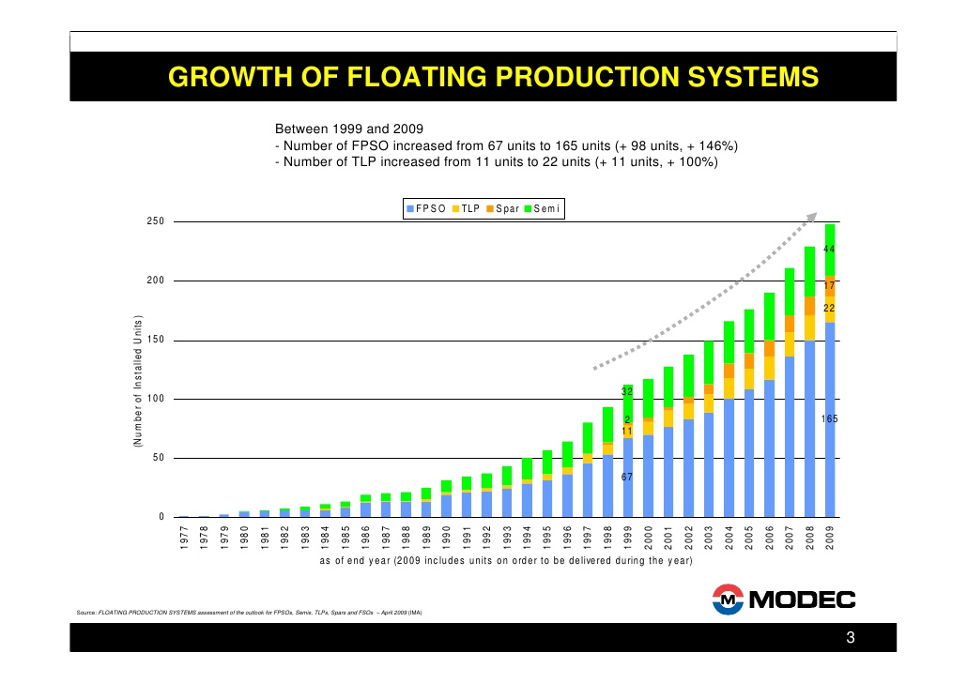
Figure.1-4: Development of deep-water floating systems, 1977 to 2009

Figure.1-5: Application of FPSO -Petrobras Cascade and Chinook Project-

1.1.4 Topside Processing System
As mentioned earlier, the crude is normally treated by topside processing facilities before
being sent to the onshore. Due to space and weight limit on the platform deck, topside processing facility is required to be compact, so its design is more complicated than that of an onshore process facility.
Requirements on topside processing systems depend on well conditions and future extension plan. General topside processing systems required for typical deep-water field developments are:
- Well control unit
- Hydraulic power unit (HPU)
- Uninterruptible power supply (UPS)
- Control valves
- Multiphase meter
- Umbilical termination panel
- Crude oil separation
- Emulsion breaking
- Pumping and metering system
- Heat exchanger (crude to crude and gas)
- Electric heater
- Gas compression
- Condensate stabilization unit
- Subsea chemical injection package
- Pigging launcher and receiver
- Pigging pump, etc.

12.1. Flow Assurance
Flow assurance is an engineering analysis process that is used to ensure that hydrocarbon fluids are transmitted economically from the reservoir to the end user over the life of a project in any environment. With flow assurance, our knowledge of fluid properties and thermal-hydraulic analyses of a system are utilized to develop strategies for controlling solids such as hydrates, wax, asphaltenes, and scale from the system.
The term flow assurance was first used by Petrobras in the early 1990s; it originally referred to only the thermal hydraulics and production chemistry issues encountered during oil and gas production. Although the term is relatively new, the problems related to flow assurance have been a critical issue in the oil/gas industry from very early days. Hydrates were observed to cause blockages in gas pipelines as early as the 1930s and were solved with chemical inhibition using methanol, as documented in the pioneering work of Hammerschmidt [E.G. Hammerschmidt ].

12.1.1. Flow Assurance Challenges
Flow assurance analysis is a recognized critical part of the design and operation of subsea oil and gas systems. Flow assurance challenges focus mainly on the prevention and control of solid deposits that could potentially block the flow of product. The solids of concern generally are hydrates, wax, and asphaltenes. Sometimes scale and sand are also included. For a given hydrocarbon fluid, these solids appear at certain combinations of pressure and temperature and deposit on the walls of the production equipment and flowlines. Figure 12-1 shows the hydrate and wax depositions formed in hydrocarbons flowlines, which ultimately may cause plugging and flow stoppage.
The solids control strategies used for hydrates, wax, and asphaltenes include the following:
- Thermodynamic control: Keep the pressure and temperature of the entire system out of the regions where the solids may form.
- Kinetic control: Control the conditions under which solids form so that deposits do not form.
- Mechanical control: Allow solids to deposit, but periodically removing them by pigging.
Flow assurance has become more challenging in recent years in subsea field developments involving long-distance tie-backs and deepwater. The challenges include a combination of low temperature, high hydrostatic pressure for deepwater and economic reasons for long offsets. The solutions to solids deposition problems in subsea systems are different for gas versus oil systems.

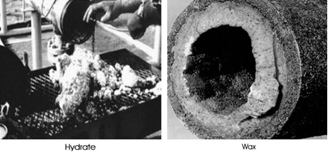
Figure 12-1 Solid depositions formed in hydrocarbon flowlines [A.A. Kaczmarski]

For gas systems, the main concern of solids usually is hydrates [E.D. Sloan]. Continuous inhibition with either methanol or mono-ethylene-glycol (MEG) is a common and robust solution, but low-dosage hydrate inhibitors (LDIs) are finding more applications in gas systems. The systems using methanol for inhibition are generally operated on a once-through basis. The methanol partitions into gas and water phases and is difficult to recover. Systems using MEG on the other hand normally involve the reclamation of MEG. If a hydrate plug forms, the remediation method may be a depressurization.
For oil systems, both hydrates and paraffins are critical issues. In the Gulf of Mexico (GoM), a blowdown strategy is commonly used [F.M. Pattee]. The strategy relies on the insulation coating on the flowline to keep the fluids out of the hydrate and paraffin deposition regions during operation. During start-ups and shutdowns, a combination of inhibition, depressur-ization, and oil displacement is performed to prevent hydrate and paraffin deposition. Wax is removed by pigging. The strategy is effective, but depends on successful execution of relatively complex operational sequences. If a hydrate plug forms, it is necessary to depressurize the line to a pressure usually below 200 psi for a deepwater subsea system and wait for the plug to disassociate, which could take a very long time in a well-insulated oil system.

12.1.2. Flow Assurance Concerns
Flow assurance is only successful when the operations generate a reliable, manageable, and profitable flow of hydrocarbon fluids from the reservoir to the end user. Some flow assurance concerns are:
- System deliverability: Pressure drop versus production, pipeline size and pressure boosting, and slugging and emulsion. These topics are discussed in detail in Chapter 13 on hydraulics.
- Thermal behavior: Temperature distribution and temperature changes due to start-up and shutdown, and insulation options and heating requirements..

12.2. Typical Flow Assurance Process
As mentioned earlier, flow assurance is an engineering analysis process of developing a design and operating guidelines for the control of solids deposition in subsea systems. Depending on the characteristics of the hydrocarbons fluids to be produced, the processes corrosion, scale deposition, and erosion may also be considered in the flow assurance process. The main part of the flow assurance analysis should be done prior to or during the earlier front-end engineering and design (FEED) process. The requirements for each project are different and, therefore, project-specific strategies are required for flow assurance problems. However, during the past several decades, the flow assurance process itself has become standardized, and a typical procedure is shown in Figure 12-2. The main issues associated with the flow assurance process are as follows:
- Fluid characterization and flow property assessments;
- Steady-state hydraulic and thermal performance analyses;
- Transient flow hydraulic and thermal performance analyses;
- System design and operating philosophy for flow assurance issues. Detailed explanations for each issue are given in the following sections. Some issues may occur in parallel, and there is considerable “looping back” to earlier steps when new information, such as a refined fluids analysis or a revised reservoir performance curve, becomes available.

12.2.1. Fluid Characterization and Property Assessments
The validity of the flow assurance process is dependent on careful analyses of samples from the wellbores. In the absence of samples, an analogous fluid, such as one from a nearby well in production, may be used. This always entails significant risks because fluid properties may vary widely, even within the same reservoir. The key fluid analyses for the sampled fluid are PVT properties, such as phase composition, GOR (gas/oil ratio), and bubble point; wax properties, such as cloud point, pour point, or WAT and asphaltene stability.
Knowledge of the anticipated produced water salinity is also important, but water samples are seldom available and the salinity is typically calculated from resistivity logs. The composition of the brine is an important factor in the hydrate prediction and scaling tendency assessment. In cases where a brine sample is not available, predictions about composition can be made based on information in an extensive database of brine composition for deepwater locations.
The hydrate stability curves are developed based on PVT data and salinity estimates, and methanol dosing requirements are also obtained. A thermal-hydraulic model of the well(s) is developed to generate flowing wellhead temperatures and pressures for a range of production conditions. Then wellbore temperature transient analyses are carried out. Figure 12-3 demonstrates typical production profiles for oil, water, and gas for which the water content increases with time. Water content (water cut) is very important when choosing a flow assurance strategy to prevent hydrate formation.
Hydrate stability curves show the stability of natural gas hydrates as a function of pressure and temperature, which can be calculated based on the hydrocarbon phase and aqueous phase compositions. A thermodynamic package such as Multiflash is used for the calculations. The hydrate curves define the temperature and pressure envelope. The dosing calculations of the hydrate inhibitor, such as methanol or MEG, indicate how much inhibitor must be added to the produced water at a given system pressure to ensure that hydrates will not form at the given temperature. Hydrate inhibitor dosing is used to control hydrate formation when system temperatures drop into the range in which hydrates are stable during the steady state or transient state of a subsea system during start-up, normal operations, and shutdown. The inhibitor dosing requirements are used to determine the requirements for the inhibitor storage, pumping capacities, and number and size of inhibitor flowlines in order to ensure that the inhibitor can be delivered at the required rates for treating a well and subsea system during start-up, normal operation, and shutdown.

Fluid characterization and analyses:  - validation and characterization of data for reservoir and fluid;  - identify flow assurance issues |  | Fluid properties:  - PVT data, wax properties;  - hydrate curve;  - asphaltene stability and scale;  - emulsion, corrosion and erosion.
Preliminary steady state thermal  and hydraulics analyses |  | Concept design:  - flowline pressure and flow rate;  - flowline size;  - maximum allowable slug size;  - flowline insulation.
Preliminary transient thermal &  hydraulics analyses:  - start-up & shut-down;  - process interruptions;  - blow down & warm up;  - risk and safe condition analysis. |  | warm-up times and chemical injection requirements;  - insulation requirements;  - transient response in early, midand late life;  - basic flow blockage remediation.  - strategies
Re-evaluation of flow assurance issues  for a preferred concept. |  | OPEX & CAPEX for various concept designs to get preferred concept.
Detailed analyses of flow assurance issues for system design and operation procedures. |  | - detailed operation logic;  - chemical injection type & rates;  - chemical storage volumes;  - • host facilities requirements
Update flow assurance risk management plan and develop operation guidelines |  | Final OPEX & CAPEX and tender  packages
Figure 12-2 Typical Flow Assurance Process

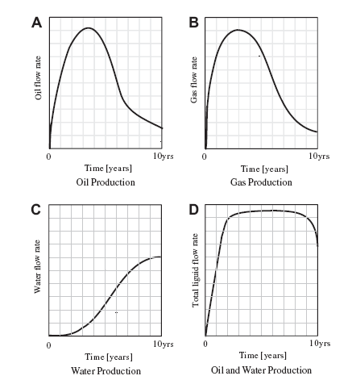
Figure 12-3 Typical Oil, Water, and Gas Production Profiles with Time

12.2.2. Steady-State Hydraulic and Thermal Performance Analyses
The steady-state flowline model can be generated with software such as PIPESIM or HYSYS. Steady-state modeling has several objectives:
- To determine the relationship between flow rate and pressure drop along the flowline. The flowline size is decided based on the maximum allowable flow rate and the minimum allowable flow rate.
- To check temperature and pressure distributions along flowlines in a steady-state condition to ensure that the flowline never enters the hydrate-forming region during steady-state operation.
- To choose an insulation combination that prevents the temperature at the riser base of a tie-back subsea system from falling below the minimum value for cooldown at the maximum range of production rates. The riser base temperature is determined as a function of flow rate and the combined wellbore/flowline insulation system.
- To determine the maximum flow rate in the system to ensure that arrival temperatures do not exceed any upper limits set by the separation and dehydration processes or by the equipment design.

12.2.3. Transient Flow Hydraulic and Thermal Performances Analyses
Transient flowline system models can be constructed with software packages such as OLGA and ProFES. Transient flowline analyses generally include the following scenarios:
- Start-up and shutdown;
- Emergent interruptions;
- Blowdown and warm-up;
- Ramp up/down;
- Oil displacement;
- Pigging/slugging.
During these scenarios, fluid temperatures in the system must exceed the hydrate dissociation temperature corresponding to the pressure at every location; otherwise, a combination of an insulated pipeline and the injection of chemical inhibitors into the fluid must be simulated in the transient processes to prevent hydrate formation.

12.2.3.1. Start-Up
Hydrate inhibitor should generally be injected downhole and at the tree during start-up. When the start-up rate is high, inhibitor is not required downhole, but the hydrocarbon flow should be treated with inhibitors at the tree. Otherwise, the hydrocarbon flow is required to be treated with inhibitors downhole. Once the tree is outside the hydrate region, hydrate inhibitor can be injected at the tree and the flow rate increased to achieve system warm-up. The start-up scenario is different for the combination of a cold well with a cold flowline and a hot flowline.

12.2.3.2. Shutdown
Shutdown scenarios include planned shutdowns and unplanned shutdowns from a steady state and unplanned shutdowns during warm-up. In general, the planned and unplanned shutdowns from the steady state are the same with the exception that for a planned shutdown, hydrate inhibitor can be injected into the system prior to shutdown. Once the system is filled with inhibited product fluids, no further inhibitor injection or depressurization is needed prior to start-up.
After shutdown, the flowline temperature will decrease because of heat transfer from the system to surrounding water. The insulation system of the flowline is designed to keep the temperature of fluids above the hydrate dissociation temperature until the “no-touch time” has passed. When considering minimum cooldown times, the “no-touch time” is the one in which operators can try to correct problems without having to take any action to protect the subsea system from hydrates. Operators always want a longer “no-touch time,” but it is a cost/benefit balancing problem and is decided on a project-by-project basis. Analyses of platform operation experience in West Africa indicate that many typical process and instrumentation interruptions can be analyzed and corrected in 6 to 8 hours.
Let’s use a tie-back subsea system in West Africa as an example. If the system is shut down from a steady state, the first step is to see if the system can be restarted within 2 hours. If so, start-up should begin. If not, one option for hydrate control is for the riser to be bullheaded with MeOH (if MeOH is chosen as a hydrate inhibitor) to ensure that no hydrates can form in the base of the riser where fluids are collecting. Next the tree piping will be dosed with methanol. After that, the fluid in the flowline will begin to be fully treated with methanol. Once 8 hours have passed, operators must determine if the system can be started up or not. If it can be started, they will proceed to the start-up procedure outlined previously. If it cannot be started up, the flowlines will be depressurized. The intention of depressurization is to reduce the hydrate dissociation temperature to below the ambient sea temperature. Once the flowlines have been depressurized, the flowlines, jumpers, and trees are in a safe state. If the wells have been shutdown for 2 days without a system restart, then the wellbores need to be bullheaded with MeOH to fill the volume of the wellbore down to the SCSSV. Once these steps have been taken, the entire system is safe

Table 12-1 Unplanned Shutdown Sequence of Events
Time (hr) | Activity
0 | Shutdown
3 | No-touch time
6 | Blowdown with gas-lift assist Jumper/tree, MeOH injection
12 | Dead oil displacement

Table 12-1 shows a typical sequence of events during an unplanned shutdown of a flowline system for the tie-back subsea system in West Africa. The shutdown event is followed by 3 hours of no-touch time. After these 3 hours, the wellbore and the jumpers are treated with methanol. Simulta-neously, the flowline is depressurized. To ensure that this procedure can be finished in 3 hours, the blowdown is carried out with a gas-lift assist. Blowdown is followed by dead oil displacement.

12.2.3.3. Blowdown
To keep the flowline system out of the hydrate-forming region when the shutdown time is longer than the cooldown period, flowline blowdown or depressurization may be an option. The transient simulation of this scenario shows how long blowdown and liquid carryover during blow-down take. The simulation also indicates whether the target pressure to avoid hydrate formation can be reached. Figure 12-4 shows that shorter blowdown times are accompanied by greater liquid carryover. The blowdown rate may also need to be limited to reduce the amount of Joule-Thompson cooling downstream of the blowdown valve, to prevent the possibility of brittle fracture of the flowline. During blowdown, sufficient gas must evolve to ensure that the remaining volume of dep-ressurized fluids exerts a hydrostatic pressure that is less than the hydrate dissociation pressure at ambient temperature. Until the blowdown crite-rion is met, the only way to protect the flowline from hydrate formation is to inject inhibitor.

Figure 12-4 Liquid Carryover versus Blowdown Time [S.E. Lorimer]

12.2.3.4. Warm-Up
During the warm-up process, hydrate inhibitor must be injected until the flowline temperatures exceed the hydrate dissociation temperature at every location for a given pressure. Figure 12-5 shows the effects of insulation material on the warm-up time. Hot oiling has two beneficial effects. First, it reduces or eliminates the time required to reach the hydrate dissociation temperature in the flowline. Once the minimum void fraction has been reached, methanol injection can be safely stopped. Reduction of the methanol injection time is a tremendous advantage for projects with limited available methanol volumes. Hot oiling also warms up the pipeline and surrounding earth, resulting in a much longer cooldown time during the warm-up period than is accomplished by warming with product fluids. This gives more flexibility at those times when the system must be shutdown before it has reached steady state.

Figure 12-5 Effect of Flowline Insulation on Warm-Up from Cold Earth [S.E. Lorimer ]

12.2.3.5. Riser Cooldown
The most vulnerable portion of the subsea system, in terms of hydrate formation, is typically the riser base. The steady-state temperatures at the riser base are near the lowest point in the whole system. The available riser insulation systems are not as effective as the pipe-in-pipe insulation that is used for some flowlines. The riser is subject to more convective heat transfer because it has a higher current velocity than a pipeline and, finally, it may be partially or completely gas filled during shutdown conditions, leading to much more rapid cooling.
The desired cooldown time before the temperature at the riser base reaches the hydrate temperature, is determined by the following formula:

$$t_{min}=t_{no touch}+t_{treat}+t_{blowdown}$$

Where; $t_{min}$ is minimum cooldown time, in hours; $t_{no touch}$ is no touch time, 2 to 3 hours; $t_{treat}$ is time to treat wellbores, trees, jumpers, and manifolds with inhibitors, in hours; $t_{blowdown}$ is time to blow down flowlines, in hours.
Cooldown times are typically on the order of 12to 24 hours. Figure 12-6 shows cooldown curves for an 8–in. oil riser with various insulation materials. The increase in the desired cooldown time requires better flowline insulation and or higher minimum production rates. The desired cooldown dictates a minimum riser base temperature for a given riser insulation system. This temperature becomes the target to be reached or exceeded during steady-state operation of the flowline system.

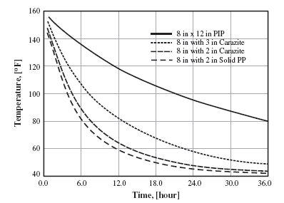

Figure 12-6 8-in. Oil Riser Cooldown Curves for Different Insulation Materials [S.E.Lorimer]

12.2.4. System Design and Operability
In a system design, the entire system from the reservoir to the end user has to be considered to determine applicable operating parameters; flow diameters and flow rates; insulation for tubing, flowlines, and manifolds; chemical injection requirements; host facilities; operating strategies and procedures etc., to ensure that the entire system can be built and operated successfully and economically. All production modes, including start-up, steady state, flow rate change, and shutdown throughout the system life, must be considered.
Operating strategies and procedures for successful system designs are developed with system unknowns and uncertainties in mind and can be readily adapted to work with the existing system, even when that is different from that assumed during design. In deepwater projects, the objective of operating strategies is to avoid the formation of hydrate or wax plugs at any time, especially hydrates in the subsea system including wellbores, trees, well jumpers, manifold, and flowlines during system operation.
Although the operations are time, temperature, and pressure dependent, a typical operating procedure is as follows:
- Operate the flowlines in an underpacked condition during steady state; for example, maintain a sufficient gas void fraction to allow successful depressurization to below the hydrate dissociation pressure at ambient temperatures.
- For a platform shutdown, close the boarding valves and tree as close to simultaneously as possible in order to trap the underpacked condition.
- Design the insulation system to provide enough cooldown time to address facility problems before remedial action is needed, and perform the interventions.
- Inject hydrate inhibitor into the well, tree, jumpers, and manifolds
- Blow down the flowline to the pressure of fluid below the hydrate-forming pressure.
- Flush flowlines with hot oil prior to restart from a blowdown condition.
- Start up the wells in stages, while injecting hydrate inhibitor. Continue hydrate inhibitor injection until the warm-up period for the well, tree,
- jumpers, and manifold has passed and enough gas has entered the flowline to permit blowdown.

The systems are normally designed to have a 3-hr no-touch time during which no hydrate prevention actions are required. Blowdown is carried out only during longer, less frequent shutdowns, and about three times per year. The logic charts for start-up and shutdown serve as an outline for the oper-ating guidelines. Figure 12-7 shows a typical logic start-up chart for the cold well start-up of a deepwater field. The start-up logic begins with the pigging of the flowlines, assuming the flowlines have been blown down. The flowlines must be pigged to remove any residual, uninhibited fluids from them. The flowlines are then pressured up to system pressure to avoid any problems caused by a severe pressure drop across the subsea choke and to make manifold valve equalization easier when it is time to switch flowlines. The next step is to start up the well that heats up the fastest, remembering to inject hydrate inhibitor at upstream of the choke while this well is ramping up. When the system is heated, hydrate inhibitor injection can stop. For this case, once the tree has reached 150_F, MeOH injection can be stopped. The temperature of 150_F has been determined to provide 8 hr of cooldown for the tree.

12.2.4.1. Well Start-Up and Shut-Down
Figure 12-8 shows a simplified typical tree schematic. The subsea tree’s production wing valve (PWV) is designated as the underwater safety valve (USV). The production master valve (PMV) is manufactured to USV specifications, but will only be designated for use as the USV if necessary. The well has a remotely adjustable subsea choke to control flow. The subsea choke is used to minimize throttling across the subsea valves during start-up and shutdown.

12.2.4.1.1. Well Start-Up
The following start-up philosophies are used for cases in which well start-up poses a risk for flowline blockage, particularly if a hydrate blockage is suspected based on the flow assurance study from the design phase:

Wells will be started up at a rate that allows minimum warm-up time, while considering drawdown limitations. There will be a minimum flow Figure 12-7 Operating Logic Chart of Start-Up for a Cold Well and a Cold Flowline rate below which thermal losses across the system will keep the fluids in the hydrate-formation region.
- It may not be possible to fully inhibit hydrates at all water cuts, partic-ularly in the wellbore. High water-cut wells will be brought on line without being fully inhibited. Procedures will be developed to minimize the risk of blockage if an unexpected shutdown occurs.
- The system is designed to inject hydrate inhibitor (typically methanol) at the tree during start-up or shutdown. The methanol injected during initial start-up will inhibit the well jumpers, manifold, and flowline if start-up is interrupted and blowdown is not yet possible

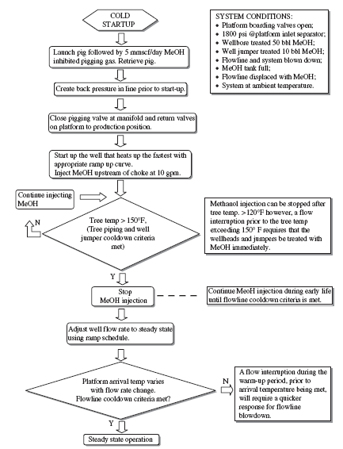

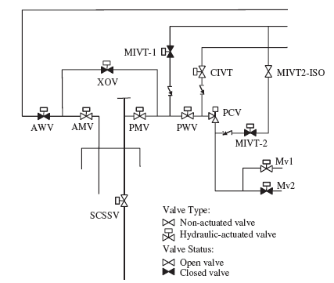

12.2.4.1.2. Well Shut-down
Well shutdown also poses a significant hydrate risk. The following philosophies may be adopted during shut-down operations:
- The subsea methanol injection system is capable of treating or displacing produced fluids with hydrate inhibitor between the manifold and SCSSV following well shutdown to prevent hydrate formation.
- Hydrate prevention in the flowlines is accomplished by blowing the flowline pressure down to less than the hydrate-formation pressure at ambient seabed temperatures.
- Most well shut-downs will be due to short-duration host facility shut-downs. The subsea trees, jumpers, and flowlines are insulated to slow the cooling process and allow the wells to be restarted without having to initiate a full shutdown operation.

12.2.4.2. Flowline Blowdown

12.2.4.2.1. Why Do We Blow Down?
The temperature of a flowline system is kept from forming hydrates by the heat from the reservoir fluids moving through the subsea flowlines during steady-state operation. When well shutdown occurs, and the pressure in the system is still high but the temperature of the system will decrease as heat is transferred to the ambient environment, hydrates may form in the flowline. Once the blowdown of the fluid pressures to below the hydrate-formation pressure corresponding to the environmental temperature has been per-formed, it is safedfrom the hydrate-formation point of the viewdto leave the system in this condition indefinitely.

12.2.4.2.2. When Do We Blow Down?
The blowdown is carried out based on several factors such as flowline pressure, available thermal energy in the system, and ability of the insulation to retain heat. When the flowline is shut down, the countdown to the hydrate-formation temperature begins. Several hours of no-touch cooldown time is expended before hydrate inhibitor injection or blowdown is required. The base of the risers is the most at risk for hydrate formation in a subsea tie-back system. Riser bases have the least amount of insulation, lowest temperature fluid at the seafloor, and, once the system is shutdown, fluids in the vertical section condense and flow downhill to pool at the riser base. Therefore, this section of the flowline must be treated early to prevent hydrate formation. The hydrate inhibitor is injected at the platform and this will mix with the fluids at the riser base and will effectively lower the temperature at which gas/water interfaces form hydrates. This will allow us to avoid blowdown for several more hours.
Once a blowdown operation has begun, the topside PLC timer is used to determine the length of time to blow the system down. Following a shut-down, all of the flowlines will need to be completely blown down by the end of 12th hour, which is different depending on the project’s requirement. Following an extended shutdown that resulted in blowdown of the subsea system, the remaining fluids must be removed from the flowlines before the flowlines can be repressurized. The fluids remaining in the flowlines will have water present and the temperature will be the same as the water temperature. When cold, high-pressure gas is introduced to water, hydrates can form. One option is pigging the flowline to remove residual fluids; sometimes displacement with hot oil is performed without pigging. Prior to beginning a pigging operation, ensure that adequate quantities of methanol are on board the platform for start-up operations and subsequent shutdown or aborted start-up

Chapter.2

2.0 Design Requirements and Analysis

2.1. Introduction
The engineering design process is a methodical series of steps that engineers use in creating functional products and processes. The process is highly iterative - parts of the process often need to be repeated many times before another can be entered - though the part(s) that get iterated and the number of such cycles in any given project can be highly variable. The design of pipelines is usually performed in three stages, namely; conceptual, preliminary engineering or basic engineering and detail engineering.’ The value of the early engineering work is that it reveals potential difficulties and areas where more effort may be required in the data collection and design areas.

2.2. Design Parameters
The basic concept of a subsea pipeline design is to safely, sustainability, environmental friendly and economically oil and gas transport, multi-phase flow to the destination with acceptable pressure loss. The object of the design process for a pipeline is to determine, based on given operating parameters, the optimum pipeline size parameters. These parameters include in subsea pipeline as shown in Figure.2.1

Figure.2-1: Subsea pipeline design parameters.

2.3. Optimum Design Process
The design process required to optimize the subsea pipeline size parameters is an iterative one on design parameters analysis such as wall thickness, material grade selection, pipeline protection and installation, which is summarized in Figure 2.2.

Figure.2-2: Subsea Pipeline Design Process

2.4. Design Requirement Analysis
Pipeline Design Requirement consists of several factors as follows:
- Hydraulic Design:
Single and multi-phase flow
- Structural Design
  - Internal pressure and temperatures
  - External pressure
  - Free spanning including VIV
  - Handling during fabrication including reeling
  - Installation and Laying
    - Using Lay barge
    - Using Reel ship
    - Towing single or bundled line
  - Trenching and burying
  - Pipeline crossing
  - Upheaval buckling
- Further Aspect to be considers
  - Inspection
  - Monitoring
  - Intervention
  - Repair
  - Abandonment

2.5. Process Design Analysis
The design requirement and analysis to optimize subsea pipeline is illustrated in Figure 2.3. Each stage in the design should be addressed whether it would be conceptual, preliminary or detailed design. However, the level of analysis will vary depending on the required output. For instance, reviewing the objectives of the detailed design, the design should be developed such that:
- Pipeline wall thickness, grade, coating and length are specified so that pipeline can be fabricated;
- Route is determined such that alignment sheets can be compiled;
- Pipeline stress analysis is performed to verify that the pipeline is within allowable stresses at all stages of installation, testing and operation. The results will also include pipeline allowable spans, tie-in details (including expansion spoolpieces), allowable testing pressures and other input into the design drawings and specifications;
- Pipeline installation analysis is performed to verify that stresses in the pipeline at all stages of installation are within allowable values. This analysis should specifically confirm if the proposed method of pipeline installation would not result in pipeline damage. The analysis will have input into the installation specifications;
- Analysis of global response; Expansion, effective force and global buckling, Hydrodynamic response, Impact
- Analysis of local strength; Bursting, local buckling, ratcheting and Corrosion defect, dents

Figure.2-3: Subsea pipeline design analysis

Chapter.3

3.0 Subsea Pipeline Design

3.1. Introduction
This chapter discusses on subsea pipeline design and analysis based on safety margin of pipeline wall thickness.

3.2. Standard Codes Practiced Design
The current design practice is to limit the hoop stress for design against the differential pressure, and to limit the equivalent stress for design against combined loads. This practice has proved to be very safe in general, except when external impact loads are critical to the integrity of the pipeline. Nevertheless, this practice has been used by the pipeline industry for decades with little change, despite significant improvements and developments in the pipeline technology [Sotberg, Bruschi, Verley].
The practices codes are ABS, API, ASME B31, BS8010, DNV and ISO. Major standard practice of onshore pipeline design is dominated by ASME B31 and applied to design subsea pipeline in shallow water as well. The ASME 31.B code consists of ASME B31.8 for gas transmission and distribution system and ASME B.31.4 for oil transportation system. The principle code practiced of ASME 31.B is based on limit the hoop stress to specific yield stress as shown in Table 3.1

Table.3-1: Design factor for pipelines and risers (ASME B31.4 and ASME B31.8)
 | Hoop Stress | Longitudinal Stress | Equivalent Stress
Oil and gas pipelines, liquid hydrocarbon piping and risers | 0.72 | 0.80 | 0.90
Gas riser on non-production platform | 0.60 | 0.80 | 0.90
Gas piping, gas risers on production platform | 0.50 | 0.80 | 0.90

API RP 1111 addresses for design, construction, testing, operation and maintenance of subsea steel pipeline. Limit State Design (LSD) concept is a design approach to assure adequate serviceability of pipeline by explicitly considering uncertainties in load and resistance. The Pipeline strength will be maintained even if the pipe should be subjected to abnormal conditions that may crack its wall. Three types of limit-states design criteria are proposed: serviceability limits, elastic limits, and strength limits.
DNV Pipeline Rules establish a philosophy for safety subsea pipeline design by providing safety class methodologies based on failure consequences in which the pipeline is classified into one or more safety classes. The level of safety has to satisfy the design load effect ($L_{d}$), but not exceed the design resistance ($R_{d}$), as shown in Table 3.2 and Table 3.3, respectively.

Table.3-2: Load effect factor and load combination
Limit State / Load Combination |  | Functional loads | Environmental load | Accidental load | Pressure load
 |  | $$γ_{F}$$ | $$γ_{E}$$ | $$γ_{A}$$ | $$γ_{P}$$
SLS & ULS | a | 1.2 | 0.7 | - | 1.05
SLS & ULS | b | 1.1 | 1.3 | - | 1.05
FLS |  | 1.0 | 1.0 | - | 1.0
ALS |  | 1.0 | 1.0 | 1.0 | 1.0

Table.3-3: Safety class resistance factor, $γ_{SC}$
$$γ_{SC}$$
Safety class | Low | Normal | High
Pressure Containment | 1.046^{3,4} | 1.138 | 1.308¹
Others | 1.04 | 1.14 | 1.26

3.3. Route Selection
Pipeline route selection or routing is choosing the best route or path for the pipeline system to be outstretched toward the existing bathymetry and platform location. There are some criteria to be considered in routing as shown in Figure.3-1

Figure.3-1: Criteria to be considered in route selection

3.3.1 Safest Route
That would probably be the most crucial thing in the whole process of producing the pipeline system. The safest route should be considered due to its minimum risk and impact for human and for the existing environmental surround. Moreover, existing landscape should be taken into account. Troughs, volcanoes, scarps, faults, and other extreme landscape including geo-hazard should be avoided in selecting the pipeline route.

3.3.2 Shortest Route
The shortest means the most efficient and effective route. Minimum material will be needed, minimum pressure loss, as well as minimizing installation risk. Please note that longer pipeline will be more susceptible to pressure loss. If long pipeline route shall be installed, then putting some additional compressor along will be necessary.

3.3.3 Easy Installation
As told before, installing offshore pipeline system is not an easy task. Therefore we should manage the simplest way to install them offshore

3.3.4 Minimum Cost
If the three criteria mentioned before is obeyed, then it’s possible to have the minimum cost all the way.

3.3.5 Sustainability and Environmental friendly
Sustainability and environmental friendly currently become critical issues in subsea pipeline design and installation. These issues will be related to the environmental and culture condition such as fishing, seabed, rock outcrops and shipping activities.

3.6.6 Factors Considered in Route Selection
In order to find the optimum route selection as mentioned above, several factors are required to be considered as follows:
- Water depth
- Seabed roughness, rock outcrops, boulders
- Crossing of other pipelines
- Geo-technics of the seabed
- Iceberg movement
- Fishing
- Military movement
- Old minefields
- Shipwrecks
- Trenches
- Shipping activities
- Shore activities, etc.

3.4. Pipeline Material Grade Selection
Generally carbon steels are used for subsea pipelines. API-5L "Specification for Line Pipe" (2000) is used for standard specifications. API-5L covers Grade B to Grade X80 steels with Outside Diameters (OD) ranging from 4.5 to 80 inch. Table 1 shows tensile strength properties according to API-5L. Generally the most common steel grade used for deep-water subsea pipelines is X65, regarding its cost-effectiveness and adequate welding technology. For buried offshore pipeline in the Arctic, the more ductile X52 has been proven the best choice for limit state design and the need for a high toughness material that could sustain the high strain based design.

Table.3-4: Tensile strength properties.
API GRADE | SMYS | SMTS
API GRADE | MPa | MPa
X42 | 289 | 413
X46 | 317 | 434
X52 | 358 | 455
X56 | 386 | 489
X60 | 413 | 517
X65 | 448 | 530
X70 | 482 | 565
X80 | 551 | 620

Generally, higher grades of steel (e.g. X70, X80, Duplex) cost more per unit volume. Welding higher grades is harder, therefore each joint requires more time so the overall operation time of the lay barge is higher. On the other hand by using higher grade steels the required wall thickness is reduced. Therefore although higher grades cost more per unit volume, the cost of pipeline per meter is slightly reduced. Higher grade steels result in a lighter pipeline, therefore the required tension is lower. This factor is very important in deep waters, where required tension can be a limiting factor.

3.5. Pipeline Diameter Selection
The process for selecting a pipeline diameter involves a detailed hydraulic analysis, especially for multiphase flows. However, there exist some empirical formulas that produce reasonable accuracy. For example Equation 3.1 can be used for sizing single phase gas lines and Table 3.5 for crude oil pipelines (Nogueira & Mckeehan, 2005).

$Q=\frac{500 D_{I}^{3}\sqrt{P_{1}^{2}-P_{2}^{2}}}{\sqrt{L_{m}}}$ (3.1)

Where $D_{I}$ is Pipeline inner diameter, $P_{1}$is psia at start point of pipeline, $P_{2}$is psia at end point of pipeline $L_{m}$ is Length of pipeline in Miles.

Table.3-5: Crude oil sizing guidance (Nogueira & Mckeehan, 2005)
For | Use
Through puts (bbl per day) | Pipe outside diameter  (in) | Pressure drop  (psi per mile)
0 – 2000 | $$3\frac{1}{2}$$ | -
2000 – 3000 | $$4\frac{1}{2}$$ | 32
3000 – 7500 | $$6\frac{5}{8}$$ | 16
7500 – 16500 | $$8\frac{5}{8}$$ | 10.5
16500 – 23500 | $$10\frac{3}{4}$$ | 8.5
23500 – 40000 | $$12\frac{3}{4}$$ | 7

Diameters of pipeline of some selected offshore projects can be also presented in Table 3.6

Table.3-6: Diameters for selected offshore projects (Nogueira & Mckeehan, 2005)
Project | Contents and peak flow rate | Maximum operating pressure | Pipeline length | Nominal Outside Diameter (OD)
Canyon | Gas condensate at 500 MMSCFD | 4200 psig at  40º F | 55 miles | 2 x 12 in
Northstar Export Line | 42º API Oil at 65000 barrels per day | 1480 psig at  100º F | 6.0 miles | 10 in
Northstar Gas Line | Processed gas 100 MMSCFD | 1480 psig | 6.0 miles | 10 in
Scarab/Saffron | Gas condensate at 600 - 1800 MMSCFD | 3750 psig | 56 miles | 2 x 20 in  1 x 24 in  1 x 36 in

3.6. Pipeline Wall Thickness Selection
Wall thickness selection is one of the most important and fundamental tasks in design of offshore pipelines. While this task involves many technical aspects related to different design scenarios, primary design loads relevant to the containment of the internal pressure are as follows: the differential pressure loads, longitudinal functional loads and external impact loads
In order to calculate the required wall thickness for an offshore pipeline, four different failure modes must be assessed:
- Internal pressure containment (burst) during operation and hydro-test.
- Collapse due to external pressure.
- Local buckling due to bending and external pressure.
- Buckle propagation and its arrest.
- End expansion

3.6.1. Wall Thickness Allowance
Having established the minimum required wall thickness, the designer should add a corrosion allowance and, for piping systems but not for pipelines, a fabrication tolerance. The minimum wall thickness required by code plus allowance is then rounded up to obtain the commercial pipe size to be procured and used in construction.
It is up to the designer to select the corrosion allowance, based on experience with similar fluids, pipe material, temperatures and flow rates.
The tolerance on wall thickness depends on the pipe material specifications. For example, an ASTM A106 carbon steel pipe may be furnished 12.5% below the specified nominal pipe wall thickness. Therefore, the minimum pipe wall thickness $tmin$ calculated by the code design equation needs to be increased by the corrosion allowance C and the fabrication tolerance f (for example with a fabrication tolerance of 12.5% on the pipe wall thickness, $f$ = 0.125. With these corrections, we now obtain the commercial pipe size to be procured:

$t = ( tmin + C )(1 + f )$ (3.2)

Where; $t$ is pipeline wall thickness, $tmin$ is minimum wall required by Code, $C$ is corrosion or threading allowance, and $f$ is the pipe wall thickness fabrication tolerance.

3.6.2. Pipeline Expansion
The expansion of pipeline can be calculated by summing the forces which are accumulated in the pipeline. Taking an anchor point at the hot end and the cool end of the pipe the following expressions can be derived based on the relationship.
$$F_{axial}$$
$$F_{axial}$$
$$F_{friction}$$
$$F_{friction}$$
Free End
Free End

Figure.3-1: Sketch of pipeline in flat seabed
KP (m)
Effective
Tension (kN)

Figure.3-2: Force Distribution along the pipeline

Force due to temperature change;

$F_{t}= α.E.A_{s}.∆T$ (3.3)

Where; $α$ is thermal expansion coefficient, $E$ is Modulus of elasticity, $A_{s}$ is steel cross sectional area of pipe and $∆T$ is temperature difference.

Force due to pressure change;

$F_{p}=P.A_{i}$ (3.4)

Where; $P$ is pressure and $A_{i}$ is internal cross section

Force due to Poisson contraction;

$F_{v}=-v.A_{s}.σ_{h}$ (3.5)

Where; $σ_{h}$ is Hoop stress and $v$ is Poisson ratio.

Force due to soil friction resistance;
The frictional resistance provided by the seabed soil can be calculated based on the operational submerged weight along the pipeline length. This is given by:

$F_{f}=\int_{0}^{x}{μ.W_{s}.dx=μ.W_{s}.L_{a}}$ (3.6)

Friction factor ($μ$) is defined as the ratio between the force required to move a section of pipe and the vertical contact force applied by the pipe on the seabed. The friction factor is dependent upon soil type, pipe roughness, seabed slope and burial depth. In the absence of site specific data, the following can be used:
    - Loose sand: $μ=\tan\left(∅\right), ∅=30$
    - Compact sand: $μ=\tan\left(∅\right), ∅=35$
    - Soft clay: $μ=0.7$
    - Stiff clay: $μ=0.4$
    - Rock and gravel: $μ=0.7$
The starting friction factor in sand is about 30% less than the maximum value, which occurs after a very small displacement of the pipe builds a wedge of soil.

By equilibrium of the above forces:

$F_{t}+F_{p}+F_{v}=F_{f}$ (3.7)

The anchor length can be obtained using the above equation

$L_{a}=\frac{1}{μW_{s}}(αEA_{s}∆T+PA_{i}-vA_{s}σ_{h})$ (3.8)

The stress induced by the thermal and pressure expansion, including the end cap effect can be written as:
$σ_{h}=\frac{PD}{2t}$ (3.9)

$σ_{L1}=\frac{PA_{i}}{A_{s}}-\frac{μ{.W}_{S.}x}{A_{S}} if x < L_{a}$ (3.9)
This condition is for the unrestrained line that the stress limitation to maintain the expansion stress $σ_{e}$ should not exceed 0.72% of the SMYS.

$σ_{e}=({σ_{L}^{2}+4σ_{t}^{2})}^{0.5}≤0.72σ_{y}$ (3.11)

$σ_{L2}=- αE∆T+vσ_{h} if x ≥ L_{a} ,$ (3.12)

$σ_{et}={\left\{{\left(σ_{h}-σ_{L}\right)}^{2}+{4σ}_{t}^{2}\right\}}^{0.5} ≤ 0.9.σ_{y}$ (3.13)

Where $σ_{L}$ is the longitudinal stress consisting of axial and bending stress. The maximum pipe hoop stress should not exceed 72% of the SMYS.
The equation for strains induced from the thermal and pressure expansion:

$ε_{h1}=α∆T+{\left(σ_{h}-{υσ}_{L1}\right)}/E$ if $x<L_{a}$ (3.14)

$ε_{h2}=α∆T+{\left(σ_{h}-{υσ}_{L2}\right)}/E$ if $x≥L_{a}$ (3.15)

$ε_{L1}=α∆T+{\left(σ_{L1}-{υσ}_{h}\right)}/E$ if $x<L_{a}$ (3.16)

$$ε_{L2}=0 if x≥L_{a}$$

Movement at the free end of the pipe can be obtained using

$∆x=\int_{0}^{L_{a}}{ε_{L1}dx=\left\{α∆T+\frac{σ_{h}}{2E}\left(1-2υ\right)-\frac{μW_{s}L_{a}}{2A_{s}E}\right\}}L_{a}$ (3.17)

The end of movement is not proportional to the moving length which is a function of temperature and pressure.

3.6.3. Temperature Profile
The temperature along a subsea pipeline should be maintained to prevent wax deposit in the pipeline. The different temperature between internal and external pipeline will make the heat is transferred into or out of the pipe. This condition results temperature gradient alongside the pipeline length as shown in Figue.3.3.

Figure.3-3: Distribution temperatures along the pipeline
Temperature difference along the pipeline is written as:

$DT=∆T.exp⁡(-x/{λ)}$ (3.18)
Where;
$λ=\frac{R_{c}}{{mC}_{p}}=$ the decay length of pipeline temperature.
$R_{c}$= reciprocal of overall linear heat transfer coefficients,
m = mass flow rate of pipe content
$C_{p}$= specific heat of fluid content
The exp$\left({{-L}_{a}}/λ\right)$ represent the temperature decay over the anchor length.

3.6.4. Hoop Stress
The burst pressure of the pipeline is basically calculated by the hoop stress formula for thin walled pressure vessels. Thin wall theory is valid for D/t > 20 and t < 0.1 inner pipe radius. It assumes uniform wall stress and gives mean circumferential stress. The burst pressure is calculated by setting the hoop stress equal to pipeline yield stress and incorporating safety factors. Thin wall equation can be used for D/t < 20 but it gives slightly higher estimates of stress than thick wall theory. The principal difference between the thin and thick wall formulations is that for thick wall conditions, the variation in stress between inner and outer surfaces becomes significant.
Pressure
(P)
T
F
D
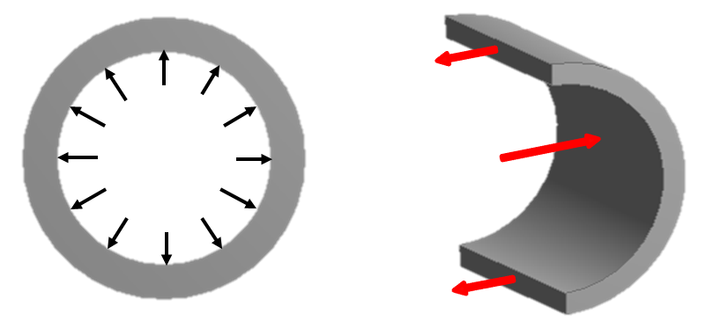

Figure.3-4: Distribution of Internal Pressure
The pipe is being subjected by internal pressure $P$ as shown in Figure 3-4 with having pipe length $L$ and pipe wall thickness $t$. The forces acting $F$ are the total of pressure and the total of tension $T$ in the wall. Where the force can be calculated as follow:

$F=PDL$ (3.19)

And the tension can be determined by equation:

${T= σ}_{h}tL$ (3.20)

The equilibrium of forces are expressed as follow :

$F+2T=0$ (3.21)

$$PDL=2σ_{h}tL$$

The hoop stress is resulted as follow:

$σ_{h}=\frac{PD_{in}}{2t}$ (3.22)

Since the pipe is subjected by external pressure, the hoop stress may be expressed as follow:

$σ_{h}=\frac{(P_{i}-P_{e)}D_{in}}{2t}$ (3.23)

Depending on which code, the hoop stress has been modified in order to find more reliable to the requirement of pipe formula. The primary requirement of the pipe wall-thickness selection is to sustain the stresses for pressure containment. The pipe wall thickness calculation formula is basically based on the tensile hoop stress equation. The failure of pipe is occurred when the value of hoop stress attains to the value of Specified Minimum Yield Stress (SMYS). Therefore, the hoop stress should be below the SMYS of pipe in design of pipeline. In order to accommodate the criteria design of pipeline, then the design factor is required to limit the work pressure based on the various codes. According to DNV – 2000 that the tensile hoop stress is due to the difference between internal ($P_{i}$) and external pressure ($P_{e}$), and is not to exceed the permissible value as given by the following hoop stress criterion:

$σ_{h}=(P_{i}-P_{e})\frac{D-t}{2t}≤ή(SMYS – f_{y.temp})$ (3.24)

Where:
The usage factor for pressure containment is expressed as

$ή = \frac{{2.α}_{U}}{\sqrt{3}.γm.γsc.γinc}$ (3.25)

where; $α_{U}$ is strength of material is 0.96
${ γ}_{sc}$is safety class factor (refer to Table 3.3 Safety class resistance factor)
$γ_{m}$is resistance factor of material (1.15 for SLS/ULS/ALS and 1.0 for FLS)
$γ_{inc}$is incidental of design pressure ratio is 1.1

The allowable hoop stress ($F_{h}$) the criterion of ABS (2000) to be expressed by the following equation:

$F_{h}=η.SMYS.k_{T}$ (3.26)

The hoop stress $F_{h}$ in a pipe can be formulated as below:

$σ_{h}=(P_{i}-P_{e})\frac{D-t}{t}$ (3.27)

3.6.5. Longitudinal Stress
The longitudinal stress is defined as the axial stress experienced by the pipe wall. Internal pressure induces stresses and axial loading which contribute to the expansion of pipeline as shown in Figure.3-5. At the same time, Poisson contraction is occurred where a contraction effect is observed due to hoop pressure acting in opposite direction to end cap force.

$$P_{i}$$
$$σ_{end cap}$$
$$σ_{thermal}$$
$${0.3σ}_{lh}$$
$$P_{i}$$
$$σ_{lb}$$
$${-σ}_{lb}$$

Figure.3-5: Pipeline Stresses.

The longitudinal stresses consist of:

End Cap Effect

$σ_{lc}= \frac{PD}{4t}$ (3.28)

Hoop stress Poison’s effect
The internal pressure induces a hoop stress and expansion circumferentially to the pipeline wall. At the same time, the pipe expands in hoop direction and the Poisson’s effect results in an axial contraction as shown in the Figure 4.5. For unrestrained pipeline, the corresponding strain and stress due to Poisson’s effect are calculated as follows:

$σ_{lh}=ν.σ_{h}$ (3.29)

Bending Stress

$σ_{lb}=\frac{Mb}{Zs}$ (3.30)

Thermal stress
In the restraint condition, the prevention of expansion gives rise to the compressive stresses, but the longitudinal strain is zero. The compressive stress generated by the expansion is calculated as follows:

$σ_{lt} = -α.E.∆T$ (3.31)

The stresses are acting axially. The negative sign on the thermal stress reflects that the pipe is under compressive for the positive temperature increase under restrained conditions.

Total longitudinal stress

$σ_{l} =σ_{lc}+σ_{lh} + σ_{lb}+ σ_{lt}$ (3.32)

3.6.6. Combined Stress
The combined stress is depending on the code/standard utilized. The combined stress shall meet the following requirement

$\sqrt{σh²+σl²-σh.σl} ≤F_{3}.SMYS$ (3.33)

3.6.7. Thermal Strain
In the unrestrained condition, the thermal strain will present due to the temperature differences between the maximum operating temperature and the minimum installation temperature. The longitudinal strain is proportional to the magnitude of the temperature difference. The thermal ${(ε}_{t})$ is given by:

$ε_{t}=αt.∆T$ (3.34)

3.6.8. Pressure Strain
Internal pressure also affects to the material strain which describes the deformation of geometry with comparing to the original shape. The change of pipe length is longitudinal strain which expressed as follow:

$ε_{l}=\frac{1}{E}(σ_{l}-vσ_{h})$ (3.35)

Whereas the change of pipe diameter is known as hoop strain which expressed as follow

$ε_{h}=\frac{1}{E}(σ_{h}-vσ_{l})$ (3.36)

The volumetric strain is described three mutually perpendicular direct strain, thus the volume strain is sum of equation (3.35) and equation (3.36)

$ε_{v}=ε_{l}+2ε_{h}$ (3.37)

$ε_{v}=\frac{1}{E}(σ_{l}-vσ_{h})+\frac{2}{E}(σ_{h}-vσ_{l})$ (3.38)

This equation is simplified by inserting equation 3.22 and equation 3.28 and resulted as follow:

$ε_{v}=\frac{PD}{4tE}(5-4v)$ (3.39)

3.6.9. Combined Strain
The combined thermal and pressure strains for unrestrained case is given by:

$ε_{total}=αt.∆T+\frac{PD}{4tE}(5-4v)$ (3.40)

3.7. Safety Margin of Pipeline Wall Thickness
Safety margin of pipeline wall thickness is a minimum wall thickness selection based on either internal or external pressure. In subsea application, the determination of wall thickness safety margin depends on the biggest one of the minimum wall thickness between internal and external calculation. So it can be called as dominant safety margin.

3.7.1 Burst Pressure Design

3.7.1.1 Specified Minimum Burst Pressure
The pipeline is filled with pressurized liquid or gas which is called the internal pressure. The burst pressure refers to the internal pressure that causes a pipe to burst or fracture. The internal pressure generates stresses in the pipeline. If the stresses exceed the limit strength, then the pipeline will be burst. The nominal burst pressure is commonly calculated using the minimum specified tensile strength of the pipe being used.
The Specified Minimum Burst Pressure ($P_{b}$) which can be written as

$P_{b}=0.90\left(SMYS+SMTS\right)(\frac{t}{D-t})$ (3.41)

Where: D= outside diameter for D/t >15

3.7.1.2 Hydrostatic Test Pressure
Test pressure refers to the hydrostatic pressure test applied at the mill. It is an inspection device used to assure integrity of the pipe body and weld. A general rule applied in selecting test pressures is that test pressure must exceed service pressure to which the pipe would ordinarily be subjected. Test pressures do, however, increase as the wall thickness of the pipe increases.
For continuous butt-welded (CBW) and electric-resistance welded (ERW) pipe, the mill applied test pressure ($P_{t}$) is ordinarily calculated from a constant mathematical formula known as the “Barlow Equation”:

$P_{t}=\frac{2∙S∙t}{D}$ (3.42)

Where;
$S$ is the specified yield strength of material normally, 60% of the yield
$t$ is the wall thickness
$D$ is the nominal outside diameter
The relation between maximum operating pressure, maximum incidental over pressure, hydro-test pressure and burst pressure are shown graphically in Figure.3-6, with $f_{e}$ and $f_{t}$ equal to 1.
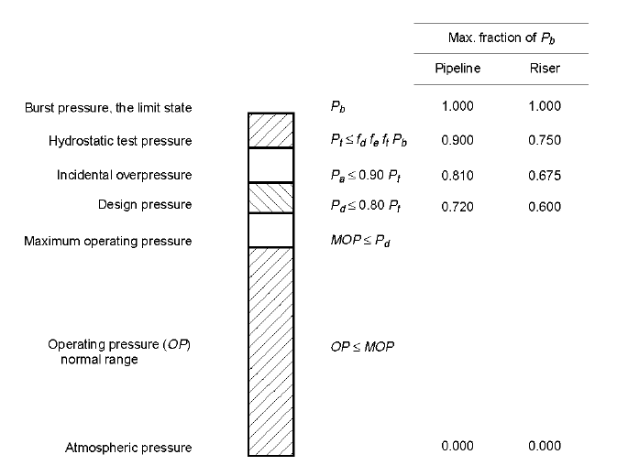
Figure.3-6: Pressure level relations (API-RP-1111, 1999)

The limit state of hydrostatic test pressure can be formulated as follows:

$P_{t} ≤f_{d}.f_{e}.f_{t}.P_{b}$ (3.43)

Where; $f_{d}$ is the burst design factor of internal pressure 0.90 for pipeline and 0.75 for riser, $f_{e}$ is the joint factor of weld and $f_{t}$ is the temperature derating factor as shown in Table.3-7.

Table.3-7: Temperature derating factor, T, for steel pipe according to ASME B31.8
Temperature (⁰C) | Temperature derating factor ($f_{t}$)
121.11 or less | 1.00
148.89 | 0.967
176.67 | 0.933
204.44 | 0.900
232.22 | 0.867

3.7.1.3 Incidental Over-Pressure
The incidental over pressure ($P_{a}$) is written as

$P_{a} ≤0.90P_{t}$ (3.44)

Substituting the hydrostatic pressure test Eq.3-41, then the incidental over pressure is written as:

$P_{a}=≤0.90f_{d}f_{e}f_{t}0.90\left(SMYS+SMTS\right)(\frac{t}{D-t})$ (3.45)

3.7.1.4 Design Pressure
Working design pressure is a term used to describe the maximum allowable pressure a tubular product may be subjected to while in-service. This includes what is commonly known as “pressure surges”.
The design pressure ($P_{d}$) is written as

$P_{d} ≤0.80P_{t}$ (3.46)

Substituting the hydrostatic pressure test Eq.3-43, then the design pressure is written as:

$P_{d}≤0.80f_{d}f_{e}f_{t}0.90\left(SMYS+SMTS\right)(\frac{t}{D-t})≥P_{Internal}$ (3.47)

3.7.2 External Pressure
External pressure is an important factor which should be taken into consideration in the design of subsea pipeline. The External pressure of subsea pipeline refers to hydrostatic pressure, which varies to every water depth level. The hydrostatic pressure is critical in the deep and ultra-deep water that may lead to collapse of pipeline structure. In order to determine a hydrostatic pressure for a certain water depth could be calculated as follows:

$P_{external}=ρ.g.h$ (3.48)

3.7.3 Collapse Pressure Design
During installation, subsea pipelines are typically subjected to conditions where external pressure exceeds the internal pressure. The differential pressure may cause collapse of pipe. Generally, the collapse pressure is between the elastic and plastic collapse pressures. The collapse pressure should exceeds the external pressure
The fundamental equation of elastic collapse due to external pressure has been proposed by Timoshenko and Gere (1961) for thin wall pipe that can be described as follow:

$P_{el}=\frac{2E}{{\left(D/t\right)}^{3}\left(1-v^{2}\right)}$ (3.49)

Thus, by using equation (3.22) and equation (3.45) correspond to elastic collapse pressure which resulted critical hoop stress:

$σ_{e}=\frac{E}{{\left(D/t\right)}^{2}\left(1-v^{2}\right)}$ (3.50)

The hoop stress is limited by yield stress of the pipe $σ_{y}$ and the maximum collapse pressure due to external pressure which lead to cross section of collapse. Therefore, the yield pressure can be given as equation:

$P_{y}=\frac{2σ_{y}t}{D}$ (3.51)

Thimosenko and Gere (1961) also propose the approximation of critical stress ($σ_{cr}$),

$σ_{cr}=\frac{σ_{y}}{1+{σ_{y}}/{σ_{e}}}=\frac{σ_{e}σ_{y}}{σ_{e}+σ_{y}}$ (3.52)

Thus, the critical stress is corresponding to the critical pressure in the equation below:

$P_{cr}=\frac{P_{e}P_{y}}{P_{e}+P_{y}}≥P_{external}$ (3.53)

Afterwards, API RP 1111 has adopted the equation (3.49) with providing interpolation the critical hoop pressure between the elastic collapse pressure and the plastic collapse pressure. The formula can be written as below:
$P_{c}=\frac{P_{y}P_{e}}{\sqrt{P_{y}^{2}+P_{e}^{2}}}$ (3.54)

Where elastic collapse pressure:

$P_{e}=2.SMYS\left(\frac{t}{D}\right)$ (3.55)

3.7.4 Euler Buckling Theory
The initial theory of buckling columns was studied by Euler in 1757 where a column is under axial compression responds elastically in the horizontal direction along the column as shown in Figure.
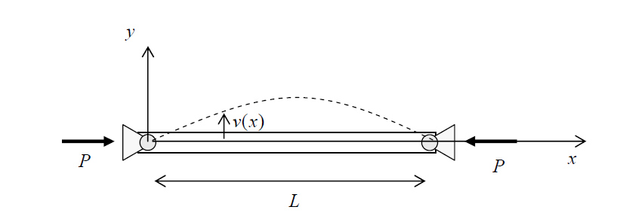
Figure.3-6: Deflection of column

The lateral deflection is given by $v(x)$ at any location $x$ and maximum deflection is located at $x=0$

$EI\frac{d^{2}y}{{dx}^{2}}=M=-Py$. (3.56)

$\frac{d^{2}y}{{dx}^{2}}+\frac{Py}{EI}=0$ (3.57)

$k^{2}=\frac{P}{EI}$ (3.58)

$y” +k^{2}y=0$ (3.59)

The second order differential equation has general solution of this equation:

$y=A sin kx+B cos kx$ (3.60)

and the boundary condition at: $y\left(0\right)=0 , B=0$ , thus $y\left(x\right)=A sin kx$, $y\left(L\right)=0, A\sin{kL=0}$, thus $kL=nπ$, Where buckling mode $n=1,2,3,…$

$k=\frac{nπ}{L}$ (3.61)

$k^{2}=\frac{P}{EI}$ (3.62)

The critical buckling load of the column can be defined

$P_{cr}=\frac{{n^{2}π}^{2}EI}{L^{2}}$ (3.63)

3.7.5 Lateral Buckling Analysis
The occurrence of buckling in the subsea pipelines was caused by high internal pressure which deform to either upward or sideways direction. The direction of movement will depend on the resistance between the pipeline and the seabed.
L

y
w
$$L/2$$

$$L/2$$

Figure.3-7: Pipeline Lateral Buckling Mode

Hobbs (1984) conducted a small scale experiment to describe the buckling shape of the pipeline. As shown in Figure 4-7, a linear differential equation can be expressed as follow:

$y^{''}+n^{2}y+\frac{m}{8}\left({4x}^{2}-L^{2}\right)=0$ (3.64)
Where:
$m=w/EI$ (3.65)

$n^{2}=P/EL$ (3.66)

With the boundary condition $y|_{x=0}=y$ and $y|_{L/2}= 0$. The results are obtained for:
Compressive effective axial force in the buckle, given by

$P=k_{1}\frac{EI}{L^{2}}$ (3.67)

$P_{0}=P+k_{2}μWL\left[\sqrt{1+k_{2}\frac{EAμ^{2}WL^{5}}{μ{\left(EI\right)}^{2}}}\right]$ (3.68)

The maximum amplitude of the buckle can be determined

$y=k_{4}\frac{WL^{4}}{EI}$ (3.69)

The maximum bending moment is calculated by

$M=k_{5}WL^{4}$ (3.70)

Table.3-7: Lateral Buckling Constant
Mode | k₁ | k₂ | k₃ | k₄ | k₅
1 | 80.76 | 6.391 x 10⁻⁵ | 0.5 | 2.407 x 10⁻³ | 0.06938
2 | 4π² | 1.743 x 10⁻⁴ | 1.0 | 5.532 x 10⁻³ | 0.1088
3 | 34.06 | 1.668 x 10⁻⁴ | 1.294 | 1.032 x 10⁻² | 0.1434
4 | 28.20 | 2.144 x 10⁻⁴ | 1.608 | 1.047 x 10⁻² | 0.1483

Whereas for minimum buckle length is determine by the equation:

$L={\left[\frac{1.6856×{10}^{6}{\left(EI\right)}^{3}}{w^{2}AE}\right]}^{0.125}$ (3.71)

The frictional resistance from the interaction between the pipe and soil and the flexibility of the pipe end will restrain the expansion along the pipeline. Under restrained condition, a compressive axial force will arise on the pipeline. The magnitude of the compressive axial force depends on the extent of the constraint applied to oppose the expansion. To release the compressive axial force, the pipe will deform into a new shape and obtain a new equilibrium state by seeking a large deflection. This structural response of the pipeline is called buckling and the amount of load to initiate buckling is the critical buckling load. A buckle of originally straight pipeline is similar to the bending deformation occurring in the elastic (Euler) buckling of a column which is loaded axially.
The pipeline response under compression depends on the level of the compression developed under the thermal loading. A high effective axial compressive force can cause the pipeline to buckle laterally or vertically. The lateral buckle mode occurs at a lower axial load than vertical mode.
For pipeline that is exposed on the seabed, lateral buckling will occur naturally at interval along the pipeline if the effective axial compressive force is sufficient for the pipe to buckle. There are several factors govern the lateral buckle to occur, such as pressure and temperature, pipe weight, pipe-soil interaction (frictional resistance), initial imperfection from the lay process due to vessel motion, wave or current loading, imperfection caused by seabed variations and external interference.
Generally, the design of subsea pipeline has requirements to determine the allowable wall thickness of pipeline according to applicable codes, the physical characteristics of the pipe material and the design pressure. After all of requirements have been fulfilled to select the subsea pipeline wall thickness, one of concern should be taken into consideration in the design of subsea pipeline namely pipeline buckling. The buckling is inevitable in the pipeline due to internal loads. Therefore, the necessity to obtain a secure supply of petroleum and gas has been studied to mitigate the buckle. The mitigation method that used in this study is buckle initiation site. Buckle initiation is design according to Hobbs Method in order to obtain elastic deformation.

3.8. Free Span of Pipeline
Proper care should be taken to ensure the subsea installed pipeline is as safe as possible to other seabed users. The pipeline is laid on seabed by various methods such as trench or buried method and uneven seabed or unburied method. Construction of unburied pipeline is the most common method for its rapid and economic performance. The unburied pipelines are subjected to various lengths of free spanning throughout the route during its life time, which may threaten the pipelines safety. Free spanning in offshore pipelines mainly occurs as a consequence of uneven seabed and local scouring due to flow turbulence and instability; hence, with no doubt, free spanning occurrences for unburied pipelines are completely inevitable as shown Figure 3-8. Free spans also may occur due to tidal currents or scouring. A free span on a pipeline is where the seabed sediments have been eroded or scoured away and the pipeline is no longer supported on the seabed.

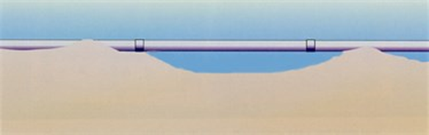
Free span length
Span shoulder
Span height
Figure 3-8. : A pipeline spanning the seabed.

Span is a function of the weight of the pipe that must be supported by the support. The size of the pipe corresponds to the maximum permissible range between the pipe supporters. As the pipe size increases, the weight of the pipe also increases. The amount of fluid that can be carried by the pipe also increases, thus increasing the weight per unit length of the pipe.
The locations of piping supports are dependent upon four factors: pipe size, piping configuration, locations of valves and fittings, and the structure available for support. Individual piping materials have independent considerations for span and placement of supports.
The critical span length or the unsupported pipeline length at which oscillations of the pipeline occur for a specific current is based on the relationship between the natural frequency of the pipe free span ($f_{n}$) and the reduced velocity ($U_{r}$). If the lay pipeline includes free spans longer than the critical length then the umbilical may be subject to Vortex Induced Vibration (VIV) possibly leading to fatigue, wear, curvature and infringement of local structural capacity at span shoulder.
The reduced velocity ($U_{r}$) at the vortex shedding induced oscillations may occur which given by

$U_{r}=\frac{U_{c}}{f_{n}D_{o}}$ (3.72)

Where;$U_{c}$ is sea current, $D_{o}$ is outer diameter of pipe. If $U_{r}>2$ for cross-flow and $U_{r}>1$ for in-line as shown figure below

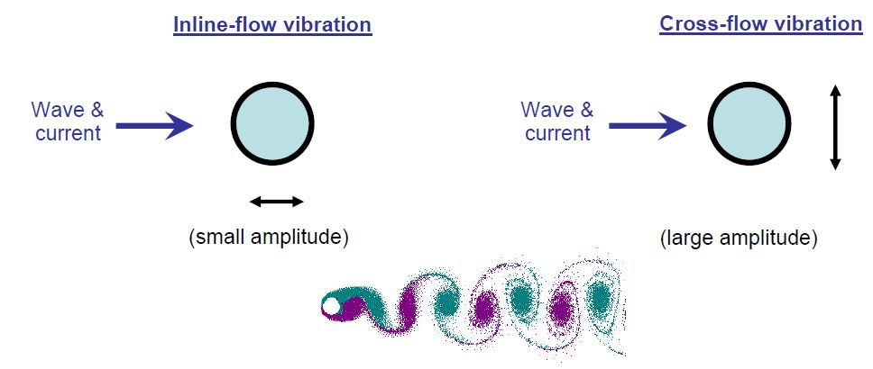
Figure 3-9: Inline and cross flows of pipeline.

The fundamental natural frequency may be approximated by

$f_{n}=C_{1}\sqrt{1+CSF}\sqrt{\frac{EI}{M_{e}L_{eff}^{4}}\left(1+\frac{S_{eff}}{P_{cr}}+C_{3}{\left(\frac{δ}{D_{o}}\right)}^{2}\right)}$ (3.73)

Where; $C_{1}$ and $C_{3}$ are boundary condition coefficients, $E$ is the modulus Young for steel, $I$ is moment of inertia for steel, $CSF$ is concrete stiffness enhancement factor, $L_{eff}$ is the effective span length and $P_{cr}$ is critical buckling load (positive sign), $δ$ is static deflection, normally ignored for in-line direction and $S_{eff}$ effective axial force (negative in compression).
The critical span length for cross-flow motion is expressed as:

$L_{c}=\sqrt{\frac{C_{e}U_{r}D_{o}}{2π}\sqrt{\frac{EI}{M_{e}}}}$ (3.74)

The critical span length for in-line motion is expressed as

$L_{c}=\sqrt{\frac{C_{e}f_{n}}{2π}\sqrt{\frac{EI}{M_{e}}}}$ (3.75)

Where $C_{e}$ is the end condition of the span whether to be pinned or fixed or mixes of these two, $EI$ is the stiffness of the pipe, $M_{e}$ ($kg/m$) is the submerged effective mass of the pipeline.
The submerged effective mass of the pipe is calculated by

$M_{e}=M_{s}+M_{c}+M_{b}$ (3.76)

Where; $M_{s}$ is mass of pipe and coating which is $M_{s}=π.ρ_{st}.\left(D_{o}-t\right)t$ , $M_{c}$ is mass of fluid inside of pipe which is $M_{c}=\frac{π.ρ_{cn}.D_{i}^{2}}{4}$, and $M_{b}$is mass pipe due to sea water which is $M_{b}=\frac{π.ρ_{w}.D_{cn}^{2}}{4}$.
The reason of spanning analysis is to determine the maximum allowable span length. Factors affecting the allowable span length include pipe wall thickness, material grade, product transported, residual tension, weight coating and currents. Allowable span lengths are governed by code limitations regarding maximum allowable stresses. In the conceptual design, it is necessary only to conduct analysis for static condition not including vortex shedding and oscillatory frequency effect.
The effective axial force in a span is difficult to estimate due to uncertainties in operational temperature and pressure, residual lay tension and axial force relaxation by sagging, axial sliding (feed-in), lateral buckling, multi-spanning and significant unevenness seabed. All these effects should be considered and taken into account if relevant. The most reliable method to estimate the effective axial force is use of non-linear FE analysis. As boundary values, the effective axial force for a completely unrestrained (axially) pipe becomes:

$S_{eff}=0$

While for a totally restrained pipe the following effective axial force applies (if pipe considered thin-walled):

$S_{eff}=H_{eff}-∆p_{i}A_{s}\left(1-2v\right)-A_{s}E∆Tα_{e}$

Where; $H_{eff}$ is effective lay tension, $∆p_{i}$ is internal pressure difference relative to laying,
(see DNV-OS-F101), $A_{s}$ is pipe steel cross section area, $∆T$ is temperature difference relative to laying and $α_{e}$ is temperature expansion coefficient, may be temperature dependent.
The critical buckling load can be expressed as

$P_{cr}= {(1+CSF)C_{2}π^{2}EI}/{L_{eff}^{2}}$ (3.77)

$L_{eff}$ is the length of the effective span length of the free span which can be obtain from the given equation

$L_{eff}=L\left\{\begin{aligned}\frac{4.73}{-0.066β^{2}+1.02β+0.63}for β≥2.7 \\ \frac{4.73}{0.036β^{2}+0.61β+1.0}for β≤2.7\end{aligned}\right\}$ (3.78)

Where

$β=\log_{10}\left(\frac{K.L}{(1+CSF(EI)}\right)$ (3.79)

The $L_{eff}$ term used above accounted for the effective span length in order to consider the span as fully fixed. The $\frac{L_{eff}}{L}$ term is given by (Hobbs, 1986) referred by DNV. $K$ is the relevant soil stiffness (vertical or horizontal, static or dynamic), $CSF$ denotes the stiffness of concrete coating relative to the steel pipe stiffness. The stiffening effect of concrete coating may be accounted for by:

$CSF=k_{c}{\left({EI_{conc}}/{EI_{steel}}\right)}^{0.75}$ (3.80)

Where; where $CSF$ denotes the stiffness of concrete coating relative to the steel pipe stiffness and $(1 + CSF)$ is the stress concentration factor due to the concrete coating and localized bending. The parameter $k_{c}$ is an empirical constant accounting for the deformation/slippage in the corrosion coating and the cracking of the concrete coating. The value of $k_{c}$ may be taken as 0.33 for asphalt and 0.25 for PP/PE coating.
The cross-sectional bending stiffness of the concrete coating ($EI_{conc}$) is the initial, uncracked stiffness. Young’s modulus for concrete may be taken as:

$E_{conc}=10000f_{cn}^{0.3}$ (3.81)

In case the static deflection is not given by direct measurement (survey) or estimated by accurate analytical tools, it may be estimated as:

$δ=C_{6}\frac{qL_{eff}^{4}}{EI\left(1+CSF\right)}\frac{1}{\left(1+\frac{S_{eff}}{P_{cr}}\right)}$ (3.82)

Where; $C_{6}$ is a boundary condition coefficient, $L_{eff}$ shall be calculated using the static soil stiffness in the ${L_{eff}}/L$ calculation due to historical effects and the local seabed geometry.
The static bending moment can be estimated by

$M_{static}=C_{5} \frac{q.L_{eff}^{2}}{\left(1+\frac{S_{eff}}{P_{cr}}\right)}$ (3.83)

Where; $q$ q represents the loading, i.e. the submerged weight of the pipe in the vertical (cross-flow) direction and/or the drag loading in the horizontal (in-line) direction.
The maximum environmental bending moment due to in-line and cross-flow VIV or direct wave and current action may be found from the dynamic stresses:

$M_{E}=σ_{E}\frac{2I}{D_{O}-t}$ (3.84)

Where; $σ_{E}$ is maximum environmental stress given below, $I$ is moment of inertia, $D_{O}$ is outer diameter of steel pipe and $t$ is wall thickness.
The stiffness of the pipeline consists of material stiffness and geometrical stiffness. The geometrical stiffness is governed by the effective axial force. This force is equal to the true steel wall axial force ($N_{tr}$), with corrections for the effect of external and internal pressures:

$S_{eff}=N_{tr}-P_{i}A_{i}+P_{e}A_{e}$ (3.85)

Where; $N_{tr}$ is true steel wall axial force, $P_{i}$ is internal pressure, $A_{i}$ is internal cross section area of the pipe, $P_{e}$ is external pressure and $A_{e}$ External cross section area of the steel pipe.
Table 6-1 Boundary conditions coefficients
Coefficient | Pinned-Pinned | Fixed-Fixed | Single span on seabed
C1 | 1.57 | 3.56 | 3.56
C2 | 1.0 | 4.0 | 4.0
C3 | 0.8 | 0.2 | 0.4
C4 | 4.93 | 14.1 | Shoulder: 14.1${(L/L_{eff})}^{2}$  Mid-span: 8.6
C5 | 1/8 | 1/12 | Shoulder:  $\frac{1}{{18(L_{eff}/L)}^{2}-6}$  Mid-span: 1/24
C6 | 5/384 | 1/384 | 1/384
Note that
- C3 = 0 is normally assumed for in-line if the steady current is not accounted for.
- For pinned-pinned boundary condition Leff is to be replaced by L in the above expressions also for Pcr.
- For fixed-fixed boundary conditions, $L_{eff}/L$ = 1 per definition.
- 4) C5 shall be calculated using the static soil stiffness in the Leff/L calculation.

Note:
Area moment of inertia section properties: $I={π({D_{out}}^{4}-{D_{in}}^{4})}/{64}$
Section modulus: $Z=I/y={π({D_{out}}^{4}-{D_{in}}^{4})}/{32D_{out}}$
Radius of gyration: ${\sqrt{({D_{out}}^{2}-{D_{in}}^{2})}}/4$
Area: $A={π({D_{out}}^{2}-{D_{in}}^{2})}/4$
Distance to neutral axis $y={D_{out}}/2$

Example.1:
The offshore pipeline specification is as follows: the outside diameter ($D_{out}$) of pipelines is 711.2 mm with a wall thickness ($t$) of 14 mm, and the pipeline is laid on seabed with the clay formations. The effective mass ($m_{e}$) is approximated 1507 Kg/m and the pipe’s Young Modulus ($E$) is $207x{10}^{9}$ (N/m²), the intensity of tension force is 407kN. Determine the deflection and stress of pipe.
P

$P/2=kδ_{max}=\frac{3EI}{({l/2)}^{3}}δ_{max}=\frac{24EI}{l^{3}}δ_{max}$

Where; $k=\frac{24EI}{l^{3}}$

$δ_{max}=P\frac{1}{2k}$

Where; $I={π({D_{out}}^{4}-{D_{in}}^{4})}/{64}$

Example.2:
We have carbon steel pipe 4" SCH-40 then the input data are as follow: $m_{e}$ is 24.3 kg/m, section modulus ($Z$) is 52680 mm³, moment of inertia section properties ($I$) is 3010500 mm⁴, the pipe’s Young Modulus ($E$) is 203390 N/mm² and pipe span between adjacent ($L$) is 7 m. Determine the deflection and stress of pipe.
Answer:
Deflection
$δ=98*{10}^{6}\left({m_{e}L^{4}}/{EI}\right)$
$δ=98*{10}^{6}\left({24.3*7^{4}}/{203390*3010500}\right)=9.388 mm$

Pipe stress
$σ=981*\left({m_{e}*L^{2}}/Z\right)=22.17 N/{mm}^{2}$

3.9. Buckle Arrestors
Buckle arrestors are located at some intervals along the pipeline to increase the bending stiffness of the pipeline. It is helpful in reducing the damage effects of the pipeline due to occurrence of collapse propagation. The propagation buckle resistance (from adjacent pipe/ of infinite buckle arrestor) and arrestor lengths are the main parameters of the capacity of buckle arrestor.
According to DNV (2007), integral arrestor can be designed following the equations:
(3.72)
(3.73)
Where,
= Crossover pressure
= Propagation buckling capacity of infinite arrestor
L_{BA} = Buckle arrestor length

Chapter.4

4.0 Subsea Pipeline Installation

4.1. Introduction
Various methods are used to install subsea pipelines. The method of installation determines the type of analyses that must be performed.

Figure.4-1: Typical types of subsea pipeline installation

4.2. Pull & Tow System
In the pull or tow system, the submarine pipeline is assembled onshore and then towed to location. Assembly is done either parallel or perpendicular to the shoreline – in the former case, the full line can be built prior to tow out and installation. A significant advantage with the pull/tow system is that pre-testing and inspection of the line are done onshore, not at sea. It allows to handle lines of any size and complexity. As for the towing procedures, a number of configurations can be used, which may be categorized as follows: surface tow, near-surface tow, mid-depth tow and off-bottom tow as shown in Figure.4-2.
- Surface Tow: In this configuration, the pipeline remains at the surface of the water during tow, and is then sunk into position at lay site. The line has to be buoyant – this can be done with individual buoyancy units attached to it. Surface tows are not appropriate for rough seas and are vulnerable to lateral currents.

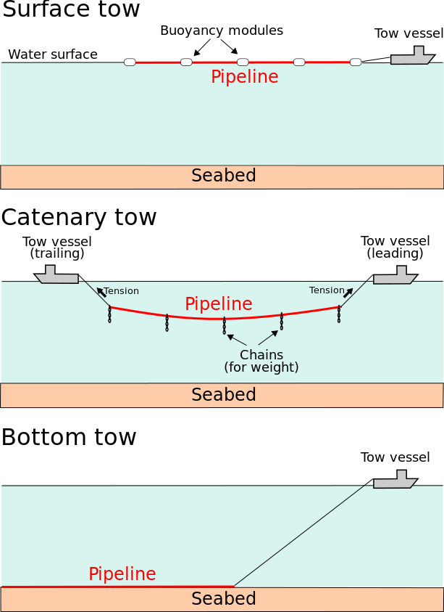
Figure.4-2: Pull and tow pipeline installations (surface)

- Near-Surface Tow: The pipeline remains below the water surface but close to it – this mitigates wave action. But the spar buoys used to maintain the line at that level are affected by rough seas, which in itself may represent a challenge for the towing operation.
- Mid-Depth Tow: The pipeline is not buoyant – either because it is heavy or it is weighted down by hanging chains. In this configuration, the line is suspended in a catenary between two towing vessels. The shape of that catenary (the sag) is a balance between the line’s weight, the tension applied to it by the vessels and hydrodynamic lift on the chains. The amount of allowable sag is limited by how far down the seabed is.

Figure.4-3: Pull and tow pipeline installations (catenary)

- Off-Bottom Tow: This configuration is similar to the mid-depth tow, but here the line is maintained within 1 to 2 m (several feet) away from the bottom, using chains dragging on the seabed.
- Bottom Tow: In this case, the pipeline is dragged onto the bottom – the line is not affected by waves and currents, and if the sea gets too rough for the tow vessel, the line can simply be abandoned and recovered later. Challenges with this type of system include: requirement for an abrasion-resistant coating, interaction with other submarine pipelines and potential obstructions (reef, boulders, etc.). Bottom tow is commonly used for river crossings and crossings between shores.

Figure.4-4: Pull and tow pipeline installations (bottom)

4.3. Laying by Lay Vessel
Pipe laying method includes the S-lay and J-lay by a lay vessel involves joining pipe joints on the lay vessel, where welding, inspection, and field joint coating take place at a number of different workstations. Figure.4-5 illustrates an the S-lay and J-Lay method. Pipe laying method progresses with the lay vessel moving forward on its anchors. The pipe is placed on the seabed in a controlled S-bend shape. The curvature in the upper section, or the overbend, is controlled by a supporting structure, called a stinger, that is fitted with rollers to minimize damage to the pipe. The curvature in the lower portion is controlled by application of tension on the vessel using special machines.

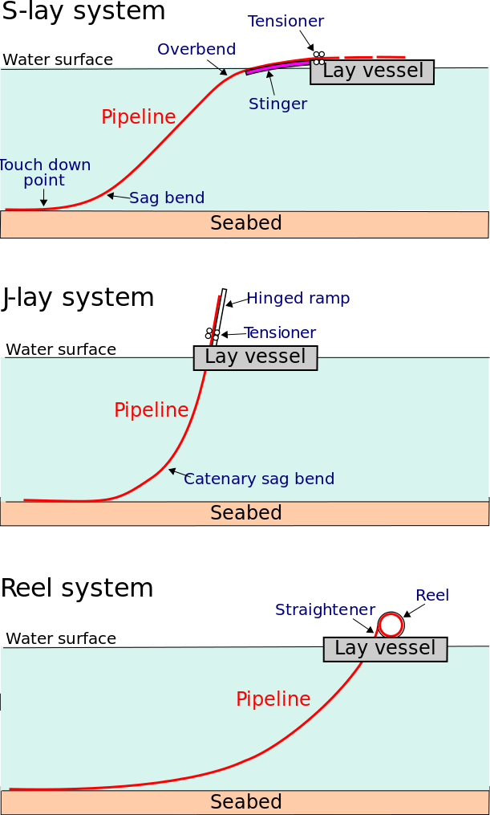
Figure.4-5: Typical Pipe Configuration during S-Lay and J-Lay Pipeline Installations

The pipeline designer must analyze the pipe-lay configuration to establish that the correct tension capacity and barge geometry have been used and that the pipe will not be damaged or overstressed during the laying process.
An appropriate analysis can be performed by a range of methods, from a simple catenary analysis that provides approximate solutions, to a precise analysis that uses finite element analysis. The main objective of the analysis is to identify stress levels in two main areas. The first is on the stinger where the pipe can undergo high bending, especially at the last support. Because the curvature can now be controlled, the pipeline codes generally allow a small safety factor. The second high-stress area is in the sag bend where the pipe is subject to bending under its own weight. The curvature at the sag bend varies with the pipeline’s lay tension and, consequently, is less controllable than the over-bend area.
In all cases the barge geometry and tension are optimized to produce stress levels in the pipe wall that stay within specified limits.

4.4. Laying by Reel Ship
The pipe reeling method has been applied widely in the North Sea and Gulf of Mexico for pipeline sizes up to 18 in. The pipeline is made up onshore and is reeled onto a large drum on a purpose-built vessel as shown in Figure.4-6. During the reeling process the pipe undergoes plastic deformation on the drum. During installation the pipe is unreeled and straightened using a special straightening ramp. The pipe is then placed on the seabed in a configuration similar to the J-lay configuration that is used by the laying barge, although in most cases a steeper ramp is used and over-bend curvature is eliminated. The analysis of the reeled pipe-laying method can be carried out using the same techniques as for a laying vessel. Special attention must be given to the compatibility of the reeling process with the pipeline steel grade since the welding process can cause unacceptable work hardening in higher grade steels. A major consideration in pipeline reeling is that the plastic deformation of the pipe must be kept within limits specified by the relevant codes, such as DNV-RP-F108. Existing reel ships reflect such code requirements.

Figure.4-6: Typical pipe configurations during reel-system pipeline installations

Chapter.5

5.0 Subsea Pipeline Flow Assurance

5.1. Flow Assurance
Flow assurance is an engineering analysis process that is used to ensure that hydrocarbon fluids are transmitted economically from the reservoir to the end user over the life of a project in any environment. With flow assurance, our knowledge of fluid properties and thermal-hydraulic analyses of a system are utilized to develop strategies for controlling solids such as hydrates, wax, asphaltenes, and scale from the system.
The term flow assurance was first used by Petrobras in the early 1990s; it originally referred to only the thermal hydraulics and production chemistry issues encountered during oil and gas production. Although the term is relatively new, the problems related to flow assurance have been a critical issue in the oil/gas industry from very early days. Hydrates were observed to cause blockages in gas pipelines as early as the 1930s and were solved with chemical inhibition using methanol, as documented in the pioneering work of Hammerschmidt.

5.1.1. Flow Assurance Challenges
Flow assurance analysis is a recognized critical part of the design and operation of subsea oil/gas systems. Flow assurance challenges focus mainly on the prevention and control of solid deposits that could potentially block the flow of product. The solids of concern generally are:
- hydrates,
- wax, and
- asphaltenes.
Sometimes scale and sand are also included. For a given hydrocarbon fluid, these solids appear at certain combinations of pressure and temperature and deposit on the walls of the production equipment and flowlines. Figure 5.1 shows the hydrate and wax depositions formed in hydrocarbons flowlines, which ultimately may cause plugging and flow stoppage.
The solids control strategies used for hydrates, wax, and asphaltenes include the following:
- Thermodynamic control: Keep the pressure and temperature of the entire system out of the regions where the solids may form.
- Kinetic control: Control the conditions under which solids form so that deposits do not form.
- Mechanical control: Allow solids to deposit, but periodically removing them by pigging.
Flow assurance has become more challenging in recent years in subsea field developments involving long-distance tie-backs and deepwater. The challenges include a combination of low temperature, high hydrostatic pressure for deepwater and economic reasons for long offsets. The solutions to solids deposition problems in subsea systems are different for gas versus oil systems.

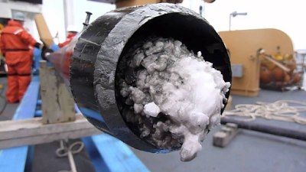
Figure 5.1: Hydrate in pipeline
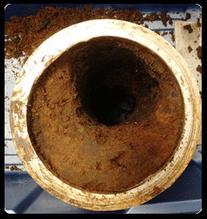
Wax in pipeline

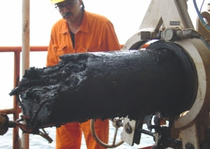
Asphalted
Figure 5-1: Solid depositions formed in hydrocarbon flowlines [SPE]

Hydrates particles set a problem:
- The flowing driving force is the differential pressure between the well head and the production facilities area. So the occurrence of gas hydrate phase acts as a decrease of this driving force because particles consume the lighter components and decrease the pressure.
- The viscosity of the fluid increases and so the flow rate decreases which is prejudicial to the productivity of the well.
- Finally, one has to separated the hydrate phase (solid phase) from the rest of the liquid before it enters in the classical separation apparatus.

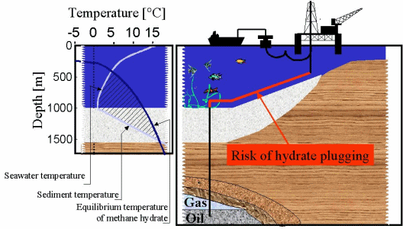
Figure 5-2: Risk of hydrate plugging

For gas systems, the main concern of solids usually is hydrates [E.D. Sloan]. Continuous inhibition with either methanol or mono-ethylene-glycol (MEG) is a common and robust solution, but low-dosage hydrate inhibitors (LDIs) are finding more applications in gas systems. The systems using methanol for inhibition are generally operated on a once-through basis. The methanol partitions into gas and water phases and is difficult to recover. Systems using MEG on the other hand normally involve the reclamation of MEG. If a hydrate plug forms, the remediation method may be a depressurization.
For oil systems, both hydrates and paraffins are critical issues. In the Gulf of Mexico (GoM), a blowdown strategy is commonly used [F.M. Pattee]. The strategy relies on the insulation coating on the flowline to keep the fluids out of the hydrate and paraffin deposition regions during operation. During start-ups and shutdowns, a combination of inhibition, depressurization, and oil displacement is performed to prevent hydrate and paraffin deposition. Wax is removed by pigging. The strategy is effective, but depends on successful execution of relatively complex operational sequences. If a hydrate plug forms, it is necessary to depressurize the line to a pressure usually below 200 psi for a deepwater subsea system and wait for the plug to disassociate, which could take a very long time in a well-insulated oil system.

5.1.2. Flow Assurance Concerns
Flow assurance is only successful when the operations generate a reliable, manageable, and profitable flow of hydrocarbon fluids from the reservoir to the end user. Some flow assurance concerns are:
- System deliverability: Pressure drop versus production, pipeline size and pressure boosting, and slugging and emulsion.
- Thermal behavior: Temperature distribution and temperature changes due to start-up and shutdown, and insulation options and heating requirements.

5.2. Typical Flow Assurance Process
As mentioned earlier, flow assurance is an engineering analysis process of developing a design and operating guidelines for the control of solids deposition in subsea systems. Depending on the characteristics of the hydrocarbons fluids to be produced, the processes corrosion, scale deposition, and erosion may also be considered in the flow assurance process. The main part of the flow assurance analysis should be done prior to or during the earlier Front-End Engineering and Design (FEED) process. The requirements for each project are different and, therefore, project-specific strategies are required for flow assurance problems. However, during the past several decades, the flow assurance process itself has become standardized, and a typical procedure is shown in Figure 12-2. The main issues associated with the flow assurance process are as follows:
- Fluid characterization and flow property assessments;
- Steady-state hydraulic and thermal performance analyses;
- Transient flow hydraulic and thermal performance analyses;
- System design and operating philosophy for flow assurance issues. Detailed explanations for each issue are given in the following sections. Some issues may occur in parallel, and there is considerable “looping back” to earlier steps when new information, such as a refined fluids analysis or a revised reservoir performance curve, becomes available.

5.2.1. Fluid Characterization and Property Assessments
The validity of the flow assurance process is dependent on careful analyses of samples from the wellbores. In the absence of samples, an analogous fluid, such as one from a nearby well in production, may be used. This always entails significant risks because fluid properties may vary widely, even within the same reservoir. The key fluid analyses for the sampled fluid are PVT properties, such as phase composition, GOR (gas/oil ratio), and bubble point; wax properties, such as cloud point, pour point, or WAT; and asphaltene stability.
Knowledge of the anticipated produced water salinity is also important, but water samples are seldom available and the salinity is typically calculated from resistivity logs. The composition of the brine is an important factor in the hydrate prediction and scaling tendency assessment. In cases where a brine sample is not available, predictions about composition can be made based on information in an extensive database of brine composition for deepwater locations.
The hydrate stability curves are developed based on PVT data and salinity estimates, and methanol dosing requirements are also obtained. A thermal-hydraulic model of the well(s) is developed to generate flowing wellhead temperatures and pressures for a range of production conditions. Then wellbore temperature transient analyses are carried out. Figure 12-3 demonstrates typical production profiles for oil, water, and gas for which the water content increases with time. Water content (water cut) is very important when choosing a flow assurance strategy to prevent hydrate formation.
Hydrate stability curves show the stability of natural gas hydrates as a function of pressure and temperature, which can be calculated based on the hydrocarbon phase and aqueous phase compositions. A thermodynamic package such as Multiflash is used for the calculations. The hydrate curves define the temperature and pressure envelope. The dosing calculations of the hydrate inhibitor, such as methanol or MEG, indicate how much inhibitor must be added to the produced water at a given system pressure to ensure that hydrates will not form at the given temperature. Hydrate inhibitor dosing is used to control hydrate formation when system temperatures drop into the range in which hydrates are stable during the steady state or transient state of a subsea system during start-up, normal operations, and shutdown. The inhibitor dosing requirements are used to determine the requirements for the inhibitor storage, pumping capacities, and number and size of inhibitor flowlines in order to ensure that the inhibitor can be delivered at the required rates for treating a well and subsea system during start-up, normal operation, and shutdown.

Fluid characterization and analyses:  - validation and characterization of data for reservoir and fluid;  - identify flow assurance issues |  | Fluid properties:  - PVT data, wax properties;  - hydrate curve;  - asphaltene stability and scale;  - emulsion, corrosion and erosion.
Preliminary steady state thermal  and hydraulics analyses |  | Concept design:  - flowline pressure and flow rate;  - flowline size;  - maximum allowable slug size;  - • flowline insulation.
Preliminary transient thermal &  hydraulics analyses:  - start-up & shut-down;  - process interruptions;  - blow down & warm up;  - risk and safe condition analysis. |  | warm-up times and chemical injection requirements;  - insulation requirements;  - transient response in early, midand late life;  - basic flow blockage remediation.  - strategies
Re-evaluation of flow assurance issues  for a preferred concept. |  | OPEX & CAPEX for various concept designs to get preferred concept.
Detailed analyses of flow assurance issues for system design and operation procedures. |  | - detailed operation logic;  - chemical injection type & rates;  - chemical storage volumes;  - • host facilities requirements
Update flow assurance risk management plan and develop operation guidelines |  | Final OPEX & CAPEX and tender  packages

Figure 12-2 Typical Flow Assurance Process

Figure 12-3 Typical Oil, Water, and Gas Production Profiles with Time

5.2.2. Steady-State Hydraulic and Thermal Performance Analyses
The steady-state flowline model can be generated with software such as PIPESIM or HYSYS. Steady-state modeling has several objectives:
• To determine the relationship between flow rate and pressure drop along the flowline. The flowline size is decided based on the maximum allowable flow rate and the minimum allowable flow rate.
• To check temperature and pressure distributions along flowlines in a steady-state condition to ensure that the flowline never enters the hydrate-forming region during steady-state operation.
- To choose an insulation combination that prevents the temperature at the riser base of a tie-back subsea system from falling below the minimum value for cooldown at the maximum range of production rates. The riser base temperature is determined as a function of flow rate and the combined wellbore/flowline insulation system.
- To determine the maximum flow rate in the system to ensure that arrival temperatures do not exceed any upper limits set by the separation and dehydration processes or by the equipment design.

5.2.3 Transient Flow Hydraulic and Thermal Performances Analyses
Transient flowline system models can be constructed with software packages such as OLGA and ProFES. Transient flowline analyses generally include the following scenarios:
- Start-up and shutdown;
- Emergent interruptions;
- Blowdown and warm-up;
- Ramp up/down;
- Oil displacement;
- Pigging/slugging.

During these scenarios, fluid temperatures in the system must exceed the hydrate dissociation temperature corresponding to the pressure at every location; otherwise, a combination of an insulated pipeline and the injection of chemical inhibitors into the fluid must be simulated in the transient processes to prevent hydrate formation.

5.2.3.1. Start-Up
Hydrate inhibitor should generally be injected downhole and at the tree during start-up. When the start-up rate is high, inhibitor is not required downhole, but the hydrocarbon flow should be treated with inhibitors at the tree. Otherwise, the hydrocarbon flow is required to be treated with inhibitors downhole. Once the tree is outside the hydrate region, hydrate inhibitor can be injected at the tree and the flow rate increased to achieve system warm-up. The start-up scenario is different for the combination of a cold well with a cold flowline and a hot flowline.

5.2.3.2. Shutdown
Shutdown scenarios include planned shutdowns and unplanned shutdowns from a steady state and unplanned shutdowns during warm-up. In general, the planned and unplanned shutdowns from the steady state are the same with the exception that for a planned shutdown, hydrate inhibitor can be injected into the system prior to shutdown. Once the system is filled with inhibited product fluids, no further inhibitor injection or depressurization is needed prior to start-up.
After shutdown, the flowline temperature will decrease because of heat transfer from the system to surrounding water. The insulation system of the flowline is designed to keep the temperature of fluids above the hydrate dissociation temperature until the “no-touch time” has passed. When considering minimum cooldown times, the “no-touch time” is the one in which operators can try to correct problems without having to take any action to protect the subsea system from hydrates. Operators always want a longer “no-touch time,” but it is a cost/benefit balancing problem and is decided on a project-by-project basis. Analyses of platform operation experience in West Africa indicate that many typical process and instrumentation interruptions can be analyzed and corrected in 6 to 8 hours.
Let’s use a tie-back subsea system in West Africa as an example. If the system is shut down from a steady state, the first step is to see if the system can be restarted within 2 hours. If so, start-up should begin. If not, one option for hydrate control is for the riser to be bullheaded with MeOH (if MeOH is chosen as a hydrate inhibitor) to ensure that no hydrates can form in the base of the riser where fluids are collecting. Next the tree piping will be dosed with methanol. After that, the fluid in the flowline will begin to be fully treated with methanol. Once 8 hours have passed, operators must determine if the system can be started up or not. If it can be started, they will proceed to the start-up procedure outlined previously. If it cannot be started up, the flowlines will be depressurized. The intention of depressurization is to reduce the hydrate dissociation temperature to below the ambient sea temperature. Once the flowlines have been depressurized, the flowlines, jumpers, and trees are in a safe state. If the wells have been shutdown for 2 days without a system restart, then the wellbores need to be bullheaded with MeOH to fill the volume of the wellbore down to the SCSSV. Once these steps have been taken, the entire system is safe

Table 12-1 Unplanned Shutdown Sequence of Events
Time (hr) | Activity
0 | Shutdown
3 | No-touch time
6 | Blowdown with gas-lift assist Jumper/tree, MeOH injection
12 | Dead oil displacement

Table 12-1 shows a typical sequence of events during an unplanned shutdown of a flowline system for the tie-back subsea system in West Africa. The shutdown event is followed by 3 hours of no-touch time. After these 3 hours, the wellbore and the jumpers are treated with methanol. Simulta-neously, the flowline is depressurized. To ensure that this procedure can be finished in 3 hours, the blowdown is carried out with a gas-lift assist. Blowdown is followed by dead oil displacement.

5.2.3.3. Blowdown
To keep the flowline system out of the hydrate-forming region when the shutdown time is longer than the cooldown period, flowline blowdown or depressurization may be an option. The transient simulation of this scenario shows how long blowdown and liquid carryover during blow-down take. The simulation also indicates whether the target pressure to avoid hydrate formation can be reached. Figure 12-4 shows that shorter blowdown times are accompanied by greater liquid carryover. The blowdown rate may also need to be limited to reduce the amount of Joule-Thompson cooling downstream of the blowdown valve, to prevent the possibility of brittle fracture of the flowline. During blowdown, sufficient gas must evolve to ensure that the remaining volume of dep-ressurized fluids exerts a hydrostatic pressure that is less than the hydrate dissociation pressure at ambient temperature. Until the blowdown crite-rion is met, the only way to protect the flowline from hydrate formation is to inject inhibitor.

Figure 12-4 Liquid Carryover versus Blowdown Time [S.E. Lorimer]

5.2.3.4. Warm-Up
During the warm-up process, hydrate inhibitor must be injected until the flowline temperatures exceed the hydrate dissociation temperature at every location for a given pressure. Figure 12-5 shows the effects of insulation material on the warm-up time. Hot oiling has two beneficial effects. First, it reduces or eliminates the time required to reach the hydrate dissociation temperature in the flowline. Once the minimum void fraction has been reached, methanol injection can be safely stopped. Reduction of the methanol injection time is a tremendous advantage for projects with limited available methanol volumes. Hot oiling also warms up the pipeline and surrounding earth, resulting in a much longer cooldown time during the warm-up period than is accomplished by warming with product fluids. This gives more flexibility at those times when the system must be shutdown before it has reached steady state.

Figure 12-5 Effect of Flowline Insulation on Warm-Up from Cold Earth [S.E. Lorimer ]

5.2.3.5. Riser Cooldown
The most vulnerable portion of the subsea system, in terms of hydrate formation, is typically the riser base. The steady-state temperatures at the riser base are near the lowest point in the whole system. The available riser insulation systems are not as effective as the pipe-in-pipe insulation that is used for some flowlines. The riser is subject to more convective heat transfer because it has a higher current velocity than a pipeline and, finally, it may be partially or completely gas filled during shutdown conditions, leading to much more rapid cooling.
The desired cooldown time before the temperature at the riser base reaches the hydrate temperature, is determined by the following formula:

$t_{min}=t_{no touch}+t_{treat}+t_{blowdown}$

Where; $t_{min}$ is minimum cooldown time, in hours; $t_{no touch}$ is no touch time, 2 to 3 hours; $t_{treat}$ is time to treat wellbores, trees, jumpers, and manifolds with inhibitors, in hours; $t_{blowdown}$ is time to blow down flowlines, in hours.

Cooldown times are typically on the order of 12to 24 hours. Figure 12-6 shows cooldown curves for an 8–in. oil riser with various insulation materials. The increase in the desired cooldown time requires better flowline insulation and or higher minimum production rates. The desired cooldown dictates a minimum riser base temperature for a given riser insulation system. This temperature becomes the target to be reached or exceeded during steady-state operation of the flowline system.

Figure 12-6 8-in. Oil Riser Cooldown Curves for Different Insulation Materials [S.E.Lorimer]

5.2.4. System Design and Operability
In a system design, the entire system from the reservoir to the end user has to be considered to determine applicable operating parameters; flow diameters and flow rates; insulation for tubing, flowlines, and manifolds; chemical injection requirements; host facilities; operating strategies and procedures etc., to ensure that the entire system can be built and operated successfully and economically. All production modes, including start-up, steady state, flow rate change, and shutdown throughout the system life, must be considered.
Operating strategies and procedures for successful system designs are developed with system unknowns and uncertainties in mind and can be readily adapted to work with the existing system, even when that is different from that assumed during design. In deepwater projects, the objective of operating strategies is to avoid the formation of hydrate or wax plugs at any time, especially hydrates in the subsea system including wellbores, trees, well jumpers, manifold, and flowlines during system operation.
Although the operations are time, temperature, and pressure dependent, a typical operating procedure is as follows:
- Operate the flowlines in an underpacked condition during steady state; for example, maintain a sufficient gas void fraction to allow successful depressurization to below the hydrate dissociation pressure at ambient temperatures.
- For a platform shutdown, close the boarding valves and tree as close to simultaneously as possible in order to trap the underpacked condition.
- Design the insulation system to provide which is enough cooldown time to address facility problems before remedial action is needed, and perform the interventions.
- Inject hydrate inhibitor into the well, tree, jumpers, and manifolds
- Blow down the flowline to the pressure of fluid below the hydrate-forming pressure.
- Flush flowlines with hot oil prior to restart from a blowdown condition.
- Start up the wells in stages, while injecting hydrate inhibitor. Continue hydrate inhibitor injection until the warm-up period for the well, tree, jumpers, and manifold has passed and enough gas has entered the flowline to permit blowdown.
The systems are normally designed to have a 3-hr no-touch time during which no hydrate prevention actions are required. Blowdown is carried out only during longer, less frequent shutdowns, and about three times per year. The logic charts for start-up and shutdown serve as an outline for the oper-ating guidelines. Figure 12-7 shows a typical logic start-up chart for the cold well start-up of a deepwater field. The start-up logic begins with the pigging of the flowlines, assuming the flowlines have been blown down. The flowlines must be pigged to remove any residual, uninhibited fluids from them. The flowlines are then pressured up to system pressure to avoid any problems caused by a severe pressure drop across the subsea choke and to make manifold valve equalization easier when it is time to switch flowlines. The next step is to start up the well that heats up the fastest, remembering to inject hydrate inhibitor at upstream of the choke while this well is ramping up. When the system is heated, hydrate inhibitor injection can stop. For this case, once the tree has reached 150_F, MeOH injection can be stopped. The temperature of 150_F has been determined to provide 8 hr of cooldown for the tree.

5.3.1. Well Start-Up and Shut-Down
Figure 12-8 shows a simplified typical tree schematic. The subsea tree’s production wing valve (PWV) is designated as the underwater safety valve (USV). The production master valve (PMV) is manufactured to USV specifications, but will only be designated for use as the USV if necessary. The well has a remotely adjustable subsea choke to control flow. The subsea choke is used to minimize throttling across the subsea valves during start-up and shutdown.

5.3.1.1. Well Start-Up
The following start-up philosophies are used for cases in which well start-up poses a risk for flowline blockage, particularly if a hydrate blockage is suspected based on the flow assurance study from the design phase:
Wells will be started up at a rate that allows minimum warm-up time, while considering drawdown limitations. There will be a minimum flow Figure 12-7 Operating Logic Chart of Start-Up for a Cold Well and a Cold Flowline rate below which thermal losses across the system will keep the fluids in the hydrate-formation region.
- It may not be possible to fully inhibit hydrates at all water cuts, particularly in the wellbore. High water-cut wells will be brought on line without being fully inhibited. Procedures will be developed to minimize the risk of blockage if an unexpected shutdown occurs.
- The system is designed to inject hydrate inhibitor (typically methanol) at the tree during start-up or shutdown. The methanol injected during initial start-up will inhibit the well jumpers, manifold, and flowline if start-up is interrupted and blowdown is not yet possible

5.3.1.2. Well Shut-down
Well shutdown also poses a significant hydrate risk. The following philosophies may be adopted during shutdown operations:
- The subsea methanol injection system is capable of treating or displacing produced fluids with hydrate inhibitor between the manifold and SCSSV following well shutdown to prevent hydrate formation.
- Hydrate prevention in the flowlines is accomplished by blowing the flowline pressure down to less than the hydrate-formation pressure at ambient seabed temperatures.
- Most well shut-downs will be due to short-duration host facility shut-downs. The subsea trees, jumpers, and flowlines are insulated to slow the cooling process and allow the wells to be restarted without having to initiate a full shutdown operation.

5.3.2. Flowline Blowdown

5.3.2.1. Blow Down
In the deep water oil and gas exploration, the temperature of a flowline system is always kept from forming hydrates by the heat from the reservoir fluids moving through the subsea flowlines during steady-state operation. When well shutdown occurs due to some reasons, and the pressure in the system is still high but the temperature of the system will decrease as heat is transferred to the ambient environment, hydrates may form in the flowline. Once the blowdown of the fluid pressures to below the hydrate-formation pressure corresponding to the environmental temperature has been performed, it is safe from the hydrate-formation point of the viewed to leave the system in this condition indefinitely.

5.3.2.2. Factor for Blow Down
The blowdown is carried out based on several factors:
- Flowline pressure;
- Available thermal energy in the system;
- Ability of the insulation to retain heat.
When the flowline is shut down, the countdown to the hydrate-formation temperature begins. Several hours of no-touch cooldown time is expended before hydrate inhibitor injection or blowdown is required. The base of the risers is the most at risk for hydrate formation in a subsea tie-back system. Riser bases have the least amount of insulation, lowest temperature fluid at the seafloor, and, once the system is shutdown, fluids in the vertical section condense and flow downhill to pool at the riser base. Therefore, this section of the flowline must be treated early to prevent hydrate formation. The hydrate inhibitor is injected at the platform and this will mix with the fluids at the riser base and will effectively lower the temperature at which gas/water interfaces form hydrates. This will allow us to avoid blowdown for several more hours.
Once a blowdown operation has begun, the topside PLC timer is used to determine the length of time to blow the system down. Following a shut-down, all of the flowlines will need to be completely blown down by the end of 12th hour, which is different depending on the project’s requirement. Following an extended shutdown that resulted in blowdown of the subsea system, the remaining fluids must be removed from the flowlines before the flowlines can be repressurized. The fluids remaining in the flowlines will have water present and the temperature will be the same as the water temperature. When cold, high-pressure gas is introduced to water, hydrates can form. One option is pigging the flowline to remove residual fluids; sometimes displacement with hot oil is performed without pigging. Prior to beginning a pigging operation, ensure that adequate quantities of methanol are on board the platform for start-up operations and subsequent shutdown or aborted start-up

Chapter.6

6.0 Subsea Pipeline Corrosion and Protection

6.1. Introduction
In most subsea developments, oil and gas products are transported from subsea wells to platforms in multiphase flow without using a separation process. Corrosion, scale formation, and salt accumulation represent increasing challenges for the operation of subsea multiphase pipelines. Corrosion can be defined as a deterioration of a metal, due to chemical or electrochemical interactions between the metal and its environment. The tendency of a metal to corrode depends on a given environment and the metal type.
The unprotected buried or unburied pipelines that are exposed to the atmosphere or submerged in water are susceptible to corrosion in external pipe surfaces, and without proper maintenance, the pipeline will eventually corrode and fail, because corrosion can weaken the structure of the pipeline, making it unsafe for transporting oil, gas, and other fluids. A strong adhesive external coating over the whole length of the pipeline will tend to prevent corrosion. However, there is always the possibility of coating damage during handling of the coated pipe either during shipping or installation. Cathodic protection is provided by sacrificial anodes to prevent the damaged areas from corroding.
The presence of carbon dioxide ($CO_{2}$), hydrogen sulfide (H₂S), and free water in the internal production fluid can cause severe corrosion problems in oil and gas pipelines. Internal corrosion in wells and pipelines is influenced by temperature, $CO_{2}$ and H₂S content, water chemistry, flow velocity, oil or water wetting, and the composition and surface condition of the steel. Corrosion-resistant alloys such as 13% Cr steel and duplex stainless steel are often used in the down-hole piping of subsea structures. However, for long-distance pipelines, carbon steel is the only economically feasible alternative and corrosion has to be controlled so as to protect the flowline both internally and externally.
Scale is a deposit of the inorganic mineral components of water. Solids may precipitate and deposit from the brine once the solubility limit or capacity is exceeded. The solid precipitates may either stay in suspension in the water or form adherent scale on a surface such as a pipe wall. Suspended scale solids may cause problems such as formation plugging. Adherent scale deposits can restrict flow in pipes and damage equipment such as pumps and valves. Corrosion and microbiological activity are often accelerated under scale deposits.
The purpose of this chapter is to evaluate the effects of corrosion and scale deposits on subsea oil and gas pipelines and describe protection methods. The evaluation focuses on the following three aspects:
- Pipeline internal corrosion and protection;
- Pipeline external corrosion and protection;
- Scale.

6.2. Pipeline Internal Corrosion
When $CO_{2}$ and $H_{2}S$ are present in the hydrocarbon fluid, there may be two types of corrosion which can be occurred in oil and gas pipeline systems: sweet corrosion and sour corrosion. Sweet corrosion occurs in systems containing only carbon dioxide or a trace of hydrogen sulfide ($H_{2}S$ partial pressure < 0.05 psi). Sour corrosion occurs in systems containing hydrogen sulfide above a partial pressure of 0.05 psia and carbon dioxide.
When corrosion products are not deposited on the steel surface, very high corrosion rates of several millimeters per year can occur. This “worst case” corrosion is the easiest type to study and reproduce in the laboratory. When $CO_{2}$ dominates the corrosivity, the corrosion rate can be reduced substantially under conditions where iron carbonate can precipitate on the steel surface and form a dense and protective corrosion product film. This occurs more easily at high temperatures or high pH values in the water phase. When $H_{2}S$ is present in addition to $CO_{2}$, iron sulfide films are formed rather than iron carbonate, and protective films can be formed at lower temperature, since iron sulfide precipitates much easier than iron carbonate. Localized corrosion with very high corrosion rates can occur when the corrosion product film does not give sufficient protection, and this is the most feared type of corrosion attack in oil and gas pipelines.

6.2.1. Sweet Corrosion: Carbon Dioxide ($CO_{2}$)
$CO_{2}$ is composed of one atom of carbon with two atoms of oxygen. It is a corrosive compound found in natural gas, crude oil, and condensate and produced water. It is one of the most common environments in the oil field industry where corrosion occurs. CO₂ corrosion is enhanced in the pres-ence of both oxygen and organic acids, which can act to dissolve iron carbonate scale and prevent further scaling.
Carbon dioxide is a weak acidic gas and becomes corrosive when dis-solved in water. However, $CO_{2}$ must hydrate to carbonic acid H₂CO₃, which is a relatively slow process, before it becomes acidic. Carbonic acid causes a reduction in the pH of water and results in corrosion when it comes in contact with steel.
Areas where $CO_{2}$ corrosion is most common include flowing wells, gas condensate wells, areas where water condenses, tanks filled with $CO_{2}$, saturated produced water, and pipelines, which are generally corroded at a slower rate because of lower temperatures and pressures. $CO_{2}$ corrosion is enhanced in the presence of both oxygen and organic acids, which can act to dissolve iron carbonate scale and prevent further scaling.
The maximum concentration of dissolved $CO_{2}$ in water is 800 ppm. When $CO_{2}$ is present, the most common forms of corrosion include uniform corrosion, pitting corrosion, wormhole attack, galvanic ringworm corrosion, heat-affected corrosion, mesa attack, raindrop corrosion, erosion corrosion, and corrosion fatigue. The presence of carbon dioxide usually means no H₂ embrittlement.
$CO_{2}$ corrosion rates are greater than the effect of carbonic acid alone. Corrosion rates in a $CO_{2}$ system can reach very high levels (thousands of mils per year), but it can be effectively inhibited. Velocity effects are very important in the $CO_{2}$ system; turbulence is often a critical factor in pushing a sweet system into a corrosive regime. This is because it either prevents formation or removes a protective iron carbonate (siderite) scale.
$CO_{2}$ corrosion products include iron carbonate (siderite, FeCO₃), iron oxide, and magnetite. Corrosion product colors may be green, tan, or brown to black. This can be protective under certain conditions. Scale itself can be soluble. Conditions favoring the formation of a protective scale are elevated temperatures, increased pH as occurs in bicarbonate-bearing waters, and lack of turbulence, so that the scale film is left in place. Turbulence is often the critical factor in the production or retention of a protective iron carbonate film. Iron carbonate is not conductive. There-fore, galvanic corrosion cannot occur. Thus, corrosion occurs where the protective iron carbonate film is not present and is fairly uniform over the exposed metal. Crevice and pitting corrosion occur when carbonate acid is formed. Carbon dioxide can also cause embrittlement, resulting in stress corrosion cracking.

6.2.1.1. Corrosion Predictions
$CO_{2}$ corrosion of carbon steel used in oil production and transportation, when liquid water is present, is influenced by a large number of parameters, some of which are listed below:

The detailed influence of these parameters is still poorly understood and some of them are closely linked to each other. A small change in one of them may influence the corrosion rate considerably.
Various prediction models have been developed and are used by different companies. Among them are the de Waard et al. model (Shell), CORMED (Elf Aquitaine), LIPUCOR (Total), and a new electrochemically based model developed at IFE. Due to the complexity of the various corrosion controlling mechanisms involved and a built-in conservatism, the corrosion models often overpredict the corrosion rate of carbon steel.
The Shell model for $CO_{2}$ corrosion is most commonly used in the oil/gas industry. The model is mainly based on the de Waard equation [C. de Waard] published in 1991. Starting from a “worst case” corrosion rate prediction, the model applies correction factors to quantify the influence of environmental parameters and corrosion product scale formed under various conditions. However, the first version of the model was published in 1975, and it has been revised several times, in order to make it less conservative by including new knowledge and information. The original formula of de Waard and Milliams [C. de Waard] implied certain assumptions that necessitated the application of correction factors for the influence of environmental parameters and for the corrosion product scale formed under various conditions.
$CO_{2}$ corrosion rates in pipelines made of carbon steel may be evaluated using industry accepted equations that preferably combine contributions from flow-independent kinetics of the corrosion reaction at the metal surface, with the contribution from the flow dependent mass transfer of dissolved $CO_{2}$₂.
The corrosion rate calculated from the original formula with its correction factors is independent of the liquid velocity. To account for the effect of flow, a new model was proposed that takes the effect of mass transport and fluid velocity into account by means of a so-called resistance model:

$V_{cr}=\frac{1}{\frac{1}{V_{r}}+\frac{1}{V_{m}}}$ (6.1)

where $V_{cr}$ is the corrosion rate in mm/year, $V_{r}$ is the flow-independent contribution, denoted as the reaction rate, and $V_{m}$ is the flow-dependent contribution, denoted as the mass transfer rate.
In multiphase turbulent pipeline flow, $V_{m}$ depends on the velocity and the thickness of the liquid film, whereas $V_{r}$ depends on the temperature, $CO_{2}$ pressure, and pH. For example, for pipeline steel containing 0.18% C and 0.08% Cr, the equations for $V_{r}$ and $V_{m}$ for liquid flow in a pipeline are:

$\log\left(V_{r}\right)=4.93-\frac{1119}{T_{mp}+283}+0.58∙\log\left(p_{{CO}_{2}}\right)$ (6.2)

where; $T_{mp}$ is the pipeline fluid temperature in _C, and the partial pressure $p_{{CO}_{2}}$ of $CO_{2}$ in bar. The partial pressure p_{CO2} can be found by:

$p_{{CO}_{2}}=n_{{CO}_{2}}∙ p_{opr}$ (6.3)

where $n_{{CO}_{2}}$ is the fraction of $CO_{2}$ in the gas phase, and $p_{opr}$ is the operating pressure in bar.
The mass transfer rate $V_{m}$ is approximated by:

$V_{m}=2.45 ∙\frac{U^{0.8}}{d^{0.2}}∙ p_{{CO}_{2}}$ (6.4)
where $U$ is the liquid flow velocity in m/s and $d$ is the inner diameter in meters.

6.2.1.2. Comparison of $CO_{2}$ Corrosion Models
The corrosion caused by the presence of $CO_{2}$ represents the greatest risk to the integrity of carbon steel equipment in a production environment and is more common than damage related to fatigue, erosion, or stress corrosion cracking. NORSOK, Shell, and other companies and organizations have developed models to predict the corrosion degradation.
NORSOK’s standard M-506 [NTSI] can be used to calculate the CO₂ corrosion rate, which is an empirical model for carbon steel in water containing $CO_{2}$ at different temperatures, pH, $CO_{2}$ fugacity and wall shear stress. The NORSOK model covers only the corrosion rate calculation where $CO_{2}$ is the corrosive agent. It does not include additional effects of other constituents, which may influence the corrosivity (e.g. H₂S), which commonly appears in the production flowlines. If such a constituent is present, the effect must be evaluated separately. None of the de Waard models includes the H₂S effect.
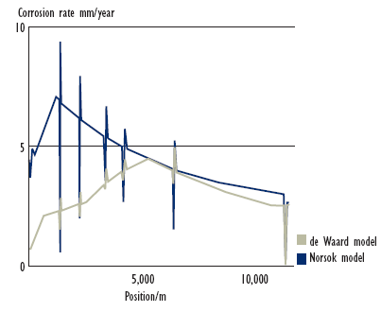
Figure 6.1: Predicted Corrosion Rate in a Subsea Pipeline [R. Nyborg ]

Figure 6.1 shows an example of corrosion rate prediction in a subsea gas condensate pipeline. Here, two of the most commonly used corrosion prediction models were combined with a three-phase fluid flow model in order to calculate corrosion rate profiles along a pipeline. This can help to identify locations where variations in the flow regime, flow velocity, and water accumulation may increase the risk of corrosion damage. For this pipeline, the temperature was 90 ºC at the inlet and 20 ºC at the outlet, and the decrease in predicted corrosion rates toward the end of the pipeline is mainly a result of the decreasing temperature. The lower corrosion rates close to the pipeline inlet are due to the effect of protective corrosion films at high temperature, which is predicted differently by the two corrosion models used. The peaks in predicted corrosion rates result from variation in flow velocity due to variations in the pipeline elevation profile.

6.2.1.3. Sensitivity Analysis for $CO_{2}$ Corrosion Calculation
Table 6-1 presents the base case for the following sensitivity analysis. These data are based on the design operating data for a 10–in. production flowline.

Table 6-1 Base Case for Sensitivity Analysis
Parameter | Units | Base Case
Total pressure | bar | 52
Temperature | _C | 22.5
$CO_{2}$ in gas | mol% | 0.5
Flow velocity | m/s | 2.17
H₂S | ppm | 220
pH |  | 4.2
Water cut |  | 50%
Inhibitor availability |  | 50%

6.2.1.3.1. Total System Pressure and $CO_{2}$ Partial Pressure
An increase in total pressure will lead to an increase in corrosion rate because $p_{{CO}_{2}}$ will increase in proportion. With increasing pressure, the $CO_{2}$ fugacity f_{CO2} should be used instead of the $CO_{2}$ partial pressure p_{CO2} since the gases are not ideal at high pressures. The real $CO_{2}$ pressure can be expressed as:

$f_{{CO}_{2}}=a∙p_{{CO}_{2}}$ (6.5)

where $a$ is fugacity constant that depends on pressure and temperature:

$a={10}^{P(0.0031-\frac{1.4}{T})}$ for $P≤250 bar$

$a={10}^{250(0.0031-\frac{1.4}{T})}$ for $P<250 bar$

Figure 6-2 and Figure 6-3 present the effect of total pressure and $CO_{2}$ partial pressure, respectively, on the corrosion rate. With increasing total pressure and CO₂ partial pressure, the corrosion rate is greatly increased.

Figure 6-2: Effect of Total Pressure on Corrosion Rate

Figure 6-3: Effect of CO₂ on Corrosion Rate

6.2.1.3.2. System Temperature
Temperature has an effect on the formation of protective film. At lower temperatures the corrosion product can be easily removed by flowing liquid. At higher temperatures the film becomes more protective and less easily washed away. Further increases in temperature result in a lower corrosion rate and the corrosion rate goes through a maximum [C. de Waard]. This temperature is referred to as the scaling temperature. At temperatures exceeding the scaling temperature, corrosion rates tend to decrease to close to zero, according to de Waard. Tests by IFE Norway revealed that the corrosion rate is still increasing when the design temperature is beyond the scaling temperature [A. Dugstad]. Figure 6-4 shows the effect of temperature on the corrosion rate, where the total pressure is 48 bar and the pH is equal to 4.2. The corrosion rate increases with increasing temperature, when the temperature is lower than the scaling temperature.

Figure 6-4: Effect of Temperature on Corrosion Rate

6.2.1.3.3. H₂S
H₂S can depress pH when it is dissolved in a $CO_{2}$ aqueous solution. The presence of H₂S in $CO_{2}$/brine systems can reduce the corrosion rate of steel when compared to the corrosion rate under conditions without H₂S at temperatures of less than 80_C, due to the formation of a metastable iron sulfide film. At higher temperatures the combination of H₂S and chlorides will produce higher corrosion rates than just $CO_{2}$/brine system because a protective film is not formed.
H₂S at levels below the NACE criteria for sulfide stress corrosion cracking (per the MR0175 NACE) reduces general metal loss rates but can promote pitting. The pitting proceeds at a rate determined by the $CO_{2}$ partial pressure; therefore, $CO_{2}$-based models are still applicable at low levels of H₂S. Where the H₂S concentration is greater than or equal to the $CO_{2}$ value, or greater than 1 mol%, the corrosion mechanism may not be controlled by $CO_{2}$ and therefore $CO_{2}$-based models may not be applicable.

6.2.1.3.4. pH
pH affects the corrosion rate by affecting the reaction rate of cathodes and anodes and, therefore, the formation of corrosion products. The contamination of a $CO_{2}$ solution with corrosion products reduces the corrosion rate. pH has a dominant effect on the formation of corrosion films due to its effect on the solubility of ferrous carbonate. An increase in pH slows down the cathodic reduction of H^{þ}. Figure 6-5 presents the relationship between pH and corrosion rate. In a solution with a pH of less than 7, the corrosion rate decreases with increasing pH.

Figure 6-5: Effect of pH on Corrosion Rate

6.2.1.3.5. Inhibitors and Chemical Additives
Inhibitors can reduce the corrosion rate by presenting a protective film. The presence of corrosion rate is at 0.1 mm/year. Use of inhibitor can greatly decrease corrosion rates and, hence, increase pipeline life.
The impingement of sand particles can destroy the inhibitor film and, therefore, reduce inhibitor efficiency. Inhibitors also perform poorly in low-velocity lines particularly if the fluids contain solids such as wax, scale, or sand. Under such circumstances, deposits inevitably form at the 6 o’clock position, preventing the inhibitor from reaching the metal surface. Flow velocities below approximately 1.0 m/s should be avoided if inhibitors are expected to provide satisfactory protection; this will be critical in lines containing solids.

6.2.1.3.6. Inhibitor Efficiency versus Inhibitor Availability
When inhibitors are applied, there are two ways to describe the extent to which an inhibitor reduces the corrosion rate: inhibitor efficiency (IE) and inhibitor availability (IA). A value of 95% for IE is commonly used. However, inhibitors are unlikely to be constantly effective throughout the design life. For instance, increased inhibitor dosage or better chemicals will increase the inhibitor concentration. It may be assumed that the inhibited corrosion rate is unrelated to the uninhibited corrosivity of the system and all systems can be inhibited to 0.1 mm/year. The corrosion inhibitor is not available 100% of the time and therefore corrosion will proceed at the uninhibited rate for some periods. Figure 6-6 shows the inhibited corrosion rate under different inhibitor availabilities. This figure is based on the assumed existence of corrosion inhibitors that are able to protect the steel to a corrosion rate ${CR}_{mit}$ (typically 0.1 mm/year) regardless of the uninhibited corrosion rate ${CR}_{unmit}$, taking into consideration the percentage of time IA the inhibitor is available.

Figure 6-6: Inhibited Corrosion Rate under Different Inhibitor Availabilities

6.2.1.3.7. Chemical Additives
Glycol (or methanol) is often used as a hydrate preventer on a recycled basis. If glycol is used without the addition of a corrosion inhibitor, there will be some benefit from the glycol. De Waard has produced a glycol correction factor. However, if glycol and inhibitor are both used, little additional benefit will be realized from the glycol and it should be ignored for design purpose. Methanol is batch injected during start-up until flowline temperatures rise above the hydrate formation region and during extended shutdown.

6.2.1.3.8. Single-Phase Flow Velocity
Single-phase flow refers to a flow with only one component, normally oil, gas, or water, through a porous media. Fluid flow influences corrosion by affecting mass transfer and by mechanical removal of solid corrosion products. The flow velocity used in the corrosion model is identified as the true water velocity. Figure 6-7 shows that the corrosion rate increases consistently with increased flow rate at low pH.

Figure 6-7: Effect of Flow Velocity on Corrosion Rate

6.2.1.3.9. Multiphase Flow
Multiphase flow refers to the simultaneous flow of more than one fluid phase through a porous media. Most oil wells ultimately produce both oil and gas from the formation and often also produce water. Consequently, multiphase flow is common in oil wells. Multiphase flow in a pipeline is usually studied by the flow regime and corresponding flow rate. Because of the various hydrodynamics and the corresponding turbulence, multiphase flow will further influence the internal corrosion rate, which is significantly different from that of single-phase flow in a pipeline in terms of corrosion.

6.2.1.3.10. Water Cut
The term water cut refers to the ratio of water produced compared to the volume of total liquid produced. $CO_{2}$ corrosion is mainly caused by water coming in contact with the steel surface. The severity of the $CO_{2}$ corrosion is proportional to the time during which the steel surface is wetted by the water phase. Thus, the water cut is an important factor influencing the corrosion rate. However, the effect of the water cut cannot be separated from the flow velocity and the flow regime.

6.2.1.3.11. Free-Span Effect
Pipeline spanning can occur on a rough seabed or a seabed subjected to scour. The evaluation of the allowable free-span length should be considered in order to avoid excessive yielding and fatigue. The localized reduction of wall thickness influences the strength capacity of the pipeline and, therefore, the allowable free-span length.
Figure 6-8 shows that the middle point of a free span contains additional accumulated waters and marine organisms that may accelerate corrosion development. The flow regime and flow rates will change. The corrosion defect depth in the region close to the middle point will most likely be deeper.

Figure 6-8: Effect of Free Spans on Corrosion Defect Development

6.2.2. Sour Corrosion: Hydrogen Sulfide (HS)
Hydrogen sulfide is a flammable and poisonous gas. It occurs naturally in some groundwater. It is formed from decomposing underground deposits of organic matter such as decaying plant material. It is found in deep or shallow wells and also can enter surface water through springs, although it quickly escapes to the atmosphere. Hydrogen sulfide often is present in wells drilled in shale or sandstone, or near coal or peat deposits or oil fields.
Hydrogen sulfide gas produces an offensive “rotten egg” or “sulfur water” odor and taste in water. In some cases, the odor may be noticeable only when the water is initially turned on or when hot water is run. Heat forces the gas into the air, which may cause the odor to be especially offensive in a shower. Occasionally, a hot water heater is a source of hydrogen sulfide odor. The magnesium corrosion control rod present in many hot water heaters can chemically reduce naturally occurring sulfates to hydrogen sulfide.
Hydrogen sulfide (H₂S) occurs in approximately 40% of all wells. Wells with large amounts of H₂S are usually labeled sour; however, wells with only 10 ppm or above can also be labeled sour. Partial pressures above 0.05 H₂S are considered corrosive. The amount of H₂S appears to increase as the well ages. H₂S combines with water to form sulfuric acid (H₂SO₄), a strongly corrosive acid. Corrosion due to H₂SO₄ is often referred to as sour corrosion. Because hydrogen sulfide combines easily with water, damage to stock tanks below water levels can be severe.
Water with hydrogen sulfide alone does not cause disease. However, hydrogen sulfide forms a weak acid when dissolved in water. Therefore, it is a source of hydrogen ions and is corrosive. It can act as a catalyst in the absorption of atomic hydrogen in steel, promoting Sulfide Stress Cracking (SSC) in high-strength steels. Polysulfides and sulfanes (free acid forms of polysulfides) can form when hydrogen sulfide reacts with elemental sulfur.
The corrosion products are iron sulfides and hydrogen. Iron sulfide forms a scale at low temperatures and can act as a barrier to slow corrosion. The absence of chloride salts strongly promotes this condition and the absence of oxygen is absolutely essential. At higher temperatures the scale is cathodic in relation to the casing and galvanic corrosion starts. The chloride forms a layer of iron chloride, which is acidic and prevents the formation of an FeS layer directly on the corroding steel, enabling the anodic reaction to continue. Hydrogen produced in the reaction may lead to hydrogen embrittlement. A nuisance associated with hydrogen sulfide includes its corrosiveness to metals such as iron, steel, copper, and brass. It can tarnish silverware and discolor copper and brass utensils.

6.2.3. Internal Coatings
The primary reason for applying internal coatings is to reduce friction, which enhances flow efficiency. Besides, the application of internal coatings can improve corrosion protection, precommissioning operations, and pigging operations. Increased efficiency is achieved through lowering the internal surface roughness since the pipe friction factor decreases with a decrease in surface roughness. In actual pipeline operation the improved flow efficiency will be observed as a reduction in pressure drop across the pipeline.
The presence of free water in the system is one cause of corrosion in an inner pipeline. An effective coating system will provide an effective barrier against corrosion attack. The required frequency of pigging is significantly reduced with a coated pipeline. The wear on pig disks is substantially reduced due to the pipe’s smoother surface.
The choice of a coating is dictated by both environmental conditions and the service requirements of the line. The major generic types of coatings used for internal linings include epoxies, urethanes, and phenolics. Epoxy-based materials are commonly used internal coatings because of their broad range of desirable properties, which include sufficient hardness, water resistance, flexibility, chemical resistance, and excellent adhesion.

6.2.4. Internal Corrosion Inhibitors
Corrosion inhibitors are chemicals that can effectively reduce the corrosion rate of the metal exposed to the corrosive environment when added in small concentration. They normally work by adsorbing themselves to form a film on the metallic surface. Inhibitors are normally distributed from a solution or by dispersion. They reduce the corrosion process by either:
- Increasing the anodic or cathodic polarization behavior;
- Reducing the movement or diffusion of ions to the metallic surface;
- Increasing the electrical resistance of the metallic surface.
Inhibitors can be generally classified as follows:
- Passivating inhibitors;
- Cathodic inhibitors;
- Precipitation inhibitors;
- Organic inhibitors;
- Volatile corrosion inhibitors.
The key to selection of an inhibitor is to know the system and anticipate the potential problems in the system. The system conditions include water composition (such as salinity, ions, and pH), fluid composition (percentage water versus hydrocarbon), flow rates, temperature, and pressure. Application of the inhibitors can be accomplished by batch treatments, formation squeezes, continuous injections, or a slug between two pigs.
Inhibitor efficiency can be defined as:

$Inhibitor efficiency \left(\%\right)=100 ∙\left({CR}_{uninhibited}- {CR}_{inhibited}\right)/{CR}_{uninhibited}$

where ${CR}_{uninhibited}$ is the corrosion rate of the uninhibited system and ${CR}_{inhibited}$ is the corrosion rate of the inhibited system. Typically the inhibitor efficiency increases with an increase in inhibitor concentration.

6.3. Pipeline External Corrosion
Infrastructures such as steel pipelines are susceptible to corrosion. External corrosion is the degradation of a metal through its electrochemical reaction with the environment. A primary cause of corrosion is due to an effect known as galvanic corrosion. All metals have different natural electrical potentials. When two metals with different potentials are electrically connected to each other in an electrolyte (e.g., seawater), current will flow from the more active metal to the other, causing corrosion to occur. The less active metal is called the cathode, and the more active, the anode.
This section deals with coatings and external corrosion protection such as cathodic protection (CP). The preferred technique for mitigating marine corrosion is use of coatings combined with CP. Coatings can provide a barrier against moisture reaching the steel surface and therefore provide a defense against external corrosion. However, in the event of the failure of coatings, a secondary CP system is required.
In Figure 6-9, the more active metal, zinc, is the anode and the less active metal, steel, is the cathode. When the anode supplies current, it will gradually dissolve into ions in the electrolyte, and at the same time produce electrons, which the cathode will receive through the metallic connection with the anode. The result is that the cathode will be negatively polarized and, hence, protected against corrosion.
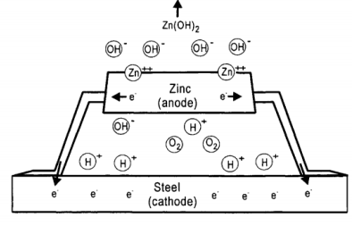
Figure 6-9 Galvanic Corrosion

6.3.1. Fundamentals of Cathodic Protection
Carbon steel structures exposed to natural waters generally corrode at an unacceptably high rate unless preventive measures are taken. Corrosion can be reduced or prevented by providing a direct current through the electrolyte to the structure. This method is called cathodic protection (CP), as showed in Figure 6-10.
The basic concept of cathodic protection is that the electrical potential of the subject metal is reduced below its corrosion potential, such that it will then be incapable of corroding. Cathodic protection results from cathodic polarization of a corroding metal surface to reduce the corrosion rate. The anodic and cathodic reactions for iron corroding in an aerated near neutral electrolyte are:

$Fe→{Fe}^{2}+2e^{-}$ (6.6)

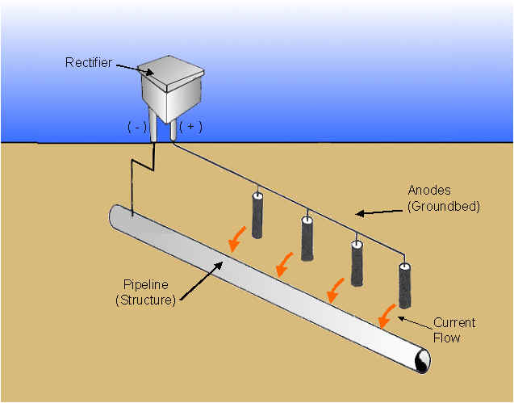
Figure 6-10: Cathodic Protection of a Pipeline

and

$O_{2}+2H_{2}O+4e^{-} →4OH^{-}$ (6.7)

respectively. As a consequence of Equation (6-7), the pH of the seawater immediate close to a metal surface increases. This is beneficial because of the precipitation of solid compounds (calcareous deposits) by the reactions:

$Ca^{2+}+HCO_{3}^{-}+OH^{-}→H_{2}O+CaCO_{3}$ (6.8)

and

$Mg^{2+}+2OH^{-}→Mg{\left(OH\right)}_{2}$ (6.9)

These deposits decrease the oxygen flux to the steel and, hence, the current necessary for cathodic protection. As a result, the service life of the entire cathodic protection system is extended.
Offshore pipelines can be protected as a cathode by achieving a potential of –0.80 $V_{Ag/AgCl}$ or more negative, which is accepted as the protective potential (E_{c}º) for carbon steel and low-alloy steel in aerated water. Normally, it is the best if the potentials negative to –1.05 $V_{Ag/AgCl}$ are avoided because these can cause a second cathodic reaction [D.A. Jones]:

$H_{2}O+e^{-}→H+OH^{-}$ (6.10)

which results in
- Wasted resources;
- Possible damage to any coatings;
- The possibility of hydrogen embrittlement.
Cathodic protection systems are of two types: impressed current and galvanic anode. The latter has been widely used in the oil and gas industry for offshore platforms and marine pipeline in the past 40 years because of its reliability and relatively low cost of installation and operation. The effectiveness of cathodic protection systems allows carbon steel, which has little natural corrosion resistance, to be used in such corrosive environments as seawater, acid soils, and salt-laden concrete.

6.3.2. External Coatings
Oil and gas pipelines are protected by the combined use of coatings and cathodic protection. The coating systems are the primary barrier against corrosion and, therefore, are highly efficient at reducing the current demand for cathodic protection. However, they are not feasible for supplying sufficient electrical current to protect a bare pipeline. Cathodic protection prevents corrosion at areas of coating breakdown by supplying electrons.
Thick coatings are often applied to offshore pipelines to minimize the holidays and defects and to resist damage by handling during transport and installation. High electrical resistivity retained over long periods is a special requirement, because cathodic protection is universally used in conjunction with coatings for corrosion control. Coatings must have good adhesion to the pipe surface to resist disbondment and degradation by biological organisms, which abound in seawater. Pipe coating should be inspected both visually and by a holiday detector set at the proper voltage before the pipe is lowered into the water. Periodic inspection of the pipeline cathodic protection potential is used to identify the coating breakdown areas.
Coatings are selected based on the design temperature and cost. The principal coatings, in rough order of cost, are:
- Tape wrap;
- Asphalt;
- Coal tar enamel;
- Fusion bonded epoxy (FBE);
- Cigarette wrap polyethylene (PE);
- Extruded thermoplastic PE and polypropylene (PP).
The most commonly used external coating for offshore pipeline is the fusion bonded epoxy (FBE) coating. FBE coatings are thin-film coatings, 0.5 to 0.6 mm thick. They consist of thermosetting powders that are applied to a white metal blast-cleaned surface by electrostatic spray. The powder will melt on the preheated pipe (around 230_C), flow, and subsequently cure to form thicknesses of between 250 and 650 mm. The FBE coating can be used in conjunction with a concrete weight coating. The other coating that can be used with a concrete coating is coal tar enamel, which is used with lower product temperatures.
The external coating can be dual layer or triple layer. Dual-layer FBE coatings are used when additional protection is required for the outer layer, such as protection from high temperatures or abrasion resistance. For deep water flowlines the high temperature of the internal fluid dissipates rapidly, reaching ambient within a few miles. Therefore, the need for such coatings is limited for steel catenary riser (SCRS) at the touchdown area where abrasion is high and an additional coating with high abrasion resistance is used. Triple-layer PP coating consists of an epoxy or FBE, a thermoplastic adhesive coating, and a PP top coat. The PE and PP coatings are extruded coatings. These coatings are used for additional protection against corrosion and are commonly used for dynamic systems such as steel catenary risers and where the temperature of the internal fluid is high. These pipe coatings are also frequently used in reel pipelines. The field joint coating for the three-layer systems is more difficult to apply and takes a longer time. However, in Europe, PE and PP coatings are preferred because of their high dielectric strength, water tightness, thickness, and very low CP current requirement.

6.3.2.1. Cathodic Protection
Cathodic protection is a method by which corrosion of the parent metal is prevented. For offshore pipelines, the galvanic anode system is generally used. This section specifies parameters to be applied in the design of cathodic protection systems based on sacrificial anodes.

6.3.2.1.1. Design Life
The design life t_{r} of the pipeline cathodic protection system is to be specified by the operator and shall cover the period from installation to the end of pipeline operation. It is normal practice to apply the same anode design life as for the offshore structures and submarine pipelines to be protected because maintenance and repair of CP systems are very costly.

6.3.2.1.2. Current Density
Current density refers to the cathodic protection current per unit of bare metal surface area of the pipeline. The initial and final current densities, i_{c} (initial) and i_{c} (final), give a measure of the anticipated cathodic current density demands to achieve cathodic protection of bare metal surfaces. They are used to calculate the initial and final current demands that determine the number and sizing of an anode. The initial design current density is necessarily higher than the average final current density because the calcareous deposits developed during the initial phase reduce the current demand. In the final phase, the developed marine growth and calcareous layers on the metal surface will reduce the current demand. However, the final design current density should take into account the additional current demand to repolarize the structure if such layers are damaged. The final design current density is lower than the initial density.
The average (or maintenance) design current density is a measure of the anticipated cathodic current density, once the cathodic protection system has attained its steady-state protection potential. This will simply imply a lower driving voltage, and the average design current density is therefore lower than both the initial and final design value.
Table 6-2 gives the recommended design current densities for the cathodic protection systems of nonburied offshore pipelines under various seawater conditions in different standards. For bare steel surfaces fully buried in sediments, a design current density of 20 mA/m² is recommended irrespective of geographical location or depth.

Table 6-2: Summary of Recommended Design Current Densities for Bare Steel
Organization | Location | Water | Design Current Density (mA/m²)
Organization | Location | Temp. (_C) | Initial | Mean | Final
NACE | Gulf of Mexico | 22 | 110 | 55 | 75
 | U.S. West Coast | 15 | 150 | 90 | 100
 | N. North Sea | 0e12 | 180 | 90 | 120
 | S. South Sea | 0e12 | 150 | 90 | 100
 | Arabian Gulf | 30 | 130 | 65 | 90
 | Cook Inlet | 2 | 430 | 380 | 380
 | Buried/mud zone | All | 10e30 | 10e30 | 10e30
DNV | Tropical | >20 | 150/130 | 70/60 | 90/80
 | Subtropical | 12e20 | 170/150 | 80/70 | 110/90
 | Temperate | 7e12 | 200/180 | 100/80 | 130/110
 | Arctic | <7 | 250/220 | 120/100 | 170/130
 | Buried/mud zone | all | 20 | 20 | 20
ISO | Nonburied | >20 | d | 70/60 | 90/80
 |  | 12e20 | d | 80/70 | 110/90
 |  | 7e12 | d | 100/80 | 130/110
 |  | <7 | d | 120/80 | 170/130
 |  | All | 20 | 20 | 20
Note: DNV and ISO format: “(depths less than 30 m)/(depth greater than 30 m).”

6.3.2.1.3. Coating Breakdown Factor
The coating breakdown factor describes the extent of current density reduction due to the application of a coating. The value $f_{c}$ means the coating is 100% electrically insulating, whereas a value of $f_{c}$implies that the coating cannot provide any protection.
The coating breakdown factor is a function of coating properties, operational parameters and time. The coating breakdown factor f_{c} can be described as follows:

$f_{c}=k_{1}+k_{2}∙t$ (6.11)

where $t$ is the coating lifetime, and $k_{1}$ and $k_{2}$ are constants that are dependent on the coating properties.
Four paint coating categories have been defined for practical use based on the coating properties in DNV [DNV]:
Category I: one layer of primer coat, about 50-mm nominal dry film thickness (DFT);
Category II: one layer of primer coat, plus minimum one layer of intermediate top coat, 150- to 250-mm nominal DFT;
Category III: one layer of primer coat, plus minimum two layers of intermediate/top coats, minimum 300-mm nominal DFT;
Category IV: one layer of primer coat, plus minimum three layers of intermediate top coats, minimum 450-mm nominal DFT.
The constants k₁ and k₂ used for calculating the coating breakdown factors are given in Table 6-3.

Table 6-3: Constants (k₁ and k₂) for Calculation of Paint Coating Breakdown Factors [W.H. Hartt]
Depth (m) |  | Coating Category
Depth (m) | I | II | III | IV
Depth (m) | k₁ ¼ 0.1 | k₁ ¼ 0.05 | k₁ ¼ 0.02 | k₁ ¼ 0.02
Depth (m) | k₂ | k₂ | k₂ | k₂
0 - 30 | 0.1 | 0.03 | 0.015 | 0.012
>30 | 0.05 | 0.02 | 0.012 | 0.012

For cathodic protection design purposes, the average and final coating breakdown factors are calculated by introducing the design life $t_{r}$:

$f_{c}(average)=k_{1}+k_{2}∙t_{r}/2$ (6.12)

$f_{c}(final)=k_{1}+k_{2}∙t_{r}$ (6.13)

6.3.2.1.4. Anode Material Performance
The performance of a sacrificial anode material is dependent on its actual chemical composition. The most commonly used anode materials are Al and Zn. Table 6-4 gives the electrochemical efficiency e of anode materials applied in the determination of the required anode mass. The closed circuit anode potential used to calculate the anode current output should not exceed the values listed in the Table 6-6.

Table 6-4: Design Electrochemical Efficiency Values for Al- and Zn-Based Sacrificial
Anode Materials [DNV]
Anode Material Type | Electrochemical Efficiency (Ah/kg)
Al-based | 2000 (max 25_C)
Zn-based | 700 (max 50_C)

Table 6-5: Design Closed-Circuit Anode Potentials for Al- and Zn-Based Sacrificial Anode Materials [DNV]

Anode Material Type | Environment | (V rel. Ag/AgCl Seawater)
Al-based | Seawater | e1.05
 | Sediments | e0.95
Zn-based | Seawater | e1.00
 | Sediments | e0.95

6.3.2.1.5. Resistivity
The salinity and temperature of seawater have an influence on its resistivity. In the open sea, salinity does not vary significantly, so temperature becomes the main factor. The resistivities of 0.3 and 1.5 U$m are recommended to calculate anode resistance in seawater and marine sediments, respectively, when the temperature of surface water is between 7 and 12_C [DNV].

6.3.2.1.6. Anode Utilization Factor
The anode utilization factor indicates the fraction of anode material that is assumed to provide a cathodic protection current. Performance becomes unpredictable when the anode is consumed beyond a mass indicated by the utilization factor. The utilization factor of an anode is dependent on the detailed anode design, in particular, the dimensions and location of anode cores. Table 17-6 lists anode utilization factors for different types of anodes [DNV].

6.3.2.2. Galvanic Anode System Design

6.3.2.2.1. Selection of Anode Type
Pipeline anodes are normally of the half-shell bracelet type. The bracelets are clamped or welded to the pipe joints after application of the corrosion coating. Stranded connector cables are be used for clamped half-shell anodes. For the anodes mounted on the pipeline with concrete, measures should be taken to avoid the electrical contact between the anode and the concrete reinforcement.
Normally, bracelet anodes are distributed at equal spacing along the pipeline. Adequate design calculations should demonstrate that anodes can provide the necessary current to the pipeline to meet the current density requirement for the entire design life. The potential of a pipeline should be polarized to –0.8 V_{Ag/AgCl} or more negative. Figure 6-11 shows the potential profile of a pipeline protected by galvanic bracelet anodes.
Because the installation expense is the main part of CP design, larger anode spacing can reduce the overall cost. However, the potential is not evenly distributed along the pipeline. The pipeline close to the anode has a more negative potential. The potential at the middle point on the pipeline between two anodes is more positive and must be polarized to –0.80 V_{Ag/AgCl} or more negative in order to achieve cathodic protection for the whole pipeline. Increased anode spacing results in a bigger mass per anode, causing an uneven potential distribution. The potential close to the anode could be polarized to be more negative than –1.05 V_{Ag/AgCl}, which should be avoided because of reaction 1.5. [W.H. Hartt]. Figure 6-12 illustrates the anticipated potential attenuation for situations using large anode spacing [W.H. Hartt].

Table 6-6 Design Utilization Factors for Different Types of Anodes
Anode Type | Anode Utilization Factor
Long 1, slender stand-off | 0.90
Long 1, flush-mounted | 0.85
Short 2, flush-mounted | 0.80
Bracelet, half-shell type | 0.80
Bracelet, segmented type | 0.75

Figure 6-11: Potential Profile of a Pipeline Protected by Bracelet Anodes

Figure 6-12 Pipeline Potential Profile for Large Anode Spacing

6.3.2.2.2. CP Design Practice
Offshore pipeline CP design includes the determination of the current demand I_{c}, required anode mass M, and number and current output per anode I_{a}. The current demand is a function of cathode surface area A_{c}, a coating breakdown factor f_{c}, and current density $I_{c}$, and can be expressed as follows [9]:

$I_{c}=A_{c}∙f_{c}∙i_{c}$ (6.14)

where i_{c} depends on water depth, temperature, seawater versus mud exposure, and whether or not the mean or final life of the CP system is being evaluated. Current density i_{c} is normally in the range of 60 to 170 mA/m² [DNV]. Because the initial polarization period preceding steady-state conditions is normally quite short compared to the design life, the mean (time-averaged) design current density ($i$) comes very close to the steady-state current density. Therefore, it is used to calculate the minimum mass of anode material necessary to maintain cathodic protection throughout the design life. Correspondingly, $M$ can be calculated as:

$M=\frac{8760 ∙i∙T_{l}}{u ∙C}$ (6.15)

where $u$ is a utilization factor, $C$ is anode current capacity, and $T_{l}$ is design life. The cathode potential is assumed to be spatially constant. Therefore, the current output per anode can be calculated by:

$I_{d}=\frac{∅_{c} - ∅_{d}}{R_{d}}$ (6.16)

where $∅_{c}$ and $∅_{d}$ are the closed-circuit potential of the pipe and anode, respectively, and R_{a} is the anode resistance.

6.3.2.2.3. Anode Spacing Determination
Bethune and Hartt [K. Bethune] have proposed a new attenuation equation to modify the existing design protocol interrelating the determination of the anode spacing $L_{as}$, which can be expressed as:

$L_{as}=\frac{∅_{c} - ∅_{d}}{∅_{corr} - ∅_{c}}∙\frac{α∙γ}{2π∙r_{p}∙R_{d}}$
(6.17)
where,
$∅_{corr}$ is free corrosion potential; $α$ is polarization resistance; $γ$ is reciprocal of coating breakdown factor $f$; $r_{p}$ is pipe radius.
This approach makes certain assumptions:
- Total circuit resistance is equal to anode resistance.
- All current enters the pipe at holidays in the coating (bare areas).
- The values of $∅_{c}$ and $∅_{d}$ are constant with both time and position. The ISO standards recommend that the distance between bracelet anodes not exceed 300 m [ISO].

6.3.2.2.4. Commonly Used Galvanic Anodes
The major types of galvanic anodes for offshore applications are slender stand-off, elongated flush mounted, and bracelet as shown in Figure 6-13. The type of anode design to be applied is normally specified by the operator and should take into account various factors, such as anode utilization factor and current output, costs for manufacturing and installation, weight, and drag forces exerted by ocean current. The slender stand-off anode has the highest current output and utilization factor among these commonly used anodes.

Figure 6-13 Commonly Used Anodes

6.3.2.2.5. Pipeline CP System Retrofit
Cathodic protection system retrofits become necessary as pipeline systems age. An important aspect of such retrofitting is determination of when such action should take place. Assessment of cathodic protection systems is normally performed based on potential measurements. As galvanic anodes waste, their size decreases; this causes a resistance increase and a corresponding decrease in polarization. Models have been constructed for potential change that occurs for a pipeline protected by galvanic bracelet anodes as these deplete. Anode depletion is time dependent in the model.
Bracelet anodes have been used for cathodic protection of marine pipelines, especially during the “early period” (roughly 1964 to 1976), when many oil companies had construction activities in the Gulf of Mexico. According to recent survey data, many of these early anode systems have been depleted or are now being depleted. Retrofitting of old anode systems on pipelines installed in the 1960s and 1970s and even newer ones is required since these are still being used for oil transportation. Anodes can be designed as multiples or grouped together to form an anode array (anode sled). Anode arrays typically afford a good spread of protection on a marine structure. They are a good solution for retrofitting old cathodic protection systems.

6.4. Scales
Scales are deposits of many chemical compositions as a result of crystallization and precipitation of minerals from the produced water. The most common scale is formed from calcium carbonate. Scale is one of the most common and costly problems in the petroleum industry. This is because it interferes with the production of oil and gas, resulting in an additional cost for treatment, protection, and removal. Scale also results in a loss of profit that makes marginal wells uneconomical. Scale deposition can be minimized using scale inhibition chemicals. Anti-scale magnetic treatment methods have been studied for the past several decades as an alternative. Acid washing treatments are also used for removal of scale deposits in wells.
The solubility of individual scale species is dependent on the equilibrium constants of temperature and pressure; the activity coefficients, which are dependent on concentrations plus the temperature and pressure of each individual species; the bulk ionic strength of the solution; and the other ionic species present. Once the solution exceeds the saturation limit, scale will begin to precipitate.

6.4.1. Oil Field Scales
Oil field scales are generally inorganic salts such as carbonates and sulfates of the metals calcium, strontium, and barium. Oil field scales may also be the complex salts of iron such as sulfides, hydrous oxides, and carbonates. Oil field scales may form in one of following two ways:
- Due to the change of temperature or pressure for brine during production, the solubility of some of the inorganic constituents will decrease and result in the salts precipitating.
- When two incompatible waters (such as formation water rich in calcium, strontium, and barium and seawater rich in sulfate) are mixed. Scales formed under these conditions are generally sulfate scales.
Table 6-7 lists the most common water-formed scales in oil field waters. Table 6-8 lists the common causes for the formation of these deposits.

Table 6-7 Common Oil Well Scale Depositsd Solubility Factors [DeepStar]
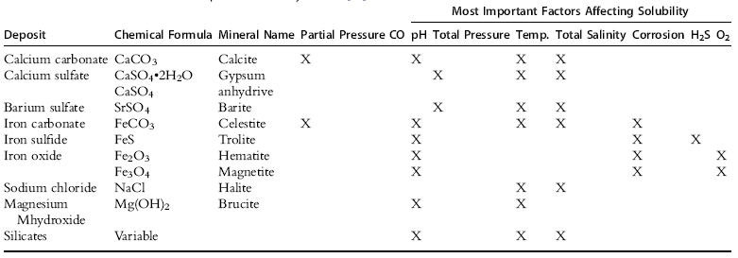

Table 6-8 Common Oil Well Scale DepositsdCauses and Removal Chemicals [DeepStar]
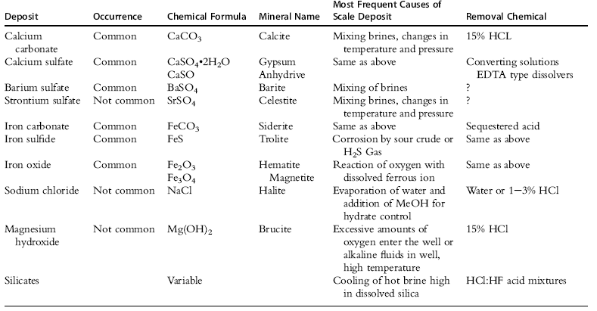

6.4.1.1. Calcium Carbonate
Calcium carbonate, the most common scale in oil and gas field operations, occurs in every geographical area. Calcium carbonate precipitation occurs when calcium ion is combined with either carbonate or bicarbonate ions as follows,

${Ca}^{2+}+{CO}_{3}^{2-}→CaCO_{3}$ (6.18)

${Ca}^{2+}+2\left(HCO^{-}\right)→CaCO_{3}+CO_{2}+H_{2}O$ (6.19)

The preceding equations show that the presence of $CO_{2}$ will increase the solubility of $CaCO_{3}$ in brine. Increasing $CO_{2}$ also makes the water more acidic and decreases the pH. The calcium carbonate scaling usually occurs with a pressure drop, for example, at the wellbore. This reduces the partial pressure of $CO_{2}$, thereby increasing the pH and decreasing the $CaCO_{3}$ solubility. The solubility of calcium carbonate decreases with increasing temperature.

6.4.1.2. Calcium Sulfate
The precipitation of calcium sulfate is given by the reaction

${Ca}^{2+}+SO_{4}^{2-}→CaSO_{4}$ (6.20)

This scale may occur in different forms. Gypsum ($CaSO_{4}$•$2H_{2}O$) is the most common scale in oil field brines. It is associated with lower temper-atures. Anhydrite ($CaSO_{4}$) may occur at high temperatures. Theoretically, anhydrite would be expected to precipitate above 100_F in preference to gypsum because of its lower solubility. However, gypsum may be found at temperatures as high as 212_F. With the passage of time, gypsum will dehydrate to anhydrite.
A common mechanism for gypsum precipitation in the oil field is a reduction in pressure (e.g., at the production wellbore). The solubility increases with higher pressure because, when the scale is dissolved in water, the total volume of the system decreases.

6.4.1.3. Barium Sulfate
This scale is especially troublesome. It is extremely insoluble and almost impossible to remove chemically. Barium sulfate scaling is likely when both barium and sulfate are present, even in low concentrations.

${Ba}^{2+}+SO_{4}^{2-}→BaSO_{4}$ (6.21)

Barium sulfate scale is common in North Sea and GoM reservoirs. These fields often have barium in the original formation brine. Seawater injection (high sulfate concentration) for secondary oil recovery causes the scale problem. As the water flood matures and the seawater breaks through, these incompatible waters mix and a barium scale forms.

Generally, barium sulfate solubility increases with temperature and salinity. Similar to gypsum, BaSO₄ solubility increases with an increase in total pressure and is largely unaffected by pH.

6.4.1.4. Strontium Sulfate
Strontium sulfate is similar to barium sulfate, except fortunately its solubility is much greater:

${Sr}^{2+}+SO_{4}^{2-}→SrSO_{4}$ (6.22)

Strontium sulfate solubility increases with salinity (up to 175,000 mg/L), temperature, and pressure. Again, pH has little effect. Pure strontium sulfate scale is rare except for some fields in the Middle East. $SrSO_{4}$ deposits in producing wells where the strontium-rich formation water mixes with the sulfate-rich injected seawater.

6.4.2. Operational Problems Due to Scales
Scale deposits are not restricted to any particular location in the production system, although some locations are more important than others in terms of ease and cost of remedial treatment. The following are areas or events where scale formation is possible in production systems.

6.4.2.1. Drilling/Completing Wells
Scale can cause problems at this early stage if the drilling mud and/or completion brine is intrinsically incompatible with the formation water. For example, allowing a seawater-based mud to contact a formation water rich in barium and strontium ions would be undesirable, similar to allowing a high calcium brine to contact a formation water rich in bicarbonate.

6.4.2.2. Water Injection
Scale problems may be encountered when new water injection wells are commissioned if the injection water is intrinsically incompatible with the formation water. For example, seawater injection into an aquifer rich in strontium and/or barium ions could cause problems.

6.4.2.3. Water Production
As soon as a well begins to produce water, the risk of carbonate scale formation arises, assuming that the produced water has a tendency to precipitate carbonate scale. The severity of the problem will depend on the water chemistry, the rate of drawdown, and other factors such as pressure and temperature.

6.4.2.4. HP/HT Reservoirs
HP/HT reservoirs have some potentially unique scaling problems due to the following characteristics:

- Total dissolved solids (TDS) up to 300,000þ ppm;
- Reservoir temperatures in excess of 350_F (175_C);
- Reservoir pressures in excess of 15,000 psi.
Examples are the Eastern Trough Area Project and Elgin/Franklin reservoirs in the North Sea.

6.4.3. Scale Management Options
Scale can be managed in several ways:
- Prevent deposition by using scale inhibitors, etc.
- Allow scale to form, but periodically remove it.
- Use pretreatments that remove dissolved and suspended solids.
The typical way of preventing scale deposition in oil field production is through the use of scale inhibitors.

6.4.4. Scale Inhibitors
Scale inhibitors are chemicals that delay or prevent scale formation when added in small concentrations in water that would normally create scale deposits. Use of these chemicals is attractive because a very low dosage (several ppm) can be sufficient to prevent scale for extended periods of time for either surface or downhole treatments. The precise mechanism for scale inhibitors is not completely understood but is thought to be following:
- Scale inhibitors may adsorb onto the surface of the scale crystals just as they start to form. The inhibitors are large molecules that can envelop these microcrystals and hinder further growth. This is considered to be the primary mechanism.
- Many oil field chemicals are designed to operate at oil/water, liquid/gas, or solid/liquid interfaces. Since scale inhibitors have to act at the interface between solid scale and water, it is not surprising that their performance can be upset by the presence of other surface active chemicals that compete for the same interface. Before deployment, it is important to examine in laboratory tests the performance of a scale inhibitor in the presence of other oil field chemicals.
- Because these chemicals function by delaying the growth of scale crystals, the inhibitor must be present before the onset of precipitation. Suspended solids (nonadherent scales) are not acceptable. This suggests two basic rules in applying scale inhibitors: (1) The inhibitor must be added upstream of the problem area. (2) The inhibitor must be present in the scaling water on a continuous basis to stop the growth of each scale crystal as it precipitates.

6.4.4.1. Types of Scale Inhibitors
The common classes of scale inhibitors include:
- Inorganic polyphosphates;
- Organic phosphates esters;
- Organic phosphonates;
- Organic polymers.

6.4.4.2. Scale Inhibitor Selection
Following are criteria for the selection of scale inhibitor:
- Efficiency;
- Stability;
- Compatibility. The inhibitor must not interfere with other oil field chemicals nor be affected by other chemicals.
The detailed factors in the selection of scale inhibitor candidates for consideration in the performance tests include:
- Type of scale: The best scale-inhibitor chemistry based on the scale composition should be selected.
- Severity of scaling: Fewer products are effective at high scaling rates.
- Cost: Sometimes the cheaper products prove to be the most cost effective; sometimes the more expensive products do.
- Temperature: Higher temperatures and required longer life limit the types of chemistry that are suitable.
- pH: Most conventional scale inhibitors perform less effectively in a low-pH environment.
- Weather: The pour point should be considered if the inhibitor will be used in a cold-climate operation.
- Chemical compatibility: The scale inhibitor must be compatible with other treatment chemicals, such as oxygen scavengers, corrosion inhibitors, and biocides.
- Application technique: This is most important if the inhibitor is to be squeezed into the formation.
- Viscosity: This is important when considering long umbilical applications such as in remote subsea fields.

6.4.5. Scale Control in Subsea Field

6.4.5.1. Well
The production wells of a HP/HT reservoir in the G0M have a potential for barium sulfate scale deposition in the formation at the near-wellbore location or within the tubing. These deposits occur due to mixing of injection seawater and formation water. Sulfates in the injected seawater react with naturally occurring barium in the formation water to induce barium sulfate scale. Barium sulfate is not soluble in acid, so prevention rather than remediation by acid treatment is the key.
- If left untreated, barium sulfate scale is likely to form downhole and possibly in the formation after produced water breakthrough. These areas are not treatable with continuous downhole chemical injection. For this reason the treatment method will consist of periodic batch scale squeeze treatments into each production well. It is estimated that each production well will require treatment once per year.
- The barium sulfate scale control will depend on accurate well testing and analysis of produced fluids to detect whether there is adequate scale inhibitor in the near-wellbore area in order to prevent the formation of the scale. Well tests and fluid analysis will be required for each well at a frequency of once every 2 weeks.

6.4.5.2. Manifold and Pipeline
Both barium sulfate and calcium carbonate scale formation may occur at the manifold and in the pipelines due to comingling of incompatible produced waters from different reservoirs. Deposition in these areas will be controlled by scale inhibitor injection at the subsea tree. Scale inhibitor injection is required upstream of the subsea choke.

6.5. Subsea Pipeline Protection
Subsea pipelines are protected based on several methods such as trenched and buried, start-up, upheaval and rock dumping as shown in the Figure.6-14.

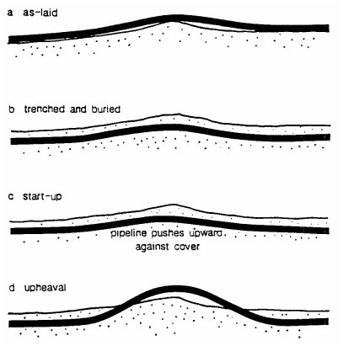

Figure.6-14: Subsea pipeline protection systems.

6.5.1. Trenching and Burying
A submarine pipeline may be laid inside a trench as a means of safeguarding it against fishing gear (e.g. anchors) and trawling activity as shown in Figure 6-15. This may also be required in shore approaches to protect the pipeline against currents and wave action (as it crosses the surf zone). Trenching can be done prior to pipeline lay (pre-trenching), or afterward by seabed removal from below the pipeline (post-trenching). In the latter case, the trenching device rides on top of, or straddles, the pipeline. Several systems are used to dig trenches in the seabed for submarine pipelines:
- Jetting: This is a post-trenching procedure whereby the soil is removed from beneath the pipeline by using powerful pumps to blow water on each side of it.
- Mechanical cutting: This system uses chains or cutter disks to dig through and remove harder soils, including boulders, from below the pipeline.
- Plowing: The plowing principle, which was initially used for pre-trenching, has evolved into sophisticated systems that are lighter in size for faster and safer operation.
- Dredging/excavation: In shallower water, the soil can be removed with a dredger or an excavator prior to laying the pipeline. This can be done in a number of ways, notably with a ′′cutter-suction′′ system, with the use of buckets or a with a backhoe.

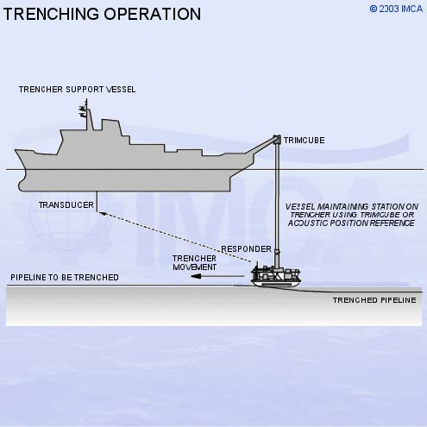 | 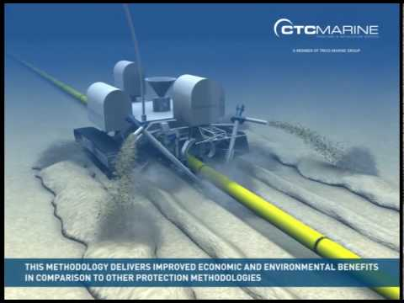
Figure.6-15: Trenching protection of subsea pipeline [CTC Marine]

A buried pipe is far better protected than a pipe in an open trench. This is commonly done either by covering the structure with rocks quarried from a nearby shoreline. Alternatively, the soil excavated from the seabed during trenching can be used as backfill. A significant drawback to burial is the difficulty in locating a leak should it arise, and for the ensuing repairing operations.

6.5.2. Rock-dumping
Rock-dumping, like the other installation activities for offshore, has become more specialized in the last 17 years. The rock-dumping vessels were designed to deposit large quantities of rock in localized areas. Along with the requirement of small quantities of rock being placed over pipelines, new vessels have been developed as shown Figure 6-16.

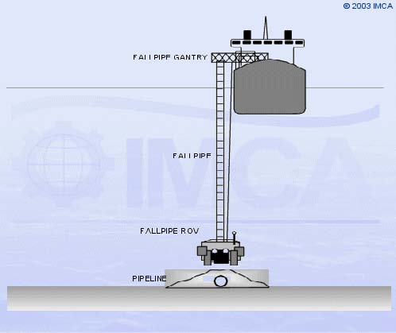 | 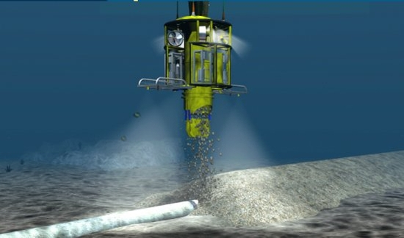

Figure.6-16: Rock-dumping protection of subsea pipeline.

6.5.3. Mattress

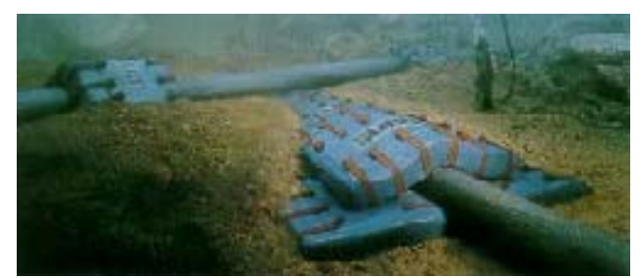
Figure.6-17: Mattresses protection of subsea pipeline.

6.5.4. Concrete Cover
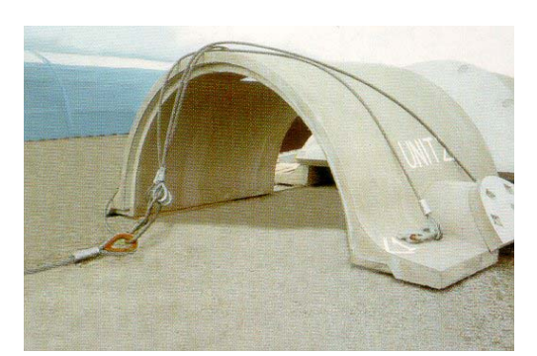
Figure.6-18: Concrete cover protection of subsea pipeline

Chapter.7

7.0 Subsea Pipeline Maintenance

6.1. Preventive maintenance
Because of the high cost and potential delays associated with intervention, preventive maintenance should be eliminated at the design stage, wherever possible.

6.2. Routine maintenance
Routine maintenance tasks are required where the elimination of specific intervention is uneconomic or technically problematic. Normally such maintenance would be undertaken during repair activity, or combined with planned inspection campaigns.

6.3. Corrective Maintenance
Intervention to rectify breakdown or degradation (Corrective Maintenance) is referred to as ‘Repair’.
- Normally Subsea Facilities shall possess sufficient reliability to ensure availability throughout the field life.
- Subsea equipment that is susceptible to failure should be designed to minimize the effort/cost required for replacement of the failed assembly.

6.4. Code Requirements DNV OS-F101
- Define equipment scope ( i.e. All equipment that can lead to a failure) (DNVOS- F101, Sec. 11, D304)
- For each equipment, identify all threats which can lead to a failure (DNV-OSF101, Sec. 11, D201)
- For each threat; estimate risk (DNV-OS-F101, Sec. 11, D202)
  - Consequence of failure (CoF)
  - Probability of failure (PoF)
Propose plans for:
- Inspection, monitoring and testing (IMT) (DNV-OS-F101, Sec. 11, D103)
- Mitigation, intervention and repair (MIR) (DNV-OS-F101, Sec. 11, D700)
- Integrity assessment (IA) (DNV-OS-F101, Sec. 11, D600)

6.5. Inspection Strategy and Methods
- Planned inspection campaigns are an integral part of the IMR strategy, the purpose of the inspections being to monitor pipeline system integrity over time pipeline.
- Understanding and confirming design assumptions
- Routine inspections may indicate a requirement for more specific investigations involving detailed or specialist techniques. The normal physical inspection tasks undertaken on the Deepwater Pipelines can be split into locations internal and external to the pipeline.
- Internal and External locations are typically periodically inspected by Pigging and ROV/AUV methods respectively.
- Permanent monitoring methods also exist and are becoming more commonplace.
- With deepwater lateral buckling and walking issues, Inspection strategy needs to include interaction with the designers.
- If your system is anticipated to have multiple start up and shut down scenarios you will need to understand what the designers anticipated happening and how to monitor it.
- In addition there may be need to reconfirm whats happened once the pipeline is in operation. I.e. the designers have probably p lanned for the worst case, but if things are not that bad and/or the operational approach changes this can result in very different results to those planned and design for.
- The requirement for and frequency of inspection will most commonly be determined using risk based techniques
There are several inspection methods as shown figure 7.1.

Location | Method | Technique | Defects
Internal | Pigging | Magnetic Flux  Ultrasonic Sound  Direct visual  Calliper  Geometry in XYZ directions | Spanning/Burial  Corrosion  Dents  Gouges  Leak & CP Failure  Coating Damage  Hydrate  Movement  Buckling  Vibration  Cracking & Fatigue  Protection Integrity (mattresses/  Rock/Covers)
Internal | Permanent  Monitoring | Surface corrosion  Probe/Spool  Sand Probe
External | Remote Operating Vehicle | Direct visual  Geometry in XYZ directions  Burial  Acoustic sounding  CP Probe  Weld Scanner  Tomography  Scanning  Side Scan
External | Autonomous Under Vehicle | Direct visual  Geometry in XYZ directions  Side scan
External | Permanent  Monitoring | Vibration  Strain
Figure 7.1: Inspection Methods

6.5.1. Deep-water Pig Inspection
- Pig Inspection of offshore pipelines tends to look for internal problems.
- Generally running pigs in offshore pipelines is very similar to running in onshore lines, after the wall thickness and higher pressures are taken in to consideration.
- The most favored inspection methods are either ultrasonic or magnetic flux inspection.
- Magnetic flux is limited by magnet strength, i.e. get enough magnetism in the wall of the pipe to enable good results to be obtained.
- Ultrasonic can inspect very thick wall pipe but Ultra Sonic’s have to be run in a liquid medium.
- The main difference between offshore and onshore is the length of run between pig traps, as offshore pipelines tend not to have intermediate compression stations with conveniently located pig traps. The pig must not get stuck in the pipeline as retrieving it will be much more expensive than from an onshore pipeline. The pig must stay alive and recording data (battery duration may be an issue)

6.5.2. Deep-water ROV Inspection
- Traditionally, external inspection, of deep-water pipelines is performed using work ROVs deployed from DP ROV support vessels.
- These vessels are expensive, and they may not be available when they are needed most.
- In deep waters, ROVs become heavy to handle from these vessels, because of long umbilicals; and they become prone to breakdowns.
- ROV inspections of long transmission lines can be very slow and may take many months to complete end to end
- Weather downtime is also an issue for ROV support vessels when working in harsh and hostile environments

6.5.3. AUV based Inspection
AUV- based Inspection in deep-water fields may provide dramatic improvements in cost, performance, safety and reliability.
- Large DPII vessels with high-end ROV spreads would no longer be required for simple inspection.
- AUVs have demonstrated solid performance requiring simple autonomy for missions such as bathymetric survey and high resolution sonar imaging
- AUVs can be deployed from small utility vessels, be capable of operations in higher seas, without the operational limitations and equipment hazards imposed by umbilical and tether management systems.
- Reduction in equipment complexity, vessel size and crew size would also result in improved safety, reliability, and lower environmental impact.
- In the future AUVs would become “field resident”, residing in the subsea field for periods of months. The end state of “Vessel Independent Operations” will achieve further reductions in cost while improving performance and safety.

6.5.4. Risk Assessment
DNV RP-F116 (Sec H1)
The risk assessment comprises the following main tasks;
- Establish equipment scope
- Identify threats
- Data gathering
- Data quality review
- Estimate probability of failure (PoF)
- Estimate consequences of failure (CoF)
- Determine risk
- Identify risk mitigating measures
- All equipment threats have considered
- Determine aggregated risk
- Planning of inspection, monitoring and testing

Figure 7.2: Risk Based Inspection Concept

7.6. Pipeline Pigging

7.6.1. Pigging Technology
Pigging is a method of pipeline maintenance which is conducted periodically by cleaning and inspection in order to ensure the pipeline integrity due to the impurities that may be occurred and accumulated inside the pipeline for a certain period of time. Pigging can travel to a certain long distance according to the requirement of pig component material which scrapping the side of pipeline wall. In addition, pigging is also used for the pipeline drying process after conducting the hydro test of pipeline and to inspect the pipeline condition either internal or external flaws that caused by some factors.

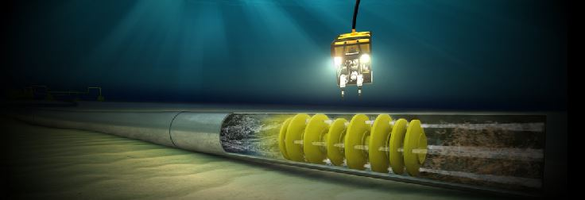 | 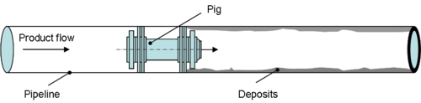
Figure 7.3: Pigging in pipeline [Drinkwtaer]

7.6.2. Type of Pigging
The pipeline construction consist of wide range of liquid and gas products which flowing in the pipeline. The assorted of deposits may accumulated inside of pipeline that need to be clean. Certainly, such condition makes various kind of pigging type that used in the pigging operation.

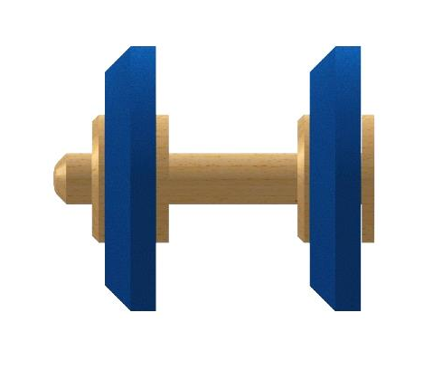  a. Conical | 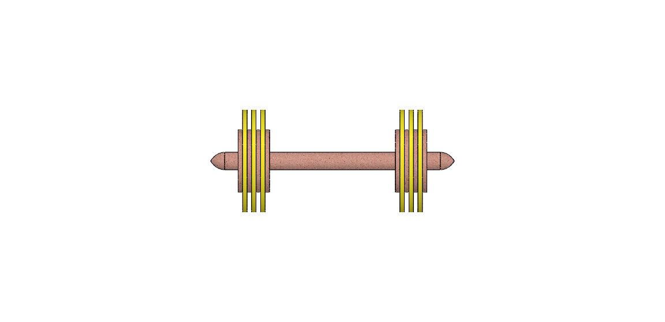  b. Bi-directional
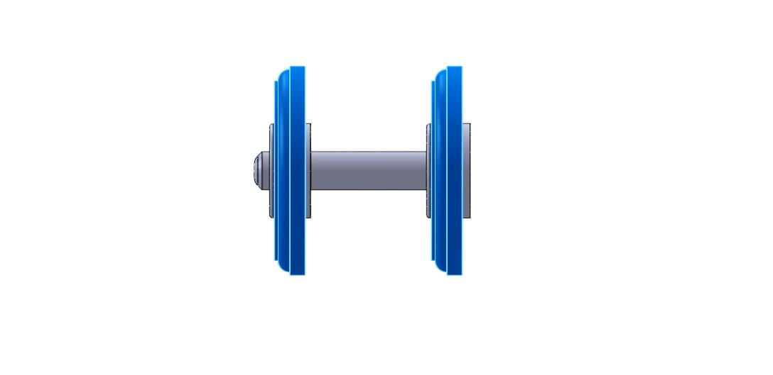  c. Scraper-Cup | 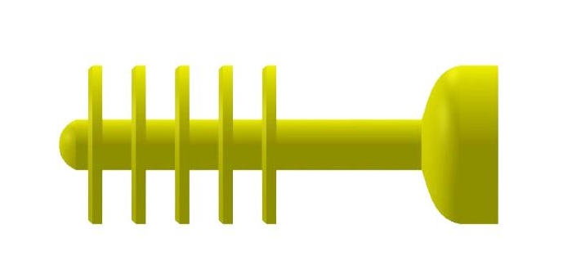  d. All-Uretahne

Figure 7.4: Various types of pig

Chapter.8

8.0 Medgaz Gas, Algeria-Spain

7.1. Medgaz Gas Transmission Project

7.1.1. Field Description
This study based on Medgaz Gas Transmission Project by completion of subsea pipeline linking Algeria and Spain across the Mediterranean Sea as shown in figure.6-1, to overcome the challenges of 2,155 meters water depth. The pipelines are made of X70 API Grade Steel.

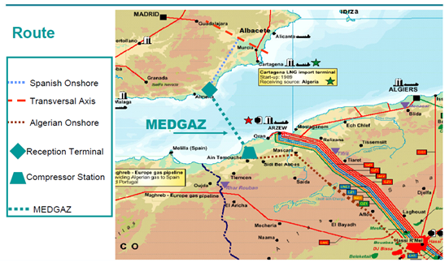
Figure.6-1: Route Map of Medgaz Pipeline (OTC20770)

The Medgaz subsea pipeline route traverses various contours of sea bottom as shown in figure.6-2. The route starts from Algerian Coastline to Spanish continental. The route has some area with sandy sediments and a clayey section between the shore approach and the outer shelf. Buckles potentially occurred from KP-22 to KP-37 because of the pipeline traverses the sandy sediment with a wide clayey section near the shore approach. The pipeline has been designed for 50 years life time period and using different thickness of concrete coating (45mm and 80 mm).

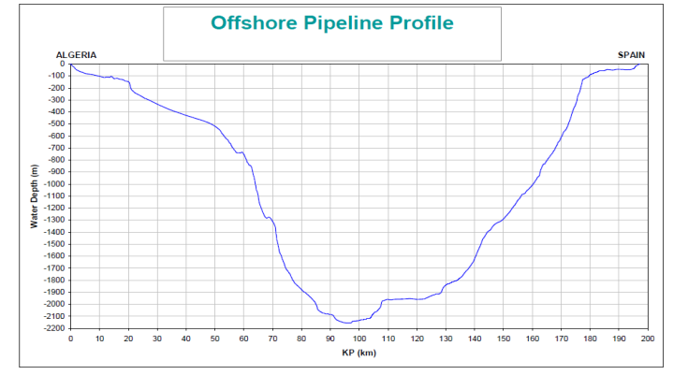
Figure.6-2: Seabed profile along the route (OTC20770).

7.1.2. Design Parameters
This section presents the design parameters which include the data related to pipeline geometry, mechanical properties of the material, operation and environmental loads as shown in Table.6-1.
Table.6-1: Parameters design of Medgaz project
Parameter | Unit | Value
Outside Diameter | mm | 609.6
Current Wall thickness | mm | 22.9, 28.5, 29.9
Pipe Material Grade | - | X70
Steel Density | Kg/m³ | 7850
SMYS | MPa | 482
SMTS | MPa | 565
Poisson ratio (v) | - | 0.3
Young’s Modulus (E) | GPa | 207
Thermal Expansion Coef.(α) | C⁻¹ | 1.17x10E-05
Concrete Coating Thickness | mm | 45, 80
Concrete Coating Density | Kg/m³ | 3040
Content density (Gas) | Kg/m³ | 0.668
Design Pressure | MPa | 22
Operating Temperature | ⁰C | 60
Seawater Density | Kg/m³ | 1027
Water Depth of Shallow Water | m | 350
Water Depth of Deep Water | m | 1000
Water Depth of Ultra-Deep Water | m | 2155
External Pressure | MPa | 3.5
Ambient Temperature | ⁰C | 15

7.1.3. Burst and Collapse Pressure Analysis
Subsea pipeline wall thickness is crucial parameter when it interfaces with internal and external pressures in deep and ultra-deep waters. Figure.6-3 demonstrates wall thickness of subsea pipeline versus burst and collapse pressures. External pressure was calculated using hydrostatic equation (3.52) with different water depth level such as shallow, deep and ultra-deep. The burst and collapse pressures of pipeline were calculated according to API RP 1111 rule with equation (3.41) and equation (3.45) as discussed in chapter 3.
As shown in figure.6-3, the pipe strength is defined to the failure pressure namely burst and collapse pressure, whereas the pressure is representative of internal and external of pipeline. Internal pressure is highlighted in black line as operating pressure and external pressure consists of different water depth level such as shallow (green line), deep (yellow line) and ultra-deep water (red line).
In the figure.6-3, it also has 4 intersections which describe the minimum wall thickness of subsea pipeline for a certain condition. For burst pressure, the intersection is occurred between burst line (light blue) and operating line (black) which pointed out in the graph as the minimum wall thickness of subsea pipeline is 14 mm, whereas the collapse pressure, the intersections are found in different water depth level. In shallow water, the intersection is occurred between collapse line (purple) and external pressure line (green) pointed out the minimum wall thickness is 12 mm. In deep water, the crossing line between collapse line (purple) and external pressure line of deep water (yellow) was the minimum wall thickness of 18 mm, and for ultra-deep water, the crossing line between collapse line (purple) and external pressure line of ultra-deep water (red) was the minimum wall thickness of 24 mm.

Figure.6-3: Burst and collapse pressures analysis

7.2. Safety Margin of Wall Thickness Analysis
The wall thickness is calculated using Subsea Pro -Simulation and Installation- software which was developed by the Ocean & Aerospace Research Institute, Indoensia as shown in Figure.6-4.

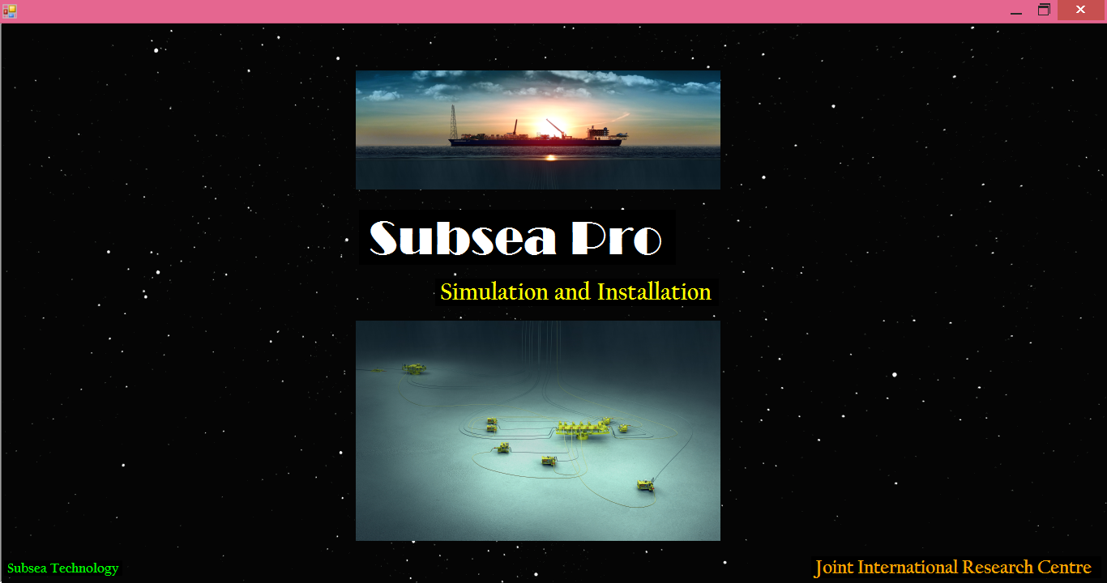
Figure.6-4: Subsea Pro Simulation and Installation software.

7.2.1. Shallow Water
Figure.6-5.a shows the point of intersection for burst and collapse pressure. The intersection of two lines between burst (light blue) and operating pressure (black) resulted the minimum wall thickness of 14 mm, whereas the intersection of two lines between collapse (purple) and external pressure in shallow (green) resulted minimum wall thickness of collapse pressure of 12mm. When these two points are compared, the minimum wall thickness of burst pressure is greater than the minimum wall thickness of collapse pressure. In the design of subsea pipeline, the minimum wall thickness of burst pressure should be selected as safety margin of wall thickness.

Figure.6-5.a: Safety Margin of Wall Thickness Analysis in the Shallow Water

Figure.6-5.b illustrates the safety margin of wall thickness selection and the current wall thickness namely 22.9 mm (Red grid line), 28.5 mm (Yellow grid line) and 29.9 mm (Black grid line). The operating pressure of 22 MPa resulted the minimum wall thickness of burst pressure is 14 mm, whereas the collapse pressure resulted the minimum wall thickness is 12 mm. In this water depth, the minimum wall thickness burst pressure is greater than the minimum wall thickness of collapse pressure. Hence, the consideration of subsea pipeline design should be based on the burst pressure. The simulation also is conducted by using Subsea Pro Simulation to select the wall thickness which is applied in the subsea pipeline project. The selected wall thickness of 23.5 mm is resulted as shown in figure.6-5.c. However, the different result of wall thickness between the current wall thickness of 22.9 mm with Subsea Pro Simulation is in the safety of wall thickness selection and it is acceptable in the shallow water.

Figure.6-5.b: Wall thickness analysis in the shallow water.

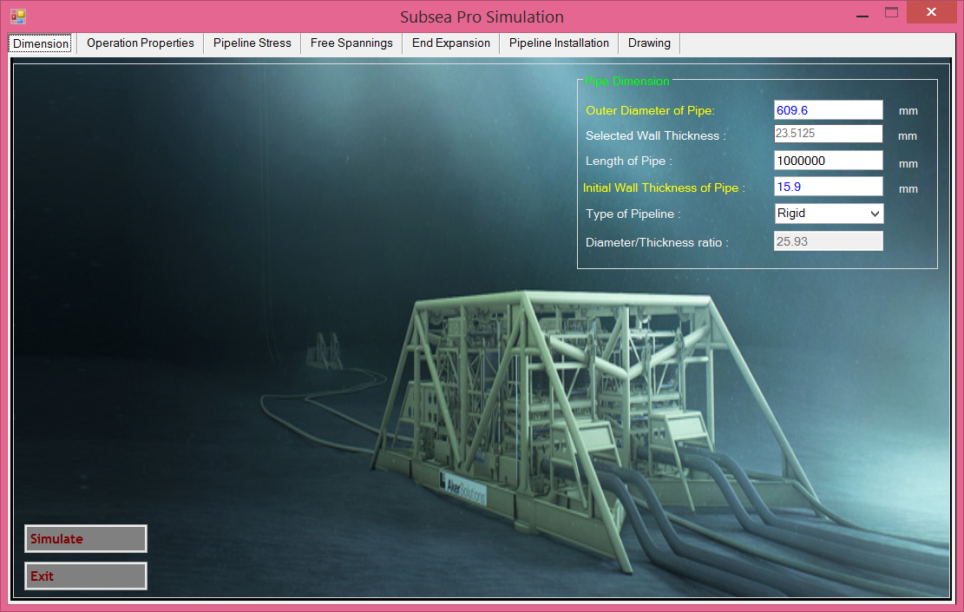

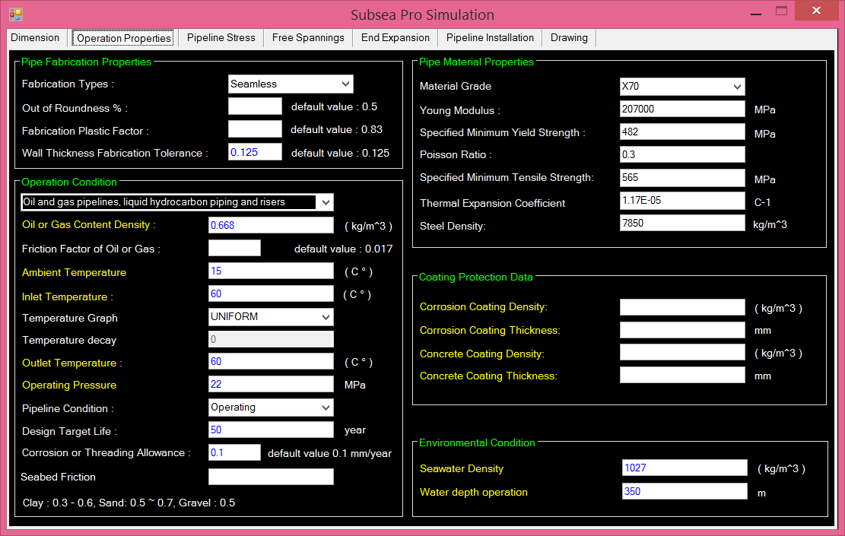

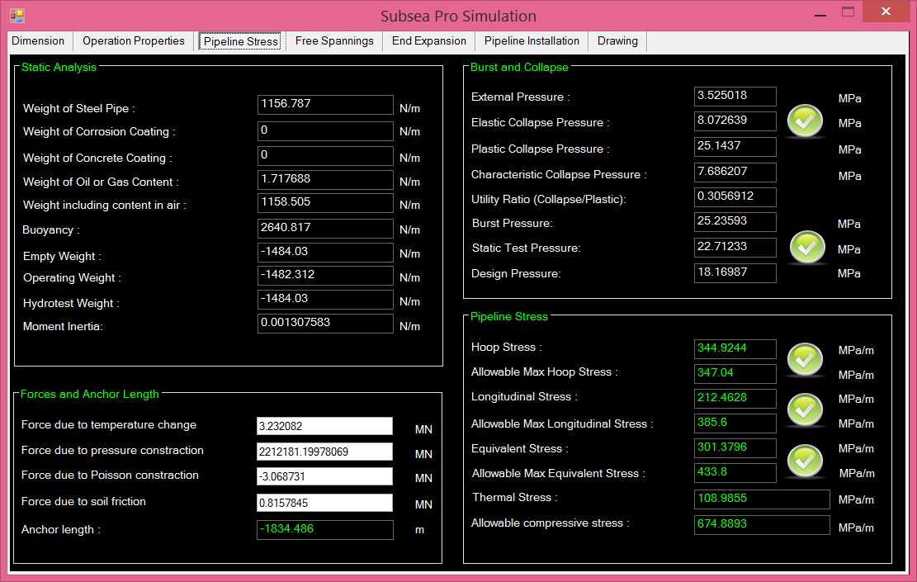

Figure.6-5.c: Wall Thickness determination using Subsea Pro in the shallow water

7.2.2. Deep Water
In the figure.6-6.a shows the condition in deep water, the intersection point of burst pressure is equal whereas the intersection point of collapse pressure between collapse (purple) and external pressure in deep water (yellow) resulted minimum wall thickness of collapse pressure of 18 mm. In this region, the minimum wall thickness of collapse pressure is greater than the minimum wall thickness of burst pressure. Therefore, in the design of subsea pipeline should be based on the minimum wall thickness of collapse pressure as safety margin

Figure.6-6.a: Safety margin of wall thickness analysis in the deep water

In this region, as shown in figure 4.6.b illustrates the safety margin of wall thickness with the current wall thicknesses in the water depth of 1000 m. As mentioned in section 5.3, the safety margin of collapse pressure (purple line) is greater than the safety margin of burst pressure (blue-line). Based on the collapse pressure resulted the minimum wall thickness is 18 mm. Therefore, the accepted wall thickness of subsea pipeline should be greater than 18 mm as shown in the figure 4.6.b. Thus the current 22.9 mm of wall thicknesses is still acceptable in the deep water because of under safety margin of wall thickness. Whereas the wall thickness of 28.5 mm and 29,9 mm are suitable in line with the design life of pipeline. In comparison with the Subsea Pro Simulation results with the wall thickness of 25.8 mm, the presented wall thickness of 29.25 mm is still suitable for water depth of 1500 m.

Figure.6-6.b: Wall thickness analysis in the deep water.

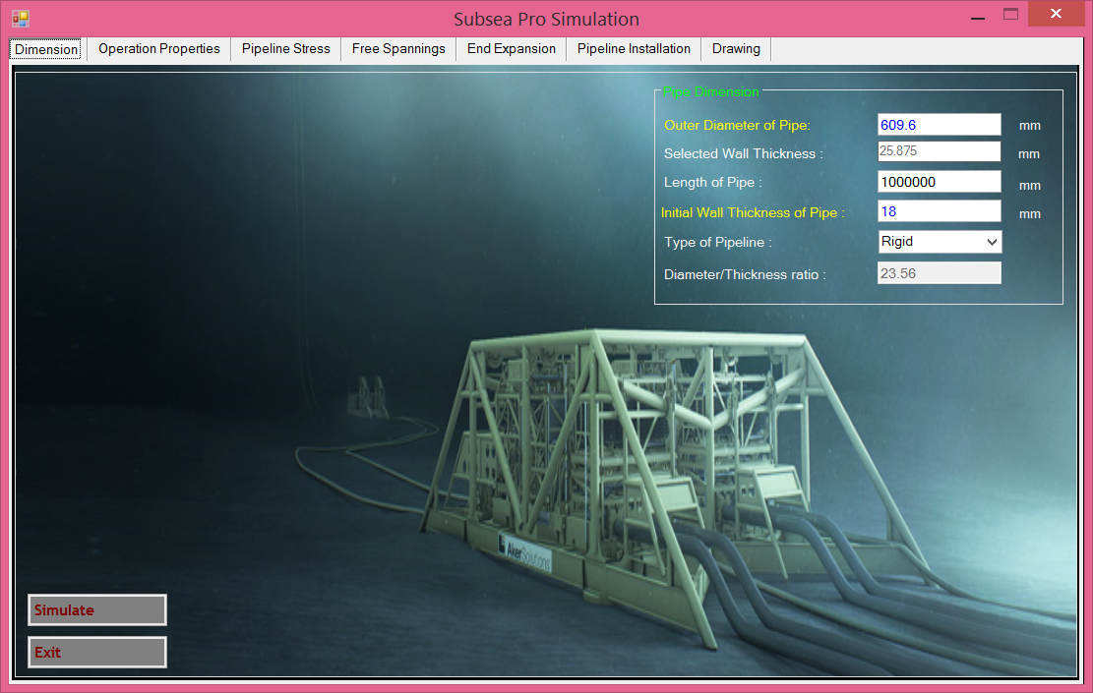
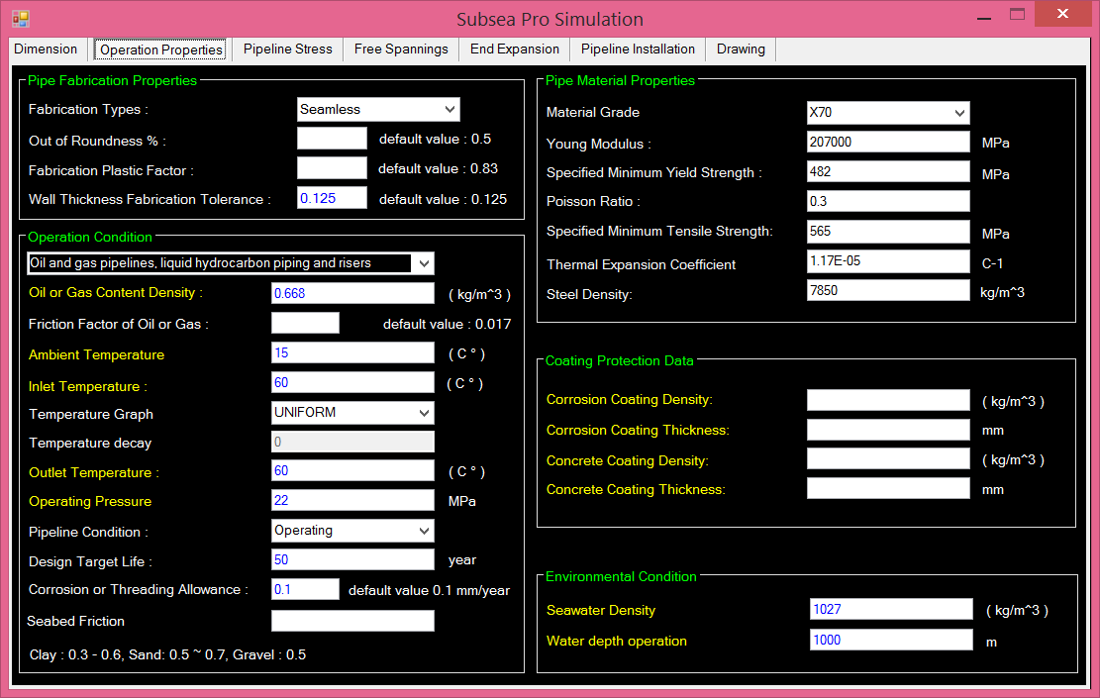

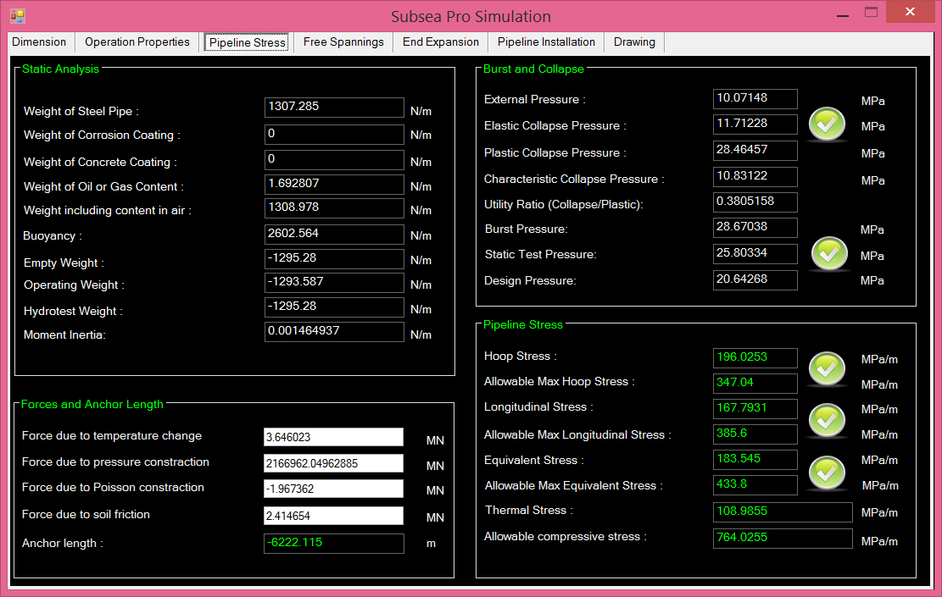
Figure.6-6.c: Wall thickness determination using Subsea Pro in the deep water

7.2.3. Ultra-deep Water
Figure.6-7.a shows the condition of ultra-deep water. The intersection point of burst pressure is still equal. The intersection point of collapse pressure between collapse (purple) and external pressure in ultra-deep water (red) which obtained the minimum wall thickness is 24 mm. This region also indicates that the minimum wall thickness of collapse pressure becomes more dominant instead of the minimum wall thickness of burst pressure. Therefore, in the design of subsea pipeline should be based on the minimum wall thickness of collapse pressure as safety margin.

Figure.6-7.a: Safety margin of wall thickness analysis in the ultra-deep water

In the figure.6-7.b illustrates the safety margin of wall thickness. The current of wall thicknesses of 22.9 mm, 28.5 mm and 29.9 mm are applied in this method in the ultra-deep water. In this region of ultra-deep water, the selection of wall thickness is to be critical due to increasing of water depth which causes increasing of external pressure. The minimum wall thickness resulted from the collapse pressure is 23 mm. When the current wall thicknesses apply to the safety margin of ultra-deep water, the wall thickness of 22.9 mm is not acceptable in this region, whereas the wall thicknesses of 28.5 mm is still acceptable and 29.9 mm is suitable for the ultra-deep water. Simulation result based on the Subsea Pro Simulation, the selected wall thickness is 32.3 mm for Ultra-deep Water as shown figure.6-7.c. Hence, the safety margin of the proposed method is an acceptance criteria for design of subsea pipeline.

Figure.6-7.b: Wall Thickness Analysis in Ultra-Deep Water

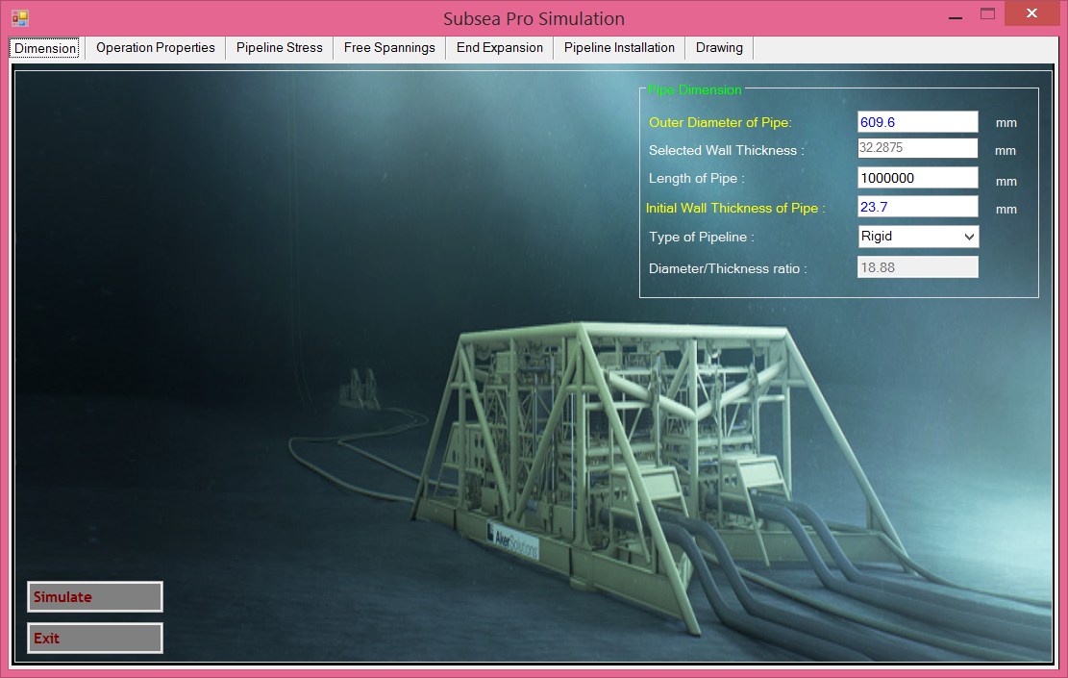

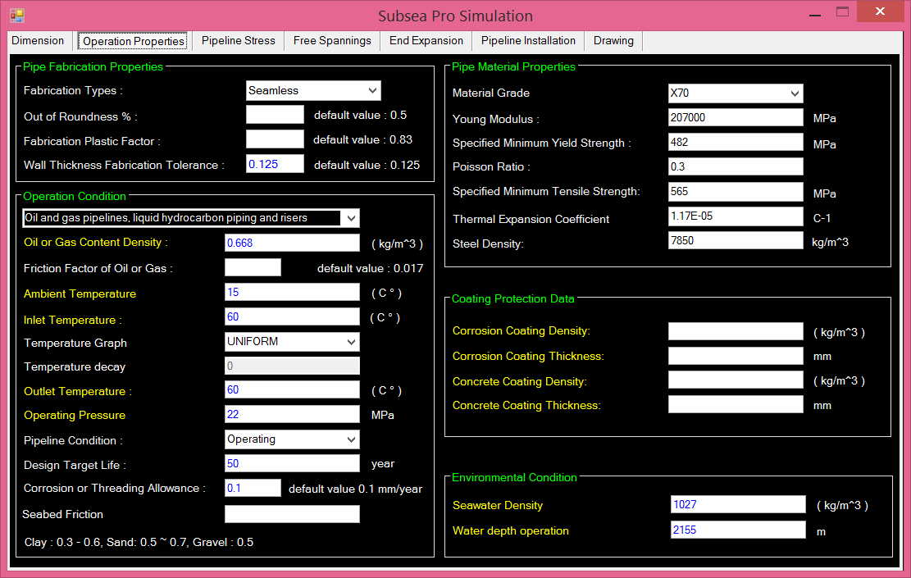

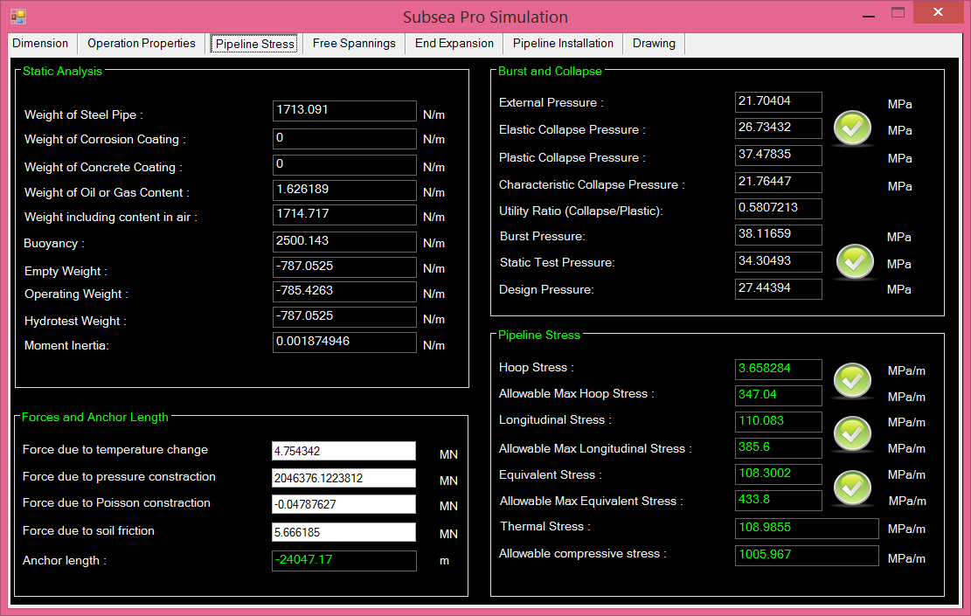
Figure.6-7.c: Wall Thickness determination using Subsea Pro in the ultra-deep water

7.3. Finite Element Analysis
ANSYS 14 denotes Finite Element Analysis (FEA) software which is used to establish the pipeline modeling in order to perform an analysis of structural behavior under loading condition. Finite element method is a numerical procedure to obtain verification and engineering solutions. FE analysis is carried out with ANSYS Workbench structural. This section presents the main features of Finite Element Model to introduce the pipeline model in ANSYS.

7.3.1. Geometry and Meshing
The geometry of the pipeline is created in tubular shape which modeled by using ANSYS structure design modeler. Before conducting the simulation process, the surface of geometry is meshed with the proper type of element. In this modeling, the meshes are created with free mesh and resulted brick shape of element as shown in figure 5.10. The meshes consist of 18672 elements, 130784 nodes and the element size is 1 m. A node in each element has coordinate location where degrees of freedom and physical problem takes place.

Figure.6-8: Pipeline Mesh.

7.3.2. Load and Boundary Condition
In this section, the pipeline model is built by ANSYS 14 according to the scale which is illustrated in Figure.6-8 to define stress and strain during normal operation in different water depth level. The pipe has total length of 84 m, and the material properties are correspond to API 5L which refer to Table 4.1.The internal pressure of 22 MPa is applied to the pipe, whereas the external pressure consists of three types of water depth level refer to Table.6-2.
Table.6-2: External Pressure of Water Depth Level
Type of Water Depth | Depth (m) | External Pressure (MPa)
Shallow | 350 | 3.5
Deep | 1000 | 10
Ultra-Deep | 2155 | 21

The both ends of the pipeline are fixed as restraint condition. When the pressures are applied, the pipe will expand symmetrically which induce buckle or lateral displacement. These simulations are conducted to analyze the stresses and the height of displacement.

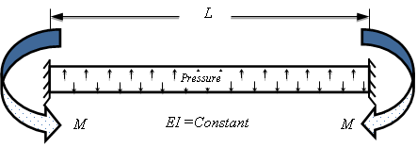
Figure.6-9: Pipeline Model.

7.3.3. Behavior of Pipeline without Coating

7.3.3.1. Equivalent Stress
In the figure.6-10 illustrates the equivalent stress in elastic model without concrete coating by using static structure analysis of ANSYS in three types of water depth that resulted different external pressure which refer to the Table.6-2. As shown in figure.6-10 (a), the equivalent stress distribution along the pipeline is uneven when it is compared to figure.6-12 (b) and figure.6-12 (c). This condition is indicating that the increasing of external pressure is able to reduce hoop stress of pipeline.
(a). Water Depth 350 m | (b). Water Depth 1000 m
(c). Water Depth 2155 m

Figure.6-10: Equivalent Stress with different water depth

7.3.3.2. Equivalent Strain
In the figure.6-13 illustrates the equivalent strain of pipeline without concrete coating in different water depth. With increasing water depth, the external pressure also increase. There are two pressures with opposite side which comes from internal. This condition leads to the equivalent stress decreases and at the same time, the equivalent strain decreases. In the figure.6-13 (a), 6-13 (b) and 6-13 (c) show the equivalent strain performance where the distributions of equivalent strain are uniformly along the pipeline because of the pipeline model is constraint condition where the pipeline is not free to expand longitudinally.

(a). Water Depth 350 m | (b). Water Depth 1000 m
(c). Water Depth 2155 m

Figure.6-11: Equivalent Strain with different water depth

7.3.4. Behavior of Pipeline with Coating Thickness 45 mm

7.3.4.1. Equivalent Stress
Concrete coating is used to protect the pipeline against external corrosion and bottom stability. The application of concrete coating is simulated in ANSYS to configure the behavior of pipeline stresses during normal operation. The connection between pipeline and concrete coating are modeled with bonded type.
Figure.6-12 displays the equivalent stress by using concrete coating thickness of 45 mm in different water depth. The concrete coating influences to the proportion of pipeline stiffness, consequently the pipeline experiences constraint resulted in increasing stress in the pipeline. As seen in figure.6-12 (a), 6-12 (b) and 6-12 (c) illustrate the performance of equivalent stress and describing interaction between pipeline and concrete coating. The distributions of equivalent stresses are uniformly along the pipeline.

(a). Water Depth 350 m | (b). Water Depth 1000 m
(c). Water Depth 2155 m
Figure.6-12: Equivalent Stress by using concrete coating thickness 45 mm

7.3.4.2. Equivalent Strain
As well as the equivalent strain with coating thickness 45 mm shows in Figure.6-13 experiences a constraint in different water depth. With increasing of water depth the equivalent strain decreases. In finite element ANSYS simulation shows the behavior equivalent strain at water depth 2155. It is the lowest when it is compared to deep water and shallow water at the same coating thickness.

(a). Water Depth 350 m | (b) Water Depth 1000 m
(c). Water Depth 2155 m
Figure.6-13: Equivalent Strain by using concrete coating thickness 45 mm

7.3.5 Behavior of Pipeline with Coating Thickness 80 mm

7.3.5.1. Equivalent Stress
From Figure.6-14 (a), 6-14 (b) and 6-14 (c) illustrate the equivalent stress performance each of water depth. When using concrete coating thickness 80 mm which is thicker than in Figure.6-12 at the same water depth level, the equivalent stress increases. It indicates the condition of pipeline that the pipeline experiences more constraint by increasing of concrete coating thickness. The distributions of equivalent stress are not uniform along the pipeline.

(a). Water Depth 350 m | (b). Water Depth 1000 m
(c). Water Depth 2155 m

Figure.6-14: Equivalent Stress by using concrete coating thickness 80 mm.

7.3.5.2. Equivalent Strain
In figure.6-15 shows the equivalent strain with variation of water depth by using ANSYS finite element software. With coating thickness 80 mm, the pipeline is more rigid than the figure.6-13. The coating thickness gives an effect to pipeline structure. However, the pipeline structure needs to provide the flexibility in order to be able to absorb the expansion.

(a). Water Depth 350 m | (b). Water Depth 1000 m
(c). Water Depth 2155 m

Figure.6-15: Equivalent Strain by using concrete coating thickness 80 mm.

7.3.6 Model of Pipeline Buckling in ANSYS Workbench
Operating pressure of 22 MPa also induces axial force that lead to lateral buckling or displacement. In order to control lateral buckling, the linear analysis of elastic buckling is conducted to configure the maximum height of displacement in different water depth. The height of displacement is used to determine the height of sleeper as one of method to control lateral buckling. Figure.6-16 shows the height of pipeline displacement from the original axis in the linear buckling analysis. Three types of water depth as shown in Table.6-2 are modeled in this simulation to configure buckling mode and maximum displacement. The curvature resulted from the internal load with different external pressure provide the height of displacement is equal. Thus, the external pressures do not influence the magnitude of buckle configuration.

(a). Water Depth 350 m | (b). Water Depth 1000 m
(c). Water Depth 2155 m
Figure.6.16: Pipeline Buckling In ANSYS Configuration

The lateral buckling calculation according to Hobbs Method resulted the height of displacement is 0.65 m to each water depth level as shown in table.6-3. Using the Finite Element Analysis (FEA) of ANSYS can be identified the critical height of linear buckling when dealing with the use of sleeper, where the vertical height of displacement that resulted from Hobbs Method is in the allowable range of elastic model.

Table.6-3: Pipeline deformation in ANSYS Workbench.
Water Depth (m) | Max-Deformation (m) | Deformation of Hobbs Method (m)
350 | 1.0004 | 0.65
1000 | 1.0921 | 0.65
2155 | 1.0004 | 0.65

7.3.7. Buckling Configuration of Hobbs Method
The figure.6-17 presents the configuration of pipeline buckling in accordance with Hobbs method. The Hobbs method is used in preliminary analysis in order to obtain buckling configuration of pipeline. Internal pressure 22 MPa and external pressure 3.5 MPa are applied to the pipeline. As a result of Hobbs method calculation as shown in figure.6-18 and figure.6-19, the concrete coating thickness affect to the buckle configuration of pipeline. The buckle length will be decreased by increasing concrete coating thickness and slipping length become shorter. Height of imperfection ($δ)$ anomalies occurred as shown in figure.6-20 where the maximum displacement reach to a point. The results explain the deformation of buckle for different concrete coating thickness where the maximum height of imperfection at coating thickness 45 mm. This indicates that concrete coating will decrease buckle length of pipeline.
Figure.6-17: Buckling configuration

Figure.6-18: Buckle Length versus Concrete thickness

Figure.6-19: Slipping Length versus Coating Thickness
Figure.6-20: Imperfection Height of buckling versus Concrete Coating.

7.3.8. Non Linear Analysis of ANSYS
The subsea pipeline is also modeled in nonlinear finite element analysis of ANSYS Structure for predicting the burst and collapse pressure. The subsea pipeline wall thickness of 22.9 mm is used to simulate burst and collapse pressure in order to analyze the strength of subsea pipeline. Material properties of X70 refer to section 3.4.

7.3.8.1. Internal Pressure
Non-linear Finite Element model of subsea pipeline is created in 3D model by applying internal pressure of 60 MPa. The non-linear finite element of wall thickness is illustrated in Figure.6-21 which resulted plasticity response of circumferentially yield. Figure 4.22 shows the equivalent stress behavior that reaches the maximum elastic strain of 600 MPa during loading time, whereas the ultimate strength occurred in plastic region at 650 MPa and an incremental equivalent stress decreases with large deformation. The deformation shows nonlinear state at point $5×{10}^{-4}m$ which indicated the yield state.

Figure.6-21: Plastic Strain of Pipeline

Figure.6-22: Graph of Equivalent Stress due to Internal Pressure.

Figure.6-23: Graph of Pipeline Deformation due to Internal Pressure

7.3.8.2. External Pressure
The pipeline collapse under external pressure is also simulated in 3D model by using ANSYS workbench in order to analyze the nonlinear deformation of pipeline strength. Figure.6-24 illustrate the typical collapse of pipeline that subjected to external pressure where the profile of the pipeline is changed from circular into ovality and the maximum stress of elastic strain is 550 MPa as shown in figure 4.25 The stress continually increases during loading time after the pipe yield and the deformation or strain of the pipe will not increase obviously.

Figure.6-24: Plastic Strain of Collapse Pressure

Figure.6-25: Graph of Equivalent Stress due to External Pressure.

Figure.6-26: Graph of Pipeline Deformation due to External Pressure.

Chapter.9

9.0 Nosong-Bongawan, Malaysia

8.1. Nosong-Bongawan Field

8.1.1. Field Description
PETRONAS undertakes the development of Nosong North field which is located in Block B310 in Sabah Area, approximately 75 km North of Labuan and approximately 30 km North of Sumandak Central Processing Platform (SUPG-B CPP). Nosong Gas Development facilities hub scopes are comprised of following:
- One Wellhead Platform (WHP).
- Two dedicated new trunk lines; 10-inch FWS (High Pressure) ; approximately 30 km from WHP to existing SUPG-B.
- Offshore modification and tie-in WORKS at existing SUPG-B
Figure 8.1: Nosong-Bongawan field development.

8.1.2 Nosong Field Development

8.1.2.1 Business Target of Production
The business target by the stakeholders of this Nosong Gas Development project is to deliver 50 MMSCFD production by June 2017 to SUPG-B CPP, and ultimately to Labuan Gas Terminal (LGAST). The Nosong field is at 90 m water depth.

8.1.2.2 Specific Location of Field
From exploration and the field study, the location (geodetic data) of the field is furnished by them is as table follow. The geodetic data for the offshore pipelines are referenced to Universal Transverse Mercator (UTM) local projection with Timbalai 1948 local datum.

Table 8.1: Datum and local projection info.
Local Datum | Detail Information
Datum | Timbalai 1948
Spheroid | Everest 1830 (1967 Def)
Semi-major axis | 6 377 298.556 m
Semi-minor axis | 6 356 097.550 m
Inverse flattening | 300.8017

Local Projection | Detail Information
Map projection | UTM Zone 50°N
Grid projection | Universal Transverse Mercator
Latitude of origin | 00° 00’ 00” N
Longitude of origin | 117° 00’ 00” E
False Easting at origin | 500 000 m
False Northing at origin | 0 m
Scale factor at origin | 0.9996

8.1.2.3 Regulation, Design Codes and Standard
The design of the pipeline system in order of priority are conformance with the requirements of the PETRONAS Technical Standards (PTS) and international codes and standards as specified in PTS, unless specified otherwise.
If the Government or Local Authority Laws and Regulations are more stringent than the PTS, the former takes precedence. Deviations from these standards shall be agreed upon and approved by Petroliam Nasional Bhd. For any deviation/ conflict from applicable rules, codes and standards, the prevailing priorities will be according to following sequence:
- PETRONAS Technical Standards (PTS)
- National or Local Rules and Regulations
- International Codes (API, ANSI, AISC, ASME, DNV and ISO)
As for pipeline, the primary code for the design of the pipeline and riser systems shall be in accordance with PTS 31.40.00.20, September 2012 Rev 0, ‘Pipeline and Riser Engineering’ and its supplementary documents.

8.1.2.4 Malaysian Government, Local Authority Laws and Regulation
The field development was governed by the below government and local authority laws and regulations as follows:
- Petroleum (Safety Measures) Act 302, 1984 (incorporating all amendments up to 1 January 2006)
- Petroleum (Safety Measures) (Transportation of Petroleum by Pipeline) Regulation, 1985, PU(A) 85/1985
- Department of Occupational Safety and Health (DOSH), Malaysia

8.1.3 Standard and Specifications

8.1.3.1 Technical Specifications
The specification of the platform shall be complying with the Petronas Technical Specification (PTS).

Table 8.2: Technical Specifications
Specification
Pipeline and Riser Engineering
Riser Design
Installation and Commissioning of Cathodic Protection Systems
Design of Cathodic Protection Systems for Offshore Pipelines (Amendments/Supplements to DNV RP F103)
Protective Coatings and Linings
Linepipe Induction Bends (Amendments/supplements to ISO 15590-1)
Linepipe Specification (Amendments/supplements to API 5L 44th Edition / ISO 3183:2007)
Pipeline Fittings (Amendments/Supplements to ISO 15590-2)
Pipeline and Riser Engineering
Carbon and Low Alloy Steel Pipeline Flanges for Use in Oil and Gas Operations (Amendments/Supplements to MSS SP-44)
Pipeline Transportation Systems – Pipeline Valves (Amendments / Supplements to API Spec 6D/ISO 14313)
Design of Pipeline Pig Trap Systems
Concrete Coating of Linepipe
External Polyethylene and Polypropylene Coating for Linepipe
External Fusion Bonded Epoxy Powder Coating for Linepipe
Bituminous Enamel Coating of Steel Linepipe
Elastomer Coatings and Monel Sheating for Offshore Riser Protection
Hydrostatic Pressure Testing of New Pipelines
Pre-commissioning of Pipelines
Welding of Pipelines and Related Facilities (Amendments/Supplements to ANSI/API STD 1104)

8.1.3.2 Industry Codes and Standards
Besides PTS, the field also shall in conformance with API and ASME as shown in Table.3 and Table.4, respectively.

8.1.3.2.1 American Petroleum Institute (API)

Table 8.3: API specification
API | Description
API RP 1111 | Design, Construction, Operation and Maintenance of Offshore Hydrocarbon Pipelines, May 2011
API Spec 5L | Specification for Line Pipe, 45th Edition, December 2012
API Spec 6D | Specification for Pipeline Valves, October 2012
API Std 1104 | Welding of Pipelines and Related Facilities, 21st Edition, September 2013

8.1.3.2.2 American Society of Mechanical Engineers (ASME)

Table 8.4: ASME specification
ASME | Description
ASME VIII Div. 1 | Rules of Construction of Pressure Vessel, July 2013
ASME B31.8 | Gas Transmission and Distribution Piping Systems, January 2013
ASME B16.5 | Pipe Flanges and Flanged Fittings, April 2013
ASME B16.9 | Factory-Made Wrought Butt Welding Fittings, February 2013
ASME B16.20 | Metallic Gasket for Pipe Flanges – Ring-Joint, Spiral-Wound, and Jacketed, June 2013
ASME B36.10M | Welded and Seamless Wrought Steel Pipe, 2010

8.1.3.3 Water Depth
The water depths at the offshore facilities/platforms are presented in Table.5 below and are taken from Nosong WHP (NDP-A) to Sumandak (SUPG-B CPP) Pipeline route.

Table 8.5: Water Depths at Facilities
Location | Approximate Water Depth wrt. Mean Sea Level (m)
NDP-A | 89.3
SUPG-B | 42.81

The water depths along the proposed pipeline routes from Nosong WHP to Sumandak SUPG-B are presented in Table 4.5 below and are taken from Nosong WHP to Sumandak SUPG-B Pipeline route survey information (which is not covered in this report).

Table 8.6: Maximum and Minimum Water Depth along Pipeline Routes
Pipeline | Water Depth wrt. MSL  (m)
Pipeline | Minimum | Maximum
16-inch NAG LP Pipeline from NDP-A to SUPG-B | 36.82 | 89.27

8.1.3.4 Tidal and Surge Data
The tidal and surge data to be used for wellhead, manifold and pipeline design and riser at NDP-A platform are extracted from Nosong Bongawan Metocean Criteria. The tidal and surge data to be used for riser design at existing SUPG-B are extracted from Metocean Criteria at Sumandak Tepi and Sumandak Selatan as shown in Table 8.7:

Table 8.7: Tidal and Surge data for Nosong field and compared also with Sumandak Tepi and Sumandak Selatan area
Criteria | Nosong Bongawan | Sumandak Tepi & Sumandak Selatan
Highest Astronomical Tide (m) | 0.94 | 1.23
Mean Sea Level (m) | 0 | 0
Lowest Astronomical Tide (m) | -1.17 | -0.97
1 Year Storm Surge (m) | 0.3 | 0.3
100 Year Storm Surge (m) | 0.6 | 0.6

8.1.3.5 Wave Data
The wave data to be used for pipeline design and riser at NDP-A platform are as given in Table 8.8 and Table 8.9 and are extracted from Nosong Bongawan Metocean Criteria.

Table 8.8: Wave criteria for return period of 1 year
Direction | Omni | N | NE | E | SE | S | SW | W | NW
H_{s} (m) | 3.9 | 3.9 | 3.2 | 1.6 | 2 | 2 | 2.7 | 3.1 | 3.5
T_{p} (sec) | 9.7 | 9.7 | 8.8 | 6.3 | 6.9 | 7 | 8.1 | 8.6 | 9.2
H_{max} (m) | 6.8 | 6.8 | 5.7 | 3 | 3.6 | 3.7 | 4.9 | 5.5 | 6.2
T_{ass} (sec) | 9 | 9 | 8.2 | 5.9 | 6.4 | 6.5 | 7.6 | 8 | 8.5

Table 8.9: Wave criteria for return period of 10 years
Direction | Omni | N | NE | E | SE | S | SW | W | NW
H_{s} (m) | 4.6 | 4.6 | 3.9 | 2.0 | 2.4 | 2.4 | 3.3 | 3.7 | 4.2
T_{p} (sec) | 10.6 | 10.6 | 9.7 | 6.9 | 7.6 | 7.7 | 8.9 | 9.4 | 10.0
H_{max} (m) | 8.1 | 8.1 | 6.8 | 3.6 | 4.3 | 4.4 | 5.9 | 6.5 | 7.3
T_{ass} (sec) | 9.8 | 9.8 | 9.0 | 6.4 | 7.1 | 7.2 | 8.3 | 8.8 | 9.3

8.1.3.6 Current Data
The current data to be used for project development especially for pipeline design and riser at NDP-A platform are as given in Table.10 and Table.11 which are extracted from Nosong Bongawan Metocean Criteria.

Table 8.10: Current data for return period 1 year
Direction | Omni | N | NE | E | SE | S | SW | W | NW
At surface (1.0D)  (cm/s) | 114 | 71 | 114 | 74 | 53 | 64 | 82 | 74 | 51
Mid Depth (0.5D)  (cm/s) | 91 | 57 | 91 | 59 | 42 | 51 | 65 | 59 | 40
Near ottom (0.1D) (cm/s) | 53 | 33 | 53 | 34 | 25 | 30 | 38 | 34 | 24
Near Seabed (0.01D) (cm/s) | 25 | 15 | 25 | 16 | 11 | 14 | 18 | 16 | 11

Table 8.11: Current data for return period 10 years
Direction | Omni | N | NE | E | SE | S | SW | W | NW
At surface (1.0D)  (cm/s) | 143 | 89 | 143 | 93 | 67 | 80 | 103 | 93 | 64
Mid Depth (0.5D)  (cm/s) | 114 | 71 | 114 | 74 | 53 | 64 | 82 | 74 | 51
Near ottom (0.1D) (cm/s) | 67 | 42 | 67 | 43 | 31 | 37 | 48 | 43 | 30
Near Seabed (0.01D) (cm/s) | 31 | 19 | 31 | 20 | 14 | 17 | 22 | 20 | 14

Notes:
At other water depths not specified above, the current velocities shall follow the 1/7th rule. The formula is as below:

$V_{z}=V_{d}∙{\left(\frac{z}{d}\right)}^{1/7}$ (8.1)

Where, $d$ is total water depth, $z$is depth of interest above seabed, $V_{z}$ is current speed at depth ‘z’ metres and $V_{d}$ is current speed at the surface

8.1.3.7 Seawater Properties
The seawater properties are presented in Table 8.12

Table 8.12: Sea Water Properties
Parameters |  | Values
Sea Water | Density | 1025 kg/m³
Sea Water | Kinematic Viscosity | 0.96 x 10⁻⁶ m²/s (At 25°C)
Sea Water | Mean Surface Temperature | 28.5 ˚C
Sea Water | Mean Seabed Temperature | 21.1 ˚C

8.1.3.8 Marine Growth
In the absence of more accurate data, the marine growth thickness for the risers is considered to be 90mm at Mean Sea Level. Marine growth is assumed to decrease by 1mm for every 2m of water depth. The Marine growth density is 1025 kg/m³.

8.1.3.9 Soil Properties
The soil properties along the proposed pipeline route are extracted from the Nosong WHP to Sumandak SUPG-B Pipeline Route Survey Report. The soil properties with respect to KP as summarized in Table 8.13.

Table 8.13: Nosong WHP to Sumandak SUPG-B Pipeline Route Soil Properties
Kilometer  Point | Drop Core | Soil Type | Su (kPa)
0 - 0.5 | DC-1.0 | Very loose SAND with shell fragments | N/A
0.5 - 1.5 | DC-2.0 | Very loose SAND with shell fragments | N/A
1.5 - 2.5 | DC-3.0 | Very loose SAND with shell fragments | N/A
2.5 - 3.5 | DC-4.0 | Very loose SAND with shell fragments | N/A
3.5 - 4.5 | DC-5.0 | Very loose clayey SAND with shell fragments | N/A
4.5 - 5.5 | DC-6.0 | Very loose clayey SAND with shell fragments | N/A
5.5 - 6.5 | DC-7.0 | Very loose clayey SAND with shell fragments | N/A
6.5 - 7.5 | DC-8.0 | Soft grey sandy CLAY with shell fragments | 14
7.5 - 8.5 | DC-9.0 | Very soft grey sandy CLAY with shell fragments | 11
8.5 - 9.5 | DC-10.0 | Soft grey sandy CLAY with shell fragments | 12.5
9.5 - 10.5 | DC-11.0 | Very soft grey sandy CLAY with shell fragments | 5
10.5- 11.5 | DC-12.0 | Very soft grey sandy CLAY with shell fragments | 7
11.5 - 12.5 | DC-13.0 | Very soft grey sandy CLAY with shell fragments | 7
12.5 - 13.5 | DC-14.0 | Very soft grey sandy CLAY with shell fragments | 9
13.5 - 14.5 | DC-15.0 | Very soft grey sandy CLAY with shell fragments | 9
14.5 - 15.5 | DC-16.0 | Very soft grey sandy CLAY with shell fragments | 5
15.5 - 16.5 | DC-17.0 | Very soft grey sandy CLAY with shell fragments | 5
16.5 - 17.5 | DC-18.0 | Very soft grey sandy CLAY with shell fragments | 7
17.5 - 18.5 | DC-19.0 | Very soft grey sandy CLAY with shell fragments | 3
18.5 - 19.5 | DC-20.0 | Very soft grey sandy CLAY with shell fragments | 5
19.5 - 20.5 | DC-21.0 | Very soft grey sandy CLAY with shell fragments | 5
20.5 - 21.5 | DC-22.0 | Very soft grey sandy CLAY with shell fragments | 6
21.5 - 22.5 | DC-23.0 | Very soft grey sandy CLAY with shell fragments | 7
22.5 - 23.5 | DC-24.0 | Very soft grey sandy CLAY with shell fragments | 8
23.5 - 24.5 | DC-25.0 | Very soft grey sandy CLAY with shell fragments | 3
24.5 - 25.5 | DC-26.0 | Very soft grey sandy CLAY with shell fragments | 4
25.5 - 26.5 | DC-27.0 | Very soft grey sandy CLAY with shell fragments | 5
26.5 - 27.5 | DC-28.0 | Very soft grey sandy CLAY with shell fragments | 10
27.5 - 28.5 | DC-29.0 | Very soft grey sandy CLAY with shell fragments | 3
28.5 - 29.5 | DC-30.0 | Very soft grey sandy CLAY with shell fragments | 6
29.5 - 30.5 | DC-31.0 | Very soft grey sandy CLAY with sheTestll fragments | 6
30.5 - 31.5 | DC-32.0 | Very soft grey sandy CLAY with shell fragments | 6
31.5 - 31.9 | DC-33.0 | Very soft grey sandy CLAY with shell fragments | 4

The soil geotechnical properties along the pipelines are taken from Laboratory Test of Nosong WHP to Sumandak SUPG-B Pipeline Route Survey and are summarised in Table 8.14.

Table 8.14: Nosong WHP to Sumandak SUPG-B Pipeline Route Soil Properties
Drop Core | Depth | Water Content | Wet Density | Dry Density
Drop Core | (m) | (%) | (Mg/m³) | (Mg/m³)
DC-1.0 | 0.8 | 40 | 1.95 | 1.39
DC-2.0 | 0.8 | 40 | 1.92 | 1.37
DC-3.0 | 0.8 | 40 | 1.92 | 1.37
DC-4.0 | 0.8 | 39 | 1.95 | 1.4
DC-5.0 | 0.72 | 39 | 1.95 | 1.4
DC-6.0 | 0.72 | 39 | 1.95 | 1.4
DC-7.0 | 0.77 | 37 | 1.95 | 1.42
DC-8.0 | 0.8 | 40 | 1.92 | 1.37
DC-9.0 | 0.3 | 33 | 1.83 | 1.38
DC-10.0 | 0.3 | 33 | 1.83 | 1.38
DC-11.0 | 0.3 | 35 | 1.83 | 1.36
DC-12.0 | 0.3 | 35 | 1.83 | 1.36
DC-13.0 | 0.4 | 40 | 2.29 | 1.64
DC-14.0 | 0.4 | 41 | 1.94 | 1.38
DC-15.0 | 0.4 | 32 | 2.03 | 1.54
DC-16.0 | 0.4 | 30 | 2.06 | 1.58
DC-17.0 | 0.4 | 36 | 2.01 | 1.48
DC-18.0 | 0.4 | 35 | 2 | 1.48
DC-19.0 | 0.4 | 34 | 2 | 1.49
DC-20.0 | 0.4 | 42 | 1.91 | 1.35
DC-21.0 | 0.2 | 21 | 1.84 | 1.52
DC-22.0 | 0.4 | 34 | 2.05 | 1.53
DC-23.0 | 0.4 | 46 | 1.91 | 1.31
DC-24.0 | 0.4 | 34 | 1.99 | 1.49
DC-25.0 | 0.4 | 35 | 1.99 | 1.47
DC-26.0 | 0.3 | 38 | 1.89 | 1.37
DC-27.0 | 0.3 | 38 | 1.7 | 1.23
DC-28.0 | 0.2 | 42 | 1.93 | 1.36
DC-29.0 | 0.4 | 45 | 1.8 | 1.24
DC-30.0 | 0.3 | 38 | 1.7 | 1.23
DC-31.0 | 0.3 | 38 | 1.7 | 1.23
DC-32.0 | 0.2 | 40 | 1.87 | 1.34
DC-33.0 | 0.2 | 39 | 1.87 | 1.35

8.2. Subsea Pipeline Analysis

8.2.1. Pipeline Design Parameter
The pipeline design and calculation is the most crucial part in any subsea field development process. The parameters will be taken into consideration in this work are: structure of pipe, weight of pipe, design pressure and pipeline stress.
The pipeline design and operational data is based upon Pipeline Steady State Hydraulic Analysis Report and Corrosion Design Basis Memorandum is presented in Table 8.1. The hydrostatic test pressure shall be 1.5 times maximum allowable operating pressure / design pressure of the pipeline system or the pressure that produces hoop stress in the weakest component equal to 90% of SMYS, whichever is smaller. In the event of pig stuck during pigging operation, it is anticipated that the riser and spool at NDP-A side may be exposed to a build-up of topside pressure. Therefore, all flanges at NDP topside, riser and spool has been rated to NDP-A topside pressure and the NDP-A riser and spool has been designed to withstand NDP-A topside pressure.

Table 8.1: Pipeline Design and Operating Data
Parameter |  | 10-inch FWS HP Pipeline from NDP-A to SUPG-B |  | 16-inch NAG LP Pipeline from NDP-A to SUPG-B
Flow Medium |  | FWS |  | NAG
Min. Product Density (kg/m³) |  | 117.68 |  | 14.64
Max. Product Density |  | 266.68 |  | 41.49
(kg/m³) |  |  |  | 41.49
Internal Corrosion Allowance (mm) |  | 3 |  | 3
Corrosion Allowance for Riser Splash zone (including external) (mm) |  | 6 |  | 6
Outside Diameter (mm) |  | 273 |  | 406.4
Design Pressure for NDP-A Topside, Riser and Spool (bar) |  | 186.2 |  | 186.2
Design Pressure for Subsea Pipeline, SUPG-B Topside, Riser, Spool (bar) |  | 137.9 |  | 82.74
Hydrotest Pressure for Pipeline System (bar) |  | 206.85 |  | 124.11
Max. Design Temperature |  | 80 |  | 80
(C) |  |  |  | 80
Min. Design Temperature |  | 0 |  | 0
(C) |  |  |  | 0
Maximum Operating Temperature (C) |  | 68 |  | 64
Pipeline and Riser Design Life (years) |  | 25 |  | 25
Linepipe Type |  | HFW
Material Grade for Linepipe |  | API 5L
NDP-A Topside Rating |  | 1500 | 1500
Subsea Flange Rating |  | 1500 | 1500
(Note 2) |  | 1500
SUPG-B Topside and Pipeline System Rating |  | 900 | 600
Proposed External Anti-Corrosion Coating | Above Splashzone | 1mm thk. Glass Flake Filled Polyester | 1mm thk. Glass Flake Filled Polyester
Proposed External Anti-Corrosion Coating | Riser Splashzone | 12.7mm thk. Neoprene over 0.5mm thk. FBE | 12.7mm thk. Neoprene over 0.5mm thk. FBE
Proposed External Anti-Corrosion Coating | Submerged Risers and Bends | 0.5mm thk. FBE | 0.5mm thk. FBE
Proposed External Anti-Corrosion Coating | Subsea Pipeline | 5.5mm thk. AE with Concrete Weight Coating | 5.5mm thk. AE with Concrete Weight Coating

8.2.2. Pipeline Material and Steel Properties
The material thermal properties and densities of the pipelines and risers are shown in Table 8.2.

Table 8.2: Material Thermal Properties and Densities
Coating Type | Density | Thermal Conductivity
Coating Type | (kg/m3) | (W/m.K)
Asphalt Enamel (AE) | 1280 | 0.69
Fusion Bonded Epoxy (FBE) | 1400 | 0.3
3 Layer Polyethylene (3LPE) | 925 | 0.6
3 Layer Polypropylene (3LPP) | 900 | 0.22
Concrete Coating | 3044 | 2.1
Carbon Steel Pipe | 7850 | 45.35
Neoprene Coating | 1450 | 0.265

The design will be based on the following steel material properties shown in Table 8.3.

Table 8.3: Steel Properties
Description | Unit | Value
Young’s Modulus, E | MPa | 207000
Poisson’s Ratio, | - | 0.3
Coefficient of Thermal Expansion | C | 11.7 x 10-6

8.3. Subsea Strength Analysis

8.3.1. Pipeline Design Parameter
The pipeline analysis is carried out using Subsea Pro Simulation to determine wall thickness and ANSYS to determine total deformation during operation. The pipeline is subjected to internal pressure and hydrostatic pressure. Table 8.4 and Figure 8.1 show wall thickness and stress analysis using Subsea Pro Simulation. The simulation result shows very close to the actual wall thickness.

Table 8.4: Actual and simulation result wall thicknesses.
 | Actual | Subsea Pro Simulation
Wall Thickness (mm) | 9.525 | 9.130

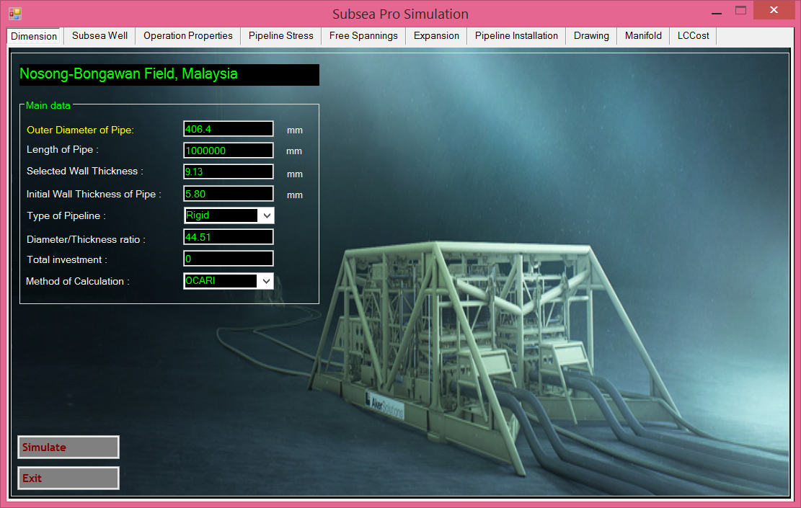
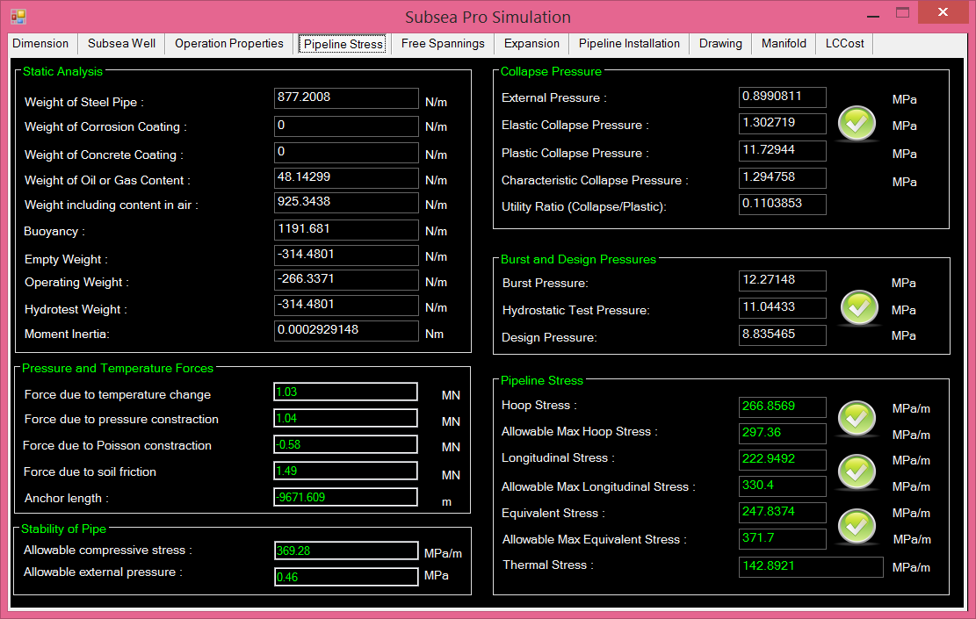
Figure 8.1: Wall thickness and stress analysis using Subsea Pro Simulation.

8.3.2. Buckling Analysis
Two types of analysis were carried out, the first is static analysis and the second is buckling analysis. The table below shows the characteristics of the pipeline.
Figure 8.2: Maximum Deformation (100m free span)

The analysis shows that the maximum deformation is 7.1688m at the middle of the pipeline. This analysis is carried out for 100m free span. As we can see the maximum deformation is quite high. Therefor a shorter free span is considered to decrease the maximum deformation.

Figure 8.3: Maximum Deformation (50m free span)

The figure above shows maximum deformation for 50m free span. As can be seen, the value is now 0.4486m only which is considerably lower than for 100m free span. The pipeline will require support on the middle of free span to offset the buckling load.

Figure 8.4: Maximum Deformation (10m free span)

The figure above shows maximum deformation for 10m free span. The maximum value is 0.0008 m which is almost zero. This proves that the shorter the free span, the smaller the static deformation. However, selecting the optimum free span must include other factor such as cost and efficiency.

Chapter.10

10.0 Kikeh, Malaysia

9.1. Kikeh Field

9.1.1. Malaysian Offshore
Malaysia is one of the main players in oil and gas industry among other big Asia-Pacific countries. Malaysia was ranked as the 4th highest reserves after China, India and Vietnam, with proved reserves of 4 billion barrels as of January 2014. For overall total petroleum production in the year 2014, Malaysia is ranked at 26th, after big countries such as China, Russia, Saudi Arabia and United States. Study by Frost & Sullivan in 2014 estimated that Malaysia’s deep water will contribute to 30 percent of total oil production in the year 2020.
As up to these day, Malaysia’s deep water for oil and gas activities has covered up to the depth of approximately 1400 meters for its first deep water project, Kikeh Field in 2006. The trend of deep water development is prone to conduct of offshore of Sabah state. Currently, all four existed deep water project on Malaysia are developed in Sabah’s deep water. Table.1 listed a brief detail on all deep water projects in Malaysia.

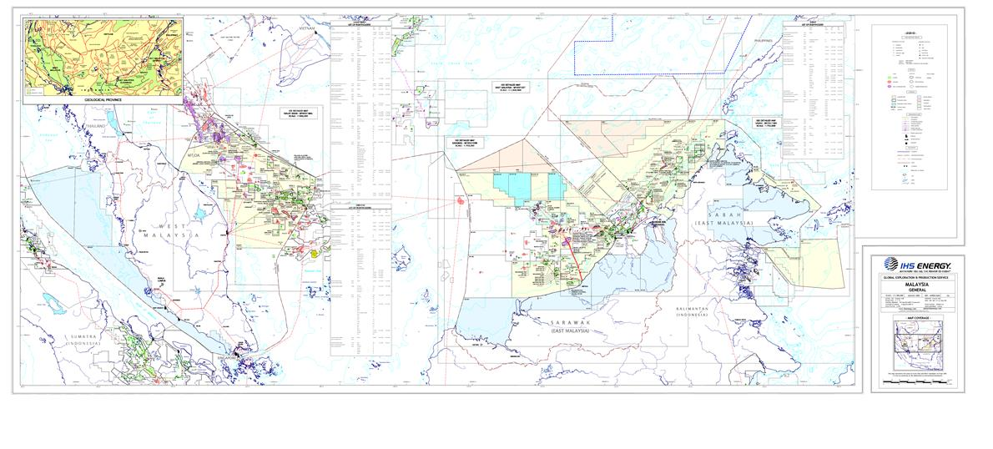
Figure 9.1: Malaysia Oilfield Offshore Concession Map

Table.9.1: Deep water projects in Malaysia’s seas
Project | Location | Approximate depth | Operator
Kikeh  (2007) | Block K and P, 120Km northwest of Labuan island. | 1400m | Murphy Sabah Oil Company, Petronas Carigali
Gumusut-Kakap  (2015) | Block J and K, 120Km offshore from Sabah state | 1200m | Sabah Shell (Gumusut), Murphy Oil (Kakap), ConocoPhillips Sabah, Petronas Carigai
Malikai  (2017) | Block G, 100Km off the coast of Sabah | 500m | Shell, ConocoPhillips, Petronas Carigali
Siakap North-Petai (2014) | Block K and G, offshore Sabah | 1300m | Murphy Oil, ConocoPhillips, Shell, Petronas Carigali

9.1.2. Deep Water Challenges
As the water depth goes deeper from shallow water to deep water, the governing main challenges are related to the high external pressure and potential collapse of pipeline. High external pressure means pipeline collapse failure mode governs wall thickness design rather than pressure containment. Pipeline wall thickness design is one of the most critical design considerations that have to be done before pipeline construction.

9.1.3. Pipe Wall Thickness Design Criteria
As external pressure becomes dominant, the wall thickness design will be governed by the pressure containment criterion, collapse, combined pressure and bending and buckle propagation. Hence, during the designing state the selection of pipe and material properties should satisfy the following requirements:
- Allowable Hoop stress
- Pressure containment (Burst design)
- Collapse Pressure
- Combined load of loading and external pressure

9.1.4. Material Selection and Wall Thickness Design
The use of higher steel grades has a significant effect on the required wall thickness to avoid collapse for deep water pipelines. The effect on wall thickness reduction is higher with increasing depths.
Higher strength steel grade has a higher effect on wall thickness requirements especially for deeper water compared to shallow water. Wall thickness generally will affect both cost and weight and by using higher steel grade these both parameters can be greatly reduced especially when involving high external pressure.

9.1.5. Design Criteria
The main design criteria in designing the deep water subsea pipeline in this study are as follows:
- To have a minimum wall thickness for deep water subsea pipeline which satisfies the required pipe wall thickness to contain collapse pressure and propagation pressure.
- To design a deep water subsea pipeline with the consideration of safety factor, location factor and load effect factor which suited to Malaysian deep water seas.

9.1.6. Design Limit States, Classes and Load Effect Factor
In this study, a selection towards the design limit states, safety and location classes, and load effect factor are chosen based on the case study of Kikeh Oil Field. The selected design criteria are as follows:
- Limit State: Ultimate Limit State (ULS). A condition which, if exceeded, compromises the integrity of the pipeline.
- Safety Class: Low. A condition where failure implies insignificant risk of human injury and minor environment and economic consequences.
- Location Class: Location 1. The area where no frequent human activity is anticipated along the pipeline route.
- Condition Load Effect Factor: Pipeline resting on uneven seabed.
- Load Effect Combination: ULS – system check. The condition where the combination of functional loads and environmental load could affect or jeopardized pipeline’s operation and integrity.

9.2. Kikeh Field Development
Malaysia has a relatively limited oil pipeline network and relies on tankers and trucks to distribute products onshore. Malaysia's main oil pipelines connect oil fields offshore Peninsular Malaysia to onshore storage and terminal facilities. The 124-mile Tapis pipeline runs from the Tapis oil field and terminates at the Kerteh plant in Terengganu, as does the 145-mile Jerneh condensate pipeline. The oil pipeline network for Sabah connects offshore oil fields with the onshore Labuan Crude Oil Terminal.
Malaysia has one of the most extensive natural gas pipeline networks in Asia, totaling about 1,530 miles. The Peninsular Gas Utilization (PGU) project, completed in 1998, expanded the natural gas transmission infrastructure on Peninsular Malaysia. The PGU system spans more than 880 miles and has the capacity to transport 2 billion cubic feet per day (Bcf/d) of natural gas. Other gas pipelines run from offshore gas fields to gas processing facilities are at Kertih. Also, a number of pipelines link Sarawak's offshore gas fields to the Bintulu LNG facility.
Designing a decent pipeline for the deep water usage activities are more challenges as compared to for shallow water pipeline. At deep water depth, more than 300 meters, the pipeline will experience high external pressure. External pressure experience by the pipelines is directly proportional to its operational depth. Hence, designing a subsea pipeline for deep water in Malaysian seas should give big consideration and attention to the external pressure since it will give bigger impact and effect on the pipelines as compared to the shallow depth’s pipelines.
Pipeline installed at deep water depth will have a high potential to collapse compared to if installed at shallow depth. The potential of collapse is due to the high external pressure experienced by the pipeline. Hence, a decent design should be done, together with a suitable design criteria and consideration that can overcome the collapse failure of the pipeline in deep water depth.
The Kikeh field is located at Block K as shown in Figures 9.2 and Figure 9.3, deepwater offshore Sabah, Sabah Delta basin, which is the first deepwater development in Malaysia and the Asia Pacific region, has been in production since 2007. It is located in approximately 1350 meter water depth as shown in Table 9.2. The field consists of a floating production storage and offloading (FPSO) vessel, Kikeh FPSO, receiving production from both wet-tree subsea wells and dry-tree wells drilled from a spar dry tree unit. The FSPO has the capacity to store up to two million barrels of crude oil, and will be able to process 120,000 barrels of oil per day, with an offloading rate of 37,500 barrels per hour. It has 138 kilometer with 12-inch diameter export pipeline.

Figure.9.2: Location of Malaysia’s deep water project

Figure.9.3: Location of Malaysia’s on-development deep water project
Table.9.2: General Details on Kikeh Gas Pipeline Design (Source: Sapura Acergy)
Location | Kikeh Field / Offshore Labuan, West Malaysia
Water Depth (Sapura 3000 Start-up @ KP90) | 50 m
Water Depth (at PLET/PLEM) | 1340 m
Max. Operating Water depth | 1410 m
Pipeline Material | Carbon Steel API 5L (PSL2) Grade X65  Seamless  Applicable for sour and non-sour service
Pipe Size | Line pipe:  Zone II: 339.7 mm OD x 27.3 mm WT (LFP – 1.5 km)  Zone I: 323.9 mm OD x 18 mm WT (1.5 km (from LFP) – KP 0)
Average Joint Length | 11.9m – 12.5m
Estimated no. of Joint | 11270
Design Pressure (Operating) | 358.6 barg / 5200 psig (relative to LAT)  413.8 barg / 6000 psig at PLEM piping
Design Pressure  (Hydrotest) | 1.25 x design pressure
Design  Maximum Temperature and Minimum Temperature | Max. Temperature: 60ºC  Min. Temperature: -10ºC
Pipe Ovality,  Fabrication Tolerance,  Fabrication Factor,  Material Strength Factor | See API5L
Pipe Content and Density | Sour Gas  (0.33 kg/m³)
Pipe’s Design Lifespan | - years

9.3. Subsea Pipeline Design and Analysis

9.3.1. Failure Mode and Wall Thickness Design Analysis
For this analysis, the failure mode for deep water pipeline are being investigated on which mode is the main failure that govern the wall thickness of the pipeline. Two types of failure mode which is system collapse and propagation buckling of the pipeline is evaluated in this analysis. The analysis is done for three different deep water depths with the use of material grade type X65 for the pipeline. The remarks are made based on the required wall thickness for both type of failure.

Figure.9.4: Wall thickness design towards failure modes

From the result and the generated graph we can conclude that,
- Containing the propagation buckling of the pipeline requires bigger or thicker wall thickness compared to the system collapse failure.
- Propagation pressure was experienced by the pipeline at the deep water depth are bigger and higher compared to the collapse pressure.
- At deep water depth, the propagation buckling is the main failure mode that governs the pipeline wall thickness design compared to the system collapse failure.
- Designing a pipeline wall thickness according to propagation buckling requirement will able to help sustain both system collapse and propagation buckling failure.

9.3.2. Material Grade Effect Analysis
For this analysis, the effect on the material grade selection for the deep water pipeline was being investigated. Three different quality of API material grade comprising X60, X65 and X70 type are used in this analysis and only cover for the propagation buckling failure mode, since it is the main mode that governs deep water pipeline failure. The main focus on the analysis is to evaluate the effect of the material grade quality that used in pipeline design towards the required wall thickness of the pipeline.
From the result and the generated graph we can conclude that,
- Material grade selection give effects on the pipeline wall thickness design.
- Increase in material grade quality will be able to help reducing the required wall thickness of the deep water pipeline design.
- Increase in yield stress and tensile strength of a material used in pipeline design give effect on the pipeline durability for deep water operation.
- As the pipeline’s operation depth goes deeper, the importance of the material grade selection for the pipeline design will become more significant.
- The use of high quality material grade will give most effect on the wall thickness required especially for deep water depth compared to shallow water depth. Reduction in wall thickness requirement then can greatly help to reduce the production cost and weight of the pipeline, especially for the pipeline in deep water depth usage.

Figure.9.5: Effect of material grade selection towards wall thickness design

9.3.3. Subsea Pipeline Stress Analysis
For this part, the analysis is done based on the case study of Kikeh Gas Pipeline. The actual data of the pipeline from the Kikeh Oil Field will be used as a parameter in this analysis. This analysis was carried out using two simulation programs which are developed for analyzing pipeline design. The first program used are called UGP Pipeline which have been developed through this study by using DNV class rule while the second program used is an established pipeline design analysis software named Subsea Pro which have been developed by using safety margin design. The UGP Pipeline program have been developed using the design factor, design load and design safety which are choose to suite the application towards Malaysian deep water seas. Through this analysis, the evaluation then was being made on the reliability and suitability aspect of the designed pipeline for the use in Malaysian deep water seas.

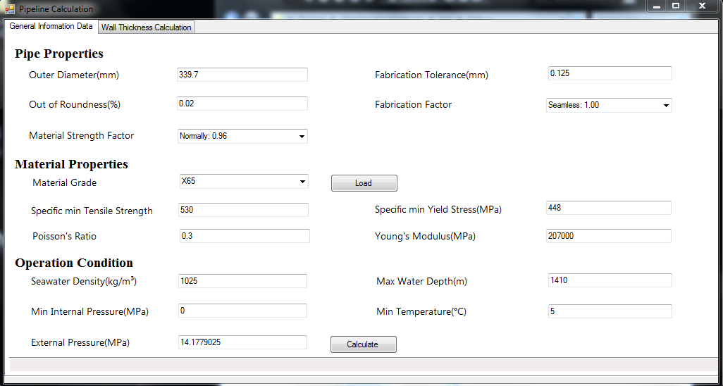
Figure.9.6: Input data using UGP Pipeline program.

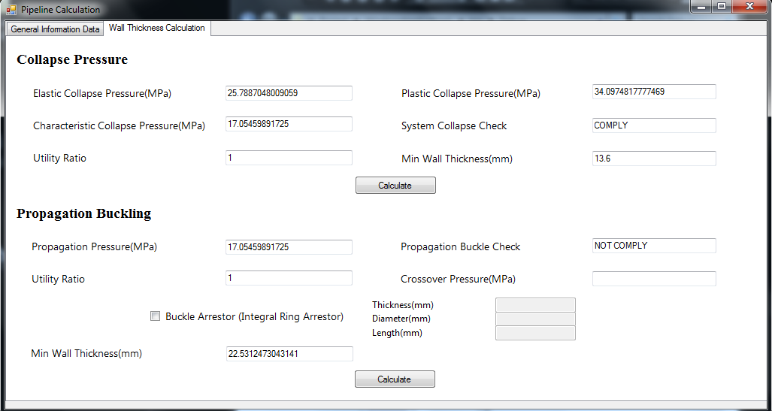
Figure.9.7: Analysis using UGP Pipeline program.

Table.9.3: Result from UGP Pipeline program
 | Local Buckling (System Collapse) | Propagation Buckling
Required Wall Thickness | 13.6 mm | 22.6 mm

Considering the failure mode and wall thickness analysis that have being done at in Section 9.3.1, the minimum wall thickness required to contain both failure will be equal to 22.6 mm, taken from propagation buckling mode. In addition to that, to comply with the Kikeh case study, the corrosion allowance thickness will be taken into account, where corrosion allowance rate are taken at 0.1 mm/year.

Table.9.4: Corrosion allowance calculation
Min. Wall Thickness | 22.6 mm
Corrosion Allowance | 0.1 mm/year x 50 year (Kikeh pipe’s design lifespan)  = 5 mm
 | 27.6 mm

Table.9.5: Wall thickness comparison
 | UGP Pipeline Program | Subsea-Pro Program | Kikeh Gas Pipeline (Actual Data)
Class Rule | DNV | Design by Safety Margin | -
Design Life Span | 50 Years | 50 Years | 50 Years
Wall Thickness Required | 27.6 mm | 27.83 mm | 27.3 mm

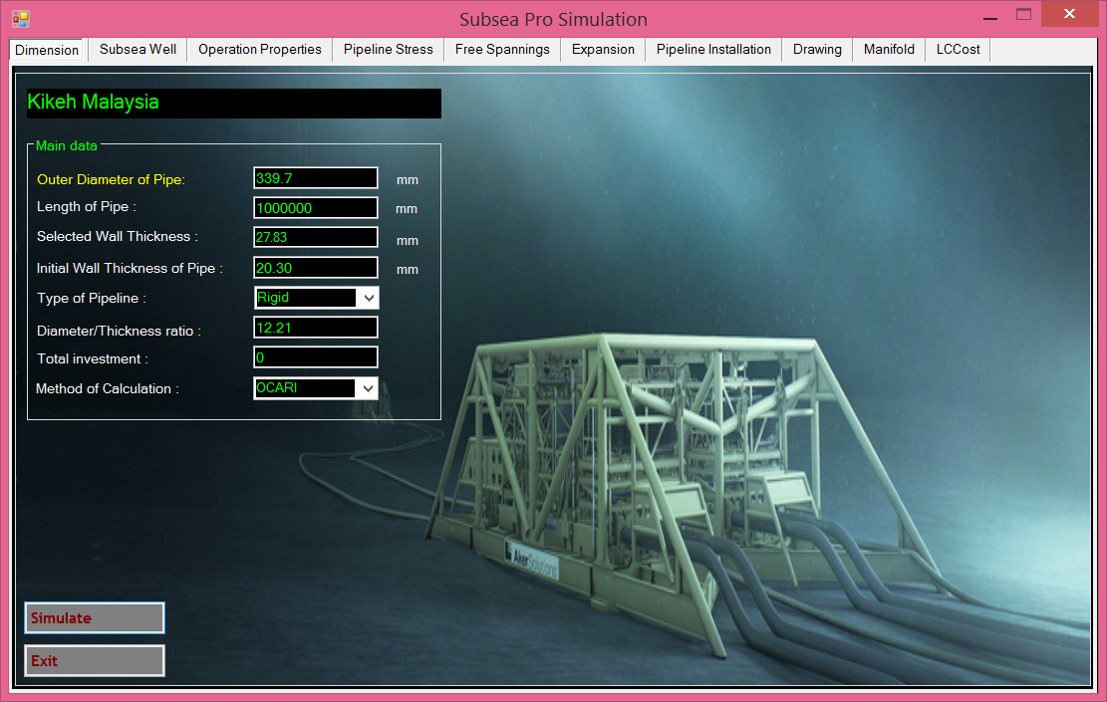
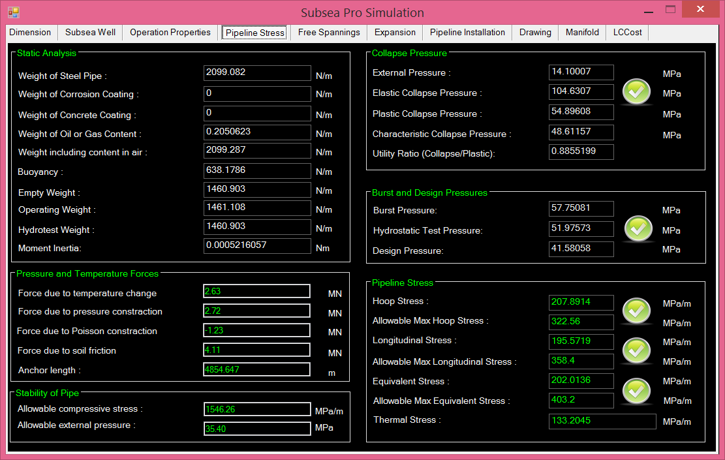
Figure.9.8: Kikeh Subsea Pipeline analysis using Subsea Pro Simulation.

From the results and comparison above we can conclude that:
- The developed program, UGP Pipeline program showed good result.
- The selected design factor, design load and design safety for the UGP Pipeline program are suite to the pipeline design for Malaysian deep water seas.
- The importance of safety factor, location factor and load effect factor for deep water project in Malaysian seas can be applied thoroughly when designing a pipeline using DNV class rule.
- The result illustrate the capability of the developed program and DNV class rule in designing a decent pipeline for deep water depth operation in Malaysia seas.
- Although the wall thickness requirement by UGP Pipeline program are slightly thicker compared to actual data, this however should never being concerned, because in a case of selecting between two different wall thickness of the subsea pipeline, we as a designer will always take the thicker one due to the consideration in pipe’s safety and strength aspect.
The minimal difference in wall thickness value between the developed UGP Pipeline program and established Subsea Pro program give means that the developed program can be considered reliable in designing the wall thickness for the deep water pipeline

Chapter.11

11.0 Gumusut-Kakap, Malaysia

10.1. Sedimentary Malaysia Basins
The major oil and gas reservoirs in Malaysia are located in the sedimentary basins with potential hydrocarbon deposits underneath the rock layers. Geologically Malaysia’s continental shelf is made up of six major sedimentary basins as shown in the Figure.10.1, located offshore of Malaysian waters for the creation of hydrocarbons which are
- Malacca Strait basin,
- Malay basin: The Malay Basin in the offshore east covers more than 12,000 metres,
- Penyu basin: The Penyu Basin in the south covers an area of 5,000 square kilometres,
- Serawak basin,
- Sabah basin: The Sabah Basin cover Northeast Sabah Basin and Southeast Sabah Basin,
- Sandakan basin
The six sedimentary basins in Malaysian deep waters may be a great source of oil and gas energy if these resources can be properly obtained.

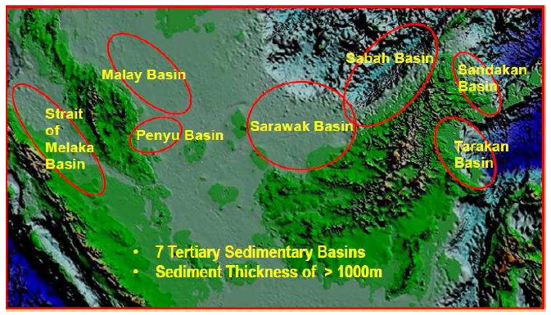
Figure.10.1: Seven sedimentary Malaysia basins.

The major ongoing oil and gas exploration and production activities are Malay basin, Serawak basin and Sabah basin, but the majority of the country’s reserves are located at offshore Sabah and Sarawak basins. The amount of oil reserves from these basins are around 68%. Furthermore, offshore Sarawak and Sabah meet the 48% and 38% reserves of natural gas, respectively.
Malaysia produces very light and sweet crude oil known as Tapis Blend, where it has low sulphur content and lesser impurities compared to other crude oil with gravity of 44◦ and sulfur content of 0.08% by weight. More than 50% of the total Malaysian oil production comes from the Tapis field.
In 1910, Shell discovered the first Malaysia’s first oil well on Canada Hill in Miri, Sarawak which produced approximately 80 million barrels of oil. Then, there were no other drilling activities elsewhere in Borneo or Peninsular Malaya until the 1950s.
In the late 1960s, few foreign petroleum companies such as Esso and Conoco had received concession for oil and gas off the east coast of the Peninsula. Then, based 1974 Petroleum Development Act, PETRONAS received power that granted PETRONAS ownership and exclusive rights and powers over Malaysia’s hydrocarbon resources and comes under direct purview of the Prime Minister.
The first deep-water oil was discovered in 2002 by Murphy Oil in Kikeh area, lies in around 1340 metres in offshore Sabah, which produced 440 million barrels. Currently, there are many existing deep water projects in Malaysia are developed in Serawak and Sabah’s deep waters. Table.10.1 shows listed a brief detail on all deep water projects in Malaysia.
Table.10.1: List oil and gas field developments in Malaysia’s seas
Project | Location | Approximate depth | Operator
Kikeh  (2007)  536 MBOED | Block K and P, 120Km northwest of Labuan island. | 1340m | Murphy Sabah Oil Company,  Petronas Carigali
Gumusut-Kakap  (2015)  620 MBOED | Block J and K, 120Km offshore from Sabah state | 1200m | Sabah Shell (Gumusut), Murphy Oil (Kakap), ConocoPhillips Sabah,  Petronas Carigai
Malikai  (2017) | Block G, 100Km off the coast of Sabah | 500m | Shell, ConocoPhillips, Petronas Carigali
Siakap North-Petai (2014) | Block K and G, offshore Sabah | 1300m | Murphy Oil, ConocoPhillips, Shell,  Petronas Carigali
Kebabangan  (2007)  130-140 MBOED | 130km offshore Sabah | 100 -400m | Conoco P.
Jangas  81 MBOED |  | >1000 | Murphy oil
Ubah Crest  215 MBOED |  | >1000 | Shell
Pisangan  56 MBOED |  | >1000 | Shell
Kamunsu |  | >1000 | Shell

10.2. East Malaysia Oil and Gas Reservoir

Currently, Malaysia has approximately 615,100 square kilometers of acreages available for oil and gas explorations in which 36 percent of these total acreages are currently covered by Production Sharing Contract (PSC). Exploration drilling by the PSCs has resulted in the discovery of 163 oil fields and 216 gas fields.
In 2005-2012, several data sets of wildcat wells were established to provide hydrocarbon evaluation, to give a better understanding of regional structural features and also to explore the hydrocarbon potential of deep-water NW Sabah. The NW Sabah Basin is an offshore of predominantly Middle Miocene age sedimentary basin that underlies the continental margin off Western Sabah and continues to the Sabah Trough and the Dangerous Ground provinces. Figure.1 shows oil and gas field location at Sabah basin
The Sabah Trough is also known as the Borneo Trough/Nansha Trough to the southwestern part and the Palawan Trough/Trench to the north-eastern part with bathymetric featuring water depths of the depression that varies from 2410 m to about 2900 m, extends over 300 km in length with an average width of 80 km as shown in Figure.2. Figure.3 shows location of deep water projects in East Malaysia.

Figure.10.2: Geological features of NW Borneo offshore.

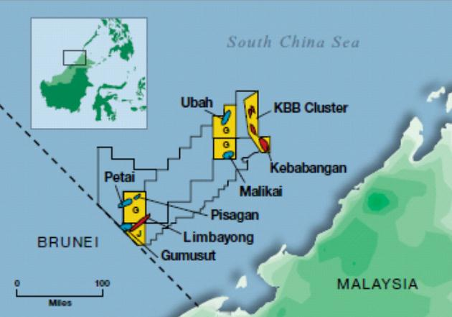
Figure.10.3: Location of deep water projects in Malaysia.

10.3. Challenges of East Malaysian Deep Water

Malaysia’s deep water oil and gas exploration presents unique and challenges. There several main factors such as Complicated Seabed Relief, Long Thin Fields and Long Thin Tieback

10.3.1 Complicated Seabed Relief
- The Shelf covers circa 100-120 km wide with folding belt or slope and instability issues which is circa 60-80 km wide North Malaysia, shallow hazards, hydrate management as shown in Figure.4.
- It is required special ability to install flowlines and facilities on steep slopes -allowing for more direct routes-.
- High CO₂ content in gas

Figure.10.4: Rendered 3D image of Borneo Slope.

10.2. Long Thin Fields
- Most fields require 2-4 drill centers with a high well count to develop, as shown in Figure.5
- Need to reduce number of drill Centre through ERD capability, or low cost wells

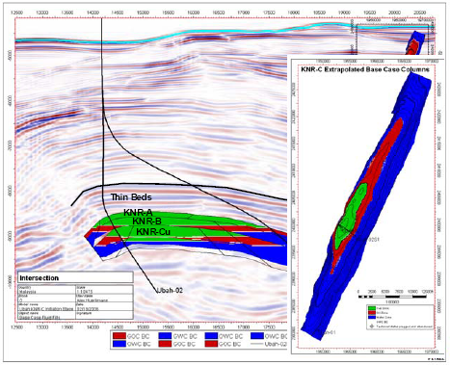
Figure.10.5: Long Thin Fields of Malaysia deep water exploration

10.3 Long Distance Tiebacks:
- It is required 25 -50 km tieback distances, as shown in Figure.6
- Flow assurance with waxy crudes
- Need for subsea separation and boosting technologies

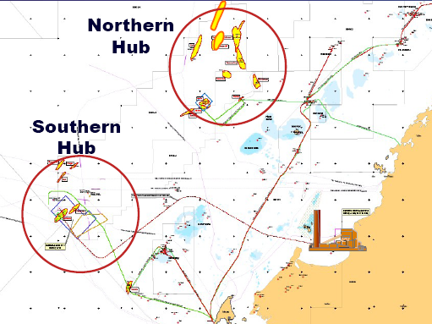
Figure.10.6: Long Distance Tiebacks of Malaysia deep water exploration

10.4. Gumusut-Kakap Field Development

10.4.1 Subsae Flowlines
The Gumusut-Kakap Field is operated by Sabah Shell Petroleum Company Limited (SSPC), which owns a 33% stake, in partnership with ConocoPhilips Sabah (33%), Petronas Carigali (20%) and Murphy Oil (14%).
The Gumusut-Kakap field is located at offshore Sabah Blocks J & K at 1200 m of deep water, will embrace the regions’ first deep water floating production system with a processing capacity of 150,000 barrels a day from 19 sub-sea wells.
The Gemusut-Kakap field was estimated to contribute up to 25 percent of the country’s oil production. The oil extracted from the 19 subsea wells will be exported to the onshore Sabah Oil and Gas Terminal (SOGT) at Kimanis, Sabah via 200 km long pipeline as shown in Figure.7.

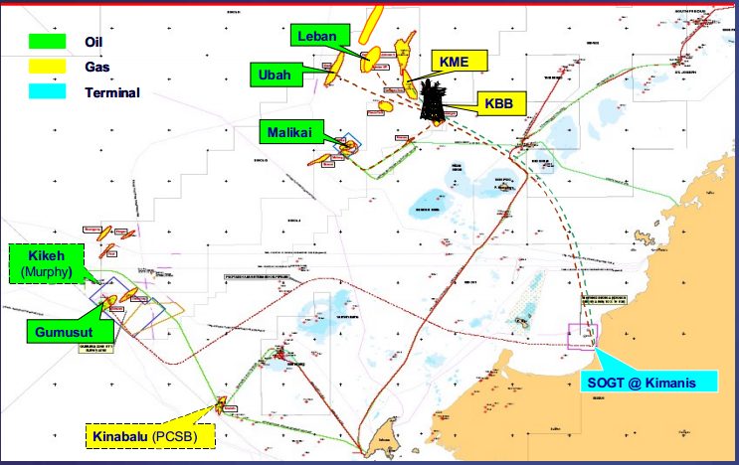
Figure.10.7: Gemusut-Kakap Subsea Oil export pipeline.

Initially, there are 7 wells out of 19 wells that needed to be operated which included three production wells, three water injection wells and a gas injection well. This particular project used 7 subsea manifolds for each wells. Table.10.2 shows particular dimension of Gemusut-Kakap subsea flowlines.

Table.10.2: Sizing of the flowlines according to type of wells.
Flowlines | Outside Diameter | Length
Production Flowlines | 203.2 mm | 31miles
Gas Injection Flowlines | 254.0 mm | 11 miles
Water Injection Flowlines | 304.8 mm | 7 miles

10.4.2 Subsea Tree Systems
The field development utilized the modular EVDT tree concept with standardized tree materials allowing for interchangeability for production, water injection and gas injection tree styles. The primary difference is the FMC Technologies retrievable flow control module (FCM) which allows easy conversion between tree systems to allow project flexibility. The production FCM includes a bolted bonnet choke with multiphase meter packaged in a single unit and included insulation to achieve a 10-hr thermal cool-down performance
The Gumusut-Kakap utilized FMC Technologies' 5”x2” 10K modular EVDT tree system configured in different ways to accommodate the needs of the field. The modular EVDT tree concept with standardized tree materials allows for interchangeability for production, water injection, and gas injection tree styles as shown in Figure.8.
All trees will be provided for API Material Class HH utilizing CRA cladding on all production-wetted surfaces. The maximum flowing temperature condition is 210 F (99 C) and anticipated flowing pressures up to 6000 psi (41.37 MPa). Table.3 shows characteristics of subsea tress of Gemusut-Kakap field development.

Table.10.3: Characteristic of subsea trees
Parameter | Description
Tree Pressure: | 10000 psi
Tree Type: | EVDT
Tree Count: | 15
Tree Bore Size: | 5" x 2"

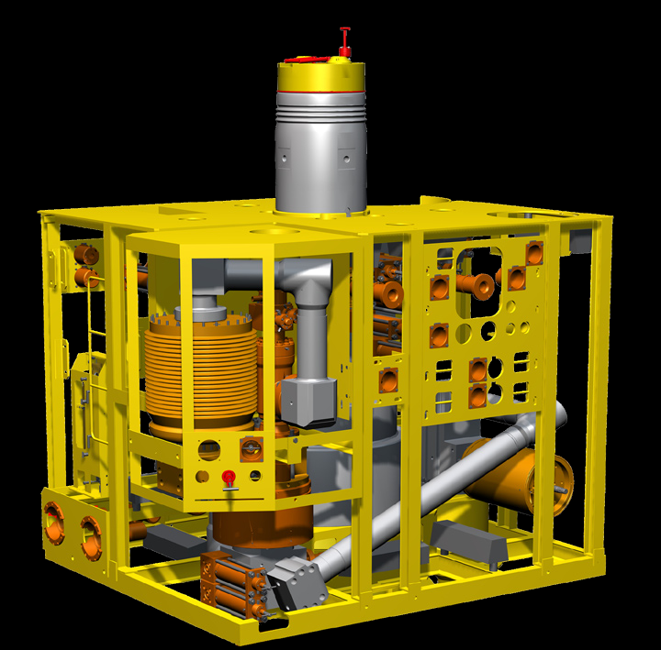
Figure.10.8: Modular EVDT Tree installed at Gemusut-Kakap Subsea Field.

The Gumusut-Kakap field development provided Shell with state-of-the-art high-speed communications using FMC Technologies 200e protocol. FMC Technologies' 200e system provides a minimum communication rate of 9600 with full duplex point-to-point communications. This enhances the performance of data flow between the FPS and subsea architecture, and the system is designed to operate and control up to 40 SCMs, which will cover the current requirements and future phases.
The field comprises three unique manifold styles. Three production manifolds are provided with dual 8-inch headers and 6-inch branches completed with API material class HH trim components and novelistic insulation for production, water injection and gas injection configurations. The manifold utilizes hydraulically actuated M3000 valves controlled by a manifold mounted subsea control module. The jumper connection systems utilize field-proven Torus-III connector systems with integral hydraulics and MC metal-to-metal gaskets.

10.5. Flowlines of Gumusut-Kakap Field

10.5.1. Design Parameters
Design parameters of flowlines used in the present study is shown in Table.4. Material grade used for this project is X60 with density of 7850 Kg/m³. Operating temperature and pressure are assumed to be 99 ⁰C and 41.37 MPa.

Table.10.4: Design Parameters for flowlines.
Parameter | Unit | Value
Pipe Material Grade | - | X65
Steel Density | Kg/m3 | 7850
SMYS | MPa | 448
SMTS | MPa | 530
Poisson Ration (v) | - | 0.3
Young's Modulus (E) | GPa | 207
Thermal Expansion Coef. (a) | C⁻¹ | 1.17 x 10E-05
Content Density (Oil) | Kg/m3 | 855
Design Pressure | MPa | 41.37
Operating Temperature | ⁰C | 99
Seawater Density | Kg/m3 | 1027
Target Life | Years | 50

10.5.2. Safety Margin Theory
Simulation is done by using Subsea Pro Simulation based on Safety Margin Theory. Safety margin of pipeline wall thickness is a minimum wall thickness selection based on either internal or external pressure as shown in the Figure.9. The Subsea Pro Simulation was developed by Joint International Research Center (JIRC).Figure.9 demonstrates wall thickness of subsea pipeline versus burst and collapse pressures. External pressure was calculated using hydrostatic equation with different water depth level such as shallow, deep and ultra-deep. The burst and collapse pressures of pipeline were calculated according to API RP 1111 rule.

Figure.10.9: Burst and collapse pressures analysis for Gemusut-Kakap.

The burst pressure refers to the internal pressure that causes a pipe to burst or fracture. The Specified Minimum Burst Pressure ($P_{b}$) which can be written as

$P_{b}=0.90\left(SMYS+SMTS\right)(\frac{t}{D-t})$ (10.1)

Where; $t$ is wall thickness of flowline and the $D$ is outside diameter of flowline for D/t >15
The hydrostatic pressure test, then the design pressure is written as:

$P_{d}≤0.80f_{d}f_{e}f_{t}P_{b}≥P_{Internal}$ (10.2)

Where; $f_{d}$ is the burst design factor of internal pressure 0.90 for pipeline and 0.75 for riser, $f_{e}$ is the joint factor of weld and $f_{t}$ is the temperature derating factor.
The critical stress is corresponding to the critical pressure in the equation below:

$P_{cr}=\frac{P_{e}P_{y}}{P_{e}+P_{y}}≥P_{external}$ (10.3)

10.5.3. Results and Discussion
In the present study, stress and buckling of flowlines were calculated using Subsea Pro Simulation. Table.10.5 shows wall thickness and slipping length of flowlines which are explained in Figures.10.10 – 10.19.

Table.10.5: Wall thickness and buckling of flowlines for Gemusut-Kakap.
Flowlines | Outside Diameter | Wall Thickness | Slipping Length
Production Flowlines | 203.2 mm | 18.59 mm | 123.25 m
Gas Injection Flowlines | 254.0 mm | 22.00 mm | 161.76 m
Water Injection Flowlines | 304.8 mm | 25.41 mm

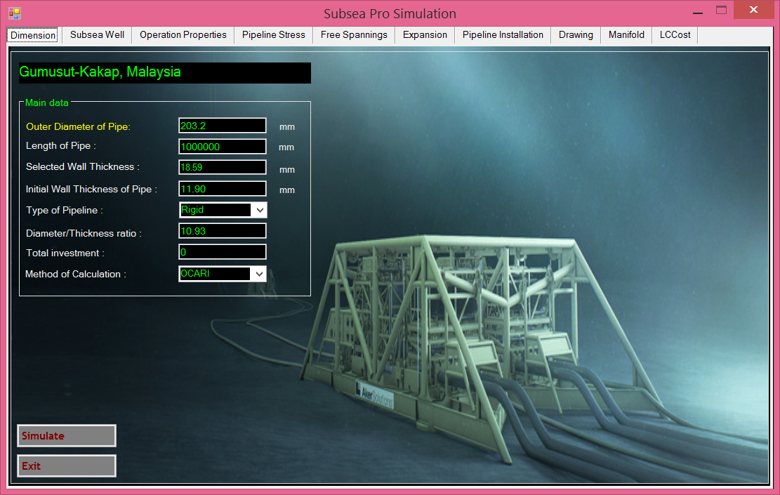
Figure.10.10: Minimum thickness of production flowlines for Gemusut-Kakap.
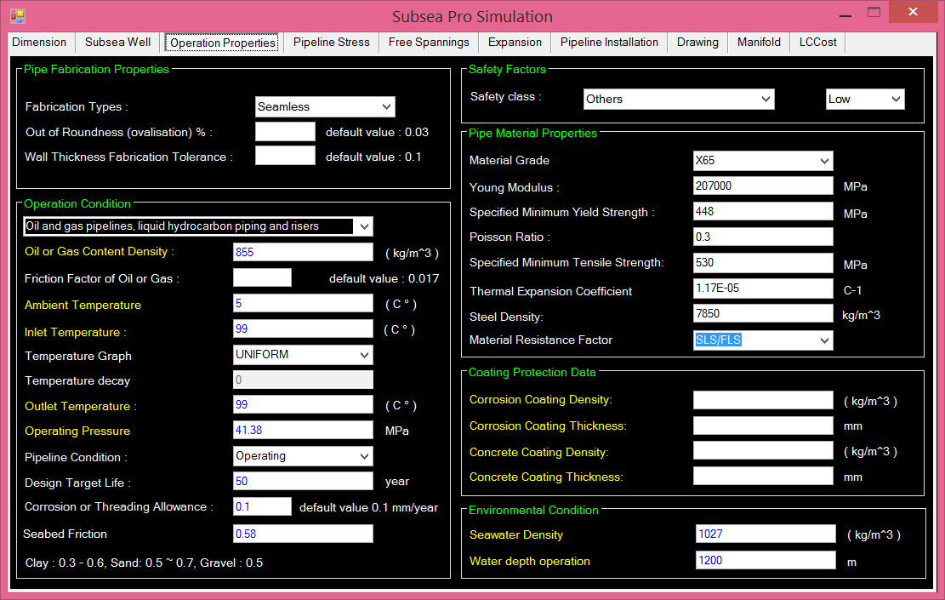
Figure.10.11: Design parameters of production flowlines for Gemusut-Kakap.

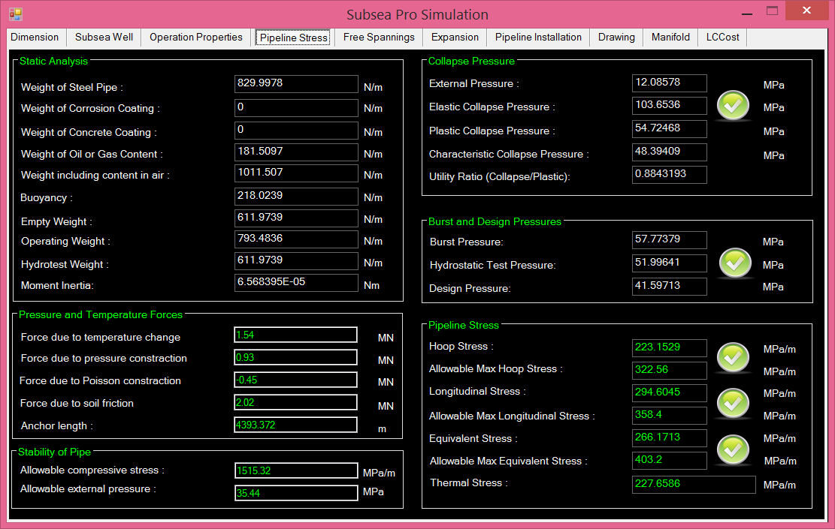
Figure.10.12: Pressure and Stress of production flowlines for Gemusut-Kakap.

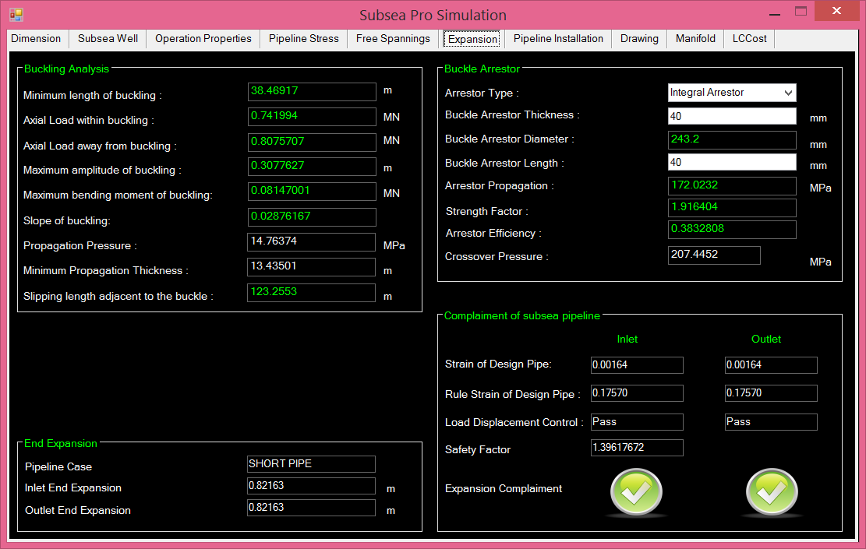
Figure.10.13: End expansion safety factor of production pipelines for Gemusut-Kakap.

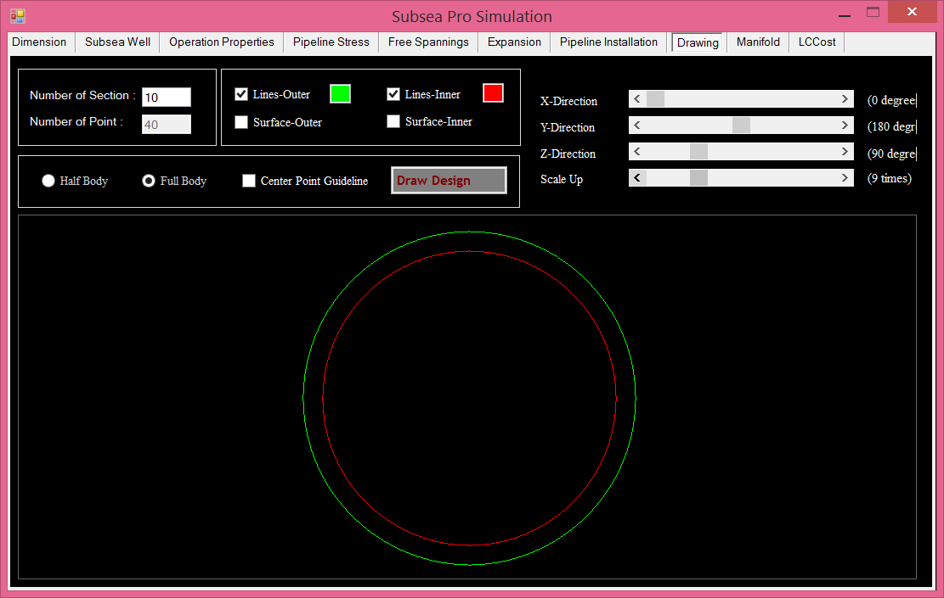
Figure.10.14: Drawing of production flowlines for Gemusut-Kakap.

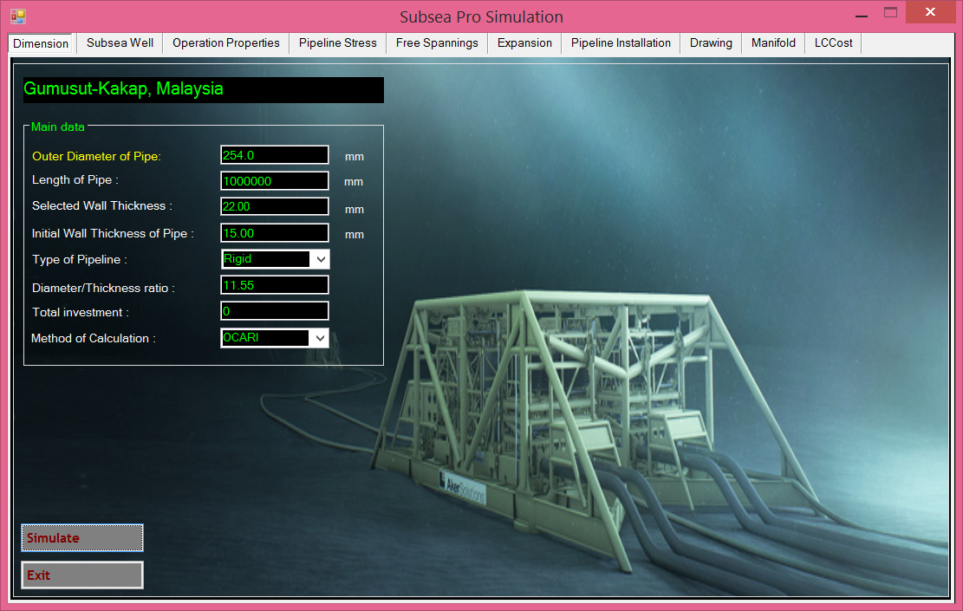
Figure.10.15: Minimum thickness of gas injection flowlines for Gemusut-Kakap.

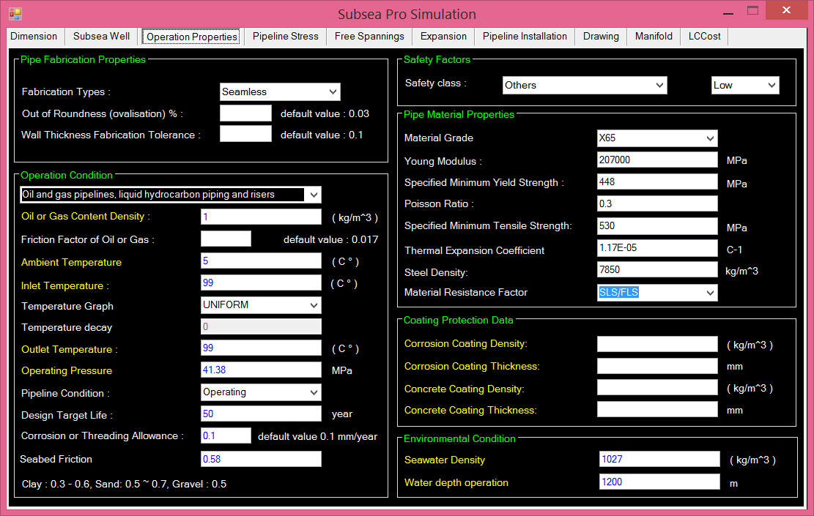
Figure.10.16: Design parameters of gas injection flowlines for Gemusut-Kakap.

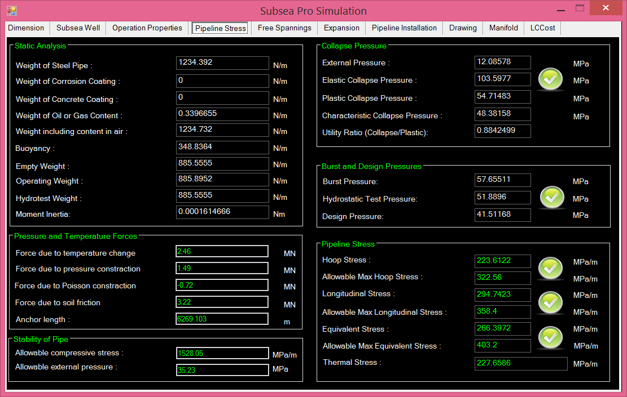
Figure.10.17: Pressure and Stress of gas injection flowlines for Gemusut-Kakap.

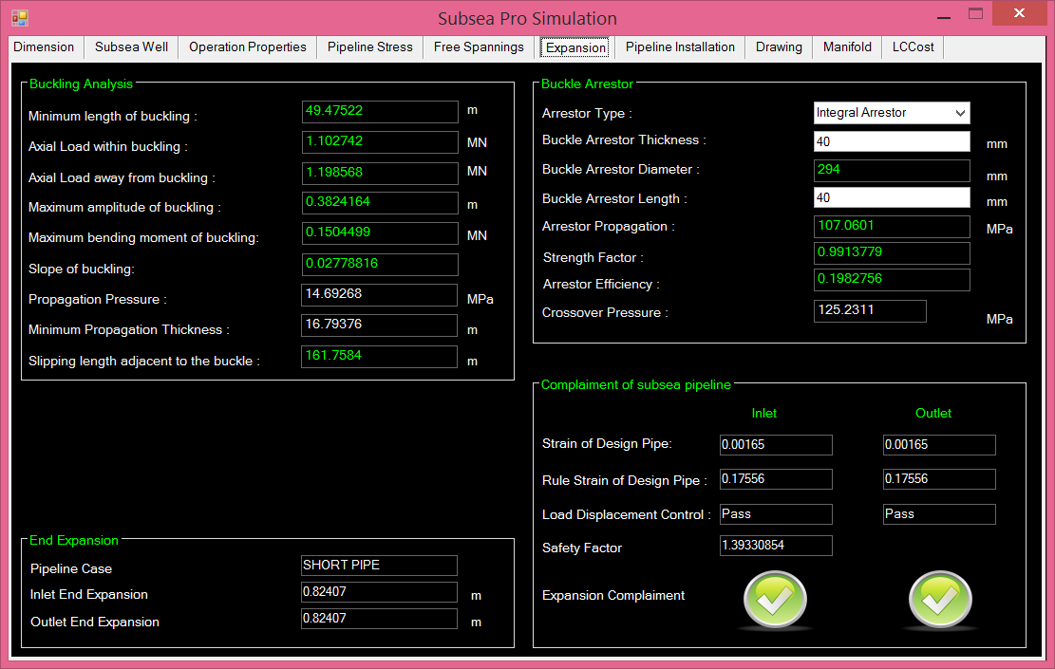
Figure.10.18: End expansion safety factor of gas injection pipelines for Gemusut-Kakap.

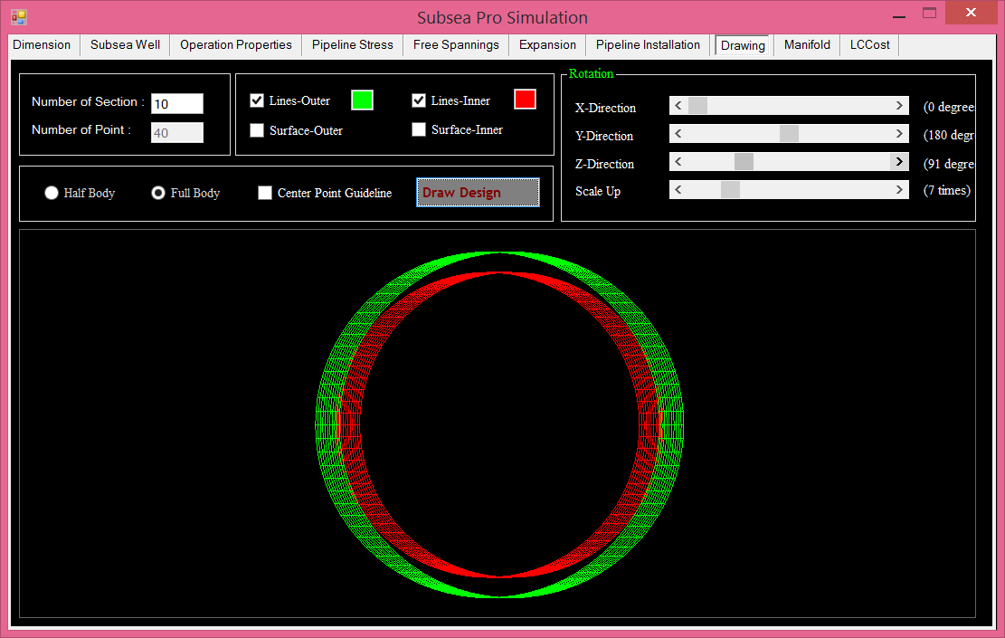
Figure.10.19: Drawing of gas injection for Gemusut-Kakap.

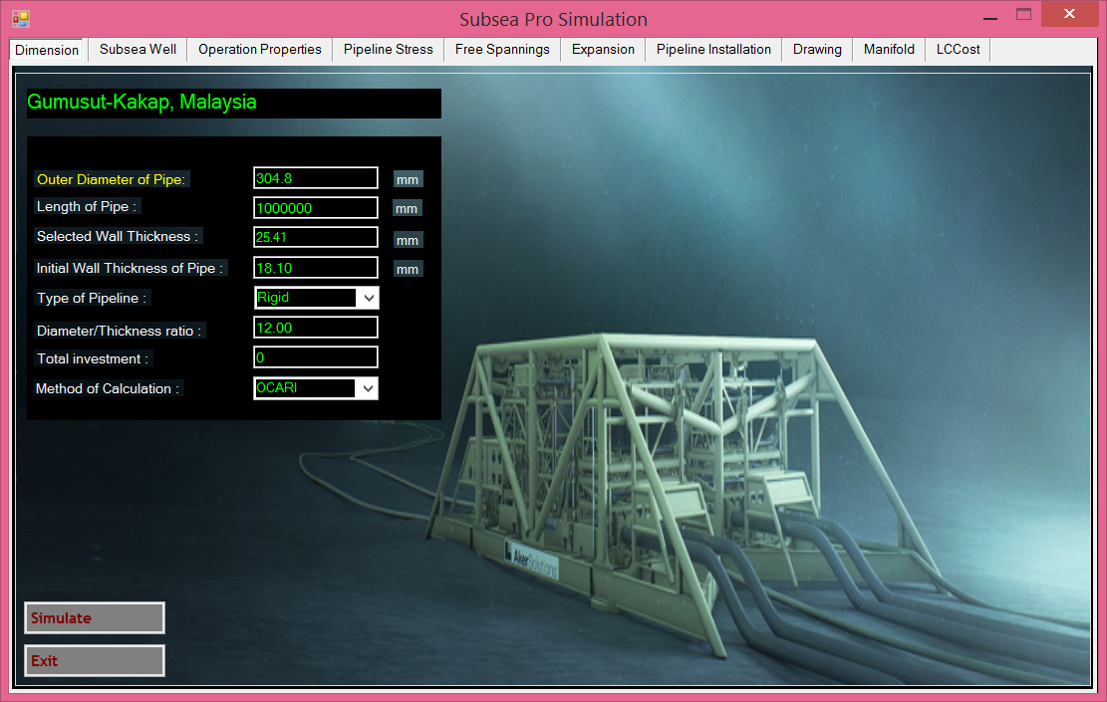
Figure.10.20: Minimum thickness of water injection flowlines for Gemusut-Kakap.

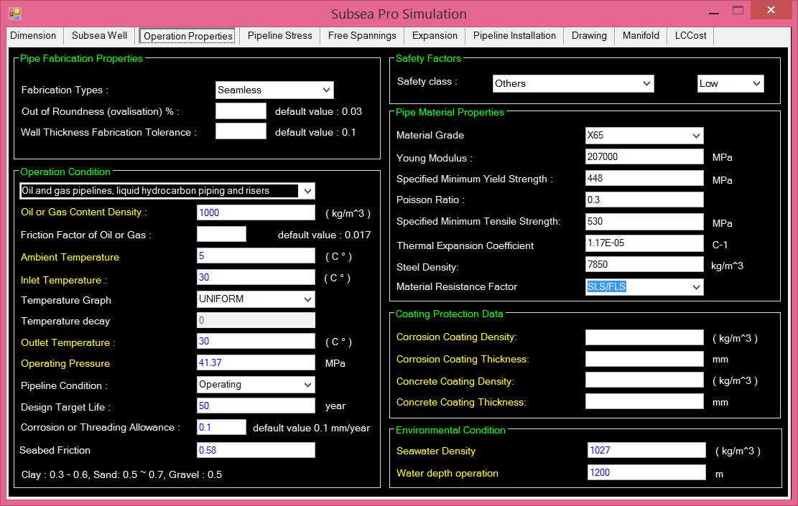
Figure.10.21: Design parameters of water injection flowlines for Gemusut-Kakap.

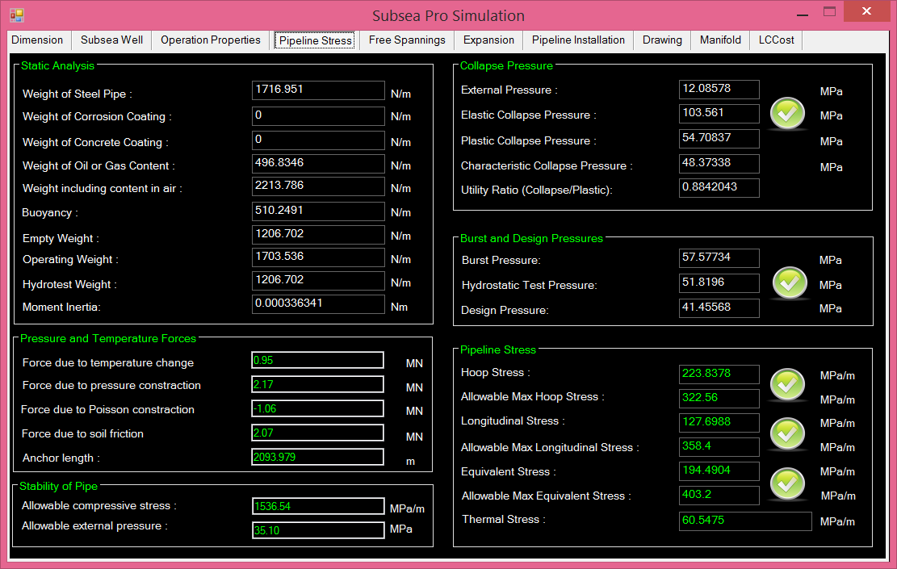
Figure.10.22: Pressure and Stress of water injection flowlines for Gemusut-Kakap.

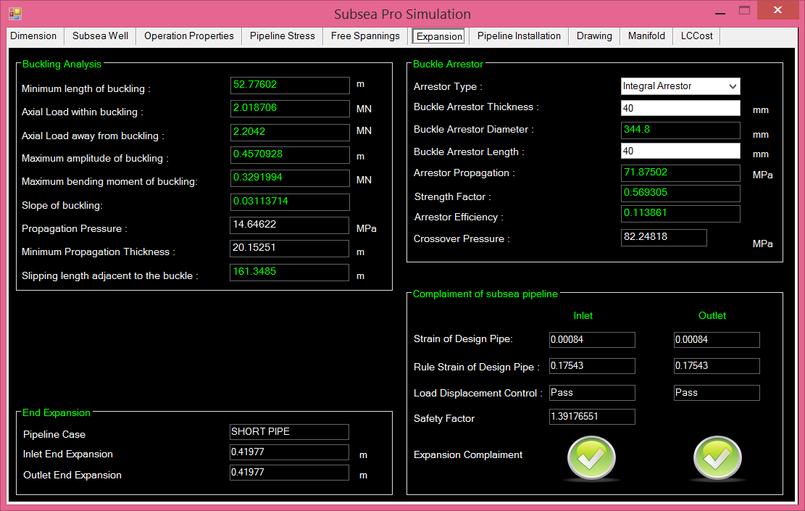
Figure.10.23: End expansion safety factor of water injection pipelines for Gemusut-Kakap.

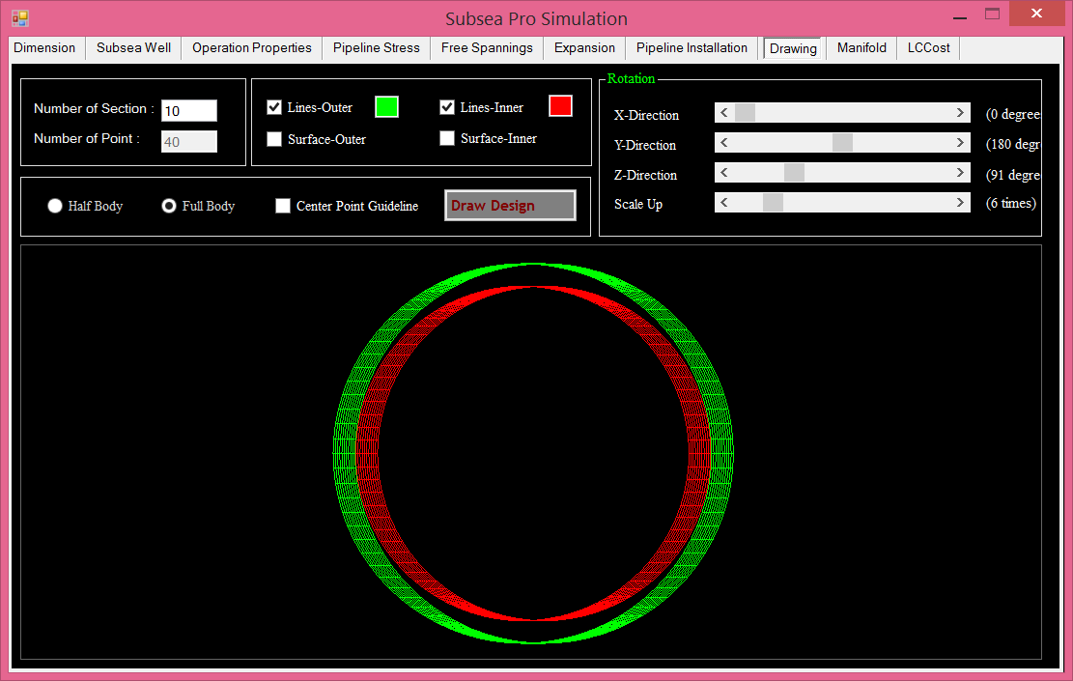
Figure.10.24: Drawing of water injection flowlines for Gemusut-Kakap.

Chapter.12

12.0 Roncador, Brazil

11.1. Introduction
Campos Basin is located offshore Rio de Janeiro State, on the Southeast region of Brazil. It covers area 100 kilometers square ranging from 20 m to 3400 m water depth. After Petrobras discovered 2 giant fields in Campos Basin, Albacora, 1984 and Marlim, 1985 in water depth from 200 m to 2000 m, they faced 11 years later until 1996 to the discovery of Roncador Field in water depth ranging from 1500 m to 1900 m. Roncador Field is a giant field located in the northern area of Campos Basin. The Roncador field seabed is located 125 kilometers off the coast of Rio de Janeiro and approximately 500 meters away from the Frade field border line.

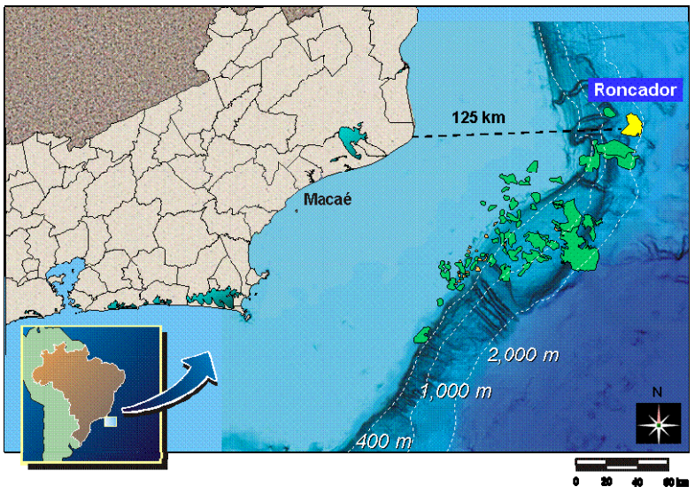
Figure.11.1: Maps of Campos Basin and Roncador Field.

11.2. Field Development
Petrobras developed Roncador field in four modules because of its large size and different oil gravity in each area. Module 1 has several phases. Figure.11. shows the project development modules in Roncador Field.
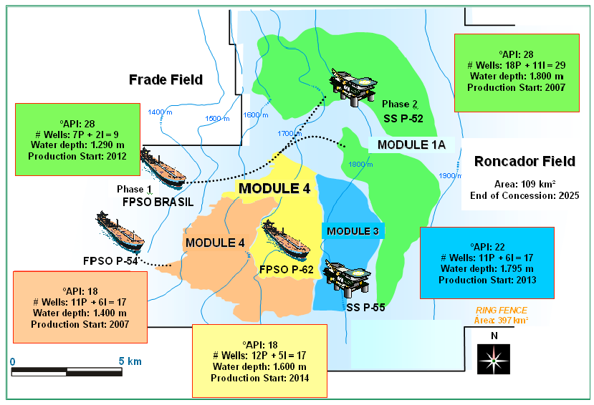
Figure.11.2: Project Development Modules in Roncador Field

The Early Production Phase started producing in 1999 from the first well, RJS-436. This well located at water depth 1,853 m and connected to FPSO Seillean. This phase was set to produce early in order to create revenue for the project to cover the huge costs for development the whole field. During this phase, the production was 20,000 bbld.
Phase one of Module 1 consisted of several wells connected to semi-submersible production facility P-36. It is start producing in 2000 and later in March 15, 2001, this semi-submersible has sunk due to explosions due to human error. During that time, P-36 is considered the biggest submersible which produced 84,000 bbld of oil and 1.3MMscmd of processing gas. After the P-36 incident, Petrobras has started with Module 1A: Phase One. They want the field to producing as soon as possible. FPSO Brasil has been installed on water depth 1,290 m and eight production wells have been connected to the vessel. On 2002, the field has started production again.
In Module 1A Phase Two, new build semi-submersible P-52 has been fabricated and installed in 2007. This platform is connected to 18 subsea production wells and 11 water injection wells. The submersible produce 20,000 bbld peaking to 180,000 in second part of 2008. The peak gas produced from this phase was 3.2MMscmd. For this project, we will focus on Module 1A only.
A module 2 development consists of 17 long horizontal wells which 11 of them are production wells and 6 are water injection wells. FPSO P-54 has been assigned for production in this module and started operation in 2007. This phase has helped to boost the overall production from the field to 460,000 bbld.
A module-3 development consists of 11 add-on production wells and 7 water injection wells. For this module, semi-submersible P-55 has been assigned for production. The production capacity for this platform is 180,000 bbld and gas compression capacity is 6 MMscmd. The platform started its production in 2013.
Module 4 development consists of 19 wells, which is 12 wells are production well and another 7 wells are water injection well. An FPSO P-62 has been assigned for this module. This FPSO is a cloned to the P-54 FPSO. The production capacity is 180,000 bbld and gas compression capacity is 6 MMscmd. This platform started its production in 2014.

11.2.1 Roncador Subsea System
The Roncador Field has been leading the technological challenges of Petrobras in ultra-deep water since it is discovery. In order to maximise reservoir information and improve the economics of the project, Petrobras took the decision to develop Roncador with an Early Production System (EPS) until the main facilities were completed.
The Early Production System used subsea equipment comprised by the following parts resident on the seabed: two subsea trees, six vertical connection modules and an emergency disconnect package with multiplex controls. It has the world's first drill pipe riser, subsea tree and Early Production Riser (EPR) rated 2000m of water depth.
The first well in Roncador is RJS-436A connected to the FPSO Seillean from 1999 to 2001 using EPR at water depth 1853m with GLL TLD 2000 subsea tree. This field has 3 billion barrels of proven recoverable oil reserves. Due to its large reservoir size, the field was divided into four modules, Module 1 has oil well 28-31 API, Module 2 oil wells 18 API, Module 3 has oil well 22 API and Module 4 has oil well 18 API. Module 1 has two phases, Phase 1 and Phase 1A. There are total 94 wells in Roncador Field, which is 60 wells are production well and 34 wells are water injection wells.
Two types of subsea technologies were used as follows vertical and horizontal. Both tree technologies are guide lineless with vertical flowline connection with individual vertical modules. Several offshore floating structures have been chosen to operate in Roncador Field for production activity such as floating production storage and offloading vessels and semi-submersibles.

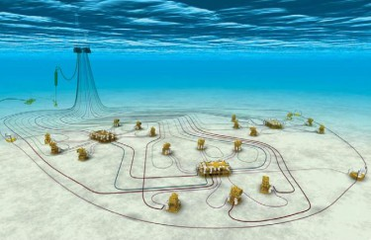
P-52
Oil: 180.000 bpd
Water depth: 1800 m
MSGL-RO-02 6 production wells
Subsea System: 29 Wells
-18 Production Wells
-11 Water Injection Wells
-1 Oil Export Pipeline
-1 Gas Export Pipeline
-3 Subsea Manifolds:
- Gas-lift Injection
- Chemical Products inj.
- Well control
MSGL-RO-01 6 production wells
MSGL-RO-03
3 production wells + 3 injection wells
Figure.11.3: Roncador P-52 subsea layout.

Table 11.1: Summarize the subsea infrastructure that has been installed in Roncador field [Bordieri E., 2008]
Module | Subsea Manifold | Gathering System
Module | Subsea Manifold | Flexible | Rigid | Umbilical
1A Phase 1 | 1 gas-lift manifold | 4in - 6in (205km) | 5.5in - 7in (33 km) | 115km
1A Phase 2 | 2 gas-lift manifolds | 4in - 7in  (295 km) | - | 168km
2 | 2 control manifolds | 2.5in - 6in (143 km) |  | 76km
3 | 2 gas-lift manifolds  & 2 water injection manifolds | 4in - 7in  (59 km) | 8in - 10in (61km) | 96km
4 | 2 gas-lift manifolds  & 2 water injection manifolds | 4in - 7in  (107 km) |  | 68km

Table 11.2: Summarize the subsea transportation system that has been installed in Roncador field [Bordieri E., 2008]
Module | Risers | Oil Export System |  | Gas Export System
Module | Risers | Rigid | Flexible | Rigid | Flexible
1A Phase 1 | 40 | - | - | 10in (37km) | 9.13in (6km)
1A Phase 2 | 57 | 18in (58km) | 16in (475km) | 10in (37km) | 9.13in (10km)
2 | 42 |  |  | 10in (35km) | 9.13in (4km)
3 | 37 | 12in (61km) | 9in (61km) | 12in (42km)
4 | 30 |  |  | 12in (50km) | 12in (1km)

11. 3 Pipeline Design

11.3.1. Pipeline for Production
The crude reached the vessel through a single-production rigid riser. Because of the relatively low reservoir temperature and the temperature drop in the production riser, it was necessary to increase the wellstream temperature. Two heaters were installed to boost the temperature to 67°C. The natural gas produced fuels for the turbo-generators, which supply all Seillean's energy requirements.
For production pipeline, Rocandor field use type single pipe with coating for production pipelines. The pipe consists inside pipe, coating and insulation. The pipelines data as per in Table 11.3 is as input data for calculation of production pipeline.
Table.11.3: Rigid production pipeline data
PARAMETER | UNIT | VALUE
Outside Diameter, D | m | 0.1778
Wall thickness, t | m | 0.014
Pipe material grade | - | X60
>Steel Density, ρ_{st} | Kg/m³ | 7850
> Specified Minimum Yield Strength, (SMYS) | Mpa | 413
> Specified Minimum Tensile Strength, (SMTS) | MPa | 517
> Poisson ratio (ν) | - | 0.3
Young's Modulus, E | Gpa | 207
Thermal Expansion Coefficient (α) | C⁻¹ | 1.17x10⁻⁵

Table.11.4: Insulation and Coating Data for Production Pipeline for Production Pipeline
PARAMETER | UNIT | VALUE
Insulation Thickness, t_{cr} | m | 0.0001
Insulation Density, ρ_{cr} | Kg/m³ | 1300
Concrete Coating Thickness, t_{cn} | m | 0.060
Concrete Coating Density,ρ_{cn} | Kg/m³ | 912.2

Table.11.5: Operating Data for Production Pipeline
PARAMETER | UNIT | VALUE
Content Oil density, ρ_{cn} | Kg/m³ | 897
Design Internal Pressure, P_{i} | Mpa | 22
Operating Temperature, T_{o} | ºC | 60

Table.11.6: Environmental data for Production Pipeline
PARAMETER | UNIT | VALUE
Seawater density | Kg/m³ | 1027
Water Depth | m | 1800
External Pressure (P_{e}) | Mpa | 18
Ambient Temperature, T_{a} | ºC | 5
Friction factor | - | 0.58

Table 11.7: Soil data for Production Pipeline
PARAMETER | VALUE
Axial Friction | 0.5
Lateral Friction | LB | 0.3
Lateral Friction | BE | 0.5
Lateral Friction | UB | 0.7
Soil Mobilization |  | 2mm - 4mm

11.3.2. Pipeline for Gas Lift
For production pipeline, Rocandor field use type single pipe with coating for production pipelines. The pipe consists inside pipe, coating and insulation. Below is the calculation for gas lift pipeline. The pipelines data is as per in Table 6.6.

Table.11.8: Rigid gas pipeline data
PARAMETER | UNIT | VALUE
Outside Diameter, D | m | 0.1413
Wall thickness, t | m | 0.013
Pipe material grade | - | X60
>Steel Density, ρ_{st} | Kg/m³ | 7850
> Specified Minimum Yield Strength, (SMYS) | Mpa | 413
> Specified Minimum Tensile Strength, (SMTS) | MPa | 517
> Poisson ratio (ν) | - | 0.3
Young's Modulus, E | Gpa | 207
Thermal Expansion Coefficient (α) | C⁻¹ | 1.17x10⁻⁵

Table.11.9: Insulation and coating data for gas pipeline
PARAMETER | UNIT | VALUE
Insulation Thickness, t_{cr} | m | 0.0001
Insulation Density, ρ_{cr} | Kg/m³ | 1300
Concrete Coating Thickness, t_{cn} | m | 0.005
Concrete Coating Density,ρ_{cn} | Kg/m³ | 3040

Table.11.10: Operating Data for gas pipeline
PARAMETER | UNIT | VALUE
Content Oil density, ρ_{cn} | Kg/m³ | 0.668
Design Internal Pressure, P_{i} | Mpa | 22
Operating Temperature, T_{o} | ºC | 60

Table.11.11: Environmental data for gas pipeline
PARAMETER | UNIT | VALUE
Seawater density | Kg/m³ | 1027
Water Depth | m | 1800
External Pressure (P_{e}) | Mpa | 18
Ambient Temperature, T_{a} | ºC | 5
Friction factor | - | 0.58

Table.11.12: Soil data for gas pipeline
PARAMETER | VALUE
Axial Friction | 0.5
Lateral Friction | LB | 0.3
Lateral Friction | BE | 0.5
Lateral Friction | UB | 0.7
Soil Mobilization |  | 2mm - 4mm

11.4. Finite Element Analysis
Finite element method is a numerical procedure to obtain verification and engineering solutions. The aim for this analysis is to access the structural behaviour of the pipe under loading condition. For this analysis, ANSYS Workbench Static Structural Analysis has been used based on available operating data.

11.4.1. Load and boundary conditions
For this study, the pipe model is built by ANSYS 14 according to the scale to define stress and strain during normal operation in different water depth level of 1800 meters. The pipe has total length of 120 m and the material properties are correspond to API 5L. The internal pressure of 22 MPa and external pressure of 18 MPa are applied and the wall thickness and outer diameter of pipe for production line are 14.3 mm and 177.8 mm respectively, meanwhile the wall thickness and outer diameter for gas line are 12.7 mm and 141.3 mm respectively (details of the operating condition can be refer at previous section). The both ends of the pipeline are fixed as restraint condition and the simulation is running without pipeline coating coating.

11.4.2 Equivalent stress, strain and buckling for production pipeline
Figure 8.1 illustrates the equivalent stress in elastic model without concrete coating by using static structure analysis of ANSYS for production pipe. The maximum stress is 190 MPa while the minimum stress is 79 MPa. The equivalent strain is illustrated by figure 8.2 which the maximum 9.6313e-4 and the minimum strain will be 4.7654e-4. Figure 8.3 show the pipeline buckling for production line which is the maximum deformation is 1.0326 m.
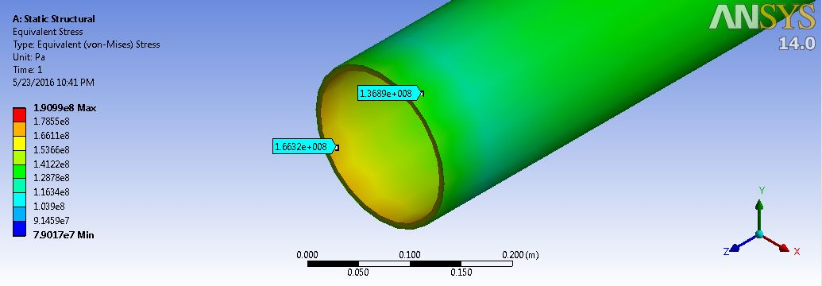

Figure.11.4: Equivalent stress for production pipeline

Figure.11.5: Equivalent strain for production pipeline

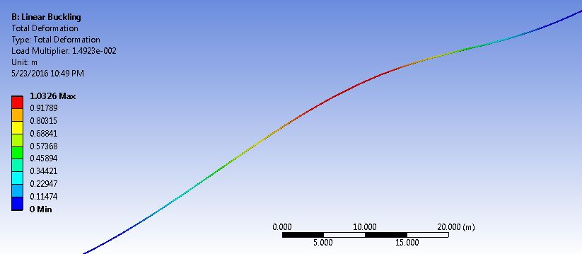

Figure.11.6: Production Pipeline Buckling In ANSYS Configuration

11.4.3. Equivalent stress, strain and buckling for gas pipeline
Figure 8.4 illustrates the equivalent stress in elastic model without concrete coating by using static structure analysis of ANSYS for gas pipeline. The maximum stress is 170 MPa while the minimum stress is 80 MPa. The equivalent strain is illustrated by figure 8.5 which the maximum 9.093e-4 and the minimum strain will be 5.244e-4. Figure 8.6 show the pipeline buckling for production line which is the maximum deformation is 1.0024 m.

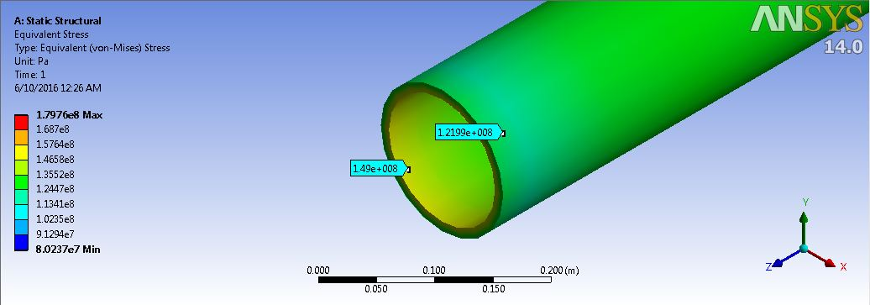

Figure.11.7: Equivalent stress for gas pipeline

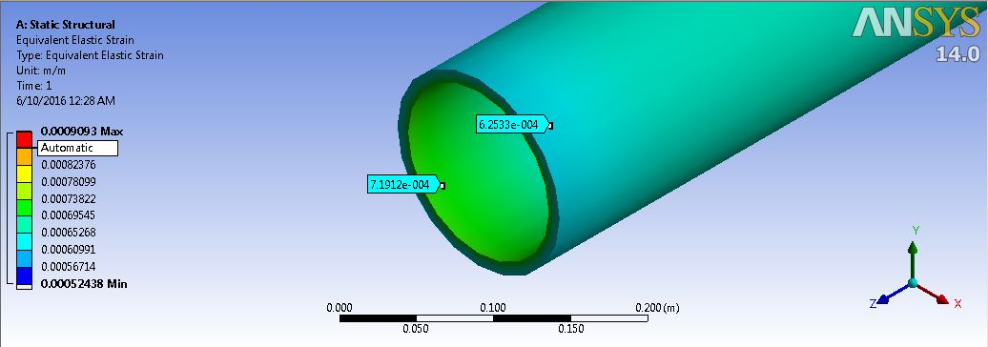

Figure.11.8: Equivalent strain for production pipeline
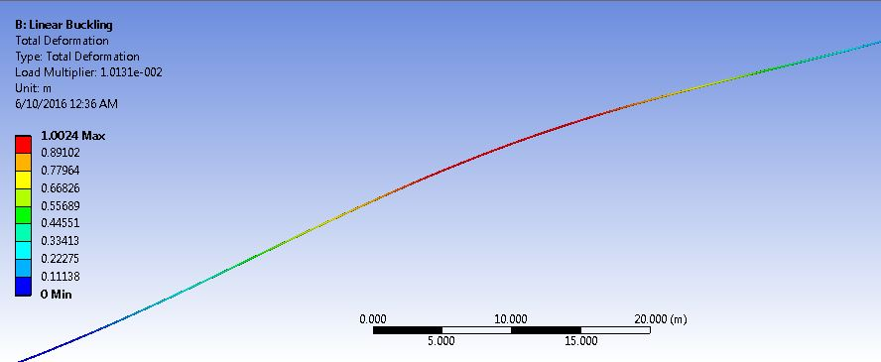

Figure.11.6: Gas Pipeline Buckling In ANSYS Configuration
Figure.11.19: Gas Pipeline Buckling In ANSYS Configuration

References

- Tian Ran Lin, Boyun Guo,, Shanhong Song, Offshore Pipelines - Design, Installation, and Maintenance-,
- Abbas Yeganeh Bakhtiary, Abbas Ghaheri, Reza Valipour, 2007, Analysis of Offshore Pipeline Allowable Free Span Length, International Journal of Civil Engineerng. Vol. 5, No. 1, pp.84-91, March 2007
- Det Norske Veritas (DNV1998): “Guidelines No.14, Free Spanning Pipelines”.
- American Bureau of Shipping, ABS (2001): “Guide for Building and Classing SubSea Pipeline Systems and Riser”.
- A Fathi, J. R. C. (2011). "Effect of Cross sectional Strain Distribution on the Critical Buckling Strain of Energy Pipeline" International Offshore and Polar Engineering Conference.
- A. Dugstad, L. Lunde, K. Videm, Parametric Study of CO₂ Corrosion of Carbon Steel, Corrosion/94, NACE International, paper no.14, Houston, TX, 1994.
- A.A. Kaczmarski, S.E. Lorimer, Emergence of Flow Assurance as a Technical Discipline Specific to Deepwater: Technical Challenges and Integration into Subsea Systems Engineering, OTC 13123, Offshore Technology Conference, Houston, 2001.
- Abdul Khair Junaidi and Jaswar Koto, 2015, Initial Imperfection Design of Subsea Pipeline to ResponseBuckling Load, Journal of Ocean, Mechanical and Aerospace-Science and Engineering, Vol. 15.
- Abdul Khair Junaidi, Jaswar Koto, 2015, Parameters Study of Deep Water Subsea Pipeline Selection,. Jurnal Teknologi.
- Abdul Khair Junaidi, Jaswar, Adi Prayitno,and M.Dalil, 2015, Reliability Of Subsea Pipeline API X70 In Different Water Depth,. Conference on Ocean, Mechanical and Aerospace Scientish and Engineer (ISOMAse).
- Abdul Khair Junaidi, Jaswar, Efi Afrizal, 2013, Subsea Petroleum Pipeline Design In Deep Water, International Conference on Numerical Analysis in Engineering (NAE2013), Pekanbaru, Riau, Indonesia
- Abdul Khair Junaidi, Jaswar, H.A Rashid, 2013, Expansion of Deep Water Subsea Pipeline, The International Conference on Marine safety & Environment (IMSE2013), Johor Bahru, Malaysia
- Abdul Khair, J, Jaswar Koto, Affis Effendi, Ahmad Fitriadhy, 2014, Buckling Criteria for Subsea Pipeline, Jurnal Teknologi.
- Amitabh Kumar, B. M. M. (Texas May 2009). "Global Buckling and Axial Stability for HPHT." Offshore Technology Conference (OTC) 20126.
- Andre C. Nogueira, I. a. G. E. H. (2011). "Collapse Due to Bending and External Pressure per RP 1111 Fourth Edition." Offshore Technology Conference (OTC).
- Andrew Palmer, et al. (1996). ” Lateral Buckling Of Subsea Pipelines: Comparison Between Design and Operation”. Division of SAIC Limited 13 Bon Accord Square Aberdeen AB 11, 6DJ, United Kingdom.
- Andrew Palmer, U. E. D., Cambridge, England (Houston, 1998). "A Radical Alternative Approach to Design And Construction Of Pipelines In Deep Water." Offshore Technology Conference (OTC)-8670.
- Angus Mather, Offshore Engineering -An Introduction-, Witherby & Company Limited, 1995
- API-5L (2000), “Specification for Line Pipe”, 42nd Edition, American Petroleum Institute.
- Bai, Y, 2001, Pipelines and Risers, Elsevier
- Bai, Y. and Q. Bai (2010). ‘’Subsea Engineering Handbook.’’ USA, ELSEVIER.
- Bakhtiary, A. Y., A. Ghaheri, et al. (2007). "Analysis of Offshore Pipeline Allowable Free Span Length." International Journal Of Civil Engineering
- Ballard, R. J. a. J. C. (Houston, USA May 2011.). "Axial pipe soil interaction a suggested frame work." Offshore Technology Conference (OTC) 22010.
- Bordieri, E., Barbosa V. C., Dias, R. (2008). An Overview of the Roncador Field Development, a Case in Petrobras Deep Water Production, Offshore Technology Conference, 5-8 May, Houston, Texas, USA
- C. de Waard, U. Lotz, D.E. Milliams, Predictive Model for CO₂ Corrosion Engi-neering in Wet Natural Gas Pipelines, Corrosion vol. 47 (no12) (1991), pp. 976–985.
- Collberg, O. F. a. L. (2005). "Influence of Pressure in Pipeline Design – Effective Axial Force." 24th International Conference on Offshore Mechanics and Arctic Engineering (OMAE 2005).
- D.A. Jones, Principles and Prevention of Corrosion, first ed.). McMillan, New York, 1992, pp. 437-445.
- DeepStar, Flow Assurance Design Guideline, 2001.
- Deepwater Petroleum Exploration and Production, Leffler, W.L., et. al., Penn Well Books, 2003
- Deep-water Solutions & Records for Concept Selection, Offshore Magazine Poster, 2006
- Det Norsk Veritas, Cathodic Protection Design, DNV RP B401, 1993.
- Det Norske Veritas. DNV 2007. Offshore standard DNV-OS-F101: Submarine Pipeline Systems. Hovik, Norway : Det Norske Veritas, DNV.
- DNV, Integrity Management of Submarine Pipeline Systems, October 2009.
- Drinkwater, Pipeline Pigging.
- E.D. Sloan, Hydrate Engineering, Monograph 21, Society of Petroleum Engineers, Richardson, , Texas, 2000.
- E.D. Sunde, Earth Conduction Effects in Transaction Systems, Dover Publishing, New York, 1968, pp. 70–73.
- E.G. Hammerschmidt, Gas Hydrate Formation in Natural Gas Pipelines, Oil & Gas Journal vol. 37 (1939). No. 50.
- Elsayed, T., M. Fahmy, et al. (2012). "A Finite Element Model for Subsea Pipeline Stability and Free Span Screening." Canadian Journal on Mechanical Sciences & Engineering 3(1): 13.
- F.M. Pattee, F. Kopp, Impact of Electrically-Heated Systems on the Operation of Deep Water Subsea Oil Flowlines, OTC 11894, Offshore Technology Conference, Houston, 2000.
- Frazer, D. P. a. I. (USA, 2006). "Mitigation Methods for Deepwater Pipeline Instability Induced by Pressure and Temperature Variations." Offshore Technology Conference (OTC), OTC-17815.
- Fyrileiv, O. and L. Collberg (2005). "Influence of Pressure in Pipeline Design – Effective Axial."24th International Conference on Offshore Mechanics and Arctic Engineering, OMAE2005 (67502): 8.
- Global Deepwater Development Poster by E&P Magazine, 2008
- Guarracino, F., M. Fraldi and A. Giordano (2008). "Analysis of testing methods of pipelines for limit state design." Applied Ocean Research 30(4): 297-304.
- Han S. Ghoi, Hudson Engineering Corporation. (1995). "Expansion Analysis of Offshore Pipelines Close to Restraints." International Offshore and Polar Engineering Conference. (Vol-II)
- Hauch, S. and Y. Bai (1999). "Bending Moment Capacity of Pipes." Offshore Mechanical and Arctic Engineering PL-99(5033).
- Hermann Moshagen, E. G., Sverre Lund and Richard Verley (1998). "New International Standards for Offshore Pipelines." International Offshore and Polar Engineering Conference (May 24-29,1998).
- Hobbs R.E. (1984). "In-Service Buckling of Heated Pipelines”. ASCE Journal of Transportation Engineering, 110(2), 175- 189.
- Indu K. Mahendran, A. M. A.-S., INTEC Engineering Inc.; Charles D. Young, Conoco, Inc.; Carl C. Langner, Shell Development Co (1997). "Limit State Design of Subsea Flowlines for Pressure Containment." Offshore Technology Conference (OTC 8526).
- International Organization for Standardization, Pipeline Cathodic Protection-Part 2: Cathodic Protection of Offshore Pipelines, ISO/TC 67/SC 2 NP 14489, Wash-ington, D.C, 1993.
- J. Chaudhuri, P. L. M. P., Saipem Energy Services and M. Pulici, Saipem S.p.A (Houston-USA 2010). "The MEDGAZ Project Ultra deep water pipeline" Offshore Technology Conference, OTC 20770.
- J. Guijt, A. S. N. S. (Houston USA 1990). "Upheaval Buckling of Offshore Pipelines: Overview and Introduction." Offshore Technology Conference (OTC) 6487.
- J.Koto, 2016, Review on Deep Water Flowlines of Gumusut-Kakap, Malaysia, Journal of Ocean, Mechanical and Aerospace -Science and Engineering-, Vol.33, p.1-8.
- Jaeyoung Lee, P.E, Introduction to Offshore Pipelines and Risers, 2006
- James Wang, R. B. (2010). "An Efficient Global, Local and Solid Finite Element Modeling Approach for Pipeline Expansion Loops" International Offshore and Polar Engineering Conference.
- Jaswar Kotoa, Abd. Khair Junaidi, M. H. Hashim, 2015, Local Buckling in End Expansion of Subsea Pipelines, Jurnal Teknologi.
- Jaswar,Abdul Khair Junaidi, Efi Afrizal, 2013, Effect of Axial Force Concept in Offshore Pipeline Design, , The International Conference on Marine safety & Environment (IMSE2013), Johor Bahru, Malaysia.
- Jim McCaul, “Floating Production Projects: What Now?”, Marine Technology Reporter, Jan/Feb 2009
- Jiong Guan, P. R. N. (2008). "Design Loads Uncertainties Study - Thermal Buckling of Subsea Pipelines." The International Society of Offshore and Polar Engineers (ISOPE).
- José Luis Henríquez Miranda and Luis Alonso Aguirre López, 2011, Piping Design: The Fundamentals, “Short Course on Geothermal Drilling, Resource Development and Power Plants, El Salvador.
- Juan. A.Vera, Medgaz: The New Direct Gas Link between Algeria and Europe via Spain, World Gas Conference, Kuala Lumpur, 2016.
- K. Bethune, W.H. Hartt, A Novel Approach to Cathodic Protection Design for Marine Pipelines: Part II -Applicability of the Slope Parameter Method, presented at Corrosion, paper no.00674, 2000.
- Levold, S. S. a. E. (Norway 1995). "High Temperature Snaking Behaviour of Pipelines." The International Society of Offshore and Polar Engineers (ISOPE).
- Liang Chuan, et al. (2010).”Pipe Stress Engineering”. Houston, USA, ASME Press.
- Liming Liu, T. Z., Xiaonggang Yang (Portugal, July 2007.). "Design of HT Subsea Pipeline against Upheaval Buckling by Pre-heating before Trenched." The International Society of Offshore and Polar Engineers (ISOPE).
- Liu, Y. X. (2011). "Control Method of Subsea Pipeline Lateral Buckling." Applied Mechanics and Materials 71-78: 5030-5033.
- M.N.Junaidi and J.Koto, 2016, Review on Design of Oil Subsea Pipeline in Kikeh Field, Malaysia, Journal of Ocean, Mechanical and Aerospace -Science and Engineering-, Vol.32, p.1-6.
- Maconochie, J. O. a. A. (London, UK 2007). "The Axial Resistance of Buried and Unburied Pipelines." International Offshore Site Investigation and Geotechnics Conference.
- Maddahi, M. (2011). "A review on Offshore Concepts and feasibility study consideration." Society of Petroleum Engineer (SPE).
- Mouselli, A.H, 1981, Offshore Pipeline Design, Analysis and Methods, Penn Well Books
- N.I Thusyantan, S. M., D.J Robert, KW Ltd, J.Wang & S.K.Haigh, (USA 2011). "Upheaval buckling Assessment Based on Pipeline Features." Offshore Technology Conference (OTC) 21802.
- National Association of Corrosion Engineers, Metals for Sulfide Stress Cracking and Stress Corrosion Cracking Resistance in Soul Oilfield Environments, NACE MR 0175 (December 2003).
- Nogueira, A. C. and Mckeehan, D. S. (2005), “Design and Construction of Offshore Pipelines, Chapter 11 in Handbook of Offshore Engineering, S. Chakrabarti (Ed.)”, Elsevier Ltd.
- Norwegian Technology Standards Institution, CO2 Corrosion Rate Calculation Model, NORSOK Standard No. M-506, 2005.
- Nourpanah, N. (2008/2009). Subsea Pipelines, DALHOUSIE UNIVERSITY: 80.
- Novák, P., et al. (2013). "High-Pressure Pipelines Repaired by Steel Sleeve and Epoxy Composition." Applied Mechanics and Materials 486: 181-188.
- Nurul Nabila, Mukminah, Muhammed Amirul Asyraf, Fahd Ezadee, and J.Koto, 2016, Subsea Pipeline Analysis of Nosong-Bongawan Field, Malaysia, Journal of Subsea and Offshore -Science and Engineering-, Vol.6, p.1-8.
- Offshore Pipelines, Guo, Boyun, et. al, Elsevier, 2005
- Olav Fyrileiv, O. A. a. A. V. and N. Det Norske Veritas H0Vik (1996). "Analysis of Expansion Curves for Subsea Pipelines." International Offshore and Polar Engineering Conference.
- Oyeneyin, B. M. (2011). "Challenges of Deepwater Developments." Advanced Materials Research 367: 367-373.
- Palmer, A. C. and M. T. S. Ling (1981). "Movements of Submarine Pipelines Close to Platforms." Offshore Technology Conference (OTC 4067): 8.
- Palmer, A. C. and R. A. King (2008). Subsea Pipeline Engineering, Pennwell Corporation.
- Palmer, A.C. and Baldry, J.A.S., “In-Service Buckling of Heated Pipelines”, Journal of Petroleum Technology, pp. 1283-1284, November 1974.
- Petroleum Production Systems, Economides, Michael, et. al., Prentice Hall Petroleum Engineering Series
- Qiang Bai, X. Q. a. M. B. (Texas USA 2009). "Global Buckle Control with Dual Sleepers in HP/HT Pipelines,." International Offshore and Polar Engineering Conference, OTC 19888.
- R. Nyborg, Controlling Internal Corrosion in Oil and Gas Pipelines, Oil and Gas Review, Section Head, Multiphase Corrosion, Institute for Energy Technology (IFE) (Issue 2) (2005).
- Ragnar T Igland and Svein Sævik, Y. B., J P Kenny, Stig Berge, Leif Collberg, Koji Gotoh, Philippe Mainçon, Christian Thaulow (Houston,2000). "Deepwater Pipelines and Flowlines." Offshore Technology Conference OTC 12187.
- S. Mebarkia, Chevron. (2006). "Effect of High-Pressure/High-Temperature Flowlines and Soil Interaction on Deepwater Subsea Development." Offshore Technology Conference.
- S.E. Lorimer, B.T. Ellison, Design Guidelines for Subsea Oil Systems, presented at Facilities 2000: Facilities Engineering into the Next Millennium, (2000).
- Shao, B., X. Yan, et al. (2011). "Reliability Analysis of Locally Thinned Submarine Pipelines in Cheng Dao Oil Field." Applied Mechanics and Materials Vols. 94-96, pp.1527-1530.
- Subsea Pipeline Engineering (SPE), Hydrate/Wax/Asphalt In Subsea Pipeline.
- Susanne Höhler, S. Z. (Beijing, China, June, 2010). "Analytical Approach of Limit State Assessment for Multi-Axially loaded UOE Line Pipe." The International Society of Offshore and Polar Engineers (ISOPE).
- SUT (Society for Underwater Technology) Subsea Tieback (SSTB) Workshop, Galveston, Texas, 2007
- Thimosenko,S.P and Gere,J.M (1961) Theory of Elastic Stability. McGraw-Hill, NY.
- Tran, N. T. V. (1996). "Experimental and Theoretical Studies in Subsea Pipeline Buckling." Elsevier Science Limited. www.slp-eng.com
- W.H. Hartt, X. Zhang, W. Chu, Issues Associated with Expiration of Galvanic Anodes on Marine Structures, Paper 04093, Corrosion (2004).
- Wikipedia, Hydraulically activated pipeline pigging
- www.corrosion-doctors.org/Inhibitors/lesson11.htm.
- Yan, Y. F. (2011). "Axial Load on the Submarine Pipeline Suspended Law of Vortex Induced Vibration." Applied Mechanics and Materials 94-96: 1511-1514.
- Yong Bai, Qiang Bai, Subsea Engineering Handbook, 2010, Elsevier.

Appendixes

A. CALCULATION

1. Structure of Pipe

Inside diameter
$D_{i}=D-2t$ = 0.6096-(2*0.0229)
= 0.5638 m

Radius of Pipe
R = 0.5D = 0.5 x 0.6096
= 0.3048 m

Ratio
D/t = 0.6096/0.0229
= 26.62

Moment of Inertia
$I=\frac{π\left(D^{4}-D_{i}^{4}\right)}{64}$ = (3.14*(0.6096^4-0.5638^4)/64)
= 0.0018179609347 m⁴

Section of Modulus
$Z=I/y=\frac{π\left(D^{4}-D_{i}^{4}\right)}{32D}$ - y = D/2
= (3.14*(0.6096^4-0.5638 ^4))/(32*0.6096)
= 0.005964438762 m³

Cross sectional Area of Pipe
$A_{s}=\frac{π\left(D^{2}-D_{i}^{2}\right)}{4}$ = (3.14*(0.6096^2-0.5638 ^2)/4)
= 0.0421872502 m²

Internal of cross sectional Area
$A_{i}=\frac{π\left(D_{i}^{2}\right)}{4}$ = (3.14*(0.5638)^2)/4
= 0.2495282954 m²

2. Weight of Pipe

Weight of steel pipe
$W_{st}=π.ρ_{st}.g\left(D-t\right)t$ = 3.14*7850*9.8*($0.6096$-0.0229)* 0.0229
= 3245.5 N/m

Weight of content
$W_{ρw}=\frac{π.ρ_{cn}.gD_{i}^{2}}{4}$ = (3.14*0.668*9.8*0.5638^2)/4
= 1.6 N/m

Buoyancy
$B=\frac{π.ρ_{w}.g.D_{cn}^{2}}{4}$ = (3.14*1027*9.8*$0.6096$^2)/4
= 2936 N/m

Submerge weight
$W_{sub}=W_{st}+W_{ρw}-B$
= 3245.5+1.6 – 2936
= 311.1 N/m

3. Design Pressure and Burst Pressure

$P_{t} ≤f_{d}.f_{e}.f_{t}.P_{b}$
$P_{d} ≤0.80P_{t}$
$P_{a} ≤0.90P_{t}$
$f_{d}$= internal pressure burst design factor 0.90 for pipeline and 0.75 for riser
$f_{e}$= weld joint factor 1.00 refer to ASME B31.4 for X80
$f_{t}$= Temperature derating factor, 1.0 for temp less than 121⁰C
$P_{b}$=Specified Minimum Burst Pressure
$P_{d}$=Pipeline Design pressure
$P_{t}$= Hydrostatic test pressure
$$P_{b}=0.90\left(SMYS+SMTS\right)(\frac{t}{D-t})$$
= 0.90*(482000000 + 565000000)*(0.0229/(0.6096-0.0229))
= 36.7 MPa

Substituting the pressure test:
$P_{d}=≤0.80f_{d}f_{e}f_{t}P_{b}$
$P_{d}=≤0.80f_{d}f_{e}f_{t}0.90\left(SMYS+SMTS\right)(\frac{t}{D-t})$
$≤$0.80*0.90*1*1*0.90*(482000000 + 565000000)*(0.0229/(0.6096-0.0229))
= 26481408.556332026 Pa = 26.5 MPa

4. Collapse Pressure

$P_{y}=2SMYS\left(\frac{t}{D}\right)$ = 2*482*(0.0229/0.6096)
= 36.2 MPa
$P_{e}=2E\frac{{\left(\frac{t}{D}\right)}^{3}}{\left(1-v^{2}\right)}$ = 2*207000*(0.0229/0.6096)^3/(1-0.3^2)
= 24.1 MPa

$P_{c}=\frac{P_{y}P_{e}}{\sqrt{P_{y}^{2}+P_{e}^{2}}}$ = (36.2*24.1)/((36.2)^2+(24.1)^2))^0.5
= 20 MPa

Table C.2 Wall thickness versus pressure
Wall Thickness Selection (mm) | Burst Pressure (MPa) | Design Pressure  (MPa) | Collapse Pressure  (MPa)
5 | 7.8 | 5.6 | 0.25
10 | 15.7 | 11.3 | 1.99
15 | 23.8 | 17.1 | 6.51
20 | 31.96 | 23 | 14.3
25 | 40.3 | 29 | 24.6
30 | 48.77 | 35.1 | 35.7
35 | 57.4 | 41.3 | 46.55
40 | 66.2 | 47.6 | 56.75

6. Pipeline Stress

Hoop stress
$σ_{h}={(P}_{i}-P_{e})\frac{D-t}{2t}$
= (22000000-3500000)*(0.6096- 0.0229)/(2*0.0229)
= 236985807.86 Pa

Longitudinal Stress
$σ_{L}=P\frac{D_{o}}{4t}$
= 22000000*0.6096/(4*0.229)
= 14641048.03 Pa

Equivalent stress
$σ_{e}=\sqrt{σ_{h}^{2}+σ_{l}^{2}-σ_{h}.σ_{l}}$
= ((236985807.86)^2+(14641048.03)^2-(236985807.86)*
(14641048.03))^0.5
= 230015027.38 Pa

Thermal stress
$σ_{t}=Eα∆T$
= (1.17*10^-5*207*10^9*(60-15))
= 108985500 Pa

4. Pressure and Temperature Forces

Force due to temperature change;
$F_{t}= α.E.A_{s}.∆T$
= (1.17*10^-5*207*10^9*0.0421872502 *(60-15))
= 4597798.56 N

Force due to pressure change;
$F_{p}=P.A_{i}$
= 22000000*0.2495282954
= 5489622.499 N

Force due to Poisson contraction;
$F_{v}=-v.A_{s}.σ_{h}$
= (-0.3)* 0.0421872502 *236985807.86
= -2999333.87 N

Anchor Length;
$L_{a}=\frac{1}{μW_{s}}(αEA_{s}∆T+PA_{i}-vA_{s}σ_{h})$
= (1/(0.5*311.1))*( 4597798.56 + 5489622.499 -2999333.87)
= 45567 m

Force due to soil friction resistance;
$F_{f}=\int_{0}^{x}{μ.W_{s}.dx=μ.W_{s}.L_{a}}$
= 0.5* 311.1*45567
= 7087946.8 N

5. Stability of Pipeline

Allowable external pressure of subsea pipeline :
$P_{allow}=\frac{2E}{3\left(1-v^{2}\right)}{\left(t/D\right)}^{3}$ = (((2*207*10^9)/(3*(1-0.09))*(0.0229/0.6096)^3)
= 8039133.97 Pa =8.04 MPa

The allowable compressive stress :
$S_{allowable}=\frac{0.125}{2}E\left(t/R\right)$ = (0.125/2)*207*10^9*(0.0229/0.3048) = 972010334.6 Pa

7. Equilibrium of the forces:

${F_{f}=F}_{t}+F_{p}+F_{v}$
= 4597798.56 + 5489622.499 -2999333.87
= 7088087.19 N

8. Design Initial Imperfection

Minimum Buckle Length
$L={\left[\frac{1.6856×{10}^{6}{\left(EI\right)}^{3}}{w^{2}A_{s}E}\right]}^{0.125}$
= ((1.6856*10^6)*((207*10^9) * (0.0018179609347))^3/((311.1)^2*0.0421872502*207*10^9))^0.125
= 86519989.07912156m

Axial Load within the buckle
$P=80.76\frac{EI}{L^{2}}$
= (80.76*207*10^9*0.0018179609347)/( 134.4)^2
= 1682490.7 N

Axial Load away from the buckle
$P_{0}=P+\frac{wL}{EI}{\left[1.597×{10}^{-5}EAϕwL^{5}-0.25{\left(ϕEI\right)}^{2}\right]}^{1/2}$
= (1682490.7 + (((311.1*134.4) / (207*10^9*0.0018179609347))*((1.597*10^5*207*10^9*0.0421872502*0.5*311.1*134.4^5)-(0.25)*(0.5*207*10^9*0.0018179609347)^2)^0.5)
= 1790354.6 N

The Maximum amplitude of buckle
$y=2.408×{10}^{-3}\frac{{wL}^{4}}{EI}$ = 2.408*10^-3*((311.1*134.4^4)/
(207*10^9*0.0018179609347)
= 0.649 = 0.65 m

The maximum bending moment
$M=0.06938wL^{2}$ =0.06938*311.1*134.4^2
= 389881.7 Nm

The size of the slipping length adjacent to the buckle
$L_{s}=\frac{P_{0}-P}{ϕw}-0.5L$
= ((1790354.6 - 1682490.7)/(0.5*311.1))-(0.5*134.4)
= 626 m

134.4 m
0.65 m
$$L_{s}$$
$$L_{s}$$
Figure.A.1: Buckle Configuration

Autobiographies

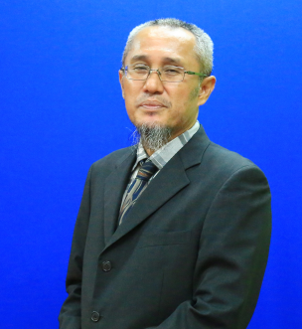 | Jaswar Koto was born on October, 1970. He is a descendant of the Prophet Rasullullah S.A.W through Husein R.A. He is a president of Ocean and Aerospace Research Institute, Indonesia and Professor on offshore engineering. He is also president of International Society of Ocean, Mechanical & Aerospace for scientist and engineers.
He has been invited as a Visiting Professor more than 16 times, received several international awards and supervised PhD, Master and Bachelor Students.
He received his bachelor degree in 1994 from Institut Teknologi Sepuluh Nopember (ITS), Indonesia, further studies on marine in Curtin University of Technology and business in Notre Dame University. In 2003, he has completed his PhD and also received “Excellence Academic Award” for doctor degree in engineering form Aerospace and Marine Engineering, Osaka Prefecture University, Japan.
He has started his researches since 1994 on structure analysis of fluid flow in subsea pipelines, subsea pipeline corrosion due to Carbon Monoxide, design and hydrodynamic analysis of AUV in Australia. Then, he joined Research and Development Institute, Sumitomo Heavy Industries -Marine Engineering-, Japan. In 2005, he joined ExxonMobil LNG Engineering Plan for Middle East projects. Since 2010, he has a contract with Department of Aeronautical, Automotive, and Ocean Engineering, Faculty of Mechanical Engineering. He also appointed as head of High Performance Computing, CICT, Universiti Teknologi Malaysia.

 | Abdul Khair Junaidi was born on September, 1973. He is a senior researcher at Ocean and Aerospace Research Institute, Indonesia. He received his bachelor degree in 2010 from Institute of Technology Pekanbaru, Riau, Indonesia. In 2016 he has completed his Master of Philosophy form Department of Aeronautical, Automotive and Ocean Engineering, Faculty of Mechanical Engineering, Universiti Teknologi Malaysia.
In 2011, he jointed PT Transportasi Gas Indonesia (TGI) for pipeline repair and maintenance.

