Compensated Moment of Electric Vehicle use Electronic Stability Control

Bagus Yunanto,^{a,*}Charis Faridchie Siswoyo^{b}and Era Purwanto,ª
^{a)}Electronic Engineering, Electronic Engineering Polytechnic institute of Surabaya, Indonesia
^{b)}Mechatronic Engineering, Electronic Engineering Polytechnic institute of Surabaya, Indonesia

*Corresponding author: bagusyunanto@gmail.com

Paper History

Received : xxxxx
Received in revised form: xxxxx
Accepted : xxxxxxx

ABSTRACT

This research is reporting a skid adjustment method of an electric vehicle passenger car model by using active brake force control to improve vehicle stability in various driving condition. The presence of skid is determined by comparing the tires rotational speed and the free-rolling speed. The discrepancy of the measured velocities between these sensors indicates the presence of skidding. Further, a two wheels front steering model is used in this work. When the model performing a turning motion, the measured yaw rates Obtained from speed sensors and steering angle sensor can also be used and compared to observe the skidding that indicates either understeer or oversteer. Ackerman calculation is used to investigate the motion of the model. Compensated moment method is used for braking system during the test, such as accelerating, braking, turning and straight cruising. The control system for either simulation or operation test was performed using fuzzy logic controller. The results then were compared and analyzed to show the capability of the controller method to improve the performance of the vehicle model.

KEY WORDS: ESC, yaw, electric vehicle, moment, skid

NOMENCLATURE
EV Electric Vehicle
ESC Electronic Stability Control
$M$ Vehicle moment
$a$ Acceleration [m/sec²]
$m$ Vehicle mass [kg]
$g$ Gravity acceleration [m/sec²]
$V$ Vehicle speed [km/hr]
$V_{o}$ Start Vehicle speed [km/hr]
$R_{i}$ Ackerman / ideal turn radius [m]
$δ_{f}$ Angle steer front wheel [rad.]
$β$ Side-slip angle [rad.]
$α_{f}$ Slip angle front wheel [rad]
$α_{r}$ Slip angle rear wheel [rad]
$F_{B}$ Braking force [N]
$F_{c}$ Centrifugal force[N]
$F_{yc}$ Cornering force[N]
$F_{L}$ All lateral force [N]
$W$ Vehicle weigh [N]
$F_{z}$ Normal force[N]
$μ$ Friction wheel longitudinal
$μ_{c}$ Friction Wheel lateral
$ω_{ack}$ Yaw rate Ackerman [rad/sec]
$ω_{resp}$ Yaw rate response [rad/sec]

1.0 INTRODUCTION
In a passenger car, the safety of the passenger is the main priority. From the engineering perspective, the passenger’s safety is closely related to the vehicle stability by ensuring the ability to maneuver under extreme drive conditions such as sudden braking, high acceleration, sudden turning to avoid obstacles and high speed turning [1]. The extreme driving gives rise to unstable vehicle conditions which are very dangerous. The vehicle stability might be attained back by compensating the forces and moments which brought the vehicle to unstable through wheel traction and braking controls [2]. Figure 1 shows various vehicle slip conditions due to lacking of stability system during high-speed maneuver.

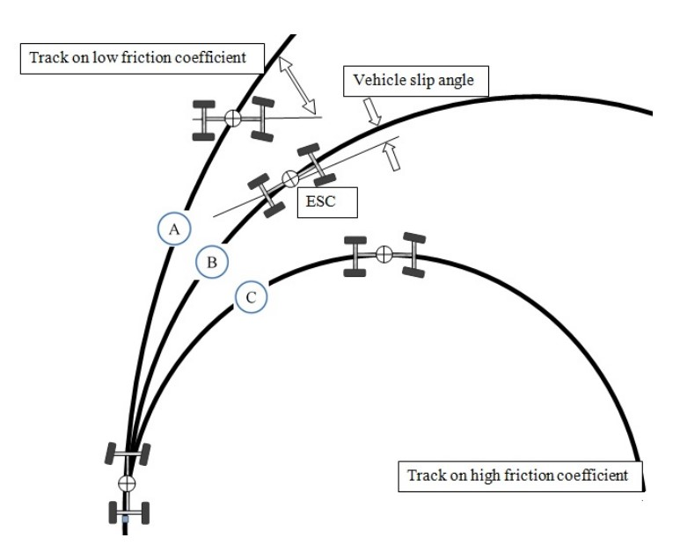

Figure 1. Vehicle Slip Condition

Wheel slip arises when a particular wheel fails to withstand forces larger than its friction force between the wheel and road surfaces. Under this condition, the vehicle is difficult to be controlled by an ordinary driver and it can be considered that the vehicle is losing its stability. This vehicle slip may include events of over steer or under steer that could jeopardize the safety of the passengers.

Electronic stability control (ESC) technology has been applied to fuel combustion passenger car. Application of the technology was done by the leading automobiles manufacturers such as BMW, Mercedes, Volvo and etc. The technology had already applied in developed countries that all cars have to have an ESC installed to reduce the road car accidents [3]. Regulation of ESC technology application in Europe had been done since 2014 for all cars including the latest production cars [3].

ESC includes sensors such as wheel speed sensor, yaw rate sensor, a lateral acceleration sensor, and steering wheel sensor to identify the dynamics of the vehicle maneuver conditions [1]. ESC has different modes of yaw stability control and roll stability control. In this study, yaw stability control mode is discussed. In yaw stability control mode, the ESC calculates [2]:

- The heading vehicle using steering angle sensor and vehicle speed sensor.
- The current path radius using lateral acceleration sensor and vehicle speed.
- The correct yaw rate of the vehicle traveling on the path by calculating the path radius and measuring vehicle speed using onboard yaw rate sensor.

Generally, in an ESC system, a microcontroller based system does the ESC calculations and estimates the intended heading and ideal motion then compares them with the actual motion [4]. If the difference between the measured yaw rate and calculated yaw rate exceeds the threshold value then the ESC system sends control signals to its respective actuators to apply corrective forces on the vehicle. There are number of different techniques for correcting the vehicle motion. ESC in the conventional vehicles with single electric motor and insufficiently existing resources cannot perform the corrective force adequately. So, some additional sensors and actuators are introduced to support the proposed ESC technique. Providing the expected longitudinal response in accordance with the driver needs is another key point to focus on for ESC. In this research different types of ESC are briefly discussed and analyzed to find the most suitable type of ESC Fitted Electric Vehicle. In this research, the proposed ESC is equipped with ABS and Fuzzy Logic Controllers (FLC). The FLC is used to set the suitable braking force from ABS to each wheel when the vehicle accelerates and turns.

2.0 VEHICLE DYNAMIC

Though different methods of finding wheel torque are adopted in different research for ESC, the vehicle model is similar in most of the research works. The difference can be seen in the degree of freedom of the vehicle model. The vehicle model is required for the simulation to observe the responses of the vehicle slip conditions. This vehicle body model can then be used as a plant vehicle. In other research work a vehicle model is employed for a four-wheel-drive electric vehicle with the equation of motion of vehicle dynamics [1]. Some equations of motion when the vehicle having plane motion are given follows:

$mV\left(β+γ\right)=\sum{F_{y}=F_{yfr}+F_{yfl}+F_{yrr}+F_{yrl}}$ (1)

$I_{z}γ=\sum{M_{z}=\left(F_{yfr}+F_{yfl}\right)L_{f}-{(F}_{yrr}+F_{yrl})L_{r}+M}$ (2)

$MV=\sum{F_{x}=F_{xfr}+F_{xfl}+F_{xrr}+F_{xrl}}$ (3)

Where, $V$ is longitudinal velocity of the vehicle, $β$ and $γ$ denote side slip and yaw rate.

$M={\frac{ω}{2}l(F}_{xfr}+F_{xfl}+F_{xrr}+F_{xrl})$ (4)

2.1 Turning Vehicle Dynamic
Turning on vehicle will highly depend on vehicle maneuver conditions, which must be response fast by the Electronic Control Unit (ECU). If the ECU detects over steer condition, the vehicle will apply braking force to the rear right wheel accordingly. Alternately, if the ECU detects under steer condition, the vehicle will also apply braking force to the rear left wheel accordingly. But, if the ECU detects the turning condition, the vehicle will apply suitable amount of braking forces for all wheels accordingly [1,2]. Figure 2 shows the vehicle condition while turning.
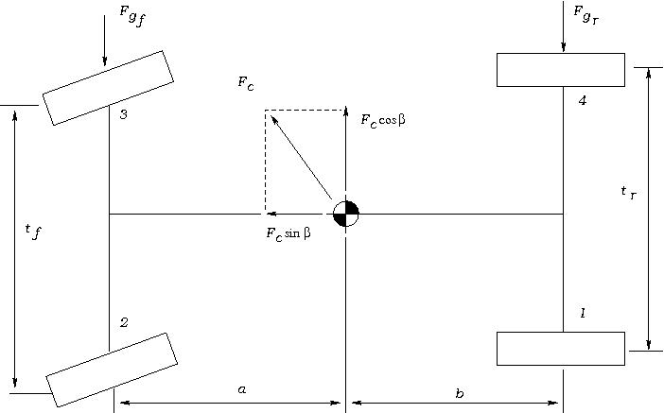

Figure 2. Force and Moment on Vehicle when turning

Analysis of normal force on each wheel on sloping and incline road conditions can be formulated as follows:

- Front Left Wheel
$F_{zf(2)}= \frac{l_{r}}{2L}\left[\left(\frac{W∙Cosθ+(F_{Cg}cosβ∙Sinθ)}{2}\right)-\frac{l_{r}}{L}\left(\frac{{(F}_{c}cosβsinθ+F_{s})∙h+M_{Ra}}{t_{f}}\right)\right]+\frac{H_{t}∙\left(F_{c}sinβ+w cosψ-F_{D}\right)-M_{Pa}}{2L}$ (5)
- Rear Left Wheel
$F_{zr(3)}= \frac{l_{r}}{2L}\left[\left(\frac{W∙Cosθ+(F_{Cg}cosβ∙Sinθ)}{2}\right)-\frac{l_{r}}{L}\left(\frac{{(F}_{c}cosβsinθ+F_{s})∙h+M_{Ra}}{t_{f}}\right)\right]+\frac{H_{t}∙\left(F_{c}sinβ+w cosψ-F_{D}\right)-M_{Pa}}{2L}$ (6)

- Front Right Wheel
$F_{zf(1)}= \frac{l_{r}}{2L}\left[\left(\frac{W∙Cosθ+(F_{Cg}cosβ∙Sinθ)}{2}\right)-\frac{l_{r}}{L}\left(\frac{{(F}_{c}cosβsinθ+F_{s})∙h+M_{Ra}}{t_{f}}\right)\right]+\frac{H_{t}∙\left(F_{c}sinβ+w cosψ-F_{D}\right)-M_{Pa}}{2L}$ (7)

- Rear Right Wheel
$F_{zr(4)}= \frac{l_{r}}{2L}\left[\left(\frac{W∙Cosθ+(F_{Cg}cosβ∙Sinθ)}{2}\right)-\frac{l_{r}}{L}\left(\frac{{(F}_{c}cosβsinθ+F_{s})∙h+M_{Ra}}{t_{f}}\right)\right]+\frac{H_{t}∙\left(F_{c}sinβ+w cosψ-F_{D}\right)-M_{Pa}}{2L}$ (8)

2.2 Force Braking
According to the national high traffic safety administration, Force braking is the emergency condition braking system caused the vehicle to stop. The braking force on each wheel can be shown as follows:
$F_{Bi}=\frac{M_{b}-I_{i}α_{i}}{4r}$ (9)
- Straight – down
$F_{res}= \frac{W_{a}}{g}$
$=F_{B}+f_{r}∙W cosψ+R_{a} ±Wsinψ+R_{r}$ (10)
- Turning – down
$F_{res}= \frac{W_{a}}{g}$
$=F_{B}+f_{r}∙W cosψ+R_{a} ±Wsinψ+R_{r}+ F_{c}sinβ$ (11)
where,
$F_{b}= \sum{F_{Bi}}$ (12)
Force $F_{Bi}$ works on tires contact with the opposite direction of (Fx) and has magnitude as$(F_{Bi})={(F}_{x})$. Maximum allowable braking force occurs in adhesive maximum limit tire-road tires on the structure when slip angle of 40$°$ and the percentage of skid 20% on the normal force, resulting in the maximum Automatic Braking System(ABS) braking can be formulated for each tire [6-7]. The proportion of Automatic Braking System(ABS) braking for each tire is the ratio between the maximum brake force of the tire to the total braking force of all wheels,
$F_{B_{i}max}= μ_{x max}∙F_{z(i)}$
$=F_{x max}$ (13)
The proportion of Automatic Braking System(ABS) braking of each tire is the ratio between the maximum brake force of the tire to the total braking force of all wheels:
$K_{Bi}=\frac{F_{Bi max}}{{\sum{F_{Bi max}}}_{}}$ (14)
where,
$\sum{F_{Bi max}}=F_{B max}$ (15)

2.3 Setting Force Braking by ABS
Critical deceleration during braking which resulted in longitudinal skid obtained as follow:
- Straight /down
$F_{B}= \frac{W_{}∙a}{g}-f_{r}∙W cosψ+R_{a} ±Wsinψ-R_{r}$ (16)

- Turning /down
$F_{B}= \frac{W_{}∙a}{g}-f_{r}∙W cosψ+R_{a} ±Wsinψ-R_{r}-F_{c}\sin{β}$ (17)

From equations 16 & 17 by eliminating Ra and Rr, resulting in a critical deceleration rate each tire is used as setting deceleration:
- Straight /down
${\left[\frac{a_{max}}{g}\right]}_{i}=\frac{μ_{x max}F_{z(i)}}{K_{Bi}}+f_{r}cosψ±sinψ$ (18)
- Turning/down
${\left[\frac{a_{max}}{g}\right]}_{i}=\frac{μ_{x max}F_{z(i)}}{K_{Bi}}+f_{r}cosψ±sinψ+\frac{f_{c} sinβ}{W}$ (19)

In this way we can determine the order of occurrence of lock tendencies (resulting in longitudinal skid above 20%) on all four wheels, small deceleration rate goes first lock on $μ_{x max}$. ABS controls the proportion of braking of each wheel according to its deceleration rate [7].

2.4 Centrifugal Force and Wheel Slip Angle
Centrifugal force is divided into the front and rear wheels lead to slip angle as follows:
- Front wheel
$F_{yαf}=\frac{W∙V^{2}b}{g∙R_{act}∙L}$ (20)
- Rear wheel
$F_{yαf}=\frac{W∙V^{2}a}{g∙R_{act}∙L}$ (21)
Where,
$L=(a+b)$
$R_{act}=\frac{L}{δ_{f}{+α}_{f}{-α}_{r}}$
Distribution of static condition weight on front wheel and rear wheel [9],
$W_{f}=\frac{W∙b}{L}$ (22)
$W_{r}=\frac{W∙a}{L}$ (23)
Then,
$F_{yαf}=\frac{W_{f}∙V^{2}}{g∙R_{act}}$ (24)
$F_{yαf}=\frac{W_{r}∙V^{2}}{g∙R_{act}}$ (25)
Slip angle at front wheel and rear wheel,
$α_{f}=\frac{F_{yαf}}{C_{αf}}$
$= \frac{W_{f}∙V^{2}a}{g∙R_{act}∙C_{αf}}$ (26)
$α_{r}=\frac{F_{yαr}}{C_{αr}}$
$= \frac{W_{r}∙V^{2}a}{g∙R_{act}∙C_{αr}}$ (27)
when,
$\frac{W_{f}}{C_{αf}}-\frac{W_{r}}{C_{αr}}=K_{us}$ (28)
so,
$α_{f}-α_{r}=K_{us}∙\frac{V^{2}}{g∙R_{act}}$ (29)

2.5 Characteristics of Adhesion between Road and Tire
The friction force is caused by the slip that occurs between the drive wheel and the road surface. During the acceleration causing the slip (λ) on the wheels [9], it is formulated by the following equation:
$λ=\frac{r∙ω-V}{V}$ (30)
where,
V = Vehicle speed (km/h)
r = Radius(m)
$ω$ = Angle wheel speed (rad/s)
In the seventies, some researchers including Easton, Moore, Taborek [8] proposed a concept of tire and road contacts that altered an existing braking and concerning effort concept. The principle of the ABS system concept is to keep the wheel slip (λ) as expected (desired range), so that the optimum braking condition is obtained.

2.6 Yaw rate
The yawing rate is the moment of inertia to the axis Z arises at the center of mass. The yaw rate can be distinguished either by steady state yaw rate or dynamic yaw rate condition. In a condition where the moment of inertia of the vehicle is absent, the turn state by assuming angle parameter of steer (δ), turning radius (R) and vehicle velocity (V) constant [9]. Steady-state yaw rate determination for 2WS vehicle used standard Ackerman:
$ωa=\frac{V^{2}∙δ_{f}}{l_{r}+l_{f}}$ (31)
Given the effect of the slip angle to yaw rate, actual gain becomes,
$ω_{act}=\frac{V^{2}∙R_{n}}{l_{r}+l_{f}}$
$=ω_{a}+\frac{V^{2}∙(α_{f}+α_{r})}{l_{r}+l_{f}}$ (32)
From the above equation, it can be seen that it affects the turning properties of Kus (turn coefficient).If the Kus<0 the vehicle will be over steer, and if Kus>0 it will be under steer whilst if Kus=0 it will be normal. So, to make neutral turn the respective controller should be performed such that$α_{f}$ and $α_{r}$ can have the same value. This is done by reducing the proportion of the application of braking forces to control the slip percentage (λ).Yaw rate condition using for detect vehicle when turning, it can detect under steer and over steer. This is the actual heading for vehicle.

2.7 Dynamic Condition
Yaw rate dynamic occurs due to the acceleration of yaw steady in the form of acceleration yawing, due to changes in input angle steer (δ). The actual yawing of the vehicle dynamic conditions is formulated as follows,
$ω_{dyn}=ω_{act}a+{\dot{ω}}_{tor}∙t$ (33)

Acceleration of yawing under steady state
${\dot{ω}}_{act}=\frac{{∂ω}_{act}}{∂t}$
$={\dot{ω}}_{a}+\frac{∂}{∂t}\left(\frac{V^{2}∙(α_{f}-α_{r})}{l_{r}+l_{f}}\right)$ (34)
The yawing acceleration occurring as a result of the skidding motion is shown as
$ω_{skid}=\frac{A_{r}+A_{f}}{l_{r}+l_{f}}$ (35)
where,
$A_{f}=A_{y1}+A_{y4}$
$A_{r}=A_{y2}+A_{y3}$
with,
$A_{y1}={\dot{V}}_{y}+l_{r}\ddot{θ}+0.05∙t_{f}∙{\dot{θ}}^{2}$
$A_{y2}={\dot{V}}_{y}+l_{r}\ddot{θ}+0.05∙t_{f}∙{\dot{θ}}^{2}$
$A_{y3}={\dot{V}}_{y}+l_{r}\ddot{θ}+0.05∙t_{f}∙{\dot{θ}}^{2}$
$A_{y4}={\dot{V}}_{y}+l_{r}\ddot{θ}+0.05∙t_{f}∙{\dot{θ}}^{2}$ (36)
direction to turn according to Ackerman then,
${\dot{ω}}_{tot}={\dot{ω}}_{ack}$ (37)

3.0 ALGORITHM
The calculation method used is quasi-dynamic quantification method where the dynamic condition of the vehicle is analyzed partly as if in a static condition and then used the simulator to get the simulation result with high time increment resolution/density with numerical calculation effort mostly done by computer. The calculation algorithm is shown in Figure 3. Model for this vehicle is implemented using Simulink Matlab. The first input parameter for Ackerman condition, Force moment, inertia moment, and tire moment, then the skid analysis can be performed using Fuzzy Logic in Simulink Matlab[11]. Next step is to do analysis on vehicle motion with skid and to obtain real vehicle motion.

3.1 Calculation algorithm
The results of this simulation are still limited in numerical form and plot diagrams, but not in graphical forms

3.2 Brake force controller
Brake force FB for each wheel is adjusted by considering the slip requirement, which is obtained from Fuzzy Logic Controller output. So Active Brake Force Control is obtained by altering the slip set point dynamically based on Yaw Rate Real Response ratio of the vehicle with Yaw Rate Neutral. Figure 4 explains how the Brake Force Controller works.
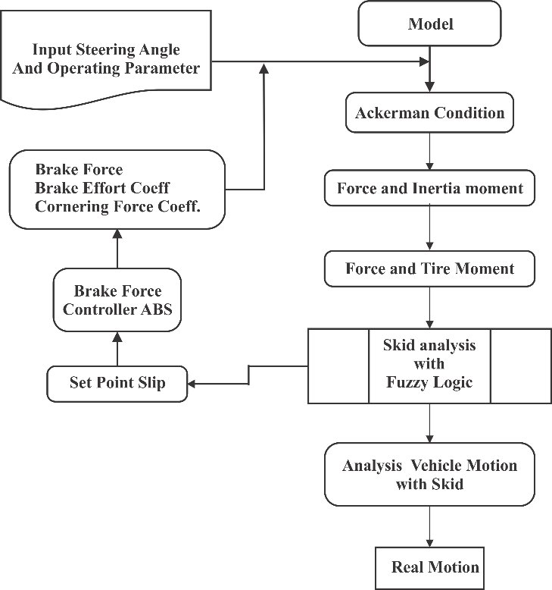

Figure 3. Flowchart Calculation Algorithm

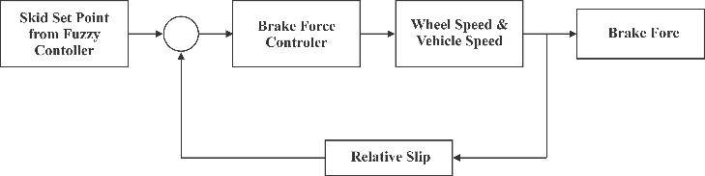

Figure 4. Brake force Controller

3.3 Fuzzy Logic Controller for ESC
By using Mamdani method on Fuzzy Logic Controller, and with the conditions of selected Member Functions and Rules used are good enough it will get the optimal results of control response with small acceptable overshoots [12,15]. The FLC has two inputs: Neutral and Response yaws, two outputs for controlling actuators on right and left wheels and 17 Rules. It can be seen in figure 5.

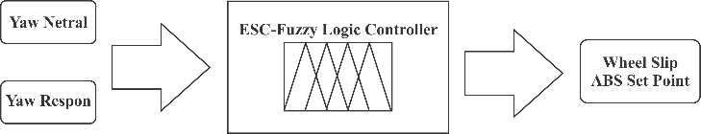

Figure 5. Fuzzy Logic Controller For ESC

With the ability to control the braking force on all four wheels of the vehicle, during cruising deceleration and acceleration at various steer angles, road and surface conditions, the forces that generate an unsuitable Yaw Rate will be overcome by controlling adequate brake forces on each wheel various driving conditions.

4.0 SIMULATION RESULT
Using the calculation method and simulation work as described, we have generated numerical data from the simulation by applying controlled parameters on ESC model. The lack of accuracy of the simulation results from Simulink Matlab is due to the following described limitation:

* Vehicle direct braking from initial velocity V0 from initial time t0, so there is no comparison between steady-state (for example during cruising without interruption) and transient conditions (beginning to end braking).

* Vehicle brakes while turn, where the turning is given in the form of step signal whose value changes one time during braking takes place→ there is two value steer angle in one braking (one value discontinuous, two the same value with opposite direction).

* Yaw responses and slip responses are obtained based on calculations, later on, real conditions use gyro sensors and speed sensors on each wheel.

* The representation of left and right wheel subscript here is meant, the left wheel represents the forces or moments that the vehicle rotates to the left at yaw axis, and the right wheel represents the forces or moments that the vehicle rotates to the right at yaw axis.

The simulation test uses the steer angle conditions. It appears that the steer angle as a step function with a value of 5̊ at t = 0 and -5̊ at t = 1 sec with initial velocity V0 = 200 [km/hr] and at the moment when t = 0 in which the braking has been started.

In Figure 6, the proportion of left and right wheel brake force, it appears when t = 1 second, the right wheel braking force rises drastically and the left wheel braking force drops dramatically, this is due to a steering angle where the steer angle position of the + 5 ̊ is rapidly changed to the -5̊ and at t ≈ 2 the braking force of the two wheels approach almost the same value, due to the condition being closed to the steady state.

Figure 6. Proportion braking force at Right wheel and left wheel

Figure 7 shows the output of the fuzzy logic controller, which is used as the input set point for the ABS controller. It appears that the setpoint of ABS is a dynamic function of the vehicle's directional behavior, not static at only 0.2.

The moment that works on the vehicle body on the yaw axis can be seen in Figure 8, where it appears that there is a very large moment change in the event of steer angle change, and in relatively short period of time, the system is returned to steady-state conditions (not fully ideal) by the work of the controller. Proportion brake on right wheel and left wheel is different.

Figure 7. Setpoint slip output from fuzzy logic controller

Figure 8. Total moment on yaw (Z)

Figure 9. shows slip condition in electric vehicle. Yaw rate response can follow yaw rate Ackerman’s path. But, at 10 seconds the vehicle detects overshoot when the vehicle is turning, so this condition is named as over steer. When vehicle detects oversteer, the vehicle must be kept on the right track accordingly.

Figure 9. Yaw response and Ackerman

5.0 CONCLUSION
This paper presented the use of Electronic Stability Control for the Electric vehicle. By utilizing the active brake force control, the control of vehicle stability can be improved adequately. So, use of ESC Controller can improve the ability to control the stability of vehicle. This condition is used for compensating yaw moment for an electric vehicle. Compensated moments are applied to both right and left wheels when turning.

ACKNOWLEDGEMENTS
The author would like to thank the Electronic Engineering Polytechnic Institute of Surabaya for support.

REFERENCE

- Rajesh, Rajamani, Vehicle Dynamic and Control, New York : Springer, 2012.

- Rajamani, R., & Piyabongkarn, D. New paradigms for the integration of yaw stability and rollover prevention functions in vehicle stability control. Intelligent Transportation Systems, IEEE Transactions on, Vol. 14(1),pp. 249-261. 2013

- Bosch., Electronic Stability Program (ESP), Braking System Co., P.O. Box 4001, South Bend, Indiana, USA.

- Khurana, P., Arora, R., & Khurana, M. K. Microcontroller based implementation of Electronic Stability Control for autoMobils. In Advances in Engineering and Technology Research (ICAETR), International Conference on (pp. 1-5). IEEE. 2014.

- Guoye, W., Juanli, Z., Yanli, F., & Yanru, Z., Study on ESP control principle of light off-road vehicle based on brake/drive integrated control. Physics procedia, Vol 25, pp. 834-841, 2012

- Cau, Min., Advance Automotive Control in Future, Proceeding, International Pasific Conference 11 (IPC - 11), Nov. 6 - 9, 2001, Shanghai, China.

- I. N. Sutantra, 2001, Teknologi Otomotif - Teori dan Aplikasinya, Gunna Widya, Surabaya, Indonesia.

- Taborek, "Study Experimental Wheel Road Adhesive Factor".

- Francis H. Raven, 1995, Automatic Control Engineering, 5th Edition, McGraw Hill, New York, USA.

- Lohith, K., Shankapal, S.R. and Gowda, M.H., Development of Four Wheel Steering System for a Car. Sastech journal vol. 12: pp 90-97, 2013.

- Kawashima, K., Uchida, T., & Hori, Y. Rolling Stability Control Based on Electronic Stability Program for In-wheel-motor Electric Vehicle. system, 2, 4. 2009.

- Hakima, A., & Ameli, S. Improvement of vehicle handling by an integrated control system of four wheel steering and ESP with fuzzy logic approach. In Mechanical and Electrical Technology (ICMET), 2010 2nd International Conference on (pp. 738-744). IEEE. 2010.

- Guoye, W., Juanli, Z., Yanli, F., & Yanru, Z., Study on ESP control principle of light off-road vehicle based on brake/drive integrated control. Physics procedia, Vol 25, pp. 834-841, 2012
- Guo, J., Chu, L., Liu, H., Shang, M., & Fang, Y, Integrated control of active front steering and electronic stability program. In Advanced Computer Control (ICACC), 2010 2nd International Conference on (Vol. 4, pp. 449-453). IEEE, 2010

