SEM Observation on Fracture Surface of Coconut Fibers Reinforced Polyester Composite

Muftil Badri ª, Sugiman ª, Aguswandi ª, Jayadi ^{a,*}
^{a)}Department of Mechanical Engineering, Universitas Riau, Indonesia

*Corresponding author: muftil_bm@unri.ac.id

Paper History

Received:
Received in revised form:
Accepted:

ABSTRACT

The fracture behavior of coconut fibers reinforced polyester composite depends on different fibers orientation was experimentally investigated under static loading conditions. The static uniaxial tensile and flexural loading for three (random discontinuous, longitudinal and woven direction) coconut fibers reinforced polyester composite was implemented using servo hydraulic material testing machine. The microstructure was observed using SEM observation in order to better understand damage mechanism during the stress of polyester phase. SEM observation on fracture surface can provide important information for research and development as well as fracture analysis. It was found that fracture modes were considerably different for these composites. The random discontinuous coconut fibers composite fracture caused by defects in fiber pull out, the longitudinal coconut fibers composite fracture caused by matrix cracking and delamination, the woven coconut fibers fracture caused by debonding and void. Based on the SEM observation results, the fracture behavior was determined and it was found that static loading conditions and fiber direction influence the fracture surface of coconut fibers reinforced polyester composite.

KEY WORDS: SEM, fracture surface, coconut fibers, composite.

1.0 INTRODUCTION

A composite material is a macroscopic combination of two or more distinct materials, having a recognizable interface between them. Composites are used not only for their structural properties, but also for electrical, thermal, and environmental applications. Modern composite materials are usually optimized to achieve a particular balance of properties for a given range of applications. Given the vast range of materials that may be considered as composites and the broad range of uses for which composite materials may be designed, it is difficult to agree upon a single, simple, and useful definition. However, as a common practical definition, composite materials may be restricted to emphasize those materials that contain a continuous matrix constituent that binds together and provides form to an array of a stronger, stiffer reinforcement constituent. The resulting composite material has a balance of structural properties that is superior to either constituent material alone. The improved structural properties generally result from a load-sharing mechanism. Although composites optimized for other functional properties (besides high structural efficiency) could be produced from completely different constituent combinations than fit this structural definition, it has been found that composites developed for structural applications also provide attractive performance in these other functional areas as well [1].
Natural fibers such as coconut fibers are used almost exclusively in polymer matrix composites. The use of natural fibers with the natural-oil resins described here in promises to give economical, potentially biodegradable or recyclable engineering materials. The advantages of natural fibers include low cost, low density, unlimited and sustainable availability, and low abrasive wear of processing machinery [2-4].
Natural plant fibers reinforced polymeric composite, also has some disadvantages such as the incompatibility between the hydrophilic natural fibers and hydrophobic thermoplastic and thermoset matrices requiring appropriate use of physical and chemical treatments to enhance the adhesion between fibers and the matrix [5].
Numerous publications can be found on the SEM observation of natural fibers reinforced polyester composite. A polymer matrix composite contains the various natural fibers as the reinforcement phase was successfully fabricated and the homogeneity of natural fibers-matrix combinations and their bonding structures was characterized through SEM analysis [6]. The effect of the addition of a resin impregnation process on static strength of the injection molded composites was investigated by carrying out tensile and bending tests, followed by SEM observation of fiber surface and fracture surface of composites [7]. The tensile properties, flexural properties and hardness increase with the increase in the weight fraction of natural fibers to certain extent. The morphology of composites is studied by using SEM [8]. SEM observation of a specimen cross section can provide important information for research and development as well as fracture analysis. In many cases, surface observation alone cannot compare to the cross sectional image of granular materials, layered materials, fibrous materials, and metallic coatings, etc [9].

2.0 EXPERIMENTAL METHOD

2.1 Specimen preparation
The specimens chosen for this investigation were coconut fiber and polyester eternal 2250. Coconut fibers were pre-treated with NaOH 1 M (5% w/v) for 60 minutes under constant steering at room temperature. Once the time of treatment was reached, the solution was filtered in a vacuum filter and fibers were washed with distilled water until neutral pH was attained. Then, fibers were dried in an oven at 50ºC for 24 hours. Coconut fibers reinforced polyester composite consists of a 30% coconut fibers and 70% polyester volume fraction.
The composites were manufacture in a glass mold (300 mm x 300 mm). For the preparation of composites were used: polyester resin and treated coconut fibers. The composites were prepared by vacuum assisted resin infusion technique. The polyester resin were mixed manually. Furthermore, the fibers were added.
The static uniaxial tensile and flexural loading for three (random discontinuous, longitudinal and woven direction) coconut fibers reinforced polyester composite was implemented using servo hydraulic material testing machine.

2.2 Experimental setup
The standard used is ASTM D638- 03 the gauge length and cross head speeds are chosen according to the standard.

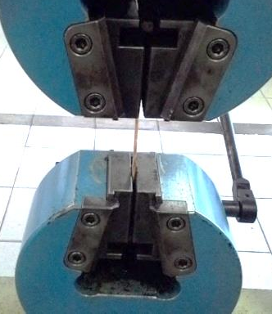

Figure 1: Tensile testing machine

The test is carried out in Universal Testing Machine (UTM) at room temperature as shown in Figure 1. The test involves application of tension in the work piece until it fracture. The tensile stress recorded according to strain. The test conducted for the following combinations and corresponding graph is plotted.
The three points bending flexural test of composite sample is carried out in ASTM D 790 test standard. In flexural test, a uniaxial load was applied through both the end as shown in Figure 2.

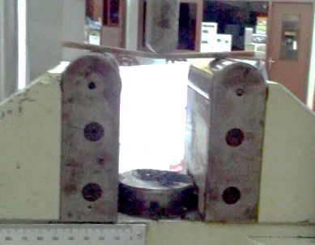

Figure 2: Flexural testing machine

The microstructure was observed using SEM observation in order to better understand damage mechanism during the stress of polyester phase. SEM observation on fracture surface can provide important information for research and development as well as fracture analysis.
The morphological characterization of the composite surface is observed in scanning electron microscope of TESCAN VEGA3 as shown in Figure 3. TESCAN offers the LaB6 – lanthanum hexaboride – electron source as an option, which can be classified as somewhere in-between the Schottky emitter and a tungsten heated filament.

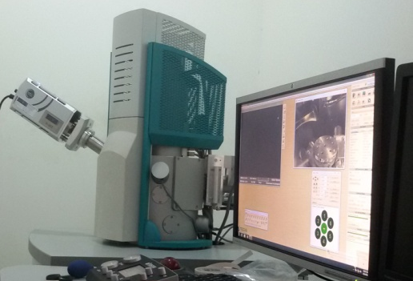

Figure 3: TESCAN VEGA3

3.0 RESULTS AND DISCUSSION

Three different orientation of coconut fibers composite were subjected under static uniaxial tensile and flexural loading. The influence of coconut fibers orientation on static uniaxial tensile and flexural properties were studied [10]. The longitudinal orientation of coconut fibers resulted in a maximum tensile and flexural strength [10].
The fracture surface of coconut fibers reinforced polyester composite was analyzed by SEM. From SEM observation, it is found that different fibers orientation may be due to the changed microstructure which is influence for the fracture behavior and damage mechanism of coconut fibers reinforced polyester composite. It shows that the morphology of the fracture coconut fibers composites revealed the tensile and flexural behavior.
Figure 4 shows the fracture surface of random discontinuous coconut fibers reinforced polyester composite under static uniaxial tensile loading. It was observed the random discontinuous coconut fibers composite fracture caused by defects in fiber pull out.

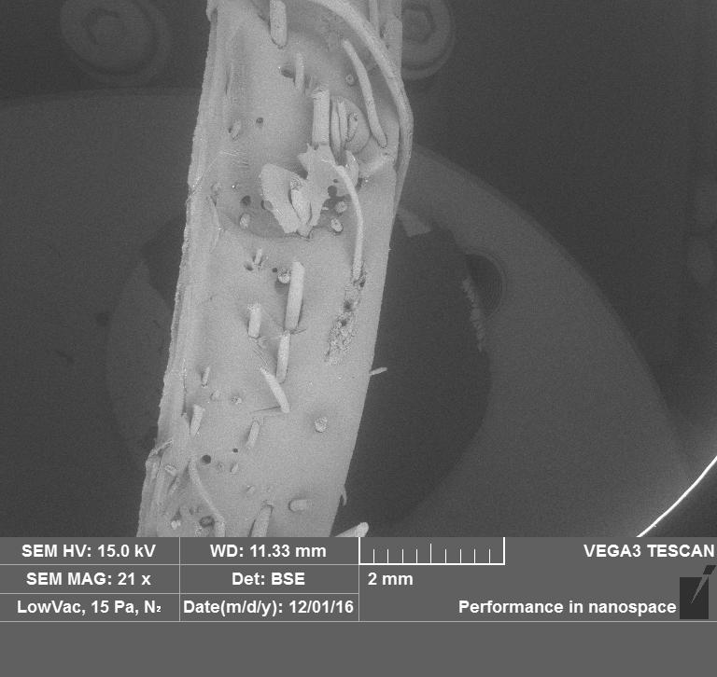

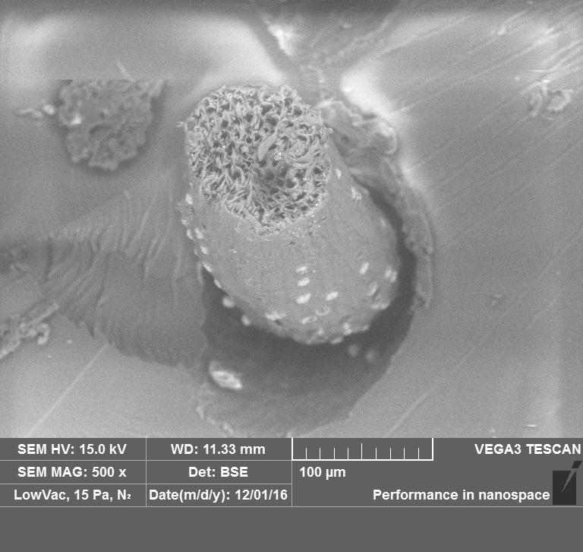

Figure 4: SEM on fracture surface of random discontinuous coconut fibers composite subjected to uniaxial tensile loading

Figure 5 shows that fracture occurs because of defects fiber pull out. It indicates that the random discontinuous improved the interfacial bond strength between matrix and fiber decreasing the value of the flexural strength of the composite. Some load transfer between fibers and matrix is possible by interfacial forces due to matrix shrinkage into the fibers. The friction produces a non-uniform stress along the debonded fibers. After fracture, the coconut fibers composite typically shows a matrix-crack plane. Analyzing Figure 4 and 5, it was observed the random discontinuous of coconut fibers, which can decrease of the interfacial bond strength between fibers and matrix.

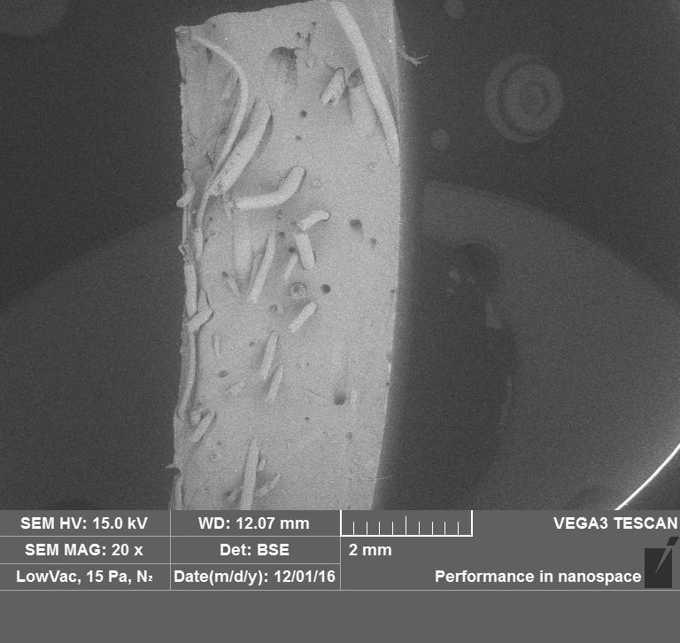

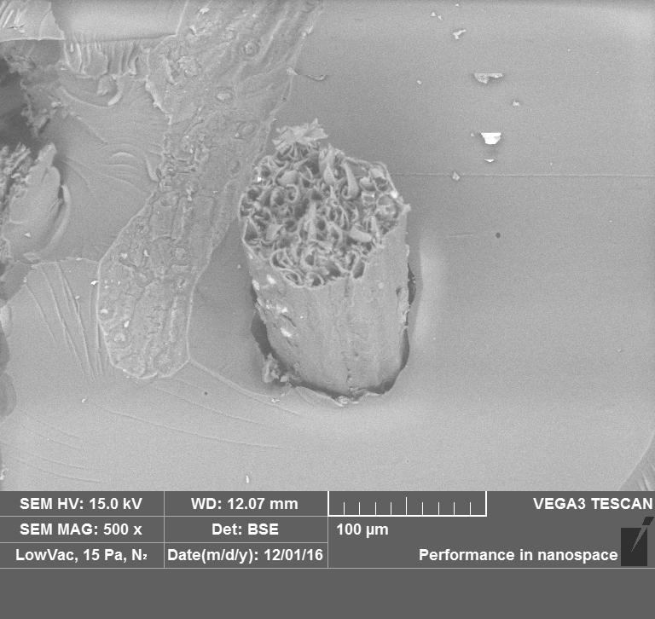

Figure 5: SEM on fracture surface of random discontinuous coconut fibers composite subjected to static flexural loading

Figure 6 shows the fracture surface of longitudinal coconut fibers reinforced polyester composite under static uniaxial tensile loading. It was observed the longitudinal coconut fibers composite fracture caused by matrix cracking and delamination. The load carried by the matrix, is transferred by shear to the fibers which are still intact. A crack at the interface propagates from the matrix crack surface along the fibers.
Figure 7 shows ​​matrix cracking area which occurs in longitudinal coconut fibers larger than the random discontinuous fibers direction. It indicates the value of the flexural strength of longitudinal coconut fibers is higher than the random discontinuous coconut fibers composite because the interfacial bond strength between fiber and matrix increasing the value of the flexural strength of the composite.
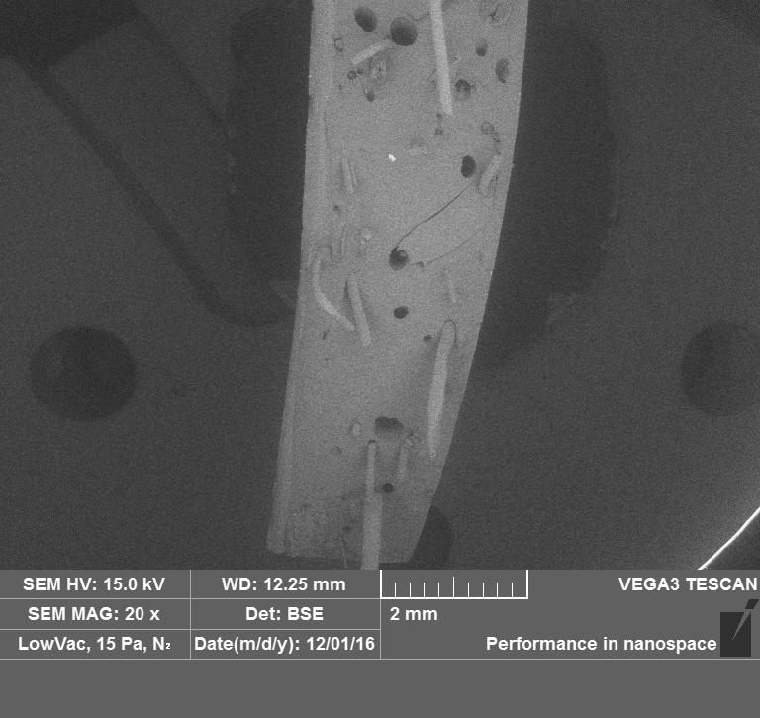

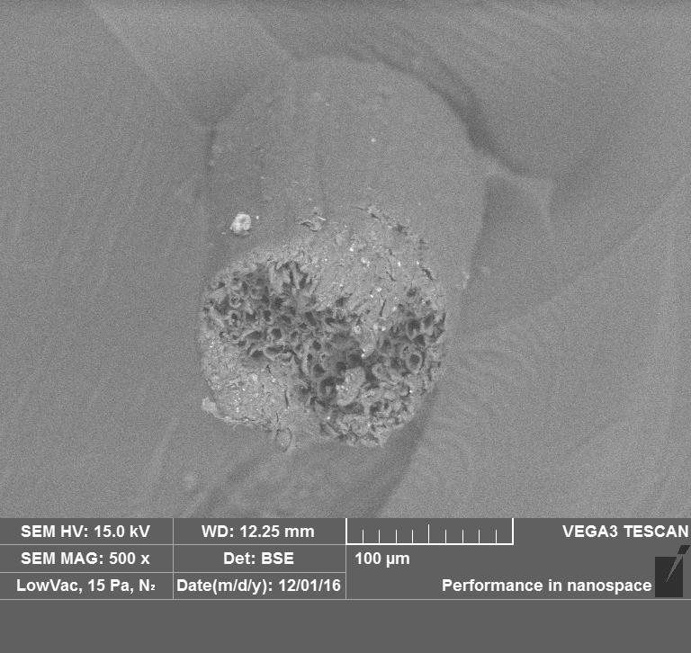

Figure 6: SEM on fracture surface of longitudinal coconut fibers composite subjected to static uniaxial tensile loading

Figure 8 shows the fracture surface of woven discontinuous coconut fibers reinforced polyester composite under static uniaxial tensile loading. It was observed the woven coconut fibers composite fracture caused by delamination and void. The delamination and void are pores that remains unoccupied in the coconut fibers composite. The void is typically the result of an imperfection from the processing of the material and is generally deemed undesirable. From SEM observation in Figure 8, it is found the void decrease the static tensile strength of coconut fibers composite [11]. Figure 9 shows that fracture occurs because of delamination. It indicates that the woven improved the separate layers between matrix and fiber decreasing the value of the flexural strength of the composite. The dominant failure decrease the flexural strength of woven coconut fibers composite.
The fracture surface resulted in voids and defects originated from matrix cracking. At the time of the load on the composite, the matrix will be plastically deformed early result of the void and matrix cracking which are in the matrix, the deformation of the matrix is ​​spread down the fiber. It will have dropped out early and produces fiber pull out, debonding and delamination.

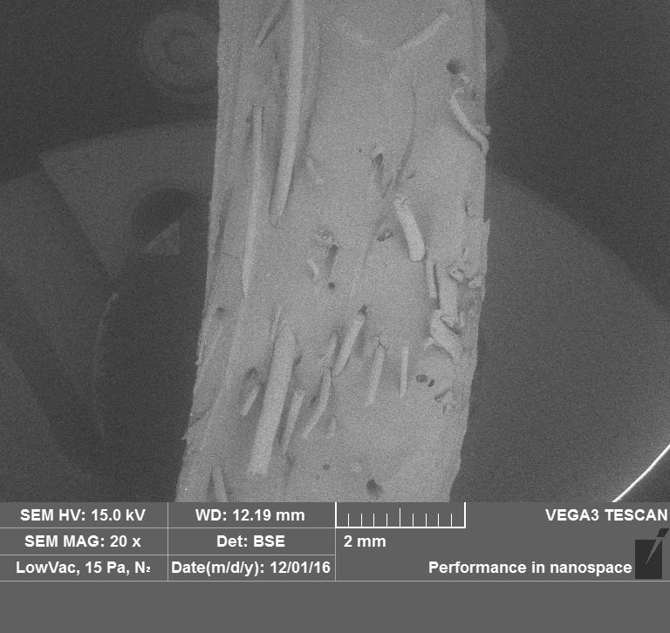

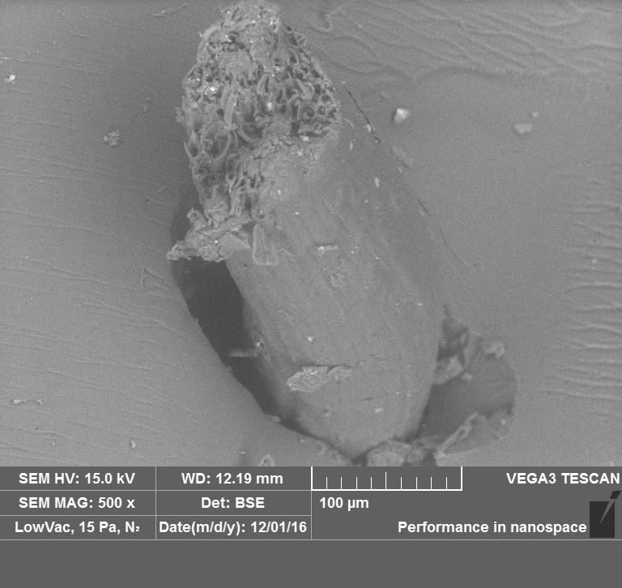

Figure 7: SEM on fracture surface of longitudinal coconut fibers composite subjected to static flexural loading

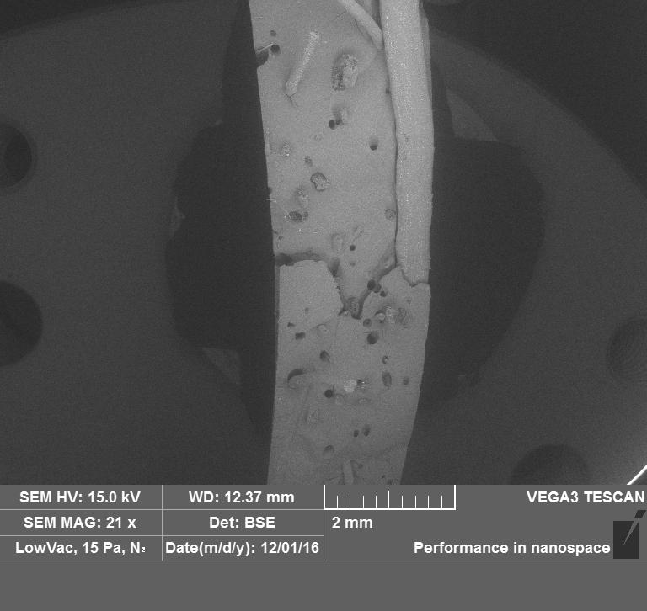

Figure 8: SEM on fracture surface of woven coconut fibers composite subjected to static uniaxial tensile loading

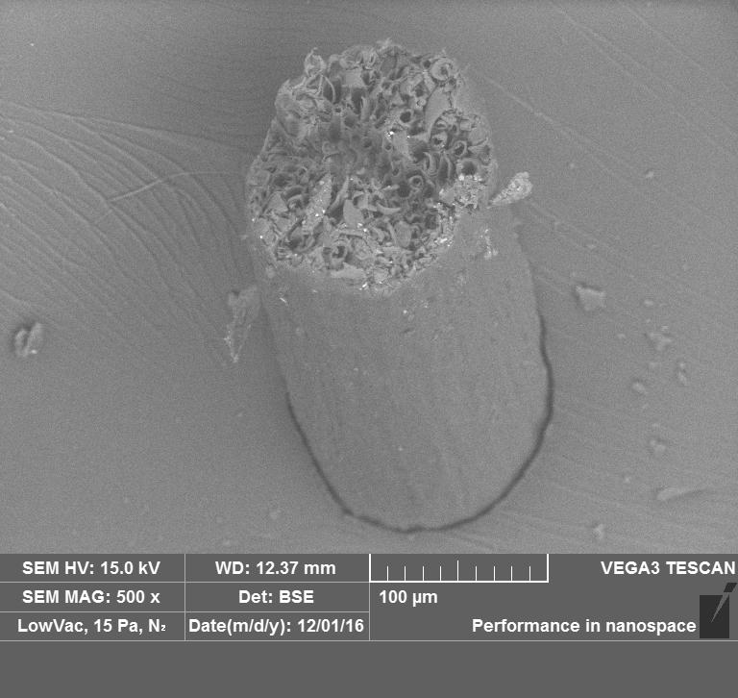

Figure 8: SEM on fracture surface of woven coconut fibers composite subjected to static uniaxial tensile loading

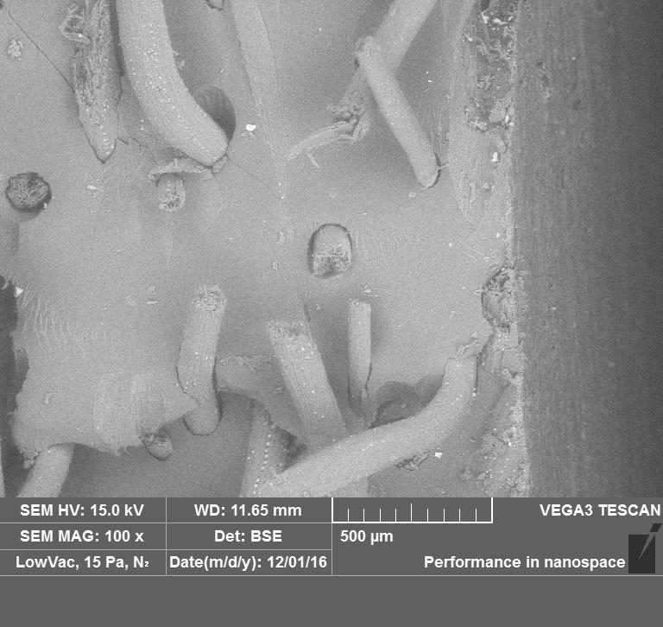
\
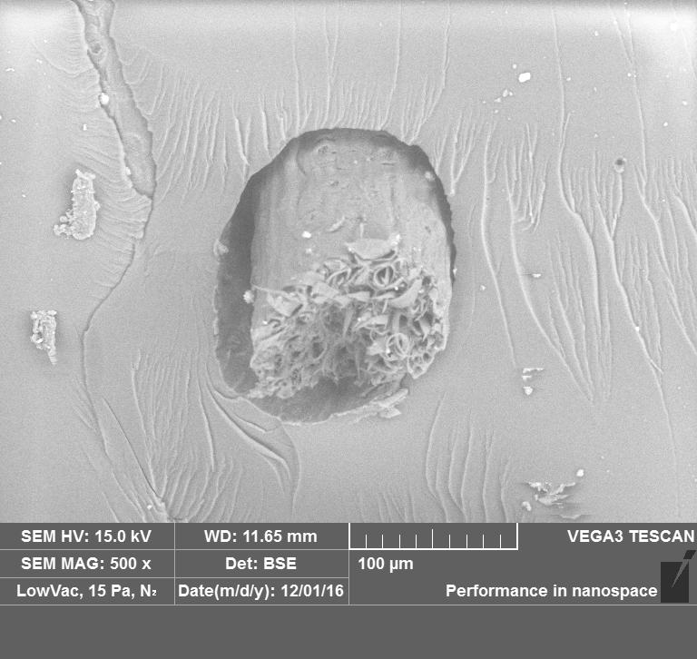

Figure 9: SEM on fracture surface of woven coconut fibers composite subjected to static flexural loading.

4.0 CONCLUSION

This work has reported the SEM observation on fracture surface of coconut fibers reinforced polyester composite. It was found that fracture modes were considerably different for these composites. The random discontinuous coconut fibers composite fracture caused by defects in fiber pull out, the longitudinal coconut fibers composite fracture caused by matrix cracking and delamination, the woven coconut fibers fracture caused by debonding and void. Based on the SEM observation results, the fracture behavior was determined and it was found that static loading conditions and fiber direction influence the fracture surface of coconut fibers reinforced polyester composite.

ACKNOWLEDGEMENTS

The authors sincerely acknowledge the Directorate General of Research Technology and Higher Education of Indonesia (Ristekdikti) which supported this research by Student Creativity Program (PKM) in 2016.

REFERENCE

- ASM International Handbook Committee. (2001). Composites. Vol. 21.
- Bakri. (2011). Tinjauan Aplikasi Serat Sabut Kelapa Sebagai Penguat Material Komposit, Jurnal Mekanikal Vol.2: 10-15.
- Mulinari D R, Voorwald HJC, Cioffi MOH, Da Silva MLCP, Luz SM. (2009). Preparation and properties of HDPE/sugarcane bagasse cellulose composites obtained for thermokinetic mixer. Carbohydr Polym. 75: 317-320.
- Mulinari D R, Baptista C A R P, Souza J V C, Voorwald H J C. (2011). Mechanical properties of coconut fibers reinforced polyester composite. Procedia Engineering 10: 2074-2079.
- Neher, B., Bhuiyan, M.M.R., Kabir, H., Qadir, M.R., Gafur, M.A. and Ahmed, F. (2014). Study of Mechanical and
Physical Properties of Palm Fiber Reinforced Acrylonitrile Butadiene Composite. Materials Sciences and Applications,
5, 39-45.
- Senthiil Dr P V, Sirsshti A. (2014). Studies on material and mechanical properties of natural fiber reinforced composite. International Journal of Engineering and Science: 18-24.
- Nam G, Wu N, Okubo K, Fujii T. Effect of natural fiber reinforced polypropylene composite using resin impregnation. Journal of Scientific Research 5 (2014): 1338-1343.
- Sivakumar M, Kumar R M, Sasikumar S, Prabhu D, Sabarish C, Sengottaiyan P. (2016). Mechanical properties and SEM analysis of glass/nylon/jute reinforced epoxy hybrid composites. International Journal of Mechanical Engineering and Technology (IJMET). Volume 7: 196-207.
- Erdman N, Rodriguez S A. New cross-section sample preparation method applied to microstructural and chemical investigation of steel coating using FE-SEM.
- Aguswandi, Badri M, Yohanes. (2016). Study on tensile and flexural strength of coconut fibers reinforced polyester composite as the alternative materials of traditional ship. JOM Universitas Riau.
- ASTM. (2009). D2734-09, Standard Test Methods for Void Content of Reinforced Plastics, ASTM International, West Conshohocken, PA.

