Compensated Moment of Electric Vehicle use Electronic Stability Control

Bagus Yunanto,^{a,*} Charis Faridchie Siswoyo ^{b} and Era Purwanto,ª
^{a)}Electronic Engineering, Electronic Engineering Polytechnic institute of Surabaya, Indonesia
^{b)}Mechatronic Engineering, Electronic Engineering Polytechnic institute of Surabaya, Indonesia

*Corresponding author: bagusyunanto@gmail.com

Paper History

Received: xxxxx
Received in revised form: xxxxx
Accepted: xxxxxxx

ABSTRACT

This research is reporting on the utilization of an IMU sensor and a set of rotary encoders to detect slip of 3 different types of mobile robot steering systems to model a passenger car. The presence of slip is determined by comparing the tires rotational speed and the free-rolling speed

A two wheels front steering 2WS system mobile robots are used in this work.

During a forward translation motion, the velocity of the mobile robot can be measured using both the IMU sensor and rotary encoders attached to the wheels. Discrepancy of the measured velocities between these sensors indicates the presence of skidding. When the robot performing a turning motion, the measured yaw rates from both sensors with a steering angle sensor added can also be used and compared to observe the skidding that indicates either understeer or oversteer. The SSMR and Ackermann calculation are used to investigate the motion of the 2WS mobile robot respectively.

KEY WORDS: IMU, ESC, yawing moment, electric vehicle

1.0 INTRODUCTION
In a passenger car, the safety of the passenger is the main priority. From the engineering perspective, the passenger’s safety is closely related to the vehicle stability by ensuring the ability to maneuver under extreme drive conditions such as sudden braking, high acceleration, sudden turning to avoid obstacles and turning at a high speed[3]. The extreme driving gives rise to unstable vehicle conditions which are very dangerous. The vehicle stability might be attained back by compensating the forces and moments which brought the vehicle to unstable through a wheels traction control and braking[10].
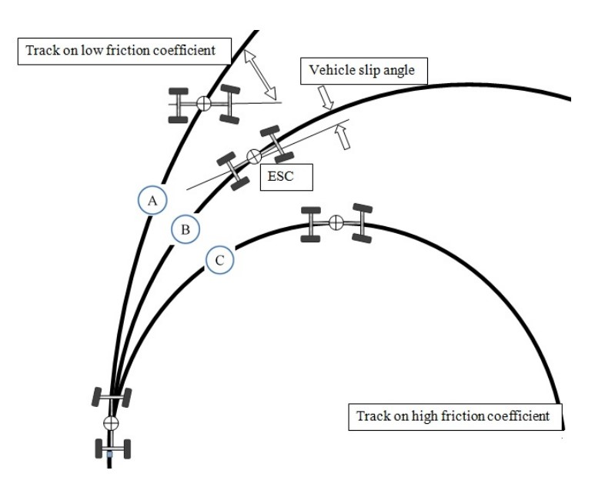

Figure 1. Condition Vehicle

Wheel slip arises when a particular wheel fails to withstand forces larger than its friction force between the wheel and road surfaces. Under this condition, the vehicle is difficult to be controlled by an ordinary driver and it can be considered that the vehicle is losing its stability. This vehicle slip may include events of oversteer or understeer that could jeopardize the safety of the passengers.

Figure 1 shows slip caused events that can happen to vehicles with lacking an adequate stability system during high-speed maneuver.

Electronic stability control (ESC) technology has been applied to fuel combustion passenger car. Application of the technology was done by the leading automobiles manufacturers such as BMW, Mercedes, Volvo and etc. The technology had already applied in developed countries that all the cars have to have an ESC installed to reduce the road car accidents[1].
Regulation of ESC technology application in Europe had been done since 2014 for all cars and the latest productions.

ESC includes sensors such as wheel speed sensor, yaw rate sensor, a lateral acceleration sensor, and steering wheel sensor to identify the dynamics of the vehicle[3]. ESC has the different mode of yaw stability control and roll stability control. In this study, yaw stability control mode is discussed. In yaw stability control mode, the ESC calculates:

- Heading of the vehicle using steering angle sensor and vehicle speed sensor.
- The Radius of the current path using lateral acceleration sensor and vehicle speed.
- Correct yaw rate of the vehicle traveling on the path by calculated radius and measured vehicle speed using onboard yaw rate sensor from which ESC system measures actual yaw rate.

In an ESC system usually, a microcontroller based system does the calculations mentioned above and estimates the intended heading and ideal motion then compares them with the actual motion[11]. If the difference between the measured yaw rate and calculated yaw rate exceeds the threshold value then the ESC system sends control signals to the actuators to apply corrective forces on the vehicle. There are a number of different techniques for correcting the vehicle motion. ESC in the conventional vehicles with single electric motor or ICE has limitations for control with the existing resources, so different additional sensors and actuators are introduced in different techniques of ESC. Providing the expected longitudinal response the driver needs is another key point to focus on for ESC. In this research different types of ESC are briefly discussed and analyzed to find a suitable type for the proposed EV. Then an ESC is proposed with sliding mode controller using a comprehensive dynamic vehicle model.

2.0 VEHICLE DYNAMIC

2.1 Turning Vehicle Dynamic
Analysis of normal force on each wheel on sloping and incline road conditions can be formulated as follows :
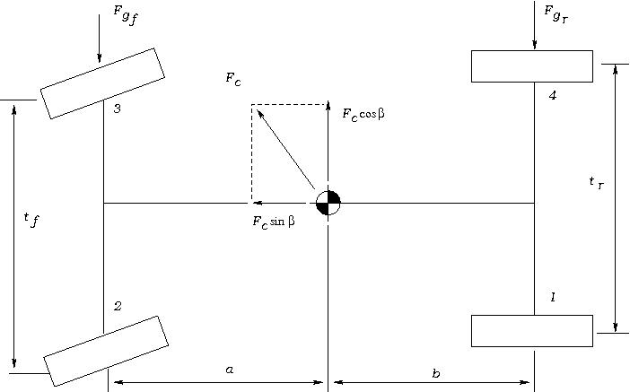

Figure 2. Force and Moment on Vehicle When turning

- Front Left Wheel
$F_{zf(2)}= \frac{l_{r}}{2L}\left[\left(\frac{W∙Cosθ+(F_{Cg}cosβ∙Sinθ)}{2}\right)-\frac{l_{r}}{L}\left(\frac{{(F}_{c}cosβsinθ+F_{s})∙h+M_{Ra}}{t_{f}}\right)\right]+\frac{H_{t}∙\left(F_{c}sinβ+w cosψ-F_{D}\right)-M_{Pa}}{2L}$ (1)
- Rear Left Wheel
$F_{zr(3)}= \frac{l_{r}}{2L}\left[\left(\frac{W∙Cosθ+(F_{Cg}cosβ∙Sinθ)}{2}\right)-\frac{l_{r}}{L}\left(\frac{{(F}_{c}cosβsinθ+F_{s})∙h+M_{Ra}}{t_{f}}\right)\right]+\frac{H_{t}∙\left(F_{c}sinβ+w cosψ-F_{D}\right)-M_{Pa}}{2L}$ (2)

- Front Right Wheel
$F_{zf(1)}= \frac{l_{r}}{2L}\left[\left(\frac{W∙Cosθ+(F_{Cg}cosβ∙Sinθ)}{2}\right)-\frac{l_{r}}{L}\left(\frac{{(F}_{c}cosβsinθ+F_{s})∙h+M_{Ra}}{t_{f}}\right)\right]+\frac{H_{t}∙\left(F_{c}sinβ+w cosψ-F_{D}\right)-M_{Pa}}{2L}$ (3)

- Rear Right Wheel
$F_{zr(4)}= \frac{l_{r}}{2L}\left[\left(\frac{W∙Cosθ+(F_{Cg}cosβ∙Sinθ)}{2}\right)-\frac{l_{r}}{L}\left(\frac{{(F}_{c}cosβsinθ+F_{s})∙h+M_{Ra}}{t_{f}}\right)\right]+\frac{H_{t}∙\left(F_{c}sinβ+w cosψ-F_{D}\right)-M_{Pa}}{2L}$ (4)

2.2 Force Braking
The braking force on each wheel can be shown as follow:
$F_{Bi}=\frac{M_{b}-I_{i}α_{i}}{4r}$ (5)
- Straight – down
$F_{res}= \frac{W_{a}}{g}$
$=F_{B}+f_{r}∙W cosψ+R_{a} ±Wsinψ+R_{r}$ (6)
- Turning – down
$F_{res}= \frac{W_{a}}{g}$
$=F_{B}+f_{r}∙W cosψ+R_{a} ±Wsinψ+R_{r}+ F_{c}sinβ$ (7)
where,
$F_{b}= \sum{F_{Bi}}$ (8)
Force $F_{Bi}$ works on tires contact with the opposite direction of (Fx) and has magnitude as $(F_{Bi})={(F}_{x})$.

Maximum allowable braking force occurs in adhesive maximum limit tire-road tires on the structure when slip angle of 40$°$ and the percentage of skid 20% on the normal force, resulting in the maximum ABS braking can be formulated for each tire. The proportion of ABS braking for each tire is the ratio between the maximum brake force of the tire to the total braking force of all wheels,
$F_{B_{i}max}= μ_{x max}∙F_{z(i)}$
$=F_{x max}$ (9)
The proportion of ABS braking of each tire is the ratio between the maximum brake force of the tire to the total braking force of all wheels:
$K_{Bi}=\frac{F_{Bi max}}{{\sum{F_{Bi max}}}_{}}$ (10)
where,
$\sum{F_{Bi max}}=F_{B max}$ (11)

2.3 Setting Force Braking by ABS
Critical deceleration during braking which resulted in longitudinal skid obtained as follow:
- Straight /down
$F_{B}= \frac{W_{}∙a}{g}-f_{r}∙W cosψ+R_{a} ±Wsinψ-R_{r}$ (12)

- Turning /down
$F_{B}= \frac{W_{}∙a}{g}-f_{r}∙W cosψ+R_{a} ±Wsinψ-R_{r}-F_{c}\sin{β}$ (13)

From equations 12 & 13 by eliminating Ra and Rr, resulting in a critical deceleration rate each tire is used as setting deceleration:
- Straight /down
${\left[\frac{a_{max}}{g}\right]}_{i}=\frac{μ_{x max}F_{z(i)}}{K_{Bi}}+f_{r}cosψ±sinψ$ (14)
- Turning/down
${\left[\frac{a_{max}}{g}\right]}_{i}=\frac{μ_{x max}F_{z(i)}}{K_{Bi}}+f_{r}cosψ±sinψ+\frac{f_{c} sinβ}{W}$ (15)

In this way we can determine the order of occurrence of lock tendencies (resulting in longitudinal skid above 20%) on all four wheels, small deceleration rate goes first lock on $μ_{x max}$. ABS controls the proportion of braking of each wheel according to its deceleration rate.

2.4 Centrifugal Force and Wheel Slip Angle
Centrifugal force is divided into the front and rear wheels lead to slip angle as follows:
- Front wheel
$F_{yαf}=\frac{W∙V^{2}b}{g∙R_{act}∙L}$ (16)
- Rear wheel
$F_{yαf}=\frac{W∙V^{2}a}{g∙R_{act}∙L}$ (17)
Where,
$L=(a+b)$
$R_{act}=\frac{L}{δ_{f}{+α}_{f}{-α}_{r}}$
Distribution of static condition weight on front wheel and rear wheel[9],
$W_{f}=\frac{W∙b}{L}$ (18)
$W_{r}=\frac{W∙a}{L}$ (19)
Then,
$F_{yαf}=\frac{W_{f}∙V^{2}}{g∙R_{act}}$ (20)
$F_{yαf}=\frac{W_{r}∙V^{2}}{g∙R_{act}}$ (21)
Slip angle at front wheel and rear wheel,
$α_{f}=\frac{F_{yαf}}{C_{αf}}$
$= \frac{W_{f}∙V^{2}a}{g∙R_{act}∙C_{αf}}$ (22)
$α_{r}=\frac{F_{yαr}}{C_{αr}}$
$= \frac{W_{r}∙V^{2}a}{g∙R_{act}∙C_{αr}}$ (23)
when,
$\frac{W_{f}}{C_{αf}}-\frac{W_{r}}{C_{αr}}=K_{us}$ (24)
so,
$α_{f}-α_{r}=K_{us}∙\frac{V^{2}}{g∙R_{act}}$ (25)

2.5 Characteristics of Adhesion between Road and Tire
The friction force is caused by the slip that occurs between the drive wheel and the road surface. During the acceleration causing the slip (λ) on the wheels[9], it is formulated by the following equation:
$λ=\frac{r∙ω-V}{V}$ (26)
where,
V = Vehicle Speed (Km/H)
r = Radius(m)
$ω$ = Angle Wheel Speed (rad/second)
In the seventies, some researchers including Easton, Moore, Taborek[5] proposed a concept of tire and road contacts that altered an existing braking and concerning effort concept. The principle of the ABS system concept is to keep the wheel slip (λ) as expected (desired range), so that the optimum braking condition is obtained.

2.6 Yaw rate
The yawing rate is caused by the moment of inertia to the axis Z arises at the center of mass. The yaw rate can be distinguished either by a steady state yaw rate or dynamic yaw rate condition.

In a condition where the moment of inertia of the vehicle is absent, the turn state by assuming angle parameter of steer (δ), turning radius (R) and vehicle velocity (V) constant.

Steady-state yaw rate determination for 2WS vehicle used standard Ackerman:
$ωa=\frac{V^{2}∙δ_{f}}{l_{r}+l_{f}}$ (27)
Given the effect of the slip angle to yaw rate, actual gain becomes,
$ω_{act}=\frac{V^{2}∙R_{n}}{l_{r}+l_{f}}$
$=ω_{a}+\frac{V^{2}∙(α_{f}+α_{r})}{l_{r}+l_{f}}$ (28)
From the above equation, it can be seen that it affects the turning properties Kus. If the Kus < 0 the vehicle will undergo oversteer, and if Kus > 0 understeer happens whilst if Kus = 0 normal or neutral behavior takes place. So to make a neutral turn it needs to be controlled so that $α_{f}$ and $α_{r}$ can be the same. This is done by reducing the proportion of the application of braking forces to control the slip percentage (λ).

2.7 Dynamic Condition
Yaw rate dynamic occurs due to the acceleration of yaw steady in the form of acceleration yawing, due to changes in input angle steer (δ).

The actual yawing of the vehicle dynamic conditions is formulated as follows,
$ω_{dyn}=ω_{act}a+{\dot{ω}}_{tor}∙t$ (29)

Acceleration of yawing under steady state
${\dot{ω}}_{act}=\frac{{∂ω}_{act}}{∂t}$
$={\dot{ω}}_{a}+\frac{∂}{∂t}\left(\frac{V^{2}∙(α_{f}-α_{r})}{l_{r}+l_{f}}\right)$ (30)
The yawing acceleration occurring as a result of the skidding motion is shown as
$ω_{skid}=\frac{A_{r}+A_{f}}{l_{r}+l_{f}}$ (31)
where,
$A_{f}=A_{y1}+A_{y4}$
$A_{r}=A_{y2}+A_{y3}$
with,
$A_{y1}={\dot{V}}_{y}+l_{r}\ddot{θ}+0.05∙t_{f}∙{\dot{θ}}^{2}$
$A_{y2}={\dot{V}}_{y}+l_{r}\ddot{θ}+0.05∙t_{f}∙{\dot{θ}}^{2}$
$A_{y3}={\dot{V}}_{y}+l_{r}\ddot{θ}+0.05∙t_{f}∙{\dot{θ}}^{2}$
$A_{y4}={\dot{V}}_{y}+l_{r}\ddot{θ}+0.05∙t_{f}∙{\dot{θ}}^{2}$ (32)
direction to turn according to Ackerman then,
${\dot{ω}}_{tot}={\dot{ω}}_{ack}$

3.0 ALGORITHM
The calculation method used is quasi-dynamic quantification method where the dynamic condition of the vehicle is analyzed partly as if in a static condition and then used the simulator to get the simulation result with high time increment resolution/density with numerical calculation effort mostly done by computer. The calculation algorithm is shown in Figure 3.
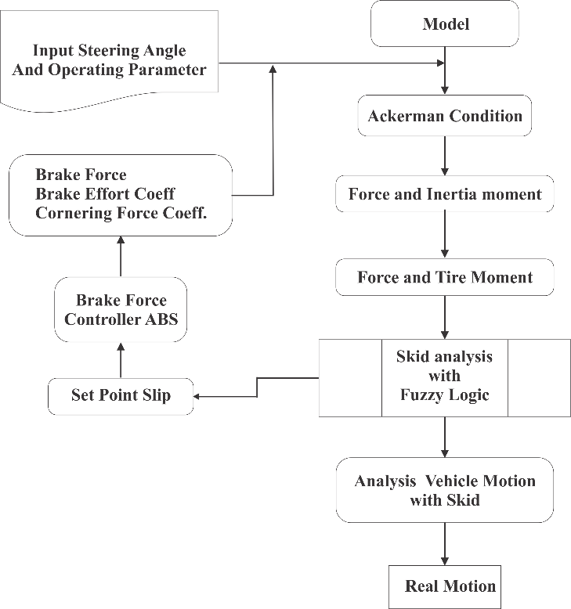

Figure 3. Flowchart Calculation Algorithm

3.1 Calculation algorithm
The results of this simulation are still limited in numerical form and in the form of plot diagrams. have not produced a graphical simulation form that is user-friendly.

3.2 Brake force controller
Brake force FB for each wheel is adjusted by considering the slip requirement, which is obtained from Fuzzy Logic Controller output. So Active Brake Force Control is obtained by altering the slip setpoint dynamically based on Yaw Rate Real Response ratio of the vehicle with Yaw Rate Neutral.
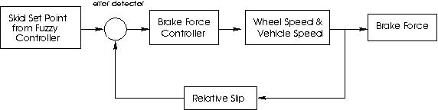

Figure 4. Brake force Controller

3.3 Fuzzy Logic Controller for ESP
By using Mamdani method on Fuzzy Logic Controller, and with the condition Member Function and Rule used is good enough it will get the result of controlling responsive that does not happen overshoot which is too big and optimal enough, so not too burdening resources from controller engine.

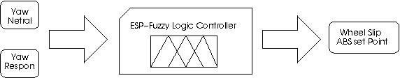

Figure 5. Fuzzy Logic Controller For ESC

With the ability to control the braking force against all four wheels of the vehicle, during cruise, deceleration and acceleration at various steer angles and road and surface conditions, the forces that generate an unsuitable Yaw Rate will be overcome by providing a force on the brakes of each wheel which requires a variety of driving conditions.

4.0 SIMULATION RESULT
Using the calculation method and simulator as described, we have generated numerical data from the simulation by applying controlled parameters on ESP model. The lack of accuracy of the simulation results is due to the following described limits:

* Vehicle direct braking from initial velocity V0 since initial time t0, so there is no comparison between steady-state conditions (for example during cruise without interruption) transient (beginning to end braking).

* Vehicle brakes while turn, where the turning is given in the form of step signal (ladder) whose price changes 1 time during braking takes place→ there is 2 value steer angle in one braking (value discontinuous, 2 the same price with opposite direction).

* Yaw responses and slip responses are obtained based on calculations, later on, real conditions use gyro sensors and speed sensors on each wheel.

* The representation of left and right wheel subscript here is meant, the left wheel represents the forces or moments that cause the vehicle rotates to the left against the yaw axis, and vice versa on the right wheel.

The test with this simulation uses the steer angle conditions, it appears that the steer angle as a step function with a value of 5̊ at t = 0 and -5̊ at t = 1 sec with initial velocity V0 = 200 {km / jam} and at the moment when t = 0 has been started braking.

In Figure 6, the proportion of left and right wheel brake force, it appears when t = 1 second, the right wheel braking force rises drastically and the left wheel braking force drops dramatically, this is due to a steering angle where the steer angle position of the + 5 ̊ is slammed to the -5̊ and at t ≈ 2 the braking force of the two wheels approach almost the same value, due to the condition being closed to the steady state.

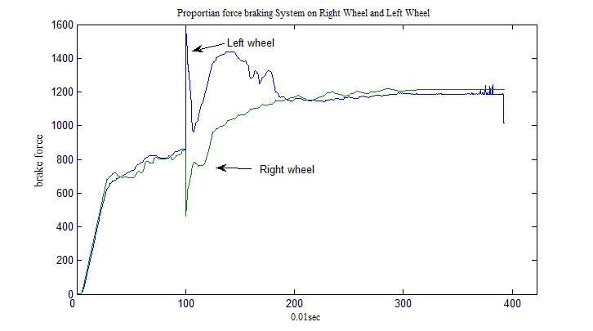

Figure 6. Proportion braking force at Right wheel and left wheel

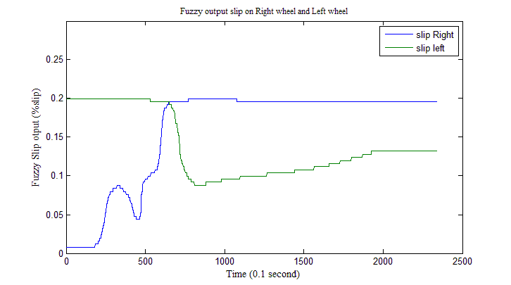

Figure 7. Setpoint slip output from fuzzy logic controller

Figure 7 shows the output of the fuzzy logic controller, which is used as the input set point of the ABS controller. It appears that the setpoint of ABS is a dynamic function of the vehicle's directional behavior, not static at only 0.2.
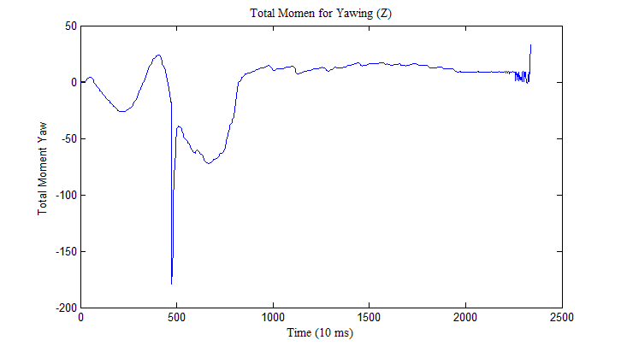

Figure 8. Total moment on yaw (Z)

The moment that works on the vehicle body on the yaw axis can be seen in Figure 8, where it appears that there is a very large moment change in the event of steer angle change, and in relatively short period of time, the system is returned to steady-state conditions (not fully ideal) by the work of the controller. Proportion brake on right wheel and left wheel is different.

5.0 CONCLUSION
This paper presented use Electronic Stability Control for the Electric vehicle. With the active brake force control, the control of vehicle stability can be improved, So the use of ESP Controller can improve the ability to control the stability of vehicle. This Condition used for compensated yaw moment for an electric vehicle. Compensated moment use right wheel and left wheel when turning.

ACKNOWLEDGEMENTS
The author would like to thank the Electronic Engineering Polytechnic Institute of Surabaya for support.

REFERENCE

- Bosch., Electronic Stability Program (ESP), Braking System Co., P.O. Box 4001, South Bend, Indiana, USA.

- Guoye, W., Juanli, Z., Yanli, F., & Yanru, Z., Study on ESP control principle of light off-road vehicle based on brake/drive integrated control. Physics procedia, Vol 25, pp. 834-841, 2012

- Rajesh, Rajamani, Vehicle Dynamic and Control, New York : Springer, 2012.

- Cau, Min., Advance Automotive Control in Future, Proceeding, International Pasific Conference 11 (IPC - 11), Nov. 6 - 9, 2001, Shanghai, China.

- Taborek, "Study Experimental Wheel Road Adhesive Factor".

- Willian J. Palm, 1998, Matlab for Engineering Application, 1st Edition, WCB McGraw Hill, Rhode Island USA.

- J. Y. Wong, 1978, Theory of Ground Vehicle, John Wiley& sons, Ottawa, USA.

- Francis H. Raven, 1995, Automatic Control Engineering, 5th Edition, McGraw Hill, New York, USA.

- I. N. Sutantra, 2001, Teknologi Otomotif - Teori dan Aplikasinya, Gunna Widya, Surabaya, Indonesia.

- Rajamani, R., & Piyabongkarn, D. New paradigms for the integration of yaw stability and rollover prevention functions in vehicle stability control. Intelligent Transportation Systems, IEEE Transactions on, Vol. 14(1),pp. 249-261. 2013

- Khurana, P., Arora, R., & Khurana, M. K. Microcontroller based implementation of Electronic Stability Control for autoMobils. In Advances in Engineering and Technology Research (ICAETR), International Conference on (pp. 1-5). IEEE. 2014.

