Hydrodynamic Analysis of Patrol Vessel Based On Seakeeping and Resistance Performance

NurmanFirdaus,^{a,*} and Baharuddin Ali ª
^{a)} Indonesian Hydrodynamyic Laboratory, Agency for Assessment and Application of Technology (BPPT), Indonesian

*Corresponding author: nurmanfirdaus.bppt@gmail.com

Paper History

Received:xxxxx
Received in revised form: xxxxx
Accepted: xxxxxxx

ABSTRACT

The patrol vessel must have a good performance criteria for a sea worthiness.The hydrodynamic aspects analysis of a ship design is a main step conduct by designer. This study describes an analysis of motions and ship resistance. The seakeeping test conducted two variations of a ship loading condition. The ship’s motion response to sea-state 4 waves with the heading of 180 and 135 deg. The ship resistance test with two draft conditions is calculated by model test and numerical simulation. The ship motion response is expressed in terms of the probability distribution. The values of ship resistance are presented as a non-dimensional graph with a Froude number. The ship loading conditions on a vertical center of gravity is higher resulting in a larger ship motion response than lower vertical center of gravity, as well as the heading of wave is very influential.The results of resistance test above Froude number 0.3, a resistance of ship increase and began to appear hump resistance around a hull.

KEY WORDS: Seakeeping, Resistance, Hydrodynamic, Probability Distribution, Ship Performance.

1.0 INTRODUCTION

The patrol vessel is one type of fleet, it is important to support surveillance of a sea territory such as an Indonesian country. The vessel must have a good performance criteria for sea worthiness. The ship performance can be influenced by many factors such as an environmental conditions, ship structure, hydrodynamic aspects and others. Therefore, the patrol vessel design is expected to have a good stability and powering capabilities to support operation at seas. An attempt to see ship’s ability from the hydrodynamic aspect, it is a necessary to know the ship’s performance of resistance and seakeeping characteristics [Faltinsen, 2005].
An attempt to see the seakeeping characteristics of vessel is necessary in an early stages of design, this is to determine a behavior of ship motion against ocean waves. Most of the seakeeping tables are used to predict ship performance in the oceans [Baree & Afroz, 2017]. To predict a seakeeping performance can use a numerical or experimental method with a required design. The shape of hull and a loading conditions may affect a ship motion [Grin et al, 2016]. The changing loading conditions on the vessel may induce to changes in the ship’s inertia radius, and generate in different ship response behavior.
The powering predictions of ships also have an important role in designing a ship. The designer will consider an installed propulsion engine to estimate a speed capability of the vessel in its opertaion. So, the resistance test is an importance for discovering characteristics of ship in the prediction of powering performance. The vessel’s resistance come from a fundamental behavior of fluid flow to a surface of immersed hull [F. Molland, 2011].
The analysis of hydrodynamic aspects of ship design is a step that must be perfomed by designer. One of the ship performance can be seen from the aspect of seakeeping and hydrodynamics resistance. The study on yacht performance optimization based on two criteria of resistance and seakeeping [Poundra et al, 2017]. Therefore, this research will describe analysis of patrol vessel performance based on seakeeping and resistance with model test method.

2.0 INVETIGATION METHOD

The seakeeping test of ship model is conducted in maneuvering ocean basin (MOB), and resistance test at towing tank (TT) Indonesian Hydrodynamics Laboratory - BPPT. The basin tank has two types of tank, deep tank part in length 60 m, width 35 m, maximum depth of 2.5 m and shallow tank part in length of 45 m, width of 35 m, maximum depth of 1.25 m. The wave generator can generate regular and irregular waves. The towing tank facility has a length dimension of 234.5 m, width of 11, depth of 5.5 m, and equipped towing carriage which can attract a maximum of 9 m/s. The patrol vessel of model test is made from laminated plywood and fiber. The size of the model test is made on a 1:18 scale. To ensure the ship model has same a shape as full scale of ship drawing, it is necessary to check the main dimension and the part of ship model station length in the marking table. The test model of patrol vessel is shown in figure 1 and the main dimension of model are presented table 1.

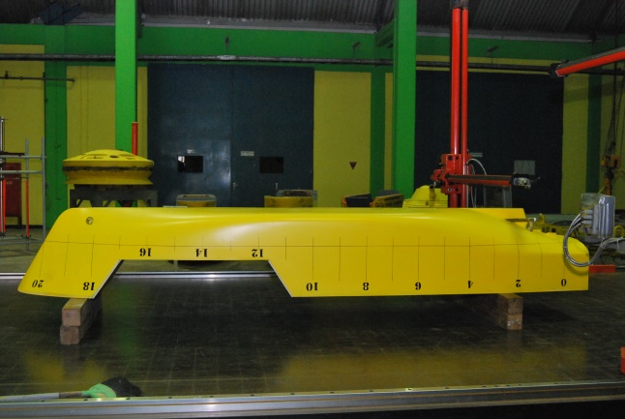
Figure 1 : the test model

Table 1 : the main particulars of test model
Item | Dimension | Unit
Loa  Lpp  B  D  T_{AP}  T_{FP} | 3.333  3.000  0.667  0.461  0.194  0.194 | m  m  m  m  m  m

This study conducted seakeeping test with irregular wave parameter on the type of Pierson-Moskowitz spectrum. The approach of spectrum selection due to wave characteristics in most of indonesia’s sea tends to be close to the spectrum of Pierson-Moskowitz, as the crest of wave energy generated is scattered over the wave frequency. The wave spectrum of Pierson-Moskowitz can be calculated using the equation as follow [Djatmiko, 2012]:

$$S_{ζ}(ω)=0.0081\frac{g^{2}}{ω^{2}}exp⁡\{-0.74{(\frac{g}{ωU_{w}})}^{4}\}$$

Where :
$S_{ζ}$ = the wave spectrum (m²/rad/s)
ω = the wave frequency (rad/s)
g = gravity (m/s²)
$U_{w}$ = wind velocity (m/s)

The wave parameters used to seakeeping test under a sea-state 4 waves, ie significant wave height (Hs) of 2 m and wave period (Tp) of 9 s. The study of model test uses two variations of wave heading, the heading 135 deg (bow quartering seas) and 180 deg (head seas). In addition, seakeeping test carried out variations of loading conditions on the ship. This condition to see a difference of ship motion, if it has different center of gravity. Prediction of weight distribution and inertia radius to determine a seakeeping performance [Grin et all, 2016]. The seakeeping test for each wave heading is conducted as much as 10 to 19 times running, this is aims to get 100 wave cycle data. The irregular wave analysis for statistical data is at least 100 cycles [Lloyd, 1989]. The result of wave measurement calibration can be seen in figure 2. In the graph shows the comparison of spectrum wave theoretical calculations with measurements wave spectrum in the Basin Tank. The measured laboratory waves are also derived from numerical simulation inputs.

Figure 2 : the measurement of wave spectrum

The seakeeping test of patrol vessel on irregular wave used 2 conditions of ship loading. The ship model of load case 1 or called LC 1 has a vertical center of gravity (VCG) of 0.208 m from baseline dan longitudinal center of gravity (LCG) of 1.418 m from AP. While the ship model of load case 2 or called LC 2 has a value of VCG of 0.238 m from baseline dan LCG of 1335 m from AP. To know the variation of load condition more clearly can be seen in table 2. The result of ship motion on LC 1 and LC 2 will be analyzed and compared in the form of probability distribution.

Table 2 : the load condition of seakeeping test
Item | Load Case 1 | Load Case 2 | Unit
VCG above baseline  LCG from AP  Δ  Ixx | 0.208  1.418  273.69  0.748 | 0.238  1.335  266.68  0.793 | m  m  kg  m

For the analysis of ship resistance, this study conducted two methods of calculation, namely model testing and numerical simulations. [Ali et all, 2017] performed two methods of calculation for the analysis of ship resistance, experimental and numerical simulation. The testing of vessel model resistance is done in towing tank by following the method of ITTC procedure (International Towing Tank Conference). Meanwhile, the prediction of value of ship resistance used numerical calculation by applying the holtrop method. The analysis of patrol vessel resistance is perfomed by 2 variations of condition, full load condition and trim condition. The condition of resistance test of patrol vessel model can be seen more detail in table 3.

The extrapolation for resistance values of vessel model can be calculated using the following formula [ITTC 7.5-02-02-02, 2011]:

$$R_{TS}=\frac{1}{2}ρ_{S}V_{S}^{2}S_{0}C_{TS}$$

$$C_{TS}=(C_{TM}-\left(\left(1+k\right)\right)\left(C_{FM}-C_{FS}\right)+C_{A}$$

Where :
$R_{TS}$ = ship resistance (N)
$ρ_{S}$ = density (
$V_{S}$ = speed (m/s)
$S_{0}$ = wetted surface area (m²)
$C_{TS}$ = the total coefficient of ship resistance
$C_{TM}$ = the total coefficient of ship model resistance
$C_{FM}$ = the friction coefficient of ship model resistance
$C_{FS}$ = the friction coefficient of ship resistance
$C_{A}$ = model-ship correlation allowance
1+k = form factor

The numerically prediction of ship resistance can be calculated by the holtrop method the following formula [J. Holtrop et all, 1978] :

$$R_{Total}=R_{F}\left(1+k_{1}\right)+R_{APP}+R_{W}+R_{B}+R_{TR}+R_{A}$$

$R_{Total}$ = total resistance
$R_{F}$ = friction resistance
$1+k_{1}$ = form faktor
$R_{APP}$ = resistance of appendages
$R_{W}$ = wave making and wave-breaking resistance
$R_{B}$ = additional pressure resistance of bulbous bow
$R_{TR}$ = additional pressure resistance of immersed transom stern
$R_{A}$ = model-ship correlation resistance

Table 3 : the load condition of resistance test
Item | Full Load Condition | Trim Condition | Unit
Lwl  T_{AP}  T_{FP}  Δ  S | 3.167  0.667  0.667  273.69  2.554 | 2.967  0.171  0.126  201.35  2.143 | m  m  m  kg  m²

3.0 RESULT ANALYSIS AND DISCUSSION

The presentation of motion analysis data of ship make use of approach of data a graph of probability of motion occurrence. The measured incidence of ship motion is also complemented by linearity predictions with the Rayleigh distribution plot. (Firdaus et al, 2017; Guo et al, 2016; Rajendran et al, 2016) perform motion analysis with probability of ship response occurrence. The motion response data of LC 1 and LC 2 have same a time span in order to reduce a discrepancy due to different duration. The motion data of ship analyzed in this study is only heave, roll and pitch motion. The response of patrol vessel to irregular wave with forward speed is done free running method at the speed of 15 knots. The motion of test model is measured according to the center of gravity for loading case respectively.
The documentation of seakeeping test on the patrol vessel model can be seen in figure 3 in the basin tank. The result of heave motion analysis is shown by the probability graph in figure 4 and 5. The ship roll motion from the results of seakeeping test can be seen on the figures 6 and 7. And the pitch motion of ship is shown in Figs. 8 and 9. The statistical data of LC 1 model seakeeping test is shown by circle symbol. While, the statistical data of LC 2 is shown triangular symbol. For positive peak values given the sign (+ Ve) and negative peak values given the sign (- Ve). Positive and negative values show 1 cycle of motion from time series measurement.

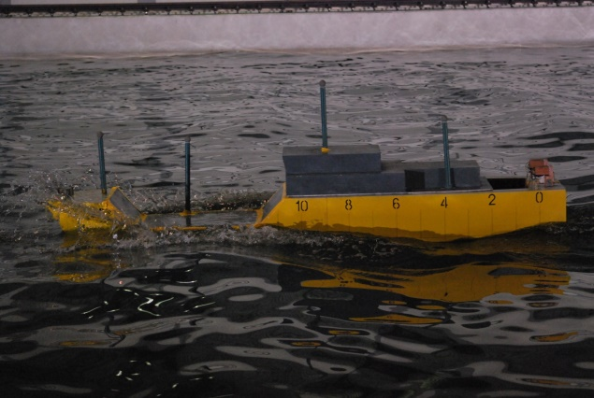
Figure 3 : the seakeeping model testing in MOB

The analysis of the probability distribution of the patrol vessel response to an irregular waves is presented in this section. Additionally, The exceedance probabilities of ship motions of positive peak or negative peak values are analysed. Most of the results of LC 1 and LC 2 show that both encounter non-linear motion, although some are linear. The results of non-linear motion occur both on the heading of bow-quartering seas and head seas. The motion response of patrol vessel on the heading of 135 degree tends to be larger than 180 deg. This is due to the coming waves directly shock the right side of ship’s body, so that the ship encounter a motion response increases.
From the experimental, this test shows results of the patrol vessel motion tendency to increase when a displacement is smaller and the vertical center of gravity is higher. In general, the LC 2 ship motion response compared to LC 1 shows an increase in both positive peak and negative peak values. Note, that the determination of LC 1 and LC 2 still has more than 1 parameter different, so it needs to be detailed in comparing parameters. This requires further investigation.

Figure 4 : the probability distribution of heave motion on heading 135 deg

Figure 5 : the probability distribution of heave motion on heading 180 deg

In Figs. 4 and 5, the ship heave motion clearly shows that LC 1 ship response is smaller than LC 2 ship response. The probability of heave motion occurrence shows that peak values are normally distributed. For the sign ‘+ve’ indicates the ship emergence and the sign ‘-ve’ shows the the ship submergence. There is a heave motion incident for the LC 2 vessel on a heading 135 deg which shows the tail of the motion distribution slightly asymmetric and scattered. The prediction of heave motion of linearity depicted on the Rayleigh graph shows results that tend to be similar when peak values are relatively small. For large peak values, rayleigh’s distribution tail deviate from the testing model results.
In Figs. 6 and 7 present the probability of rolling motion occurrence. The ‘+ve’ and ‘-ve’ indicates the ship shaking to the right and left. Like the motion distribution of heave peak values, the roll motion of peaks are slightly asymmetric in the tails of distribution and the data is scattered. The LC 2 vessel have a larger roll motion response than the LC 1 vessel. The result of roll motion on wave heading 135 deg is bigger than the heading of 180 deg, but the peak values is not significant. The linearity prediction of the roll motion, the graph of Rayleigh distribution coincides with the testing data but the linear predictions shifts away when the peak values is greater.

Figure 6 : the probability distribution of roll motion on heading 135 deg

Figure 7 : the probability distribution of roll motion on heading 180 deg

Figure 8 : the probability distribution of pitch motion on heading 135 deg
Figure 9 : the probability distribution of pitch motion on heading 180 deg

The probability of ship pitch motion occurrence is presented in figures 8 and 9. The sign of ‘+Ve’ and ‘-Ve’ show the ship bow of submergence and emergence. Like previous ship motion analysis, the result of pitch motion peaks are distributed symmetrically for small relative peak values and there are begins to spread to larger peak values. Pitch motion on heading 180 deg, the motion response of LC 2 vessels is greater than the motion response of the LC 1 vessel. In contrast, the LC 2 vessel motion response is smaller than the LC 1 vessel motion response on heading 135 deg. The difference in pitch motion response results with the motion response of heave and roll is due to many possibilities that need to be further investigated.
The difference of vertical center of gravity, longitudinal center of gravity and displacement will affect the value of inertia radius of the ship and the impact on seakeeping performance. On the same normal loading and sea-state wave limit, the seakeeping performance of patrol vessels on LC 1 is better than LC 2. An incorrect prediction of the radii of inertia could therefore result in an incorrect prediction of the ship performance [Grin et al, 2016]. Therefore, as an operator, the user, the government should pay close attention to the fact that the weight distribution of the vessel is very influential on the stability. The importance of ship weight distribution prediction is a good at full load, half load or extreme condition to get a good motion in operational in the oceans.

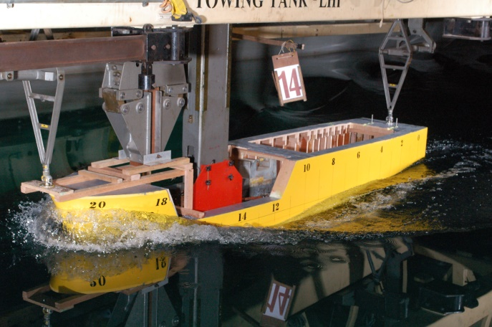
Figure 10 : the resistance model testing in TT

The patrol vessel resistance test is done by 2 methods, with numerical and experimental simulation. the resistance test is calculated from Froude number 0.218 to 0.392 with increment 0.011. The documentation of model testing in towing tank can be seen in figure 10. In the figure shows the documentation of model resistance test in full load condition. The result of patrol vessel resistance analysis are presented in a non-dimensional graph with Froude number, and it is described in figures 11 and 12. The experimental result of model resistance is shown by square symbol and numerical calculation with circle symbol .

Figure 11 : the curve of the resistance test on trim condition

Figure 12 :the curve of the resistance test on trim condition

The comparison between the resistance (non-dimensional) results of the patrol vessel by experimental and numerical calculation perfomed on 2 draft conditions, full load condition and trim condition. In figs 11, the results of resistance on trim condition indicate that the value of the ship’s resistance by numerical method is smaller than the experimental method. This is the same as the full load condition, in figure 12 shows the value of the vessel resistance on the model test is greater than the numerical calculation. The test results of ship resistance on full load condition is greater than trim condition. This is due to area of WSA (wetted surface area) in the trim condition is smaller than the full load condition. This is one of the factors that causes the ship’s resistance results. The result of numerical calculation tends to be the same as experimental simulation under value of Froude number of 0.3. Above Froude number of 0.3, the result of model testing resistance away wide from the numerical results.
From the resistance curve describes the numerical calculation trendline and the experimental method equals. The characteristics of the patrol vessel resistance are hump resistance around Froude number between 0.3 and 0.36. Around the Froude number there is an increase in resistance which is caused by waves forming around the surface of the ship’s body. Figure 10 shows the presence of fluid plugs in the bow, so that the ship is restrained by waves formed by the body of the vessel itself. The phenomenon of wave making and wave patterns around the ship’s body cannot be seen when the resistance calculation is conducted by numerical method. The calculation of resistance by the numerical method of the CFD (Computational Fluids Dynamics) may help to show the flow pattern phenomenon, but it has not been able to get definite values such as model test.

4.0 CONCLUSION

The seakeping analysis of patrol vessel to sea-state 4 waves with model testing perfomed on 2 conditions of weight distribution and 2 waves heading conditions. The vertical center of gravity and longitudinal center of gravity can affect motion response of ship. The characteristic of the ship’s motion can also be affected by the direction of ship;s heading to waves. The patrol vessel has a higher vertical center of gravity, it is likely to have a large motion response.
The comparison of resistance results of the patrol vessel with experimental and numerical calculation show a similarity of results, if sailing vessel performed on speed below Froude number 0.3. And froude number above 0.3, the resistance results of experimental method is greater than numerical simulations. The value of vessel resistance may be affected by the wetted surface area of the vessel. The value of resistance at a higher Froude number can increase and cause hump resistance around the ship’s body.

REFERENCE

- Ali, B., Firdaus, N., Nurhadi. (2017). Analisa Hidrodinamika Kapal Container Sarat Rendah, KAPAL Vols. 14, pp : 65-70
- Bare, M., S., Afroz, L. (2017). Seakeeping Performance of Series 60 Ships. Procedia Engineering Vols. 194, pp: 189-196
- Djatmiko, E., B. (2012). Perilaku dan Operabilitas Bangunan Laut di Atas Gelombang Acak. ITS Press
- Faltinsen, O., M. (2005). Hydrodynamics of High-Speed Marine Vehicles. Cambridge University Press
- Firdaus, N., Ali, B. (2017). Experimental Study of the Probability Distributions on the Seakeeping Performance of Monohull and Catamaran Design, Journal of Ocean, Mechanical and AerospaceVols. 47, pp: 1-5.
- Grin, R., Fernandez, S., R., Bradbeer, N., et al. (2016). On the Prediction of Weight Distribution and its Effect on Seakeeping, Proceedings of PRADS 2016
- Guo, B., Bitner, E.M., Sun, H., et al. (2016). Statistics Analysis of Ship Response In Extreme Seas, Ocean EngineeringVols. 119, pp: 154-164.
- Lloyd, A., R., J., M. (1989). Seakeeping : Ship Behaviour in Rough Weather. Ellis Horwood Limited
- Molland, A., F. (2008). The Maritime Engineering Book. Elsevier
- Poundra, G.A.P., Utama, I.K..A.P., Hardiato, D., et al. (2017). Optimizing Trimaran Yacht Hull Configuration Based on Resistance and Seakeeping Criteria, Procedia Engineering Vols. 194, pp: 112-119
- Rajendran, S., Fonseca, N., Guedes, C.S. (2016). A Numerical Investigation of The Flexible Vertical Response of An Ultra Large Containership In High Seas Compared with Experiments, Ocean EngineeringVols. 122, pp: 293-310.

