Maneuver Control System For Collision Avoidance Based On Experimental Study

Kusnindar Priohutomo ^{a*}, A.A. Masroeri ^{b}, Chandra Permana ª
^{a)} Indonesian Hydrodynamics Laboratory, Agency For The Assessment and Application Of Technology (BPPT), Indonesian
^{b)} Departement of Ship Design Engineering, Institut Teknologi Sepuluh Nopember (ITS), Indonesian
*Corresponding author: kusnindar.priohutomo@gmail.com

ABSTRACT
Autopilot mode in the ship navigation system is intended to assist the work of the captain in controlling the ship, but the autopilot mode still has some disadvantages such as in the case of maneuvers to avoid collisions. Many studies on design of anti-collision design. But almost all use a numerical approach. In this paper will be discussed the design of maneuver controls that will be used on the ship model to avoid the ship from the collision. Where within the control system there are several sensors, including ultrasonic sensors, gyro sensors and Qualysis cameras. From ship model testing conducted, the design of maneuver control proved able to avoid the ship from the occurrence of collisions. Minimum distance of ship and obstacle at 250 m distance is 34,17 m, at a distance of 200 m is 13,46 m while at a distance of 150 m is 13,36 m.

KEY WORDS: System Control, Collision Avoidance, Model Test, Fast Patrol Boat, Microcontroller.

1. INTRODUCTION
The mode of autopilot in the cruise world becomes an important discussion as it helps the seafarers in making it easier to sail the ship. But in autopilot mode itself still has weakness among others in use to avoid collision.
Avoiding collisions is an important issue in transportation systems. The purpose of collision avoidance maneuvers is that ships avoid the risk of collisions and determine actions to avoid or reduce collisions [1].
Much research on the design of controls maneuver to avoid collisions on ships with various methods. Methods ever used among others is manual calculation method, fuzzy logic method and image processing method. Each method has different advantages and disadventages. Some studies releted to avoid ship collisions include:
[2] Research about “Design Boat Control System For Collision Avoidance Using Image Processing”. The object used in this study is USV (unmanned surface vehicle) in the form of unmanned ships that work automatically according to the program designed. To support the working system USV required several types of sensors such as cameras. The camera works to record the image in front of the ship for further processing by the computer by using the image processing method of HSV Filter, to identify the object and use Fuzzy Logic to determine the angle of the turning of the ship while avoiding the object. From this research, it can be concluded that the ship succeeded in avoiding obstruction objects in all scenarios, to identify the object distance using image processing, the optimal angle of object readings is 750 to 1050 with the average of object coordinate readout error of 0.868 px and the mean error the object's reading angle is 7.450⁰ / cm.
[3] Research with topic “Fuzzy Control For Optimizing Ship Tracking In Karang Jamuang-Tanjung Perak”. Based on research that has done, the conclusion as follows has been done a design of fuzzy logic controller to control the bow and the speed for this type of MT Brotojoyo Tanker which capable of keeping the trajectory in the Port of Tanjung Perak, Surabaya. In the test without disturbance occurs the maximum error of 35,09 meters and a minimum error of 0,9 meters, while in testing with disturbance macimum error value of 35,59 meters and a a minimum errror of 0,84 meters. Fuzzy logic system has been designed can increase the efficiency of time sailing 38 minutes.
[4] Another research with topic “Design Prototype Track Control System Trajectory On Unmanned Ships Using Fuzzy Logic”. The fuzzy logic control system used is the Sugeno method with nine fuzzy rules. The value of fuzzy output using the weight average method. The control system is designed using a GPS module to determine the position and compass sensor to determine the direction. The conclusion of this research is the design of control system using fuzzy logic controller can control the ship to track the path well. The ship can move at a speed of 0.28 m / s and the rudder speed is 5.639 0 / sec. The compass sensor used has an error of 0.089%. While the GPS module has an average error error of 6.449 meters. the average time it takes is 3.625 seconds.
From several literatures, it is done by using ship model scale test method in the basin of maneuver testing. For the purposes of testing it is necessary to design the proper maneuver control so that the ship can avoid the collision. The use of microcontrolers and some sensors such as ultrasonic sensors to detect the distance of the ship with obstacles, gyro sensors to know the movement of ship yaw, servo rudder to know the movement of ship rudder and Qualysis camera to know the trajectory between the ship and obstacles.

2. EXPERIMENT METHOD
The research methodology was developed to produce a technically good maneuver control design, in which the steps in the methodology can be described as follows:
2.1 Main Dimension
First determine the main dimension of the ship which is an important factor in ship designing. The ship model used follows Fast Patrol Boat, where the main dimension between real scale and model scale to be used in research can be seen in table 1.
Table 1
Main Dimension
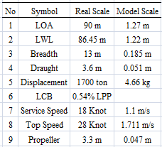

2.2 Collision Avoidance Control System Equipment
2.2.1 Arduino Mega 2560
Arduino Mega 2560 is a microcontroller board based on Atmega 328. This board has 54 digital input / output pins (14 pins can be used as PWM output), 16 analog inputs. 16 MKz crystal oscillator, USB connection, power jack, ICSP header and reset button.
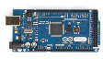
Figure 1. Microcontroller Arduino Mega 2560

2.2.2 Ultrasonic Sensor
The ultrasonic sensor used is a non-contact distance measuring module. To trigger and read the measurement data requires only 1 pin microcontroller. In addition provided 12C communication interface.

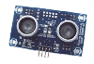
Figure 2. Ultrasonic Sensor

2.2.3 IMU Sensor
The inertial measurements unit (IMU) is an inertial component used to guide a system commonly used in ground vehicles, marine vehicles, and control rockets. The IMU sensor works by sensing a movement, and the directional displacement using a combination of accelerometer sensor is used to determine the acceleration of gravity, gyroscopes are used to determine angular acceleration and the magnetometer sensor is used for heading or determining the direction of the wind and is used as a reference to the yaw axis.

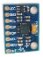
Figure 3. Sensor IMU GY – 521

2.2.4 Radio Telemetry
Radio telemetry is a hardware that serves to transmit a data using wireless communication system.

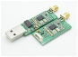
Figure 4. Radio Telemetry 433 Mhz

2.3 Design of Control System
2.3.1 Ultrasonic Sensor Design Model Test
In the ultrasonic sensor book manual of Elecfreaks [5], the design of ultrasonic sensors serves to know and measure the distance of the model with a obstacle.
Figure 5. Ultrasonic Sensor Block Diagram Circuit

The design of ultrasonic sensors uses wire communication by connecting Vcc, Gnd, Echo and trigger pins.

Figure 6. Design of Ultrasonic Sensor

To avoid the ship from collision, the ultrasonic sensor in the setting as in table 2.
Table 2
Ultrasonic Sensor Setting
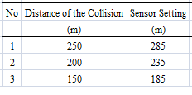

2.3.2 IMU Sensor Design Model Test
According to the manual book of IMU Sensor [6], the design of gyro sensor serves to know and measure changes in heading angle yaw model of the ship.
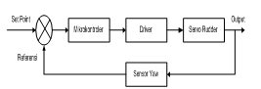Figure 7. IMU Sensor Block Diagram Circuit

The design of the gyro sensor uses i2c serial data communication by connecting Vcc, Gnd, SDA, SCl and INT.

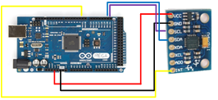
Figure 8. Design of Gyro Sensor

2.3.3 Servo Rudder Design Model Test
The design of servo rudder serves to know and measure the angle change rudder model ship.
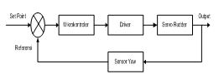
Figure 9. Servo Rudder Block Diagram Circuit

The design of servo rudder using PWM (Pulse Width Modulation) method. With PWM method can be generated servo movement is quite accurate with the desired resolution.
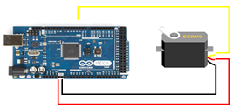
Figure 10. Design of Servo Rudder

2.3.4 Radio Telemetry Design Model Test
In the Advanced Telemetry System manual book [7], telemetry radio design on the test model serves to transmit raw data information changes yaw model ship to the system ground station with realtime.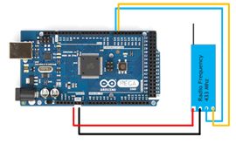
Figure 11. Design of Radio Telemetry

2.4 Trajectory Model Measurement System
Measurement of trajectory model movement during the test was performed using QTM (Qualisty Track Manager) equipment. QTM is a software designed using Qualisys camera model, the camera is used as a medium of fast and precise data collection. This system allows users to record data in real time both in 2D, 3D and 6DOF with fast response time [8]. QTM can also identify marker automatically either passive or active marker, easy in addition of camera if necessary expansion of area object that is recorded.
At the time of capture measurement implemented software will immediately record marker movement (if no setting delay) and can be displayed preview of measurement with preview button. For the sampling rate of the measurement itself can be adjusted from the capture period. The results of the QTM calibration can be seen in Figure 12. Where the red dot is the marker of the ship that has been installed the Qualisys marker, whereas the x, y and z axis each represent the axis present in the test basin.

Figure 12. QTM

2.5 Scenario Testing
The test scenario in this study follows the pattern of COLREG 72 [10]. COLREG 72 has arranged scenarios to avoid collisions in accordance with the position of the ship, including head-on position, crossing position and overtaking (the ship behind will precede the ship in front). Of the three scenarios according to COLREG 72 which will be used in this research is the head-on scenario (ship facing). Where the two ships will do the steering wheel (rudder) to the starboard (right). So the ship can avoid the collision.
In this study the speed of the ship is made constant at 10 knots. While the speed of the ship obstacle at 2 knots. Model test conducted at Manauvering Ocean Basin (MOB) where basin test fasilities belongs Indonesian Hydrodynamics Laboratory - BPPT Surabaya, in calm water condition (non disturbance).
Variations that are done is the distance of the ship with the obstacle (the distance of the collision) that is 250 meters, 200 meters and 150 meters. Tests on each variation of the distance of the ship against the obstruction are done as much as 3x in order to be taken on average.
3. RESULTS ANALYSIS AND DISCUSSION
3.1 Ship & Obstacle Trajectory
From the test results by using Qualysis camera, the ship trajectory graphic (x axis, y-axis) at 250 m, 200 m and 150 m.

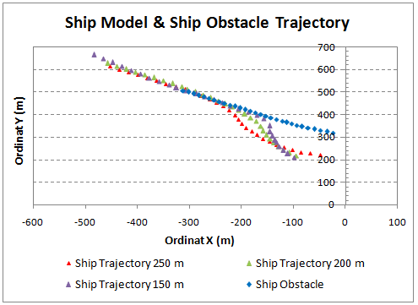
Figure 13. Ship & Obstacle At Distance Of Collision 250 m, 200 m and 150 m

3.2 Distance From Ship to Obstacle
From the trajectory of the ship and the obstacle in figure 13, we can find the distance between the two points of the ship's trajectory point (x-axis, y-axis) and the point of the obstacle (x-axis, y-axis). The z-axis on the ship and the obstacle is not counted because during the test the ship moves on the axis of the 2D axis is the X and Y axis. The formula for finding two points is as follows:

Distance = √ (difference x)² + (difference y)² (1)
= √ (X2 − X1)² + (Y2 − Y1)² (2)

Where:
X1 = Value X Obstacle
X2 = Value X Ship
Y1 = Value Y Obstacle
Y2 = Value Y Ship

From equation 2, we can calculate the distance between the two points that is x-axis, y-axis of the ship’s trajectory and x-axis, y-axis obstacles at 250 m, 200 m and 150 m. The results shown in figure 14.
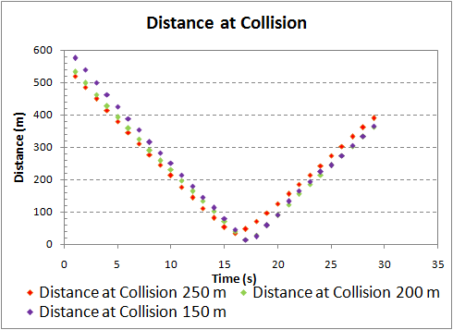
Figure 14. Distance from Ship & Obstacle At Distance Of Collision 250 m, 200 m and 150 m

4. CONCLUSION
From the results of measurement and analysis of test results it can be taken a conclusion. Based on the experimental results it is found that the design of maneuver controls installed in the model of fast patrol boats during the test, may prevent the ship from occurring collisions.
Ships at 10 knots can avoid collisions at 250 m, 200 m and 150 m in non-disturbance conditions. The closest distance between the ship and the obstacle at a distance of 250 m is 34.17 m at T = 16 seconds, at a distance of 200 m is 13.46 m at T = 17 seconds and at a distance of 150 m is 13.36 m at time T = 17. This distance is obtained when the ship is adjacent or side by side with obstacles.

REFERENCE

[1] L. P. Perera, J. P. Carvalho, and C. . Guedes Soares, “Autonomous Guidance And Navigation Based On The COLREGs Rules And Regulations Of Collision Avoidance .,” Adv. Sh. Des. Pollut. Prev., no. 1999, pp. 205–216, 2010.
[2] M. Iqbal, R. Nugraha, “Design Boat Control System For Collision Avoidance,” e-Proceeding Universitas Telkom, vol. 4, no. 2, pp. 1426–1433, 2017.
[3] A. S. Aisjah, A. A. Masroeri, M. A. Efendi, E. B. Djatmiko, W. D. Ariyawan, and F. A. Iskandarianto, “Fuzzy Control for Optimizing Ship Tracking in Karang Jamuang – Tanjung Perak,” The Journal for Technology and Science, vol. 23, no. 4, pp. 118–125, 2012.
[4] M. Ridwan, A. S. Aisjah, “Rancang Bangun Prototipe Sistem Kontrol Penjejak Lintasan Pada Kapal Tanpa Awak Menggunakan Fuzzy Logic,” Jurnal Teknik. Elektro, no. 1, pp. 1–8. 2014.
[5] E. Freaks, “HC-SR04 User Guide,” Elec Freaks, pp. 1–6, 2011.
[6] Studuino, “Studuino Gyroscope.” Environment and Software, pp. 1-15, 2012.
[7] Ats, “Advanced Telemetry Systems - Manual Tracking,” pp. 1–5, 2009.
[8] A. . Fallis, “Qualisis pdf,” J. Chem. Inf. Model., vol. 53, no. 9, pp. 1689–1699, 2013.
[9] IMO, “COLREGS - International Regulations for Preventing Collisions at Sea,” Conv. Int. Regul. Prev. Collisions Sea, 1972, pp. 1–74, 1972.

