Application of Hybrid Fuzzy Logic Controller for
Controlling AFR Engine

Mohammad Javad Nekooei,^{a,*}
^{a)}Faculty of Mechanical Engineering, Universiti Teknologi Malaysia (UTM), Malaysiaa

*Corresponding author: mjnekooei@gmail.com

Paper History

Received: 24-February-2017
Received in revised form: 25-March-2017
Accepted: 30-March-2017

ABSTRACT

The Kyoto Protocol (1997) has been a turning point for future economic and environmental policies for both industrialized and developing countries. The vehicle engine manufacturers are continuously working towards reducing fuel consumption and emissions while maintaining optimum performance by keeping the Air to fuel ratio (AFR) as close to the stoichiometric value of 14.7. In the present paper, new simulation model using Matlab Simulink for a SI (Spark-Ignition) engine has been developed that included all engine dynamic models such as dynamic model of the throttle body, a lambda dynamic model, a model of the intake manifold dynamic, and models of engine torque and fuel injection dynamic. Then, to control the AFR in SI engines, new controllers were proposed to maximize fuel economy and minimize exhaust emissions. A hybrid fuzzy logic controller (HFLC) was created by combining a PID control and fuzzy control. However, this model was validated using the results from engine for various constant load operation tests such as 40 Nm, 50 Nm and 60 Nm but this paper only presented operation at 60 Nm. The simulation results founded that the maximum and minimum AFR for convectional look-up and HFLC methods were (16.80, 12.4) and (15.02, 14.4) respectively. Simulation results from HFLC were lower than other methods such as Sliding Mode Control (SMC), Neural Network (NN), Proportional–Integral controller (PI) and Model-based Predictive Control (MPC) extracted from publishing data.

KEY WORDS: Hybrid Fuzzy Logic Controller, Air to Fuel Ratio, Matlab/Simulink, SI Engine.

NOMENCLATURE
$AFR$ Air to Fuel Ratio
HFLC Hybrid Fuzzy Logic Controller
MIMO Multi Input Multi Output
MPC Model-Based Predictive Control
NN Neural Network
PID Proportional Integral Derivative
SDO Simulink Design Optimization
SMC Sliding Mode Control
TWC Three Way Catalytic

- INTRODUCTION

Environment in forms of air pollution emitted by land, ocean and air transportation systems such as hydrocarbons (HC), compounds of hydrogen nitrogen (${NO}_{x}$), carbon dioxide (${CO}_{2}$), particulate matter (PM) and sulfur oxides (${SO}_{x}$) became an essential issue on societies’ point of view. The Kyoto Protocol (1997) has been a turning point for the future economic and environmental policies for both industrialized and developing countries [Koto, et.al, 2002].
According to the Ward’s research, the number of vehicles jumped from 980 million units in 2009 to 1.015 billion in 2010 [Sousanis, 2011]. The governments and vehicle manufactures in industrialized and developing countries consider not only economical issue but also environmental issue. In order to do that, the vehicle engine manufacturers are continuously working towards reducing fuel consumption and emissions while maintaining optimum performance as they try to meet the growing demands of governmental automotive standards based on the Kyoto Protocol (1997) [Koto, et.al, 2002].
To reach this goal, many different variables must be controlled such as engine torque, engine speed, timing of fuel injection, timing of spark ignition, air intake, and air to fuel ratio (AFR) which is related to each other. Furthermore, several different operating modes are defined for spark-ignition (SI) engines such as startup, idle, running and braking. Consequently, the engine dynamics very nonlinear and multivariable due to those factors [Balluchi, et.al, 1999].
To decrease effectively the emission of harmful gases subsequent to engine combustion, a three way catalytic (TWC) converter can be installed at the exhaust system. TWC is very important element of the car’s exhaust system due to capable of making some harmful gases such as unburned hydrocarbons ($HC$), carbon monoxide ($CO$), and hydrogen nitrogen (${NO}_{x}$) in the exhaust gas to less toxic pollutants by catalyzes the redox reaction as shown in Figure 1 [Berkeley]. A catalyst is a chemical compound that helps the reaction to occur faster by reducing the activation energy barrier of the reaction [Berkeley]. Conversion efficiency depends on the air to fuel ratio during combustion. The effect of emission controls can be also influenced by AFR due to its stoichiometric value that guarantees the highest TWC efficiency.

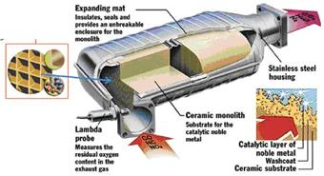
Figure 1: Catalytic Converter -Deconstructed- [Berkeley].

According to Benninger, et al, 1991 variations in the AFR should be within ± 0.2%. More than a 1% variation below 14.7 may significantly increase emissions of unburned hydrocarbons ($HC$) and carbon monoxide ($CO$). As shown in Figure 2, the production of hydrogen nitrogen (${NO}_{x}$), up to 50% can be the result of deviations greater than 1% [Kilagiz, et.al, 2005].
To control the AFR in most of SI engines, proportional and integral (PI) controls together with a look-up table were used. This was not a robust system due to the effect of uncertainty and time variations. A neural network (NN) and a Proportional-integral (PI) control for the AFR was established by Zhai et al, 2010. There was a control performance but still the deviation between the AFR and stoichiometric AFR is too great .The maximum and minimum AFR with PI and NN methods based on the Zhai et al,. 2010 was (22.5, 12.8) and (17.7, 13.25), respectively. Wang, 2006 studied the air–fuel ratio control using the MPC controller (16.2, 14.05)

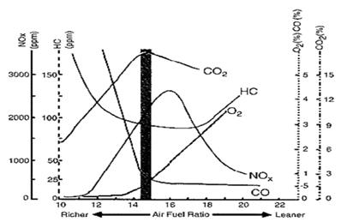
Figure 2: The most suitable values of $CO$, $HC$, ${NO}_{x}$, ${CO}_{2}$ and air to fuel ratio for an Internal Combustion engine [Kilagiz, et.al, 2005].

In this study, the AFR in SI engines was controlled using new control methods to maximize fuel economy while minimizing exhaust emissions. In this way, a hybrid fuzzy logic control (HFLC) was created by combining two control models, PID control and fuzzy control This research was continuation from previous research [Nekooei, et.al, 2014 & 2015, Priyanto, et.al, 2014].

2.0 SOFTWARES SIMULATION
2.1 Commercial Software Simulation
Currently, engineering simulation software can be found abundantly in market. To simulate the engine model, appropriate software should be selected. In the automotive engineering field, simulation software is provided mainly in two different groups: commercial software and custom in-house software, which are explained in detail in the following subsections
Nowadays, four commercial packages of engine simulation are principally applied to automotive industry, namely Lotus Engine Simulation (LESoft), Ricardo Wave (RW), GT Power, mathematica and AVL CRUISE as shown in Figure 3; functionality of all is the same [Chan, et.al 2013]. Note that detailed input parameters should be provided for them to simulate the engine operation in an integrated manner rather than using a variety of subsystems.

 |  | 
 | 
Figure 3: Commercial packages of engine simulation

The commercial engine simulation software has a number of advantages; the most important ones include as follows:
- The commercial software is use friendly, hand on and click button software. They can handle a wide range of technical applications in regard to vehicle and engine due to contain many modules and libraries.
- Innovative graphical user interface and methods of model construction help a user perform the simulation by means of drag-and-drop element library, easy-to-use, modular, extendable.
- The application software can provide an accurate engine performance block, engine component blocks, and dynamic control blocks in order to apply to a real-time simulation. The application is also fast and reliable fuel economy and performance predictions from early concept phase. In addition, vehicle dynamics blocks are included in some of the software, which help to analyze the engine combustion and emissions; simulated items are fast, and the obtained results have a high accuracy.
- Strong teams are ready to update modules and provide solution to the problems faced by customs. In essence, car designers can make use of simulation software in making appropriate decisions; such decisions are expected to contribute to designing competitive vehicles regarding important factors such as performance, fuel efficiency, emissions, and drivability.

1. Ricardo Wave (RW)
Ricardo Wave (RW) is used worldwide in industry sectors including ground transportation, rail, motor sport, marine, and power generation for 1D engine and gas dynamics analysis [Ricardo software] The engine simulation package of RW has been proposed for the analysis of the pressure wave dynamics, plenums, energy losses in ducts, mass ﬂows, and manifolds of a variety of machines and systems [Ricardo software]. RW makes use of two-zone model to simulate time-dependent ﬂuid dynamics and thermodynamics. Several key features of Ricardo Wave are as follows [Ricardo software]:
- Advanced SI and combustion models (non-predictive, semi-predictive and predictive models) allowing accurate single or multiple fuels handling
- State of the art compressor and turbine physics
- Comprehensive 1D and 3D after treatment library including TWC, DPF, LNT, DOC, SCR and user models
- Advanced acoustic features including, engine speed audio player, modeling absorptive materials, porous ducts user defined flow noise calculation
- Graphical plotting on the fly and interactive input control using the WAVE Live interface

2. Lotus Engineering Software (LESoft)
Lotus Engineering Software (LESoft) which is an in-house code has been developed by automotive engineers [. Lotus Group] .Engine simulation is processed by this package in two modules, i.e., the data module and the solver module [13, 14]. The former provides users with the possibility of inputting the engine dimension data. The latter is a built in combustion and heat transfer zero-dimensional equation and fuel/gas composition solver based on data input by the user in the previous module. The code is capable of predicting combustion, gas ﬂow, and overall performance of the IC engines.
LESoft has several modules as follows [Lotus Group]:
- Lotus Suspension Analysis (SHARK & RAVEN)
- Lotus Engine Simulation (LES)
- Lotus Vehicle Simulation (LVS)
- Lotus Concept Valve Train (LCVT)
- Lotus Concept Crank Train (LCCT)
Ricardo software, WAVE
3. GT POWER
The professional software company of Gamma Technologies is mainly focused on engine and vehicle industry. GT POWER, provided by Gamma Technologies, has various vehicle and engine technical applications, including vehicle dynamics and engine performance modeling [GT-POWER]. GT-POWER is used to predict engine performance quantities such as power, torque, airflow, volumetric efficiency, fuel consumption, turbocharger performance and matching, and pumping losses [GT-POWER]. GT POWER is fundamentally a greatly adaptable multi-physics platform that can be used to construct a variety of engineering models through combining the flow, thermal, acoustics, electric, chemistry, mechanical, and controls. GT-POWER includes physical models for extending the predictions to include cylinder and tailpipe-out emissions, intake and exhaust system acoustic characteristics (level and quality), in-cylinder and pipe/manifold structure temperature, measured cylinder pressure analysis, and control system modeling [GT-POWER].
The application of GT can be as follows [GT-POWER]:
- Combustion and Emissions
- Cylinder Pressure Analysis
- Intake and Exhaust Acoustics
- Exhaust Aftertreatment
- Valvetrain
- Waste Heat Recovery
- Performance, Fuel Economy, and Emissions
- Control, MiL, SiL and HiL
- Real-Time Engine

4. AVL CRUISE
Powertrain analysis and vehicle simulation can be done using AVL CRUISE [AVL]. This product is applicable to the development and optimization of reliable powertrains, low emission engines, complex control systems of engine, as well as cooling and transmission systems. The application field covers fuel efficiency, driving emissions and performance analyses along the vehicle development process with model re-use from concept design through to HiL and testing [AVL]. AVL CRUISE is able to support engineers during the process of developing the engine and vehicle in standard applications, e.g., fuel economy and full load acceleration tests, traction diagrams, hill climbing performance, and computational concept studies including the thermal, electrical, mechanical, and control systems. AVL CRUISE supports everyday tasks in vehicle system and driveline analysis from the concept phase to control function development and testing. Its modular and open structure enables applications for different architectures (conventional, hybrid, electric) and engineering focuses (transmission, engine, electric system, controls, etc.) in all relevant industries (passenger, commercial, 2-wheeler, off road) [AVL].

5. mathematica
Mathematica provides a single integrated, continually expanding system that covers the breadth and depth of technical computing—and with Mathematica Online, it is now seamlessly available in the cloud through any web browser, as well as natively on all modern desktop systems [Wolfram]. Mathematica excels across all areas of technical computing—including neural networks, machine learning, image processing, geometry, data science, visualizations. For example, SystemModeler 4 module gives users the possibility to control simulations directly from Mathematica [Wolfram].

2.2 Code Languages for Simulation
The development of simulation software can be done by writing source code in the program in a way to implement the required functions through programming languages for example Java, C, C++, VC, Python, VF, Openfoam, R, etc). Some of the programming software such as Matlab, Dymola, Modelica, VB, VS, V#, and VisSim has been designed particularly for data processing and mathematical operations. Such software comprises algorithmic components and toolbox comparable to statements or blocks; by simply entering the equation or logical relationship, they will be operational. For writing source code, there is a need for expertise in a variety of subjects such as knowledge of the application domain, formal logic, specialized algorithms, and so on. Many researchers have developed their own software for example Koto has developed several software using VB code such as Subsea Pro Software, Offshore Pro Software, Navigation Integrated System, Ice Ship Software Heli Pro Software, Mobile Harbour Pro Software, Ship Manoeuvring Pro Software, DSM-SP Pro Software [Koto Ocari].
When, in the late 1970s, Cleve Moler was attempting to make an interactive access to FORTRAN linear algebra software packages (i.e., LINPACK and EISPACK). FORTRAN is an imperative programming language which is for general-purpose and numerical computation and analysis. FORTRAN has rapidly developed from FORTRAN to FORTRAN 2015.
Among other languages, Matlab is a programming language of a high level; it makes available such a problem-solving environment that makes easy the scientific and mathematical computations. Matlab was originated, and then in was developed by Mathworks founded in 1984 [Moler, 2004]. The Matlab is used for machine learning, signal processing, image processing, computer vision, communications, computational finance, control design, robotics, and much more [Mathworks]. This software is capable of analyzing data, developing algorithms, and creating applications and models. Furthermore, in 2002, an additional package, i.e., SIMULINK, was developed by Mathworks. It offers a graphical block diagramming environment for multi-domain simulation and model-based design. This software provides a unified integration with the rest of the Matlab environment; it has the capacity to either drive the Matlab software or be scripted from it. Matlab/Simuliink makes a great experience for users. Simulink and Matlab have been rapidly promoted by much higher performance requirements of signal processing and numerical analysis based on evolution occurring in the Science and Engineering fields. It can be said that one of the three or four key developments, which have taken place in numerical computation during the last decade, is the advent of the Matlab software that has been widely preferred by thousands of foremost engineers and scientists [Chan, 2013].
There are several reasons for choosing Matlab/Simulink to develop engine simulation platforms and design engine control systems. Firstly, Matlab offers a high level of programming language as well as user-friendly, powerful graphics and many math tool boxes. Matlab has ability to read in a wide variety of both common and domain-specific image formats and also ability auto-generate C code, using Matlab Coder.
Then, language, built-in math functions, and tools of Matlab help to find multiple approaches and achieve solutions faster compared to those in spreadsheets or conventional programming languages like C/C++ or Java. Matlab allows the users to test algorithms immediately without recompilation.
Matlab/Simulink contains toolbox called Simulink Control Design (SCD) makes designing and analyzing the control systems very easy. For instance, users are able to design and analyze control systems modeled, the gains of PID controllers can be tuned automatically by users in a way to satisfy performance requirements [Mathworks]. The users can also automatically tune arbitrary SISO and MIMO control architectures [Mathworks, Nekooei, 2013]. Using such toolbox, users are also capable of exploring non-intrusively the operating points and calculating the accurate linearization of the Simulink models in a variety of operating conditions [Mathworks]. The tools provided by the Control Design toolbox help users to calculate the simulation-based frequency responses with no modification on the simulation model.
Matlab/Simulink also contains Simulink Design Optimization (SDO) which has useful functions, interactive tools, and blocks for analyzing and tuning model parameters [Mathworks]. Using the Simulink Design Optimization toolbox, controllers are able to design improvements through estimating and tuning the model parameters by means of numerical optimization. In addition, the model accuracy can be enhanced using test data for the calibration of physical parameters. Then, the design parameters in the Simulink models can be automatically tuned by users.

3.0 HFLC AFR CONTROL FOR SI ENGINE

Research flowchart used in this study consists of the six phases as shown in Figure 4, as follows:
- Proposed new engine and mathematical modeling,
- Develop engine dynamic modeling using Matlab/Simulink
- Conducting experiment using Peugeot 405 1.8i engine,
- Validating the engine simulation model by comparing with experiment results
- Proposed HFLC by based development of PID and Fuzzy controls which consists of Design PID Control, Design Fuzzy Control, Design Fuzzy PID Control and Hybrid Fuzzy Controller (HFLC)
- Evaluating the proposed HFLC.

Figure 4: Flowchart of engine simulation using HFLC in term of AFR.

3.1 Proposed New Engine Structure and Mathematical Model
The simulation model for the engine dynamics with associated with all operational dynamics of the engine including fuel, air, and AFR dynamics, and engine speed. There are 5 mathematical modules for the engine operation as shown in Figure 5, they are as follows
- Model of throttle body
- Model of Intake manifold dynamic
- Model of Fuel Injection Dynamic
- Model of Crank shaft dynamic
- Model of Engine Air to fuel ratio
In the figure it can be seen that there were two sub-models for air dynamic which is throttle model and intake manifold models.

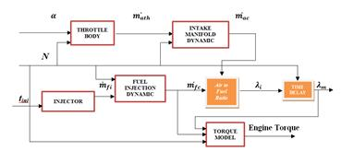
Figure 5: Proposed new engine structure.
In the operation of a real engine, there are two main parameters: any event in engine operation and delivery of the signal. This is why a delay of data occurs between every event or a signal block may be occurred.

3.2 Development of Engine Dynamic Simulation
The development and confirmation of simulation model of engine is used to design and optimize the engine control systems. A Simulink engine dynamic model was developed for some reasons. First, the engine simulation model must be compiled on the basis of the equation of engine dynamic as well as the parameter data of the model achieved from the engine testing platform. Lastly, the simulation model should be verified through a comparison between the simulation data and experiment.
The dynamic equations and engine standards explained in shown in Figure 5 were formed the basis of the engine system dynamics simulation. Using these equations, the engine simulation model in Matlab/Simulink has been created.
The use of modular structure makes it easier to check the performance and precision of the model. This model is a module; therefore, it can be simply used to simulate various types of engines.

3.3 Experimental Setup
Based on parameters of the engine model needed for the tests, there is a need for the testing platform of engine. The responsibility of optimization and modification of the platform engine is assumed for engine research laboratory. The experimental tests were carried out at the engine research laboratory in Shiraz University, Iran. In the engine research laboratory, a Peugeot 405 1.8i engine was used to conducting our tests. Many of the parameters for the equations as explained in Section 3.1, such as engine displacement volume, engine manifold volume, and injector parameters were calculated using the engine information and the engine parts. Figure 6 shows the testing platform used for the engine.

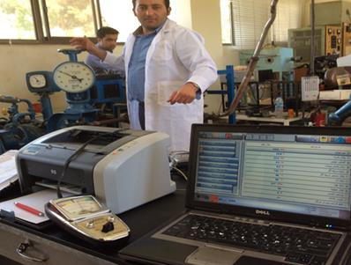
Figure 6: Experimental Platform of Engine
Figure 7 illustrates the throttle angle for the entire time the test with 40 second maximum run at 40 Nm of engine load. A stable pressure at a 3.5° angle was the start point. It was obtained by randomly pushing and releasing the accelerator pedal. The greatest open angle for the throttle was about 24.8°. Figure 8 shows AFR taken from experiment at 40 Nm of constant engine load. The AFR model is not second order differential equation it’s just a transfer function.
Figure 7: Variation of throttle at 40 Nm of engine load.
Figure 8: AFR result at 40 Nm of engine load.
3.4 Validating the Engine Simulation Model
The conducted experiment with a wide range of operation was required to validate the developed engine simulation model. In order to accurately evaluate the simulation model, a comparative study was performed using the data collected from the simulation and actual experiments under several different operating conditions with predicted values for different variables for the engine simulation and using identical inputs including fuel flow rate calculated using injection time, throttle open angle, and engine speed.
In the simulation process the engine behavior under several conditions was validated using the dynamometer with a constant load torque and then, a group of data in time domain was recorded. The intake manifold pressure and the air flow rate were two variables that were measured directly while the gas analyzer and O₂ sensor placed in the exhaust pipe were used to measure the AFR. Because it is not easy to measure fuel film dynamics, the gas analyzer and O₂ sensor were used to measure the mass of fuel in the film.
According to the requirements of the experiment, the validation of the simulation was divided into three sections as follows: setting up load for dynamometer, run engine under the given load and determine the error.
The constant loads were set for the dynamometer were 40, 50 and 60 N.m. These numbers were approximate values. Three different loads absorbed with three different throttle angle paradigms from the engine to simulate low, middle, and high load conditions.
After setting up the dynamometer, the engine was run under the given load as discussed above. A greater absorbed load and a greater throttle angle paradigm have been used.
Furthermore, a comparative analysis is performed between the simulation data and the platform test data for engine speed, intake manifold pressure, AFR and lambda. Error between simulation and experimental data was calculated.

3.5 Designing and Simulating of HFLC
The principal idea behind of the study firstly was to develop an engine simulation model as shown in Figure 5 that included all dynamic engine parts such as throttle body, intake manifold dynamic, fuel injection dynamic, crankshaft dynamic and engine air to fuel ratio (AFR). After that it was designing and simulating a Hybrid Fuzzy Logic Controller (HFLC) by combination between a fuzzy logic and PID controller using Matlab/Simulink as shown in Figure 5. The purpose of those points was to takes advantage of the properties of the fuzzy logic and PID controllers. A fuzzy controller was used for the online tuning of the PID controller gains proportional ($K_{p}$), integral ($K_{i}$), and derivative ($K_{d}$). The target of the new engine controlled by HFLC was the AFR control of SI engines which closes to the stoichiometric value of 14.7.
A Proportional Integral Derivative (PID) controllers are the most famous and popular industrial controllers. Their robust operation and the simplicity of their structure for use under many different operating conditions is the reason for their popularity. The (PID) controller continuously calculates an error value as the difference between a desired AFR and a measured AFR. There are three gain specifications needed for a PID controller design: proportional ($K_{p}$), integral ($K_{i}$), and derivative ($K_{d}$). The PID applies a correction based on proportional, integral, and derivative terms. The controller attempts to minimize the error over time by adjustment of a control variable.
Many scientists have tried to improve and develop different techniques to tune or optimize these gains. The tuning method presented by Ziegler-Nichols (Z/N) is perhaps the most well-known one. The initial estimates were obtained using the Z/N technique. However, many of the controlled objects will have complicated mechanism in real world applications. Normally, it is difficult to generate a mathematical model for these objects because they are time varying, non-linear and lagging. Fortunately, fuzzy controls can be used to define control rules using if-then rules as well as including the expert’s control rules. Fuzzy controls are robust enough to overcome the impact of non-linear objects. Therefore, combining conventional PID controls with fuzzy controls to create a new Fuzzy PID control will generate a control that incorporates the advantages of both techniques. In the new fuzzy PID controller, the PID parameters are adjusted according to deviations between the set and actual speeds using fuzzy logic. In a fuzzy inference system, the current rate of change in the deviation is calculated using a fuzzy reasoning. Then, the PID controller parameters such as proportional ($K_{p}$), integral ($K_{i}$), and differential ($K_{d}$) coefficients can be provided by the fuzzy inference. By real time adjusting of the fuzzy controller parameters prior to each action, it is possible to achieve optimal control. This feature means that this system is precise, practicable and flexible.
Three fundamental fuzzy PID controllers are direct-action fuzzy PID, Hybrid fuzzy PID controller and fuzzy gain scheduling PID controller.
The fuzzy gain scheduling PID controller is a rule-based scheme for gain scheduling of PID controllers that is remarkably effective in nonlinear systems control. PID controller is highly effective for controlling systems with nonlinearity [Yesil, 2003]. In conventional gain-scheduled PID algorithms, the performance of the algorithm can be improved when a fuzzy inference mechanism is employed and adopted for interpolating the algorithms of the local PID control. This controller can handle incomplete and inaccurate knowledge.
By using fuzzy algorithm, the PID actions can be managed through a direct-action fuzzy PID controller located inside the feedback control loop. When the model has nonlinear characteristics, the PID controller is effective when it uses fuzzy logic controllers.
Fuzzy logic controllers are very effective since the model has nonlinearities. Hybrid fuzzy PID controller can be appeared with various forms, such as the combination of gain-scheduling and direct controller, or combine the PID with fuzzy controller [Paris et al., 2011]. In this study, the HFLC has a function as Real Simulation Continuous. A full analysis of HFLC performance revealed that the speed of response and suppressed overshoot in the composite controllers was enhanced, eliminating the steady state error. A gain-scheduling HFLC with a parallel structure in this study has been used.
The precision of the PID control and the flexibility and adaptability of fuzzy control were combined in the HFLC control as shown in Figure 9. With these two inherited characteristics, the fuzzy control of dynamic and static performances as well as the single PID control can be improved. There also effectively control time-varying and nonlinear complicated systems [Gao, et.al, 2011].
Figures 9 & 10 provide a block diagram of the HFLC for the AFR in a SI engine which has divided into two sectors. The first sector was the air to fuel ratio (AFR) setting controller developed for this study. It was important that this HFLC controller operated under the various working conditions found in an engine. The Second sector was the perfect air to fuel ratio (AFR) controller. Fuel injection must be controlled by this HFLC controller according to the model AFR settings (red break line). This type of control scheme has some benefits:
- The developed air to fuel ratio setting controller concentrated on the best AFR analysis
- The performance of the transient control may be improved by the ideal AFR controller.
The HFLC and PID AFR controls require the engine should be operated under stable conditions. The ideal AFR was set with respect to fuel output. By using the PID and HFLC controller the variations were corrected.

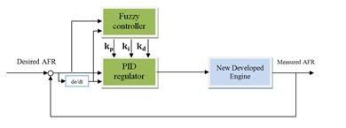
Injection Time

Figure 9: Block diagram of HFLC AFR control of SI engine
Injection Time

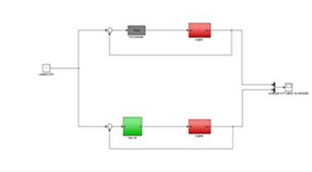

Injection Time
Setting
1 or 14.7

Figure 10: HFLC and PID in Simulink.

3.6 Evaluating HFLC
A comparative study of engine operations was required to evaluate the developed HFLC. In the first evaluation method, the AFR from the simulated engine model using the developed HFLC has been collected then compared it with the AFR of a real engine that used a conventional look-up table control model.
For the second evaluation methods, the AFR from the simulated engine model using the developed HFLC has been collected then compared with the AFR from the simulated engine model using the developed PID controller.
For the third evaluation method, the AFR from the developed HFLC has been collected and then compared with AFR results from four other controller methods such as NN, PI, SMC and PMC developed by other researchers to control AFR in SI engines.
Based on the first evaluation method, the following steps were used in our evaluating processes:
- Apply the developed controller on the validated engine model in Matlab/Simulink.
- Start the engine test using a specific throttle angle paradigm.
- Measuring the AFR of the real engine using a conventional look-up table controller.
- Run the developed simulated engine model using the same inputs (throttle angle paradigm, ambient temperature, and pressure) as were used with the real engine.
- Monitor the AFR of the simulated engine model.
- Compare the AFR of the real engine with the AFR from the simulated engine model.

4.0 SIMULINK IMPLEMENTATION OF ENGINE MODEL

An experimental process was used to obtain all the parameters used in the throttle body model. Using the idle intake method together and the throttle valve directly operated method, the throttle opening cross-sectional area was effectively described using the equation for throttle mass air flow and the accuracy of the simulation was improved. The effects of charges and discharges for the intake manifold were fully represented by the Intake manifold dynamics model. Realistic dynamic responses were provided and reasonable control over dynamic errors was produced.
Fuel injection models were included in the fuel dynamics. Using various injectors, fuel injection dynamics can be modeled. In this study, fuel was measured using air to fuel ratio (AFR) controller and fuel injection outputs. This model required engine events and engine speed to control the inputs. Engine speed and AFR were the two sub-models used for combustion dynamics.
Figure 11 shows AFR comparison between simulation and experiment at 60 Nm of constant loading condition. It was founded that results of the experimental and the simulation model were very similar indicating that our model was valid. The research also conducted a comparative analysis of the results of simulation and test results under transient conditions using step and sinusoidal throttle inputs. The outputs of the model of constant engine load, such as the lambda, air to fuel ratio, engine speed and manifold pressure, were very close to the experimental results.

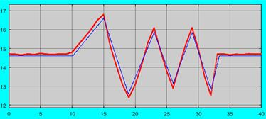
Figure 11: AFR validation at 60 Nm (Experiment and simulation results are shown in red and blue, respectively)

4.0 PID SIMULATION
In order to simulate AFR, a PID controller was designed to communicate with engine to facilitate tuning and collaborate with the toolbox as shown in 12. The Figure illustrates the PID controller containing Gain, Integrator and Derivative blocks which were used to comprehend the PID controller. Variables input for PID control were received from fuzzy logic control.

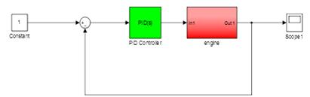
Figure 12: PID Structure in SIMULINK

After the simulation finished, the research set the PID gains to tune the simulation. By double-clicking on the PID block, the window shown in Figure 13 becomes visible.

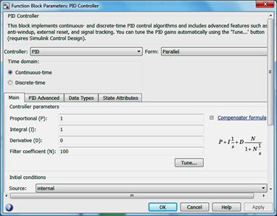
Figure 13: Function block parameters for the PID controller

In this study, the research set the PID gains using the Ziegler-Nichols (Z/N) method based on Table 1 and as shown in Figure 14.

Table 1: PID gains parameter based on Ziegler-Nichols (Z/N) method [Ziegler and Nichols, 1942].
Control Types | K_{p} | K_{i} | K_{d}
P | 0.5 K_{u} | - | -
PI | 0.45 K_{u} | 1.2K_{p}/T_{u} | -
PD | 0.8 K_{u} | - | K_{p}T_{u}/8
Classic PID | 0.6 K_{u} | 2K_{p}/T_{u} | K_{p}T_{u}/8

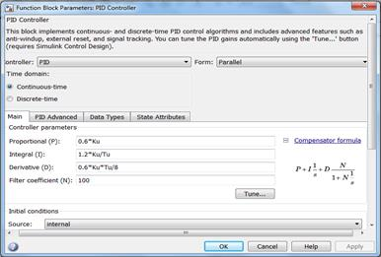
Figure 14: PID Controller Based on Ziegler-Nichols (Z/N) method

5.0 HFLC SIMULATION

The research designed fuzzy logic in MATLAB was writing in the command window. The fuzzy tool box is shown in Figure 15.

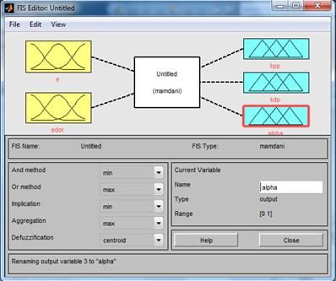
Figure 15: Fuzzy logic editor windows

As shown in Figure 16, there are two inputs: $e\left(K\right)$ and $∆e\left(K\right)$ and three outputs $K_{p}^{'}, K_{d}^{'}$ and $∝$ for membership function in matlab.

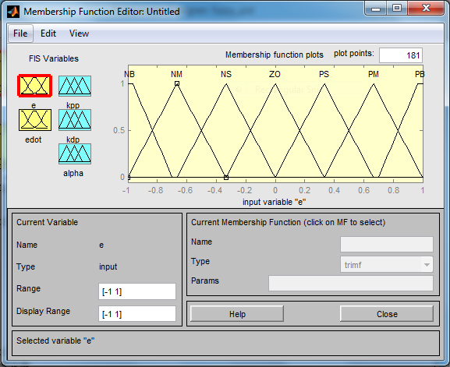
Figure 16: $e\left(K\right)$ membership function in Matlab

In the next section, it was required to define the Member Function (MF) as shown in Figure 14, Figure 15 and Figure 16 and Figure 17. The research used 7 triangular functions with the range [-1 1] to define $e\left(K\right)$ and$∆e\left(K\right)$, and MF. To define the MF of $K_{p}^{'}, K_{d}^{'}$ we used 2 Gaussian functions with range [0 1] as shown in Figure 17.

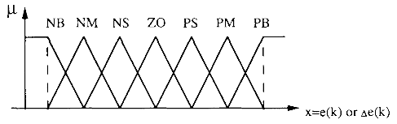
Figure 17: Membership functions for $e\left(K\right)$ and $∆e\left(K\right)$ [Zhao, et.al 1992, 1993 & 1999].

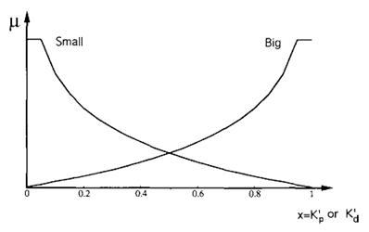
Figure 18: $K_{p}^{'}$ and $K_{d}^{'}$ membership functions [Zhao, et.al 1992, 1993, 1999].

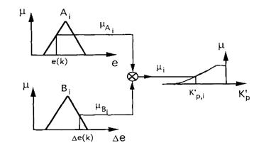
Figure 19: Singleton- membership functions for $∝$ [Zhao, et.al 1992, 1993 & 1999].

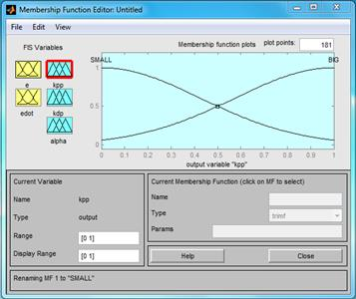
Figure 20: MF for $K_{p}^{'}, { K}_{d}^{'}$ in Matlab

To define $∝$ the research used the 4 triangular functions instead of singleton functions with the range [1 6] as shown in Figure 21.

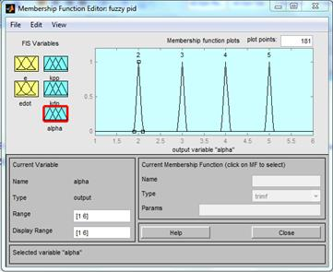
Figure 21: Membership function for $∝$in Matlab

After the defined membership function the research defined the 49 rules based on Tables 2 ~ 4 as shown in Figure 22.

Table 2: Fuzzy-tuning role for $K_{p}^{'}$ [Zhao, et.al 1992, 1993 & 1999].
$$∆e(k)$$
$$e(k)$$ |  | NB | NM | NS | ZO | PS | PM | PB
$$e(k)$$ | NB | B | B | B | B | B | B | B
$$e(k)$$ | NM | S | B | B | B | B | B | S
$$e(k)$$ | NS | S | S | B | B | B | S | S
$$e(k)$$ | ZO | S | S | S | B | S | S | S
$$e(k)$$ | PS | S | S | B | B | B | S | S
$$e(k)$$ | PM | S | B | B | B | B | B | S
$$e(k)$$ | PB | B | B | B | B | B | B | B

Table 3: Fuzzy tuning role for $K_{d}^{'}$ [Zhao, et.al 1992, 1993 & 1999].
$$∆e(k)$$
$$e(k)$$ |  | NB | NM | NS | ZO | PS | PM | PB
$$e(k)$$ | NB | S | S | S | S | S | S | S
$$e(k)$$ | NM | B | B | S | S | S | B | B
$$e(k)$$ | NS | B | B | B | S | B | B | B
$$e(k)$$ | ZO | B | B | B | B | B | B | B
$$e(k)$$ | PS | B | B | B | S | B | B | B
$$e(k)$$ | PM | B | B | S | S | S | B | B
$$e(k)$$ | PB | s | s | S | S | S | S | S

Table 4: Fuzzy tuning role for $∝$ [Zhao, et.al 1992, 1993 & 1999].
$$∆e(k)$$
$$e(k)$$ |  | NB | NM | NS | ZO | PS | PM | PB
$$e(k)$$ | NB | 2 | 2 | 2 | 2 | 2 | 2 | 2
$$e(k)$$ | NM | 3 | 3 | 2 | 2 | 2 | 3 | 3
$$e(k)$$ | NS | 4 | 3 | 3 | 2 | 3 | 3 | 4
$$e(k)$$ | ZO | 5 | 4 | 3 | 3 | 3 | 4 | 5
$$e(k)$$ | PS | 4 | 3 | 3 | 2 | 3 | 3 | 4
$$e(k)$$ | PM | 3 | 3 | 2 | 2 | 2 | 3 | 3
$$e(k)$$ | PB | 2 | 2 | 2 | 2 | 2 | 2 | 2

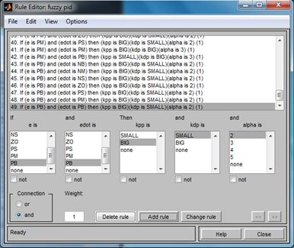Figure 22: The 49 rules in MATLAB

As shown in Figure 23, the rules surface are visible and they show that the surface is symmetrically colored due to the use of truly defined rules in MATLAB.

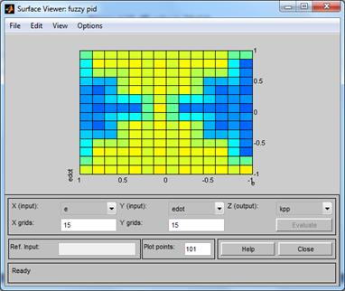
Figure 23: Rules surface viewer in Matlab.

Figure 24 illustrated a HFLC structure in MATLAB which consists of fuzzy logic and PID controls. After designing the fuzzy logic control model, then it was applied to the PID control to online adjusting the PID gains. As there were delay factors and required linearization of experimental data, therefore the PID control was tuned and optimized under PID tuning tool block in SIMULINK. This was due to the PID Tuning Tool was not appropriate for nonlinear systems.
In the study, fuzzy logic control was developed and further optimization based on Ziegler-Nichols (Z/N) method as shown in Table 1. As shown in the Figure 24, a single factor was applied by the fuzzy controller to parameterize three PID parameters such as:$K_{p}$,$K_{i, }$and $K_{d}$. The PID controller was used as a basic control and as a recompensing formula when the process drifted away from a real-time parameter. Hence, the automatic adjustment of the process output to the given value was possible. Five fuzzy values were used in the fuzzy control which is 2 inputs ($e\left(K\right)=14.7$ and $∆e\left(K\right)'$) and 3 outputs ($K_{p}$’, $K_{d}$’, $∝$) as shown in Figure 24. To maintain the smoothness of the control, a triangular membership function as shown in Figures 17 ~ 20 were used at the start before the Gaussian membership function was applied. The Fuzzy Rule Table as shown in Figure 20 was developed by Zhen-Yu Zhao method which was according to the typical second-order system error curve and the PID air to fuel ratio control errors.

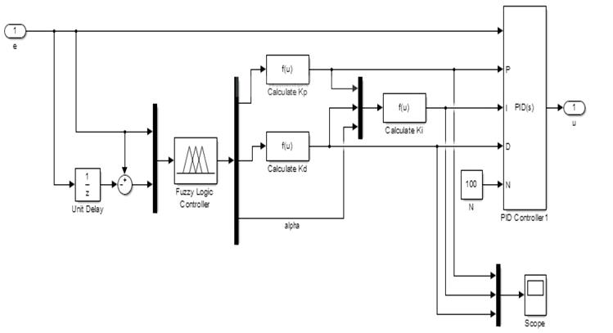
Figure 24.a HFLC in SIMULINK

3.2 HFLC Simulation for SI-Engine
The HFLC was applied to simulate AFR of SI engine “Peugeot 405 1.8i Engine” as shown in Figure 25. Experimental tests were performed at the Engine Research Laboratory (ERL) at Shiraz University in Iran. The experiment was conducted under various constant loading conditions which is 40 Nm 50 Nm and 60 Nm. This paper only discussed on 60 Nm of loading condition.

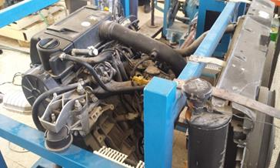
Figure 25: Peugeot 405 1.8i Engine.

Figure 26 illustrates this comparison and the percentage of improved HFLC performance. The red line represents the HFLC results and the blue line is the developed PID AFR Controller at a constant load of 60 N.m. The AFR using HFLC is more stable with range between 15.0 ~ 14.4 and more stable compared to using NN [Bai, Y, 2013] as shown in Figure 27.

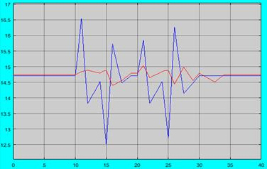
Figure 26: Comparing HFLC with the Developed PID AFR Controller at 60 Nm of constant load.

Table 5 shows the comparison of AFR results for the HFLC and Convectional Look-up Table. The maximum AFR in the real engine using the lookup-table controller was 16.8 and it was 15.02 for the HFLC. The minimum AFR in the real engine using the lookup-table controller was 12.4 and it was 14.4 for the HFLC.

Table 5: Comparison of AFR results for the HFLC and Convectional Look-up Table
 | Maximum AFR Result | Minimum AFR Result
Convectional Look-up | 16.80 | 12.40
HFLC | 15.02 | 14.4

Seventh different types of control methods for controlling AFR from studies conducted by other researchers used for comparison purposes. In Table 6, the results of a comparison study between an AFR control using Diagonal Recurrent Neural Networks (DRNN) [Zhai, et.al, 2010] as shown in Figure 27, Neural Networks (NN) [Bai, Y, 2013,], sliding mode control (SMC) [Pieper and Mehrotra, 1999], PI control [Zhai, et.al, 2010] as shown in Figure 28 and PID control [Bai, Y, 2013], Fuzzy PID method [Bai, Y, 2013], MPC method [Wang, et.al 2006] as shown in Figure 29 and developed HFLC method are presented.

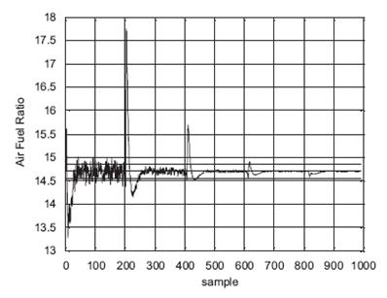
Figure 27: Simulation results of DRNN-based MPC on AFR [Zhai, et.al, 2010].

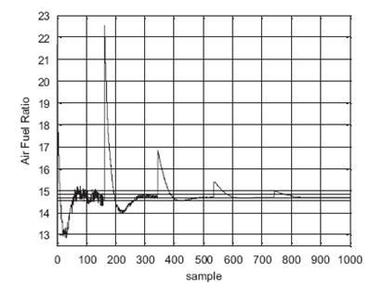
Figure 28: Simulation result of PI control on AFR [Zhai, et.al, 2010].
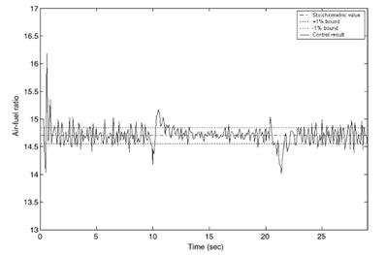
Figure 29: Air–fuel ratio control result of the MPC controller (tracking MAE = 0:2566) [Wang, et.al 2006].

Yang Bai in 2013 had conducted the test with constant engine load torque which was set at 80 Nm. The controlled AFR comparison results are shown in Figure 30. The simulation result shows 15.5 of maximum AFR and 14.4 of minimum AFR. After 3 seconds, the system is unstable due to the throttle change, and it can be seen that the NN controlled AFR reduced the maximum error by 50% and 30% from the PID control fuzzy PID control [Bai, Y, 2013].

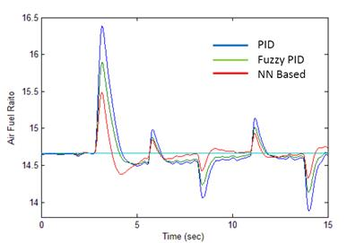
Figure 30: AFR Comparison for the constant engine load torque at 80 Nm [Bai, Y, 2013].

Table 6 showed that, the developed HFLC can control the AFR very good in comparison with other reviewed methods. The average error between the maximum and minimum AFR with stoichiometric AFR was just approximately 7 %. However, the existing control methods have been improved by researchers and also controlled the AFR but still there are still having big deviation between the AFR and stoichiometric AFR.
Using the proposed new engine simulation and HFLC simulation, the AFR result closes to the stoichiometric value of 14.7 as shown in Table 6 and Figure 31, compared to using other methods such as Neural Networks (NN) method, a sliding mode control (SMC) method, a Proportional–Integral (PI) control method and Model Predictive Control (MPC) method.

Table 6: Comparison Between the AFR results for the developed HFLC with NN, SMC, MPC and PI Controller.
No | Methods | Maximum AFR Result | Minimum AFR Result
1 | DRNN [Zhai, et.al, 2010] | 17.70 | 13.25
2 | PI [Zhai, et.al, 2010] | 22.50 | 12.80
3 | SMC [Pieper and Mehrotra, 1999] | 17.64 | 11.76
4 | MPC (Fig.24) [Wang, et.al 2006] | 16.20 | 14.05
5 | PID (Fig.24) [Bai, Y, 2013] | 16.40 | 13.80
6 | Fuzzy PID  (Fig.24) [Bai, Y, 2013] | 15.90 | 14.10
7 | NN (IP) (Fig.24) [Bai, Y, 2013] | 15.50 | 14.30
8 | Convectional Look-up  (Fig.26) | 16.80 | 12.40
9 | Developed HFLC  (Fig.26) | 15.00 | 14.40

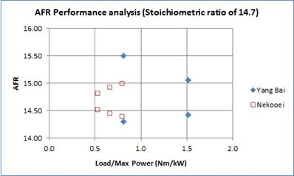

Figure 31: AFR comparison between Bai.Y aand Nekooei methods.

4.0 CONCLUSION

In this research a new algorithm for engine air to fuel (AFR) control model was developed. To develop this new control algorithm, a combination of PID and Hybrid Fuzzy Logic Control (HFLC) methods was proposed. In order to examine this new proposed method, an engine simulation model was used. The engine simulation model was made by Matlab-Simulink. To ensure the numerical engine able to be used, testing of the proposed PID and HFLC control model was carried out and the output of this numerical engine was compared to the experimental result which conducted by using Peugeot 405 1.8i engine.
After verified the accuracy of the numerical engine, the control model of the numerical engine was able to modify by using the proposed model. The original Peugeot 405 1.8i engine is control by convectional look-up table controller. In this research, only the AFR ratio control model is focus. To able the proposed model work together with the original control model, a gain-scheduling HFLC AFR controller was developed by combined the PID control principle with fuzzy control. From the study, this research found the following results
- The simulation results show that the HFLC able to perform better compare to individual PID or fuzzy control in order to control the AFR ratio. Where in HFLC model, the range between maximum and minimum AFR ratio used is 15.02 to 14.4 while the conventional look-up controlled need the maximum and minimum AFR ratio of 16.8 and 12.4. From the comparison, this clearly shows that HFLC able to reduce the range of fluctuation of AFR ratio and this can lead to reduce of fuel consumption.
- This research also proposed an engine simulation model so the numerous engine operation conditions and influence of engine control model can be test numerically. In this numerical engine, dynamic model of the throttle body, a lambda dynamic model, a model of the intake manifold dynamic, and models of engine torque and fuel injection dynamic are take into consideration to simulate the engine torque. By compare to experimental results, it is obtained that the different between the numerical and simulation result for 40 N.m absorbed load test and 50 Nm absorbed load test are 0.5% and 0.4% respectively. The high similar between the data obtain from numerical engine and experiment data show that the performance test result of the PID and HFLC control model by numerical engine is reliable.
- The simulation results founded that the maximum and minimum AFR for convectional look-up and HFLC methods were (16.80, 12.4) and (15.02, 14.4) respectively. Simulation results from HFLC were lower than other methods such as Sliding Mode Control (SMC), Neural Network (NN), Proportional–Integral controller (PI) and Model-based Predictive Control (MPC) extracted from publishing data.

ACKNOWLEDGEMENTS
The authors would like to convey a great appreciation to Ocean and Aerospace Engineering Research Institute, Indonesia and Universiti Teknologi Malaysia for supporting this research.

REFERENCES

- AVL Product Description Cruise, 2009, AVL – Advanced Simulation Technologies GmbH.
- AVL, AVL CRUISE, Vehicle driveline simulation
- Balluchi, A., Benvenuti, L., Di Benedetto, M., Cardellino, S., Rossi, C. and Sangiovanni-Vincentelli, A, 1999, Hybrid control of the air-fuel ratio in force transients for multi-point injection engines. Decision and Control, 1999. Proceedings of the 38th IEEE Conference on, 1999. IEEE, 316-321
- Benninger, N. and Plapp, G, 1991, Requirements and performance of engine management systems under transient conditions. SAE Technical Paper.
- Berkeley, Three Way Catalytic Converter, University of California
- Chan, K., Ordys, A., Volkov, K., & Duran, O, 2013, Comparison of engine simulation software for development of control system, Modelling and Simulation in Engineering, 2013, 5.
- Gao, S., Tan, D., Lang, H. and Shao, J. (2011). Study on air-fuel ratio control of coal-bed gas engine based on fuzzy PID control. Remote Sensing, Environment and Transportation Engineering (RSETE), 2011 International Conference on, 2011. IEEE, 1624-1627.
- GT-POWER, 2009, Overview - Engine and vehicle simulation platform for concept and system detailed design analysis, Gamma Technologies, Inc.
- GT-POWER, GT-POWER Engine Simulation Software
- Kilagiz, Y., Baran, A., Yildiz, Z. and Çetin, M, 2005, A fuzzy diagnosis and advice system for optimization of emissions and fuel consumption, Expert Systems with Applications, 28, 305-311.
- Koto, J. and Ikeda, Y. (2002). A Feasibility Study on a Podded Propulsion LNG Tanker in Arun, Indonesia–Osaka, Japan Route. The Twelfth International Offshore and Polar Engineering Conference, 2002. International Society of Offshore and Polar Engineers, pp 525 ~ 532.
- Koto, Ocean and Aerospace Research Institute (OCaRI), Indonesia, http://isomase.org/OCAri/Achievement.php
- Lotus Group plc, 2011, Lotus Engineering Software user menu, 2011.
- Lotus, Lotus Engineering Software (LESoft), Engineering Software.
- Mathworks, Matlab, the Language of Technical Computing.
- Mathworks, Simulink Control Design (SCD), Linearize models and design control systems.
- Mathworks, Simulink Design Optimization (SDO), Analyze model sensitivity and tune model parameters.
- Mohammad Javad Nekooei, J. Koto, M.Pauzi Ghani, Zahra Dehghani, 2015, A New Engine Simulation Structure Model Applied to SI Engine Controlling, Journal of Ocean, Mechanical and Aerospace -Science and Engineering-, Vol.22, p.9-12.
- Moler, C, 2004, the origins of MATLAB. MathWorks.
- Nekooei, Mohammad Javad, et al, 2015, "Reviewed on Combustion Modelling of Marine Spark-Ignition Engines." and Authors Pages 17: 1.
- Nekooei, Mohammad Javad, Jaswar Koto, and A. Priyanto, 2014, Review on Combustion Control of Marine Engine by Fuzzy Logic Control Concerning the Air to Fuel Ratio. Jurnal Teknologi 66.2.
- Nekooei, Mohammad Javad, Jaswar Koto, and A. Priyanto, 2015, A Simple Fuzzy Logic Diagnosis System for Control of Internal Combustion Engines, Jurnal Teknologi 74.5.
- Nekooei, Mohammad Javad, Jaswar Koto, and Agoes Priyanto, 2013, Designing Fuzzy Backstepping Adaptive Based Fuzzy Estimator Variable Structure Control: Applied to Internal Combustion Engine. Applied Mechanics and Materials. Vol. 376.
- Paris, B., Eynard, J., Grieu, S. and Polit, M, 2011, Hybrid PID-fuzzy control scheme for managing energy resources in buildings. Applied Soft Computing, 11, 5068-5080.
- Pieper, J. and Mehrotra, R. (1999). Air/fuel ratio control using sliding mode methods. American Control Conference, 1999. Proceedings of the 1999, 1999. IEEE, 1027-1031.
- Priyanto, Agoes, and Mohammad Javad Nekooei, Jaswar Koto, 2014, Design Online Artificial Gain Updating Sliding Mode Algorithm: Applied to Internal Combustion Engine. Applied Mechanics and Materials. Vol. 493.
- Ricardo software, 2009, WAVE user’s manual. Version 8.0. Ricardo Inc, 2009.
- Ricardo software, WAVE, Product, https://www.software.ricardo.com/Products/WAVE
- Sousanis, J, 2011, World Vehicle Population Tops 1 Billion Units.
- Wang, S. and Yu, D, 2008, Adaptive RBF network for parameter estimation and stable air–fuel ratio control, Neural Networks, 21, 102-112.
- Wang, S. and Yu, D, 2009, Neural network model-based automotive engine air/fuel ratio control and robustness evaluation, Engineering Applications of Artificial Intelligence, 22, 171–180.
- Wang, S., Yu, D., Gomm, J., Page, G. and Douglas, S, 2006, Adaptive neural network model based predictive control for air–fuel ratio of SI engines, Engineering Applications of Artificial Intelligence, 19, 189-200.
- Wang, S., Yu, D., Gomm, J., Page, G. and Douglas, S, 2006, Adaptive neural network model based predictive control for air–fuel ratio of SI engines. Engineering Applications of Artificial Intelligence, 19, 189-200.
- Wolfram, mathematica, Wolfram Mathematica.
- Wolfram, Mechanical Engineering (ME), DC Motor: Real‐Time Simulation.
- Bai, Y, 2013, Studies on Si Engine Simulation and Air/Fuel Ratio Control Systems Design, Ph.D Thesis, School of Engineering and Design, Brunel University, London, United Kingdom, September 2013
- Yesil, E., Guzelkaya, M. and Eksin, I. (2003). Fuzzy PID controllers: An overview. The Third Triennial ETAI International Conference on Applied Automatic Systems, Skopje, Macedonia, 2003. 105-112.
- Zhai, Y.-J., Yu, D.-W., Guo, H.-Y, Yu, D.-L, 2010, Robust air/fuel ratio control with adaptive DRNN model and AD tuning, Engineering Applications of Artificial Intelligence, 23, 283-289.
- Zhao, F., Lai, M.-C, Harrington, D. L, 1999, Automotive spark-ignited direct-injection gasoline engines, Progress in energy and combustion science, 25, 437-562.
- Zhao, Z.-Y. Tomizuka M, Isaka S, 1993, Fuzzy gain scheduling of PID controllers, IEEE Trans on Systems Man & Cyhemtics, 23, 1392-1398.
- Zhao, Z.-Y., Tomizuka, M. and Isaka, S, 1992, Fuzzy gain scheduling of PID controllers. Control Applications, 1992, First IEEE Conference on, 1992. IEEE, 698-703.
- Ziegler, J. G. and Nichols, N. B, 1942, Optimum settings for automatic controllers, trans. ASME, 64.

